Case report

Orthodontic Camouflage of an Asymmetric Angle Class III Malocclusion in an Adult Patient: A Case Report with 10-Year Follow-Up

ABSTRACT

Background.
The management of Angle Class III malocclusion in adults is challenging, particularly when skeletal discrepancies are moderate and patients refuse surgical treatment. Orthodontic camouflage using extraction protocols may represent a valid alternative in carefully selected cases.
Case Presentation.
This case report describes the orthodontic treatment of a 35-year-old woman presenting with an asymmetric Angle Class III malocclusion associated with maxillary protrusion, severe mandibular crowding, and a significant dental midline deviation. Cephalometric analysis revealed a Class I skeletal pattern with dentoalveolar compensation. An asymmetric premolar extraction protocol was selected, followed by fixed appliance therapy. Treatment was completed after 24 months, achieving correction of crowding, midline alignment, satisfactory facial esthetics, and stable occlusion.
Results.
Post-treatment records demonstrated improved facial harmony, normalized overjet and overbite, Class I occlusal relationships, and correction of dental compensations. Clinical and radiographic evaluations at a 10-year follow-up confirmed long-term stability of the results.
Conclusion.
Orthodontic camouflage with asymmetric premolar extraction can be an effective and stable treatment option for selected adult patients with Angle Class III malocclusion who are not candidates for, or refuse, surgical intervention.

Keywords: Angle class III malocclusion, Asymmetry, Crowding, Extraction, Bi-maxillary protrusion.

1. INTRODUCTION

Angle Class III malocclusion is traditionally characterized by a mesial relationship of the mandibular dentition relative to the maxillary dentition and may be associated with mandibular prognathism, maxillary retrusion, or dentoalveolar compensations. The treatment of Class III malocclusion in adult patients is often complex due to the absence of growth and the limited potential for orthopedic correction [1-2].
In severe skeletal Class III cases, orthognathic surgery combined with orthodontic treatment is often indicated. However, many adult patients present with moderate discrepancies and significant dentoalveolar compensations and may refuse surgical treatment due to cost, risk, or personal preference. In such cases, orthodontic camouflage represents a viable alternative [3].

Extraction-based orthodontic camouflage aims to correct dental compensations, improve facial esthetics, and establish functional occlusion without altering the underlying skeletal pattern [4-5].

The purpose of this case report is to describe the orthodontic management of an adult patient with asymmetric Angle Class III malocclusion treated successfully using an asymmetric premolar extraction approach, with emphasis on long-term stability

2. Case Presentation
A 35-year-old woman presented with an Angle Class III malocclusion, characterized by maxillary protrusion, severe mandibular crowding, and a significant midline shift. Her chief complaint was the esthetic impact of maxillary protrusion, inferior crowding, and midline discrepancy.
Clinical examination revealed a symmetrical face with moderate upper incisor exposure at rest. However, maxillary asymmetry was noticeable upon smiling, along with a large diastema between the upper central incisors. Both upper and lower incisors were proclined (itoNA = 32°, I/NA = 11 mm; itoNB = 35°, IMPA = 93°). Overbite and overjet were reduced, with a tendency toward an open bite and a cross-bite between the upper lateral incisor and lower canine.
Panoramic radiograph confirmed the presence of all permanent teeth, including third molars, with adequate bone support. Cephalometric analysis indicated Class I skeletal occlusion (ANB = 3°) with bimaxillary retrognathism (SNB = 76°, SNA = 79°). In the vertical aspect, the patient presented measures indicative of a hyperdivergent growth pattern (SNGoGn = 47°, FMA = 30°). (Table 1) (figure 1)
Measurement | Description
iTONA | Incisor to NA angle
I/NA | Incisor to NA linear distance
ITONB | Incisor to NB angle
IMPA | Incisor Mandibular Plane Angle
ANB | A point – Nasion – B point
SNB | Sella – Nasion – B point
SNA | Sella – Nasion – A point
SNGoGn | Sella-Nasion to Gonion-Gnathion angle
FMA | Frankfort Mandibular Plane Angle

Table I: Cephalometric measurements used for diagnosis and treatment planning. The table includes angular and linear parameters assessing incisor positioning, skeletal relationships, and mandibular plane inclination.
TREATMENT OBJECTIVES
The treatment objectives were to:
- Correct mandibular crowding and dental midline deviation
- Reduce maxillary incisor protrusion
- Establish Class I canine and functional molar relationships
- Normalize overjet and overbite
- Improve facial esthetics and lip posture
- Achieve a stable occlusion with long-term retention
TREATMENT ALTERNATIVES:
Several treatment options were considered. Orthognathic surgery combined with orthodontic treatment was discussed but refused by the patient. A non-extraction approach using interproximal enamel reduction or skeletal anchorage was considered; however, the severity of mandibular crowding and the degree of dentoalveolar compensation made these options less favorable [6-7].
An asymmetric premolar extraction protocol was selected to address crowding, correct the dental midline discrepancy, and improve incisor inclination while preserving facial esthetics and periodontal health [8].
TREATMENT PROGRESS
The main goal of treatment in our case was correcting the proclination of maxillary incisors, which presented a real esthetic problem for the patient, while also resolving the asymmetry and midline discrepancy between the maxilla and the mandible. Establishing an ideal occlusal relationship and achieving facial harmony were prioritized to enhance esthetics and function. Additionally, maintaining a stable, long-term, occlusal result was essential to ensure that any improvements in overbite and overjet remained consistent over time.
The treatment plan included extraction of maxillary right first premolar (14) and mandibular first premolars (34 and 44). Fixed orthodontic appliances with passive conventional brackets were placed in both arches.
0.12 Ni-Ti archwires were inserted into the lower and upper arches, marking the beginning of alignment. During this period, the extraction spaces were utilized effectively for the retraction of anterior teeth, facilitating both profile enhancement and reduction of the proclination in the maxillary region (Figure 2).
Continuous adjustments were made to achieve alignment. 0.14 Ni-Ti archwires were followed by 0.16 Ni-Ti archwires to enhance the final adjustments and correct midline discrepancies, while stainless steel archwires were inserted to refine the occlusal relationship towards a Class I. Throughout this active treatment phase, significant progress was observed: dental compensations were corrected through stainless steel (016x022), and alignment was improved progressively in both arches.
At the end of the treatment, 019x025 stainless steel archwires were introduced with moderate buccal torque to address the final adjustments. The results were satisfactory, with the patient achieving an improved facial profile characterized by a more balanced and harmonious labial relationship, in addition to proper occlusal function.
TREATMENT RESULTS:
After periods of active orthodontic treatment, an improved facial profile was achieved, with harmonious labial relationships and reduced steepness in the profile. Correction of tooth positioning and occlusion was obtained, with proper positioning of maxillary and mandibular incisors accomplished, correction of dental compensations, and establishment of a Class I occlusal relationship. (Figures 3 and 4)
Alignment of dental midlines was achieved, with noticeable improvement in the symmetry between the maxilla and mandible, as seen in post-treatment radiographs (Figure 5). Normal overjet and overbite were attained, providing a stable occlusion with no open bite or cross-bite tendencies, as seen in post-treatment study models. (Figure 6). The patient’s smile was improved, with better incisor positioning and a competent lip seal, contributing to an esthetically pleasing and functionally stable outcome.

3. discussion

Management of Angle Class III malocclusion, particularly in adult patients, presents significant challenges that require a comprehensive understanding of both dental and skeletal components [9]. This case report focuses on the orthodontic treatment of a 35-year-old woman presenting with Angle Class III malocclusion characterized by maxillary protrusion, severe inferior crowding, and a noticeable midline shift.
Angle Class III malocclusion has been defined as a condition in which the first molars occlude in a mesial relationship, resulting in a concave facial profile that can manifest as either mandibular protrusion, maxillary retrusion, or a combination of both [10-11]. Angle classification addresses the dental relationships without adequately addressing the skeletal components involved [12]. This oversight has led to considerable debate within the orthodontic community regarding appropriate treatment methodologies, particularly in adults, where skeletal maturity limits certain options [13]. The present case highlights the importance of recognizing the nuanced interplay between dental compensation and skeletal relationships. Unlike cases primarily involving skeletal Class III deformities, our patient exhibited significant dental compensations that influenced treatment planning.
In addition to the orthodontic approach used in the present case, it is important to acknowledge alternative treatment options reported in the literature. One such option is an incisor–canine segmental surgical asymmetric setback following unilateral first premolar extraction, which has been described as a relatively short surgical procedure (approximately 3 hours). This approach may represent a viable alternative to prolonged orthodontic mechanics lasting up to two years in selected cases, depending on the clinical indication, patient preference, and risk–benefit assessment.
Studies have shown that the extraction of premolars can be a highly effective strategy in managing Angle Class III malocclusion. For example, Kim and Baek investigated changes in maxillary incisor inclination during surgical-orthodontic treatment, and found that extracting the maxillary first premolars could lead to substantial improvements in incisor positioning and facial esthetics [14]. These findings directly informed our decision to extract the premolars in our case, as it allowed for the management of crowding and the correction of dental protrusion while enhancing overall facial harmony.
The efficacy of premolar extraction in the treatment of Class III malocclusion is well supported in the literature. Needham et al. explored the use of lower-incisor extraction in Class III treatment with clear aligners and demonstrated that this strategy could effectively address occlusal discrepancies [15]. Although our treatment utilized fixed appliances rather than clear aligners, the underlying principle was still to manage tooth positioning for optimal occlusion and esthetics. The successful resolution of our patient’s malocclusion through the extraction of two premolars reflects a critical consensus within the field regarding the effectiveness of this approach.
In exploring alternative treatment strategies, Lin and Gu examined the role of lower second molar extraction in a severe skeletal Class III case [16]. Their findings suggested that selective extraction can facilitate alignment and improve occlusion, supporting our choice to perform premolar extractions to alleviate crowding and facilitate the correction of the midline shift. These findings reinforce the understanding that extraction protocols should be thoughtfully considered based on individual patient characteristics, particularly in cases where dental compensations are prominent.
The discussion surrounding extraction versus non-extraction treatment strategies continues to be a focal point in orthodontic literature. Janson et al. conducted a comprehensive evaluation of various extraction protocols over several decades, indicating a trend towards individualized treatment plans that consider both functional and esthetic outcomes [17]. Our approach, which showed the necessity of extracting premolars to address both the crowding and esthetic concerns associated with maxillary protrusion, reflects an adaptive strategy that aligns with evolving clinical practices. In addition, studies by Holman et al. demonstrated the significance of using standardized indices, such as the Peer Assessment Rating index, to assess treatment effectiveness [18]. Such tools provide invaluable feedback for clinicians, and ensure that treatment outcomes can be measured against established benchmarks. In our case, the application of these indices was instrumental in tracking the progress of the orthodontic treatment and evaluating the final results.
The presence of a thin periodontal biotype in our patient also necessitated careful planning and monitoring throughout the treatment process. Literature indicates that patients with thin periodontal tissues may experience increased risk of periodontal complications following orthodontic treatment [19], which underscores the importance of treatment strategies that minimize adverse effects on the periodontium while effectively addressing malocclusion. By ensuring meticulous control of tooth movement and maintaining a conservative approach to extractions, we were able to protect the periodontal health of our patient throughout her treatment journey.
In their comprehensive review, Ngan and Moon examined the evolution of Class III malocclusion treatments, emphasizing the importance of a multifaceted approach tailored to individual patient needs [13]. They discussed various treatment modalities, including early orthopedic intervention, orthodontic camouflage, and surgical correction, highlighting that while surgical intervention is often necessary for severe skeletal Class III cases, non-surgical orthodontic methods can yield satisfactory outcomes for patients with significant dental compensations. Our patient’s successful treatment outcome through solely orthodontic means underscores the effectiveness of non-surgical options in carefully selected cases.

4. Conclusion

The literature reflects a consensus that effective management of Angle Class III malocclusion requires a multifaceted approach that considers individual patient characteristics. This case report contributes to the understanding of treatment strategies for Angle Class III malocclusion in adults by highlighting the successful use of premolar extractions and fixed appliances. The approach not only addressed the functional aspects of the patient’s occlusion but also enhanced her facial esthetics, ultimately improving her quality of life. These results highlight the importance of comprehensive treatment planning and the integration of evidence-based practices in orthodontic care.

COMPETING INTERESTS

The authors declare no conflicts of interest with respect to the research, authorship, and/or publication of this article.

Consent (where ever applicable)

The patient provided written informed consent for the publication of this case report and accompanying clinical images.

Ethical approval (where ever applicable)

Not applicable

Disclaimer (Artificial intelligence)
Author(s) hereby declare that NO generative AI technologies such as Large Language Models (ChatGPT, COPILOT, etc.) and text-to-image generators have been used during the writing or editing of this manuscript.

References

- Ellis, E. 3rd, & McNamara, J. A. Jr. (1984). Components of adult Class III malocclusion. Journal of Oral and Maxillofacial Surgery, 42(5), 295-305. https://doi.org/10.1016/0278-2391(84)90109-5
- Zammit D, Ettinger RE, Sanati-Mehrizy P, Susarla SM. Current Trends in Orthognathic Surgery. Medicina (Kaunas). 2023 Nov 30;59(12):2100. doi: 10.3390/medicina59122100. PMID: 38138203; PMCID: PMC10744503.
- Wilcko, W. M., Wilcko, T., & Bissada, N. F. (2008). An evidence-based analysis of periodontally accelerated orthodontic and osteogenic techniques: A synthesis of scientific perspectives. Seminars in Orthodontics, 14(4), 305-316. https://doi.org/10.1053/j.sodo.2008.07.007
- Aslan, B. I., & Küçükkaraca, E. (2019). Nonextraction Treatment of a Class III Malocclusion Case Using Mini-Screw-Assisted Lower Molar Distalization. Turk J Orthod, 32(2), 119-124. https://doi.org/10.5152/TurkJOrthod.2018.18026
- Gehlot M, Sharma R, Tewari S, Kumar D, Gupta A. Effect of orthodontic treatment on periodontal health of periodontally compromised patients. Angle Orthod. 2022 May 1;92(3):324-332. doi: 10.2319/022521-156.1. PMID: 34882193; PMCID: PMC9020398.
- Kwak, Y. Y., Jang, I., Choi, D. S., & Cha, B. K. (2014). Functional evaluation of orthopedic and orthodontic treatment in a patient with unilateral posterior crossbite and facial asymmetry. Korean Journal of Orthodontics, 44(3), 143–153. https://doi.org/10.4041/kjod.2014.44.3.143
- Joss-Vassalli, I., Grebenstein, C., Topouzelis, N., Sculean, A., & Katsaros, C. (2010). Orthodontic therapy and gingival recession: A systematic review. Orthodontics & Craniofacial Research, 13(3), 127-141. https://doi.org/10.1111/j.1601-6343.2010.01491.x
- Zurfluh MA, Kloukos D, Patcas R, Eliades T: Effect of chin-cup treatment on the temporomandibular joint: a systematic review. Eur J Orthod. 2015, 37:314-24. 10.1093/ejo/cju048
- Gencer, D., Kaygisiz, E., Yüksel, S., & Tortop, T. (2015). Comparison of double-plate appliance/facemask combination and facemask therapy in treating Class III malocclusions. Angle Orthodontist, 85(2), 278-283. https://doi.org/10.2319/013114-83.1
- Pavoni, C., Masucci, C., Cerroni, S., Franchi, L., & Cozza, P. (2015). Short-term effects produced by rapid maxillary expansion and facemask therapy in Class III patients with different vertical skeletal relationships. *Angle Orthodontist*, *85*(6), 927–933. https://doi.org/10.2319/052414-366.1
- Yepes, E., Quintero, P., Rueda, Z. V., & Pedroza, A. (2014). Optimal force for maxillary protraction facemask therapy in the early treatment of class III malocclusion. European Journal of Orthodontics, 36(5), 586-594. https://doi.org/10.1093/ejo/cjt091
- Chang, H. P., Tseng, Y. C., & Chang, H. F. (2006). Treatment of mandibular prognathism. Journal of the Formosan Medical Association, 105(10), 781-790. https://doi.org/10.1016/S0929-6646(09)60264-3
- Ngan, P., & Moon, W. (2015). Evolution of Class III treatment in orthodontics. American Journal of Orthodontics and Dentofacial Orthopedics, 148(1), 22-36. https://doi.org/10.1016/j.ajodo.2015.04.012
- Kim, D. K., & Baek, S. H. (2013). Change in maxillary incisor inclination during surgical-orthodontic treatment of skeletal Class III malocclusion: comparison of extraction and nonextraction of the maxillary first premolars. American Journal of Orthodontics and Dentofacial Orthopedics, 143(3), 324-335. https://doi.org/10.1016/j.ajodo.2012.10.014
- Needham, R., Waring, D. T., & Malik, O. H. (2015). Invisalign treatment of Class III malocclusion with lower-incisor extraction. Journal of Clinical Orthodontics, 49(7), 429-441. https://www.jco-online.com/archive/2015/07/429/
- Lin, J., & Gu, Y. (2006). Lower second molar extraction in correction of severe skeletal Class III malocclusion. Angle Orthodontist, 76(2), 217-225. https://doi.org/10.1043/0003-3219(2006)076[0217:LSMEIC]2.0.CO;2
- Janson, G., Maria, F. R., & Bombonatti, R. (2014). Frequency evaluation of different extraction protocols in orthodontic treatment during 35 years. Progress in Orthodontics, 15(1), 51. https://doi.org/10.1186/s40510-014-0051-z
- Holman, J. K., Hans, M. G., Nelson, S., & Powers, M. P. (1998). An assessment of extraction versus nonextraction orthodontic treatment using the peer assessment rating (PAR) index. Angle Orthodontist, 68(6), 527-534. https://doi.org/10.1043/0003-3219(1998)068<0527:AAOEVN>2.3.CO;2
- Alassfar, A., Benyahia, H., Zaoui, F., & Halimi, A. (2023). Managing orthodontic treatment in periodontally compromised patients. European Journal of Oral and Maxillofacial Surgery, 7, 75-81. https://doi.org/10.23736/S2532-3466.23.00320-x

Figure 1: Pre-treatment radiographs

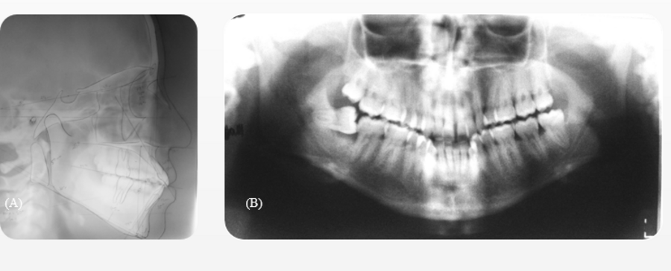
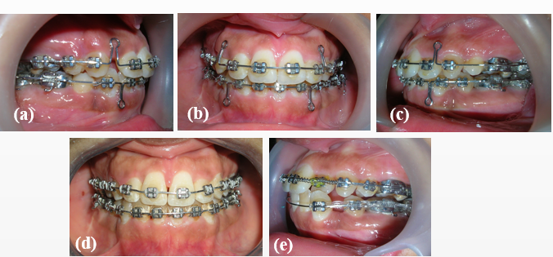

Figure 2: Orthodontic bonding and alignment phase.
(a) Brackets in place with an initial 0.014 Ni-Ti archwire.
(b)Left intraoral view demonstrating early alignment progress
(c) Use of bull loops for controlled incisor retraction.
(d) The frontal view shows progressive space closure.
(e) The left occlusal view shows progressive space closure.

Figure 3: Comparative pre-treatment and long-term post-treatment extraoral photographs of the patient, highlighting the initial facial and occlusal characteristics. The 10-year post-treatment photographs demonstrate stable occlusal correction, improved facial harmony, and satisfactory long-term esthetic outcomes.

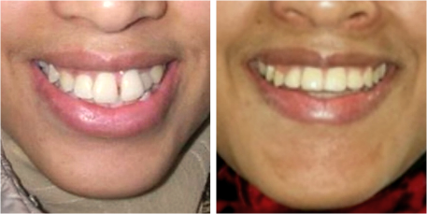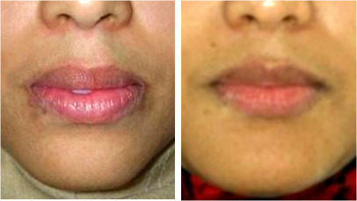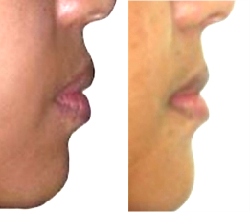

Figure 4: Comparative pre-treatment and long-term post-treatment intraoral photographs. The pre-treatment images demonstrate the initial occlusal relationships and dental alignment, while the 10-year post-treatment photographs show corrected occlusion, improved intercuspation, and stable intraoral outcomes at long-term follow-up.
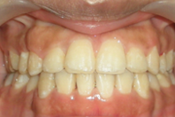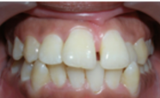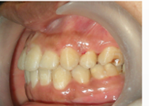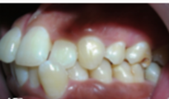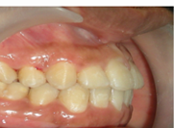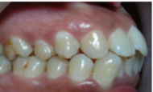

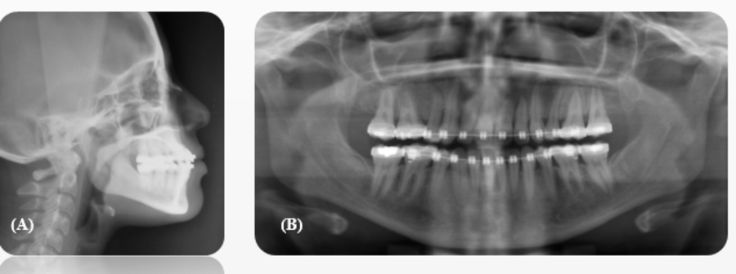

Figure 5: Post-treatment radiographs.
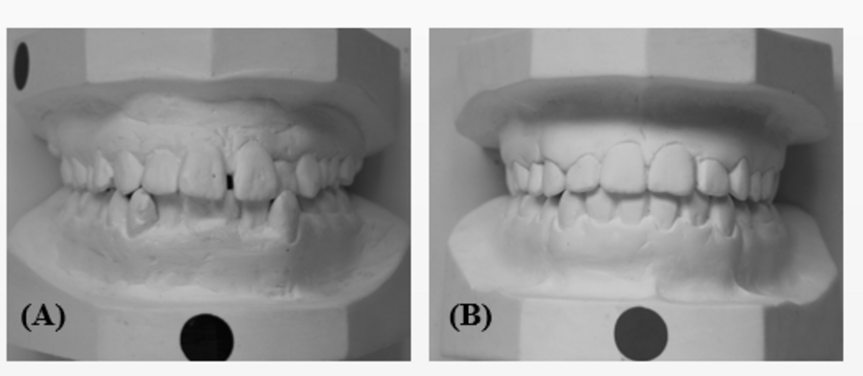

Figure 6: Comparison of pre-treatment and post-treatment study models.
(A) Frontal view illustrating the initial malocclusion.
(B) Post-treatment study models showing correction of overjet, overbite, and midline shift, achieving a stable Class I occlusion. The resolution of mandibular crowding and improved arch coordination contribute to functional and esthetic stability.

