Case report
Juvenile Maxillary Ossifying Fibroma: A Rare Case in a 12-Year-Old Girl

Abstract:
Ossifying fibroma (OF) is a benign fibro-osseous neoplasm characterized by the replacement of normal bone with a fibro-cellular stroma containing variable mineralized material such as bone and cementum. It most commonly affects the mandibular premolar–molar region, with maxillary involvement being relatively uncommon. This report describes a rare case of ossifying fibroma in a 12-year-old girl presenting with a painless swelling on the right side of the face for four months. Radiographic evaluation showed a well-defined radiolucent lesion with a sclerotic border and displacement of adjacent tooth roots. Surgical enucleation and curettage were performed under local anesthesia. Histopathological examination demonstrated a fibrocellular stroma with irregular trabeculae of lamellar bone and cementum-like calcifications, confirming the diagnosis of ossifying fibroma. Surgical enucleation and curettage were performed under local anaesthesia. Postoperative healing was uneventful, and no recurrence was observed during six months of follow-up. Overall, this case emphasizes the value of integrating clinical, radiographic, and histopathological assessment for definitive diagnosis and successful management of ossifying fibroma.
Keywords: Benign neoplasm, Facial swelling, Fibro-osseous lesion, Histopathology, Maxilla, Paediatric case, Ossifying Fibroma, Surgical enucleation.
Introduction:
Ossifying fibroma (OF) is a benign fibro-osseous neoplasm characterized by the replacement of normal bone with a fibrous stroma containing varying amounts of mineralized material such as bone and cementum. It arises from the mesenchymal cells of the periodontal ligament, which have the potential to produce bone, cementum, and fibrous tissue. Ossifying fibroma most frequently involves the mandible, particularly the premolar–molar region, and is relatively uncommon in the maxilla [1,2]. The lesion is typically slow-growing and painless but may cause facial asymmetry, tooth displacement, and cortical expansion [3]. Although it predominantly affects individuals in the second to fourth decades of life, its occurrence in children is rare and poses a diagnostic and therapeutic challenge because of its potential for aggressive growth and facial deformity during developmental years [4,5]. This report presents a case of ossifying fibroma in the maxilla of a 12-year-old girl.
Case Report:
A 12-year-old girl reported to the Department of Oral Medicine and Radiology with a chief complaint of swelling on the right side of her face for the past four months. Initially, the swelling was small in size which gradually increased over a period of four months, which was not associated with pain, pus discharge, or any other symptoms. The patient’s medical, dental, and family histories were non-contributory, and there was no history of trauma or systemic illness.
Extraorally, well-defined swelling was noted over the right mid-facial region, superoinferiorly extending from the infraorbital margin to the corner of the mouth, and antero-posteriorly from ala of nose to the intersection point of alatragus line with the perpendicular line drawn from outer canthus of eye, causing mild facial asymmetry (Fig. 1). The overlying skin appeared normal. On palpation, the swelling was firm to hard in consistency, afebrile and non-tender. No palpable lymphadenopathy was present.
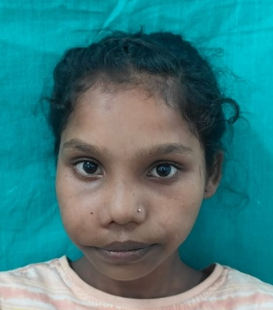
Fig. 1: Preoperative frontal view showing swelling on the right mid-facial region.

Intraoral examination revealed a well-defined swelling on the buccal aspect of the right posterior maxillary alveolus extending from 14 to 17 with obliteration of buccal vestibule. The overlying mucosa appeared normal with mild purplish discoloration (Fig. 2). On palpation, the swelling was hard and non-tender. The teeth in the affected area were firm and non-mobile. The maxillary right canine (13) was positioned in cross-bite with respect to opposing mandibular dentition . Based on history and clinical findings, provisional diagnosis was given as adenomatoid odontogenic tumour of right maxilla.
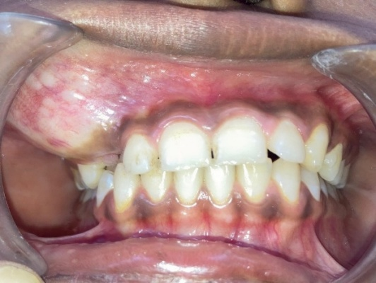
Fig. 2: Intraoral view showing swelling on the buccal aspect of the right posterior maxillary alveolus extending from tooth 14 to 17.
For radiological evaluation, intraoral periapical radiograph (IOPA) and maxillary occlusal radiographs were done. IOPA showed a well-defined mixed lesion with sclerotic border causing displacement of roots with 13 and 14 without resorption. The maxillary occlusal radiograph typically showed a lesion extending from mesial aspect of 13 to distal aspect of 15 with localized area of altered trabecular pattern and interspersed radiopaque calcific flecks. There was widening of the interdental space and mesial displacement of 13 and 14 (Fig. 3). Orthopantomogram (OPG) revealed a well-circumscribed, unilocular radiolucent to mixed radiolucent–radiopaque lesion in the upper right canine–premolar region, bordered by a thin sclerotic rim. The lesion showed mild alveolar cortical expansion with displacement of adjacent tooth roots and no evidence of root resorption(Fig.4).Based on radiographic findings, adenomatoid odontogenic tumour (extrafollicular type), calcifying odontogenic cyst (CEOC), calcifying odontogenic tumour (CEOT) and fibro-osseous lesion were considered as radiographic differentials.
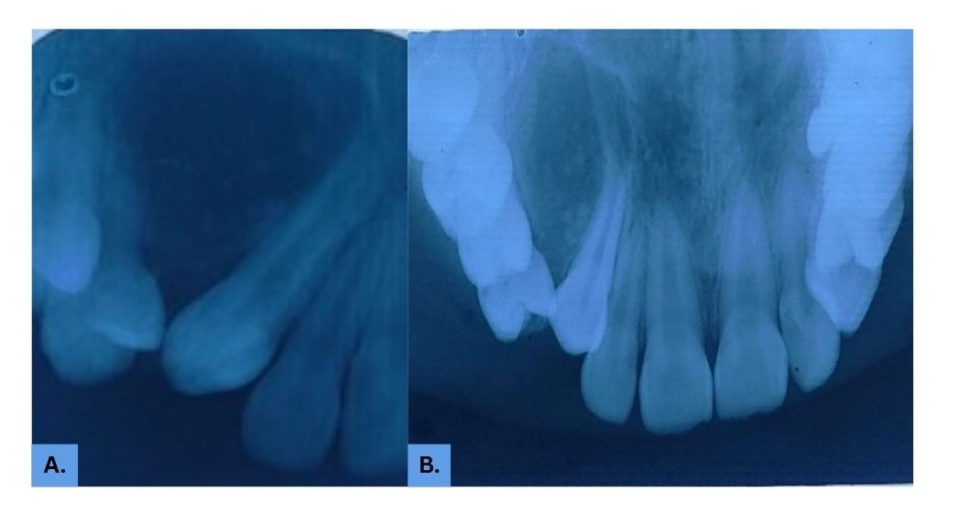
Fig.3: A. IOPA B. Occlusal Radiograph

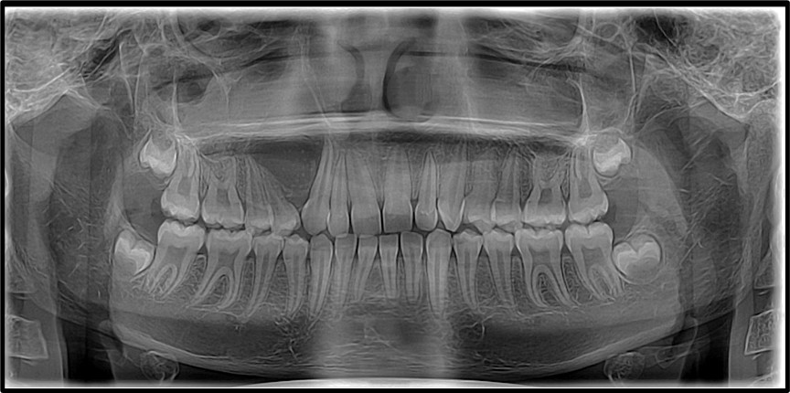
Fig.4- Orthopantomogram
The lesion was surgically excised under local anaesthesia. A crevicular incision was made from the maxillary first premolar to the second molar, and a full-thickness mucoperiosteal flap was reflected. The lesion was well-encapsulated and easily separable from the surrounding bone. Complete enucleation and curettage were performed.(Fig.5).The surgical cavity was irrigated with saline, and the flap was repositioned and sutured with resorbable sutures. Post-operative medications included antibiotics and analgesics for five days. The patient was advised to maintain oral hygiene and follow up regularly. Healing was uneventful.
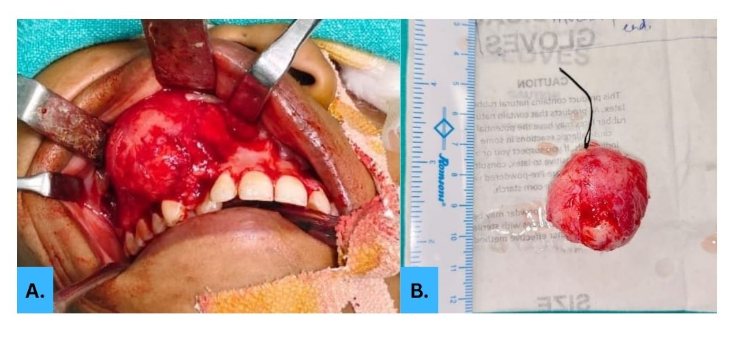

Fig .5-Intraoperative Photograph
Microscopic examination of the excised specimen revealed hypercellular connective tissue stroma with dense collagen fibre bundles arranged in interlacing manners forming fascicles and storiform pattern. Abundant spindle shaped fibroblasts and fibrocytes with calcified foci were seen throughout the connective tissue stroma with mild degree of vascularity. Peripheral areas showed immature osseous trabeculae with osteoblastic rimming (Fig. 6). Based on above findings ossifying fibroma was given as final diagnosis.

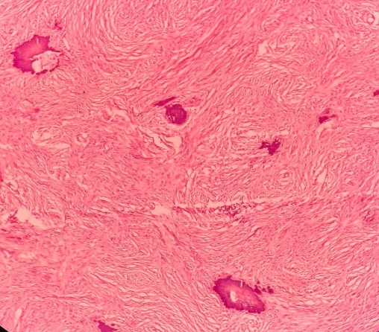
10X

Fig. 6: Histopathological section showing fibro-cellular stroma containing cementum-like calcifications.
The patient was reviewed at one week, one month, three months, and six months postoperatively. Post-operative OPG showed obturated root canals in relation to teeth 13,14,and 15. Healing was satisfactory, and no recurrence or residual lesion was observed clinically or radiographically. Facial symmetry was restored (Fig.7).
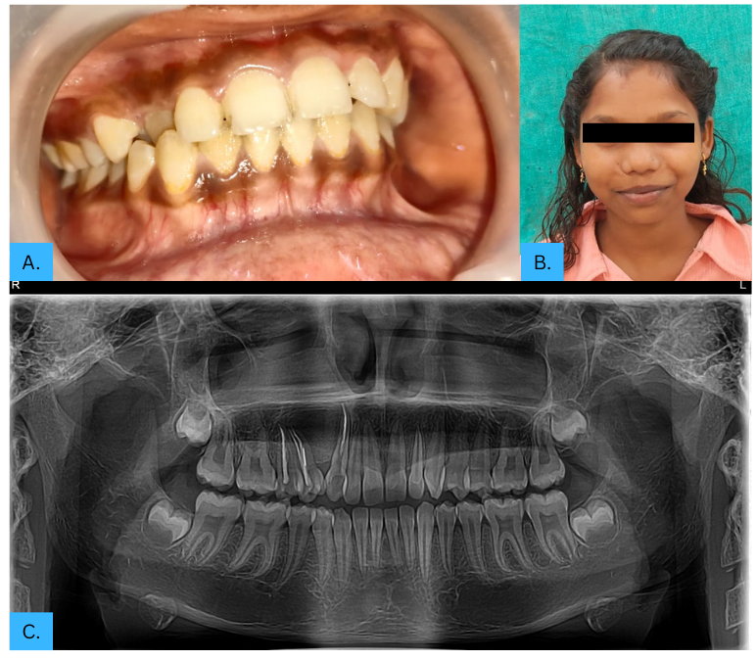
Fig.7.Postoperative follow-up images after 6 months
(A) Intraoral view (B) Extraoral view (C) Orthopantomogram

Discussion:
Ossifying fibroma is a distinct entity among benign fibro-osseous lesions of the jaws. It differs from fibrous dysplasia in that it is well-demarcated and encapsulated, which allows for easy surgical enucleation. The lesion originates from the periodontal membrane and shows potential for bone and cementum formation [1,2,6]. The World Health Organization (WHO) classifies ossifying fibroma as a benign fibro-osseous neoplasm. It occurs most commonly in the third and fourth decades of life and shows a strong female predilection. Paediatric cases are uncommon, and maxillary involvement is even rarer [4,5]. The present case in a 12-year-old girl with a maxillary lesion therefore represents an unusual presentation.
Clinically, ossifying fibroma usually presents as a slow-growing, painless swelling that can cause facial asymmetry, tooth displacement, and cortical expansion. The overlying mucosa typically remains intact. Pain or paraesthesia is uncommon unless secondary infection occurs. In the present case, the swelling was asymptomatic and resulted primarily in facial asymmetry [2].
Radiographically, ossifying fibroma evolves from a radiolucent lesion in the early stage to a mixed radiolucent–radiopaque appearance as calcification progresses. The well-defined sclerotic border is a characteristic feature that helps distinguish it from fibrous dysplasia, which blends imperceptibly with the surrounding bone. The displacement of adjacent teeth roots without resorption, as observed in this case, is a common finding [7].
Histologically, the lesion consists of a fibrocellular stroma with varying amounts of calcified material. The presence of both bone and cementum-like calcifications within a well-demarcated lesion supports the diagnosis of ossifying fibroma. The differential diagnosis includes fibrous dysplasia, cemento-osseous dysplasia, and juvenile ossifying fibroma. Fibrous dysplasia typically lacks clear demarcation and blends imperceptibly with the surrounding bone, whereas cemento-osseous dysplasia is a non-neoplastic, tooth-associated lesion that is uncommon in pediatric patients. The later, especially the psammomatoid and trabecular variants, tends to occur in younger patients and shows more aggressive behavior, often requiring more extensive surgical intervention [8].
The management of ossifying fibroma depends on the size, location, and aggressiveness of the lesion. Small, well-defined lesions can be treated successfully by conservative surgical excision and curettage. Larger or recurrent lesions may require block resection with reconstruction. In the present case, because of the lesion’s encapsulated nature and moderate size, complete enucleation was performed [9]. Recurrence rates of ossifying fibroma vary between 10% and 28%, depending on the completeness of excision and the type of lesion, with most recurrences occurring within the first year post-surgery, highlighting the influence of surgical method and lesion margins on long-term outcomes. Juvenile variants tend to recur more frequently. Therefore, long-term follow-up is essential, particularly in paediatric cases where facial growth continues. In this patient, no recurrence was noted during six months of follow-up, but extended monitoring is planned to ensure stability.
Early diagnosis is crucial in children to prevent significant facial deformity and functional impairment. Conservative management aims to preserve normal bone and dental structures while achieving complete lesion removal. The prognosis is generally favourable if the lesion is completely excised [3].
Conclusion:
Ossifying fibroma is a benign but potentially deforming fibro-osseous lesion that requires careful diagnosis and management. The present case of ossifying fibroma in a 12-year-old girl highlights the importance of early detection and conservative surgical excision to achieve excellent functional and aesthetic outcomes.

Disclaimer (Artificial intelligence)
Option 1:
Author(s) hereby declare that NO generative AI technologies such as Large Language Models (ChatGPT, COPILOT, etc.) and text-to-image generators have been used during the writing or editing of this manuscript.
Option 2:
Author(s) hereby declare that generative AI technologies such as Large Language Models, etc. have been used during the writing or editing of manuscripts. This explanation will include the name, version, model, and source of the generative AI technology and as well as all input prompts provided to the generative AI technology
Details of the AI usage are given below:
1.
2.
3.
References:
- Kumar, N., Punde, P., Patil, N. S., & Gautam, A. (2020). Central ossifying fibroma of mandible. BMJ Case Reports, 13(12), e239286. https://doi.org/10.1136/bcr-2020-239286
- Jih, M. K., & Kim, J. S. (2020). Three types of ossifying fibroma: A report of 4 cases with an analysis of CBCT features. Imaging Science in Dentistry, 50(1), 65-71. https://doi.org/10.5624/isd.2020.50.1.65
- Tompodung, L. M., & Sensusiati, A. D. (2023). Ossifying fibroma of the maxilla: A case report with literature review. Radiology Case Reports, 19(3), 915-921. https://doi.org/10.1016/j.radcr.2023.10.059
- Gautier, B., Dugast, S., Guyonvarc'h, P., Longis, J., Corre, P., & Bertin, H. (2025). Ossifying fibroma and juvenile ossifying fibroma: A systematic review on clinical and radiological parameters, treatment modalities and recurrence. Journal of Stomatology, Oral and Maxillofacial Surgery, 126(4), 102185. https://doi.org/10.1016/j.jormas.2024.102185
- Chandini, R., Saranya, R., Mohideen, K., Balasubramaniam, M., Ghosh, S., & Dhungel, S. (2023). Juvenile psammomatoid ossifying fibroma of the maxilla and mandible: A systematic review of published case reports. Clinical and Experimental Dental Research, 9(1), 186-197. https://doi.org/10.1002/cre2.687
- Kaur, T. (2021). Fibro-osseous Lesions in the Maxillofacial Region. In K. Bonanthaya, E. Panneerselvam, S. Manuel, V. V. Kumar, & A. Rai (Eds.), Oral and Maxillofacial Surgery for the Clinician (pp. 615-628). Springer. https://doi.org/10.1007/978-981-15-1346-6_30
- Collins, L. H. C., Zegalie, N. F. T., Sassoon, I., & Speight, P. M. (2023). A Clinical, Radiological and Histopathological Review of 74 Ossifying Fibromas. Head and Neck Pathology, 17(2), 433-446. https://doi.org/10.1007/s12105-022-01522-w
- Guddadararangiah, S., Ram Shetty, S., Al-Bayatti, S., & Narasimhan, S. (2021). Large cemento-ossifying fibroma of the mandible involving the infratemporal and parapharyngeal spaces. Heliyon. https://doi.org/10.1016/j.heliyon.2021.e07594
- Nnko, K. A., Pima, R. T., Damas, S., & Mremi, A. (2024). Management of ossifying fibroma of the bone of the maxilla: a case report and review of the literature. Journal of Surgical Case Reports, 2024(4), rjae198. https://doi.org/10.1093/jscr/rjae198

