Traditional Cocoa-Based Agroforestry Systems and Food Security in the Localities of Séria and Zépréguhé (Central-West, Côte d’Ivoire)

Abstract
Agriculture has been a central activity in the organisation of human societies for millennia, serving both as a source of sustenance and as a driver of economic development. In Côte d’Ivoire, agriculture, particularly cocoa farming, which covers 30% of the territory, threatens biodiversity. Agroforestry systems, integrating trees and crops, offer ecological and social benefits. However, their impacts on flora preservation, ecosystem services, and food security remain understudied. To optimise their management and improve food security, this study aims to contribute to better management of useful phytodiversity in cocoa-based agroforestry systems. Floristic and dendrometric data collection and surveys were conducted. The studied cocoa agroforestry systems harbour 77 species across 50 genera and 27 families, with a predominance of Fabaceae and Euphorbiaceae. Producers utilise various species to meet agricultural and social, with local variations. The results also show differences in food consumption and food security levels according to agricultural periods. This study highlights the importance of key species in cocoa agroforestry systems, particularly in the Daloa department, and proposes foundations for conservation policies adapted to local variability. These results argue for the integration of traditional agroforestry systems with cocoa trees through the promotion of agroforestry practices based on the conservation of multi-purpose species, technical support for producers and the consideration of food security in the sustainable management of cocoa landscapes.
Keywords : Phytodiversity, Agroforestry, Food Security, Ecosystem Services

1. INTRODUCTION
Agriculture has historically and continues to be a fundamental pillar of human societal development, ensuring both population subsistence and economic stability, particularly in developing countries (Le Cacheux, 2011 ; Agreste, 2015 ; FAO, 2022). Even today, it remains the primary source of income and food security for more than 2.5 billion people worldwide, while being highly exposed to environmental, climatic, and socio-economic crises (Cortes et al., 2020). Among tropical crops, cocoa (Theobroma cacao) occupies a central position, particularly in West Africa (Osseni, 2020). In Côte d’Ivoire, the world’s leading producer since 1978, cocoa farming contributes significantly to the national economy, accounting for approximately 15% of GDP and a major share of rural employment (MINEF, 2015 ; ICCO, 2020). This sector relies mainly on millions of smallholder farmers, whose livelihoods and food security are closely dependent on farm productivity (FAO, 2009 ; National REDD+ Strategy, 2018). However, the dominant cocoa production model, based on spatial expansion and intensive monoculture, has led to extensive deforestation, soil degradation, biodiversity loss, and a decline in ecosystem services (SODEFOR, 1996 ; Koulibaly, 2008 ; Gbozé et al., 2020 ; IFFN, 2021 ; Dramane, 2023). These dynamics weaken agricultural production systems, reduce food availability, and increase the vulnerability of rural households to climatic shocks, international market fluctuations, and food insecurity (Koulibaly et al., 2010b ; Dahan et al., 2021).
In this context, the food security of cocoa-producing households appears to be closely linked to the diversification of production systems and income sources (ICRAF, 2015). Cocoa-based agroforestry systems represent a sustainable alternative to the intensive model by integrating trees, associated crops, and sometimes livestock within agricultural plots (MEA, 2005a; Atangana et al., 2014; Koulibaly, 2019; AfDB, 2020). These systems promote more resilient production by improving soil fertility, regulating microclimates, and reducing sensitivity to climatic hazards (Diomandé et al., 2021). Beyond cocoa production, agroforestry systems provide complementary food products (fruits, vegetables, medicinal plants) as well as timber and non-timber forest products, thereby contributing to dietary diversification and income stabilization for households (Diomandé et al., 2023). This multifunctionality strengthens food security both by improving local food availability and by increasing the economic capacity of farmers (MINEF, 2015 ; Thomas, 2024).
In Côte d’Ivoire, traditional cocoa-based agroforestry systems thus emerge as a strategic lever for reconciling agricultural production, food security, natural resource conservation, and climate change adaptation. Their promotion represents a relevant response to current sustainability challenges, by reducing pressure on natural forests while enhancing the resilience of rural food systems. Nevertheless, despite their numerous advantages, traditional cocoa-based agroforestry systems remain insufficiently studied and poorly valued in Côte d’Ivoire. This situation is particularly pronounced in the Centre-West, where knowledge remains limited to structural characteristics, floristic diversity, and, in some cases, the contribution of these systems to ecosystem services. This scientific gap hinders their effective integration into agricultural, climate, and rural development policies. In a context of climate change, it therefore appears essential to assess their capacity to reconcile the provision of ecosystem services with the improvement of producers’ living conditions. The central question is to what extent traditional cocoa-based agroforestry systems can constitute a sustainable solution by simultaneously ensuring household food security and conserving natural resources. It is within this framework that the present study aims, first, to characterize the flora preserved in traditional cocoa-based agroforestry systems, second, to identify the ecosystem services provided by these systems, and finally, to assess the level of food security of producer households.

2. MATERIAL AND METHODS

2.1. Description of the Study Area
The study was conducted in the Department of Daloa, located in the Haut-Sassandra Region (Central-Western Côte d’Ivoire), which is characterized by a sub-equatorial climate with two distinct seasons (Figure 1). The area receives an average annual rainfall of approximately 930.62 mm and has a mean annual temperature of 26.47 °C (Koffié-Bikpo & Kra, 2013 ; Boko et al., 2020). The landscape is predominantly dominated by cocoa-based agroforestry systems (Figure 2), which constitute the main agricultural and economic activity of the region (N’Guessan et al., 2014 ; Bolou, 2021 ; Koudougnon, 2020).
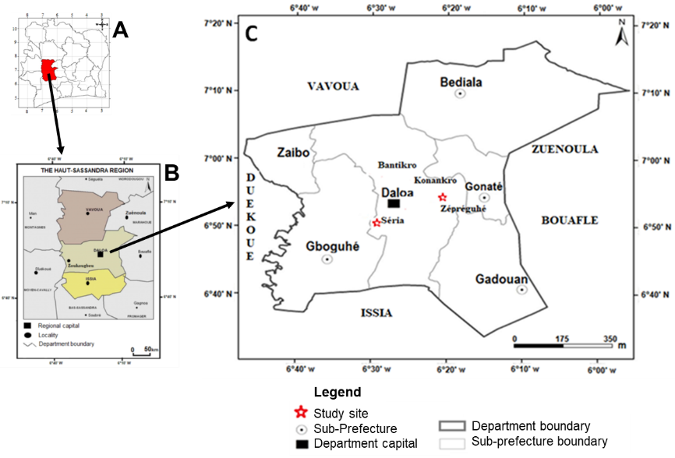
Fig 1. (A) Administrative divisions of Côte d’Ivoire ; (B) Location of the Department of Daloa in Côte d’Ivoire ; (C) Sampling sites
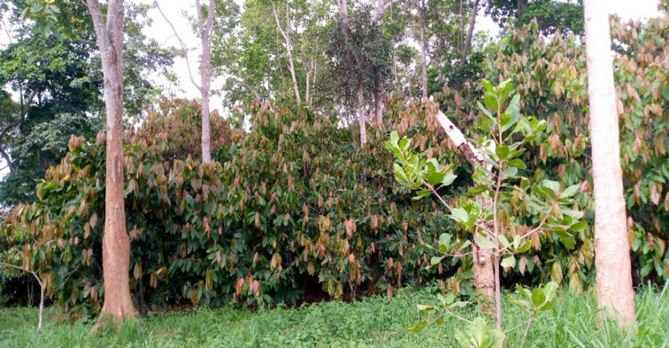
Fig 2. Cocoa tree orchard with associated plant species

2.2. Data Collection Methods

2.2.1. Floristic Characteristics
The collection of floristic data (Figure 3) combined plot-based inventories and itinerant surveys (Figure 4). In total, 75 plots of 400 m² were established across five agroecosystems within the study area (Koulibaly, 2008 ; Dramane et al., 2023). The itinerant inventory made it possible to complete the census of plant species occurring outside the plots (Aké-Assi, 1984 ; Koulibaly, 2008 ; Diomandé et al., 2021 ; Boko et al., 2020).
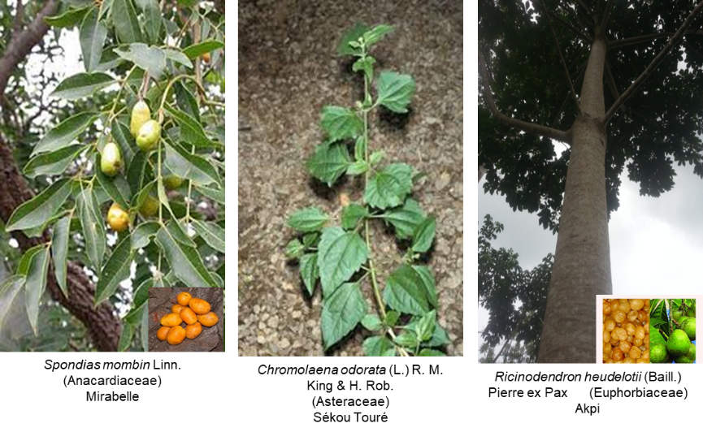
Fig 3 : Examples of species preserved in traditional cocoa agroforestry systems

2.2.2. Ecosystem Services
To identify the use domains of the preserved species, the so-called “walk-in-the-woods interview” method was applied (Phillips & Gentry, 1993). A total of 200 producers were interviewed using a structured questionnaire. A preliminary meeting was held with village authorities to explain the objectives of the study and to designate a person responsible for translation into the local language (Diomandé et al., 2023).

2.2.3. Food Security
Household food security among producers was assessed using questionnaire-based surveys, in accordance with the methodological recommendations of the World Food Programme (WFP). This approach is based on recognized indicators that allow analysis of the different dimensions of food security. Data were collected through semi-structured interviews with producers, complemented by direct field observations (HLPE, 2020 ; FAO, 2015).
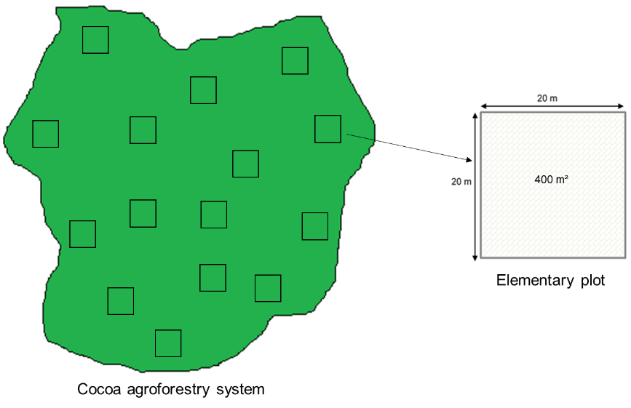
Fig 4. Plots of surface sampling in traditional cocoa-based agroforestry systems

2.3. Data Analysis Methods

2.3.1. Floristic Characteristics
Species identification was based on field observations and herbarium samples following the APG IV classification of 2016. Floristic richness was assessed through taxonomic composition, life forms, and chorological affinities (Spichiger et al., 1981 ; Aké-Assi, 2001 ; 2002).
The qualitative analysis of the flora focused on floristic richness and composition (Kouamé, 1998), as well as on biological and chorological types (Raunkiaer, 1934 ; Aké-Assi, 2001 ; 2002). Floristic richness was evaluated through an exhaustive census of species. Life forms were determined according to Raunkiaer’s classification adapted to tropical environments, and chorological types were used to identify the biogeographical origin of the taxa.
Floristic diversity in traditional cocoa agroforestry systems was evaluated using indices integrating both species richness and relative abundance. In addition to species richness (S), the Shannon diversity index (H’), Simpson’s index (D), and Pielou’s evenness index (E) (Table 1) were employed (Temgoua et al., 2019). The Shannon index was used to estimate the overall diversity of the stands by combining richness and relative abundance, while Simpson’s index, sensitive to dominant species, served to validate observed trends. Pielou’s evenness index was employed to analyze the distribution of individuals among species and detect potential dominances (Zounon et al., 2019). These indices, widely used in the study of cocoa agroforestry systems, provide a robust evaluation of floristic diversity.
Table 1. Liste des équations utilisées pour le calcul des indices de diversité
INDICES | EQUATIONS | INTERPRETATION
Shannon diversity index (H’) | $$H'=-\sum_{i=1}^{s}{\left(\frac{ni}{N}\right)}\log_{2}\frac{ni}{N}$$ | Dans cette formule, ni : nombre d’individus de l’espèce i, et N : nombre d’espèces dans chaque milieu.  L’indice de diversité considéré dans cette étude varie théoriquement entre 0 et la valeur et $\log_{2}$S qui est la diversité maximale où S représente le nombre total d’espèces présentes dans le milieu étudié. H’ est minimal (H’ = 0) lorsque le peuplement est composé d’une seule espèce. L’indice tend vers la diversité maximale (H’max) lorsque la flore comporte un nombre élevé d’espèces.
Simpson index (D) | $$D'=\sum_{k=0}^{n}{\left(\frac{ni}{N}\right)}$$ | Dans cette formule, D’ = indice de diversité de Simpson, ni = nombre d’individus d’une espèce i et N = nombre total d’individus de toutes les espèces.  Cet indice varie de 0 (diversité minimum) à 1 (diversité maximum). Dans cette étude, l’indice de diversité de Simpson a été utilisé pour valider les résultats obtenus avec l’indice de Shannon. Aussi, cet indice renseigne sur la réponse de la biodiversité face aux pressions anthropiques.
Pielou's evenness index (E) | $$E=\frac{H'}{(lnS)}$$ | Dans cette formule, E = l’indice d’équitabilité de Piélou, H’ = Indice de Shannon, S = Nombre total d’espèces du biotope concerné et lnS : H’max (diversité maximale).  L’indice a une valeur comprise entre 0 et 1. Il tend vers 0 lorsque la quasi-totalité des individus correspond à une seule espèce dans un milieu donné. Il évolue vers 1 lorsque toutes les espèces ont tendance à être représentées chacune par le même nombre d’individus. Selon Inoussa et al. (2013), si E est situé entre [0 ; 0,6], l’équitabilité de Piélou est faible, dans ce cas on observe une dominance d’espèce ; par contre, si E est situé entre [0,6 ; 0,8[, l’équitabilité de Piélou est moyenne et enfin si E est situé entre [0,8 ; 1], l’équitabilité de Piélou est élevée, dans ce cas on observe une absence de dominance d’espèce. L’indice d’Equitabilité de piélou (Piélou, 1966) a été utilisé dans cette étude pour connaître la répartition des effectifs entre les différentes espèces dans les systèmes agroforestiers traditionnels à cacaoyers.

2.3.2. Identification of Ecosystem Services
Ethnobotanical data were collected from 200 producers through semi-structured interviews conducted in French and local languages, following consultation with local authorities. The “Walk-in-the-woods” method was used to identify plants and their uses within cocoa agroforestry systems. The collected information allowed for the characterization of species diversity and the assessment of their distribution across use categories, including food, medicine, materials, and cultural uses.
The ethnobotanical use value (UV) measures the importance of plants for local communities, encompassing food, medicine, materials, and cultural uses. It helps identify critical species and supports conservation efforts (Albuquerque et al., 2006 ; Ladoh-Yemeda et al., 2016). Citation frequency (CF) was used to quantify the relative importance of species, considering as priority those mentioned by at least 20% of informants, in accordance with the TRAMIL method.

2.3.3. Assessment of Food Security
Data on household food security were collected using the method recommended by the World Food Programme (WFP), based on food groups and their nutritional weights (Table 2).
Table 2. Food groups and their weights in the Food Consumption Score (FCS)
Food | Food groups | Food group weight in FCS (a) | Number of days of consumption in the past 7 days (x) | FCS (AxB)
Maize, millet, sorghum, rice, bread, and other cereals | Cereals | 2 | 7 | 14
Cassava, sweet potatoes, yams, potatoes, and taro | Tubers | 2 | 7 | 14
Beans, soybeans, peanuts, and cashew nuts | Legumes | 3 | 1 | 3
Onion, tomatoes, spinach, eggplant, and other vegetables | Vegetables | 1 | 2 | 2
Mango, papaya, banana, orange, lemon, and other fruits | Fruits | 1 | 0 | 0
Beef, goat, fish, snails, poultry, pork, and eggs | Meat and fish | 4 | 0 | 0
Milk, yogurt, and other dairy products | Milk | 4 | 1 | 4
Sugar and sugary products | Sugar | 0.5 | 4 | 2
Oil, palm oil, fats, and butter | Oil | 0.5 | 2 | 1
Composite score |  |  |  | 26
PAM (2008)

2.4. Statistical Data Analysis Methods
The data collected in the field were analysed using a test to compare the means of quantitative variables. The non-parametric Wilcoxon test was therefore performed. The normality and homogeneity of variances were studied using the Shapiro-Wilk test and the Batlett test, respectively. The Wilcoxon test was used because the data distribution was not normal, the variance was not homogeneous, only two sites were compared, and the sites were similar. The quantitative variables analysed were the specific diversity indices of cocoa tree SAFs at the two (2) study sites (specific richness, Shannon diversity index, Simpson index and Piélou's evenness index).
Household food security data were analyzed using the Sphinx² Statistics software (version 5). The assessment relied on the CARI methodology of the World Food Programme (WFP), a standardized approach that classifies households according to their food security status. This method aggregates three key indicators : the Food Consumption Score (FCS), the share of food expenditures, and the use of coping strategies. Households were thus categorized into four groups : food secure, mildly food insecure, moderately food insecure, and severely food insecure.
The Food Consumption Score was calculated based on the frequency of consumption of food groups over seven days, weighted by their nutritional importance (during the four cocoa production periods), according to the national thresholds defined for Côte d’Ivoire.
In this formula : a = weight assigned to the food group ; x = number of days of consumption for each food group (≤ 7 days).
The thresholds defined for Côte d’Ivoire are as follows : score < 21, poor food consumption ; 21.5 to 35, borderline food consumption ; and score > 35.5, acceptable food consumption (Ministry of Agriculture, 2007). Following this calculation, depending on the obtained result, the FCS is classified as poor, borderline, or acceptable by comparing it to the FCS thresholds (Table 3).
Table 3. Interpretation of the Food Consumption Score (FCS)
Food consumption score (FCS) | Interpretation
<21 | Poor (Inadequate quantity and quality)
21,5-35 | Borderline (Inadequate quality)
>35 | Acceptable (Adequate diet)

3. RESULTS AND DISCUSSION

3.1. Results

3.1.1. Floristic characteristics of traditional cocoa agroforestry systems

3.1.1.1. Floristic richness
In Séria, the analysis of the flora in traditional cocoa agroforestry systems revealed 44 species distributed among 39 genera and 21 families. The dominant families are : Euphorbiaceae, representing 16% of the species, including Alchornea cordifolia (Schum. & Thonn.) Müll.Arg. and Euphorbia heterophylla L.; Fabaceae, representing 11% of the species, with the most frequent species being Albizia zygia (DC.) J.F. Macbr. and Desmodium adscendens (Sw.) DC. var. adscendens and Asteraceae, representing 9% of the species, with the most frequent being Achillea millefolium L. and Synedrella nodiflora Gaertn. (Figure 5).
Regarding the locality of Zépréguhé, the study of traditional cocoa agroforestry systems identified 61 plant species belonging to 50 genera and 27 families (Figure 6). Fabaceae dominate with 11% of the species, the most frequent being Acacia mangium Willd. and Albizia zygia (DC.) J.F. Macbr.; Euphorbiaceae represent 10% of the species, including Euphorbia heterophylla L. and Hevea brasiliensis (Kunth) Müll.Arg.; and Malvaceae account for 8% of the species, with the most frequent species being Ceiba pentandra (L.) Gaerth. and Cola nitida (Vent.) Schott & Endl.
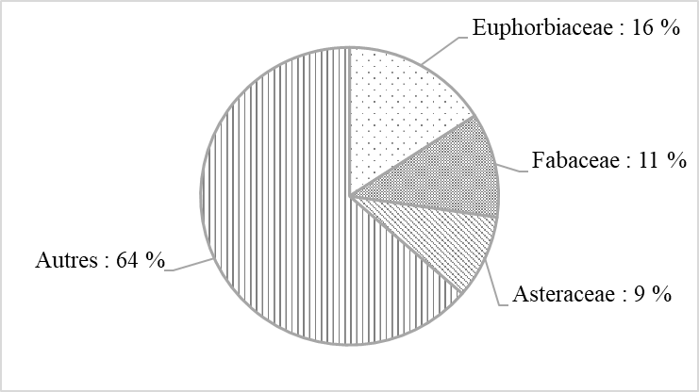
Fig 5. Spectrum of dominant families in traditional cocoa agroforestry systems in the Séria locality
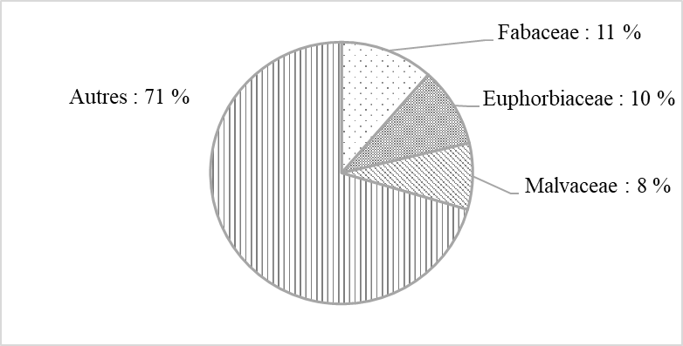
Fig 6. Spectrum of dominant families in traditional cocoa agroforestry systems in the Zépréguhé locality

3.1.1.2. Biological Types
In the Séria locality, the analysis of the flora in traditional cocoa agroforestry systems revealed 11 biological types (Figure 7). Microphanerophytes dominate, representing 36% of the species, with the most frequent species being Anacardium occidentale L., Azadirachta indica A. Juss., and Morinda lucida Benth. Mesophanerophytes account for 14% of the species, with the most frequent being Albizia adianthifolia (Schumach.) W.F. Wright and Albizia zygia (DC.) J.F. Macbr. Megaphanerophytes represent 11%, including species such as Alstonia boonei De Wild. and Bombax buenopozense P. Beauv. Nanophanerophytes account for 9% of the species, with the most frequent being Ananas comosus (L.) Merr. and Capsicum annuum L. Chamaephytes represent 7% of the species, with the most frequent being Commelina benghalensis L. var. benghalensis.
In Zépréguhé, the study of the flora in traditional cocoa agroforestry systems identified 10 biological types (Figure 8). Microphanerophytes dominate with 46%, including species such as Baphia bancoensis Aubrév. and Gliricidia sepium (Jacq.) Walp. They are followed by Mesophanerophytes, representing 18% of the species, with the most frequent being Albizia zygia (DC.) J.F. Macbr. and Cola nitida (Vent.) Schott & Endl. Megaphanerophytes account for 15% of the recorded species, with the most frequent being Ceiba pentandra (L.) Gaerth. and Entandrophragma utile (Dawe & Sprague) Sprague.
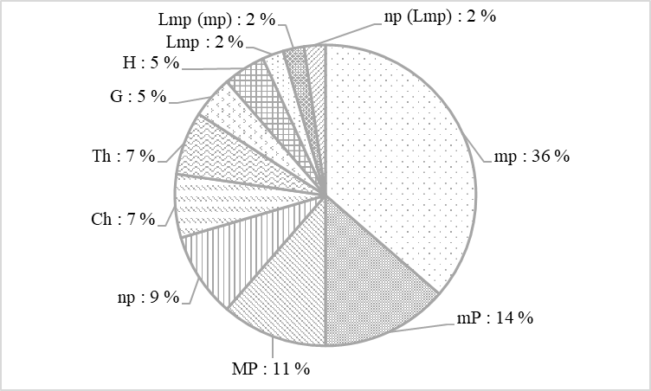
Fig 7. Spectrum of biological types in traditional cocoa agroforestry systems in Séria
With : MP = Megaphanerophyte, mP = Mesophanerophyte, mp = Microphanerophyte, np = Nanophanerophyte, Ch = Chamephyte, Th = Therophyte, G = Geophyte, H = Hemicryptophyte, Lmp = Lianescent microphanerophyte, Lmp (mp) : Microphanerophyte-Microphanerophyte Lianescent, np (Lmp) = Nanophanerophyte- Microphanerophyte lianescent.
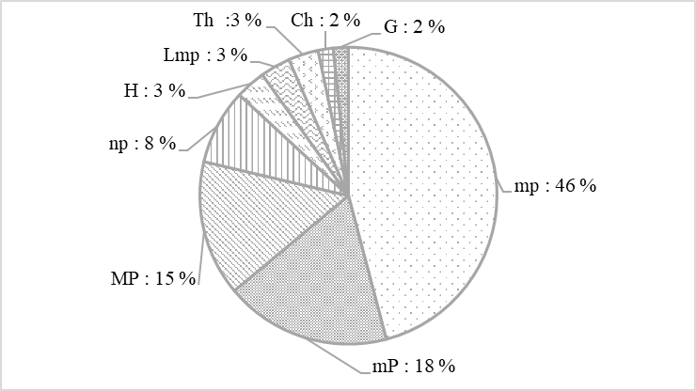
Fig 8. Spectrum of biological types in traditional cocoa agroforestry systems in Zépréguhé
With : MP = Mégaphanérophyte, mP = Mésophanérophyte, mp = Microphanerophyte, np = Nanophanérophyte, H = Hémicryptophyte, Lmp = Microphanérophyte lianescante, Th = Thérophyte, Ch = Chamephyte, G = Géophyte, np (Lmp) = Nanophanérophyte- Microphanerophyte lianescent.

3.1.1.3. Chorological Affinities
The inventory of species in traditional cocoa agroforestry systems in Séria shows that 39% originate from the Guineo-Congolian (GC) region, including species such as Albizia adianthifolia (Schumach.) W.F. Wright and Alstonia boonei De Wild. (Figure 9). Introduced or cultivated species (i) represent 34% of the species, including Anacardium occidentale L. and Ananas comosus (L.) Merr. Species from the transition zone between the Guineo-Congolian and Sudanian-Zambezian regions account for 25% of the species, with the most frequent being Albizia zygia (DC.) J.F. Macbr. and Alchornea cordifolia (Schum. & Thonn.) Müll.Arg.
In traditional cocoa agroforestry systems in the Zépréguhé locality, 41% of species belong to the Guineo-Congolian (GC) region, with the most common being Annona muricata L. and Cola nitida (Vent.) Schott & Endl. (Figure 10). They are followed by introduced or cultivated species (i), which account for 34% of the species, including Capsicum annuum L. and Gliricidia sepium (Jacq.) Walp. Species from the transition zone between the Guineo-Congolian and Sudanian-Zambezian regions represent 21% of the species, with the most frequent being Antiaris toxicaria var. africana (Engl.) C.C. Berg and Hoslundia opposita Vahl. One species endemic to Côte d’Ivoire (Baphia bancoensis Aubrév.) and one species from the Sudanian-Zambezian region (Acacia sieberiana var. villosa A. Chev.) were the least represented, each accounting for 2% of the recorded species.
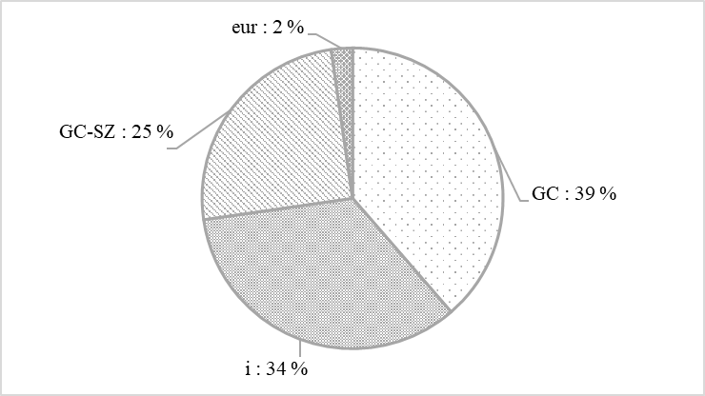
Fig 9. Spectrum of chorological affinities in traditional cocoa agroforestry systems in the Séria locality
With : GC = Taxon from the Guineo-Congolian region ; i = Introduced or cultivated taxon ; GC-SZ = Taxon from the transition zone between the Guineo-Congolian and Sudanian-Zambezian regions ; Eur = Species from the Eurasian domain.
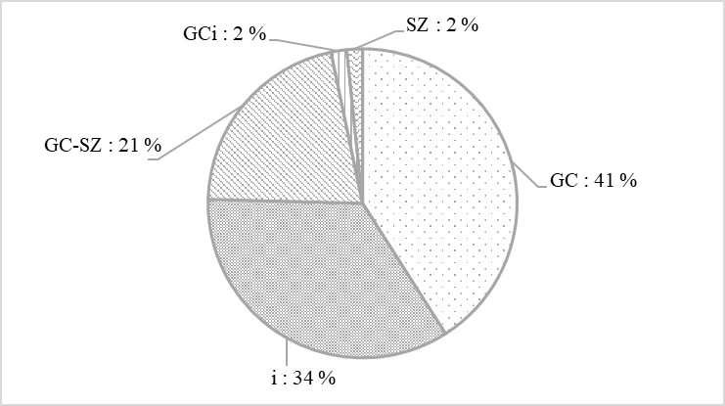
Fig 10. Spectrum of chorological affinities of traditional cocoa agroforestry systems in the Zépréguhé locality
With : GC = Taxon from the Guineo-Congolian region ; i = Introduced or cultivated taxon ; GC-SZ = Taxon from the transition zone between the Guineo-Congolian and Sudanian-Zambezian regions.

3.1.1.4. Species Diversity of the Flora in Traditional Cocoa-Based Agroforestry Systems
The results for the Séria locality show an average of 2,560 individuals per hectare. The mean Shannon–Weaver diversity index for the different traditional cocoa agroforestry systems is 1.45. This index value is closer to 0 than to the maximum diversity value of 3.78. The Simpson index indicates a mean value of 0.71, close to 1. Regarding Pielou’s evenness index, the mean value is 0.83.
In the Zépréguhé locality, the average is 559 individuals per hectare. The mean Shannon–Weaver diversity index of traditional cocoa agroforestry systems is 1.42, which is closer to 0 than to the maximum diversity value of 4.11. The Simpson index shows a mean value of 0.69, close to 1. The mean Pielou’s evenness index is 0.82.
Overall, traditional cocoa agroforestry systems across the four localities exhibit a moderately diverse flora and a high evenness of individuals among species. Comparisons of means using the non-parametric Wilcoxon test shows that there is no significant difference between the number of species (W = 2817.5 ; P = 0.99), the Shannon & Weaver diversity indices (W = 2937 ; P = 0.64), the Simpson diversity indices (W = 3190.5 ; P = 0.16), and Pielou’s evenness (W = 2870 ; P = 0.83) among the traditional cocoa agroforestry systems across the two (02) study sites (Table 4).
Table 4. Specific diversity indices of traditional cocoa agroforestry systems in the Daloa department
Parameters | Average values |  | Statistical test
Parameters | Séria | Zépréguhé
Number of species/Site | 44 | 61
Number of individuals/ha | 2560 | 559
Species richness (S)/400 m² | 6 | 6 | W = 2817.5 ; P = 0.9864
Shannon-Weaver (H’) | 1.449 | 1.425 | W = 2937 ; P = 0.64
Maximum diversity (H’max) | 3,78 ± 0,45 | 4,11 ± 0,80 | W = 2937 ; P = 0.64
Pielou's evenness (E) | 0.8316 | 0.8239 | W = 2870 ; P = 0.83
Simpson's diversity (1-D) | 0.7159 | 0.6893 | W = 3190.5 ; P = 0.16
W : Rapport entre la variabilité inter et intra-groupe ; P : niveau de signifiance

3.1.2. Ecosystem services provided by traditional cocoa agroforestry systems

3.1.2.1. Provisioning Services
In Séria, surveys conducted with farmers on the species recorded in traditional cocoa agroforestry systems identified 42 commonly used species. These species enable producers to meet their needs across several domains. Considering the different uses, species used for medicine represent 75% of the species, with the most frequent being Alstonia boonei De Wild. and Azadirachta indica A. Juss. Species used as fuelwood represent 52% of the species, with the most frequent being Albizia zygia (DC.) J.F. Macbr. and Ceiba pentandra (L.) Gaerth. Species used for food account for 48%, with the most frequent being Ananas comosus (L.) Merr. and Mangifera indica L. Species used for commercial purposes represent 39%, with the most frequent being Anacardium occidentale L. and Elaeis guineensis Jacq. Species used for construction represent 32%, with the most frequent being Ceiba pentandra (L.) Gaerth. and Piptadeniastrum africanum (Hook.f.) Brenan B. Species used for crafts also represent 32%, with the most frequent being Alchornea cordifolia (Schum. & Thonn.) Müll.Arg. and Alstonia boonei De Wild. Species used as fodder represent 27%, with the most frequent being Bombax buenopozense P. Beauv. and Euphorbia heterophylla L. (Figure 11).
In Zépréguhé, surveys with farmers on the species recorded in traditional cocoa agroforestry systems identified 57 commonly used species. These species allow producers to satisfy their needs in several domains. Considering the different uses, species used as fuelwood represent 67%, with the most frequent being Acacia mangium Willd. and Antiaris toxicaria var. africana (Engl.) C.C. Berg. Species used for medicine account for 66%, with the most frequent being Carica papaya var. papaya L. and Chromolaena odorata (L.) R.M. King & H. Rob. Species used for food represent 52%, with the most frequent being Spondias mombin L. and Musa paradisiaca L. Species used for commercial purposes account for 39%, with the most frequent being Annona reticulata L. and Persea americana Mill. Species used for crafts represent 38%, with the most frequent being Annona reticulata L. and Antiaris toxicaria var. africana (Engl.) C.C. Berg. Species used for construction account for 38%, with the most frequent being Albizia adianthifolia (Schumach.) W.F. Wright and Antiaris toxicaria var. africana (Engl.) C.C. Berg. Species used as fodder represent 23%, with the most frequent being Euphorbia hirta L. and Gliricidia sepium (Jacq.) Walp. Species used as timber represent 20%, with the most frequent being Anacardium occidentale L. and Entandrophragma angolense (Welw.) C. DC. (Figure 12).
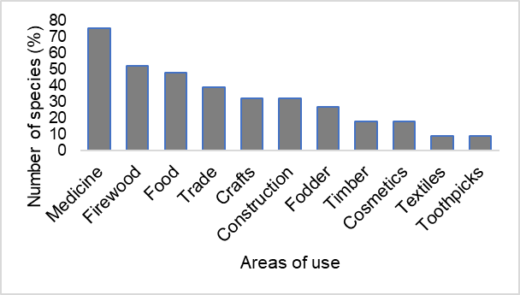
Fig 11. Histograms of species distribution according to their use categorie in the Séria locality
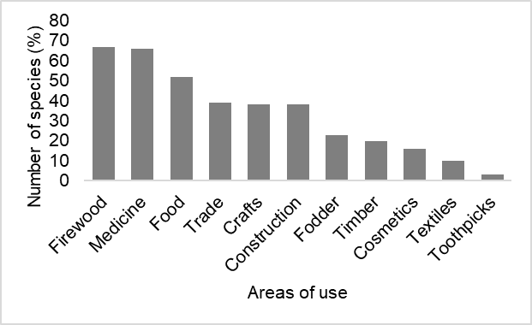
Fig 12. Histograms of species distribution according to their use categorie in the Zépréguhé locality

3.1.3. Food Security Levels of Cocoa-Producing Households in the Studied Farms
In the Séria locality, surveys conducted with households revealed that most producers and their families have acceptable food consumption (FCS > 35). This food security situation is dominant across the four (04) agricultural periods. The period with the highest number of food-secure households is the Long Cocoa Trading Period, from October to March, with 85% of households (Figure 13). However, there are periods with households experiencing moderate food insecurity (21.5 < FCS < 35). The largest proportion of households in this situation occurs during the Main Cocoa Lean Period (GPSC), from May to September, with 22% of households. Severe food insecurity (FCS < 21) is observed during the Long Cocoa Lean Period, from May to September, affecting 12% of households.
In the Zépréguhé locality, surveys with households revealed that most producers and their families also have acceptable food consumption (FCS > 35). This food security situation is dominant across the four (04) agricultural periods. The period with the highest number of food-secure households is the Long Cocoa Trading Period, from October to March, with 87% of households (Figure 14). However, there are periods with households experiencing moderate food insecurity (21.5 < FCS < 35). The largest proportion of households in this situation occurs during the Main Cocoa Lean Period (GPSC), from May to September, with 16% of households. Severe food insecurity (FCS < 21) is observed during the Long Cocoa Lean Period, from May to September, affecting 15% of households.
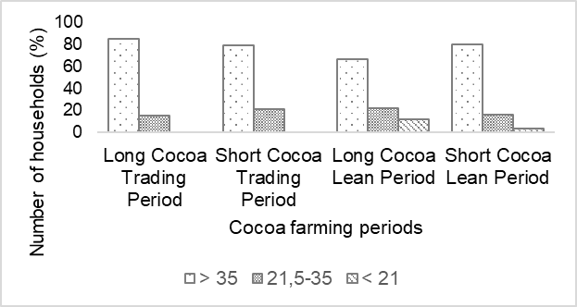
Fig 13. Food security status of cocoa-producing households in the Séria locality
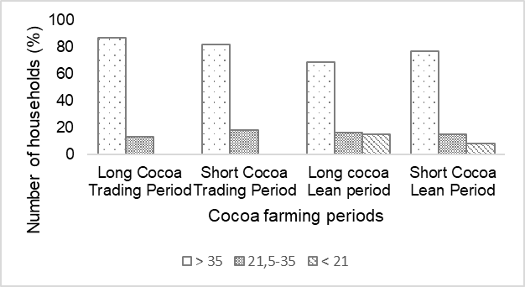
Fig 14. Food security status of cocoa-producing households in the Zépréguhé locality

3.2. Discussion
The study of the floristic characteristics of traditional cocoa agroforestry systems in the Daloa department, and specifically in the localities of Séria and Zépréguhé, aimed not to compare but to highlight the specific realities of different localities within the department. Surveys conducted across the various traditional cocoa agroforestry systems recorded 77 species belonging to 50 genera and 27 families. This result suggests that producers in the study area face constraints that require the preservation and/or introduction of certain species into their agroforestry systems. The number of species recorded is comparable to that reported by Plas (2020) in western Côte d’Ivoire, who found 75 species. Several authors have reported that the conservation and/or introduction of a large number of species in plantations is common, including Koulibaly (2008), Tondoh et al. (2015), Diomandé et al. (2021), Boko et al. (2020), and Dramane (2023) in Côte d’Ivoire, as well as Sonwa et al. (2007) in Cameroon. Among these species are Acacia mangium, Persea americana, and Piptadeniastrum africanum. The floristic richness of the agroforestry systems may be explained by the fact that producers conserve or introduce species according to their preferences and usefulness (Piba et al., 2011 ; Temgoua et al., 2019). Regarding the families recorded, four were dominant in terms of species numbers : Fabaceae, Euphorbiaceae, Malvaceae, and Asteraceae. Many of these families have been reported as dominant in traditional cocoa agroforestry systems in the Lamto region (Central-Southern Côte d’Ivoire) by Koulibaly (2008) and in the Central-West region of Côte d’Ivoire by Diomandé et al. (2021). Their dominance may be explained by the location of the study area, which lies in a semi-deciduous forest zone, a preferred habitat for these families (Aké-Assi, 2002). Additionally, their dominance could be attributed to their adaptability to agroforestry conditions and their ecological and economic importance (Diomandé et al., 2021). Concerning biological types, the study highlighted the diversity of life forms present. Microphanerophytes were the most dominant, representing 36–46% of species. Their predominance can be explained by their perennial life form, which includes vegetative regrowth. Microphanerophytes play a central role in these environments, emphasizing the importance of maintaining structural and functional diversity to ensure system sustainability (Blaser et al., 2011). Similar observations were reported in the Lamto Reserve region, in the Oumé department (Piba et al., 2011). From a phytogeographical perspective, species from the Guineo-Congolian region were dominant. This can be explained by the fact that cocoa agroforestry systems are established while preserving several native species according to producers’ needs. This finding is consistent with Koulibaly (2008), who reported a dominance of Guineo-Congolian species in traditional cocoa agroforestry systems in the Comoé National Park. The inventory of flora in the traditional cocoa agroforestry systems of the Daloa department reveals significant species richness and diversity. Based on diversity indices, the Shannon values (1.42–1.45) and Simpson indices indicate a moderately diverse flora with high Pielou’s evenness among species. This suggests that the traditional cocoa agroforestry systems in the study area provide favorable conditions for the establishment of many species, indicating the stability of these systems (Dajoz, 1985). Similar results were found by Asare & Tetteh (2010) in Ghana and Oke & Odebiyi (2007) in Nigeria. Overall, the flora of traditional cocoa agroforestry systems in the Daloa department is rich and diverse, with each locality exhibiting distinct floristic characteristics influenced by local agroforestry practices and specific environmental conditions. The comparative analysis of averages shows that the values for specific richness, Shannon index, Simpson index and Pielou's equitability index for the Séria and Zépréguhé sites are similar. This is due to the fact that the localities not only belong to the same geographical area, but also that the producers are members of cooperatives that provide them with the same training. Surveys in the localities also identified a diverse set of species used by producers (Kouadio et al., 2016). Cocoa farmers in the study area preserve and introduce multiple-use species into their plantations, improving the livelihoods of local populations. This phenomenon has been reported by several authors, including Diomandé et al. (2021), who studied tropical agrarian systems in Côte d’Ivoire. The presence of these species is closely related to their utility and the ecosystem services they provide.
For provisioning services, the most dominant use categories were : medicine, with species such as Alstonia boonei and Azadirachta indica ; fuelwood, with species like Acacia mangium and Triplochiton scleroxylon ; food, with species like Ananas comosus and Ricinodendron heudelotii and crafts, with species such as Alchornea cordifolia and Entandrophragma angolense. The high frequency of citations of species in medicine, food, fuelwood, and crafts is linked to the fact that cocoa producers preserve these species to meet essential needs, namely health and nutrition. These results are consistent with those reported by Koulibaly (2019) in cash crop plantations in Côte d’Ivoire and Diomandé et al. (2021 ; 2023) in Central-West Côte d’Ivoire.
Survey results on food consumption revealed significant variations between agricultural periods and household food security levels. In general, households had acceptable food consumption (FCS > 35), indicating a stable food security situation across the four agricultural periods : the Short Cocoa Lean Period, the Long Cocoa Lean Period, the Short Cocoa Trading Period and the Long Cocoa Trading Period. The Long Cocoa Lean Period showed higher levels of moderate and severe food insecurity compared to other periods. This can be explained by reduced food reserves and rising food prices, as indicated by Koffi et al. (2018) in their study on cocoa production methods, land scarcity, and food security in the Dania sub-prefecture. Conversely, the Long Cocoa Trading Period is the period with the highest food security across all localities. This period generally corresponds to the main harvest, which improves households’ access to fresh food and income from surplus sales, thereby supporting food security (WFP, 2006 ; Rebuffel, 1994). Although high levels of food security were observed, the Daloa department also recorded higher rates of severe food insecurity during the Main Cocoa Lean Period, likely due to local factors such as variations in agricultural practices or differences in market access (WFP et al., 2012). These results highlight the importance of strengthening food security strategies, especially during lean periods. Targeted interventions, such as support for agricultural production and improvement of storage infrastructure, could mitigate the negative effects of seasonality on food security (FAO et al., 2022).

4. CONCLUSION
Agroforestry represents a promising alternative for Côte d’Ivoire to stabilize current cocoa-growing areas. The flora comprises 77 species distributed across 50 genera and 27 families. Traditional cocoa agroforestry systems are primarily composed of arboreal species from the Guineo-Congolian domain, dominated by the Fabaceae and Euphorbiaceae families. These observations highlight the richness and complexity of traditional agroforestry systems, where diverse biological types interact to create dynamic and resilient ecosystems. Microphanerophytes play a central role in these environments, emphasizing the importance of maintaining structural and functional diversity to ensure the sustainability of these systems. Overall, these systems exhibit a moderately diverse flora with high evenness among species. The study revealed local variations in the use of species within traditional cocoa agroforestry systems for provisioning purposes, with medicine and food being the most dominant uses. The analysis of food security shows a range of situations among households, highlighting the need to strengthen food security strategies, especially during lean periods. Targeted interventions, such as support for agricultural production and improvement of storage infrastructure, could mitigate the negative effects of seasonality on food security. Taken together, these results underline the importance of managing agroforestry systems to maintain floristic and structural diversity while simultaneously meeting the needs of producers and ensuring sustainable household food security.

Disclaimer (Artificial intelligence)

Author(s) hereby declare that NO generative AI technologies such as Large Language Models (ChatGPT, COPILOT, etc.) and text-to-image generators have been used during the writing or editing of this manuscript.

REFERENCES

Agreste (2015). Agriculture in Côte-d'Or, yesterday and today. Technical report, Agreste Bourgogne, no. 176, 4 p.
Aké-Assi L. (1984). Flora of Côte d'Ivoire : Descriptive and biogeographical study with some ethnobotanical notes. Doctoral thesis, Faculty of Science and Technology, University of Cocody (Abidjan, Côte d'Ivoire), 1206 p.
Aké Assi L. (2001). Flora of Côte d'Ivoire : systematic catalog, biogeography and ecology. Geneva. Boissiera, 57 : 1-396.
Aké Assi L. (2002). Flora of Côte d'Ivoire : systematic catalog, biogeography and ecology. Geneva. Boissiera, 58 : 1-401.
Albuquerque U.P., Lucena R.F.P., Monteiro J.M., Florentino A.T.N. & Almeida C.F.C.B.R. (2006). Evaluating two quantitative ethnobotanical techniques. Ethnobotany Research & Applications, 4 : 51-60.
APG IV (2016). Orders, Families, Subfamilies and Genera represented in the Spanish ornamental flora, according to the system. Report, prepared by José Manuel Sánchez de Lorenzo Cáceres. www.arbolesornamentales.es, 11 p.
Asare U. & Tetteh D. (2010). The role of complex agroforestry systems in the conservation of forest tree species diversity and structure in southern Ghana. Agroforestry Systems, 79 : 355-368.
Atangana A., Khasa D., Chang S. & Degrande A. (2014). Tropical agroforestry. Springer Science + Business Media, Dordrecht, Netherlands, 412 p.
AfDB (African Development Bank) (2020). Long-term financing initiative in Côte d'Ivoire. Country diagnostic report, Côte d’Ivoire, 56 p.
Blaser J., Sarre A., Poore D. & Johnson S. (2011). Status of tropical forest management 2010. International Tropical Timber Organization. Technical Series No 38. Yokohama, Japan, 367 p.
Boko B. B., Koulibaly A., Amon-Anoh D. E., Dramane K.B., M’Bo K.A.A. & Porembski S. (2020). “Farmers’ Influence on Plant Diversity Conservation in Traditional Cocoa Agroforestry Systems of Côte D’Ivoire”. International Journal of Research Studies in Agricultural Sciences, 6(12) : 1-11.
Bolou, G.A. (2021). Urban sprawl and access to socio-collective services in the city of Daloa (Central-West Côte d’Ivoire). DaloGéo, 5: 1–21.
Cortes, A.D., Opulencia, B.R., Nelly, S., & Aggangan, N.S. (2020). Characterization of plant growth-promoting diazotrophic bacteria isolated from cacao (Theobroma cacao L.) rhizosphere treated with bamboo biochar and arbuscular mycorrhizal fungi. Philippine Journal of Science, 149(4): 1063–1070.
Dahan K.S., N’da H.D. & Kaudjhis C.A. (2021). Spatiotemporal dynamics of fires from 2001 to 2019 and degradation of vegetation cover in the forest-savanna contact zone, Toumodi Department, Central Côte d’Ivoire. Afrique Science, 19 : 94-113.
Dajoz R. (1985). Précis d’écologie. Bordas, Paris, France, 504 p.
Diomandé V.P.A., Koulibaly A., Voui Bi B.N.B., Boko B.B., Dramane K.B., Kouadio N.K.C. & Traoré K. (2021). Farmers' strategy for preserving associated woody flora in cocoa plantations in the Djêkro cocoa-growing area (Centre-West, Côte d'Ivoire). Agronomie Africaine, 33(1) : 29-39.
Diomande V.P-A., Koulibaly A., Kouadio N.K.C., Dramane K.B., N’Guéssan K.P.U. & Boko B.B. (2023). Flora, structure and uses of the woody plant population in traditional cocoa-based agroforestry systems in the Konankro locality (Center-West, Côte d'Ivoire). International Journal of Innovation and Scientific Research, 69(1) : 191-200.
Dramane K.B. (2023). Typology of cocoa-based agroforestry systems and their effect on yield in the Daloa department (Center-West, Côte d'Ivoire). Doctoral thesis, UFR Environment, Specialization : Plant Ecology, Jean Lorougnon Guédé University, Daloa, Côte d'Ivoire, 174 p.
Dramane, B.K., Koulibaly, A., Kouadio, N.K.C., Boko, B.B., & Soro, G. (2023). Effect of different types of traditional agroforestry systems on cacao yield (Central-West Côte d’Ivoire). International Journal of Innovation and Applied Studies, 39(3): 1462–1474.
FAO (2009). State of plant genetic resources for food and agriculture : Second national report, Technical report, Côte d'Ivoire, 65 p.
FAO (2015). The landmark climate agreement recognizes food security as a priority. Rome, Italy. http://www.fao.org/news/story/fr/item/358438/icode. Accessed March 5, 2023.
FAO, European Union & CIRAD. (2022). Food Systems Profile – Côte d'Ivoire. Enabling the sustainable and inclusive transformation of our food systems. Rome, Brussels and Montpellier, France. https://doi.org/10.4060/cc1267fr, 52 p. Accessed January 5, 2023.
Gbozé, A.E., Sanogo, A., Amani, B.H.K., & N’dja, J.K. (2020). Floristic diversity and conservation value of the Badenou classified forest (Korhogo, Côte d’Ivoire). Agronomie Africaine, 32(1): 51–73.
HLPE (2020). Food security and nutrition : articulating a global vision for 2030. Report of the High-Level Panel of Experts on Food Security and Nutrition of the Committee on World Food Security, (Rome, Italy), 112 p.
ICCO (2020). Annual Report 2019/2020. International Cocoa Organization (ICCO), London WC1A (United Kingdom), 5 p.
ICRAF (World Agroforestry Center), (2015). What diversification strategies for sustainable cocoa production ? Experience of the V4C project. ICRAF Abidjan, Côte d’Ivoire, 22 p.
IFFN (2021). Forest and wildlife inventory of Côte d’Ivoire. Final technical report, Côte d’Ivoire, 2 p.
Ingram, J. (2020). Nutrition security is more than food security. Institute for Environmental Change. Nature Food, 1(1): 2.
Koffi G.R.Y., Kouassi K., Barima Y.S.S., Kpangui K.B. & Assi-Kaudjhis J.P. (2018). Cocoa farming practices, land access constraints and food security in the sub-prefecture of Dania (Central-West Côte d’Ivoire). TROPICULTURA, 36(2) : 380-391.
Koffié-bikpo C.Y. & Kra K.S. (2013). The Haut-Sassandra region in the distribution of agricultural food products in Côte d’Ivoire. Revue de Géographie Tropicale et d’Environnement, 2 : 95-103.
Kouamé N.F. (1998). Influence of logging on the vegetation and flora of the Haut-Sassandra classified forest (Central-West Côte d'Ivoire). PhD thesis, UFR Biosciences, Cocody-Abidjan University (Abidjan, Côte d'Ivoire), 227 p.
Koukougnon, W.G. (2020). Resilience of hotels in Daloa to inconsistent access to drinking water (Central-West Côte d’Ivoire). Revue Espace Géographique et Société Marocaine, 33(34): 289–309.
Koulibaly A. (2008). Characteristics of vegetation and regeneration dynamics, under the influence of land use, in forest-savanna mosaics, in the Lamto Reserve and Comoé National Park regions, in Côte d’Ivoire. Doctoral Thesis, UFR Biosciences, University of Cocody, Abidjan, Côte d’Ivoire, 150 p.
Koulibaly A., Traoré D. & Goetze D. (2010b). Cocoa and plant diversity. In : Konaté S. & Kampmann D. (Eds). Biodiversity Atlas of West Africa, Côte d’Ivoire Abidjan & Frankfurt/Main. 3 : 418-425.
Koulibaly A., Kouamé D., Groga N., Kouassi K.E., Bakayoko A. & Porembski S. (2016). Floristic characteristics of the mosaic and how forest progresses on savanna in the Lamto Reserve region (Côte d’Ivoire). International Journal of Development Research, 6(5) : 7792-7799.
Koulibaly A. (2019). Sustainable agricultural development : phytodiversity as a management tool for cash crop plantations in Côte d’Ivoire. Agronomie Africaine, 8 : 138-149.
Ladoh-Yemeda C. F., Vandi D., Dibong S. D., Mpondo M. E., Wansi J. D., Betti J. L., Choula F., Ndongo D. & Tomedi E. M. (2016). Ethnobotanical study of medicinal plants sold in the markets of the city of Douala, Cameroon. Journal of Applied Biosciences, 99 : 9450-9468.
Le Cacheux J. (2011). Global and European Agriculture : Challenges of the 21st Century. French Observatory of Economic Trends, pp. 187-234.
MEA (Millennium Ecosystem Assessment) (2005a). “Biodiversity”. Chap. 4 : In : Ecosystems and Human Well-being : Current State and Trends, Millennium Assessment Reports, Island Press, Washington D.C., United States, 3 : 77-122.
Ministry of Agriculture of Côte d'Ivoire (2007). In-depth assessment of food security of rural households in Côte d'Ivoire. Final technical report, Côte d'Ivoire, 79 p.
MINEF (Ministry of Water and Forests). (2015). Annual report of economic statistics 2015, November 2015 edition. Directorate of Documentation and Information Technology, Côte d'Ivoire, 110 p.
N’Guessan A.H., N’Guessan K.F., Kouassi K.P., Kouame N.N. & N’Guessan P.W. (2014). Population dynamics of the cocoa stem borer, Eulophonotus myrmeleon Felder (Lepidoptera : Cossidae) in the Haut-Sassandra region of Côte d'Ivoire. Journal of Applied Biosciences, 83 : 7606-7614.
Oke D.O. & Odebiyi K.A. (2007). Traditional cocoa-based agroforests and forest species conservation in Ondo State (Nigeria). Agriculture, Ecosystems and Environment, 122 : 305-311.
Osseni I. A. (2020). COVID-19 pandemic in sub-Saharan Africa : preparedness, response, and hidden potentials. Tropical medicine and health, 48(1) : 48 p.
WFP (World Food Programme) (2006). Final report, In-depth food security assessment, Volume 2 : Descriptive analyses and annexes ; Abidjan, Côte d'Ivoire, 90 p. PAM, INS, MINAGRI & FAO. (2012). Emergency Food Security Assessment (EFSA). Abidjan, Côte d'Ivoire, 65 p.
Phillips O.L. & Gentry A.H. (1993). The useful plants of Tambopata, Peru. II : Additional hypothesis testing in quantitative ethnobotany. Economic Botany, 47 : 33-43.
Piba S.C., Koulibaly A., Goetze D., Porembski S. & Traore D. (2011). Diversity and social importance of medicinal species conserved in cocoa agroecosystems in West-Central Côte d'Ivoire. West African Botanical Annex, 7 : 80-96.
Plas B. (2020). Agroforestry cocoa plantations in the Man region : a dying farming system or the emergence of a post-forest strategy ? Master's Thesis, Specialization : Agroecology, Free University of Brussels, (Belgium), 86 p.
Raunkiaer C. (1934). The life form of plants and statistical plant geography. Clarendon Press, Oxford, England, 632 p.
Rebuffel P., Lidon B. & Leplaideur A. (1994). The revival of smallholder rice farming in Ghana. Agricultural Development, 3 : 66-70.
SODEFOR (1996). Management plan for the Bouaflé classified forest. Ministry of Agriculture and Animal Resources, Bouaflé, Côte d'Ivoire, 3-61.
Sonwa D.J., Nkongmeneck B.A., Weise S.F., Tchatat M., Adesina A.A. & Jansens M.J.J. (2007). Diversity of plants in cocoa agroforests in the humid forest zone of Southern Cameroon. Biodiversity and Conservation, 16 : 2385-2400. Spichiger R. & Lasailly V. (1981). “Research on the forest-savanna contact in Côte d’Ivoire : note on the evolution of vegetation in the Béoumi region (Central Côte d’Ivoire)”. Candollea, 36 : 145-153.
National REDD+ Strategy (2018). Report entitled Sustainable cocoa production in Côte d’Ivoire : financing needs and solutions for smallholder farmers. Technical report, Côte d’Ivoire, 48 p.
Temgoua L.F., Momo S.M.C. & Boucheké R.K. (2019). Floristic Diversity of Woody Plants in Cocoa Agroforestry Systems of the Cameroonian Littoral : Case of the District of Loum. European Scientific Journal, 15(9) : 1857-1881.
Thomas, A., Alpha, A., Barczak, A., & Zakhia-Rozis, N. (Eds.) (2024). Sustainability of systems for food security: Combining local and global approaches. Versailles, France: Quæ, 246 p.
Tondoh J.E., N’Guessan K.F., Guéi A.M., Sey B., Koné A.W. & Gnessougou N. (2015). Ecological changes induced by full-sun cocoa farming in Côte d’Ivoire. Global Ecology and Conservation, 3 : 575-595.
Zounon C.S.F., Abasse T., Massaoudou M., Habou R., Addam K. & Ambouta K. (2019). Diversity and structure of woody plant communities resulting from Assisted Natural Regeneration (ANR) along an agro-ecological gradient in South-Central Niger. Journal of Agriculture and Veterinary Science, 12(1) : 52-62.

