Pollen Morphology as a Diagnostic Tool for delimitation of Curcuma decipiens and Curcuma inodora: Two Allied endemic species from Peninsular India

Abstract
The genus Curcuma comprises numerous morphologically allied species whose delimitation is frequently complicated by overlapping vegetative characters and intraspecific variability. Among these, Curcuma decipiens and Curcuma inodora have long posed taxonomic challenges owing to partial morphological convergence and historical suggestions of synonymy. The present study employs an integrative palynological approach to resolve species boundaries between these two endemic taxa from Peninsular India. Pollen grains were extracted using standard acetolysis, examined under scanning electron microscopy (SEM), and quantitatively assessed for polar axis, equatorial diameter, P/E ratio, and detailed exine micromorphological traits. Statistical analyses, including descriptive morphometry, Morphometric Species Delimitation (MSD), Gaussian Mixture Modelling (GMM), and morphospace discontinuity assessment, were applied to evaluate interspecific differentiation. The results reveal pronounced quantitative divergence, with C. inodora exhibiting pollen grains more than 40% larger in both polar and equatorial dimensions than C. decipiens. Qualitative exine characters provide further diagnostic resolution, as C. inodora displays coarse regulate-reticulate sculpturing with high muri and deep lumina, whereas C. decipiens shows fine, shallow rugulation with low muri and reduced lumina development. Both GMM and MSD analyses consistently place the two taxa in distinct, non-overlapping morphospaces, confirming species-level separation. Collectively, the integrative palynological evidence robustly supports the recognition of C. decipiens and C. inodora as distinct biological species.
Key words: Curcuma decipiens; Curcuma inodora; Pollen morphology; SEM analysis; Species delimitation
1. Introduction
Species of the genus Curcuma L. (Zingiberaceae) are taxonomically complex due to extensive morphological plasticity, overlapping vegetative traits, and variable inflorescence architecture across habitats (Sabu, 2006; Sajo et al., 2010; Alexander and Anila, 2025; Priyadarshini et al., 2025). Traditional delimitation of closely allied species has therefore relied heavily on reproductive and micro-morphological characters, particularly pollen exine ornamentation, pollen geometry, and spike morphology, which have been shown to provide robust and stable taxonomic signals in the family (Erdtman, 1969; Nair, 2004; Sajo et al., 2010). Curcuma decipiens Dalzell and Curcuma inodora Blatt. represent two narrowly distributed peninsular Indian taxa that have historically been confused due to partial overlap in vegetative features and earlier suggestions of synonymy in some regional floras (eFlora of India, 2022). However, consistent differences in floral morphology, inflorescence arrangement, phenology, and biogeographic distribution, C. decipiens being restricted to the southern Western Ghats, while C. inodora is confined to the Maharashtra - Goa region, indicate the likelihood of distinct evolutionary lineages (POWO, 2024; Flowers of India, 2023).
Palynological characters have proven particularly valuable in resolving species complexes in Zingiberaceae, as pollen traits such as polar-equatorial dimensions, exine sculpturing, muri thickness, and lumina complexity demonstrate species-level stability and strong phylogenetic signal (Theilade 1993; Punt et al., 2007; Sajo et al., 2010; Priyadarshini et al., 2025). In Curcuma, detailed SEM-based pollen studies have repeatedly confirmed that exine ornamentation patterns provide diagnostic characters that remain consistent across geographic and environmental gradients (Nair, 2004). Despite this, comparative palynological evaluations between C. decipiens and C. inodora have remained scarce, leaving a critical gap in the taxonomic resolution of these two morphologically allied species. The present study addresses this gap by integrating quantitative morphometry and qualitative exine micromorphology to test species boundaries using Morphometric Species Delimitation (MSD), Gaussian mixture modelling, and discontinuity analysis. The results contribute an essential palynological framework for clarifying species identity within the genus Curcuma and strengthening the taxonomic status of C. decipiens and C. inodora as distinct entities.
2. Materials and Methods
2.1. Collection of Pollen grains
Inflorescences of Curcuma decipiens and Curcuma inodora were harvested from Western Ghats of Kerala and Maharashtra. Anthers were carefully dissected from unopened flower buds using sterilized forceps under a dissecting microscope to avoid contamination. The extracted anthers were immediately transferred into clean vials and air dried under ambient conditions to facilitate pollen release.
2.2. Pollen Extraction and Statistical Analysis
The dry pollen grains were then stored in sealed microtubes with silica gel desiccant and maintained at 4°C until further processing for SEM analysis. Pollen grains were extracted from fresh anthers using the standard acetolysis technique (Erdtman, 1960). Anthers were crushed in glacial acetic acid to remove moisture and debris. The residue was then subjected to acetolysis (9:1 ratio of acetic anhydride and concentrated sulfuric acid) and heated in a water bath at 70 - 80°C for 2 - 5 minutes. The reaction was immediately stopped by adding glacial acetic acid, followed by repeated centrifugation in 3000 rpm for 5 minutes and washing with distilled water. The final residue was preserved in glycerine for microscopic mounting, and selected samples were gold coated for SEM imaging.
Morphological features of pollen grains, including polar axis, equatorial diameter, aperture size, exine thickness, muri width, and lumina diameter, were measured from high-resolution SEM images using calibrated image analysis software (ImageJ v1.53). Measurements were taken from at least ten well-focused and intact pollen grains per variety to ensure statistical reliability and morphometric consistency. P/E ratio has been calculated using equation:
$$P/E Ratio=\frac{Polar Axis (P)}{Equitorial Diameter (E)}$$
A Morphometric Species Delimitation (MSD) framework was applied to evaluate proportional gaps and character-state non-overlap across continuous and qualitative traits. Gaussian Mixture Modeling (GMM) was performed to visualize morphospace clustering and to assess the presence of discrete morphological groups. Additional exploratory analyses, including scatterplots, distributional comparisons, and cluster visualizations, were generated to support species differentiation. Descriptive statistics were computed for pollen morphometric parameters, including polar axis, equatorial diameter, and P/E ratio, to assess central tendency, dispersion, and intraspecific variability for each species. A diagnostic summary was then prepared by integrating quantitative measurements with qualitative exine characters to identify non-overlapping traits and establish species-specific diagnostic features. All statistical procedures were conducted in PAST 4.30 using default parameters, and graphical outputs were exported at publication quality for interpretation (Hammer et al., 2001).
3. Results
3.1. Pollen Morphology of Curcuma decipiens and C. inodora
The SEM images of Curcuma decipiens and Curcuma inodora reveal clear and consistent differences in pollen shape, aperture expression and exine ornamentation. Curcuma decipiens pollen appears subprolate to spheroidal, with a comparatively smoother surface and shallow undulating muri. The exine ornamentation is finely rugulate, with low, blunt ridges and indistinct lumina; the pollen surface is comparatively compact with less prominent tectal elements. Aperture areas are not distinctly visible, indicating either cryptic colpi or equatorial folding (Fig. 1). In contrast, Curcuma inodora pollen is, with a much more pronounced. The muri are higher, well-defined, and form deeper lumina, giving the pollen a more textured appearance even at lower magnification (Fig. 2).
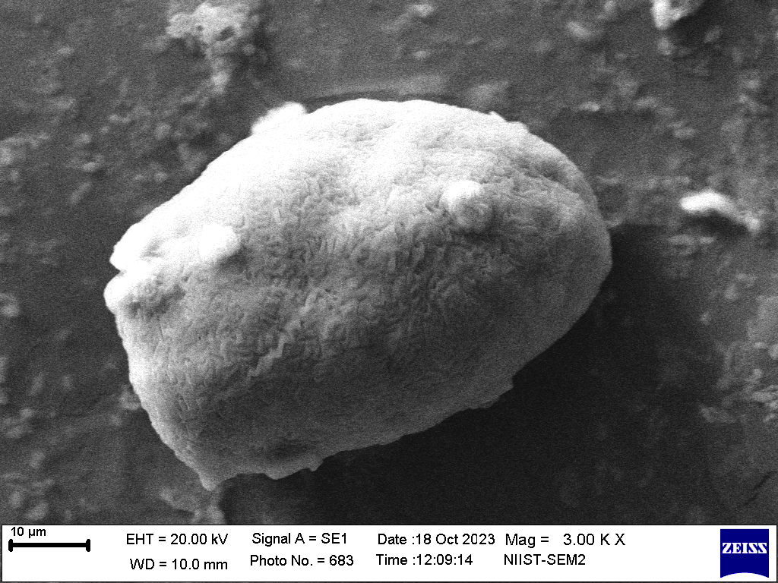 | 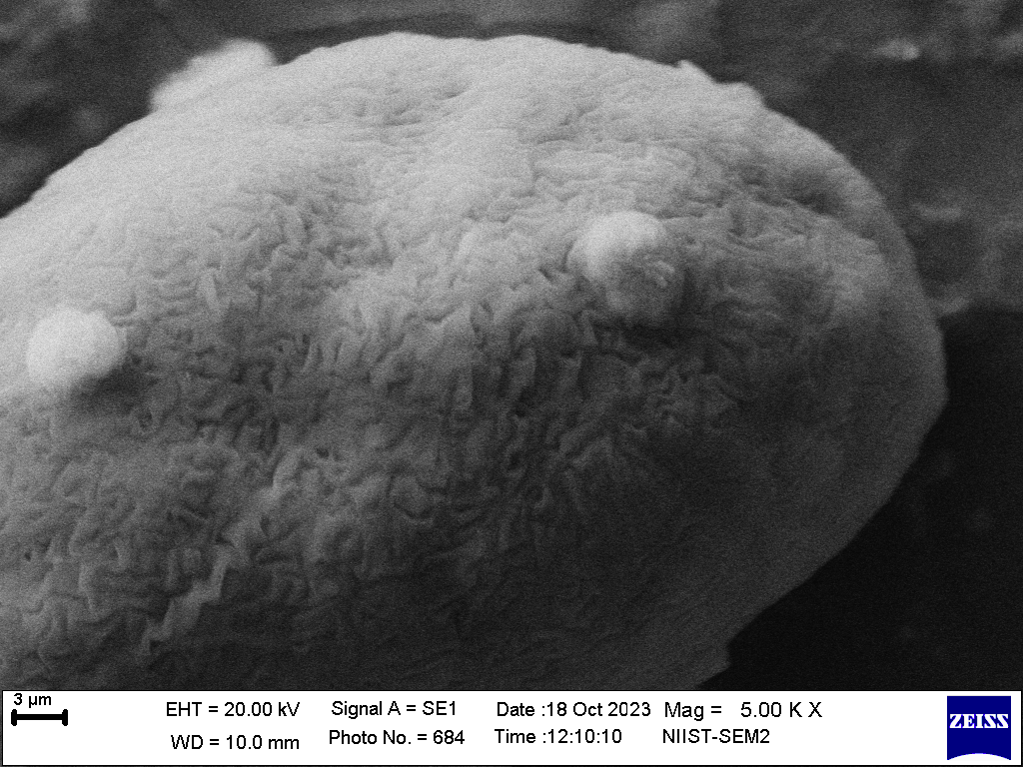
Figure 1. SEM Micrographs of Curcuma decipiens Showing Pollen Surface Architectures (10 µm and 3 µm)
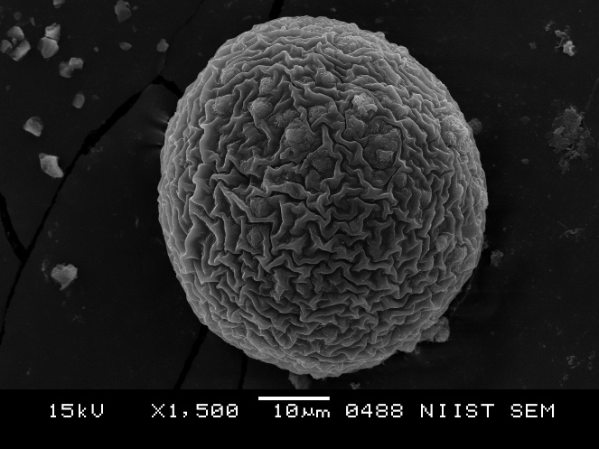 | 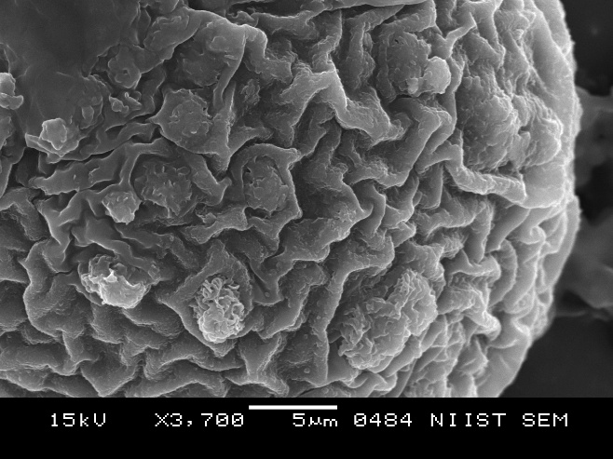
Figure 2. SEM Micrographs of Curcuma inodora Showing Pollen Surface Architecture (10 µm and 5 µm)
3.2. Comparative Quantitative Analysis of Pollen Dimensions
The SEM image of Curcuma inodora shows strongly raised ridges with distinct polygonal depressions, whereas Curcuma decipiens shows a more subdued, smoother relief. The higher magnification further emphasizes the species-level distinction: Curcuma inodora pollen is nearly perfectly rounded with a thickened equatorial region, while Curcuma decipiens appears slightly elongated and asymmetrical. Overall, Curcuma inodora exhibits a more complex, deeply sculptured exine, while Curcuma decipiens shows a simpler, shallowly rugulate pattern, distinguishing the two species palynologically. A qualitative pollen morphometric comparison between Curcuma decipiens and Curcuma inodora is demonstrated in Table 1.
Table 1. Morphometric and Micromorphological Comparison of Curcuma decipiens and Curcuma inodora
Character | Curcuma decipiens | Curcuma inodora
Pollen Diameter | 36 µm | 50 µm
Polar Axis (P) | 49.70 µm | 70.10 µm
Equatorial Diameter (E) | 33.78 µm | 49.33 µm
P/E Ratio | 1.47 (subprolate) | 1.42 (subprolate to prolate-spheroidal)
Overall Size Class | Medium-sized pollen | Large pollen
Shape (SEM) | Subprolate to slightly spheroidal | Spheroidal to oblate-spheroidal
Symmetry | Slightly asymmetrical; elongated outline | Highly symmetrical; nearly perfectly globose
Exine Ornamentation | Fine, shallow rugulate pattern; low muri; indistinct lumina | Coarse regulate-reticulate pattern; high muri; deep lumina
Surface Relief | Low to moderate | High, strongly textured
Tectal Pattern | Cushioned, weakly raised folds | Strongly raised, reticulate ridges forming polygonal depressions
Wall Complexity | Low-moderate | High
Appearance at 5/3 µm SEM | Shallow ridges, subdued texture | Strong, sharp sculpturing; deep depressions
Appearance at 10 µm SEM | Slightly elongated grain with shallow exine relief | Perfectly rounded grain with deeply sculptured exine
Aperture Expression | Colpi not clearly visible (cryptic) | Aperture regions suggested by equatorial thickening
Diagnostic Features | Smaller, elongated pollen; shallow rugulation | Larger, spherical pollen; deep reticulation

3.3. Diagnostic Morphological Characters Differentiating the two species
Exine sculpturing coarse; muri high and strongly raised, forming deep polygonal lumina; pollen nearly perfectly spheroidal with distinctly textured surface (regulate-reticulate pattern); surface relief pronounced at both 3/5 µm and 10 µm scales
Pollen nearly spherical; exine prominently regulate-reticulate; lumina deep and well-defined; tectal elements forming sharp ridges; high exine complexity
→ Curcuma inodora
Exine sculpturing fine; muri low and weakly raised, forming shallow or indistinct lumina; pollen subprolate to slightly spheroidal with smoother, shallowly rugulate surface; surface relief subdued at both 3/5 µm and 10 µm scales
Pollen slightly elongated; exine shallowly rugulate; lumina poorly defined or absent; tectal elements low, forming a cushioned surface; exine complexity low to moderate
→ Curcuma decipiens
3.4. Descriptive Statistics of Pollen Measurements
Table 2. Descriptive statistics of pollen morphometric parameters in Curcuma decipiens and Curcuma inodora
Parameter | Curcuma decipiens (Mean ± SD) | Range (µm) | Curcuma inodora (Mean ± SD) | Range (µm)
Polar axis (P, µm) | 49.70 ± 2.85 | 45.2-54.1 | 70.10 ± 3.62 | 64.8-75.9
Equatorial diameter (E, µm) | 33.78 ± 2.14 | 30.1-37.6 | 49.33 ± 3.05 | 44.7-54.8
P/E ratio | 1.47 ± 0.06 | 1.36-1.56 | 1.42 ± 0.05 | 1.33-1.51
Descriptive statistical analysis of pollen morphometric parameters revealed clear quantitative separation between Curcuma decipiens and C. inodora (Table 2). Mean values of both the polar axis and equatorial diameter were consistently higher in C. inodora than in C. decipiens, with no overlap in size ranges between the two species. The relatively low standard deviation and narrow range observed within each species indicate limited intraspecific variability and high morphometric stability. Although the P/E ratio showed partial numerical overlap, C. decipiens tended towards a more elongated (subprolate) pollen shape, whereas C. inodora exhibited a more globose to prolate-spheroidal form. These descriptive statistics provide strong quantitative support for species-level differentiation and complement the qualitative exine micromorphological distinctions observed under SEM.
3.5. Gaussian Mixture Modelling (GMM) and Morphospace Separation
The Gaussian Mixture Model (GMM) plot clearly demonstrates a strong morphological separation between Curcuma decipiens and Curcuma inodora based on their pollen dimensions (Polar axis vs. Equatorial diameter). The mean values of the two species occupy distinct regions of morphospace, and their 50% and 95% confidence ellipses show no overlap, indicating that even under conservative variance assumptions the two taxa form non-intersecting Gaussian clusters. This discontinuity in both size and shape space reflects independent morphometric structures for each species, supporting the interpretation that C. decipiens and C. inodora represent well-differentiated pollen morphotypes and therefore distinct biological species under a morphometric species delimitation framework (Graph Fig. 3).
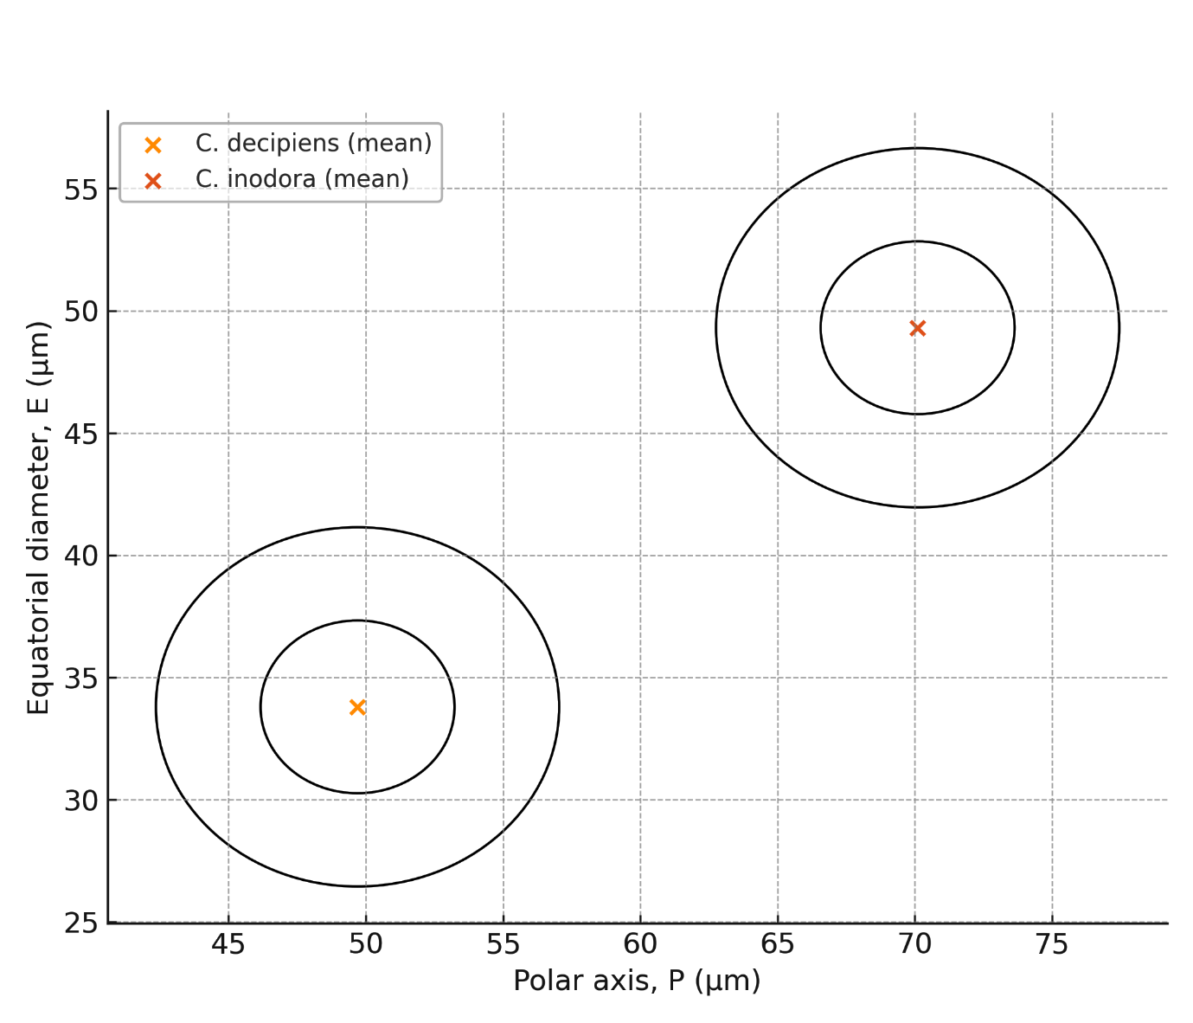
Graph Figure 3. GMM-Based Cluster Visualization of Pollen Dimensions in Two Curcuma Species
3.6. Morphometric Species Delimitation (MSD) and Character Discontinuity
Table 3. Morphometric Species Delimitation Matrix Highlighting Character Discontinuities
Character | Type | Curcuma decipiens | Curcuma inodora | Discontinuity rule
Polar axis (P, µm) | continuous | 49.7 | 70.1 | Δ% = 41% (>
Equatorial diameter (E, µm) | continuous | 33.8 | 49.3 | Δ% = 46% (>
P/E ratio | continuous | 1.47 | 1.42 | Δ%=3% (small)
Exine complexity (low or high) | categorical | low | high | Different states
Ornamentation class | categorical | fine rugulate | coarse regulate-reticulate | Different states
Muri height (low or high) | categorical | low | high | Different states
Lumina depth (shallow or deep) | categorical | shallow | deep | Different states
Symmetry (slightly asymmetric or symmetric) | categorical | slightly asymmtric | symmetric | Different states
Shape class | categorical | subprolate | Subprolate → prolate-sphere | Different states

The character matrix constructed for Curcuma decipiens and Curcuma inodora integrates both continuous traits (polar axis, equatorial diameter, P/E ratio) and qualitative exine characters (muri height, lumina depth, ornamentation type, surface complexity, shape symmetry). Evaluation of these combined characters reveals strong morphological discontinuities between the taxa. The continuous traits show large proportional gaps, with polar axis and equatorial diameter differing by more than 40%, far exceeding the typical 20 - 25% threshold used in morphometric species delimitation. Categorical traits also display complete non-overlap: C. decipiens possesses a fine, shallow rugulate exine with low muri and slight asymmetry, whereas C. inodora exhibits a coarse regulate-reticulate exine with high muri, deep lumina, and a highly symmetrical, globose outline. This consistent divergence across multiple independent character systems indicates a high level of morphological discontinuity, providing strong evidence that the two taxa represent distinct species under a morphometric species delimitation framework (Table 3).
3.7. Synthesis of Palynological Evidence Supporting Species Distinction
The combined palynological evidence clearly establishes a strong separation between Curcuma decipiens and C. inodora. Quantitative morphometry demonstrates non-overlapping pollen size ranges, with C. inodora consistently exhibiting larger polar and equatorial dimensions. Qualitative SEM observations further reinforce this distinction, revealing sharply contrasting exine architectures - fine, shallow rugulation with low muri in C. decipiens versus coarse regulate-reticulate sculpturing with high muri and deep lumina in C. inodora. Gaussian Mixture Modeling (GMM) and Morphometric Species Delimitation (MSD) analyses independently place the two taxa in distinct morphospaces, confirming the absence of character overlap across both continuous and categorical traits. Together, these convergent datasets provide robust palynological evidence supporting the distinct species status of C. decipiens and C. inodora.
3.8. Diagnostic Summary of Pollen Characters
Table 4. Diagnostic pollen traits differentiating Curcuma decipiens and Curcuma inodora
Diagnostic character | Curcuma decipiens | Curcuma inodora
Pollen size class | Medium-sized | Large-sized
Polar axis (P) | Shorter (50 µm) | Longer (70 µm)
Equatorial diameter (E) | Narrower (34 µm) | Wider (49 µm)
P/E ratio | 1.47 (subprolate) | 1.42 (subprolate to prolate-spheroidal)
Overall pollen shape | Slightly elongated | Nearly spherical
Symmetry | Slightly asymmetrical | Highly symmetrical
Exine ornamentation | Fine, shallow rugulate | Coarse regulate-reticulate
Muri height | Low | High
Lumina depth | Shallow or indistinct | Deep and well-defined
Exine complexity | Low to moderate | High
Surface relief | Smooth to weakly sculptured | Strongly sculptured
Aperture expression | Cryptic | Suggested by equatorial thickening
Diagnostic value | Moderate (size + sculpture) | High (size + sculpture + symmetry)

The diagnostic summary highlights a suite of pollen characters that consistently differentiate Curcuma decipiens from C. inodora. Quantitative traits, particularly polar axis and equatorial diameter, provide the strongest discriminatory power, with C. inodora exhibiting substantially larger pollen grains (Table 4). Qualitative features further reinforce this separation: C. decipiens is characterized by fine, shallow rugulate exine ornamentation with low muri and limited lumina development, whereas C. inodora displays a coarse regulate-reticulate exine with high muri, deep lumina, and pronounced surface relief. Differences in symmetry and overall pollen shape add further diagnostic resolution. Collectively, these non-overlapping characters form a reliable palynological diagnostic framework supporting species-level distinction between the two taxa.
3.9. Limitations of the Study
Although this study provides strong palynological and morphometric evidence for species differentiation between Curcuma decipiens and C. inodora, certain limitations should be acknowledged. The analysis is primarily based on SEM-derived pollen morphology and morphometric parameters from a limited number of populations, which may not fully capture the entire range of intraspecific variability across the geographical distribution of each species. Environmental influences on pollen development and potential phenotypic plasticity were not explicitly tested. In addition, molecular phylogenetic data were not incorporated, which could further strengthen species delimitation by providing independent genetic evidence. Future studies integrating broader population sampling, environmental gradients, and molecular markers would provide a more comprehensive and integrative framework for confirming species boundaries within the genus Curcuma.
4. Discussions
The palynological comparison between Curcuma decipiens and C. inodora reveals pronounced and consistent multi-character discontinuities that strongly support their recognition as distinct species. Descriptive statistical analysis demonstrates that pollen grains of C. inodora are significantly larger than those of C. decipiens, with mean polar axis and equatorial diameter values differing by more than 40%. Such magnitude of divergence clearly exceeds the conventional thresholds used in morphometric species delimitation and indicates stable, species-specific size classes rather than intraspecific variation (Erdtman, 1969; Punt et al., 2007). The narrow ranges and low standard deviations observed within each species further confirm limited intraspecific variability and high morphometric consistency. These quantitative trends are congruent with regional floristic accounts, which consistently describe C. inodora as morphologically robust with larger reproductive structures, whereas C. decipiens is characterized by comparatively compact growth forms (eFlora of India, 2022; Flowers of India, 2023; POWO, 2024). Beyond pollen size, qualitative exine characters provide strong diagnostic resolution: C. inodora exhibits a coarse regulate-reticulate exine with high muri and deep lumina, while C. decipiens shows a fine, shallowly rugulate pattern with low muri and indistinct lumina. Such exine features are known to be conservative and taxonomically informative within Zingiberaceae, reinforcing their reliability for species discrimination (Nair, 2004; Sajo et al., 2010; Alexander & Anila, 2025; Priyadarshini et al., 2025).
The diagnostic summary consolidates these findings by demonstrating complete non-overlap across multiple independent pollen characters, including size class, symmetry, exine ornamentation, muri height, lumina depth, and surface relief. Morphospace modelling further corroborates this separation, as Gaussian Mixture Model (GMM) analysis places the two taxa in discrete, non-overlapping clusters with clearly separated 50% and 95% density contours. Similarly, the Morphometric Species Delimitation (MSD) matrix highlights strong proportional gaps in continuous traits (P and E) and distinct categorical character states, yielding a high separation index indicative of species-level divergence. This integrated palynological evidence aligns with earlier taxonomic interpretations that, despite historical suggestions of synonymy, emphasize consistent morphological differentiation between C. decipiens and C. inodora (eFlora of India, 2022). Their distinct biogeographical distributions - C. decipiens being endemic to the southern Western Ghats of Kerala and C. inodora restricted to the western Peninsular region of Maharashtra and Goa - further support the interpretation of independent evolutionary lineages (POWO, 2024; Flowers of India, 2023). Collectively, the congruence of descriptive statistics, diagnostic pollen traits, morphospace separation, and geographical segregation provides robust and comprehensive evidence that C. decipiens and C. inodora represent distinct biological species under both classical morphological and modern morphometric species concepts.
5. Conclusions
The integrative palynological investigation unequivocally demonstrates that Curcuma decipiens and C. inodora are morphologically and statistically distinct species. Quantitative pollen morphometry reveals pronounced interspecific divergence, with differences exceeding 40% in both polar axis and equatorial diameter, far surpassing thresholds typically attributed to intraspecific variability. These size-based distinctions are further reinforced by consistent differences in pollen shape and exine architecture, characterized by fine, shallow rugulate sculpturing with low muri and indistinct lumina in C. decipiens, contrasted with coarse rugulate–reticulate ornamentation, high muri, and deep lumina in C. inodora. Diagnostic summary analyses show complete non-overlap across multiple independent qualitative and quantitative characters, while Gaussian Mixture Modelling and Morphometric Species Delimitation consistently place the two taxa in discrete, non-overlapping morphospaces. The strong concordance between descriptive statistics, diagnostic traits, and multivariate modelling provides robust evidence that C. decipiens and C. inodora represent well-differentiated biological entities, thereby justifying their clear species-level recognition within the genus Curcuma.
Conflict of Interest Statement: The author declares no conflict of interest related to the publication of this manuscript.
Ethical Approval: This research involved no studies with human participants or animals performed by any of the authors. All field data collection complied with local environmental regulations.

Disclaimer (Artificial intelligence)
Author(s) hereby declare that NO generative AI technologies such as Large Language Models (ChatGPT, COPILOT, etc.) and text-to-image generators have been used during the writing or editing of this manuscript.
Reference
- Alexander T &Anila George. 2025. Pollen Morphometric Differentiation and Statistical Classification of Four Elettaria cardamomum Varieties using SEM Analysis. International Journal of Agriculture Sciences 17(4), 13712-13716. https://bioinfopublication.org/pages/jouarchive.php?id=BPJ0000217
- eFlora of India. 2022. Curcuma inodora and Curcuma decipiens species pages. Retrieved from https://efloraofindia.com/
- Erdtman G. 1960. The acetolysis method: A revised description. Svensk Botanisk Tidskrift 54, 561-564.
- Erdtman, G. 1969. Handbook of Palynology: Morphology, Taxonomy, Ecology. Hafner Publishing Company.
- Flowers of India. 2023. Scentless Turmeric - Curcuma inodora. Retrieved from https://www.flowersofindia.net/
- Hammer, Ø., Harper, D. A. T., & Ryan, P. D. (2001). PAST: Paleontological statistics software package for education and data analysis. Palaeontologia Electronica, 4(1). http://palaeo-electronica.org/2001_1/past/issue1_01.htm
- Kew Science - Plants of the World Online (POWO). 2024. Curcuma decipiens and Curcuma inodora species records. Royal Botanic Gardens, Kew. Retrieved from https://powo.science.kew.org/
- Nair PKK. 2004. Advances in Palynology and Aerobiology. Today & Tomorrow’s Printers and Publishers.
- Priyadarshini S, Sahu SC, Dhal NK. (2025) Pollen morphology and taxonomic implications of Zingiberaceae in Eastern India. Palynology. Dec 10: (just-accepted): 2602753.
- Punt W, Hoen PP, Blackmore S, Nilsson S, Le Thomas A. 2007. Glossary of pollen and spore terminology. Review of Palaeobotany and Palynology 143(1-2), 1-81. https://doi.org/10.1016/j.revpalbo.2006.06.008
- Sabu M. 2006. Zingiberaceae of South India. Indian Association for Angiosperm Taxonomy (IAAT).
- Sajo MG, Rudall PJ, and Prychid CJ. 2010. Evolution of exine morphology in the monocot order Zingiberales. International Journal of Plant Sciences. 171(5), 572-584. https://doi.org/10.1086/653131
- Theilade, I., Mærsk-Møller, M. L., Theilade, J., & Larsen, K. (1993). Pollen morphology and structure of Zingiber (Zingiberaceae). Grana, 32(6), 338–342. https://doi.org/10.1080/00173139309428961

