Identification, Incidence, and Prevalence of Foliar Diseases of Sorghum in Farmers’ Fields of the Tanout Commune in the Zinder region, Niger

Abstract
Sorghum plays an important role in the rural economy of Niger. However, the production of this cereal is hampered by multiple pressures, including fungal diseases. The objective of this study is twofold: first, to identify foliar diseases of sorghum in the fields of farmers in the commune of Tanout, and second, to determine the incidence and prevalence of these diseases. The study was carried out in the commune of Tanout during the winter season from June to September 2025. One hundred (100) fields belonging to sorghum producers in 20 villages of the commune were surveyed, with five (5) fields per village. In each field, five (5) elementary plots, each composed of twelve (12) planting holes, were marked out for the identification and assessment of the prevalence and incidence of sorghum foliar diseases. Six (6) foliar diseases were identified: anthracnose, leaf blight, oval leaf spot, grey spot, zoned leaf spot, and sand grain disease. Out of a total of 6,000 sorghum hills examined, 3,839 hills showed symptoms of anthracnose, representing an average incidence of 63.98%; 3,088 hills showed symptoms of oval leaf spot, representing 51.47%; 2,039 hills showed symptoms of leaf blight, representing an average incidence of 33.98%; and only 94 hills showed symptoms of zoned leaf spot, representing an average incidence of 1.57% in the commune of Tanout. The prevalence of these diseases fluctuates in line with their incidence. The prevalence is respectively 97.6% for anthracnose, 87.2% for oval leaf spot, 82.6% for leaf blight and 13.4% for zoned leaf spot. The study revealed that anthracnose and oval leaf spots are the most widespread in the fields of farmers in the commune of Tanout with average incidence rates of 63.98% and average prevalence of 97.6% for anthracnose, and 51.47% incidence and 87.20% prevalence for oval leaf spots.
Keywords: Sorghum, disease, incidence, prevalence, Tanout
1. Introduction
Sorghum (Sorghum bicolor L. Moench) is a major cereal crop cultivated in many tropical regions of the world. Along with millet, it is one of the main food sources in the arid and semi-arid zones of Africa and Asia, where millions of people depend on it for their livelihoods (Abdou et al., 2014; Karimou et al., 2023). Sorghum is cultivated primarily for its grain, which is used in human food in various forms (porridge, flatbreads, couscous, traditional beverages, etc.). The stalks and culms are also valued as animal fodder, fuel for household use, or building material (Karimou et al., 2023; Upadhyaya et al., 2017). In Niger, sorghum is the second most produced and consumed cereal after pearl millet. It is primarily used as a staple food for the population and secondarily for livestock feed, particularly its stalks. In 2023, national production was estimated at 1,646,000 tonnes from an area of ​​3,700,000 hectares, with a yield of 581 kg/ha, making it the second most cultivated cereal after millet (FAO, 2024). In 2022, sorghum production in the Tanout department reached 118,276 tonnes from an area of ​​211,586 ha, with a yield of 559 kg/ha (INS/DR, 2024). This yield is low compared to the national average. This low productivity is explained by several constraints, including unfavourable climatic conditions, the use of low-performing local varieties, reduced use of agricultural inputs, but also and especially attacks by pests and diseases (Kadi Kadi et al., 2005; Louis et al., 2020). This low productivity can be explained by several constraints, including unfavorable climatic conditions, the use of low-performing local varieties, the reduction in the use of agricultural inputs, the demand from urban areas where the population prefers to consume other more important cereals such as maize and rice, but also and especially attacks from parasites and diseases (Kadi Kadi et al., 2005; Mundia et al., 2019; Pereira and Hawkes, 2022). The new challenges posed by climate change and increased sorghum production risk increasing the proliferation of fungi, bacteria and other pathogenic microorganisms (Prom et al., 2011). Some fungal diseases, when they affect susceptible varieties, can lead to yield losses of up to 100% and a decline in quality, thus compromising the food security of rural populations dependent on this crop (Cuevas et al., 2016; Prom et al., 2011). Leaf blight, for example, causes significant yield losses, up to 70%, due to a reduction in grain weight (Rajeshwar et al., 2014). Furthermore, several pathogens have the capacity to produce mycotoxins that can negatively impact human and animal health and limit the use of the crop (Leslie et al., 2005; Isakeit et al., 2008; Prom et al., 2011; Funnell-Harris et al., 2013; Cuevas et al., 2016; Louis et al., 2020). Controlling these diseases requires precise knowledge of their frequency, extent, and severity in the field. Disease control is based on the use of healthy seeds or seeds treated with hot water, and crop rotation of two to three years. The application of fungicides and the cultivation of resistant varieties could also help eliminate pathogens (Ramathani et al., 2011).The objective of this study is twofold: first, to identify foliar diseases of sorghum in the fields of farmers in the commune of Tanout, and second, to determine the incidence and prevalence of these diseases. The study will provide information on the pressure of sorghum foliar diseases in the commune of Tanout in order to develop effective strategies for managing these diseases.
2. Materials and Methods
2.1. Study Area
The commune of Tanout is located in the far north of the Zinder Region and 1046 km northeast of Niamey, the capital of Niger, between 14°5’ and 17°30’ North latitude and between 7°20’ and 9°37’ East longitude. It covers an area of ​​6,780 km², representing 22.42% of the total area of ​​the Tanout Department, estimated at 30,247 km² (Kailou et al., 2022). The commune of Tanout is bordered to the east by the communes of Tenhya and Allakos (Gouré Department), to the west by the commune of Gangara, to the north by the communes of Aderbissanatt (Agadez Region) and Tenhya, and to the south by the communes of Olléléwa, Alakoss (Gouré Department), and Kangna Wamé (Mirriah Department). The climate is sub-desert Sahel-Saharan with rainfall ranging from 200 mm to 400 mm. Agriculture is the main activity of the population of the Tanout department. It is practiced primarily during the rainy season on the dune lands and during the dry season around a few existing ponds (PDC, 2025). Cultivated areas amount to 1,942,800 ha, representing 58.57% of the department's total area. The main crops are millet, sorghum, and cowpeas.
2.2. Methods
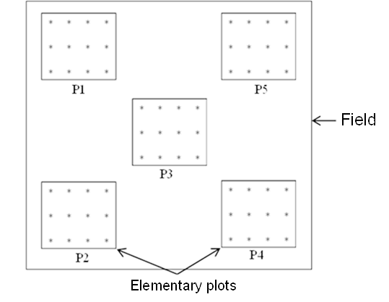
Surveys of sorghum farmers' fields in the commune of Tanout were conducted during the rainy season from June to September 2025. A total of 100 randomly selected fields in the Tanout district agricultural area in the Zinder region are being surveyed at the physiological maturity stage at the level of 20 administrative villages. Five (5) farmers' fields were surveyed in each village. In each field, five (5) elementary plots are materialized using a W-shaped pattern (Louis et al., 2020). Each plots consist of 12 sorghum plant in each (Figure 1).

Figure 1: Layout of elementary plots in the fields
2.3 Identification of diseases
In each plot, sorghum foliar diseases are identified using the guide to the identification of major sorghum diseases in Niger (Haougui et al., 2025). The number of hills showing symptoms of each disease is counted to determine the incidence and prevalence of these diseases. Incidence is the proportion or percentage of infected hills in the plot. It is determined by the formula below:
$$Incidence \left(\%\right)=\frac{Number of infected spots}{Total number of spots} x 100$$
Prevalence is the percentage of individual plots in a field (or fields in a village) that have at least one sorghum plant (or field) affected by the disease. It expresses the geographical extent of the disease in a given area (field, village, municipality, department, etc.). It is calculated using the formula below:
$$Prevalence \left(\%\right)=\frac{Number of infected plots (or fields)}{Total number of plots (or fields) surveyed} x 100$$
2.3. Data analaysis
The collected data was entered and processed using Excel 14th Edition. The same spreadsheet was used to calculate arithmetic means and to create the various tables and graphs.
3. Results and Discussion
3.1. Village Locations
Table 1 presents the geographic coordinates of the villages whose fields were surveyed. Analysis of this table shows that the study covers a large part of the Tanout municipality, with villages located between 14.53° and 15.01° North latitude and 8.72° and 9.18° East longitude. This spatial distribution of the sites indicates good geographic representation of the survey, encompassing both the northern and southern areas of the municipality.
Table 1: Geographic coordinates of the villages whose fields are being surveyed
Villages | Altitude | Longitude
TCHIMBORAGAN | N14°46’47,06’’ | E8°50’55,53’’
DALLI | N14°51’14,74’’ | E8°52’52,89’’
DALLI HAOUSSAWA | N14°50’21,80’’ | E8°52’18,40’’
ALBOURDATAN | N14°48’46,55’’ | E8°51’53,67’’
BAKATCHIRABA | N14°56’04,52’’ | E8°49’53,74’’
GAMDOU | N14°54’03,86’’ | E8°47’16,48’’
ABAGA | N14°52’45,78’’ | E8°47’26,16’’
ZABEWA | N14°49’26,28’’ | E8°47’40,31’’
MAIDIGA | N14°49’29,96’’ | E8°43’17,83’’
GOGUINE KASSOULA | N14°54’43,57’’ | E8°53’48,82’’
GOGUINE GWOM-GWOM | N14°52’23,07’’ | E8°53’25,69’’
OUMARADI | N14°49’12,77’’ | E8°53’37,36’’
AFOUNORI | N14°40’29,86’’ | E9°00’49,95’’
GARGADA | N14°32’19,01’’ | E9°10’46,06’’
BABOUL-YACHI | N14°49’35,23’’ | E9°03’29,62’’
GARIN MARMA | N15°00’45,36’’ | E8°57’50,40’’
MARMARI | N14°46’07,77’’ | E8°52’51,51’’
CHIRWA | N14°44’33,82’’ | E8°54’51,65’’
TANOUT | N14°58’10,83’’ | E8°53’26,97’’
DAN YARI | N14°58’38,31’’ | E8°52’31,06’’
3.2. Diseases encountered
A total of six (6) sorghum foliar diseases were identified in farmers’ fields in the commune of Tanout: anthracnose, sand grain disease, grey spot, zoned leaf spot, leaf blight, and oval leaf spot (Figure 2, Table 2). These results are similar to those found by Louis et al. (2020) in a survey on the prevalence and incidence of foliar and panicle diseases in sorghum-producing areas of Niger.

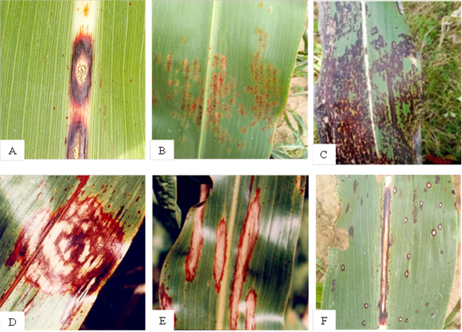
Figure 2: Symptoms of diseases identified in the commune of Tanout:
A = Anthracnose, B = Sand grains, C = Grey spots, D = Zoned leaf spot,
E = Leaf blight, F = Oval leaf spots

Table 2: Foliar diseases identified in the fields of producers in the commune of Tanout
Diseases | Causal agent | Symptoms
Anthracnose | Colletotrichum sublineola | - Small, elliptical leaf spots with the appearance of an eye staring at you in the center, on the upper surface of the leaves.  - Elliptical spots on the midrib.
Sand grains | Ascochyta sorghi | - Small reddish spots with initially whitish centers.  - As the lesions spread across the upper surface of the leaves, small black bodies appear in the centers of the spots, giving them a rough appearance.
Grey spots | Cercospora sorghi | - Small, dark, moist spots surrounded by a yellowish border on the leaves.  - Over time, the lesions elongate parallel to the veins and become pale brown to grey, rectangular in shape with a diffuse outline (without a precise border).
Zoned leaf spot | Gloeocercospora sorghi | - Small lesions on the lower leaves,  - These lesions become circular on the leaf blade and semi-circular on the edges of the leaf.
Leaf blight | Exserohilum / Helminthosporium turcicum | - Elongated, elliptical lesions with reddish margins (depending on the variety) and a bronze center.  - The center of the lesions may have a powdery or black appearance in high humidity.
Oval leaf spots | Ramulispora sorghicola | - Spots a few millimeters wide and generally oval in shape,  - Lesions arranged parallel to the veins, which limits their lateral expansion.  - They are straw-colored, surrounded by a purplish or reddish border
3.3. Prevalence of Foliar Diseases
The prevalence of foliar diseases across the surveyed villages is presented in Table 3. All identified diseases were observed in the surveyed fields, except zoned leaf spot, which was not detected in the villages of Goguine Gwom-Gwom and Oumaradi. Anthracnose stood out as the most widespread disease, with prevalence ranging from 80% to 100%. It was followed by leaf blight, with a prevalence varying from 64% to 100%. Grey spot showed significant variability, ranging from 28% to 92%. Zoned leaf spot was the least frequent disease in the majority of villages, with overall low infestation levels of 0% to 28%. Sand grains showed a moderate but heterogeneous prevalence (4% to 64%), while oval leaf spot was characterized by high variability (20% to 100%). Several villages, including Dalli, Dalli Haoussawa, Baboul-Yachi, Goguine Kassoula, Goguine Gwon-Gwon, and Tanout, recorded particularly high infestation levels for multiple diseases, indicating a high phytosanitary risk. Studies conducted in Niger also indicate that anthracnose, oval leaf spot, and leaf blight are among the most prevalent diseases in the main sorghum-producing areas of Niger (Louis et al., 2020; Louis et al., 2023; Haougui et al., 2025). In western Kenya, anthracnose, leaf blight, grey spot, and zoned leaf spot were found to be the most frequently observed diseases in farmers' fields (Ngugi et al., 2002). In southern Tigray, Ethiopia, Teklay and Muruts (2015) reported that anthracnose, leaf blight, downy mildew, and smut are among the destructive diseases of sorghum. Authors have reported, each in their respective study areas, that anthracnose and leaf blight are the most common sorghum leaf diseases in farmers' fields, with prevalence ranging from 84% to 99% (Chala et al., 2010; Beshir et al., 2015; Teklay and Muruts, 2015; Tsedaley et al., 2016, Louis et al., 2020; Koima et al., 2022; Prom et al., 2021; Louis et al., 2023). Similar to this study, oval leaf spot has also been found to be one of the predominant sorghum diseases in four major climatic growing zones in Nigeria (Pande et al., 1993). However, a survey conducted in three climatic zones of the main sorghum-growing regions of Ghana revealed a low incidence of leaf blight (Nutsugah et al., 2008). In contrast, zoned leaf spot, grey spot, and sand spots are less prevalent in the fields of farmers in the commune of Tanout. Haougui et al. (2025) reported that zoned leaf spot is observed only in a few sorghum-producing regions of Niger.
Table 3: Prevalence of sorghum foliar diseases by village
Villages | Prevalence of diseases (%)
Villages | Anth | LB | GS | ZS | SG | OS
TCHIMBORAGAN | 96 | 80 | 44 | 28 | 20 | 80
DALLI | 100 | 96 | 88 | 28 | 8 | 100
DALLI HAOUSSAWA | 100 | 96 | 92 | 16 | 4 | 96
ALBOURDATAN | 100 | 84 | 72 | 12 | 40 | 84
BAKATCHIRABA | 100 | 80 | 52 | 8 | 48 | 100
GAMDOU | 100 | 76 | 32 | 20 | 64 | 100
ABAGA | 100 | 80 | 36 | 4 | 60 | 72
ZABEWA | 96 | 84 | 68 | 16 | 48 | 92
MAIDIGA | 80 | 72 | 28 | 4 | 40 | 100
GOGUINE KASSOULA | 96 | 96 | 40 | 16 | 56 | 100
GOGUINE GWOM-GWOM | 92 | 92 | 28 | 0 | 36 | 100
OUMARADI | 96 | 92 | 28 | 0 | 36 | 96
AFOUNORI | 100 | 84 | 28 | 4 | 20 | 100
GARGADA | 100 | 68 | 60 | 12 | 52 | 52
BABOUL-YACHI | 100 | 100 | 84 | 44 | 24 | 100
GARIN MARMA | 100 | 84 | 40 | 16 | 52 | 100
MARMARI | 100 | 64 | 68 | 4 | 42 | 64
CHIRWA | 96 | 84 | 64 | 20 | 48 | 88
TANOUT | 100 | 76 | 48 | 12 | 48 | 100
DAN YARI | 100 | 64 | 80 | 4 | 12 | 20
Anth : Anthracnose ; LB : Leaf blight; GS : Grey spots; ZS : Zoned leaf spot; SG : Sand grains ; OS : Oval leaf spots
3.4. Incidence of Foliar Diseases
Anthracnose and oval leaf spot are the most common diseases, with incidence rates ranging from 0% in the Maidiga and Goguine Gwom-Gwom fields to 100% in the Zabewa and Goguine Gwom-Gwom fields for anthracnose, and from 0% in the Gargada and Dan Yachi fields to 100% in the Goguine Gwom-Gwom and Oumaradi fields for oval leaf spot. Leaf blight is the third most prevalent disease, with incidence rates reaching 81% in the Dalli and Abaga fields. Zoned leaf spot disease had no incidence in more than 50% of the surveyed fields, with the highest incidence of 8.33% recorded in the Tchimboragan fields. Other diseases, namely grey spot and sand grain disease, had incidences ranging from 0% in 11% of fields to 81% in the Dalli Haoussawa fields for grey spot, and from 0% in 27% of the surveyed fields to 61.67% in the Gargada fields. The incidence of each disease was determined on 60 field samples. Table 4 shows the percentage of fields per disease according to incidence. For anthracnose, four percent (4%) of the surveyed fields had an incidence of 20% or less, thirty percent (30%) had a moderate incidence between 21% and 50%, and twenty-nine percent (29%) had an incidence greater than 80%. Fields were nearly evenly distributed across oval leaf spot incidence classes, with 19% showing ≤20% incidence, 31% showing moderate incidence (21–50%), and 20% exceeding 80%. One hundred percent (100%) of the fields recorded an incidence of less than 20% for Zoned leaf spot disease, and ninety-one (91%) of the fields had an incidence of grey spot less than 20%. Similar to the present study, surveys conducted in 2019 on sorghum diseases in Niger demonstrated that foliar disease pressure varied significantly across regions and fields. Of the 121 fields surveyed, twenty (20) had anthracnose incidences greater than 95%, including four fields in the Tillabéri region, seven in the Dosso region, six in the Tahoua region, and three in the Maradi region (Louis et al., 2020). In southern Tigray, Ethiopia, Teklay and Muruts (2015) reported that the average anthracnose incidence, which was 100% in 27 plots across seven farmers' associations in the two districts, ranged from 10% to 84.6% in eight other farmers' associations.
Table 4: Percentage of fields surveyed per disease according to incidence
Disease | Disease incidence (%)
Disease | [0 to 20] | [21 to 50] | [51 to 80] | [81 to 100]
Anthracnose | 4 | 30 | 37 | 29
Leaf blight | 26 | 55 | 17 | 2
Grey spots | 75 | 12 | 11 | 2
Zoned leaf spot | 100 | 0 | 0 | 0
Sand grains | 91 | 8 | 1 | 0
Oval leaf spot | 19 | 31 | 30 | 20
3.5. Incidence of Sorghum Foliar Diseases by Village
The incidence of foliar diseases of sorghum identified in the farmer’s fields of 20 villages in the commune of Tanout is recorded in Figure 3. Anthracnose and oval leaf spot are the most frequent diseases, with incidence peaks sometimes exceeding 80% in the villages of Bakatchiraba (80.67%), Dan Yari (83.67%), and Afunori (87.67%) for anthracnose, and Oumaradi (78%), Goguine Gwom-Gwom (79.67%), and Tanout (80.67%) for oval leaf spot. Leaf blight ranks third after anthracnose and oval leaf spot, with incidence rates ranging from 73.33% in Dalli to 16% in Gargada. Zoned leaf spot disease and sand grains have the lowest incidence rates, ranging from 0% in Goguine Gwom-Gwom and Oumaradi, to 4.33% in Baboul-Yachi for zoned leaf spot and from 0.33% in Dalli Haoussawa, to 23.33% in Gargada. In 2022, the highest average incidence of leaf blight (95%) was recorded in the Tahoua and Zinder regions, while the Maradi region showed the highest average incidences for oval leaf spot (80%), anthracnose (56%), and grey spot (Louis et al., 2023). The observed differences between fields and between villages reveal a diversity of disease pressure, highlighting the need to adapt phytosanitary interventions locally according to the dominant disease and its intensity in each village.

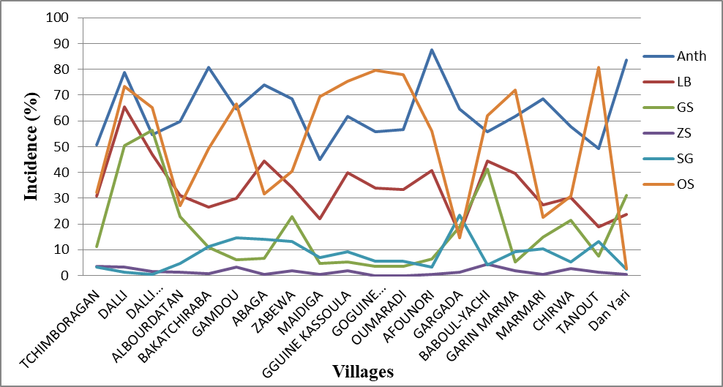
LB = Leaf blight, GS = Grey spots, ZS = Zoned leaf spots, SG = Sand grains,
OS= Oval leaf spots
Figure 3: Incidence of sorghum foliar diseases by village: Anth = Anthracnose,

3.6. Incidence and Prevalence of Foliar Diseases in the Commune of Tanout
The average incidence and prevalence of foliar diseases found in the commune of Tanout are illustrated in Figure 3. Out of a total of 6,000 sorghum hills examined, 3,839 hills showed symptoms of anthracnose, representing an average incidence of 63.98%; 3,088 hills showed symptoms of oval leaf spot, representing 51.47%; 2,039 hills showed symptoms of leaf blight, representing an average incidence of 33.98%; and only 94 hills showed symptoms of zoned leaf spot, representing an average incidence of 1.57% for the commune of Tanout. The variation in the prevalence of these diseases in the commune of Tanout follows the same pattern as that of their incidence. Thus, the prevalence in the commune is 97.6% for anthracnose, 87.2% for oval leaf spot, 82.6% for leaf blight, and 13.4% for zoned leaf spot. Overall, these results reveal that the phytosanitary pressure on sorghum in Tanout is dominated by a few major diseases, the control of which is essential to improve production. Similarly, Eshte et al. (2015) recorded an anthracnose incidence of 100% in three districts in the southern Omo and Segen areas of Ethiopia.
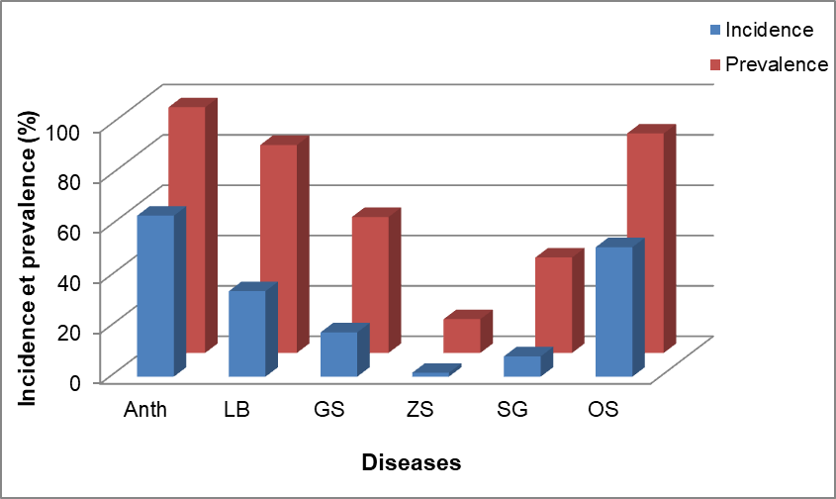
Anth = Anthracnose, LB = Leaf blight, GS = Grey spots, ZS = Zoned leaf spots,
SG = Sand grains, OS = Oval leaf spot
Figure 4: Incidence and prevalence of sorghum foliar diseases in the commune of Tanout

4. CONCLUSION
This study identified six (6) sorghum foliar diseases: anthracnose, sand grain, grey spot, zoned leaf spot, leaf blight, and oval leaf spot. It also determined the incidence and prevalence of these diseases in the commune of Tanout. The study revealed that anthracnose and oval leaf spots are the most widespread in the fields of farmers in the commune of Tanout with average incidence rates of 63.98% and average prevalence of 97.6% for anthracnose, and 51.47% incidence and 87.20% prevalence for oval leaf spots. The results of this work constitute a database for agricultural planning and phytosanitary research in Niger in general and in the commune of Tanout in particular, and can serve as a guide to researchers, including phytopathologists, funding bodies, as well as producers on the incidence, prevalence and importance of foliar diseases of sorghum in the production areas of this cereal.

Disclaimer (Artificial intelligence)

Author(s) hereby declare that NO generative AI technologies such as Large Language Models (ChatGPT, COPILOT, etc.) and text-to-image generators have been used during the writing or editing of this manuscript.
REFERENCES
- Abdou, M.M., Alzouma, M.Z., Dan Lamso, N., Elhadji Seybou, D., & Jean-Marie, K.A. (2014). Productivity of sorghum cultivation (Sorghum bicolor) in an agroforestry system based on Acacia senegal (L.) Willd. in Niger. J. Appl. Biosci., 82, 7339-7346.
- Karimou, I., Halilou, H., & Issa, M.L. (2023). Occurrence And Distribution of Sorghum Smuts in the Field’s Producer in the South-Eastern Regions of Niger. Int. J.Sci. Eng. Applied Sci. (IJSEAS), 9(7), 1-7
- Upadhyaya, H. D., Narsimha Reddy, K., Vetriventhan, M., Irshad Ahmed, M., Gumma, M. K,, Thimma Reddy, M., & Singh, S. K. (2017). Sorghum germplasm from West and Central Africa maintained in the ICRISAT genebank: Status, gaps, and diversity. The Crop Journal, 5 (6), 518-532.
- FAO. (2024). FAOSTAT database. Food and Agriculture Organization, Rome, Italy. http://www.fao.org/faostat/en/#data/QC/visualize
- INS/DR. (2024). Regional statistical yearbook 2018-2022. 253p
- Kadi Kadi, H. A., Kapran, I., & Pendleton, B. B. (2005). Identification of sorghum genotypes resistant to sorghum midge in Niger. Int. Sorghum Millets Newslet, 46, 57-59.
- Louis, K.P., Haougui, A., Adamou, I., Abdoulaye, A.A., Karimou, I., Ali, O.B., & Clint, M. (2020). Survey of the prevalence and incidence of foliar and panicle diseases of sorghum across production fields in Niger. Plant Pathol. J., 19, 106-113. DOI: 10.3923/ppj.2020.106.113
- Mundia, C.W., S. Secchi, K. Akamani & Wang, G. (2019). A regional comparison of factors affecting Global sorghum production: The case of North America, Asia and Africa’s Sahel. Sustainability, 11(7), 1-18. DOI: 10.3390/su11072135.
- Pereira, L. M., & Hawkes, C. (2022). Leveraging the potential of sorghum as a healthy food and resilient crop in the South African food system. Frontier in Sustainable Food Systems, 6, 786151. https://doi.org/10.3389/fsufs.2022.786151
- Cuevas, H. E., Prom, L. K., Isakeit, T., & Radwan, G. (2016). Assessment of sorghum germplasm from Burkina Faso and South Africa to identify new sources of resistance to grain mold and anthracnose. Crop Protect., 79, 43-50.
- Prom, L. K., Thomas, I., Perumal, R., Erpelding, J. E., Rooney, W., & Magill, C. W. (2011). Evaluation of the Ugandan sorghum accessions for grain mold and anthracnose resistance. Crop Protect, 30, 566-571.
- Rajeshwar, R.P., Narayan, P.R., Ranga, R.R. (2014). Turcicum leaf blight of maize incited by Exserohilum turcicum: A review. Int. J. Appl. Biol. and Pharmaceutical Technol., 5(1), 54-59.
- Leslie, J.F., Zeller, K.A., Lamprecht, S.C., Rheeder, J.P., & Marasas, W.F. (2005).Toxicity, pathogenicity, and genetic differentiation of five species of fusarium from sorghum and millet. Phytopathology, 95, 275-283, https://doi.org/10.1094/PHYTO-95-0275
- Isakeit, T., Prom, L.K., Wheeler, M., Puckhaber, L., & Liu, J. (2008). Mycotoxigenic potential of ten Fusarium species grown on sorghum and in vitro. Plant Pathology Journal, 7, 183-186. https://doi.org/10.3923/ppj.2008.183.186
- Funnell-Harris, D.L., Prom, L.K., Sattler, S.E., & Pedersen, J.F. (2013). Response of near-isogenic sorghum lines, differing at the P locus for plant colour, to grain mould and head smut fungi. Annals of Applied Biology, 163, 91-101. https://doi.org/10.1111/aab.12037
- Ramathani, I., Biruma, M., Martin, T., Dixelius, C., & Okori, P. (2011). Disease severity, incidence and races of Setosphaeria turcica on sorghum in Uganda. Eur. J. Plant Pathol., 131(3): 383-392.
- Kailou, D.A., Adamou, A., & Abdou, H. (2022). Planning of Water and Electricity Network Services in the Town of Tanout in Niger. Urban and Regional Planning, 7(4), 141-149. DOI: 10.11648/j.urp.20220704.11
- PDC. (2025). Communal Development Plan of the Urban Commune of Tanout, developed with the financial support of PIDUREM and Louis et al., 2020
- Haougui, A., Issa, K., Basso, A., Ali, O.B., Bori, H., Kadri, A.A., & Halilou, O.O. (2025). Guide to identifying the main sorghum diseases in Niger. National Institute of Agronomic Research of Niger. 23p.
- Louis, K.P., Haougui, A., Ali, O.B., Karimou, I., Abdoulaye, A.A., Oumarou, H.O., Basso, A., Coumba, F., & Clint, M. (2023). Incidence, Severity, and Prevalence of Sorghum Diseases in the Major production regions in Niger. Journal of Plant Studies, 12(1), 48-59. DOI:10.5539/jps.v12n1p48
- Ngugi, H.K., King, S.B., Abayo, G.O., & Reddy, Y.V.R. (2002). Prevalence, incidence and severity of sorghum diseases in Western Kenya. Plant Diseases., 86(1), 65-70. DOI: 10.1094/pdis.2002.86.1.65
- Teklay, A. T., & Muruts, L. W. (2015). Prevalence and Intensity of Economically Important Fungal Diseases of Sorghum in South Tigray, Ethiopia. Journal of Plant Sciences. 3(2), 92-98. doi: 10.11648/j.jps.20150302.18
- Chala, A., Alemu, T., Prom, L. K., & Tronsmo, A. M. (2010). Effect of Host Genotypes and Weather Variables on the Severity and Temporal Dynamics of Sorghum Anthracnose in Ethiopia. Plant Pathol. J., 9(1), 39-46. doi:10.3923/ppj.2010.39.46
- Beshir, M.M., Ahmed, N.E., Abdelbagi, M.A., Ibrahim HB, Patrick R, & Patrick O. (2015). Prevalence and severity of sorghum leaf blight in the sorghum growing areas of central Sudan. Wudpecker J. Agric. Res., 4(4), 054 – 060.
- Tsedaley, B., Adugna, G., & Lemessa, F. (2016). Distribution and Importance of Sorghum Anthracnose (Colletotrichum sublineolum) in Southwestern and Western Ethiopia. Plant Pathol. J., 15, 75-85.
- Koima, I.N., Kilalo, D.C., Orek, C.O., Wagacha, J.M., & Nyaboga, E.N. (2022). Survey of fungal foliar and panicle diseases in smallholder sorghum cropping systems in different agro-ecologies of lower Eastern Kenya. Microbiology Research, 13, 765-787. DOI: 10.3390/microbiolres13040055
- Prom, L.K., Sarr, M.P., Diatta, C., Ngom, A., Aïdara, O., Cisse, N., & Magill, C. (2021). The occurrence and distribution of sorghum diseases in major production regions of Senegal, West Africa. Plant Pathol. J., 20, 1-10. DOI: 10.3923/ppj.2021.1.10
- Pande, S., Harikrishnan, R., Alegbejo, M. D., Mughogho, L. K., Karunakar, R. I., & Ajayi, O. (1993). Prevalence of sorghum diseases in Nigeria. Int. J. Pest Manage, 39(3), 297-303.
- Nutsugah, S. K., Atokple, I. D. K., & Leth, V. (2008). Sorghum Diseases Prevalent in Ghana. Ghana J. Agric. Sci., 40, 119-126. DOI:10.4314/gjas.v40i2.2161
- Eshte, Y., Mitiku, M., & Shiferaw, W. (2015). Assessment of Important Plant Disease of Major Crops (Sorghum, Maize, Common Bean, Coffee, Mung Bean, Cowpea) in South Omo and Segen People Zone of Ethiopia. Curr. Agric. Res. J., 3, 75-79. DOI: 10.12944/carj.3.1.10

