Shelter plant preference of an atypical white grub species, Lepidiota mansueta Burmeister (Coleoptera: Scarabaeidae) in relation to plant morphological characters

.
ABSTRACT

Efforts were undertaken to identify the most preferred shelter plant of a white grub beetle, Lepidiota mansueta on the basis of different morphological characters of the plants with the objective of improving beetle management strategies. During the study period, seven most preferred shelter plants viz., Tamarix (Tamarix dioica), Bush morning glory (Ipomea carnea), Wild sugarcane (Saccharum spontaneum), Ber (Ziziphus jujuba), Tropical soda apple (Solanum viarum), Chinese chaste tree (Vitex negundo) and Lantana (Lantana camera) were recorded. These plants were naturally grown in the sand bars of Majuli river island, Assam and found preferred by the beetles as shelter plants where they exhibited both normal and multiple mating behaviour. Field and laboratory studies revealed the most preferred plant among the seven shelter plants by the beetles as Tamarix dioica (14.40±1.17 numbers/ plant) which registered a mean plant height of 187.50±14.77 cm, total leaf area of 2.18±0.15 cm², leaf length and breadth of 6.91±0.78 and 0.26±0.07 cm, respectively. Shelter plants with alternate type of leaf phyllotaxy and horizontal spreading canopy were further recorded to be highly preferred by the beetles over the plants with whorled or opposite type of leaf phyllotaxy. The findings of the present study will practically enhance beetle trapping efficiency under endemic field conditions leading to their effective management.

Keywords: Canopy, host plant, phyllotaxy, scarabaeids, Tamarix

1. INTRODUCTION

Lepidiota mansueta Burmeister (Coleoptera: Scarabaeidae) is a biennial white grub species of India and established as a severe key pest of many economically important crops in Majuli river island, Assam. Adults of this species are completely non feeding (Bhattacharyya et al., 2011) in nature and known as the first Indian phytophagous white grub species with non-feeding adults, but the second and third instar grubs cause significant damages to the roots and tubers of many crops leading to substantial yield losses (Bhattacharyya et al., 2023). These grubs can be found beneath the soil throughout the year due to their overlapping generations (Bhattacharyya et al., 2015) and cause significant damages to potato, colocasia, green gram and sugarcane with the extent of damage ranged between 42-48%, 35-40%, 30-35% and 15-20% respectively (Bhattacharyya et al., 2014; Pujari et al., 2017; Bhagawati et al., 2019). This white grub species spends its entire life cycle as an egg (12 to 17 days), larva (635 to 671 days) and pupa (28 to 35 days) underground and the adults (20-25 days) come out from the soil during the month of April each year after receiving the premonsoon shower only for mating (Bhattacharyya et al., 2013; Bhattacharyya & Dutta, 2014). Although the adults of this species are non-feeding but the beetles were observed to take shelter in a few wild plant species which are naturally available in the island, especially to perform the premating postures and mating behaviour guided by both environmental and pheromonal cues (Bhattacharyya et al., 2013). The probable reason for endemism of the species in the island is also believed to be the presence of such sheltering plants in the breeding grounds of the species (Bhattacharyya & Bhagawati, 2021). Therefore, in the present research attempts were made to study the shelter plant preference and also to identify the most preferred shelter plant of the beetles in relation to various morphological characters of the plants at the heavy beetle emergence sites.

2. material and methods

Study was conducted during the peak emergence of the beetles in a breeding site of the species located in Bhakatchapori village (26°57' N and 94°10' E) of Majuli, Assam during 2014-18. The field was selected based on the prior records of heavy emergence of the beetles. Based on congregation of the beetles, a total of seven plants viz., Tamarix (Tamarix dioica), Bush morning glory (Ipomea carnea), Wild sugarcane (Saccharum spontaneum), Ber (Ziziphus jujuba), Tropical soda apple (Solanum viarum), Chinese chaste tree (Vitex negundo) and Lantana (Lantana camera) were recorded as the sheltering plants of the beetles. These plant species were naturally present at the beetle breeding sites and consistently harbored adult beetles during the study period. Portions of the ten randomly selected plants of each species in the beetle breeding sites were tagged and different morphological characters viz., leaf length, leaf breadth, leaf area, leaf phyllotaxy, plant canopy and plant heights were recorded. Leaf length and breadth of ten healthy leaves of the tagged plants were recorded with the help of a standard centimetre ruler, leaf areas were measured with the help of a portable area meter (Model-LI-3000) and plant height were recorded with the help of a standard measuring tape as per the standard methods described by Das et al. (2016).
The leaf phyllotaxy and canopy were further confirmed in the Department of Crop Physiology, Assam Agricultural University, Jorhat. Finally, the number of beetles congregating in each of the tagged plants were then visually counted to correlate the shelter plant preference of the beetles with the morphological characters of the plants. Data obtained from the present study were subjected to Fisher's method of analysis of variance (ANOVA) for completely randomized design (Gomez and Gomez, 1984). The significance and non-significance of mean values among the plants were ascertained through post-hoc tests at 5 per cent level of significance (Panse and Sukhatme, 1985).
3. results and discussion

Different morphological characteristics of seven shelter plants of Lepidiota mansueta beetles are presented in table 1. Among the sheltering plants, the maximum leaf length was recorded in Saccharum spontaneum (60.00±20.28 cm) which was found to be significantly superior over rest of the plants. Leaf length recorded in case of Ziziphus jujube (5.54±0.36 cm), Tamarix dioica (6.91±0.78 cm), Lantana camera (9.47±0.43 cm), Vitex negundo (10.14±0.97 cm) and Solanum viarum (10.70±1.06 cm) were found to be statistically at par with each other but significantly differed from Ipomea carnea (19.10±1.79 cm). The maximum leaf breadth was recorded in Solanum viarum (13.33±1.13 cm) which was found to be significantly superior over other shelter plants. Leaf breadth recorded in case of Ipomea carnea and Lantana camera were found to be 9.50±1.08 cm and 5.92±0.25 cm. However, Vitex negundo (3.24±0.35 cm) and Ziziphus jujube (3.63±0.33 cm) showed statistical parity with each other in terms of leaf breadth. The minimum leaf breadth was recorded in case of Tamarix dioica (0.26 ± 0.07 cm). In case of leaf area, the maximum leaf area per leaf was observed in Ipomea carnea (141.66±3.28 cm²) which was significantly superior over rest of the leaf samples of shelter plants. Total leaf area per leaf recorded in case of Lantana camera, Saccharum spontaneum and Vitex negundo were found to be 37.56±4.62, 33.35±1.91 and 26.84±1.75 cm², respectively. Leaf area per leaf recorded in case of Solanum viarum was 22.43±1.19 cm² and found at par with Ziziphus jujube (24.74±3.73 cm²). Minimum leaf area per leaf was recorded in Tamarix dioica (2.18 ± 0.15 cm²). Amongst the sheltering plants, the highest plant height was registered for Ipomea carnea (194.80±13.01 cm) followed by Tamarix dioica (187.50±14.77 cm) and Vitex negundo (182.50±21.73 cm) and these were found to be at par with each other. The plant height of Ziziphus jujube was found to be 170.80±19.14 cm. Saccharum spontaneum and Lantana camera registered a mean plant height of 119.80±18.05 and 121.20±7.60, respectively and found nonsignificant. Lowest mean plant height (28.00±4.55) was measured in case of Solanum viarum.
The leaf phyllotaxy of the studied sheltering plants revealed three distinct types i.e. Alternate, Whorled and Opposite and depicted in figure 1. Out of the seven shelter plants, Tamarix dioica, Ipomea carnea, Saccharum spontaneum, Ziziphus jujube and Solanum viarum exhibited Alternate phyllotaxy, whereas Vitex negundo and Lantana camera showed Whorled and Opposite type of leaf phyllotaxy, respectively. Studies on plant canopy of seven different plants exhibited various canopy structure. Horizontally spreading canopy was observed in case of Tamarix dioica, Ipomea carnea, Solanum viarum and Lantana camera. While Flat topped spreading crown and Spreading canopy were noticed in case of Ziziphus jujube and Vitex negundo, respectively. However, there was no definite canopy structure ascertained in Saccharum spontaneum.
Out of all seven shelter plants recorded, the most preferred plant by the beetles was found to be Tamarix dioica (14.40±1.17 numbers/ plant) which was found to be significantly superior over rest of the shelter plants. The number of beetles registered in case of Ipomea carnea, Saccharum spontaneum, Ziziphus jujube and Solanum viarum were found to be 8.80±1.14, 7.30±0.67, 5.50±0.53 and 4.50±0.53, respectively. Relatively few beetles were observed to take shelter on Vitex negundo and Lantana camera which registered a mean of 2.40±0.52 and 1.50±0.53, respectively.
Observations recorded in the endemic fields confirmed that the beetles mostly congregated during the dusk on seven numbers of shelter plants viz., Tamarix (Tamarix dioica), Bush morning glory (Ipomea carnea), Wild sugarcane (Saccharum spontaneum), Ber (Ziziphus jujuba), Tropical soda apple (Solanum viarum), Chinese chaste tree (Vitex negundo) and Lantana (Lantana camera). Similar line of work was carried out by Mahal et al. (1991) who reported Magnifera indica, Iberis amara and Lagerstroemia indica as shelter plants of Holotrichia consanguinea in Punjab, India. Kulkarni et al. (2009) also reported Ziziphus jujuba, Z. mauritiana, Z. xylopyra, Acacia leucophloea and A. catechu as the most preferred sheltering plants of two white grub species i.e. Holotrichia rustica and H. mucida in Nagpur, India. Out of seven shelter plants, the most preferred plant by the L. mansueta beetles (14.40±1.17 numbers/ plant) was found to be Tamarix dioica which registered a mean plant height of 187.50±14.77 cm, total leaf area of 2.18±0.15 cm², leaf length and breadth of 6.91±0.78 and 0.26±0.07 cm respectively. The present findings corroborated the work carried out by Pujari & Bhattacharyya (2014) who also observed that soon after emergence from the ground, L. mansueta adults were settled on some shelter plants grown abundantly near the breeding grounds. Sreedevi et al. (2019) also reported that most of the scarab beetles emerged out from the soil during dusk and settle on nearby trees either for feeding or mating. The Lepidiota mansueta beetles did not observe to settle on tall trees since the adults are poor fliers and they preferred the plants having a height of 1.5-2.0 meter for shelter and mating purpose. In a similar line of research, Lopez (1930) also reported that the adults of Leucopholis irrotata do not prefer long range flight and tend to settle on small vegetation rather than standing sugarcane plants. Field observations of the present research also revealed that the shelter plants with alternate type of leaf phyllotaxy and horizontal spreading canopy were mostly preferred by the beetles over the plants with whorled/opposite type of leaf phyllotaxy. The present finding was in agreement with the findings of Das & Bhattacharyya (2012) who also reported that some host plants with alternate type of leaf phyllotaxy were mostly preferred by scarabaeid beetles like Adoretus aerial, Adoretus pallens, Adoretus bicolor, Anomala chlorosoma, Anomala chloropus and Heteronychus sp. They also established that the leaves of Satadolpadma (Hibiscus mutabilis), Agar (Aquilaria malaccensis), Jute (Corchorus sp.), Soalu (Litchea polyantha) and Ber (Zyjiphus jujube) exhibited alternate type of phyllotaxy and recorded heavy infestation by the scarab beetles on the above plants indicating that this type of phyllotaxy might have facilitated easy movements of beetles for grasping on the petioles of the leaves at different angles while shifting from one leaf to another during the process of mating and feeding as reported earlier by Das et al. (2016).

4. Conclusion

Based on the above fact, it may be concluded that various morphological characteristics of the shelter plants especially plant height within 1.5-2 meter and alternate leaf phyllotaxy played a significant role in successful mating in case of L. mansueta beetles. The present finding of this study will be helpful in planning mass collection and destruction of beetles in the endemic fields during the peak period of emergence with the help of light traps. Installation of light traps near the preferred plants at a height of 1-1.5 metre will improve the trapping efficiency. Moreover, eradication of preferred plants near the beetle infested crop fields will negatively affect the success rate of mating and subsequent oviposition of the species. Further studies are required for the biochemical analysis of those sheltered plants as regards to primary metabolites as well as volatile organic compounds to synthesize some potential compounds as attractant (s) for the mass trapping of the beetles.

COMPETING INTERESTS DISCLAIMER:
Authors have declared that they have no known competing financial interests OR non-financial interests OR personal relationships that could have appeared to influence the work reported in this paper.
Disclaimer (Artificial intelligence)
Author(s) hereby declare that NO generative AI technologies such as Large Language Models (ChatGPT, COPILOT, etc.) and text-to-image generators have been used during the writing or editing of this manuscript.

References

- Bhagawati, S., Bhattacharyya, B., Mishra, H. & Bhattacharjee, S. (2019). Efficacy of different microbial agents against Lepidiota mansueta Burmeister (Coleoptera: Scarabaeidae) in green gram. Journal of Entomological Research, 43 (1): 69-72. DOI: 10.5958/0974-4576.2019.00013.6
- Bhattacharyya, B. & Bhagawati, S. (2021). Entomophagy success story of Majuli beetle-pest into cuisine. Indian Entomologists, 2 (2): 6-18. (PDF) Entomophagy success story of Majuli beetle-pest into cuisine
- Bhattacharyya, B., & Dutta, S. K. (2014). White grubs as emerging pests in the North Eastern Region of India and their management. In Proceedings of the National Symposium on Entomology as a Science and IPM as a Technology: The Way Forward (pp. 88-119). CAU, Pasighat, Arunachal Pradesh, India.
- Bhattacharyya, B., & Pujari, D. (2014). Field evaluation of Beauveria brongniartii and Metarhizium anisopliae against white grubs damaging green gram in Assam. International Journal of Plant Protection. https://www.researchjournal.co.in/
- Bhattacharyya, B., Bhagawati, S., Mishra, H. & Gogoi, D. (2014). Evaluation of some insecticides against white grub, Lepidiota masueta in Colocasia esculenta. Journal of Entomological Research, 39 (4): 361-363. DOI: 10.5958/0974-4576.2015.00047.X
- Bhattacharyya, B., Bhuyan, U., Baruah, A. A. L. H., Pujari, D., & Saud, R. K. (2011). Lepidiota mansueta Burmeister (Coleoptera: Scarabaeidae): A new severe key pest in Majuli island, Assam. In Proceedings of the 7th International Conference on Arthropods: Chemical, Physiological, Biotechnical and Environmental Aspects. University of Wroclaw, Poland.
- Bhattacharyya, B., Handique, G., Borkataki, S., & Boruah, R. (2023). Surviving submergence in larval stage: A strategy of Lepidiota mansueta Burmeister (Coleoptera: Scarabaeidae) living on flood plains of Majuli river island. International Journal of Tropical Insect Science, 43(2), 719-726. https://doi.org/10.1007/s42690-023-00978-9
- Bhattacharyya, B., Pujari, D., Bhuyan, U., Handique, G., Baruah, A. A. L. H., Dutta, S. K., & Tanaka, S. (2015). Seasonal life cycle and biology of Lepidiota mansueta (Coleoptera: Scarabaeidae): A serious root-feeding pest in India. Applied Entomology and Zoology, 50(4), 435-442. https://doi.org/10.1007/s13355-015-0349-4
- Bhattacharyya, B., Pujari, D., Handique, G., & Dutta, S. K. (2013). *Monograph on Lepidiota mansueta Burmeister (Coleoptera: Scarabaeidae)*. Directorate of Research, Assam Agricultural University, Jorhat. https://www.researchgate.net/publication/280900000_Monograph_on_Lepidiota_mansueta_Coleoptera_Scarabaeidae
- Das, M. (2012). *Species profiling and population monitoring of foliage feeding scarab beetles on certain host trees* [Master's thesis, Assam Agricultural University].
- Das, M., Bhattacharyya, B., Das, K. & Dutta, S. K. (2016). Morpho-physiological and biochemical analysis of host plants of foliage feeding scarab beetle. Journal of Entomology and Zoology Studies, 4(5): 239-241. (PDF) Morpho-physiological and biochemical analysis of host plants of foliage feeding scarab beetles
- Gomez, K. A., & Gomez, A. A. (1984). Statistical procedures for agricultural research. Wiley-Interscience. https://www.wiley.com/en-us/Statistical+Procedures+for+Agricultural+Research,+2nd+Edition-p-9780471879312
- Kulkarni, N., Paunikar, S., Joshi, K. C. & Rogers, J. (2009). White grubs, Holotrichia rustica and Holotrichia mucida (Coleoptera: Scarabaeidae) as pests of teak (Tectona grandis L. f.) seedlings. Insect Science, 16: 519–525. https://onlinelibrary.wiley.com/doi/epdf/10.1111/j.1744-7917.2009.01289.x
- Lopez, A. W. (1930): Report of the Entomology Department. In: Annual Report of the Philippine Sugar Associ- ation, 1929–1930, Manila, Philippines, pp. 145–172.
- Mahal, M. S., Singh, R., & Singh, B. (1991). Mating behaviour of white grub, Holotrichia consanguinea Blanchard and its use as an index of population estimation. Journal of Insect Science, 41: 27-31.
- Panse, V.S. & Sukhatme, P. V. (1985). Statistical Methods for Agricultural Workers. ICAR Publishing, New Delhi, pp. 14-33.
- Pujari, D., & Bhattacharyya, B. (2014). Bioecology and management of Lepidiota mansueta Burmeister (Coleoptera: Scarabaeidae). Ph.D. thesis, Assam Agricultural University, Jorhat, India. pp. 48-54.
- Pujari, D., Bhattacharyya, B., Mishra, H., Gogoi, D., & Bhagawati, S. (2017). Field evaluation of some insecticides against white grub, Lepidiota mansueta B. (Coleoptera: Scarabaeidae) on potato (Solanum tuberosum) in Assam, India. Applied Biological Research, 19(1), 89-93. https://doi.org/10.5958/0974-4517.2017.00012.X
- Sreedevi, K., Reddy, P. V. R., Singh, S., Bhattacharyya, B., & Bhagawati, S. (2019). White grubs (Coleoptera: Scarabaeidae) on fruit crops: Emerging as pests of economic importance. Pest Management in Horticultural Ecosystems, 25 (2), 263-267. https://www.researchgate.net/profile/Sandeep-Singh-27/publication/339770197_White_grubs_Coleoptera_Scarabaeidae_on_fruit_crops_Emerging_as_pests_of_economic_importance/links/5e6341294585153fb3c84edd/White-grubs-Coleoptera-Scarabaeidae-on-fruit-crops-Emerging-as-pests-of-economic-importance.pdf

Table 1. Shelter plant preference by L. mansueta adults and their morpho-physiological characters
Sl. No. | Shelter plants |  | Family | Plant height (cm.)  (Mean* ± SD) | Total leaf area /leaf (cm.²) (Mean*±SD) | Leaf length (cm.) (Mean*± SD) | Leaf breadth (cm.) (Mean* ± SD) | Leaf phyllotaxy | Plant canopy | Beetles/ plant (Mean* ± SD)
Sl. No. | English name | Scientific name
1 | Tamarix | Tamarix dioica | Tamaricaceae | 187.50 ± 14.77 | 2.18 ± 0.15 | 6.91 ± 0.78 | 0.26 ± 0.07 | Alternate | Horizontally spreading canopy | 14.40±1.17
2 | Bush morning glory | Ipomea carnea | Convolvulaceae | 194.80 ± 13.01 | 141.66 ± 3.28 | 19.10 ± 1.79 | 9.50 ± 1.08 | Alternate | Horizontally spreading canopy | 8.80 ± 1.14
3 | Wild sugarcane | Saccharum spontaneum | Poaceae | 119.80 ± 18.05 | 33.35 ± 1.91 | 60.00± 20.28 | 1.10 ± 0.12 | Alternate | No define canopy | 7.30 ± 0.67
4 | Ber | Ziziphus jujuba | Rhamnaceae | 170.80 ± 19.14 | 24.74 ± 3.73 | 5.54 ± 0.36 | 3.63 ± 0.33 | Alternate | Flat topped spreading crown canopy | 5.50 ± 0.53
5 | Tropical soda apple | Solanum viarum | Solanaceae | 28.00 ± 4.55 | 22.43 ± 1.19 | 10.70 ± 1.06 | 13.33 ± 1.13 | Alternate | Horizontally spreading canopy | 4.50 ± 0.53
6 | Chinese chastetree | Vitex negundo | Lamiaceae | 182.50 ± 21.73 | 26.84 ± 1.75 | 10.14 ± 0.97 | 3.24 ± 0.35 | Whorled | Spreading canopy | 2.40 ± 0.52
7 | Lantana | Lantana camera | Verbenaceae | 121.20 ± 7.60 | 37.56 ± 4.62 | 9.47 ± 0.43 | 5.92 ± 0.25 | Opposite | Horizontally spreading canopy | 1.50 ± 0.53
S.Ed(±) |  |  |  | 6.83 | 1.24 | 3.45 | 0.28 |  |  | 0.35
CD_{0.05} |  |  |  | 14.09 | 2.57 | 7.13 | 0.58 |  |  | 0.72
*Data are average of ten replications

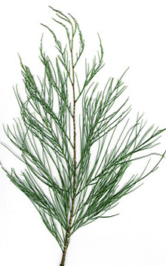 | 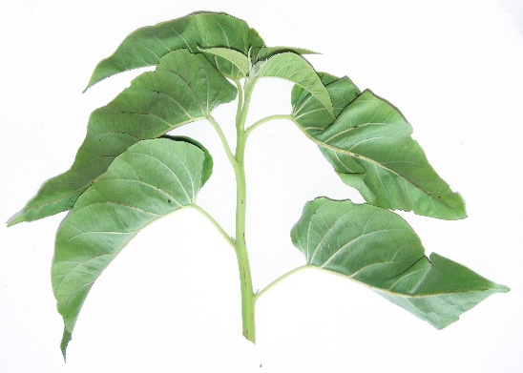
(a) Alternate (Tamarix dioica) | (b) Alternate (Ipomea carnea)
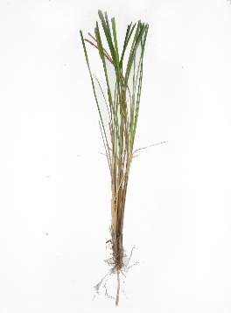 | 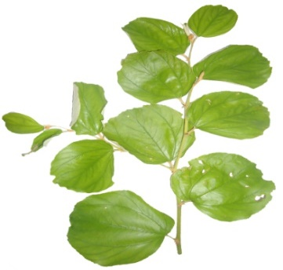
(c) Alternate (Saccharum spontaneum) | (d) Alternate (Ziziphus jujuba)
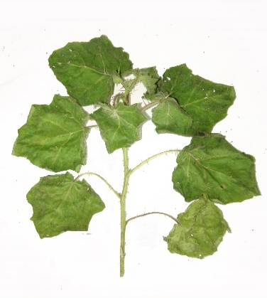 | 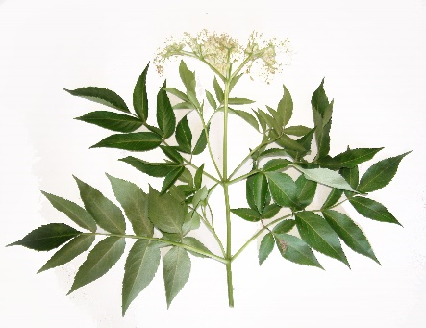
(e) Alternate (Solanum viarum) | (f) Whorled (Vitex negundo)
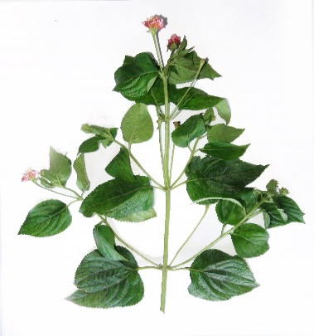
(g) Opposite (Lantana camera)
Fig. 1 (a-g). Leaf phyllotaxy of different shelter plants preferred by l. mansueta adults

