Original Research Article
CORRELATION ANALYSIS BETWEEN GROWTH AND YIELD COMPONENTS OF SORGHUM (Sorghum bicolor L.) DURING KHARIF 2022
Abstract
This study investigated the simple correlation relationships between growth, yield, and yield-related traits in sorghum, aiming to identify key determinants for yield improvement. A randomized block design experiment, comprising ten treatments with three replications, was conducted at the Crop Research Farm, Department of Agronomy, SHUATS, Prayagraj (U.P.). Treatments consisted of varying levels of Azotobacter chroococcum (10, 15, and 20 g/kg) and zinc (15, 20, and 25 kg/ha). Correlation analysis revealed significant positive correlations between sorghum grain yield and plant height, plant dry weight, ear head length, and test weight. Ear head length exhibited the highest individual contribution to yield, followed by plant height. Furthermore, plant dry weight and test weight also demonstrated positive contributions. Path analysis indicated that the highest combined contribution to yield was mediated through plant height via ear head length, followed by plant height via plant dry weight. These findings highlight the importance of plant height, ear head length, plant dry weight, and test weight as critical selection criteria for enhancing sorghum yield.
Keywords: Sorghum, Correlation, Kharif, Azotobacter Chroococcum, Zinc, Growth, Yield.

INTRODUCTION
Sorghum (Sorghum bicolor L.), often referred to as the "king of millets," is a versatile and highly productive crop with applications spanning grain production, livestock feed, and industrial uses. Renowned for its adaptability, it stands as a crucial forage crop, demonstrating superior tolerance to heat, drought, and even waterlogging compared to other forage species (Singh et al., 2016). While sorghum possesses a significant yield potential, actual production often lags, largely due to its high nutrient demands. As a nutrient-exhaustive crop, sustainable high productivity necessitates maintaining native soil fertility and health.
Sorghum's resilience and dependable yields under challenging conditions, coupled with its sensitivity to photoperiod for panicle initiation (Jakhad et al., 2023), underscore the importance of optimizing production factors. These factors, including fertilizer application, seeding rates, and moisture availability, significantly influence crop performance. Understanding the intricate relationships among growth and yield-related traits is paramount for developing effective strategies to enhance sorghum yield.
Correlation analysis serves as a valuable tool for quantifying the type and strength of associations between various plant parameters (Aliyu et al., 2000). Furthermore, path coefficient analysis, pioneered by Wright (1918) and further elaborated by Li (1956), Turner and Stevens (1959), and Wright (1960), allows for the partitioning of correlation coefficients into direct and indirect effects, revealing the relative contributions of individual traits to yield. This approach enables the identification of key characters for targeted selection and yield improvement.
In this context, the present study investigates the association between diverse sorghum growth characteristics and yield components. Specifically, it aims to elucidate the roles of Azotobacter chroococcum and zinc fertilization in influencing these relationships. Azotobacter chroococcum, a beneficial soil bacterium, is known to enhance nutrient availability and promote plant growth through nitrogen fixation and other mechanisms. Similarly, zinc, an essential micronutrient, plays a crucial role in various physiological processes, including enzyme activation and hormone regulation. By examining the impact of varying levels of these treatments, this research seeks to identify critical factors that contribute to enhanced sorghum yield.

MATERIALS AND METHODS
Field experiments were conducted during the Kharif season of 2022 at the Crop Research Farm, Department of Agronomy, SHUATS, Prayagraj, Uttar Pradesh, India (25°24'42"N latitude, 81°50'56"E longitude). The experimental site was characterized by sandy loam soil with a near-neutral pH of 7.6. The soil exhibited medium levels of organic carbon (0.87%), available nitrogen (225 kg/ha), high levels of available phosphorus (41.8 kg/ha), and medium levels of available potassium (261.2 kg/ha). The experiment employed a randomized block design (RBD) with ten treatments, each replicated three times. The treatments consisted of a factorial combination of three levels of Azotobacter chroococcum inoculation (10, 15, and 20 g/kg seed) and three levels of zinc application (15, 20, and 25 kg/ha). Each experimental plot measured 3 x 3 meters. Data were collected on various growth and yield parameters, including plant height, plant dry weight, ear head length, test weight, seed yield, straw yield, and harvest index. Statistical analysis was performed using the treatment means across replications. Correlation coefficients were calculated to assess the relationships between pairs of characters, employing the formula provided by Steel and Torrie (1984). Path coefficient analysis, as described by Dewey and Lu (1959), was utilized to determine the direct and indirect effects of the measured characters on grain yield. Multiple regression analysis was also performed to quantify the relationship between yield and yield components.
RESULTS AND DISCUSSIONS
Correlation analysis revealed significant positive correlations between sorghum grain yield and plant height, ear head length, and test weight (Table 1). This suggests that taller plants, longer ear heads, and heavier seeds are associated with higher yields. The observed relationship between plant height and yield could be attributed to increased leaf area index (LAI) in taller plants, leading to enhanced photosynthetic capacity and subsequent assimilate production. This, in turn, likely contributed to the observed increases in ear head length and test weight, which exhibited strong positive correlations with yield. These findings align with previous research by Kamoshita et al. (1998) and Utzurrum et al. (1998), who reported significant relationships between sorghum yield and various growth and yield attributes.
Furthermore, ear head length demonstrated a significant positive correlation with other growth and yield parameters, indicating its pivotal role in overall yield determination. The positive correlations observed among other yield components and growth characters further reinforce the interconnectedness of these traits.
While correlation analysis effectively established the type and magnitude of relationships, it did not elucidate the direct and indirect contributions of individual traits to yield. To address this, path coefficient analysis was conducted. The results indicated that ear head length made the highest individual contribution to yield, followed by plant height. Plant dry weight and test weight also exhibited positive direct effects on yield.
The path analysis further revealed that the highest combined contribution to yield was mediated through plant height via ear head length. This was followed by the contribution of plant height via plant dry weight. These findings underscore the importance of plant height, ear head length, plant dry weight, and test weight as critical selection criteria for yield improvement in sorghum. The observed indirect effects highlight the complex interplay of these traits, where plant height influences yield not only directly but also indirectly through its impact on ear head length and plant dry weight.
In summary, the correlation and path analyses demonstrated the significant positive associations between sorghum yield and key growth and yield attributes. Furthermore, the path analysis identified ear head length and plant height as primary contributors to yield, emphasizing their significance in breeding programs aimed at enhancing sorghum productivity.

Table 1: Correlation Coefficients of Sorghum Growth and Yield Components (Kharif 2022).

 | Plant height | Plant dry weight | CGR | RGR | Length of ear head | Seed yield | Straw yield | Test weight | Harvest index
Plant height | 1.000
Plant dry weight | 0.989** | 1.000
CGR | 0.167 | 0.178 | 1.000
RGR | -0.185 | -0.18 | 0.933** | 1.000
Length of ear head | 0.921** | 0.933** | -0.112 | -0.442 | 1.000
Seed yield | 0.947** | 0.953** | -0.068 | -0.409 | 0.985** | 1.000
Straw yield | 0.782* | 0.787* | -0.278 | -0.575 | 0.84* | 0.875** | 1.000
Test weight | 0.981** | 0.978** | 0.043 | -0.306 | 0.944** | 0.97** | 0.864* | 1.000
Harvest index | 0.889** | 0.895** | 0.05 | -0.255 | 0.928** | 0.921** | 0.62 | 0.871** | 1.000
Note: * Significant at P < 0.05, ** Significant at P < 0.03. CGR = Crop Growth Rate, RGR = Relative Growth Rate.

Fig. 1: Relationships Between Growth and Yield Components: A Correlation Analysis.
VISUAL DOCUMENTATION OF THE FIELD EXPERIMENT
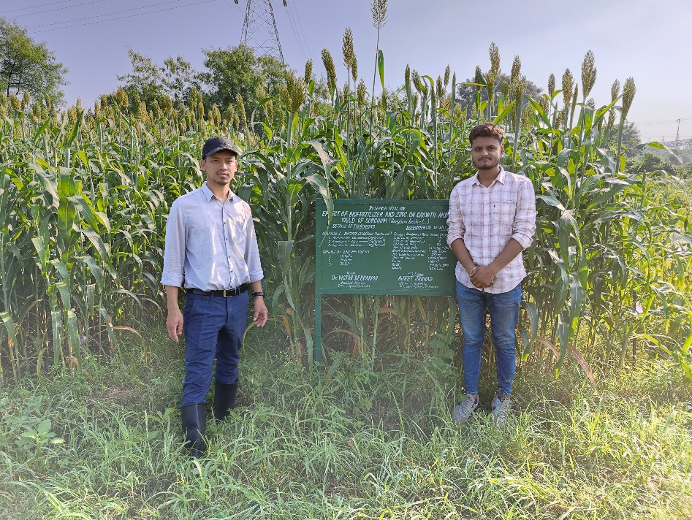

Fig2: Field Survey with Advisor
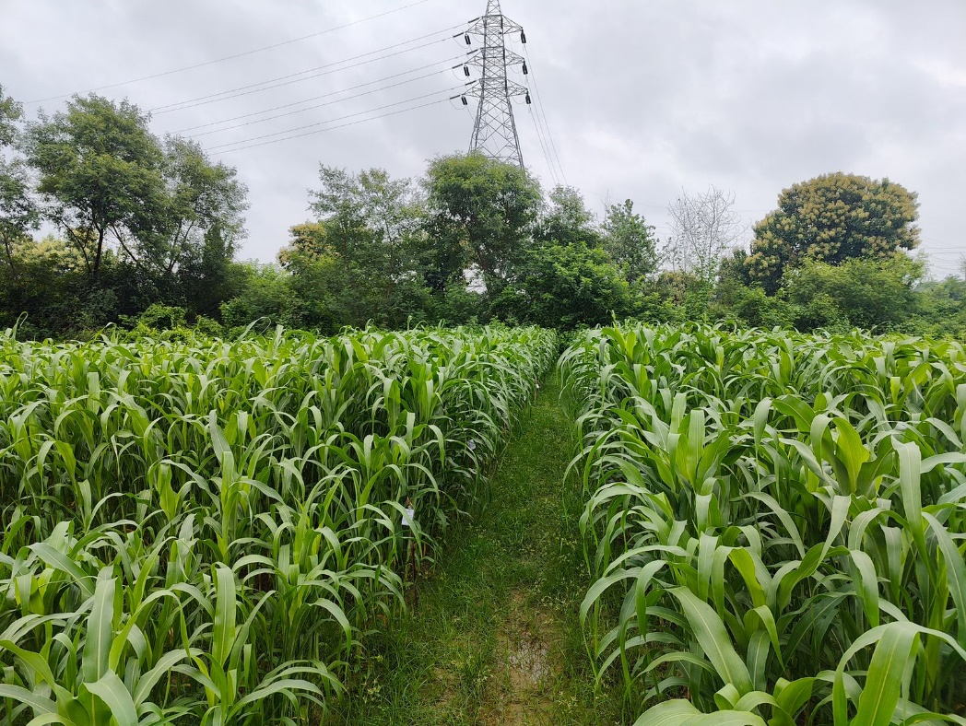

Fig 3: Experimental Field Overview
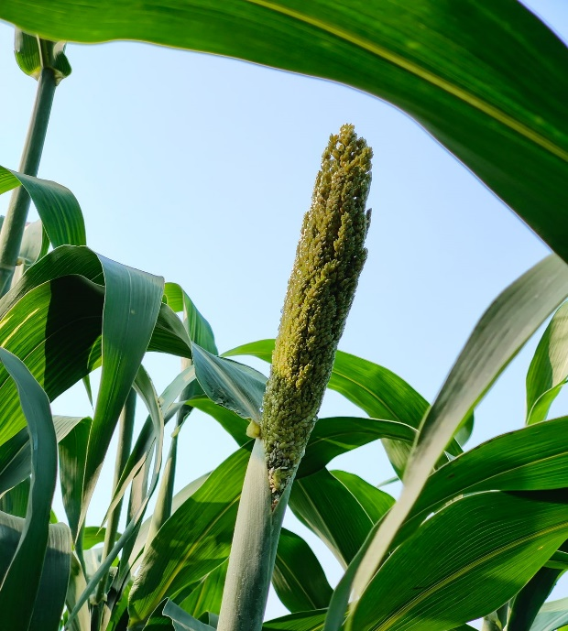

Fig 4: The Development of the Sorghum Ear Head
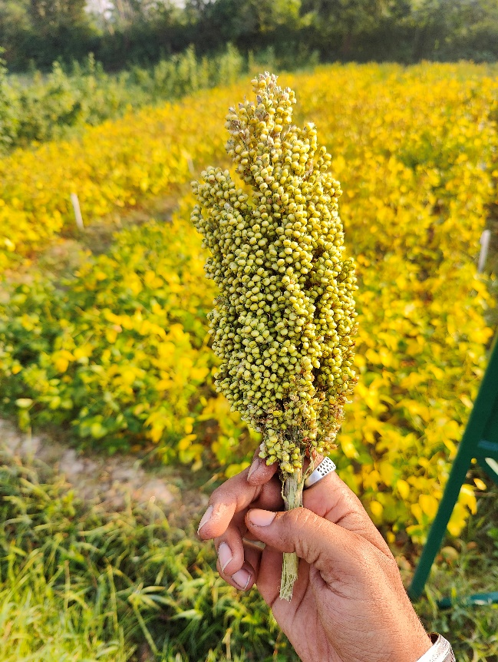

Fig 5: Mature Ear Head

CONCLUSION
This study elucidated the intricate relationships between growth, yield, and yield-attributing traits in sorghum, revealing critical parameters for enhancing productivity. Correlation analysis demonstrated significant positive associations between grain yield and plant height, ear head length, and test weight. Notably, path coefficient analysis identified ear head length as the primary contributor to yield, followed by plant height, emphasizing their direct and substantial influence. These findings underscore the importance of selecting and breeding sorghum varieties with enhanced ear head length and plant height to maximize grain yield. Furthermore, the significant positive contribution of test weight suggests that improving seed density and size is also crucial for yield enhancement. The observed indirect effects, particularly the contribution of plant height via ear head length, highlight the complex interplay of these traits and the importance of considering their combined effects in breeding programs. The positive correlations observed between yield and plant dry weight indicate the importance of overall biomass accumulation in achieving higher yields. Moreover, the study demonstrated the effectiveness of Azotobacter chroococcum and zinc fertilization in influencing these growth and yield traits, suggesting that optimizing these inputs could further enhance sorghum productivity. In conclusion, this research identifies ear head length, plant height, and test weight as key selection criteria for sorghum improvement. Future breeding efforts should prioritize these traits, alongside optimizing Azotobacter and zinc applications, to develop high-yielding sorghum varieties adapted to diverse agro-ecological conditions. This will contribute to sustainable sorghum production and address the growing demand for this vital crop.
ACKNOWLEDGEMENT
The authors express their sincere gratitude to the Department of Agronomy, Naini Agricultural Institute, Prayagraj, Sam Higginbottom University of Agriculture, Technology and Sciences (SHUATS), Uttar Pradesh, India, for providing the essential facilities and resources that enabled the successful completion of this research. We would also like to acknowledge the dedicated field staff and laboratory personnel whose assistance was invaluable throughout the study.
Furthermore, we recognize that the findings of this research contribute to the broader understanding of sorghum yield enhancement strategies, which are crucial for addressing food security challenges in regions reliant on this vital crop. Continued research exploring the interactions between genotype, environment, and management practices will be essential for developing resilient and high-yielding sorghum varieties. Additionally, disseminating these findings to farmers and extension workers will facilitate the adoption of improved agronomic practices and contribute to sustainable agricultural development.
REFERENCES
Jakhad, A., and Debbarma, V. (2023). Influence of biofertilizer and zinc on growth, yield and economics of sorghum (Sorghum bicolor L.). International Journal of Plant & Soil Science, 35(8), 90-97.
Singh KP, Chaplot PC, Sumeriya HK and Choudhary GL. Performance of single cut forage sorghum genotypes to fertility levels. Forage Research. 2016;42(2):140- 142.
Aliyu, L. M.K. Ahmed M.D. Magaji (2000). Correlation and multiple regression analysis between morphological characters components of yield in pepper (Capsicum annum L.) Crops Research 19 9(2) 318-323.
Dewey, D.R and Lu, K.H (1959). A correlation and path coefficient analysis of crested wheat grass seed production. Agronomy Journal 51: 515- 518.
Wright, S. (1918). On the nature on size factors genetics 3: 367.
Wright, S. (1960). Path coefficients and path of regression. Alternator or complimentary concepts. Biometrics 16: 189- 202.
Li, C.C (1956). The concept of path coefficient and its impact on population genetics, Biometrics 12 (190- 210).
Turner, M.F.; C.D. Stevens (1959). The regression analysis of causes path. Biometrics 15: 236- 58.
Steel. R.G. J.W. Torrie (1984). Principles and procedures of statistics. A Biometrical Approach, 2nd Ed. Mac. Graw, hall Inter Book Aust. 1633.
Kamoshita, A.S R.C. Fukai M. Cooper 91998). Sorghum hybrid differences in grain yield and nitrogen concentration under low soil nitrogen availability Australia Journal Agricultural Research 49, 1267- 76.
Utzurrum, S.B. Fuksi M.A. Foale (1998). Effect of late nitrogen application on growth and nitrogen balance of two cultivars of water stressed grain sorghum Australia Journal Agricultural (49). 657- 94.
Nachiketa, Vikram Singh, and Shruti Grace George. 2023. “Evaluation of Rice (Oryza Sativa L.) under Agro-Climatic Zone of Prayagraj, India”. International Journal of Plant and Soil Science 35 (10):168-73

