A Case Study of Chronic Aplastic Anemia with Severe Thrombocytopenia and Menorrhagia in A Young Adult

.

ABSTRACT

Introduction:
Aplastic anemia is a rare but serious hematological disorder characterized by bone marrow failure leading to pancytopenia. The condition often presents with nonspecific symptoms, resulting in delayed diagnosis and an increased risk of life-threatening complications. Early identification and appropriate management are crucial for improving patient outcomes.
CasePresentation:
A 23-year-old female with a known history of aplastic anemia presented with heavy menstrual bleeding and generalized weakness. Laboratory investigations revealed severe pancytopenia, including markedly reduced hemoglobin, leukocyte, and platelet counts. Bone marrow findings were consistent with a hypocellular marrow. The patient was treated with supportive measures such as packed red blood cell and platelet transfusions, along with immunosuppressive therapy using cyclosporine and adjunctive agents, including danazol and tranexamic acid.
Discussion:
Aplastic anemia is primarily an immune-mediated disorder characterized by the destruction of hematopoietic stem cells. Accurate differentiation from other causes of pancytopenia is essential for effective management. Immunosuppressive therapy remains the mainstay of treatment for patients who are not eligible for hematopoietic stem cell transplantation, with regular monitoring required to evaluate response and prevent complications.
Conclusion:
This case emphasizes the challenges in diagnosing and managing aplastic anemia in young adults. Early recognition and timely supportive care with immunosuppressive therapy are crucial for improving clinical outcomes, survival, and quality of life.

Keywords: Aplastic anemia; Pancytopenia; Bone marrow failure; Immunosuppressive therapy.

- INTRODUCTION

Aplastic anemia has a long history and has resulted in confusing terminology. “The term anemia derives from the early ability to measure red blood cells using the hematocrit. Most patients have pancytopenia, with decreased platelets and white blood cells. The term aplastic refers to the inability of the bone marrow to produce blood cells, which represents the end-organ effect of diverse pathophysiological mechanisms. Historically, aplastic anemia was identified post mortem and bone marrow biopsy remains fundamental to diagnosis. However, a seemingly empty bone marrow may be entirely capable of supporting normal hematopoiesis. Conversely, bone marrow failure can occur despite normal marrow cellularity, as seen in myelodysplastic syndromes (MDS) and paroxysmal nocturnal hemoglobinuria (PNH)”.^{[1]}

“Aplastic anemia (AA) is a rare, heterogeneous disorder, characterized by failure of hematopoiesis and leads to bone marrow aplasia and pancytopenia”.^{[2]} “Paul Ehrlich introduced the concept of aplastic anemia in 1888 when he studied a case of a pregnant woman who died of bone marrow failure. However it was not until 1904 that Anatole Chauffard named this disorder aplastic anemia”.^{[3]}

- Epidemiology
The overall incidence is 2.34 per million inhabitants per year and the incidence increased with age. The sex-specific incidence rates were 2.54 for males and 2.16 for females.^{[4]}

- Etiology

- Most cases of Aplastic Anemia are idiopathic (cause unknown).
- Aplastic Anemia may also be caused by : Cytotoxic drugs (e.g., Chloramphenicol, gold), Radiation exposure, Toxic chemicals (e.g., Benzene, solvents and glue vapors), Viral infections (e.g., Epstein–Barr virus and seronegative non A–G hepatitis), Immune-related disorders (e.g., Eosinophilic fasciitis, systemic lupus erythematosus (SLE) and graft-versus-host disease).

- Pathophysiology
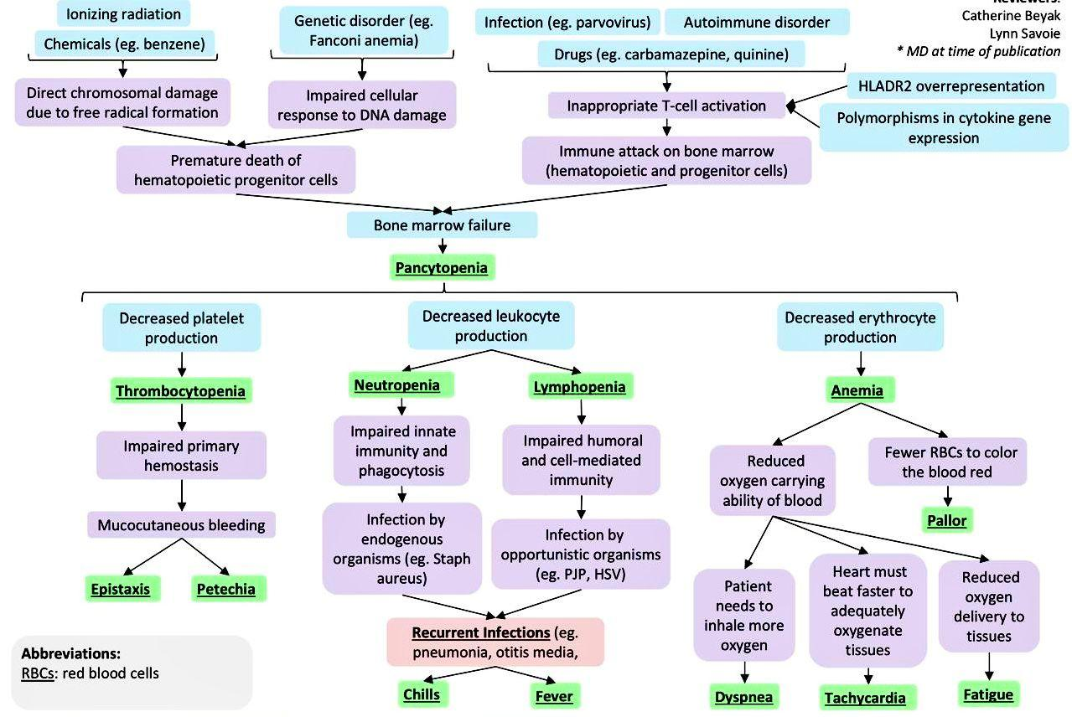
Fig. 1. Pathophysiology of aplastic anemia^{[5]}

- Clinical manifestations

Signs of pancytopenia :-
- Anemia : Pallor, tachycardia, dyspnea.
- Neutropenia : Fever, signs of infection.
- Thrombocytopenia : Petechiae, bruising, mucosal bleeding.^{[6]}
- Diagnosis
- Full blood count : Demonstrates pancytopenia with reduced hemoglobin, neutrophils and platelets.
- Reticulocyte count : Shows reticulocytopenia, indicating reduced bone marrow activity and disease severity.
- Peripheral blood smear : Reveals macrocytosis and abnormal cell morphology while excluding blasts or dysplasia.
- Hb F (Fetal hemoglobin) level : Assessed before transfusion and may be elevated in inherited marrow failure syndromes.
- Vitamin B12 and folate levels : Deficiencies should be corrected before confirming aplastic anemia; marrow aplasia due to deficiency is rare. ^{[7]}

- Treatment
- HLA-Identical Sibling Transplantation (BMT)
- First-line therapy for patients <40 years with a matched sibling donor.
- Conditioning regimen :
- Standard : Cyclophosphamide 200 mg/kg (CY200) + ATG (Anti-Thymocyte Globulin).
- FLU (Fludarabine) - based regimens with lower Cyclophosphamide doses : Recommended for older patients (>40 years) to reduce toxicity.
- Alternatives : Fludarabine + Anti-Thymocyte Globulin or Fludarabine + alemtuzumab (CAMPATH).

- Immunosuppressive Therapy (IST)
- Standard first-line regimen : ATG + Cyclosporine A (CsA).
- Indications :
- Patients without a matched sibling donor.
- Patients >40 years, even if matched sibling donor exists.
- CsA duration : Minimum 6 months; prolonged low-dose therapy >1 year is recommended with slow tapering.

- High-Dose Cyclophosphamide (CY)
- Investigated as IST alternative to ATG + CsA.
- Response rate : 77%; 10-year survival: 88%.^{[8]}

- Androgen therapy
“Danazol is a synthetic anabolic steroid with unique properties similar to corticosteroids, such as inhibition of interleukin-1 and TNF-α production with reduced virilising and toxic effects; it has been employed for the treatment of AA patients having no stem cell donor and those refractory to IST”.^{[9]}

- CASE PRESENTATION
A 23-year-old female patient was admitted to vijayanagara institute of medical science(VIMS), Ballari (Karnataka) with chief complaints of heavy menstrual bleed since 3 days which is brick red colour around 100-200ml and H/O passage of clots and the patient was changing around 3-4 pads for per day. On day 5 the patient was adviced to check for GBM Antibodies test were it was found to be positive(++).
Social history - No habits
Past history - K/C/O Aplastic anemia since 3 years on medication T.Cyclosporine 50mg and the H/O blood transfusion 3-4 times in the past 2 years
Family history - Nothing significant
On Examination -
The patient’s blood pressure was recorded at 90/60 mmHg, and the pulse rate was 96 beats per minute. Oxygen saturation was 98% on room air. The random blood glucose level was 84 mg/dL. The patient was conscious and oriented. On respiratory examination, bilateral normal vesicular breath sounds were present. Cardiovascular examination revealed normal S1 and S2 heart sounds. Per abdominal examination showed a soft and non-tender abdomen.
Table 1. Laboratory examination of the patient
PARAMETERS | RESULT  (18-12-25) | RESULT  (19-12-25) | RESULT  (20-12-25) | REFERENCE RANGE
Hemoglobin  Red blood cells  PCV  WBC  Polymorphs  Lymphocytes  Platelets  ESR  RDW-CV  CRP  Serum ferritin | 4.2  1.32  12.4  2350  50  40  4.4  65  17.0 | 4.7  1.56  14.5  1700  65  30  1.61  11.9  11.4  394.0 | 6.2  2.04  18.4  2070  20  72  0.17 | 12-16g/dl  3.5-5.0 million/cumm  33-43%  4500-11,000 cells/cumm  40-75%  20-50%  1.5-4.5 lacs/cumm  0-20mm/hr  11.5-14.5%  0-6g/l  11-307ng/ml

Other examinations –
USG Abdomen and pelvis : Moderate ascites.

Table 2. Treatment regimen in hospital
NAME OF MEDICATIONS | DOSE | ROUTE | FREQUENCY
TAB.CYCLOSPORINE | 50mg | PO | BD FOR 3 DAYS
1PINT PRBC |  | IV | FOR 1 DAY
4PINT RDP |  | IV | FOR 1 DAY
4PINT FFP |  | IV | FOR 1 DAY
TAB.IRON FOLIC ACID | 333mg | PO | BD FOR 3 DAYS
TAB.FOLIC ACID | 5mg | PO | OD FOR 3 DAYS
TAB.ALBENDAZOLE | 400mg | PO | FOR 1 DAY
TAB.DANAZOL | 100mg | PO | BD FOR 2nd AND 3rd DAY
ING.TRANEXAMIC ACID | 500mg | IV | BD FOR 2nd AND 3rd DAY
SYP.LACTULOSE | 10ml | PO | BD FOR 2nd AND 3rd DAY

- DISCUSSION
The clinical findings and management of this patient reflect several important aspects of aplastic anemia, including disease chronicity, bleeding complications and the need for individualized therapeutic strategies.
Aplastic anemia is an uncommon but potentially life-threatening hematological disorder characterized by immune-mediated destruction of hematopoietic stem cells, resulting in bone marrow hypocellularity and pancytopenia. Owing to its nonspecific initial symptoms, diagnosis is frequently delayed, increasing the risk of severe complications such as bleeding and infection. In the present case, the patient exhibited profound anemia and thrombocytopenia, which clinically manifested as heavy menstrual bleeding and generalized weakness.
The patient had a known history of aplastic anemia for three years, suggesting a chronic or relapsing disease course. Relapse following an initial response to immunosuppressive therapy is well documented in aplastic anemia and highlights the need for long-term surveillance. The markedly reduced hemoglobin, leukocyte, and platelet counts observed at admission indicated disease progression or inadequate hematological recovery. Bone marrow findings consistent with hypocellularity further supported the diagnosis and helped exclude other causes of pancytopenia, such as acute leukemia or myelodysplastic syndromes.
Menorrhagia, as observed in this case, represents a significant yet often under-recognized clinical manifestation of thrombocytopenia in young female patients with aplastic anemia. Early identification and prompt management of bleeding complications are essential to prevent hemodynamic instability and reduce transfusion requirements. The use of tranexamic acid in this patient was effective in controlling bleeding, while danazol was administered as an adjunct therapy to enhance platelet recovery and reduce transfusion dependence.
Immunosuppressive therapy remains the cornerstone of treatment for patients who are not immediate candidates for hematopoietic stem cell transplantation. Cyclosporine was continued in this patient because of its ability to suppress aberrant T-cell activity responsible for hematopoietic stem cell destruction. Supportive care, including packed red blood cell and platelet transfusions, played a critical role in stabilizing the patient during the acute phase. However, prolonged transfusion support necessitates careful monitoring for complications such as iron overload and alloimmunization.
In addition to standard immunosuppressive therapy, danazol was used as adjunctive treatment in the present case. The use of danazol in the present case aligns with evidence demonstrating its utility as a therapeutic option in aplastic anemia, particularly in patients who are not candidates for hematopoietic stem cell transplantation or who lack access to standard immunosuppressive therapy.
Supportive care remains a fundamental component of aplastic anemia management, particularly during periods of severe cytopenia. Timely transfusion of packed red blood cells and platelet concentrates not only stabilizes patients clinically but also reduces morbidity associated with hypoxia and hemorrhage. In this patient, prompt transfusion support was essential in controlling symptomatic anemia and preventing further bleeding, underscoring the importance of comprehensive supportive strategies alongside disease-modifying therapy.
Jaime-Pérez et al. reported an overall response rate of approximately 46% among patients treated with danazol as first-line therapy, supporting its role as a viable treatment in selected clinical settings. In the current case, danazol was employed as adjunctive therapy alongside cyclosporine, reflecting real-world practice where combination strategies are often used to optimize hematologic recovery.
Bleeding-related mortality has been reported in danazol-treated patients, largely attributable to the severity of thrombocytopenia rather than drug-related toxicity. This observation is consistent with the current case, in which menorrhagia was a direct consequence of severe platelet depletion. The combined use of danazol and tranexamic acid represents a rational strategy to mitigate bleeding risk while addressing the underlying marrow failure.
Long-term follow-up is essential in patients with chronic aplastic anemia to assess treatment response, monitor drug-related toxicity, and detect clonal evolution to conditions such as paroxysmal nocturnal hemoglobinuria or myelodysplastic syndrome. Although immunosuppressive therapy remains effective for many patients, hematopoietic stem cell transplantation continues to be the only curative option and should be reconsidered if the patient develops refractory disease or experiences recurrent relapses.

- CONCLUSION
Aplastic anemia is a rare but serious hematological disorder associated with bone marrow failure and pancytopenia. This case illustrates the clinical challenges involved in managing chronic aplastic anemia in a young adult, particularly when complicated by severe thrombocytopenia and bleeding manifestations. Timely supportive care, including blood component therapy, along with continued immunosuppressive treatment using cyclosporine and adjunctive agents such as danazol and tranexamic acid, was essential in stabilizing the patient. Regular monitoring and individualized therapeutic strategies are crucial for preventing complications, assessing treatment response and determining the need for advanced interventions such as hematopoietic stem cell transplantation to improve long-term outcomes. Overall, this case highlights the complexities involved in managing aplastic anemia in young adults and underscores the importance of individualized treatment strategies, early recognition of complications and sustained clinical monitoring to improve long-term outcomes.

CONSENT
As per international standards or university standards, patient(s) written consent has been collected and preserved by the author(s).

DISCLAIMER (ARTIFICIAL INTELLIGENCE)
Author(s) hereby declare that NO generative AI technologies such as Large Language Models (ChatGPT, COPILOT, etc) and text-to-image generators have been used during writing or editing of this manuscript.

References

- Young NS. Aplastic anemia. N Engl J Med. 2018 Oct 25;379(17):1643–1656. doi:10.1056/NEJMra1413485.
- Jain D, Kumar R, Tyagi N, Negi A, Pande A, Mahajan A, et al. Etiology and survival of aplastic anemia: a study based on clinical investigation. J Clin Lab Anal. 2012;26(6):452–458.
- Singh P, Sinha A, Kamath A, Malhotra S, Chandra AB. Aplastic anemia: a quick review. J Cancer Prev Curr Res. 2017;7(5):152–156.
- Montané E, Ibáñez L, Vidal X, Ballarín E, Puig R, García N, et al. Epidemiology of aplastic anemia: a prospective multicenter study. Haematologica. 2008;93(4):518–523.
- Adapted from: Bacigalupo A. Blood. 2017;129(11):1428–1436; Singh P, et al. J Cancer Prev Curr Res. 2017;7(5):152–156; Nimmana BK, Penney SW. StatPearls. 2025.
- Nimmana BK, Penney SW. Aplastic anemia. In: StatPearls [Internet]. Treasure Island (FL): StatPearls Publishing; 2025 Jan–. Updated 2025 Jul 7.
- Kulasekararaj A, Cavenagh J, Dokal I, Foukaneli T, Gandhi S, Garg M, et al.; on behalf of the British Society for Haematology Committee. Guidelines for the diagnosis and management of adult aplastic anaemia: A British Society for Haematology guideline. Br J Haematol. 2024;204(3):784–804. doi:10.1111/bjh.19236.
- Bacigalupo A. How I treat acquired aplastic anemia. Blood. 2017;129(11):1428–1436.
- Jaime-Pérez JC, Colunga-Pedraza PR, Gómez-Ramírez CD, Gutiérrez-Aguirre CH, Cantú-Rodríguez OG, Tarín-Arzaga LC, et al. Danazol as first-line therapy for aplastic anemia. Ann Hematol. 2011;90:523–527. doi:10.1007/s00277-011-1163-x.
- Ashwini BR, Palo S, Ahmed SM. Aplastic anemia in a developing country: the present and the need. Natl J Lab Med. 2016 Jul;5(3):PO08–PO10. doi:10.7860/NJLM/2016/19178.2126.
- Yang H, Xu X, Jiang X, Yao Z. Treatment of menorrhagia due to aplastic anemia by hysteroscopic resection of endometrial functional layer and levonorgestrel-releasing intra-uterine system: three case reports. Medicine (Baltimore). 2019;98(17):e15156. doi:10.1097/MD.0000000000015156.
- Yang HD, Xia MT, Shao YF, Ying P. Recurrent ovarian hemorrhage in a patient with aplastic anemia: a case report. Medicine (Baltimore). 2018;97(27):e11409. doi:10.1097/MD.0000000000011409.
- Xing L, Yang W, Fan H, Li J, Zhao Y, Liang W, Shi J, Zhang F, Zhao X. Cyclosporine-related adverse events in aplastic anemia patients treated with immunosuppressive therapy. Ann Hematol. 2026;105:27. doi:10.1007/s00277-026-06780-0.
- Shoaib MI, Elmeissery MM. Transfusion-related complications in intensive care unit (ICU): risk factors, prevention and management: a literature review. Pak J Intensive Care Med. 2025;5(2):190. doi:10.54112/pjicm.v5i02.190.
- Adewoyin AS, Oyewale OA. Complications of allogeneic blood transfusion: current approach to diagnosis and management. Int Blood Res Rev. 2015;3(4):135–151. doi:10.9734/IBRR/2015/17874.

