Bilateral Asymmetric Best Vitelliform Macular Dystrophy in Adulthood: Insights from Multimodal Imaging

Abstract
Purpose: This case report addresses bilateral asymmetric adult-onset Best vitelliform macular dystrophy (BVMD), highlighting the significance of multimodal imaging—such as fundus autofluorescence (FAF), optical coherence tomography (OCT), and OCT angiography (OCTA)—for identifying retinal impairment and subclinical choroidal neovascularization (CNV), as well as underscoring the value of genetic testing and prompt intervention
Methods: A 34-year-old patient presenting with decreased vision underwent comprehensive ophthalmic examination, color fundus photography, FAF, OCT, and OCTA. Clinical features, imaging findings, and follow-up data were documented.
Results: Asymmetric macular lesions were detected: a Stage IV vitelliruptive lesion in the right eye and a Stage III pseudohypopyon lesion in the left eye. FAF exhibited central hypoautofluorescence along with dispersed hyperautofluorescent regions in the right eye and an irregular semi-lunar pattern in the left eye. OCT showed disturbance in the outer retinal layers, with intraretinal fluid (IRF) present in regions of RPE impairment. OCTA revealed no signs of active CNV during the initial assessment. The patient had no acknowledged family background of hereditary retinal conditions
Conclusion: BVMD that starts in adulthood may manifest asymmetrically with gradual advancement. Multimodal imaging is crucial for the early identification of RPE dysfunction and subclinical CNV. Prompt recognition of CNV and prompt intravitreal anti-VEGF therapy, if needed, can maintain visual stability. Genetic testing is suggested to assist with diagnosis, counseling, and ongoing management.
Keywords: Best vitelliform macular dystrophy, adult-onset, choroidal neovascularization, OCTA, multimodal imaging, BEST1.

Introduction
“Best vitelliform macular dystrophy (BVMD) is a rare autosomal dominant macular disorder caused by mutations in the BEST1 gene, encoding bestrophin, an ion channel protein in the retinal pigment epithelium (RPE)” [1,2]. “Dysfunction of bestrophin disrupts RPE ion transport, leading to lipofuscin accumulation, photoreceptor-RPE interface disruption, and progressive photoreceptor degeneration” [3,4]. “BVMD classically presents in childhood with yellow-orange vitelliform lesions, but adult-onset and asymmetric presentations are uncommon and can be diagnostically challenging” [5,6]. “The phenotypic spectrum ranges from subclinical RPE changes to advanced vitelliruptive and atrophic stages” [3,4].
“Color fundus photography is useful for documenting lesion morphology; however, multimodal imaging—including fundus autofluorescence (FAF), near-infrared FAF (NIR-FAF), optical coherence tomography (OCT), and OCT angiography (OCTA)—provides critical structural, functional, and vascular information [3,7–10]. FAF allows early detection of RPE dysfunction even in subclinical or atypical cases” [7,8]. “NIR-FAF demonstrates central hypoautofluorescence surrounded by hyperautofluorescent zones in clinically inapparent eyes” [7]. “OCT identifies outer retinal changes, including thinning of the outer nuclear layer and ellipsoid zone disruption” [9]. “OCTA can detect non-exudative or subclinical choroidal neovascularization (CNV), a significant late complication of BVMD” [10].
“Adult-onset cases may occur without a known family history of inherited retinal disease; therefore, genetic testing is essential for diagnosis, prognostication, and family counseling” [3,4].
To present a case of bilateral asymmetric adult-onset BVMD, highlighting the utility of multimodal imaging (FAF, OCT, OCTA) for detecting retinal dysfunction and subclinical CNV, and discussing the implications of genetic testing and early intervention.

Case Report
A 34-year-old male presented with long-standing decreased central vision in both eyes. Best-corrected visual acuity was 20/40 in the right eye (OD) and 20/30 in the left eye (OS). Anterior segment examination was unremarkable. Peripheral retina was normal in both eyes. No known family history of inherited retinal disease was reported.
Fundus Examination
- Right eye (OD): Stage IV (vitelliruptive) lesion with breakup of vitelliform material, giving a “scrambled egg” appearance (Figure 1A).
- Left eye (OS): Stage III (pseudohypopyon) lesion with semi-lunar configuration (Figure 1B).
Fundus Autofluorescence (FAF)
- Right eye (OD): Central hypoautofluorescence with scattered punctiform hyperautofluorescent areas (Figure 2A).
- Left eye (OS): Heterogeneous semi-lunar hyperautofluorescence with peripheral hypoautofluorescent areas (Figure 2B).
Fluorescein Angiography (FA)
- Right eye (OD): Early phase and late phase showing semi-lunar staining without leakage and bordered by a thin hyperfluorescent rim (Figure 3A–B).
- Left eye (OS): Early phase and late phase showing semi-lunar hyperfluorescent staining with irregular contours without leakage (Figure 3C–D).
Although OCTA is valuable for detecting subclinical CNV, it was not performed in this case. The patient was advised to undergo regular follow-up for early detection of potential complications, including choroidal neovascularization (CNV).

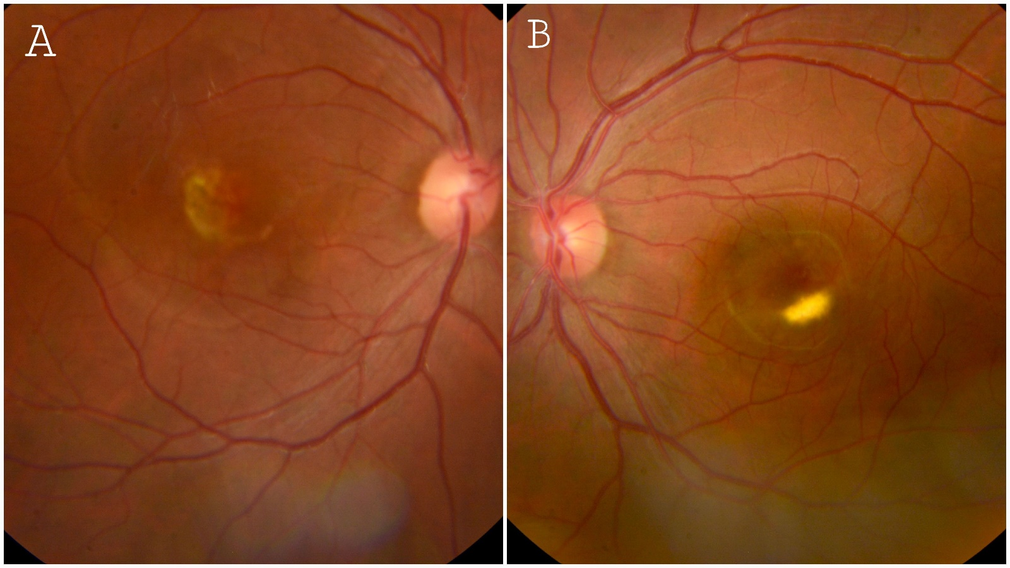
Figure 1. Color Fundus Photography
- (A) Right eye: Stage IV vitelliruptive lesion (“scrambled egg” appearance).
- (B) Left eye: Stage III pseudohypopyon lesion with semi-lunar configuration.

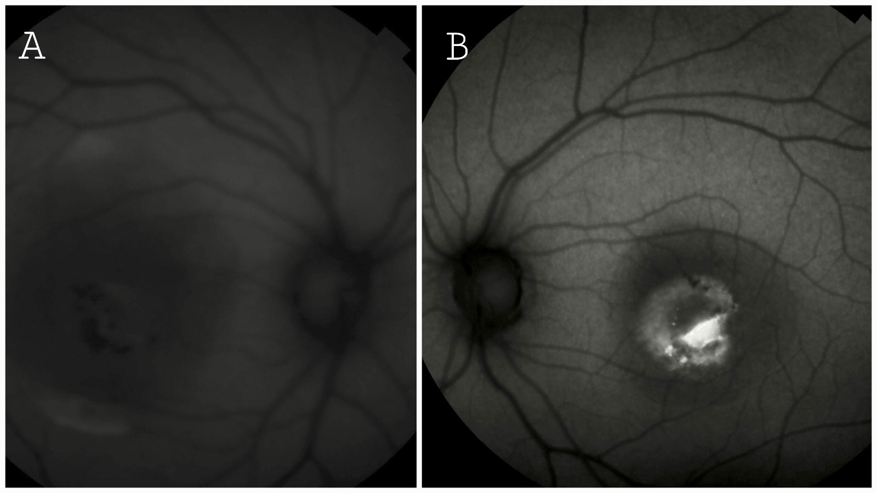
Figure 2. Fundus Autofluorescence (FAF)
- (A) Right eye: Central hypoautofluorescence with scattered hyperautofluorescent spots.
- (B) Left eye: Heterogeneous semi-lunar hyperautofluorescence with peripheral hypoautofluorescent areas.
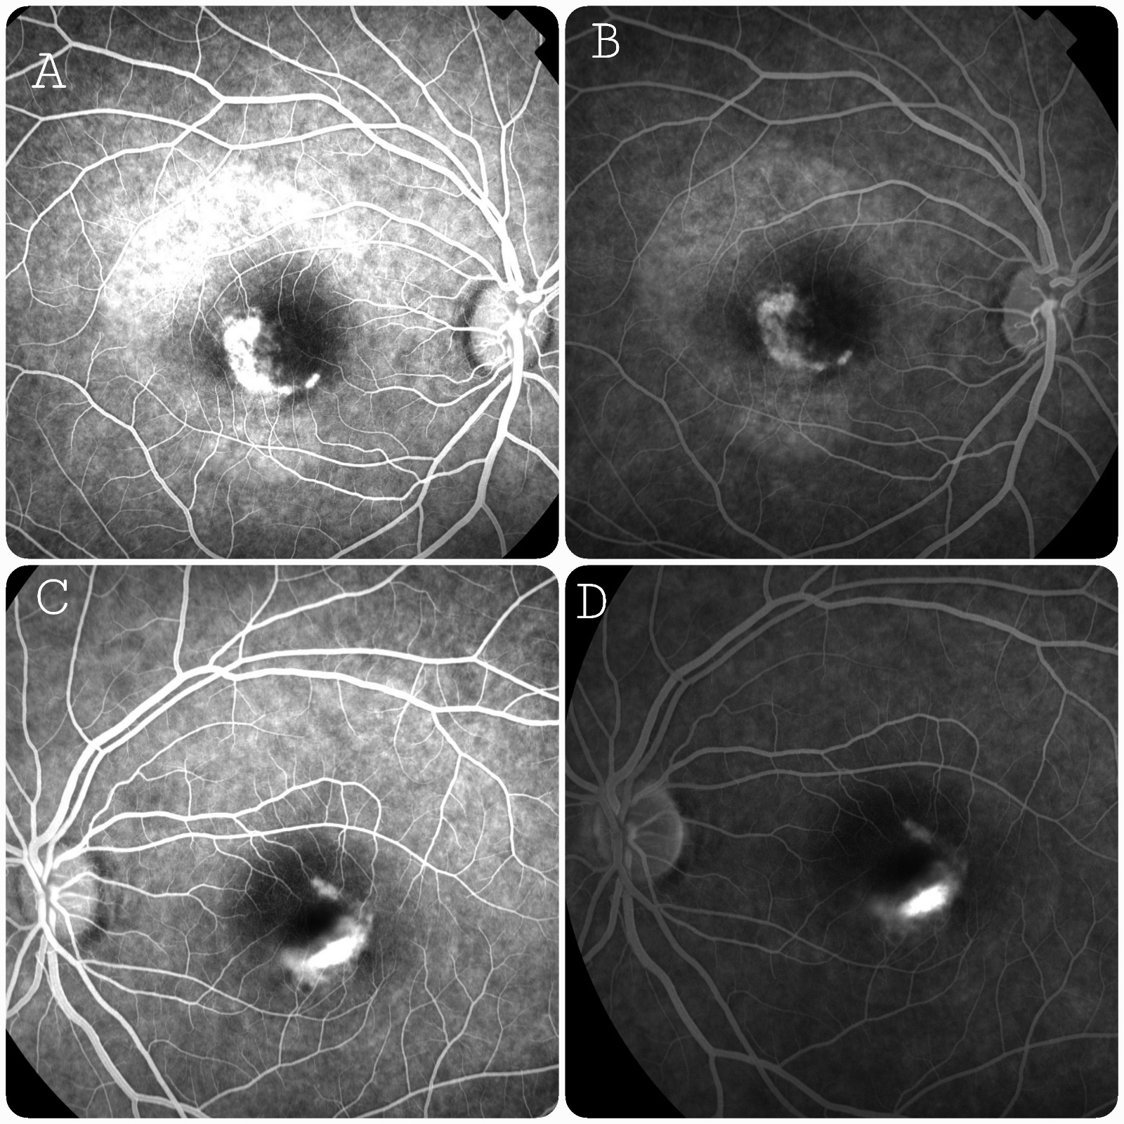
Figure 3. Fluorescein Angiography (FA)

- (A) Right eye, early phase: Semi-lunar staining without leakage.
- (B) Right eye, late phase: Persistent semi-lunar staining with thin hyperfluorescent rim.
- (C) Left eye, early phase: Semi-lunar hyperfluorescent staining with irregular contours, no leakage.
- (D) Left eye, late phase: Persistent semi-lunar hyperfluorescent staining, no leakage.
Discussion
“Best vitelliform macular dystrophy (BVMD) is traditionally characterized as an autosomal dominant macular condition arising from mutations in the BEST1 gene, which codes for the bestrophin protein, an ion channel located in the retinal pigment epithelium (RPE)” [1,2]. “Dysfunction of bestrophin disrupts ion transport across the RPE, leading to abnormal accumulation of lipofuscin within the RPE cells, photoreceptor-RPE interface disruption, and progressive photoreceptor degeneration” [3,4]. “This pathophysiology underlies the characteristic yellow-orange vitelliform lesions observed in BVMD. While BVMD typically presents in childhood, adult-onset and asymmetric forms are rare and may pose diagnostic challenges” [5,6]. “Epidemiologically, BVMD affects approximately 1 in 10,000 individuals, with adult-onset and asymmetric presentations particularly uncommon” [5,7]. Our report of bilateral asymmetric BVMD in a 34-year-old patient emphasizes these atypical features and highlights the critical role of multimodal imaging in disease characterization.
“Color fundus photography remains a useful tool for documenting lesion morphology, but advanced imaging modalities, including fundus autofluorescence (FAF), near-infrared FAF (NIR-FAF), optical coherence tomography (OCT), and OCT angiography (OCTA), provide essential structural, functional, and vascular information” [3–8]. “FAF allows early detection of RPE dysfunction even in subclinical or atypical cases. Querques et al. demonstrated that NIR-FAF reveals central hypoautofluorescence surrounded by hyperautofluorescent zones in clinically inapparent BVMD, emphasizing its sensitivity for early disease detection” [5]. “Similarly, Schönbach and Scholl reported a subclinical case in which FAF identified discrete hyperautofluorescent foci despite normal visual acuity and unremarkable OCT and microperimetry” [6]. “Correlation between FAF patterns and retinal function has been further emphasized in several studies, with hyperautofluorescent, hypoautofluorescent, and patchy patterns correlating to varying degrees of RPE and photoreceptor dysfunction” [3,7]. “Quantitative OCT can detect outer retinal changes, such as thinning of the outer nuclear layer and disruption of the ellipsoid zone, which correlate with decreased visual function [4,6]. OCTA has further enabled detection of non-exudative and subclinical choroidal neovascularization (CNV)” [9–14], highlighting its value for early vascular assessment and longitudinal surveillance.
Choroidal neovascularization is a serious complication of BVMD, reported in 17–20% of patients [8,9]. CNV occurs secondary to structural damage to the RPE and Bruch membrane, often at later disease stages [10–12]. In this patient, no CNV was seen during the initial assessment; however, literature indicates that OCTA can identify early, non-exudative CNV even prior to the onset of clinical symptoms [11–14]. Significantly, Elbany et al. and Miyagi et al. emphasized that OCTA offers essential understanding of CNV structure and function in BEST1-related retinopathies [12,13]. Karaca Adiyeke and Ture noted that OCTA allows for accurate tracking of CNV progression, with intraretinal fluid (IRF) acting as an early sign of lesion activity [8]. In situations complicated by CNV, intravitreal anti-vascular endothelial growth factor (anti-VEGF) treatment successfully decreases CNV activity, with IRF resolving initially and occasional restoration of the external limiting membrane (ELM) noted during follow-up [8,12]. These results highlight the significance of prompt CNV identification and timely anti-VEGF treatment to maintain visual function and avert permanent outer retinal injury.
Genetic research in BVMD demonstrates significant phenotypic diversity based on the particular BEST1 variant [15]. Laich et al. indicated that specific variants, like p.(Ala243Val), are linked to a later onset and less severe Gass stages, whereas p.(Arg218Cys) and p.(Arg218His) are associated with an earlier onset and more severe disease [15]. These correlations between genotype and phenotype are important for predicting outcomes, providing genetic counseling, and assisting in family planning. Our patient disclosed no recognized family history of inherited retinal disease; however, genetic testing is advised in adult-onset BVMD to verify the diagnosis, evaluate recurrence risk, and direct long-term monitoring [15,16]
In the present patient, multimodal imaging revealed asymmetric macular lesions, with a Stage IV vitelliruptive lesion in the right eye and a Stage III pseudohypopyon lesion in the left eye. FAF demonstrated central hypoautofluorescence with scattered hyperautofluorescent areas in the right eye and a heterogeneous semi-lunar pattern in the left eye. These observations align with previous FAF studies correlating lesion morphology to disease stage and functional impairment [5,7]. Fluorescein angiography confirmed semi-lunar staining without leakage, supporting the utility of multimodal imaging for accurate staging and detection of early RPE dysfunction.
Conclusion and Clinical Implications
This case illustrates that adult-onset BVMD can present asymmetrically and progress subtly, reinforcing the need for thorough multimodal evaluation even when visual acuity is relatively preserved. Clinicians should perform baseline multimodal imaging in all suspected BVMD cases, including FAF, OCT, and FA/OCTA when available. Documentation of lesion stage, symmetry, and FAF pattern is essential for prognosis and follow-up. Periodic monitoring should be scheduled every 6–12 months depending on lesion stage, patient age, and symptoms. Patients should be educated on early warning signs of CNV, such as sudden distortion or scotoma, to ensure urgent assessment. Early detection and treatment of CNV with anti-VEGF injections remain crucial to control disease progression and improve visual prognosis. Genetic counseling should be considered for adult-onset cases and for family planning.
These insights underscore that multimodal imaging, combined with genetic assessment, is essential for optimal management of BVMD, particularly in atypical adult presentations, and highlight the importance of a structured long-term surveillance strategy to preserve vision and detect complications promptly.

Authors’ Contributions
All authors contributed to the conception, data acquisition, analysis, drafting, and critical revision of the manuscript. All authors approved the final version of the manuscript.

Consent
Written informed consent for publication of this case report and accompanying images was obtained from all patients.

Disclaimer (artificial intelligence): The author(s) hereby declare that no generative AI technologies, including Large Language Models (e.g., ChatGPT, Copilot) or text-to-image generators, have been used in the writing or editing of this manuscript

References
- Pinckers A, Cuypers MH, AandekerBESTk AL. The EOG in Best's disease and dominant cystoid macular dystrophy (DCMD). Ophthalmic Genet. 1996;17(3):103–108.
- Weingeist TA, Kobrin JL, Watzke RC. Histopathology of Best's macular dystrophy. Arch Ophthalmol. 1982;100:1108–1114.
- Battaglia Parodi M, Arrigo A, Calamuneri A, et al. Multimodal imaging in subclinical Best vitelliform macular dystrophy. Br J Ophthalmol. 2022;106(4):564–567.
- Bianco L, Arrigo A, Antropoli A, et al. Multimodal imaging in Best Vitelliform Macular Dystrophy: Literature review and novel insights. Eur J Ophthalmol. 2024;34(1):39–51.
- Querques G, Bux AV, Carnevali A, et al. Near-infrared fundus autofluorescence imaging in Best vitelliform macular dystrophy: characteristic patterns in subclinical cases. Retina. 2014;34(1):120–128.
- Schönbach EM, Scholl HP. Fundus Autofluorescence in a Subclinical Case of Best Disease. Retin Cases Brief Rep. 2017;11(Suppl 1):S159–S162.
- Battaglia Parodi M, Arrigo A, Calamuneri A, et al. Functional assessment of fundus autofluorescence patterns in Best vitelliform macular dystrophy. Retina. 2015;35(4):737–744.
- Karaca Adiyeke S, Ture G. Choroidal neovascularization associated with Best vitelliform macular dystrophy. Beyoglu Eye J. 2022;7(2):103–108. doi:10.14744/bej.2022.54376.
- Bianco L, Arrigo A, Antropoli A, Berni A, Saladino A, Vilela MA, Mansour AM, Bandello F, Battaglia Parodi M. Multimodal imaging in Best Vitelliform Macular Dystrophy: Literature review and novel insights. Eur J Ophthalmol. 2024;34(1):39–51.
- Wang XN, You QS, Li Q, et al. Findings of Optical Coherence Tomography Angiography in Best Vitelliform Macular Dystrophy. Ophthalmic Res. 2020;63:219–228.
- Hoyek S, Lin LY, Klofas Kozek L, et al. Bilateral consecutive choroidal neovascularization in Best vitelliform macular dystrophy.
- Elbany S, Kodjikian L, Boucher S, et al. Neovascularized Best disease in child: contribution of optical coherence tomography angiography. Ophthal Surg Lasers Imag Retina. 2019;50(9):597–601. doi:10.3928/23258160-20190905-11.
- Miyagi M, Takeuchi J, Koyanagi Y, et al. Clinical findings in eyes with BEST1-related retinopathy complicated by choroidal neovascularization. Graefes Arch Clin Exp Ophthalmol. 2022;260(4):1125–1137. doi:10.1007/s00417-021-05447-y.
- Arrigo A, Bordato A, Aragona E, et al. Macular neovascularization in AMD, CSC and Best vitelliform macular dystrophy: quantitative OCTA detects distinct clinical entities. Retina. 2021;41:105–115.
- Mirshahi A, Lashay A, Masoumi A, et al. Optical coherence tomography angiography in Best vitelliform macular dystrophy. Int Ophthalmol. 2019;39:2705–2715.
- Laich Y, Georgiou M, Fujinami K, et al. Best Vitelliform Macular Dystrophy Natural History Study Report 1: Clinical Features and Genetic Findings. Ophthalmology. 2024;131(7):845–854. doi:10.1016/j.ophtha.2024.01.027.
- Heath Jeffery RC, Chen FK. Macular neovascularization in inherited retinal diseases: A review. Prog Retin Eye Res. 2021;80:100879.
- Bianco L, Arrigo A, Antropoli A, et al. BEST1 genotype-phenotype correlations in BVMD. Eur J Ophthalmol. 2024;34(1):39–51.

