Early-Onset Scleral Dellen After Pterygium Excision: A Case Series

.
ABSTRACT

Background: Scleral dellen is a rare, non-infectious complication of pterygium surgery caused by localized scleral dehydration and tear film instability. Although uncommon, delayed diagnosis may lead to severe scleral thinning and uveal exposure.
Objective: To describe the clinical presentation, management, and outcomes of scleral dellen following pterygium excision and to highlight preventive strategies.
Case Presentation: We report four male patients aged 38–65 years who developed scleral dellen between 5 and 16 days after primary pterygium excision with conjunctival autograft, performed without mitomycin C. All patients presented with localized scleral thinning without signs of infection or systemic inflammatory disease.
Results: Three patients responded favorably to intensive conservative treatment including preservative-free lubricants, topical antibiotics, autologous serum eye drops (30%), and ocular patching. One patient with deep scleral thinning and uveal show required amniotic membrane transplantation. Complete healing was achieved in all cases within four weeks, with no residual scleral defects.
Conclusion: Scleral dellen is an uncommon but potentially serious early postoperative complication of pterygium surgery. Early recognition, aggressive ocular surface lubrication, cautious steroid use, and timely surgical intervention when indicated lead to excellent outcomes. Preventive measures remain essential to minimize risk.

Keywords: Scleral dellen, Pterygium surgery, Ocular surface complications, Conjunctival autograft, Amniotic membrane transplantation, Autologous serum eye drops.

1. INTRODUCTION :

Pterygium is a common fibrovascular proliferation of the conjunctiva extending onto the cornea, often associated with ultraviolet exposure and chronic ocular irritation. Surgical excision with conjunctival autograft remains the preferred technique to minimize recurrence, and alternatives such as amniotic membrane transplantation or multilayer grafting have been described [1,2].
While most postoperative complications are mild, rare but potentially serious events such as scleral dellen may occur. This entity, characterized by focal scleral thinning due to localized dehydration and tear film instability, typically develops in the early postoperative period and has been reported following various ocular surface procedures [3,4].
We present four cases of scleral dellen following primary pterygium surgery, emphasizing risk factors, management strategies, and preventive considerations.

2. Presentation of cases :

2.1 Case 1:
A 56-year-old man with no significant medical history underwent pterygium excision of the left eye. The conjunctival autograft was sutured with 7-0 Vicryl, leaving a 2 mm bare scleral area. No mitomycin C or cautery was used. Postoperatively, the patient received topical dexamethasone 0.1%–tobramycin 0.3% eight times daily with tapering. The first two postoperative weeks were uneventful. On day 15, slit-lamp examination revealed a brownish nasal scleral thinning surrounded by edematous conjunctiva (Figure 1).

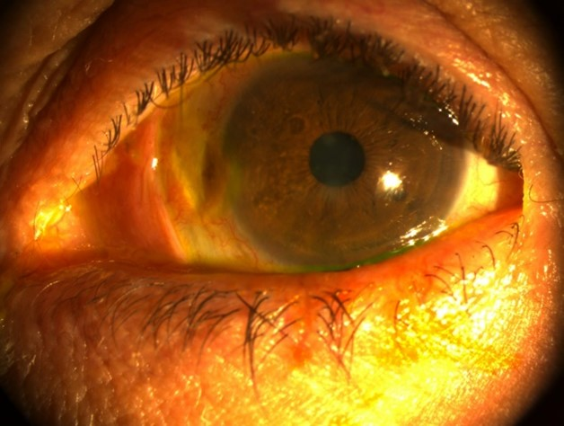

Figure 1: Scleral dellen with focal scleral thinning and brown discoloration at postoperative day 15 (Case 1).

A second autograft with smaller bare sclera was attempted but dislodged on day 3. Conservative management was pursued with preservative-free artificial tears (hourly), topical tobramycin 0.3%, autologous serum 30%, cicatrizing ointment (vitamin A - carbomer gel), and occlusion. Progressive improvement occurred, and complete healing was achieved within four weeks (Figure 2).

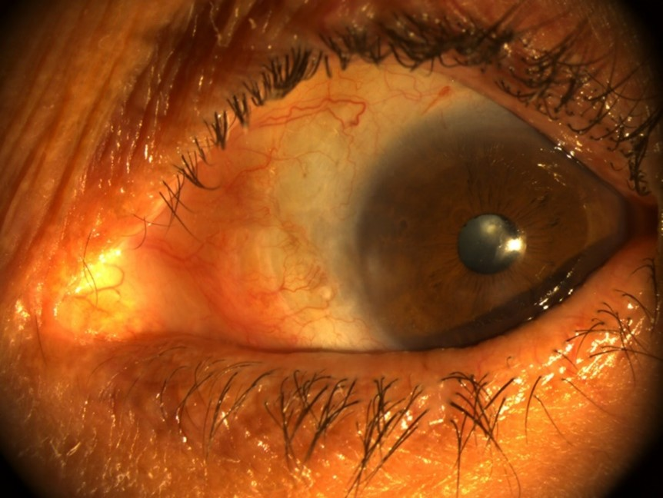

Figure 2 : Progressive healing after intensive topical therapy (Case 1, week 3).

Systemic work-up : including complete blood count, inflammatory and autoimmune screening, and infectious serologies, was unremarkable.

2.2 Case 2:
A 38-year-old man underwent uncomplicated primary pterygium excision with a conjunctival autograft sutured by 7-0 Vicryl, without mitomycin C or cautery. On day 16, he reported ocular pain and noted a dark nasal spot. Examination revealed scleral thinning with visible ciliary body and surrounding conjunctival edema; sutures had loosened. Intensive lubrication, topical antibiotics, and patching were prescribed. Epithelial recovery was noted within one week, and subsequent systemic evaluation was normal.

2.3 Case 3:
A 52-year-old man presented with stinging and redness in the left eye after pterygium surgery that included four perilimbal cauterization points. Postoperative therapy consisted of topical dexamethasone 0.1%–tobramycin 0.3%, unpreserved artificial tears, and healing ointment (vitamin A - carbomer gel),. By day 11, the conjunctival graft had melted, revealing a 4 × 3 mm corneoscleral dellen (Figure 3).

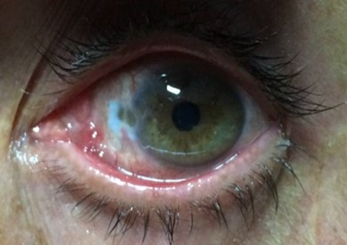

Figure 3: Corneoscleral dellen with necrotic conjunctival graft (Case 3, day 11).

Necrotic tissue was debrided, and steroids were discontinued. Intensive lubrication and antibiotic therapy were maintained. Because of slow epithelial recovery, 30% autologous serum was initiated hourly on day 15, resulting in rapid healing within one week. The serum was tapered over one month. At six-month follow-up, a mild pterygium recurrence was observed.

2.4 Case 4:
A 65-year-old man underwent grade II nasal pterygium excision under local anesthesia with lidocaine–adrenaline. A conjunctival autograft was secured with 7-0 Vicryl; no cautery or mitomycin C was used. Standard postoperative care included topical tobramycin–dexamethasone, unpreserved lubricants, healing ointment, and patching. On day 5, a 2 × 2.5 mm scleral dellen with visible uveal tissue developed. Despite five days of intensive medical therapy with autologous serum 30%, no improvement occurred. Surgical repair using cryopreserved amniotic membrane transplantation (AMT) was performed. The membrane was sutured with 7-0 Vicryl at conjunctival edges, providing complete coverage of the defect. AMT acted as a biologic dressing and source of epitheliotrophic factors. Complete epithelial and stromal healing occurred within four weeks (Figure 4), with full graft integration and no recurrence during follow-up.

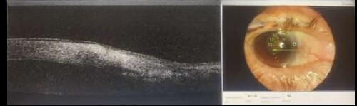

Figure 4: Healed scleral defect following amniotic membrane transplantation (Case 4, postoperative day 10).

All four patients presented localized scleral thinning without infection or inflammation. Three responded to conservative management; one required AMT. Complete recovery occurred in all within four weeks, with no residual thinning or recurrence of scleral defects.

3. discussion:

Scleral dellen is an uncommon postoperative complication characterized by localized scleral thinning secondary to focal dehydration and tear film instability over an avascular scleral surface [3,4]. Although rare, it represents a potentially serious adverse outcome of pterygium surgery if not promptly recognized and managed.
The pathogenesis is primarily mechanical and related to disruption of the tear film and exposure of bare sclera. Surgical factors such as conjunctival graft dehiscence, excessive cautery, and inadequate coverage of the scleral bed may compromise local hydration and perfusion, thereby predisposing to scleral thinning [3,5,7]. Previous reports indicate that scleral dellen typically develops within the first two postoperative weeks, a timeline consistent with the clinical course observed in our patients [3,4].
Topical corticosteroids remain a cornerstone of postoperative management after pterygium excision; however, their prolonged or intensive use may delay epithelial healing by inhibiting fibroblastic activity and epithelial migration, potentially aggravating scleral dehydration in vulnerable areas [5]. This highlights the importance of judicious steroid tapering in the early postoperative period.
Conservative management remains the first-line treatment and is effective in most reported cases. Intensive lubrication, topical antibiotic prophylaxis, cicatrizing ointments, and temporary ocular occlusion promote rehydration and epithelial regeneration [3,4]. Autologous serum eye drops have gained increasing interest due to their high concentration of growth factors, vitamins, and anti-inflammatory mediators essential for ocular surface healing. Their efficacy has been demonstrated in persistent epithelial defects and following pterygium surgery, with significant improvement in epithelial recovery [2,6].
In cases where medical therapy fails or when deep scleral thinning with uveal exposure is present, surgical intervention becomes necessary. Amniotic membrane transplantation provides both mechanical protection and a biologically active scaffold that promotes epithelialization and stromal repair. Its effectiveness in managing scleral thinning and complex ocular surface defects has been well documented [1,9,12].
Our findings are consistent with previously published case series reporting early-onset scleral dellen following pterygium excision, particularly in the presence of bare sclera exposure or graft instability [3–5]. In our series, three patients responded favorably to conservative therapy, including autologous serum, while one required amniotic membrane transplantation, reflecting a stepwise management approach supported by existing literature.
Preventive strategies remain essential and include avoiding bare sclera techniques, minimizing cautery near the limbus, ensuring secure conjunctival graft fixation, initiating early intensive lubrication, and carefully tapering topical corticosteroids [5,8,11]. Early recognition and appropriate management are crucial to prevent progression to scleral necrosis or perforation and to ensure favorable visual outcomes.

4. Conclusion

Scleral dellen is an uncommon but potentially serious early complication of pterygium surgery. Early recognition, intensive ocular surface therapy, and timely surgical intervention when required ensure excellent recovery. Preventive strategies : complete graft coverage, minimal cautery, adequate lubrication, and prudent steroid use, are key to reducing postoperative risk.

Consent

The authors certify that they have obtained all appropriate patient consent forms. In the form, the patient(s) has/have given his/their consent for his/their images and other clinical information to be reported in the journal. The patients understand that their names and initials will not be published and due efforts will be made to conceal their identity, but anonymity cannot be guaranteed.

Ethical approval

The authors certify that the study was conducted in accordance with ethical standards and was reviewed and approved by the appropriate Institutional Ethics Committee/Institutional Review Board (IRB). The study was performed in compliance with the ethical principles outlined in the Declaration of Helsinki (1964) and its later amendments. All necessary permissions were obtained prior to the commencement of the study.

Disclaimer (Artificial Intelligence)
Author(s) hereby declare that generative artificial intelligence technologies were used during the preparation of this manuscript exclusively for language editing, grammar correction, and formatting assistance. The scientific content, clinical data, interpretation of results, and final decisions remain the sole responsibility of the authors.
AI tool used: ChatGPT (OpenAI)
Model: GPT-5.2
Source: https://www.openai.com
Purpose of use:
Improvement of language clarity and academic style
Assistance with formatting of references according to journal requirements
Editing for grammar, spelling, and coherence
No generative AI tool was used for data generation, image creation, clinical decision-making, or fabrication of results.

References

- Sridhar MS, Bansal AK, Rao GN. Multilayered amniotic membrane transplantation for partial thickness scleral thinning following pterygium surgery. Eye. 2002;16(5):639-642. DOI: 10.1038/sj.eye.6700123.
- Tsubota K, Goto E, Shimmura S, Shimazaki J. Treatment of persistent corneal epithelial defect by autologous serum application. Ophthalmology. 1999;106(10):1984-1989. DOI: 10.1016/S0161-6420(99)90412-8.
- Boui H, Mouzari Y, Al Asri F, Reda K, Oubaaz A. Scleral dellen: Early complication of pterygium surgery. International Journal of Medical Science and Clinical Invention. 2020;7(6):4845-4847. DOI:10.18535/ijmsci/v7i06.04
- González-Gómez A, González de Gor Crooke JL, García-Ben A, García-Campos JM. Dellen and corneal perforation after bilateral pterygium excision in a patient with no risk factors. BMJ Case Reports. 2015;2015:bcr2015213319. DOI: 10.1136/bcr-2015-213319.
- Shukla P, Bhartiya S. Complications and recurrence after pterygium excision using mitomycin C eye drops versus sutureless and glue-free conjunctival autograft: A prospective study. Journal of Clinical and Diagnostic Research. 2020;14(9):NC01-NC04. DOI: 10.7860/JCDR/2020/44271.13926.
- Sul S, Korkmaz S, Alacamli G, Ozyol P, Ozyol E. Application of autologous serum eye drops after pterygium surgery: a prospective study. Graefes Archive for Clinical and Experimental Ophthalmology. 2018;256(10):1939-1943. DOI: 10.1007/s00417-018-4068-8.
- Mahar PS, Manzar N. Pterygium recurrence related to its size and corneal involvement. Journal of the College of Physicians and Surgeons Pakistan. 2013;23(2):120-123. PMID: 23374515.
- Clearfield E, Muthappan V, Wang X, Kuo IC. Conjunctival autograft for pterygium. Cochrane Database of Systematic Reviews. 2016;2:CD011349. DOI: 10.1002/14651858.CD011349.pub2. PMID: 26867004.
- Dua HS, Gomes JAP, King AJ, Maharajan VS.The amniotic membrane in ophthalmology. Survey of Ophthalmology. 2004;49(1):51-77. DOI: 10.1016/j.survophthal.2003.10.004. PMID: 14711440.
- Ti SE, Tan DTH.Tectonic corneal lamellar grafting for severe scleral melting after pterygium surgery. Ophthalmology. 2003;110(6):1126-1136. DOI: 10.1016/S0161-6420(03)00260-4. PMID: 12799236.
- Mutlu FM, Sobaci G, Tatar T, Yildirim E. A comparative study of recurrent pterygium surgery: limbal conjunctival autograft transplantation versus mitomycin C with conjunctival flap. Ophthalmology. 1999;106(4):817-821. DOI: 10.1016/S0161-6420(99)90172-0. PMID: 10201608.
- Solomon A, Espana EM, Tseng SCG.Amniotic membrane transplantation for reconstruction of the conjunctival fornices. Ophthalmology. 2003;110(1):93-100. DOI: 10.1016/S0161-6420(02)01441-0. PMID: 12511352.

