A Rare Case Report on Left Atrial Myxoma

.
ABSTRACT
Left atrial myxoma is the most common benign primary cardiac tumor, typically arising from the interatrial septum. It is associated with nonspecific systemic, embolic, and obstructive symptoms, making early diagnosis and timely intervention essential. Early surgical excision is the treatment of choice once the diagnosis is established. We report the case of a 60-year-old female with known risk factors for coronary artery disease, including diabetes mellitus and hypertension, who presented with fever, progressive dyspnea for 8–10 days, and a transient episode of right-sided weakness lasting 5–10 minutes. Transthoracic echocardiography revealed a mobile left atrial mass attached to the interatrial septum, suggestive of myxoma. Preoperative coronary angiography showed significant coronary artery disease. The patient underwent successful surgical excision of the left atrial myxoma along with concomitant coronary artery bypass grafting under cardiopulmonary bypass. Histopathological examination confirmed the diagnosis. The postoperative course was uneventful, with complete resolution of symptoms and no recurrence on follow-up.

Keywords: Left atrial myxoma, Echocardiography, Cardiopulmonary bypass, Cardiac myxoma

1. INTRODUCTION
“Cardiac myxoma is a rare disease; however, the exact prevalence is unknown. The reported prevalence is 0.03% in the general population” [1]. “The annual incidence of cardiac Myxoma 0.5 to 1 case per million individuals”. [2,3]
“Cardiac myxomas are rare benign and slowly proliferating neoplasms of uncertain histogenesis with heterogeneous histomorphology and variable and sometimes clinically quite malignant pathological manifestations”.[4] “Cardiac myxomas are common primary neoplasms of the heart. They are biologically benign but “functionally malignant” because of the potential for embolization. They arise most commonly from the left atrium”.[5]
“It is located in the left atrium and typically arises from the foramen ovale in approximately 75% of the general patient population, in the right atrium in 23%, and in the ventricles in only 2%”.[6] “The most frequent initial manifestations of myxomas include dyspnoea and symptoms of congestive heart failure by cardiac obstruction, palpitations, chest pain, signs of embolism and systemic rheumatism, depending on the localization, size and humoral activity of the tumor”.[7] “Medical history, conducting a physical examination, and performing necessary diagnostic tests such as echocardiography particularly transthoracic echocardiography, computed tomography scan, coronary angiography, cardiac MRI, or biopsy are crucial for an accurate diagnosis of cardiac myxoma” .[8] “Surgical resection of the myxoma is the treatment of choice, surgery being safe with low morbidity and mortality’.[9] However, “incomplete resection, multifocal tumors, and embolism caused by tumors are important factors in its recurrence and complications”.[10]
2. CASE PRESENTATION

A 60-year-old female presented to the Cardiothoracic and Vascular Surgery (CTVS) outpatient department with complaints of low-grade fever persisting for 8–10 days, progressive dyspnea, and a sudden episode of right-sided weakness that resolved spontaneously within 5–10 minutes. She was a known case of type 2 diabetes mellitus, managed with oral hypoglycemics (tablet metformin 500 mg and tablet glimepiride 1 mg once daily in the morning), and had a history of hypertension and coronary artery disease, though prior records were unavailable.
Initial echocardiography revealed a left atrial mass attached to the interatrial septum measuring approximately 1.5 × 1.5 cm. The patient was admitted on 10 December 2024 for further evaluation. On physical examination, basal crepitations and use of accessory muscles of respiration were noted. Laboratory evaluation showed hemoglobin within normal limits, normal iron profile, HbA1c of 6.7%, and random blood glucose of 190 mg/dL. NT-proBNP levels were within normal range.
Transthoracic echocardiography demonstrated a left atrial myxoma measuring 14 × 12 mm attached to the interatrial septum, with no mitral inflow obstruction. Left ventricular ejection fraction was preserved, pulmonary artery pressures were normal, and no significant diastolic dysfunction was noted, making HFpEF unlikely. Chest radiography revealed bilateral pleural effusion.
Coronary angiography performed due to significant coronary artery disease risk factors revealed single-vessel coronary artery disease (Fig-1). Doppler ultrasonography showed atherosclerotic changes in bilateral lower limb arteries and increased bilateral carotid artery intima-media thickness. Cardiac MRI confirmed a well-defined, broad-based pedunculated mass attached to the interatrial septum just above the mitral valve, consistent with left atrial myxoma (Fig-2). Neurological evaluation with CT/MRI brain showed no acute infarct, consistent with a transient ischemic attack.
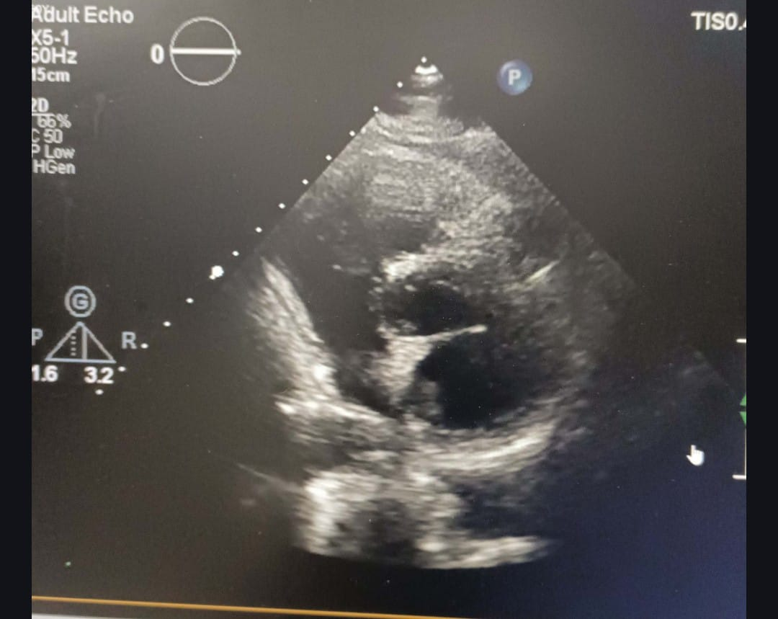
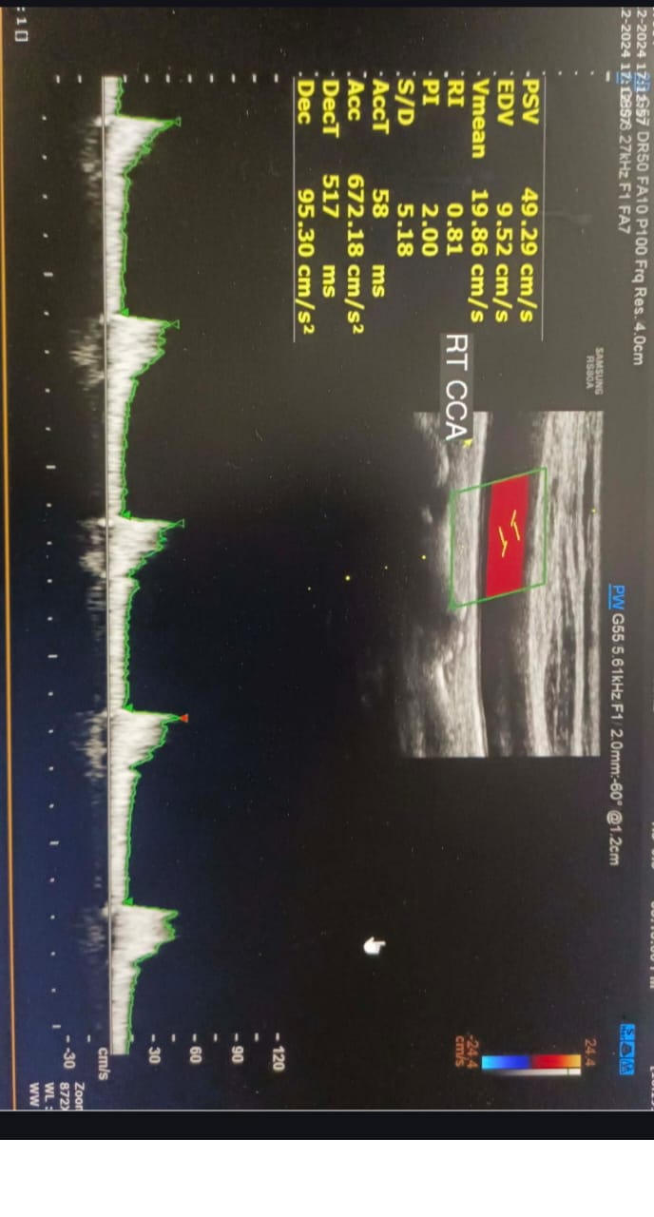
The patient was managed preoperatively with anticoagulation (injection heparin 2000 IU stat), antihypertensive therapy (tablet cilnidipine 5 mg BD, tablet nebivolol 2.5 mg BD), and insulin therapy (human Actrapid as per sliding scale). The CTVS team planned surgical excision of the myxoma with concomitant coronary artery bypass grafting in view of significant coronary artery disease.

FIG-2 Echocardiography showed a left atrial myxoma measuring 14x12 mm, attached to the interatrial septum (IAS), with no mitral inflow obstruction
FIG-1 Doppler ultrasonography indicated atherosclerotic changes in the bilateral lower limb arteries and increased bilateral carotid artery intima-media thickness

On 12 December 2024, the patient underwent surgery, which included left atrial myxoma excision and coronary artery bypass grafting. A saphenous vein graft (SVG) was used to bypass the obstruction in the third diagonal branch (D3) of the left anterior descending artery. (Fig-3) Histopathological examination confirmed the presence of a benign tumor, composed of lepidic cells within myxoid stroma, with a gelatinous mass appearance (Fig-4). Postoperatively, the patient was managed in the CTVS ICU with ventilator support. IV antibiotics (Inj cefuroxime sodium 1.5 gm BD) were administered initially, and on postoperative day 2, the IV antibiotics were switched to oral cefuroxime 500 mg BD. On postoperative day 1, the patient developed a cough, and a chest X-ray revealed pleural effusion and consolidation.

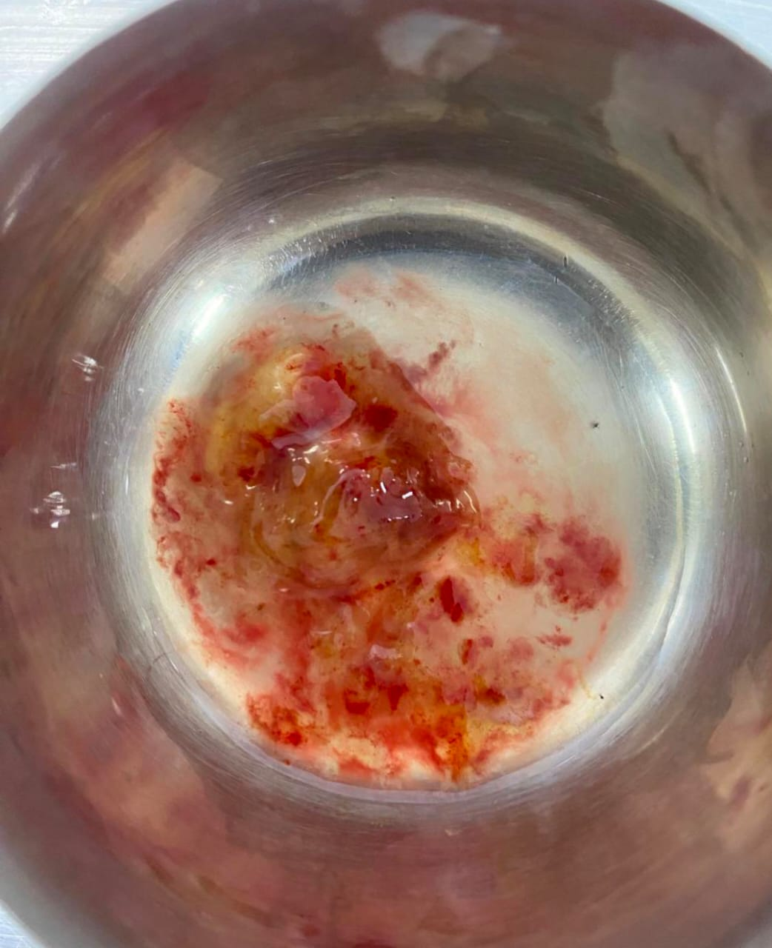
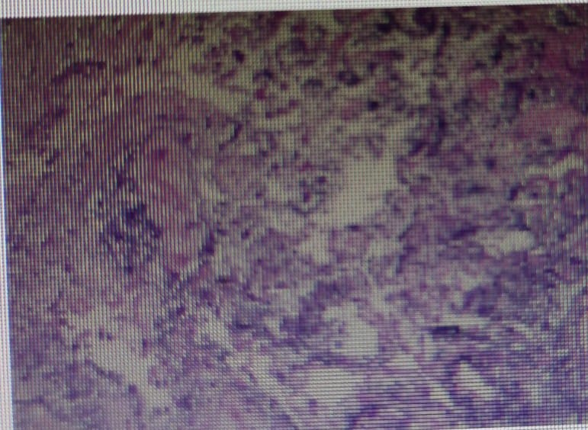
Fig-4 Histopathological findings; Histopathological examination confirmed the presence of a benign tumor, composed of lepidic cells within myxoid stroma, with a gelatinous mass appearance.
Fig-3 surgical findings; A saphenous vein graft (SVG) was used to bypass the obstruction in the third diagonal branch (D3) of the left anterior descending artery

patient was managed with nebulization (acetylcysteine twice daily and budesonide 0.5 mg) and chest physiotherapy, resulting in symptomatic improvement. For underlying coronary artery disease, she was initiated on guideline-directed medical therapy including dual antiplatelet agents, high-intensity statin therapy, beta-blocker, diuretics, and optimized glycemic control with insulin.
The postoperative course was uneventful. The patient was transferred to a step-down ward on postoperative day 3 and showed progressive clinical recovery with resolution of dyspnea. She was discharged in stable condition on postoperative day 8 on appropriate cardiac, antihypertensive, antidiabetic, and supportive medications, with advice for regular follow-up

3. discussion

“Cardiac myxomas are rare benign and slowly proliferating neoplasms of uncertain histogenesis with heterogeneous histomorphology and variable and sometimes clinically quite malignant pathological manifestations”.[1]. “The growth rate of LA myxomas was first described in 1987” [11, 12] and has been reported in several studies since then. “The median value and range of growth rate were 3.5 mm/ month and 0–28.3 mm/month”, respectively. Walpot et al.[13] . “In our case, although there were no significant change in the growth rate of the left myxoma within 15 days. The most frequent initial manifestations of myxomas include dyspnoea and symptoms of congestive heart failure by cardiac obstruction, palpitations, chest pain, signs of embolism and systemic rheumatism, depending on the localization, size and humoral activity of the tumor” .[7] Our patient was a 60 years female patient was presented with a complains of fever and difficulty on breathing since 8-10 days and history of right sided weakness- sudden onset and disappeared within 5-10 mins . Echocardiography performed by physician revealed LA mass attached to the inter- atrial septum(1.5cm x1.5cm) .surgical resection of the myxoma is the treatment of choice, surgery being safe with low morbidity and mortality.[9].In our case surgery was performed which included LA myxoma excision and coronary artery bypass grafting.
However, “incomplete resection, multifocal tumors and embolism caused by tumors are important factors in its recurrence and complications”.[10]. our patient developed respiratory complication inhomogeneous opacification of the left mid and lower zone obscuring left CP angle, dome of diaphragm suggestive of pleural effusion, and haziness noted underlying lung field suggestive of consolidation of lungs. Anticipating such complications and timely interventions accordingly is needed in such instances.

4. Conclusion

Cardiac myxoma is a rare heart disease observed in a small proportion of the general population Combining echocardiography and clinical manifestations may help make an accurate diagnosis. Early diagnosis through non-invasive imaging, such as transthoracic or transesophageal echocardiography, is critical to prevent serious complications like stroke or sudden cardiac death. Surgical excision remains the definitive treatment, offering excellent outcomes and symptom resolution. Regular postoperative follow-up with echocardiographic examination is required to evaluate for the recurrence of myxoma. This case highlights the importance of early recognition and management of left atrial myxoma to prevent embolic and obstructive complications.

Consent
As per international standards or university standards, patient(s) written consent has been collected and preserved by the author(s).

Disclaimer (Artificial intelligence)
Author(s) hereby declare that NO generative AI technologies such as Large Language Models (ChatGPT, COPILOT, etc.) and text-to-image generators have been used during the writing or editing of this manuscript.

References

1. Yoon, D. H., & Roberts, W. (2002). Sex distribution in cardiac myxomas. American Journal of Cardiology, 90(5), 563-565. https://doi.org/10.1016/s0002-9149(02)02540-7
2. Keeling, I. M., Oberwalder, P., Anelli-Monti, M., Schuchlenz, H., Demel, U., Tilz, G. P., Rehak, P., & Rigler, B. (2002). Cardiac myxomas: 24 years of experience in 49 patients. European Journal of Cardio-Thoracic Surgery, 22(6), 971-977. https://doi.org/10.1016/s1010-7940(02)00592-4
3. Gošev, I., Paić, F., Đurić, Ž., Gošev, M., Ivčević, S., Jakuš, F. B., & Biočina, B. (2013). Cardiac myxoma the great imitators: comprehensive histopathological and molecular approach. International Journal of Cardiology, 164(1), 7-20. https://doi.org/10.1016/j.ijcard.2011.12.052
4. Islam, A. K. M. M. (2022). Cardiac myxomas: A narrative review. World Journal of Cardiology, 14(4), 206-219. https://doi.org/10.4330/wjc.v14.i4.206
5. Grebenc, M. L., Rosado de Christenson, M. L., Burke, A. P., Green, C. E., & Galvin, J. R. (2000). Primary cardiac and pericardial neoplasms: radiologic-pathologic correlation. *Radiographics*, *20*(4), 1073–103. https://doi.org/10.1148/radiographics.20.4.g00jl081073
6. Samanidis, G., Khoury, M., Balanika, M., & Perrea, D. N. (2020). Current challenges in the diagnosis and treatment of cardiac myxoma. Kardiologia Polska (Polish Heart Journal), 78(4), 269-277. https://doi.org/10.33963/KP.15254
7. Knepper, L. E., Biller, J., Adams, H. P., Jr., & Bruno, A. (1988). Neurologic manifestations of atrial myxoma. A 12-year experience and review. Stroke, 19(11), 1435-1440. https://doi.org/10.1161/01.str.19.11.1435

8. Rabiee Rad, M., Ghasempour Dabaghi, G., Darouei, B., Amani-Beni, R., Zare, M. M., Shirin, F., & Jamalian, M. (2024). Clinical and laboratory manifestations, ECG findings, and outcomes of right atrial myxoma: a systematic review of cases reported worldwide. The Egyptian Heart Journal, 76(1), 125. https://doi.org/10.1186/s43044-024-00550-x .
9. Lone, R. A., Ahanger, A. G., Singh, S., Mehmood, W., Shah, S., Lone, G. N., Dar, A. M., Bhat, M. A., Sharma, M. L., & Lateef, W. (2008). Atrial myxoma: Trends in management. International Journal of Health Sciences, 2(2), 141-151. https://ijhs.qu.edu.sa/index.php/journal/article/view/59
10. Chojdak-Łukasiewicz, J., Budrewicz, S., & Waliszewska-Prosół, M. (2022). Cerebral Aneurysms Caused by Atrial Myxoma—A Systematic Review of the Literature. Journal of Personalized Medicine, 13(1), 8. https://doi.org/10.3390/jpm13010008 .
11. Marinissen, K. I., Essed, C., de Groot, C., Schelling, A., & Hagemeijer, F. (1987). Growth rate of left atrial myxoma. Development of a symptomatic left atrial myxoma less than two years after coronary artery bypass grafting. Chest, 92(5), 941–2. https://doi.org/10.1378/chest.92.5.941
12. Roudaut, R., Gosse, P., & Dallocchio, M. (1987). Rapid growth of a left atrial myxoma shown by echocardiography. British Heart Journal, 58(4), 413–416. https://doi.org/10.1136/hrt.58.4.413
13. Walpot, J., Shivalkar, B., Rodrigus, I., Pasteuning, W. H., & Hokken, R. (2010). Atrial myxomas grow faster than we think. Echocardiography, 27(10), E128-E131. https://doi.org/10.1111/j.1540-8175.2010.01186.x

14.Kato T, Umeda E, Suzui N, et al. Rapid expansion of a left atrial myxoma caused by acute multiple internal hemorrhages: a case report and literature review. J Cardiothorac Surg. 2024;19:13. doi:10.1186/s13019-024-02495-3. This recent report discusses unusual growth behavior and clinical implications of left atrial myxoma.

15.Li Y, Tang M, Wu Q, et al. First report of successful surgical management of left atrial myxoma coexisting with pulmonary squamous cell carcinoma and thymic cyst. Eur J Med Res. 2024;29:373. doi:10.1186/s40001-024-01974-6. This 2024 case highlights complex presentations and surgical considerations of LA myxoma.

16.Lancaster I, Hrobowski-Blackman T, Patel D, et al. Left atrial myxoma with cardiogenic shock following myocardial infarction: a case report. J Med Case Rep. 2024;18:151. doi:10.1186/s13256-024-04420-7. This recent case emphasizes the potential for myxoma to complicate coronary disease presentations.

