Phenological pattern of Sterculia villosa Roxb. ex Sm., A Lesser Known and Threatened Tree Species in the Tropical Moist Deciduous Forest

Abstract
The present trial was carried out with the objective to study the phenological pattern and the relation of weather parameters with phenophases of Sterculia villosa Roxb. ex Sm., distributed at Panas medicinal plot in tropical moist deciduous forest, during the year 2022 and 2023. Trees with distinctive crown having more than 10 cm DBH were selected by following selective sampling method. Different phenophases (leaf fall, leaf renewal, flowering, fruiting and fruit falling) were observed fortnightly for two years. In the vegetative phenology, S. villosa, leaf fall started in the month of November and continued till the first half of February month about 14 weeks. Likewise, leaf renewal period was noticed 10 weeks in the months of the second half of May to July. Leafless period of S. villosa, was noticed from the second half of February to the first half of May with a duration of 12 weeks in leafless condition. In reproductive phenological events, flowering initiation was recorded for 8 weeks which started from second half of January to first half of March; whereas, fruiting period was noticed from first half of March to first half of April with 6 weeks duration. Further, fruit fall occurred during April and May with a duration of 8 weeks. Weather parameters showed significant correlation with phenophases of S. villosa, Temperature showed the negative correlation with leaf fall, fritting and fruit fall; however positively related with leaf renewal. Rainfall and relative humidity both negatively related with leaf renewal, fruiting and fruit fall phenophases of S. villosa.
Keywords: Climate change, reproductive phenology, sterculia species, tropical moist deciduous forest, vegetative phenology
Introduction
Phenology is the field of scientific inquiry in which the study of the timing of recurring seasonal biological events are carried out for centuries (Nadarajan and Pujari, 2019). At its core, phenology represents the temporal dimension of natural history, a critical aspect because it determines the developmental stage of an organism or population when it interacts with specific environmental components. It encompasses the rhythmic appearance of plant vegetation and reproductive cycles over time, as well as the relationship between climatic factors and periodic events in plants (Gordo and Sanz, 2005). Phenological events include flowering, changes in leaf colour, leaf fall, leaf initiation, and fruiting (Nadarajan and Pujari, 2019). Recent climate changes have impacted these events, affecting plant lifecycles (Ibeabuchi et al., 2018). Therefore, phenology serves as a crucial tool for studying climate change, allowing observation of direct changes in species composition, longer growing seasons, earlier flowering, and shifts in phenophases (Kanwar and Sharma, 2023). As such, phenology is a major structuring element in nearly all areas of ecology and evolution (Forrest and Miller-Rushing, 2010). Generally, phenology study helps to provide information about the seasonal changes of tree species with respect to change in weather parameters, so that the timing of flowering, fruiting and fruit falling helps the farmers, foresters and scientists for collection or improvement characteristics of studied tree species (Chmielewski, 2003). The phenology of the tropical forest is still not understood well (Borchert, 2002) and due to a lack of standardized terminology information regarding tropical forest trees is adequate and studies are based on community-level patterns only (Newstrom et al., 1994). Therefore, the phenological data information is one of the essential parts of the conservation tool and a major indicator of climate change in biodiversity (Janetos et al. 2012; Parry et al. 2007). In dry tropical forests, changes in phenological patterns are mostly caused by the seasonal variation in rainfall, soil water availability and photoperiod (Hernández et al., 2010).
Sterculia villosa also known as Udal or Odal or Udar or Sardol is native to India and one of the indigenous fast-growing tree species which is widely distributed almost throughout the greater part of India, up to an elevation of 1000 m, particularly in the states of Uttar Pradesh, Bihar, West Bengal, Assam, Odisha, Gujarat, Northeastern states and hills of South India including Andaman and Nicobar Islands (Dholariya et al., 2019). It is a moderate-sized deciduous tree belongs to the family Malvaceae as per Plants of the World Online, though it was formerly placed in its own family Sterculiaceae (Singh et al., 2024; Morton and Thomas, 1977). Tree is producing ‘karaya gum’ one of the important non-timber forest products; wood is used to make tea boxes, toys, guitars, cheap matchboxes, splints, and commercial plywood grade IV. It is also a good raw material for paper and pulp (Saikia et al., 2021; Barua and Rabha, 1992). This tree produces pellucid gum with significant medical properties that emerges from the bark is referred locally as ‘katila gum’ and is used in place of gum tragacanth, which has significant therapeutic properties. Moreover, whole plant extract is used to treat skin conditions (Dholariya et al., 2019). Very limited study was carried out on the phenology patterns and climatic parameters impact on the phenophases of the threatened tree species in the tropical deciduous forest conditions. So, in this study, examined the phenological pattern (leaf fall period, leaf renewal period, leafless period, flowering period, fruiting period and fruit fall period) of S.villosa, one of the threatened tree species of Gujarat, and correlating phenophases with various weather parameters, to infer the effect of these weather parameters on vegetative and reproductive phenophases.
Material and Methods
- Study site
Present study was carried out at Panas medicinal plot present in the Moist Teak Forest type (3B/C1_{b}) of Southern Tropical Moist Deciduous Forest (3B) of South Valsad Forest Division, in the South Gujarat region, India. The location map of research site is depicted as in Fig. 1.
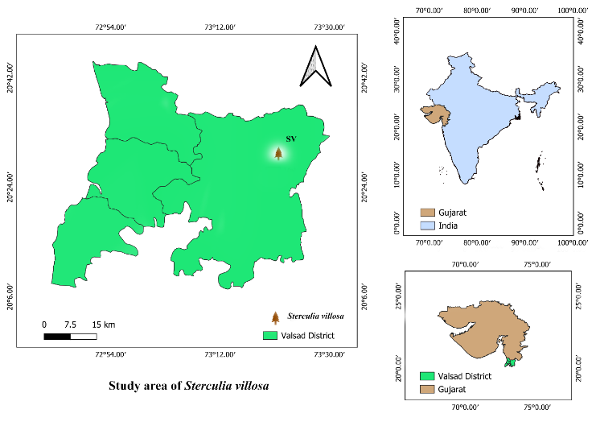
Fig. 1. Location map of Sterculia villosa at Panas Medicinal Garden, Valsad, Gujarat
- Climatic conditions
The study area situated in the South Gujarat region, which consists of the seven districts of Bharuch, Narmada, Navsari, Surat, Tapi, the Dangs and Valsad. Climatically, this region one of the wettest areas of India (Patil et al., 2023). Among this the Dangs, Navsari, Valsad and southern part of Surat district falls under the South Gujarat heavy rainfall Agro-Climatic zone-I. characterised by very high annual precipitation. Mean annual temperature of South Gujarat during summer ranging from 25 to 45 °C and winter ranging from 15 to 35 °C. South Gujarat falls into Southern Heavy Rainfall Zone I, which receives over 1500 to 2200 mm of rainfall annually. The studied area comes under the Southern Heavy Rainfall Zone I which consists of hilly and forest soil with moderately deep loamy soil (Patil et al., 2023).
- Methodology and Phenological data collection
Study was carried out by randomly selecting 5 individuals (>10 cm DBH) of S. villosa with well-developed crown distributed in the Panas medicinal plot. Trees with distinctive crown were marked for the study using selective sampling. Tree biometrical parameters are also noted and depicted in Table 1. Observations of phenophase such as leaf fall, leaf renewal, flowering, fruiting and fruit fall were recorded consecutively for two years of the study period of 2022 and 2023. Phenological events observations were taken twice in a month, first at the first fortnight and second at the second fortnight having intervals of 15 days. Further for phenophases, four different scores were used such as Score 1=1 to 25 %, Score 2=26 to 50%, Score 3=51 to 75 % and Score 4=76 to 100% (Gunaga, 2000). The average value of 5 individuals for each event was provided for easy understanding. The weather parameters like rainfall, temperature and humidity data collected from the nearest meteorological observatory present at Agricultural Experimental Sation, Navsari Agricultural University, Paria, Valsad.
Table 1: Tree biometrical parameters of Sterculia villosa
Tree biometrical parameters
Girth (cm) |  |  | Tree height (m) |  |  | Crown Diameter (m)
Min | Max | Mean | Min | Max | Mean | Min | Max | Mean
70.00 | 80.00 | 75.00 | 6.50 | 9.60 | 8.05 | 7.25 | 9.5 | 8.45

d. Statistical analysis
Phenological observations were analysed by using descriptive statistics. Moreover, to evaluate the independent impact of each environment factors, Spearman’s rank correlation was performed following the methodologies outlined by Zar (2007) by using GRAPES software. Heatmap based on the results of the correlations matrix and circular plot for phenophases were prepared using R software.
Results and Discussion
Phenological patterns in Sterculia villosa
During the present investigation, Sterculia villosa was enumerated for the documentation for the detailed phenological study. In the vegetative phenology, S. villosa, leaf fall started in the month of November and continued till the first half of February month about 14 weeks; whereas, leaf renewal period was noticed 10 weeks in the months of the second half of May to July. In the first half of November, the leaf fall recorded up to 25% then in later half it increased up to 26 to 75%. In December to January, it increased 51 to 75% and it was 76 to 100% completed in first half of February. Likewise, leaf renewal noted up to 25% in the second half of May, which increased up to 50% in the first half of June and gradually increased up to 75% in the second half of June and first half of July. Leaf renewal completed (100%) in the second half of July. Moreover, leafless period of S. villosa, was recorded from the second half of February to the first half of May with of 12 weeks leafless condition. S. villosa in reproductive phenological events, flowering initiation was recorded for 8 from second half of January to first half of March; whereas, fruiting period was noticed from first half of March to first half of April with 6 weeks duration. Further, fruit fall occurred during April to May with a duration of 8 weeks. Furthermore, up to 25% flower initiation was observed in the second half of the January; 26 to 50% in the first half of February; 51 to 75% in the second half of February and completed 76 to 100% in the first half of March. Likewise, fruit fall was noticed for short duration of two months and up to 25% was noted in the first half of April; 26- 50% in the second half of April; 51- 75% first half of May and completed 100% in the second half of May. The phenological events recorded for the first year and second year were also same with little variation as described in the phenogram (Table 2 and Fig. 2). Moreover, on the basis of leafless period noticed, the tree was deciduous in nature and the leafless was found for a period of 12 weeks (Table 3). The different photographs of phenophases of S. villosa is depicted in Photo 1.
Phenological monitoring has become a crucial technique for the impacts of shifting weather patterns determination (Antwi Boasiako et al., 2024). Since many phenological phenomena are extremely sensitive to various weather parameters (Likewise temperature, humidity and rainfall), they serve as early and reliable indicators of climate change (Bajpai et al., 2025). The phenology of tree species normally influenced by the environmental conditions of a specific region and moreover, phenophases varies according to the variation in environmental conditions and in certain conditions due to management practices. In S. villosa, leaf fall occurred during November and December, with trees becoming leafless in May or June. The flowering period was noted from January to February, while fruiting took place in April and May as reported by Troup (1921). Additionally, scientist of Gujarat reported that flowering occurred between November and April, with fruiting occurring from December to May in S. villosa. Moreover, looking into the phenology of S. urens in Amrabad Tiger Reserve, Telangana, India, leaf fall occurred from second half of November to second half of December about 30 days; leafless in fourth week of December to second week of April about 106 days; flowering from fourth week of March to fourth week of April about 30 days; fruiting from second half of March to second half of August about 92 days; fruit dispersal last week of August to second half of October about 46 days as per Shankar et al. (2022). Similar way, Dutta and Devi (2015) worked on six tropical tree species in the tropical forest of Assam, Northeast India and reported that S. colorata and S. villosa, leaf fall in January to March and December to April respectively; flowering in February to March; fruiting in March to April and March to June. Moreover, flowering occurred from December to March with a duration of 4 months and leafless period more than 4 months of S. urens in Vindhyan dry forest of India as reported by Kushwaha et al. (2011).

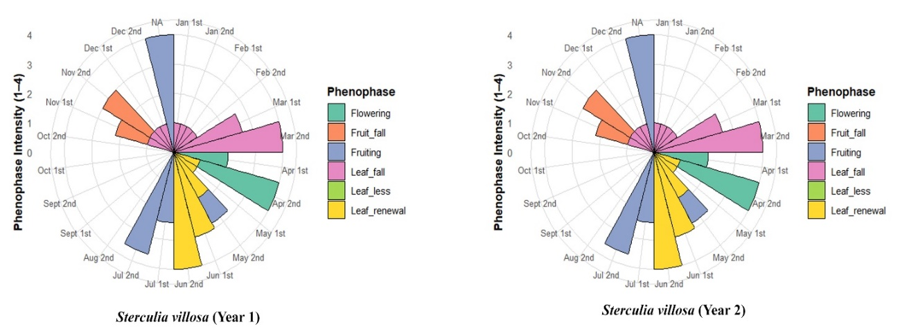
Fig 2: Circular plot of different phenophases of Sterculia villosa for two years

Table 2: Details of different phenological events of Sterculia villosa
Vegetative phenophases
Leaf falling |  | Leaf renewal |  | Leafless character
Period (Months) | Duration (Week) | Period (Months) | Duration (Week) | Period (Months) | Duration (Week)
Nov-1st half- Feb | 14 | 2nd half- May - July | 10 | 2nd half Feb - 1st half- May | 12
Reproductive phenophases
Flowering |  | Fruiting |  | Fruit falling
Period (Months) | Duration (Week) | Period (Months) | Duration (Week) | Period (Months) | Duration (Week)
2nd half Jan - 1st half- March | 8 | March- 1st half-April | 6 | April -May | 8

Table 3: Phenophase pattern and nature of Sterculia villosa

Leaf fall period | Leaf renewal period | Leafless period | Flowering period | Fruiting period | Fruit fall period | Nature of Tree species
Nov-Feb | May-Jul | Feb-May | Jan-Mar | Mar-Apr | Apr-May | Deciduous

Leaf falling | Leaf renewal | Leafless | Flowering | Fruiting
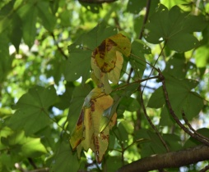 | 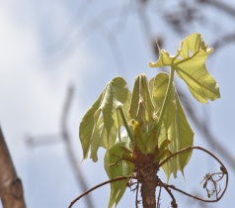 | 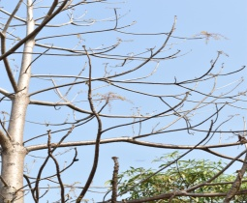 | 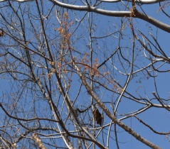 | 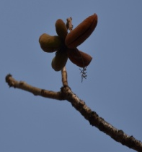

Photo 1: Different Phenophases photographs of Sterculia villosa
Weather factors influencing on phenology of Sterculia villlosa
Spearman’s rank correlation analysis was performed for ten phenological and climatic variables in S. villosa. The correlation of the phenological parameters with climatic variables reveals a complex network of primary relationships with temperature and rainfall. During the vegetative phenophases, leaf fall exhibited the most pronounced negative correlation with Tmax (r= -0.493, p < 0.01) and Tmin (r= -0.488, p < 0.01); conversely, it demonstrated a positive correlation with fruit fall (r= 0.380, p < 0.01) and fruiting (r= 0.341, p < 0.05), while remaining independent of precipitation, relative humidity (RH₁= morning humidity and RH₂= afternoon humidity), flowering, and leaf renewal. Leaf renewal had the most significant negative connection with rainfall (r=-0.617, p < 0.01), followed by RH₁ (r=-0.544, p < 0.01), RH₂ (r=-0.539, p < 0.01), and blooming (r=-0.464, p < 0.01). However, it exhibited a favorable correlation with the variable Tmax and fruit fall. In the reproductive phases, the most independent phase, flowering exhibited a significant negative link with leaf renewal (r=-0.464, p < 0.01) and no significant correlation with other meteorological factors. Fruiting had a negative connection with Tmin (r=-0.504, p < 0.01), Tmax (r=-0.394, p < 0.01), rainfall (r=-0.284, p < 0.005), and afternoon relative humidity (RH₂) (r=-0.354, p < 0.005). Additionally, fruit fall had the most significant negative connection with RH₂ (r=-0.555, p < 0.01), followed by RH₁ (r=-0.506, p < 0.01), rainfall (r=-0.413, p < 0.01), and Tmin (r=-0.355, p < 0.005). Similarly, among the environmental variables, RH₂ exhibited a strong positive correlation with rainfall (r=0.785, p < 0.01); minimum temperature (Tmin) showed a moderate positive correlation with both rainfall (r=0.570, p < 0.01) and RH₁ (r=0.802, p < 0.01) with RH₂.
These results are comparable with earlier studies that highlight the role of weather parameter in the phenological events of different tree species. For instance, Nanda et al. (2014) reported flowering of 22 tree species in tropical deciduous forest positively correlated with rainfall and humidity. Moreover, Nadarajan and Pujari (2019) reported temperature effected flowering and precipitation effected fruiting in Syzygium caryophyllatum (L.) Alston. In the Garhwal Himalaya, Singh et al. (2020) found negative correlation between rainfall and leaf senescence, Shankar et. al (2022) reported flowering negatively correlate with rainfall in the selected tree species of Amrabad Tiger Reserve, Telangana. Singh et al. (2023) found rainfall and minimum temperature are the primary parameters which activates the leaf initiation and flowering in temperate species. Sharma et al. (2024) also observed strong correlation of leaf initiation with temperature and flowering with sunshine and similarly in the study, result indicated significant positive correlations but more moderate r values suggesting that in moist climate multiple weather parameters effecting not only one factor.
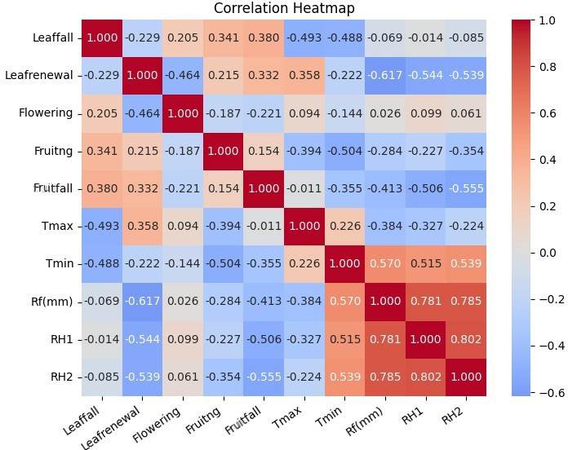
Fig. 3: Spearman correlation of weather parameters and phenology of Sterculia villosa (r ≤ 0.250 NS)
Conclusion
Sterculia villosa is a deciduous tree species in the Moist Teak Forest of Southern Tropical Moist Deciduous Forest. Different phenophases are observed with specific duration of each phenophase. Leaf fall, leaf renewal, leafless condition, flowering, fruiting and fruit falling are recorded for a period of 14 weeks, 10 weeks, 12 weeks, 8 weeks, 6 weeks and 8 weeks respectively. Moreover, weather parameters show significant correlation with phenophases of S. villosa, Temperature is negatively correlated with leaf fall, fritting and fruit fall; however positively related with leaf renewal. Rainfall and relative humidity both negatively related with leaf renewal, fruiting and fruit fall phenophases of S. villosa.

Disclaimer (Artificial intelligence)

Author(s) hereby declare that NO generative AI technologies such as Large Language Models (ChatGPT, COPILOT, etc.) and text-to-image generators have been used during the writing or editing of this manuscript.

References
- Antwi-Boasiako, A., Amponsah, P., Adoma Opoku, J., Coulibaly, D. & Mintah, P. (2024). Increasing mango production efficiency under the fast-changing climate. In: Abiotic stress in crop plants- Eco physiological responses and molecular approaches. IntechOpen. DOI: 10.5772/intechopen.112951.
- Bajpai, Y., Bajpai, A., Soni, S. K., Rastogi, L. & Trivedi, M. (2025). Impact of Weather Changes on the Phenostages and Flowering Times of Mango (Mangifera indica L.). Applied Fruit Sci., 67(2), 51. DOI: 10.1007/s10341-025-01272-3
- Chmielewski, F. M. (2003). Phenology and agriculture. Springer Netherlands, 505-522.
- Chmielewski, F. M. (2003). Phenology and agriculture. Springer Netherlands: pp. 505-522
- Dholariya, C. A., Sukhadiya, M., Behera, L. K., Desai, B. S., Huse, S. A. & Mehta, A. A. (2019). Utilization and silviculture of a lesser-known tree species: Sterculia villosa Roxb. Van Sangyan, 6(4), 16-18.
- Dutta, G., & Devi, A. (2015). Phenology and population structure of six tree species in Tropical Forest of Assam, northeast India. Tropical Ecology, 56(3), 393-399.
- Fitchett, J. M., Grab, S. W. & Thompson, D. I. (2015). Plant phenology and climate change: Progress in methodological approaches and application. Progress in Physical Geography, 39(4), 460-482.
- Forrest, J. & Miller-Rushing, A. J. (2010). Toward a synthetic understanding of the role of phenology in ecology and evolution. Philos Trans R Soc Lond B Biol Sci., 365(1555), 3101-12.
- Gopinath, et al., (2021). Grapes Agri1: Collection of Shiny Apps for Data Analysis in Agriculture. Journal of Open-Source Software, 6(63), 3437.
- Gordo, O. & Sanz, J. J. (2005). Phenology and climate change: a long-term study in a Mediterranean locality. Oecologia. 146, 484-495.
- Gunaga, R. P. (2000). Genetic Variation for Phenology in a Clonal Seed Orchards of Teak (Tectona grandis Linn.f). (M.Sc. thesis). U. A. S., Dharwad.
- Hernández, V. M., Andrade, J. L., Jackson, P. C. & Rebolledo-Vieyra, M. (2010). Phenology of five tree species of a tropical dry forest in Yucatan, Mexico: effects of environmental and physiological factors. Plant and soil, 329, 155-171.
- Igboabuchi, N. A., Echereme, C. B. & Ekwealor, K. U. (2018). Phenology in Plants: Concepts and Uses. Ijsrm. Human, 11(1), 8-24.
- Janetos, A. C., Chen, R. S., Arndt, D. & Kenney, M. A. (2012). National climate assessment indicators: background, development and examples. US Global Change Research Program. USGCRP.gov, 1-59.
- Kanwar, H. & Sharma, S. (2023). Phenology and Global Climate Change: A Comprehensive Review. eJournal of Applied Forest Ecology, 11(1), 20-30.
- Kushwaha, C. P., Tripathi, S. K. & Singh, K. P. (2011). Tree-specific traits affect flowering time in Indian dry tropical forest. Plant Ecology, 212, 985-998.
- Morton, J. F. (1977). Major medicinal plants: botany, culture, and uses. Springfield, Ill. 431 p. (ISBN 9780398036737; ISBN 039803673X)
- Nadarajan, S., & Pujari, S. S. (2018). Phenological patterns of an endangered tree species Syzygium caryophyllatum in Western Ghats, India: implication for conservation. Proceedings of the National Academy of Sciences, India Section B: Biological Sciences, 89(4), 1275-1281.
- Negi, G. C. S., Joshi, S., Singh, P. & Joshi, R. (2022). Phenological response patterns of forest communities to annual weather variability at long-term ecological monitoring sites in Western Himalaya. Trees, Forests and People, 8, 100237.
- Newstrom, L. E., Frankie, G. W. & Baker, H. G. (1994). New classification for plant phenology based on flowering patterns in lowland tropical rainforest trees at La Selva, Costa Rica. Biotropica, 26, 141–159.
- Parry, M. L., Canziani, O. F., Palutikof, J. P, Van der Linden, P. J. & Hanson, C. E. (2007). IPCC Climate change: impacts, adaptation and vulnerability. Contribution of working group II to the fourth assessment report of the intergovernmental panel on climate change. Cambridge University Press, Cambridge.
- Patil, L. M., Patel, K. G., Neethu T. M., Patel, J. M. & Naik, V. R. 2023. “Soil Related Issues of South Gujarat, India”. International Journal of Plant & Soil Science, 35 (18), 1714-21.
- Prakasha, B. & Mishra, B. (2009). Shavaprakash of Bhavamishra, eleventh ed., Choukambha Sanskrit Bhawan, Vanarasi, India, 2009.
- Ram, M. L., Malek, S., Patel, M. H., Vashi, B. G., Parekh, V. B., Prajapati, V. M., Desai, B. S., & Jha, S. K. (2022). Conservation of few threatened NTFP’s (Trees) of south Gujarat. The Pharma Innovation Journal 2022; SP-11(1): 338-341
- Saikia, D., Kalita, B. B. & Gogoi, N. (2021). Extraction of bast fibres from odal (Sterculia villosa) and evaluation of physical characteristics. Int. J. Home Science, 7(1), 255-260.
- Shankar, S., Ramakrishna, A., Kumar, M. U., Sadasivaiah, B., Reddy, M. S., & Rao, N. B. (2022). Phenological patterns of selected tree species in Amrabad Tiger Reserve, Telangana, India. Indian Journal of Ecology, 49(4), 1258-1263.
- Sharma, B., Kumar, V. G. A., Poorvashree, P., Kumar, V. K. H., Begum, N., Saha, D. & Suresh, H. S. (2024). Phenological Patterns of Woody Plant Species in a Tropical Dry Forest, Bannerghatta National Park, Bengaluru. Tropical Plant Research, 11(2), 46–57.
- Singh, A. B., Singh, P. D., Vanlalmalsawmropuia, H., Kumar, S., Khanduri, V. P. & Kumar, K. S. (2024). Traditional uses and pharmacological activities of Sterculia villosa Roxb. - an underutilized tree of South East Asia. Ethnobotany Research and Applications, 27, 1-23.
- Singh, R., Rawat, M., Chand, T., Tripathi, S. K., & Pandey, R. (2023). Phenological variations in relation to climatic variables of moist temperate forest tree species of western Himalaya, India. Heliyon, 9(6).
- Sukhadiya, M., Dholariya, C. A., Behera, L. K., Mehta A. A., Sinha S. K. & Patel S. M. (2019). Biography Of Lesser Known and Medicinal Tree Species Marking Nut (Semecarpus anacardium L.). MFP News, 29(1), 9-13.
- Sumanth, M. V., Yellanthoor, M. B., Ravikumar, K. & Ravichandran, P. (2013). Comparative physicochemical, phytochemical and HPTLC studies on root species used as Patala in Ayurvedic system of medicine, J. Pharm. Res., 7(9), 810–816.
- Troup, R.S. (1921) The silviculture of Indian trees. Clarendon Press, Oxford.
- Wahab Sab., B. A., Jacob, J., Manjunath, G. G., Singh V. K., Mundkinajeedu D. & Shankarappa, S. (2015). Cycloolivil, a lignan from the roots of Stereospermum suaveolens, Pharmacogn. Res., 7(1), 45-48.
- Zar, J. (2007). Biostatistical Analysis. Pearson Education, London, 663.

