Influence of rainfall on the spatiotemporal dynamics of wildfires in Guinea

Article Information

DOI: …………………………………..

Open Peer Review History:
This journal follows the Advanced Open Peer Review policy. Identity of the Reviewers, Editor(s) and additional Reviewers, peer review comments, different versions of the manuscript, comments of the editors, etc are available here:

Received: DD/MM/20YY
Original Research Article
Published: DD/MM/20YY

ABSTRACT

The Republic of Guinea, characterized by significant eco-climatic diversity and four major natural regions, has a population heavily reliant on natural resources. Rainfall plays a crucial role, influencing not only agriculture and water availability but also the dynamics of bushfires. These fires are a recurring phenomenon, linked to human activities (slash-and-burn agriculture, hunting, and pasture management) and climatic conditions. However, few studies have thoroughly explored the relationship between rainfall patterns and bushfires, despite these interactions being crucial for the sustainable management of ecosystems and the prevention of environmental risks. The overall objective of this study is to analyze the spatio-temporal impact of rainfall indices on wildfire dynamics in the Republic of Guinea, in order to make a dual scientific and operational contribution: understanding climatic mechanisms and supporting public policy. The data used come from satellite rainfall estimates from the CHIRPS (Climate Hazards Group InfraRed Precipitation with Station data) product, covering the period 2010 - 2018, as well as wildfire data from the AVHRR-LTDR Burned Area Grid v1.1 product, allowing for the assessment of the spatial and temporal dynamics of burned areas and the intensity of wildfires. The methodology is based on the calculation of monthly and annual climatology, the analysis of standardized anomalies, and the correlation between rainfall and burned areas. The results show a clear inverse relationship between rainfall and wildfires. Burned areas peak in January-February and November-December, periods of extreme drought, and almost completely disappear during the rainy season (June-September). Spatially, fires are more intense in the east and southeast during the dry season, while they become almost nonexistent during the wet periods. Standardized anomalies confirm a negative correlation between rainfall and burned areas, although this correlation is not statistically significant over the period 2010–2018. Finally, this study reveals the crucial role of rainfall patterns in the seasonal and spatial regulation of wildfires in Guinea. It highlights the need to integrate rainfall indices into prevention and adaptation strategies in the face of climate change, while also taking into account human activities.

Keywords: Spatio-temporal impact, vegetation fires, rainfall indices, Guinea

INTRODUCTION
The Republic of Guinea, a West African country, is characterized by a wide range of eco-climatic zones and a strong dependence of its population on natural resources. This diversity is reflected in the existence of four major natural regions - Lower Guinea, Middle Guinea, Upper Guinea, and Forest Guinea - which experience contrasting rainfall patterns strongly influenced by regional and global atmospheric dynamics (Nicholson, 2013). Rainfall, a major climatic factor, influences not only agricultural and pastoral activities but also ecosystem dynamics and the frequency of natural phenomena such as wildfires (IPCC, 2021).

In Guinea, wildfires are a recurring phenomenon, especially during the dry season, and are linked to both human practices (slash-and-burn agriculture, hunting, pasture management) and climatic conditions (FAO, 2019; Bowman et al., 2009). Among the latter, rainfall plays a central role by influencing the availability of combustible biomass, soil dryness, and the length of the fire season (Bond & Keeley, 2005; Archibald et al., 2013). Thus, rainfall indices, such as the Standardized Precipitation Index (SPI), the soil moisture index, and the frequency of rainy days, appear to be key variables for understanding and modeling the spatio-temporal dynamics of fires (McKee et al., 1993; Vicente-Serrano et al., 2010).

The importance of such a study in Guinea is justified for several reasons. First, the interannual and intraseasonal variability of rainfall exacerbates the vulnerability of ecosystems and local populations to uncontrolled fires (Niang et al., 2014, ). Second, the lack of in-depth scientific work directly linking rainfall indices to wildfires limits the capacity for forecasting and sustainable management of natural resources in the country (Niang et al., 2014; IPCC, 2021). Third, fires, by degrading vegetation cover, contribute to soil erosion, biodiversity loss, and greenhouse gas emissions, thus reinforcing the challenges related to climate change (Andreae & Merlet, 2001; IPCC, 2021).

In this context, analyzing the spatio-temporal impact of rainfall indices on wildfire dynamics in the Republic of Guinea offers a dual scientific and practical contribution. On the one hand, this research sheds light on the mechanisms of climate variability and their influence on environmental risks (Nicholson, 2013; Sylla et al., 2016). On the other hand, it provides decision-making tools for public policies related to sustainable land management, ecosystem protection, and fire risk reduction (FAO, 2019; Archibald et al., 2013).

In summary, the study adopts a perspective of adaptation and resilience to climate change, highlighting the crucial role of rainfall in regulating and spatially distributing wildfires. It thus addresses a critical need for scientific knowledge to support environmental planning and strengthen natural resource governance in Guinea.

DATA AND METHODS

Presentation of the study area
The Republic of Guinea, located in West Africa along the Atlantic coast, is bordered by Guinea-Bissau, Senegal, Mali, Côte d'Ivoire, Liberia, and Sierra Leone. Its strategic geographic position gives the country a notable climatic and ecological diversity. Extending approximately between 7°N and 13°N latitude and 7°W and 15°W longitude, Guinea's territory has a length that allows for significant variations in climatic conditions, from the coast to the interior (Fig. 1).

Guinea is subdivided into four major natural regions: Lower Guinea, Middle Guinea, Upper Guinea, and Forest Guinea. The map shows these regions using distinct colors: light blue for Lower Guinea, yellow for Middle Guinea, brown for Upper Guinea, and green for Forest Guinea (Figure 1). This organization reflects both administrative distinctions and significant geographical, climatic, and ecological variations. According to Diallo (2018), “the territorial divisions in Guinea allow for better management of natural resources and facilitate the study of climate-environment interactions.”

Lower Guinea, along the Atlantic coast, is characterized by plains and a humid climate, while Middle Guinea, in the center, consists of plateaus with moderate relief. Upper Guinea, in the east, features savannas and high plateaus with a drier climate, while Forest Guinea, in the southeast, is dominated by dense forests and a humid equatorial climate. These regional variations strongly influence rainfall distribution, vegetation cover, and agricultural activities. As Diallo (2018) notes, “the diversity of Guinean landscapes is intimately linked to climatic variations and local agricultural potential.”

Guinea's proximity to several neighboring countries fosters regional trade and cultural exchange. The administrative map also reveals geographical corridors that facilitate infrastructure and trade. Regional distinctions are crucial for planning development, managing natural resources, and organizing agriculture and environmental conservation. According to Keita (2017), "a detailed knowledge of Guinean territory is essential for guiding sustainable development and resource management policies."
Fig. 1. Map of the Republic of Guinea
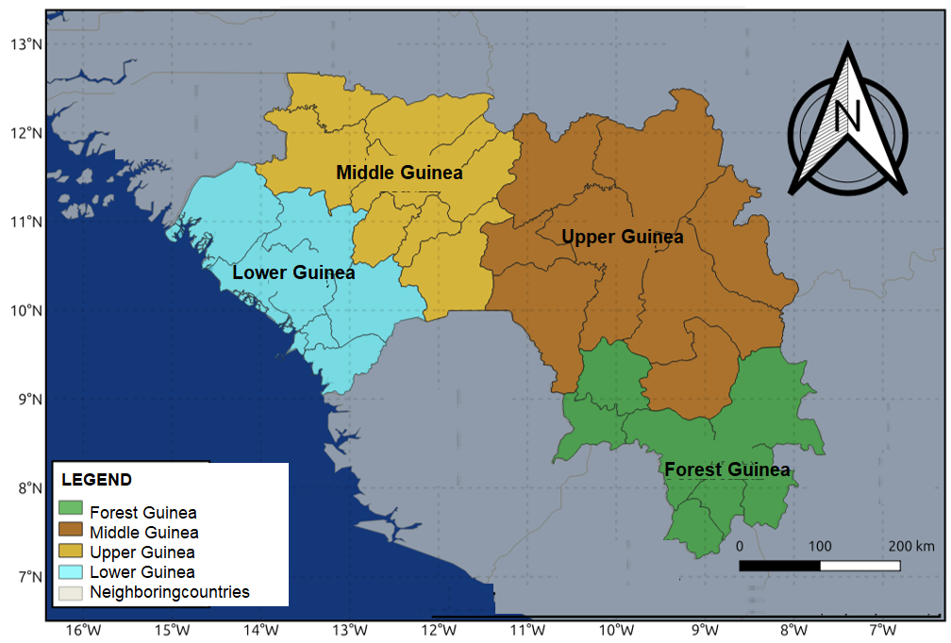

Data
The data used in this study come exclusively from climate and environmental remote sensing, in order to ensure homogeneous spatial and temporal coverage across the entire Guinean territory. Two main types of data were used:

- Precipitation CHIRPS (Climate Hazards Group InfraRed Precipitation with Station data):
The CHIRPS product provides daily precipitation data at a spatial resolution of 0.05° (~5 km). It combines infrared satellite observations, data from weather stations, and reanalysis models (Funk et al., 2015). The period covered by this study is 2010–2018, allowing for the assessment of recent interannual and seasonal variability. Open access: https://data.chc.ucsb.edu/products/CHIRPS-2.0/global_daily/netcdf/p05/.

- Vegetation Fires (AVHRR-LTDR Burned Area Grid v1.1): The ESA's Fire_cci AVHRR-LTDR Burned Area Grid v1.1 dataset provides monthly information on burned areas worldwide from 2010 to 2018 (0.25° × 0.25° resolution). The data, in NetCDF format, include burned area, standard error, and the fraction of burnable and observed area. They are derived from daily AVHRR observations and processed using spectral indices and a random forest model calibrated to NASA's MCD64A1 product. This dataset is intended for studying fire trends, ecological and climate modeling, and assessing impacts on ecosystems. Open access: https://data.ceda.ac.uk/neodc/esacci/fire/data/burned_area/AVHRR-LTDR/grid/v1.1.

METHODS

3.1. Monthly and seasonal climatology of precipitation and burned areas
The monthly climatology was calculated for each month of the year by averaging the values ​​of precipitation and burned areas over the period 2010–2018 (Fabio et al., 2015):
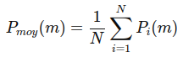

Where Pmoy(mm) is the average rainfall for month m, Pi(mm) is the monthly value for year i, and N is the total number of years in the period studied. A similar calculation was applied to burned areas.
These averages allow us to characterize the seasonal relationship between water availability and the extent of fires.

3.2. Standardized anomalies (interannual variability)
To assess interannual variability, standardized anomalies in precipitation and burned areas were calculated:
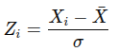

Where Xi is the annual value of the variable under consideration (precipitation or burned area), Xˉ its mean, and σ the standard deviation. Positive anomalies indicate a year above average, and negative anomalies a year below average.

3.3. Correlation between rainfall and vegetation fires.
After establishing rainfall trends, a statistical analysis was conducted to examine the relationship between rainfall and wildfires in the Republic of Guinea. This relationship was quantified by calculating Spearman's rank correlation coefficients, defined by the following equation (Akyürek, Ö. 2023):
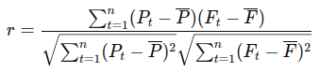

Where Pt represents rainfall at time t, Ft the burned area observed at that same time, and P and F their average values ​​over the period studied. This approach makes it possible to determine the intensity and direction of the relationship between rainfall and fire occurrence, which is essential for fire risk management and understanding the spatio-temporal dynamics of wildfires.
Next, to test the significance of Spearman's rank correlation coefficient between the two variables, a transformation into a t-statistic is often used under certain null hypothesis conditions (absence of correlation). The t-statistic can be calculated as follows:
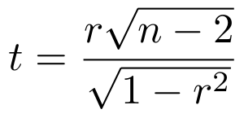

Or: is Spearman's correlation coefficient; n is the number of pairs of values.
This t statistic approximately follows a student’s t distribution with n−2 degrees of freedom.
The t-value thus obtained is then compared to a critical value in the student’s t-distribution table for a given significance level (for example, 0.05 for a 95% confidence interval). If the absolute value of t is greater than the critical value, the correlation is considered statistically significant.
Next, to test the significance of Spearman's rank correlation coefficient between the two variables, a transformation into a t-statistic is often used under certain null hypothesis conditions (absence of correlation). The t-statistic can be calculated as follows:

Or: r is Spearman's correlation coefficient; n is the number of pairs of values.
This t statistic approximately follows a student’s t distribution with n−2 degrees of freedom.
The t-value thus obtained is then compared to a critical value in the student’s t-distribution table for a given significance level (for example, 0.05 for a 95% confidence interval). If the absolute value of t is greater than the critical value, the correlation is considered statistically significant.

RESULTS AND DISCUSSION
4.1. Results
Monthly climatology of precipitation and burned areas: Figure 2 highlights the inverse relationship between rainfall (blue curve) and burned area (brown curve) throughout the year. Peaks in burned area occur during periods of low rainfall, particularly in January-February and November-December. Conversely, during the rainy season (June to September), when rainfall reaches its maximum, burned area drops to almost zero. This clearly demonstrates the crucial influence of rainfall patterns on bushfire dynamics.

Analysis shows that abundant water availability during the rainy season significantly reduces the likelihood of fires, as the moisture in the soil and vegetation prevents the rapid spread of flames. Conversely, during the dry season, the scarcity of rain leads to the gradual drying out of vegetation, making it more flammable. Thus, fires appear to be a seasonal phenomenon, closely linked to annual climate variability, with peak intensity at the beginning and end of the dry season (Hang et al., 2023 and Nandita Mondal, 2026).

These results underscore the importance of managing bushfires during critical periods, particularly January-February and November-December. These two periods correspond to the times when the risks of environmental and agricultural losses are highest. Understanding this relationship between rainfall and burned areas can therefore serve as a tool for anticipating prevention policies, by implementing early warning and awareness strategies tailored to local climate cycles.
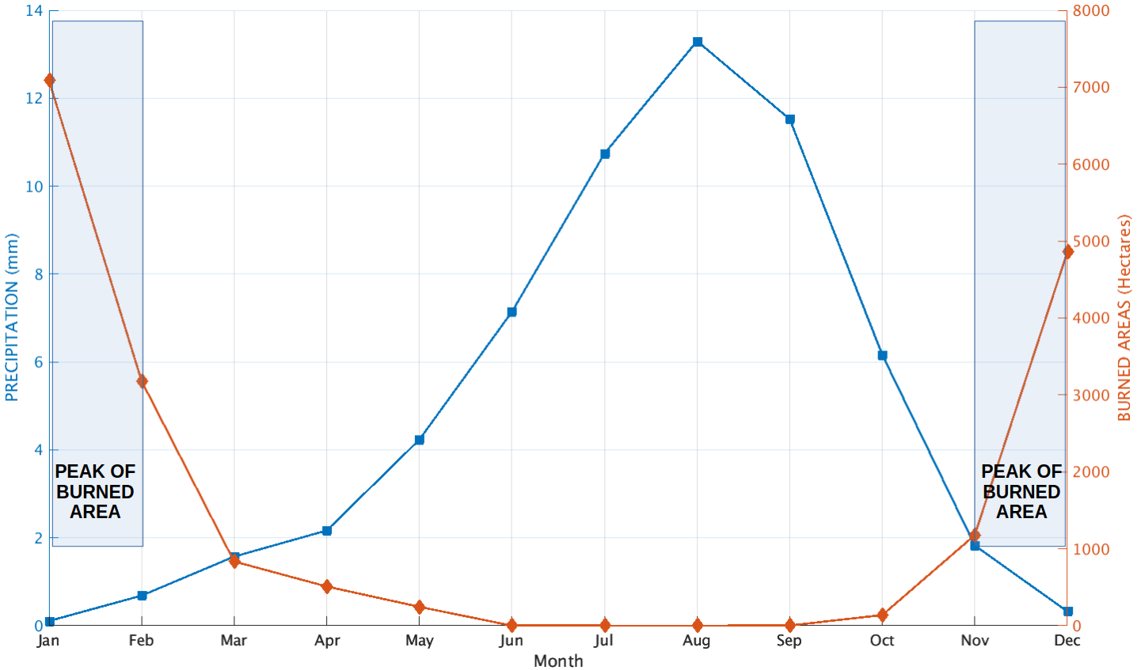
Fig.2. Monthly evolution of rainfall (mm, left axis, blue curve) and burned areas (hectares, right axis, brown curve). An inverse relationship is observed between the two variables: burned areas reach their maximum at the beginning (January-February) and end (November-December) of the dry season, when rainfall is almost zero, while they almost completely disappear during the rainy season (June-September).

Spatial variability of seasonal climatology of precipitation and burned areas: These maps highlight the spatial and seasonal relationship between rainfall and burned areas in Guinea. Three distinct periods stand out clearly: the main dry season (December-February, NDJF), the pre-rainy transition (March-June, MAMJ), and the rainy season (July-October, JASO). The combined evolution of these two variables confirms the crucial role of rainfall patterns in bushfire dynamics (Tamba et al., 2027)

During the NDJF dry season, burned areas are very extensive, particularly in the east and southeast of the country, sometimes exceeding 6,000 hectares (Figure 3a1). At the same time, rainfall is almost nonexistent (Figure 3a2), generally less than 5 mm across the entire territory. This combination reflects a high vulnerability of the parched vegetation to fires, exacerbated by the prolonged drought and the lack of moisture in the vegetation cover.

During the MAMJ period, burned areas decreased sharply and became virtually nonexistent in most areas (Fig.3. b1). At the same time, rainfall gradually increased (Fig. 3. b2), particularly in the south and southeast of the country. The rising humidity and the regrowth of green vegetation significantly limited the spread of fires, marking a transition phase between intense burning activity and the gradual extinguishing of fires.

Finally, during the JASO rainy season, burned areas almost completely disappear (Fig. 3. c1), as rainfall reaches its peak, exceeding 20 to 30 mm in several regions (Fig. 3. c2). The abundance of water and widespread humidity render the vegetation non-flammable, preventing any fire spread. Thus, a clear inverse and seasonal relationship emerge: bushfires peak during the dry season and are completely extinguished during the rainy season. This spatio-temporal dynamic underscores the importance of focusing fire prevention and management efforts on periods of drought, when the risks are highest.

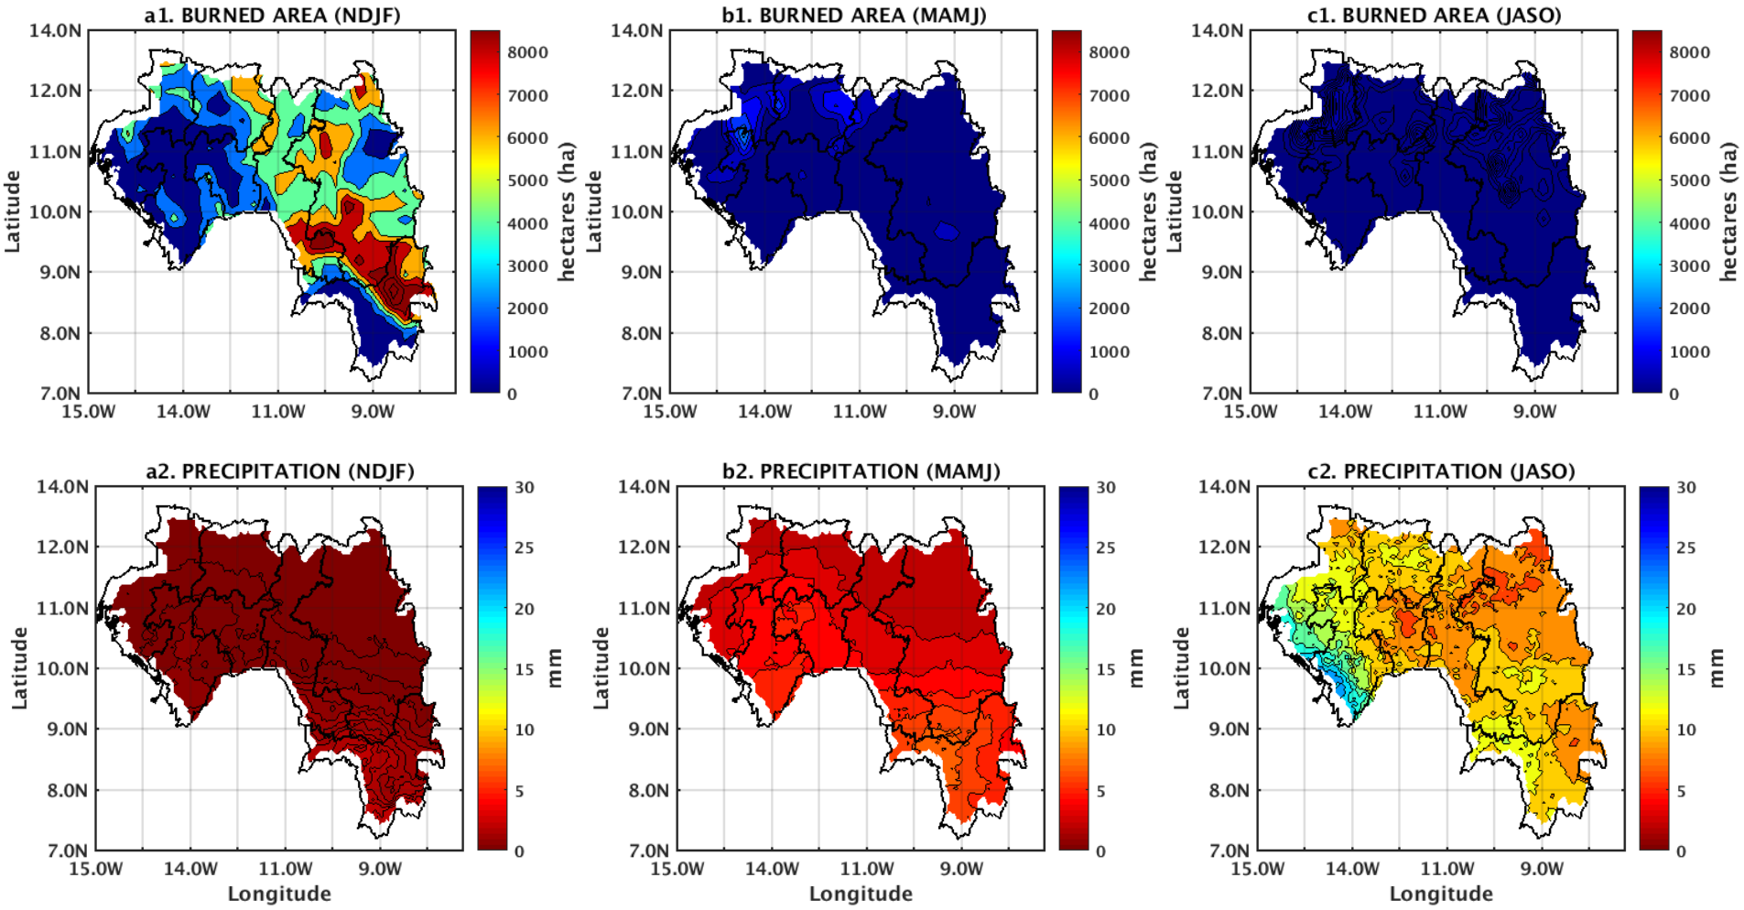
Fig.3. Seasonal distribution of burned areas (in hectares, panels a1, b1, c1) and rainfall (in mm, panels a2, b2, c2) in Guinea for three periods: NDJF (December-February), MAMJ (March-June), and JASO (July-October). The results highlight a marked inverse relationship: burned areas reach their maximum during the dry season (NDJF), decrease during the transition period (MAMJ), and virtually disappear during the rainy season (JASO), when rainfall is most abundant.

Spatial distribution of areas burned during the dry season in Guinea: First, these maps represent the spatial distribution of burned areas in Guinea for the months of January (Fig. 4a), February (Figure 4b), November (Fig. 4c), and December (Fig. 4d). They highlight the seasonal and regional variability of bushfires, generally associated with the dry season when the lack of rainfall makes vegetation more flammable. Fire intensities are expressed in hectares, with maximum values ​​exceeding 30,000 hectares in some areas.

Then, in January (Fig. 4a), the burned areas were particularly concentrated in the southeastern part of the country, with intense fires reaching the maximum intensity on the scale. This coincides with the peak of the dry season, when herbaceous vegetation is completely dried out and becomes highly flammable. Furthermore, the location of the most affected areas suggests a strong influence of agricultural practices, such as slash-and-burn agriculture, combined with arid climatic conditions.

Furthermore, in February (Fig. 4b), the fire dynamics remained similar, with high intensity in the southeast, but the total area burned tended to decrease compared to January. This reduction can be explained by the fact that a large portion of the flammable biomass had already been consumed at the beginning of the dry season, thus reducing fuel availability. However, some localized areas continued to experience active fires, indicating the persistence of human activities.

Furthermore, in November (Fig. 4c), fires reappeared with moderate intensity, mainly in the north and center of the country. This resurgence coincided with the beginning of the dry season following the rains. At this stage, the vegetation begins to gradually dry out, creating conditions conducive to the first outbreaks of fires. Nevertheless, their intensity remained lower than that observed in January and February, as the vegetation cover was not yet completely dry.

Finally, in December (Fig. 4d), the burned areas expanded further and became more intense than those of November, marking the full onset of the dry season. The most affected areas were concentrated in the central and southern parts of the country, where vegetation is abundant and subject to agricultural burning. Thus, this month constitutes a transitional phase towards the peak of fires observed in January, reflecting a marked annual cycle: small areas burned at the beginning of the dry season (November), intensification in December, peak in January-February, then a gradual decrease towards March.
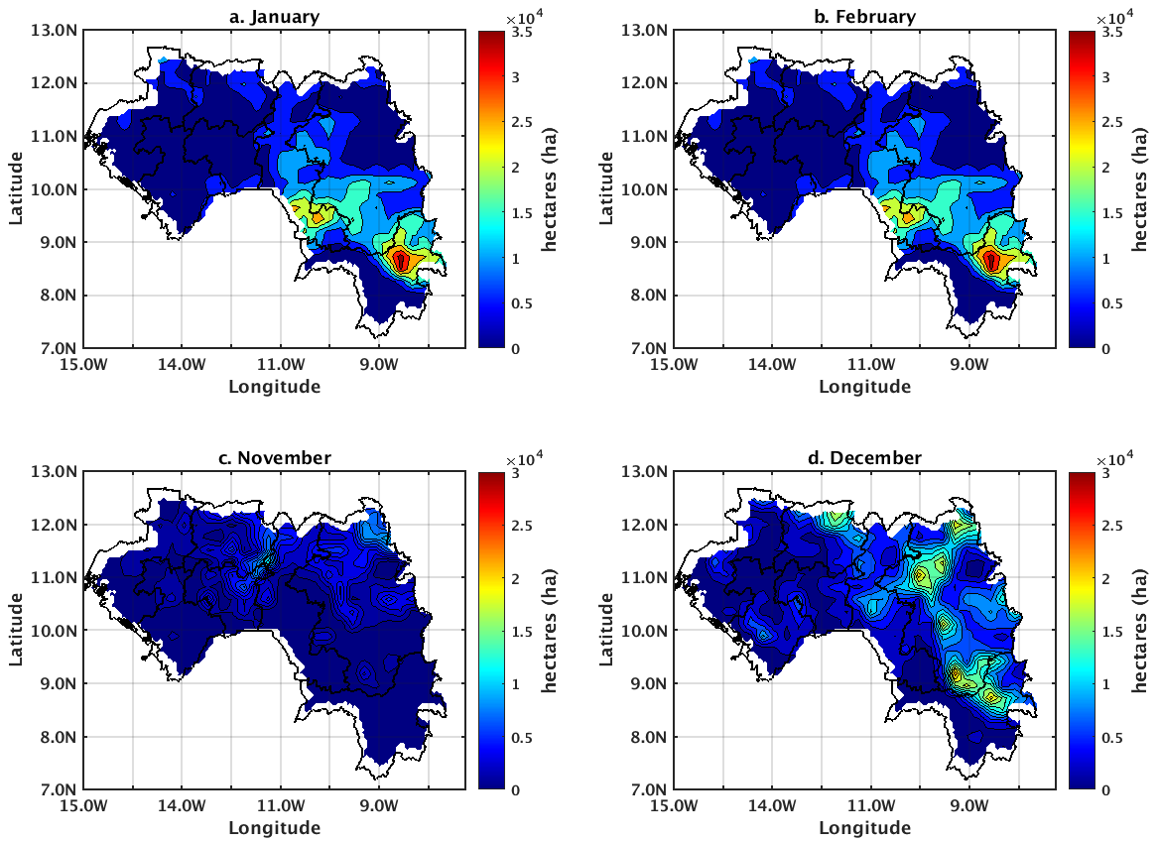
Fig. 4. The spatial distribution of burned areas in Guinea for the months of January (a), February (b), November (c) and December (d).

Relationships between standardized anomalies of burned areas and rainfall in Guinea (2010–2018): Figure 5a illustrates the standardized anomalies of the burned area (ISSB) in Guinea between 2010 and 2018. A general downward trend is observed (Trend = -0.2510), although this is not statistically significant (p-value = 0.1753). This means that, over the period studied, burned areas tended to decrease gradually, but this trend could be attributed to chance given the significance threshold usually set at 0.05. Positive bars (in magenta) represent years in which burned areas were above average, while negative bars (in cyan) reflect years of deficit.

Figure 5b shows the standardized rainfall anomalies (SIAs) over the same period. The trend is slightly negative (Trend = -0.0186) but not statistically significant (p-value = 0.7545), suggesting relative interannual stability in rainfall in Guinea between 2010 and 2018. The years 2012 and 2017 are distinguished by rainfall surpluses (blue bars), while 2011, 2013, and 2014 show marked rainfall deficits (red bars). This variability illustrates the influence of regional and global climatic factors on the annual distribution of rainfall.

Finally, the relationship between ISSB and IPS is characterized by a negative correlation coefficient (-0.3438), although not statistically significant (p-value = 0.3650). This negative correlation suggests that increased rainfall would tend to reduce burned areas, and conversely, decreased rainfall could promote a greater spread of wildfires. However, the lack of statistical significance indicates that this relationship cannot be generalized with certainty to the entire study period. These results highlight the need to analyze a longer time series and to integrate other factors (anthropogenic pressure, agricultural practices, fire management policies) in order to better understand the dynamics between wildfires and rainfall variability in Guinea.
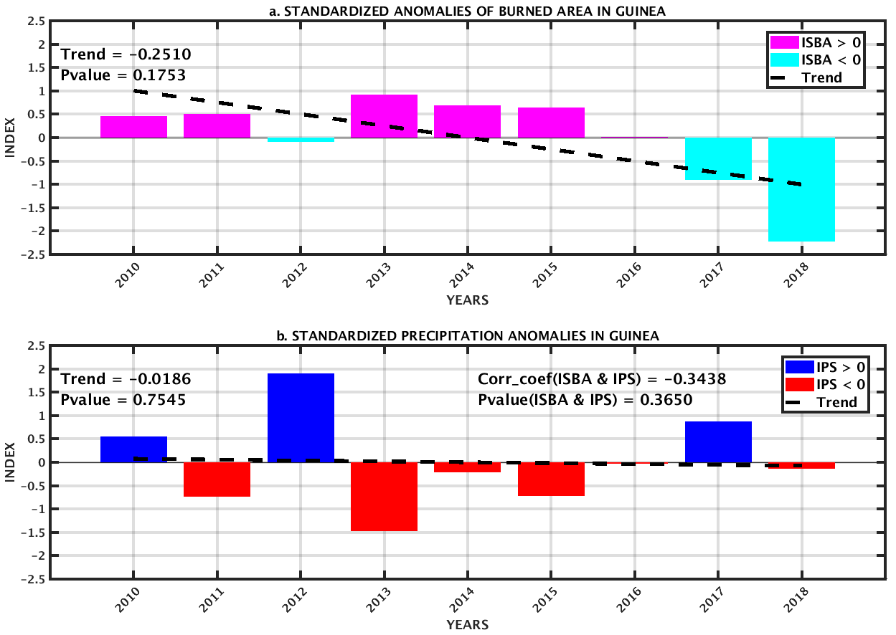
Fig.5. Evolution of monthly rainfall in Guinea from 2010 to 2018.
The bars indicate the monthly average and the points represent the observed values. The red and blue lines show long-term trends and anomalies respectively.

4.2. Discussions
Analysis of the spatial variability of seasonal rainfall and burned areas reveals significant regional heterogeneity in the Republic of Guinea. Areas characterized by abundant rainfall, particularly Forest Guinea and parts of Lower Guinea, exhibit marked seasonality that directly influences the accumulation of plant biomass. This high fuel availability, combined with a more contrasting dry season, promotes the intensity and spread of wildfires (Archibald et al., 2009; Andela and van der Werf, 2014). Conversely, in the Upper and Middle Guinea regions, where rainfall distribution is more irregular and dry periods are longer, fire dynamics depend more on interannual rainfall variability and local weather conditions, reflecting a complex relationship between climate and burned areas.

Furthermore, the comparison between seasonal rainfall and burned areas suggests a temporal lag between biomass accumulation and the actual timing of fire ignition, confirming the importance of pre-dry season climatic conditions in modulating fire regimes (Bowman et al., 2009; Giglio et al., 2018). These results underscore the need to integrate rainfall indices into fire management and prevention strategies, particularly in the context of climate change where increased rainfall variability could exacerbate the frequency and severity of fires. They also call for a better understanding of the interactions between anthropogenic factors (agricultural practices, pastoralism) and climatic conditions to explain the spatiotemporal dynamics of fires in Guinea.

CONCLUSION
The study conducted on the spatio-temporal impact of rainfall indices on wildfire dynamics in the Republic of Guinea reveals a clear inverse relationship between rainfall and fire spread. The results show that the seasonality of rainfall patterns is the determining climatic factor in the occurrence of fires: burned areas reach their maximum during the dry season (January-February and November-December), while they almost completely disappear during the rainy season (June-September). This dynamic reflects the central role of soil and vegetation moisture in limiting or amplifying fires, and underscores the importance of interannual rainfall variability in modulating these phenomena.

Spatially, the analysis reveals marked heterogeneity between the country's natural regions. Forest Guinea and parts of Lower Guinea, where vegetation biomass is abundant, experience high fire intensity during the dry season, while Upper and Middle Guinea exhibit a more irregular pattern, dependent on local climatic fluctuations. Furthermore, the results confirm that, beyond rainfall variability alone, anthropogenic factors-particularly agricultural and pastoral practices-contribute significantly to the distribution and intensity of wildfires.

This study highlights the need to jointly integrate rainfall indices, environmental conditions, and human pressures into fire management and prevention strategies. In a context of climate change, marked by increased rainfall variability and more intense droughts, the implementation of appropriate policies for awareness-raising, climate monitoring, and land-use planning is essential for reducing the risks associated with bushfires and sustainably preserving Guinean ecosystems.

DISCLAIMER (ARTIFICIAL INTELLIGENCE)

Author(s) hereby declares that NO generative AI technologies such as Large Language Models (ChatGPT, COPILOT, etc) and text-to-image generators have been used during writing or editing of this manuscript.

COMPETING INTERESTS

Authors have declared that no competing interests exist.

Authors’ contributions

This work was carried out in collaboration among all authors. All authors read and approved the final manuscript.

REFERENCES
Akyürek, Ö. (2023). Spatial and temporal analysis of vegetation fires in Europe. Natural Hazards, 117(1), 1105-1124. DOI:10.1007/s11069-023-05896-0
Andela, N., & van der Werf, GR (2014). Recent trends in African fire regimes. Geophysical Research Letters, 41(8), 201–209.https://doi.org/10.1002/2014GL059576
Andreae, MO, & Merlet, P. (2001). Emission of trace gases and aerosols from biomass burning. Global Biogeochemical Cycles, 15(4), 955–966.https://doi.org/10.1029/2000GB001382
Archibald, S., Lehmann, CER, Gómez-Dans, JL, & Bradstock, RA (2013). Defining pyromes and global syndromes of fire regimes. Proceedings of the National Academy of Sciences, 110(16), 6442–6447.https://doi.org/10.1073/pnas.1211466110
Archibald, S., Scholes, RJ, Roy, D.P., Roberts, G., & Boschetti, L. (2009). Southern African fire regimes as revealed by remote sensing. International Journal of Wildland Fire, 18(7), 698–706.https://doi.org/10.1071/WF08123
Bond, W. J., & Keeley, J. E. (2005). Fire as a global “herbivore”: The ecology and evolution of flammable ecosystems. Trends in Ecology & Evolution, 20(7), 387–394.https://doi.org/10.1016/j.tree.2005.04.025
Bowman, DMJS, Balch, JK, Artaxo, P., Bond, WJ, Carlson, JM, Cochrane, MA, … Pyne, SJ (2009). Fire in the Earth system. Science, 324(5926), 481–484.https://doi.org/10.1126/science.1163886
Fabio Attorre, Navashni Govender, Anna Hausmann, Alessio Farcomeni, Alfredo Guillet, Edoardo Scep, Izak P.J. Smit, Marcello Vitale, Assessing the effect of management changes and environmental features on the spatio- temporal pattern of fire in an African Savanna: Fire spatio-temporal pattern. Journal for Nature Conservation, Volume 28, November 2015, Pages 1-10. https://doi.org/10.1016/j.jnc.2015.07.001
FAO. (2019). Global forest resources assessment 2020 – Main report. Rome: Food and Agriculture Organization of the United Nations.https://www.fao.org/forest-resources-assessment/en/
Funk, C., Peterson, P., Landsfeld, M., Pedreros, D., Verdin, J., Shukla, S., … Michaelsen, J. (2015). The climate hazards infrared precipitation with stations—a new environmental record for monitoring extremes. Scientific Data, 2, 150066.https://doi.org/10.1038/sdata.2015.66
Giglio, L., Randerson, JT, & van der Werf, GR (2018). Analysis of daily, monthly, and annual burned area using the fourth-generation global fire emissions database (GFED4). Journal of Geophysical Research: Biogeosciences, 123(6), 1–16.https://doi.org/10.1029/2017JG004139
Hang Xing, Keyan Fang , Qichao Yao, Feifei Zhou, Tinghai Ou, Jane Liu, Shengfang Zhou, Shixiong Jiang, Yao Chen, Maowei Bai, Jing Ming Chen. Impacts of changes in climate extremes on wildfire occurrences in China. Ecological Indicators Volume 157, 15 December 2023, 111288. 10.1016/j.ecolind.2023.111288
IPCC. (2021). Climate change 2021: The physical science basis. Contribution of Working Group I to the Sixth Assessment Report of the Intergovernmental Panel on Climate Change. Cambridge University Press.https://www.ipcc.ch/report/ar6/wg1/
McKee, T.B., Doesken, N.J., & Kleist, J. (1993). The relationship of drought frequency and duration to time scales. Proceedings of the 8th Conference on Applied Climatology, 17–22.https://digitalcommons.unl.edu/natrespapers/196/
Nandita Mondal and Raman Sukumar. Fires in Seasonally Dry Tropical Forest: Testing the Varying Constraints Hypothesis across a Regional Rainfall Gradient. July 2016, 11(7):e0159691
Niang, I., Ruppel, OC, Abdrabo, MA, Essel, A., Lennard, C., Padgham, J., & Urquhart, P. (2014). Africa. In VR Barros, CB Field, DJ Dokken, MD Mastrandrea, KJ Mach, TE Bilir, LL White (Eds.), Climate change 2014: Impacts, adaptation, and vulnerability (pp. 1199–1265). Cambridge University Press.
Nicholson, S.E. (2013). The West African Sahel: A review of recent studies on the rainfall regime and its interannual variability. ISRN Meteorology, 2013, 1–32.https://doi.org/10.1155/2013/453521
Sylla, M.B., Diedhiou, A., & Giorgi, F. (2016). Regional climate modeling over West Africa: Validation and future projections. Climate Dynamics, 46(9–10), 2781–2800.https://doi.org/10.1007/s00382-015-2692-0
Tamba Nicolas Millimono, Saïdou Moustapha Sall, Daouda Badiane, Alassane Bah, Moussa Diakhate, Ibra Toure, Mamadou Baïlo Barry, Diakaria Diallo, Idrissa Diaby Analysis of Bushfires Spatial and Temporal Variability in Guinea. Atmospheric and Climate Sciences, 2017, 7, 463-475. doi.org/10.4236/acs.2017.74034
Vicente-Serrano, S.M., Beguería, S., & López-Moreno, J.I. (2010). A multiscalar drought index sensitive to global warming: The standardized precipitation evapotranspiration index. Journal of Climate, 23(7), 1696–1718. https://doi.org/10.1175/2009JCLI2909.1

