Impact assessment of climate-resilient watershed strategies on vegetation cover and water availability using Geospatial technology in the Mal Somat Watershed (GJ), India
------------------------------------------------------------------------------------------------------------------------------
Abstract
The impact of integrated watershed management interventions on land use, vegetation health, and moisture conditions was assessed in the Mal Somat Watershed, Gujarat, India, between 2022 and 2024. The watershed development adopted a ridge-to-valley approach, combined with climate-resilient soil and water conservation measures, including trench-cum-bunds, stone bunds, gabion structures and check dams. These measures aimed to reduce runoff, enhance soil moisture, and improve groundwater recharge. Land use and land cover (LULC) analysis revealed significant positive transformations: agricultural land increased from 768.27 ha (25.5%) to 1078.49 ha (35.8%), vegetation cover rose from 840.33 ha (27.9%) to 922.13 ha (30.6%) and water bodies nearly doubled from 11.95 ha (0.40%) to 23.19 ha (0.77%), while fallow and open lands declined substantially. Remote sensing indices indicate improved ecosystem health, with NDVI increasing from 0.32 to 0.48, NDWI from 0.45 to 0.48, and NDMI from 0.38 to 0.51, reflecting enhanced vegetation vigor, surface water availability, and soil moisture. Correlation analysis among NDVI, NDWI, and NDMI reveals that the functional linkage between vegetation and hydrological processes, which was weakened under moisture-stressed conditions in 2023, was restored by 2024, indicating ecosystem stabilization. Overall, the study demonstrates that targeted watershed interventions, supported by geospatial monitoring, can effectively improve land productivity, water resources and ecological resilience in semi-arid areas.
Keywords: NDVI, NDWI, NDMI, Soil and Water Conservation, Land Use Land Cover, Ecosystem Resilience
- Introduction
Watershed development is a vital approach for sustainable natural resource management, particularly in regions facing land degradation, erratic rainfall, and increasing impacts of climate variability (Tsige et al., 2025). A watershed is a logical and rational unit for undertaking natural resource management, studying human–environment interactions, economic planning, and eco-restoration (Singh et al., 2025). The development of watersheds is a major strategy for the holistic development of rural areas. A watershed represents a geo-hydrological unit in which surface and subsurface water flows toward a common outlet. The components of integrated watershed management include soil, water, vegetation, and land resources (Chai et al., 2024). Watershed-based interventions play a crucial role in enhancing agricultural productivity, restoring land degradation neutrality, creating nature-positive impacts on biodiversity, building resilience against climate change and improving rural livelihoods(Kumar and Dahiya, 2025).
Climate-resilient watershed strategies focus on soil and water conservation measures, including contour bunding, gully plugs, loose boulder structures, core wall gabions, stone bunds, check dams, percolation tanks, recharge farm ponds and afforestation. These adopted interventions aim to reduce surface runoff and soil erosion, enhance groundwater recharge, improve soil moisture availability and support ecological restoration and sustainable land use(Xiaoyu et al., 2024). Vegetative cover is a key indicator of soil watershed health. It reflects the combined effects of soil moisture availability and land management practices implemented through climate-resilient watershed strategies (Hishe et al., 2017).
In recent decades, Remote Sensing (RS) and Geographic Information Systems (GIS) technologies have emerged as essential tools for watershed planning, monitoring, and impact assessment (Wang et al., 2023). RS provides spatially and temporally consistent, cost-effective imagery for analyzing spatio-temporal changes in land surface characteristics. GIS enables the analysis, integration, and visualization of multi-layered spatial datasets (Dandois et al., 2021). Together, RS and GIS, as geospatial technologies, play a significant role in assessing watershed interventions and evaluating their long-term outcomes(Kumar and Dahiya, 2025).
The Government of India has consistently prioritized the holistic and sustainable development of rainfed areas, drought-prone regions, degraded lands, hilly areas, and wastelands through watershed development programmes(Mathew et al., 2022). For the implementation of watershed development programmes, various government agencies, institutions, and non-governmental organizations (NGOs) are actively involved. The Mal Somat watershed (GJ) was developed under the Jaljeevika Project (2022–2024), which the BAIF Development Research Foundation implements and supported by Schaeffler India Ltd under CSR grant. The main objectives of the project are to enhance water security, improve land productivity, and strengthen climate resilience at the watershed scale. The interventions under this project include the treatment of drainage lines, the construction of water-harvesting and groundwater-recharge structures, the promotion of moisture conservation practices, and the enhancement of vegetative cover through afforestation and land-based livelihood activities.
Monitoring LULC changes helps in understanding the effectiveness of watershed development programs and their role in promoting sustainable land management(Mehetre et al., 2023)(Kumar and Dahiya, 2025)(Damtie, 2022). Additionally, vegetation and moisture-related indices derived from satellite imagery provide valuable quantitative measures to assess environmental conditions within a watershed. The Normalized Difference Vegetation Index (NDVI) is widely used to evaluate vegetation health, density, and spatial distribution of biomass improvement resulting from watershed interventions(Angmo et al., 2025). The Normalized Difference Water Index (NDWI) is effective in detecting surface water bodies and assessing changes in water availability(Xiaoyu et al., 2024). The Normalized Difference Moisture Index (NDMI) is particularly useful for estimating vegetation and soil moisture conditions(Mehetre et al., 2023). The combined analysis of NDVI, NDWI, and NDMI offers a comprehensive understanding of the hydrological and ecological responses of a watershed to soil and water conservation measures.
Given the ecological significance and socio-economic importance of the Mal Somat watershed (Gujarat), there is a strong need for a scientific geospatial assessment to evaluate the impacts of watershed development programmes. The impact assessment is based on improvements in land use and land cover (LULC), soil erosion, biomass, groundwater levels, irrigation area, and related indicators (Pal et al., 2023). This study aims to analyze changes in LULC, NDVI, NDWI, and NDMI using multi-temporal satellite data to assess the effectiveness of climate-resilient watershed strategies(Singh et al., 2025). The findings of this research are expected to contribute to evidence-based watershed planning, support sustainable natural resource management, and provide insights for scaling up similar interventions in comparable agro-ecological regions.
- Material and Methods
  - Study Area
The Mal Somat watershed is located in the Dediapada Block of Narmada District, Gujarat, India. The study area spans latitudes 21.45° N to 21.60° N and longitudes 73.30° E to 73.45° E. The region is characterized by a semi-arid climate with seasonal rainfall patterns, making it heavily reliant on monsoon rains for agricultural activities. The watershed covers an area of approximately 3,022 hectares, and the local population primarily depends on agriculture for their livelihood. The area faces challenges related to water availability, including declining groundwater levels and limited surface water resources, which hinder agricultural productivity. Watershed management efforts in the region focus on enhancing water retention through soil conservation measures, water-harvesting structures, and afforestation initiatives. These climate-resilient interventions help enhance water availability, particularly during periods of drought. The Mal Somat watershed (GJ) was developed under the Jaljeevika Project (2022–2024), which the BAIF Development Research Foundation implements and supported by Schaeffler India Ltd under CSR grant. The location map of the study area as shown in fig 1.

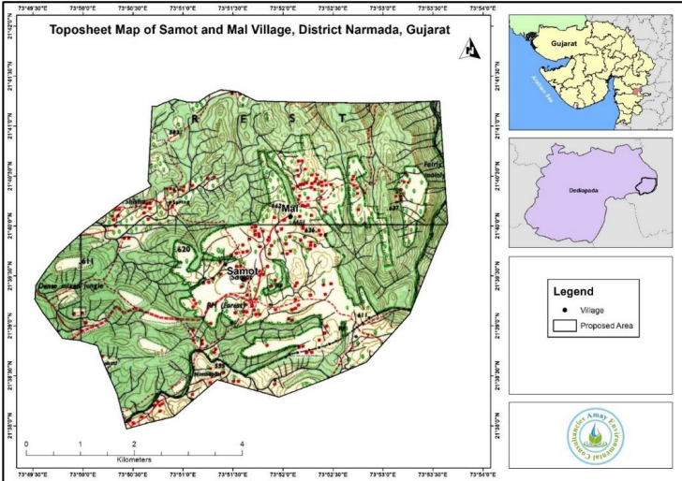
Fig. 1 Location map of Mal Somat watershed
  - Data Collection
The multispectral Sentinel-2 satellite imagery was downloaded from the Copernicus Open Access Hub, providing high-resolution multispectral data with a spatial resolution of 10 m. Shuttle Radar Topography Mission (SRTM) Digital Elevation Model (DEM) data with a spatial resolution of 30 m were obtained. The DEM used to prepare thematics elevation-related parameters such as slope and aspect. The field data were collected through ground surveys to support validation and accuracy assessment of the results.
2.3 Climate-resilient soil and water conservation measures
The implementation of watershed management interventions under the Jaljeevika Programme commenced in June 2022 in the study area. The programme adopted a ridge-to-valley integrated watershed development approach, ensuring systematic treatment of the watershed from upper catchment areas to downstream zones. A range of soil and water conservation measures was implemented between June 2022 and December 2024 to reduce runoff, enhance soil moisture retention, and improve groundwater recharge.
Key interventions included the construction of trench-cum-bunds (TCBs), stone bunds, gabion and core wall gabion structures, and check dams, among others. These measures were strategically designed and placed based on topography, drainage patterns, and land use characteristics to control soil erosion, increase surface water storage, and promote sustainable land and water resource management across the watershed. Table 1 shows the various climate resilient soil and water conservation measures.

Table No 1 Climate resilient soil and water conservation measures
Sr No | Activity/Interventions | Physical units | Unit of Measure
1 | Check dam | 1 | Nos
2 | Core wall gabion | 7 | Nos
3 | DBI (Diversion based irrigation) | 1 | Nos
4 | Recharge Farm pond | 29 | Nos
5 | Gabion structure | 23 | Nos
6 | Gully plug | 71 | Nos
7 | LBS (Loose boulder structure) | 161 | Nos
8 | MFO (Masonry field outlet) | 6 | Nos
9 | Nala bund | 5 | Nos
10 | Open well | 2 | Nos
11 | Soil stone bund | 148 | Running meter
12 | Solar lift irrigation system | 2 | Nos
13 | Spring development | 1 | Nos
14 | Stone bund | 8,887 | Running meter
15 | Stone outlet | 25 | Running meter
16 | TCB (Trench cum bund) | 36,148 | Running meter

2.4 Land Use/Land Cover (LULC) Classification and Change Detection
Multi-temporal satellite imagery representing pre- and post-management periods was used to analyze land use and land cover (LULC) dynamics. The satellite images were classified into major LULC categories, including agricultural land, water bodies, forest cover, and barren land, using a supervised classification approach within a Geographic Information System (GIS) environment (Pal et al., 2023). Representative training samples for each land cover class were selected based on field observations, high-resolution reference imagery, and existing land cover maps. Classification was performed using standard supervised algorithms, such as the Maximum Likelihood classifier, to ensure accurate discrimination among LULC classes(Abebaw et al., 2024). Temporal changes in LULC were assessed through change detection analysis of the classified images, enabling the identification and quantification of spatial and areal transitions between land cover classes over time. Furthermore, classification accuracy was evaluated using reference data, and accuracy metrics such as overall accuracy and the Kappa coefficient were computed to validate the reliability of the results.
Formula for Change Detection: The basic formula for change detection in LULC is:
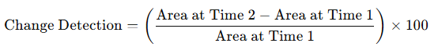
Where:
Area at Time 1 and Area at Time 2 represent the area covered by each LULC category at the two different time points.

2.5 Normalized Difference Vegetation Index (NDVI)
Vegetation health was assessed using the Normalized Difference Vegetation Index (NDVI) derived from multi-temporal satellite imagery (Benson et al., 2022). NDVI was calculated by comparing the reflectance values of the near-infrared (NIR) and red spectral bands. Healthy and dense vegetation typically exhibits higher NDVI values due to greater absorption of red light for photosynthesis and higher reflection of NIR radiation, whereas sparse or stressed vegetation shows lower NDVI values (Ubale et al., 2021).
Formula for NDVI:
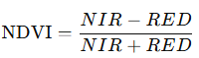
Where:
NIR = Near-Infrared Band (typically 0.76-0.90 µm).
RED = Red Band (typically 0.63-0.69 µm).
NDVI values range from -1 to 1, where higher values (closer to 1) indicate healthy vegetation and lower values (closer to -1) indicate barren land or water bodies.
2.6 Normalized Difference Water Index (NDWI)
The Normalized Difference Water Index (NDWI) was used to assess surface water availability and water content by enhancing the detection of water bodies in satellite imagery (McFeeters., 1996). NDWI was calculated using the reflectance values of the green and near-infrared (NIR) spectral bands. Water bodies typically exhibit higher NDWI values due to strong absorption of NIR radiation and higher reflectance in the green band, while non-water features such as vegetation and bare soil show lower or negative NDWI values (Huete et al., 1994). The spatial distribution and temporal variation of NDWI were analyzed to identify changes in surface water extent between the pre- and post-management periods.
Formula for NDWI:
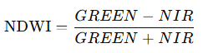
Where:
GREEN = Green Band (typically 0.52-0.60 µm).
NIR = Near-Infrared Band (typically 0.76-0.90 µm).
NDWI values range from -1 to 1, where values close to 1 indicate water, and negative values indicate vegetation or soil.

2.7 Normalized Difference Moisture Index (NDMI)
Surface water availability and moisture conditions were assessed using the Normalized Difference Moisture Index (NDMI) derived from multi-temporal satellite imagery. NDMI is effective in estimating moisture content in both vegetation and soil, thereby providing valuable insights into surface water availability and hydrological conditions. The index is particularly useful for evaluating crop water stress and vegetation moisture dynamics.
Formula for NDMI:
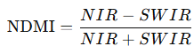
Where:
NIR = Near-Infrared Band.
SWIR = Short-Wave Infrared Band (typically 1.55-1.75 µm).
NDMI values range from -1 to 1, where values closer to 1 indicate higher moisture content, and values closer to -1 indicate dry conditions.
The figure 2 shows the flow chart of detailed methodology adopted to conduct this research.

Fig 2 Flow chart of methodology adopted

- Result and Discussions
3.1 Land use land cover (LULC) change detection
The land use and land cover (LULC) analysis between 2022 and 2024 reveals notable shifts in landscape composition resulting from watershed development and the impact of climate-resilient soil and water conservation measures (Table 2). Agricultural land increased from 768.27 ha (25.5% of total area) to 1078.49 ha (35.8%), a significant increase of 310.22 ha (10.3% of total area), mainly from the conversion of fallow and open lands into productive fields. Built-up areas also expanded slightly, from 11.44 ha (0.38%) to 21.96 ha (0.73%), reflecting improvements in rural infrastructure and livelihoods. In contrast, fallow land and open land decreased by 58.08 ha (−1.93%) and 355.82 ha (−11.8%), respectively, indicating effective land reclamation and enhanced utilization of previously underutilized areas.
Vegetation cover increased from 840.33 ha (27.9%) to 922.13 ha (30.6%), demonstrating the positive impact of afforestation, tree plantation, and agroforestry activities under the watershed programme. Water bodies nearly doubled from 11.95 ha (0.40%) to 23.19 ha (0.77%), indicating improved surface water storage through structures such as check dams, farm ponds, and percolation tanks. Overall, these changes reflect the success of integrated watershed management in enhancing soil moisture, water availability, vegetation cover, and sustainable land use, transforming the watershed toward greater productivity and ecological stability.
Table No 2 Land use land cover
LULC Class | Area 2022 (ha) | % of Total 2022 | Area 2024 (ha) | % of Total 2024 | Change (ha) | Change  (% of Total)
Agriculture | 768.27 | 25.5 | 1078.49 | 35.8 | +310.22 | +10.3
Built-up Area | 11.44 | 0.38 | 21.96 | 0.73 | +10.52 | +0.35
Fallow Land | 190.64 | 6.33 | 132.56 | 4.40 | −58.08 | −1.93
Open Land | 1190.64 | 39.5 | 834.82 | 27.7 | −355.82 | −11.8
Vegetation | 840.33 | 27.9 | 922.13 | 30.6 | +81.80 | +2.7
Waterbody | 11.95 | 0.40 | 23.19 | 0.77 | +11.24 | +0.37
Total | 3013.27 | 100 | 3013.27 | 100 | 0 | 0

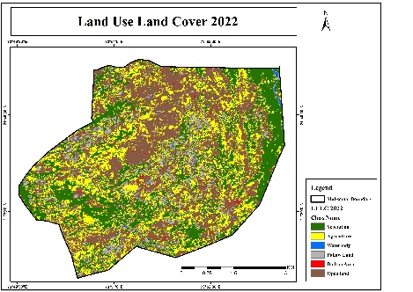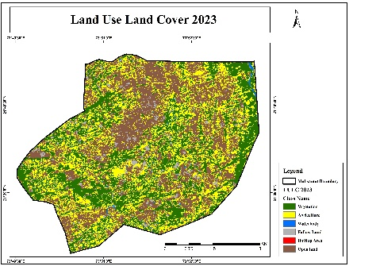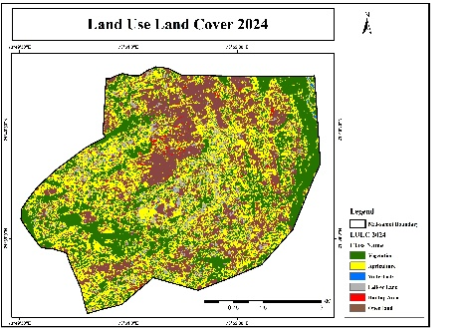
Fig. 3 Land use land cover (LULC) change (2022-2024) of the Mal Somat Watershed (GJ), India

Fig. 4 Land use land cover (LULC) percentage change (2022-2024) of the Mal Somat Watershed (GJ), India
3.2 Normalized Difference Vegetation Index (NDVI)
In 2022, vegetation health (NDVI) was generally poor, with a low mean of 0.32. The wide range between the minimum (0.27) and maximum (0.98) indicates the presence of isolated variability of healthy vegetation; however, most of the watershed areas remained barren/fallow land. A moderate standard deviation of 0.16 highlights considerable spatial variability, suggesting uneven vegetation conditions and localized degradation across the area. Whereas, in 2024, vegetation health showed a substantial improvement, with the mean NDVI increasing to 0.48. While the minimum value of 0 still signifies the presence of barren or highly stressed zones, the high maximum value of 0.94 reflects the expansion of healthy vegetation cover. The lower standard deviation of 0.07 indicates more uniform vegetation conditions, pointing to a stabilized watershed. These improvements strongly correlate with the adoption of climate-resilient soil and water conservation measures, as well as afforestation and tree plantation activities. These interventions enhanced soil moisture, reduced erosion, and strengthened positive ecosystem resilience. The fig 5 shows NDVI of the study area.
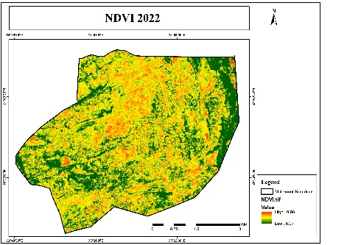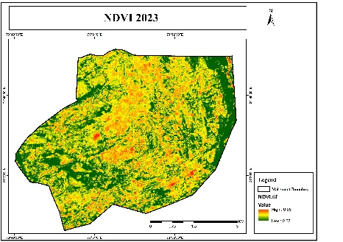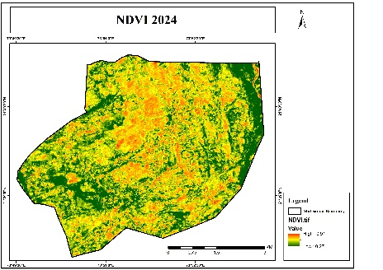
Fig. 5 Normalized Difference Vegetation Index (NDVI) change (2022-2024) of the Mal Somat Watershed (GJ), India
3.3 Normalized Difference Water Index (NDWI)
In 2022, water availability across the study area was moderate, with NDWI values ranging from 0.17 to 0.91. The low standard deviation (0.08) suggests that water resources were distributed in a relatively stable and uniform manner throughout the region. In 2023, a slight decline in overall water availability was observed compared to 2022. Although the NDWI range remained comparable, with a maximum value of 0.96 indicating the presence of adequate water resources in certain areas, the mean NDWI value decreased to 0.45, reflecting a marginal reduction in overall water content. The low standard deviation (0.08) continued to suggest stability in spatial water distribution. Whereas in 2024, water availability exhibited a modest improvement, as reflected by an increase in the mean NDWI value to 0.48, indicating a return to moderate water conditions. The standard deviation decreased further to 0.07, highlighting increased spatial stability in water distribution. This improvement in NDWI values is likely associated with the implementation of water-harvesting structures and soil and water conservation measures, which enhanced surface water retention and soil moisture, thereby contributing to improved overall water availability. The fig 6 shows the NDWI of the study area.
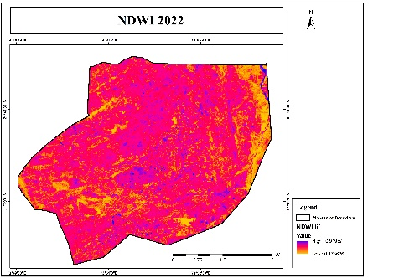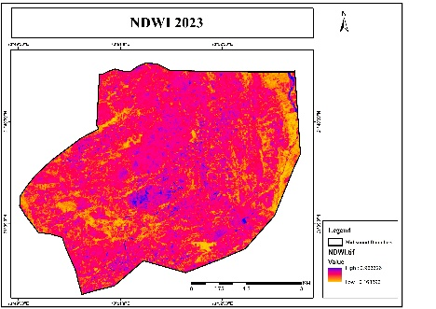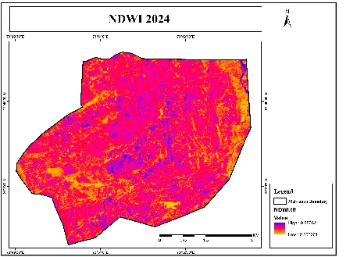
Fig. 6 Normalized Difference Water Index (NDWI) change (2022-2024) of the Mal Somat Watershed (GJ), India

3.4 Normalized Difference Moisture Index (NDMI)
The temporal analysis of the Normalized Difference Moisture Index (NDMI) from 2022 to 2024 reveals significant variations in vegetation moisture conditions and overall watershed hydrology. In 2022, the study area exhibited moderately low moisture levels, with a mean NDMI value of 0.38. Although maximum values reached 1.00, indicating areas with low moisture or destructive vegetation cover, the presence of a minimum value of 0.00 and a relatively high standard deviation (SD = 0.44) reflects substantial spatial heterogeneity, including zones experiencing moisture stress or sparse vegetation cover. Whereas, in 2024, NDMI values indicate a moderate to high improvement in moisture conditions, with the mean increasing to 0.51 (SD = 0.42). This increase points to an overall enhancement in the moisture regime and a heterogeneous yet positive response across the watershed area. The observed recovery can be largely attributed to the implementation of water-harvesting structures and soil and water conservation (SWC) measures. Interventions such as contour trenching, mulching, and the construction of check dams have improved soil moisture retention, enhanced groundwater recharge and strengthened soil hydraulic properties. Collectively, these measures have mitigated the impacts of earlier moisture deficits, promoted vegetation recovery, and improved the overall water-holding capacity of the watershed. The fig 7 shows the NDMI of the study area.
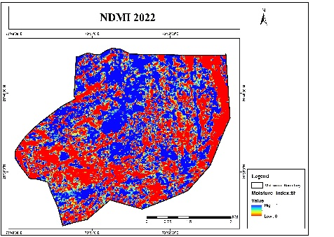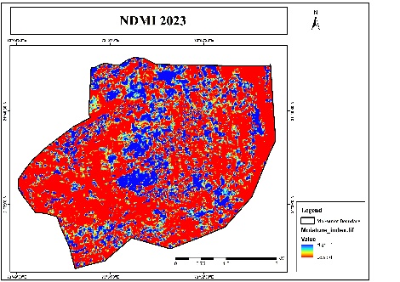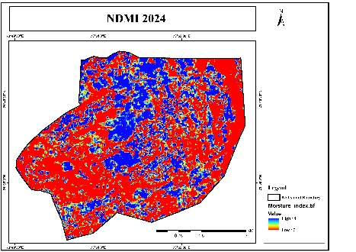
Fig. 7 Normalized Difference Moisture Index (NDMI) change (2022-2024) of the Mal Somat Watershed (GJ), India
3.5 Relationship between NDVI, NDWI and NDMI
The table 3 represents the comparative analysis of Pearson correlation coefficients among the Normalized Difference Vegetation Index (NDVI), Normalized Difference Water Index (NDWI), and Normalized Difference Moisture Index (NDMI) provides important insight into the coupling between vegetation vigor and hydrological conditions from 2022 to 2024. In 2022, strong positive correlations between NDMI and both NDWI and NDVI indicate that vegetation health was closely synchronized with surface water availability and canopy moisture status. This relationship weakened substantially in 2023, when correlations between NDWI and NDVI were weak or absent and only a moderate association was observed between NDWI and NDMI, suggesting a decoupling of vegetation response from available moisture under stress conditions, likely driven by uneven desiccation across land-cover types. In 2024, moderate positive correlations were re-established across all index pairings, reflecting a stabilization of ecosystem processes. This recovery highlights the role of climate resilient soil and water conservation measures in promoting a more uniform hydrological response and restoring the functional linkage between moisture availability and vegetation growth, such that improvements in surface and soil moisture once again translated into enhanced biomass condition.
Table 3 Relationship between NDVI, NDWI and NDMI
Year | NDWI vs. NDVI | NDWI vs. NDMI | NDVI vs. NDMI
2022 | Moderate positive correlation | Strong positive correlation | Strong positive correlation
2023 | Weak or no correlation | Moderate positive correlation | Weak positive correlation
2024 | Moderate positive correlation | Moderate positive correlation | Moderate positive correlation
- Conclusion
The present study demonstrates the effectiveness of climate-resilient, integrated watershed management interventions implemented in Mal Somat Watershed (GJ), India, under the Jaljeevika Programme. These interventions improved land use dynamics, vegetation health, and hydrological conditions in the study area between 2022 and 2024. A ridge-to-valley approach was adopted for watershed development. This approach, combined with the systematic implementation of climate-resilient soil and water conservation measures, played a critical role in restoring ecological balance and enhancing vegetative cover.
Land use and land cover (LULC) analysis indicates substantial significant transformations across the watershed during this period. Agricultural land expanded from 768.27 ha (25.5% of the total area) in 2022 to 1078.49 ha (35.8%) in 2024, representing an increase of 310.22 ha (10.3%), primarily due to the conversion of fallow and open lands, which decreased by 58.08 ha (−1.93%) and 355.82 ha (−11.8%), respectively. Vegetation cover increased from 840.33 ha (27.9%) to 922.13 ha (30.6%) through afforestation, tree plantation, and agroforestry activities. Water bodies nearly doubled from 11.95 ha (0.40%) to 23.19 ha (0.77%), reflecting enhanced surface water storage via check dams, farm ponds, and percolation structures. These transformations demonstrate improved soil moisture retention, land reclamation, and utilization of previously underused areas, while modest growth in built-up areas reflects parallel improvements in rural infrastructure and livelihoods.
Remote sensing–based vegetation and moisture indices further confirm ecosystem restoration. NDVI values increased from a mean of 0.32 in 2022 to 0.48 in 2024, indicating enhanced vegetation health, increased biomass, and more uniform vegetation cover. NDWI and NDMI analyses reveal improved water availability and soil moisture conditions, with mean NDWI increasing from 0.45 to 0.48 and mean NDMI rising from 0.38 to 0.51. These improvements reflect the effectiveness of water-harvesting structures and soil and water conservation measures in reducing runoff, enhancing infiltration, promoting groundwater recharge, and improving overall hydrological stability.
Correlation analysis among NDVI, NDWI, and NDMI highlights the functional linkages between vegetation vigor and hydrological processes. While these linkages weakened under moisture-stressed conditions in 2023, moderate positive correlations were re-established by 2024, indicating ecosystem stabilization. Overall, the integrated watershed management approach under the Jaljeevika Programme has significantly enhanced soil moisture regimes, water availability, vegetation cover, and land-use efficiency. These results underscore the potential of targeted watershed interventions, supported by geospatial monitoring, as an effective strategy for climate adaptation, land restoration, improving livelihood and sustainable rural development in semi-arid and degraded landscapes.
- Disclaimer (Artificial intelligence)
Author(s) hereby declares that NO generative AI technologies such as Large Language Models (ChatGPT, COPILOT, etc.) and text-to-image generators have been used during the writing or editing of this manuscript.
- References
Abebaw A. G, M.A. Desta. and R. Mansberger., 2024. Impacts of Integrated Watershed Management Interventions on Land Use/Land Cover of Yesir Watershed in Northwestern Ethiopia 1–16.
Angmo, S., Gharde, K.D., Patode, R.S., Patil, N.G., Mhaske, A.R., Deshmukh, M.M., 2025. Spatio-Temporal Assessment of Vegetation Dynamics Using NDVI in the Mann River Watershed , Maharashtra , India 15, 553–561.
Benson, M. C., & Darboux, F. (2022). Vegetation health monitoring using satellite remote sensing indices. Remote Sensing of Environment, 272, 112–126. https://doi.org/10.1016/j.rse.2021.112126
Chai, Y., Shi, X., Zhang, R., Han, C., 2024. Effects of conventional soil and water conservation measures on soil moisture of sloping land in the loess region 24, 1298–1314. https://doi.org/10.2166/ws.2024.074
Damtie, B.B., 2022. Impacts of Soil and Water Conservation Practice on Soil Moisture in Debre Mewi and Sholit Watersheds , Abbay.
Dandois, J. P., & Ellis, E. C. (2021). Advances in remote sensing applications for watershed management. Environmental Monitoring and Assessment, 193(2), 14–29. https://doi.org/10.1007/s10661-021-8489-x
Hishe, S., Lyimo, J., Bewket, W., 2017. Effects of soil and water conservation on vegetation cover : a remote sensing based study in the Middle Suluh River Basin , northern Ethiopia. Environ. Syst. Res. https://doi.org/10.1186/s40068-017-0103-8
Huete, A. R., Justice, C. O., & van Leeuwen, W. (1994). Development of vegetation and soil indices for MODIS-EOS. Remote Sensing of Environment, 49(3), 299–305. https://doi.org/10.1016/0034-4257(94)90132-7
Kumar, K., Dahiya, S., 2025. Advanced Remote Sensing and GIS Integration for Sustainable Watershed Management and Conservation Planning 18, 166–179.
Mathew, B., Prasad, H.D.V., Naveena, K., 2022. Impact of Watershed Development Projects Implemented in Kerala 33, 3–4.
McFeeters, S. K. (1996). The use of the Normalized Difference Water Index (NDWI) in the delineation of wetlands. International Journal of Remote Sensing, 17(7), 1425–1432. https://doi.org/10.1080/01431169608948714
Mehetre, S., Jagatap, T., Chavan, S., Gore, R., 2023. Impact assessment of watershed approach ( Change detection in water bodies ’ area and LULC , NDVI , NDMI ) for reducing vulnerability of drinking water & availability of water for agriculture of Dahegaon Cluster watershed in Gangapur block of Aurangabad District- Maharashtra 12, 147–156.
Pal, S. C., Chakrabortty, R., Islam, A. R. M. T., Roy, P., Chowdhuri, I., Saha, A., Islam, A., Costache, R., & Alam, E. (2023). Land use and climate change-induced soil erosion mapping in a sub-tropical environment. Geomatics, Natural Hazards and Risk. https://doi.org/10.1080/19475705.2023.2270129
Singh, D., Narayan, N., Stutee, G., 2025. Assessment of crop parameters and groundwater level in a policy ‑ implemented micro ‑ watershed environment using geospatial technology. Arab. J. Geosci. https://doi.org/10.1007/s12517-021-08744-2
Tsige Yenalem, Yilma Kidanie, A.M.D. and T.Y., 2025. Investigating the effect of watershed management on land use , groundwater recharge , and irrigation potential in Tigray region , northern Ethiopia Tsige Yenalem * Yilma Kidanie Ahmed Mohammed Degu and Teame Yisfa 19, 24–39.
Ubale, S. P., Jakku Prasanna, A. A. Atre, C. Pande and Gorantiwar, S. D. 2021. Application of Ndvi in Vegetation Monitoring using Sentinel -2 Data for Shrirampur Region of Maharashtra. Int.J.Curr.Microbiol.App.Sci. 10(01): xx-xx. doi: https://doi.org/10.20546/ijcmas.2021.1001.xx
Wang, J., Wu, Y., Hu, Z., 2023. Remote Sensing of Watershed : Towards a New Research Paradigm 1–6.
Xiaoyu Sun, Guiying Li, Qinquan Wu, D.L. and D.L., 2024. Examining the Effects of Soil and Water Conservation Measures on Patterns and Magnitudes of Vegetation Cover Change in a Subtropical Region Using Time Series Landsat Imagery.

