Original research article
Assessing Spatiotemporal Land Use and Land Cover Changes Using Geoinformatics Insights from the Godavari-Purna River Sub-Basin, India

Abstract
The land use land cover (LULC) change detection is an effective approach for understanding spatial and temporal landscape dynamics driven by both natural processes and human activities, especially in environmentally sensitive river basins such as the Godavari-Purna River sub-basin, Maharashtra. In this study, LULC changes from 2015 to 2025 were assessed using multi-temporal Sentinel-2 imagery and geoinformatics techniques. Maximum likelihood classification, used for supervised classification in ArcGIS 10.8, identified seven land use classes. Classification accuracy was validated using field observations and high-resolution Google Earth Pro software data.
The results indicate noticeable land transformation during the study period. A decadal decline in agricultural land occurred from 89.98% to 87.86%, while built-up areas increased from 2.25% to 3.70%, reflecting rapid urban growth. Minor variations were observed in tree cover, water bodies, flooded vegetation, rangeland, and bare ground, largely influenced by land conversion and seasonal hydrological changes. The classification achieved high reliability, with overall accuracies of 95% (2015) and 94% (2025) and Kappa coefficients of 0.86 and 0.81, respectively.
Overall, the study demonstrates the strong capability of remote sensing and GIS for monitoring LULC dynamics and provides valuable inputs for sustainable watershed planning and land resource management in the Purna River Basin.
Keywords: Geoinformatics, River basin, LULC, Kappa coefficient, spatial.

Introduction
Land use and land cover are closely related concepts but represent distinct aspects of the Earth’s surface and its interaction with human activities. Land cover describes the biophysical characteristics of the land surface, including natural elements such as vegetation, water bodies, soil, and rock, as well as artificial features like built-up areas and infrastructure. In contrast, land use refers to the manner in which humans exploit and manage land resources, emphasizing the purpose or function of land in relation to economic, social, and cultural activities, such as agriculture, settlement, industry, or recreation (Anderson et al., 1976; Lambin et al., 2003). Although these terms are often used interchangeably, distinguishing between land use and land cover is essential for accurate environmental assessment, land management, and spatial planning.
These LULC changes have been mostly associated with the interaction between humans and the environment (Matsa et al., 2020; Tarore et al., 2021). The resulting negative impacts on ecosystems and human well-being, which include erosion, increased runoff, flooding, loss of water resources, degradation of water quality, and other adverse effects, have brought these changes to the attention of the world (Attua et al., 2011; Mishra et al., 2021; Ahmed et al., 2023).
Detecting land use/cover change is crucial for understanding landscape dynamics over time and ensuring sustainable land management. These changes are widespread and rapidly increasing, mainly due to both natural processes and human activities, which in turn affect ecosystems (Wang et al., 2023; Yesuph et al., 2019). Understanding landscape patterns, their changes, and the interaction between human activities and natural processes is vital for effective land management and decision-making (Burgi et al., 2022; Li et al., 2021).
Satellite remote sensing has become a fundamental tool for monitoring land use and land cover (LULC) dynamics due to its capability to provide consistent, synoptic, and multi-temporal observations over large spatial extents. Over the last two decades, advancements in remote sensing and Geographic Information System (GIS) technologies have significantly enhanced the accuracy and efficiency of LULC mapping and change detection (Foody, 2002; Lambin et al., 2003). These developments have facilitated the identification of areas suitable for agriculture, urban expansion, and industrial development, thereby supporting spatial planning and sustainable resource management (Mondal et al., 2013; Abebe et al., 2022).
In the Indian context, several basin-scale studies have demonstrated the effectiveness of RS–GIS techniques for analyzing LULC changes and their implications for hydrology, agriculture, and ecosystem sustainability. Assessed land use changes in the Cauvery Basin and highlighted the rapid conversion of agricultural and forest lands into built-up areas due to urbanization pressures. Similarly, Singh et al. (2015) documented significant LULC transformations in the Ganga River Basin, emphasizing their influence on surface runoff, groundwater recharge, and watershed response. Basin-level investigations in semi-arid regions of India, such as the Godavari and Tapi basins, have further shown that agricultural expansion and declining forest cover are key drivers of land degradation and water stress (Rimal et al., 2019).
Remotely sensed data enable rapid, cost-effective, and reliable analysis of land cover changes while maintaining high spatial and temporal consistency (Hermosilla et al., 2022; Amini et al., 2022). The availability of long-term satellite archives, including Landsat and Sentinel missions, combined with advanced GIS-based spatial analysis tools, has enabled routine monitoring of LULC dynamics across Indian river basins. Consequently, land use and land cover mapping have become one of the most widely applied remote sensing applications in India, supporting watershed management, climate adaptation planning, and sustainable land and water resource management (Zhang & Li, 2022).
This study focuses on mapping, classifying, and analyzing land use and land cover (LULC) dynamics in the Purna River Basin, Maharashtra, using integrated remote sensing (RS) and Geographic Information System (GIS) techniques. The specific objectives are to: (i) generate up-to-date LULC maps of the basin using recent satellite imagery; (ii) identify and categorize major land use classes, including agricultural land, forest cover, water bodies, built-up areas, and wastelands; and (iii) examine the spatial distribution and temporal patterns of LULC changes over the study period. Emphasis is placed on the application of geospatial technologies to support watershed management, climate adaptation strategies, and sustainable regional development.
Understanding the spatial extent and temporal evolution of LULC is essential for effective land and water resource planning, particularly in river basins experiencing rapid environmental and socio-economic changes. Accurate and updated LULC information provides critical inputs for policymakers, planners, and environmental managers to formulate evidence-based strategies for sustainable land management (Lambin et al., 2003; Turner et al., 2007). By delivering a reliable assessment of LULC changes in the Purna Basin, this research contributes to regional planning initiatives. It enhances decision-making processes related to land and water resource management in Maharashtra.
The primary aim of this study is to apply RS and GIS techniques to assess changes in LULC categories and to understand land use transformation patterns in the Purna River Basin over ten years, from 2015 to 2025. LULC changes were quantified through spatial comparison of classified maps generated for different time periods, enabling the identification of trends and transitions among land cover classes. The integration of RS and GIS has proven to be an effective approach for monitoring LULC dynamics and supporting sustainable watershed-scale management practices (Foody, 2002; Weng, 2012; Mishra et al., 2022).
2. MATERIALS AND METHODS
2.1 Description of study area
The Purna River basin, a significant left-bank tributary of the Godavari, lies in the Marathwada region of Maharashtra, India. The river originates from the Ajanta Hills in Aurangabad district and flows generally eastward, traversing the districts of Aurangabad, Jalna, Buldhana, Hingoli, and Parbhani before joining the Godavari. The basin extends between approximately 19°15′–21°15′ N latitude and 75°15′–77°45′ E longitude, covering a drainage area of about 15826.51 km². The main river course is nearly 370–380 km long, with several tributaries contributing to its flow, forming predominantly dendritic to sub-dendritic drainage patterns in the basaltic uplands and more parallel systems in the alluvial valleys.
The basin lies in the Deccan Plateau, characterized by gently undulating uplands and broad alluvial plains. Elevation varies from around 450 m in the central plains to over 900 m in the Ajanta ranges, which serve as the principal watershed boundary. The basin is underlain mainly by Deccan Trap basalts, overlain locally by Quaternary alluvium. Soils are dominantly deep black cotton soils in valley areas, with shallow to medium black soils in upland regions. These soils, though fertile, are highly dependent on monsoonal rainfall.
Climatically, the basin experiences a semi-arid tropical monsoon climate. Rainfall is concentrated between June and September, with mean annual precipitation ranging between 700 and 950 mm. High inter-annual variability, recurrent droughts, and uneven distribution of rainfall strongly influence the basin’s hydrology. The Purna River exhibits a seasonal flow regime, with substantial discharge during the monsoon and minimal flow in the dry months, making the basin water-stressed and vulnerable to droughts.
Land use is predominantly agricultural, with major crops including cotton, soybean, pulses, and cereals. Urban centers such as Jalna, Buldhana, and Parbhani rely heavily on the basin for water resources. Increasing population pressure, agricultural expansion, and groundwater over-extraction have intensified concerns over water scarcity and land degradation. therefore, the Purna River basin is of particular importance for geoinformatics-based studies of land use/land cover change, groundwater recharge, and sustainable water resource management.
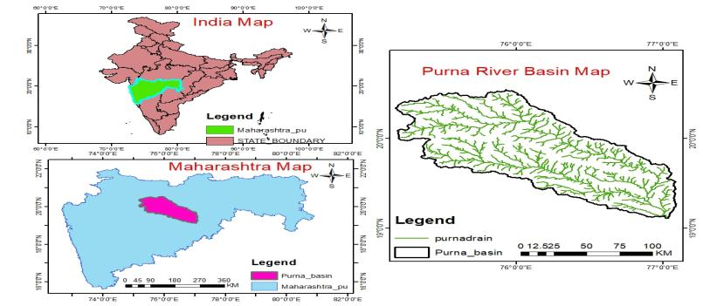
Fig.1 Location map of the study area
2.2 Data and Software Used
The shapefile of the study area was obtained from DIVA-GIS (https://www.diva-gis.org). The Purna River was digitized using a base map in ArcGIS 10.8 software, while the basin map was downloaded from the Hydro SHEDS website (https://www.hydrosheds.org). The analysis was carried out in the Irrigation and Drainage Engineering Laboratory, College of Agricultural Engineering and Technology, Vasantrao Naik Marathwada Krishi Vidyapeeth, Parbhani.
In this study, ArcGIS 10.8 and ERDAS Imagine were employed to view and edit geospatial data, delineate basin boundaries, and generate land use land cover maps. The MS Office Suite 2021 was used for documentation, calculations, and organizing notes. To verify the accuracy of the land use land cover (LULC) maps, Google Earth Pro software was also utilized. The land cover datasets consisted of Sentinel-2 imagery with a spatial resolution of 10 m for the years 2015 and 2025. These images were downloaded from the Copernicus Data Space Ecosystem https://dataspace.copernicus.eu and processed to prepare LULC maps for the respective years.
The central objective of this study was to employ satellite imagery for detecting LULC changes. Maximum likelihood classification, used for a supervised classification approach, was applied, which enables the grouping of land cover types identified from satellite images. This method involves image analysts supervising pixel classification using specific algorithms, where numerical representations of land cover types are defined. Training sites were carefully selected as representative samples of each identified land cover class. These training samples were then compiled to develop a classification key, which assigns numerical values to spectral attributes corresponding to specific land cover categories (Tesfaye et al., 2024; Basheer et al.,2022).
Among supervised classification methods, it is one of the most widely applied (Basukala et al., 2017). The principle of supervised classification is based on a probability function, assuming that the training data for each class in every spectral band follows a normal distribution (Seyam et al., 2023). The flowchart of overall methodological framework for land use land cover mapping is illustrated in Figure 2.
Data Acquisition

Sentinel-2 images 2015, 2025

Data processing and composite Band in ArcGIS

Clip the study Area

Supervised Classification of images

Ground truthing and accuracy Assessment

Add Basemap for Ground truthing in classification
Image Reclassification

Apply Raster to polygon tool and Dissolve images

Change detection image

Fig. 2. Flowchart of the methodology of Land Use Land Cover Classification.
“Land use and land cover are a dynamic process. The change can be detected by making maps of land use and land cover patterns for different periods. For the current study, land use and land cover maps for the years 2015 and 2025 were prepared. The change in the LULC was calculated by comparing the area under each LULC pattern for the years 2015 and 2025.
Area under each LULC pattern was calculated by using the equation as
Area (m)= Pixel count of land use pattern × cell size of one pixel …… (1)
So, Sentinel-2 has a resolution of 10 metres. Therefore, the formula becomes-
Area(m)=Pixel count of particular land use pattern ×10 m × 10 m.
The percent area covered by each land use pattern was calculated as
Area (%) = Area under specific land use (ha)Total area (ha) ×100……… (2)
To assess the accuracy of classification, land use land cover (LULC) maps must be compared with reference data. The identification of LULC patterns in any area is not considered valid until accuracy has been evaluated. In this study, the LULC maps for the years 2015, and 2025 were compared with high-resolution imagery from Google Earth. User accuracy, producer accuracy, and overall accuracy were calculated using the Kappa coefficient to quantify the classification accuracy.
2.3 Accuracy Assessment of Land Use/Land Cover Classification
Accuracy assessment is a critical post-classification step in land use and land cover (LULC) change analysis, as it determines the reliability, validity, and practical applicability of classification outputs. This process evaluates how accurately classified remote sensing data represent real-world surface conditions and provides confidence to decision-makers using LULC products for environmental planning and resource management. Overall accuracy quantifies the proportion of correctly classified pixels by comparing classified outputs with independent reference or ground truth data. Producer’s accuracy measures omission errors and reflects the classifier’s ability to correctly identify actual land cover categories, whereas user’s accuracy addresses commission errors and represents the probability that a pixel assigned to a given class truly corresponds to that category on the ground (Congalton & Green, 2019).
For the years 2015 and 2025, accuracy assessment was carried out using field-based reference data to validate LULC maps derived from Sentinel satellite imagery with a spatial resolution of 10 m. A total of 100 randomly distributed validation points were selected to ensure adequate representation of all land cover classes and to establish statistically robust estimates of classification performance. These validation points were interpreted using ground truth observations and high-resolution reference data to extract quantitative information on land use categories and their spectral characteristics. Similar validation strategies have been widely adopted in European-scale LULC studies to enhance classification reliability and spatial consistency.
Communicating classification accuracy is essential to ensure that LULC maps are used appropriately in scientific analysis and policy formulation. Several studies published in the European Journal of Geography emphasize that LULC change detection studies should achieve a minimum overall accuracy threshold of 80% to be considered reliable for spatial planning and environmental assessment. The confusion (error) matrix remains the most widely used method for accuracy assessment, as it provides a comprehensive statistical summary of classification results, including omission and commission errors. This matrix enables the computation of key accuracy metrics such as overall accuracy, producer’s accuracy, user’s accuracy, and the Kappa coefficient, which are routinely reported in LULC studies to evaluate classification performance and uncertainty (Congalton & Green, 2019).
The formulae to calculate user accuracy, producer accuracy, and overall accuracy are given below-
$User Accuracy =\frac{Number of correctly classified pixels in each category}{\begin{aligned}Total number of reference points in the category \\ (the row total)\end{aligned}} ×100$… (3)
$Producer Accuracy=\frac{Number of correctly classified pixels in each category}{\begin{aligned}Total number of reference pixel in the category \\ (the column total)\end{aligned}} ×100$ ..(4)
$Total overall Accuracy=\frac{Total Number of correctly classified pixels (diagonal)}{Total number of reference points} ×100$ ……(5)
Table 1. Quality of land use mapping according to the Kappa coefficient range
Sr No | Kappa Coefficient | Rate
1 | <0.4 | Very Poor
2 | 0.4-0.55 | Poor
3 | 0.55-0.7 | Good
4 | 0.7-0.85 | Very Good
5 | >0.85 | Excellent
(Source: Nilam Kumari et al., 2024)
$Kappa coefficient=\frac{\left(Ts ×Tcs\right)-£( Total Row ×Total Column)}{(Ts)^2- £(column total×Row total)}$ ………………………. (6)
Where,
Ts = Total Sample
Tcs = Total Corrected Sample
The values of different accuracies indicate the quality of land use mapping. The higher the value of user accuracy, producer accuracy, and overall accuracy, the higher the precision and quality of the data. The classification of the quality of work according to the value of the Kappa coefficient is shown in Table 1.
3. RESULTS AND DISCUSSION

3.1 Land Use and Land Cover Dynamics (2015–2025)
The analysis of Sentinel-2 imagery revealed substantial LULC transitions in the Purna River Basin during the ten-year study period. In 2015, agricultural land dominated the basin with an area of 14,240.22 km² (89.98%), followed by rangeland (967.75 km²; 6.11%) and built-up areas (356.46 km²; 2.25%). Water bodies and tree cover together accounted for less than 2% of the total basin area (Table 2).
By 2025, agricultural land had reduced to 13,905.06 km² (87.86%), indicating a net decline of 335.16 km² (-2.12%) (Table 5). This loss corresponds to the increasing encroachment of built-up areas, which expanded to 586.21 km² (3.70%), reflecting an increment of 229.75 km² (+1.45%). The decline in tree cover (-8.89 km²) and flooded vegetation (-0.65 km²) highlights the continuing anthropogenic pressures and changing hydrological regimes. Rangeland increased modestly to 1104.37 km² (6.98%), suggesting shifts in cultivation patterns and grazing intensity. These findings clearly point towards a gradual but significant transformation in the basin. The reduction in agricultural land, particularly rainfed cropland, suggests a gradual shift in land use driven by declining agricultural profitability, land fragmentation, and increasing dependence on groundwater-based irrigation. In several parts of the basin, intensification of irrigated agriculture has led to the conversion of traditional croplands into fallow or non-agricultural uses, especially in areas experiencing groundwater stress. This transformation is further exacerbated by rising irrigation costs, declining water tables, and uncertainties associated with monsoon variability. Natural landscapes are increasingly giving way to urban expansion.

3.2 Water Bodies and Vegetation Trends
Water bodies experienced a marginal decline from 243.19 km² (1.54%) in 2015 to 221.42 km² (1.40%) in 2025. This reduction may be attributed to seasonal variability, overextraction for irrigation, and sedimentation within reservoirs. Tree cover also declined from 18.05 km² to 9.16 km², underscoring deforestation, agricultural expansion, and unplanned urban growth as contributing drivers. Flooded vegetation, a minor class in the study area, almost disappeared by 2025, reflecting ecological stress and altered hydrological conditions. Such transformations have implications for biodiversity conservation, water regulation, and carbon sequestration functions of the basin.

3.3 Agricultural Land and Built-up Expansion
Agricultural land, though still the predominant LULC category, showed a consistent decrease. The 2.12% reduction over ten years can be linked to fragmentation of farmland, diversion of agricultural plots for housing, and changes in cropping intensity. On the other hand, built-up areas grew by 229.75 km², confirming rapid urbanization in towns like Jalna, Buldhana, and Parbhani. This trend, if continued, could intensify challenges such as water scarcity, soil sealing, and loss of productive farmland.
Table 2. Land cover and land use in the Purna River basin for year 2015
Sr No | Land Cover | Area sq km | Percent (%)
1 | Water Body | 243.19 | 1.54
2 | Trees | 18.05 | 0.11
3 | Flooded Vegetation | 0.73 | 0.00
4 | Agricultural Land | 14240.22 | 89.98
5 | Built-up Area | 356.46 | 2.25
6 | Bare Ground | 0.11 | 0.00
7 | Range land | 967.75 | 6.11
Total |  | 15826.5175 | 100.00

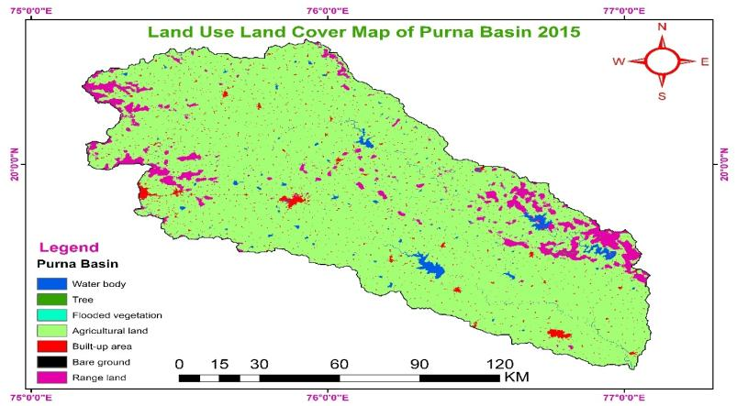
Fig. 3. Land use land cover map of Purna River basin for year 2015

Table 3. Land cover and land use in the Purna River basin for year 2025
Sr No | Land Cover | Area sq km | Percent
1 | Water Body | 221.42 | 1.40
2 | Trees | 9.16 | 0.06
3 | Flooded Vegetation | 0.08 | 0.00
4 | Agricultural Land | 13905.06 | 87.86
5 | Built-up Area | 586.21 | 3.70
6 | Bare Ground | 0.23 | 0.00
7 | Range land | 1104.37 | 6.98
Total |  | 15826.5175 | 100.00

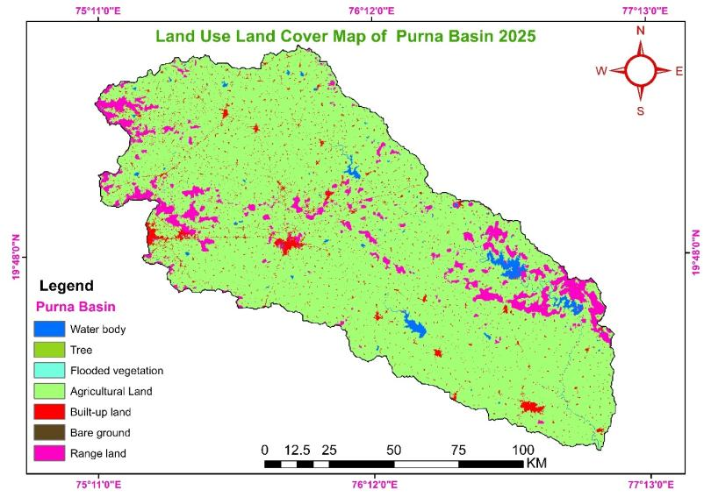
Fig. 4. Land use land cover map of Purna River basin for year 2025
3. Detection in Land Use Change Patterns Over Time
To detect changes in land use patterns in the Purna River basin, Maharashtra, from 2015 to 2025, Sentinel-2 (10 m resolution) data, along with ArcGIS 10.8 and Google Earth software, were used. The land use was classified into seven categories as waterbodies, Tree cover, Flooded Vegetation, agricultural area, Built-up area, Bare ground, and Rangeland using the supervised classification method. Land use and land cover are dynamic properties of any area. The extent of LULC changes spatially and temporally due to human needs and other climatic conditions. The changes in the land use and land cover of the study area obtained from this study are mentioned in Table 4.
Table 4. Land cover change detection in the Purna River basin using Sentinel-2 satellite data
Sr No | Land Class | 2015 Area sq km |  | 2025 Area sq km
Sr No | Land Class | (Km²) | (%) | (Km²) | (%)
1 | Water Body | 243.19 | 1.54 | 221.42 | 1.40
2 | Trees | 18.05 | 0.11 | 9.16 | 0.06
3 | Flooded Vegetation | 0.73 | 0.00 | 0.08 | 0.00
4 | Agricultural Land | 14240.22 | 89.98 | 13905.06 | 87.86
5 | Built-up Area | 356.46 | 2.25 | 586.21 | 3.70
6 | Bare Ground | 0.11 | 0.00 | 0.23 | 0.00
7 | Range land | 967.75 | 6.11 | 1104.37 | 6.98
Total |  | 15826.5175 | 100.00 | 15826.5175 | 100.00

The LULC analysis reveals notable changes in the study area between 2015 and 2025. Agricultural land, which dominates the region, decreased from 14,240.22 km² (89.98%) in 2015 to 13,905.06 km² (87.86%) in 2025, indicating a gradual conversion of agricultural areas to other land uses. In contrast, the built-up area showed a significant increase from 356.46 km² (2.25%) to 586.21 km² (3.70%). The expansion of built-up areas during the study period can be primarily attributed to population growth, infrastructure development, and the spatial spillover of urban centres into peri-urban and agricultural landscapes. Such trends are consistent with regional demographic expansion and increasing demand for housing, transportation networks, and industrial facilities. The area under water bodies slightly declined from 243.19 km² (1.54%) to 221.42 km² (1.40%), which may be attributed to reduced surface water availability or seasonal variability. Tree cover also decreased notably, from 18.05 km² (0.11%) to 9.16 km² (0.06%), suggesting loss of vegetation cover, possibly due to land conversion or anthropogenic pressure and the decline in tree cover and forested patches represents a critical environmental concern. This reduction due to agricultural expansion in earlier periods, fuelwood extraction, and infrastructure development, as well as insufficient enforcement of land conservation policies. Climatic stressors, including prolonged dry spells and increasing temperature extremes, may have further contributed to vegetation degradation, particularly in marginal and ecologically sensitive zones. Rangeland exhibited an increase from 967.75 km² (6.11%) to 1,104.37 km² (6.98%), indicating expansion of grazing or fallow lands. Minor classes such as flooded vegetation and bare ground occupied negligible areas in both years and showed minimal change. Overall, the observed LULC dynamics highlight a trend of urban expansion at the expense of agricultural land and natural vegetation, which may have implications for groundwater recharge, surface runoff, and long-term land sustainability.
Table 5. LULC change detection (2015-2025) of the Purna River Basin under study.
Sr No | Land Use Land Cover | LULC change 2015-2025
Sr No | Land Use Land Cover | Area KM² | Percent (%)
01 | Water Body | -21.77 | -0.14
02 | Trees | -8.89 | -0.05
03 | Flooded Vegetation | -0.65 | 0
04 | Agricultural Land | -335.16 | -2.12
05 | Built-up Area | 229.75 | 1.45
06 | Bare Ground | 0.12 | 0
07 | Range land | 136.62 | 0.87

The LULC change analysis between 2015 and 2025 indicates substantial transformations in the study area. Agricultural land experienced the largest decline, decreasing by 335.16 km² (−2.12%), suggesting conversion of cropland to non-agricultural uses. Similarly, water bodies reduced by 21.77 km² (−0.14%), indicating a contraction of surface water extent, possibly due to climatic variability or increased water withdrawal. Tree cover also declined by 8.89 km² (−0.05%), reflecting loss of natural vegetation. A notable increase was observed in the built-up area, which expanded by 229.75 km² (1.45%), highlighting rapid urbanization and infrastructure growth during the study period. Rangeland showed a moderate increase of 136.62 km² (0.87%), possibly due to land degradation or conversion of agricultural land into grazing or fallow areas. Changes in flooded vegetation and bare ground were minimal and occupied negligible proportions of the total area.
therefore, the results reveal a clear trend of urban expansion and land transformation at the expense of agricultural land and natural resources, which may have significant implications for land management, water availability, and groundwater recharge processes.
3.2 Accuracy Assessment of Land Use Mapping
The accuracy of land use and land cover for Purna River basin was calculated using the Kappa coefficient. The different reference points selected from the land use maps of Purna River basin were compared with the Google Earth image. The results obtained from the comparison of the reference points of Purna River basin during the years 2015, and 2025 with Google Earth images are presented in Tables 6 and 7, respectively.
Table 6. Accuracy assessment of land use mapping of Purna River basin during the year 2015
Sr No | Class | Water Body | Trees | Flooded Vegetation | Agricultural Land | Built-up Area | Bare Ground | Range land | Total
1 | Water Body | 2 | 0 | 0 | 0 | 0 | 2 | 0 | 2
2 | Trees | 0 | 1 | 0 | 0 | 0 | 0 | 0 | 1
3 | Flooded Vegetation | 0 | 0 | 0 | 0 | 0 | 0 | 0 | 0
4 | Agricultural Land | 0 | 1 | 0 | 87 | 1 | 0 | 0 | 89
5 | Built-up Area | 0 | 0 | 0 | 0 | 1 | 0 | 1 | 3
6 | Bare Ground | 0 | 0 | 0 | 0 | 0 | 0 | 0 | 0
7 | Range land | 0 | 0 | 0 | 0 | 3 | 0 | 4 | 5
 | Total | 1 | 2 | 0 | 87 | 5 | 20 | 5 | 100

Table 7. Accuracy assessment of land use mapping of Purna River basin during the year 2025
Sr No | Class | Water Body | Trees | Flooded Vegetation | Agricultural Land | Built-up Area | Bare Ground | Range land | Total
1 | Water Body | 1 | 0 | 0 | 0 | 0 | 0 | 0 | 1
2 | Trees | 0 | 0 | 0 | 0 | 0 | 0 | 0 | 0
3 | Flooded Vegetation | 0 | 0 | 0 | 0 | 0 | 0 | 0 | 0
4 | Agricultural Land | 0 | 0 | 1 | 87 | 0 | 0 | 2 | 90
5 | Built-up Area | 0 | 1 | 0 | 0 | 3 | 0 | 0 | 4
6 | Bare Ground | 0 | 0 | 0 | 0 | 0 | 0 | 0 | 0
7 | Range land | 0 | 0 | 0 | 1 | 0 | 1 | 3 | 5
 | Total | 1 | 1 | 1 | 88 | 3 | 1 | 5 | 100
It was observed from Tables 6 and 7 that sample points for water bodies, tree cover, flooded vegetation, agricultural land, built-up area, bare ground, and rangeland were compared with high-resolution Google Earth imagery. These tables show that correctly classified points are aligned diagonally from the top-left to the bottom-right of the confusion matrix. The total reference points used for validation are summarized in the "User Total" column, while all points predicted as a particular land cover class are summed in the "Producer Total" row. Some validated images from Google Earth imagery and actual ground truth images are shown in the following figure. 5.
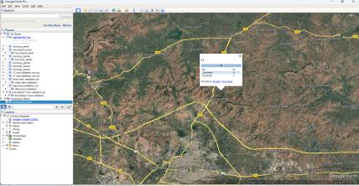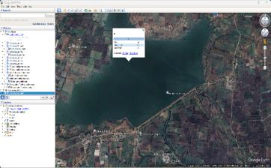
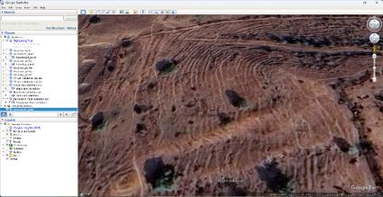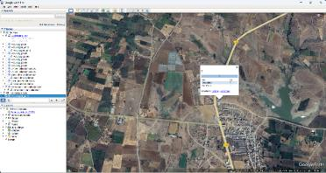
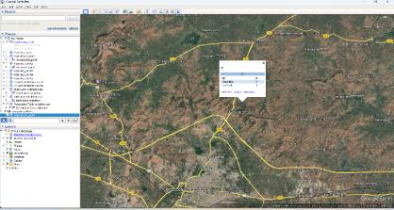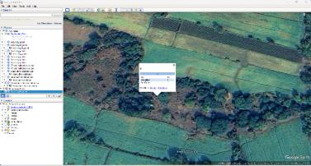
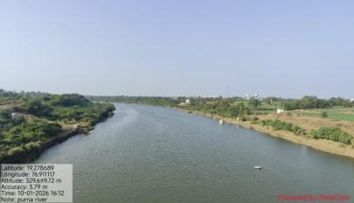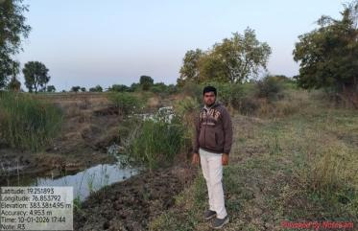

Figure 5. Ground truth points of Godavari Purna River sub -basin
Each number within the matrix represents the count of instances for each combination of predicted and actual land cover classes. The diagonal elements indicate correctly classified instances (i.e., accurate predictions), while the off-diagonal elements reflect misclassifications. The "Total" row and column provide the overall number of instances evaluated for each class. Tables 6 and 7 provide a detailed breakdown of the classification model’s performance for the years 2015 and 2025. These tables help identify which land cover classes were classified accurately and which presented challenges for the model. According to Anderson et al. (1976), a contingency matrix includes several accuracy metrics, namely producer’s accuracy, user’s accuracy, overall accuracy, and the kappa coefficient. Producer’s accuracy reflects how well a particular class has been classified from the perspective of the map maker, while user’s accuracy indicates the reliability of the map from the perspective of the end user. The classification accuracy results for the two years are shown in Tables 8 and 9.
3.3 Overall Accuracy and Kappa
The overall accuracy, user’s accuracy, producer’s accuracy, and Kappa Coefficient were calculated using the procedures described in Methodology Equations 3, 4, 5, and 6. User’s Accuracy (also known as Producer's Accuracy) refers to the proportion of correctly classified instances for each class out of the total number of instances in that class. It is calculated by dividing the diagonal element of the confusion matrix by the sum of the column corresponding to that class. Overall Accuracy is a general measure of classification performance. It is computed by dividing the total number of correctly classified instances (i.e., the sum of the diagonal elements) by the total number of all classified instances. Producer’s Accuracy for each class is calculated by dividing the diagonal element by the sum of the corresponding row, indicating how well real-world features of a given class are classified.
Table 8. User and producer accuracy of Purna River basin during the year 2015
Sr No | Land Use Patterns | User accuracy (%) | Producer accuracy (%) | Overall accuracy (%)
1 | Water Body | 100 | 100 | 95
2 | Trees | 100 | 100
3 | Flooded Vegetation | 0 | 0
4 | Agricultural Land | 98 | 100
5 | Built-up Area | 100 | 100
6 | Bare Ground | 0 | 0
7 | Range land | 97 | 100

Table 9. User and producer accuracy of Purna River basin during the year 2025
Sr No | Land Use Patterns | User accuracy (%) | Producer accuracy (%) | Overall accuracy (%)
1 | Water Body | 100 | 100 | 94
2 | Trees | 0.00 | 0 | 94
3 | Flooded Vegetation | 0.00 | 0 | 94
4 | Agricultural Land | 97 | 99 | 94
5 | Built-up Area | 75 | 100 | 94
6 | Bare Ground | 0.00 | 0 | 94
7 | Range land | 60 | 60 | 94
Based on the overall accuracy and Kappa Coefficient (Table 10), the classification accuracy for the years 2015 and 2025 is 95% and 94%, respectively. The corresponding Kappa Coefficient values are 0.85 in 2015 and 0.81 in 2025. These results indicate a high level of classification accuracy and consistency, which are considered excellent and suitable for further analysis. Similar findings were reported by Islami et al. (2022). The calculated values of user’s accuracy, producer’s accuracy, and overall accuracy for each year are presented in Tables 8, 9, and respectively.
Table 10. Quality of land use mapping according to overall accuracy Kappa coefficient range
Sr No | Year | Overall accuracy | Kappa coefficient | Grade
1 | 2015 | 95 | 0.85 | Excellent
2 | 2025 | 94 | 0.81 | Very good

3.4 Kappa for Each Class
The Kappa Coefficient measures the agreement between predicted and actual classifications, adjusted for chance agreement. It indicates how well the model performs for each specific class, considering the possibility of random agreement. A Kappa value of 1 represents perfect agreement, 0 indicates agreement equivalent to chance, and negative values suggest agreement worse than chance.
A higher Kappa value reflects stronger agreement and better classification accuracy. A Kappa value of 0.85 or higher is generally considered to represent a strong correlation in land use classification. In this study, the Kappa Coefficient was calculated using 100 reference points and was found to be 0.85 in 2015 and 0.81 in 2025, indicating an excellent level of classification accuracy across both years. These results are presented in Table 10.

Conclusion
The present study successfully demonstrates the utility of remote sensing and GIS techniques in assessing spatiotemporal changes in land use and land cover (LULC) in the Purna River Basin, Maharashtra, over the decadal period from 2015 to 2025. Using Sentinel-2 satellite imagery and maximum likelihood supervised classification methods, LULC maps were generated and analysed for the years 2015 and 2025. The study highlights significant transitions, particularly the consistent decline in agricultural land and the concurrent increase in built-up areas, which reflect the growing influence of urbanization and infrastructure development in the region.
While the built-up area expanded significantly between both periods, agricultural land steadily declined, raising concerns about sustainable land use, food security, and the degradation of natural resources. Water bodies and flooded vegetation showed inconsistent trends, likely due to seasonal variations and hydrological influences. Tree cover showed a marginal increase, possibly due to afforestation or conservation efforts. Rangeland showed both loss and recovery in different periods, emphasizing the complex dynamics of land management and ecological pressures.
The accuracy assessment using the Kappa coefficient and error matrices for the classified images yielded overall accuracies of 95% (2015) and 94% (2025), with Kappa values exceeding 0.85, indicating excellent classification quality. These results validate the reliability of the generated LULC maps for further environmental monitoring and planning purposes.
therefore, this research underscores the critical role of geospatial technologies in supporting land resource management, policy planning, and environmental monitoring. It advocates for continuous LULC monitoring to inform sustainable development, mitigate land degradation, and enhance climate resilience in ecologically sensitive river basins like the Purna. Future research should consider integrating socio-economic variables and climatic data to better understand the drivers of land use change and to promote data-driven land use policy formulation.

Disclaimer (Artificial intelligence)

Author(s) hereby declare that NO generative AI technologies such as Large Language Models (ChatGPT, COPILOT, etc.) and text-to-image generators have been used during the writing or editing of this manuscript.

References
- Abebe, G., Getachew, D. & Ewunetu, A.(2022) Analysing land use/land cover changes and its dynamics using remote sensing and GIS in Gubalafito district, Northeastern Ethiopia. SN Appl. Sci. 4, 30 . https://doi.org/10.1007/s42452-021-04915-8
- Ahmed, H., Kheiry, M., & Yasin, E. (2023). Land-Use Land-Cover Change Detection Using Geospatial Techniques in Zalingei, Central Darfur, Sudan. Journal of Information Systems and Informatics, 5(4), 1676-1690.
- Amini, S., Saber, M., Rabiei-Dastjerdi, H., & Homayouni, S. (2022). Urban Land Use and Land Cover Change Analysis Using Random Forest Classification of Landsat Time Series. Remote Sensing, 14(11), 2654. https://doi.org/10.3390/rs14112654
- Anderson, J. R., Hardy, E. E., Roach, J. T., & Witmer, R. E. (1976). A land use and land cover classification system for use with remote sensor data (U.S. Geological Survey Professional Paper No. 964). U.S. Government Printing Office.
- Attua, E. M. and Fisher, J. B. (2011). “Historical and future land-coverchange in a municipality of Ghana,” Earth Interactions,vol. 15, no. 9, pp. 1–26,
- Basheer, S., Wang, X., Farooque, A. A., Nawaz, R. A., Liu, K., Adekanmbi, T., & Liu, S. (2022). Comparison of Land Use Land Cover Classifiers Using Different Satellite Imagery and Machine Learning Techniques. Remote Sensing, 14(19), 4978. https://doi.org/10.3390/rs14194978.
- Basukala, A.K., Oldenburg, C., Schellberg, J., Sultanov, M., Dubovyk, O.,2017. Towards improved land use mapping of irrigated croplands: performance assessment of different image classification algorithms and approaches. European Journal of Remote Sensing, VOL. 50, NO. 1, 1308235 http://dx.doi.org/10.1080/22797254.2017.1308235.
- Bürgi, M., Celio,E., Diogo,V., Hersperger,A. M., Kizos,T., Juraj Lieskovsky, Robert Pazur, Tobias Plieninger, Alexander V. Prishchepov & Peter H. Verburg (2022) Advancing the study of driving forces of landscape change, Journal of Land Use Science, 17:1, 540-555, DOI: 10.1080/1747423X.2022.2029599
- Congalton, R. G., & Green, K. (2019). Assessing the accuracy of remotely sensed data: Principles and practices (3rd ed.). CRC Press. https://doi.org/10.1201/9780429052729
- Fonji and Taff: Using satellite data to monitor land-use land-cover change in North-eastern Latvia. Springer Plus. 3:61.
- Foody, G. M. (2002). Status of land cover classification accuracy assessment. Remote Sensing of Environment, 80(1), 185–201.https://doi.org/10.1016/S0034-4257(01)00295-4
- Hermosilla, T., Wulder, M. A., White, J. C., & Coops, N. C. (2022). Land cover classification in an era of big and open data: Optimizing localized implementation and training data selection to improve mapping outcomes. Remote Sensing of Environment, 268, 112780. https://doi.org/10.1016/j.rse.2022.112780
- Islami1, F.A., Tarigan, S.D., Wahjunie, E.D., Dasanto, B.D., (2022). Accuracy Assessment of Land Use Change Analysis Using Google Earth in Sadar Watershed Mojokerto Regency. Earth and Environmental Science. 950 (012091). doi:10.1088/1755-1315/950/1/012091
- Lambin, E. F., Geist, H. J., & Lepers, E. (2003). Dynamics of land-use and land-cover change in tropical regions. Annual Review of Environment and Resources, 28, 205–241.
https://doi.org/10.1146/annurev.energy.28.050302.105459
- Li, J., Zhou, K., Xie, B., & Xiao, J. (2021). Impact of landscape pattern change on water-related ecosystem services: Comprehensive analysis based on landscape pattern metrics and ecosystem functions. Ecological Indicators, 173, 107384. https://doi.org/10.1016/j.ecolind.2021.108372
- Mashala, M. J., Dube, T., Mudereri, B. T., Ayisi, K. K., & Ramudzuli, M. R. (2023). A Systematic Review on Advancements in Remote Sensing for Assessing and Monitoring Land Use and Land Cover Changes Impacts on Surface Water Resources in Semi-Arid Tropical Environments. Remote Sensing, 15(16), 3926. https://doi.org/10.3390/rs15163926
- Matsa, M., Mupepi, O., Musasa, T. & Defe, R. (2020) “A GIS and remote sensing aided assessment of land use/cover changes in resettlement areas; a case of ward 32 of Mazowe district, Zimbabwe,” Journal of Environmental Management, vol. 276, Article ID 111312.
- Mishra, B. K., Kumar, P., Saraswat, C., Chakraborty, S., & Gautam, A. (2021). Water Security in a Changing Environment: Concept, Challenges and Solutions. Water, 13(4), 490. https://doi.org/10.3390/w13040490
- Mishra, P. K., Rai, A., & Rai, S. C. (2020). Land use and land cover change detection using geospatial techniques in the Sikkim Himalaya, India. The Egyptian Journal of Remote Sensing and Space Sciences, 23(1), 133–143.https://doi.org/10.1016/j.ejrs.2019.02.001
- Mondal, M. S., Sharma, N., Kappas, M., & Garg, P. K. (2013).Modeling of spatio-temporal dynamics of land use and land cover in a part of Brahmaputra River basin using Geoinformatic techniques. Geocarto International, 28(7), 632-656. https://doi.org/10.1080/10106049.2013.776641
- Rimal, B., Sharma, R., Kunwar, R., Keshtkar, H., Stork, N.E., Rijal, S., Rahman, S.A., Baral, H., 2019. Effects of land use and land cover change on ecosystem services in the Koshi River Basin. Eastern Nepal. Ecosystem Services 38, 100963. https://doi.org/10.1016/j.ecoser.2019.100963
- Seyam, M. M. H., Haque, M. R., Rahman, M. M., 2023. Identifying the land use land cover (LULC) changes using remote sensing and GIS approach: A case study at Bhaluka in Mymensingh, Bangladesh. Case Studies in Chemical and Environmental Engineering, 7, Article 100293. https://doi.org/10.1016/j.cscee.2022.100293.
- Tesfaye, W., Elias, E., Warkineh, B. (2024). Modeling of land use and land cover changes using google earth engine and machine learning approach: implications for landscape management. Environ Syst Res 13, 31. https://doi.org/10.1186/s40068-024-00366-3
- Traore, M., Lee, M. S., Rasul, A., and Balew, A. “Assessment of land use/land cover changes and their impacts on land surface temperature in Bangui (the capital of Central African Republic),” Environmental Challenges, vol. 4, Article ID 100114,2021
- Turner, B. L., Lambin, E. F., & Reenberg, A. (2007). The emergence of land change science for global environmental change and sustainability. Proceedings of the National Academy of Sciences, 104(52), 20666–20671.https://doi.org/10.1073/pnas.0704119104
- Weng, Q. (2012). Remote sensing of impervious surfaces in the urban areas: Requirements, methods, and trends. Remote Sensing of Environment, 117, 34–49.
https://doi.org/10.1016/j.rse.2011.02.030
- Wang Q, Xiong K, Zhou J, Xiao H and Song S (2023), Impact of land use and land cover change on the landscape pattern and service value of the village ecosystem in the karst desertification control. Front. Environ. Sci. 11:1020331. doi: 10.3389/fenvs.2023.1020331
- Yesuph, A.Y., Dagnew, A.B. Land use/cover spatiotemporal dynamics, driving forces and implications at the Beshillo catchment of the Blue Nile Basin, North Eastern Highlands of Ethiopia. Environ Syst Res 8, 21 (2019). https://doi.org/10.1186/s40068-019-0148-y
- Zhang, C., & Li, X. (2022). Land Use and Land Cover Mapping in the Era of Big Data. Land, 11(10), 1692. https://doi.org/10.3390/land11101692

