Original Research Article

Study of spatial variation of soil moisture availability in Akola district using geoinformatics

ABSTRACT
The soils of Akola district are medium to deep black soil. Monsoon break for 7-10 days may not be a serious concern but more than 15 days duration especially at critical growth stages leads to soil moisture stress reduction in crop yield. Drought due to break in monsoon adversely affect the crops in shallow soils as compared deep soils. Soil moisture plays an important role in determining the amount of runoff that occurs and the chances of droughts and floods that may affect an area. The spatial variation of soil moisture availability in the study area was estimated using GIS tools based on spatial variation of soil types and digital elevation mode land region specific pedo-transfer functions. The point data on textural composition were converted into hydraulic data using pedo-transfer functions to estimate field capacity, permanent wilting point and bulk density of the soils. These estimates were then applied to the identical textural classes to generate soil moisture data. The maximum part of Akola district is having high available water holding capacity except the hilly area lying in Akot, Telhara Patur and Barshitakli taluka in the district. the available water holding capacity above 25 cm per meter depth of soil is observed in most part of Akola, Akot, Telhara and Balapur talukas and some part of Murtizapur, Barshitakli and Patur talukas. The spatial variation of available water holding capacity of soil in different talukas of Akola district indicated that the soil moisture availability is more in the Akola, Akot, Telhara and Balapur talukas as compared to the Murtizapur, Barshitakli and Patur taluka.
Key words: Soil moisture, water holding capacity, Vidarbha region
Introduction
Rainfall is considered as principal source of water for agricultural production, particularly in rain-fed systems where irrigation is limited. Under such conditions, crop success or failure is strongly influenced by the rainfall pattern like timing, amount, and distribution of rainfall during the growing season. The Indian Summer Monsoon (ISM), a key component of the Asian monsoon system, exhibits a wide spectrum of variability across multiple time scales - daily, sub seasonal, inter-annual, decadal and centennial trends. During the summer monsoon season (June to September), a substantial component of this variability convection and rainfall over the Indian region arises from the fluctuation on the intra seasonal scale between active spell with good rainfall and weak spell or breaks with little rainfall.
The inter annual variability of the sub-seasonal fluctuations during monsoon season is large. Long intense breaks are known to have an impact on the seasonal monsoon rainfall over the country. Frequent or prolonged breaks in rainy days during the monsoon season, can lead to drought conditions. Long breaks during critical growth periods of agricultural crops lead to substantial reduction in crop yield. Therefore, understanding the intra-seasonal behaviour of the monsoon, including the occurrence, duration, and intensity of breaks, is essential for agricultural planning, drought early warning, and sustainable water resource management (Ramesh & Kumar, 2023).
The soils of Akola district are medium to deep black soil. Monsoon break for 7-10 days may not be a serious concern but more than 15 days duration especially at critical growth stages leads to soil moisture stress reduction in crop yield. Drought due to break in monsoon adversely affect the crops in shallow soils as compared deep soils. Soil moisture controls interactions between the land surface and the atmosphere, as changes in soil moisture affect both energy and water cycles. Soil moisture plays an important role in determining the amount of runoff that occurs and the chances of droughts and floods that may affect an area.
Now a days, remote sensing technology has become an integral part of ever growing Information Technology, which acquires modern remote sensing means information about earth’s land and water surfaces by using reflected or emitted electromagnetic energy. Remote sensing provides solution to facilitate sustainable development of the natural resources and conservation of environment at varying scales. The technical capabilities of remote sensing and GIS are found useful to study the different scenario with the help of historical satellite imageries. It is easy to generate combinations of spatio-temporal themes of various resources. Satellite imageries are useful in the study of spatial variations of available soil moisture during dry spells.
The GIS acronym stands for Geographic Information System. An integrated computer system, which facilitate the data generation, editing, storage, analysis and retrieval of geographic data of various scale and dimensions with capability of data analysis on different scale, pattern and themes. The modern computing facility has widened the scope of this science through virtual analysis and presentations of data in three and four dimensions. These specific tools have made possible the virtual tour of remote part of globe using remote sensing data of suitable resolutions. The data spatial interpolation technique helps to find out the pattern of specific themes in unknown regions, where the data recording facility is not available. These tools are useful in the study of weather parameter, land, slope, vegetation etc.
Analysis of soil moisture variability helps to develop and modify the management practice to increase and stabilize the agriculture production in the rainfed ecosystem. At certain level, it is essential to plan agriculture by making best use of rainfall pattern of an area. The farmers have adopted their own farming system based on experience gained from generations to generation and plan crop planning without adopting proper agro - advisory system. However, under current circumstances of uncertain weather conditions, there is a wide scope for planning of rainfed farming based on recent analysis tools without any additional input cost and it can help in increasing crop production.
Materials and methods
Computation of Soil Moisture Using GIS Techniques
The spatial variation of soil moisture availability in the study area was estimated using GIS tools based on spatial variation of soil types and digital elevation mode land region specific pedo-transfer functions. The point data on textural composition were converted into hydraulic data using pedo-transfer functions recommended by Patil et al. (2010, 2012, and 2013) to estimate field capacity, permanent wilting point and bulk density of the soils. These estimates were then applied to the identical textural classes to generate soil moisture data.
The overlay operation was performed in GIS environment to identify the vivid combinations of soil texture, depth and slope along with derived properties such as bulk density, actual water holding capacity and permanent wilting points. The flow chart of methodology adopted for soil moisture estimation is depicted in Fig. No. 1
Integration of different layers of soil properties with weather database facilitated generation of different combinations of soil moisture allowing the viewer synoptic visualization of soil moisture distribution. The extrapolation technique was found useful to identify the status of soil moisture for remote locations/area.
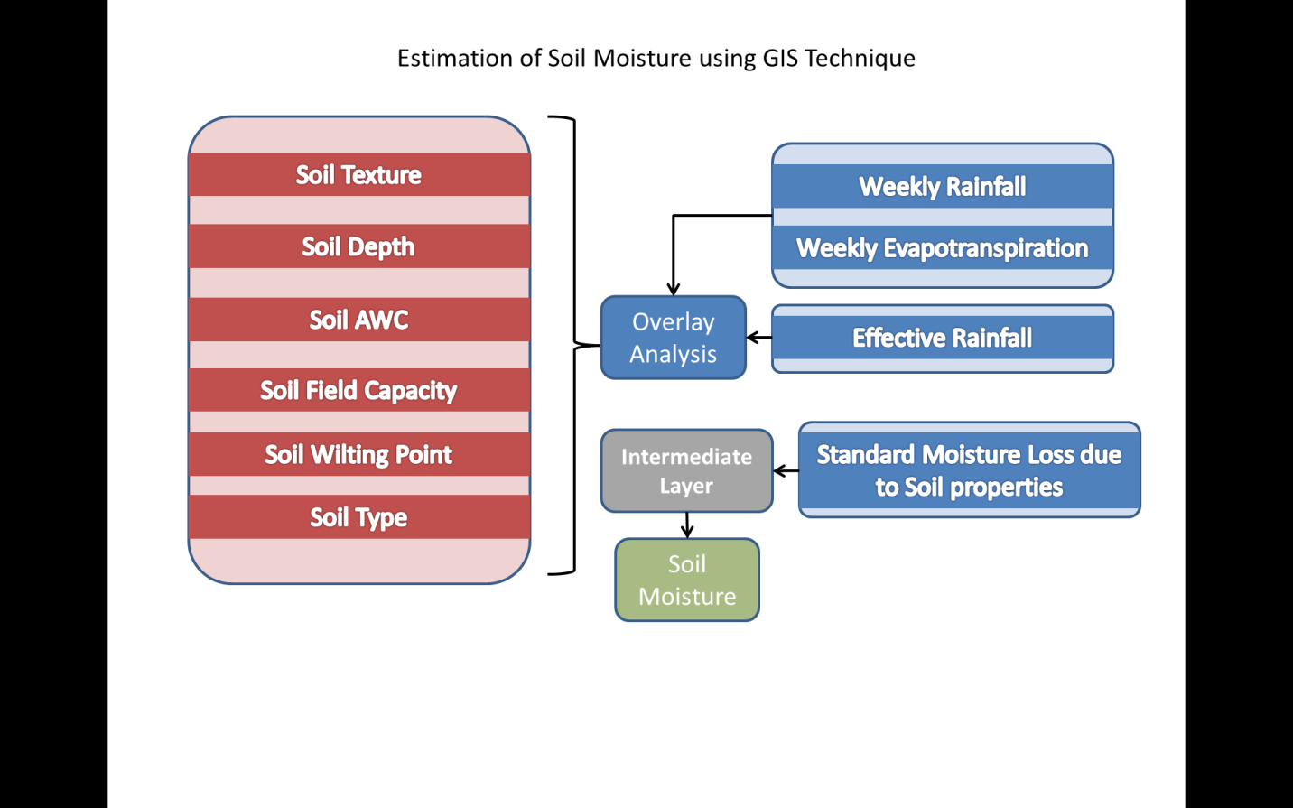

Fig. 1 Flow Chart for Soil Moisture Estimation in GIS Environment
Available Water Holding Capacity
The difference in the moisture content of the soil between field capacity and the permanent wilting point is called the available moisture. The available water holding capacity of soil for its depth can be determined by using following relationship between soil moisture constants (field capacity and wilting point), bulk density of soil and soil depth.

$$d=\frac{(Mf-Mw)}{100}×As×D$$
In which,
d = Available water holding capacity, cm/ m
M_{f} = Field capacity moisture content of the soil, percent
M_{w} = Wilting point moisture content of the soil, percent
As = Bulk density of the soil
D = Depth of soil, cm
Results and Discussion
Spatial Variation of Soil Moisture Availability
The spatial variation of soil moisture availability in different taluka places of Akola district was studied with the information on variation in soil texture, soil depth, soil slope using remote sensing imageries and geographical information system (GIS) tools. The results so obtained are discussed as below.
1. Soil texture map
The soils of Akola district are classified into eight different textural classes viz. clayey, clay loam, gravelly clay, gravelly clay loam, gravelly sandy clay loam, gravelly sandy loam, sandy clay loam, and silty loam. The Spatial distribution maps shown in Fig. 2, indicate that clayey soils dominate most of the district followed by clay loam soils and some part of northern and southern side of the district, the sandy to sandy loam soils were observed, suggesting high water-holding capacity and nutrient retention, although these soils may require management to improve aeration and root penetration (Deshmukh, Patil, & Sharma, 2024; Raju & Kumar, 2025).
2. Soil depth map
The spatial variation of soil depth in different talukas of Akola district shown in Fig. 3. Shows that soil depth is classified in five groups viz. shallow to very shallow (< 10cm), shallow (10 to 25 cm), moderately deep (25 to 50 cm), deep (50 to 100 cm) and very deep (> 100 cm). Maximum area in Akola district is under deep to very deep soils except that of extreme northern and southern side, where maximum area is under hilly terrain is the shallow to medium soils, which are more susceptible to erosion and require conservation measures (Moharana, Singh, & Verma, 2024).
3. Soil slope map
The soil/land slope variation in different taluka places of Akola district in Fig. 4 varies from 1 to 3 %, 3 to 5%, 5 to 10 %, 10 to 15 %, 15 to 35 % and 35 to 50 %. The spatial distribution of land slope in the district indicates that maximum area in Akola, Balapur, Akot, Telhara, Murtizapur and Patur taluka is having rolling topography (1 to 3 %). Large area in Barshitakli taluka followed by Patur taluka is under 3 to 5 percent land slope. The relationship between slope and soil properties highlights the influence of terrain on soil depth, texture, and overall land capability, with steeper areas tending to have shallower soils due to erosion (Sharma & Joshi, 2024; Raju & Kumar, 2025).
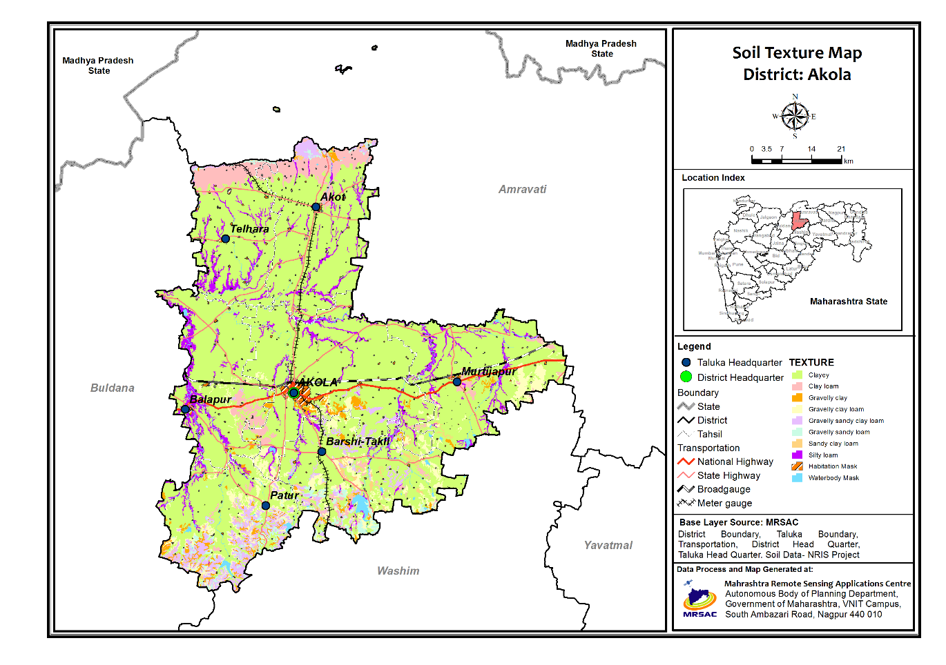
Fig. 2 Distribution of soil texture in different talukas of Akola district
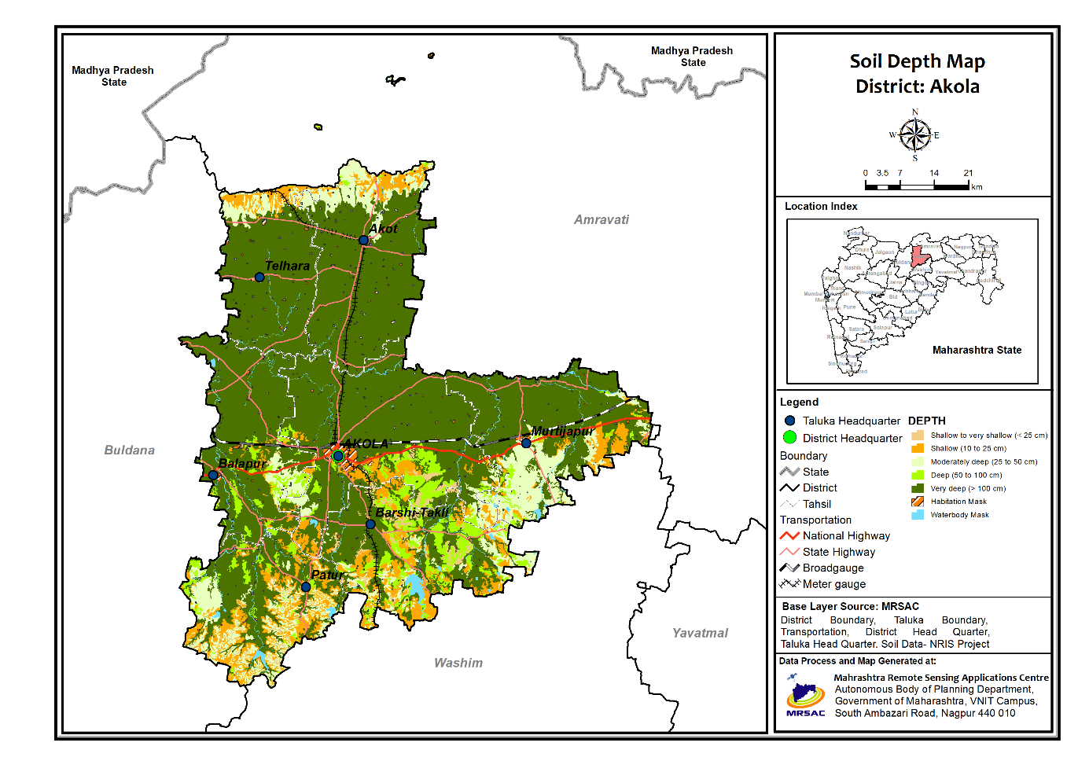
Fig. 3 Distribution of soil depth in different talukas of Akola district
4. Available water holding capacity
The spatial variation of available water holding capacity of soil at different stations in Akola district was developed by using maps of soil depth, soil texture and soil slope (Fig. 5). The available water holding capacity of the soils in the study area varies from less than 5 cm to greater than 25 cm per meter depth of soil. The maximum part of Akola district is having high available water holding capacity except the hilly area lying in Akot, Telhara Patur and Barshitakli taluka in the district.
It is seen from Fig. 5 that the available water holding capacity above 25 cm per meter depth of soil is observed in most part of Akola, Akot, Telhara and Balapur talukas and some part of Murtizapur, Barshitakli and Patur talukas i.e., major portion of Akola district. The available water holding capacity below 5 cm is observed in some part of Akola and Barshitakli talukas and some north part of Akot and telhara talukas. The available water holding capacity within 5-10 cm, 10-15 cm, 15-20 cm and 20-25 cm per meter depth of soil range is observed sparsely distributed in almost all talukas of Akola district.
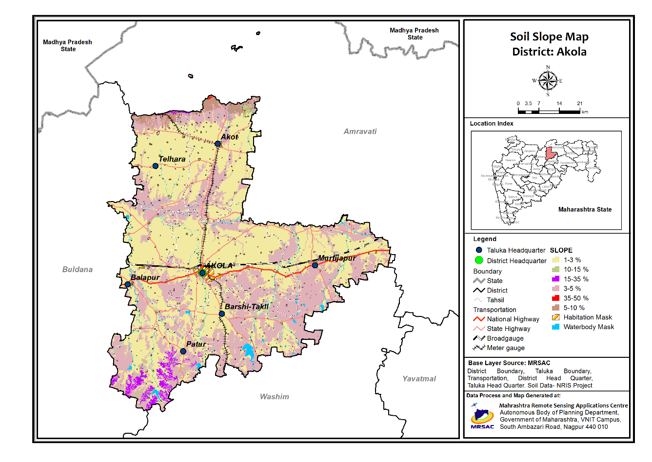
Fig. 4 Distribution of soil slope in different talukas of Akola district
From capacity of the soil moisture availability is more in the Akola, Akot, Telhara and Balapur talukas as compared to the Murtizapur, Barshitakli and Patur taluka. The soil depth, slope and texture were correlated to available water holding capacity. The available water holding capacity is less were the Soil slope is very high, shallow soil depth and sandy soils (L.F. Stone et. al. 2025). This information on spatial variability of available water holding capacity of soil in different taluka places is very much useful for planners and development agencies for proper selection of crops and their varieties and deciding different package of practices for contingency measures in case of prolonged dry spells or delayed onset of monsoon.
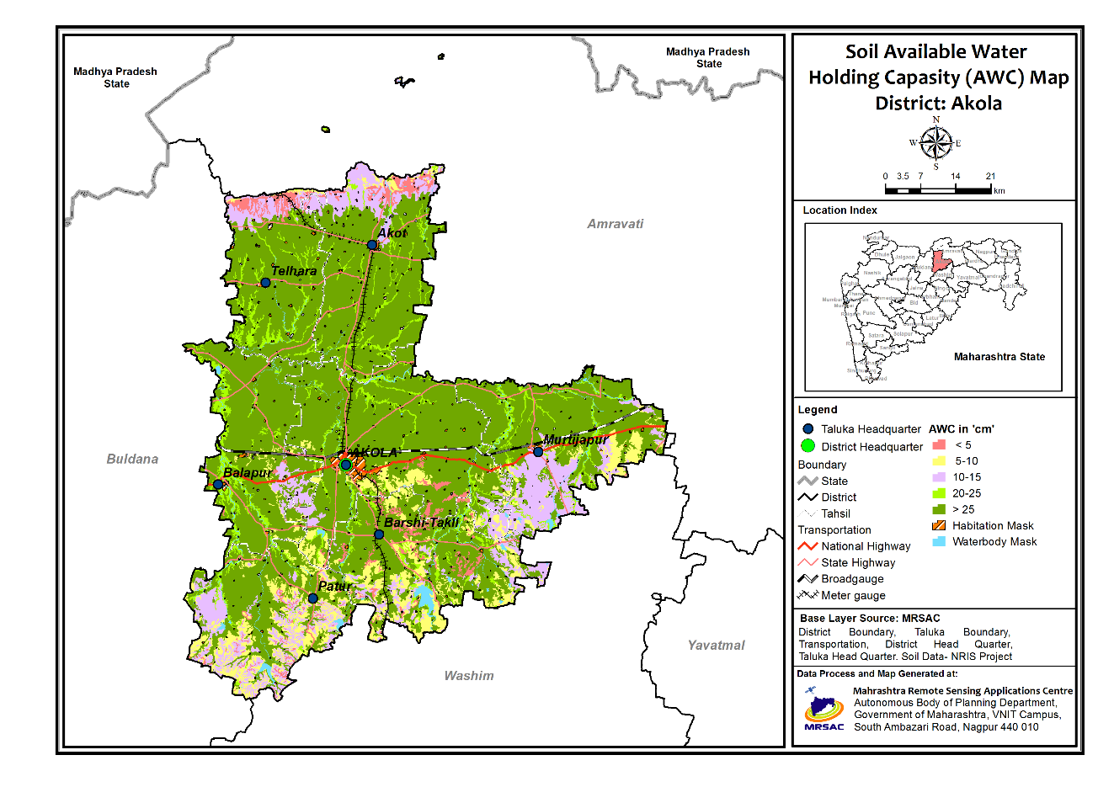
Fig. 5 Distribution of soil available water holding capacity in different talukas of Akola district
Conclusion
The spatial variation of soil moisture availability in Akola district was carried out using geoinformatics. The spatial variation of available water holding capacity of different soil types in Akola district was developed by using the information compiled in spatial maps of soil depth, soil texture and soil slope of study area using data from remote sensing imageries and GIS tools. The spatial variation of available water holding capacity of soil in different talukas of Akola district indicated that the soil moisture availability is more in the Akola, Akot, Telhara and Balapur talukas as compared to the Murtizapur, Barshitakli and Patur taluka. This information on spatial variability of available water holding capacity of soil in different taluka places can be very much useful for planners and development agencies for proper selection of crops and their varieties and deciding different package of practices.
Competing interests
Authors have declared that no competing interests exist.
Disclaimer (Artificial intelligence)
Option 1:
Author(s) hereby declare that NO generative AI technologies such as Large Language Models (ChatGPT, COPILOT, etc.) and text-to-image generators have been used during the writing or editing of this manuscript.
References:
- Ramesh, S., & Kumar, P. (2023). Intra-seasonal variability of Indian summer monsoon and its impact on rainfall and agriculture. EGU General Assembly 2023. https://meetingorganizer.copernicus.org/EGU25/EGU25-6038.html
- Patil, N. G., Rajput, G. S., Nema, R. K., & Singh, R. B. (2010). Calibration and evaluation of pedotransfer functions to estimate available water capacity of seasonally impounded shrink-swell soils of central India. Archives of Agronomy and Soil Science, 56(5), 525-538. https://doi.org/10.1080/03650340903161187
- Patil, N. G., Pal, D. K., Mandal, C., & Mandal, D. K. (2012). Soil Water Retention Characteristics of Vertisols and Pedotransfer Functions Based on Nearest Neighbor and Neural Networks Approaches to Estimate AWC. Journal of Irrigation and Drainage Engineering, 138(2), 177-184. https://doi.org/10.1061/(ASCE)IR.1943-4774.0000375
- Patil, N. G., Tiwary, P., Pal, D. K., Bhattacharyya, T., Sarkar, D., Mandal, C., Mandal, D. K., Chandran, P., Ray, S. K., Prasad, J., Lokhande, M., & Dongre, V. (2013). Soil Water Retention Characteristics of Black Soils of India and Pedotransfer Functions Using Different Approaches. Journal of Irrigation and Drainage Engineering. https://doi.org/10.1061/(ASCE)IR.1943-4774.0000527
- Deshmukh, S. R., Sarap, P. A., Hadole, S. S., Kadale, S. R., & Sarode, M. D. (2024). Mapping the distribution of micro nutrients in soils of Akola district: A spatial analysis. International Journal of Advanced Biochemistry Research, 8(11), 545–550. https://doi.org/10.33545/26174693.2024.v8.i11g.2895
- Moharana, P. C., Naitam, R. K., Kumar, N., Nagaraju, M. S. S., Biswas, H., & Patil, N. G. (2024). Soil Depth Prediction through Soil-Landscape Modelling Using Machine Learning in the Vidarbha Region of Central India. Journal of the Indian Society of Soil Science, 72(2), 145–155. https://doi.org/10.5958/0974-0228.2024.00029.2
- Raju, B., & Kumar, V. (2025). Geospatial analysis of soil texture and terrain attributes: Implications for land management. Environmental Earth Sciences, 84(4), 219. https://link.springer.com/article/10.1007/s12665-025-12530-8
- Sharma, D., & Joshi, R. (2024). Terrain slope influence on soil properties and agricultural potential in Vidarbha region. International Journal of Environmental Research and Public Health, 15(9), 1903. https://www.mdpi.com/1660-4601/15/9/1903
- Ramachandran, J., Lalitha, R., Kannan, S. V., & Sivasubramanian, K. (2024). Geo-statistical assessment of spatial variability of soil water-holding capacity for optimal irrigation under semi-arid vertisols in South India. Journal of Agriculture and Ecology, 19, 103–119. https://doi.org/10.58628/JAE-2419-212
- Blanka-Végi, V., Tobak, Z., Sipos, G., Barta, K., & van Leeuwen, B. (2025). Estimation of the spatiotemporal variability of surface soil moisture using machine learning methods integrating satellite and ground based soil moisture and environmental data. Water Resources Management, 39, 2317–2334. https://doi.org/10.1007/s11269-024-04069-3
- Kumar, S., Prasad, R., Sharma, J., & Prajapati, B. S. (2025). High-Resolution Soil Moisture Mapping using MSAVI-LST based Triangle Method. ISPRS Annals of the Photogrammetry, Remote Sensing and Spatial Information Sciences, X-5/W2, 357–364. https://doi.org/10.5194/isprs-annals-X-5-W2-2025-357-2025
- Chakraborty, A., Seshasai, M. V. R., Murthy, C. S., & Rao, S. V. C. K. (2013). Assessing early season drought condition using AMSR-E soil moisture product. Geomatics, Natural Hazards and Risk, 4(2), 164–186. https://doi.org/10.1080/19475705.2012.689779
- Bouma, J. (1989). Using soil survey data for quantitative land evaluation. In B. A. Stewart (Ed.), Advances in Soil Science (Vol. 9, pp. 177-213). Springer. https://doi.org/10.1007/978-1-4612-3532-3_4
- Ladda, K. C., Maruthi Sankar, G. R., Sharma, S. K., Soddani, S. N., & Mishra, P. K. (2010). Modeling effects of rainfall and soil moisture on productivity of maize and black gram in semi-arid vertisols. Journal of Agrometeorology, 12(1), 27–32. https://doi.org/10.54386/jam.v12i1.1262
- Leeuwen, B. V. (2015). GIS workflow for continuous soil moisture estimation based on medium resolution satellite data. AGILE 2015 – Lisbon, June 9-12, 2015. https://agile-online.org/conference_paper/cds/agile_2015/shortpapers/65/65_Paper_in_PDF.pdf
- Mondal, S.S. (1991). Moisture availability and its application in evaluating agriculture potential in semi-arid region. Mausam, 42(1), 65-70. https://doi.org/10.54302/mausam.v42i1.2845
- Nandagiri, L., & Prasad, R. (1997). Relative performances of textural models in estimating soil moisture characteristic. Journal of Irrigation and Drainage Engineering, 123(3), 211-214. https://doi.org/10.1061/(ASCE)0733-9437(1997)123:3(211)
- Pachepsky, Y. A., & Rawls, W. J. (1999). Accuracy and reliability of pedotransfer functions as affected by grouping soils. Soil Science Society of America Journal, 63, 1748-1756. https://doi.org/10.2136/sssaj1999.6361748x
- Singh, R. P., Mishra, D. R., Sahoo, A. K., & Dey, S. (2005). Spatial and temporal variability of soil moisture over India using IRS P4 MSMR data. International Journal of Remote Sensing, 26(10), 2241-2247. https://doi.org/10.1080/01431160500043723
- Thanunathan, K.; M. Thiruppathi and V. Imayavaramban (2006). Rainfall climatology and cropping system for tail-end Veeranam ayacut command area of Tamilnadu. Research on crops. 7(2): 571-574.
https://eurekamag.com/research/012/814/012814580.php?srsltid=AfmBOoo_3GPUlE7qUc9ne4cOC1TOfGdYGuKGW7iM0YInjuivXhPDcNMq
- Stone L.F., Carvalho M.T.M., Silva M.A.S., Calil F.N., Siqueira M.M.B., Moura T.M., Trogello E., Machado P.L.O.A., Heinemann A.B., Rangel A.C.M., Madari B.E. (2025). Intrinsic soil properties shape water availability under changing land-use in contrasting soil textures. Soil Advances. 4:100082, 1-13. https://doi.org/10.1016/j.soilad.2025.100082
- Berg, A.; Sheffield, J. Climate change and drought: The soil moisture perspective. Curr. Clim. Change Rep. 2018, 4, 180–191. DOI: 10.1007/s40641-018-0095-0
- Li, M.; Ma, Z.; Niu, G.Y. Modeling spatial and temporal variations in soil moisture in China. Chin. Sci. Bull. 2011, 56, 1809–1820. DOI: 10.1007/s11434-011-4493-0
- Bai, W.; Chen, X.; Tang, Y.; He, Y.; Zheng, Y. Temporal and spatial changes of soil moisture and its response to temperature and precipitation over the Tibetan Plateau. Hydrol. Sci. J. 2019, 64, 1370–1384. DOI: 10.1080/02626667.2019.1632459
- Setia, R.; Pandey, D.K.; Putrevu, D.; Misra, A.; Pateriya, B. Soil moisture retrieval techniques using satellite remote sensing. Geospat. Technol. Crops Soils 2021, 357–385. DOI 10.1007/978-981-15-6864-0_10
- Yao, X.L.; Jiang, Q.; Liu, Y.; Li, L.Y.; Wang, Q.Y.; Yu, J.S. Spatiotemporal variation of soil moisture in Northern China based on climate change initiative data. Agron. J. 2021, 113, 774–785. DOI: 10.3390/w16040556
- Walker, J.P.; Willgoose, G.R.; Kalma, J.D. In situ measurement of soil moisture: A comparison of techniques. J. Hydrol. 2004, 293, 85–99. DOI: 10.1016/j.jhydrol.2004.01.008
- eneviratne, S.I.; Corti, T.; Davin, E.L.; Hirschi, M.; Jaeger, E.B.; Lehner, I.; Orlowsky, B.; Teuling, A.J. Investigating soil moisture-climate interactions in a changing climate: A review. Earth Sci. Rev. 2010, 99, 125–161. DOI: 10.5194/gmd-10-1665-2017

