Estimation of Irrigation Water Requirements for Existing and High-Value Crops in the Appapuram Channel Command Area Using the FAO AquaCrop Model

Abstract
The present study aims to estimate irrigation water requirements and crop yields for existing and high-value crops cultivated in the Appapuram Channel Command of the Krishna Western Delta (KWD). The command area, covering approximately 10,000 ha, is predominantly cultivated with rice, cotton, maize, chilli, black gram, green gram, and sugarcane during the Kharif and Rabi seasons. In the KWD irrigation system, canal water is supplied continuously until about ten days prior to harvest, meeting the water needs for land preparation, field saturation, crop establishment, and subsequent growth stages. Crop water requirements were estimated by considering saturation requirement, effective rainfall, evapotranspiration, and seepage–percolation losses. The FAO AquaCrop model was employed to estimate irrigation water requirements and crop yields using long-term meteorological data (2000–2015), while effective rainfall was computed using the CROPWAT model based on the USDA–SCS method. The results showed total irrigation water requirements of 1010 mm for paddy, 656.0 mm for maize, 573.3 mm for black gram, 816.2 mm for chilli, 672.2 mm for cotton, and 552.2 mm for green gram across both seasons. The study identified misutilization of canal water and underutilization of groundwater resources, leading to a cultivated area lower than the actual irrigation potential. The findings highlight the effectiveness of the AquaCrop model as a decision-support tool for irrigation planning and efficient water management in canal command areas.
Key words: AquaCrop Model, CROPWAT, Irrigation water requirement, Crop yield

INTRODUCTION
Agriculture plays a central role in sustaining rural livelihoods and ensuring food and nutritional security, while also contributing significantly to economic development. With increasing population pressure and growing demand for agricultural production, efficient utilization of water resources has become a critical challenge, particularly in canal command areas. In the Appapuram Channel Command of the Krishna Western Delta, irrigation water is supplied extensively to support diverse crops during Kharif and Rabi seasons; however, traditional practices often overlook crop-specific water needs, effective rainfall, and losses due to seepage and percolation. Such practices lead to inefficient water use, reduced irrigation potential, and suboptimal crop productivity. Accurate estimation of crop water requirements is therefore essential for scientific irrigation planning and sustainable water management. Since direct measurement of evapotranspiration is difficult under field conditions, crop–water simulation models such as the FAO AquaCrop provide a reliable and practical approach by integrating long-term climatic data with crop and soil parameters. In this context, the present study focuses on estimating irrigation water requirements and crop yields for existing and high-value crops in the Appapuram Channel Command, aiming to enhance water-use efficiency and support informed decision-making in canal command irrigation systems. All this can be achieved by using appropriate tools to predict water productivity under different irrigation regimes or deficit irrigation approaches for different crops (Sarangi, 2010).
MATERIALS AND METHODS
The command area of Appapuram Channel, which branches form Commamuru branch canal (KrishnaWestern main canal) near Sangam Jagarlamudi lock was selected as the study area. It lies in Krishna Western Delta in Guntur district of Andhra Pradesh and is located at 16o 01’ N to 16o 04’ N latitude and 800 25’ to 800 34’ E longitude (Fig.1). The climate can be classified as sub-humid, with minimum and maximum average temperatures ranging from 17.16 to 27.62 °C and 30.48 to 40.84 °C, respectively. The maximum monthly rainfall observed during the months of August and September was 200.1 and 176.4 mm respectively. The mean monthly evaporation rate is highest in the month of May i.e. 153.76 mm/day and lowest in the month of December with 3 mm/day. The mean maximum temperature of 40.80C during the month of May was observed. The mean minimum temperatures varied from 17.160C to 27.620C. It spread over 10000 ha and is on an average 6 m above the mean sea level. In the study area paddy, cotton, maize, chillies, black gram, and green gram and sugarcane are commonly grown. The model CROPWAT was run to calculate the effective rainfall which is an important parameter for calculating crop irrigation requirement. The canal water release data for 10 years (2005-2015) were collected from Irrigation and Command Area Development (I and CAD) Department at Bapatla and analyzed further. The details of crops grown in the command, climate, soil data, etc. were collected to assess the net irrigation requirement in the distributaries using Aqua Crop 4.0. Model was run to calculate yield and other data.
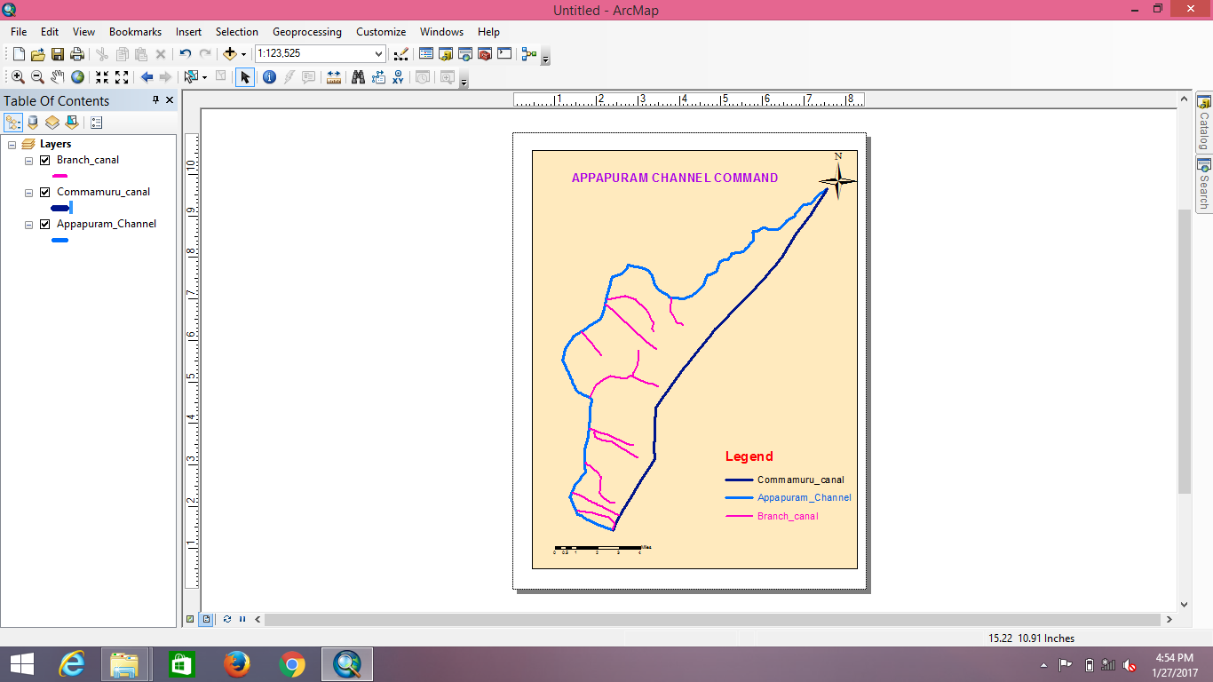 | 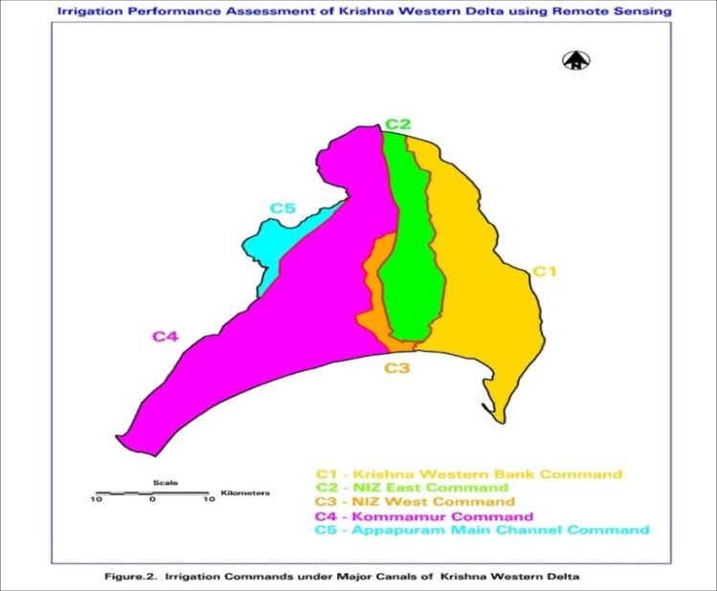
Fig. 1 Map Showing Appapuram Channel Command area
Climate
The Appapuram Channel Command area experiences a sub-humid climate, with heavy rainfall occurring during the late Kharif season, particularly in August and September. The southwest monsoon generally begins in mid-June and brings significant rainfall up to mid-October, while occasional cyclonic rains occur once every five years during October–November. The summer period from April to mid-June is characterized by high temperatures. Analysis of daily climatic data (2000–2015) indicates that minimum and maximum temperatures range from 17.16–27.62 °C and 30.48–40.84 °C, respectively. Most of the annual rainfall (about 90%) is received during the monsoon season, with peak rainfall in August and September. Evaporation rates are highest in May and lowest in December, while wind speed and sunshine hours vary seasonally, influencing crop water requirements in the command area.

Table 1. Monthly mean meteorological data of study area (2000- 2015)
S.  No. | Month | Min. temp.  (°C) | Max. Temp.  (°C) | Humidity  (%) | Wind speed (km/d) | Sunshine (h/day) | Solar Radiation (MJ/m²/d) | ET₀  (mm/d) | Monthly  ET₀  (mm)
1 | January | 17.2 | 30.5 | 90 | 5 | 6.5 | 15.7 | 2.89 | 89.59
2 | February | 17.5 | 31.8 | 88 | 5 | 7.7 | 18.9 | 3.42 | 95.76
3 | March | 22 | 35.5 | 86 | 7 | 7.3 | 19.9 | 4.04 | 125.24
4 | April | 25.2 | 37.7 | 81 | 8 | 8.1 | 21.9 | 4.77 | 143.10
5 | May | 27.6 | 40.8 | 72 | 9 | 7.7 | 21.4 | 4.96 | 153.76
6 | June | 26.7 | 37.5 | 71 | 9 | 5.5 | 17.9 | 4.13 | 123.90
7 | July | 25.2 | 34.5 | 78 | 8 | 4.2 | 15.9 | 3.59 | 111.29
8 | August | 24.2 | 33.3 | 83 | 7 | 4.3 | 16.0 | 3.5 | 108.50
9 | September | 24.1 | 33.4 | 82 | 5 | 4.8 | 16.3 | 3.49 | 104.70
10 | October | 23 | 32.5 | 87 | 4 | 5.1 | 15.5 | 3.19 | 98.89
11 | November | 23 | 35.3 | 96 | 4 | 6.5 | 16.0 | 3.42 | 102.60
12 | December | 19.9 | 34.1 | 98 | 4 | 5.8 | 14.3 | 3 | 93.01
 | Total |  |  |  |  |  |  |  | 1350.33
*Penman- Montieth equation was used in ET₀ calculations with the values
for Angstrom’s Coefficients a = 0.25 and b = 0.5

Soils
The Appapuram Channel Command area consists of four major soil types, namely black cotton soils, sandy clay loams, red loamy soils, and sandy soils, including some saline and alkali problem soils. Black cotton soils are the most dominant and widely distributed across the command, while sandy clay loams occur mainly along rivers and streams, and sandy soils are found along the coastal fringe. Soil pH ranges from 6.40 to 8.21, electrical conductivity from 1.0 to 3.0 dS/m, and exchangeable sodium percentage from 10.0 to 15.8%, indicating varying soil fertility and salinity conditions. The soils are generally low to medium in available nitrogen, medium to high in phosphorus, and high in potassium, with black clay soils having an effective depth of about 180 cm and a topsoil depth of 40–50 cm.

Description of Aqua Crop 4.0 Model
Fig. 2 Main menu of Aqua Crop 4.0 model
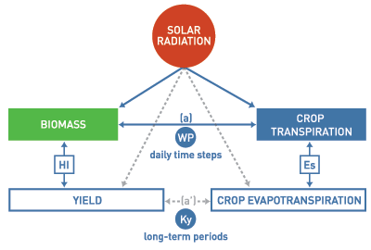
Fig. 3 Schematic representation Aqua Crop 4.0 model
Aqua Crop 4.0 is a crop water productivity model developed and modified by the Land and Water Division of FAO (2012) to simulate yield response to water. AquaCrop is a general model, as it is widely used for a wide range of herbaceous crops, including forage, vegetable, grain, fruit, oil, and root and tuber crops. It simulates yield response to water of herbaceous crops and is particularly suited to address conditions where water is a key limiting factor in crop production. Aqua Crop results from the revision of the FAO Irrigation and Drainage Paper No. 33“Yield Response to Water” (Doorenbos and Kassam, 1979), a key reference for estimating the yield response to water. Aqua Crop evolves from the fundamental equation of Paper No. 33, where relative yield (Y) loss is proportional to relative evapotranspiration (ET) decline, with Ky as the yield response proportional factor.
Aqua Crop operation: With a daily time step the model simulates successively with the processes of soil water balance, crop development and crop transpiration. a) Simulation of the soil water balance: In a schematic way, the root zone can be considered as a reservoir. By keeping track of the incoming (rainfall, irrigation and capillary rise) and outgoing (runoff, evapotranspiration and deep percolation) water fluxes at the boundaries of the root zone, the amount of water retained in the root zone, and the root zone depletion can be calculated at any moment of the season by means of a soil water balance. The amount of water stored in the root zone is simulated by accounting for the incoming and outgoing water fluxes at its boundaries. The root zone depletion determines the magnitude of a set of water stress coefficients (Ks)affecting: (a) green canopy (CC) expansion, (b) stomatal conductance and hence transpiration (Tr) per unit CC, (c) canopy senescence and decline, (d) the harvest index (HI) and (e) the root system deepening rate.
Field and Irrigation water management
The field management related to the fertility level or regime to be adopted during the crop simulation and to field-surface practices such as mulching to reduce soil evaporation, or the use of soil bunds to control surface run-off and infiltration can be considered.
The water management options related to (i) rain fed-agriculture (no irrigation) and (ii) irrigation after selecting the method (sprinkler, drip, or surface, either by furrow or flood irrigation) can be considered. The user can define their own schedule on the basis of depth or timing criteria, or allow the model to automatically generate the scheduling on the basis of fixed interval, fixed depth, or fixed percentage of soil water content criteria. The irrigation option is particularly suited for simulating the crop response under supplemental or deficit irrigation.
Reference evapotranspiration
The ETo Calculator, an evapotranspiration model developed by FAO was used to compute the reference evapotranspiration values. The model uses Penman-Monteith method to calculate the ETo values. The ETo values thus obtained are uploaded to Aqua Crop model.
Effective rainfall
The effective precipitation is one of the water inputs to the soil root zone. For irrigation purpose the effective rainfall is defined as the part of total precipitation during the crop growing period that is available to meet the evapotranspiration needs of that crop. USDA Soil Conservation Service Method (USDA-SCS Method) is used by the crop model for calculating the effective rainfall. The net irrigation requirement for crops grown in the distributary is computed by the Aqua Crop 4.0 Model.
Net Irrigation requirement of crops
The net irrigation requirement (NIR) of a crop is the amount of water, in addition to rainfall, that must be applied to meet crop evapotranspiration (ET_{C}) without significant reduction in yield. To avoid crop water stress, rainfall and irrigation must be sufficient to meet the crop ET requirement. Various methods are available to estimate the reference crop evapotranspiration (ETo). The crop evapotranspiration is calculated by using the following equation,
ETc= Kc *ETo
Where,
ETc = crop evapotranspiration (mm/day)
Kc = crop coefficient and
ETo = reference evapotranspiration (mm/day)
The net irrigation requirement of crop can be estimated from the following equation,
NIR = ET_{C} – ER
Where,
NIR = Net irrigation requirement in a given month, mm/month and
ER = Effective rainfall in a given month, mm/month
The NIR for crops grown in the study area from the year 20013 to 2016 were obtained by running the model for multiple years successively using Aqua Crop 4.0 Model.
Table .2 Estimated monthly irrigation water requirement of different crops
S.  No. | Month | Paddy  (mm) | Maize  (mm) | Blackgram  (mm) | Chilli  (mm) | Cotton  (mm) | Green gram  (mm)
1 | January | 0.0 | 107.5 | 0.0 | 103.0 | 103.0 | 0.0
2 | February | 0.0 | 114.9 | 0.0 | 110.1 | 110.1 | 0.0
3 | March | 0.0 | 150.3 | 131.5 | 144.0 | 0.0 | 131.5
4 | April | 0.0 | 171.7 | 150.3 | 0.0 | 0.0 | 150.3
5 | May | 0.0 | 0.0 | 161.4 | 0.0 | 0.0 | 161.4
6 | June | 0.0 | 0.0 | 130.1 | 0.0 | 0.0 | 109.0
7 | July | 250 | 0.0 | 0.0 | 0.0 | 0.0 | 0.0
8 | August | 220 | 0.0 | 0.0 | 0.0 | 0.0 | 0.0
9 | September | 210 | 0.0 | 0.0 | 120.4 | 120.4 | 0.0
10 | October | 180 | 0.0 | 0.0 | 113.7 | 113.7 | 0.0
11 | November | 150 | 0.0 | 0.0 | 118.0 | 118.0 | 0.0
12 | December | 0.0 | 111.6 | 0.0 | 107.0 | 107.0 | 0.0
 |  | 1010 | 656.0 | 573.3 | 816.2 | 672.2 | 552.2

The computer-based crop simulation model AquaCrop was employed in the present study to estimate both crop water requirements and yield levels of major crops grown in the study area, namely rice, cotton, chilli, maize, green gram, and black gram, during the Kharif and Rabi seasons. The model simulations were carried out using long-term decennial meteorological data for the period 2000–2015, which included rainfall, temperature, reference evapotranspiration, and other climatic variables influencing crop growth. AquaCrop integrates crop, soil, climate, and management practices to realistically simulate crop response to water availability. The results of the simulation indicated that the total irrigation water requirements were approximately 1010 mm for paddy, 656.0 mm for maize, 573.3 mm for black gram, 816.2 mm for chilli, 672.2 mm for cotton, and 552.2 mm for green gram during the Kharif and Rabi seasons, reflecting significant variation in water demand among different crops.

RESULTS AND DISCUSSION
The model estimated the effective rainfall on a monthly basis using the average monthly rainfall data of the study area. The weather inputs provided to the model, the annual rainfall in the Appapuram Channel Command area from 2000 to 2015, showing considerable variability over the years. Rainfall ranged from a low of around 600 mm in years like 2002 and 2009 to a peak of nearly 1500 mm in 2010, indicating both dry and exceptionally wet years. Most years received moderate rainfall between 800 mm and 1200 mm, reflecting typical climatic conditions in the region. This variability underscores the importance of efficient water management and irrigation planning to ensure that crop water requirements are met during dry years and excess water is effectively utilized during wetter years to maintain crop productivity. Thus, the effective rainfall for each month represented only the portion of total rainfall that was actually available for crop use within the root zone. The computed monthly effective rainfall values were subsequently used for estimating crop water requirements and irrigation demand in the study area.

Fig. 4 Annual rainfall in Appapuram channel command (2000-2015)
The season-wise rainfall distribution for the same period is presented in Fig. 5, which indicates that a major portion of the rainfall occurs during the Kharif season, while Rabi and Summer seasons receive comparatively low and irregular rainfall. This uneven seasonal distribution highlights the importance of Kharif rainfall in meeting crop water requirements and emphasizes the need for supplemental irrigation during Rabi and Summer seasons for effective agricultural water management.

Fig.5 Seasonal rainfall in Appapuram channel command (2000-2015)
From the above figure, it is clearly observed that the Kharif season receives significantly higher rainfall compared to the Rabi and Summer seasons throughout the study period (2000–2015). The rainfall during Kharif shows considerable inter-annual variation, with pronounced peaks in certain years, reflecting the dominant influence of the southwest monsoon. This higher and relatively dependable rainfall during Kharif substantially contributes to meeting the crop water requirements, thereby reducing the dependence on irrigation during this season. In contrast, the Rabi and Summer seasons receive comparatively low and erratic rainfall, which is inadequate to satisfy crop water demands and necessitates supplemental irrigation from surface and groundwater sources. The clear seasonal disparity in rainfall distribution highlights the critical role of Kharif rainfall in agricultural water availability and groundwater recharge. This information was effectively utilized in estimating the irrigation water requirements of different crops and was further incorporated in formulating the constraints for irrigation planning and water allocation models, ensuring realistic and season-specific representation of water availability in the analysis.

Fig. 6 Monthly and effective rainfall in the study area
Effective rainfall is a crucial component of the water balance in the crop root zone, as it directly contributes to meeting the evapotranspiration requirements of crops and thereby reduces the need for supplemental irrigation. In the present study, effective rainfall was estimated using the FAO CROPWAT model by incorporating long-term rainfall data along with other relevant meteorological parameters such as temperature, relative humidity, wind speed, and sunshine hours on a mean monthly basis. The model simulations were carried out for multiple crops grown in the study area and for multiple crop periods covering the years 2000 to 2015, in order to capture the temporal variability in rainfall and its effectiveness. The USDA Soil Conservation Service (SCS) method, which is widely accepted for estimating effective rainfall, was adopted within the CROPWAT model to compute daily effective rainfall values, and the results are presented in Fig. 6. This method accounts for rainfall losses due to surface runoff and deep percolation, thus providing a realistic estimate of the portion of rainfall that is actually available to crops. The estimated effective rainfall values were subsequently used as key input data in the AquaCrop model for simulating crop growth and predicting yield levels of different crops in the study area, thereby ensuring a consistent and integrated approach to water requirement assessment and crop yield estimation.

Table.3 Average yield of different crops in command area
S.No. | Crop | Yield(t/ha)
1 | Rice | 5.5
2 | Cotton | 1.5
3 | Chilli | 4.1
4 | Maize | 4.0
5 | Greengram | 1.0
6 | Blackgram | 1.0
From the above table yield estimation was carried out by calibrating and validating the model using the last three years of yield records obtained from the Agriculture Department and field-level information collected from farmers. Based on this validation, the simulated yields were found to be in close agreement with observed values, with average yields of about 5.5 t/ha for rice, 1.5 t/ha for cotton, 4.1 t/ha for maize, 4.0 t/ha for chilli, and around 1.0 t/ha each for green gram and black gram during the Kharif and Rabi seasons. The results demonstrate the applicability of the AquaCrop model for assessing crop water requirements and predicting yields under varying climatic and water availability conditions, thereby providing a reliable tool for irrigation planning and crop management in the study area.
CONCLUSIONS
The computer simulation model AquaCrop was applied to estimate crop water requirements of rice and maize crops grown in both the seasons. The decennial meteorological data for years 2000 to 2015 is averaged and given as input to the model. The simulated yields were found to be in close agreement with observed values, with average yields of about 5.5 t/ha for rice, 1.5 t/ha for cotton, 4.1 t/ha for maize, 4.0 t/ha for chilli, and around 1.0 t/ha each for green gram and black gram during the Kharif and Rabi seasons. The computer simulation model AquaCrop was used in this study to estimate crop water requirements and yields of major crops such as rice, cotton, chilli, maize, green gram, and black gram grown during Kharif and Rabi seasons. AquaCrop effectively evaluates crop performance under both irrigated and rainfed situations and has been widely calibrated and validated for several field crops, demonstrating its reliability under different agro-climatic conditions. Overall, AquaCrop is a useful tool for developing efficient irrigation strategies, particularly under water deficit conditions, and supports effective irrigation planning and water management.
Disclaimer (Artificial intelligence)

Author(s) hereby declare that NO generative AI technologies such as Large Language Models (ChatGPT, COPILOT, etc.) and text-to-image generators have been used during the writing or editing of this manuscript.

REFERENCES
- Akol, A.M., Hassan, D.F., Mohammed, R.J., AlJanaby, Z.A.A., Abed, M.A.K., Hussain, S., Nassif, N., Jaddoa, K.A. and Razzaq, H.K., 2024. Optimizing wheat yield and water use efficiency using AquaCrop model calibration and validation in various irrigation and tillage systems under climate change. Soil Science Annual, 75(3), pp.1-12. https://doi.org/10.37501/soilsa/195823

- Amiri, E. & Abedinpour, M. (2020) Simulating maize yield responseto depletion of available soil water and nitrogen management1066 AMIRI ET AL. under drip irrigation with the FAO AquaCrop model. RussianAgricultural Sciences, 46(6), 602–608. https://doi.org/10.3103/S1068367420060038

- Ahmadi, S.H., Elnaz, M., Kamgar-Haghighi, A.A and Sepaskhah, A.R. 2015. Modeling Maize Yield and Soil Water Content with AquaCrop Under Full and Deficit Irrigation Managements. Water Resources Management.1-17. https://doi.org/10.1007/s11269-015-0973-3

- Maucieri, Carmelo, Maurizio Borin, Francesco Morbidini, Tjaša Pogačar, Marko Flajšman, Graziano Ghinassi, Leonardo Verdi, Anna Dalla Marta, and Roberto Ferrise. "Projecting the impacts of climate change on soybean production and water requirements using AquaCrop model." European Journal of Agronomy 165 (2025): 127538. https://doi.org/10.1016/j.eja.2025.127538
- Fallah, M., Rasulov, A., Ekambaram, Y., Khudayberganov, K., Kosuru, S. D., & Ghate, A. D. (2025). Simulating Plant Growth Under Water Stress Using the AquaCrop Model. Natural and Engineering Sciences, 10(2), 447-458.

- Fazel, F., Ansari, H., & Aguilar, J. (2023). Determination of the most efficient forage sorghum irrigation scheduling strategies in the US Central High Plains using the AquaCrop model and field experiments. Agronomy, 13(10), 2446.

- Sarangi, A. 2010. Crop Yield Simulation Using Aquacrop Model Under Rainfed and Irrigated Conditions,Water Technology Centre, Indian Agricultural Research Institute Library Avenue, New Delhi.MIV51:1-11.

- Salemi, H., Soom, M.A.M., Teang, S.L., Sayed, F.M.,Arman, G and Mohd, K.Y. 2011. Application of AquaCrop model in deficit irrigationmanagement of Winter wheat in arid region. African Journal of Agricultural Research. 610: 2204-2215. https://doi.org/10.5897/AJAR10.1009

- Shaw, S. K., Sharma, A., Khatua, K. K., & Oliveto, G. (2023). An integrated approach to evaluating crop water requirements and irrigation schedule for optimizing furrow irrigation design parameters in Kurnool District, India. Water, 15(10), 1801. https://doi.org/10.3390/w15101801

- Shengli, Q., Willardson, L, S., Deng, W., Jum li, X and Jiang liu, C. 2004. Crop water deficit estimation and irrigation scheduling in Western Jilin province, Northeast China. Agricultural water management. 71: 47-60. https://doi.org/10.1016/j.agwat.2004.07.016

- Srinivasulu, A., Satyanarayana, T.V., Ravi Kumar, M. and Sai Sudha, J.L.N. 2003. Crop water requirement in comparison to actual applied in some canal commands of Krishna Western Delta. Journal of Agricultural Engineering, 40(4): 43-50. https://epubs.icar.org.in/index.php/JAE/article/view/14175

- Yuan, B. Z., Nishiyama, S. & Kang, Y.2003 Effects of different irrigation regimes on the growth and yield of drip-irrigated potato. Agric. Water Manag. 63(3), 153–167. https://doi.org/10.1016/S0378-3774(03)00174-4

- Zhiming, F., L. Dengwei and Y. Zang. 2007. Water requirements and irrigation scheduling of spring maize using GIS and Crop Water model in Beijing-Tianjin-Hebei region. Chinese Geographical Science, 17: 56-63. https://doi.org/10.1007/s11769-007-0056-3

- Zhang, Ting, et al. "Evaluation and improvement of crop root-water-uptake and transpiration in AquaCrop." Agricultural Water Management 318 (2025): 109686.

