Assessment of Groundwater Potential for Urban and Peri-urban Irrigated Agriculture in the Wa Municipality of Ghana

ABSTRACT
The increasing dependence on groundwater for domestic and irrigation purposes, especially in the context of climate variability necessitates the identification of areas with high groundwater potential. This study aimed to delineate groundwater potential zones in the Wa Municipality of Ghana to support urban and peri-urban irrigated agriculture using ArcGIS 10.3 . Key physical and environmental factors, including geology, lineament density, rainfall, drainage density, soil type, landuse/landcover (LULC), topographic wetness index (TWI), slope, and elevation, were integrated and assigned weights based on their relative influence on groundwater occurrence. The weighting process employed the Analytic Hierarchy Process (AHP), yielding an acceptable consistency ratio of 0.088. The analysis revealed that 185.33 km² of the study area possesses very high groundwater potential, while 112.39 km² falls under high potential. Moderate and low potential zones cover 130.15 km² and 145.71 km², respectively. Validation using existing well data showed a prediction accuracy of 87%, confirming the reliability of the delineated zones. The study therefore revealed that, the Wa Municipality demonstrates considerable groundwater potential suitable for irrigated agriculture. The results provide a valuable decision-support tool for stakeholders and policymakers in promoting sustainable groundwater management. Furthermore, in areas identified with low groundwater potential, the implementation of recharge-enhancing interventions such as injection wells, fish ponds, and dugouts is recommended to support aquifer replenishment.

Keywords: Groundwater potential, Analytic Hierarchy Process (AHP), Geology, Irrigation, Wa Municipality

INTRODUCTION
The intensification of agricultural activities continues to parallel global population growth, resulting in an ever-increasing demand for water resources, particularly groundwater (Al-Gburi and Al-Tamimi, 2020). Groundwater serves not only as a crucial source of irrigation water globally but also plays an essential role in providing potable water (Mif et al., 2021). The expansion of urban agriculture, driven by rural-to-urban migration and infrastructural development, now competes for limited resources such as space and irrigation water (Addo, 2010). Although advancements in irrigation technologies and improved agricultural practices have decelerated the growth rate of agricultural water demand, the pressure on water resources remains high due to rapid population growth, urbanization, and climate change (Al-Gburi, 2022; Oh et al., 2011).
In recent years, groundwater demand has surged, driven by the combined forces of population expansion, agricultural intensification, industrial development, and sedimentation (Adongo et al., 2021; Chatterjee and Dutta, 2022; Ghosh et al., 2022). In Ghana, inadequate water resource management and environmental degradation have exacerbated water scarcity, leaving millions without access to safe and reliable water supplies (Gyampo et al., 2014). Specifically, in the Upper West Region, prolonged dry seasons result in the evaporation of many surface water bodies and dugouts. During these periods, groundwater becomes the sole source of water for both domestic and agricultural use.
Agriculture plays a critical role in the socioeconomic development of communities in the Wa Municipality, and optimizing available water resources, especially groundwater is essential for improving food production (Abdul-Ganiyu and Kpiebaya, 2020). However, groundwater exploration is resource-intensive, requiring significant technical and financial input (Kwami et al., 2019). Nevertheless, recent studies emphasize the strategic role of groundwater in mitigating food insecurity and supporting urban expansion (Zango et al., 2023). Moreover, industrial activities in the municipality, such as sachet water ("pure water") production, rely entirely on groundwater resources.
Conducting comprehensive groundwater potential assessments is, therefore, a critical strategy for ensuring the sustainable use of groundwater across multiple sectors, particularly for irrigation (Bhadran et al., 2022). Climate change-induced declines in crop yields have led to rising food prices and shortages, worsening food insecurity and income disparities, especially among rural populations. To sustain year-round agricultural production, particularly in semi-arid areas like the Wa Municipality, where rainfall is unpredictable, there is an urgent need to harness groundwater as a reliable irrigation source during the dry season.
Despite its importance, there has been limited research on groundwater potential in the Upper West Region of Ghana using modern techniques such as remote sensing (RS), geographic information systems (GIS), and the Analytic Hierarchy Process (AHP). The misconception that groundwater is scarce in the region and is only viable for domestic purposes has contributed to its underutilization. However, with advancements in geospatial technologies, researchers globally have demonstrated the successful application of RS and GIS for groundwater prospecting across diverse geological settings.
Given the increasing demand for water resources and the growing pressure on cropland, particularly in arid and semi-arid regions, this study aims to delineate areas of groundwater potential within the Wa Municipality. The findings of this research will serve as a foundational reference for groundwater zoning in the region. This information can support government agencies, policymakers, and stakeholders in making informed decisions for the sustainable management and utilization of groundwater resources for both household and agricultural purposes. Ultimately, this work contributed towards achieving several United Nations Sustainable Development Goals (SDGs), including eradicating poverty (SDG 1), ending hunger (SDG 2), promoting good health and well-being (SDG 3), ensuring access to clean water and sanitation (SDG 6), and fostering decent work and economic growth (SDG 8).
MATERIALS AND METHODS

Study Area
The study was conducted in the Wa Municipality, located in the Upper West Region of Ghana (Figure 1). Geographically, the municipality lies in the southern part of the region, between latitudes 9°55′N and 10°25′N, and longitudes 1°10′W and 2°5′W. The total land area of the municipality is approximately 579 km², representing 8.3% of the regional landmass. Wa Municipality is bordered by Wa West District to the west and southwest, Nadowli-Kaleo District to the north, and Wa East District to the east. The area experiences a mono-modal rainfall pattern, with average annual rainfall ranging between 832 mm and 1,142 mm. A significant proportion of rainfall in urban zones is lost as surface runoff, with minimal infiltration to recharge the underlying aquifers (Carrier et al., 2008). The municipality has a predominantly dry climate, with the dry season peaking in March and April, when temperatures are highest. The coolest months are December and January, although daytime temperatures can still reach up to 42 °C.
Topographically, the municipality features gently undulating terrain, with elevations ranging from 248 to 369 meters above sea level. The lower elevation zones form valleys, which act as natural catchments for rainwater and serve as potential recharge zones for groundwater aquifers. However, the Sing-Bakpong and Billi streams, along with their tributaries, typically dry up during the extended dry season, reducing surface water availability for irrigation and domestic use. Geologically, the area is underlain primarily by the Birimian Supergroup and intrusive granitoids, both of which influence groundwater occurrence and yield. The municipality falls within the Guinea Savannah ecological zone, characterized by short grasses, shrubs, and economically important tree species such as shea (Vitellaria paradoxa), dawadawa (Parkia biglobosa), and baobab (Adansonia digitata). However, overgrazing by livestock, frequent bushfires during the dry season, and indiscriminate tree felling have contributed to increased surface runoff, erosion (both wind and water), and soil degradation.
The predominant soil types in the area are Ferric Luvisols and Lithosols, which, though moderately fertile, are suitable for cultivating cereal and root crops, especially with the application of manure and fertilizers. Agriculture remains the principal source of livelihood for the local population, with common crops including cowpea, maize, guinea corn, millet, yam, rice, and soybeans. Water supply in the municipality is managed exclusively by the Ghana Water Company Limited (GWCL). The municipal water system relies on groundwater extraction from 24 boreholes, which collectively produce an average of 55,000 m³ of water per month (https://www.gwcl.com.gh/upper-west, 2023).
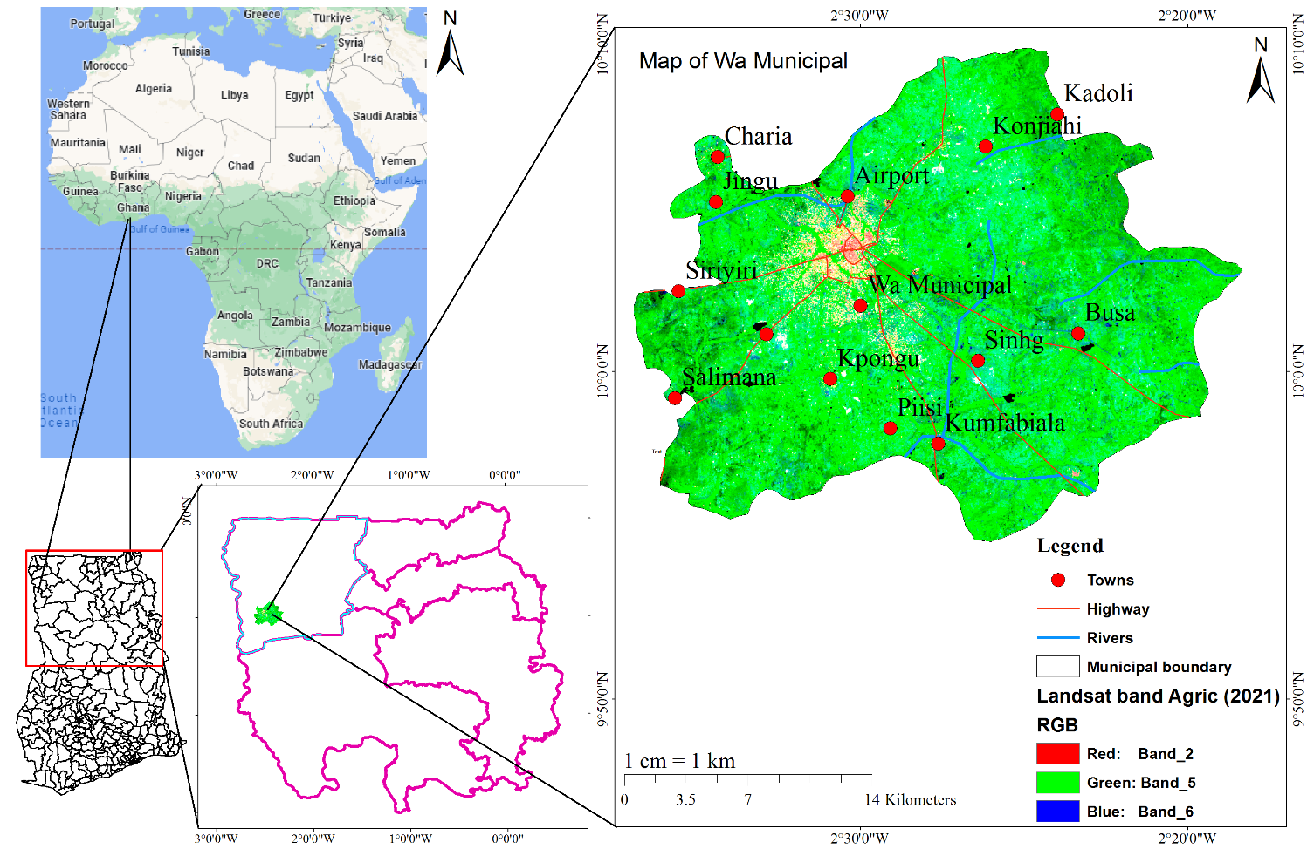
Figure 1: Geographical Location of the Wa Municipality

Data Acqisition
To assess groundwater potential in the Wa Municipality, various geospatial and thematic datasets were acquired from reputable sources. These datasets were processed and analyzed using Geographic Information Systems (GIS) techniques. The thematic layers were selected based on their relevance and influence on groundwater occurrence, including topography, geology, soil, landuse/landcover, rainfall, and hydrological features. All datasets were resampled to a uniform spatial resolution of 30 meters to ensure consistency during overlay analysis. Details of the data sources and their applications are presented in Table 1.

Table 1: Data Sources and Thematic Layers Used
Data | Data Source | Resolution (m) | Derived Thematic Maps
Digital Elevation Model | USGS Earth Explorer (www.usgs.earthexplorer.gov) | 30 x 30 | Slope, Drainage density, Lineament density, Elevation, TWI
Geological Shapefile | Ghana Geological Survey | 30 x 30 | Lithology
Rainfall | NASA POWER (www.power.larc.nasa.gov) | 30 x 30 | Rainfall
Landsat 8 OLI Imagery | USGS Earth Explorer (www.usgs.earthexplorer.gov) | 30 x 30 | Landuse and Landcover
Soil Shapefile | International Soil Reference and Information Centre (ISRIC, 2011) (www.isric.org) | 30 x 30 | Soil Type
Tube Well Data | Community Water and Sanitation Agency (CWSA) | 30 x 30 | Well Yield

Thematic Layers for the Model
In many groundwater potential mapping studies, researchers rely on expert judgment to assign weights to various thematic layers and their associated features. Consequently, the type and number of factors used for delineating groundwater potential zones using remote sensing (RS) and geographic information systems (GIS) can vary across studies, depending on the local context and data availability. In this study, nine (9) thematic layers were selected based on their relevance and influence on groundwater occurrence. These include: Geology, landuse/landcover (LULC), soil type, lineament density, elevation, drainage density, slope, topographic wetness index (TWI), and rainfall.
The integration of these thematic layers was performed using ArcMap version 10.8. Each layer was assigned a weight reflecting its relative importance in influencing groundwater potential, based on Saaty's scale of relative importance within the Analytic Hierarchy Process (AHP) framework. All thematic layers were projected into the WGS 1984 UTM Zone 30N coordinate system and uniformly resampled to a spatial resolution of 30 meters to ensure consistency during spatial analysis and overlay operations. This standardized spatial framework allowed for the development of a robust groundwater potential model that reflects both the physical characteristics of the terrain and the hydrological processes influencing groundwater recharge and storage in the Wa Municipality.

Geology
The Wa municipality was extracted from the shapefile of Ghana's geology through the utilization of the clip tool, which is a component of the arcToolbox within ArcMap. The lithological classifications observed within the municipality encompassed the Birimian supergroup, Tamnean Plutonic suite, Mesozoic, and Eburnean plutonic suite. Subsequently, the geology map of the municipality underwent conversion into raster format and was reclassified via the employment of the conversion and reclassification tool, which is another feature of the arcToolbox.

Landuse and Landcover
A supervised classification technique was employed in ArcMap to recognize and categorize the pixels into different landuse and landcover (LULC) classes. This involved selecting training samples to derive various LULC characteristics and enable accurate classification. The band combinations of Landsat 8, namely natural-color (4,3,2), color infrared (5,4,3), agriculture (6,5,2), and false-color for urban zones (7,6,4), were utilized to determine the overall nature of the municipality. The resulting land use and land cover map classified the municipality into six categories: vegetation, forest, bare land, settlements, water bodies, and agricultural lands. Forests were defined as areas where trees grow closely together, forming a dense canopy. Vegetation cover included various plant species thriving in the absence of a forest canopy. Settlements encompassed housing areas in farm, urban, or rural communities. Water bodies encompassed rivers, streams, dams, and dugouts. Agricultural land comprised areas used for farming. Bare lands encompassed rocky areas and areas without land cover, where the soils were minimally exposed to runoff and erosion. The Maximum likelihood classification algorithm, known for its high accuracy, was employed for this analysis (Gebere et al., 2015).

Soil Type
The map of the municipality was masked from the International Soil Reference and Information Centre soil shapefile (ISRIC, 2011). The soil map was then reclassified for weight assigning and integration with other thematic layers. The soil types found in the municipality are the ferric Luvisols and lithosols.

Lineament Density
The lineament density is simply the total length of lineaments per unit area in square kilometers (km/km²) (Magesh et al., 2012). The lineament density was therefore calculated using the formula below.
$LD=\sum_{i-1}^{n}{\frac{Li}{A}}$ (1)
Where: LD = Lineament density, L = lineament length (km), i = lineament number, and A = Area (km²).
Using the hill shade feature in ArcGIS 10.3, the lineament density map of the municipality was produced from the Shuttle Radar Topographic Mission (SRTM) Digital Elevation Model (DEM). The fractures are easily visible after hill shading using the Azuthimal combinations of (315 - 45), (200 - 45), (170 - 60), and (55 - 90). The line density was developed after the fractures were drawn as polylines using the editor's keys.

Elevation
The elevation of the municipality was obtained from the Shuttle Radar Topographic Mission (SRTM) digital elevation model (DEM) which was downloaded from the Earth Explorer website. The elevation was then reclassified using the reclassify tool in the arcToolBox for weigh assigning and overlay analysis.

Drainage Density
Drainage density is the measure of the proximity of streams and other similar water bodies. The SRTM DEM was used to delineate the drainage density of the area. The stream order was first obtained following the algorithm in the “Hydrology Tool” in ArcMap, The line density tool was finally applied to obtain the drainage density (km/km²) using Equation 2 (Ifediegwu, 2022). The drainage density was reclassified into five (5) classes using natural breaks.
$D=\sum_{i-1}^{n}{\frac{Di}{A}}$ (2)
Where: Di is the total length of the entire streams in stream order i (km) and A is the basin area (km²).

Slope
The slope was made from the DEM using the surface of the spatial analyst tool. The slope was classified and reclassified into five (5) classes using natural breaks for the weighted overlay analysis.

Topographic Wetness Index (TWI)
The TWI is mathematically defined as
$TWI=In(\frac{As}{\tan{β}})$ (3)
Where, As is the cumulative upslope area draining through a point (per unit contour length) and β is the slope gradient (in degrees). The ln tan index (ln(tanθ)) takes into account the propensity of water to collect at each location in the catchment and the propensity of gravitational forces to carry that water down the slope. Water infiltration is primarily influenced by the strength of the soil and material characteristics like permeability and pore water pressure. In this study, TWI was therefore considered to be one of the influencing groundwater potentials. The TWI map for the municipality was developed using the raster calculator by the algorithm of flow direction, flow accumulation, and slope.

Rainfall
Historical rainfall data (1991-2021) was used for interpolation using the inverse distance weight (IDW) interpolation tool in the ArcMap toolbox to produce the rainfall distribution map of the municipality. The layer was reclassified for integration with the other layers by weight assignment. Areas with higher precipitation may have the potential for groundwater.
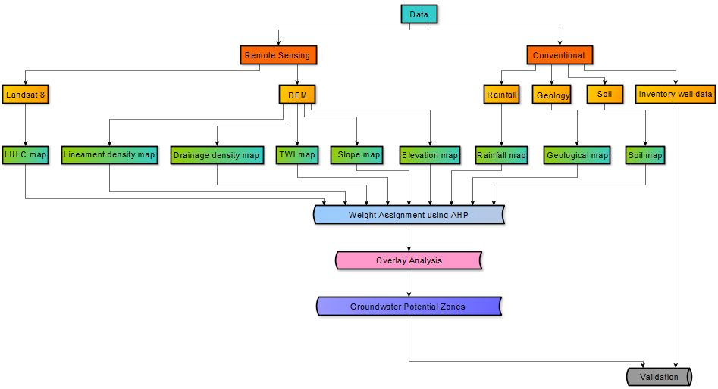
Figure 2: Flowchart for mapping zones of groundwater potential in the Wa Municipality

Mapping of Groundwater Potential Zones
The potential zones of groundwater were mapped after integrating the various factors influencing groundwater water occurrence. The integration was done based on weight assignment using the
Analytic Hierarchy Process (AHP) (Saaty, 1984). The GWPZ was calculated using Eq. (4).
$GWPZ=GGw ×GGr+RFw×RFr+TWIw×TWIr+LDw×LDr+LULCw×LULCr+DDw×DDr+ELw×ELr+SLw×SLr+SOw×SOr$ ………….(4)
Where: GWPZ = Groundwater potential zone, w = weigh, r = rate, GG = geology, RF = rainfall, TWI = topographic wetness index, LD = lineament density, LULC = land use and land cover, DD = drainage density, EL = elevation, SL = slope and SO = soil

Table 2: Groundwater Potential Index
Value | Groundwater Potential
1 | Low
2 | Moderate
3 | High
4 | Very high

RESULTS AND DISCUSSION
Thematic Layers and Maps
In this study, nine (9) thematic layers were utilized to assess groundwater potential in the Wa Municipality. These included: geology, land use/land cover (LULC), soil type, lineament density, elevation, drainage density, slope, rainfall, and the topographic wetness index (TWI). Each of these layers was processed individually, classified into relevant categories, and reclassified based on their influence on groundwater occurrence. The layers were then resampled to a common spatial resolution and projected coordinate system to facilitate overlay analysis using GIS techniques.
Geology
As presented in Figure 3, the geological composition of the Wa Municipality includes four (4) major rock formations: Tamnean Plutonic Suite (250 km²), Birimian Supergroup (231 km²), Eburnean Plutonic Suite (86 km²), and Mesozoic Rocks (11.6 km²). Among these, the Eburnean Plutonic Suite exhibits favorable hydrogeological characteristics, such as permeability and porosity, which facilitate groundwater storage. In contrast, the Tamnean Plutonic Suite is a consolidated rock formation with limited to no primary or secondary porosity or permeability, rendering it poor in groundwater retention. The Birimian Supergroup, which dominates a substantial portion of the municipality, is widely recognized for its excellent groundwater potential. According to Yidana et al. (2012), Birimian rocks in Ghana typically offer good groundwater yields. In the Wa Municipality specifically, the Birimian formation has an average yield of 0.55 L/s and a drilling success rate of approximately 80% (Abdul-Ganiyu and Kpiebaya, 2020).
As a result of its substantial influence on groundwater availability, geology was assigned the highest normalized principal eigenvector score of 19.94% (Table 7), indicating its primary role among the factors influencing groundwater potential in the area. The study area is largely characterized by Precambrian basement rocks and fractured sedimentary aquifers, both of which are known for their relatively high groundwater yields. Understanding the geological and hydrogeological framework of the area is, therefore, essential for the sustainable and efficient development of groundwater resources, particularly for irrigation (Kpiebaya et al., 2020). Previous research supports the assertion that geological characteristics play a pivotal role in the occurrence and movement of groundwater within a catchment (Bhuvaneswaran et al., 2015; Zarate et al., 2021). Thus, accurate geological mapping and classification are critical steps in identifying zones with high groundwater potential.

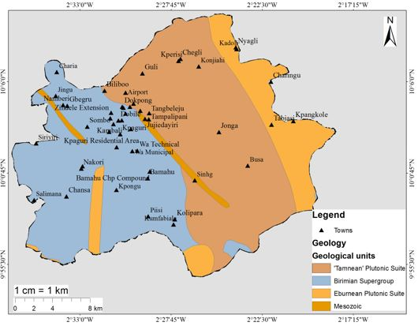
Figure 3: Geological Map of Wa Municipality

Landuse and Landcover
Landuse and Landcover (LULC) is an important factor in groundwater potential assessment due to its significant influence on surface runoff, infiltration, and recharge dynamics (Al-Gburi, 2022). Changes in land cover, whether gradual or seasonal, affect both the volume and timing of groundwater recharge. Several studies have highlighted the role of LULC variations in altering groundwater storage and recharge conditions (Muavhi et al., 2021; Siddik et al., 2022). In this study, the LULC of the Wa Municipality was classified into six (6) distinct categories: Agricultural land, bare land, forest, settlement, vegetation, and water bodies. Table 4 presents the percentage (%) coverage and area (in km²) of each LULC class. Agricultural land covers the largest portion of the study area (44.96%), followed by vegetation (28.89%) and forest (12.97%). These three (3) categories collectively account for over 86% of the municipality's land area, indicating a potentially favorable environment for groundwater recharge. Vegetative cover plays a key role in impeding surface runoff and enhancing infiltration, which are essential for aquifer recharge. Although water bodies occupy a relatively small area, they were assigned the highest rank during the thematic layer classification, as they directly contribute to groundwater recharge through percolation and surface-groundwater interaction. Conversely, settlement areas were ranked lowest due to ground surface compaction associated with urban development, which significantly reduces infiltration potential and enhances runoff (Das, 2019). Forested and vegetative lands, on the other hand, promote infiltration due to the presence of deep-rooted trees, leaf litter, and canopy cover, all of which reduce evapotranspiration losses and aid in groundwater recharge. Agricultural and forested areas, especially those with deep-rooted crops and trees, further contribute to groundwater sustainability. According to Koffi et al. (2020), such areas support groundwater availability by drawing moisture from deeper soil layers, while also minimizing groundwater depletion due to canopy-induced microclimatic regulation. Generally, the LULC layer demonstrated a strong influence on groundwater potential and was considered a major input in the multi-criteria evaluation framework for delineating groundwater potential zones.
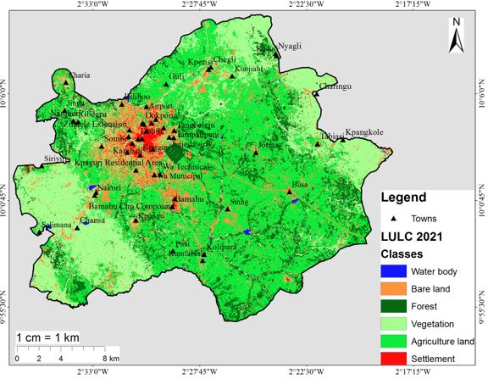
Figure 4: Landuse and Landcover Map of Wa Municipality

Table 3: Landuse and Landcover (LULC) Coverage of Wa
S/N | LULC | Area (km²) | Percentage (%)
1 | Water | 1.64 | 0.28
2 | Bare land | 66.84 | 11.54
3 | Forest | 75.13 | 12.97
4 | Vegetation | 167.38 | 28.89
5 | Agriculture | 260.46 | 44.96
6 | Settlement | 7.84 | 1.35
 | Total | 579.29 | 100.00
Soil Type
Soil type plays an important role in influencing infiltration, runoff, and consequently, groundwater recharge (Falah and Zeinivand, 2019). The infiltration capacity of soils determines how much rainfall percolates into the subsurface to replenish aquifers, making it a key factor in groundwater potential mapping.The major soil types identified in the Wa Municipality, as shown in Figure 5, are; Ferric luvisols – covering approximately 96.5% of the total land area, and lithosols – accounting for the remaining 3.5%. Ferric luvisols are moderately well-drained soils with good structure and moderate porosity, which enhance infiltration and percolation. These soils are generally fertile and support agricultural activities, which indirectly influence recharge by promoting vegetation cover and reducing surface runoff. On the other hand, Lithosols are characterized by coarse textures and macropores, which allow for rapid infiltration of surface water. Despite their limited areal extent, Lithosols were assigned a higher weight than Luvisols in the Analytical Hierarchy Process (AHP) due to their superior drainage characteristics and enhanced permeability, which significantly favor groundwater recharge (Ifediegwu, 2022). Whilst Ferric Luvisols dominate the municipality, the high infiltration capacity of Lithosols, though spatially limited, contributes meaningfully to groundwater occurrence in localized areas. Therefore, both soil types were considered essential in determining groundwater potential, with Lithosols exerting a greater influence per unit area due to their higher recharge potential.

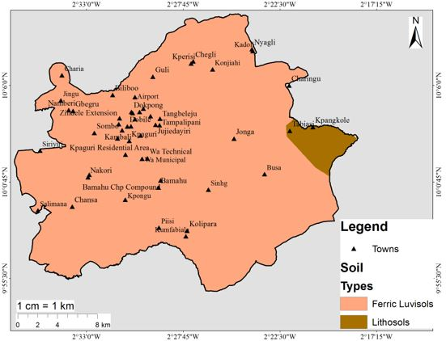
Figure 5: Soil Map of Wa Municipality

Lineament Density
Lineament density plays an important role in groundwater recharge, as areas with higher density typically correspond to fractured or weathered zones that allow for greater percolation of surface water into aquifers (Bhuvaneswaran et al., 2015). Studies have consistently shown a positive correlation between high lineament density and groundwater potential (Steven et al., 2022). In the Wa Municipality, the basement rocks exhibit notably high lineament densities, as illustrated in Figure 6, indicating favorable conditions for groundwater accumulation. Due to its significant influence on groundwater movement and storage, lineament density was ranked second in importance, with a normalized weight of 18.92% in the AHP framework (Table 7).
For the purpose of analysis, lineament density values were classified into five distinct categories:Very Low (0.00 – 0.32 km/km²), Low (0.33 – 0.63 km/km²), Moderate (0.64 – 0.95 km/km²), High (0.96 – 1.30 km/km²), and Very High (1.31 – 1.60 km/km²). Areas falling under the high and very high-density classes are considered to have the greatest groundwater potential, while areas with low lineament density correspond to less fractured and less permeable zones, which limit groundwater infiltration and storage. The study revealed that, lineament density serves as a primary structural control on groundwater occurrence in the Wa Municipality, particularly in the hard rock terrains typical of the region.
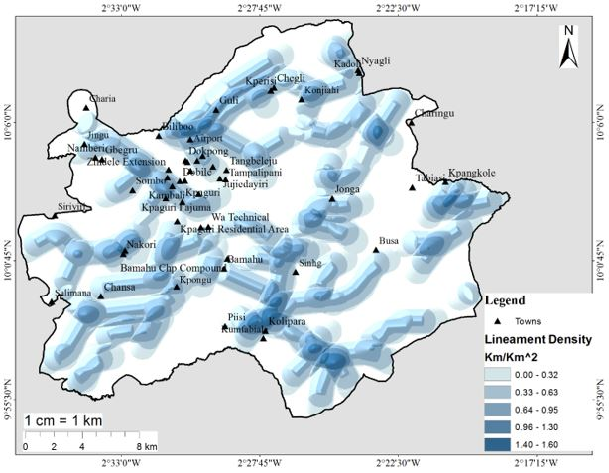
Figure 6: Lineament Density of the Wa Municipality

Elevation
Elevation has an important influence in groundwater occurrence due to its impact on runoff and infiltration (Al-gburi, 2022). As presented in Figure 7, the elevation of the Wa Municipality ranges from 248-283 (very low), 283-301 (low), 301-318 (moderate), 318-335 (high) and 335-369 m (very high). Runoff is high in areas of high elevation leading to a low infiltration rate and the vice versa. Groundwater possibly occurred in areas of low elevation because of low runoff and high rate of infiltration. More weight was therefore assigned to the lowest elevation.

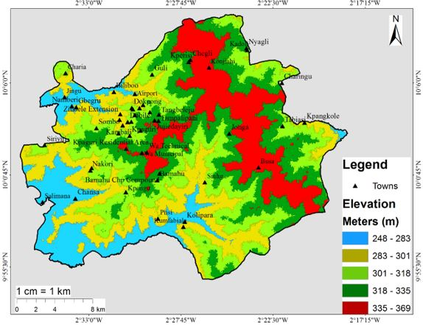
Figure 7: Elevation Map of the WA municipality

Drainage Density
Drainage density refers to the proportion of the surface area of the drained basin to the sum of the lengths of the watercourses in the basin (Al-Ruzouq et al., 2019). It’s a vital criterion in assessing the prospects of groundwater. Typically, Groundwater occurrence is negatively correlated with drainage density; areas with lower drainage densities are potential groundwater zones while areas of higher drainage density have low potential for groundwater occurrence (Magesh et al., 2012). However, a number of factors including; rainfall, slope gradient, vegetation cover, soil absorption capacity, climate, terrain, and subsurface properties, affect the drainage system (Mif et al., 2021). A study indicated that the underlying rocks' high permeability causes poor drainage density due to high penetration into the porous underlying rock (Shao et al., 2020).
As presented in Figure 8, the drainage density of the municipality ranges from 0.00 – 0.21, 0.22 – 0.54, 0.55 – 0.89, 0.90 – 1.30, and 1.40 – 2.00 km/km² representing very low, low, moderate, high, and very high drainage density.
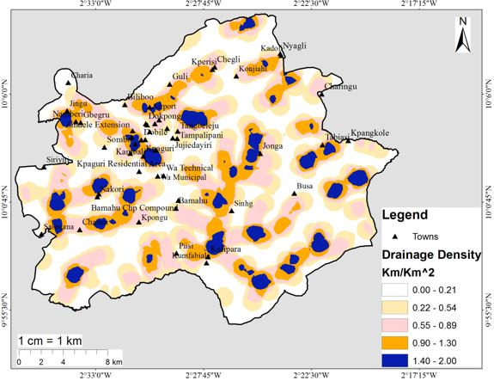
Figure 8: Drainage Density Map of Wa Municipality

Slope
The nature of the topography directly influences rainfall infiltration and is considered and deemed a cardinal factor in determining groundwater availability (Manugula and Singh, 2022). The slope of the Wa Municipality is grouped into five (5) classes; 0-1⁰ (very low), 1-2⁰ (low), 2-4⁰ (moderate), 4-5⁰ (high), and 5-18⁰ (very high) (Figure 9). The municipality therefore has a flat to gentle slope and may not entertain much runoff than infiltration. There is an indirect relationship between slope and groundwater recharge potential. High runoff is observed in steeply sloping areas as rainwater runs off rapidly on slope surfaces, with little or no infiltration or recharge. Groundwater potential is therefore low in these areas. However, flat and gently sloping areas have less runoff and high groundwater potential. Previous research which is consistent with this research had it that, gentle slopes have the affinity to hold rainfall longer to facilitate infiltration leading to groundwater recharge and possible occurrence (Abdullateef et al., 2021; Doke et al., 2021; Falowo et al., 2023).
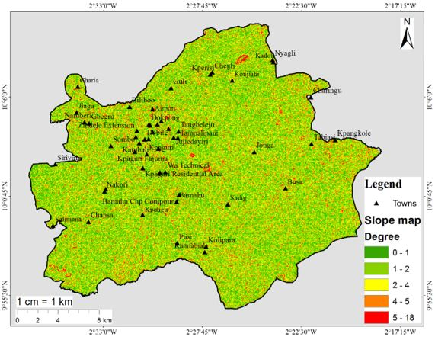
Figure 9: Slope Map of Wa Municipality

Topographic Wetness Index (TWI)
Among the groundwater potential influencing factors is the TWI. TWI has been extensively utilized to explain how topographic features affect the intensity and distribution of saturated areas that cause surface runoff (Razandi et al., 2015). The TWI (Figure 10) of the municipality ranges; 4.66-6.94 (Very low), 6.94-7.96 (Low), 7.96-9.31 (Moderate), 9.31-10.94 (High) and 10.94-16.51 (Very high). TWI and groundwater are directly related, the higher the TWI value the higher the area’s potential for groundwater and vice versa (Arulbalaji et al., 2019).
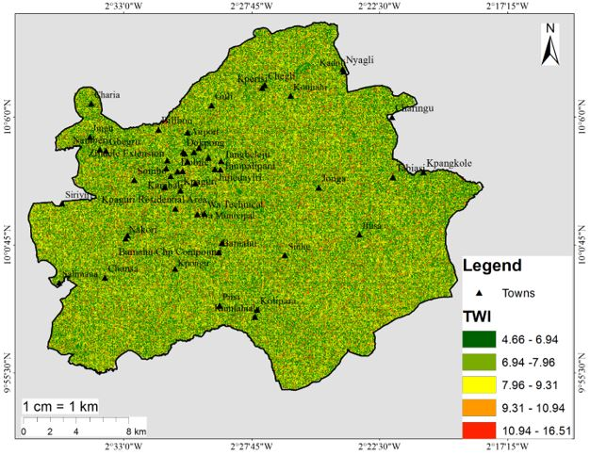
Figure 10: Topographic Wetness Index

Rainfall
The groundwater system is recharged by precipitation such as rainfall, which is one of the most significant sources of acquifer recharge (Models et al., 2021). This shows that areas with higher rainfall distribution have higher groundwater recharge provided there is less runoff. On the other hand, areas with lower annual rainfall distribution have less groundwater recharge. As presented in Figure 11, the rainfall distribution of the municipality ranges from; 832-892 mm (very low), 892-938 mm (low), 938-990 mm (moderate), 990-1051 mm (high), and 990-1142 mm (very high). Rainfall ranks third among the nine (9) factors with an assigned weight of 12.97% because it’s the main source of groundwater recharge via infiltration and percolation (Masroor et al., 2023).
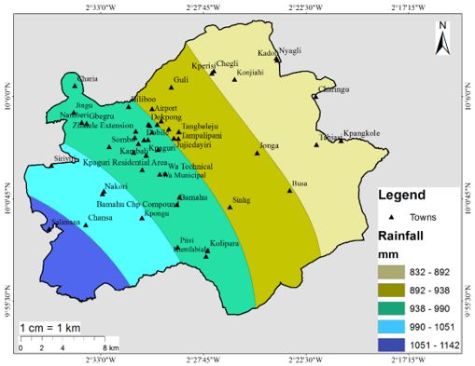
Figure 11: Rainfall of Wa Municipality

Weight Assignment to the Thematic Factors
Nine (7) factors which include geology, rainfall, LULC, soil, lineament density, slope, drainage density, and elevation were chosen to delineate the zones of groundwater occurrence in the municipality. These nine (9) factors were integrated using the overlay analysis tool in ArcMap where weights were assigned to them according to their level of influence in groundwater occurrences. The analytic hierarchy process (AHP) was utilized in the assignment of weights. AHP is a Multi-Criteria Decision-Making (MCDM) instrument use in complex situations such as groundwater studies (Mustapha et al., 2023)where the criterion with the highest impact on groundwater potential is identified by the expert's own judgment and knowledge of the physical and environmental factors (thematic factors) of the municipality. Using the pairwise comparison matrix, the various factors and their classes were paired, compared, and assign weight depending on their relative influence on groundwater potential. Saaty’s Scale of Relative Importance (Table 5) was therefore used for rating (1-9) the thematic factors and their classes based on their influences on groundwater potential.

Table 4: Scale of Relative Importance
Level of Importance | Description
1 | Equal importance
3 | Moderate importance
5 | Strong importance
7 | Very strong importance
9 | Extreme importance
2, 4, 6 and 8 | Middle values

Table 5: Assigned Normalized Weight for the factors and their classes
Thematic Factor | Classes | Rank | Rate | Normalized weight of classes | Normalized weight of factors
Geology | Tamnean Plutonic suite  Birimian supergroup Eburnean plutonic suite  Mesozoic | 5  9  7  3 | Poor  Very good  Good  Very poor | 0.079  0.716  0.145  0.06 | 0.1994
LULC | Agriculture land  Bare land  Forest  Settlement  Vegetation  Waterbody | 3  1  7  3  5  9 | Moderate  Very poor  Good  Poor  Good  Very good | 0.112  0.032  0.288  0.033  0.143  0.391 | 0.1013
Soil | Ferric Luvisols  Lithosols | 5  7 | Moderate  Very good | 0.333  0.667 | 0.0980
Lineament density (km/km²) | 0.00-0.32  0.33–0.63  0.64-0.95  0.96-1.30  1.40-1.60 | 1  3  5  7  9 | Very poor  Poor  Moderate  Good  Very good | 0.513  0.261  0.129  0.063  0.033 | 0.1892
Elevation (m) | 248-283  283-301  301-318  318-335  335-369 | 9  7  5  3  1 | Very good  Good  Moderate  Poor  Very poor | 0.513  0.261  0.129  0.063  0.033 | 0.0388
Drainage density (km/km²) | 0.00–0.21  0.22–0.54  0.55–0.89  0.90-1.30  1.40–2.00 | 9  7  5  3  1 | Very good  Good  Moderate  Poor  Very poor | 0.507  0.285  0.124  0.046  0.038 | 0.1025
Slope (⁰) | 0-1  1-2  2-4  4-5  5-18 | 9  7  5  3  1 | Very good  Good  Moderate  Poor  Very poor | 0.515  0.264  0.118  0.066  0.037 | 0.0585
TWI | 4.66-6.94  6.94-7.96  7.96-9.31  9.31-10.94  10.94-16.51 | 1  3  5  7  9 | Very poor  Poor  Moderate  Good  Very good | 0.09  0.114  0.183  0.271  0.342 | 0.0808
Rainfall (mm) | 832-892  892-938  938-990  990-1,051  1,051-1,142 | 1  3  5  7  9 | Very poor  Poor  Moderate  Good  Very good | 0.079  0.112  0.172  0.267  0.366 | 0.1297
Table 6: Pairwise Comparison Matrix
Matrix | Geology | Rainfall | TWI | Lineament density | LULC | Drainage  density | Elevation | Slope | Soil | Weight | Normalize Principal Eigenvector (%)
Geology | 1 | 3 | 3 | 1 | 3 | 2 | 5 | 3 | 1 | 0.1994 | 19.94
Rainfall | 1/3 | 1 | 3 | 1/3 | 3 | 1 | 3 | 3 | 1 | 0.1297 | 12.97
TWI | 1/3 | 1/3 | 1 | 1/3 | 1 | 1 | 5 | 1 | 1 | 0.0808 | 8.08
Lineament density | 1 | 3 | 3 | 1 | 3 | 1 | 5 | 3 | 1 | 0.1892 | 18.92
LULC | 1/3 | 1/3 | 1 | 1/3 | 1 | 3 | 5 | 1 | 1 | 0.1013 | 10.13
Drainage density | 1/2 | 1 | 1 | 1 | 1/3 | 1 | 3 | 3 | 1 | 0.1025 | 10.25
elevation | 1/5 | 1/3 | 1/5 | 1/5 | 1/5 | 1/3 | 1 | 1 | 1 | 0.0388 | 3.88
Slope | 1/3 | 1/3 | 1 | 1/3 | 1 | 1/3 | 1 | 1 | 1 | 0.0585 | 5.85
Soil | 1 | 1 | 1 | 1 | 1 | 1 | 1 | 1 | 1 | 0.0998 | 9.98

A consistency ratio (CR) was computed to determine if the thematic factors and their subclasses have consistent weights. Using Eq. (6) (Saaty, 1984) the consistency ratio (CR) was derived by dividing consistency index (CI) by random consistency index (RCI).
$CR=\frac{CI}{RCI}$ ………….. (6)
Where, the consistency index (CI) was determined by applying the primary eigenvalue (Saaty, 1984).
$CI=\frac{λmax-n}{n-1}$ …… (7)
Where; λmax is denoted as the consistency vector and n is the number of layers utilized. A consistency ratio of 0.088 < 0.1 was obtained. A consistency ratio smaller or equal to 0.1 is deemed acceptable for more than a 4x4 matrix whereas a CR greater than 0.1 is unacceptable and the process needs to be revised. This indicates clearly that the weights assigned were consistent, hence a valid result.

Distribution of Groundwater Potential Zones in the Municipality
The groundwater potential zones in the Wa Municipality were delineated and categorized into Very High, High, Moderate, and Low potential classes (Figure 12). These classifications were derived from the integration of nine thematic layers through the Analytic Hierarchy Process (AHP) within a GIS environment.
The Very High Potential Zone, covering approximately 185.33 km² (32.31%) of the total municipal area, includes communities such as Dondoli, Kpaguri, Nakori, Sombo, Kambali, and Kolipara. These findings are consistent with previous vertical electrical sounding studies conducted in the Upper West Region, which identified Dondoli and Kpaguri as having significant groundwater potential for irrigation purposes (Abdul-Ganiyu and Kpiebaya, 2020). Similarly, areas such as Piisi and Kumfabiala fall within the very high potential zone due to their low elevation (Pande et al., 2018) and high lineament density.
This zone is predominantly underlain by the Birimian Plutonic Suite, a geologic formation known for its fractured rock systems and associated secondary porosity, which enhance groundwater storage and movement (Chegbeleh et al., 2020). The combination of favorable rainfall levels (Masroor et al., 2023), high lineament density, and low to moderate elevation creates ideal conditions for groundwater accumulation. This supports findings by Danso and Ma (2023), who emphasized the significance of lineament density as a key determinant of groundwater occurrence.
The High Potential Zone occupies 112.39 km², accounting for 19.59% of the municipal area. These zones are evenly distributed across the municipality, excluding the far eastern part, which is characterized by higher elevations, lower rainfall, lower lineament density, and higher drainage density, resulting in less favorable conditions for infiltration and recharge (Hagos and Andualem, 2021).
The Moderate Potential Zone spans 130.15 km² (22.69%), serving as a transition between high and low potential areas. In contrast, the Low Potential Zone, covering 145.71 km² (25.40%), is predominantly found in the eastern portions of the municipality, notably in Nyagli, Tabiasi, Kpangkole, Kadoli, Konjiahi, and Kperisi. These areas are underlain by the Eburnean Plutonic Suite, with limited rainfall (832–892 mm) and high elevations (335–369 m), which contribute to increased surface runoff and reduced groundwater infiltration (Manu et al., 2016).
The spatial distribution of groundwater potential in the Wa Municipality confirms that geological formations, lineament density, rainfall distribution, and elevation are the dominant factors influencing groundwater occurrence. These findings demonstrate the critical role of physical and environmental parameters in controlling the availability, movement, and storage of groundwater, and underscore the importance of spatial analysis tools in guiding sustainable groundwater resource management.

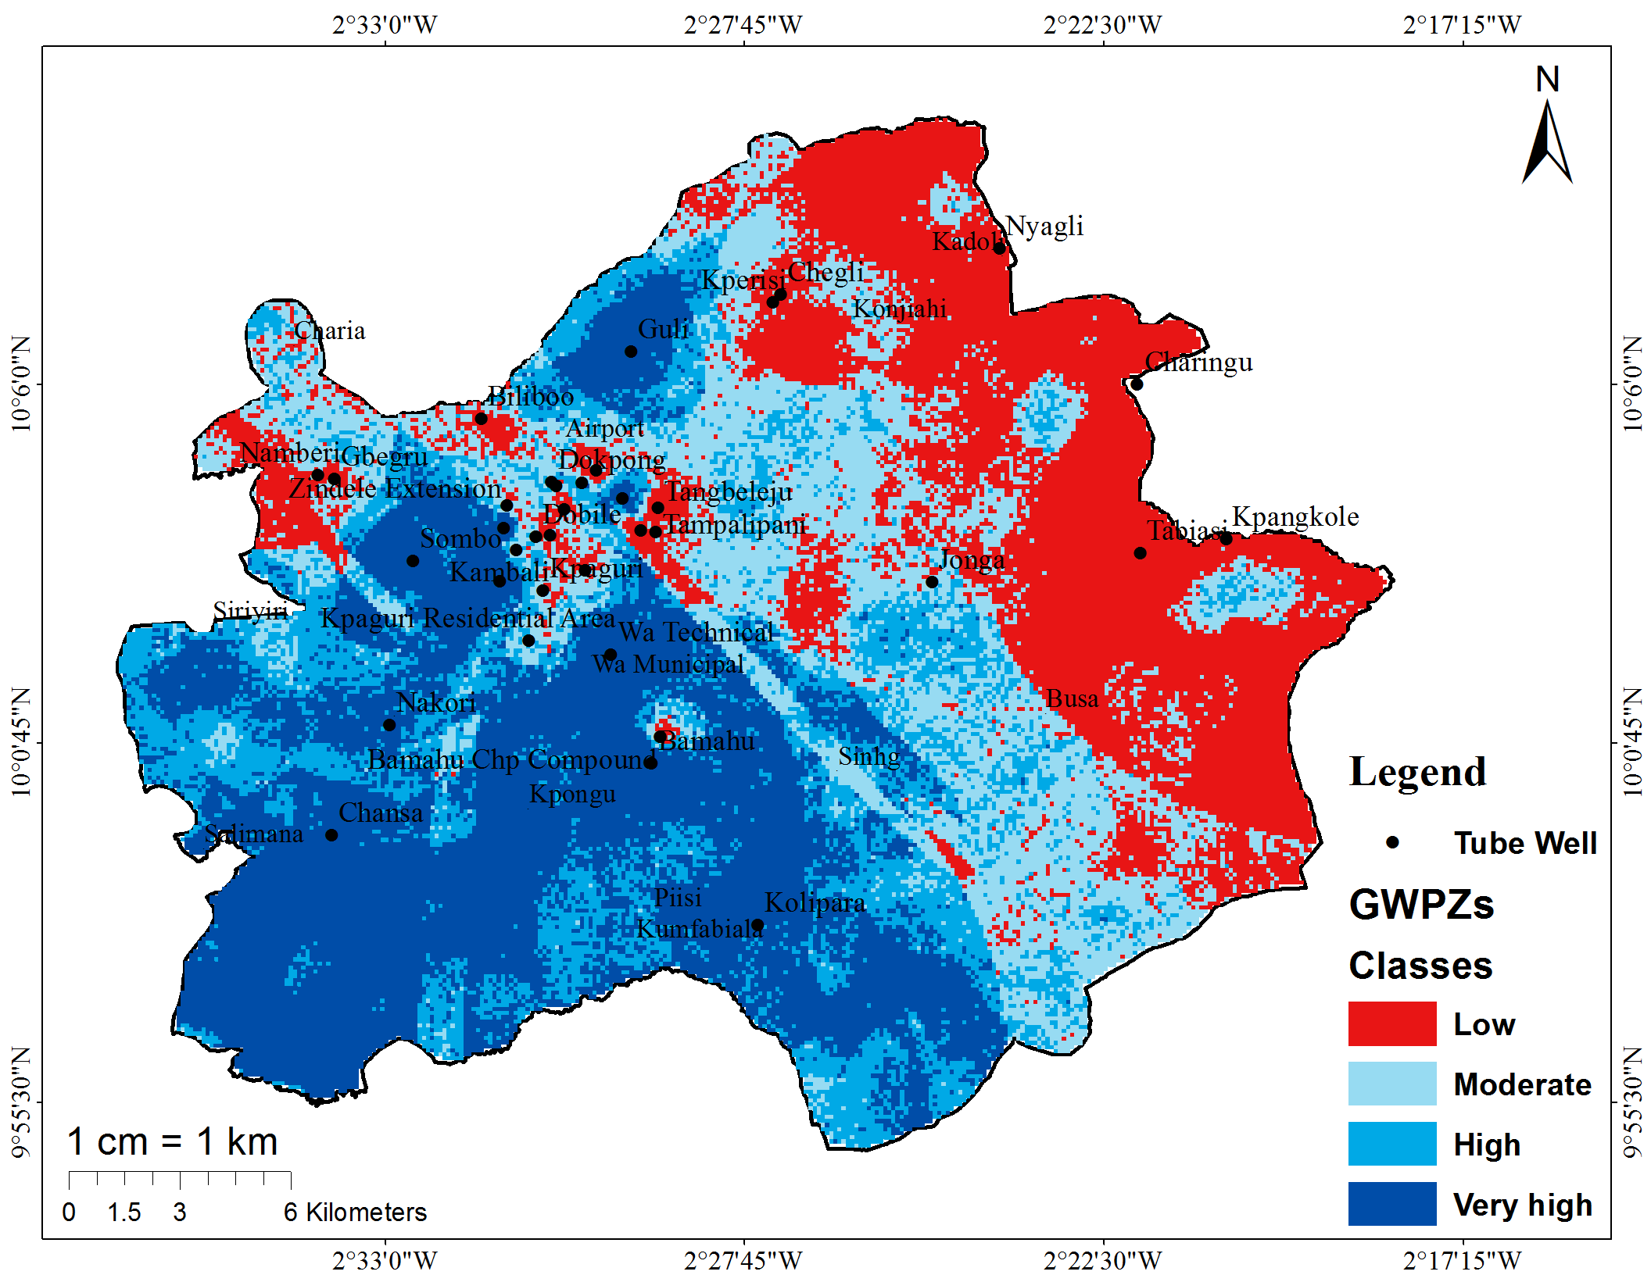
Figure 12: Groundwater Potential Zones of Wa Municipality

Table 7: Classification of Groundwater Potential Zones of Wa Municipality
Classes of GWPZs | Area (km²) | Percentage (%)
Low | 145.71 | 25.40
Moderate | 130.15 | 22.69
High | 112.39 | 19.59
Very high | 185.33 | 32.31

Validation of the Groundwater Potential Map
To assess the accuracy and reliability of the groundwater potential (GWP) map generated through GIS-based weighted overlay analysis, hydrogeological data including static water levels and tube well yield were obtained from the Community Water and Sanitation Agency (CWSA) in Wa. These datasets were interpolated using the Inverse Distance Weighted (IDW) method in ArcMap 10.8. Validation followed methodologies referenced in previous groundwater studies (Nithya et al., 2019; Abdullateef et al., 2021; Mustapha et al., 2023).

Spatial Validation Using Tube Well Yield
The validation focused on comparing well yield data with the classified GWP zones. The comparison revealed a strong correlation between areas of high yield and those delineated as high or very high potential on the GWP map. In the eastern parts of the municipality namely; Tabiasi, Nyagli, Kpangkole, Charingu, Kadoli, and Jonga, tube wells showed low yields ranging from 9–34 liters per minute (L/min), with an average depth of 70 meters. These areas correspond with the low to moderate GWP zones on the potential map. The low groundwater productivity in these areas can be attributed to higher elevations and sparser rainfall, as supported by Figures 7 and 11. In contrast, the central parts of the municipality including Kpongu, Wa Technical, Dondoli, Kambali, Sombo, and Bamahu exhibited high tube well yields between 106–130 L/min. These areas align with the very high GWP zones on the map, validating the model’s predictions.
Groundwater Yield in Wa Municipality
The spatial distribution of tube-well yields in the Wa Municipality is presented in Figure 13. Tube wells in the eastern part of the Municipality, including Tabiasi, Nyagli, Kpangkole, Charingu, Kadoli, and Jonga, record low yields ranging from 9 to 34 L/min, with an average drilling depth of approximately 70 m. These low yields are consistent with the groundwater potential (GWP) map, which classifies these areas as having low to moderate groundwater potential, likely influenced by higher elevations and relatively low rainfall distribution. Conversely, very high yields (106–130 L/min) are observed in Wa Central and the western parts of the Municipality, notably in Kpongu, Wa Technical, Dondoli, Kambali, Sombo, and Bamahu. These high-yielding zones closely correspond with areas delineated as very high groundwater potential on the GWP map. Cross-validation of observed well yields with the groundwater potential classes indicates a strong level of agreement. Of the eight wells in the very high yield category (80–130 L/min), seven occur within zones mapped as very high potential. The single well classified as high yield (60–70 L/min) also corresponds with a high-potential zone. In the moderate yield category, three out of five wells align with moderate groundwater potential areas, while nineteen out of twenty-six low-yield wells occur within zones of low groundwater potential. Overall, approximately 87% of the sampled tube-well yield data is consistent with the delineated groundwater potential map, confirming the reliability of the groundwater prospect assessment (Ifediegwu, 2022).

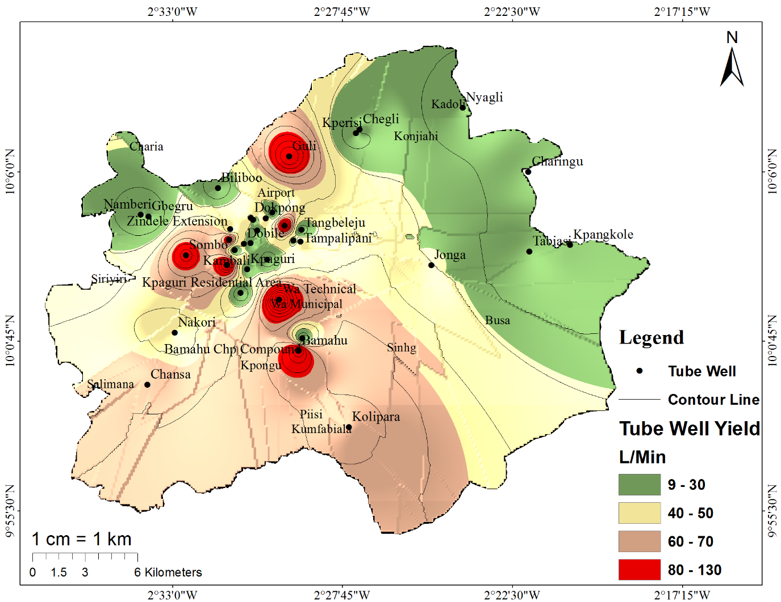
Figure 13: Groundwater Yield in Wa Municipality

Cross-tabulation of Well Yields and GWP Zones
Groundwater potential (GWP) zones were validated using observed tube-well yield data through a GIS-based spatial overlay analysis. Well locations were digitized as point features and overlaid on the classified GWP map. Each well was assigned a groundwater potential class based on its spatial position. Observed well yields were independently classified into yield categories, and a cross-tabulation was performed between yield classes and GWP classes. Wells were considered matching where the yield class corresponded to the groundwater potential class at the well location. The proportion of matching wells relative to the total number of sampled wells was calculated to assess the accuracy of the groundwater potential map. A statistical comparison of well yield categories with GWP classes further confirms the map’s accuracy as presented in Table 8.
Table 8. Cross-tabulation of Well Yields and GWP Zones
Well Yield Class (L/min) | No. of Wells | Wells Matching GWP Zones | Agreement (%)
Very High (80–130) | 8 | 7 | 87.5%
High (60–70) | 1 | 1 | 100%
Moderate (35–59) | 5 | 3 | 60%
Low (9–34) | 26 | 19 | 73%
Out of a total of 40 tube wells, approximately 87% were located in zones that accurately reflected their yield levels, demonstrating a high degree of agreement between observed well performance and the delineated groundwater potential map. The validation results strongly support the reliability of the groundwater potential zones identified in the Wa Municipality. The 87% predictive accuracy confirms that the GIS-based AHP model, supported by thematic datasets and well yield information, is effective for identifying suitable areas for groundwater development, especially for irrigated agriculture and domestic water supply.

CONCLUSION
This study evaluated the groundwater potential of the Wa Municipality by analyzing the influence of physical and environmental factors through a geospatial multi-criteria decision-making approach. Using the Analytic Hierarchy Process (AHP), nine (9) thematic layers namely; geology, lineament density, land use/land cover, soil type, rainfall, elevation, slope, drainage density, and topographic wetness index (TWI) were assigned weights based on their relative importance to groundwater occurrence. The model achieved a consistency ratio of 0.088, indicating that the pairwise comparisons were logically sound and statistically acceptable.
The final groundwater potential map revealed the following spatial distribution across the municipality; Very High Potential (185.33 km², 32.31%), High Potential (112.39 km², 19.59%), Moderate Potential (130.15 km², 22.69%), and Low Potential (145.71 km², 25.40%). Zones identified as having very high and high groundwater potential are primarily located within geological formations of the Birimian Supergroup, which are known for their fractured rock systems that enhance groundwater storage and flow. Other influential factors included high lineament density, low slope, favorable land cover, and adequate rainfall.
Validation of the model using tube well yield data confirmed a strong correlation between observed yields and the predicted groundwater potential zones, with a prediction accuracy of approximately 87%. This confirms the reliability of the model and its practical application in water resource planning.
The study revealed that, the western portion of the Wa Municipality exhibits greater groundwater development potential compared to the eastern section. Given the increasing importance of irrigated agriculture in mitigating the impacts of climate variability, the results of this study provide a scientific basis for sustainable groundwater management and land use planning in the region.
The study recommended that to further improve groundwater sustainability; additional hydrochemical studies should be conducted to assess water quality for irrigation use, artificial recharge techniques such as injection wells, dugouts, and fish ponds should be implemented in low potential zones to enhance aquifer replenishment, and policy makers, planners, and agricultural stakeholders may adopt the results of this study to guide well drilling and water infrastructure development.
DECLARATION OF COMPETING INTEREST
The authors declare that they have no known competing interests regarding the publication of this paper.

DISCLAIMER (ARTIFICIAL INTELLIGENCE)
Author(s) hereby declare that NO generative AI technologies such as Large Language Models (ChatGPT, COPILOT, etc) and text-to-image generators have been used during writing or editing of this manuscript.

REFERENCES
Abdul-Ganiyu, S., & Prosper, K. (2020). Groundwater Resources as a Resilient Alternative for Irrigation in the Upper West Region of Ghana – A Study of Groundwater Potential. International Journal of Innovative Science and Research Technology, 5(6), 1121–1130. https://doi.org/10.38124/ijisrt20jun811
Abdullateef, L., Tijani, M. N., Nuru, N. A., John, S., & Mustapha, A. (2021). Assessment of groundwater recharge potential in a typical geological transition zone in Bauchi, NE-Nigeria using remote sensing/GIS and MCDA approaches. Heliyon, 7(4), e06762. https://doi.org/10.1016/j.heliyon.2021.e06762
Addo, K. A. (2010). Urban and peri-urban agriculture in developing countries studied using remote sensing and in situ methods. Remote Sensing, 2(2), 497–513. https://doi.org/10.3390/rs2020497
Adongo, T. A., Abagale, F. K., & Agyare, W. A. (2021). Modelling and forecasting reservoir sedimentation of irrigation dams in the Guinea Savannah Ecological Zone of Ghana. Water Practice & Technology, 16(4), 1355–1369. https://doi.org/10.2166/wpt.2021.073
Ramzi, M. S. M., & Al-Gburi, M. R. G. (2022). Delineation of Groundwater Potential Using GIS, RS and AHP Techniques of the Chia Sur Sub-Basin in Sulaymaniyah-Kirkuk, Northeastern Iraq. Iraqi Geological Journal, 55(2E), 165-175. https://doi.org/10.46717/igj.55.2E.11ms-2022-11-25
Al-Gburi, M. R. G., & Ibrahiem Al-Tamimi, O. S. (2020). Groundwater vulnerability assessment using drastic model of up Al-Khassa dam sub-basin, Kirkuk, NE Iraq. Iraqi Geological Journal, 53(2), 12–24. https://doi.org/10.46717/igj.53.2E.2Ms-2020-11-24
Al-Ruzouq, R., Shanableh, A., Merabtene, T., Siddique, M., Khalil, M. A., Idris, A. E., & Almulla, E. (2019). Potential groundwater zone mapping based on geo-hydrological considerations and multi-criteria spatial analysis: North UAE. Catena, 173, 511–524. https://doi.org/10.1016/j.catena.2018.10.037
Arulbalaji, P., Padmalal, D., & Sreelash, K. (2019). GIS and AHP Techniques Based Delineation of Groundwater Potential Zones: a case study from Southern Western Ghats, India. Scientific Reports, 9(1), 2082. https://doi.org/10.1038/s41598-019-38567-x
Bhadran, A., Girishbai, D., Jesiya, N. P., Gopinath, G., Krishnan, R. G., & Vijesh, V. K. (2022). A GIS based Fuzzy-AHP for delineating groundwater potential zones in tropical river basin, southern part of India. Geosystems and Geoenvironment, 1(4), 100093. https://doi.org/10.1016/j.geogeo.2022.100093
Bhuvaneswaran, C., Ganesh, A., & Nevedita, S. (2015). Spatial analysis of groundwater potential zones using remote sensing, GIS and MIF techniques in uppar Odai sub-watershed, Nandiyar, Cauvery basin, Tamilnadu. Int J Curr Res, 7(09), 20765–20774.
Carrier, M.-A., Lefebvre, R., Racicot, J., & Asare, E. B. (2008). Northern Ghana hydrogeological assessment project. In H. Jones (Ed.), Access to sanitation and safe water - Global partnerships and local actions: Proceedings of the 33rd WEDC International Conference (pp. 353-361). Loughborough University. https://repository.lboro.ac.uk/articles/conference_item/Northern_Ghana_hydrogeological_assessment_project/9370008/1
Chatterjee, S., & Dutta, S. (2022). Assessment of groundwater potential zone for sustainable water resource management in south-western part of Birbhum District, West Bengal. Applied Water Science, 12(3), 1–16. https://doi.org/10.1007/s13201-021-01549-4
Chegbeleh, L. P., Akurugu, B. A., & Yidana, S. M. (2020). Assessment of Groundwater Quality in the Talensi District, Northern Ghana. Scientific World Journal, 2020, 8450860. https://doi.org/10.1155/2020/8450860
Danso, S. Y., & Ma, Y. (2023). Geospatial techniques for groundwater potential zones delineation in a coastal municipality, Ghana. Egyptian Journal of Remote Sensing and Space Science, 26(1), 75–84. https://doi.org/10.1016/j.ejrs.2022.12.004
Das, S. (2019). Comparison among influencing factor, frequency ratio, and analytical hierarchy process techniques for groundwater potential zonation in Vaitarna basin, Maharashtra, India. Groundwater for Sustainable Development, 8, 617–629. https://doi.org/10.1016/j.gsd.2019.03.003
Doke, A. B., Zolekar, R. B., Patel, H., & Das, S. (2021). Geospatial mapping of groundwater potential zones using multi-criteria decision-making AHP approach in a hardrock basaltic terrain in India. Ecological Indicators, 127, 107685. https://doi.org/10.1016/j.ecolind.2021.107685
Falah, F., & Zeinivand, H. (2019). GIS-Based Groundwater Potential Mapping in Khorramabad in Lorestan, Iran, Using Frequency Ratio (FR) and Weights of Evidence (WoE) Models. Water Resources, 46(5), 679–692. https://doi.org/10.1134/S0097807819050051
Falowo, O. O., & Bamoyegun, O. A. (2023). AHP GIS-supported overlay/index models in Okeigbo, southwestern Nigeria, for groundwater susceptibility zonation. HydroResearch, 6, 184–202. https://doi.org/10.1016/j.hydres.2023.05.003
Gebere, S. B., Alamirew, T., Merkel, B. J., & Melesse, A. M. (2016). Land use and land cover change impact on groundwater recharge: The Case of Lake Haramaya watershed, Ethiopia. In Landscape dynamics, soils and hydrological processes in varied climates (pp. 93-110). Cham: Springer International Publishing. https://doi.org/10.1007/978-3-319-18787-7_6
Ghosh, A., Adhikary, P. P., Bera, B., Bhunia, G. S., & Shit, P. K. (2022). Assessment of groundwater potential zone using MCDA and AHP techniques: case study from a tropical river basin of India. Applied Water Science, 12(3), 1–22. https://doi.org/10.1007/s13201-021-01548-5
Gyampo, M. A., Zango, M. S., & Ampadu, B. (2014). Assessment of Drinking Water Quality of Groundwaters in Bunpkurugu-Yunyo District of Ghana. Environment and Pollution, 3(3). https://doi.org/10.5539/ep.v3n3p1
Hagos, Y. G., & Andualem, T. G. (2021). Geospatial and multi-criteria decision approach of groundwater potential zone identification in Cuma sub-basin, Southern Ethiopia. Heliyon, 7(9), e07963. https://doi.org/10.1016/j.heliyon.2021.e07963
Ifediegwu, S. I. (2022). Assessment of groundwater potential zones using GIS and AHP techniques: a case study of the Lafia district, Nasarawa State, Nigeria. Applied Water Science, 12(1), 1–17. https://doi.org/10.1007/s13201-021-01556-5
ISRIC (2011). International Soil Reference and Information Centre soil shapefile (ISRIC, 2011)
Abdelaziz, K. K., Nicaise, Y., Séguis, L., Ouattara, I., Moussa, O., Auguste, K. K., Kamagaté, B., & Diakaria, K. (2020). Influence of Land Use Land Cover Change on Groundwater Recharge in the Continental Terminal Area of Abidjan, Ivory Coast. Journal of Water Resource and Protection, 12(5), 431-453. https://doi.org/10.4236/jwarp.2020.125026
Kpiebaya, P., Abdul-Ganiyu, S., Amadu, I., & Bismark, M. (2020). Assessment of Groundwater for Dry Season Farming in the Upper East Region of Ghana-Determining the Storage Capacity. International Journal of Creative Research Thoughts, 8(7), 4147–4159. http://www.ijcrt.org/papers/IJCRT2007438.pdf
Kwami, I. A., Ishaku, J. M., Mukkafa, S., Haruna, A. I., & Ankidawa, B. A. (2019). Delineation of aquifer potential zones using hydraulic parameters in Gombe and environs, North-Eastern, Nigeria. Heliyon, 5(7), e01927. https://doi.org/10.1016/j.heliyon.2019.e01927
Magesh, N. S., Chandrasekar, N., & Soundranayagam, J. P. (2012). Delineation of groundwater potential zones in Theni district, Tamil Nadu, using remote sensing, GIS and MIF techniques. Geoscience Frontiers, 3(2), 189–196. https://doi.org/10.1016/j.gsf.2011.10.007
Manu, E., Agyekum, W. A., Duah, A. A., Mainoo, P. A., Okrah, C., & Asare, V. S. (2016). Improving Access to Potable Water Supply using Integrated Geophysical Approach in a Rural Setting of Eastern Ghana. Elixir Environment and Forestry, 95, 40714–40719. https://www.elixirpublishers.com/articles/1462900000-0000000000-95-40714-40719.pdf
Ashok, P., Manugula, S. S., Pavani, C. S. L., Kumar, M. K., Singh, D., Singh, S. P., Rout, C., & Chakravarti, A. (2022). AHP and GIS Techniques for the Demarcation of Groundwater Potential Zones in a Part of Granitic Bundelkhand, India- A Case Study of District Jhansi. International Journal of Mechanical Engineering, 7(2). https://www.researchgate.net/publication/358300000_AHP_and_GIS_Techniques_for_the_Demarcation_of_Groundwater_Potential_Zones_in_a_Part_of_Granitic_Bundelkhand_India-A_Case_Study_of_District_Jhansi_Chadetrik_Rout
Masroor, M., Sajjad, H., Kumar, P., Saha, T. K., Rahaman, M. H., Choudhari, P., Kulimushi, L. C., Pal, S., & Saito, O. (2023). Novel Ensemble Machine Learning Modeling Approach for Groundwater Potential Mapping in Parbhani District of Maharashtra, India. Water (Switzerland), 15(3). https://doi.org/10.3390/w15030419
Mahala, A. (2021). Delineating the Status of Groundwater in a Plateau Fringe Region Using Multi-influencing Factor (MIF) and GIS: A Study of Bankura District, West Bengal, India. In P. P. Adhikary, P. K. Shit, P. Santra, G. S. Bhunia, A. K. Tiwari, & B. S. Chaudhary (Eds.), *Geostatistics and Geospatial Technologies for Groundwater Resources in India* (pp. 215-237). https://doi.org/10.1007/978-3-030-62397-5_11
Ahmadi, H., Kaya, O. A., Babadagi, E., Savas, T., & Pekkan, E. (2021). GIS-Based Groundwater Potentiality Mapping Using AHP and FR Models in Central Antalya, Turkey. Environmental Sciences Proceedings, 5(1), 11. https://doi.org/10.3390/IECG2020-08741
Muavhi, N., Thamaga, K. H., & Mutoti, M. I. (2021). Mapping groundwater potential zones using relative frequency ratio, analytic hierarchy process and their hybrid models: Case of Nzhelele-Makhado area in South Africa. Geocarto International. https://doi.org/10.1080/10106049.2021.1936212
Ikirri, M., Boutaleb, S., Ibraheem, I. M., Abioui, M., Echogdali, F. Z., Abdelrahman, K., Id-Belqas, M., Abu-Alam, T., El Ayady, H., Essoussi, S., & Faik, F. (2023). Delineation of Groundwater Potential Area using an AHP, Remote Sensing, and GIS Techniques in the Ifni Basin, Western Anti-Atlas, Morocco. Water, 15(7), 1436. https://doi.org/10.3390/w15071436
Nithya, C. N., Srinivas, Y., Magesh, N. S., & Kaliraj, S. (2019). Remote Sensing Applications : Society and Environment Assessment of groundwater potential zones in Chittar basin , Southern India using GIS based AHP technique. Remote Sensing Applications: Society and Environment, 15(June), 100248. https://doi.org/10.1016/j.rsase.2019.100248
Oh, H. J., Kim, Y. S., Choi, J. K., Park, E., & Lee, S. (2011). GIS mapping of regional probabilistic groundwater potential in the area of Pohang City, Korea. Journal of Hydrology, 399(3–4), 158–172. https://doi.org/10.1016/j.jhydrol.2010.12.027
Pande, C. B., Khadri, S. F. R., Moharir, K. N., & Patode, R. S. (2018). Assessment of groundwater potential zonation of Mahesh River basin Akola and Buldhana districts, Maharashtra, India using remote sensing and GIS techniques. Sustainable Water Resources Management, 4(4), 965–979. https://doi.org/10.1007/s40899-017-0193-5
Razandi, Y., Pourghasemi, H. R., & Neisani, N. S. (2015). Application of analytical hierarchy process, frequency ratio, and certainty factor models for groundwater potential mapping using GIS. Earth Science Informatics. https://doi.org/10.1007/s12145-015-0220-8
Saaty, T. L. (1984). The Analytic Hierarchy Process: Decision Making in Complex Environments. In R. Avenhaus & R. K. Huber (Eds.), Quantitative Assessment in Arms Control: Mathematical Modeling and Simulation in the Analysis of Arms Control Problems (pp. 285–308). Springer US. https://doi.org/10.1007/978-1-4613-2805-6_12
Shao, Z., Huq, M. E., Cai, B., Altan, O., & Li, Y. (2020). Integrated remote sensing and GIS approach using Fuzzy-AHP to delineate and identify groundwater potential zones in semi-arid Shanxi Province, China. Environmental Modelling and Software, 134, 104868. https://doi.org/10.1016/j.envsoft.2020.104868
Siddik, M. S., Tulip, S. S., Rahman, A., Islam, M. N., Haghighi, A. T., & Mustafa, S. M. T. (2022). The impact of land use and land cover change on groundwater recharge in northwestern Bangladesh. Journal of Environmental Management. https://doi.org/10.1016/j.jenvman.2022.115130
Ejepu, J. S., Jimoh, M. O., Abdullahi, S., & Mba, M. A. (2022). Groundwater Exploration Using Multi Criteria Decision Analysis and Analytic Hierarchy Process in Federal Capital Territory, Abuja, Central Nigeria. International Journal of Geosciences. https://doi.org/10.4236/ijg.2022.131003
Yidana, S. M., Banoeng-Yakubo, B., Aliou, A. S., & Akabzaa, T. M. (2012). Groundwater quality in some Voltaian and Birimian aquifers in northern Ghana—application of mulitvariate statistical methods and geographic information systems. Hydrological Sciences Journal, 57(6), 1168–1183. https://doi.org/10.1080/02626667.2012.693612
Zango, M. S., Anim-Gyampo, M., Gibrilla, A., Pelig-Ba, K. B., & Okofo, L. B. (2022). Groundwater recharge and dating in crystalline basement aquifers of Vea catchment: An integrated environmental tracers’ approach. Scientific African https://doi.org/10.1016/j.sciaf.2022.e01505
Zarate, E., Hobley, D. E. J., MacDonald, A. M., Swift, R. T., Chambers, J. E., Kashaigili, J. J., Mutayoba, E., Taylor, R. G., & Cuthbert, M. O. (2021). The role of superficial geology in controlling groundwater recharge in the weathered crystalline basement of semi-arid Tanzania. Journal of Hydrology: Regional Studies, 36, 100833. https://doi.org/10.1016/j.ejrh.2021.100833

