Modeling of Flows and Flood Forecasting in an Urbanized Watershed: Case of the Gourou Basin in Abidjan, Côte d’Ivoire

.

.
ABSTRACT

The Gourou watershed is characterized by its high urbanization and poor rainwater drainage due to malfunctions in evacuation infrastructure. This situation leads to recurring floods at the basin's outlet and surrounding neighborhoods, often causing traffic interruptions as well as sedimentation and unsanitary conditions in the Ebrié lagoon, the recipient of these waters.
This study aims to model water flows and forecast flood risks in the Gourou watershed using the SWMM conceptual model. Model validation was possible through flow rates observed in 2018 at the Martyrs' Monument station using a RAVEN-YE RS485 flowmeter with a 5-minute time step. Horton's formula was used to evaluate soil infiltration capacity. The dynamic wave formula, which involves complete resolution of the Barré de St. Venant equations, allowed for runoff modeling. SRTM-3 images version 2 from the USGS site with a 1 arc-second resolution and covering the entire watershed led to the extraction of the Digital Terrain Model. The primary input data for the SWMM model is the Desbordes double triangle rainfall, providing hyetographs with a 2-hour duration and a 30-minute intense period.
The estimation of physical parameters of the Gourou watershed reveals a maximum altitude of 149 m with an average slope of 7.67%. Infiltration is maximal upstream in the sub-basin S7 (20.60 mm/h) and gradually decreases downstream, with a minimum value of 6.23 mm/h in sub-basin S18, reflecting significant urbanization downstream. The Nash criterion of 92.52% and Pearson coefficient of 0.56 confirm that the SWMM simulation for the Gourou watershed provides excellent results. There is also a strong correlation between simulated and observed flow rates.
No overflow is recorded at the watershed outlet for recurrence periods of 1, 2, 3, 5, 10, 20, 30, 50, and 100 years. Only the flood-limiting dams of Dokoui Est and Agban overflow during these identified return periods. Flow velocities vary from 0.01 m/s to 10 m/s in the sections of the main Gourou canal. Furthermore, all flood control dams receive rain runoff at more than 100% of their required capacities. Then the floods observed in recent years at the Indenié Crossroads are generally caused by drainage infrastructure malfunctions (obstruction, sedimentation, ruptures, wastewater connections). These findings are important and should serve as decision-making tools for policies implemented to combat floods in urban environments.

Keywords: simulation, model, forecast, SWMM, watershed, Gourou, Abidjan.

1. INTRODUCTION

Floods, landslides, and debris flow are all triggered by excess water (BADRZADEH, 2015). The consequences of anarchic urbanization in general, and particularly in Africa particularly in large capitals such as the city of Abidjan affect rainwater flows and volumes in drainage networks. This leads to enormous risks of overflow. In recent decades, the city of Abidjan has experienced numerous floods in the Gourou basin, sometimes causing material and human damage by blocking traffic to the Plateau business district for hours. On July 8, 2022, floods caused 19 deaths and 5 injuries in Abidjan (CNS, 2022). According to BADRZADEH, (2015). flood disaster mitigation can be achieved by structural means and non-structural means. The structural means are expensive for the developing countries but an early warning system can save more people and infrastructures. The implementation of that system needs a better knowledge of the watershed system. In Abidjan, the hydrographic network of the Gourou watershed consists of a main canal and tributaries, which are secondary canals, either earthen or concrete, with runoff waters drained towards the Indenié Crossroads, its outlet. Recurring overflows caused by the accumulation of solid waste and sedimentation of drainage infrastructure lead to material and human damage in the basin and its surroundings. Understanding and controlling runoff positively impacts the proper functioning of this infrastructure. Therefore, using the classic double-triangle rainfall model in drainage infrastructure design allows for faster evacuation of runoff waters (DAOUED, 2019). In this case, emphasis should be placed on protecting people and property from flood risks in urban environments, highlighting the importance of the double-triangle project rainfall, which is one of the means to represent local rainfall and synthetic hyetograph (TAMARA AND YAHIA, 2009). The Storm Water Management Model (SWMM) conceptual model is one of the most robust models used to simulate hydrographs from urban basins with their propagation through the main pipe network (TAMARA AND YAHIA, 2009). According to BEHROUZ et al., (2023), the SWMM is an urban watershed model for simulating urban runoff quantity and quality. Furthermore, the EPA’s Storm Water Management Model (SWMM) has been applied across the globe for citywide stormwater modeling due to its robustness and versatility. Recent research indicated that SWMM, with proper setup, can be applied in the description of more dynamic flow conditions, such as rapid inflow conditions (GELLER et al., 2025). In recent years, there has been a decrease in soil water infiltration capacity, especially in urban and peri-urban basins like the Gourou watershed in Abidjan (SORO et al., 2016). The increase in runoff causes overloading and overflows in drainage infrastructure, sometimes causing their malfunction. It is urgent to turn to rainwater flow simulation processes to reduce flood risks.
The present study aims to model and forecast the urban runoff quantity in the urban watershed of Gourou with the EPA’s SWMM for various return periods to provide a decision-support tool.

2. material and methods

2.1. PRESENTATION OF THE STUDY AREA
The Autonomous District of Abidjan (DAA) is located in the south of Côte d'Ivoire, between 5°17 and 5°30 degrees North latitude and 3°45 and 5°20 degrees West longitude. The Gourou Watershed is situated within this Autonomous District (Figure 1). It extends across the communes of Cocody, Plateau, Adjamé, and Abobo and drains flows towards the Bay of Cocody. The area is bordered to the west by the Adjamé-Anyama railway line, which runs along the Banco National Park, to the east by the extension of Latrille Boulevard up to the Two Plateaux neighborhood, and to the north by the Abobo district.
The geometric shape of this watershed is similar to a rectangle, approximately 9 km long (North-South axis) by 3 km wide (East-West axis). Its surface area is estimated at 28.6 km² (BAD, 2010). Progressive quantities of sand, solid waste, and wastewater are deposited in the drainage network canals, causing the retention basins to become obstructed (BAD, 2010). This phenomenon causes floods at the Indenié crossroads while accelerating sand deposition on the banks of the Ebrié lagoon.
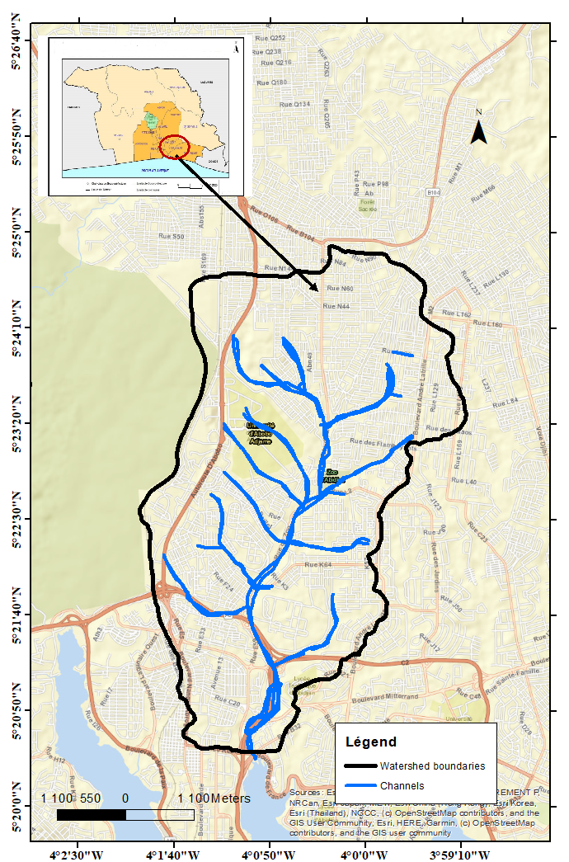

Figure 1: Hydrographic Network of the Gourou Watershed

2.2 DATA AND MATERIALS
The material used in this study consists of a Garmin 64X GPS used for geographic coordinate surveys on the watershed, a flow measurement station (coordinates) installed at the watershed outlet, and Global Mapper V 19 software for delineating sub-watersheds and calculating hydrological parameters. Climatic data come from the database of Société d'Exploitation et de développement Aéroportuaire Aéronautique et Météorologique (SODEXAM) in Abidjan, with a chronological series extending over a fifty-eight-year period (1958-2016). These essentially include maximum annual intensities for return periods of 5, 10, 20, 30, and 50 years with time steps of 10, 15, 30, 45, 60, 90, 120, 180, and 240 minutes. The RAVEN-EYE RS458 flowmeter was used to measure observed flows at the outlet at a 5-minute time step at the Martyrs' Monument station (Table 1) during the year 2018. The flows processed with the TOPKAPI software were obtained from the Gourou Watershed Project database. Finally, the SWMM model was used to model peak flows at the outlet.

Table I: GPS Coordinates of dicharge Measurement Stations
Dicharge Measurement Sites | X |  | Y | Z (m) | Code
Canal Martyrs' Monument | 5°21’6,78’’N |  | 4°1’30,71’’O | 47 | DEBIT01CAM
Canal Williamsville | 5°21’46,91’’N |  | 4°1’30,71’’O | 45 | DEBIT02CWI
Paillet Crossroads Canal | 5°22’11,64’’N |  | 4°0’43,56’’O | 42 | DEBIT03CPA

  - METHODS

2.3.1. Modeling of Drainage Network Objects
In the SWMM simulation process, two types of objects are used. The conceptual hydrological objects are rain gauges, whose properties include the type of rainfall data, the recording time interval, the rainfall data source, and its name. Added to this are the watersheds with their physical parameters (slope, roughness defined by Manning's coefficient, percentage of impervious surfaces relative to the total surface, surface storage modeled by a coefficient, and the percentage of impervious surfaces without surface storage (ROSSMAN, 2009).
As for hydraulic objects, these are nodes and links. It is necessary to insert a node upstream and downstream of each link. Beyond their specific functions, the different nodes help define the topographical parameters of the associated links.

2.3.2. Modeling of Flows in Drainage Infrastructure
Urbanization, known to reduce infiltration capacity, leads to increased runoff and subsequent flooding during rainfall events (SAHA et al., 2025). Numerous models in literature allow to evaluate infiltration capacity such as SCS-CN (Soil Conservation Service Curve Number) model, Green-Ampt (GA) model and Horton’s model. However, Horton’s model is used quite often by model developer due to the simplicity and established empirical parameters (SAHA et al., 2025). Thus, Horton’s model was used in this study for watershed flow simulation because it considers surface runoff occurs when rainfall capacity exceeds the limit of infiltration capacity (DAHAK, 2021). Then Horton’s model method is widely used for computational efficiency since they do not require iterative computations to estimate infiltration rates (SAHA et al., 2025).
It is a highly non-linear production function that transforms gross rainfall in the basin into effective rainfall and runoff, and the linear transfer function (FT), which distributes a given effective rainfall over time in the form of flow rates Q.
The model parameters, such as minimum and maximum infiltration rates and the time constant that sets the rate of soil drying and the drying duration according to the equation below (Equation 1) (ROESNER et al., 2009).

$I\left(t\right)=i_{min}+\left(i_{max} - i_{min}\right)e^{-kt}$ (1)

- i_{max} the maximum soil infiltration capacity (mm/h),
- i_{min} the minimum soil infiltration capacity (mm/h)
- and k is a time constant (h).
For the routing or transfer process, SWMM uses three models. These three models correspond to three degrees of sophistication in solving the Barré de St Venant equations (TELLIEZ, 2010). In this study, the dynamic wave model was selected because it allows modeling of all observable events in a drainage network (floods, flow overloads, backwater) and theoretically provides more precise results (TELLIEZ, 2010).
The Manning-Strickler formula (equation 2) was used to evaluate the maximum discharge potentially drainable by the channels of different sections. This formula is written in the form (HOUNKPE et al., 2020).

$Q=K_{s}{Rh}^{2/3}J_{f}^{1/2}$ (2)

Where Q: the peak flow to be evacuated; Ks: the Strickler coefficient: Ks = 70 for reinforced concrete channels;
Rh: the hydraulic radius = $R_{h}=\frac{S}{P}$ with
Jf: the longitudinal slope of the channel;
S: the wetted section,
P: Wetted perimeter
For retention basin modeling, the physical data taken into account are the hydrograph resulting from hydrological calculations for the various elementary watersheds, the retention basin area considered as an average area of a basin with vertical walls, and the dimensional characteristics of the outlet structure, orifice, weir, or throttle pipe. The flow rate is given by the formula (equation 3).

$Q=C_{q^{ x}} S×2gH^{0,5}$ (3)

With: Q: flow rate in m³/s Cq: a discharge coefficient depending on the orifice S: orifice cross-sectional area H: head (water level) over the orifice All calculations are performed in the SWMM model.

2.3.2.1 SWMM Model Simulation Process
Continuous simulation is useful for modeling infiltration and evaporation processes, and its strength is that the program itself determines the antecedent conditions for the selected rainfall event (BOON et al, 2008). To limit simulation time, the method proposed by VAES et al. (1999), which simulates the network using project rainfall and proceeds with model calibration by adjusting runoff and infiltration parameters, was chosen. The production and transfer modules are executed simultaneously and mutually influence each other through coupling (BERTHIER AND MOHAMAD, 2020).

2.3.2.2 Model Performance Evaluation and Identification of Overflow Zones
To evaluate the performance of the rainwater drainage network, the methodology used in this study is divided into two steps (FUAMBA et al., 2007). Important parameters such as maximum velocity in pipes, runoff flow, and total flood volume are recorded to evaluate the hydraulic performance of the network subject to repeated overflows.

2.3.2.3 Model Calibration and Validation
Model calibration consists of estimating its unknown parameters to obtain responses as close as possible to observations. Generally, this step allows modifying hydrological parameters, with hydraulic parameters being estimated with greater certainty.
The calibration was done using data from the rainy event of June 19, 2018 at the technical high school station and the discharge observed at the outlet of the martyrs' monument. Parameters such as the roughness coefficient of permeable and impermeable surfaces, the depth of runoff on these surfaces, and the simulation time step were selected for calibration.
The estimated values then allow simulating events that were not used in the calibration.
Validation aims to determine the model's adequacy with known events and estimate simulation error. Precipitation data from May 24, 2017 and June 18, 2018 at the Adama Sanogo High School station located outside the basin outlet were used for model validation. The Nash criterion analyzes the difference between observed and simulated flow rates has been use to evaluates rainfall-runoff model performance of the SWMM model. The equation (4) of Nash is given by the formula in GOULA et al. (2015).
$E=\left(1-\frac{\sum_{i=0}^{n}{{\left(Q_{0}-Q_{s}\right)}^{2}}}{\sum_{i=0}^{n}{{\left(Q_{0}-\overline{Q_{s}}\right)}^{2}}}\right)x 100$(4)

where Qo and Qs are respectively the observed and simulated flows during the calibration period; and the mean of observed flows during calibration.
When E > 90% the model is excellent, 80% < E < 90%, the model is very good, 60% < E < 80%, the model is good and E < 60%, the model is poor. The Pearson correlation coefficient is commonly used to evaluate the performance of hydrogeological and hydrological models (LEGATES AND MCCABE, 1999). It is obtained by calculating the linear regression between the calculated flow values and those of observed or measured flows. Its formulation is as follows (Equation 5):"
Note that the text appears to be discussing model evaluation metrics in hydrology, specifically mentioning the Nash-Sutcliffe efficiency criterion (E) and the Pearson correlation coefficient.

$R=\frac{i=\sum{Q_{o}Q_{s}}}{\sqrt{\left(\sum_{i=1}^{n}{Q_{o}^{2}}\right)\sqrt{\left(\sum_{i=1}^{n}{Q_{s}^{2}}\right)}}}$ (5)

where Qo and Qs are respectively the observed and calculated flows for i: 1..., N.
The correlation between observed flows and calculated flows is (LEGATES and MCCABE, 1999).
For R=1, the correlation is perfect, R > 0.8, very strong, 0.5<R<0.8, strong, 0.2<R<0.5, moderate intensity, 0 < R< 0.2, weak, and R= 0, it is null." This text appears to be continuing the explanation of the Pearson correlation coefficient (R) and providing interpretation guidelines for different R values in the context of hydrological modeling.

3. results and discussion
3.1. RESULTS
3.1.1. Topography and Hydrographic Network
Figure 2 shows the topography and hydrographic network in the Gourou watershed. The analysis of this figure indicates that the hydrographic network is quite densified and runs from upstream (Abobo Commune) to downstream towards the Indenié intersection, which is the outlet of the Gourou watershed. This network consists of a main concrete canal (Gourou canal) and tributaries that are either concrete or earthen channels. As for the topography, it shows a relatively rugged relief with elevations ranging from 0 to 139 m within the watershed.

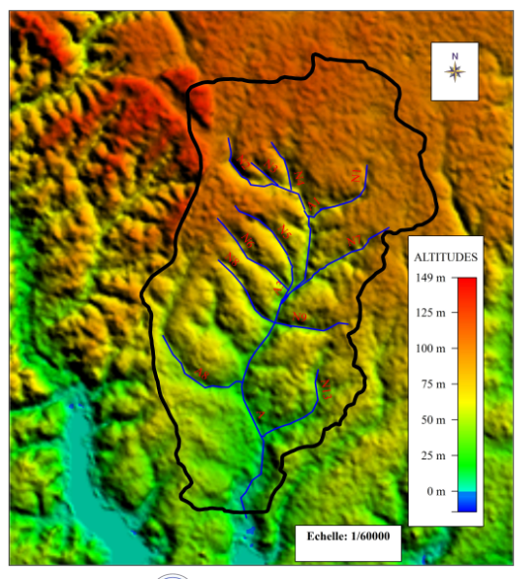
Figure 2: Topography and hydrographic network of the Gourou watershed
3.1.2. Discretization of Sub-watersheds Using the Digital Elevation Model (DEM)
Figure 3 presents the different sub-basins obtained from the digital elevation model (DEM) using Global Mapper software. In total, eighteen (18) sub-watersheds were delineated. The estimation of the physical parameters of the watershed yielded areas ranging from 0.18 km² (sub-basin S2) to 2.8 km² for sub-basin S18 (Table 2). The DEM shows elevations in the study area varying from 0 to 149 m.

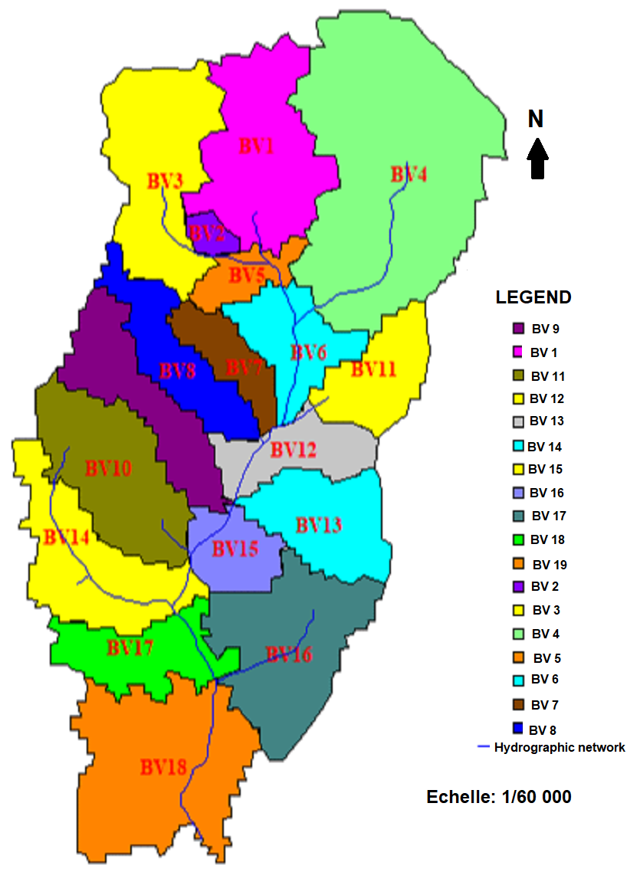
Figure 3: Sub-watersheds extracted from the DEM of the Gourou watershed

Table 2: Physical parameters of the Gourou basin
Sub-watershed | S1 | S2 | S3 | S4 | S5 | S6 | S7 | S8 | S9 | S10 | S11 | S12 | S13 | S14 | S15 | S16 | S17 | S18 | BV
Area (Km²) | 2,2 | 0,1 | 2,1 | 5,27 | 0,5 | 1 | 0,6 | 1,1 | 1,4 | 1,9 | 1 | 0,9 | 1,3 | 1,8 | 0,7 | 2,2 | 1,2 | 2,8 | 28,2
Perimeter (Km) | 8,6 | 1,7 | 8,2 | 11,6 | 4,5 | 6 | 5 | 7,8 | 8,6 | 7,4 | 4,9 | 5,4 | 5,8 | 8,7 | 4 | 8,7 | 7,9 | 10,7 | 7

3.1.3. Modeling of Drainage Network Objects
Figures 4, 5, and 6 show the mapping of sub-watersheds, storage units (nodes), and channels (conduits) obtained following the simulation of the SWMM model.
Analysis of the results indicates that eighteen (18) sub-watersheds were modeled with sub-watershed areas ranging from 0.1 to 3 km². The Carrefour de l'Indenié, the outlet of the watershed, is located in sub-watershed number S18.
For junction nodes, there are forty-nine (49) in total, including one (1) outlet, which is the Cocody Bay. There are also ten (10) storage units, including seven (7) flood control dams equipped with seven (7) aerial spillways or flood spillways of various shapes, with maximum depths of 5 m.
Finally, for the drainage channels, there are forty-three (43) conduits, which are channels of several types and regular or irregular shapes (transects), made of earth or concrete. The regular shapes of the channels encountered are triangular and trapezoidal. It is noted that canal C9 has the greatest depth with a value of 4.45 m. The smallest depth of the channels is approximately 0.5 m.
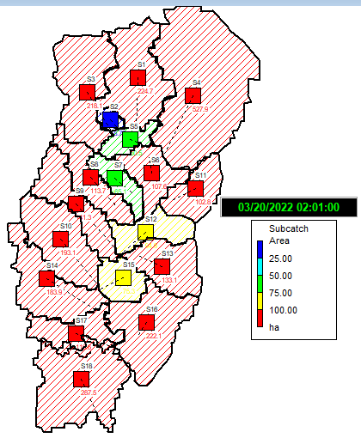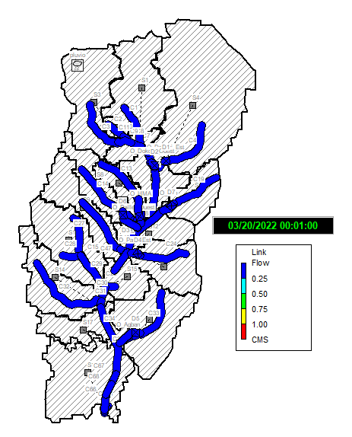
Figure 4: Modeled sub-watersheds Figure 5: Modeled drainage channels
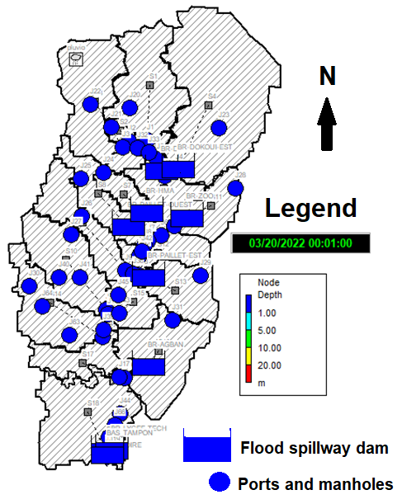
Figure 6: Modeled junction nodes
3.1.4. Hyetographs
The graphs in Figure 7 present the double triangle hyetographs obtained after the simulation of the design storm. They all have a symmetrical double triangle shape for a rainfall event of less than 2 hours duration with an intense period of 30 minutes. These graphs correspond to return periods of 1, 2, 3, 5, 10, 20, 30, 50, and 100 years. During the intense rainfall period, the intensity gradually increases to a maximum value before decreasing to zero. At the beginning of the rainfall, a lag time is observed for all storms. The maximum value of 369.19 mm/h is obtained for the intensity corresponding to the 100-year return period. For the 10-year return period, the maximum intensity is 330.3 mm/h, while it has a value of 263.08 mm/h for the one-year return period.
Figure 7: Double-triangle hydrographs for T = 1, 2, 3, 5, 10, 20, 30, 50, 100 years
3.1.5. Simulation of Flow at the Watershed Outlet
Figure 8 compares the simulated hydrograph with default parameters and the observed hydrograph at the watershed outlet. Analysis of the two hydrographs shows that they are offset and do not have the same shape. The observed flow has a maximum value of 2,260.80 m³/s, while the maximum simulated flow is 1,575.76 m³/s. This high observed flow is due to the discharge of wastewater into the channels.
3.1.6. Calibration and Validation of the SWMM Model
Figure 9 compares the simulated hydrograph (Qs) with a 1-year return period and the observed hydrograph (Qo) at the Monument des Martyrs station at the watershed outlet (watershed S18). Analysis of this figure indicates that both hydrographs have similar shapes for observed and simulated flows. Thus, after the initial simulation, a second simulation produced two nearly identical hydrographs. It is noted that the maximum value of the simulated flow reached 2,260.80 m³/s, corresponding to that of the observed flow. The Nash validation criterion obtained is 92.52%, and the Pearson coefficient is estimated at 0.56. These coefficients indicate a good correlation between observed and simulated flows.
3.1.7. Flow Forecasting
Figure 10 shows the hydrographs according to the return period. Analysis of the hydrographs shows they all have the same shape. Each curve presents a peak after 1 hour of model simulation corresponding to the peak flow at the outlet. The highest peak is for T=100 years with a value of 2,463.13 m³/s compared to a lower peak of 1,575.75 m³/s at T=1 year (Table 3).

Figure 8: Hydrographs of observed and simulated flows for a return period T= 1 year

Figure 9: Observed and simulated hydrographs after SWMM calibration

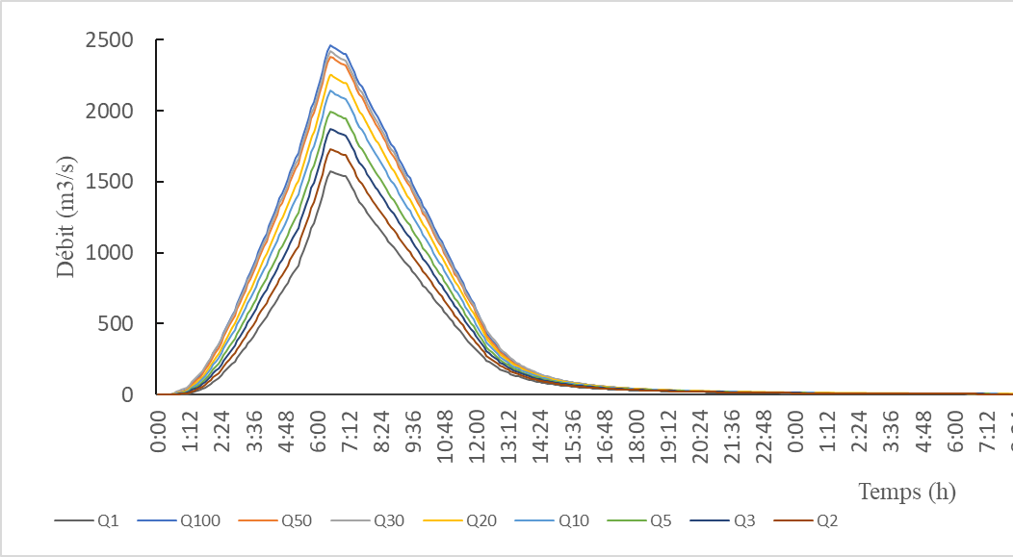
Figure 10 : Projection of flows based on the return period
Table 3: Prediction of peak flows at the watershed outlet
Return period  (an) | T= 1 | T= 2 | T= 3 | T= 5 | T= 10 | T= 20 | T= 30 | T= 50 | T= 100
Flow Q (m³/s) | 1575,75 | 1730,87 | 1874,68 | 1996,84 | 2140,28 | 2251,45 | 2418,20 | 2382,33 | 2463,13
3.1.8. Flow Velocities
Figure 11 shows the result of modeling stormwater velocities in the channels by return period. Analysis of the results shows that velocities are grouped into 5 classes according to colors for all return periods. Thus, for return periods of 1 year and 2 years, the critical velocity threshold (3 m/s) is exceeded in channels C5, C7, C8, C30, C34, C35, and C47 (in yellow and red). For other return periods, this threshold is exceeded in channels C5, C7, C8, C11, C12, C18, C20, C30, C31, C34, C35, C42, C46, C47, C67, C68, and C69 (green, yellow, and red). A maximum velocity of around 10 m/s is recorded.

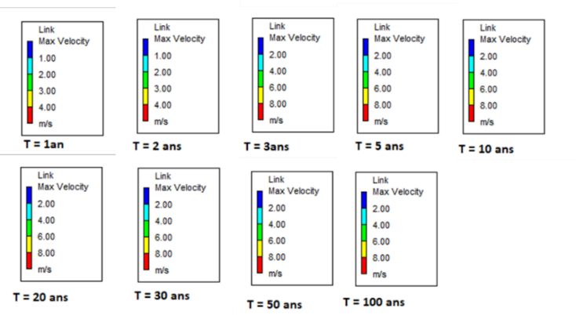
Figure 11: Flow velocities simulated for different return periods
3.1.9. Infiltration in the Watershed
Figure 12 shows the infiltration profiles in the eighteen (18) sub-watersheds according to return period. Analysis of the curves shows that the maximum infiltration of 20.60 mm/h was recorded in sub-basin S7 (upstream). The minimum value of 6.23 mm/h is obtained in watershed S18 (downstream), towards the watershed outlet.
All curves have the same shape for all return periods and for all eighteen (18) sub-watersheds. These results indicate that stormwater infiltration decreases from upstream to downstream in the watershed.

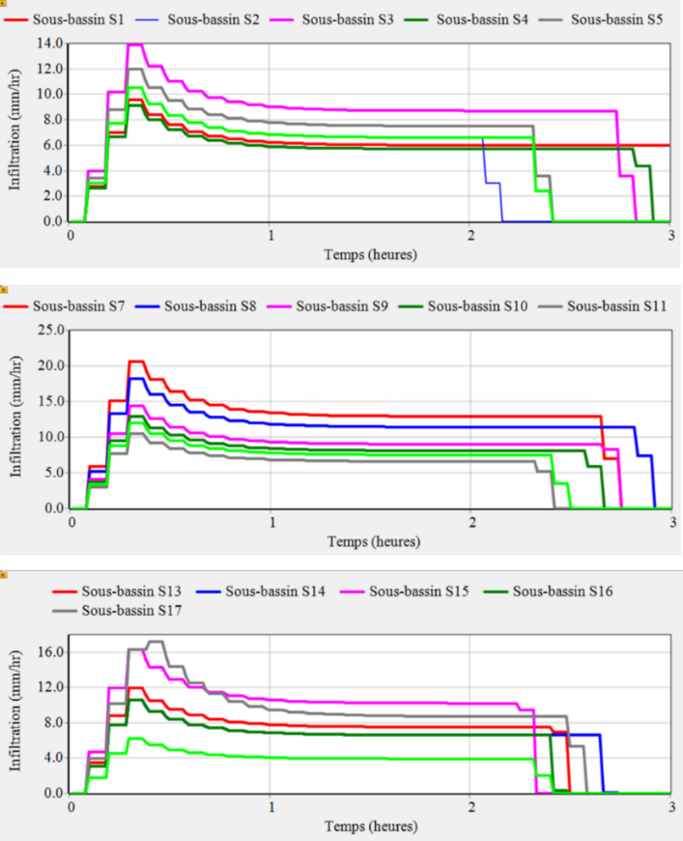
Figure 12: Variations in infiltration in the sub-basins of the Gourou watershed
3.1.10. Channel and Node Capacity
Figures 13 and 14 show the simulation results of channel capacity for a rainfall event lasting less than 2 hours with return periods of 1, 2, 3, 5, 10, 20, 30, 50, and 100 years. Analysis of Figure 14 shows that the channels can be grouped into five (5) classes. Channels receiving rainwater at less than 25% of their capacity (in blue). Channels receiving rainwater between 25% and 50% of their capacity (in light blue). Channels receiving rainwater between 50% and 75% of their capacity (in green). Channels receiving rainwater between 75% and 100% of their capacity (in yellow). Finally, channels receiving rainwater at more than 100% of their capacity (in red). In this last class, the overloaded channels (red) are sections of the main Gourou canal leading to the Indenié Intersection. These are channels C5, C8, C12, C16, C17, and C46, whose overflows are illustrated in Figure 15. Some of the seven (7) flood control dams also receive rainwater at a capacity greater than or equal to 100%. As for the manholes and spillways, they are mostly utilized at less than 25% of their capacity. The overflow of water beyond the riverbed sometimes leads to the disruption of road traffic, soil erosion, or the destruction of water drainage structures.

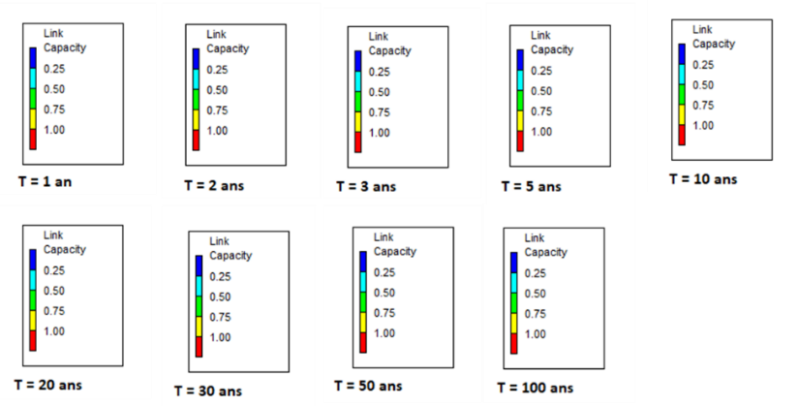
Figure 13: Capacity of drainage structures in the Gourou basin for different return periods
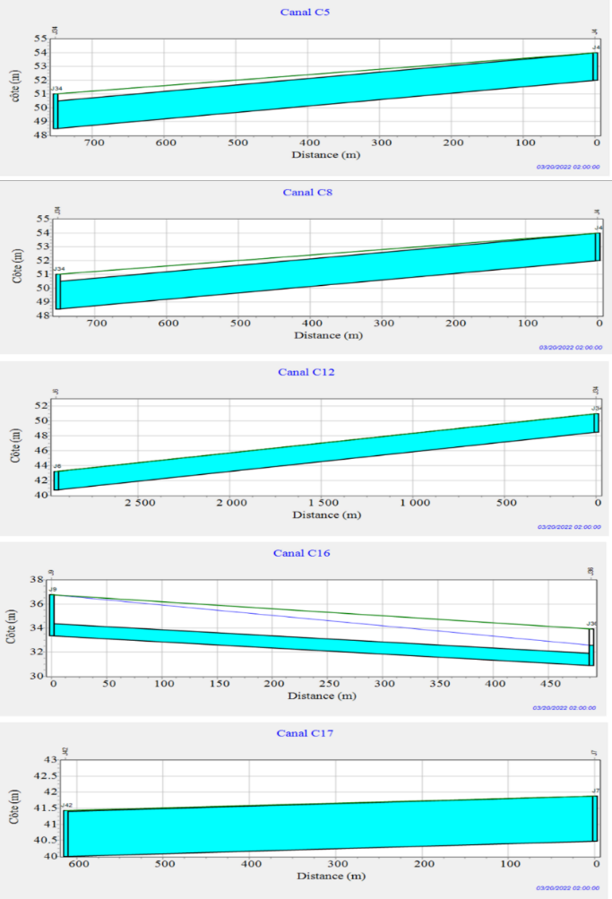
Figure 14: Simulation of the variation in water level in the channels
3.1.11. Storage Volume of Flood Control Dams
Figure 15 shows the simulation results of the different nodes (manholes, dams, and spillways) in charge of the watershed for a rainfall event lasting 2 hours with return periods of 1, 2, 3, 5, 10, 20, 30, 50, and 100 years. The overloaded nodes (in green) after the model simulation primarily consist of the 7 flood control dams (Dokoui West, Dokoui East, Paillet East, Paillet West, Agban, Zoo, HMA) as well as the buffer basin (in light blue) at the Indenié intersection. It is noted that these structures receive both runoff water and wastewater.
Figure 16 shows the storage volume profiles of the seven (7) flood control dams in the Gourou watershed for a rainfall event lasting less than 2 hours with return periods of 1, 2, 3, 5, 10, 20, 30, 50, and 100 years. Analysis of this figure shows that the Dokoui East dam stores the most water with a maximum volume of 6,612.74 m³. The Paillet West dam stores the least with a maximum water volume of 1,850.10 m³. It is also noted that all retention basins store less water, with 882.25 m³ for the buffer basin (at the outlet), 98.89 m³ for the Technical High School basin, and 1,074.28 m³ for the Fraternité Matin basin. The flood recession for all dams is not spontaneous when analyzing the different volume profiles. Indeed, the basins of the flood control dams are often covered with vegetation and filled with solid waste that contributes to clogging the bottom openings, disrupting the passage of water downstream of the dam. This phenomenon is especially pronounced at the Dokoui East and Agban flood control dams.

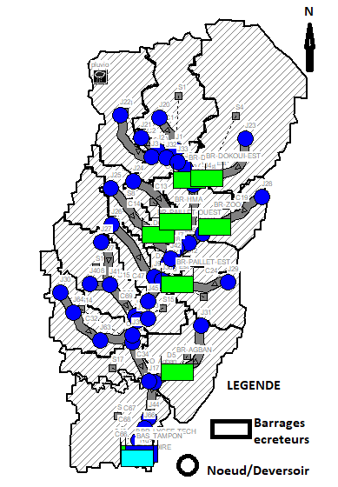
Figure 15: simulation of the nodes in charge in the Gourou basin for a 2-hour rainfall event for different return periods.

Figure 16: simulation of Storage volume profiles of dams in the Gourou basin for a 2-hour rainfal

3.2. DISCUSSION
3.2.1. Discretization of Sub-watersheds
The Digital Elevation Model (DEM) allowed for the delineation of eighteen (18) sub-basins in the Gourou watershed. It should be noted that this number of sub-watersheds obtained is not exhaustive because it depends on the topography of the area and the minimum surface area chosen for the discretization process. Indeed, the extraction of the hydrographic network is generated by the choice of accumulation thresholds, and the lower this threshold, the higher the number of waterways obtained (JAZIRI, 2009). It also offers several advantages in structural mapping (DURAND, 2015). With a maximum altitude of 149 m, the digital elevation model of the watershed shows that the relief is quite rugged with numerous depressions that can sometimes reach dozens of meters. This configuration facilitates the drainage of all runoff water toward the Indenié Intersection, the outlet of the watershed.
3.2.2. Drainage Network
The hydrographic network of the Gourou watershed consists of a main canal flowing into the lagoon and tributaries that are secondary canals, either earthen or concrete. The modeling results yielded forty-nine (49) junction nodes that are either flood control dams, manholes, spillways, or outlets. The seven (7) flood control dams constitute storage units. There are forty-three (43) modeled canals with depths ranging from 0.5 to 4.5 meters. They are rectangular or trapezoidal in shape and open-air. Indeed, these types of canals allow for their cleaning in case of obstruction, and the positive inclination of the canal is an advantage for energy dissipation (KATEB, 2014).

3.2.3. Hyetographs
The simulation results of the double triangle design rainfall produced synthetic hyetographs with a total duration of 2 hours and an intense period of 30 minutes. The statistical simulation of rainfall allowed for obtaining a "symmetrical double triangle" model, characteristic of short-duration rainfall often encountered in humid tropical zones. The symmetrical double triangle design rainfall model finds its interest in the fact that the construction characteristics of the design rainfall are determined from the characteristics of the watershed and the IDF (intensity-duration-frequency) curves of local precipitation (CHOCAT, 1997), unlike other models. These results are similar to the work of DAOUED (2019), who concluded that the shape of the rainfall counts significantly in the network's response because a classic double-triangle rainfall used in the design of drainage structures takes less time to evacuate, which allows for the protection of people and property against this risk of flooding in urban areas.
3.2.4. Flow Prediction
Regarding peak flows, the different peaks reached indicate that drainage structures reach their respective maximum capacities for stormwater evacuation. For a 1-year return period, the flow is 1,575.75 m³/s, and for a 100-year return period, it equals 2,463.13 m³/s. For a rainfall with a 10-year return period, the corresponding peak flow equals 2,140.28 m³/s. This flow is significant, and one should consider increasing the dimensions of the Gourou canal. Water overflows occur when the limit capacity of canals is exceeded. The different flood and ebb periods are short, and the peak flow is reached after approximately 1 hour of model simulation. The SWMM model simulation takes into account all storage effects, thus allowing for assessment of canal overflow risks. This is therefore a notable advantage of the SWMM model (TAMARA and YAHIA, 2009).
3.2.4. Flow Velocities
The results of the model simulation showed that flow velocities vary from 0.01 m/s to 10 m/s in the sections. It is noted that sections C8, C11, C12, C18, C20, C47, C31, C34, C67, C68, C42, C65, C49, C50, and C51, whose velocities exceed 2 m/s, are located on the main Gourou canal. Indeed, this canal receives rainwater from other branches or tributaries that put it in overload. Analysis of the velocity profiles indicates that the maximum velocity of 10 m/s is reached in section C35. For the proper functioning of sanitation structures, velocities must respect certain conditions insofar as the flows and flow velocities contribute to the self-cleaning of collectors since the topography of the terrain does not often allow for this (Riochet, 2013). Moreover, the acceptable velocities within the framework of the master plan for sanitation and drainage of the city of Abidjan are 3 m/s for the maximum velocity and 0.60 m/s for the minimum velocity (DAUD, 2016). This limit velocity of 3 m/s is lower than that obtained in the present study (10 m/s), which does not allow for self-cleaning of the structures. Indeed, high flow velocities create silting of canals and thus cause rainwater overflows. Similarly, these velocities also lead to soil and structure erosion by solid materials carried by wastewater, such as sand and gravel. It should be noted that the soil of the Gourou watershed is derived from sedimentary formations of the ferrallitic type, presenting a clay-sandy texture very favorable to erosion (KABLAN, 2016).

3.2.5. Infiltration
Analysis of the different infiltration profiles according to the Horton model in the Gourou watershed shows that all curves have the same patterns. Infiltration is maximal upstream in sub-basin S7 (20.60 mm/h) and decreases progressively downstream with a minimum of 6.23 mm/h in sub-watershed S18 at the outlet of the watershed. The soil of the Gourou watershed is therefore more permeable upstream than downstream. A fairly permeable soil will induce strong infiltration and, consequently, a significant recharge of the water table (HOUNKPE et al., 2020). In reality, the Gourou watershed is more urbanized and has less vegetation cover downstream than upstream. Soil impermeabilization due to developments (buildings, roads, parking lots...) limits the infiltration of precipitation into the soil and accentuates runoff (TARIQ, 2021). This infiltration is therefore lower, or even non-existent, downstream of the watershed in the direction of the Indenié Intersection. These results are also similar to those of SORO et al. (2016), who observed the decrease in soil water infiltration capacities, especially in urban and peri-urban basins such as the Gourou watershed.
3.2.6. SWMM Model Performance
The performance of a stormwater network is measured using numerous indicators such as the number of critical nodes, maximum flow, flooding, runoff, etc. (BRIERE, 2012). There are also validation criteria such as Nash and Pearson used for SWMM validation in this study. Thus, the Nash criterion gave a value of 92.52% while the Pearson correlation coefficient equals 0.56, which shows that the SWMM model is effective for simulating peak flows at the watershed outlet. However, it should be noted that there are errors related to the measurement method. Inadequacies in measuring instruments superimpose a higher degree of variability on the inherent factor (PLANCHON, 2005). Similarly, the choice and arrangement of reservoirs and functions involved in the model's production and routing modules also play an essential role in model performance (PERRIN, 2007). As for the validation of urban flood models against field data, it remains limited due to the small amount of validation data available on this Gourou watershed. The use of real rainfall in this work leads to better model simulations (LE LAY, 2006). Thus, uncertainties inherent in modeling real cases show that it is difficult to evaluate the true benefits of using more detailed models (BAZIN et al., 2014). Ultimately, hydraulic performance determines the network's capacity to evacuate stormwater (MAILHOT et al., 2008).
3.2.7. Capacity of Structures
The results of the flow simulation showed that canals C5, C8, C12, C17, and C46 are insufficient and do not allow for the evacuation of all stormwater passing through them, with their capacities being utilized at more than 100%. Indeed, the dimensions (height and width) selected for these structures seem to be small, which appears to be the source of recurring overflows in these canals. To address this inadequacy, the technical characteristics of these structures should be reviewed. One of the major causes of flooding remains the problem of cleaning collectors and gutters in African agglomerations (HOUNTONDJI et al., 2004). The sub-watersheds causing overflows at Indenié are those directly connected to the main Gourou canal and unregulated branches. They correspond to areas of dense habitat or major road infrastructure where runoff is predominant. The same applies to the work of ITOUMBA (2016), during which the author confirms that rainwater runoff is the cause of overflows observed in both combined and separate sewerage systems. The flooding observed in recent years would therefore be partly linked to a problem of maintenance (cleaning of structures) and solid waste management in the buffer basin. As for nodes, they represent storage units in the model (manholes, basins, flood control dams, spillways). The results showed that all flood control dams receive water at more than 100% of their required capacities. It is therefore essential to anticipate and take into account the functional evacuation capacity of a hydraulic structure (TACNET et al., 2011). To achieve this, their structure must resist stress constraints. Risk assessment is essential to, on one hand, guarantee the safety of property and people and, on the other hand, decide on the necessity and relevance of resource allocations for their management. (CARLADOUS et al., 2014).

4.CONCLUSION
Modeling the flows of the watershed required knowledge of the digital terrain model of the study area as well as that of the hydrographic network. The maximum elevation obtained is 139 m with an average watershed slope of 7.67%. The drainage network consists of primary, secondary, or tertiary canals, either concrete or earthen, with the main canal flowing into the Indenié intersection. The symmetrical double triangle rainfall with a duration of 2 hours and an intense period of 30 minutes served as input data during the flow simulation. Flow observations from 2018 at the Monument des Martyrs station at the outlet were used to validate the SWMM model. Calibration was done by reintegrating into the SWMM model the parameters of sub-watersheds from an initial simulation. Flow predictions give a peak flow of 2,463.13 m³/s for T=100 years compared to a peak flow of 1,575.75 m³/s for T=1 year. The estimation of the Nash criterion gave a value of 92.52%, and the Pearson correlation coefficient equals 0.56. These results confirm that there is a good correlation between observed flows and simulated flows. The numerous overflows in the watershed observed during the simulation showed that the buffer basin at the Indenié Intersection does not overflow for recurrences of 1, 2, 3, 5, 10, 20, 30, 50, and 100 years, contrary to the overflows observed in recent years. In reality, these overflows are generally caused by the dysfunction of drainage structures (obstruction, silting, ruptures, wastewater connections). The results showed that only the Dokoui East and Agban flood control dams overflow for the identified return periods. For some time, fewer water overflows have been recorded at the Indenié Intersection since the construction of new flood control dams. Moreover, a solution should be found for the issue of wastewater management in the watershed, which records approximately 27.72 m³ per day. Efficient use of the results obtained in this study could constitute a decision-making tool within the framework of the development of the Gourou watershed.

Disclaimer (Artificial intelligence)
Option 1:
Author(s) hereby declare that NO generative AI technologies such as Large Language Models (ChatGPT, COPILOT, etc.) and text-to-image generators have been used during the writing or editing of this manuscript.
Option 2:
Author(s) hereby declare that generative AI technologies such as Large Language Models, etc. have been used during the writing or editing of manuscripts. This explanation will include the name, version, model, and source of the generative AI technology and as well as all input prompts provided to the generative AI technology
Details of the AI usage are given below:
1.All the pictures and tables are not generated by IA.
2. for traduction we use sometimes Reverso
3.

References

- African Development Bank (AfDB). (2010). Evaluation Report, Gourou Integrated Watershed Management Project - Emergency Phase, Côte d'Ivoire. 27 p.https://www.afdb.org/fr/projects-and-operations/project-portfolio/cote-divoire-projet-de-gestion-integree-du-bassin-versant-du-gourou-phase-durgence

- Badrzadeh, H., Sarukkalige, R., & Jayawardena, A. W. (2015). Hourly runoff forecasting for flood risk management: Application of various computational intelligence models. Journal of Hydrology, 529, 1633-1643.http://dx.doi.org/10.1016/j.jhydrol.2015.07.057

- Bazin, P. H., Nakagawa, H., Kawaike, K., Paquier, A., & Migno, E. (2014). Modelling flow exchanges between a street and an underground drainage pipe during urban floods. Journalof Hydraulic Engineering, 140(5), 10 p.https://doi.org/10.1061/(ASCE)HY.1943-7900.0000917

- Behrouz M S, Sample D J., Yazdi M N (2023). Robustness of storm water management model parameter sets for dry and wet hydroclimatic conditions. Journal of Cleaner Production Vol 411, 20 July 2023, 137328;https://doi.org/10.1016/j.jclepro.2023.137328

- Berthier, E., & Mohamad, R. (2020). Improvement of urban stormwater runoff production modeling during frequent events. Cerema - French Office for Biodiversity. 62 p.

- Boon S T, Chua L H, Shuy E B, Lo E Y and Lim L W (2008). Performances of rainfall-runoff models calibrated over single and continuous storm flow events. Journal of Hydrologic Engineering, 13(7), 699-1084. https://doi.org/10.1061/(ASCE)1084-0699(2008)13:7(597)

- Brière, F. G. (2012). Water Distribution and Collection (3rd ed.). Presses internationales. https://www.pressespoly.ca/catalogue/distribution-et-collecte-des-eaux-3e-edition

- Chocat, B. (1997). The possible role of urbanization in aggravating flood risk: the example of the Yzeron (Lyon). Géocarrefour, 72(4), 273-280.https://doi.org/10.3406/geoca.1997.4707

- Dahak, A. (2021). Contribution to the hydrological modeling of Algerian watersheds: the case of the Madjez Ressoul watershed (Doctoral dissertation). Badji Mokhtar University – Annaba. 199 p. https://dspace.univ-annaba.dz//handle/123456789/3682

- Daoued, B. A. (2019). Modeling the conjunction of rainfall and sea level and taking into account uncertainties and the impact of climate change: application to the Le Havre site (Doctoral dissertation). University of Technology of Compiègne. 147 p.https://www.theses.fr/2019COMPC209

- Directorate of Urban Sanitation and Drainage (DAUD). (2016). Updating of the sanitation and drainage master plan for the Abidjan district. Ministry of Sanitation and Public Health. 172 p.

- Durand, L. (2015). Physical, conceptual and statistical approaches to the hydrological functioning of a covered karst (Doctoral dissertation). University of Normandy. 315 p.https://www.theses.fr/2015NORMUN0001

- Fuamba, M., & Daynou, M. (2007). Overflow frequency and performance of urban drainage networks. Sustainable techniques and strategies for urban rainwater management. GRAIE, Lyon, 981-988.

- Geller V. G., Tao Y., Lokhandwala A., Vasconcelos J. G., Wright D. B. and Ben R. Hodges B. R. (2025). Evaluating SWMM Modeling Performance for Rapid Flows on Tunnels with Geometric Discontinuities. J. Hydraul. Eng., 2025, 151(1) : 04024052https://doi.org/10.1061/JHEND8.HYENG-14107

- Goula, B., Yao, B., Kouame, K., Kouassi, K., Kouadio, K., & Savane, I. (2015). Estimation of the recharge of a coastal aquifer in a humid tropical zone: the case of the Continental Terminal aquifer of Abidjan (Côte d'Ivoire). International Journal of Innovation and Applied Studies, 12(4), 888-898. https://www.ijias.issr-journals.org/issue.php?volume=12&issue=4&year=2015

- Hountondji, B., Codo, F. P., Dahounto, S. V., & Gbaguidi, T. B. (2004). Flood management in urban areas: The case of the city of Cotonou in Benin. Larhyss Journal, 333-347. https://www.asjp.cerist.dz/en/article/99999

- Hounkpe, J., Boassa, Y. A., Yacouba, Y., Fusillier, J. L., Da, S. A., & Keita, A. (2020). Hydrological and hydraulic functioning of the redeveloped Bankandi low-lying area. Journal of Water and Environment, 205-215.https://doi.org/10.4000/books.irdeditions.36399

- Itoumba, A. (2016). Modeling of a reservoir to optimize rainwater management (doctoral dissertation). University of Lille 1 - Science and Technology. 130 p.http://www.theses.fr/2016LIL10180/document

- Jaziri, B. (2019). Contribution to the delineation of hydrological basins in Tunisia using a Digital Elevation Model. Academia. 28 p.

- Kateb, S. (2014). Theoretical and experimental study of some types of hydraulic jumps in a trapezoidal channel (doctoral dissertation). Mohamed Khider University – Biskra. 182 p. http://thesis.univ-biskra.dz/id/eprint/63

- Kablan, M. (2016). Vulnerability and adaptation of urban populations to the effects of climate variations (temperature and rainfall): analysis of the situation in the municipality of Cocody, Abidjan, Côte d'Ivoire (doctoral dissertation). Félix Houphouët-Boigny University. 242 p.

- Le Lay, M. (2006). Hydrological modeling in a context of hydro-climatic variability: a comparative approach for the study of the hydrological cycle at the mesoscale in Benin (doctoral dissertation). National Polytechnic Institute of Grenoble. 210 p.https://horizon.documentation.ird.fr/exl-doc/pleins_textes/divers11-07/010078589.pdf

- Legates, D. R., & McCabe, G. J. (1999). Evaluating the use of goodness-of-fit measures in hydrologic and hydroclimatic model validation. Water Resources Research, 35(1), 233-241. https://doi.org/10.1029/1998WR900018

- Mailhot, A., Bolduc, S., Talbot, G., & Khedhaouiria, D. (2014). Stormwater management and climate change. National Institute for Scientific Research – Water, Earth and Environment Centre. 412 p.https://espace.inrs.ca/id/eprint/2902/1/R1418.pdf

- National Security Council (CNS). (2022). Press release on flooding in Abidjan. https://www.gouv.ci/doc/1645787070Communique-du-Conseil-National-de-Securite-8-juillet-2022.pdf

- Perrin, C., Claude, M., & Vazken, A. (2007). Hydrological models in Agricultural Engineering. Cemagref, 1-16. https://webgr.inrae.fr/outils/modeles-hydrologiques
- Planchon, V. (2005). Outlier treatment: current concepts and general trends. Biotechnology, Agronomy, Society and Environment, 9(1), 19-34. https://popups.uliege.be/1780-4507/index.php?id=1000&lang=en

- Saha A., Stelling G. a,c , Vuik C. (2025). Modified Horton’s infiltration model integrated with a Sub-Grid shallow water equation solver for High-Resolution flooding simulation. Journal of Hydrology, 660, 133326,https://doi.org/10.1016/j.jhydrol.2025.133326

- Soro, G. E, Kouakou K S and Goula BI T A. (2016). Land use dynamics in the Lakes region (Central Côte d'Ivoire). Africa Science, 12(4), 292-305.https://www.afriquescience.info/article/determination-des-zones-a-risque-dinondation-sur-le-bassin-versant-du-gourou-abidjan-cote-divoire

- Riochet, B. (2013). Networked sediments: a perspective from operators – The example of Nantes. Water and Environment Days 2013, 41-42. http://actions-incitatives.ifsttar.fr/seminaires/jee/2013/

- Roesner, A., Davis, J., & Gironas, J. (2009). Storm Water Management Model: Applications Manual. US EPA. 180 p.https://nepis.epa.gov/Exe/ZyPDF.cgi?Dockey=P100412D.PDF

- Rossman, L. A. (2009). A new applications manual for the Storm Water Management Model. Academia, 1-4.https://nepis.epa.gov/Exe/ZyPDF.cgi?Dockey=P100412D.PDF

- Tacnet, J. M. (2011). Effectiveness of torrent control structures: indicators based on operational reliability. Annals of Building and Public Works, 4(5), 78-86.https://hal.science/hal-02596387/document

- Tamara, B., & Yahia, H. (2009). Estimation of the hydrological response of an urbanized watershed. European Journal of Scientific Research, 29(3), 334-348.http://www.eurojournals.com/ejsr.htm

- Tariq, C. (2021). Hydrodynamic modeling of flows during urban floods: interaction between surface runoff and flow in the drainage network (Doctoral dissertation). University of Lyon. 232 p.http://repository.enp.edu.dz/xmlui/handle/123456789/10072

- Telliez, M. (2010). Initiation manual. Underground Weather. http://www.wunderground.com

- Vaes, G., Luykx, G., & Berlamont, J. (1999). Experimental investigation on the efficiency of a high side weir overflow. Journal of Hydraulic Research, 32(2), 61-68.https://doi.org/10.1016/S0273-1223(99)00008-6

