Climate Variability and Its Influence on Vegetation Dynamics in Tanzania

Abstract
Understanding how climate variability drives tropical vegetation is critical for sustainable land management and climate-change adaptation. This study aimed to characterize the spatiotemporal distribution and trends of vegetation using the Enhanced Vegetation Index (EVI), Land Surface Temperature (LST), CHIRPS rainfall, and MODIS-derived Evapotranspiration (ET) in Tanzania from 2000 to 2024, and quantify the relative influence of climatic drivers on observed vegetation dynamics. Datasets were accessed via Google Earth Engine and processed with Savitzky–Golay noise filtering and spatial harmonization to generate annual and seasonal time series. Long-term trends were assessed using Sen’s slope estimator and Mann–Kendall significance tests, while vegetation cover was quantified through Fractional Vegetation Cover (FVC). Results showed heterogeneous rainfall increase during DJFMA (December to April) and MAM (March to May), 9.6 mm/year and 5.2 mm/year respectively. EVI and FVC revealed mixed vegetation trajectories: central, southeastern, and western regions experienced degradation, whereas southwestern and northeastern highlands and parts of the northern coast showed greening. Correlation and lag analyses indicate LST exerts the strongest immediate suppressive effect (ρ = -0.78, p < 0.05), while rainfall and ET influence both instantaneous growth and multi-year recovery (rainfall: ρ = 0.64 at year 0, ρ = 0.54 at year 5; ET: ρ = 0.72 at year 0, ρ = 0.56 at year 5). These findings demonstrate that vegetation dynamics in Tanzania are governed by a dual climatic control system: the acute, immediate sensitivity of vegetation to surface thermal conditions and a protracted, multi-year recovery potential driven by antecedent rainfall. The study underscores the necessity of integrated management frameworks that combine immediate heat-mitigation strategies to counter LST-induced suppression with multi-year water-governance policies that leverage the five-year ecological memory of rainfall and ET. Such evidence-based interventions are critical for stabilizing vegetation trajectories and enhancing ecosystem resilience across Tanzania’s climate-vulnerable landscapes.
Keywords: Vegetation dynamics, Enhanced Vegetation Index, Land Surface Temperature, Rainfall variability, Tanzania

1 Introduction
Vegetation is crucial for terrestrial environments by acting as the planet's primary carbon sink and oxygen source, while also regulating regional climate through evapotranspiration and moisture control (Chaturvedi et al., 2025; Houghton, 2007; Miralles et al., 2025). It critically manages the water cycle by promoting infiltration and stabilizing soil against erosion, enriching it with vital organic matter for all life (Wang et al., 2018; Wiesmeier et al., 2019). This essential role is magnified by the sheer scale of plant life, terrestrial plants collectively comprise more than 90% of global biomass, and the world's forests alone uptake around one-third of human-induced carbon emissions, highlighting their indispensable influence on the entire planetary system (Forzieri et al., 2022).
Tropical climates, situated near the Equator, are characterized by consistently high temperatures and abundant rainfall, leading to the world's most biologically diverse and carbon-rich ecosystems. These regions are globally critical because their immense vegetation cover plays an outsize role in regulating the planetary climate and hydrological cycles (Friedlingstein et al., 2023). Tanzania particularly contains vast stores of Miombo woodlands and rainforests that serve as immense reservoirs of carbon and biodiversity essential for planetary climate regulation (Mwakalukwa et al., 2024). Thus, understanding the spatio-temporal patterns and drivers of vegetation cover dynamics in Tanzania is essential, as monitoring how and why vegetation changes across space and time provides the critical data needed to inform effective conservation, sustainable land-use planning, and targeted climate change mitigation strategies (Horion et al., 2013).
Variability in rainfall and temperature profoundly impacts global vegetation dynamics by controlling plant physiological processes and geographic distribution (O’Sullivan et al., 2020). Changing precipitation patterns dictate soil moisture and productivity in water-limited regions, while temperature dictates growth rates, the length of the growing season, and overall biome boundaries. Despite the recognized pressure on Tanzania's tropical vegetation, several critical knowledge gaps remain in the scientific understanding necessary for effective planning, particularly concerning the climatic influence. Existing regional studies have monitored localized degradation (Kambi et al., 2025; Kashaigili et al., 2010), but a comprehensive national-level, high-resolution assessment of the long-term spatio-temporal trends and synchronicity among Enhanced Vegetation Index (EVI), Land Surface Temperature (LST), and rainfall is currently lacking across the entire country and there is a significant gap in the quantified statistical assessment of the relationship between EVI and the primary climate parameters.
To address these gaps, this study sets forth the following objectives, i. Identifying the spatiotemporal distribution and trends in annual and seasonal EVI, rainfall, and LST using relevant remote sensed data products. ii. Comparing the spatiotemporal pattern of vegetation change across the country and quantifying the relative influence of climate change on the observed vegetation dynamics.

Data and Methodology

Characteristics of the Study Area
Tanzania is located in East Africa between latitudes 1°S and 12°S, longitudes between 29°E and 41°E, covering approximately 945,100 km² (Kabanda, 2024). The country exhibits highly diverse physical, climatic, and ecological conditions, making it an ideal setting for assessing long-term vegetation dynamics and their relationship with climate and hydrological variability. Tanzania’s elevation ranges from coastal lowlands along the Indian Ocean to high mountains and volcanic highlands, including Mount Kilimanjaro (Figure 1). This topographic diversity strongly influences spatial patterns of temperature, rainfall, and vegetation productivity. Tanzania experiences a tropical climate with marked regional variations. The northern and eastern regions are predominantly bimodal rainfall zones, receiving rainfall during the “Masika” (March-May) and the “Vuli” (October-December). In contrast, the central, western, and southern parts experience a unimodal rainfall pattern, mostly concentrated between December and April (Borhara et al., 2020). Temperature variation also reflects the country’s elevation gradients, with higher LST observed in lowland and semi-arid zones. Tanzania's vegetation is diverse, largely consisting of miombo woodlands in the western and southern parts of the country. The landscape also features a variety of other vegetation types, including savanna woodlands, coastal mangrove swamps, tropical rainforests high-altitude forests on mountain ranges like Kilimanjaro. Other vegetation types include grasslands, shrublands, and semi-desert areas.
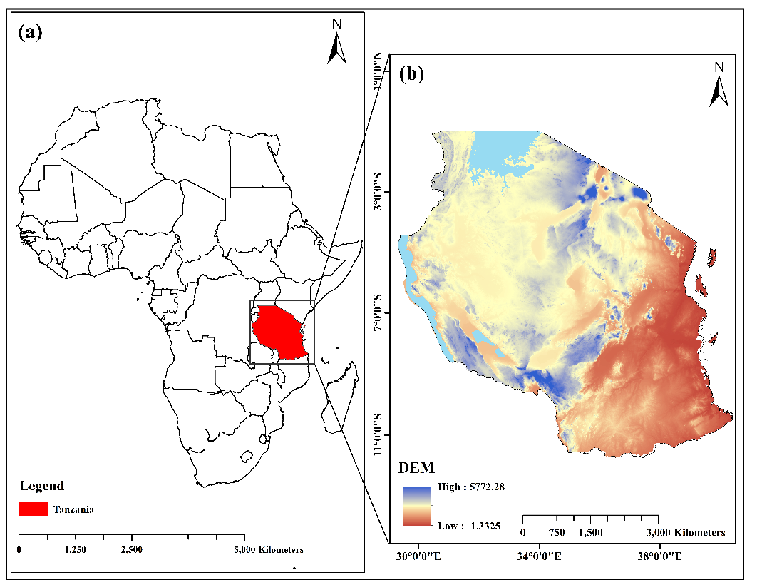
Figure 1 Geographic context of Tanzania: (a) Continental-scale map showing the location of Tanzania in Africa, and (b) detailed topography of Tanzania derived from the digital elevation model (DEM).

2.2 Datasets
Several high-resolution remote sense datasets have been utilized in the study covering a period from 2000 to 2024, Table 1 shows the description of each dataset.
Table 1 Details of data sources used in this study.
Dataset | Product ID | Band | Period | Resolution
Vegetation | MODIS/061/MOD13Q1 | Enhanced Vegetation Index | 2000-2024 | 250m
Rainfall | Ucsb-Chg/Chirps/Daily | Precipitation | 2000-2024 | 0.05⁰
Land surface temperature | MODIS/061/MOD11A1 (Terra and Aqua) | LST_Day_1 km | 2000-2024 | 1⁰ x 1⁰
Evapotranspiration | MODIS/061/MOD16A2GF | Total evapotranspiration | 2000-2024 | 0.005⁰
DEM | USGS/SRTMGL1_003 | elevation | 2000 | 30m

2.3 Data Pre-processing and Temporal Aggregation
All data processing, filtering, and pre-aggregation were conducted using the Google Earth Engine (GEE) cloud-computing platform. This process began with rigorous quality control (QC) and scaling. Specifically, the 16-day composite Enhanced Vegetation Index (EVI) values were scaled by dividing by 10,000, and high-confidence observations were retained by masking out pixels flagged as poor or marginal quality using the Summary band. The 8-day Land Surface Temperature (LST) values were scaled by 0.02 and converted from Kelvin to degrees Celsius by subtracting 273.15. The Rainfall and evapotranspiration (ET) products, which are already in physical units, were processed by explicitly casting all input images to a 32-bit floating point format to ensure numerical stability.
To generate a continuous and reliable time series, the filtered EVI and LST data underwent noise reduction and gap-filling using the Savitzky-Golay (S-G) filtering technique (Savitzky et al., 1964). This non-linear digital filter fits a low-degree polynomial to the time series data within a moving window, effectively smoothing the data and replacing masked or invalid values with a temporally consistent estimate. Following smoothing, all variables were spatially harmonized to enable pixel-wise comparison. The target resolution was set to 250m, matching the native resolution of the MODIS EVI data, which represents the highest resolution available in the MODIS suite used. Bicubic Interpolation was employed as the resampling method for all variables (LST, EVI, Rain, ET and DEM), as it uses a weighted average of the 4 by 4 nearest pixels, providing smoother transitions and better preservation of local feature details than simpler interpolation methods. Finally, all datasets were projected to a consistent geographical coordinate system.
The final step in pre-processing involved temporal aggregation. The high-frequency data were first aggregated to a monthly temporal scale, using summation for flow variables (Rain and ET) to capture total monthly values, and the mean for state variables (EVI and LST) to capture average monthly conditions. These monthly composites were then aggregated into four continuous time series (N=25) for the entire study period, the Annual Mean (ANNUAL), the Masika Season (MAM) (March, April, May), the Vuli Season (OND) (October, November, December), and the DJFMA Season (DJFMA) (December to April). For the DJFMA period, which spans two calendar years, the aggregated value was consistently assigned to the time step of the year in which the period predominantly fell.

2.4 Spatial-Temporal Trend Analysis and Trend Categorization
Annual and seasonal pixel-wise long-term spatio-temporal trends were performed by employing non-parametric Sen’s slope estimator and quantifying the corresponding statistical significance level test at 95% confidence using the Mann-Kendall test. These methods were used in the study because the Sen’s slope estimator is resistant to the influence of outliers and missing values and the Mann-Kendall test does not require the data to follow any distribution and also not influenced by missing or extreme values.
The Mann-Kendall test statistic S is defined as:
$S=\sum_{i=1}^{n-1}{\sum_{j=i+1}^{n}{sgn(x_{j}-x_{i}}})$ 1
Where the sign function is defined as:
$sgn\left(x_{j}-x_{i}\right)=\left\{\begin{aligned}+1 x_{j}-x_{i}>0 \\ 0 x_{j}-x_{i}=0 \\ -1 x_{j}-x_{i}<0\end{aligned}\right.$ 2
The standardized test statistic Z is calculated as:
$Z=\left\{\begin{aligned}\frac{S}{\sqrt{Var(S)}} (S>0) \\ 0 (S=0) \\ \frac{S+1}{\sqrt{Var(S)}} (S<0)\end{aligned}\right.$ 3
With the variance of S calculated as:

$Var\left(S\right)=\frac{1}{18}\left[n\left(n-1\right)\left(2n+5\right)-\sum_{k=1}^{t}{m_{k}(m_{k}-1)(2m_{k}+5)}\right]$ 4
Where n is the number of observations in the time series, t is the number of tied groups and m_{k} indicates the number of observations in the k^{th} group.
The Mann-Kendall test is limited by its inability to handle serial correlation (autocorrelation), which is prevalent in climate variables Yue & Wang, 2004). When the autocorrelation is present, the test may erroneously identify a trend where none exists and vice versa (Yue et al., 2002). Therefore, a modified Mann-Kendall test approach which utilizes trend-free pre-whitening and variance correction adopted from different studies (Kagabo et al., 2024; Niyigena et al., 2025) was used in this study. This Mann-Kendall test modifies the variance Var(S) which is now calculated as shown in equation 5.
${Var}^{*}\left(S\right)=Var\left(S\right)\frac{n}{n_{k}^{*}}$ 5
The term $\frac{n}{n_{k}^{*}}$ is correction due to the autocorrection in the data which is calculated as shown in equation 6.
$\frac{n}{n_{k}^{*}}=1+\frac{2}{n(n-1)(n-2)}×\sum_{i=1}^{n-1}{(n-i)(n-i-1)(n-i-2)ρ_{k}}$ 6
where ρ_{k} is the autocorrelation function of the ranks of the observations.
A two-tailed significance test was used to assess the reliability of the observed trends, where a Z-value exceeding ±1.96 indicated a statistically significant trend at the 95% confidence level (α = 0.05). This threshold follows the criteria established by (Yuan et al., 2013)(Yuan et al., 2013). To better interpret the spatial and temporal dynamics of vegetation, each pixel in the study area was classified into one of five trend categories based on the magnitude of the Theil-Sen slope (β) and the statistical significance of the Mann-Kendall Z-statistic (|Z|). This dual-criteria approach ensures that both the direction and reliability of the trend are considered. The classification scheme used in this study is summarized in Table 2.
Table 2 Mann-kendall test trend categories.
β | Z | Trend class | Trend features
β ≥ 0.0005 | |Z| ≥ 1.96 | 5 | Significant improvement
β ≥ 0.0005 | |Z| < 1.96 | 4 | Slight improvement
|β| < 0.0005 | |Z| < 1.96 | 3 | Stable and unchanged
β < - 0.0005 | |Z| < 1.96 | 2 | Slight degradation
β < - 0.0005 | |Z| ≥ 1.96 | 1 | Severe degradation

2.5 Fractional Vegetation Cover (FVC) Estimation
Fractional Vegetation Cover (FVC) quantifies the proportion of a land surface that is covered by green vegetation and is widely recognized as an essential variable for land surface characterization and ecosystem monitoring. In this study, FVC was estimated using the Image Element Dichotomous Model (He et al., 2023; Ning et al., 2023), which assumes that the spectral reflectance of a mixed pixel is a linear combination of contributions from two endmembers i.e., bare soil and full vegetation. To apply the model, the EVI data was used. To avoid subjectivity associated with using predefined fixed values for EVI_{soil} and EVI_{veg}, the EVI values with 95% and 0.5% percentiles of the aggregate distribution from the entire EVI time series datasets were assigned to EVI_{max} and EVI_{min}, corresponding to EVI_{veg} and EVI_{soil}. FVC for each pixel was then calculated using Equation 7;
$FVC=\frac{EVI-{EVI}_{soil}}{{EVI}_{veg}-{EVI}_{soil}}$ 7

2.6 Spatio-Temporal Correlation Analysis
To quantify the relationship between vegetation dynamics and the driving climate variables, the Spearman's rank correlation coefficient (Spearman, 1904) was computed using Equation 8. The Spearman method, a non-parametric measure, was selected due to its robustness against non-normally distributed data and its ability to measure monotonic relationships without assuming linearity (Liu et al., 2022). The correlation coefficient was calculated between the annual and seasonal EVI time series and the corresponding time series for rainfall, LST and ET.
$ρ=1-\frac{6\sum{d_{i}^{2}}}{n(n^{2}-1)}$ 8
where d_{i} is the difference between the two ranks of each observation and n is the number of observations.

Results

3.1 Rainfall Distribution and Trends
The rainfall distribution across the study region for the period 2000 to 2024 exhibited marked spatial heterogeneity, with an overall mean annual precipitation of 1024.4 mm. Spatially, the highest annual totals were concentrated at the coastal regions and high-altitude areas of the southwest, while central and mid-western inland regions consistently recorded the lowest amounts (Figure 2a). Inter-annual variability was substantial (Figure 2i), fluctuating from a minimum of 708.7 mm in the exceptionally dry year of 2005, to a maximum of 1305.7mm observed in 2022. Seasonally, precipitation is strongly dominated by the DJFMA period, receiving a mean amount of 804.1 mm of rainfall during the study period. The MAM season and the OND season observed a mean amount of 398.1 mm and 299 mm of rainfall, respectively during the study period (Figure 2b-d). Analysis of the linear trends revealed an overall statistically significant increasing trend in rainfall of almost 14.1 mm/year. This significant annual increase was spatially concentrated over the coasts, extending towards the south-western parts of the country and regions around Lake Victoria (Figure 2e), with a largely similar pattern observed during the DJFMA season, with a trend increase of 9.6 mm/year (Figure 2h). The Masika (MAM) season showed a distinct significant increase in precipitation of 5.2 mm/year on average which was more pronounced over the southwestern highlands extending to the coastal regions (Figure 2f). Conversely, the Vuli (OND) rainfall (Figure 2g) depicted a non-significant decrease across the majority of the country during the study period, with isolated areas around the southwestern parts of Lake Victoria being the only exceptions to register a significant positive trend with an average of 2.6 mm/year over the whole country.
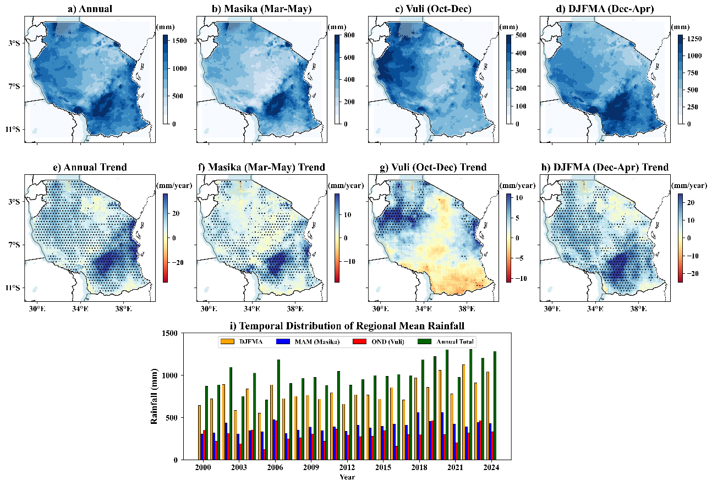
Figure 2 Spatial and temporal patterns of annual and seasonal rainfall across Tanzania. Panels (a–d) Spatial distribution, (e–h) corresponding spatial trends derived using Sen’s slope estimator, with black dots indicating statistically significant trends (p < 0.05), and (i) the temporal distribution of regional means.

3.2 Land Surface Temperature Distribution and Trends
The spatiotemporal analysis of LST revealed a markedly varying pattern across the study area (Figure 3). Annually, mean LST varied broadly across the landscape, with temperatures ranging from approximately 25⁰C in the southern highlands to over 35⁰C in the coast regions of Indian ocean towards northern and northeastern regions (Figure 3a). Seasonally, the Masika (MAM) period was the coolest, with mean temperatures primarily between 22.5 ⁰C and 35⁰C (Figure 3b), reflecting the cooling influence of the peak rainy season. Conversely, the Vuli (OND) season presented the highest temperatures, with peak LST values exceeding 35⁰C in localized hot spots distributed over a larger part of the country (Figure 3c) and DJFMA season exhibited a similar pattern as that of MAM but at a relatively higher temperature (Figure 3d).
The temporal analysis revealed a slight cooling trend of about -0.04⁰C/year during the study period over most parts of the country including the regions around Lake Victoria, northeastern and southwestern highlands (Figure 3e). Seasonally, the MAM, DJFMA and OND seasons exhibited an overall cooling trend over most parts of the country of about -0.02⁰C/year, -0.01⁰C/year and -0.08⁰C/year, respectively (Figure 3f-h). Despite the overall cooling trend both annually and seasonally across the country, some parts especially the areas along the coast and central regions showed a warming trend. On temporal distribution of the study area mean LST tended to vary yearly but showed to decline during the study period (Figure 3i).
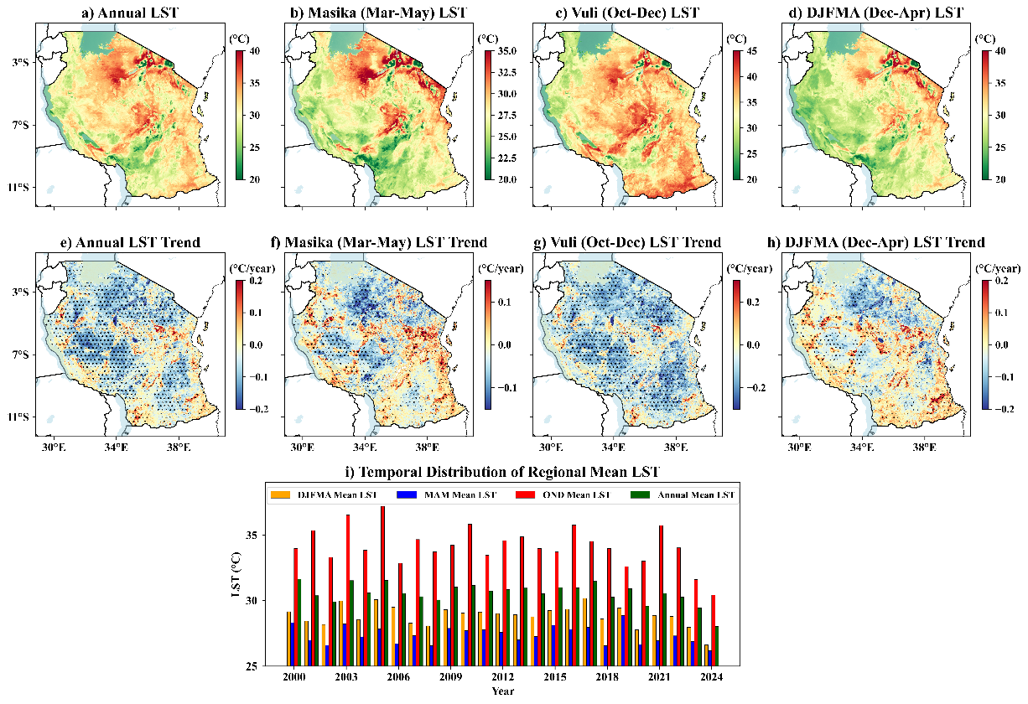
Figure 3 Spatial and temporal patterns of annual and seasonal land surface temperature (LST) across Tanzania. Panels (a–d) Spatial distribution, (e–h) corresponding spatial trends derived using Sen’s slope estimator, with black dots indicating statistically significant trends (p < 0.05), and (i) the temporal evolution of regional means.

3.3 Vegetation Health (EVI) Distribution and Trends
The Enhanced Vegetation Index (EVI), used as a proxy for vegetation health and productivity, exhibited clear spatial and seasonal variability across the study area (Figure 4). Annually, the highest EVI values (up to 0.6) characterize the high-productivity regions such as the western and southwestern forest zones and the coastal areas (Figure 4a). Conversely, the central arid and semi-arid interior consistently recorded the lowest EVI values, often less than 0.2. Seasonally, vegetation cover peaked during the Masika (MAM) season, with maximum EVI values recorded over the study region (Figure 4b), a clear response to the major rainfall period. The Vuli (OND) and DJFMA seasons showed lower to intermediate EVI values, reflecting the post-rain recession and the main dry season, respectively (Figure 4c-d).
Analysis of the EVI trends over the 24-year period revealed a spatially heterogeneous pattern of both greening and degradation (Figure 4e-h). Annually, there was a pronounced and significant signal of vegetation degradation (browning) concentrated over the central and southeastern regions (Figure 4e). Conversely, significant greening trends (EVI increase) were localized primarily in southwestern and northeastern highlands and certain parts of the northern coast. The seasonal breakdown shows that the significant browning signal is most dominant during the Vuli (OND) short rainy season (Figure 4g). The DJFMA season also recorded significant mixed trends, balancing greening in the northern coast extending towards the northeastern highlands with browning in the central (Figure 4h). In contrast, the main growing season, MAM, showed a relatively stable trend with only localized and less severe significant changes (Figure 4f).
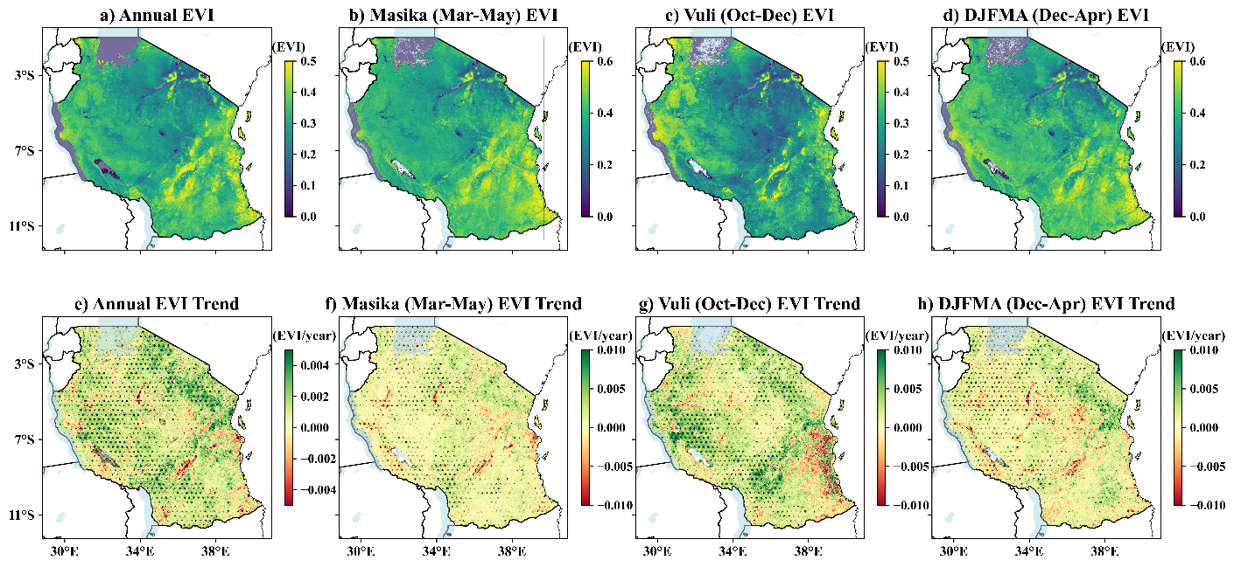
Figure 4 Spatial and temporal patterns of annual and seasonal EVI across Tanzania. (a-d) Spatial distribution and (e-f) Spatial trends with black dots showing pixels with statistically significant trends at p < 0.05.

3.4 Spatiotemporal Pattern of Vegetation Change
Analysis of the Fractional Vegetation Cover (FVC) trends provided a quantitative measure of long-term land degradation and restoration across the country (Figure 5). Overall, the mean annual FVC exhibited a statistically significant positive trend over the study period, increasing at a rate of 0.0032 per year (p < 0.05), as shown by the linear regression (R² = 0.299). This finding suggests that, on average, the total fraction of vegetation cover improved slightly across the country. However, this aggregate mean masks profound spatial heterogeneity in land condition (Figure 5a-d). Spatially, significant FVC degradation (browning and red areas) was widespread, particularly concentrated in the central regions, southeastern regions as well as parts of the western regions of the country, regardless of the season. Conversely, significant improvement (greening, light green areas) was mainly confined to the southwestern highlands, the northeastern regions, and isolated pockets along the northern coast.
The quantification of area coverage confirms this mixed signal (Figure 5i). Over the 24-year period, 40% of the landmass showed some degree of FVC improvement (including Slight and Significant Improvement), while almost 22% of the landmass experienced FVC degradation (Slight and Severe Degradation). Annually, the most dominant category was Slight Improvement (~48%), followed by significant improvement (~27%). Critically, severe degradation affected approximately 5% of the total area annually.
Seasonally, the highest mean FVC and the largest extent of improvement were observed during the Vuli (OND) season, which also recorded the strongest positive trend (0.0042/year, R² = 0.246). Despite this overall improvement signal, the seasonal maps confirmed that the areas vulnerable to FVC degradation are consistent across all periods, pointing to persistent underlying environmental or anthropogenic stressors in those specific regions. The DJFMA season showed a lower positive trend (0.0006/year, R² = 0.007) with a higher proportion of degraded land compared to MAM.
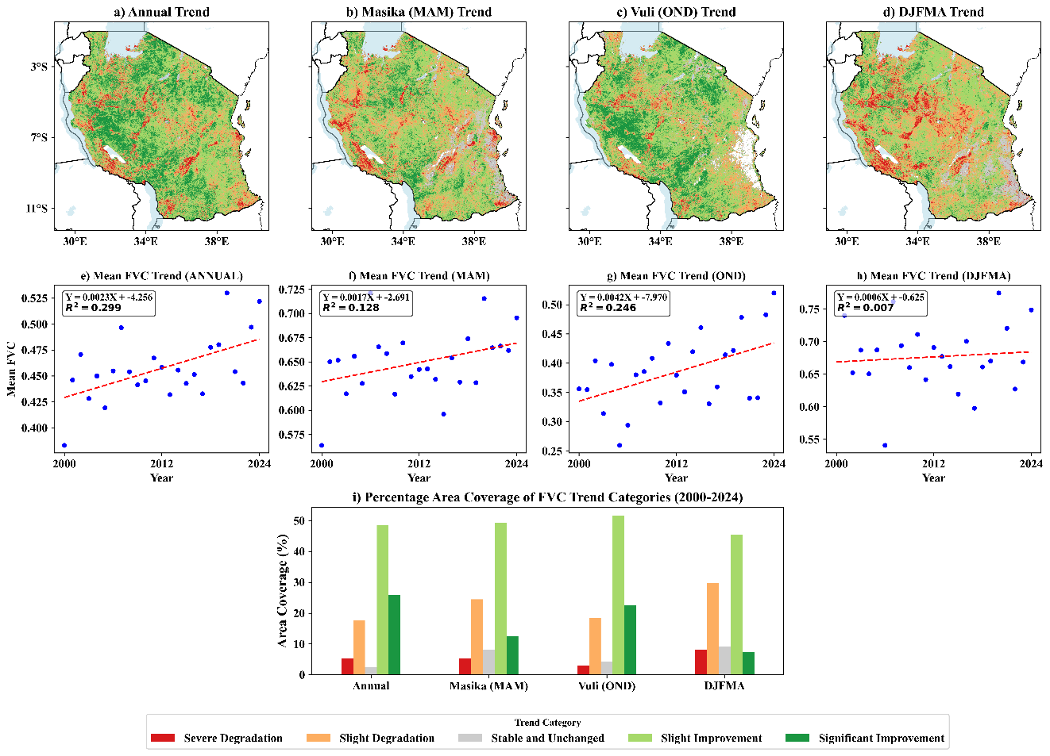
Figure 5 Spatial trends in annual and seasonal FVC (a–d), corresponding scatter plots of mean FVC (e–h), and percentage area coverage of FVC trend categories (i).

3.5 Spatial Relationship Between Climatic Variables and Vegetation
The spatial distribution of correlation coefficients (ρ) revealed contrasting influences of rainfall and temperature on vegetation health across the country (Figure 6). The correlation between EVI and Rainfall is overwhelmingly positive across all seasons (Figure 6a-d), with strong significance (ρ > 0.5) dominating the moisture-limited central and northern regions, confirming precipitation as the primary driver of productivity. Conversely, a strong and pervasive negative correlation (ρ < -0.5) is evident between EVI and LST across the vast majority of the country (Figure 6e-h), underscoring the severe and widespread negative constraint of thermal stress on vegetation health.
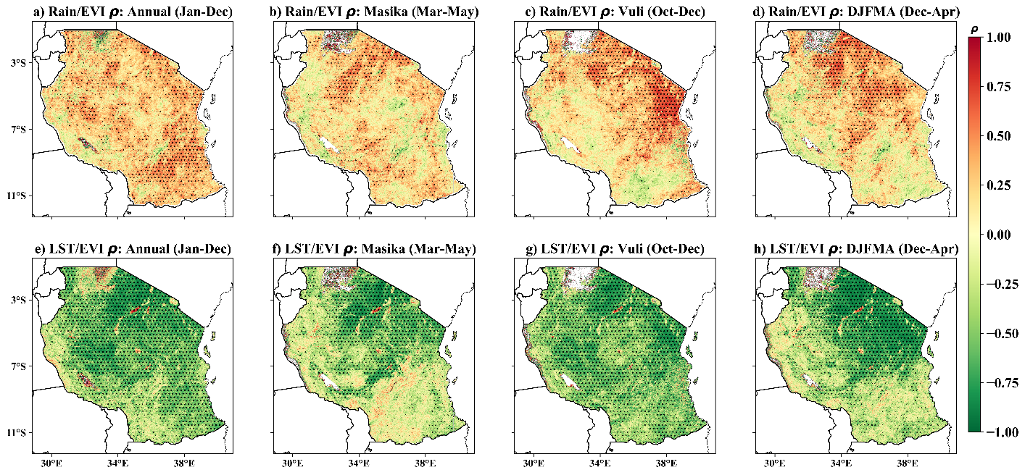
Figure 6 Spatial correlations between vegetation greenness (EVI) and hydroclimatic variables across Tanzania (2000–2024): (a–d) Annual and seasonal rainfall–EVI correlations and (e–h) land surface temperature (LST)–EVI correlations. Black dots indicate areas with statistically significant correlations (p < 0.05).

3.6 Temporal Lagged Relationships Climatic Variables and Vegetation
The Annual cross-correlation heatmap (Figure 7) provided critical insight into the memory and delayed response of the ecosystem to climatic drivers. Analysis of the time lags indicated that the maximum influence of LST on FVC is overwhelmingly immediate, occurring at Lag 0 (ρ= -0.78, p < 0.05). Beyond the contemporaneous relationship, no other significant relationships were observed, confirming that LST acts primarily as an immediate suppressor of vegetation productivity through thermal stress. In contrast, the influence of rainfall on FVC demonstrated a more complex pattern, the strongest relationship was contemporaneous (Lag 0, ρ= 0.64, p < 0.05), yet significant positive correlations were also observed at Lag -4 (ρ= 0.46) and critically at Lag +5 (ρ= 0.54). This significant positive correlation at Lag +5 suggests a long-term carry-over effect, where antecedent rainfall from five years prior continues to influence current annual FVC by potentially replenishing deeper moisture reserves or supporting slow-growing perennial species. Similarly, relationship between ET to FVC showed its maximum influence at Lag 0 (ρ= 0.72, p < 0.05), with significant positive lagged correlations also appearing at Lag +4 (ρ= 0.59) and Lag +5 (ρ= 0.56), signifying that the ecosystem’s current FVC condition remains highly predictable based on the active hydrological cycling five years earlier. Furthermore, the strong and significant positive correlation observed in the Rainfall to ET interaction at Lag -4 (ρ= 0.68) indicates a multi-year memory in the regional water system, where the current rate of ecosystem water use is significantly driven by antecedent rainfall that occurred up to four years prior.
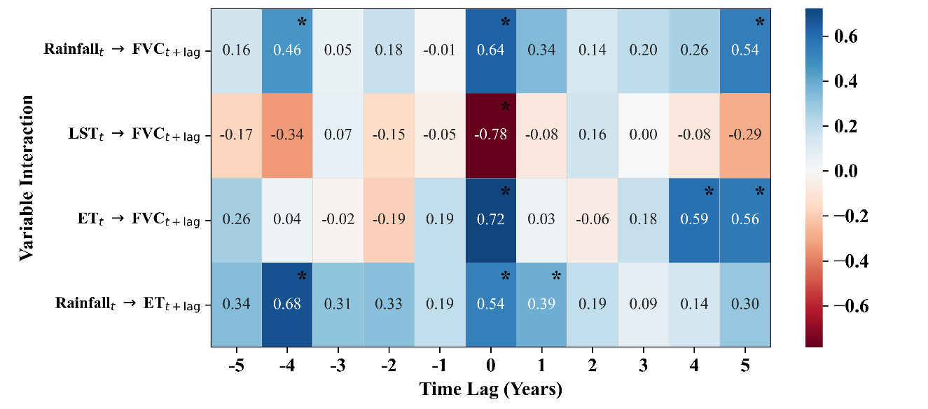
Figure 7 Lagged annual cross-correlations of key environmental variables with significant correlations at p < 0.05 indicated with (*)

3.7 Quantification of Relative Influence of Climatic Variables on Vegetation Cover
The quantification of the relative influence of the climatic and hydrological drivers by comparing their annual anomaly patterns with the annual FVC anomaly is depicted in the combined anomaly time series (Figure 8). Visually inspecting the time series shows a strong inverse relationship between the FVC anomaly and the LST Anomaly (Figure 8a). In years characterized by extreme heat (high positive LST anomaly, e.g., 2000, 2005), the FVC anomaly consistently registered its largest negative values, confirming LST as the most dominant immediate constraint on vegetation health. Conversely, the FVC Anomaly demonstrated a strong direct relationship with the rainfall anomaly (Figure 8b), with positive FVC growth corresponding well to positive rainfall surges (e.g., 2017, 2020, 2023). However, the most consistent and highest congruence was observed between the FVC anomaly and the ET anomaly (Figure 8c). ET, which reflects the active water consumption by the ecosystem, tracked the FVC trajectory most closely, peaking with high FVC years (e.g., 2021, 2024) and dropping during FVC reduction years. The robust statistical correlations confirmed this visual assessment in section 3.6, LST exhibited the highest negative correlation (ρ= -0.78), while ET showed the highest positive correlation (ρ= 0.72) with annual FVC, indicating that thermal stress (LST) is the primary factor limiting FVC, and active ecosystem water use (ET) is the best integrated predictor of annual FVC productivity.
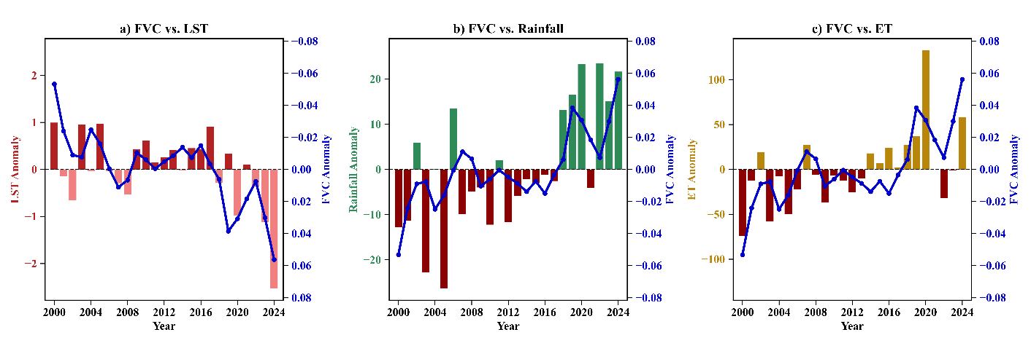
Figure 8 Annual anomalies of FVC in relation to (a) LST, (b) Rainfall, and (c) ET from 2000-2024.

Discussion
The spatiotemporal dynamics observed across Tanzania from 2000 to 2024 reveal a complex environmental narrative where an intensifying hydrological cycle is in a constant state of feedback with surface thermal conditions. The results indicate a statistically significant increase in annual rainfall of 14.1 mm/year, particularly concentrated in the coastal and southwestern highlands. This seasonal wetting trend aligns with the strengthening of the temperature gradient between the Indian Ocean and continental landmasses and the east African monsoon, which drives enhanced moisture transport into East Africa (Behera et al., 2005; Nicholson et al., 2018; Saji et al., 1999). Substantial inter-annual variability was evident, such as the low rainfall and reduced EVI recorded in 2005, which can be contextualized by the broader impacts of El Niño-Southern Oscillation (ENSO) phases that frequently drive moisture deficits across the region (Palmer et al., 2023). Conversely, the surges in rainfall observed in years like 2022 mirror the effects of La Niña events, which typically result in exceptionally heavy precipitation, higher soil moisture, and improved vegetation health (Palmer et al., 2023).
Crucially, this study identified a localized cooling trend in LST of approximately -0.04°C/year, primarily in the southwestern and northeastern highlands. Our analysis clearly indicates that the increased values of EVI at higher elevations of the study area are attributable to increasing rainfall and reduced LST. This suggests a robust negative feedback effect, whereby increased greenness results in lower LST through enhanced canopy shade and higher rates of transpiration, which releases water back to the atmosphere through photosynthesis and consumes latent heat (Gupta et al., 2018; Park et al., 2024; Yu et al., 2024). This localized cooling further promotes vegetation health by augmenting soil moisture and reducing potential evapotranspiration, creating a self-reinforcing cycle of ecological recovery. Such trends are consistent with global observations that increasing greenness can significantly mitigate LST, particularly in moisture-limited regions (Banerjee et al., 2023; Li et al., 2023).
Despite these favorable trends in the highlands, a significant browning signal persists across 22% of the landmass, particularly in the central and southeastern interior. In these arid and semi-arid regions, LST consistently exceeds 35°C, underscoring a severe thermal constraint that likely surpasses the physiological thresholds of indigenous vegetation, leading to stomatal closure and reduced carbon assimilation (Zahra et al., 2023). The occurrence of browning in areas simultaneously experiencing increased rainfall points toward an anthropogenic override. In these specific regions, human-induced land-use changes such as overgrazing, biomass harvesting, or deforestation alter surface albedo and soil thermal properties. These activities effectively neutralize potential climatic gains, decoupling vegetation dynamics from regional wetting trends and pointing to persistent underlying environmental stressors (Gül & Esen, 2024; Yirdaw et al., 2017).
The quantification of climatic influences highlights a profound ecological memory within the Tanzanian landscape. While the relationship between LST and FVC is overwhelmingly immediate (Lag 0), reflecting the acute impact of thermal stress on plant hydraulics, the influence of rainfall demonstrates a significant carry-over effect at a 5-year lag (ρ= 0.54). This protracted hydrological legacy suggests that current vegetation health is supported by the multi-year recharge of deep soil moisture and groundwater aquifers from antecedent wet years (Jin et al., 2025). The high congruence between actual evapotranspiration (ET) anomalies and FVC further substantiates that ecosystem water consumption is the most robust predictor of productivity, as it serves as the functional bridge between surface temperature and water availability (Fisher et al., 2017). This memory warns that the current relative stability of some vegetation cover may be a legacy effect that masks a burgeoning vulnerability, potentially leading to non-linear degradation if deep-seated moisture reserves are exhausted.
The findings of this research necessitate a shift in environmental governance toward spatially targeted and temporally aware adaptation strategies. Since LST remains the most dominant immediate constraint on vegetation health, management in degradation hotspots should prioritize thermal management through agroforestry and canopy restoration to provide shade, reduce vapor pressure deficits, and enhance water-use efficiency. Furthermore, the divergence in seasonal rainfall reliability increasing Masika (MAM) versus stagnant Vuli (OND) suggests that agricultural planning must prioritize the MAM season to capitalize on the favorable balance of moisture and cooling. Accounting for the observed five-year hydrological lag is essential for long-term planning, ensuring that land-use policies move beyond short-term observations to build genuine resilience against shifting climate patterns.

Conclusion
This study establishes that land surface dynamics across Tanzania over the past two decades are governed by a dual control mechanism which are, the acute, immediate sensitivity of vegetation to surface thermal conditions and a protracted multi-year recovery potential driven by antecedent rainfall. The analysis demonstrates that the strong inverse correlation between LST and FVC highlights the persistent role of surface temperature in modulating primary productivity, particularly within moisture-limited central and southeastern regions. The localized cooling, most evident in high-altitude and coastal zones, suggests a robust negative feedback loop where improved vegetation greenness facilitates surface cooling through transpiration and shading. Consequently, conservation strategies must move beyond traditional water-centric approaches to prioritize the maintenance of this transpiration cooling effect, utilizing agroforestry and canopy restoration to stabilize the microclimate and reduce vapor pressure deficits.
Furthermore, the significant positive influence of rainfall identified at a five-year time lag reveals a profound ecological memory inherent in the Tanzanian landscape. This hydrological legacy underscores the critical necessity of long-term water management and conservation efforts aimed at enhancing deep soil infiltration and groundwater recharge, which collectively sustain ecosystem resilience during intermittent dry spells. In light of the continuing patterns of severe degradation observed in arid and semi-arid rangelands where browning persists even amid regional wetting land management policies must transition from reactive drought relief to proactive, multi-year planning. Prioritizing water harvesting and the afforestation of deep-rooted, indigenous species is essential for effectively banking surplus moisture in the soil to support the long-term biomass stability identified in this research. Future studies should focus on disaggregating the degradation signal to precisely distinguish human-induced land-use changes from climate-driven effects, enabling more targeted and effective policy interventions to ensure the long-term sustainability of Tanzania's diverse ecosystems.
Data Availability Statement
All the datasets used in this study can be accessed through the GEE platform freely https://code.earthengine.google.com .
Conflicts of Interest
The authors declare that they have no competing interests.
Disclaimer (Artificial intelligence)
Author(s) hereby declare that NO generative AI technologies such as Large Language Models (ChatGPT, COPILOT, etc.) and text-to-image generators have been used during the writing or editing of this manuscript.

References
- Banerjee, A., Kang, S., Meadows, M. E., Xia, Z., Sengupta, D., & Kumar, V. (2023). Quantifying climate variability and regional anthropogenic influence on vegetation dynamics in northwest India. Environmental Research, 234, 116541. https://doi.org/10.1016/j.envres.2023.116541.
- Behera, S. K., Luo, J.-J., Masson, S., Delecluse, P., Gualdi, S., Navarra, A., & Yamagata, T. (2005). Paramount Impact of the Indian Ocean Dipole on the East African Short Rains: A CGCM Study. Journal of Climate, 18(21), 4514–4530. https://doi.org/10.1175/JCLI3541.1.
- Chaturvedi, M., Lakshmi, S., Kumar, D., & Gupta, J. (2025). Carbon Cycling and Climate Feedback in Terrestrial Ecosystems (pp. 97–117). https://doi.org/10.1007/978-981-96-3993-9_5.
- Das, P., Zhang, Z., Ghosh, S., Lu, J., Ayugi, B., Ojara, M. A., & Guo, X. (2023). Historical and projected changes in Extreme High Temperature events over East Africa and associated with meteorological conditions using CMIP6 models. Global and Planetary Change, 222, 104068. https://doi.org/10.1016/j.gloplacha.2023.104068.
- Fisher, J. B., Melton, F., Middleton, E., Hain, C., Anderson, M., Allen, R., McCabe, M. F., Hook, S., Baldocchi, D., Townsend, P. A., Kilic, A., Tu, K., Miralles, D. D., Perret, J., Lagouarde, J., Waliser, D., Purdy, A. J., French, A., Schimel, D., … Wood, E. F. (2017). The future of evapotranspiration: Global requirements for ecosystem functioning, carbon and climate feedbacks, agricultural management, and water resources. Water Resources Research, 53(4), 2618–2626. https://doi.org/10.1002/2016WR020175.
- Forzieri, G., Dakos, V., McDowell, N. G., Ramdane, A., & Cescatti, A. (2022). Emerging signals of declining forest resilience under climate change. Nature, 608(7923), 534–539. https://doi.org/10.1038/s41586-022-04959-9.
- Friedlingstein, P., O’Sullivan, M., Jones, M. W., Andrew, R. M., Bakker, D. C. E., Hauck, J., Landschützer, P., Le Quéré, C., Luijkx, I. T., Peters, G. P., Peters, W., Pongratz, J., Schwingshackl, C., Sitch, S., Canadell, J. G., Ciais, P., Jackson, R. B., Alin, S. R., Anthoni, P., … Zheng, B. (2023). Global Carbon Budget 2023. https://doi.org/10.5194/essd-2023-409.
- Gül, E., & Esen, S. (2024). High Desertification Susceptibility in Forest Ecosystems Revealed by the Environmental Sensitivity Area Index (ESAI). Sustainability, 16(23), 10409. https://doi.org/10.3390/su162310409.
- Gupta, S. K., Ram, J., & Singh, H. (2018). Comparative Study of Transpiration in Cooling Effect of Tree Species in the Atmosphere. Journal of Geoscience and Environment Protection, 06(08), 151–166. https://doi.org/10.4236/gep.2018.68011.
- He, X., Zhang, F., Cai, Y., Tan, M. L., & Chan, N. W. (2023). Spatio-temporal changes in fractional vegetation cover and the driving forces during 2001–2020 in the northern slopes of the Tianshan Mountains, China. Environmental Science and Pollution Research, 30(30), 75511–75531. https://doi.org/10.1007/s11356-023-27702-x.
- Horion, S., Cornet, Y., Erpicum, M., & Tychon, B. (2013). Studying interactions between climate variability and vegetation dynamic using a phenology based approach. International Journal of Applied Earth Observation and Geoinformation, 20, 20–32. https://doi.org/10.1016/j.jag.2011.12.010.
- Houghton, R. A. (2007). Balancing the Global Carbon Budget. Annual Review of Earth and Planetary Sciences, 35(1), 313–347. https://doi.org/10.1146/annurev.earth.35.031306.140057
- Jin, J., Ding, X., Li, F., Jia, Z., Wei, H., Li, J., & Li, M. (2025). Impact of Deep-Rooted Vegetation on Deep Soil Water Recharge in the Gully Region of the Loess Plateau. Water, 17(2), 208. https://doi.org/10.3390/w17020208.
- Kagabo, A. S., Safari, B., Gasore, J., Kipkoech Mutai, B., & Ndakize Sebaziga, J. (2024). Assessing the impact of Land Use Land Cover changes on land surface temperature over Kigali, Rwanda in the past three decades. Environmental and Sustainability Indicators, 23, 100452. https://doi.org/10.1016/j.indic.2024.100452.
- Kambi, S. H., Mbilinyi, B., & Silungwe, F. (2025). Assessment of Precipitation and Temperature Variability on Land Suitability for Surface Irrigation in Kilosa District, Morogoro, Tanzania. Asian Journal of Environment & Ecology, 24(5), 51–67. https://doi.org/10.9734/ajee/2025/v24i5694.
- Kashaigili, J. J., & Majaliwa, A. M. (2010). Integrated assessment of land use and cover changes in the Malagarasi river catchment in Tanzania. Physics and Chemistry of the Earth, Parts A/B/C, 35(13–14), 730–741. https://doi.org/10.1016/j.pce.2010.07.030.
- Li, Y., Li, Z.-L., Wu, H., Zhou, C., Liu, X., Leng, P., Yang, P., Wu, W., Tang, R., Shang, G.-F., & Ma, L. (2023). Biophysical impacts of earth greening can substantially mitigate regional land surface temperature warming. Nature Communications, 14(1), 121. https://doi.org/10.1038/s41467-023-35799-4.
- Liu, Y., Liu, H., Chen, Y., Gang, C., & Shen, Y. (2022). Quantifying the contributions of climate change and human activities to vegetation dynamic in China based on multiple indices. Science of The Total Environment, 838, 156553. https://doi.org/10.1016/j.scitotenv.2022.156553.
- Magang, D. S., Ojara, M. A., Yunsheng, L., & King’uza, P. H. (2024). Future climate projection across Tanzania under CMIP6 with high-resolution regional climate model. Scientific Reports, 14(1), 12741. https://doi.org/10.1038/s41598-024-63495-w.
- Makunga, J. E., & Misana, S. B. (2017). The Extent and Drivers of Deforestation and Forest Degradation in Masito-Ugalla Ecosystem, Kigoma Region, Tanzania. Open Journal of Forestry, 07(02), 285–305. https://doi.org/10.4236/ojf.2017.72018.
- Miralles, D. G., Vilà‐Guerau de Arellano, J., McVicar, T. R., & Mahecha, M. D. (2025). Vegetation–climate feedbacks across scales. Annals of the New York Academy of Sciences, 1544(1), 27–41. https://doi.org/10.1111/nyas.15286.
- Mwakalukwa, E. E., Meilby, H., & Treue, T. (2024). Carbon storage in a dry Miombo woodland area in Tanzania. Southern Forests: A Journal of Forest Science, 86(2), 115–124. https://doi.org/10.2989/20702620.2024.2319185.
- Nicholson, S. E., Funk, C., & Fink, A. H. (2018). Rainfall over the African continent from the 19th through the 21st century. Global and Planetary Change, 165, 114–127. https://doi.org/10.1016/j.gloplacha.2017.12.014.
- Ning, L., Peng, W., Yu, Y., Xiang, J., & Wang, Y. (2023). Quantifying vegetation change and driving mechanism analysis in Sichuan from 2000 to 2020. Frontiers in Environmental Science, 11. https://doi.org/10.3389/fenvs.2023.1261295.
- Niyigena, B., Uwamahoro, J., Nkurikiyimfura, I., Sebaziga, N. J., Kazora, J., Iyakaremye, V., Ukwishaka, D., Bavuge, B., Tuyisenge, A., Nizeyimana, A., Byukusenge, O., Mugabo, W., Musafiri, G., Munyaneza, J., & Mugaragu, P. I. (2025). Assessment of rainfall variability and trend using variational indices and modified Mann Kendell-Test in Gicumbi, Northern Province of Rwanda. Discover Environment, 3(1), 139. https://doi.org/10.1007/s44274-025-00338-z.
- O’Sullivan, M., Smith, W. K., Sitch, S., Friedlingstein, P., Arora, V. K., Haverd, V., Jain, A. K., Kato, E., Kautz, M., Lombardozzi, D., Nabel, J. E. M. S., Tian, H., Vuichard, N., Wiltshire, A., Zhu, D., & Buermann, W. (2020). Climate‐Driven Variability and Trends in Plant Productivity Over Recent Decades Based on Three Global Products. Global Biogeochemical Cycles, 34(12). https://doi.org/10.1029/2020GB006613.
- Palmer, P. I., Wainwright, C. M., Dong, B., Maidment, R. I., Wheeler, K. G., Gedney, N., Hickman, J. E., Madani, N., Folwell, S. S., Abdo, G., Allan, R. P., Black, E. C. L., Feng, L., Gudoshava, M., Haines, K., Huntingford, C., Kilavi, M., Lunt, M. F., Shaaban, A., & Turner, A. G. (2023). Drivers and impacts of Eastern African rainfall variability. Nature Reviews Earth & Environment, 4(4), 254–270. https://doi.org/10.1038/s43017-023-00397-x.
- Park, S., Kim, E.-S., Yun, S.-H., & Lee, D.-K. (2024). Efficiency of urban greening systems with maximized latent heat effect in urban heat island and climate change mitigation. Environmental Challenges, 15, 100956. https://doi.org/10.1016/j.envc.2024.100956.
- Saji, N. H., Goswami, B. N., Vinayachandran, P. N., & Yamagata, T. (1999). A dipole mode in the tropical Indian Ocean. Nature, 401(6751), 360–363. https://doi.org/10.1038/43854.
- Savitzky, Abraham., & Golay, M. J. E. (1964). Smoothing and Differentiation of Data by Simplified Least Squares Procedures. Analytical Chemistry, 36(8), 1627–1639. https://doi.org/10.1021/ac60214a047.
- Spearman, C. (1904). The Proof and Measurement of Association between Two Things. The American Journal of Psychology, 15(1), 72. https://doi.org/10.2307/1412159.
- Wang, L., Wei, X., Bishop, K., Reeves, A. D., Ursino, N., & Winkler, R. (2018). Vegetation changes and water cycle in a changing environment. Hydrology and Earth System Sciences, 22(3), 1731–1734. https://doi.org/10.5194/hess-22-1731-2018.
- Wiesmeier, M., Urbanski, L., Hobley, E., Lang, B., von Lützow, M., Marin-Spiotta, E., van Wesemael, B., Rabot, E., Ließ, M., Garcia-Franco, N., Wollschläger, U., Vogel, H.-J., & Kögel-Knabner, I. (2019). Soil organic carbon storage as a key function of soils - A review of drivers and indicators at various scales. Geoderma, 333, 149–162. https://doi.org/10.1016/j.geoderma.2018.07.026.
- Yirdaw, E., Tigabu, M., & Monge, A. (2017). Rehabilitation of degraded dryland ecosystems – review. Silva Fennica, 51(1B). https://doi.org/10.14214/sf.1673.
- Yu, Z., Chen, J., Chen, J., Zhan, W., Wang, C., Ma, W., Yao, X., Zhou, S., Zhu, K., & Sun, R. (2024). Enhanced observations from an optimized soil-canopy-photosynthesis and energy flux model revealed evapotranspiration-shading cooling dynamics of urban vegetation during extreme heat. Remote Sensing of Environment, 305, 114098. https://doi.org/10.1016/j.rse.2024.114098.
- YUAN Lihua, JIANG Weiguo, SHEN Wenming, LIU Yinghui, WANG Wenjie, TAO Liangliang, ZHENG Hua, & LIU Xiaofu. (2013). The spatio-temporal variations of vegetation cover in the Yellow River Basin from 2000 to 2010. Acta Ecologica Sinica, 33(24). https://doi.org/10.5846/stxb201305281212.
- Yue, S., Pilon, P., Phinney, B., & Cavadias, G. (2002). The influence of autocorrelation on the ability to detect trend in hydrological series. Hydrological Processes, 16(9), 1807–1829. https://doi.org/10.1002/hyp.1095.
- Yue, S., & Wang, C. (2004). The Mann-Kendall Test Modified by Effective Sample Size to Detect Trend in Serially Correlated Hydrological Series. Water Resources Management, 18(3), 201–218. https://doi.org/10.1023/B:WARM.0000043140.61082.60.
- Zahra, N., Hafeez, M. B., Ghaffar, A., Kausar, A., Zeidi, M. Al, Siddique, K. H. M., & Farooq, M. (2023). Plant photosynthesis under heat stress: Effects and management. Environmental and Experimental Botany, 206, 105178. https://doi.org/10.1016/j.envexpbot.2022.105178.

