Assess the Leaf Phenological Characters of Main Tree Species in Urban Forests of Smart City Srinagar
Abstract
Study was carried out to determine the phenological characteristics of prominent tree species in the urban forests of Srinagar city in India from 2023 to 2024 at three sites viz, Shalimar Bagh, Botanical Garden and Iqbal Park. Phenology of five deciduous species namely Platanus orientalis, Salix babylonica, Salix alba, Juglans regia and Ginkgo biloba was recorded in all the seasons at all the three sites following the Observational and Herbarium approaches. All phenological stages occurred earlier in 2024 than 2023, with leafing concentrated in early March–April and defoliation in late September–early December. Greatest advances were in vegetative bud initiation (1–2 months earlier across species), followed by leafing, flowering, and defoliation in P. orientalis (16, 10–20, and 8 days earlier). Juglans regia showed minimal shifts (3–4 days or on time). Salix alba had the earliest bud break (early March) and longest growing season (to early December), while Ginkgo biloba was latest to bud.

Keywords: Phenology, Climate change, Phenophase, Defoliation, Urban, Tree species, Urban forests, Srinagar city

- INTRODUCTION
Events in phenology occur at varying times. According to Miller and Primack (2008), spring time plant activities including bud burst and flowering are happening substantially earlier. These changes reflect changes on the weather. More of these studies have demonstrated how rising temperatures affect the timing or length of phenological occurrences. However, the ways in which various ecological situations are responded by different species vary. Some of the variations have been studied, for instance in terms of functional features and environment-specific responses (Inouye, 2008). Plants adapt their phenological traits to the seasonality of their surroundings. Such plant activity, which is so closely synchronized with local temperature changes and that timing offers one of the strongest indications and that species and ecosystems are being impacted by global climate change. Globally, it has been seen that spring time plant flowering is occurring earlier than usual. The earlier spring greening up of the land surface shown in satellite photographs has also encouraged this. (Gatti et al., 2021) estimated the number of tree species at biome, continental, and global scale. The results showed that the global richness is 14% higher than numbers known today and highlight the vulnerability of global tree species diversity to anthropogenic changes. Recent changes in the timing of bud bursting, flowering, fruiting, leaf-out, or senescence are indicative of a shift in tree phenology (Farooq and Meraj, 2016).
Major phenological events, such as the widely reported spring advancement and autumn postponement (Gill et al., 2015; Jeong et al., 2011; Menzel et al., 2006; Piao et al., 2006); and phenological mismatches across trophic levels (Renner and Zohner., 2018; Tylianakis et al., 2008) have all been significantly impacted by climate change. According to Suttle et al., 2007 and Yang and Rudolf (2010), such severe phenological shifts caused by climate change can have a considerable impact on community structures and ecosystem services. The current rise in plant activity and carbon uptake is primarily due to warming-induced changes in phenology (Piao et al., 2017). By altering the flow of water and energy between terrestrial ecosystems and the atmosphere, changes in plant phenology may also have an impact on climate (Penuelas et al., 2009; Richardson et al., 2013). In order to better understand and predict the interactions between ecosystems and the climate system, it is therefore imperative to have better knowledge of phenology changes, their primary drivers, and ecological implications (Piao et al., 2019).
2. STUDY AREA
The observation sites were located in the Srinagar city at an elevation of 1,585m. [S1: Shalimar Bagh (34.1495º N, 74.8729º E)]; [S2: Botanical Garden (34.083656º N, 74.797371º E)]; [S3: Iqbal Park (34.0646º N, 74.8054º E)]. The district has total area of 294 sq. kms. The outer boundary of the Srinagar city is roughly 109.43 kms along. It is the 31th most populous city in India, and second largest metropolitan area in the Himalayas. These areas show warm temperate climate. The annual average temperature is 2.5º C (winter) and 23.8º C (summer). The average annual rainfall is 650 mm.
2.1. MATERIALS AND METHODS
The climate of the study location is defined by four distinct seasons: a chilly spring (March to May), a warm summer (June to August), a pleasant Autumn (September to November) and a severe winter (December to February). Maximum precipitation is received from December to April in the form of snow and rain. The plants at these sites are mostly deciduous broadleaves trees for which leafing finishes by April to May and the Autumn senescence starts in September. Phenology of five deciduous species namely: Platanus orientalis, Salix babylonica, Salix alba, Juglans regia and Ginkgo biloba was recorded on weekly basis (reproductive phenophases) and at an interval of 10-15 days (vegetative phenophases during the year 2023 and 2024 respectively. Data was statistically analyzed using R- Software (ggplot2, ggstatplot). In order to assess the leaf phenological characteristics, regression methods and correlation analysis methods were followed (Xu et al., 2014).
3. RESULTS AND DISCUSSION
The data presented in Table 1 & 2 summarizes vegetative and reproductive phenology of all the selected species. Phenological data of selected tree species was recorded on weekly basis during the reproductive phase as these are one of the sensitive phases while as other phenophases were observed almost after every 10-15 days. These observations were recorded from three distant sites while as Juglans regia was recorded only from Site I. Bud initiation typically occurs in response to seasonal changes, particularly during the late winters to early spring period. Bud initiation was first observed in species like Ginkgo biloba at Site II, followed by Platanus orientalis, Salix babylonica and Salix alba at Site III, and Juglans regia at Site I. Bud initiation was seen one month early in 2024 than 2023 for all the species as per metrological data, 2024 was much hotter than 2023. El Kayal et al., 2011 found that after growth cessation, bud growth and induction of dormancy continues over several weeks, and these processes are primarily controlled by temperature and bud size is a function of the number of primordia contained therein. The timing and duration of leaf initiation significantly affect a plant’s overall health and ecological fitness. leaf initiation was first observed in Salix alba and Salix babylonica in the first ten days of March, followed by Platanus orientalis in the second ten days of March. It was 4-5 days early as compared to year 2023. Leaf initiation was observed in the first ten days of April for Juglans regia at Site I, followed by Ginkgo biloba at Site II respectively. Around 60% of the tree species end their leafing in the second to third ten days of March. Juglans regia and Ginkgo biloba end their leafing processes by the second ten days in April, which is 20-30 days later than the other species. Fu et al., 2019 found that while temperature is a primary driver for leaf-out, daylength also plays a crucial role in ensuring that temperate deciduous trees initiate leaf growth at optimal times, potentially mitigating some effects of temperature variations. Qaisar et al., 2020 also found that the bud break of Salix alba, Platanus orientalis was observed from 20th February and 30th March under Shalimar conditions respectively. Flowering phenology marks as the starting point of plant reproductive growth and an important phase of general phenology and is the core attribute of plants that allows them to cope with environmental changes and progeny reproduction. Flowering was first observed for Salix alba followed by Salix babylonica, Platanus orientalis, Ginkgo biloba and Juglans regia and later on full bloom also followed the same trend as it was first observed in Salix alba at Site II and immediately followed by Salix babylonica at Site II in the second ten days of March, then by Platanus orientalis at Site III in the last ten days of March, Ginkgo biloba at Site II in the first ten days of April, and finally by Juglans regia at Site I in the first ten days of April respectively. In some species flowering starts prior to leafing and thus eventually blooms first. Qaiser et al., 2020 found that the flowering of Platanus orientalis, Salix alba starts in the last ten days of March and second ten days of February respectively. Wagay et al., 2024, while investigating the floral biology of Platanus orientalis found that the male inflorescences also known as catkins often emerge earlier than female inflorescence. Damialis et al., 2011 observed that the male catkins of P. orientalis started to develop in the early spring, usually in late March or early April. According to Geissler et al., 2023 plants flowered 2.26 days earlier per 1º C increase in spring onset average temperatures and 2.93 days earlier per 1º C increase in spring onset average temperatures. Fruit set, an important phenophase in plants life cycle where a fertilized flower begins to develop into a young fruit. As Salix alba and Salix babylonica fruits are very minute, so we were not able to identify them. Other than these species, Juglans regia was the first species to set its fruit in the last ten days of May at Site I, followed by Ginkgo biloba in the last ten days at Site II, and finally by Platanus orientalis in the second ten days of June at Site III respectively. Salama et al., 2021 reported that climate change is generally a great challenge for temperate fruit tree production. Leaf senescence patterns highlight the intricate relationship between trees and their changing environment, providing insights into how ongoing climate changes impacts the tree species. leaf senescence was first observed in Juglans regia at Site I from second ten days of September, followed by Platanus orientalis from second ten days of September, Salix babylonica and Salix alba from the last ten days of September at Site III and by Ginkgo biloba from the first ten days of October at Site II respectively. Leaf senescence was observed early in the year 2024 compared to 2023. This shift was due to climate warming and because of the early leafing in the spring 2024 compared to 2023. Ferguson et al., 1990; Scheurwater et al., 2000; Haba et al., 2014 also found that the warmer conditions can result in earlier leaf senescence and flower fall. Leaf abscission, the natural detachment of leaves is typically in response to environmental changes and is crucial for the tree’s survival and adaptation. leaf abscission was early in the 2024 compared to 2023. It was early by about 4-6 days for each species in the year 2024. This shift was due to warming temperature in 2024 which caused early leaf senescence and eventually early leaf fall for the species. Leaf fall was first observed for Platanus orientalis at Site III from the last ten days of September, followed by Juglans regia at Site I from the first ten days of October, then by Salix babylonica and Salix alba at Site III from the first ten days of October and finally by Ginkgo biloba at Site II from the first ten days of November. Around 60% of the tree species end their defoliation in the third ten days of November. However, different tree species varies greatly in defoliation end time. For example, to the second ten days in November Platanus orientalis have finished their defoliation and in the third ten days Juglans regia, Salix babylonica have finished their defoliation. The last defoliating species including Salix alba and Ginkgo biloba end their defoliation processes by the first ten days in December, which is 10-20 days later than the earliest ones. Leaf lifespan is one of the most important phenophase of a species. For early leafing species, it would be longer and consequently have advantage on carbon accumulation compared with later defoliation. The data from our study reveals that the leaf lifespan was maximum of 37 weeks for Salix alba at Site I, followed by 35 weeks for Salix babylonica, 33 weeks for Platanus orientalis at Site II, 32 weeks for Ginkgo biloba at Site II and finally of 31 weeks for Juglans regia at Site I respectively. This phenophase was almost of same order to that of year 2023 with 2024 having some 5-6 days more than 2023 for almost all observed species. Thus, the manuscript informs Srinagar’s climate resilient city action plan, enhancing green space management, pest control, and ecosystem services like air purification and provides a key insight into climate-driven shifts in leafing, lifespans and defoliation patterns. These data are vital for modelling urban ecosystem responses to warming and precipitation changes in Himalayan smart cities and fills Himalayan urban phenology gaps, influencing policy for vulnerable cities worldwide.
3.1. The relationship between beginning and Ending time of leaf emergence
Leaf initiation is crucial for plant growth and development, as leaves play key role in photosynthesis, gas exchange, and transpiration. The data from (Fig. 1) reveals that leaf initiation was first observed in Salix alba and Salix babylonica in the first ten days of March, followed by Platanus orientalis in the second ten days of March. Leaf initiation was observed in the first ten days of April for Juglans regia at Site I, followed by Ginkgo biloba at Site II respectively. Around 60% of the tree species end their leafing in the second to third ten days of March. However, different tree species varies greatly in leafing end time. Fig.1 also reveals that earlier the beginning time of leaf emergence, earlier would be its ending time of leaf emergence and as the temperature increases leaf emergence increases until it becomes threshold temperature for a species. For example, to the second ten days in March Salix babylonica and Salix alba have finished their leafing and in the third ten days Platanus orientalis have finished their leafing while many tree species had not yet begun to leaf.
3.2. The relationship between beginning and Ending time of leaf abscission
The leaf abscission data was monitored for the year 2023-2024 and it was observed that leaf abscission was early in the 2024 compared to 2023. It was early by about 4-6 days for each species in the year 2024. This shift was due to warming temperature in 2024 which caused early leaf senescence and eventually early leaf fall for the species. Leaf fall was first observed for Platanus orientalis at Site III from the last ten days of September, followed by Juglans regia at Site I from the first ten days of October, then by Salix babylonica and Salix alba at Site III from the first ten days of October and finally by Ginkgo biloba at Site II from the first ten days of November.
Analysis of the defoliating phenology of prominent tree species in Srinagar’s urban forest Fig. 2 shows that the species-specific timing differences in leaf abscission, emphasizing the effect of climatic conditions on phenological responses in the region. As the temperature decreases leaf defoliation process increases and earlier the beginning time of leaf defoliation, earlier the ending time of leaf defoliation. Around 60% of the tree species end their defoliation in the third ten days of November. However, different tree species varies greatly in defoliation end time. For example, to the second ten days in November Platanus orientalis have finished their defoliation and in the third ten days Juglans regia, Salix babylonica have finished their defoliation. The latest defoliating species including Salix alba and Ginkgo biloba end their defoliation processes by the first ten days in December, which is 10-20 days later than the earliest ones
3.3. The relationship between leaf lifespan and leaf phenology
The prominent tree species in Srinagar’s urban forest show an average leaf lifespan of 236 days. The leaf lifespan of all the observed 5 species exceeds 200 days (Table 1). Salix alba shows the longest leaf lifespan of 249 days, while as Juglans regia has the shortest leaf lifespan of 223 days. Analysis of the relationship between leaf lifespan and leaf phenology reveals that (Fig 3), leaf lifespan is negatively correlated with beginning time, ending time, duration and timing of leaf emergence, which suggests that earlier initiation of a phenophase results in a longer duration. This implies that trees initiating growth phases earlier benefit from prolonged activity, potentially due to favourable climatic conditions. Moreover, leaf lifespan is positively correlated with ending time of leaf abscission and timing of leaf abscission which indicated that the prolongation of leaf retention phases is critical for maximizing photosynthetic output.

S. no | Tree species | Budding |  | Leafing |  |  | Flowering |  |  | Fruiting | Leaf senescence | Leaf fall |  |  | Leaf life span
S. no | Tree species | V. bud | R. bud | B. T | E. T | D | B. T | E. T | D | Fruiting | Leaf senescence | B. T | E. T | D | Leaf life span
1 | Platanus orientalis | 9(I) | 9(I) | 3(II) | 3(IV) | 11-15 days | 3(II) | 3(III) | 10-12 days | 6(II) | 9(II) | 9(IV) | 11(III) | 55-60 Days | 235 days
2 | Salix babylonica | 9(I) | 9(I) | 3(II) | 3(III) | 10-13 days | 3(I) | 3(III) | 8-12 days | _ | 9(IV) | 10(I) | 11(IV) | 52-58 days | 243 days
3 | Salix alba | 9(I) | 9(I) | 3(I) | 3(III) | 10-15 days | 3(I) | 3(II) | 8-12 days | _ | 9(IV) | 10(I) | 12(I) | 50-60 days | 249 days
4 | Juglans regia | 9(I) | 9(I) | 4(II) | 4(III) | 10-14 days | 4(I) | 4(III) | 10-12 days | 5(III) | 9(II) | 10(I) | 11(IV) | 50-58 Days | 223 days
5 | Ginkgo biloba | 8(IV) | 8(IV) | 4(I) | 4(III) | 10-15 days | 3(IV) | 4(II) | 10-12 days | 5(IV) | 10(I) | 10(IV) | 12(I) | 32-37 days | 226 days
Table 1: Phenophases of different species (2023- 2024)
V. bud- Vegetative bud; R. bud- Reproductive bud; B. T- Beginning time; E. T- Ending time; D- Duration
*Arabic numbers represent months and roman numbers within parenthesis represent week.

Table 2: Leaf phenological characters of prominent tree species in urban forests of Srinagar (2023-24)
S.no | Species | Beginning time of leaf emergence | Ending time of leaf emergence | Duration of leaf emergence | Beginning time of leaf abscission | Ending time of leaf abscission | Duration of leaf abscission | Timing of leaf emergence | Timing of leaf abscission | Leaf lifespan
1 | Platanus orientalis | 74±0.86 | 84.66±1.32 | 10.66±0.70 | 265.66±1.50 | 324.11±2.36 | 58.44±2.40 | 77.11±1.26 | 312.22±2.94 | 235.11±2.75
2 | Salix babylonica | 67.55±1.22 | 78.77±1.20 | 11.22±0.66 | 278±2.121 | 335.66±1.11 | 57.66±2.12 | 74.11±0.92 | 320.88±2.08 | 246.77±2.16
3 | Salix alba | 67.33±1.22 | 78.66±1.32 | 11.33±0.70 | 278.55±1.13 | 337.55±1.01 | 59±1.65 | 74.44±1.13 | 324.66±1.58 | 250.22±1.92
4 | Juglans regia | 92.66±2.51 | 106.66±1.52 | 14±1.00 | 277.33±2.08 | 335±2.00 | 57.66±2.51 | 99.66±2.51 | 322.66±2.51 | 223±4.35
5 | Ginkgo biloba | 94.55±2.50 | 106.33±3.24 | 11.77±0.97 | 305.77±1.48 | 338.55±3.46 | 32.77±2.86 | 101.88±2.93 | 329.88±2.66 | 228±1.58

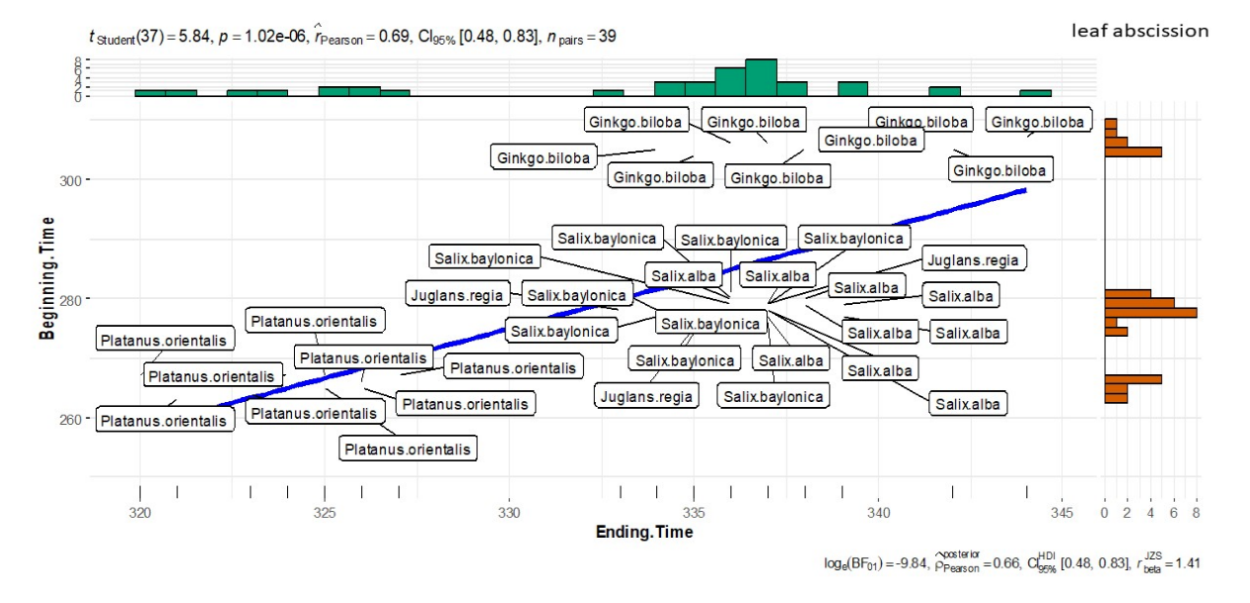
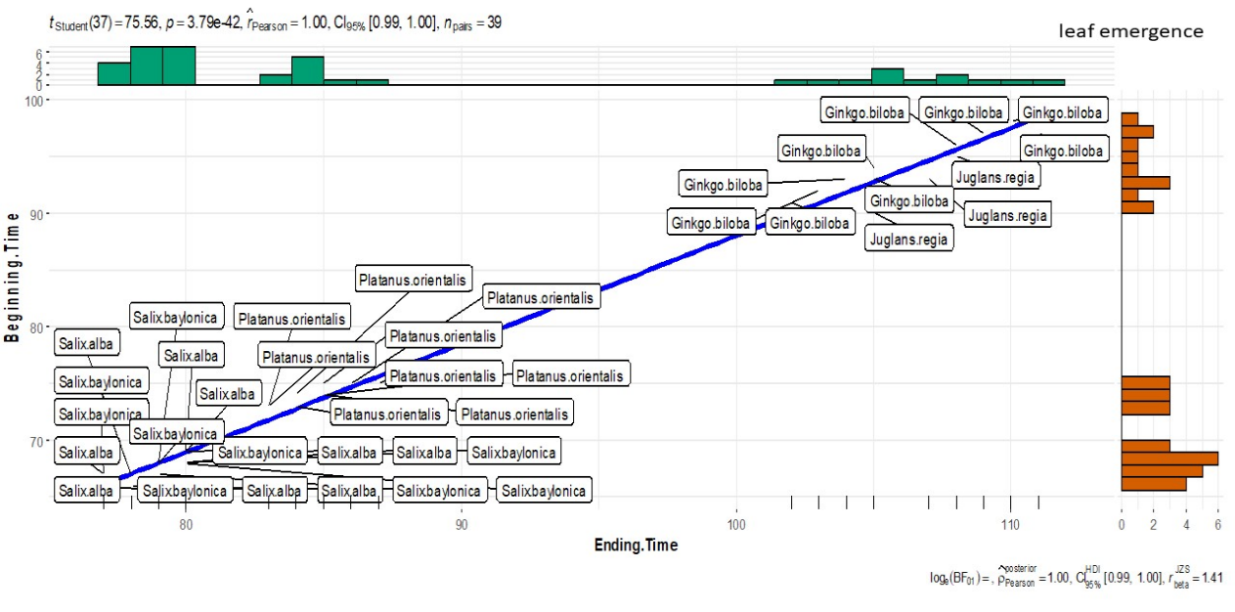
Fig. 2: Beginning and Ending time of leaf abscission
Fig. 1: Beginning and Ending time of leaf emergence
Fig. 3: Correlation analysis of leaf phenological characters of prominent tree species in urban forests of Srinagar (Relationship between leaf lifespan and leaf phenology).
B-T= Beginning time; E-T= Ending time; T= Timing (at 50%); D= Duration
Fig. 3: Correlation analysis of leaf phenological characters of prominent tree species in urban forests of Srinagar (Relationship between leaf lifespan and leaf phenology)
B-T= Beginning time; E-T= Ending time
T= Timing (at 50%); D= Duration

CONCLUSIONS
Each of the species under study viz Platanus orientalis, Salix babylonica, Salix alba, Juglans regia, and Ginkgo biloba exhibited unique phenological patterns, going through discrete stages of budburst, leaf unfolding, branching, and senescence. In the setting of an urban forest, these phenological data demonstrate the impact of environmental conditions and species-specific characteristics on leaf development and lifecycle stages. The blooming trend of species is in line with the leafing trend; when temperatures rise, flowering begins in species. The air temperature and leaf phenology are significantly correlated. As temperatures rise, Juglans regia and Ginkgo biloba bloom later, while Salix alba and Salix babylonica bloom first, followed by Platanus orientalis. When compared to species that defoliate later, early leafing species would have a longer lifespan and, as a result, have an advantage in terms of carbon accumulation.

Disclaimer (Artificial intelligence)
Option 1:
Author(s) hereby declare that NO generative AI technologies such as Large Language Models (ChatGPT, COPILOT, etc.) and text-to-image generators have been used during the writing or editing of this manuscript.
Option 2:
Author(s) hereby declare that generative AI technologies such as Large Language Models, etc. have been used during the writing or editing of manuscripts. This explanation will include the name, version, model, and source of the generative AI technology and as well as all input prompts provided to the generative AI technology
Details of the AI usage are given below:
1.
2.
3.

REFERENCES
- Damialis, A., Fotiou, C., Halley, J. M., Vokou, D. 2011. Effects of environmental factors on pollen production in anemophilous woody species. Trees 25:253-264.
- El Kayal, W., Allen, C. C. G., Ju, C. J. T., Adams, E., King-Jones, S., Zaharia, L. I., Abrams, S. R. and Cooke, J. E. K. 2011. Molecular events of apical bud formation in White Spruce, Picea glauca. Plant, Cell & Environment 34: 480-500.
- Farooq, M. and Meraj, G. 2016. Tree phenology and climate change. Jammu and Kashmir Envis Centre 3(1). ISSN: 2455-8575.
- Fergueson, D. L., Guikema, J. A. and Paulsen, G. M. 1990. Ubiquitin pool modulation and protein degradation in wheat roots during high temperature stress. Plant Physiology 92(3): 740-746.
- Fu, Y. H., Zhang, X., Piao, S., Hao, F., Geng, X., Vitasse, Y., Zohner, C. M., Penuelas, J. and Janssens, I. A. 2019. Daylength helps temperate deciduous trees to leaf out at the optimal time. Global Change Biology 25(7).
- Gatti, R. C., Reich, P. B., Gamarra, J. G., Crowther, T., Hui, C., Morera, A., Bastin, J. F., De-Miguel, S., Nabuurs, G. J., Svenning, J. C, Serra-Diaz, J. M. 2022. The number of tree species on Earth. Proceedings of the National Academy of Sciences of the United States of America 119(6)
- Geissler, C., Davidson, A. and Niesenbaum, R. A. 2023. The influence of climate warming on flowering phenology in relation to historical annual and seasonal temperatures and plant functional traits. Peerj 11: e15188.
- Gill, A. L., Gallinat, A. S., Sanders Demott, R., Rigden, A. J., Short Gianotti, D. J., Mantooth, J. A., and Templer, P. H. 2015. Changes in autumn senescence in northern hemisphere deciduous trees: A meta‐analysis of autumn phenology studies. Annals of Botany 116(6): 875–888.https://doi.org/10.1093/aob/mcv055.
- Haba De La, P., Mata De La, L., Molina, E. and Agliera, E. 2014. High temperature promotes early senescence in primary leaves of sunflower (Helianthus annuus L.) plants, Canadian Journal of Plant Science 94(4): 659-669.
- Hassan, T., Gulzar, R., Hamid, M., Ahmad, R., Waza., S. A. and Khuroo, A. A. 2023. Plant phenology shifts under climate warming: a systematic review of recent scientific literature. Environ Monit Assess 196(1): 36. Doi: 10.1007/s10661-023-12190-w. PMID: 38093150.
- Inouye, W. D. 2008. Effects of climate change on Phenology, frost damage, and floral abundance of montane wildflowers. Ecology 89(2): 353-362.
- Jeong, S. J., Ho, C. H., Gim, H. J. and Brown, M. E. 2011. Phenology shifts at start vs. end of growing season in temperate vegetation over the Northern Hemisphere for the period 1982–2008. Global Change Biology 17: 2385–2399. https://doi.org/10.1111/j.1365-2486.2011.02397.x.
- Menzel, A., Sparks, T. H., Estrella, N., Koch, E., Aasa, A., Ahas, R., Alm Kubler, K., Bissolli, P., Braslavska, O., Briede, A., M. Chimielewski, F., Crepinsek, Z., Curnel, Y., Dahl, A., Defila, C., Donnelly, A., Filella, Y., Jatczak, K., Mage, F., Mestre, A., Nordli, O., Penuelas, J., Pirinen, P., Remisova, V., Scheifinger, H., Striz, M., Susnik, A., Van Vliet, A. J. H., Weilgolaski, F., Zach, S. and Zust, A. 2006. European phenological response to climate change matches the warming pattern. Global Change Biology 12: 1969–1976. https://doi.org/10.1111/j.1365-2486.2006.01193.x
- Miller, R and Primack, R. B. 2008. Global warming and flowering times in Thoreau's Concord: a community perspective. Ecology 89: 332-341.
- Penuelas, J., Rutishauser, T. and Filella, I. 2009. Phenology feedbacks on climate change. Science 324: 887–888. https://doi.org/10.1126/science.1173004
- Piao, S., Fang, J., Zhou, L., Ciais, P. and Zhu, B. 2006. Variations in satellite‐derived phenology in China's temperate vegetation. Global Change Biology 12: 672–685. https://doi.org/10.1111/j.1365-2486.2006.01123.x
- Piao, S., Liu, Z., Wang, T., Peng, S., Ciais, P., Huang, M., Ahlstrom, A., Burkhart, J., Chevallier, F., Janssens, I., Jeong, S., Lin, X., Mao, J., Miller, J., Mohammat, A., Myneni, R., Penuelas, J., Shi, X., Stohl, A., Yao, A., Zhu, Z. and Tans, P. 2017. Weakening temperature control on the interannual variations of spring carbon uptake across northern lands. Nature Climate Change 7: 359–363. https://doi.org/10.1038/nclimate3277
- Piao. S., Liu. Q., Chen. A., Janssens. A. I., Fu. Y., Dai. J., Liu. L., Xu Lian., Shen. M. and Zhu. X. 2019. Plant phenology and global climate change: Current progresses and challenges. Global Change Biology 25: 1922–1940. DOI: 10.1111/gcb.14619.
- Qaisar, K. N., Dutt, V., Khan, P. A., Zaffar, S. N., Mugloo, J. A. and Shah, I. A. 2020. Phenodynamics of twenty Multipurpose Tree Species (MPTS) of Kashmir under Shalimar conditions. Journal of Tree Sciences 39(2): 48-61.
- Renner, S. S. and Zohner, C. M. 2018. Climate change and phenological mismatch in trophic interactions among plants, insects, and vertebrates. Annual Review of Ecology, Evolution, and Systematics 49: 165–182. https://doi.org/10.1146/annurev-ecolsys-110617-062535
- Richardson, A. D., Keenan, T. F., Migliavacca, M., Ryu, Y., Sonnentag, O. and Toomey, M. 2013. Climate change, phenology, and phenological control of vegetation feedbacks to the climate system. Agricultural and Forest Meteorology 169: 156–173. https://doi.org/10.1016/j.agrformet.2012.09.012
- Salama, A. M., Ezzat, A., Ramady, H. RE., Eldein, S. A., Okba, S. K. I., Elmenofy, H. M., Hassan, I. F., Illés, A. and Imre, H. 2021. Temperate Fruit Trees under Climate Change: Challenges for Dormancy and Chilling Requirements in Warm Winter Regions. Horticulturae 7:1-18.
- Scheurwater, L., Dunnebacke, M., Eising, R. and Lambers, H. 2000. Respiratory costs and rate of protein turnover in the roots of a fast growing (Dactylis glomerata L.) and a slow growing (Festuca ovina L.) grass species. Journal of Experimental Botany 51(347): 1089-1097.
- Suttle, K., Thomsen, M. A. and Power, M. E. 2007. Species interactions reverse grassland responses to changing climate. Science 315: 640–642. https://doi.org/10.1126/science.1136401
- Tylianakis, J. M., Didham, R. K., Bascompte, J. and Wardle, D. A. 2008. Global change and species interactions in terrestrial ecosystems. Ecology Letters 11: 1351–1363. https://doi.org/10.1111/j.1461-0248.2008.01250.x
- Wagay, O. A., Mugloo, J.A., Masoodi, T. H., Pala, N. A., Hussain, B., Khan, I., Jeelani, M. I., Bhat, G. M. and Rafeeq. J. 2024. Exploring the floral biology of Salix alba: Insights into Reproductive Dynamics, Pollen Production and Pollen Morphology in Kashmir Himalayas. International journal of Environment and Climate Change 14(7): 714-23.
- Xu, S., Xu, W., Chen, W., He, X., Huang, Y. and Wen, H. 2014. Leaf phenological characteristics of main tree species in urban forests of shenyang. Plos One 9(6): e99277. doi: 10.1371/journal.pone.0099277.
- Yang, L. H. and Rudolf, V. 2010. Phenology, ontogeny and the effects of climate change on the timing of species interactions. Ecology Letters 13: 1–10. https://doi.org/10.1111/j.1461-0248.2009.01402.x

