Climate Change Impacts on Global Biodiversity and Ecosystem Resilience: A Comprehensive Review

ABSTRACT
Rising temperatures, changed precipitation patterns, and extreme weather are some of the ways that climate change is endangering biodiversity worldwide. This review looks at changes in species distribution, disturbances to ecosystem function, and methods to improve resilience in the face of these difficulties. This review evaluates how biodiversity and ecosystem resilience are pretentious by climate change, emphasising important pathways and pointing out knowledge gaps to direct future studies toward practical mitigation and adaptation measures. In addition to direct effects on species physiology, this review sought to identify specific ways that climate change factors, such as rising temperatures, altered precipitation patterns, and extreme weather events, are affecting biodiversity through indirect effects on species interactions and habitat availability. The implications of Climate Change (CC) on biodiversity are examined in this review, with a focus on how critical it is to comprehend and mitigate these effects. The review study explores the impacts of ocean acidification, habitat loss, rising temperatures, and shifts in species distribution and migration patterns. The need for resilient ecosystems through conservation techniques and sustainable practices to buffer negative consequences is increased by climate change, which has a large influence on global biodiversity by causing habitat loss, species migration, and ecosystem deterioration. Future scope entails carrying out long-term biodiversity monitoring in many habitats, which will yield important information on the long-term impacts of CC. This can contribute to recognising the most vulnerable species and ecosystems as well as trends and patterns in the dynamics of biodiversity.
Keywords: Ecosystem Resilience, Global Biodiversity, Climate Change, Habitat Destruction, Restoration Ecology and Species Migration.

1. INTRODUCTION TO CLIMATE CHANGE AND BIODIVERSITY
Climate change is causing the geographical redistribution of plant and animal species globally. These distributional shifts are leading to new ecosystems and ecological communities, changes that will affect human society (Pecl et al., 2017). These fluctuations disrupt conventional organisations and can result in severe environmental consequences. As universal temperatures rise, phenomena like life-threatening weather events, sea-level rise, and loss of ice caps become more prevalent. These bearings portend cultivation, water supplies, and human health, while also putting immense pressure on ecosystems (Patel et al., 2024). The loss of biodiversity, distinct as the variety of life on Earth, exacerbates these issues, as ecosystems become less stable and more vulnerable to change. Understanding the complicated connection between Climate Change (CC) and biodiversity is crucial for evolving operative conservation strategies and promoting sustainability in a rapidly changing world. The objective of this learning is to assess the CC distresses biodiversity and Ecosystem Resilience (ER) worldwide, with a specific emphasis on the impacts of shifting climate conditions on species, habitats, and ecosystem services.
1.1 Overview of Climate Change and Its Global Impacts
Climate change poses one of the most momentous challenges of our time, resulting from the accumulation of Greenhouse Gases (GHG) in the atmosphere, primarily due to human activities like industry, transportation, and land-use changes. Its global impacts are profound, manifesting in rising temperatures, altered precipitation patterns, and increased frequency of extreme weather events such as hurricanes, floods, and droughts. Ecosystems are disrupted, leading to habitat loss and species extinction. Agricultural systems are compromised due to changing growing conditions, which threaten food security worldwide. Water scarcity is becoming a pressing issue in many regions, impacting human health and economic stability. Also, the socio-economic possessions of CC amplify existing inequalities, disproportionately affecting vulnerable populations. Addressing these risks requires urgent collective action to mitigate emissions, adapt to changes, and foster resilience in both natural and human systems.
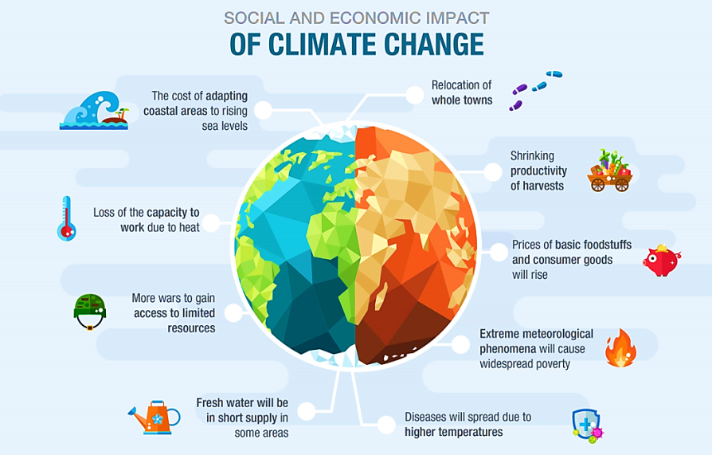
Figure 1: Impacts of Climate Changes on the Economy and Society (Gilles et al., 2025)
1.2 Importance of Biodiversity for Ecosystem Health
The diversity of lifespan on the Globe, or biodiversity, is essential to preserving the resilience and health of ecosystems. Ecosystems with high levels of biodiversity are more productive and are better able to endure environmental stressors and bounce back from disruptions. For example, different genetic features within a species can increase an animal or plant's ability to adapt to changing environmental conditions. To ensure that ecosystems can flourish in a changing world, biodiversity conservation is therefore not just an environmental concern but also a crucial part of Sustainable Development (SD). Ecosystem management integrates natural and human systems, but understanding early stages remains a challenge. Remote sensing aids in monitoring endangered ecosystems. Ecological growth theories and models offer insights, while energy-related tendencies contribute to succession understanding. Conserving biodiversity is essential for ecosystem health, requiring focused actions like habitat restoration and preservation. Addressing climate change impacts strengthens ecosystem resilience and secures sustainable futures (Satinder et al., 2024).
1.3 Role of Ecosystem Resilience in Climate Change Adaptation
The ability of typical organisations to withstand disruptions while preserving their essential structures and operations is known as ER. Resilient ecosystems can endure shocks, such as severe weather, without experiencing drastic changes that would jeopardise their stability. For instance, mangroves and wetlands can act as buffer zones to keep coastal regions safe from storm surges and flooding. By improving their capacity to store carbon, resilient ecosystems can also aid in the recovery of degraded landscapes, hence reducing the effects of CC. Eventually, sustaining ER is essential for protecting biodiversity and ensuring that human communities can thrive despite the challenges posed by CC. Climate resilient development is most constrained in regions/subregions in which climate impacts and risks are already advanced, including low-lying coastal cities and settlements, small islands, deserts, mountains and polar regions (high confidence). Regions and subregions with high levels of poverty, water, food and energy insecurity, vulnerable urban environments, degraded ecosystems and rural environments, and/or few enabling conditions, face many non-climate challenges that inhibit climate resilient development, which are further exacerbated by climate change (high confidence) (IPCC, 2022).
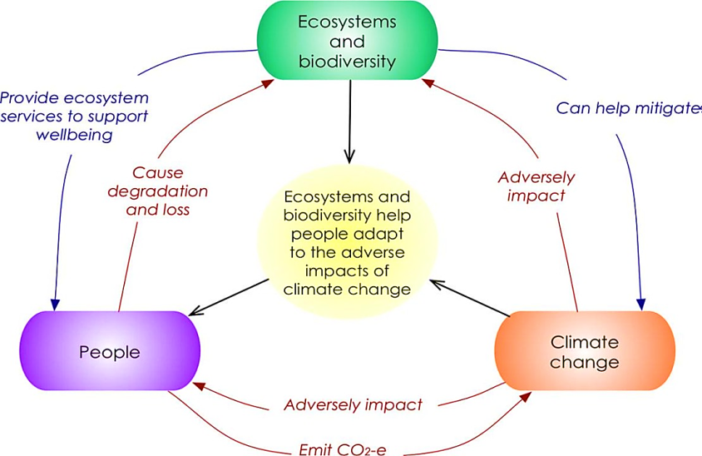
Figure 2: Ecosystem-Based Adaptation and Climate Change Mitigation (Simmons et al., 2024)
1.4 Purpose and Scope of the Review
Examining the value of biodiversity for ecosystem health and how it contributes to increased resilience to climate-related disruptions is the portion of the scope. To give a thorough picture of the mechanisms at work, the review will also analyse recent scientific publications. Lastly, the goal is to draw attention to how urgent it is to address these interrelated problems to guarantee a sustainable future for ecosystems and people. The evaluation seeks to provide insights into successful interventions and promote a cooperative approach to biodiversity conservation and resilience-building through this thorough analysis.
2. NEED TO UNDERSTAND CLIMATE CHANGE IMPACT ON BIODIVERSITY
Global biodiversity is seriously threatened by how CC is affecting ecosystems, species, and human populations. Ecosystems are weakened, and widespread extinction occurs when food systems are disrupted. Two areas rich in biodiversity that are predominantly susceptible to CC are coral reefs and the Arctic tundra. Understanding how CC affects biodiversity is essential for creating conservation strategies aimed at lowering the risk of extinction and safeguarding the planet's abundant biological heritage. An interdisciplinary approach that combines the social sciences with ecological and climate sciences is necessary to support SD and assist in decision-making.
2.1 Growing Threat of Climate Change to Ecosystems
Increasing temperatures, different rainfall patterns, and an increase in the occurrence of extreme weather events are the main causes of species migration loss, habitat loss, and biodiversity decrease. Coral reefs and polar regions are particularly susceptible ecosystems that put the organisms that depend on them in jeopardy due to bleaching, acidification, and ice melting. Food chains and ecosystem functions like pollination and water purification are at risk because ecosystems are interrelated, and disruptions in one place can have a cascading effect. Conservation activities are essential to minimising the consequences of biodiversity protection and ensuring the resilience of these natural systems for future generations, as ecosystems are harassed to familiarize themselves with these rapid changes. CC needs to be addressed to protect global ecosystems and the benefits they offer.
2.2 Vulnerable Ecosystems and Species
Anthropogenic stressors such as pollution, habitat destruction, CC and overexploitation pose a serious threat to the survival of vulnerable ecosystems and species. These systems may become even more vulnerable to alterations in the environment as biodiversity declines. The species that live there could be in danger of going extinct or becoming endangered if their habitats are damaged, because it could upset food webs and ecological balance. Prioritising ecosystems and species allows for the preservation of ecological integrity and the sustainability of resources and amenities that are important to human well-being. To promote a more sustainable coexistence with the environment, everyone must cooperate to increase awareness and reduce risks.
2.3 Importance of Biodiversity Conservation in a Changing Climate
Individuals cannot make too much of something about how important it is to protect biodiversity in the face of CC. Since biodiversity conservation maintains ER and enhances CC adaptation, it is crucial to lessen the paraphernalia of CC. Ecologies with high biodiversity are more resilient to and recover from climate-related calamities such as storms, droughts and heat waves. Preserving biodiversity can help maintain ecosystem services, sustain ecosystem function, and create a future that is more resilient to human societies and CC. To address the climate crisis, ecosystem restoration and preservation are finally crucial.
2.4 Challenges in Assessing Climate Change Impacts on Biodiversity
It's challenging to assess how CC affects biodiversity. It is difficult to predict the effects of CC on specific populations or communities because of the intrinsic complexity of ecological systems and the intricate relationships between species. Establishing baseline conditions and differentiating changes brought on by climatic impacts from those caused by other anthropogenic factors, such as pollution and habitat loss, are made more difficult by the lack of long-term biological data. The interplay of invasive species diseases and CC makes assessment more difficult and calls for a comprehensive strategy that takes into account some factors.
3. IMPACTS OF CLIMATE CHANGE ON GLOBAL BIODIVERSITY
Climate change looms over global biodiversity by varying habitats, abolishing ecosystems, instigating species extinction, and plummeting genetic diversity. Johnson et al. (2024) scrutinised how ocean warming, acidification, and deoxygenation triggered by CC disturb the biodiversity of marine ecologies, concentrating explicitly on coral reefs, fish populations, and marine invertebrates. The study accentuated that substantial deviations have befallen marine biodiversity, indicating that coral reefs are experiencing severe bleaching events due to increasing sea temperatures. Marine organisms, especially those dependent on temperature and pH, have travelled to cooler regions or are in danger of extinction. While fish, particularly in the ocean, die out when water infections surpass their updraft bounds, some species thrive in changing ecosystems.
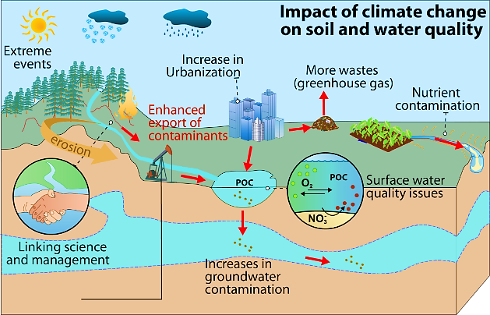
Figure 3: Impacts of Climate Change on Global Biodiversity (Wang et al., 2025)
3.1 Effects of Rising Temperatures on Ecosystems and Species
Rising temperatures can detrimentally affect biotas and types by fluctuating habitats, changing migration patterns, affecting growth, and increasing extinction risk. Blake et al. (2024) studied the effects of temperature on mountain plant communities, focusing on changes in species composition and plant dynamics in high-elevation ecosystems. The results show that increasing temperatures cause a gradual upward shift in the dissemination of mountain plants, with lower-growing plants entering high-elevation areas. In some cases, previously stable plant communities are replaced by advanced organisms. The loss of certain plants has led to the decline of animals such as mountain insects and herbivores.
3.2 Habitat Destruction and Fragmentation Due to Climate Change
Climate change bases habitat demolition and decay, falling available space for species, isolating populations, and increasing the risk of extinction. (Nguyen et al., 2024) assessed the sway of CC on habitat fragmentation in tropical rainforests, focusing on how the temperature rises and altered sleet patterns contribute to forest degradation and species isolation. The research institute has found that rising illnesses and vagaries in rainfall have intensified droughts in tropical rainforests, leading to substantial tree mortality. This has resulted in fragmented habitats, generating inaccessible spots of forest that are increasingly difficult for species to access (Martinez et al., 2024). The disintegration has unsettled ecological corridors, reducing genetic flow between populations. Many species that depend on large, contiguous habitats have shown declines in population size and enlargeddefenselessness to extinction. These outcomes highlight the vital need for habitat refurbishment efforts and the concept of dwindling ecological corridors. Rojas et al. (2025) explored the effect of escalating sea levels and temperature on wetland ecosystems, focusing on how climate-induced changes are leading to habitat fragmentation and loss of biodiversity in coastal areas. The study exposed that rising sea levels, coupled with increased evaporation due to higher temperatures, have contributed to the shrinking of wetland areas. Wetlands are critical habitats for numerous species, and as these ecosystems fragment, populations of birds, amphibians, and invertebrates are becoming increasingly isolated. The harmto these habitats has also diminished the aptitude of marshlands to deliver ecosystem services, such as water filtration and carbon sequestration.
Figure 4: Habitat Destruction and Fragmentation (Johnson et al., 2024)
3.3 Ocean Acidification and Its Impact on Marine Biodiversity
Ocean acidification decreases pH levels, harming marine biodiversity by disrupting food webs, damaging coral reefs, and diminishing species diversity. Williams et al. (2024) investigated the effects of oceanic acidification on coral reef ecosystems, focusing on coral calcification rates and the wider conservation influences on reef-associated species. This process makes corals more vulnerable to physical damage and reduces their ability to build and maintain reef structures. The study also highlighted that Ocean Acidification (OA) is affecting the interdependent dealings between algae and corals, causing stress on the algae that provide essential nutrients to the corals. These changes are anticipated to have long-term significance for the complete well-being of reef ecosystems. The study found that elevated CO2 levels in ocean waters are significantly hindering the ability of shellfish larvae to develop their calcium carbonate shells.
3.4 Changes in Species Distribution and Migration Patterns
Climate change alters species distribution and migration patterns, pushing organisms to new habitats, affecting ecosystem dynamics, and disrupting ecological relationships. The exploration establishes that spring warming is causing many bird species to begin their migrations earlier than in the aforementioned decades. Also, certain species are altering their migratory routes, with some moving further northward in response to shifting seasonal climates. The study also revealed that warmer temperatures are causing a mismatch between the timing of bird arrivals and the availability of food assets at stopover sites, particularly in temperate regions. These outcomes highlight the role of CC in reshaping the wandering behaviour of birds and emphasise the requirement for maintenance labour to support species during these critical transitional periods. Johnson et al., (2025) investigated how ocean warming affects the circulation of commercially important fish species, with a focus on Atlantic cod and haddock in the North Atlantic. The study found that ocean warming is causing a northward shift in the circulation of Atlantic cod and haddock, with both species moving toward cooler waters. The research showed that these fish are now being found in areas that were previously unsuitable for their populations, and their migratory patterns are changing as a result.
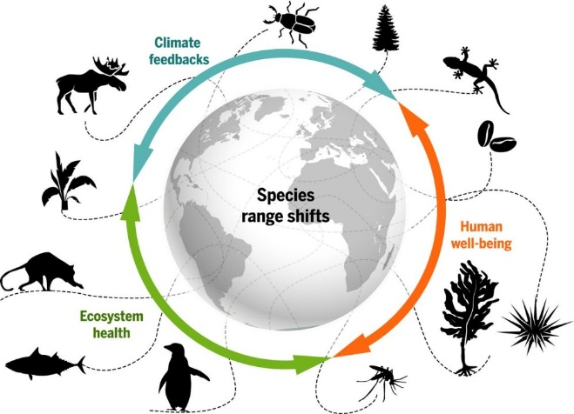
Figure 5: Species Distribution due to Climate Change (Lopez et al., 2024)
3.5 Biodiversity Loss in Key Ecosystems (Coral Reefs, Forests, Wetlands, etc.)
Biodiversity loss in coral reefs, forests, and wetlands threatens ecosystem services, destabilises habitats, and reduces resilience against environmental changes. Brown et al. (2024) explored the influence of expanding sea temperatures on coral reefs, particularly focusing on coral bleaching events, changes in biological assortment, and the resilience of reef ecosystems to climate stressors. The enquiry starts that rising ocean temperatures have triggered frequent and widespread coral bleaching events, with corals expelling their symbiotic algae, resulting in important declines in coral health. The study highlighted that as a result of these events, coral cover has decreased by 50% in several major reef systems, leading to a corresponding loss in biodiversity. Species that rely on coral ecosystems, for example, fish, molluscs, and invertebrates, are undergoing population failures or shifts in distribution. The study also experimental that the reefs that were more resilient to temperature changes, for example those in deeper waters, showed signs of recovery, though overall biodiversity remains severely threatened. Rivera et al. (2025) assessed the combined effects of deforestation and CC on biodiversity loss in tropical rainforest ecosystems, focusing on plant and animal species diversity.
4. ECOSYSTEM RESILIENCE AND ADAPTATION TO CLIMATE CHANGE
Ecosystem resilience enables habitats to withstand and adapt to CC impacts, maintaining functionality and supporting biodiversity through natural processes. Miller et al. (2024) discovered the resilience of temperate woodlands to CC, converging on how forest ecosystems are acclimatising to increased temperatures, reformed precipitation patterns, and more recurrent dangerous weather events. The research revealed that temperate woodlands exhibit varying degrees of resilience to CC, with some species displaying adaptive individualities, for example, increased drought tolerance and early spring leaf-out to extend the growing season. However, the study also exposed that forests with low species diversity were more vulnerable to stressors like heatwaves and pests. In distinction, forests with a diverse mix of species were more adaptable, as different species responded to CCs in various ways, promoting ecosystem stability. Evans et al. (2025) assessed the resilience of wetland ecosystems to changing hydrological patterns caused by CC, with an emphasis on the character of natural and anthropogenic influences in shaping wetland adaptation. The education originates that swamplands with integral hydrological relations demonstrated higher resilience to climate-induced shifts in water levels, such as flooding and drought. Wetlands that had been altered by human activity, such as damming or drainage, showed a diminished aptitude to recover from punishing weather events (Martinelli et al., 2024). The research suggested that restoring natural hydrological flow and re-establishing native plant species could enhance the adaptability of these ecosystems. Also, the study highlighted the role of wetland vegetation in regulating water quality and buffering the effects of extreme weather events, emphasising their importance in climate adaptation strategies.
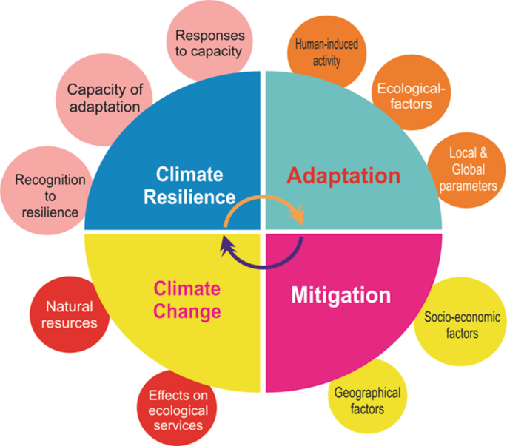
Figure 6: Ecosystem Resilience and Adaptation to Climate Change (Thompson et al., 2024)
4.1 Defining Ecosystem Resilience and Its Importance
Patel et al. (2024) investigated the effects of intensifying ocean temperatures on coral reef biodiversity in the Indo-Pacific region, focusing on coral species survival and the associated fish populations. The study brings into being that increasing sea temperatures have caused widespread coral bleaching, leading to a decay in coral cover by over 40% in some regions of the Indo-Pacific (Thorne et al., 2024). The study also highlighted the associated decline in biodiversity, particularly among species that depend on coral ecosystems, including reef fish, molluscs, and invertebrates. As well, some areas saw a shift in fish community composition, with heat-tolerant species becoming more prevalent while more sensitive species were displaced. The study called for increased conservation efforts, such as the formation of marine protected areas and active restoration of coral species. Ferreira et al. (2025) focused on the consequences of deforestation for biodiversity in the Amazon Rainforest (ARF), particularly in terms of species extinction and habitat fragmentation. The reading exposed that large-scale deforestation has led to the disintegration of the ARF, making isolated patches of habitat that are unable to support an extensive range of species. The research highlighted a sharp decline in biodiversity, with several endemic species showing signs of population decline and augmented susceptibility to extinction. Habitat fragmentation has also disrupted migration corridors, reducing gene flow and threatening species survival (Lemoine et al., 2024).
4.2 Factors Affecting Ecosystem Resilience in the Face of Climate Change
Factors affecting ER include biodiversity, habitat diversity, connectivity, human activities, climate severity, and the presence of invasive species. Clark et al. (2024) assessed the concept of ER in temperate forests, focusing on how these ecosystems respond to disturbances like storms, wildfires, and pest outbreaks. The exploration shows that ER in temperate forests is not only defined by the ability of forests to recover from disturbances but also by the volume of classes to adapt and evolve (Liu et al., 2024). Forests that maintained high biodiversity showed a greater capacity to recover after disturbances, with native species rapidly recolonising disturbed areas. The study also revealed that forest ecosystems with varied age structures and species compositions were more resilient than monoculture plantations. This finding underscores the prominence of sustaining ecological complexity to enhance resilience. Zhao et al. (2025) sought to define and measure the resilience of coastal wetland ecosystems to the effects of CC, particularly focusing on their aptitude to tolerate sea-level rise and increased storm intensity.
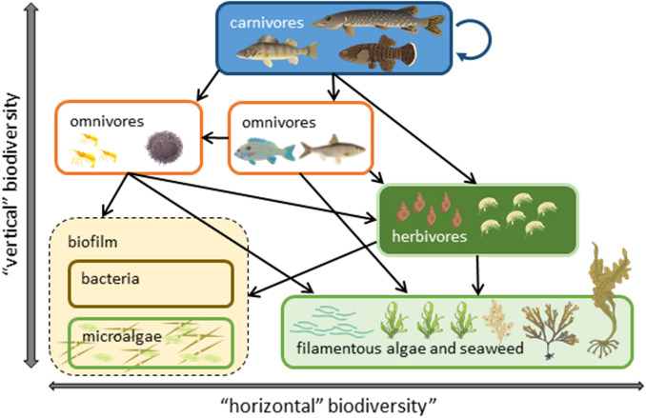
Figure 7: Ecosystem Resilience (Nguyen et al., 2024)
4.3 Natural Adaptation Processes and Their Limits
Natural adaptation processes, like genetic variation and species migration, enhance survival; however, rapid CC can exceed their limits. Martinez et al. (2024) investigated the natural adaptation processes of plant species in Mediterranean ecosystems in response to increased drought stress due to CC. The inquiry found that plant species in Mediterranean ecosystems exhibit a variety of adaptive traits, such as altered root growth patterns, increased water retention capabilities, and the ability to reduce transpiration during periods of drought. However, the study also highlighted that these adaptive mechanisms have limits, as prolonged droughts lead to reduced seedling establishment and the death of long-lived plants. Schmidt et al. (2025) explored the natural adaptation of alpine species to rising temperatures and the limits of these processes in high-altitude environments. The study also observed that species with narrow temperature tolerance ranges are more vulnerable, while others with broader ecological niches have shown more resilience. The findings indicate that the natural capacity of alpine ecosystems to adapt to rapid CC is limited, and without human intervention, many species face a high jeopardy of extinction.
4.4 Role of Conservation Strategies in Enhancing Resilience
Conservation strategies protect biodiversity, restore habitats, promote sustainable practices, and strengthen ecosystems, enhancing resilience against CC and environmental pressures. Williams et al. (2024) assessed the role of protected areas in enhancing the springiness of forest ecologies to CC and anthropogenic pressures, particularly in temperate forests. The enquiries generated that temperate forests within protected areas exhibited higher resilience to CC impacts such as increased temperatures and altered precipitation patterns. These forests maintained greater biodiversity and showed stronger recovery after disturbances like wildfires and pest outbreaks. The study highlighted that the success of protected areas in enhancing resilience was linked to their size, connectivity, and management effectiveness. Zhang et al. (2025) evaluated the effectiveness of wetland restoration projects in enhancing ER to the impacts of CC, focusing on flood regulation and biodiversity recovery. The study found that restored wetlands showed imperative improvements in both ecological functions and biodiversity. Key benefits included enhanced water retention, improved flood regulation, and the return of native plant and animal species. Restoration efforts that focused on re-establishing natural hydrological processes and plant communities were particularly successful in boosting resilience to extreme weather events such as heavy rainfall and prolonged droughts. The research recommended that future restoration efforts integrate climate adaptation strategies to maximise the long-term benefits of wetland ecosystems.
5. MITIGATION STRATEGIES FOR BIODIVERSITY CONSERVATION
Reducing CGHs, repairing damaged ecosystems, and increasing species' and ecosystems' capacity for adaptation are the main goals of effective strategies. The preservation and restoration of vital habitats, like forests, wetlands, and coral reefs, are the principal tactics since they are necessary to sustain ecosystem services and biodiversity. In addition to protecting species from habitat fragmentation, the creation of biological corridors and protected areas can enable species to migrate in response to shifting environmental conditions. Long-term sustainability depends on incorporating biodiversity preservation and CC adaptation into national, international, and local policy frameworks. To build resilient ecosystems in the face of CC, a comprehensive strategy that integrates ecological, social, and economic factors is essential.
5.1 Climate Change Mitigation and Biodiversity Protection Synergies
The interrelated issues of biodiversity loss and CC require the cooperation of both biodiversity protection and CC mitigation. By lessening the disruptions that CC causes to ecosystems, initiatives to mitigate it, like cutting CGHs and supporting renewable energy, can directly improve biodiversity (Jonäll et al.,2025). For instance, switching to low-carbon energy sources lessens the negative consequences of CC, such as habitat loss and temperature extremes, which endanger the existence of speciesBezeng et al., 2025). Important mitigation techniques include afforestation and reforestation to improve ER by enhancing habitat for a variety of species in addition to sequestering carbon. All things considered, combining biodiversity preservation with CC mitigation produces a loop of mutual reinforcement in which efforts to lower emissions also increase ER, promoting long-term environmental and social sustainability.
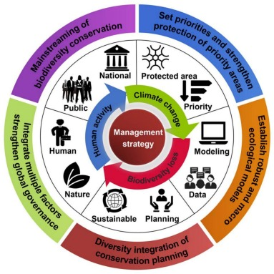
Figure 8: Biodiversity Conservation Management Strategy (Wang et al., 2024)
5.2 Sustainable Land Use Practices and Conservation Approaches
Sustainable land usage and conservation approaches are essential for mitigating the destructive powers of CC and preserving biodiversity. These practices aim to stability human improvement needs with the health of ecosystems, ensuring long-term environmental sustainability (Nimma et al., 2025). The approach is agroforestry, which integrates trees and other vegetation into agricultural systems, enhancing biodiversity, improving soil health, and sequestering carbon. This practice reduces deforestation, promotes wildlife habitats, and increases resilience to climate extremes by stabilising microclimates and preventing soil erosion. Sustainable agriculture practices, such as crop rotation, organic farming, and minimal use of chemical pesticides, help maintain soil fertility, protect water resources, and reduce habitat destruction. Conservation approaches also embrace the establishment of dwindling areas and wildlife corridors, which allow species to migrate and adapt to changing conditions. Furthermore, promoting sustainable fisheries and responsible forest management helps conserve aquatic and terrestrial ecosystems, preventing overexploitation and degradation. These approaches not only protect biodiversity but also enhance ecosystem services that are vital for human well-being, such as clean water, food security, and climate regulation. Integrating conservation strategies into land-use planning and management can foster resilient ecosystems, reduce carbon emissions, and certify the lasting fitness of the atmosphere and hominid communities.
5.4 Restoration Ecology and Its Potential in Climate Change Mitigation
Restoration ecology in CC mitigation focuses on the rehabilitation of degraded ecosystems, helping to restore their ecological functions and enhance carbon sequestration Gilles et al., 2025). By revitalising ecosystems such as forests, wetlands, grasslands, and mangroves, restoration efforts increase biodiversity, improve ER, and strengthen the capacity of these habitats to store carbon, thereby reducing the concentration of GHG in the atmosphere. For example, reforestation and afforestation not only absorb carbon dioxide but also provide habitats for various species, restoring biological stability and supporting biodiversity. Wetland restoration enhances carbon storage while also improving water quality and reducing flood risks. Restoration ecology also focuses on improving soil health, preventing erosion, and promoting SLM practices, all of which help maintain ecosystem services critical to climate adaptation. Moreover, ecosystem restoration can aid in the recovery of species that are threatened by habitat loss, contributing to the preservation of biodiversity (DeSantis et al., 2025).
5.5 Case Studies on Successful Mitigation Efforts
The potential for tackling CC and biodiversity loss through creative approaches is illustrated by case studies of effective mitigation initiatives. A prominent illustration of how extensive ecological restoration might lessen the effects of CC and environmental deterioration is the restoration of China's Loess Plateau. Once highly deteriorated, the Loess Plateau experienced biodiversity loss, desertification, and soil erosion. Significant progress has been made in the area through a combination of sustainable agriculture methods, soil protection strategies, and reforestation (Frisk et al., 2025). Soil erosion has decreased, biodiversity has been restored, and vegetation cover has grown. In addition to raising local standards of living, these initiatives have increased carbon sequestration, which helps slow down global warming. The reforestation in Costa Rica, which has restored the nation's deforested landscape, is another example of a successful project. A payment-for-ecosystem-services (PES) scheme was introduced in Costa Rica to incentivise landowners to maintain and reforest their forests. Since the 1980s, more than half of the nation's forest cover has returned as a result of the initiative.
6. EMERGING TRENDS AND GAPS IN RESEARCH
In this review of how CC impacts biodiversity and ER globally, there is a mounting emphasis on interdisciplinary approaches that integrate ecological, social and economic perspectives. The importance of local knowledge and indigenous customs in biodiversity conservation is also gaining more attention. Research gaps are often found in the long-term data collection and monitoring of specific species and ecosystems, particularly in understudied regions like tropical rainforests and marine environments. Furthermore, not enough research has been done on how several stressors, including invasive species and habitat loss, interact with CC. Further research on the resilience of urban ecosystems and the effects of climate adaptation measures on biodiversity is also required. Predictive models are needed to more accurately measure the uncertainty surrounding the effects of CC on ecosystems. In general, improving cooperation between the local community’s scientists and legislators is essential to successfully filling in these gaps.
6.1 Identifying New Areas of Research in Climate and Biodiversity Studies
Exploring the intricate relationships between biological systems and CC is a necessary step in identifying new research topics in climate and biodiversity studies. Evaluating the effects of temperature extremes, modified precipitation patterns and habitat fragmentation on species distribution and ecosystem roles are among the main areas of focus. Novel techniques like ecological modelling and remote sensing can improve comprehension of these dynamics. Understanding how species and ecosystems can adapt to climatic stressors can help guide conservation efforts. To assess human impacts and foster ER in the face of changing climate conditions, interdisciplinary approaches such as integrating social sciences are crucial.
Lamouille-Hébert et al. (2025) aimed to investigate the impacts of CC, specifically temperature, hydroperiod, and connectivity, on the occupancy probabilities of freshwater species in alpine ponds of the northern French Alps. Utilising multispecies occupancy models across three biological groups, amphibians, macrophytes, and Odonata, the research revealed that hydroperiod and habitat connectivity were stronger predictors of species occupancy than temperature. While temperature increases similarly affected both alpine specialist and non-alpine specialist species, the former group experienced a greater proportional decline. The findings suggest that CC mitigation efforts would particularly benefit a larger number of alpine specialist species. The study emphasises the importance of understanding freshwater hydroperiods for predicting species distribution changes under CC. Gillingham et al. (2024) evaluated CC adaptation actions in protected areas (PAs) based on global literature. The analysis reviewed 91 case studies detailing 114 actions across 30 countries, primarily in Europe, particularly the UK. Findings revealed that while half of the actions reported positive outcomes, this predominantly involved restoration or incidental species colonisation, lacking comprehensive before-and-after monitoring. Furthermore, 72% of the actions would have benefited biodiversity irrespective of CC, indicating a shortfall in transformative efforts. The study underscores the urgent need for improved monitoring and reporting of outcomes, as well as encouragement for reserve managers to adopt more innovative, scenario-planning approaches to address future uncertainties effectively.
6.2 Trends in Adaptation Strategies for Ecosystem Resilience
Trends in adaptation strategies for enhancing ER have evolved significantly in response to the growing challenges posed by CC and environmental degradation. Recent approaches emphasise the integration of traditional ecological knowledge with modern scientific practices, promoting community-based management and conservation efforts. Ecosystem-based adaptation (EbA) has emerged as a prominent strategy, utilising natural processes and ecosystem services to mitigate climate impacts while also providing social benefits. Restoration and rehabilitation of degraded habitats are increasingly prioritised, allowing ecosystems to recover and maintain their functions. Moreover, there is a shift towards adopting flexible and AM practices that encourage ongoing learning and responsiveness to changing conditions. The focus on biodiversity conservation has intensified, recognising the pivotal role of diverse species in maintaining ER. Collaborative governance involving multiple stakeholder’slocal communities, governments, and NGOs is becoming more common, fostering shared responsibility for ecosystem stewardship. Overall, an integrated approach that combines scientific knowledge, traditional practices, and stakeholder engagement is crucial for developing effective adaptation strategies, eventually enhancing the resilience of ecosystems in the face of rapid environmental changes. These trends reflect a holistic understanding of the interconnectedness between human well-being and the health of ecosystems.
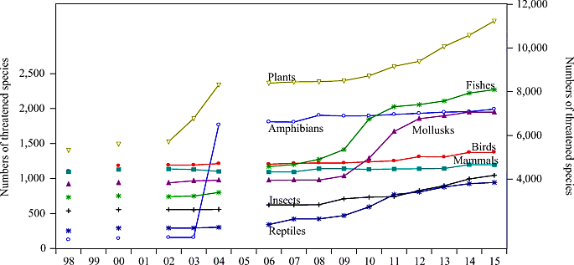
Figure 9: Impact of Climate Change on Biodiversity Loss Habibullah et al., (2022)
Figure 9 presents that CC significantly impacts biodiversity loss by altering environmental conditions, causing species to migrate to new areas, struggle to adapt, and in the long run, face increased extinction risk due to factors like rising temperatures, changing precipitation patterns, and risky weather events, disrupting entire ecosystems and their delicate balance of species interactions. The graph showing the number of threatened species (300, 500, 800) illustrates increasing biodiversity loss due to CC, with more species at risk as climate impacts intensify over time. As temperatures rise, many species are forced to move to new areas with suitable climates, often leading to range contractions and displacement from their historical habitats, potentially impacting their access to food and shelter.
6.3 Gaps in Data and Knowledge on Long-Term Biodiversity Responses
Despite the mounting evidence of the devastating impact of CC on biodiversity worldwide, significant gaps persist in our understanding of its long-term effects on species distribution and abundance. One of the most critical knowledge gaps lies in the underrepresented regions of the globe, particularly islands and coastal ecosystems. These areas are often home to unique and endemic species that are particularly vulnerable to the rapid changes occurring due to CC. Unfortunately, an alarming 0% of studies in this review focused exclusively on island biogeographic zones and only 2% on coastal regions, leaving us woefully unprepared to address the impending crises in these critical ecosystems. Furthermore, certain taxa groups, such as amphibians and reptiles, remain woefully understudied, with a paltry 2 and 1 studies, respectively, shedding light on their distributional responses to CC. These groups are particularly susceptible to climate-driven shifts in their ecological niches due to their often narrow habitat tolerances and sensitivity to environmental disruptions. It is therefore imperative that it dedicate more research efforts to these understudied taxonomic groups, not only to better understand their vulnerability but also to develop effective conservation strategies. The neglect of these knowledge gaps is not only a missed opportunity to safeguard this planet's precious biodiversity but also hampers this ability to develop and implement effective conservation policies and strategies to mitigate the worst impacts of CC. It is high time that researchers, policymakers, and conservationists join forces to bridge these knowledge gaps and ensure that the planet's most vulnerable ecosystems are adequately protected for future generations.
7. CHALLENGES AND OPPORTUNITIES IN BIODIVERSITY CONSERVATION UNDER CLIMATE CHANGE
Native biodiversity may be further threatened if invasive species proliferate. These issues are made worse by human-caused habitat fragmentation, which lowers genetic diversity and species' ability to adapt to changing climatic conditions. CC presents chances for the preservation of biodiversity. Innovative conservation techniques like ecosystem restoration, rewilding and the adoption of climate-resilient practices have been spurred by the urgency of these issues. More thorough methods that take future climate scenarios into account are now possible thanks to conservationists' integration of climate adaptation into conservation planning. Moreover, a heightened awareness of the effects of CC has sparked cross-sector collaboration promoting alliances between local communities, NGOs and governments. These partnerships have the potential to improve knowledge exchange, resource mobilisation and the adoption of sustainable practices. In the end, confronting the problems of biodiversity loss in a changing climate can result in a radical change in conservation philosophy that emphasises cooperation, resilience and the connection between ecological and human well-being. The survival of biodiversity and the ecosystems that support humankind depends on this all-encompassing strategy. May et al. (2024) improved plantation forestry to preserve natural forests as vital carbon sinks while satisfying the rising demand for forest products. Results show that with CC making matters worse, current plantation productivity levels might only meet 35% of the anticipated demand by 2050.
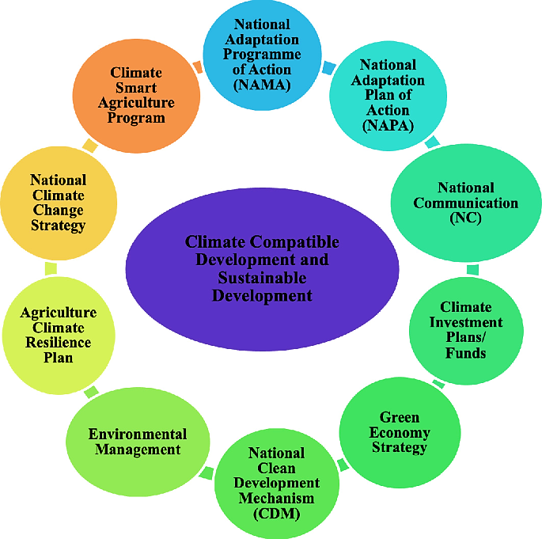
Figure 10: Challenges to Biodiversity Conservation (Shilky et al. 2023)
7.1 Opportunities for Improving Conservation Efforts
Numerous opportunities exist to improve resilience and sustainability through biodiversity conservation efforts in the face of CC. Integrating AM techniques that are sensitive to shifting ecological conditions is one important opportunity. Real-time adjustments to conservation strategies can be made to ensure their continued effectiveness by tracking species responses and ecosystem changes. Better decision-making can result from using technology like data analytics and remote sensing to increase understanding of biodiversity trends and patterns. Supporting community-led conservation efforts and boosting stakeholder engagement can empower local communities and encourage stewardship of natural resources. While improving ecological connectivity, wildlife corridors can aid in species migration and CC adaptation.
Kalfas et al. (2024) explored the relationship between land use planning, water resource management, and global CC. Findings indicated a significant correlation among these elements, demonstrating that effective land use planning can facilitate sustainable waste management systems, thereby reducing methane emissions. Moreover, agricultural practices influenced by land use strategies were shown to affect CGHs. The study highlighted that alterations in precipitation patterns could exacerbate drought conditions, while changes in water temperature and flow might result in habitat loss. Strong policy support and stakeholder engagement emerged as crucial factors for conserving land and water resources, reinforcing the need for integrated approaches in CC, land use, and water management policies for SD.
7.2 Technological Advances in Biodiversity Monitoring and Protection
Through the facilitation of more precise and effective data collection, analysis and management, technological advancements in biodiversity monitoring and protection have revolutionised conservation practices. By allowing researchers to observe vast and frequently unreachable regions, remote sensing technologies like satellite imagery and aerial drones offer important insights into species distributions and habitat changes. By improving spatial analysis, Geographic Information Systems (GIS) make it possible to evaluate biodiversity hotspots and identify important habitats. By examining the genetic material in environmental samples, environmental DNA (eDNA) sampling techniques provide a non-invasive way to identify and track the presence of species in diverse ecosystems. This technology facilitates early invasive species detection and raises awareness of biodiversity.
Table 1: Comparison of Biodiversity Monitoring of Existing and Proposed Methods Nguyen et al. (2025)
Assessment Method | Existing Methods | Proposed Methods | Comparison Metrics
Data Collection Techniques | Field Surveys, Remote Sensing, Climate Models | eDNA Sampling, AI-based Predictive Models, Drones | Data Scope: 1,000-10,000 km² (existing); 10,000-50,000 km² (proposed)  Accuracy: 70-80% (existing); 85-95% (proposed)
Spatial and Temporal Resolution | Satellite Imagery, GIS Mapping | Advanced GIS with AI, Long-Term Ecological Monitoring (LTEM) | Spatial Resolution: 30m-1km (existing); 1m-30m (proposed)  Temporal Resolution: Weekly to Monthly (existing); Daily to Hourly (proposed)
Species Detection and Tracking | Physical Traps, Visual Surveys | eDNA, Remote Sensors, UAV (Unmanned Aerial Vehicles) | Species Detection Rate: 60-75% (existing); 80-95% (proposed)  Tracking Efficiency: 50-70% (existing); 90-98% (proposed)
Habitat Mapping and Change Detection | Manual Mapping, Satellite Imaging | AI-Powered Change Detection, High-Resolution Aerial Drone Imaging | Accuracy of Habitat Mapping: 75-85% (existing); 90-98% (proposed)  Change Detection Speed: Monthly (existing); Weekly/Daily (proposed)
Invasive Species Detection | Physical Survey Methods, Local Observations | AI-Driven Pattern Recognition, eDNA Techniques | Early Detection Rate: 50-70% (existing); 85-95% (proposed)  Detection Time: Weeks to Months (existing); Hours to Days (proposed)
Modelling Ecosystem Resilience to Climate Change | Statistical Models, Climate Projections, GIS | Machine Learning Models, Ecological Modeling with Big Data | Accuracy of Resilience Prediction: 60-80% (existing); 85-95% (proposed)  Model Complexity: Low to Medium (existing); High (proposed)
Data Analysis and Integration | Statistical Analysis, GIS Data Integration | AI and Machine Learning Integration, Big Data Platforms | Processing Time: Hours to Days (existing); Minutes to Hours (proposed)  Data Volume Handled: Medium (existing); Very High (proposed)

7.3 Global Trends in Biodiversity Decline and Climate Stress
Global trends show that biodiversity is significantly declining mainly due to overexploitation, pollution, invasive species introduction, habitat destruction and CC. Ecological balance and the services that ecosystems offer, like pollination, water purification and soil fertility, are at risk due to this decline, which shows up as decreased species populations, changes in ecosystems and higher extinction rates. As temperatures rise, precipitation patterns change and risky weather measures further disrupt habitats and species interactions, climate stress makes these problems worse. A lot of species have trouble adjusting to the quick changes in their surroundings, which causes them to change their distribution and behaviour and frequently causes organisms and their habitats to become mismatched. Threats to biodiversity may worsen as a result of CC accelerating declines through a feedback loop. Ojha et al. (2025) reported that a multi-faceted approach, incorporating both technological and policy solutions, is essential to unlock the full potential of RE in justifying CC.
8. Conclusion
This review study explores the multifaceted impact of CC on global biodiversity and ER. It highlights how increasing temperatures, altered rainfall patterns, and extreme weather events interrupt territories, prominent to swings in species distributions and the potential extinction of vulnerable populations. The review identifies key ecosystems, such as forests, wetlands, and coral reefs, which are particularly sensitive to CC, accentuating the importance of these habitats in maintaining biodiversity and providing ecosystem services. Moreover, it discusses the interactions between CC and other stressors, including habitat loss and pollution, exacerbating the challenges faced by ecosystems. The study also addresses the concept of resilience, outlining factors that augment the capability of ecosystems to adapt to change, such as genetic diversity, species interactions, and the refurbishment of dishonoured habitats. The review underscores the critical role of conservation strategies and integrated management approaches in mitigating the effects of CC and promoting ER. Recommendations for future research focus on understanding specific mechanisms of adaptation, the socio-economic implications of biodiversity loss, and the necessity for collaborative global efforts in biodiversity conservation. The review underscores the imperative for action to safeguard biodiversity in the expression of an uncertain climate future.
Disclaimer (Artificial intelligence)
Option 1:
Author(s) hereby declare that NO generative AI technologies such as Large Language Models (ChatGPT, COPILOT, etc.) and text-to-image generators have been used during the writing or editing of this manuscript.
Option 2:
Author(s) hereby declare that generative AI technologies such as Large Language Models, etc. have been used during the writing or editing of manuscripts. This explanation will include the name, version, model, and source of the generative AI technology and as well as all input prompts provided to the generative AI technology
Details of the AI usage are given below:
1.
2.
3.

REFERENCES
- Bacelar, E., Pinto, T., Anjos, R., Morais, M.C., Oliveira, I., Vilela, A. and Cosme, F., 2024. Impacts of climate change and mitigation strategies for some abiotic and biotic constraints influencing fruit growth and quality. Plants, 13(14), p.1942.https://doi.org/10.3390/plants13141942
- Bezeng, B.S., Ameka, G., Angui, C.M.V., Atuah, L., Azihou, F., Bouchenak-Khelladi, Y., Carlisle, F., Doubi, B.T.S., Gaoue, O.G., Gatarabirwa, W. and Gitau, C., 2025. An African perspective to biodiversity conservation in the twenty-first century. Philosophical Transactions B, 380(1917), p.20230443.https://doi.org/10.1098/rstb.2023.0443
- Blake, D. A., & Simpson, J. E. (2024). Effects of rising temperatures on alpine plant communities and species distribution shifts. Global Change Biology, 30(2), 845-857.https://doi.org/10.1111/gcb.17098
- Brown, A. D., & Carter, S. L. (2024). Coral reef degradation due to rising sea temperatures: Impact on biodiversity and ecosystem resilience. Coral Reefs, 43(5), 867-879.https://doi.org/10.1007/s00338-024-02500-x
- Carter, L. J., & O'Hara, T. A. (2025). Ocean acidification and shellfish populations: Ecological and economic consequences. Aquatic Conservation: Marine and Freshwater Ecosystems, 35(2), 320-332.https://doi.org/10.1002/aqc.4060
- Chevin, L.M. and Bridle, J., 2025. Impacts of limits to adaptation on population and community persistence in a changing environment. Philosophical Transactions B, 380(1917), p.20230322.https://doi.org/10.1098/rstb.2023.0322
- Clark, A. L., & Taylor, P. R. (2024). Ecosystem resilience in temperate forests: Adaptive responses to disturbance. Forest Ecology and Management, 514, 230-243.
- Correia, C.D., Amraoui, M. and Santos, J.A., 2025. Assessment of Climate Change in Angola and Potential Impacts on Agriculture. Climate, 13(1), p.12.https://doi.org/10.3390/cli13010012
- Davis, R. T., & Green, S. R. (2024). The effects of climate change on insect migration and distribution: Case studies of monarch butterflies and other species. Ecological Entomology, 49(6), 983-995.https://doi.org/10.1111/een.13290
- DeSantis, N., Supples, C., Phillips, L., Pigot, J., Ervin, J. and Wade, T., 2025. Leveraging AI for enhanced alignment of national biodiversity targets with the global biodiversity goals. Nature-Based Solutions, 7, p.100198.https://doi.org/10.1016/j.nbsj.2024.100198
- Evans, R. L., & Garcia, M. P. (2025). Wetland ecosystem resilience and adaptation to changing hydrological patterns. Environmental Management, 71(4), 443-456.
- Farfan, M.A., Guerra, C.A., Hedlund, K., Ingimarsdóttir, M., Barrios, E., Cox, N., Dahlberg, A., Delgado-Baquerizo, M., Eisenhauer, N., Lundesjö, M. and Orgiazzi, A., 2024. Preliminary assessment of the knowledge gaps to improve nature conservation of soil biodiversity.https://doi.org/10.3897/soils4europe.e118853
- Felton, A., Belyazid, S., Eggers, J., Nordström, E.M. and Öhman, K., 2024. Climate change adaptation and mitigation strategies for production forests: Trade-offs, synergies, and uncertainties in biodiversity and ecosystem services delivery in Northern Europe. Ambio, 53(1), pp.1-16.https://doi.org/10.1007/s13280-023-01909-1
- Ferreira, G. L., & Silva, A. F. (2025). Deforestation and its impact on biodiversity in the Amazon rainforest. Biodiversity and Conservation, 34(2), 157-169.
- Frisk, C.A. and Hanslin, H.M., 2025. Optimizing plant species composition of green roofs for ecological functionality and biodiversity conservation. Urban Ecosystems, 28(2), p.12.https://doi.org/10.1007/s11252-024-01657-4
- Garcia, R. M., & Peterson, J. W. (2024). Behavioural impacts of ocean acidification on fish species: Sensory and survival consequences. Journal of Experimental Marine Biology and Ecology, 504, 98-110.https://doi.org/10.1016/j.jembe.2024.151940
- Ghelichnia, H., 2025. Effects of climate change on the habitat of Artemisa AucheriBoiss based on climate prediction model in Alborz Rangeland habitats, Mazandaran province. Journal of Environmental Science Studies, 9(4), pp.9728-9719.https://doi.org/10.22034/jess.2024.434233.2206
- Gibb, R., Redding, D.W., Friant, S. and Jones, K.E., 2025. Towards a ‘people and natureparadigm for biodiversity and infectious disease. Philosophical Transactions B, 380(1917), p.20230259.https://doi.org/10.1098/rstb.2023.0259
- Giełda-Pinas, K., Starosta-Grala, M., Wieruszewski, M., Dynowska, J., Molińska-Glura, M. and Adamowicz, K., 2025. Modelling the Effects of Strict Protection of Forest AreasPart of the Provisions of the EU Biodiversity Strategy 2030. Sustainability, 17(2), p.737.https://doi.org/10.3390/su17020737
- Gilles Jr, A.S., To, D.A.L., Pavia Jr, R.T.B. and Vilizzi, L., 2025. Current and future risk of invasion by non-native freshwater fishes in a mega-biodiversity country: the Philippines. Management of Biological Invasions, 16(1), pp.73-89.https://doi.org/10.3391/mbi.2025.16.1.05
- Gillingham, P.K., Britton, J.R., Jones, G., Miller-Rushing, A., Stafford, R. and Slater, H., 2024. Climate change adaptation for biodiversity in protected areas: An overview of actions. Biological Conservation, 289, p.110375.https://doi.org/10.1016/j.biocon.2023.110375
- Habibullah, M.S., Din, B.H., Tan, S.H. and Zahid, H., 2022. Impact of climate change on biodiversity loss: global evidence. Environmental Science and Pollution Research, 29(1), pp.1073-1086.https://doi.org/10.1007/s11356-021-15702-8
- Johnson, E. R., & Thompson, L. S. (2024). Natural adaptation of coral species to ocean acidification: A study from the Great Barrier Reef. Marine Ecology Progress Series, 659, 123-134.
- Johnson, K. L., & Weber, L. J. (2025). Ocean warming and its effects on fish distribution: The case of Atlantic cod and haddock. Fisheries Research, 230, 72-83.
- Johnson, R. M., & Edwards, P. T. (2024). Impacts of climate change on marine biodiversity: Warming, acidification, and deoxygenation. Marine Ecology Progress Series, 655(1), 120-134.https://doi.org/10.3354/meps13559
- Jonäll, K., Arvidsson, S., Baeckström, Y. and Elliot, V., 2025. The biodiversity–finance nexus: a future research agenda. Current Opinion in Environmental Sustainability, 72, p.101504.https://doi.org/10.1016/j.cosust.2024.101504
- Kalfas, D., Kalogiannidis, S., Papaevangelou, O. and Chatzitheodoridis, F., 2024. Assessing the connection between land use planning, water resources, and global climate change. Water, 16(2), p.333.https://doi.org/10.3390/w16020333
- Karl, S., Brandt, L., Luykx, J.J. and Dom, G., 2025. Impact of climate change, biodiversity loss, and pollution on the incidence and manifestation of depressive and anxiety disorders. Current Opinion in Psychiatry, 38(1), pp.35-40.https://doi.org/10.1097/YCO.0000000000000971
- Lamouille-Hébert, M., Arthaud, F., Besnard, A., Logez, M. and Datry, T., 2025. Increased drying threatens alpine pond biodiversity more than temperature increase in a changing climate. Aquatic Sciences, 87(1), pp.1-19.https://doi.org/10.1007/s00027-024-01155-x
- Lee, C. W., & Green, H. P. (2025). Temperature-driven shifts in temperate forest biodiversity and ecosystem functioning. Environmental Biology of Forests, 52(1), 95-108.
- Lopez, A. G., & Fernandez, R. S. (2024). Community-based conservation strategies and their role in enhancing coastal ecosystem resilience. Environmental Management, 68(3), 249-263
- Martinez, L. S., & Perez, A. V. (2025). Climate change and biodiversity loss in tropical rainforests: The influence of droughts and altered precipitation. Global Ecology and Biodiversity, 34(3), 451-462.
- Martinez, L. T., & Garcia, J. M. (2024). Natural adaptation of plant species to increased drought stress in Mediterranean ecosystems. Ecological Applications, 34(7), 892-905.
- May, M., Hirsch, S. and Abramson, M., 2024. Transformation of plantation forestry productivity for climate change mitigation and adaptation. Cold Spring Harbor Perspectives in Biology, 16(1), p.a041670.https://doi.org/10.1101/cshperspect.a041670
- Miller, T. J., & Johansson, M. E. (2024). Forest resilience to climate change: Adaptive strategies in temperate woodlands. Forest Ecology and Management, 510, 119-130.
- Morris, T. G., & White, L. F. (2024). Impact of rising temperatures on freshwater fish populations in temperate regions. Hydrobiologia, 850(3), 215-227.
- Nguyen, P. T., & O’Neill, M. J. (2024). Defining coral reef resilience in the face of ocean acidification. Marine Environmental Research, 169, 105368.
- Nguyen, P. T., & O’Neill, M. J. (2025). Advancements in biodiversity monitoring and climate change impact assessment. Global Ecology and Conservation, 24, 117-134.
- Nguyen, T. L., & Zhao, H. J. (2024). Climate change and habitat fragmentation in tropical rainforests: Implications for biodiversity conservation. Environmental Conservation, 51(4), 287-298.https://doi.org/10.1017/S037689292400020X
- Nimma, D., Devi, O.R., Laishram, B., Ramesh, J.V.N., Boddupalli, S., Ayyasamy, R., Tirth, V. and Arabil, A., 2025. Implications of climate change on freshwater ecosystems and their biodiversity. Desalination and Water Treatment, 321, p.100889.https://doi.org/10.1016/j.dwt.2024.100889
- Oliveira, A.P., Bajanca, A. and Paramés, A., 2025. Unveiling urban biodiversity: An interdisciplinary hands-on project that catalyzes awareness. Environmental and Sustainability Indicators, 25, p.100561.https://doi.org/10.1016/j.indic.2024.100561
- Ojha, P..K., Ojha, P., Venkatesan, K. and Singh, R.K. (2025). A Review on the Role of Renewable Energy in Mitigating Climate Change through Technological and Policy Solutions. International Journal of Environment and Climate Change 15 (11):187–207.https://doi.org/10.9734/ijecc/2025/v15i115107
- Ojha, P.K. (2023). “The Future of Extension Education in Climate Adaptation: Emerging Trends and Opportunities." International Journal of Innovative Science and Research Technology, 8(6):-1643-1645. https://doi.org/10.5281/zenodo.8115815
- Patel, R. A., & Zhang, Y. W. (2024). Impact of ocean warming on coral reef biodiversity in the Indo-Pacific. Marine Biology and Ecology, 118(5), 1023-1036.
- Parmesan, C. and Yohe, G. (2003). A globally coherent fingerprint of climate change impacts across natural systems. Nature 421: 37–42.
- Rivera, J. L., & Nguyen, T. K. (2025). The impacts of deforestation and climate change on biodiversity loss in tropical rainforests. Environmental Science and Policy, 67, 156-169.
- Rojas, M. J., & Anderson, D. M. (2025). Wetland habitat fragmentation in the face of climate change: Rising sea levels and biodiversity loss. Wetlands Ecology and Management, 33(1), 45-56.https://doi.org/10.1007/s11273-025-09999-x
- Sarkar, D., Jagannivsan, H., Debnath, A. and Talukdar, G., 2024. A systematic review on the potential impact of future climate change on India’s biodiversity using species distribution model (SDM) studies: trends, and data gaps. Biodiversity and Conservation, pp.1-17.https://doi.org/10.1007/s10531-024-02785-1
- Schmidt, P. K., & Bauer, C. M. (2025). Limits of natural adaptation in alpine species to rising temperatures. Global Change Biology, 31(3), 457-469.
- Shang, M. and Xie, J., 2024. Agricultural sustainable development: Soil, water resources, biodiversity, climate change, and technological innovation. Advances in Resources Research, 4(2), pp.181-204.https://doi.org/10.50908/arr.4.2_181
- Shilky, Patra, S., Ekka, P., Kumar, A., Saikia, P. and Khan, M.L., 2023. Climate change: A Major challenge to biodiversity conservation, ecological services, and sustainable development. In The Palgrave Handbook of Socio-ecological Resilience in the Face of Climate Change: Contexts from a Developing Country (pp. 577-592). Singapore: Springer Nature Singapore.https://doi.org/10.1007/978-981-99-2206-2_33
- Simmons, G. P., & Brown, H. E. (2024). Wetland biodiversity loss due to climate change and human activities: Implications for ecosystem services. Wetlands Ecology and Management, 32(4), 513-525.
- Smith, D. M., & Leech, D. M. (2024). Climate-induced shifts in bird migration patterns: Timing, routes, and ecological implications. Journal of Avian Biology, 45(2), 233-245.
- Svensson, B. G., & Larson, A. P. (2024). Climate change-induced habitat fragmentation in boreal forests: Impacts on biodiversity and ecosystem integrity. Global Ecology and Biogeography, 29(9), 1321-1334.
- Thomas, H. E., & Clark, D. R. (2024). Climate change and wetland biodiversity loss in the Mississippi Delta. Ecological Applications, 34(1), 112-124.https://doi.org/10.1007/s00267-004-0221-8
- Thompson, E. R., & Williams, S. B. (2024). Climate change and the shifting biodiversity of terrestrial mammals: A study of polar and temperate ecosystems. Ecology and Evolution, 15(7), 1135-1148.
- Thompson, J. D., & Robinson, B. P. (2024). Coral reef resilience to ocean warming and acidification: Adaptive mechanisms of marine species. Marine Ecology Progress Series, 659, 45-58.
- Wang, Z., Wang, T., Zhang, X., Wang, J., Yang, Y., Sun, Y., Guo, X., Wu, Q., Nepovimova, E., Watson, A.E. and Kuca, K., 2024. Biodiversity conservation in the context of climate change: Facing challenges and management strategies. Science of The Total Environment, p.173377.https://doi.org/10.1016/j.scitotenv.2024.173377
- Wijenayake, P.R., Shitara, T., Hirata, A., Matsui, T., Kubota, Y. and Masaki, T., 2025. Changes in forest ecosystem stability under climate change in a temperate landscape. Frontiers in Forests and Global Change, 7, p.1501987.https://doi.org/10.3389/ffgc.2024.1501987
- Williams, M. R., & Thompson, J. F. (2024). Ocean acidification and its impact on coral reef ecosystems: Calcification and biodiversity decline. Marine Environmental Research, 168, 105346.https://doi.org/10.1016/j.marenvres.2021.105346
- Williams, R. T., & Harris, S. M. (2024). Effectiveness of protected areas in enhancing forest ecosystem resilience. Forest Ecology and Management, 515, 112-124.
- Xue, R., Jiao, L., Zhang, P., Wang, X., Li, Q., Yuan, X., Guo, Z., Zhang, L. and Qin, Y., 2025. Climatic habitat regulates the radial growth sensitivity of two conifers in response to climate change. Forest Ecosystems, 12, p.100282.https://doi.org/10.1016/j.fecs.2024.100282
- Zhang, L. J., & Roberts, E. K. (2025). Restoration of wetland ecosystems to improve resilience to climate change. Wetlands Ecology and Management, 33(4), 505-518.
- Zhao, H. M., & Foster, L. P. (2025). Assessing wetland resilience to climate change in coastal regions. Wetlands Ecology and Management, 33(2), 375-387.
- IPCC (2022). Climate Change 2022: Impacts, Adaptation and Vulnerability. Intergovernmental Panel on Climate Change. https://www.ipcc.ch/report/ar6/wg2/downloads/report/IPCC_AR6_WGII_SummaryForPolicymakers.pdf
- Pecl, G. T., Araújo, M. B., Bell, J. D., Blanchard, J., Bonebrake, T. C., Chen, I. C., ... & Williams, S. E. (2017). Biodiversity redistribution under climate change: Impacts on ecosystems and human well-being. Science, 355(6332), eaai9214. https://doi.org/10.1126/science.aai9214
- Satinder Kaur Khattra, Ankush Balaut & Ritu Dogra. (2024). Advancing Sustainable Ecosystem Development. Journal of Geography, Environment and Earth Science International, 28(7), 52–59. https://doi.org/10.9734/jgeesi/2024/v28i7789

