Nicotinic tabacum Aqueous Leaf Extract Elicit Hepato-renal and Nuerotoxicity in rats

ABSTRACT

Nicotinic tabacum (Tobacco) has been in use for several years among the human race all over the world, It has been reported to be responsible for more deaths than any other herb globally. Tobacco is used in difference ways but cigarettes constitute the largest share of the manufactured tobacco products in the world. The toxicological evaluation of medicinal plants is essential to ensure their safe use. Therefore, this study investigates the hepatic, renal and neurotoxic potentials of Nicotiana tabacum aqueous leaf extract in Wistar rats.

A total of forty- eight (48) healthy male rats were separated into two groups with twenty-four rats per group. Each animal in the first group labelled control, was given 1ml of distilled water only as treatment while each animal in the second group was treated with tobacco leaf extract at a concentration of 25mg/kg body weight. All the animals exposed to the same chow and water throughout the experiment. The treatments were given daily for 12weeks. At 4weeks, 8 animals were sacrificed from each of the groups. Then at 8 weeks, 8 animals from each group were also sacrificed while the remaining animals were sacrificed at the end of the 12weeks. Serum biochemical indices, oxidative stress parameters, and histopathological alterations in liver, kidney, and brain tissues were assessed.

Results indicated cumulative increases in serum alanine aminotransferase (ALT), aspartate aminotransferase (AST), alkaline phosphatase (ALP), Bilirubin, urea, and creatinine levels, from week 4 through week 12; suggesting hepatocellular and renal damages. Decreased brain nitric oxide and antioxidant enzyme levels, along with increased malondialdehyde concentration, BCL-2, p53 and caspase 9 level indicated oxidative and neurotoxic stress. Histological evaluation revealed hepatic necrosis, tubular degeneration, and neuronal vacuolation. These findings suggest that Nicotiana tabacum aqueous leaf extract induces dose- dependent hepatic, renal and neuro-toxicities in rats, underscoring the need for caution in the useof tobacco in traditional medicine.

The implications of tobacco abuse are far reaching and have serious consequences for individuals and the society at large. Negative outcomes of tobacco abuse include mental disorders, social violence, gang formation, cultism, armed robbery, internet fraud and lawlessness among youths. Abuse of tobacco hampers academic performance and motivation and can also lead to physical and psychological dependence resulting in school dropouts. It is therefore suggested that tobacco be classified as other street drugs of abuse.

KEYWORD: Nicotiana tabacum; Toxicity; Hepatotoxicity; Nephrotoxicity; Neurotoxicity; Oxidative stress; Rats

INTRODUCTION

Herbal remedies derived from plants are widely utilized for their perceived safety and therapeutic potentials (Jamal, 2023). However, the assumption that natural products are harmless is not always valid, as many contain compounds capable of inducing significant toxicity upon continuous and chronic exposures (Schrenk et al., 2020). Nicotiana tabacum (tobacco), a member of the Solanaceae family, is one such plants that has long been employed in traditional medicine for treating wounds, pain, and microbial infections (Anas et al., 2025). The plant contains numerous alkaloids, flavonoids, terpenoids, and polyphenols, with nicotine being the most pharmacologically active compound. While nicotine and its derivatives possess biological activities, they are also associated with deleterious effects on various organs, particularly the liver, kidney, and brain (Al-Snafi, 2022). The liver and kidney serve as critical detoxifying and excretory organs, making them highly susceptible to xenobiotic-induced injury. The brain, due to its lipid-rich composition and high oxygen utilization, is particularly vulnerable to oxidative damage (Kurian et al., 2023).

Despite the abundant literature on tobacco smoke toxicity, relatively few studies have assessed the systemic impact of Nicotiana tabacum aqueous extracts prepared in ways consistent with traditional medicinal practices (Zhang et al., 2024). Given that aqueous preparations are the most common method of consumption in rural herbal medicine, it becomes imperative to investigate their toxicological implications (Naik et al., 2023). Therefore, this study was designed to evaluate the hepatic, renal and neurotoxic effects of Nicotiana tabacum aqueous leaf extract in rats, with an emphasis on biochemical, oxidative, and histopathological outcomes.

MATERIAL AND METHOD

Materials

    - Laboratory equipment

Beakers funnels, Stock pot, Conical flask, Filter paper, Test tubes, Sieve cloth, Water bath, Volumetric flask, Measuring cylinder, Oral cannula, Spectrophotometer, Excella mixing blender, Plastic containers, Examination gloves, Test tubes and racks, Foil paper, Dissecting set, Blades Pins, Bowls, Stainless, Micro-pipette and tips, cuvette, Paper tape, EDTA bottles, Urine bottles, Plastic cages, stainless plates, Liquid soap, Sponges, Centrifuge, Homogenizer, Markers, Weighing balance, Tobacco leafs

Chemical and reagents

40% formaladehyde, Disodium di-hydrogen, Sodium hydrogen, Phopshate buffer solution, Distilled water, Deionized water, DNA/RNA shield (ZYMO research, USA), Normal saline, Ethanol, Creatinine, Xantine oxidase, Gluthione (GSH), Uric acid, Urea, Superoxide dismutase (SOD), Malondialdehyde (MDA), Bicarbonate (HCO-3), Kidney injury molecule (KIM-1), 8- OHdG (8-hydroxydeoxyguanosine) and Nitric oxide (NO), Alanine aminotransferase, Aspartate aminotransferase, Bilirubin (Total and Direct) were purchased from Beacon and Agape. Other chemicals used were of analytical grade.

  - Methods

    - Plant collection

    - Source and identification of plants

Dry tobacco plants leaves were collected from Okeloko, Igboho Oorelope local government, Oyo state. This plant leaves were identified and authenticated by an expert taxonomist at the Department of pure and Biology of Ladoke Akintola University of Technology, Ogbomoso. The leaves of Nicotiana tabaccum were given herbarium voucher number LHO 692.

    - Extraction and preparation of Aqueous extract of Nicotiana tabaccum
The plant leaves collected were carefully sorted out in order to remove unwanted materials such as sticks and other species. The leaves were sliced for easy drying and air dried for at 2weeks. followed by grinding to powder using a blender. 1000g of the powdered extract was soaked in 10000ml of distilled water for 72hrs. The soaked extract was filtered with a sieve and subsequently with filter paper to perfect and fine tune the filtration process. The extract was obtained and stored while the residue was discarded. The extract was further freeze-dried to remove the water completely, using a freezer dryer to obtain the pure extract. Solid extract was obtained which was used for analysis.

Experimental design

Fresh leaves of Nicotiana tabacum were harvested and authenticated. The leaves were washed, air-dried, ground into fine powder, and extracted with distilled water by maceration for 72 hours. The filtrate was concentrated using a rotary evaporator and stored at 4°C until use. A total of forty-eight 48 healthy male Wistar rats (150–170 g) were acclimatized and randomly assigned into two groups (n=24 per group). Each group was subsequently divided in to 3 sub- groups, kept in separate cages and labelled in a well ventilated animal house preparatory to the 4, 8 and 12 weeks’ periods for the sacrifices respectively. The test group rats \98 per group) were treated with 1 ml of aqueous extract of tobacco (concentration 25mg/kg.bw) per rat and the other (control) with 1ml distilled water per rat. This dose was arrived at after the LD50 tests. The extract was administered orally once daily for 12 weeks. After treatment, blood samples were collected via cardiac puncture for serum biochemical assays, while organs were excised for histopathological and oxidative stress evaluations after treatment with 0.5mls of ketamine (100mg/kg body weight) in compliance with NIH.

Biochemical indices studied

Serum biochemical markers of hepatic function (ALT, AST, ALP, Total protein, Bilirubin) and renal function (Urea, Creatinine) were measured using standard enzymatic methods. Brain tissue homogenates were analysed for oxidative stress markers including Malondialdehyde (MDA), superoxide dismutase (SOD), catalase (CAT), and reduced glutathione (GSH), as well as nitric oxide level. Histological analysis of liver, kidney, and brain sections were carried out after fixation in 10% formalin, embedding in paraffin, sectioning, and staining with hematoxylin and eosin.

STATISTICAL ANALYSIS

All data were expressed as means, SEM. Statistical analysis was performed using one-way ANOVA to test for differences among the groups, followed by Tukey’s post-hoc test. Duncan’s multiple range test was used to test for significance differences among the means. A (p < 0.05) was considered to be statistically significant.

RESULTS

Administration of Nicotiana tabacum aqueous leaf extract produced a significant cumulalive elevation in hepatic enzymes and renal function markers. The 25mg/kg dose group exhibited the highest increase in ALT, AST, and ALP levels and direct/total bilirubin indicating hepatocellular leakage and liver dysfunction. Similarly, serum urea and creatinine concentrations increased markedly, suggesting impaired renal clearance. Brain tissue assays revealed elevated MDA levels and decreased SOD, CAT, and GSH activities, indicating oxidative stress. A decrease in nitric oxide (NO) level further confirmed neurotoxic effects. Histopathological findings correlated with biochemical alterations, showing hepatic necrosis, glomerular shrinkage, and neuronal vacuolation.

Serum Biochemical Parameters (hepatic and renal function)
- Effect of aqueous extract of Nicotiana tabacum leaves on alkaline phosphatase activity
The serum activities of Alkaline phosphatase (ALP) are shown in Fig. 1. The results showed observable increase in ALP activity of rats administered aqueous extract of Nicotiana tabacum leaves when compared with control group (P value ˂0.05), with ALP activity showing significant difference after 12 weeks but no significant difference after 4 weeks and 8 weeks respectively.

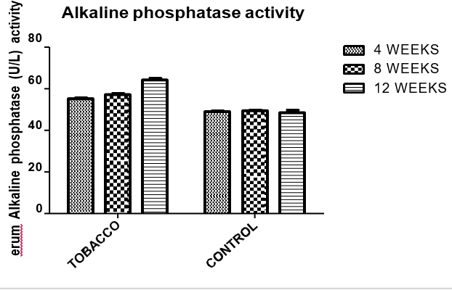

Fig 1; Serum Alkaline phosphatase activity in rats administered aqueous extract of
Nicotiana tabacum (tobacco) leaves and control group. (p < 0.05) (n = 3)

Effect of aqueous extract of Nicotiana tabacum leaves on Alanine aminotransferase activity
The serum activities of Alanine aminotransferase (ALT) are shown in Fig 2, the results showed observable increase in ALT activity of rats administered aqueous extract of Nicotiana tabacum leaves when compared with control group (P value
˂0.05), with ALT activity showing significant difference after 4 weeks and 12 weeks respectively but no significant difference after 8 weeks.

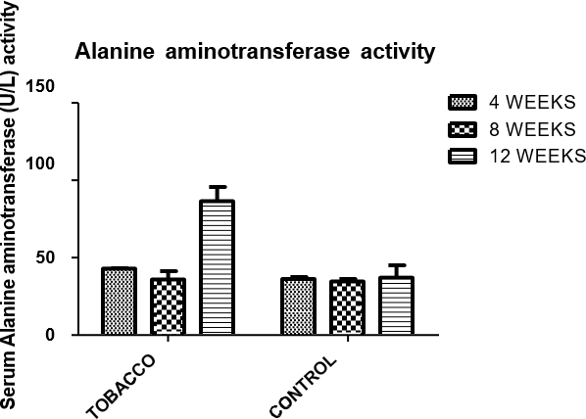

Fig. 2; Serum Alanine aminotransferase activity in rats administered aqueous extract of

Nicotiana tabacum (tobacco) leaves and control group. (p < 0.05) (n = 3)

Effect of aqueous extract of Nicotiana tabacum leaves on Aspartate aminotransferase activity
The serum activities of Aspartate aminotransferase (AST) are shown in Fig. 3, the results showed observable increase in AST activity of rats administered aqueous extract of Nicotiana tabacum leaves when compared with control group (P value
˂0.05), with AST activity showing significant difference after 4, 8 and 12 weeks respectively.

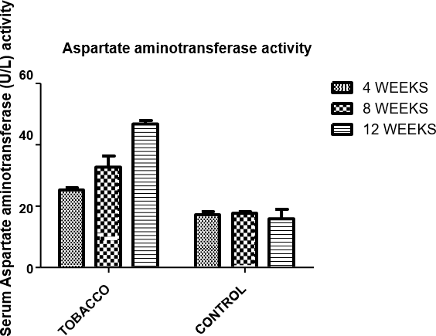

Fig 3; Serum Aspartate aminotransferase activity in rats administered aqueous extract of

Nicotiana tabacum (tobacco) leaves and control group. (p < 0.05) ( n = 3)

Effect of aqueous extract of Nicotiana tabacum leaves on serum total bilirubin concentration
The serum total bilirubin concentrations are presented in Fig 4, it showed observable increase in rats administered aqueous extract of Nicotiana tabacum leaves when compared (P value ˂0.05) with the control group, with total bilirubin concentration showing a significant difference after 4, 8 and 12 weeks respectively.
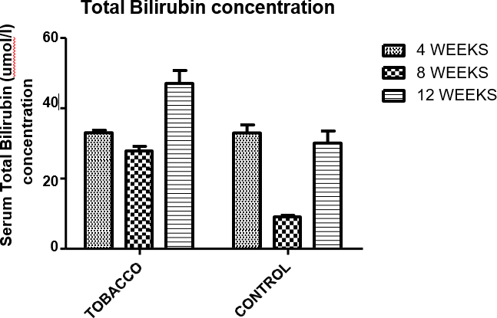

Fig 4; Serum Total bilirubin concentration in rats administered aqueous extract of
Nicotiana tabacum (tobacco) leaves and control group. (p < 0.05) (n = 3).

Effect of aqueous extract of Nicotiana tabacum leaves on serum direct bilirubin concentration
The serum direct bilirubin concentrations are presented in Fig 5 respectively showed observable increase in rats administered aqueous extract of Nicotiana tabacum leaves when compared (P value ˂0.05) with the control group, with direct bilirubin concentration showing a significant difference after 4 weeks and 12 weeks respectively.
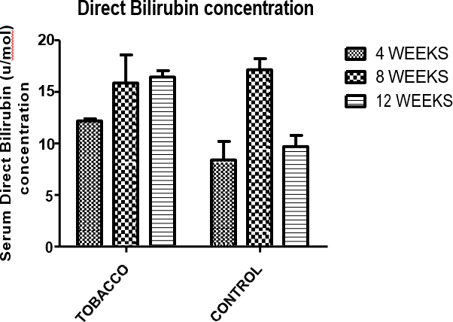

Fig 5; Serum Direct bilirubin concentration in rats administered aqueous extract of
Nicotiana tabacum (tobacco) leaves and control group. (p < 0.05) (n = 3).

Effects of tobacco extract on Caspase-9, BCl-2, and P53 level of the rats.

The serum B-cell lymphoma 2 (BCl-2), P53 (tumor protein) and Caspase-9 level results are represented below.

Effects of tobacco extract on BCl-2 level of the rats.
The BCl-2 level of the tobacco extract group increased when compared with control group (P value ˂0.05) at 4 weeks, 8 weeks and 12 weeks.

5
*
*
*

4weeks
Serum BCl-2 (ng/ml)
4 8weeks

12weeks
3

2

1

0
Tobacco
Control

Fig 6 Serum B-cell lymphoma 2(BCl-2) level of the Experimental animals at 4, 8 and 12 weeks
*- significant different when compared with each control group at 4 weeks, 8 weeks and 12 weeks. P is significant when P <0.05

Effects of tobacco extract on P53 level of the rats.
The administration of tobacco extract increased P53 level in the serum of the rats with significant different when compared (P value ˂0.05) with the control group at 4 weeks, 8 weeks and 12 weeks.

1500
*
*
*
Serum P53 (ng/ml)

1000
4weeks 8weeks 12weeks

500

0
Tobacco
Control

Fig 7 Serum P53 (tumor protein) level of the Experimental animals at 4, 8 and 12 weeks

*- significant different when compared with each control group at 4 weeks, 8 weeks and 12 weeks. P is significant when P <0.05

Effects of tobacco extract on Caspase-9 level of the rats.
The Caspase-9 level of the rats administered tobacco extract increased (P value ˂0.05) when compared with the control group at 4 weeks, 8 weeks and 12 weeks.

5
*
*
*
Serum Caspase-9 (ng/ml)

4weeks
4  8weeks

12weeks
3

2

1

0
Tobacco
Control

Fig 8 Serum Caspase-9 level of the Experimental animals at 4, 8 and 12 weeks

*- significant different when compared with each control group at 4 weeks, 8 weeks and 12 weeks. P is significant when P<0.05.
Most of the serum enzymes levels were elevated as predicted by Rudgley (2017), while the staining patterns from month to month for the tobacco treated samples were indicative of abnormal functioning of the brain, liver and kidney

Histological changes in Liver of rats in the control group

The liver sections of control groups are showing a normal central vein, and lining endothelial, no bleeding observed, normal hepatocytes radiating arrangement from central vein and blood sinusoids appear between the hepatocytes. Hepatocytes are granular and acidophilic cytoplasm, normal arrangement of hepatic cords, normal sinusoids between the hepatocytes and containing a number of kupffer cells. In portal area, a typical portal canal contains branches of portal vein, hepatic artery and bile duct, the triad is clearly bordered by the surrounding normal hepatocytes and interlobular septa. Normal structure of functional metabolic zones between central vein and portal tract, zone, normal hepatic sinusoids connecting the zones (Fig. 9).
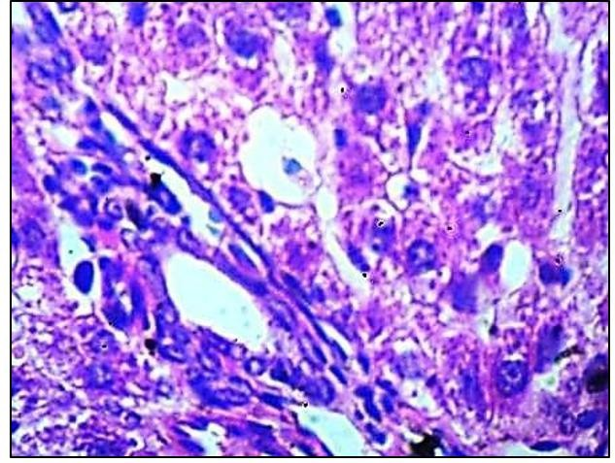

Fig 9 Microscopic representation of the liver of rats in control group. (x400)

Histological changes in Liver of rats administered aqueous extract of Nicotiana tabacum Leaves
The liver sections of nicotine treated group shows a marked injury in central vein with hemorrhage, a marked congestion of portal triad, congestion of blood sinusoids in the 3 zones of acinus, degeneration disorder of hepatocytes especially zone 3 and adjacent area, and congestion with RBC's between hepatocytes (Fig. 10).
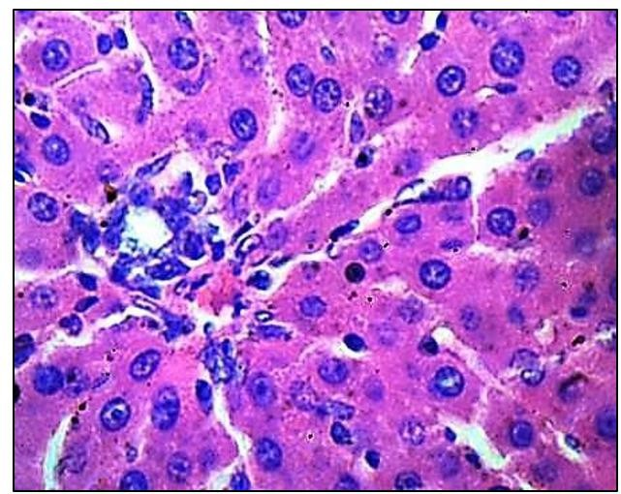

Fig.10. Microscopic representation of the liver of rats administered aqueous extract of Nicotiana tabacum leaves. x400

Histopathological Changes in Liver, Kidney, and Brain Sections
3.4 Histopathological changes in rat brain across the tobacco extract group and control. (X40)
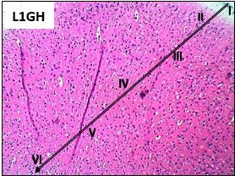

Figure 11. Photomicrographs showing panoramic views of cortex general micromorphological presentations in the brain of wistar rats across the tobacco group. H&E stain (magnification- X40). The molecular layer (I), External granular layer (II), External pyramidal layer (III), Internal granular layer (IV), Internal pyramidal layer (V) and the multiform layer (VI) are demonstrated across tobacco groups (white long arrow).

.

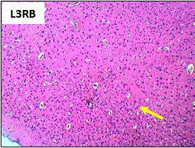

Figure 12 Photomicrographs showing panoramic views of cortex general micromorphological presentations in the brain of wistar rats across the control group. H&E stain (magnification- X40). Profiles with a mild cellular alteration is indicated by yellow arrow. (X40)

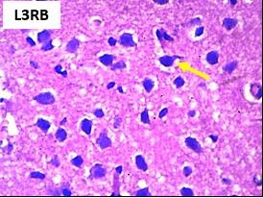
(X400)

Figure 13. Photomicrographs showing layer three and four of the cerebral cortex micromorphological presentations in Wistar rats across the control groups. H&E stain (Magnification- X400). Yellow arrow denotes a mild pyknosis and degenerating neurons.
L3RB Brain tissue for control group animal labelled RB.

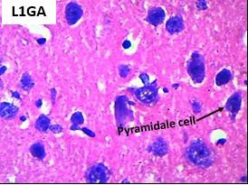

(X400)

Figure 14 Representative micrographs of H&E staining showing the general and magnified cytoarchitecture of the prefrontal cortex in Wistar rats across tobacco group (X400). Normal histological features of the cortex is observed in groups without red/yellow arrows, they are characterized by large pyramidal as well as granule neurons, the pyramidal cells are characterized with long axons that extend well from the soma to adjacent neurons within the neuropil. Apical and basal dendrites extend from the well delineated soma of the pyramidal neurons in this group. Perineural space surrounding these cells appears intact, with intact nuclear and cytoplasmic content.
L1GA Brain for Tobacco extract group administered animal labelled GA.

Oxidative Stress and Neurotoxicity Markers in Brain Tissue

Effect of aqueous tobacco extract on the Oxidative status of the rats on brain

- Superoxide dismutase

Table 1 below showed the effect of tobacco extract on the superoxide dismutase level in the brain of experimental animal. The result depicted that there is significant decrease when compared with control group of each week.

Table 1 Changes in rat brain SOD level.

Superoxide
dismutase (u/ml)
Groups | 4 weeks | 8 weeks | 12 weeks
Tobacco | 1.245±0.04803ª | 1.008±0.1196ª | 1.478±0.05022ª
Control | 1.502±0.009761 | 1.416±0.01893 | 1.793±0.08764
ª- significant different when compared with each control group at 4 weeks, 8 weeks and 12 weeks.
(P value <0.05)

Nitric oxide

Table below showed the effect of tobacco extract on the nitric oxide level in the brain of experimental animal. The result depicted that there is significant decrease when compared with control group of each week.

Table 2 Changes in rat brain NO level.

 | Nitric Oxide (µM)
Groups | 4 weeks | 8 weeks | 12 weeks
Tobacco | 5.333± 0.4925* | 18.26±0.2208* | 13.20±0.4636*
Control | 19.74±0.5604 | 26.79±0.05094 | 15.47±2.113
*- significant difference when compared with each control group at 4weeks, 8weeks and 12weeks. respectively(P value <0.05)

Malondialdehyde

The Malondialdehyde level results is shown in Table 3 The result obtained from malondialdehyde of the rat brain tissue administered aqueous tobacco extract showed increase when compared with the control group at each week.

Table 3 Changes in rat brain MDA level.

Malondialdehyde
(µM)
Groups | 4 weeks | 8 weeks | 12 weeks
Tobacco | 4.391±0.06872 ª | 4.815±0.1431 ª | 2.669±0.2183 ª
Control | 2.897±0.2716 | 2.249±0.1163 | 0.8473±0.01837
ª- significant different when compared with each control group at 4 weeks, 8 weeks and 12 weeks. (P value <0.05)

Glutathione

The Glutathione level results is shown in Table 4 The results of Glutathione of the rat brain tissue administered aqueous tobacco extract showed significant decrease when compared with the control group at each week

Table 4 Changes in rat brain GSH level.

 | Glutathione (mM)
Groups | 4 weeks | 8 weeks | 12 weeks
Tobacco | 0.3766±0.03270* | 0.4446±0.01072* | 0.4078±0.01415*
Control | 0.4484±0.009673 | 0.4707±0.06636 | 0.5190±0.03291
*- significantly different when compared with each control group at 4 weeks, 8 weeks and 12 weeks. (P value <0.05).

DISCUSSION

The findings of this study demonstrate that Nicotiana tabacum aqueous leaf extract induced hepatic, renal, and neural toxicities in a cumulative manner. The observed increases in serum transaminases (ALT and AST) reflect hepatocellular damages and leakages of enzymes into circulation, consistent with oxidative stress–mediated injuries. Elevated ALP and bilirubin suggest cholestatic impairment, while reduced total protein may indicate compromised hepatic synthetic capacity (Andong, et al., 2021). The renal dysfunction observed through increased urea and creatinine levels aligns with reports that tobacco alkaloids may impair nephron integrity via reactive oxygen species (ROS) generation and mitochondrial dysfunction (Mohamed et al., 2022)
In the central nervous system, nitric oxide level suggests decreases, which can affect the transmitting signals to cells in the nervous system (Garthwaite, 2008). In contrast, excessive nitric oxide is extremely toxic and will cause death of the nerve system, leading to neurotransmitter imbalance and oxidative neuronal stress (Teleanu et al., 2022). Increased lipid peroxidation in the brain and decreased antioxidant enzyme activity confirm the role of ROS in mediating neuronal damage (Petrovic et al., 2020). Studies demonstrated nicotine treatment found by up regulating BCl-2, decreased the susceptibility of cancer cells to apoptosis. In addition, according to Markouli et al., (2025), accumulation of BCL-2 may reflect a mechanism for counterbalancing ROS-mediated damage or it might represent the impairment of BCl-2 dependent protection from ROS.
Excessive p53 function is implicated in neural tube defects and neuronal degeneration. The p53 tumor suppressor potently limits the growth of immature and mature neurons under conditions of cellular stress (Sciaccotta et al., 2024). Thus, p53 function must be tightly controlled. Morrison and Kinoshita in year 2000 showed that the absence of p53 has been shown to protect neurons while increase in the level of p53 can result in extensive apoptosis in the central nervous system. The presence of nicotine in the Nicotiana tabacum activates Caspase 9. Elevated Caspase 9 in turn activates Caspase 3 and Caspase 7, which can initiate the hallmark of the degradation phase of apoptosis (Mohamed et al., 2022). High caspase 9 inhibition has been shown to increase the resistance of tumor cells as reported by Ping et al., 2017. These findings are consistent with prior studies that reported neurobehavioral impairments and histological alterations in tobacco-treated animals.
Collectively, these results imply that aqueous Nicotiana tabacum extract, despite its ethno medicinal applications, can exert harmful systemic effects when consumed excessively or

chronically (Zhang et al., 2024). The mechanisms appear to involve oxidative stress, inflammation, and membrane disruption across hepatic, renal, and neuronal tissues (Hajam et al., 2022). The impacts of Nicotinia tabacum was also cumulative as increased activities were found in the enzymes as the treatment progressed from week four through week 12.

The abuse of tobacco has damaged the abusers’ mental state and thinking, yet, they continue to use this and other substances of abuse to cope with depression, confidence difficulties and sexual activities (Breijyeh and Karamaan, 2020). The implications of tobacco abuse are far reaching and have serious consequences for individuals and the society at large. Negative outcomes of tobacco abuse include mental disorders, social violence, gang formation, cultism, armed robbery, internet fraud and lawlessness among youths. dependence resulting in school dropouts.

CONCLUSION

Nicotiana tabacum aqueous leaf extract elicited dose-dependent hepato-renal and neurotoxicity in rats, likely mediated through oxidative stress and disruption of antioxidant defenses. The present findings highlight the potential risks associated with traditional medicinal use of tobacco extracts and advocate for cautious regulation, dose standardization, and further mechanistic investigation into its bioactive components. Abuse of tobacco hampers academic performance and motivation and can also lead to physical and psychological dependence resulting in school dropouts. It is therefore recommended that tobacco be classified as other dangerous street drugs of abuse.

Disclaimer (Artificial intelligence)
Author(s) hereby declare that NO generative AI technologies such as Large Language Models (ChatGPT, COPILOT, etc.) and text-to-image generators have been used during the writing or editing of this manuscript.

REFERENCES.

- Al-Snafi, A. E. (2022). Pharmacological and toxicological effects of Nicotiana tabacum. World Journal of Advanced Pharmaceutical and Medical Research, 3(1), 6-18
- Anas, M., Ahmed, I., & Ismail, M. (2025). Exploring Nicotiana tabacum: The multifaceted role of tobacco in traditional medicine and pharmacology: A. Journal of Pharmacognosy and Phytochemistry, 14(3), 726-730.
- Andong, F. A., Orji, E. A., Ezenwaji, N. E., Nkemakolam, A. O., Melefa, T. D., Chukwurah, A. O. & Onwurah, A. I. (2021). Sub-acute oral toxicity study of aqueous extract of tobacco leaves (Nicotiana tabacum L.) on lipid profile, the tissue, and serum of the liver and kidney of male Wistar rats. Biomarkers, 26(2), 127-137.

- Breijyeh, Z. and Karaman, R. (2020) Comprehensive review on Alzheimer’s disease. Causes and treatment. Molecules25(24); 5789.

- Garthwaite, J. (2008). Concepts of neural nitric oxide‐mediated transmission. European Journal of Neuroscience, 27(11), 2783-2802.
- Hajam, Y. A., Rani, R., Ganie, S. Y., Sheikh, T. A., Javaid, D., Qadri, S. S. & Reshi, M. S. (2022). Oxidative stress in human pathology and aging: molecular mechanisms and perspectives. Cells, 11(3), 552.
- Jamal, A. (2023). Embracing nature's therapeutic potential: Herbal medicine. International Journal of Multidisciplinary Sciences and Arts, 2(3), 117-126.
- Kurian, R., Steen, L. T., & Wang, H. (2023). Liver Drug Metabolism. Oral Bioavailability and Drug Delivery: From Basics to Advanced Concepts and Applications, 189-212.
- Markouli.M., Pagoni Maria N., Diamantopolos. Panagiotis (2025). BBCL-2 inhibitors in haematological malignancies: biomarkers that predict response and manageme4nt strategies. Front Oncology https://pub.ncbi.nlm.nih.gov.
- Mohamed, A. A. R., El-Kholy, S. S., Dahran, N., El Bohy, K. M., Moustafa, G. G., Sab06er, T. M., ... & El-Shetry, E. S. (2022). Scrutinizing pathways of nicotine effect on renal Alpha-7 nicotinic acetylcholine receptor and Mitogen-activated protein kinase (MAPK) expression in Ehrlich ascites carcinoma-bearing mice: Role of Chlorella vulgaris. Gene, 837, 146697.
- Naik, G.G., Sahu, A. N., Kaushik, V., Kaushik, A., & Sarkar, B. K. (2023). Phytopharmaceuticals and herbal drugs: prospects and safety issues in the delivery of natural products. In Phytopharmaceuticals and Herbal Drugs (pp. 215-248).Academic Press

- Petrovic, S., Arsic, A., Ristic-Medic, D., Cvetkovic, Z., & Vucic, V. (2020). Lipid peroxidation
and antioxidant supplementation in neurodegenerative diseases: a review of human studies. Antioxidants, 9(11), 1128.
- Schrenk, D., Gao, L., Lin, G., Mahony, C., Mulder, P. P., Peijnenburg, A & These, A. (2020). Pyrrolizidine alkaloids in food and phytomedicine: Occurrence, exposure, toxicity, mechanisms, and risk assessment-A review. Food and Chemical Toxicology, 136, 111107.

- Sciaccotta, R., Gangemi, S. Penna, G., Giordano, L. Pioggia, G., &Allegra, A. (2024). Potential Potential new therapies “ROS-based” in CLL: an innovative paradigm in the induction of tumor cell apoptosis. Antioxidants, 13(4), 475.
- Teleanu, R. I., Niculescu, A. G., Roza, E., Vladâcenco, O., Grumezescu, A. M., & Teleanu, D. M. (2022). Neurotransmitters—key factors in neurological and neurodegenerative disorders of the central nervous system. International journal of molecular sciences, 23(11), 5954.

- Zhang, W., Pan, X., Fu, J., Cheng, W., Lin, H., Zhang, W., & Huang, Z. (2024). Phytochemicals derived from Nicotiana tabacum L. plant contribute to pharmaceutical development. Frontiers in pharmacology, 15, 1372456.

