Phytochemical Investigation and Evaluation of the Antioxidant and Antibacterial Potentials of the Organs of Adenanthera pavonina (Fabaceae)

.
ABSTRACT

This research was conducted on Adenanthera pavonina (Fabaceae), an exotic plant introduced to Côte d'Ivoire mainly for its ornamental value. However, beyond this use, it is of particular interest in certain regions of the world due to its nutritional and therapeutic qualities.
Aims: This study aims to promote Adenanthera pavonina from Côte d'Ivoire through chemical characterisation and biological exploration.
Methodology: For this purpose, hydroethanolic extracts from the leaves, seeds, and trunk bark of Adenanthera pavonina were prepared. These extracts were then subjected to phytochemical screening using detection tests (color reactions and precipitation), as well as spectrophotometric quantification of total phenols, flavonoids, and condensed tannins. Additionally, the antioxidant activity of these extracts was evaluated using the DPPH (free radical scavenging) and FRAP (ferric reducing antioxidant power) assays. Finally, their antibacterial activity was assessed against five resistant bacterial strains.
Results: Phytochemical analysis, carried out through qualitative and quantitative tests, revealed the presence of various bioactive compounds such as polyphenols, flavonoids, coumarins, tannins, and saponins. The FRAP and DPPH tests demonstrated an exceptional antioxidant activity in the bark (IC50 = 0.00268 mg/mL), surpassing that of vitamin C (0.0045 mg/mL), a natural antioxidant. The bark also exhibited bactericidal activity at 100 mg/mL against Escherichia coli and Pseudomonas aeruginosa, unlike the other plant parts.
Conclusion: these results highlight the potential of A. pavonina from Côte d’Ivoire as a source of natural antioxidants and antibacterial agents, justifying further research for the isolation of its active compounds.

Keywords: Adenanthera pavonina, antioxidant potential, phytochemical study, antibacterial activity, Côte d’Ivoire.

1. INTRODUCTION

Adenanthera pavonina (Fabaceae) is a fast-growing tree belonging to the Mimosaceae subfamily. This tree is also known as red bead tree, red sandalwood, saga tree, and coralwood tree, and is cultivated for forage and soil improvement. Adenanthera pavonina is native to India and Southeast China, and has been introduced to tropical regions worldwide, including Côte d’Ivoire, primarily for its ornamental value [1]. Various parts of the plant are widely used in ethnopharmacology for the treatment of diarrhea, asthma, boils, inflammation, rheumatism, and hematuria [1–3]. These traditional uses are supported by scientific evidence that attributes to the plant antidiarrheal, anti-inflammatory, analgesic, cytotoxic, antibacterial, antifungal, antioxidant, antidiabetic, and hypotensive activities [4–6]. Studies have reported that the organs of this plant contain bioactive phytochemical compounds, including phenolic compounds, alkaloids, phytosterols, and saponins [7]. Phenolic compounds are particularly important antioxidants because they prevent or slow down oxidation by neutralizing free radicals through hydrogen donation. Free radicals are molecules that can degrade biological molecules through oxidation and are thought to be involved in cellular ageing and various diseases, including inflammation, atherosclerosis and cancer [8]. Phenolic compounds also exert an effect on bacterial cells, altering the structure and morphology of the cell or causing imbalances in bacterial metabolism. Thanks to their hydroxyl groups, phenolic compounds can interact with various sites of the bacterial cell [9, 10]. They play a significant role in maintaining human health due to their known pharmacological properties (anti-inflammatory, anti-allergic, antimicrobial, antiviral, anticancer, cardioprotective, and vasodilatory) [11]. Despite all the virtues contained in the various parts of Adenanthera pavonina, the species introduced in Côte d'Ivoire remains poorly studied and local scientific data is lacking. This study therefore aims to fill this gap by characterising the phytochemical composition and evaluating the antioxidant potential of the leaves, seeds and bark of Adenanthera pavonina acclimatised in Côte d'Ivoire.

2. material and methods
2.1 Material
2.1.1 Plant material

The plant samples (leaves, seeds, and bark) of Adenanthera pavonina were collected from a tree growing in the garden of the Cercle Voile d’Abidjan, located in the Attécoubé district (Côte d’Ivoire), on January 24, 2025. Botanical identification was carried out by Dr. YAO Konan from the National Floristic Center of Félix Houphouët-Boigny University (Abidjan, Côte d’Ivoire), where a reference specimen is preserved in the herbarium under the number UCJ009619.………...

2.1.2 Bacterial material

Five (05) clinically derived bacterial strains were used for antibacterial activity testing. These included two strains of Escherichia coli (2473C/25, 2411C/25), two strains of Staphylococcus aureus (2459C/25, 2404C/25), and one strain of Pseudomonas aeruginosa (2472C/25), all obtained from the biobank of the Pasteur Institute of Côte d’Ivoire (IPCI).

2.2 Methods
2.2.1 Preparation of crude hydroethanolic extracts

The plant samples (leaves, seeds, bark) were carefully cleaned and air-dried at room temperature in a well-ventilated area for two weeks, then ground into a fine powder using an electric grinder (BLENDER HGB66E, reference HGB660EI). For each organ, twenty (20) grams of powder were macerated in 100 mL of an 80% hydroethanolic solution for 24 hours. The process was repeated three times using the same plant residues. After filtration through filter paper, the collected macerates were pooled and concentrated under reduced pressure at 50°C using a rotary evaporator. The concentrated extracts were then dried in an oven at 40°C for three (03) days to remove any solvent residues and obtain the crude hydroethanolic extracts, which were used for phytochemical analyses and antioxidant potential evaluation.

2.2.2 Qualitative analysis

A qualitative phytochemical screening was carried out on the hydroethanolic extracts of the leaves, seeds, and bark of Adenanthera pavonina to detect the presence of major classes of secondary metabolites. To this end, colorimetric tests were performed using standard methods described in the literature [12-18].

2.2.3 Quantitative analysis

2.2.3.1 Determination of total phenolic content

The total phenolic content of the extracts was determined using the spectrophotometric method described in [19]. To 1 mL of each extract at a concentration of 0.1 mg/mL, 1.5 mL of Na₂CO₃ (17%, w/v) and 0.5 mL of Folin-Ciocalteu reagent (0.5 N) were added. The mixtures were incubated at 37°C for 30 minutes in the dark. The absorbance of each solution was measured at 760 nm against a blank consisting of the reaction mixture without extract. A calibration curve was previously established using gallic acid as a standard, with concentrations ranging from 0.000390625 to 0.2 mg/mL. The calibration line in the form y = ax + b was used to calculate the total polyphenol content of the samples. The total phenolic content (TPC), expressed in milligrams of gallic acid equivalent per gram of dry matter (mg GAE/g DM), was calculated using the following formula:

$$TPT=\frac{Cf⨯d}{Ci}$$

With Cf: concentration of the extract in gallic acid equivalent (mg EAG/mL); d: dilution factor; and Ci: concentration of the extract (g/mL).

2.2.3.2 Determination of Flavonoids

The total flavonoid content was determined using the aluminum chloride method described by Arvouet-Grand et al. (1994) [20]. For each assay, 2 mL of the extract at a concentration of 1 mg/mL were mixed with 2 mL of a 2% (w/v) aluminum chloride (AlCl₃) solution in ethanol. After 10 minutes of incubation, the absorbance was measured at 415 nm using a spectrophotometer. A calibration curve was prepared using quercetin as the standard, with concentrations ranging from 0.00039 to 0.1 mg/mL. The total flavonoid content (TFC), expressed in milligrams of quercetin equivalent per gram of dry matter (mg QE/g DM), was calculated using the following formula:
$$TPT=\frac{Cf⨯d}{Ci}$$

With Cf: concentration of the extract in quercetin equivalent (mg QE/mL); d: dilution factor; and Ci: concentration of the extract (g/mL).

2.2.3.3 Determination of Condensed Tannins

The condensed tannin content was determined using the vanillin–hydrochloric acid reagent method described by Heimler et al. (2006) [21]. To 0.2 mL of each test extract (1 mg/mL), 1.5 mL of a 4% (w/v) ethanolic vanillin solution and 0.75 mL of concentrated HCl were added. The mixture was incubated for 15 minutes, and the absorbance was read at 500 nm. Quantification of condensed tannins was carried out using a linear calibration curve (y = ax + b) established with catechin as the standard, within a concentration range of 0.00078 to 0.05 mg/mL. The condensed tannin content (CTC), expressed in milligrams of catechin equivalent per gram of dry matter (mg CE/g DM), was calculated using the following formula:

$$TPT=\frac{Cf⨯d}{Ci}$$

With Cf: concentration of the extract in quercetin equivalent (mg QE/mL); d: dilution factor; and Ci: concentration of the extract (g/mL).

2.2.4 Assessment of Antioxidant Potential

2.2.4.1 DPPH test

The antioxidant activity of the extracts was evaluated based on their ability to scavenge the free radical DPPH• (2,2-diphenyl-1-picrylhydrazyl), according to the method described by Brand-Williams et al. [22], with slight modifications. DPPH• was dissolved in 80% ethanol to prepare a stock solution at a concentration of 0.03 mg/mL. Different concentration ranges of the extracts were prepared: from 0.015625 to 1 mg/mL for leaves (LE) and seeds (SE), and from 0.00078 to 0.5 mg/mL for bark (TE), reflecting its anticipated higher activity.
In dry and sterile test tubes, 1 mL of each extract concentration was mixed with 2 mL of the DPPH• solution. After shaking, the mixtures were incubated in the dark at room temperature for 30 minutes. Absorbance was measured at 517 nm against a blank composed of 2 mL of DPPH• solution and 1 mL of 80% ethanol. Ascorbic acid (vitamin C) was used as the positive reference control under the same conditions.
The percentage of DPPH• radical reduction (PR) was calculated for each concentration using the following formula:
PR (%) = (1 -$\frac{A_{e}}{A_{b}}$ ) $×$100

Where:
- Ae = absorbance of the sample (extract)
- Ab = absorbance of the blank

2.2.4.2 FRAP test

The antioxidant reducing power of the extracts was evaluated using the FRAP (Ferric Reducing Antioxidant Power) method, according to a suitable protocol [23; 24]. To prepare the FRAP reagent, a mixture of 0.1 M acetate buffer (pH 3.6), 10 mM TPTZ, and 20 mM ferric chloride (10 :1 :1, v/v) was used. For the assay, 100 µL of each extract (0.25 mg/mL) were added to 3 mL of the freshly prepared FRAP reagent. After 4 minutes, absorbance was measured at 593 nm at room temperature. A calibration curve was established using Trolox as the standard, with a concentration range from 0.00039065 to 1 mg/mL. The antioxidant reducing activity of each sample was expressed in mM Trolox equivalent per gram of dry weight (mM TE/g DW).
2.2.5 Bacterial activity of the different crude extracts

2.2.5.1 Preparation of the Bacterial Inoculum

Bacterial strains were pre-cultured on selective media at 37°C for 24 hours. For each strain, one to two well-isolated colonies with homogeneous morphology were collected and suspended in 2 mL of sterile physiological water. The suspension was homogenized using a vortex, and its turbidity was adjusted to match the 0.5 McFarland standard using a densitometer. This standardized inoculum was immediately used to seed Mueller-Hinton (MH) agar, in accordance with the EUCAST-CASFM (2024) guidelines [25].

2.2.5.2 Evaluation of antibacterial activity

The antibacterial activity of the extracts was evaluated using two complementary methods: agar diffusion and liquid microdilution, after performing the sterility test. For this purpose, a stock solution of each extract was prepared at a concentration of 100 mg/mL in sterile distilled water, homogenized using a vortex, and then serially diluted twofold to obtain a range of concentrations.

a) Agar Diffusion Method
This qualitative method was used to visualize the inhibitory effect by measuring the diameter of inhibition zones After plating Mueller-Hinton agar with the standardised inoculum, wells were drilled and filled with an identical volume (50 μL) of each extract concentration. Negative (sterile distilled water) and positive (standard antibiotics) controls were included. The plates were incubated at 37°C for 24 hours. An extract or negative control is considered active if the inhibition diameter is greater than or equal to 9 mm [26]. The activity of the antibiotic controls was interpreted according to the EUCAST-CASFM (2024) guidelines [26].

b) Microdilution Method in Liquid Medium
This quantitative method was used to determine the Minimum Inhibitory Concentration (MIC), defined as the lowest concentration of extract that prevents any visible bacterial growth after incubation. The minimum bactericidal concentration (MBC) was determined by plating wells with no visible growth onto fresh Mueller-Hinton agar. The MBC corresponds to the lowest concentration that eliminates at least 99.9% of the bacterial cells. The MBC/MIC ratio was calculated to characterize the mode of action of the extracts. A ratio of MBC/MIC ≤ 2 indicates a bactericidal effect, whereas a ratio > 2 suggests a bacteriostatic effect [27].

2.2.6 Statistical analysis

A one-way analysis of variance (ANOVA) was performed using GraphPad Prism software version 8 (USA). Differences between means were considered statistically significant at a 0.01% level. All experimental measurements were carried out in triplicate, and results were expressed as mean ± standard deviation (SD).

3. results and discussion
3.1 Yield of crude extracts

Crude extracts were obtained by maceration in 80% hydroethanolic solution. Extraction yields of phytocompounds ranged from 9 ± 0.76% for seeds (SE) to 37.67 ± 1.45% for trunk bark (TE) (Table 1).

Table 1. Yield of crude extracts

 | TE | LE | SE
Yield (%) | 37,67 ± 1,45 | 17,75 ±1,52 | 9 ± 0,76
(TE) : Trunk bark Extract, (LE) : Leaf Extract, (SE) : Seed Extract

A statistical analysis (P < 0.0001) confirmed that the yield of TE was significantly higher than that of the leaves (LE, 17.75 ± 1.52%) and seeds (SE). The low standard deviation values attest to good reproducibility of the extractions. The high content of extractable compounds in the bark can be explained by its biological role, making it a tissue rich in secondary metabolites such as polyphenols and alkaloids. The low yield of the seeds suggests that their main components (lipids, proteins) are less soluble in the hydroethanolic solvent used.

3.2 Phytochemical screening using colorimetric tests

Phytochemical screening using colorimetric tests revealed the presence of several secondary metabolites in different organs of adenanthera pavonina (table 2). the total phenol analysis with fecl₃ was positive in all organs, with an intense blue-black coloration observed in the trunk bark, while the leaves and seeds showed a green-black hue, indicating a notable content of phenolic compounds but potentially distinct chemical profiles, with the bark standing out for its particular balance between hydrolyzable and condensed tannins.

Different classes of flavonoids were identified in the three organs using lead acetate, ammonia, and sulfuric vanillin tests. The first two confirmed a widespread presence, with the ammonia test specifically indicating the presence of flavones, flavonols, chalcones, and aurones in the bark. The sulfuric vanillin test, positive only for the seeds, suggests a specific presence of flavanols, such as catechin, and condensed tannins. These flavonoids, recognized for their role in combating free radicals and regulating cellular activity, contribute to oxidative stress prevention and support effective metabolism [25, 28].

Tannins and coumarins were also identified in all organs. The positive reaction to the Folin-Ciocalteu reagent and FeCl₃, the latter being characteristic of condensed tannins confirms a notable presence of phenolic compounds throughout the plant. Although the salted gelatin test, which detects tannins with strong protein affinity, was negative for the seeds, these metabolites are well-known for their potent antioxidant and antimicrobial activities, explaining the interest they generate [29, 30]. Moreover, the positive reaction to KOH in all extracts attests to the ubiquitous presence of coumarins, compounds known for their anticoagulant and antibacterial potential [31].
Sterols and terpenes were detected in the leaves and seeds. Finally, saponins were found only in the bark, with a foam index of 1000, indicating a particularly high concentration in this organ.
In conclusion, the leaves, seeds, and trunk bark of Adenanthera pavonina exhibit distinct yet complementary phytochemical profiles, rich in secondary metabolites with promising biological properties. These results corroborate previous studies by Yumita et al. [32] and fully justify the therapeutic interest in this species.
Table 2. Compounds detected in the different plant organs studied

Detected Compounds | Reagent / Test | TE (observation) | LE (observation) | SE (observation)
Polyphenols | FeCl₃ (2%) | (+) dark blue | (+) dark green | (+) dark green
Flavonoids | with ammonia | (+) yellow and red  cold conditions | (+) yellow and red  cold conditions | (+) yellow and red  cold conditions
Flavonoids | with vanillin-sulfuric reagent | (-) | (-) | (+) strawberry red
Flavonoids | with Pb(CH₃COO)₂ | (+) précipitate | (+) précipitate | (+) précipitate
Tannins | with Folin-Ciocalteu reagent | (+) blue | (+) blue | (+) blue
Tannins | with salted gelatin | (+) white precipitate | (+) white precipitate | (-)
Tannins | FeCl₃ (2%) | (+) bottle green | (+) bottle green | (+) bottle green
Sterols & Terpenes | With Liebermann-  Burchard reagent | (-) | (+) blue-green | (+) blue-green
Coumarins | with 5% KOH | (+) bright yellow, yellow-orange | (+) bright yellow, yellow-orange | (+) bright yellow, yellow-orange
Saponins | foam index | (+) Im = 1000 | (-) | (-)
TE: Trunk bark Extract, LE: Leaf Extract, SE: Seed Extract , (+) : Positive test ; (-) : Negative test
3.3 Total phenolic, flavonoid, and condensed tannin content

The quantification of phenolic compounds in different parts of Adenanthera pavonina was performed using spectrophotometric methods calibrated with appropriate reference standards. Total phenols were quantified using gallic acid as the standard (y = 15.796x + 0.0408), total flavonoids with quercetin (y = 21.6x + 0.0054), and condensed tannins with catechin (y = 0.9364x + 0.0013).
The results reveal distinct quantitative profiles depending on the plant organ (Table 3). The trunk bark extract exhibited the highest total phenolic content, with 463.676 ± 0.985 mg GAE/g dry weight (DW), followed by the leaves (60.479 ± 0.360 mg GAE/g DW) and seeds (12.368 ± 0.053 mg GAE/g DW). These values differ from those reported in the literature, where phenolic contents between leaves (81.379 ± 0.53 mg GAE/g) and bark (80.630 ± 1.83 mg GAE/g) are closer, possibly due to variations in geographical origin, growth conditions, extraction solvents, or analytical protocols [32].

The total flavonoid concentration is significantly higher in the leaves (12.368 ± 0.053 mg QE/g DW) compared to the trunk bark (4.472 ± 0.027 mg QE/g DW) and seeds (3.598 ± 0.022 mg QE/g DW). This foliar accumulation may be attributed to the plant's exposure to sunlight, which promotes the photosynthesis of phenolic compounds, including flavonoids [33, 34].

Regarding condensed tannins, the trunk bark again stands out with the highest content (59.364 ± 0.721 mg CE/g DW), approximately twice that of the leaves (30.649 ± 0.205 mg CE/g DW) and nearly eight times higher than that of the seeds (7.630 ± 0.475 mg CE/g DW). This accumulation in the outer tissues of the plant is consistent with the ecological role of tannins in defense against external threats such as mechanical stress, insect attacks, pathogens, and fungi. Indeed, tannins are well known for their antimicrobial, antifungal, and repellent properties [35; 36].

In summary, the leaves, seeds, and trunk bark of Adenanthera pavonina represent valuable sources of phenolic compounds that may offer health benefits to humans.

Table 3. Contents of Phenolic Compounds

Extract | Total Phenols  (mg GAE/g DW) | Total Flavonoids  (mg QE/g DW) | Condensed Tannins (mg CE/g DW)
SE | 60,479 ± 0,360  a****c**** | 3,598 ± 0,022  a****c**** | 7,630 ± 0,475  a****c****
LE | 108,452 ± 0,612  a**** b**** | 12,368 ± 0,053  a**** b**** | 30,649 ± 0,205  a****c****
TE | 463,676 ± 0,985  b**** c**** | 4,472 ± 0,027  b**** c*** | 59,364 ± 0,721  a****c****
TE: Trunk bark Extract, LE: Leaf Extract, SE: Seed Extract
a**** p ˂ 0,0001: Significant difference between SE and LE; b**** p ˂ 0,0001: Significant difference between LE and TE; c**** p ˂ 0,0001; c*** p ˂ 0,0007: Significant difference between SE and

3.4 Antioxidant activity

3.4.1 Evaluation of antioxidant potential by DPPH radical scavenging assay

The evaluation of antioxidant potential using the DPPH radical scavenging method revealed significant antiradical activity for all extracts of Adenanthera pavonina, with the trunk bark extract showing particularly remarkable performance (Figure 1). Analysis of the percentage reduction (PR) indicated that the bark extract-maintained values above 50% over a concentration range of 0.003125 to 0.025 mg/mL, reaching 92.206% at the highest tested concentration (0.025 mg/mL).
Although vitamin C, used as a reference, exhibited slightly higher PR values (99.958% at 0.025 mg/mL), the analysis of effective concentrations (IC₅₀) provides more definitive insight. The IC₅₀ value, which corresponds to the concentration required to reduce the DPPH radical activity by half [37], was lower for the bark extract (0.00268 mg/mL) than for vitamin C (0.0045 mg/mL). This result indicates that the bark extract possesses intrinsically stronger antioxidant activity [38], confirming its superiority over the other plant organs tested (Table 4).
The correlation between this remarkable antioxidant activity and the exceptionally high content of polyphenols and condensed tannins previously identified in the bark strongly suggests that these phenolic compounds are the main contributors. The bark of Adenanthera pavonina thus emerges as a promising natural source of antioxidants, warranting further investigation into its pharmacological potential.

Table 4. IC₅₀ (mg/mL) of Hydroethanolic Crude Extracts of Adenanthera pavonina and Vitamin C

 | SE | TE | LE | VC
IC₅₀ | 0,468 | 0,478 | 0,00268 | 0,0045
TE: Trunk Bark Extract, LE: Leaf Extract, SE: Seed Extract, VC: Vitamin C

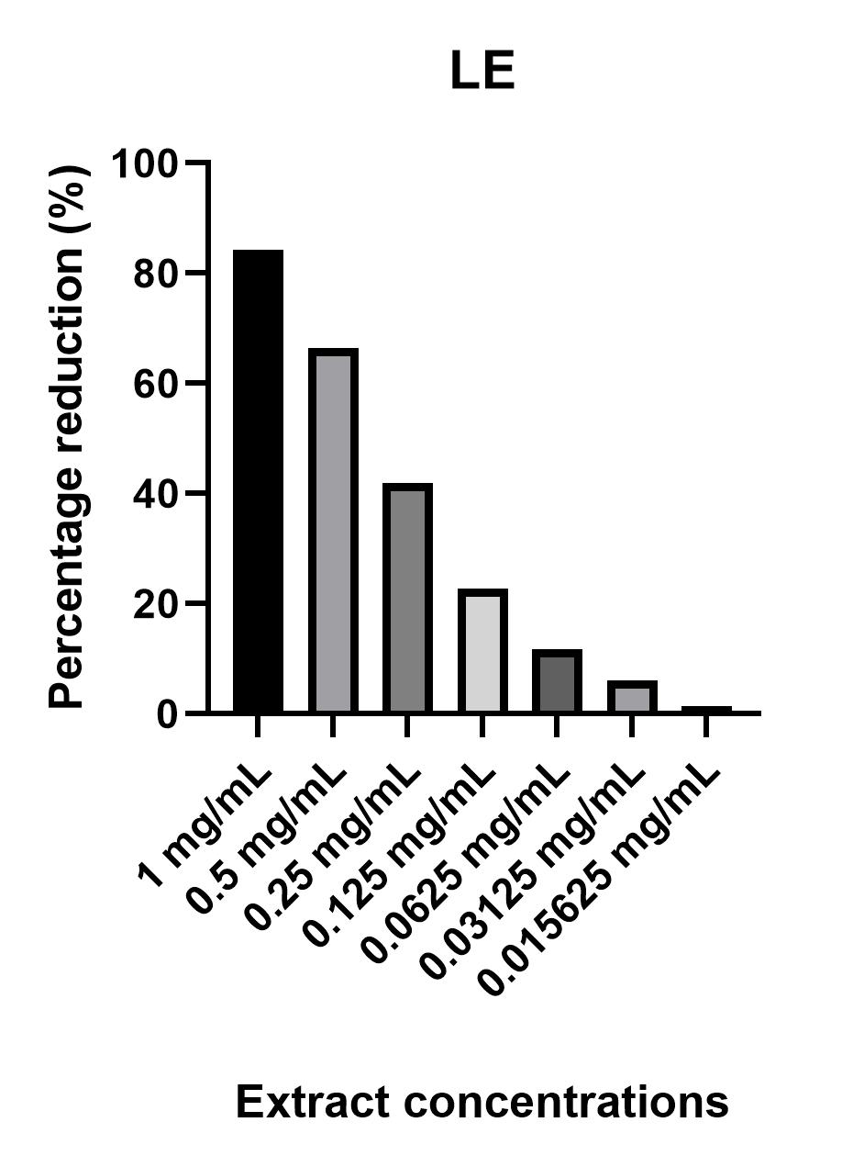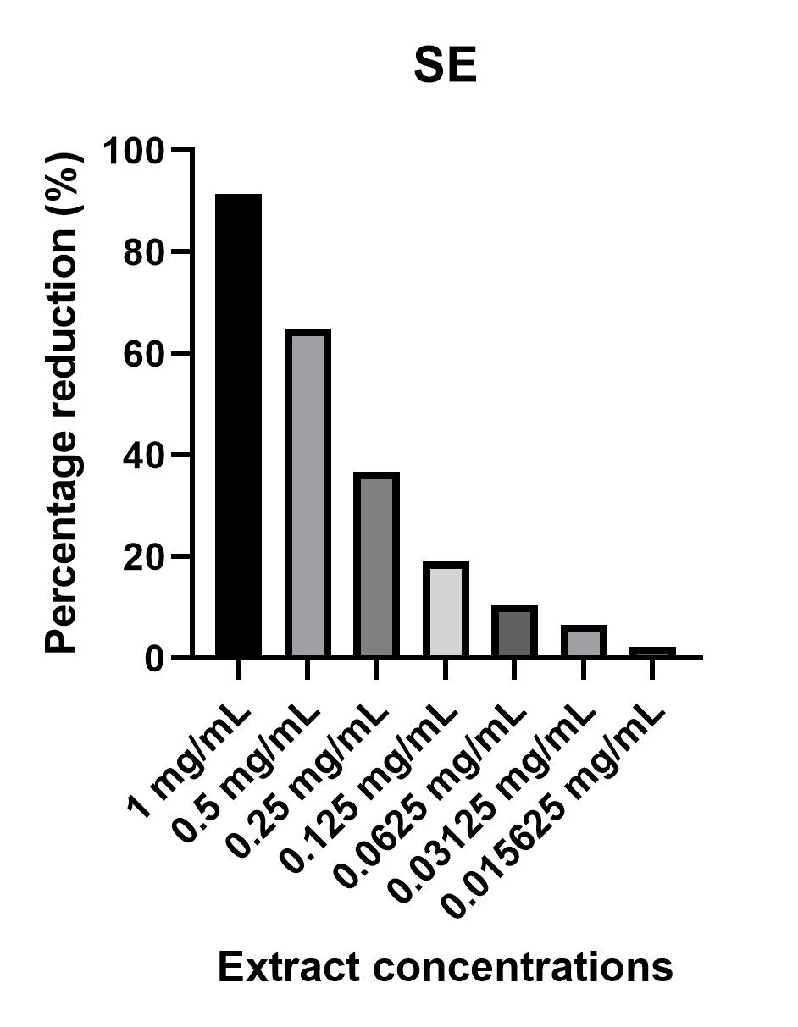
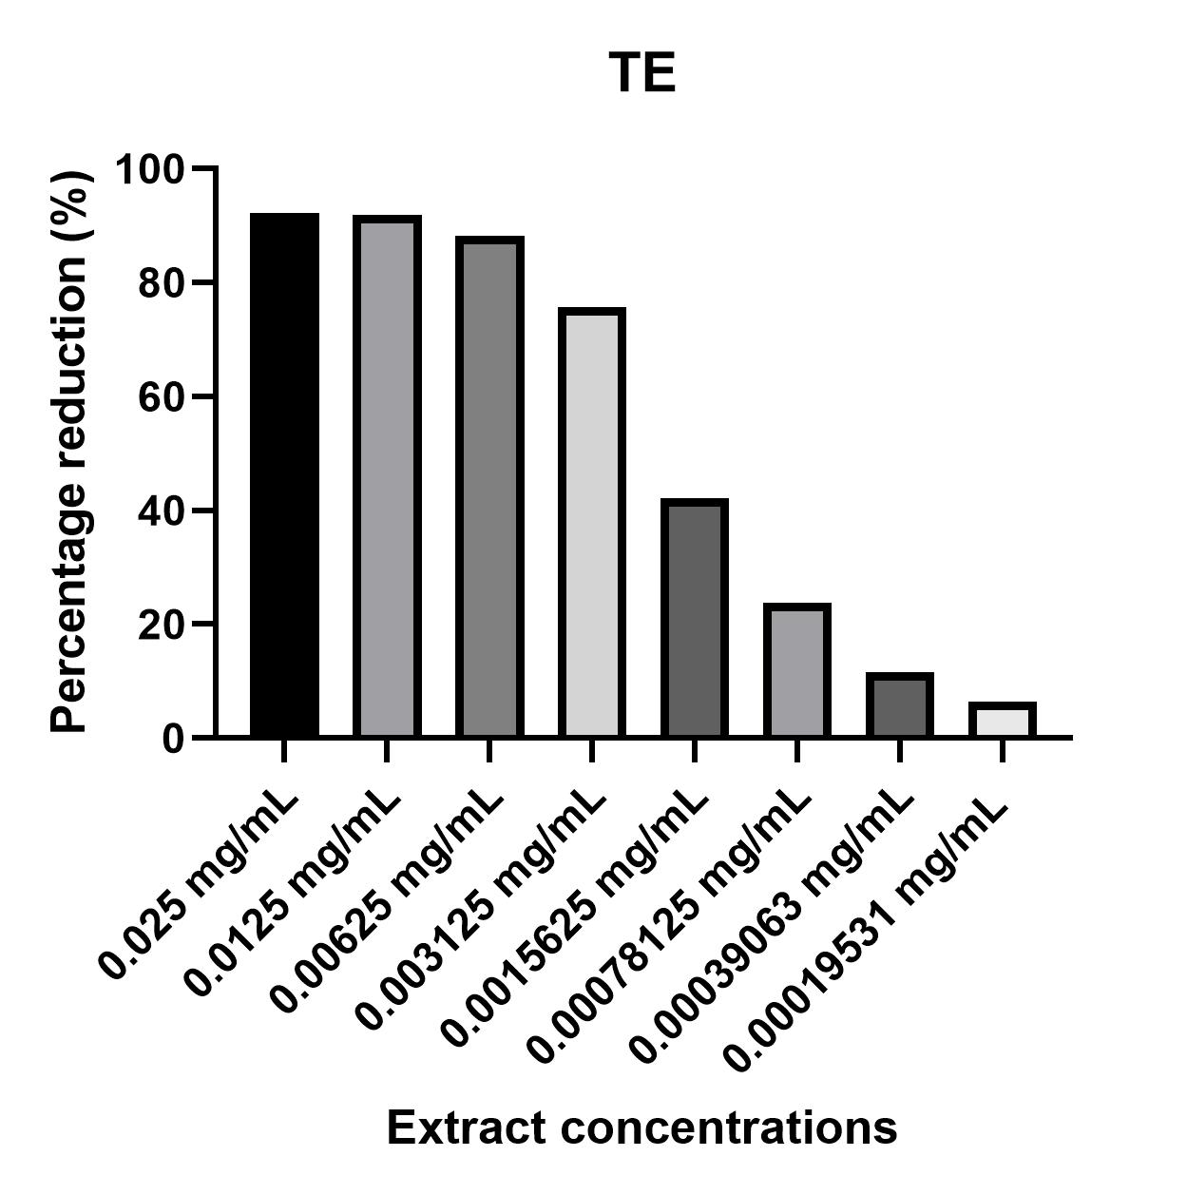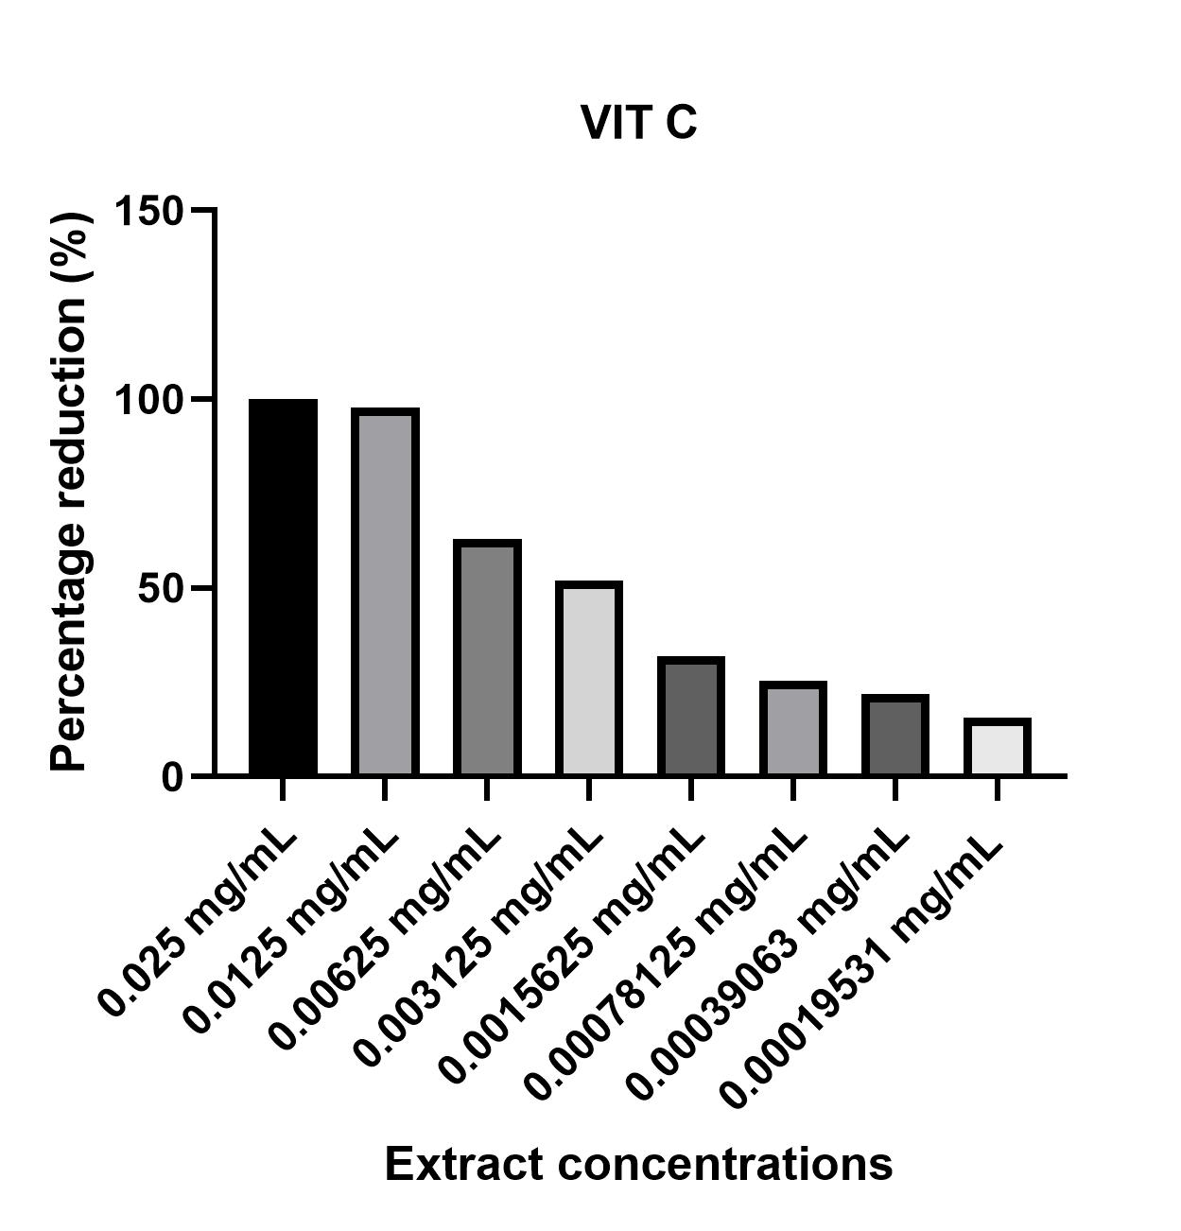

Fig.1. Percentage of DPPH Radical Reduction by the Study Extracts and Vitamin C

3.4.2 Determination of antioxidant Power by Ferric Reducing Ability (FRAP)

The antioxidant power of the different plant parts, evaluated by their ability to reduce ferric ion (Fe³⁺), was determined using a Trolox calibration curve (equation: y = 0.6905x + 0.0007; R² = 0.9987). Among the samples analyzed, the bark extract showed a significantly higher reducing power (p < 0.05) (78.877 ± 0.959 μmol TE/g extract) compared to the leaves (3.390 ± 0.045 μmol TE/gE) and seeds (3.071 ± 0.055 μmol TE/gE) (Figure 2), the latter two displaying similar values.
This high antioxidant capacity of the bark may be attributed to its richness in phenolic compounds. This assumption is supported by a strong positive correlation (r = 0.994) between the FRAP results and the total phenolic content, which reached 463.676 ± 0.985 mg GAE/g of dry matter (DM) (Table 3). Indeed, phenolic compounds are well known for their ability to donate electrons and thereby reduce ferric ions (Fe³⁺) [34].

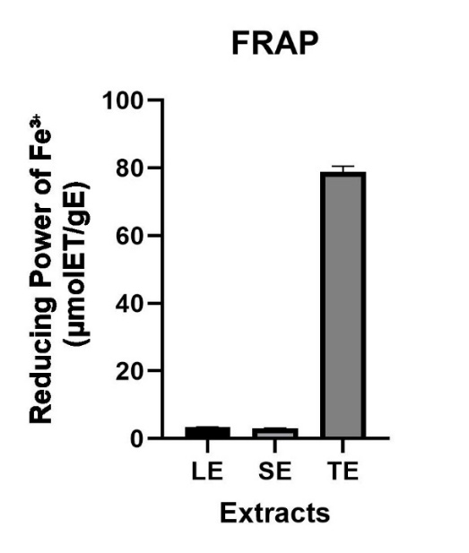
Fig. 2. Ferric Ion (Fe³⁺) reduction concentrations in the FRAP Assay

In summary, both the DPPH and FRAP assays clearly demonstrate that the hydroethanolic extract of Adenanthera pavonina stem bark possesses a significantly higher antioxidant potential compared to the leaf and seed extracts. This strong activity is highly correlated with the phenolic content, as evidenced by the high Pearson correlation coefficients (DPPH: r = -0.992; FRA: r = 0.994) with total phenols.

3.5 Antibacterial activity

3.5.1 Bacterial sensitivity and inhibitory power

The preliminary sterility test confirmed the absence of microbial contamination in all crude hydroalcoholic extracts of A. pavonina. Among the tested extracts, only the trunk bark extract (TE) showed antibacterial activity at 100 mg/mL, with inhibition zone diameters ranging from 15 ± 1 mm to 22 ± 1 mm, while the negative control (sterile distilled water) was inactive (Table 5). The reference antibiotics (Cefepime/FEP, Cefoxitin/FOX) exhibited varying levels of sensitivity against the bacterial strains, with inhibition zone diameters ranging from 15 to 30 mm.

Table 5: Inhibition diameters of extracts and reference antibiotics
 | Inhibition zone diameters (mm)
Bacterial strains | TE | LE | SE | EDS | FEP | FOX
E. coli 2473C/25 | 20 ± 0.50 | 06 ± 1 | 06 ± 1 | 06 ± 1 | 16 (R)
E. coli 2411C/25 | 15± 1 | 06 ± 1 | 06 ± 1 | 06 ± 1 | 30 (S)
S. aureus 2459C/25 | 22 ± 1 | 06 ± 1 | 06 ± 1 | 06 ± 1 |  | 16 (R)
S. aureus 2404C/25 | 18 ± 0.2 | 06 ± 1 | 06 ± 1 | 06 ± 1 |  | 25 (S)
P. aeruginosa 2472C/25 | 15 ± 1 | 06 ± 1 | 06 ± 1 | 06 ± 1 | 15 (R)

* EDS : Sterile distilled water, Cefepime (FEP), Cefoxitin (FOX) ; (S): Sensitive ; (R): Resistant.

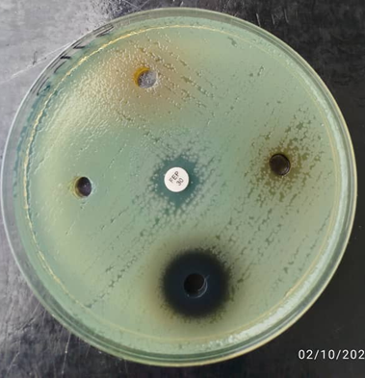
FEP
EDS
TE
LE
ES
Pseudomonas aeruginosa 2472C/25

: Sensitive : Resistant

Fig. 3. Sensitivity testing of the extracts for the study and the antibiotics against bacteria

3.5.2 Antibacterial parameters and interpretation

The antibacterial parameters of the active extract (TE) were determined and are presented in Table 6. Interpretation of the MBC/MIC ratio indicates that the trunk bark extract has a bactericidal effect against E. coli 2473C/25, E. coli 2411C/25, and P. aeruginosa 2472C/25, and a bacteriostatic effect against the two tested Staphylococcus aureus strains.

Table 6: Antibacterial parameters of the trunk bark extract (TE) of A. pavonina

 | CMI  (mg/mL) | CMB  (mg/mL) | CMB/CMI | Interpretation
E. coli 2473C/25 | 25 | 50 | 2 | Bactericidal
E. coli 2411C/25 | 12.5 | 25 | 2 | Bactericidal
S. aureus 2459C/25 | 6.25 | > 6,25 | - | Bacteriostatic
S. aureus 2404C/25 | 6.25 | > 6,25 | - | Bacteriostatic
P. aeruginosa 2472C/25 | 6.25 | 12.5 | 0.5 | Bactericidal

The liquid medium tests revealed a clear concentration-effect relationship: bacterial density decreased proportionally with increasing extract concentration. The observed antibacterial activity could be attributed to the action of phenolic compounds present in the trunk bark. These results provide preliminary scientific support for the traditional use of A. pavonina in treating conditions such as hematuria and diarrhea (often associated with E. coli), as well as in managing convulsions, where strains of Pseudomonas aeruginosa may be involved.

4. Conclusion

This study characterised the phytochemical composition and evaluated the antioxidant and antibacterial potential of hydroalcoholic extracts from the leaves, seeds and bark of Adenanthera pavonina. In summary, these results scientifically validate the pharmacological potential of Adenanthera pavonina and identify the bark as the most promising organ. They thus contribute to promoting this Ivorian ornamental species as a potential source of antioxidant and antibacterial active ingredients. Future studies could focus on the isolation and characterisation of specific active compounds, as well as the evaluation of their biological efficacy and safety in vivo.

Disclaimer (Artificial intelligence)
Option 1:
Author(s) hereby declare that NO generative AI technologies such as Large Language Models (ChatGPT, COPILOT, etc.) and text-to-image generators have been used during the writing or editing of this manuscript.

References

[1] Geronco, M. S., Melo, R. C., Hugo Barros, L. M., Aquino, S. R., de Oliveira, F., De, C. E., Islam, M. T., do A“Pessoa, C., Rizzo, D. S., & da Costa, M. P. (2020). Advances in the research of Adenanthera: From traditional use to intellectual property. Journal of Medicinal Plants Research, 14, 24–53. https://doi.org/10.5897/JMPR2019.6872
[2] Ara, A., Saleh-E-In, M. M., Hashem, M. A., Ahmad, M., & Hasan, C. M. (2019). Phytoconstituents of Adenanthera pavonina Linn from the bark extracts. Beni-Suef University Journal of Basic and Applied Sciences, 8(1), Article 13. https://doi.org/10.1186/s43088-019-0013-0
[3] Ghani, A. (2003). Medicinal plants of Bangladesh with chemical constituents and uses (2nd ed.). Asiatic Society of Bangladesh. https://www.ncbi.nlm.nih.gov/nlmcatalog/101257000
[4] Ara, A., Saleh-e-In, M. M., Ahmed, N. U., Ahmed, M. U., Hashem, M. A., & Bachar, S. C. (2010). Phytochemical screening, analgesic, antimicrobial and anti-oxidant activities of bark extracts of Adenanthera pavonina L. (Fabaceae). Advances in Natural and Applied Sciences, 4(3), 352–360. http://www.aensiweb.com/anas/2010/352-360.pdf
[5] Ara, A., Saleh-e-In, M. M., Ahmed, N. U., Hashem, M. A., & Bachar, S. C. (2013). Anti-diarrheal activity and acute toxicity of methanolic bark extract of Adenanthera pavonina Linn (Fabaceae) and its elemental composition. Turkish Journal of Pharmaceutical Sciences, 10(2), 263–272. https://cms.galenos.com.tr/Uploads/Article_12394/263-272.pdf
[6] Adedapo, A. D. A., Osude, Y. O., Adedapo, A. A., Moody, J. O., Adeagbo, A. S., Olajide, O. A., & Makinde, J. M. (2009). Blood pressure lowering effect of Adenanthera pavonina seed extract on normotensive rats. Records of Natural Products, 3(2), 82–89.https://www.acgpubs.org/journal/records-of natura lproducts/volumes?year=2009&volume=3&issue=2
[7] Saleh-e-In, M. M., Kar, P., Ara, A., Roy, A., & Iriti, M. (2022). Botany and phytochemistry of Adenanthera pavonina L. (Rakta Kambal) – A mini review. Journal of Phytomolecules & Pharmacology, 1(1), 3–18. https://doi.org/10.56717/jpp.2022.v01i01.002
[8] Chatgilialoglu, C., Ferreri, C., & O’Neill, P., (2024). Biomarkers of oxidative and radical stress. Biomolecules, 14(2), 194. https://doi.org/10.3390/biom14020194
[9] Bocquet, L., Sahpaz, S., Bonneau, N., Beaufay, C., Mahieux, S., Samaillie, J., Roumy, V., Jacquin, J., Bordage, S., Hennebelle, T., Chai, F., Quetin-Leclercq, J., Neut, C., & Rivière, C. (2019). Phenolic compounds from Humulus lupulus as natural antimicrobial products: New weapons in the fight against methicillin-resistant Staphylococcus aureus, Leishmania mexicana and Trypanosoma brucei strains. Molecules, 24(6),1024.https://doi.org/10.3390/molecules24061024
[10] Lobiuc, A., Pavăl, N.-E., Mangalagiu, I. I., Gheorghiță, R., Teliban, G.-C., Amăriucăi-Mantu, D., & Stoleru, V. (2023). Future Antimicrobials: Natural and Functionalized Phenolics. Molecules, 28(3), 1114. https://doi.org/10.3390/molecules28031114
[11] Senhaji S., Lamchouri F., Toufik H. (2020). Phytochemical content, antibacterial and antioxidant potentiel of endemic plant Anabasis aretioïdes Coss. & Moq. (Chenopodiaceae). Biomedical Research International, 6, 1-16. https://doi.org/10.1155/2020/6152932
[12] Békro, Y. A., Békro, J. A. M., Boua, B. B., Tra, B. F. H., & Ehilé, E. E. (2007). Étude ethnobotanique et screening phytochimique de Caesalpinia benthamiana (Baill.) Herend. et Zarucchi (Caesalpiniaceae). Sciences & Nature, 4(2), 217-225.https://doi.org/10.4314/SCINAT.V4I2.42146
[13] Konan K. (2010). Chemical study and evaluation of the antioxidant activity of four medicinal plants from Côte d'Ivoire. Single doctoral thesis, University of Abobo-Adjamé (Abidjan / Côte d’Ivoire), 112p.
[14] N'Guessan, H. A., Dago, D. C. E., Mamyrbékova-Békro, J. A., & Békro, Y. A. (2011). CCM d'extraits sélectifs de 10 plantes utilisées dans le traitement traditionnel de l'hypertension artérielle en Côte d'Ivoire. European Journal of Scientific Research, 66(4), 575-585.https://hal.science/hal-01447284
[15] Kabran, G. R. M., Ambeu, N. C., Mamyrbékova Békro, J. A., & Békro, Y. A. (2011). CCM D'extraits Selectifs de 10 Plantes Utilisees Dans le Traitement Traditionnel du Cancer du Sein en Côte d'Ivoire. European Journal of Scientific Research, 63(4), 592-603.http://www.europeanjournalofscientificresearch.com/vol63no4/EJSR_63_4_09.pdf
[16] N'Gaman K. C. C. (2013). Phytochemical study and effect of extracts of Gmelina arborea Roxb. (Verbenaceae) from Côte d’Ivoire on the osmotic stability of erythrocytes. PhD thesis. University Nangui Abrogoua, Abidjan (Côte d'Ivoire), 112 p.
[17] Bruneton, J. (2016). Pharmacognosy, phytochemistry, medicinal plants. Lavoisier Tec & Doc.https://www.e-lavoisier.fr/fr/ebook/pharmacognosy-phytochemistry-medicinal-plants/bruneton/ean13-9782743018726
[18] Debnath, B., Uddin, M. J., Patari, P., Das, M., Maiti, D., & Manna, K. (2015). Estimation of alkaloids and phenolics of five edible cucurbitaceous plants and their antibacterial activity. International Journal of Pharmacy and Pharmaceutical Sciences, 7(12), 223-227.https://innovareacademics.in/journals/index.php/ijpps/article/view/8992
[19] Singleton, V. L., Orthofer, R., & Lamuela-Raventós, R. M. (1999). Analysis of total phenols and other oxidation substrates and antioxidants by means of Folin-Ciocalteu reagent. Methods in Enzymology, 299, 152-178. https://doi.org/10.1016/S0076-6879(99)99017-1
[20] Arvouet-Grand, A., Vennat, B., Pourrat, A., & Legret, P. (1994). Standardisation d’un extrait de propolis et identification des principaux constituants. Journal de pharmacie de Belgique, 49(6), 462-468. https://pubmed.ncbi.nlm.nih.gov/7884635/
[21] Heimler, D., Vignolini, P., Dini, M. G., Vincieri, F. F., & Romani, A. (2006). Antiradical activity and polyphenol composition of local Brassicaceae edible varieties. Food Chemistry, 99(3), 464-469. https://doi.org/10.1016/j.foodchem.2005.07.057
[22] Brand-Williams, W., Cuvelier, M. E., & Berset, C. (1995). Use of free radical method to evaluate antioxidant activity. Lebensmittel-Wissenschaft und Technologie, 28(1), 25-30.https://doi.org/10.1016/S0023-6438(95)80008-5
[23] Benzie, I. F., & Strain, J. J. (1996). The ferric reducing ability of plasma (FRAP) as a measure of "antioxidant power": The FRAP assay. Analytical Biochemistry, 239, 70-76.https://doi.org/10.1006/abio.1996.0292
[24] Gong, J., Huang, J., Xiao, G., Chen, F., Lee, B., Ge, Q., You, Y., Liu, S., & Zhang, Y. (2016). Antioxidant capacities of fractions of bamboo shaving extract and their antioxidant components. Molecules, 21(8), 996. https://doi.org/10.3390/molecules21080996
[25] Comité de l'antibiogramme de la Société Française de Microbiologie (CA-SFM) & European Committee on Antimicrobial Susceptibility Testing (EUCAST). (2024). *CA-SFM / EUCAST 2024 V1.0*. Société Française de Microbiologie. https://www.sfm-microbiologie.org/wp-content/uploads/2024/06/CA-SFM-EUCAST-2024-V1.0.pdf
[26] Ponce, A. G., Fritz, R., del Valle, C. E., & Roura, S. I. (2003). Antimicrobial activity of essential oils on the native microflora of organic Swiss chard. LWT - Food Science and Technology, 36, 679-684. https://doi.org/10.1016/S0023-6438(03)00088-4
[27] Fauchère, J.-L., & Avril, J.-L. (2002). *Bactériologie générale et médicale*. Editions Ellipses.https://www.editions-ellipses.fr/produit/bacteriologie-generale-et-medicale/
[28] Ullah, A., Munir, S., Badshah, S. L., Khan, N., Ghani, L., Poulson, B. G., Emwas, A.-H., & Jaremko, M. (2020). Important flavonoids and their role as a therapeutic agent. Molecules, 25(22), 5243. https://doi.org/10.3390/molecules25225243
[29] Chung, K. T., Wong, T. Y., Wei, C. I., Huang, Y. W., & Lin, Y. (1998). Tannins and human health: A review. Critical Reviews in Food Science and Nutrition, 38(6), 421–464.https://doi.org/10.1080/10408699891274273
[30] Flores-Morales, V., Villasana-Ruíz, A. P., Garza-Veloz, I., González-Delgado, S., & Martinez-Fierro, M. L. (2023). Therapeutic effects of coumarins with different substitution patterns. Molecules, 28(5), 2413. https://doi.org/10.3390/molecules28052413
[31] Anywar, G., & Muhumuza, E. (2024). Bioactivity and toxicity of coumarins from African medicinal plants. Frontiers in Pharmacology, 14, 1231006.https://doi.org/10.3389/fphar.2023.1231006
[32] Yumita, A., Hanani, E., Agustina, A., Damayanti, F., Priani, K. N., & Fadila, S. N. (2023). Total Phenolic Content and Antioxidant Activities of Leaves and Bark Extract of Adenanthera pavonina L. Natural Product Sciences, 29(1), 24-30. https://doi.org/10.20307/nps.2023.29.1.24
[33] Dai, J., & Mumper, R. J. (2010). Plant Phenolics: Extraction, Analysis and Their Antioxidant and Anticancer Properties. Molecules, 15(10), 7313–7352.https://doi.org/10.3390/molecules15107313
[34] Kouassi, K. A., Kouadio, N. J., Ahoua, A. R. C., Yao, K., Kanga, Y., Moya, B. G., & Koné, M. W. (2020). Activité Antioxydante Et Teneur En Flavonoïdes De Cinq Plantes De La Famille Des Fabaceae Utilisées Contre De l'Ostéoporose Au Centre De La Côte d'Ivoire. European Scientific Journal, 16(3), 84-100. https://doi.org/10.19044/esj.2020.v16n3p84
[35] Huang, J., Zaynab, M., Sharif, Y., Khan, J., Al-Yahyai, R., Sadder, M., Ali, M., Alarab, S. R., & Li, S. (2024). Tannins as antimicrobial agents: Understanding toxic effects on pathogens. Toxicon, 247, 107812. https://doi.org/10.1016/j.toxicon.2024.107812
[36] Usman, W. A., Jada, M. S., & Jideofor, R. M. (2014). In vitro Antimicrobial Activity of Crude Tannins Isolated from the Stem Bark of Annona senegalensis. British Biotechnology Journal, 4(11), 1175-1181. https://doi.org/10.9734/BBJ/2014/11885
[37] Bekro, Y. A., Tanoh, S. K., N'gaman-Kouassi, C. C., Boa, D., & Mamyrbekova-Békro, J. A. (2019). Activité antioxydante des extraits bruts hydroéthanoliques et hydroacétoniques des organes de quatre plantes médicinales de Côte d'Ivoire. Revue Nature et Technologie, 11(2), 28-34. https://www.asjp.cerist.dz/en/article/89900
[38] Etekpo, D. S., N'Gaman-Kouassi, C. C., Mamyrbekova-Békro, J. A., & Békro, Y. A. (2022). Antioxidant profiles of alcoholic tinctures from Heterotis rodundifolia (SM.) Jacq. Fel. (Melastomacacea) by DPPH radical trapping. European Journal of Biomedical and Pharmaceutical Sciences, 10(5), 39-45. https://doi.org/10.18231/j.jpbs.2022.007

