Biochemical and Histopathological Evaluation of Ginger Extract as a Hepatoprotective Agent Against Reality Extra-Induced Liver Toxicity in Albino Mice

Abstract
Drug-induced liver injury (DILI) continues to be a major global health challenge, particularly when associated with misuse or overdose of multi-component pharmaceutical preparations. Reality Extra, a widely used analgesic–anti-inflammatory combination drug containing paracetamol, ibuprofen, diclofenac sodium, and caffeine, has been increasingly implicated in hepatic toxicity under overdose conditions. The present study integrates both biochemical and histopathological perspectives to evaluate the hepatoprotective efficacy of ginger (Zingiber officinale) extract in adult albino mice exposed to high doses of Reality Extra. Twenty rats were divided into four experimental groups: control, Reality Extra, ginger only, and ginger + Reality Extra. Serum alkaline phosphatase (ALP) and albumin were measured as indicators of hepatic biochemical function, whereas histopathological sections stained with hematoxylin and eosin (H&E) were examined for structural hepatic integrity. Reality Extra produced a marked elevation in ALP (243.25 ± 52.43 U/L) accompanied by a reduction in albumin (1.56 ± 0.37 g/dL), alongside extensive hepatic necrosis, inflammatory infiltration, vacuolization, and vascular congestion. In contrast, the ginger + Reality Extra group demonstrated near-normal ALP (61.00 ± 21.66 U/L), improved albumin (2.83 ± 0.13 g/dL), and preserved hepatic architecture. Collectively, the findings confirm that ginger extract confers significant biochemical and structural protection against multi-drug-induced liver injury, making it a potential natural adjunctive therapeutic agent against hepatotoxicity.
Keywords: Ginger extract, hepatotoxicity, Reality Extra, ALP, albumin, histopathology, drug-induced liver injury.

1. Introduction
Drug-induced liver injury represents a leading cause of acute and chronic hepatic failure worldwide. A substantial proportion of documented hepatotoxicity arises from overuse or accidental misuse of over-the-counter analgesic combinations. Reality Extra—a formulation combining paracetamol, caffeine, ibuprofen, and diclofenac sodium—poses unique toxicological complexities due to synergistic hepatotoxic effects when consumed at doses exceeding therapeutic recommendations. (Nithiyanandam & Evan Prince., 2021; Pandit et al., 2012)
Paracetamol toxicity is well documented and is primarily mediated by excessive formation of the reactive metabolite N-acetyl-p-benzoquinone imine (NAPQI), which overwhelms hepatic glutathione reserves (Chidiac et al., 2023; Md. Masum et al., 2019). This process triggers oxidative stress, mitochondrial dysfunction, and ultimately centrilobular hepatocyte necrosis. Similarly, NSAIDs such as ibuprofen and diclofenac have been associated with mitochondrial respiratory inhibition, impaired hepatic perfusion, and immune-mediated cellular injury, while caffeine contributes to metabolic acceleration that may potentiate drug–drug interactions. (Ramachandran et al., 2018)
Histopathology serves as an essential diagnostic approach for assessing the severity and progression of drug-induced liver injury. Classical microscopic hallmarks include hepatocellular degeneration, sinusoidal congestion, ballooning of hepatocytes, portal and lobular inflammatory infiltration, Kupffer cell hyperplasia, and coagulative necrosis. (Chidiac et al., 2023, 2018; E,U. Eric et al., 2024)
Ginger (Zingiber officinale) has been traditionally used for its medicinal properties, attributed to bioactive phenolics such as gingerols and shogaols. Experimental studies have highlighted ginger’s potential as an antioxidant, anti-inflammatory, and cytoprotective agent. However, a comprehensive combined biochemical–histological analysis of ginger’s effects against the hepatotoxicity induced by complex pharmaceutical mixtures remains insufficiently explored. (Islam et al. 2021; Sasidharan et al., 2010)
Therefore, the present study integrates biochemical assays and detailed histopathological evaluation to examine the hepatoprotective activity of ginger extract in rats subjected to liver damage induced by Reality Extra.

2. Materials and Methods

2.1. Experimental Animals
Twenty healthy adult albino mice (Rattus norvegicus), weighing between 30–40 grams, were obtained and housed under standard laboratory conditions (12-hour light/dark cycle, 22–25°C, with free access to food and water).

2.2. Chemicals and Extract
- Reality Extra: A pharmaceutical compound containing paracetamol, ibuprofen, caffeine, and diclofenac sodium.
- Ginger Extract: Fresh ginger rhizomes were cleaned, dried, and ground into powder, then extracted using ethanol. The extract was administered at a dose of 1 mL/day.
- Biochemical Kits: Commercial diagnostic kits were used for measuring serum alkaline phosphatase (ALP) and albumin levels.

2.3. Experimental Design
Mice were randomly divided into four groups (n = 5 per group): (Gupta et al., 2022)
- Group A (Control): Received no treatment.
- Group B (Reality Extra): Administered 50 mg/kg of Reality Extra orally for 30 consecutive days.
- Group C (Ginger only): Administered 1 mL of ginger extract daily.
- Group D (Ginger + Reality Extra): Administered both ginger extract (1 mL) and Reality Extra (50 mg/kg) concurrently.

2.4. Sample Collection
At the end of the 30-day treatment period, mice were anesthetized and sacrificed. Blood samples were collected via cardiac puncture, and serum was separated by centrifugation at 3000 rpm for 15 minutes and stored at −20°C until analysis. (Gupta et al., 2022)

2.5. Biochemical Analysis
Serum levels of ALP and albumin were determined using standard colorimetric methods according to the manufacturer’s instructions. (Bouvier et al. 2022).
2.6. Histopathological Evaluation
At the end of the experimental period, mice were sacrificed, and liver samples were collected. Tissues were fixed in 10% formalin, embedded in paraffin, sectioned at 5 µm, and stained with hematoxylin and eosin (H&E). Slides were examined under a light microscope for structural alterations, including necrosis, cellular degeneration, inflammation, sinusoidal congestion, and architectural disruption. (Makki et al., 2022)

2.7. Statistical Analysis
Data were analyzed using SPSS software (version 25). Results are expressed as mean ± standard deviation (SD). One-way analysis of variance (ANOVA) followed by Least Significant Difference (LSD) post hoc test was used to determine statistical significance between groups. A p-value < 0.05 was considered statistically significant.

3. Results

3.1. Biochemical Results

3.1.1. Effect on Alkaline Phosphatase (ALP) Levels
As shown in Table 1, the Reality Extra group (Group B) demonstrated a significant elevation in ALP levels (243.25 ± 52.43 U/L), indicating hepatic injury. In contrast, both the control group (61.75 ± 16.46 U/L) and the ginger-only group (59.80 ± 14.46 U/L) maintained normal enzyme levels. Notably, the Ginger + Reality Extra group (Group D) exhibited a marked reduction in ALP (61.00 ± 21.66 U/L), comparable to control values, suggesting a hepatoprotective effect of ginger.

Table 1. Serum ALP levels (U/L) across experimental groups.
Group | ALP (Mean ± SD)
A – Control | 61.75 ± 16.46
B – Reality Extra | 243.25 ± 52.43
C – Ginger only | 59.80 ± 14.46
D – Ginger + Reality Extra | 61.00 ± 21.66
The sharp rise in ALP in the Reality Extra group is a characteristic indicator of hepatobiliary obstruction, inflammation, or cytotoxic injury affecting the canalicular membranes. The ginger co-treatment significantly reduced ALP, restoring it to near-normal levels comparable with the control and ginger-only groups.
ANOVA analysis revealed statistically significant differences between groups (p < 0.001). LSD post hoc tests confirmed that Group B was significantly different from all other groups, while Groups C and D were not significantly different from the control.

3.1.2. Effect on Albumin Levels
Table 2 illustrates that the control group showed the highest albumin levels (2.89 ± 0.29 g/dL), followed by the Ginger + Reality Extra group (2.83 ± 0.13 g/dL) and the ginger-only group (2.58 ± 0.48 g/dL). The lowest level was observed in the Reality Extra group (1.56 ± 0.37 g/dL), indicating impaired liver synthetic function.
Table 2. Serum Albumin levels (g/dL) across experimental groups.
Group | Albumin (Mean ± SD)
A – Control | 2.89 ± 0.29
B – Reality Extra | 1.56 ± 0.37
C – Ginger only | 2.58 ± 0.48
D – Ginger + Reality Extra | 2.83 ± 0.13
The significant drop in albumin in the Reality Extra group demonstrates a marked disturbance in hepatic synthetic pathways. In contrast, ginger administration restored albumin levels almost completely.
ANOVA results showed significant differences between groups (p = 0.001). Post hoc analysis confirmed that Group B was significantly different from the other three groups, while Groups C and D were statistically similar to the control.
3.2. Histopathological Results

3.1.1. Control Group (Group A)
A histological section of the liver of mice from the control group was examined using hematoxylin and eosin dye (H&E), in which the liver tissue showed a normal appearance reflecting the health of the liver tissue. The hepatocytes were arranged in radial rows around the central veins, contained medium-sized circular nuclei, with normally double-nucleated cells. The sinusoids were normally distributed between the hepatic cords without any signs of expansion or excessive fullness with blood, and the Kupffer Cells appeared normally inside the sinuses. No signs of damage, necrosis, or infiltration of inflammatory cells into the tissue were observed. The overall structure of the tissue was intact and devoid of any pathological changes, reflecting the healthy liver condition of the control group. As shown in Figure (1).
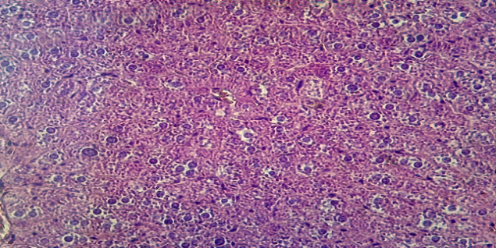
Figur 1: Histological section of liver tissue: Group A

3.1.2. Ginger-only Group (Group B)
Positive changes in the structure of the liver were observed in mice that received ginger only, as the liver tissue showed an improvement in the balance of the distribution of hepatocytes and the absence of proliferation of fat cells, which indicates the protective effect of ginger against the negative effects of toxic substances. Hepatocytes also appeared regular with normal circular nuclei in most cells without obvious signs of cellular damage such as swelling or necrosis, indicating limited or no effects of ginger on cell integrity. The blood sinuses appeared clear and well-opened, which indicates the safety of blood circulation inside the liver, with the absence of any evidence of congestion or abnormal dilatation. The hepatic immune cells (Kupffer cells) appeared to be in a normal position within the blood sinuses without any signs of increased inflammatory activity. Inflammatory infiltrates or pathological changes in the tissue were not observed, since the tissue looked largely normal, which indicates that ginger did not cause pronounced negative effects on liver tissue. As shown in Figure 2.
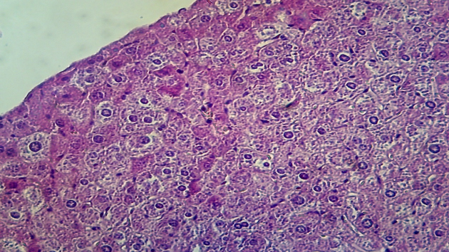
Figur 2: Histological section of liver tissue: Group B

3.1.3. Reality Extra Group (Group C)
The group that received the overdose of Reality Extra pronounced pathological histological changes were observed. Hepatocytes showed an abnormal arrangement in some areas, as they lost the regular arrangement in the hepatic cords. Cellular changes such as cytoplasmic pitting (Vacuolization), which indicates degenerative changes, as well as hypertrophy of nuclei (Nuclear inclusion) have also been observed in some cells, reflecting abnormal activity or cellular stress. In some areas, hepatocytes appeared to be decomposing, which indicates cell lysis (Necrosis) caused by a toxic effect of the drug. At the level of the hepatic sinuses (Sinusoids), a pronounced widening is observed, with the accumulation of red blood cells in some places, which indicates a possible congestion. Kupffer cells have also been observed to be activated, reflecting an innate immune response. In addition, pronounced inflammatory infiltrates appeared around the blood vessels (peripheral Areas), which indicates an acute inflammatory response as a result of cell damage or a direct effect of the drug. As for the central vessels (Central Veins), they appeared dilated, with possible congestion in them, which could affect the normal blood flow in the liver. In general, such changes reflect hepatotoxicity (Hepatotoxicity) caused by exposure to the drug, and such poisoning may be a consequence of oxidative stress (Oxidative Stress), an inflammatory response or a direct toxic effect on liver cells. As shown in Figure (3).
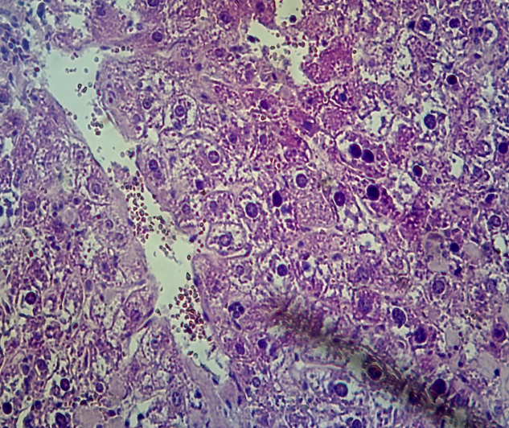
Figur 3: Histological section of liver tissue: Group C

3.1.4. Ginger + Reality Extra Group (Group D)
The group that received the mixture of ginger and the drug, the mice that received the mixture of ginger and the drug showed a marked improvement in the structure of tissues where the results showed the regularity of hepatocytes, as the cells appeared with clear boundaries with normal circular nuclei without any signs of necrosis or excessive swelling, reflecting the integrity of the cells. The blood sinuses also appeared clear and well-opened, without any signs of congestion or abnormal dilatation, which indicates the safety of blood circulation inside the liver. In addition, a marked decrease in inflammatory infiltrates was observed compared to cases of acute inflammation, which indicates that ginger contributes to a decrease in inflammatory activity in the liver. Hepatic immune cells (Kupffer Cells) appeared in a normal position inside the blood sinuses, no increase in inflammatory activity was observed, which indicates the stabilization of the immune status of the tissue as shown in Figure (4).
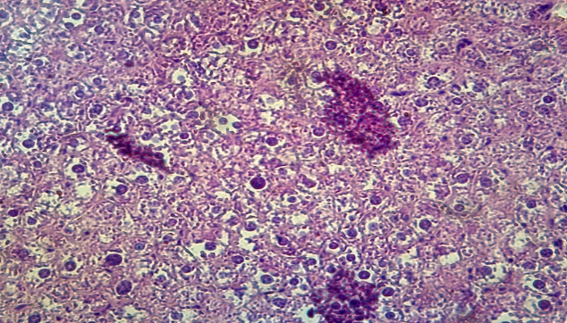
Figur 4: Histological section of liver tissue: Group D

4. Discussion
This study investigated the biochemical effects of ginger extract on liver function in albino rats exposed to toxic doses of the combination drug Reality Extra. The findings demonstrate that ginger exerts a significant hepatoprotective effect by normalizing key liver function biomarkers—alkaline phosphatase (ALP) and albumin.
The substantial increase in ALP levels observed in the Reality Extra group is indicative of hepatocellular damage, consistent with previous reports on the hepatotoxic potential of paracetamol and NSAIDs in overdose scenarios. (Stephen & Bello., 2024) Elevated ALP is commonly associated with bile duct obstruction, cellular necrosis, or drug-induced hepatotoxicity. The marked reduction in albumin levels further reflects impaired synthetic capacity of the liver, reinforcing the toxic burden induced by prolonged exposure to Reality Extra.
Importantly, co-administration of ginger extract significantly ameliorated these biochemical disturbances. ALP levels were restored to near-normal values, and serum albumin concentrations were improved significantly in the ginger + drug group. These results align with earlier studies (de Moraes et al, 2021 that identified ginger’s antioxidative and anti-inflammatory properties as crucial mechanisms for hepatic protection. Gingerol compounds in particular are known to scavenge free radicals and modulate inflammatory cytokines, thereby preventing oxidative stress and hepatocyte apoptosis.
Interestingly, the ginger-only group showed biochemical profiles nearly identical to the control group, confirming its safety and lack of hepatic toxicity at the administered dose.
Collectively, these findings suggest that ginger extract not only counters liver enzyme elevation but also supports the liver’s synthetic function during toxic drug exposure. Its therapeutic value lies in its ability to intervene in the pathological cascade initiated by drug-induced oxidative and inflammatory responses.
The histopathological analysis confirms the hepatotoxic impact of Reality Extra, as evidenced by widespread necrosis, architectural disarray, and inflammatory responses in the liver tissues of treated rats. These findings support previous reports indicating that paracetamol and NSAIDs, especially in combination, contribute to liver damage through oxidative stress and mitochondrial dysfunction.
The protective effects observed in the ginger co-treatment group validate ginger’s ability to preserve hepatic structure under toxic insult. These results are consistent with the study by (Stephen & Bello., 2024). The maintenance of hepatocyte alignment, reduction of inflammation, and absence of vascular congestion in the ginger + drug group indicate a significant protective role likely mediated through the antioxidant actions of gingerol compounds, which counteract lipid peroxidation and modulate immune responses. These results align with the research conducted by (de Moraes et al, 2021)
The ginger-only group’s histology matched that of the control group, further confirming the extract’s safety and non-toxicity at the tested dose.
These results suggest that ginger may not only prevent structural liver damage but could also support tissue recovery during ongoing drug-induced hepatic stress.

5. Conclusion
Reality Extra induces pronounced biochemical and histopathological liver damage, characterized by elevated ALP, reduced albumin, extensive hepatocyte necrosis, vascular congestion, and inflammatory cell infiltration.
The present study demonstrates that ginger extract exerts significant hepatoprotective effects against liver toxicity induced by the multi-component drug Reality Extra in albino mice. The extract effectively restored altered biochemical markers, reducing elevated ALP levels and increasing serum albumin concentrations, indicating improved hepatic function.
The findings of this study demonstrate that high-dose administration of Reality Extra leads to severe histopathological damage in liver tissues, including necrosis, inflammatory infiltration, and vascular congestion. However, co-administration of ginger extract significantly mitigates these effects and preserves hepatic structure.
These results support the therapeutic potential of ginger as a natural hepatoprotective agent and advocate its use as a complementary intervention for mitigating drug-induced liver injury
Ethical Approval:
The study was approved by the institutional ethics committee, and all animal procedures complied with internationally accepted ethical guidelines for animal research.
Disclaimer (Artificial intelligence)
Option 1:
Author(s) hereby declare that NO generative AI technologies such as Large Language Models (ChatGPT, COPILOT, etc.) and text-to-image generators have been used during the writing or editing of this manuscript.
Option 2:
Author(s) hereby declare that generative AI technologies such as Large Language Models, etc. have been used during the writing or editing of manuscripts. This explanation will include the name, version, model, and source of the generative AI technology and as well as all input prompts provided to the generative AI technology
Details of the AI usage are given below:
1.
2.
3.

References
- Bouvier, M. L., Fehsel, K., Schmitt, A., Meisenzahl-Lechner, E., Gaebel, W., & von Wilmsdorff, M. (2022). Sex-dependent effects of long-term clozapine or haloperidol medication on red blood cells and liver iron metabolism in Sprague Dawley rats as a model of metabolic syndrome. BMC Pharmacology and Toxicology, 23(1), 8. http://doi.org/10.1186/s40360-021-00544-4
- Chidiac, A. S., Buckley, N. A., Noghrehchi, F., & Cairns, R. (2023). Paracetamol (acetaminophen) overdose and hepatotoxicity: mechanism, treatment, prevention measures, and estimates of burden of disease. Expert Opinion on Drug Metabolism & Toxicology, 19 (5), 297-317. https://doi.org/10.1080/17425255.2023.2223959

- De Moraes, A. C. N., de Andrade, C. B. V., Ramos, I. P. R., Dias, M. L., Batista, C. M. P., Pimentel, C. F., ... & dos Santos Goldenberg, R. C. (2021). Resveratrol promotes liver regeneration in drug-induced liver disease in mice. Food Research International, 142, 110185. https://doi.org/10.1016/j.foodres.2021.110185
- Gupta, R. K., Chaudhary, S., El-Shorbagi, A. N., Sara, U. S., Shukla, P., & Swain, S. R. (2022). A Comprehensive Review of Experimental Animal Models of Hepatopathy. Biomedical and Pharmacology Journal, 15(2), 563-578. https://dx.doi.org/10.13005/bpj/2397

- Islam, M. T., Quispe, C., Islam, M. A., Ali, E. S., Saha, S., Asha, U. H., & Sharifi-Rad, J. (2021). Effects of nerol on paracetamol-induced liver damage in Wistar albino rats. Biomedicine & Pharmacotherapy, 140, 111732. https://doi.org/10.1016/j.biopha.2021.111732
- Makki, H. M. M., Adam, G. O., Yang, D. K., Tungalag, T., Lee, S. J., Kim, J. S., ... & Kang, H. S. (2022). Effects of gibberellic acid on thioacetamide-induced acute liver toxicity in Sprague-Dawley rats. Pakistan Veterinary Journal, 42(4), 481-486.
DOI: 10.29261/pakvetj/2022.025
- Nithiyanandam, S., & Evan Prince, S. (2021). Toxins mechanism in instigating hepatotoxicity. Toxin Reviews, 40(4), 616-631.
https://doi.org/10.1080/15569543.2020.1818105

- Panchal, N. K., & Sabina, E. P. (2023). Non-steroidal anti-inflammatory drugs (NSAIDs): A current insight into its molecular mechanism eliciting organ toxicities. Food and Chemical Toxicology, 172, 113598.
https://doi.org/10.1016/j.fct.2022.113598

- Stephen, H., & Bello, B. (2024). Protective Effect of Lantana camara Methanolic Leaf Extract Against Acetaminophen-induced Liver Injury in Male Albino Rats. Pharmaceutical and Biomedical Research, 10(2), 135-146. ‎ 10.32598/PBR.10.2.1253.1

- Pandit, A., Sachdeva, T., & Bafna, P. (2012). Drug-induced hepatotoxicity: a review. Journal of Applied Pharmaceutical Science, (Issue), 233-243. DOI: 10.7324/JAPS.2012.2541
- Chidiac, A. S., Buckley, N. A., Noghrehchi, F., & Cairns, R. (2023). Paracetamol (acetaminophen) overdose and hepatotoxicity: mechanism, treatment, prevention measures, and estimates of burden of disease. Expert opinion on drug metabolism & toxicology, 19(5), 297-317. https://doi.org/10.1080/17425255.2023.2223959
- Md. Masum Billaha, Md. Abir Hasan, Uma Rani Sarker, Ratri Banik, Md. Imran Hossen & Md. Nahid Hasan. (2019). The Ethanolic Extract of Trichosanthes dioica Leaves Can Ameliorate the Liver Damage in Paracetamol Induced Liver Toxicity in SD Rats. Journal of Pharmaceutical Research International, 25(1), 1–6. https://doi.org/10.9734/JPRI/2018/46204
- Ramachandran, A., Visschers, R. G., Duan, L., Akakpo, J. Y., & Jaeschke, H. (2018). Mitochondrial dysfunction as a mechanism of drug-induced hepatotoxicity: current understanding and future perspectives. Journal of clinical and translational research, 4(1), 75. doi: 10.18053/jctres.04.201801.005
- E,U. Eric, Avor G M & Amanukpo. P. (2024). Histopathological Evaluation of the Effects of Siam Weed in Cadmium Induced Toxicity on the Liver of Wistar Rat. Asian Journal of Biochemistry, Genetics and Molecular Biology, 16(6), 32–41. https://doi.org/10.9734/ajbgmb/2024/v16i6380
- Sasidharan, S., Aravindran, S., Latha, L. Y., Vijenthi, R., Saravanan, D., & Amutha, S. (2010). In vitro antioxidant activity and hepatoprotective effects of Lentinula edodes against paracetamol-induced hepatotoxicity. Molecules, 15(6), 4478-4489. https://doi.org/10.3390/molecules15064478

