Case report
C1q-Associated Nephropathy in a Patient with Prior Acute Interstitial Nephritis and Treated Hepatitis C Infection

Abstract

C1q nephropathy (C1qN) is an uncommon glomerular disorder defined by dominant mesangial deposition of complement component C1q on immunofluorescence in the absence of clinical or serological evidence of systemic lupus erythematosus (SLE). It classically presents with nephrotic syndrome and shows variable light microscopic appearances that may mimic minimal change disease (MCD) or focal segmental glomerulosclerosis (FSGS). We report a 48-year-old male farmer with a history of biopsy-proven acute interstitial nephritis (AIN) and previously treated hepatitis C virus (HCV) infection who presented with nephrotic-range proteinuria, severe hypoalbuminemia, and marked dyslipidemia. Renal biopsy demonstrated dominant mesangial C1q positivity with trace IgG, C3, and light chains, while electron microscopy revealed electron-dense deposits confined exclusively to the mesangium. The patient was started on high-dose corticosteroids (prednisolone 1 mg/kg/day) as per KDIGO adult nephrotic syndrome recommendations, achieved complete remission by four weeks, and is currently maintained on a six-month tapering schedule. This case highlights the importance of differentiating C1qN from mimics and suggests a potential link between antecedent immune insults and mesangial immune complex disease.

Introduction

C1q nephropathy was first characterized in 1985 and remains a subject of clinical and pathological debate owing to its heterogeneous presentation and uncertain pathogenesis. The defining diagnostic criterion is dominant or co-dominant mesangial C1q deposition on immunofluorescence in individuals without systemic lupus erythematosus^{1,2}. The clinicopathologic spectrum ranges from relatively benign proteinuria to full nephrotic syndrome with progressive kidney dysfunction. Histologically, C1qN may show MCD-like changes, mesangial proliferative features, or FSGS, and the prognosis varies with the light microscopic pattern and response to therapy. Immune complex formation with activation of the classical complement pathway is implicated, and viral infections such as hepatitis C and HIV have been reported in association with mesangial immune deposits; however, causality is not firmly established. This case report contributes to the growing body of evidence regarding the current status and issues of C1q nephropathy, particularly concerning adult-onset disease and the necessity of ruling out secondary etiologies like monoclonal gammopathies and chronic viral sequelae^{3,4}.

This manuscript is of particular importance as it details the clinical course of C1qN in the context of multiple sequential renal insults, providing insight into the "multi-hit" hypothesis of glomerular injury. By documenting a successful response to KDIGO-based therapy in an adult with prior AIN and HCV, it offers a valuable reference for clinicians managing similar complex secondary presentations where the pathological driver remains elusive. Furthermore, it reinforces the necessity of electron microscopy in clarifying the diagnosis when immunofluorescence findings are isolated. Comprehensive clinicopathologic studies have emphasized that the presence of extensive podocyte foot process effacement in C1qN often correlates with a clinical course similar to primary podocytopathies, necessitating rigorous differentiation from other immune-complex mediated diseases¹². Clinicians must carefully distinguish C1qN from lupus nephritis because management strategies and long-term monitoring differ substantially. We present a case that illustrates the diagnostic pathway and favorable steroid responsiveness of a mesangial C1q-dominant nephropathy in an adult with prior interstitial nephritis and successfully treated HCV infection.

Case Details

A 48-year-old male farmer presented to our nephrology clinic with a two-year history of intermittent bilateral lower limb swelling that had become progressively persistent and was now accompanied by increasing abdominal distension and persistently frothy urine. He reported generalized fatigue and decreased exercise tolerance but denied fever, gross hematuria, oliguria, skin rash, photosensitivity, arthralgia, oral ulcers, or breathlessness. He had not taken any over-the-counter nephrotoxic drugs or herbal medicines in the recent past. His past medical history was notable for a biopsy-proven episode of acute interstitial nephritis (AIN) three years earlier, which had been attributed to an adverse reaction to non-steroidal anti-inflammatory drugs. That episode had presented with a serum creatinine of 2.1 mg/dL and was successfully treated with an eight-week course of oral prednisolone, resulting in a return of renal function to a baseline creatinine of 0.8 mg/dL. He also had a history of hepatitis C virus infection which had been treated with direct-acting antiviral agents, and follow-up testing had shown negative HCV RNA (SVR24). There was no history of diabetes mellitus, long-standing hypertension, tuberculosis, autoimmune disease, or a family history of chronic kidney disease.

On physical examination, the patient was afebrile and hemodynamically stable with a blood pressure of 118/74 mmHg and a pulse of 84/min. He had bilateral pitting pedal edema extending to the mid-calf and mild ascites on abdominal examination. Laboratory evaluation showed severe hypoalbuminemia (serum albumin 0.9 g/dL) and pronounced dyslipidemia (total cholesterol 376 mg/dL, LDL 309 mg/dL). Urine analysis revealed nephrotic-range proteinuria with an albumin-to-creatinine ratio (ACR) of 13,372 mg/g. Serum creatinine was 0.9 mg/dL. To evaluate and rule out Monoclonal Gammopathy of Undetermined Significance (MGUS), Light Chain Deposition Disease (LCDD), and systemic autoimmune conditions, several investigations were performed. Serum and urine protein electrophoresis with immunofixation were negative for monoclonal spikes, and serum free light chain assays showed a normal kappa/lambda ratio. Complement levels (C3, C4) were in the reference range, and serologies for ANA, anti-double-stranded DNA, ANCA, anti-GBM, HIV, hepatitis B surface antigen, and hepatitis C antibody were negative at presentation. Abdominal ultrasound demonstrated normal-sized kidneys with preserved corticomedullary differentiation.

Given the severity of proteinuria and the absence of extrarenal features, a percutaneous renal biopsy was performed. Light microscopy revealed nine glomeruli, two of which were globally sclerosed. The viable glomeruli showed mild mesangial matrix expansion without significant hypercellularity, endocapillary proliferation, or crescents. There was no segmental sclerosis or necrotizing lesions, and tubulointerstitial evaluation showed only mild chronic changes. Immunofluorescence microscopy demonstrated dominant mesangial C1q staining (1+) with only trace granular staining for IgG, C3, and light chains; there was no “full-house” pattern suggestive of lupus nephritis.

Electron microscopy confirmed the presence of electron-dense deposits confined exclusively to the mesangium with no detectable subendothelial or subepithelial deposits and showed approximately 50–60% effacement of podocyte foot processes. In line with KDIGO 2021 recommendations for adult nephrotic syndrome and considering the MCD-like clinical behavior, the patient was started on high-dose oral prednisolone at 1 mg/kg/day (60 mg/day)⁵. Supportive measures included ACE inhibitor therapy, loop diuretics, and statins. Within four weeks, the patient achieved complete remission: edema resolved, serum albumin rose to 3.7 g/dL, and ACR decreased dramatically to 168 mg/g. He is currently maintained on 30 mg/day of prednisolone as part of a six-month tapering schedule and remains in biochemical remission.
Discussion

C1q nephropathy is an unusual glomerular disease with variable clinical manifestations and prognosis. Its defining pathological hallmark—dominant mesangial deposition of C1q—implicates activation of the classical complement pathway, but whether these deposits represent pathogenic immune complexes or trapped circulating reactants is unresolved.

The etiologies of C1q deposition are diverse and require careful clinico-pathological correlation to distinguish between primary and secondary forms. In Primary C1q Nephropathy, C1q is the dominant or co-dominant reactant, usually localized strictly to the mesangium in the absence of systemic autoimmunity. This contrasts sharply with Lupus Nephritis (LN), where C1q is typically part of a "full-house" immunofluorescence pattern (IgG, IgA, IgM, C3, and C1q) and deposits are often found in subendothelial or subepithelial locations alongside mesangial involvement. Furthermore, C1q deposition can occur in Monoclonal Gammopathy of Renal Significance (MGRS) or LCDD; however, these are distinguished by the restricted expression of a single light chain (kappa or lambda), whereas C1qN shows a polytypic or absent light chain profile. In Connective Tissue Diseases (CTD) and Vasculitis, while C1q may be present, the clinical hallmark is systemic inflammation and positive serology (ANA, ANCA), both of which were absent in this case. Finally, Viral-Associated Glomerulopathies (e.g., HIV, HCV) can trigger C1q deposition through chronic immune complex formation, but the localization in C1qN remains characteristically mesangial without the cryoglobulinemic patterns often seen in active HCV.

In our patient, antecedent HCV infection and prior AIN could plausibly have contributed to persistent or episodic immune activation and subsequent mesangial deposition, suggesting that chronic antigenic stimulation may predispose to mesangial immune complex formation^{1,3}. Clinically, C1qN often presents with nephrotic syndrome in children and young adults, but adult presentations are increasingly recognized as a distinct entity^{4,6}. Large-scale retrospective analyses have shown that patients with C1qN and an MCD-like pattern on light microscopy generally have an excellent response to steroids, though the risk of relapse remains high¹². Distinguishing C1qN from lupus nephritis is essential because lupus typically demonstrates peripheral capillary wall deposits on electron microscopy and systemic autoantibodies, both of which were absent here. Therapeutically, management follows established nephrotic syndrome protocols. While high-dose corticosteroids remain the first-line therapy for steroid-sensitive presentations, emerging reports have discussed the use of a single low-dose Rituximab or calcineurin inhibitors in more complex or pediatric cases^{7,8}. Our patient’s rapid remission following high-dose steroid therapy is consistent with a steroid-sensitive phenotype and predicts a favorable renal outcome; nevertheless, continuous surveillance is required to detect possible relapses as identified in recent case series^{9,10}.

Conclusion
C1q-associated mesangial immune complex nephropathy should be considered in adults presenting with nephrotic syndrome, particularly when serologic testing for SLE, MGUS, and vasculitis is negative. Early renal biopsy with combined light microscopy, immunofluorescence, and electron microscopy is critical for accurate diagnosis and to guide therapy. High-dose corticosteroid therapy, as applied in this case according to KDIGO guidance, may induce rapid remission in steroid-sensitive presentations. Continued surveillance during steroid taper and long-term follow-up are necessary to detect relapse and manage complications.

Disclaimer (Artificial intelligence)
Option 1:
Author(s) hereby declare that NO generative AI technologies such as Large Language Models (ChatGPT, COPILOT, etc.) and text-to-image generators have been used during the writing or editing of this manuscript.

References
- Jennette JC, Hipp CG. C1q nephropathy: a distinct pathologic entity usually causing nephrotic syndrome. Am J Kidney Dis. 1985;6(2):103-10. doi: 10.1016/S0272-6386(85)80150-5.
- Devasahayam J, Erode-Singaravelu G, Bhat Z, et al. C1q nephropathy: the unique underrecognized pathological entity. Anal Cell Pathol (Amst). 2015;2015:490413. doi: 10.1155/2015/490413.
- Mii A, Shimizu A, Masuda Y, et al. Current status and issues of C1q nephropathy. Clin Exp Nephrol. 2009;13(4):263-74. doi: 10.1007/s10157-009-0159-5.
- Kanodia KV, Vanikar AV, Patel RD, et al. C1q nephropathy in India: A single-center study. Saudi J Kidney Dis Transpl. 2015;26(2):398-403. doi: 10.4103/1319-2442.152562.
- Kidney Disease: Improving Global Outcomes (KDIGO) Glomerular Diseases Work Group. KDIGO 2021 Clinical Practice Guideline for the Management of Glomerular Diseases. Kidney Int. 2021;100(4S):S1-S276. doi: 10.1016/j.kint.2021.05.021.
- Sharman A, Furness P, Feehally J. Distinguishing C1q nephropathy from lupus nephritis. Nephrol Dial Transplant. 2004;19(6):1420-6. doi: 10.1093/ndt/gfh139.
- Ma R, Wu D, He Z, Chang Q, Yang Y. Case Report: Complete Remission of C1q Nephropathy Treated With a Single Low-Dose Rituximab, a Reality or Coincidence? Front Pediatr. 2021;8:568773. doi: 10.3389/fped.2020.568773.
- Markowitz GS, Schwimmer JA, Stokes MB, et al. C1q nephropathy: a variant of focal segmental glomerulosclerosis. Kidney Int. 2003;64(4):1232-40. doi: 10.1046/j.1523-1755.2003.00218.x.
- Pandya S, Batarseh TR, Shetty AR. An Unanticipated Case of C1Q Nephropathy Diagnosed after Re-biopsy: PUB345. J Am Soc Nephrol. 2024;35(10S). doi: 10.1681/ASN.20244tkv0dgw.
- Piton ML, Fernandez Berisso S, Paternina M, et al. WCN24-1233 C1Q nephropathy in children: a case series. Kidney Int Rep. 2024;9(4):S156-S157. doi: 10.1016/j.ekir.2024.02.319.
- Hisano S, Fukuma Y, Segawa Y, et al. Clinicopathologic correlation and outcome of C1q nephropathy. Clin J Am Soc Nephrol. 2008;3(6):1637-43. doi: 10.2215/CJN.00830208.
- Vizjak A, Ferluga D, Rozic M, et al. Pathology, clinical presentations, and outcomes of C1q nephropathy. J Am Soc Nephrol. 2008;19(11):2237-44. doi: 10.1681/ASN.2007080929.

Table 1 : Investigations
Parameter | Result | Reference Range | Clinical Significance
Hematology
Hemoglobin | 10.3 g/dL | 13.0–17.0 g/dL | Mild normocytic anemia
White Blood Cell Count | 7.8 ×10⁹/L | 4.0–10.0 ×10⁹/L | Normal
Platelets | 140 ×10⁹/L | 150–400 ×10⁹/L | Mild thrombocytopenia
Renal Function & Electrolytes
Serum Creatinine | 0.9 mg/dL | 0.6–1.2 mg/dL | Preserved renal function
eGFR (CKD-EPI) | 95 mL/min/1.72m² | >90 mL/min/1.72m² | Normal GFR
Serum Albumin | 0.9 g/dL | 3.5–5.0 g/dL | Severe hypoalbuminemia
Total Protein | 4.0 g/dL | 6.0–8.0 g/dL | Significant hypoproteinemia
Serum Calcium | 7.9 mg/dL | 8.5–10.2 mg/dL | Hypocalcemia (likely secondary to low albumin)
Lipid Profile
Total Cholesterol | 376 mg/dL | <200 mg/dL | Marked hypercholesterolemia
LDL Cholesterol | 309 mg/dL | <100 mg/dL | High cardiovascular risk
Triglycerides | 171 mg/dL | <150 mg/dL | Mildly elevated
Urinalysis
Urine Dipstick Protein | 4+ | Negative | Persistent massive proteinuria
Urine ACR | 13,372 mg/g | <30 mg/g | Nephrotic-range proteinuria
Urine RBC | 2–3 /HPF | 0–2 /HPF | Minimal microscopic hematuria
Urine WBC | 0–2 /HPF | 0–5 /HPF | No evidence of active pyuria
Serology & Immunology
HIV 1/2, HBsAg | Negative | Negative | No evidence of viral coinfection
HCV RNA (PCR) | Undetectable | Negative | Confirmed SVR post-DAA therapy
ANA, Anti-dsDNA | Negative | Negative | Excludes Systemic Lupus Erythematosus
ANCA, Anti-GBM | Negative | Negative | Excludes small-vessel vasculitis
SPEP / UPEP | No M-spike | No M-spike | Excludes MGUS
Serum FLC Ratio | 1.45 | 0.26–1.65 | Excludes LCDD / Amyloidosis
Complement (C3, C4) | Normal | Normal | No systemic complement consumption
Imaging
Ultrasound Abdomen | Normal kidneys, fatty liver, mild splenomegaly | N/A | No evidence of obstructive uropathy

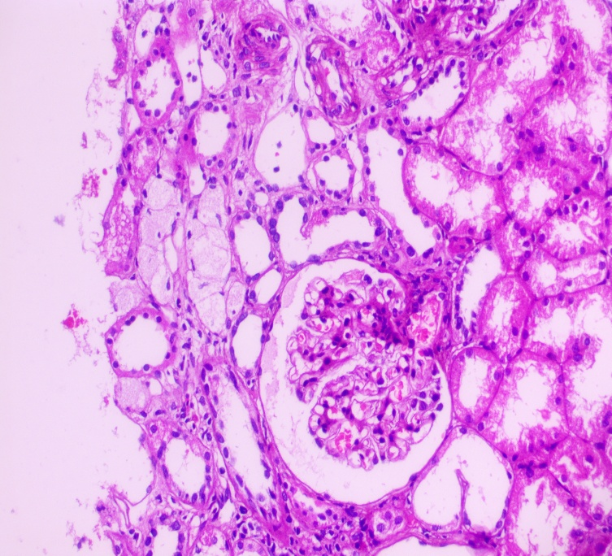
Fig 1 : Light microscopy showing a glomerulus with preserved architecture and mild mesangial matrix expansion without significant hypercellularity. Adjacent tubules demonstrate focal simplification and mild chronic changes, consistent with the patient’s history of prior acute interstitial nephritis.
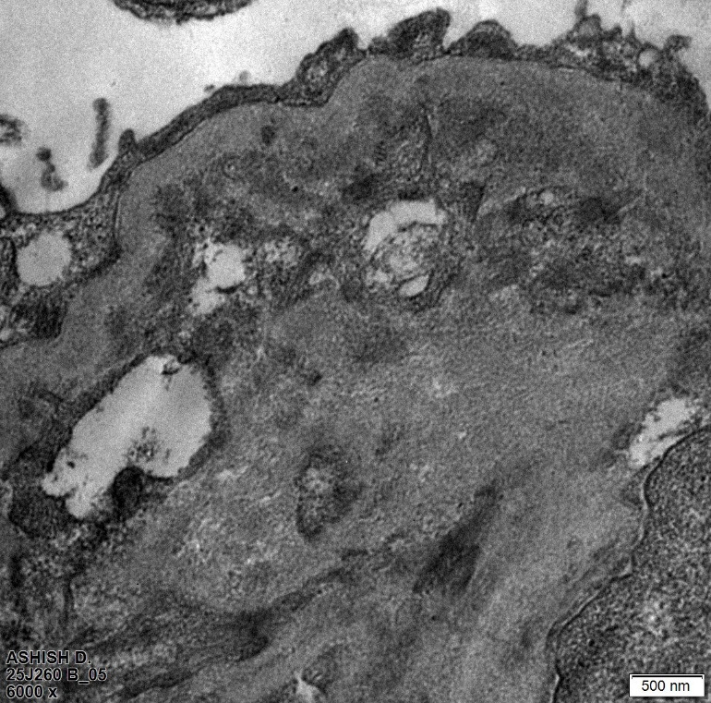
Figure 2: Electron micrograph providing a broad view of the glomerular capillary loops. The capillary basement membranes appear relatively uniform in thickness without evidence of subepithelial or subendothelial deposits. Podocyte foot processes show areas of focal effacement.
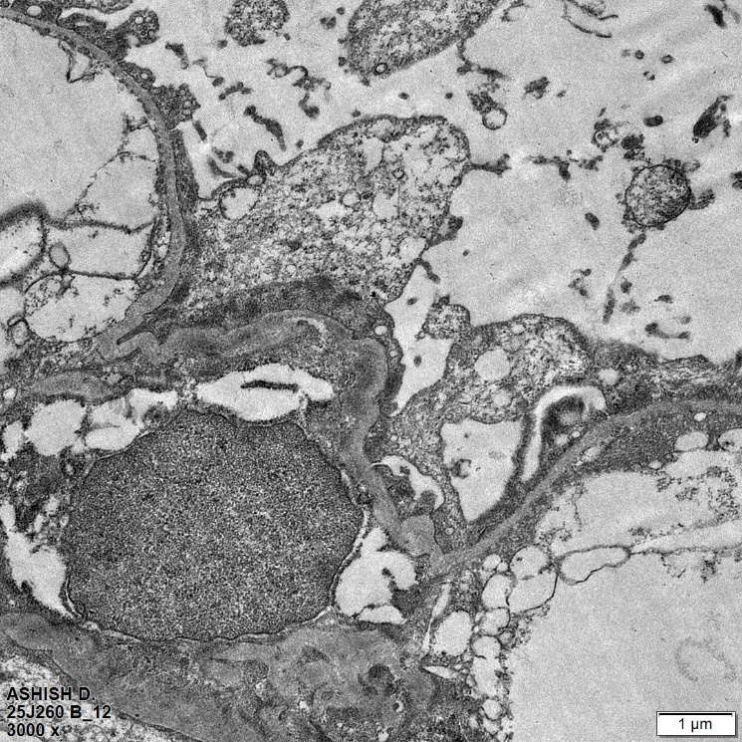
Figure 3: Electron Microscopy: Higher magnification electron micrograph illustrating the diagnostic hallmark of C1q nephropathy. Prominent, large electron-dense deposits are seen localized strictly within the mesangial matrix. There is a notable absence of peripheral capillary wall deposits.
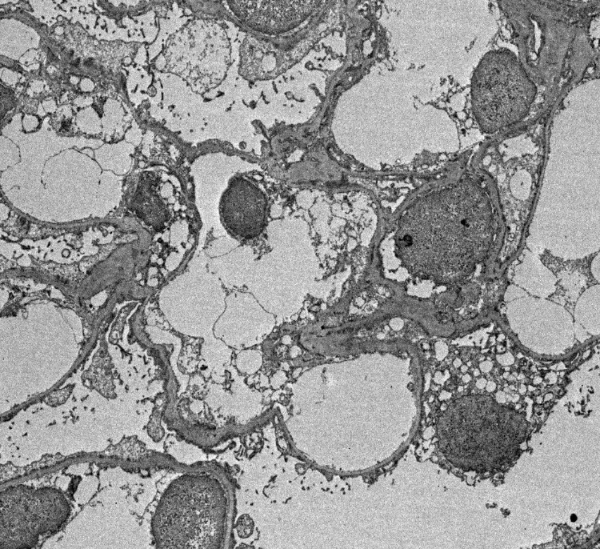
Figure 4: Electron Microscopy: High-power electron micrograph of the mesangium demonstrating the granular nature of the electron-dense deposits. The surrounding podocyte foot processes show approximately 50–60% effacement, correlating with the patient’s presentation of severe nephrotic-range proteinuria.

