Artisanal dried mango production in Chad: process characterization, hygiene challenges and proposed optimization

Abstract
Dried mangoes are an essential socio-economic resource in Chad, with 80% of production done via artisanal solar drying. However, current methods are slow (2 to 3 days) and carried out at low temperatures (30–45∘C), which promotes microbial proliferation and alters product quality. The objective of this study is to evaluate production and sales practices in order to propose concrete solutions to transform this vulnerable sector into a hygienic, standardized, and economically viable industry.The sector suffers from a critical lack of capacity, infrastructure, and skilled labor.
This study was conducted through surveys and observations of 100 female producers and vendors in the main production areas (Logone Oriental and Occidental, Mandoul, Mayo Kebbi) to characterize the processes and identify critical control points.
The results confirm that this activity is exclusively female. Production takes place on rudimentary open-air supports (3–4 days), exposing products to contamination from insects, dust, and humidity. Most producers have received no training in Good Hygiene Practices (GHP). Poor personal hygiene and inadequate cleaning of equipment constitute major risks of cross-contamination.
In conclusion, despite its vital role, the artisanal dried mango production in Chad is hindered by rudimentary methods and a critical lack of hygiene. To enhance this sector, it is imperative to adopt an optimized production diagram, implement GHP and Good Manufacturing Practices (GMP), and train stakeholders in effective drying techniques and hygiene standards. This approach is crucial for ensuring the production of a safe, nutritious, and high-quality food product."
Keywords : Dried mangoes; surveys; diagram; hygiene and consumer.
- Introduction
Fruits and vegetables are crucial components of a healthy diet, as they are excellent sources of vitamins, minerals, antioxidants, fiber, and important carbohydrates necessary for achieving the best possible nutritional and health outcomes (Pem D, Jeewon R. 2015 ; Habauzit V et al. 2015).
Chad, despite its vast agricultural and foraging potential, faces persistent challenges in food security and malnutrition. Recent reports indicate that over 3.7 million people could be in severe food insecurity in 2024, and the country officially declared a food and nutritional crisis in February 2024, with alarming figures of acute malnutrition among children under five (OCHA. 2024 ; FAO. 2024). To address this, the processing and storage of local food products are crucial, not only for social balance but also for the country's economic growth, by reducing post-harvest losses and ensuring a continuous supply. In this context, the mango sector in Chad, although rich, remains underdeveloped, mainly due to a lack of effective valorization and preservation techniques. Solar drying of mangoes represents the most common processing method in Chad, accounting for approximately 80% of artisanal production. However, this practice is characterized by prolonged drying times (2 to 3 days) and moderate temperatures (30-45°C) which, despite favorable sunshine, can unfortunately promote microbial proliferation and alter the sanitary quality of dried mangoes (Kameni et al., 2003). Solar drying, although widely adopted for its simplicity and low cost, is an inherently slow method (often 2 to 3 days) and occurs at relatively low temperatures (typically between 30 and 45°C). These conditions are unfortunately conducive to the development of microorganisms, thereby compromising the hygienic quality and safety of the final product (Islam et al. 2020 ; Amankwah et al. 2021). Although drying is a recognized preservation solution for its low cost and relative ease of control (Bélem et al. 2017), and the Chadian climate is well-suited for it (almost year-round sunshine and low humidity), this sector remains embryonic. Artisanal units lack capacity, preservation/processing infrastructure is insufficient, and the workforce is often unqualified (Kouassi. 2012). This insufficient control of drying processes affects not only organoleptic properties, such as color—a key factor in commercial quality (Djioua. 2010)—but also physicochemical properties, leading to a significant loss of nutrients. These observations underscore the imperative to better understand and optimize drying conditions (Djantou et al. 2004). It is with this in mind that the present study aimed to characterize the different technological production processes of dried mangoes consumed in Chad and to propose an optimized production diagram.
- Materials and Methods
This prospective, cross-sectional, and analytical study was conducted from March 2021 to August 2023 at the Laboratory of Food and Nutrition Sciences Research (LaRSAN) of the Faculty of Human Health Sciences (FSSH) at the University of N'Djamena, Chad.
  - Survey Area for Dried Mango Production
Surveys were conducted across several dried mango production and consumption sites in Chad, engaging both production and sales stakeholders. These sites are located in the provinces of Logone Oriental (Pende-Doba, Nya-Bebedja), Logone Occidental (Moundou), Mandoul Oriental (Koumra), and Mayo Kebbi (Mayo-boneye in Bongor). Figure (1) details these sites.
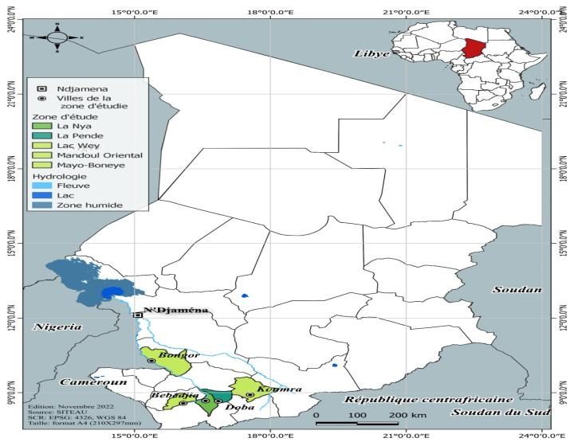
Figure 1 : Map of the different survey zones for production, sampling, and dried mango sales markets in Chad.
Source : Centre for Geographical Documentation and Information (CDIG) of the Ministry of Mines, Water, and Sanitation of Chad. 2023.

  - Sampling Type
As part of our study, we investigated and observed the traditional mango drying process to identify and characterize its unit operations, with the aim of establishing a suitable production diagram. We also evaluated the hygiene practices of the producers and determined critical control points. Data were collected through interviews using a questionnaire and recorded on a dedicated survey form (see annex), covering the process steps and the technological diagrams used.
Table 1 : Sampling details
Zones | Sample Codes | Quantity (g)
Doba | Mdn | 20
Bebedja | Bbj | 20
Koumra | Kmr | 20
Moundou | Dba | 20
Bongor | Bgr | 20

  - Data Analysis Method
Results are presented as mean ± standard deviation. We used an analysis of variance (ANOVA) to compare means, followed by a Fisher's post hoc test for classification, all performed with Minitab 18.0. The significance level was set at 5% (p<0.05).

- Results
  - Analysis of Surveys on Artisanal Dried Mango Processing
Out of 100 peoples interviewed, the sample consisted of 54 actives producers, 19 who had previously practiced the technology, and 27 producers and sellers. Figure (2) details these sites.
Dried mango is a food product obtained by solar drying, and drying allows for year-round consumption of fruits across all seasons. It is highly appreciated by populations in Chad due to its very particular flavor.

Figure 2: Proportion of surveyed individuals
The survey showed that all interviewed producers (100%) were women, with ages ranging from 15 to 72 years. This indicates that it is a purely female activity carried out by all age groups. The 15-35 age group is poorly represented. Indeed, the surveyed producers were predominantly over 45 years old (68%). They are mostly unschooled (81%), 12% have a primary education level, 7% have a secondary level, and only 10% have a higher education level. For GHP/GMP training, 87% of producers and sellers had not received any training, while those who had received training represented only 13%. The majority of sellers have an unsanitary selling place (8%) and only (9%) use packaging.
Dried mango is widely produced and consumed by the population in the southern zone of Chad, a part of the country where dried mango production and consumption are pre-eminent. This processing activity constitutes a significant source of income for processors and sellers. The surveyed individuals belong to diverse ethnic groups in Chad, with the majority originating from the southern zone. In total, one hundred (100) people were surveyed for this study, including fifty-four (54) active producers (54%), nineteen (19) producers who had previously practiced the technology (19%), and twenty-seven (27) producers and sellers (27%)
Regarding production, most of the surveyed women manage their production individually and carry out a portion exclusively for family consumption. A large part of the dried mango production is intended for commercialization rather than daily family consumption.
Table 2 : Sociodemographic characteristics of surveyed individuals
Characteristic | Category | Count (N=100) | Proportion (%)
Age | 15-35 years | 11 | 11.0
 | 36-45 years | 21 | 21.0
 | Over 45 years | 68 | 68.0
 | Total | 100 | 100.0
Gender | Male | 0 | 0.0
 | Female | 100 | 100.0
 | Total | 100 | 100.0
Education Level | None | 81 | 81.0
 | Primary | 12 | 12.0
 | Secondary | 7 | 7.0
 | Higher | 0 | 0.0
 | Total | 100 | 100.0
GHP/GMP Training | No | 87 | 87.0
 | Yes | 13 | 13.0
 | Total | 100 | 100.0
Sales Location Condition | Clean | 18 | 18.0
 | Dirty | 82 | 82.0
 | Total | 100 | 100.0
Packaging Use | Yes | 9 | 9.0
 | No | 91 | 91.0
 | Total | 100 | 100.0

  - Traditional Technologies and Processes for Producing Dried Mangoes
This section aimed to evaluate the different processes and conditions associated with dried mango production technologies. Data obtained during this study showed that there are two different types of traditional dried mango production diagrams in Chad. The dried mango production process did not vary significantly, and some practices are not commonly used. The dried mango manufacturing process's main unit operations were peeling, slicing, and drying.
Raw Material Preparation (sorting of ripe and unripe mangoes)
Raw materials (Mangifera indica) are harvested during and towards the end of the mango season (January to April), when the fruit is available. They are then rid of all foreign matter, and ripe mangoes are sorted from unripe ones. The transportation of mangoes in bulk is the most common system. The use of crates limits crushing and epidermal damage to the fruits. Failing that, straw or sawdust is used during transport to cushion impacts.
Peeling
The peeling operation practiced is a manual operation carried out using a knife. During this mechanical operation, selected unripe fruits suffered flesh loss. Fruits at the correct ripeness stage did not undergo this mechanical operation for some of the surveyed producers.
Slicing
Slicing is an operation done using stainless steel knives or multi-blade plates. However, among the surveyed producers, most of them used simple kitchen knives. Slicing defines the final shape of the dried mango pieces.
However, it is also essential for the exchange surface between the air and the product, as well as for the time required to extract water from the center of the pieces. Thus, the larger the surface area and the thinner the pieces, the faster the drying process will be.

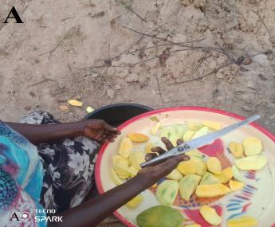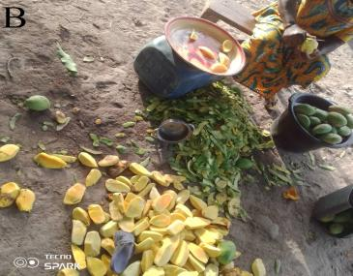

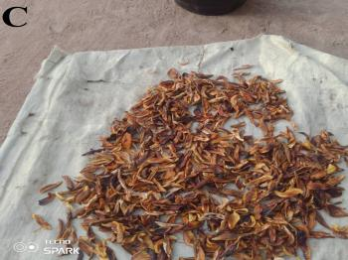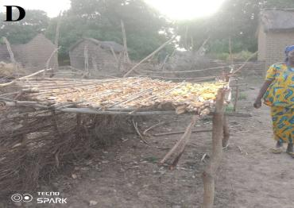

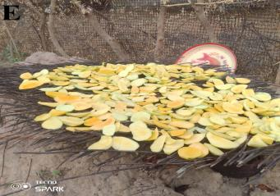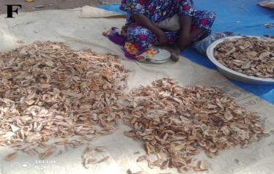

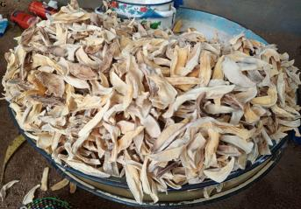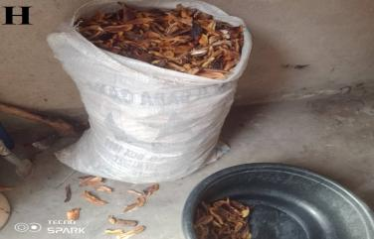

Figure 3: Processes and instruments used during dried mango production
Legend : A : Mango peeling ; B : Slicing ; C : Drying on tarpaulin ; D : Open-air drying (artisanal rack); E : Drying on straw ; F : Dried mango selling point ; G : Tray of a street vendor ; H: Storage in a bag.

- Drying
The arrangement of pieces on racks is very important, as it impacts the sanitary state of the product, the quantity of mangoes dried in one cycle, and the homogeneity of drying. The sanitary state of the product can be affected by a lack of operator hygiene and by dirt coming into contact with the mango pieces.
Artisanal drying was done by spreading pieces on various materials such as straw or plastics mats, or on hard ground in an open-air designated space for 3 to 4 days (Figure 4). Rain and humid weather often lead to the operation being cut short. For products to be dried, especially to less than 12% moisture, sufficient sunlight is required, which is often a major constraint during the rainy season. Overly humid weather during drying leads to lower quality products, frequently contaminated by undesirable microorganisms.

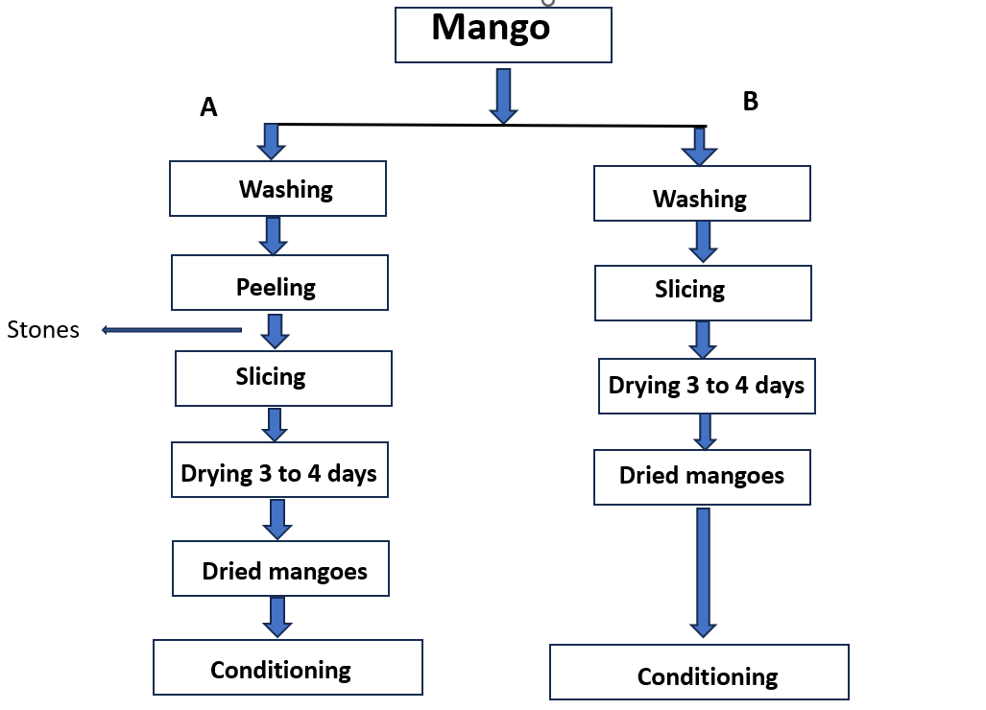

Figure 4 : Diagrams A and B represent the differences in traditional production processes according to the method adopted by the producer or the production site.

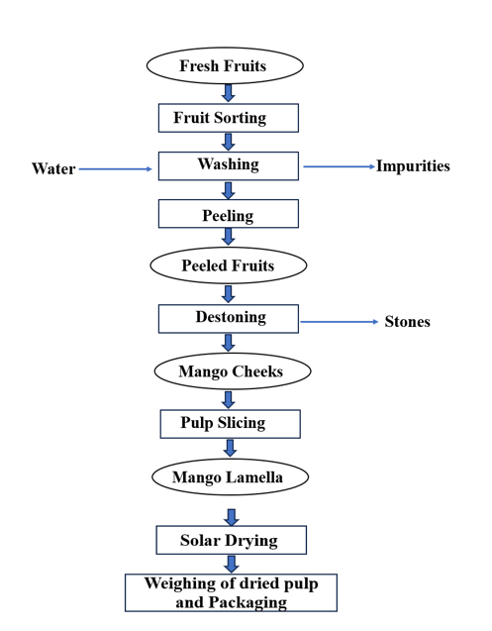
Figure 5 : Proposed improved dried mango production diagram in Chad.

  - Critical Points and General Hygiene Practices during Dried Mango Production
In this chapter, our study also focused on examining the applied hygiene conditions and practices adopted during the product production process. Good hygiene practices help prevent risks of all origins associated with all stages of dried mango production up to storage. Particular attention was paid to microbial risks during this study. By using the production diagram and manufacturing processes, as well as observations made on the production line, critical points and general practices regarding hygiene rules were determined. It may be necessary to establish microbiological criteria for the different processing stages to better apply the concept of combinations of control measures and to confirm the adequate application of the control system.
The materials and instruments used during the mango drying production process, such as knives, sawdust, straw drying racks, jute, or plastic bags, are often poorly cleaned and not disinfected, and could be a significant source of product contamination. Several authors (Pérez-Rodríguez et al., 2007 ; Vorst et al., 2006) have noted that materials and instruments are recognized as important vectors of product contamination.
Another critical point concerning the hygiene of dried mango producers is hand washing, which is done with water and generally without applying soap for the majority of producers, which can constitute an important factor for product contamination. In certain operations, notably, the peeling and slicing stages which are done manually using non-stainless steel knives by some producers. These stages also constitute a critical point. The drying operation is carried out on the ground or on tarpaulins, in the open air, without care for insects or dust that can settle on the products and again be a source of contamination. For some producers, they occupy locations in an anarchic and often inappropriate manner to dry their products.
- Discussion
The survey conducted revealed crucial information regarding artisanal mango drying practices in Chad. It emerged that all surveyed producers were women, highlighting the predominant role of women in this economic activity.
The dried mango production operations are carried out with rudimentary traditional equipment such as knives, wooden or straw racks, jute bags, or often modern ones made of plastic or stainless steel, like knives. Observations made in the field at different production sites allowed us to describe the traditional drying process. Product contamination can originate from several sources, including the equipment used in contact with the product. Plastic bags or packaging used can affect the quality of the finished product. These food packaging materials are considered one of the causes of food contamination. They contain numerous low molecular weight additives and therefore present a risk of interaction with the foods they contain (Petersen & Beindhal. 2000). During our survey of producers, we observed that the drying operation is carried out on hard ground, on straw, or on plastic tarpaulins, in the open air, without care for dust that can settle on the products and again be a source of contamination. These working conditions pose serious contamination risks in several of the visited locations. This drying operation consists of dehydrating mango slices to reduce their water content. This factor limits microbial proliferation and slows down chemical and enzymatic reactions, which ensures product stability and maintains its quality during storage. This observation is consistent with findings in the literature, where similar traditional drying practices, often involving direct exposure to the ground or plastic sheets in the open air, have been identified as major sources of environmental contamination from insects, dust, and other airborne particles (Awuni & Alhassan. 2020 ; Odedeji et al. 2021). Such uncontrolled exposure significantly compromises the hygienic quality and safety of the final product (Mutanda & Zvauya. 2019).
The artisanal processing observed on the ground is highly dependent on empirical knowledge, meaning techniques are based on experience and tradition rather than scientific principles or standardized protocols. Furthermore, the use of rudimentary equipment limits the ability to control essential drying parameters (temperature, humidity, air circulation), leading to uncontrolled drying techniques (Akinbode & Ajibola. 2020 ; Islam et al. 2020). This lack of control can result in heterogeneous drying quality, excessive drying times (promoting microbial growth), insufficient drying (risk of mold), and potential nutrient loss (Mutanda & Zvauya. 2019 ; Amankwah et al., 2021).
Another critical point during dried mango production is hand and fruit washing, which is done using water in a basin containing sorted mangoes for peeling, and generally without applying soap for most of the visited producers, which can constitute a factor of exogenous contamination and promote contamination and increase the microbial load of products. The hands of handlers constitute an important means of cross-contamination (Allwood et al. 2004). Poor personal hygiene often contributes to outbreaks of foodborne illnesses caused by microorganisms such as Staphylococcus aureus and Gram-negative bacilli such as Salmonella sp. (Hundy & Cameron 2002).
Regarding personnel hygiene, among all surveyed producers, the level and conditions of hygiene were almost not the same. In terms of hygiene concepts, training and awareness are insufficient, or even absent for most of these individuals encountered. Our observations align with the results of similar work reported by Tidjani et al. (2013a ; 2013b), who identified critical points in the processing of dried meats "Kilichi" and beef skewers commonly called "Tchélé" in Chad.
The discussion of the results highlights the urgent need to introduce improved practices. The application of good hygiene practices (GHPs), such as hand washing, cleanliness of utensils and work surfaces, and product protection against pests, is fundamental. Simultaneously, the adoption of good manufacturing practices (GMPs), including control of drying parameters (e.g., use of improved solar dryers, elevated racks), adequate product protection during drying and storage, would make processing more efficient and profitable. These improvements would not only lead to a product with better preserved nutritional quality but also a hygienically and organoleptically (color, texture, taste) satisfactory product, meeting consumer expectations and potentially market standards.
- Conclusion
Mango is a valuable resource in Chad, and its processing into dried mangoes plays an essential role in food security and generates vital income, especially for female producers. However, our surveys revealed significant problems concerning traditional drying techniques, which rely on empirical knowledge and rudimentary equipment.
These methods, often practiced on the ground or on tarpaulins in the open air, without adequate protection, lead to high risks of microbial and environmental contamination. This directly compromises the hygienic quality and safety of the final product. To remedy this, it is crucial to implement concrete interventions. We propose an improved production diagram integrating Good Hygiene Practices (GHPs) and Good Manufacturing Practices (GMPs). This involves promoting elevated drying supports, effective protection against pests and dust, as well as awareness and training on optimized drying techniques. The adoption of these measures is indispensable for fully valorizing the sector, thereby ensuring the production of safe and high-quality dried mangoes for all.

Disclaimer (Artificial intelligence)

Author(s) hereby declare that NO generative AI technologies such as Large Language Models (ChatGPT, COPILOT, etc.) and text-to-image generators have been used during the writing or editing of this manuscript.

VI. Références

Akinbode OA, Ajibola O. 2020. Traditional food processing methods and their impact on nutrient composition and food safety: A review. Journal of Food Science and Technology, 57(11), 3939-3950.
Allwood PB, Jenkins T, Paulus C, Johnson L, Hedberg W. 2004. Hand washing compliance among retail food establishment workers in Minnesota. J. Food Prot, 67(12), 2825-2828.
Amankwah EA, Abayie E, Apau, L. 2021. Microbial quality of solar-dried fruits from markets in Ghana. Journal of Food Safety, 41(2), e12869.
Amankwah EA, Sarpong AA, Glady Kyere. 2022. Modifications des propriétés physicochimiques et fonctionnelles des farines d’igname Dioscorea rotundata au Ghana par différentes méthodes de séchage
Awuni AR, & Alhassan BF. 2020. Assessment of hygiene practices and microbial quality of dried mangoes sold in selected markets in Northern Ghana. Journal of Food Quality, 2020.
Bélem A, Tapsoba F, Toulsoumdé Songre-Ouattara L, Zongo C, Savadogo A. 2017. Study of the organoleptic quality of three varieties of dried mangos : Amélie, Lippens et Brooks durant storage by enzymatic tanning technique of peroxidases (POD) and polyphenoloxydases (PPO).
Djantou NEB, Mbofung CMF, Scher J, Kameni A. 2004. Influence du procédé de production de poudre de mangue (Mamguifera indica) sur quelques caractéristiques chimiques et nutritives. Rencontres agorales. Nov/Déc 2004 / Nantes, France.
Djioua T. 2010. Amélioration de la conservation des mangues 4e gamme par application des traitements techniques et utilisation d’une conservation sous atmosphère modifiée. 6 p.
FAO. 2024. The State of Food Security and Nutrition in the World https://openknowledge.fao.org/bitstreams/d5be2ffc-f191-411c-9fee-bb737411576d/download
Habauzit H, Milenkovic D, Morand C. 2013. Vascular protective effects of fruit polyphenols R. Watson, V. Preedy, S. Zibadi (Eds.), Polyphenols in Human Health and Disease, Elsevier Inc., London pp. 875-893 View in ScopusGoogle Scholar
Hundy L, Cameron S. 2002. An outbreak of infections with a new Salmonella phage type linked to a symptomatic food handler. Comm. Dis. Intell., 4, 562-567.
Islam MR, Jaraman D.K, Das Gupta. 2020 Drying of fruits and vegetableshttps://www.taylorfrancis.com/ chapters/edit/10.1201/9780429289774-21/
Islam MS, Roy K, Barua MM. 2020. A comprehensive review on the conventional and modern drying techniques of fruits and vegetables. Journal of the Bangladesh Agricultural University, 18(2), 488-500.
Kameni A, Mbofung CM, Ngnamtam Z, Doassem J, Hamadou L. 2002. Aptitude au séchage de quelques variétés de mangue cultivées au Cameroun : Amélie, Zill, Irwin et Horé Wandou. Actes du colloque, 27-31 mai 2002, Garoua, Cameroun.
Kouassi OA. 2012. Revue nationale pour identifier les initiatives de valorisation non alimentaire de la mangue en Côte d’Ivoire. N°12/COLEACP PAEPARD-01/BNA-12. Septembre-décembre 2012, 43 p.
Mutanda C, Zvauya R. 2019. Microbiological quality and safety of dried fruits : A review of the current status. Food Quality and Safety, 3(4), 183-192.
OCHA. 2024. (Bureau de la coordination des affaires humanitaires de l'ONU) - Tchad Bulletin Humanitaire ; https://www.unocha.org/publications/report/world/propos-d-ocha-le-bureau-des-nations-unies-pour-la-coordination-des-affaires
Odedeji JO, Omojola AB, Adekunle AA. 2021. Postharvest handling, processing, and quality of dried fruits : A review. Journal of Food Processing and Preservation, 45(8), e15783.
Pem D, Jeewon R. 2015. Fruit and vegetable intake: benefits and progress of nutrition education interventions- narrative review article, Iran ; J. Public Health, 44 (10) pp. 1309-1321 ; PMID: 26576343; PMCID: PMC4644575 View in ScopusGoogle Scholar
Petersen JH, Breidhal T. 2000. Plasticizers in Total diet samples, baby food and infant formulates. Food Additives and contaminants, 17, 133-141. http://dx.doi.org/10.1080/026520300283487.
Tidjani A, Abdelsalam Adoum Doutoum, Brahim Boy Otchom, Mahamat Bechir , Hourra Djiguidé Chemi, Fatiou Toukourou, Comlan Aristide de Souza. 2013. Assessment of Hygiene Practices and Identification of Critical Control Points Relating to the Production of Skewered Meat Sold in N’Djamena-Chad. Journal of Food Research ; Vol. 2, No. 5; 2013 http://dx.doi.org/10.5539/jfr.v2n5p190.
Tidjani A, Doutoum AA, Bechir M, Abderahim I, Telar DY, Ngabozia MJ, Mornonmbaye N. 2013. Process quality assurance for control of the diagrams of homemade cheese marketed in chad : case of dairy “AL-KHALILA”. Continental J. Food Science and Technology, 7(2), 1-15. doi:10.5707/cjfst.2013.7.2.1.15.

