Dielectric Properties of Selected Nigerian Fruit Juices (Julie Mango, Sweet Orange, and Tangerine) in the Microwave Frequency Range: Implications for Microwave-Assisted Shelf-Life Extension
Original Research Article
Abstract
Microwave dielectric heating treatment and dielectric property analysis were applied to locally produced fruit juices within the microwave frequency range of 1–20 GHz, at 2.5 GHz intervals, to evaluate their potential for shelf-life enhancement and to monitor temporal variations over 8-hour periods. To support dielectric interpretation, key physicochemical properties—pH, electrical conductivity, total soluble solids (TSS), and viscosity—were determined for each juice sample. The physicochemical results indicated that tangerine (Citrus reticulata) exhibited the highest pH value (4.60 ± 1.20), followed by Julie mango (Mangifera indica L.), while Ibadan Sweet Orange (Citrus sinensis) recorded the lowest pH (2.45 ± 0.10). Julie mango juice also showed the highest electrical conductivity (0.89 ± 0.30 mS cm⁻¹) and viscosity (145.1 ± 0.1 mPa·s). Dielectric characterization revealed that Julie mango juice possessed the highest dielectric constant and dielectric loss factor at lower frequencies and temperatures, with both parameters decreasing as frequency and temperature increased. Ibadan Sweet Orange juice exhibited intermediate dielectric values, whereas tangerine juice showed the lowest dielectric response; however, all samples followed similar frequency- and temperature-dependent trends. These variations are attributed to differences in water content, soluble solids, ionic concentration, and viscosity, which govern dipolar polarization and ionic conduction mechanisms. The observed reduction in dielectric parameters with increasing frequency and temperature reflects relaxation phenomena and thermally induced disruption of dipole alignment. Overall, the results demonstrate that the dielectric behaviour of locally produced fruit juices is strongly influenced by their physicochemical composition and relaxation dynamics, underscoring the potential of microwave-induced dielectric discharge as an effective and energy-efficient strategy for shelf-life extension while preserving quality attributes in small-scale juice processing.
Keywords: Microwave dielectric heating; treatment; dielectric property; Mangifera indica L; Citrus sinensis; Citrus reticulata

- Introduction
The rising consumer's demand for minimally nutrient-rich processed foods has intensified research into non-thermal and mild-thermal preservation technologies [1-3]. Fruit juices derived from locally available fruits hold substantial nutritional and economic value; however, their short shelf-life, susceptibility to microbial spoilage, and rapid quality deterioration present persistent challenges for small-scale producers. Although conventional thermal pasteurization remains effective for microbial inactivation, it frequently compromises desirable sensory attributes and nutrient retention [4-6]. These limitations have driven interest in microwave-assisted preservation techniques, particularly Microwave dielectric heating mechanisms, which provide rapid, volumetric heating and offer the potential for selective microbial inactivation.
The interaction of microwave energy with food matrices is governed primarily by their dielectric properties, especially the dielectric constant (ε′) and dielectric loss factor (ε″) [7]. These parameters determine the ability of a material to store and dissipate electromagnetic energy and, consequently, influence heating efficiency, penetration depth, and process uniformity. A clear understanding of the dielectric behaviour of fruit juices across microwave frequencies is therefore essential for optimizing processing conditions, ensuring uniform thermal distribution, and enhancing microbial safety while maintaining nutritional and sensory quality [8-10].
Despite the importance of dielectric characterization in food engineering, data on the microwave dielectric properties of locally produced fruit juices in Nigeria remain scarce, even though indigenous fruits constitute a major component of household and commercial juice production. This study addresses this gap by characterizing the dielectric properties of selected local fruit juices over a microwave frequency range and evaluating their response to dielectric discharge treatments. The findings are intended to establish a scientific foundation for microwave-assisted shelf-life enhancement and to provide practical insights that support small-scale processors in adopting efficient, quality-preserving preservation technologies.
- Theoretical Background
  - Dielectric Properties of Liquid Foods
The interaction of electromagnetic waves with food systems is governed by their dielectric properties, which describe how materials store and dissipate electrical energy. These properties are commonly expressed through the complex permittivity:
$ε^{*}=ε^{'}-jε^{''}$ (1)
where ε′ (dielectric constant) represents the ability of the material to store electrical energy, and ε″ (dielectric loss factor) quantifies the energy dissipated as heat due to molecular relaxation and ionic conduction. The ratio of these parameters is known as the loss tangent,
$\tan{δ=\frac{ε^{''}}{ε^{'}}}$, (2)
Equation (2) indicates the efficiency with which absorbed electromagnetic energy is converted to heat.
Studies indicate that in aqueous liquid foods such as fruit juices, dielectric behaviour is strongly governed by their high-water content, dissolved sugars, organic acids, and ionic constituents [11,12]. At microwave frequencies, dielectric losses arise mainly from dipolar relaxation of water molecules and ionic conduction, both of which are highly sensitive to changes in frequency and temperature.

  - Microwave-Material Interaction
Microwave heating is based on the conversion of electromagnetic energy into thermal energy within the material or product. Research indicates that under microwave irradiation, molecular dipoles within fruit juice attempt to align with the oscillating electromagnetic field, and this repeated reorientation results in significant energy absorption and thermal generation [13, 14]. The depth to which microwaves penetrate a material, known as the penetration depth (dp), is given according to [15]

$dp=\frac{c}{2πf_{mw}\sqrt{2ε^{'}\left[1+{\left(\frac{ε^{''}}{ε^{'}}\right)}^{2}-1\right]}},$ (3)
where $f_{mw}$ is the microwave frequency and c is the speed of light. Materials with high dielectric loss exhibit shallower penetration depths, leading to more rapid heating but requiring careful control to avoid localized overheating [16,17].
  - Microwave dielectric heating and Microbial Inactivation
Microwave dielectric heating refers to the rapid release of stored electromagnetic energy within a material when exposed to high-frequency fields in liquid foods. Studies have shown that dielectric heating can create microscale hotspots, promote vigorous molecular agitation, and induce structural damage within microbial cells, thereby enhancing inactivation efficiency [18, 19]. In contrast to conventional pasteurization, which depends on conduction-based heating, dielectric discharge produces volumetric heating, allowing energy to be deposited throughout the entire juice matrix. This reduces temperature gradients and shortens processing time. Microbial inactivation under microwave treatment occurs through a combination of rapid thermal effects, which cause denaturation of essential cellular proteins, and non-thermal effects, where the oscillating electromagnetic field may disturb membrane integrity and intracellular organization. Furthermore, microscale hotspots formed at regions with varying dielectric properties can amplify local temperatures and accelerate cell destruction. The efficiency of these mechanisms depends on the dielectric loss factor (ε″), ionic composition, viscosity, and relaxation dynamics of the juice. Juices with higher ε″ values show enhanced microwave absorption and are therefore more responsive to dielectric discharge processing.
  - . Relevance to Shelf-Life Improvement
Studies have established that the shelf-life of fruit juices is predominantly constrained by microbial proliferation, enzymatic activities, and gradual physicochemical deterioration [20, 21]. Microwave dielectric heating offers a promising strategy for addressing these challenges by facilitating rapid microbial inactivation without prolonged thermal exposure. The markedly shorter processing times associated with microwave treatments help preserve thermolabile nutrients that are typically degraded under conventional pasteurization. Moreover, the volumetric and relatively uniform heating profile reduces thermal gradients and mitigates quality losses linked to surface overheating. This mode of energy delivery also enhances the retention of key sensory attributes, as rapid electromagnetic energy absorption contributes to the preservation of characteristic flavour, aroma, and colour.

- Methodology
  - Sample Collection and Preparation
Fresh, ripe orange and mango fruits of different species, commonly used for locally produced juices in Nigeria, were obtained from local markets. The fruits were carefully selected, washed, peeled, and manually processed using a hygienic cold-press juicer to preserve their natural composition. The extracted juices were subsequently filtered through a fine muslin cloth (≤200 µm) to remove large particulates and stored in airtight, food-grade containers at 4 °C prior to analysis. Before conducting dielectric and microwave-processing experiments, all samples were equilibrated to room temperature (25 ± 1 °C).
  - Physicochemical Characterization Procedures
To complement the dielectric analysis, fundamental physicochemical properties of each fruit juice sample were measured following standard analytical protocols. All measurements were conducted at room temperature (25 ± 1 °C) and performed in triplicate.
Determination of pH: pH was measured using a calibrated digital pH meter. The instrument was allowed to warm up and stabilize prior to use, after which it was calibrated with standard buffer solutions at pH 4.00, 7.00, and 10.00, following the manufacturer’s specifications.
Approximately 20 mL of each juice sample was transferred into a clean beaker. The electrode was rinsed with distilled water, gently dried with lint-free tissue, and immersed into the sample to fully submerge the sensing tip. The pH reading was recorded once the meter stabilized within 60 s. The electrode was rinsed thoroughly between samples to prevent cross-contamination.
Determination of Electrical Conductivity (EC): Electrical conductivity was determined using a digital conductivity meter previously calibrated with a 0.1 M KCl standard solution of known conductivity (12.88 mS/cm). A 20 mL aliquot of each juice was placed in a clean beaker, and the rinsed conductivity probe was inserted carefully to avoid trapping air bubbles around the sensor. After stabilization of the meter reading, the conductivity value (mS/cm) was recorded. The probe was rinsed with distilled water before subsequent measurements.
Determination of Total Soluble Solids (TSS): Total soluble solids were quantified using a digital refractometer calibrated to 0 °Brix with distilled water. Each juice sample was homogenized by gentle stirring. A small volume (approximately 2–3 drops) was placed on the refractometer prism, the cover plate was closed to ensure uniform spreading, and the °Brix value was recorded while directing the instrument toward a light source. The prism surface was thoroughly cleaned using tissue and distilled water between samples.
Determination of Viscosity: Viscosity was measured using a digital rotational viscometer equipped with an appropriate spindle (spindle numbers 1–3, depending on juice thickness).
Approximately 250 mL of each juice sample was transferred into a beaker, ensuring that the liquid depth met the spindle immersion mark. The spindle was attached and carefully lowered into the sample without contact with the beaker walls or bottom. The viscometer was operated at 30 rpm, consistent with manufacturer guidelines. Once the reading stabilized (after approximately 60 s), viscosity was recorded in mPa·s. The spindle was washed and dried thoroughly before subsequent measurements.

  - Dielectric Property Measurement
Dielectric properties of the fruit juice samples were characterized using a Keysight ENA Network Analyzer E5063A (Figure 1), coupled with an open-ended coaxial probe system (Keysight 85070E Dielectric Probe Kit).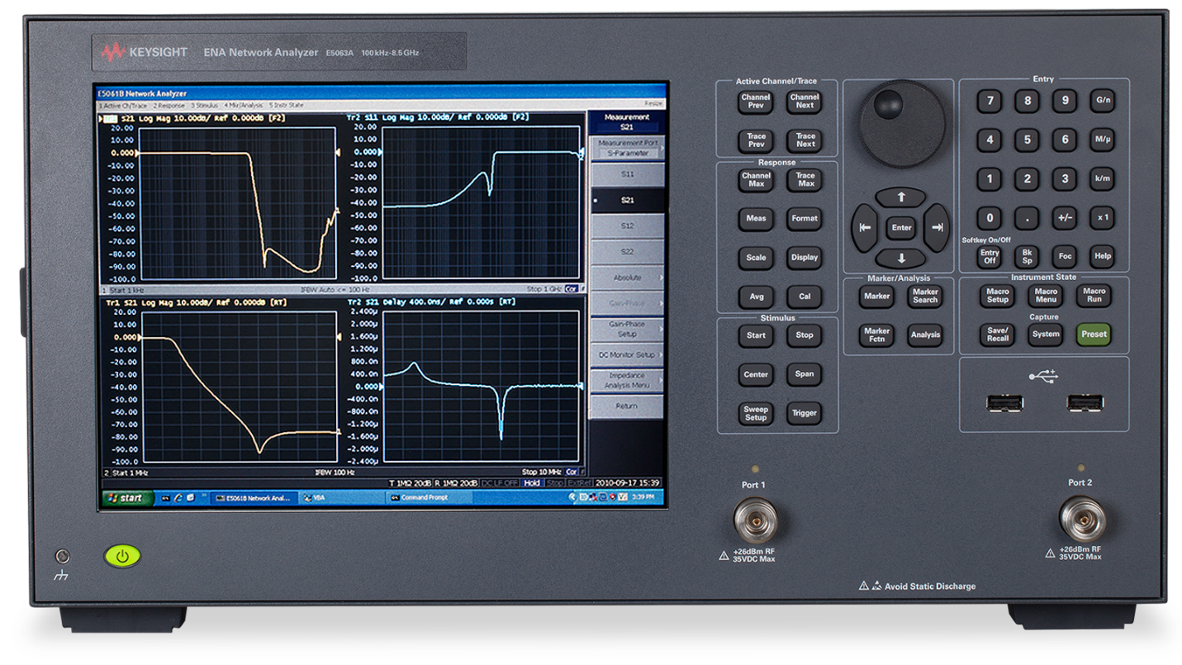
Figure1: Keysight ENA Network Analyzer E5063A
Prior to measurement, the analyzer was powered on and allowed to stabilize, and the probe was calibrated using standard open–short–load procedures recommended by the manufacturer to ensure measurement accuracy. Each juice sample was transferred into a clean beaker with sufficient depth to fully immerse the probe tip, avoiding air bubbles at the probe–sample interface. The open-ended coaxial probe was carefully inserted into the sample, and control measurements (e.g., air or distilled water) were taken separately to verify calibration.
The dielectric constant (ε′) and dielectric loss factor (ε″) were recorded over a frequency range of 1–20 GHz, with 2.5 GHz increments, at 8-hour intervals to monitor temporal variations. Additional parameters such as static permittivity (εₛ), high-frequency permittivity (ε∞), complex permittivity, relaxation time (τ), ionic conductivity (σ), and relaxation frequency $f_{r}$were computed using the probe system software, which derives these values from the phase and amplitude of the reflected electromagnetic signal at the probe sample interface.
  - Data Modelling and Analysis
The experimentally obtained dielectric spectra were fitted using the Debye and Cole–Cole relaxation models to describe frequency-dependent polarization behaviour. The quality factor (Q-factor) for each juice sample (orange and mango varieties) was calculated at selected frequencies and temperatures using:
$$Q-Factor=\frac{Energy Store}{Energy dissipated}=\frac{1}{\tan{δ}} (4)$$

- Results and Discussion
The variations in dielectric constant (ε′) and dielectric loss factor (ε″) for Julie mango, Ibadan sweet orange, and tangerine, as fitted using the Debye and Cole–Cole relaxation models, are presented in Figures 1- 6. The quality factors (Q-factors) of the fruit juices, are then presented in Figures 7–9.

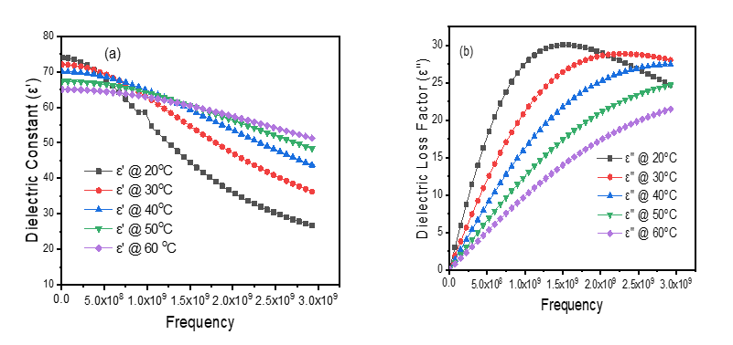
Figure 1: Variation of the dielectric constant (ε′) and dielectric loss factor (ε″) of Julie mango fitted using the Debye relaxation model
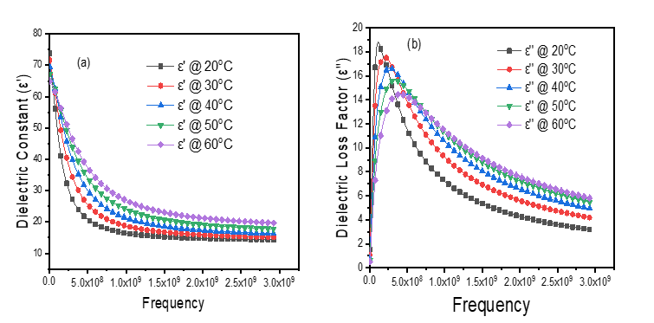
Figure 2: Variation of the dielectric constant (ε′) and dielectric loss factor (ε″) of Julie mango fitted using the Cole-Cole relaxation model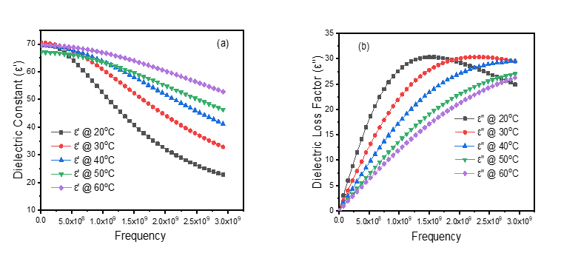
Figure 3: Variation of the dielectric constant (ε′) and dielectric loss factor (ε″) of Ibadan sweet orange fitted using the Debye relaxation model

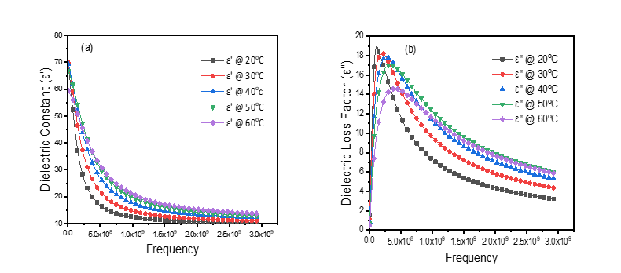
Figure 4: Variation of the dielectric constant (ε′) and dielectric loss factor (ε″) of Ibadan sweet orange fitted using the Cole-Cole relaxation model
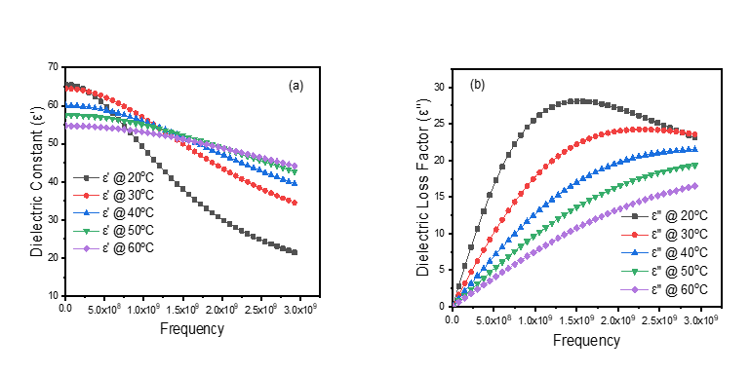
Figure 5: Variation of the dielectric constant (ε′) and dielectric loss factor (ε″) of Tangerine orange fitted using the Debye relaxation model
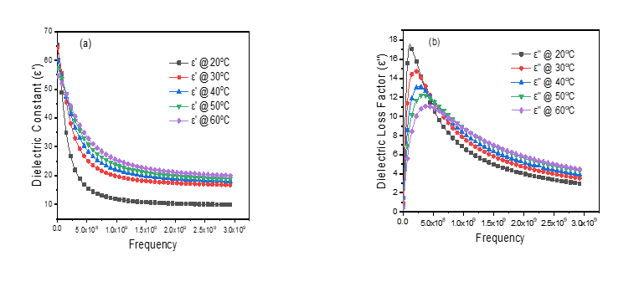
Figure 6: Variation of the dielectric constant (ε′) and dielectric loss factor (ε″) of Tangerine orange fitted using the Cole-Cole relaxation model
Figure 7: The behaviour of Q-factor of Julie mango against the frequency at different temperatures
Figure 8: The behaviour of Q-factor of Ibadan sweet orange against the frequency at different temperatures
Figure 9: The behaviour of Q-factor of Tangerine against the frequency at different temperatures

4.1 Discussion
The dielectric responses of Julie mango, Ibadan Sweet Orange, and tangerine juices (Figures 1–6) are characterized by higher dielectric constant (ε′) and small dielectric loss factor (ε″) at lower frequencies and temperatures. This behaviour is primarily governed by dipolar relaxation and ionic conduction mechanisms, which depend on the physicochemical composition of the juices. Higher total soluble solids, ionic concentration, and viscosity particularly pronounced in Julie mango juice enhance polarization density and charge mobility, resulting in increased energy storage (ε′) and dissipation (ε″). At lower frequencies, the condition $ωτ≪1$ (where $ω=2πf_{r}$ and τ is the dipolar relaxation time) is satisfied, allowing dipoles, especially water molecules, to follow the oscillating electric field effectively and maximize dielectric response [22-25].
As frequency increases, the system approaches the relaxation condition ($ωτ≈1$), beyond which dipolar reorientation becomes increasingly hindered. Consequently, both ε′ and ε″ decrease at higher frequencies due to the inability of dipoles to align with the rapidly oscillating field, a hallmark of dielectric relaxation behaviour. This effect is further intensified at elevated temperatures, where increased thermal agitation disrupts dipole alignment and shortens relaxation times, leading to reduced effective polarization and ionic conduction despite enhanced molecular motion [26-27].
The frequency dependence of ε″ is particularly critical for microwave heating applications, as it directly governs electromagnetic energy absorption. The observed peak in ε″ at intermediate frequencies corresponds to the maximum dielectric loss, where energy absorption is most efficient. Beyond this peak, ε″ declines as relaxation processes can no longer respond to the applied field. This dispersion behaviour is more accurately captured by the Cole–Cole model, which accounts for a broader distribution of relaxation times arising from the heterogeneous composition of fruit juices.
From a microwave processing perspective, these dielectric characteristics have important implications for heating efficiency and penetration depth. The microwave penetration depth (δₚ), which is inversely proportional to the dielectric loss factor, decreases in materials with high ε″ values. Accordingly, Julie mango juice, which exhibits higher ε″ at lower frequencies and temperatures, absorbs microwave energy more efficiently but displays a shallower penetration depth, increasing the risk of localized overheating if not properly controlled. In contrast, juices with lower ε″ values, such as tangerine juice, permit deeper microwave penetration but exhibit lower heating rates, necessitating longer processing times to achieve uniform thermal treatment.
Overall, the frequency- and temperature-dependent dielectric behaviour of the juices reflects their intrinsic relaxation dynamics and composition-dependent polarization mechanisms. These findings highlight the need to tailor microwave frequency and power levels to the specific dielectric properties of each fruit juice in order to optimize volumetric heating, ensure uniform energy distribution, and achieve effective microbial inactivation for up to four weeks while preserving product quality.
The quality factors (Q-factors) of all the juices investigated were higher at lower temperatures and decreased progressively with increasing temperature. A high Q-factor signifies dominant energy storage, reduced dielectric losses, and limited conversion of electromagnetic energy into heat. Conversely, the lower Q-factor observed at elevated temperatures indicates enhanced energy dissipation, increased dielectric losses, and improved microwave heating efficiency.
This trend reflects the temperature dependence of the dielectric parameters. As temperature increases, the dielectric loss factor (ε″) rises due to intensified ionic conduction and molecular agitation, while the dielectric constant (ε′) either decreases or exhibits only weak temperature sensitivity. As a result, the loss tangent (tan δ) increases, leading to a corresponding reduction in the Q-factor. From a microwave heating perspective, higher Q-factor values at lower temperatures imply greater energy storage and reduced power absorption, resulting in slower heating rates. In contrast, the increased dielectric losses at higher temperatures promote more effective energy absorption, yielding faster and more efficient heating. Overall, these findings demonstrate that microwave heating effectiveness improves with increasing temperature, albeit at the expense of reduced energy storage capability.
The quality factor (Q-factor) of the fruit juices was found to be relatively low at lower frequencies and increased progressively with rising frequency. This behaviour indicates that at low frequencies, the juices dissipate more energy as heat, whereas at higher frequencies, they become more efficient at storing electromagnetic energy with reduced losses [28]. At low frequencies, the dipoles and charge carriers in the juice can readily follow the oscillating electric field, resulting in higher polarization losses and energy dissipation. Conversely, at higher frequencies, the dipoles cannot keep pace with the rapidly oscillating field, leading to lower energy loss and a higher effective Q-factor. Overall, this trend demonstrates that fruit juices are more lossy at low frequencies but increasingly energy-efficient at higher frequencies, highlighting the interplay between dipole relaxation and dielectric losses across the frequency spectrum.
- Conclusion
The dielectric behavior of Julie mango, Ibadan Sweet Orange, and tangerine juices is strongly dependent on frequency, temperature, and juice composition. At low frequencies and temperatures, the juices exhibit higher dielectric constant (ε′) and lower dielectric loss factor (ε″) due to effective dipolar relaxation and ionic conduction, with Julie mango showing the highest values owing to its higher soluble solids, ionic concentration, and viscosity. As frequency increases, dipolar reorientation is hindered, leading to decreased ε′ and ε″, a trend further amplified at elevated temperatures due to thermal agitation. The observed frequency-dependent peaks in ε″ highlight optimal energy absorption for microwave heating, while variations in dielectric loss affect penetration depth and heating efficiency. These findings underscore the importance of tailoring microwave processing parameters to the specific dielectric properties of each juice to achieve uniform heating, maximize energy efficiency, and preserve product quality.

Disclaimer (Artificial intelligence)
Option 1:
Author(s) hereby declare that NO generative AI technologies such as Large Language Models (ChatGPT, COPILOT, etc.) and text-to-image generators have been used during the writing or editing of this manuscript.
References
- White, S., Jackson-Davis, A., Gordon, K., Morris, K., Dudley, A., Abdallah-Ruiz, A., Allgaier, K., Sharpe, K., Yenduri, A.K., Green, K., & Santos, F. A Review of Non-thermal Interventions in Food Processing Technologies, J. Food Protection, 88(6), 2025, 100508
- Jeevitha, G.C., Saravanan, R., Mittal, A., & Kumar, S.V. Non‑thermal processing as a preservation tool for health‑promoting beverages, Discover Food, 2023, 3; 26 https://doi.org/10.1007/s44187-023-00066-4
- Khojasteh, S.K., Elmizadeh, A., Sarraf, M., & Dodange, S. Non-thermal innovations in solid food processing: Eco-friendly alternatives to thermal methods, Appl. Food Research, 5, 2025, 101256
- Pagliarini, L., Neviani, U., & Rainieri, S. Numerical modelling and experimental validation of heat transfer enhancement and thermal mixing in a triple-tube heat exchanger for food processing, Int’l J. of Numeri. Methods Heat & Fluid Flow, 2025, 0961- 5539
- Rabbani, A., Ayyash, M., D’Costa, C.D.C., Chen, G., Xu, Y., Kamal-Eldin, A. Effect of Heat Pasteurization and Sterilization on Milk Safety, Composition, Sensory Properties, and Nutritional Quality, Foods, 2025, 14(8), 1342
- Kirit, B.D., Agcam, E., & Akyildiz, A. An Aroma Precursor-Based Approach to Improving the Sensory Quality of Thermally Treated Watermelon Juice, Food Sci. Nutri., 2025, 13: e70342
- Kim, W. and Kang, D. Synergistic effects of 915 MHz microwave heating and essential oils on inactivation of foodborne pathogen in hot-chili sauce, Int’l J. Food Microbio., 398, 2023, 110210
- Wang, Y., Wig, T., Tang, J., & Hallberg, L.M. Dielectric properties of food relevant to RF and microwave pasteurization and sterilization, J. Food Engr., 2003, 57(3) 257-268
- Gholamhosseinpour, A. and Hashemi, S.M.B. Evaluation of the effects of microwave and conventional heating on the microbial and bioactive properties of date milk, Appl. Food Research, 5(1), 2025, 100797
- Chang, S., Zhang, Z., Liu, Q., Wu, H., & Dong, A. An Innovative Food Processing Technology: Microwave Electrodeless Ultraviolet, luminescence Mechanism, Microbial Inactivation, and Food Application, Foods, 2024, 13(24), 4110; https://doi.org/10.3390/foods13244110
- Nelson, S.O. and Trabelsi, S. Use of Material Dielectric Properties in Agricultural Applications, J. Micro. Power & Electrom. Energy, 2016, 50(4), 237-268: http://dx.doi.org/10.1080/08327823.2016.1247235
- Nelson, S.O. and Trabelsi, S. Dielectric Spectroscopy Measurements on Fruit, Meat and Grain, American Society of Agricultural & Biological Engineers, 2008, 51(5); 1829-1834
- Kratchanova, M., Pavlova, E., & Panchev, I. The Effect of Microwave Heating of Fresh Orange Peels on the Fruit Tissue and Quality of Extracted Pectin, Carbohydrate Polymers, 56(2), 2004, 181-185
- Hashemi, S.M.B., Akbari, M., Roohi, R., & Phimolsiripol, Y. Hurdle approaches using conventional thermal, microwave heating and ginger essential oil in vegetable juice mixture: Heat transfer modeling and microbial inactivation kinetics, LWT- Food Sci. &Techn., 198, 2024 115958
- Cavalcante, T.A.B.B., Tadini, C.C., & Gut, J.A.W. Thermophysical, rheological, electrical, and dielectric properties of mango (Mangifera indica CV. Palmer) pulp and nectar: Temperature correlations for microwave and conventional thermal processing, Measurement: Food, 19, 2025, 100231
- Sun, J., Wang, W., & Yue, Q. Review on Microwave-Matter Interaction Fundamentals and Efficient Microwave-Associated Heating Strategies, Materials, 2016, 9, 231, www.mdpi.com/journal/materials
- Gezahegn, Y.A., Tang, J., Sablani, S.S., Pedrow, P.D., Hong, Y., Lin, H., & Tang, Z. Dielectric properties of water relevant to microwave assisted thermal pasteurization and sterilization of packaged foods, Innovative Food Sci. & Emerg. Techn.,74, 2021, 102837
- Luan, D., Yu, H., Hu, M., Bai, X., & Wang, Y. Underlying mechanism of the microwave non-thermal effect as additional microbial inactivation on Clostridium sporogenes at pasteurization temperature level, J. Food Eng., 387, 2025, 112337
- Bermudez-Aguirre, D. and Niemira, B.A. Radio Frequency Treatment of Food: A Review on Pasteurization and Disinfestation, Foods, 2023, 12, 3057; https://doi.org/10.3390/foods12163057
- Sourri, P., Tassou, C.C., Nychas, G.E., & Panagou, E.Z. Fruit Juice Spoilage by Alicyclobacillus: Detection and Control Methods—A Comprehensive Review, Foods, 2022, 11, 747; https://doi.org/10.3390/foods11050747
- Trishitman, D. Effect of storage conditions on quality, microbial stability, and shelf-life kinetics of beetroot juice concentrate, Sustainable Food Technol., 2025, 3, 1916-1926
- Kremer, F. & Schönhals, A. (2003). Dielectric Relaxation Spectroscopy. Springer foundational theory of dipolar relaxation and Debye model.
- Cabane, B., Ruiz, C., & Saldaña, J. (2011). Dielectric spectroscopy of water at low frequencies: The existence of an isopermitive point, Chemical Physics Letters, 503, 327–330.
- Kutus, B., Shalit, A., Hamm, P., & Hunger, J. Dielectric response of light, heavy and heavy-oxygen water: isotope effects on collective relaxation,” Phys. Chem. Chem. Phys., 2021, 23, 5467
- Kremer, F. and Tress, M. Dielectric Spectroscopy: Yesterday, Today and Tomorrow, Appl. Sci., 2025,15, 6954. https://doi.org/10.3390/app15136954
- Pabst, F., Wojnarowska, Z., Paluch, M., and Blochowicz, T. On the temperature and pressure dependence of dielectric relaxation processes in ionic liquids,” Phys. Chem. Chem. Phys., 2021, 23, 14260–14275.
- Salih, A.A. Effect of Temperature and Frequency on the Dielectric Properties of PVC/MnCl₂ Composite,” Ibn AL-Haitham J. Pure Appl. Sci., 2017, 22 (2).
- Cavalcanti, R.N., Barbosa, V.P., Gut, J.A.W., & Tadini, C.C. Predicting dielectric properties of fruit juices at 915 and 2450 MHz using machine learning and physicochemical measurements, Measurement: Food, 2024, 14, 100158

