Effect of fresh Azolla pinnata grown on different manures on growth and laying performance of Sonali birds under backyard system

ABSTRACT
The present study evaluated the nutritional quality and biomass productivity of fresh Azolla pinnata cultivated on poultry, pig and cattle manure, and assessed its effect on growth performance, laying traits and economic efficiency of Sonali birds under rural backyard conditions . Proximate composition analysis revealed only marginal variation among Azolla grown on different manure sources, indicating a stable nutritional profile irrespective of manure type. Azolla produced using poultry manure recorded slightly higher crude protein and mineral content. Biomass yield differed significantly among manure treatments, with poultry manure producing the highest yield per unit area, followed by pig and cattle manure. Dietary supplementation of fresh Azolla pinnata at 25 g/bird/day significantly increased body weight gain, reduced age at sexual maturity, improved hen-day egg production, total egg output, egg weight and feed conversion ratio in Sonali birds. Partial replacement of concentrate feed with Azolla resulted in a feed cost reduction of 12–15%. The study demonstrates that integration of on-farm Azolla cultivation with backyard poultry farming is a low-cost, sustainable and farmer-friendly strategy for enhancing productivity and profitability of Sonali birds under rural production systems.
Keywords: Backyard poultry, biomass yield, Azolla pinnata, Sonali birds, egg production, poultry, cattle, pig, manure
- INTRODUCTION
Backyard poultry has an important contribution in rural livelihoods, household nutritional security, gender empowerment in developing countries, especially in more remote and tribal areas with less land and capital (Alders et al., 2021). In India, backyard poultry provides one of the most positive contributions to household income by producing eggs and meat on regular basis and needing little infrastructure and investment for profitability, thus, it is an affordable business for marginal-crop farmers and landless households. Innovations in dual use poultry varieties such as Sonali are growing into common choices among smallholder farmers thanks to their better adaptability to scavenging-based systems, better tolerance against harsh field conditions and improved egg bearing compared to indigenous birds. Despite these genetic advantages, productivity rate in backyard systems has been found to be insufficient at the moment because of inadequate nutrition, increasing costs of commercial feed as well as the poor access of quality feed resources, particularly in the remote and rural regions (El-Deek et al., 2020). Feed accounting costs represent 60–70% of total poultry production cost, making it one of the significant constraint for resource-poor farmers and also impacting enterprise profits. Reliance on externally sourced concentrate feeds, especially due to poor market access, bottlenecks in transportation, and seasonal price variations (Alders et al., 2021), remains impractical in geographically isolated regions. As a result, the prospect of obtaining and using locally available, economical, and high-nutrient feed supplement options that can partially replace a feed source in a manner that is conducive to productivity is essential in backyard poultry systems. Azolla pinnata, a rapidly growing aquatic fern with symbiotic associations with the nitrogen-fixing cyanobacterium Anabaena azollae, recently has been developed as an interesting unconventional feed source for poultry production in smallholder environment (Samad et al., 2020; Swain et al., 2022). Azolla contains crude protein, essential amino acids, vitamins, minerals, carotenoids and can be domesticated on farm with small or no external infrastructures (Riaz, 2022; Acharya et al., 2023) and is highly applicable in low resource production systems. Dietary supplementation with Azolla has been shown to improve growth performance, egg production, feed efficiency, and gut health in poultry when used in accordance with the recommended levels in recent experimental studies (Abdelatty et al., 2020, 2021; Hafeez et al., 2024). However, no systematic field-level studies have been carried out assessing productivity and economic advantages of fresh Azolla pinnata supplementation in improved backyard poultry breeds such as Sonali in real farm conditions. Consequently, the current study aimed to assess the impact of fresh Azolla pinnata replacement on growth performance, age at sexual maturity, egg production, feed efficiency, and economic returns of Sonali birds raised in rural backyard area.
- MATERIALS AND METHODS
2.1 Experimental location and design
The study was conducted as a on farm trial (OFT) demonstration in three villages, namely Luaksim, Samathan and Dasatong, under rural backyard conditions. Azolla cultivation beds measuring 3 × 1.5 m with a depth of 0.5 m were prepared in farmers’ fields. Each bed received 35 kg of soil thoroughly mixed with 5 kg of one-week-old poultry dung, pig dung or cattle dung, forming three manure-based treatments.
2.2 Azolla cultivation and management
The beds were filled with water up to a depth of 10–15 cm and inoculated with 1 kg of fresh Azolla pinnata culture, a water depth range recommended for optimum floating growth, light penetration, and rapid mat establishment in modern Azolla production systems (Swain et al., 2022; Samad et al., 2020). Daily harvesting was initiated after an establishment period of 20 days, allowing sufficient frond multiplication and stable biomass formation. To sustain continuous growth, 50 mg superphosphate and 5 kg of the respective manure were added every six months, as phosphatic supplementation and organic nutrient inputs are critical for maintaining long-term productivity of Azolla cultures (Kacprzak et al., 2023; El-Deek et al., 2020). Water loss due to evaporation was replenished fortnightly to maintain optimal depth, and 20 kg of fresh soil was added at six-month intervals to ensure sustained micronutrient availability and culture stability (Swain et al., 2022).
2.3 Birds, feeding and management
Two hundred Sonali chicks were reared under a deep litter system for four weeks and then divided into two groups of 100 birds each. The control group was fed conventional concentrate feed, while the treatment group was supplemented with fresh Azolla starting at 5 g/bird/day and increased weekly by 5 g to reach 25 g/bird/day within five weeks. This level was maintained throughout the 72-week laying period.

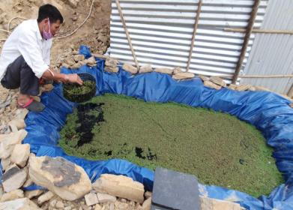 | 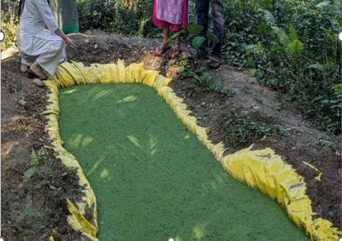
Fig.1 Cattle manure | Fig.2 Poultry manure
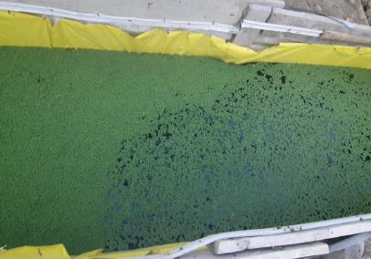 | 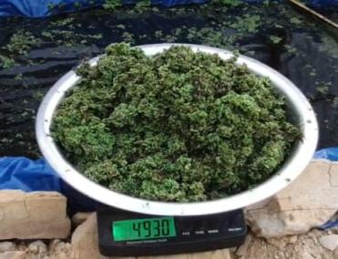
Fig.3 Pig manure | Fig.4 Weighing Azolla
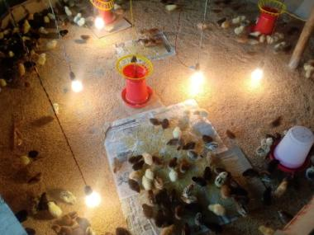 | 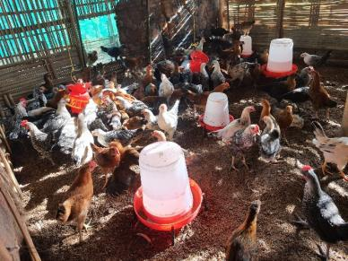
Fig.5 Brooding chicks | Fig.6 Grower
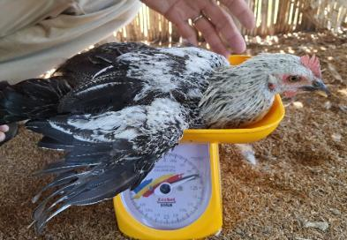 | 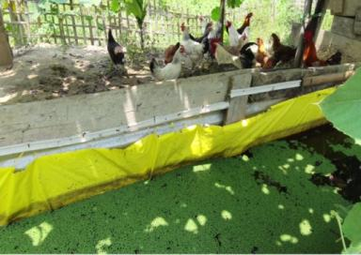
Fig.7 weighing in Kg | Fig.8 Poultry with Azolla bed
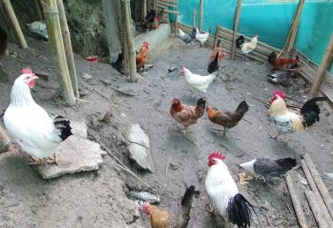 | 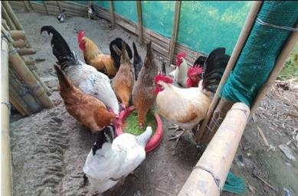
Fig.9 Adult poultry | Fig.10 Feeding Azolla
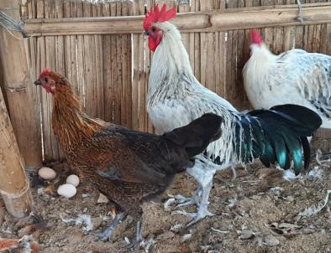 | 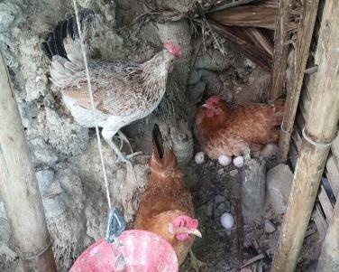
Fig.11 Egg laying started | Fig.12 laying at peak period

2.4 Chemical analysis
Dried Azolla samples were analysed for proximate composition following standard AOAC procedures (2012).
2.5 Statistical analysis
Data on Azolla yield and proximate composition were analysed using one-way ANOVA, whereas growth and laying performance data were analysed using Student’s t-test. Differences were considered significant at p < 0.05 and results are expressed as mean ± SE (Snedecor and Cochran 1994).
- RESULTS
The proximate composition of Azolla pinnata cultivated using different manure sources showed only marginal variation, although poultry manure–based Azolla recorded slightly higher crude protein and ash content (Table 1). Azolla yield differed significantly among manure sources, with poultry manure producing the highest daily and weekly biomass yield, followed by pig and cattle manure (Table.2).
Table .1. Proximate composition of Azolla pinnata cultivated using different manure sources (% DM basis)
Parameter | Poultry manure | Pig manure | Cattle manure | Mean ± SE | Significance
Dry matter (DM) | 90.23ᶜ | 90.97ᵇ | 91.52ᵃ | 90.91 ± 0.37 | *
Organic matter (OM) | 75.36ᵃ | 74.47ᵇ | 73.84ᶜ | 74.56 ± 0.44 | *
Crude protein (CP) | 23.07ᵃ | 22.73ᵇ | 22.41ᶜ | 22.74 ± 0.19 | *
Crude fiber (CF) | 10.98ᶜ | 11.25ᵇ | 11.56ᵃ | 11.26 ± 0.17 | *
Ether extract (EE) | 2.44ᵇ | 2.73ᵃ | 2.33ᶜ | 2.50 ± 0.12 | *
Nitrogen-free extract (NFE) | 38.87ᵃ | 37.76ᵇ | 37.54ᵇ | 38.06 ± 0.41 | *
Total ash (TA) | 27.95ᵃ | 26.87ᵇ | 25.61ᶜ | 26.81 ± 0.68 | *
Acid-insoluble ash (AIA) | 9.25ᵃ | 8.32ᵇ | 7.94ᶜ | 8.50 ± 0.39 | *
Footnotes:
Values are expressed as mean ± standard error (SE).
Means within a row bearing different superscripts (a, b, c) differ significantly (p < 0.05).
Statistical analysis was performed using one-way ANOVA followed by post-hoc multiple comparison test.

Table 2. Yield of Azolla pinnata per square meter using different manure sources under farmers’ field conditions
Manure source | Daily yield (g/m²/day) | Weekly yield (g/m²/week) | Mean ± SE (daily) | Significance
Poultry manure | 522ᵃ | 3654ᵃ | 522 ± 18.6 | *
Pig manure | 413ᵇ | 2891ᵇ | 413 ± 15.2 | *
Cattle manure | 368ᶜ | 2576ᶜ | 368 ± 12.9 | *
Footnotes:
Values are expressed as mean ± standard error (SE).
Each mean represents observations from three Azolla beds (one bed per village: Luaksim, Samathan and Dasatong).
Weekly yield was calculated based on cumulative harvest over seven consecutive days.
Means within a column bearing different superscripts (a, b, c) differ significantly (p < 0.05).
Data were analysed using one-way ANOVA.
Table 3. Growth and laying performance of Sonali birds under backyard farming (72-week period)
Parameter | Control (without Azolla) | Azolla supplemented (25 g/bird/day) | Significance
Monthly body weight gain (g/bird) | 372 ± 9 | 438 ± 10 | p < 0.05
Age at first egg (days) | 169 ± 4 | 157 ± 3 | p < 0.05
Hen-day egg production (%) | 46.8 ± 1.2 | 58.1 ± 1.4 | p < 0.05
Total egg production (eggs/bird/72 weeks) | 172.1 ± 5.6 | 215.4 ± 6.2 | p < 0.05
Average egg weight (g) | 49.1 ± 0.4 | 53.3 ± 0.5 | p < 0.05
Feed conversion ratio (FCR) | 3.3 ± 0.1 | 2.8 ± 0.1 | p < 0.05
Estimated feed cost reduction (%) | – | 12–15 | –
Footnotes:
Values are expressed as mean ± standard error (SE).
Birds in the treatment group received 25 g fresh Azolla pinnata per bird per day throughout the study period. Statistical analysis was performed using Student’s t-test.
Differences between treatment means were considered significant at p < 0.05.
Supplementation of fresh Azolla significantly improved growth and laying performance of Sonali birds (Table 3). Birds receiving Azolla recorded higher body weight gain, earlier age at first egg, higher hen-day egg production, greater total egg output and improved feed conversion ratio compared to control birds. Feed cost was reduced by 12–15% due to partial replacement of concentrate feed.
- DISCUSSION
The weak differences in proximate composition of Azolla in poultry, pig or cattle manure substrates show the high nutritional stability of the fern, regardless of the source of organic nutrients. This result is compatible with contemporary assessments indicating that Azolla holds fairly consistent crude protein, ether extract and fibre contents regardless of culture settings, and that such effects are typically on biomass yields more than proximate compositions (Samad et al., 2020; Swain et al., 2022; Acharya et al., 2023). That flexibility is of particular advantage for backyard chicken farms, where the uniform feed formulation may be challenging, and nutrition may vary seasonally. The slightly elevated crude protein and mineral content of poultry manure–derived Azolla appears to be due to a greater supply of rapidly mineralizable nitrogen and phosphorus fractions in poultry manure. Poultry excreta contain uric acid nitrogen and water-soluble phosphorus, which can easily be released into aquatic culture media and absorbed by rapidly growing plant tissues (Kacprzak et al., 2023). A widely reported mechanism on this fact within the context of nutrient cycling studies also demonstrates and proves the consistency in the observations that poultry manure improves the nutrient density of the Azolla biomass with respect to other livestock manures. Higher biomass production of Azolla under poultry manure is consistent with recent observations that nutrient rich substrates lead to higher frond multiplication, chlorophyll synthesis, and growth rate of Azolla (Acharya et al., 2023). Nevertheless, the satisfactory yields in pig and cattle manure demonstrates the excellent adaptive ability of Azolla and confirms its viability for a mixed crop–livestock farming system. Access to varied organic substrates equips biomass sources year-round and allows the development of sustainability of Azolla-based feedings for peasant farmers. Improved growth of Sonali birds augmented by Azolla may be attributed to the moderate concentration of protein in the plant and the nutrient supplementation and also the beneficial amino-acid content added along with the mineral complement. In contemporary controlled trials in broilers, a significant improvement was noticed in body weight gain and feed performance following the dietary inclusion of the Azolla leaf meal at a suitable proportion, with no significant impact on carcass size (Abdelatty et al., 2020; Samad et al., 2020). Moreover, Azolla addition improves the intestine morphology and changes the cecal microbiota of the plant and thus nutrients can be digested and absorbed better (Abdelatty et al., 2021). Gut morphology was not assessed in our current field study, which is however well consistent with the mechanistic results on the fact that growth performance in Azolla-fed Sonali birds was enhanced which is consistent with that data. Besides growth, dietary supplementation of Azolla was associated with a promotion of laying with the improvement of laying performance such as increased hen-day egg production, egg mass (increased egg weight) and cumulative egg laying yield. These effects are potentially attributed to greater mineral bio-availability of calcium and phosphorus, two minerals essential for eggshells formation and reproductive behavior (Sinclair-Black et al., 2023; Qiu et al., 2024). In addition, Azolla is a source of natural carotenoids that are effectively deposited in egg yolk and can enhance yolk pigmentation and antioxidant stability (Kljak et al., 2021; Dansou et al., 2023). Improved quality yolk and shell strength are likely to indirectly affect better laying persistence in backyard conditions. It can be inferred that reduced feed conversion rate in Azolla-supplemented birds results from improved utilization of nutrients, also less requirement for feed as percentage feed per unit produced. Feed is a relatively significant component of production costs in such backyard poultry systems and recent economic studies have highlighted how locally produced feed can significantly increase profitability when purchased concentrates are partially replaced by feed. Analogous feed price decreases with stable productivity have been observed in broilers and quail fed Azolla-type diets, thereby supporting its economic efficiency for smallholder poultry farming purposes (Hafeez et al., 2024; Riaz, 2022). From the standpoint of broader sustainability, incorporation of Azolla in poultry diets is in concert with international trends to produce diverse feed sources and decrease dependence on conventional protein constituents. Recent studies on alternative feed for poultry indicated that among the on-farm biomass inputs, Azolla is having more significance in backyard and tribal systems, due to its low input requirements, fast growth, high nutritional levels, and compatibility with integrated farming systems (El-Deek et al., 2020). Azolla has the unique advantage of farmer-managed production with organic nutrients available locally compared to alternatives like insect meal. All in all we were able to verify that the Azolla pinnata, irrespective of the manure source, can be used as a nutritious, economical and an environmentally friendly supplementary feed for the Sonali bird feed under backyard system.

CONCLUSION
Poultry manure enhances biomass yield and nutrient density marginally; however, pig and cattle manure remain effective substrates, ensuring wide applicability of the technology in diverse farming situations. Fresh Azolla pinnata supplementation at 25 g/bird/day significantly improved growth performance, advanced sexual maturity, enhanced egg production and reduced feed cost in Sonali birds under rural backyard conditions. On farm trails Azolla cultivation using locally available animal manures, particularly poultry manure, offers a sustainable, low-cost and farmer-friendly feeding strategy for improving productivity and profitability of backyard poultry systems.

Disclaimer (Artificial intelligence)
Option 1:
Author(s) hereby declare that NO generative AI technologies such as Large Language Models (ChatGPT, COPILOT, etc.) and text-to-image generators have been used during the writing or editing of this manuscript.
Option 2:
Author(s) hereby declare that generative AI technologies such as Large Language Models, etc. have been used during the writing or editing of manuscripts. This explanation will include the name, version, model, and source of the generative AI technology and as well as all input prompts provided to the generative AI technology
Details of the AI usage are given below:
1.
2.
3.

- REFERENCES
- Abdelatty, A. M., M. I. Mandouh, A. K. Al-Mokaddem, S. A. Mohamed, A. E. A. A. M. Al-Ghadi, A. K. G. Abdel-Moneim, and M. A. E. El-Hack. 2020. Influence of level of inclusion of Azolla leaf meal on growth performance, meat quality, and skeletal muscle p70S6 kinase α abundance in broiler chickens. Animal 14:2423–2432. https://doi.org/10.1017/S1751731120001421
- Abdelatty, A. M., M. I. Mandouh, S. A. Mohamed, A. K. G. Abdel-Moneim, and M. A. E. El-Hack. 2021. Azolla leaf meal at 5% of the diet improves growth performance, intestinal morphology, and modulates cecal microbiota in broiler chickens. Animal 15:100362. https://doi.org/10.1016/j.animal.2021.100362
- Acharya, P., Y. Singh, A. Sharma, N. Pattnaik, and A. Prakash. 2023. Azolla as an alternative feed for sustainable livestock production. Veterinary Science Research Journal 8(Suppl):1–7. https://doi.org/10.22271/veterinary.2023.v8.i3Sa.595
- Dansou, D. M., H. Zhang, Y. Yu, J. He, and G. Wang. 2023. Carotenoid enrichment in eggs from dietary sources: a biochemical and nutritional perspective. Animal Nutrition 14:315–333. https://doi.org/10.1016/j.aninu.2023.05.012
- El-Deek, A. A., A. A. A. Abdel-Wareth, M. Osman, and A. E. A. M. El-Hack. 2020. Alternative feed ingredients in finisher diets for sustainable broiler production. Scientific Reports 10:16967. https://doi.org/10.1038/s41598-020-74950-9
- Hafeez, A., M. S. Khan, A. Hussain, M. U. Rehman, and S. Ahmad. 2024. Effect of Azolla pinnata meal on growth performance, immunity, and carcass traits in Japanese quail. Journal of Applied Animal Research 52:2310750. https://doi.org/10.1080/09712119.2024.2310750
- Kacprzak, M., Malińska, K., Grosser, A., Sobik-Szołtysek, J., Wystalska, K., Dróżdż, D., … Meers, E. (2023). Cycles of carbon, nitrogen and phosphorus in poultry manure management technologies – environmental aspects. Critical Reviews in Environmental Science and Technology, 53(8), 914–938. https://doi.org/10.1080/10643389.2022.2096983
- Kljak, K., K. Carović-Stanko, I. Kos, M. Janječić, and D. Šubarić. 2021. Plant carotenoids as pigment sources in laying hen diets: effects on yolk color, carotenoid content, oxidative stability, and sensory properties of eggs. Foods 10:721. https://doi.org/10.3390/foods10040721

- Qiu, K., H. Zhao, X. Zhang, and Y. Cheng. 2024. Effects of dietary calcium lactate supplementation on laying performance, tibial quality, jejunal immunity, and egg quality of aged laying hens. Agriculture 14:256. https://doi.org/10.3390/agriculture14020256
- Riaz, A. 2022. Importance of Azolla plant in poultry production systems. World’s Poultry Science Journal. https://doi.org/10.1080/00439339.2022.2054752
- Samad, F. A. A., L. H. Idris, H. A. Hassim, Y. M. Goh, and T. C. Loh. 2020. Effects of Azolla spp. as a feed ingredient on growth performance and nutrient digestibility of broiler chickens. Journal of Animal Physiology and Animal Nutrition 104:1704–1711. https://doi.org/10.1111/jpn.13345
- Sinclair-Black, M., R. García, C. Hanlon, and M. R. Bedford. 2023. Physiological regulation of calcium and phosphorus utilization in laying hens. Frontiers in Physiology 14:1112499. https://doi.org/10.3389/fphys.2023.1112499
- Swain, B. K., P. K. Naik, and C. K. Beura. 2022. Nutritive value of Azolla as poultry feed: a review. Indian Journal of Animal Nutrition 39:1–11. https://doi.org/10.5958/2231-6744.2022.00001.9
- AOAC (2012) Official Methods of Analysis, 19th Edition, Association of Official Analytical Chemists, Arlington
- Snedecor, G. W., and W. G. Cochran. 1994. Statistical methods. 8th ed. Iowa State University Press, Ames.
- Yin-Long Qiu, Jun Yu, Azolla — A Model Organism for Plant Genomic Studies, Genomics, Proteomics & Bioinformatics, Volume 1, Issue 1, February 2003, Pages 15–25, https://doi.org/10.1016/S1672-0229(03)01004-0

