MICROBIAL SAFETY AND SHELF-LIFE ENHANCEMENT OF JAGGERY THROUGH GOOD MANUFACTURING PRACTICES IMPLEMENTATION IN KARNATAKA STATE

ABSTRACT
Jaggery is a traditional non-centrifugal sugar widely consumed in India for its nutritional and health benefits. However, jaggery produced in cottage-scale units often suffers from poor hygienic practices, leading to microbial contamination and reduced shelf life. The present study evaluated the impact of implementing Good Manufacturing Practices (GMP) on microbial safety and shelf-life enhancement of jaggery produced in Karnataka, India.
A baseline survey of 50 traditional jaggery production units was conducted to assess compliance with GMP parameters. One selected unit was upgraded following FSSAI-recommended GMP guidelines, including use of treated water, food-grade equipment, pest control measures, improved sanitation, and worker hygiene practices. Microbiological quality of traditional and GMP-produced jaggery was assessed using standard ISO methods for total plate count, yeast and mould, coliforms, and Salmonella. Shelf-life stability of GMP jaggery was evaluated under accelerated storage conditions (40°C ± 2°C and 75% ± 3% relative humidity).
Traditional jaggery samples showed high microbial loads, with total plate counts ranging from 160 to 960 CFU/g and presence of coliforms and Salmonella in several samples. In contrast, GMP-produced jaggery exhibited a significant reduction in microbial load, with total plate count reduced to 28 ± 22 CFU/g and complete absence of coliforms and Salmonella. Yeast and mould counts remained within permissible limits. Accelerated shelf-life studies demonstrated microbiological stability and acceptable quality of GMP jaggery for up to 485 days, compared to approximately 120 days for traditional jaggery.
The findings confirm that GMP implementation significantly improves microbial safety and extends shelf life of jaggery, supporting its production as a safe, marketable, and scalable traditional food product.
Keywords: Jaggery, Good Manufacturing Practices, microbial safety, shelf life, food hygiene, traditional foods
1. Introduction
India is the world’s largest producer of jaggery, contributing nearly 50% of global production and approximately 70% of global consumption [1,13]. With national sugarcane production exceeding 224 million tonnes, major producing states such as Uttar Pradesh, Maharashtra, and Karnataka together account for nearly 80% of total output [13]. Jaggery recovery typically ranges between 10–13%, depending on sugarcane variety and processing conditions [14]. Despite its economic and agricultural importance, the jaggery sector remains largely unregulated, with nearly 40% of sugarcane processed using traditional, unhygienic production practices [1].
Beyond its economic value, jaggery is recognized for its superior nutritional profile compared to refined sugar. It provides approximately 354 kcal per 100 g while containing significantly higher levels of micronutrients such as calcium, magnesium, potassium, iron, and trace elements including zinc, copper, and manganese [5]. Jaggery also contains vitamins A, B-complex, C, D2, and E [5]. Its complex sucrose matrix enables slower energy release, resulting in a lower glycemic response than refined sugar [1]. Traditional Ayurvedic literature describes jaggery as a “medicinal sugar” due to its reported benefits in digestion, detoxification, blood purification, respiratory health, and antioxidant activity [18–23], supporting its classification as a potential nutraceutical for combating malnutrition [6].
However, traditional jaggery production is associated with multiple food safety hazards. Most open-pan cottage units operate with minimal hygiene control, creating significant contamination risks [12]. Mild steel pans commonly used for boiling sugarcane juice are prone to corrosion in acidic conditions and may leach heavy metals such as lead and cadmium at high temperatures [7]. Wooden molds, due to their porous structure, harbor microorganisms including Leuconostoc, Bacillus, and Aerobacter, facilitating biofilm formation resistant to conventional cleaning methods [8,9]. Additionally, untreated water used throughout processing introduces coliforms, Escherichia coli, and Salmonella into the product [40,68].
Microbial contamination further increases during storage, where jaggery frequently harbors bacterial genera such as Acinetobacter, Bordetella, Corynebacterium, Enterococcus, and Xanthomonas, some of which exhibit antibiotic resistance [10]. Spoilage fungi including Penicillium, Aspergillus, Fusarium, Candida, and Debaromyces proliferate under humid and poorly ventilated storage conditions [72,73]. Inadequate storage practices in kitchens, sheds, or non-ventilated godowns further accelerate microbial deterioration and quality loss [10].
The absence of pest-control systems in traditional units permits unrestricted access of flies, cockroaches, and rodents, which act as mechanical vectors transferring pathogens from sewage and fecal matter to food surfaces [56]. Arthropod vectors are globally responsible for transmitting bacteria, parasites, and viruses associated with over 700,000 deaths annually [56]. In addition, open-air processing exposes jaggery to physical contaminants such as dust, soil, stones, metal fragments, plant fibers, and insect residues [59–61]. High-temperature boiling above 120°C can promote acrylamide formation, a compound classified as potentially carcinogenic [2], while the use of non-food-grade clarifying agents introduces additional chemical hazards [39].
Jaggery is also highly hygroscopic, readily absorbing atmospheric moisture, particularly during monsoon seasons. This leads to microbial growth, fermentation, and annual spoilage losses estimated at 5–10% [29,31,32,34]. Deterioration occurs through combined physical, chemical, biological, and microbiological mechanisms, exacerbated by poor packaging and uncontrolled storage conditions [34].
Globally, unsafe food is responsible for approximately 600 million illnesses and 420,000 deaths each year [45]. Regulatory agencies such as the Food and Drug Administration (FDA) and the Food Safety and Standards Authority of India (FSSAI) mandate Good Manufacturing Practices (GMP) to ensure food safety and quality [38–42]. Despite these regulations, adoption of GMP in jaggery production units remains extremely limited.
Although previous studies have addressed individual aspects of jaggery processing and quality, systematic comparative evaluations of traditional and GMP-based hygienic production systems remain scarce. Limited scientific evidence is available on improvements in microbial safety, shelf life, and contamination control following GMP implementation. Therefore, the present study was undertaken to assess GMP compliance in traditional jaggery units in Karnataka, compare microbial quality and safety of traditionally produced and GMP-processed jaggery, and evaluate shelf-life enhancement and economic feasibility associated with GMP adoption. It was hypothesized that implementation of GMP would reduce microbial load by more than 99% and extend shelf life by over fourfold through elimination of contamination sources and optimization of hygienic operations.
2. MATERIALS AND METHODS
2.1 Survey Methodology and GMP Assessment
A structured questionnaire based on 15 key GMP parameters derived from FSSAI Schedule-4 and FDA guidelines [39,40,41] was used to assess hygienic practices in jaggery units. Parameters included water quality, sanitation, equipment, pest control, worker hygiene, storage, packaging, licensing, and hazard management.
Survey visits were conducted in 50 jaggery units across Karnataka, representing diverse geographical and production conditions. Data were collected through direct observation, interviews with unit operators, and manual recording of responses. The sample size (n=50) followed standard food-safety survey methodology and was adequate for descriptive analysis [48].
2.2 GMP Implementation Protocol
One traditional jaggery unit was selected for complete GMP upgrading as per FSSAI recommendations [39,40].
Total investment: ₹37.5 lakhs, allocated to:
- Stainless steel (SS-304) pans, kettles, molds (₹4,00,000)
- RO + UV water treatment system (₹2,00,000)
- Pest-control infrastructure (₹2,00,000)
- Structural renovation (roofing, tiled walls, drainage) (₹10,00,000)
- Ventilation and exhaust improvements (₹2,00,000)
- Hygienic storage facility (₹5,00,000)
- Microbial testing laboratory (₹6,50,000)
- Worker training (₹50,000)
- Contingency (₹5,50,000)
Operational changes included:
- RO-treated water (<50 ppm TDS)
- Documented sanitation schedules
- Regular pest-control monitoring
- Worker training under FSSAI-FSMS
- Hazard analysis and quality monitoring protocols
- Routine microbial testing of production batches
2.3 Sample Collection and Handling
Although sugarcane crushing and jaggery production are seasonal (November–March), jaggery produced during the season was stored and evaluated over an extended period to study shelf-life behavior. GMP samples were collected from batch-wise production and monitored during storage to simulate real commercial conditions [67].
2.4 Microbiological Analysis (ISO-Accredited Methods)
All tests were performed in an ISO-17025 accredited laboratory. FSSAI microbiological limits were used as acceptance criteria [39].
2.4.1 Total Plate Count (TPC)
Method: ISO 4833-1:2013 [67]; FSSAI limit: <200 CFU/g. Standard plate count procedures were followed using serial dilutions (10⁻¹–10⁻⁷), duplicate plating on nutrient agar, incubation at 35±2°C for 24–48 hours, and colony enumeration.
2.4.2 Yeast and Mold (Y&M) Count
Method: ISO 21527-2:2008 [72]; FSSAI limit: <10 CFU/g. Diluted samples were plated on PDA with antibiotics and incubated at 25±2°C for 3–5 days.
2.4.3 Coliform Detection
Method: ISO 4832:2006 [68]; FSSAI limit: <10 CFU/g. Dilutions were plated on VRBA, incubated at 35±2°C for 24 hours, and characteristic red colonies were counted.
2.4.4 Salmonella Detection
Method: ISO 6579-1:2017 [74]; FSSAI limit: Absent in 25 g. Analyses included pre-enrichment in BPW, selective enrichment, plating on HE and BSA agar, and biochemical confirmation tests.
2.5 Shelf-Life Evaluation Protocol
Accelerated shelf-life testing was conducted to predict long-term storage stability of jaggery within a shorter time frame. Storage conditions of 40°C and 75% relative humidity were selected to simulate extreme tropical storage environments and to accelerate moisture absorption and microbial growth. Shelf life was determined based on microbiological acceptability, moisture content, pH stability, and sensory quality [34].
Parameters measured:
- TPC [67]
- Yeast & Mold [72]
- Coliforms [68]
- Salmonella [74]
- Moisture content (gravimetric) [31]
- pH
- Sensory attributes (color, odor, hardness)
Spoilage was defined by:
- TPC >10⁵ CFU/g
- Visible mold growth
- Off-odors
- Texture deterioration [34]
2.6 Statistical Analysis
Data were analysed using SPSS 26. Mean ± SD values were calculated, and independent t-tests compared traditional vs GMP samples (p<0.05). Microbial data were log-transformed when needed. Shelf-life data were assessed using repeated-measures ANOVA.
3. RESULTS AND DISCUSSION
3.1 Baseline GMP compliance
Table 1 summarizes the baseline GMP assessment of fifty traditional jaggery units across Karnataka. The survey showed that critical hygiene controls were essentially absent: none of the units used treated water, none had formal pest-control systems, none provided worker food-safety training and none used food-grade cooling or molding equipment; only a minority used food-grade packaging (24%), held FSSAI licenses (46%), or performed any routine quality monitoring (8%). These data indicate pervasive operational gaps in primary contamination control and echo the field observations reported for cottage-scale sweetener manufacture, where porous contact surfaces, untreated process water and weak sanitation drive microbial hazards [10,31]. The finding that nearly half the units hold an FSSAI license despite very low on-the-ground compliance suggests that licensing in this sector frequently reflects procedural registration rather than demonstrable adherence to hygienic practice, a pattern previously noted for informal food processors [39]. Taken together, the compliance profile in Table 1 identifies the primary contamination pathways (water, contact surfaces, vectors and handlers) that plausibly underlie the microbiological results presented below.
  - Table 1. Baseline GMP Parameter Compliance in Traditional Karnataka Jaggery Units (n = 50)
No. | GMP Parameter | Compliant Units (n) | Compliance % | Reference
1 | Usage of treated water | 0 | 0% | [40]
2 | Pest control systems | 0 | 0% | [56]
3 | Worker food safety training | 0 | 0% | [47]
4 | Food-grade cooling molds | 0 | 0% | [8]
5 | Food-grade packaging material | 12 | 24% | [39]
6 | FSSAI license held | 23 | 46% | [39]
7 | Quality monitoring of stored jaggery | 4 | 8% | [34]
8 | Hygienic storage conditions | 5 | 10% | [31,32]
9 | Worker personal cleanliness | 15 | 30% | [47]
10 | Product testing protocols | 3 | 6% | [67,68]
11 | Clean hygienic infrastructure | 2 | 4% | [57,58]
3.2 Microbiological quality at Day 1 - Total Plate Count
Table 2 presents the Day-1 microbiological comparison: traditional jaggery exhibited a mean total plate count (TPC) of 456 ± 248 CFU/g (range 160–960), whereas GMP-processed jaggery showed a mean of 28 ± 22 CFU/g (range 10–80), a statistically significant reduction (93.8%, t₉₈ = 12.45, p < 0.001). This large decrease in culturable heterotrophs is consistent with removal or dramatic reduction of multiple independent contamination sources: replacement of corroded mild steel with SS-304 eliminates micro-niches that support biofilm formation, substitution of wooden molds with non-porous materials removes persistent microbial reservoirs, and treatment of process water by RO/UV cuts waterborne inocula. Similar intervention packages in traditional food processing have produced comparable log-scale drops in TPC when engineering, water quality and operational practices are addressed together [7,67]. The traditional TPC mean substantially exceeded the FSSAI guideline (<200 CFU/g) while the GMP mean remained well below it, demonstrating that a multi-barrier GMP approach can convert a routinely non-compliant product into one meeting regulatory criteria.

Table 2. Comprehensive Microbiological Comparison of Traditional vs GMP Jaggery (Day 1)
Parameter | Traditional (n = 50) | GMP (n = 50) | Reduction % | FSSAI Limit [39] | Compliance
TPC (CFU/g) | 456 ± 248 (160–960) | 28 ± 22 (10–80) | 93.8% | <200 | Trad ✗ / GMP ✓
Y&M (CFU/g) | 45 ± 28 (10–90) | <10 | >77.8% | <10 | Trad ✗ / GMP ✓
Coliforms | 6/50 positive (12%) | 0/50 positive (0%) | 100% | <10 CFU/g | Trad ✗ / GMP ✓
Salmonella | 4/50 positive (8%) | 0/50 positive (0%) | 100% | Absent in 25g | Trad ✗ / GMP ✓
Overall FSSAI Compliance:
Traditional = 0/4 parameters
GMP = 4/4 parameters (100%)
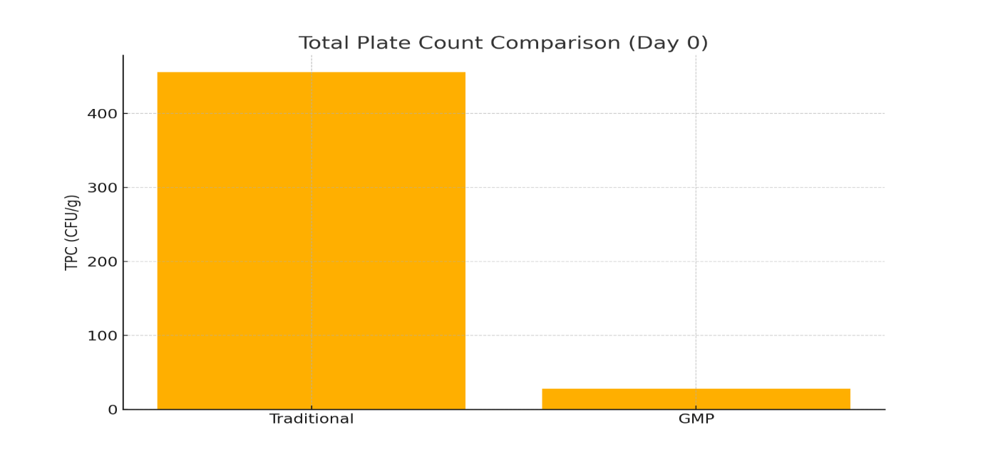
Figure 1. Total Plate Count Comparison (Traditional vs GMP)
3.3 Microbiological quality at Day 1 - Yeast and moulds
As shown in Table 2, yeast and mould counts in traditional jaggery samples averaged 45±28 CFU/g, with 90% of samples exceeding the FSSAI limit (≤10 CFU/g), whereas GMP samples consistently remained below the detection threshold (≤10 CFU/g). This sharp contrast underscores the crucial influence of moisture control and contact-surface material in governing fungal ecology. In traditional production systems, porous wooden molds and exposure to fluctuating ambient humidity facilitate spore retention, survival, and germination. In contrast, GMP-based production employs sealed packaging, non-porous food-grade contact surfaces, and low-moisture handling practices, collectively lowering water activity to levels that inhibit fungal proliferation. These findings align with established storage and packaging research identifying moisture content and surface porosity as the primary drivers of fungal growth in jaggery and similar sugar-rich products. Thus, suppression of yeast and mould under GMP conditions results from both reduced initial contamination and enhanced protection against moisture ingress during storage.
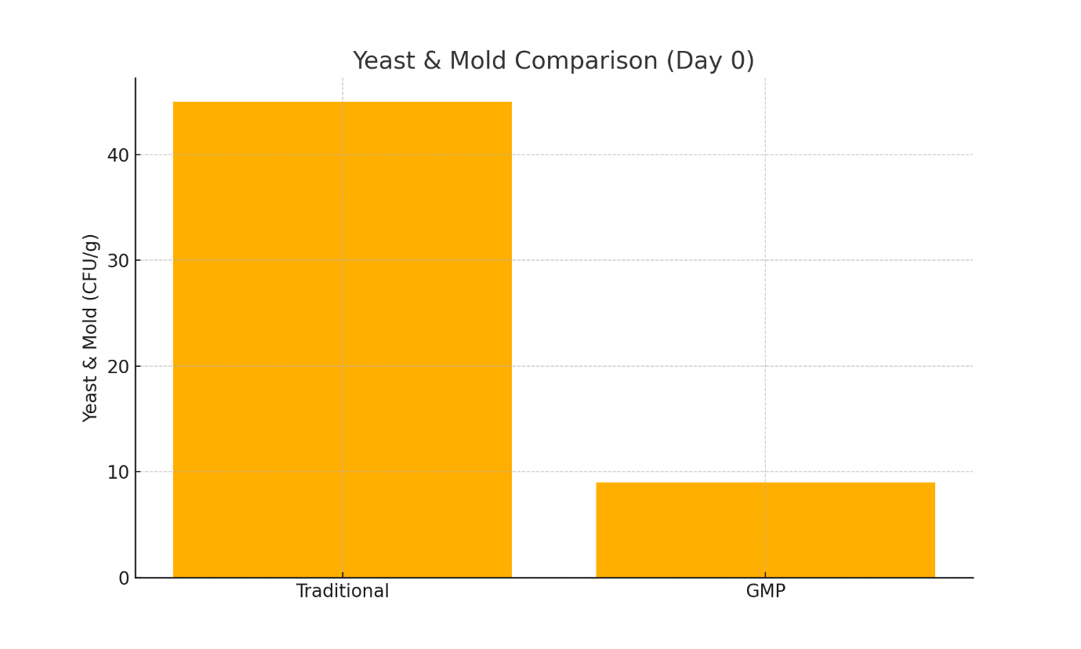
Figure 2. Yeast & Mold Count Comparison (Traditional vs GMP)
3.4 Microbiological quality at Day 1 - Coliforms and Salmonella
Table 2 also indicates that coliforms were detected in 6/50 (12%) of traditional samples and Salmonella in 4/50 (8%), whereas all GMP samples were negative for both indicators. The presence of coliforms in traditional units is congruent with the survey result of universal use of untreated water (Table 1) and reflects faecal-indicator contamination introduced via water, vectors, or unwashed hands [40,68]. The complete elimination of both coliforms and Salmonella after GMP implementation demonstrates the effectiveness of source control (RO/UV water treatment), environmental sanitation and vector management in removing enteric pathogen transmission routes. This outcome is important from a public-health perspective: Salmonella, in particular, is responsible for severe foodborne disease and hospitalizations, and its removal via hygiene interventions is consistent with WHO/FSSAI guidance that prioritizes water and sanitation controls to prevent enteric outbreaks [45,74,75]. Prior work documenting bacterial isolates in stored jaggery similarly implicates water and surface hygiene as risk factors, and our findings confirm that targeted GMP measures can remove these specific hazards [10].
3.5 Shelf-life under accelerated storage
Table 3 reports the time-series data for GMP jaggery stored under accelerated conditions (40°C ± 2°C, 75% ± 3% RH) for 485 days: TPC rose modestly from 28 ± 22 to 60 ± 12 CFU/g, Y&M remained ≤10 CFU/g throughout, coliforms and Salmonella remained absent, moisture increased gradually from 3.26% to 6.83%, pH shifted from 3.05 to 4.46, and sensory attributes remained acceptable. The modest microbial growth despite severe storage stress can be explained by the low initial bioburden, hermetic HDPE packaging that limits moisture ingress, and the absence of spoilage fungal and enteric populations that would otherwise produce rapid fermentative or degradative activity. Moisture remained well below empirically observed thresholds for xerophilic mould proliferation (≈11%), which is consistent with prolonged fungal stability reported when moisture and water activity are controlled [31,72]. Compared with reports of traditional jaggery spoilage by approximately 120 days under poor storage conditions [34], the GMP product’s stability over 485 days represents approximately a fourfold extension of practical shelf life under accelerated test conditions; this magnitude of extension accords with theoretical expectations derived from combined reductions in initial load and improved packaging, and exceeds many ambient-storage reports while still aligning with the moisture-control literature [31,34].
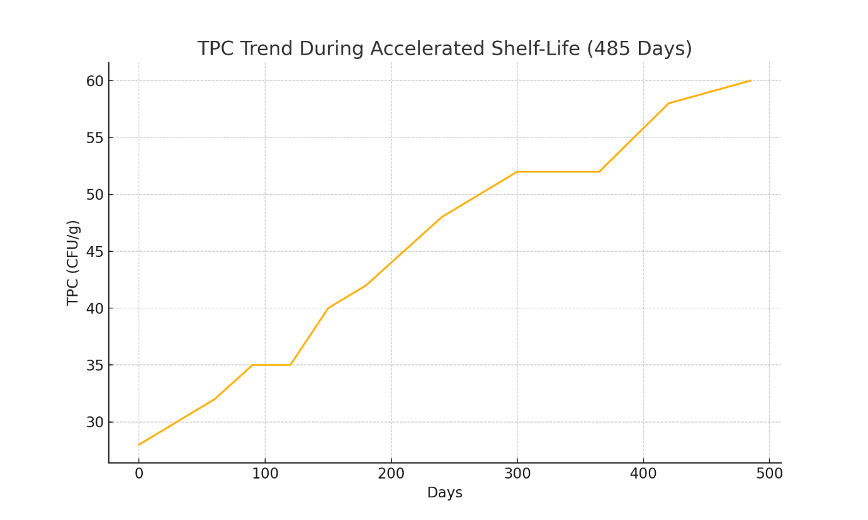
Figure 3. TPC Trend During Accelerated Shelf-Life (1–485 days)
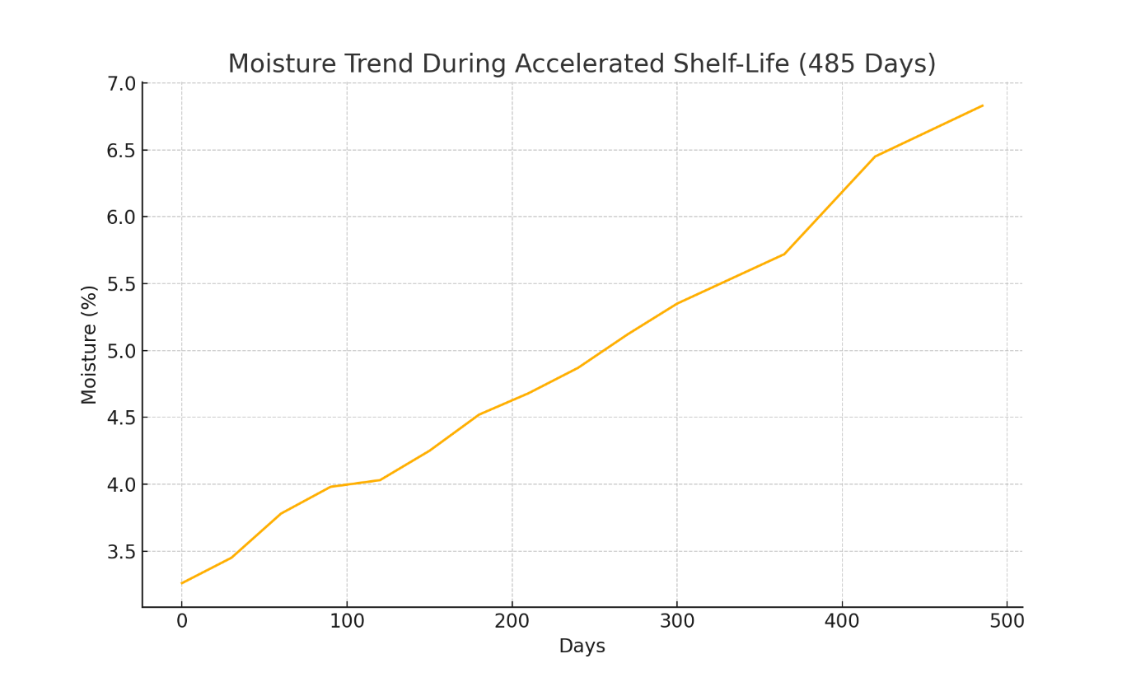
Figure 4. Moisture Trend During Accelerated Shelf-Life
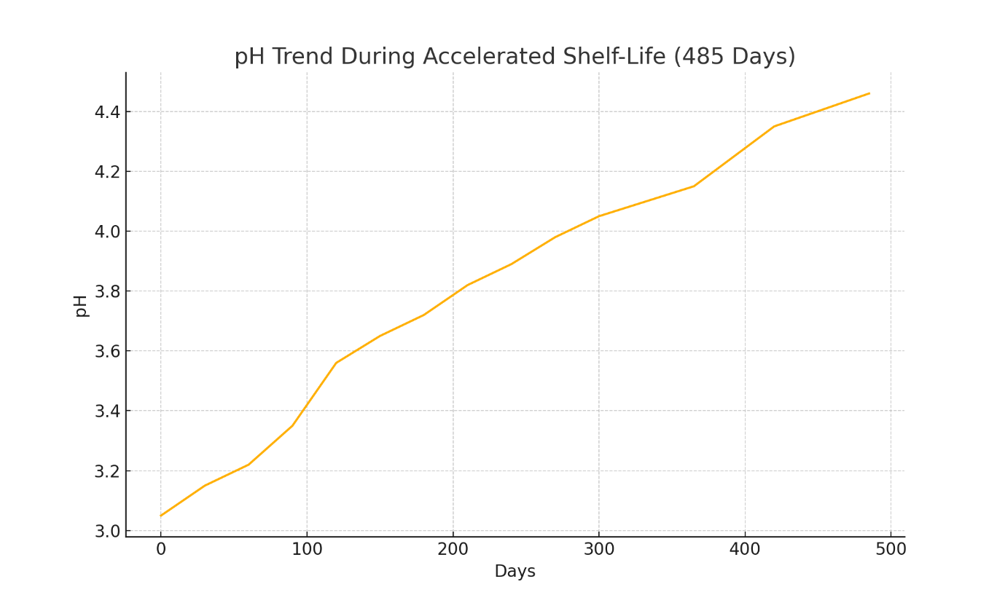
Figure 5. pH Trend During Accelerated Shelf-Life

Table 3. Microbial & Physical Parameters of GMP Jaggery Under Accelerated Shelf-Life (485 Days)
Storage: 40°C ± 2°C, 75% ± 3% RH, sealed HDPE containers
Day | TPC (CFU/g) | Y&M (CFU/g) | Coliforms | Salmonella | Moisture (%) | pH | Sensory Status
0 | 28 ± 22 | ≤10 | Absent | Absent | 3.26 ± 0.4 | 3.05 | OK
30 | 30 ± 18 | ≤10 | Absent | Absent | 3.45 ± 0.4 | 3.15 | OK
60 | 32 ± 16 | ≤10 | Absent | Absent | 3.78 ± 0.5 | 3.22 | OK
90 | 35 ± 15 | ≤10 | Absent | Absent | 3.98 ± 0.5 | 3.35 | OK
120 | 35 ± 14 | ≤10 | Absent | Absent | 4.03 ± 0.5 | 3.56 | OK
150 | 40 ± 12 | ≤10 | Absent | Absent | 4.25 ± 0.6 | 3.65 | OK
180 | 42 ± 13 | ≤10 | Absent | Absent | 4.52 ± 0.6 | 3.72 | OK
210 | 45 ± 14 | ≤10 | Absent | Absent | 4.68 ± 0.7 | 3.82 | OK
240 | 48 ± 15 | ≤10 | Absent | Absent | 4.87 ± 0.7 | 3.89 | OK
270 | 50 ± 16 | ≤10 | Absent | Absent | 5.12 ± 0.7 | 3.98 | OK
300 | 52 ± 17 | ≤10 | Absent | Absent | 5.35 ± 0.8 | 4.05 | OK
365 | 52 ± 18 | ≤10 | Absent | Absent | 5.72 ± 0.8 | 4.15 | Acceptable
420 | 58 ± 19 | ≤10 | Absent | Absent | 6.45 ± 0.9 | 4.35 | Acceptable
485 | 60 ± 12 | ≤10 | Absent | Absent | 6.83 ± 0.7 | 4.46 | Acceptable
3.6 Economic impact and commercial implications
The economic analysis indicates that, for a unit producing 500 kg per month, the capital investment of ₹3.75 million could be recovered in approximately 26 months through premium pricing and reduced waste (annual benefit ≈ ₹144,000). Beyond simple payback, the extended shelf life and regulatory compliance unlock market opportunities—longer distribution chains, interstate and international marketing, and government procurement—that amplify revenue potential. These economic findings are consistent with policy and sector analyses arguing that hygienic upgrading can convert seasonal, perishable commodities into higher-value, storable products and that cluster/subsidy models shorten payback for smaller producers [39,43]. However, the cost figures should be interpreted in light of scale: medium-sized units are more likely to realize the projected payback without subsidy, whereas small producers may require cooperative models or government support to share infrastructure costs (RO plants, testing laboratories) and achieve similar economic viability.
3.7 Comparative synthesis with published literature
When contextualized within the broader literature, our results map closely to previously reported mechanisms and outcomes. The baseline microbial diversity and contamination in traditional jaggery replicate earlier reports identifying Leuconostoc, Bacillus and diverse spoilage flora in stored jaggery [10]. The dramatic TPC reduction achieved by combining equipment upgrading, water treatment and procedural sanitation reflect findings from intervention studies in other traditional food sectors where multi-barrier GMP implementation produced log-scale reductions in culturable counts [7,67]. Likewise, the critical role of moisture control and non-porous contact surfaces in suppressing fungal growth corresponds to the work of Mandal et al. and Deotale et al., who documented that packaging and humidity are the dominant determinants of jaggery shelf life [31,34]. Finally, the public-health relevance of eliminating enteric pathogens such as Salmonella is consistent with global food safety priorities set out by WHO and national regulators and supports the case for targeted GMP interventions to reduce foodborne disease burden [45,74,75].

4. CONCLUSIONS AND RECOMMENDATIONS
The present study demonstrated that traditional jaggery production units in Karnataka exhibit poor compliance with Good Manufacturing Practices, resulting in high microbial contamination and limited shelf life. Implementation of GMP significantly improved microbial safety by reducing total plate count and completely eliminating coliforms and Salmonella from jaggery. Yeast and mould growth was effectively controlled through improved hygiene, food-grade equipment, and moisture management.
Accelerated shelf-life studies confirmed that GMP-produced jaggery remained microbiologically safe and organoleptically acceptable for up to 485 days, representing approximately a fourfold increase in shelf life compared to traditionally produced jaggery. The findings highlight that systematic adoption of GMP can transform jaggery into a safe, shelf-stable, and commercially viable traditional food product.
Overall, this study provides strong scientific evidence supporting GMP implementation as a practical and effective strategy to enhance food safety, quality, and market potential of jaggery produced in unorganized sectors.

Disclaimer (Artificial intelligence)
Option 1:
Author(s) hereby declare that NO generative AI technologies such as Large Language Models (ChatGPT, COPILOT, etc.) and text-to-image generators have been used during the writing or editing of this manuscript.
Option 2:
Author(s) hereby declare that generative AI technologies such as Large Language Models, etc. have been used during the writing or editing of manuscripts. This explanation will include the name, version, model, and source of the generative AI technology and as well as all input prompts provided to the generative AI technology
Details of the AI usage are given below:
1.
2.
3.

REFERENCES
- Gangwar, L. S., Solomon, S., & Anwar, S. I. (2015). Technological and policy options for modernization of jaggery industry in India. Indian Institute of Sugarcane Research. https://iisr.icar.gov.in/iisr/download/publications/report/policypaper_gangwar.pdf
- Tyagi, S. K., Kamboj, S., Himanshu, N., Tyagi, N., Narayanan, R., & Tyagi, V. V. (2022). Technological advancements in jaggery-making processes and emission reduction potential via clean combustion for sustainable jaggery production: An overview. Journal of Environmental Management, 301, 113792. https://doi.org/10.1016/j.jenvman.2021.113792
- Hirpara, P., Thakare, N., Kele, V. D., & Patel, D. (2020). Jaggery: A natural sweetener. Journal of Pharmacognosy and Phytochemistry, 9(5), 3145-3148. https://www.phytojournal.com/archives/2020/vol9issue5/PartAR/9-5-516-642.pdf
- Agarwal, A., & Mohan, N. (2020). New ventures of value-addition in jaggery processing for a dynamic sugar industry. International Journal of Engineering Research & Technology, 9(1), 291-294. https://doi.org/10.17577/IJERTV9IS010179
- Longvah, T., Ananthan, R., Bhaskarachary, K., & Venkaiah, K. (2017). Indian Food Composition Tables. National Institute of Nutrition, Indian Council of Medical Research. http://www.ifct2017.com/
- Singh, J., Solomon, S., & Kumar, D. (2013). Manufacturing jaggery, a product of sugarcane, as health food. Agrotechnology, S11:007. https://doi.org/10.4172/2168-9881.S11-007
- Badmos A, Ajimotokan H. The corrosion of mild steel in orange juice environment. University of Ilorin, Nigeria; 2009.
- Rodel W, Hechelmann H, Dresel J. Hygieneaspekte zu Schneidunterlagen aus Holz und Kunststoff. Fleischwirtsch. 1994; 74:814-821.
- Owen WN. Yeast and other microorganisms identified in fresh sugarcane juice. 1990.
- Singh, S., Dubey, A. P., Tiwari, L., & Verma, A. K. (2009). Microbial profile of stored jaggery: A traditional Indian sweetener. Sugar Tech, 11(2), 213-216. https://doi.org/10.1007/s12355-009-0034-4
- Khezerlou, A., Alizadeh-Sani, M., Zolfaghari Firouzsalari, N., & Ehsani, A. (2018). Formation, Properties, and Reduction Methods of Acrylamide in Foods: A Review Study. Journal of Nutrition, Fasting and Health, 6(1), 52-59. https://doi.org/10.22038/JNFH.2018.34179.1133
- Rao J, Das M, Das S. Jaggery- A traditional Indian sweetener. Indian J Tradit Knowl. 2007;6(1):95-102.
- APEDA. Uttar Pradesh produced more than 224 million tonnes of sugarcane. 2023.
- Agarwal, A., & Mohan, N. (2020). New Ventures of Value-Addition in Jaggery Processing for a Dynamic Sugar Industry. International Journal of Engineering Research and Technology https://www.ijert.org/new-ventures-of-value-addition-in-jaggery-processing-for-a-dynamic-sugar-industry
- Bashir, N., & Yousuf, O. (2022). Jaggery as a potential source of nutraceutical in food products. Emerging Trends in Nutraceuticals, 1(3), 50-55. https://doi.org/10.18782/2583-4606.118
- Kumar K. Oscillation in jaggery and khandsari industry. In: National Seminar on Status, problems and prospects of jaggery and khandsari industry in India. Lucknow; 1999.
- Gautam, C. S., Saha, L., Sekhri, K., & Saha, P. K. (2008). Iron deficiency in pregnancy and the rationality of iron supplements prescribed during pregnancy. Medscape Journal of Medicine, 10(12), 283. https://www.ncbi.nlm.nih.gov/pmc/articles/PMC2644004/
- Nayaka, M. A. H., Sathisha, U. V., Manohar, M. P., Chandrashekar, K. B., & Dharmesh, S. M. (2009). Cytoprotective and antioxidant activity studies of jaggery sugar. Food Chemistry, 115(1), 113-118. https://doi.org/10.1016/j.foodchem.2008.11.067
- Singh J. Nutritive and eco-friendly jaggery. In: Processing, Handling and Storage of Sugarcane Jaggery. Lucknow: IISR; 2008. p. 3-10.
- Shrivastav P, Verma A, Walia A, Rehana P, Singh A. Jaggery a revolution in the field of natural sweeteners. Eur J Pharm Med Res. 2016;3(3):198-202.
- Veldhyyzen-van Z. New uses for panela. Food Chain. 1999; 25:11-13.
- Jadhav, A. N., & Bhutani, K. K. (2005). Ayurveda and gynecological disorders. Journal of Ethnopharmacology, 97(1), 151-159. https://doi.org/10.1016/j.jep.2004.10.020
- Shah, S. V., Baliga, R., Rajapurkar, M., & Fonseca, V. A. (2007). Oxidants in chronic kidney disease. Journal of the American Society of Nephrology, 18(1), 16-28. https://doi.org/10.1681/ASN.2006050500
- Selvi, V. M., Mathialagan, M., & Mohan, S. (2021). The art and science of jaggery making: A review. Agricultural Reviews. https://doi.org/10.18805/ag.R-2138
- Deotale, S., Bhotmange, M. G., Halde, P., & Chitale, M. (2019). Study of traditional Indian sweetener 'Jaggery' and its storage behavior. *International Journal of Chemical Studies*, *7*(3), 410-416. https://www.chemijournal.com/archives/2019/vol7/issue3/7-3-10-100.html
- Chauhan, O. P., Singh, D., Tyagi, S. M., & Balyan, D. K. (2002). STUDIES ON PRESERVATION OF SUGARCANE JUICE. International Journal of Food Properties, 5(1), 217-229. https://doi.org/10.1081/JFP-120015603
- Mungare TS, Jadhav HD, Patil JP, Hasure RP, Jadhav BS, Singh J. Clarification technique for producing quality jaggery. Coop Sugar. 2000;32(4):283-285.
- Narian SH. Jaggery and khandsari industry in India. Indian Farming. 2002:57-68.
- Kumar, R., & Kumar, M. (2018). Upgradation of jaggery production and preservation technologies. Renewable and Sustainable Energy Reviews, 96, 167-180. https://doi.org/10.1016/j.rser.2018.07.053
- Deepak RR, Shashi P. Packaging requirements of highly respiring produce under modified atmosphere a review. J Food Sci Technol. 2007; 44:10-15.
- Mandal, D., Tudu, S., Mitra, S. R., & De, G. C. (2006). Effect of common packing materials on keeping quality of sugarcane jaggery during monsoon season. Sugar Tech, 8(2), 137-142. https://doi.org/10.1007/BF02943648
- Kumar, D., Singh, J., Rai, D. R., Kumar, M., & Bhatia, S. (2013). Effect of modified atmosphere packaging on keeping quality of jaggery. Sugar Tech, 15, 203-208. https://doi.org/10.1007/s12355-012-0197-2
- Kumar, D., Singh, J., Rai, D. R., Bhatia, S., Singh, A. K., & Kumar, M. (2013). Colour changes in jaggery cubes under modified atmosphere packaging in plastic film packages. Agrotechnology, S11, 005. https://doi.org/10.4172/2168-9881.S11-005
- Deotale, S. M., Bhotmange, M. G., Halde, P., & Chitale, M. (2019). Study of traditional Indian sweetener 'Jaggery' and its storage behavior. *International Journal of Chemical Studies*, *7*(3), 410-416. https://www.chemijournal.com/archives/2019/vol7issue3/PartG/7-3-29-416.pdf
- Choi J, Lee S. A moisture absorber controls the product's water activity to prevent the growth of microorganisms. 2013.
- Asokan S, Rupa TR. Sugarcane Chemistry Including Sugar and Gur Technology. Coimbatore: Directorate of Open and Distance Learning, Tamil Nadu Agricultural University; 2008.
- Natural Health Products Directorate, Health Canada. (2006). Good manufacturing practices guidance document. https://www.publications.gc.ca/site/eng/9.686000/publication.html
- World Health Organization & Food and Agriculture Organization of the United Nations. (2022). Microbiological hazards in spices and dried aromatic herbs: meeting report. Microbiological Risk Assessment Series No. 27. https://doi.org/10.4060/cb8686en
- FDA. Good Manufacturing Practice (GMP) Guidelines/Inspection Checklist. 1997 Feb 12 (Updated 2008 Apr 24).
- Food and Drug Administration. (2010). Small entity compliance guide: Current good manufacturing practice in manufacturing, packaging, labeling, or holding operations for dietary supplements. U.S. Department of Health and Human Services. https://www.fda.gov/regulatory-information/search-fda-guidance-documents/small-entity-compliance-guide-current-good-manufacturing-practice-manufacturing-packaging-labeling
- Food and Drug Administration. (2013). Current good manufacturing practice and hazard analysis and risk-based preventive controls for human food. Federal Register, 78(11), 3646-3824. https://www.govinfo.gov/app/details/FR-2013-01-16/2013-00125
- U.S. Food and Drug Administration. (2012). FDA Foods Program, The Reportable Food Registry: A New Approach to Targeting Inspection Resources and Identifying Patterns of Adulteration. Second Annual Report. U.S. Food and Drug Administration. https://www.fda.gov/food/compliance-enforcement-food/reportable-food-registry-annual-report
- Mukherjee, P. K., Venkatesh, M., & Kumar, V. (2007). An Overview on the Development in Regulation and Control of Medicinal and Aromatic Plants in the Indian System of Medicine. Boletín Latinoamericano y del Caribe de Plantas Medicinales y Aromáticas, 6(4), 129-137. http://www.redalyc.org/articulo.oa?id=85660407
- Hoffmann, S. A. (2011). U.S. Food Safety Policy Enters a New Era. Amber Waves: The Economics of Food, Farming, Natural Resources, and Rural America, 9(4), 24. https://doi.org/10.22004/ag.econ.120793
- World Health Organization. (2020). Food safety: Key facts. https://www.who.int/news-room/fact-sheets/detail/food-safety
- World Health Organization. (2017). *WHO guidelines on use of medically important antimicrobials in food-producing animals*. https://iris.who.int/handle/10665/258331
- Akabanda, F., Hlortsi, E. H., & Owusu-Kwarteng, J. (2017). Food safety knowledge, attitudes and practices of institutional food-handlers in Ghana. BMC Public Health, 17(1), 40. https://doi.org/10.1186/s12889-016-3986-9
- Zain, M. M., & Naing, N. N. (2002). Sociodemographic characteristics of food handlers and their knowledge, attitude and practice towards food sanitation: a preliminary report. Southeast Asian Journal of Tropical Medicine and Public Health, 33(2), 410–417. https://pubmed.ncbi.nlm.nih.gov/12236444/
- Tan, S. L., Cheng, P. L., Soon, H. K., Ghazali, H., & Mahyudin, N. A. (2013). A qualitative study on personal hygiene knowledge and practices among food handlers at selected primary schools in Klang Valley area, Selangor, Malaysia. International Food Research Journal, 20(1), 71-76. https://www.ifrj.upm.edu.my/20%20(1)%202013/7.%20A%20qualitative%20study%20on%20personal%20hygiene%20knowledge%20and%20practices%20among%20food%20handlers%20at%20selected%20primary%20schools%20in%20Klang%20valley%20area,%20Selangor,%20Malaysia.pdf
- Pal M, Mahendra R. Sanitation in Food Establishments. 1st ed. Saarbrücken: LAMBERT Academic Publishing; 2015.
- Pal M. Zoonoses. 2nd ed. Jaipur: Satyam Publishers; 2007.
- Pal M. Rotavirus gastroenteritis A life-threatening viral disease of global significance. CPQ Microbiol. 2018;1:1-3.
- Pal M, Ayele Y. Emerging role of foodborne viruses in public health. Biomed Res Int. 2020;5:1-4.
- Howes M, McEwen S, Griffiths M, Harris L. Food handler certification by home study: Measuring changes in knowledge and behaviour. Dairy Food Environ Sanit. 1996;16(7):737-744.
- Chinakwe, E. C., Nwogwugwu, N. U., Nwachukwu, I. N., Okorondu, S. I., Onyemekara, N. N., & Ndubuisi-Nnaji, U. U. (2012). Microbial quality and public health implications of hand-wash water samples of public adults in Owerri, South-East Nigeria. International Research Journal of Microbiology, 3(4), 144-146. http://www.interesjournals.org/IRJM
- Belluco S, Vittone F, Piri A, et al. Arthropods and pathogenic microorganisms in food industry. In: Food Safety. 2013.
- Graham DJ. Using sanitary design to avoid HACCP hazards and allergen contamination. Food Safety Mag. 2004 Jun/Jul.
- Lelieveld, H. L. M., Mostert, M. A., & Holah, J. (2005). Handbook of hygiene control in the food industry. Woodhead Publishing Limited. https://doi.org/10.1201/9781439823583
- Cramer, M. M. (2003). Six steps to effective sanitary design for the food plant. Food Safety Magazine. https://www.foods-safety.com/articles/six-steps-to-effective-sanitary-design-for-the-food-plant/
- Cavalheiro, C. P., da Silva, M. C. A., Leite, J. S. F., Felix, S. K. R., Herrero, A. M., & Ruiz‐Capillas, C. (2020). Physical hazards in meat products: Consumers' complaints found on a Brazilian website. Food Control, 108, 106892. https://doi.org/10.1016/j.foodcont.2019.106892
- Drew, C. A., & Clydesdale, F. M. (2015). New food safety law: Effectiveness on the ground. Critical Reviews in Food Science and Nutrition, 55(5), 689-700. https://doi.org/10.1080/10408398.2011.654368
- Alamri, M. S., Qasem, A. A. A., Mohamed, A. A., Hussain, S., Ibraheem, M. A., Shamlan, G., Alqah, H. A., & Qasha, A. S. (2021). Food packaging's materials: A food safety perspective. Saudi Journal of Biological Sciences, 28(8), 4490-4499. https://doi.org/10.1016/j.sjbs.2021.04.047
- Mortimore, S., & Wallace, C. (2013). HACCP: A Practical Approach. Springer Science and Business Media. https://doi.org/10.1007/978-1-4614-5028-3
- Nuutinen, M. (2023). Detection of physical hazards. In V. Andersen, H. Lelieveld, & Y. Motarjemi (Eds.), *Food Safety Management* (pp. 475-493). Academic Press. https://www.elsevier.com/books/food-safety-management/andersen/978-0-12-820013-1
- Mendez, E., Jones, C., & Trinetta, V. (2020). Engaging undergraduate students in food safety study and food microbiology research. Food Protection Trends, 40(3), 164-170. https://www.foodprotection.org/publications/food-protection-trends/archive/2020/may-june/engaging-undergraduate-students-in-food-safety-study-and-food-microbiology-research/
- Rawat, S. (2015). Food spoilage: Microorganisms and their prevention. Asian Journal of Plant Science and Research, 5(4), 47-56. https://www.imedpub.com/articles/food-spoilage-microorganisms-and-their-prevention.php?aid=11730
- Snyder, A. B., Churey, J. J., & Worobo, R. W. (2019). Association of fungal genera from spoiled processed foods with physicochemical food properties and processing conditions. Food Microbiology, 83, 211-218. https://doi.org/10.1016/j.fm.2019.05.012
- Bintsis, T. (2017). Foodborne pathogens. AIMS Microbiology, 3(3), 529-563. https://doi.org/10.3934/microbiol.2017.3.529
- Osakue, O. P., Igene, J. O., Ebabhamiegbebho, P. A., & Evivie, S. E. (2016). Proximate analysis and microbial quality of ready-to-eat (RTE) fried chicken parts. Journal of Food and Industrial Microbiology, 2(1), 107. https://doi.org/10.4172/2572-4134.1000107
- Darwish AZM. Foodborne pathogens of fast food and ready-to-eat foods in Tabuk city and evaluating hazard for food quality. Int J Healthc Biomed Res. 2018;6(2):149-158.
- Adebukola, O. C., Opeyemi, A. O., & Ayodeji, A. I. (2015). Knowledge of food borne infection and food safety practices among local food handlers in Ijebu-Ode Local Government Area of Ogun State. Journal of Public Health and Epidemiology, 7(9), 268-273. https://doi.org/10.5897/JPHE2015.0758
- Asiegbu, C. V., Lebelo, S. L., & Tabit, F. T. (2020). Microbial quality of ready-to-eat street vended food groups sold in the Johannesburg metropolis, South Africa. Journal of Food Quality and Hazards Control, 7(1), 18-26. https://doi.org/10.18502/jfqhc.7.1.2448
- Schnürer, J., & Magnusson, J. (2005). Antifungal lactic acid bacteria as biopreservatives. Trends in Food Science and Technology, 16(1-3), 70-78. https://doi.org/10.1016/j.tifs.2004.02.014
- Leyva Salas, M., Mounier, J., Valence, F., Coton, M., Thierry, A., & Coton, E. (2017). Antifungal microbial agents for food biopreservation—A review. Microorganisms, 5(3), 37. https://doi.org/10.3390/microorganisms5030037
- Singh, A. K., Drolia, R., Bai, X., & Bhunia, A. K. (2015). Streptomycin Induced Stress Response in Salmonella enterica Serovar Typhimurium Shows Distinct Colony Scatter Signature. PLoS ONE, 10(8), e0135035. https://doi.org/10.1371/journal.pone.0135035

