Design, Development and Performance Evaluation of an Air Classifier for Decorticated Mass of Dried Water Chestnut (Trapa Natas)

Abstract- The separation of dried and decorticated water chestnut kernels and peels is a critical step in post-harvest processing, as manual cleaning methods are labour-intensive, time-consuming and inefficient. To address this challenge, an air classifier was designed and developed; it consisted of a hopper, feed control mechanism, separation section (S-section), blowing unit, peel outlet, main outlet and power source. The experiment was conducted at three moisture contents (7, 14 and 21%), three blower RPM (1130, 1300 and 1450 RPM) and three feed rates (100, 200 and 300 kg/h) to evaluate the efficiency and capacity of the air classifier. Calculations of angular velocity, tangential velocity, terminal velocity, volumetric flow rate, mass flow rate and thrust force were carried out to analyse the air flow dynamics acting on kernels and peels. The results showed that the minimum air velocity required to separate the peels was 8.3 m/s, corresponding to the blower speed of 1130 RPM. The cleaning efficiency, separation efficiency and total efficiency were found to be 99.88%, 97.92% and 97.80% respectively with a throughput capacity of 500 kg/h and energy consumption 2.71 kWh/tonne. Hence the air classifier provides a practical, energy-efficient and scalable solution of the separation of dried and decorticated kernels and peels.
Keywords: Water chestnut, air classifier, decortication, efficiency.

Introduction
Water chestnut, belonging to the monogeneric family Trapaceae, is an important but underutilised aquatic crop with significant potential for food and industrial applications. It was originally introduced in Europe as an ornamental plant and is now widely recognised for its nutritional benefits and adaptability to freshwater ecosystems. (Hummel and Kiviat, 2004). Among the cultivated species, Trapa bispinosa and Trapa natans L. are the most commonly cultivated. In India, the crop is popularly referred to as ‘Singhara’ in Hindi, ‘Shinghoda’ in Gujarati, ‘Paniphal’ in Bengali, ‘Pani’ Singhara in Odia and ‘Kubyakam’ in Telugu. Water chestnut serves as an excellent source of starch and is increasingly considered a potential alternative to traditional starchy crops such as potato, corn, and wheat. Despite its potential, only about 5% of the total produce is consumed fresh, while the remaining 95% undergoes processing. (Sayyad et al., 2021)
Two morphological variants of water chestnut are generally recognised: thorny and thornless types. It is crucial to distinguish these species from the Chinese water chestnut (Eleocharis dulcis, family Cyperaceae), which, although also aquatic, is botanically unrelated and produces an edible tuber used extensively in East Asian cuisine. In the Indian subcontinent, water chestnut holds cultural and dietary importance, especially during religious fasting days when it serves as a cereal substitute. Water chestnut flour is low in fat, highly digestible, and particularly beneficial in dietary applications. It is widely consumed in the form of sweet dishes such as ‘halwa, puri, and as bread during festive and religious observances. Moreover, water chestnut flour has growing industrial relevance. It is employed in the preparation of biscuits, infant milk formulas, starch, and even alcohol. Importantly, the flour is gluten-free, making it an ideal substitute for wheat flour, especially for individuals suffering from coeliac disease or gluten intolerance. (Sayyad et al., 2021)
Given its rich starch content and absence of gluten, water chestnut flour holds promise for use in a variety of processed foods, including bread, cookies, snacks, and pasta. Additionally, it exhibits functional properties as a thickening agent, stabiliser, adhesive, and binding agent in various culinary and industrial applications. Its nutritional profile also positions it as a potential intervention for addressing malnutrition. (Borges et al., 2007).
Water chestnut (Trapa natans) belongs to the Trapaceae family. It is an aquatic, nutritious vegetable which is widely consumed fresh and processed in both rural and urban areas. In India it is commonly known as Paniphal or Singhara. Two varieties of water chestnut, Trapa bispinosa and Trapa quadrispinosa are grown in India. It is characterised by its floating leaves and typically grows in stagnant water bodies. It flourishes in depth, ranging from 0.3 to 3.6 metres in muddy substrates. It thrives optimally in cooler climates, with a temperature range of 12-15 °C being ideal for seed germination. (Gupta et. al., 2025). It thrives best in soft nutrient dense water, with pH range between 6.7 to 8.2 (Bhatiwal et. al., 2012)
India is an agricultural country, with 54.6% of the entire workforce involved in agriculture and related sector activities. As per land use statistics for 2022-23, the reported area of our country is 306,650 thousand hectares, of which around 59% is agricultural land. The reported net sown area is 140,705 thousand hectares and the gross cropped area is 219,357 thousand hectares with a cropping intensity of 155.9%. India produced 3,539.59 lakh tones food grain in year 2024-25, including paddy, wheat, maize, tur, red gram, green gram and many more. The harvest and post-harvest processing equipment for these crops are advanced and available everywhere, but aquatic crops, like water chestnuts, are some important crops that are still neglected and have poor processing status. (Annual Report 2024-25, Department of Agriculture and Farmer Welfare, Government of India). In India, cultivation is mainly undertaken in freshwater bodies, including lakes, rivers, and reservoirs across states such as Bihar, Madhya Pradesh, West Bengal, Uttar Pradesh, Maharashtra (Mumbai), Punjab, Tamil Nadu (Chennai), and Jammu & Kashmir. Asia's largest freshwater lake, Wular Lake of Kashmir, produces an estimated 4,000–5,000 metric tonnes of water chestnut annually (Sharma et al., 2018).
India produces around 67,600 tonnes of water chestnut from 16,900 ha. of land, every year. The major water chestnut producing states in India are Bihar, Madhya Pradesh and West Bengal with annual production 141,750, 121,500 and 40,500 tonnes respectively. Major water chestnut producing districts in Bihar are Darbhanga, Madhubani, Purnia, Katihar, Saharasa, Araria and Patna. In Madhya Pradesh it is grown in the Chhatarpur, Damoh, Panna, Sagar, Katni and Niwari districts. Midnapore, Nadia, Howrah, Hooghly and Burdwan are major water chestnut-producing districts in West Bengal. Other states like Uttar Pradesh, Odisha, Chhattisgarh Jharkhand and Tamil Nadu also contribute to water chestnut production. (Jana 2025).
They are known for their crispy texture and sweet, nutty flavour, making them a popular ingredient in Asian food. Chestnut flour is high in protein (1.87%), high in sugar (20-32%), high in starch (50-60%), high in dietary fibre (4- 10%), high in important amino acids (4-7%), and low in fat (2-4%). In addition, it contains a lot of potassium, magnesium, and calcium, as well as vitamins B, C, and E. As most gluten-free goods are currently lacking in vitamin B, iron, and fibre, it is believed that using chestnut flour will be beneficial. Chestnut flour is also utilised in the creation of gluten-free bread because of its nutritional worth. (Rajput et al., 2023). The crop is exhibiting amazing natural qualities in the form of flour and dry nuts as it is being stored. They are considered a poor man's diet since they are inexpensive, particularly in Indian areas.
In conclusion, with improved processing techniques and enhanced cultivation practices, water chestnut can emerge as a viable crop for nutritional security, rural income generation, and agro-industrial development. Increased research and policy support could facilitate its transformation from an underutilised resource to a mainstream agricultural commodity.
Considering the significance, production, and growing demand for water chestnut, it is important to step up towards improved mechanisation, processing, and storage techniques. A manual water chestnut decorticator has been developed by the All India Coordinated Research Project (AICRP) in the Post-harvest Engineering and Technology (PHET) center, Jabalpur. However, for separation and cleaning of the decorticated mass of water chestnut, no machine is available. As a further step to enhance the efficiency and quality of water chestnut processing, developing an air classifier would be a vital initiative. This innovation would not only modernise the processing stage but also reduce manual labour, minimise losses, and improve the overall quality of the produce.
Objectives
- To design and develop an air classifier for separation of dried water chestnut kernels from mixed decorticated mass of dried water chestnut and dried peels.
- To determine the physical, aerodynamic and frictional properties of the water chest nut kernels and peels.
- To evaluate the performance of the developed air classifier in terms of its efficiency, throughput capacity and energy consumption.
Material and methods
Raw material
Fresh water chestnuts were procured from the local market of Jabalpur, then dried in a tray dryer. Physical properties of both fresh and dried water chestnuts were measured and calculated. Raw materials, required for the fabrication of machine, were also procured from the local market of Jabalpur.
Determination of physical properties of water chestnut
The arithmetic mean diameter, geometric mean diameter, equivalent diameter, sphericity, volume, surface area, area of transverse surface and aspect ratio were calculated by using formulae suggested by Mohsenin (1986) and Beigh et. al. (2020).
${Geometric mean diameter Dg \left(cm\right)= LWT}^{\frac{1}{3}}$ $……………$eq.1 $Arithmetic mean diameter Da (cm) =\frac{(L+W+T)}{3}$ $……………$eq.2
$Equivalent diameter De \left(cm\right)={\left[\frac{L{\left(W+T\right)}^{2}}{4}\right]}^{\frac{1}{3}}$ $……………$eq.3
$Sphericity \left(\%\right)= \left[\frac{{(LWT)}^{\frac{1}{3}}}{L}\right]×100$ $……………$eq.4
$Surface area ({cm}^{2})= π×{Dg}^{2}$ $……………$eq.5
$Area of transverse surface ({cm}^{2}= \left[\frac{π}{4}\right]TW$ $……………$eq.6
$Aspect ratio=\frac{W}{L}$ $……………$eq.7
$Volume \left({cm}^{3}\right)=0.25\left[\frac{π}{6} L{(W+T)}^{2}\right]$ $……………$eq.8
(Where L = length, W = width and T = thickness)
Bulk density
Bulk density of water chestnut was calculated by using the formula proposed by Mohsenin (1986).
$Bulk density=\frac{mass of sample (g)}{volume cube occupied by the sample (cm³)}$ $……………$eq.9
1000 Grain Weight
Thousand grain weight was calculated using eq. 10 and 11 suggested by Kumar et. al., (2018).
Thousand grain weight = Total weight of 200 seeds ×5 $……………$eq.10
Thousand grain weight = Total weight of 100 seeds ×10 $…...……$eq.11
Moisture content
Moisture content was determined by using the formula proposed by Henderson and Perry (1976).
m = $\frac{100×Wm}{(Wm+Wd)}$ $……………$eq.12
Where m = Moisture content (wet basis) %, W_{m} = Weight of moisture (g), W_{d} = Weight of bone-dry material (g)
Terminal velocity of water chestnut
The terminal velocity of the water chestnut’s kernel and peels was determined by the formula suggested by Mohsenin (1986).
$Vt=\sqrt{\frac{2mg}{ρ A Cd}}$ $……………$eq.13
Vt = Terminal velocity (m/s)
m = mass of object (kg)
g = Acceleration due to gravity (m/s²)
ρ = Density of air (1.225) at standard conditions (Kg/m³)
C_{d} = Drag coefficient (0.9 for irregular shapes)
A = Area of kernel or peel
Airflow characteristics
Air velocity
Velocity of air was measured by using a digital anemometer.
Angular velocity
Angular velocity is the rate at which the impeller of the air classifier rotates around its axis. It is measured in rad/second. Singh (2020).
$ω= \frac{2πN}{60}$ $……………$eq.14
Tangential velocity
Tangential velocity was calculated by the formula suggested by Singh (2020).
$Tangential velocity (\frac{m}{s})= ω×r$ $……………$eq.15
Volumetric flow rate
Volumetric flow rate was calculated by the formula given by Yunus and John (2006).
$Q=V×A$ $……………$eq.16
Mass flow rate
Mass flow rate was calculated by the formula proposed by Yunus and John (2006). It is represented as kg/s.
M = ρ$×$Q $……………$eq.17
(Where V = air velocity and A = Area of blower)
Frictional properties of water chestnut
Angle of repose
It was measured by the tilting box method, suggested by Hashemi and Amoudi (2018). The angle of repose of the kernel, peel and mixture (kernels and peels) was measured by taking three samples of each moisture content, 7, 14 and 21% (wb), on a mild steel sheet.
Coefficient of friction
It was calculated by using a formula, mentioned by Sundaram et. al. (2014).
μ_{s} = $\tan{θ}$ $……………$eq.18
(Where μ_{s} = Coefficient of friction and $θ$ = Angle of repose)
Designing of working components
Main frame
The length, width and height of mainframe was 1080, 610 and 1160 mm. The length and width of the classifier were decided to completely cover and protect the inner working parts, whereas the height of the classifier was decided on the basis of anthropometric analysis of agricultural, machinery, obtained from various institutions.
Design of hopper
A triangular prism-shaped hopper was designed to accommodate 5 kg of material at once. Bulk density of the decorticated mixture was used to determine the volume of the hopper then the volume of the hopper was calculated by using eq. 20. The dimensions of the hopper was calculated by using eq. 19, two varibles, base (b) and length (l), were assumed as the height of the machine was already determined as per anthropometric data. The height of the hopper was then computed.
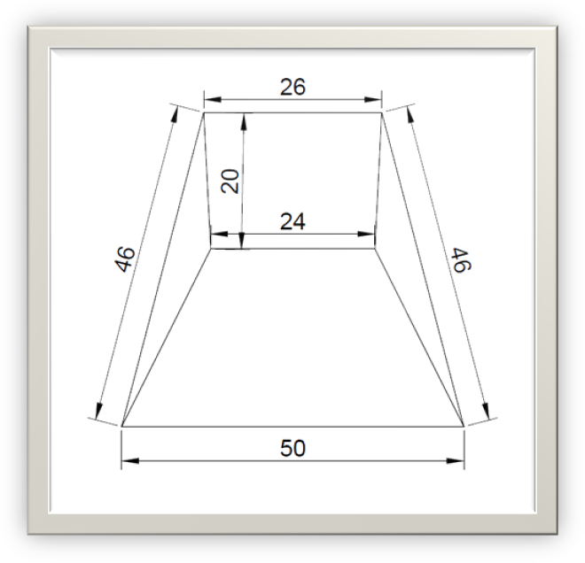
l
h
b
Fig. 1. Isometric view of hopper
Volume of triangular prism (V) = $\frac{1}{2}bhl$ $……………$eq.19
Volume of hopper(cm³) =$\frac{Mass}{Bulk density of material }$ $……………$eq.20
Where Mass (g) = 5000 g
Bulk density of mixture = 0.435 g/cm³
Base (b) = 20 cm
Length (l) = 26 cm
Height (h) was computed as 46$±$2 cm
Pulley diameter
N₁ D₁ =N₂ D₂ $……………$eq.21
Where;
N₁ and D₁ is RPM and diameter of driving pulley 2500 and 7.62mm respectively.
N₂ and D₂ is RPM and diameter of driven pulley 1450 and D₂
D₂ was calculated as 13.13 mm (5.1 inches)
In the preliminary design calculations, the diameter of the driven pulley was determined as 5.1 inches to achieve the desired speed transmission ratio. However, in the actual prototype, a 4-inch pulley was employed. This modification was intentional, as the system was equipped with a speed regulator to provide variable speed during operation. The use of a smaller pulley, in conjunction with the regulator, allowed a wider and more flexible speed adjustment range without compromising the functional requirements of the classifier. This design choice ensured that the machine could be fine-tuned under varying feed and operating conditions, thereby enhancing its adaptability and practical utility. Such deviations between theoretical design and actual fabrication are consistent with engineering practice, where modifications are introduced to improve operational control and performance.
Force calculations
Pressure force
The pressure force was calculated by the formula suggested by Yunus and John (2006).
q = ½ $ρ$v² $……………$eq.22
(Where q = pressure force, $ρ$ = air density, and v = air velocity)
Thrust force
Thrust force was calculated by using the formula given by Yunus and John (2006).
F_{T} = C_{d}$×$q $×$A $……………$eq.23
(Where q = pressure force and A = Cross-sectional area of cylindrical blower)
Determination of efficiency and capacity of air classifier
Cleaning efficiency
Cleaning efficiency was calculated by applying the formula suggested by Akinoso et. al., (2010)
$Cleaning efficiency (CE)\% =\frac{GP}{GP+GR}×100$ $……………$eq.24
Separation efficiency
Separation efficiency was calculated by applying the formula proposed by Akinoso et. al., (2010).
$Separation efficiency (SE)\% =\frac{BR}{BR+BP}×100$ $……………$eq.25
Total efficiency
Total efficiency of the air classifier was calculated by using the formula mentioned by Akinoso et. al., (2010).
$Total efficiency (η) \% = CE×SE×100$ $……………$eq.26
(Where; GP = Good product, GR = Good reject, BP = Bad product, BR = Bad reject)
Throughput capacity
Throughput capacity is the maximum feed rate that a machine can process with high efficiency. It is calculated by the formula given below:
$Throughput capacity =\frac{ Total feed(kg)}{Time(h)}×100$ $……………$eq.27
Specific consumed energy
Energy consumption was estimated by using the formula mentioned by Ghonimy and Rostom (2022).
$Ec=\frac{P}{TC}$ $……………$eq.28
Where; E_{c} = Specific consumed energy (kWh/kg), P = Motor power kW, TC = Throughput capacity of classifier (Kg/h)
Results and discussion
Table 1-Physical properties of fresh whole water chestnut
S. No. | Physical parameter | Range | Mean value | Sample variance(S)
1 | Length (mm) | 22.8-49.3 | 31.24 | 3.59
2 | Width (mm) | 19.0-40.7 | 29.93 | 3.37
3 | Thickness (mm) | 17.1-30.0 | 22.49 | 2.38
4 | Arithmetic mean diameter (mm) | 20.6-40.0 | 27.89 | 2.68
5 | Geometric mean diameter (mm) | 20.5-39.2 | 27.56 | 2.63
6 | Equivalent diameter (mm) | 20.5-39.5 | 27.77 | 2.66
7 | Sphericity (%) | 7.4-9.3 | 0.885 | 0.045
8 | Volume (mm³) | 4539-32257 | 11528 | 3730
9 | Surface area (mm²) | 1320-4825 | 2406.9 | 482
10 | Area of transverse surface (mm²) | 296.9-959 | 532.1 | 103.3
11 | Aspect ratio | 0.74-1.05 | 0.960 | 0.072

Table 2-Physical properties dried and peeled water chestnut kernels
S. No. | Physical Parameters | Range | Mean value | Sample variance (S)
1 | Length (mm) | 19.2-30.3 | 26.48 | 3.35
2 | Width (mm) | 22.6-34.2 | 27.59 | 2.57
3 | Thickness (mm) | 7.8-14.5 | 15.93 | 4.75
4 | Arithmetic mean diameter (mm) | 17.6-24.5 | 20.28 | 1.68
5 | Geometric mean diameter (mm) | 16.5-22.7 | 21.88 | 1.53
6 | Equivalent diameter (mm) | 17.5-24.4 | 21.61 | 1.63
7 | Sphericity (%) | 0.62-0.97 | 0.770 | 0.085
8 | Surface area (mm²) | 85.1-161.3 | 1299.43 | 191.1

Table 3-Physical properties of dried peels of water chestnut
S. No. | Physical Parameters | Range | Mean value | Sample variance (S)
1 | Length (mm) | 24.22-36.48 | 29.39 | 2.63
2 | Width (mm) | 10.33-30.85 | 22.14 | 5.03
3 | Thickness (mm) | 0.58-4.52 | 1.85 | 0.90
4 | Arithmetic mean diameter (mm) | 14.01-21.89 | 17.79 | 2.19
5 | Geometric mean diameter (mm) | 5.71-14.22 | 10.37 | 2.23
6 | Equivalent diameter (mm) | 9.75-20.44 | 16.08 | 2.68
7 | Surface area (mm²) | 102.52-635.25 | 352.23 | 142.1
Bulk density
The average bulk density of fresh whole water chestnut and a mixture of dried and decorticated water chestnut was 0.611$±$0.021 and 0.435$±$0.009 g/cm³ respectively. (eq. 9)
1000 grain weight
The thousand grain weight of fresh whole and dry peeled water chestnuts was 10.05 and 5.10 kg. (eq. 10 and 11)
Angle of repose
The angle of repose of the peel, kernel and mixture was 35.1$±$1.2, 33.7$±$0.9 and 33.2$±$1, respectively.
Terminal velocity
Terminal velocities of dried water chestnut kernels and peels were 15.76 m/s and 7.88 m/s respectively. (eq. 13)
Table 4-Velocity of air at different blower RPM
S. No. | Blower RPM | Air velocity near fan (m/s) | Air velocity at hopper discharge (m/s)
1 | 1130 | 8.3 | 8.9
2 | 1300 | 8.7 | 10.2
3 | 1450 | 10.2 | 10.5
Table 5-Angular and tangential velocity
S. No. | RPM | Angular velocity (rad/s) | Tangential velocity (m/s)
1 | 1130 | 118.3 | 15
2 | 1450 | 151.8 | 19.2
Table 6-Volumetric flow rate and mass flow rate
S. No. | RPM | Volumetric flow rate (m³/s) |  | Mass flow rate (kg/s)
S. No. | RPM | Near fan | At hopper discharge | Near fan | At hopper discharge
1 | 1130 | 0.374 | 0.234 | 0.458 | 0.286
2 | 1450 | 0.460 | 0.227 | 0.563 | 0.339

Table 7-Coefficient of friction of peels, kernels and mixture of kernels and peels at 7, 14 and 21% moisture content on MS sheet
Sample | Moisture content % (wet basis)
Sample | 7% | 14% | 21%
Peel | 0.700 | 0.683 | 0.726
Kernel | 0.616 | 0.665 | 0.726
Mixture | 0.609 | 0.632 | 0.726

Table 8: Pressure and thrust force
S. No. | RPM | Dynamic pressure (Pa) | Thrust force (N) acting on
S. No. | RPM | Dynamic pressure (Pa) | Kernels | Peels
1 | 1130 | 48.51 | 0.016 | 0.008
2 | 1300 | 63.72 | 0.021 | 0.011
3 | 1450 | 67.52 | 0.022 | 0.012

Effect of variables on total efficiency

Fig. 2 indicates that at a lower moisture content of 7%, the total efficiency remains relatively high across different feed rates, with values of 98.11%, 96.7%, and 98.62% for feed rates of 100 kg/h, 200 kg/h, and 300 kg/h, respectively. As moisture content increases to 14%, there's a slight decrease in total efficiency compared to the 7% MC conditions, with efficiencies of 94.23%, 97.46%, and 93.76% for the respective feed rates. At the highest moisture content of 21%, total efficiency drops further to 87.99% and 89.84% for feed rates of 100 kg/h and 200 kg/h but interestingly increases to 96.57% at a feed rate of 300 kg/h.

From the Fig. 3, it is evident that moisture content plays a significant role in determining total efficiency. At a moisture content of 7%, the total efficiency ranges from 99.25% to 99.74% as the feed rate increases from 100 kg/h to 300 kg/h. When the moisture content is increased to 14%, efficiencies remain high, with values between 99.18% and 99.82%. However, at a higher moisture content of 21%, a noticeable decrease was observed in total efficiency, with values ranging from 97.28% to 98.65%. This indicates that higher moisture content negatively impacts the air classifier’s efficiency.

As data represented in Fig. 4, at 7% moisture content, total efficiency remains at 100% across feed rates of 100 and 200 kg/h and slightly decreases to 99.69% at 300 kg/h. With a moisture content of 14%, efficiency is 100% at 100 kg/h, slightly drops to 99.76% at 200 kg/h, and returns to 100% at 300 kg/h. At the highest moisture content of 21%, efficiency slightly decreases with increasing feed rate: 99.56% at 100 kg/h, 99.51% at 200 kg/h, and 99.27% at 300 kg/h. Overall, the data suggests that higher moisture content and higher feed rates tend to slightly reduce total efficiency. The impact is more obvious at the highest moisture content of 21%.

Data from Fig. 5 indicates that at a constant RPM, increasing the feed rate generally leads to an increase in total efficiency. For example, at 1130 RPM, efficiency increases from 98.11% to 98.62% as the feed rate increases from 100 kg/h to 300 kg/h. Similarly, at 1300 RPM, total efficiency increases from 99.25% at a feed rate of 100 kg/h to 99.74% at 300 kg/h.
Moreover, an increase in RPM at a constant feed rate tends to enhance total efficiency. At a feed rate of 100 kg/h, efficiency increases from 98.11% at 1130 RPM to 100% at 1450 RPM. This suggests that higher RPM and higher feed rates contribute to improved efficiency under the given conditions. The findings imply that for achieving maximum total efficiency at 7% MC, operating at higher (1450) RPM and utilising higher feed rates (like 200 kg/h or more) would be beneficial.

As shown in Fig. 6, at an RPM of 1130, total efficiency varies with feed rate; it is 94.23% at 100 kg/h, increases to 97.46% at 200 kg/h, and then slightly decreases to 93.76% at 300 kg/h. When RPM is increased to 1300, efficiencies are higher across all feed rates: 98.82% at 100 kg/h, 99.36% at 200 kg/h, and 99.18% at 300 kg/h. At the highest RPM of 1450, total efficiency reaches or approaches 100% for all feed rates: 100% at 100 kg/h, 99.76% at 200 kg/h, and 100% at 300 kg/h. These results imply that higher RPM generally leads to higher total efficiency.

Analysis of Fig. 7 indicates that for a given RPM, increasing the feed rate generally leads to an increase in total efficiency. For instance, at 1130 RPM, total efficiency increases from 87.99% at a feed rate of 100 kg/h to 96.57% at a feed rate of 300 kg/h. A similar trend is observed at 1300 RPM, where efficiency increases from 97.28% to 98.65% as the feed rate increases from 100 kg/h to 200 kg/h, though it slightly decreases to 97.58% at 300 kg/h. At 1450 RPM, efficiencies are high across all feed rates (99.56%, 99.51%, and 99.27%), indicating that higher RPM might minimise the impact of feed rate variations on efficiency.

Analysis of Fig. 8 shows that at a lower moisture content of 7%, increasing RPM from 1130 to 1450 leads to an increase in total efficiency from 98.11% to 100%. For a moisture content of 14%, efficiency increases from 94.23% at 1130 RPM to 100% at 1450 RPM. At the highest moisture content of 21%, efficiency improves from 87.99% at 1130 RPM to 99.56% at 1450 RPM. These results suggest that higher rotational speeds generally lead to higher total efficiency.

At a moisture content of 7%, increasing RPM from 1130 to 1450 results in an increase in total efficiency from 96.7% to 100%. For MC of 14%, efficiency increases from 97.46% at 1130 RPM to 99.76% at 1450 RPM. At the highest MC of 21%, efficiency significantly drops to 89.84% at 1130 RPM however, it improves to 99.51% at 1450 RPM, as represented in Fig. 9.

As values represented in Fig. 10, at a constant feed rate of 300 kg/h and moisture content of 7%, the total efficiency increases with RPM, starting at 98.62% at 1130 RPM, rising to 99.74% at 1300 RPM, and slightly decreasing to 99.69% at 1450 RPM. For a moisture content of 14%, the efficiency starts at 93.76% at 1130 RPM, increases to 99.18% at 1300 RPM, and reaches 100% at 1450 RPM, indicating optimal performance at higher RPM with this moisture level. At 21% moisture content, efficiency improves with increasing RPM: 96.57% at 1130 RPM, 97.58% at 1300 RPM, and 99.27% at 1450 RPM.

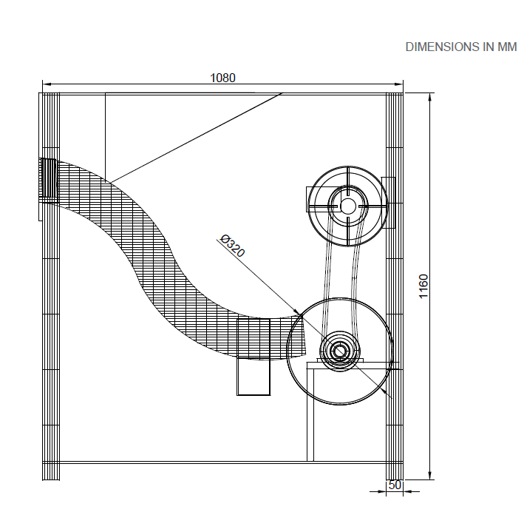
All dimensions in mm
Fig. 11. Isometric side view of air classifier
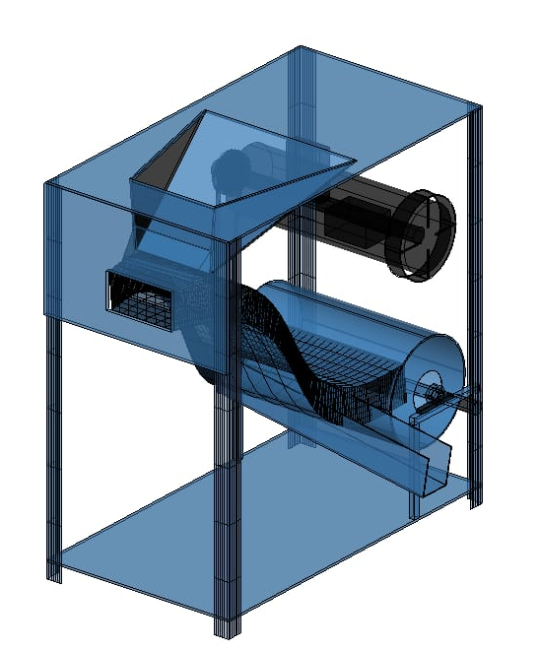
Fig. 12. Stereoscopic view of air classifier
Throughput capacity
The throughput capacity of the air classifier is 500 kg/h with 99.5% total efficiency at 1450 RPM and 7% moisture content. (eq. 27)
Efficiency of classifier
The average cleaning efficiency, separation efficiency and total efficiency of air classifier was 99.88%, 97.92% and 97.80% respectively, and the blown kernel percentage was 0.12%. (eq. 24, 25 and 26)
Capacity, inclination angle and volume of hopper
The capacity of the hopper was 5.2$±$1 kg. The inclination angle is 23.5°, and the volume of the hopper is 11,960 cm³ (eq. 20)
Table 9-Financial analysis
1 | Initial investment | 30,000 Rs.
2 | Annual fixed cost (Rs.) | 5580 Rs/yr
3 | Annual variable cost (Rs.) | 21846.4 Rs/yr
4 | Total annual cost (Rs.) | 27426.4 Rs/yr
5 | Total operating cost (Rs/h) | 85.71 Rs/h
6 | Total operating cost (Rs/kg) | 0.1714 Rs/kg
7 | Average net annual benefit (Rs/yr) | 6857.6 Rs/yr
8 | Payback period (Years) | 4.375 Years
10 | Selling price (Rs) of machine | 44,475 Rs.
11 | Return on investment (ROI) | 22.86%
Break-even analysis

The breakeven point analysis of an air classifier, based on cost and operation time, is shown in Fig. 4. As utilisation has no effect on the fixed cost (FC), FC line stays constant. The custom hiring charges (CHC) line climbs at a slightly faster rate than the total operating cost (TOC) line, which increases gradually over time. At 1400 hours of operation and 149,994 Rs. The TOC and CHC lines intersects, marking the breakeven point. At this point, the air classifier has recovered its costs since the total revenue from operating the device equals the total amount spent on it. Further operation turns a profit after this, which makes it a crucial sign of the machine's viability from an economic standpoint.
Conclusion
Performance of the air classifier was evaluated using different combinations of moisture content, RPM of blower and feed rate, and significant conclusions are presented here:
- Bulk density of decorticated mass of water chestnut was 0.435 g/cm³
- The angle of repose of the peel, kernel and mixture was 35.1$±$1.2, 33.7$±$0.9 and 32.2$±$1° respectively.
- Terminal velocity of kernel and peel was 15.76 and 7.88 m/s, respectively.
- Average cleaning efficiency, separation efficiency and total efficiency of the air classifier were 99.88, 97.92 and 97.80% respectively.
- Throughput capacity of the air classifier was 500 kg/h.
- The ideal feed rate was 200 kg/h at 1450 RPM.
- Specific energy consumption of the air classifier was 2.71 kWh/ton.
- Maximum measured air velocity near the fan was 10.2 m/s, and at hopper discharge, was 10.5 m/s at 1450 RPM.
- Maximum angular and tangential air velocity (at 1450 RPM) was 151.8 rad/s and 19.2 m/s, respectively.
- Maximum volumetric flow rate near the fan and at the hopper discharge was 0.460 m³/s and 0.227 m³/s at 1450 RPM. Similarly, the maximum mass flow rate near the fan and at the hopper discharge was 0.563 kg/s and 0.339 kg/s at 1450 RPM.
- Maximum thrust force acting on kernels and peels was 0.022 N and 0.012 N respectively, at 1450 RPM.
- Overall performance depends on the RPM of the blower, feed rate and moisture content of feed.
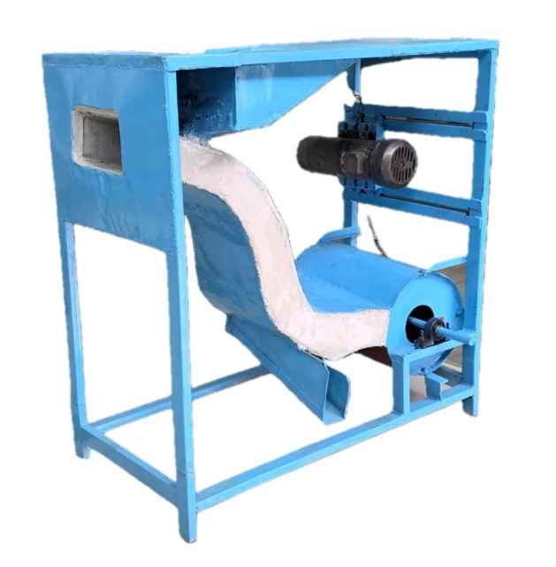
Plate 1. Air classifier for classification of dried and decorticated water chestnut kernels and peels

Disclaimer (Artificial intelligence)
Option 1:
Author(s) hereby declare that NO generative AI technologies such as Large Language Models (ChatGPT, COPILOT, etc.) and text-to-image generators have been used during the writing or editing of this manuscript.
Option 2:
Author(s) hereby declare that generative AI technologies such as Large Language Models, etc. have been used during the writing or editing of manuscripts. This explanation will include the name, version, model, and source of the generative AI technology and as well as all input prompts provided to the generative AI technology
Details of the AI usage are given below:
1.
2.
3.

References
Akinoso, R., Olayanju, T. M. A., Hassan, L. O., & Ajiboshin, I. O. (2010). Design, construction and preliminary testing of a beniseed (Sesamum indicum) air-screen cleaner. Journal of Natural Sciences Engineering and Technology, 9(2), 141-148. https://doi.org/10.51406/jnset.v9i2.1117 .
Anonymous. 2025. Annual Report 2024-25. Third Advance Estimate of Production of Food Grains. Department of Agriculture and Farmer Welfare, Government of India https://pib.gov.in/PressReleasePage.aspx?PRID=2123000 .
Beigh, M. A., Hussain, S. Z., Naseer, B., Rouf, A., & Wani, F. (2020). Grade classification for water chestnuts, their dimensional properties and correlation analysis. *Journal of Scientific & Industrial Research*, *79*, 66-70. https://doi.org/10.56042/jsir.v79i1.68143 .
Bhatiwal, S., Jain, A., & Chaudhary, J. (2012). Trapa natans (Water Chestnut): An overview. International Research Journal of Pharmacy, 3(6), 31-33. http://www.irjponline.com/ .
Borges, O. P., Carvalho, J. S., Correia, P. R., & Silva, A. P. (2007). Lipid and fatty acid profiles of Castanea sativa Mill. Chestnuts of 17 native Portuguese cultivars. Journal of Food Composition and Analysis, 20, 80–89. https://doi.org/10.1016/j.jfca.2006.07.008 .
Ghonimy, M. I., & Rostom, M. N. (2022). Design and Performance Evaluation of Canola-Seed Cleaning Machine. Turkish Journal of Agricultural Engineering Research, 3(2), 214-230. https://doi.org/10.46592/turkager.1131804 .
Gupta, A. K., Singh, M., Patel, S., Gour, M., Nandanwar, S., & Saini, R. (2025). Post-harvest processing and value addition of water chestnut-a review. Journal of Pharmacognosy and Phytochemistry, 14(2), 39-43. https://doi.org/10.22271/phyto.2025.v14.i2a.15273 .
Hashemi H. M. B. and Amoudi O. S. B. (2018). A Review on the Angle of Repose of Granular Materials. Power Technology. 330: 397-417 https://doi.org/10.1016/j.powtec.2018.02.003 .
Henderson S. M. and Perry R. L. (1976). Agricultural Process Engineering.
Hummel, M. and Kiviat, E. (2004). Review of world literature on water chestnut with implications for management in North America. Journal of Aquatic Plant Management, 42: 17-28.
Jana, B. R. (2025). Recent production and marketing scenarios of water chestnut (Trapa spp.) in India: A Review. Agricultural Reviews. https://doi.org/10.18805/ag.R-2555 .
Kumar, M., Kumar, V., & Shyam, R. (2018). Design and development of a mechanical Makhana Harvester. Journal of Pharmacognosy and Phytochemistry, 7(1S), 1314-1316. https://www.phytojournal.com/archives/2018/vol7issue1S/PartS/7-1-1S-308.pdf .
Mohsenin, N. N. (1986). Physical Properties of Plant and Animal Material. Gordon And Breach Science Publishers Inc. https://books.google.com/books/about/Physical_Properties_of_Plant_and_Animal.html?id=2_4SAAAAMAAJ .
Rajput, J. D., & Singh, S. P. (2023). Water Chestnut (Trapa natans L.): Functional characteristics, nutritional properties and applications in food industry: A review. The Journal of Phytopharmacology, 12(2), 119-126. https://doi.org/10.31254/phyto.2023.12209 .
Singh S. K. (2020). Lucent, General Knowledge. Publ. Lucent. Patna, Bihar.
Sundaram P. K., Sarkar B., Mondal S. (2014). Design and Performance Evaluation of Pedal Operating Makhana (Euryale ferox Salisb) Seed Grader. Research Journal of Agricultural Sciences. 5(3): 428-431.
Çengel, Y. A., & Cimbala, J. M. (2006). Fluid Mechanics: Fundamentals and Applications. McGraw-Hill. https://books.google.com/books/about/Fluid_Mechanics.html?id=2_4_AQAAIAAJ .
Sayyad F. G., Akbari S.H., Vyas D.K. and Trivedi M.M. (2021). Effect of Pretreatment on Dimensional Properties of water Chestnut. Biological Forum – An International Journal. 13(3b): 94-102.
Sharma, S., Saxena, D. C., & Riar, C. S. (2016). Nutritional, sensory and in-vitro antioxidant characteristics of gluten-free cookies prepared from water chestnut flour. Journal of Food Measurement and Characterization, 10, 417–426.
https://doi.org/10.1007/s11694-016-9322-9

