A Review on Ginkgo biloba L., Ginkgoaceae: A living fossil plant

Abstract: This review focuses on various phytochemical activities of Ginkgo biloba. Human intelligence and self-expression are thought to be enhanced by it. It is utilized for culinary and cultural purposes, as well as in the Indian traditional medicinal system in a variety of Ayurvedic formulations. Anti-spasmodic, anti-protective, anti-hepatotoxic, and antioxidant properties are all present in Ginkgo biloba. Despite the high medicinal promise of this plant, few recent reviews have addressed its pharmacology and other relevant issues. Therefore, the purpose of this review is to compile and analyze the corpus of research on the pharmacological, ethnobotanical, and phytochemical aspects of G. biloba.
Keywords: Conservation, Living fossil, Modern medicine, TCM, EGb 761, Antiaging.
Introduction
“The Ginkgoaceae family, which includes Ginkgo biloba L. as the only living member, is a family of "living fossils" with Mesozoic origins” (Taylor, 1993). “It is increasingly common to locate G. biloba in many nations across the world, but in the past, it was believed to grow natively exclusively in a specific area of Southeast Asia. In 1690, botanist Engelbert Kaempfer brought the ginkgo tree to Europe, and because of the distinctive shape of its leaves, he named it the duck foot tree" (Bilia, 2002). “Because of the size and color of the fruit, the tree was given the name "ginkgo," which is taken from the Chinese word for silver apricot” (Mahadevan, 2008). “Silver apricot, yajiao (duck foot), gong sun shu (grandfather tree), maidenhair tree, temple tree, noyer du Japon, kew tree, and ginkgobaum are some more common names for G. biloba” (Hori, 1997). “For thousands of years, traditional Chinese medicine (TCM) has utilized the leaves and nuts of this tree to treat a range of conditions affecting the heart, lungs, and brain. Gingko extract is mainly used in modern medicine to treat cardiovascular issues and improve cognitive function, but the standardized extract (EGb 761) has also shown promise as a cancer preventive. The synergistic tendencies of the chemicals in G. biloba make it difficult to link the plant's therapeutic effects to a particular chemical or route, as is the case with all plant-based medicines. It has been demonstrated that ginkgo leaves contain flavonoid glycosides, biflavones, and terpene lactones that interact with a range of receptors and pathways” (Spinella, 2001). “These substances give it a great deal of resilience against diseases and insect invasions, which has allowed it to proliferate in gardens and towns and become quite well-liked in international markets due to its alleged ability to enhance cognition. For its memory-boosting properties, it is also a top-selling herbal product every year worldwide” (van Dongen, 2000).
Botanical Description
Approximately 180 million years ago, the Ginkgoaceae family extended to nearly every continent, from sub-polar regions like Canada to the tropics. Ginkgo biloba, though, the last remaining species, is now thought to only grow in the wild in the Zhejiang Province in China, specifically on the Tian Mu Mountain (Shen, 2005). However, mystery still shrouds the origins of this population, and there is debate over whether the trees are truly wild or are merely semi-wild descendants of trees cultivated in Buddhist temples (Del Tredici, 1992). Due to their excellent resilience to disease, insects, and air pollution, ginkgo trees have been able to adapt to a variety of settings worldwide in recent decades, although they still thrive in cold, humid temperatures and deep soil that retains water well (Andrews, 1947). Due to their dioecious nature, ginkgo trees can only produce either all male or all female blooms. The trees themselves have a lifespan of thousands of years and can reach heights of about 100 feet (30 meters). They can continue to be fruitful for the whole of their lives, but they may not begin to produce seeds for up to 25 years (Taylor, 1993).
“Flowers emerge in tiny clusters known as catkins from stubby appendages on the branches known as short roots. The plum-sized fruit ripens to a golden hue throughout the fall, enveloping the seed in a woody shell and a plump outer layer. The pollen's motile, multiflagellated sperm are responsible for fertilization” (Dallimore, 1948). “The fruit contains butyric acid, which causes it to smell strongly of rancid butter as it falls and cracks apart in the fall, even though it contains an edible nut” (Andrews, 1947). “The leaves of Ginkgo biloba are flat and fan-shaped, with two lobes separated by a cleft of varying sizes—a characteristic that gives the tree its name—and they sprout in clusters of four to eight from the short roots. The leaves are light green in the spring and turn dark green to golden in late autumn. Male trees, which do not bear fruit, are more common in ornamental areas such as cities and gardens in order to avoid the odoriferous fruit. Ginkgo leaves differ from those of other shade trees in that their veins are branching, forming a venous pattern that extends from the stem and branches continually to fill the leaf, as opposed to having a mesh-like structure” (Andrews, 1947).
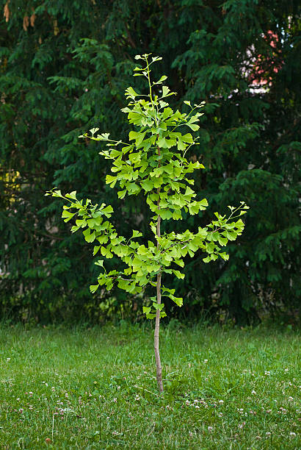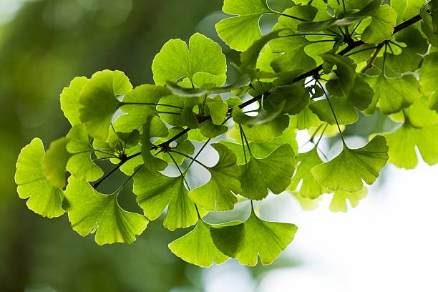
- Plant of G. biloba B. Twing of G. biloba
Traditional Uses
Ethnomedicinal uses
Ginkgo biloba has been used for several purposes in traditional Chinese medicine (TCM) for a long time. The seeds or nuts, which were extracted from the outer fruit, were used to cure leukorrhea, renal problems, bladder irritation, and several pulmonary conditions, such as bronchitis, asthma, cough, and enuresis. For thousands of years, the seeds have been widely employed in TCM. The leaves of G. biloba, on the other hand, were used sparingly in the past. But in a book written by Lan Mao and published in 1436 C.E., they were noted to have therapeutic benefits for treating skin conditions, including head sores. The first documented internal use of ginkgo leaves was for the treatment of diarrhea, as reported by C.E. Liu Wan-Tai in 1505. (Bilia, 2002). In many cultures, including in Asia, North America, South America, Europe, and Australia, it has been used for therapeutic purposes. “There are notable records on the traditional uses of the ginkgo plant in Asian nations, particularly China. Both the leaves and the seeds (nuts) of this tree have been used for ages in Traditional Chinese Medicine to cure a variety of ailments” (Hort et al., 2023). “While the leaves have been widely recommended to treat skin infections, heart and lung dysfunctions, and pulmonary diseases like bronchitis and asthma, their nuts have been utilized to treat these conditions as well as bladder irritation and alcohol misuse” (Silva, 2022; Kuraishy et al., 2022). TCM has long employed its raw nuts, stripped of their mushy pulp, to treat renal and bladder problems as well as lung-related conditions (Wang 2011). Furthermore, in China, cough and lung issues have been treated with decoctions of its fruit and leaves (Hong, 2015). Its seed is used in Korea to cure conditions like hypertension, the common cold, and asthma (Song 2011).
“G. biloba leaf extract is frequently used in Indian traditional medicine to treat memory issues, such as Alzheimer's disease” (Mehla 2020). “Its leaves, commonly referred to as jinko, are used extensively in Iran to alleviate tinnitus and earaches” (Mahmoudian 2017). “It is one of the top 20 plants that traditional practitioners in Canada prescribe for blood/circulatory issues and memory enhancement” (Barbalho 2022). This plant's leaves have been used to treat labyrinthitis in Brazil (Zhou 2003).
In addition, the herb is well-known in European Traditional Medicine. The leaves of this plant are used to treat atherosclerotic disorders that cause peripheral vascular and cerebrovascular insufficiency in France and Germany (Belwal 2019). According to Wang (2011), its leaves and fruits have been used in Greece to treat headaches, depression, arteriosclerosis, coronavirus, and ear problems. Its leaves have been decocted and used as a memory enhancer in Turkey (Biernacka 2023). It is thought that infusing its leaves might effectively cure hypertension in Edo State, Nigeria (Silva, 2022). The Australian herbal retail sector also uses G. biloba extensively to treat dementia and Alzheimer's illness (Kuraishy et al., 2022).
Uses in cuisine The seeds, also known as pak-ko (white fruit), are a common snack and a delicacy in many East Asian nations, such as China, Korea, and Japan. They can be roasted and consumed as an appetizer or made into sweet desserts, such as Cheng Tengm (Porterfield, 1951; Goh, 2002).
Harvesting the plum-sized fruits from the tree and letting them ferment in water for a few days is the first step in the seed extraction process. (This process results in a very disagreeable smell.) Since the fruit alone tastes bitter if consumed, it is usually fermented or cooked (Mahadevan, 2008). The fruit's edible seed can be readily separated from its flesh once it has been soaked in water. Since raw seeds are poisonous and frequently cause severe food poisoning, they must be roasted or heated (Bilia, 2002). Ginkgo nuts are a key component of traditional Chinese dishes such as nabe-ryori and chawan-mushi, a custard-like dish (Bilia, 2002).
Cultural uses:
The yin and yang balances are part of Taoist ideas, which are frequently symbolized by particular plants and animals. Ginkgo is used to illustrate this idea; one temple serves a delicacy called ginkgo chicken, in which a rooster represents yang and ginkgo represents yin. It is thought that the meal restores vigor when consumed in its whole from (Shermann, 1985). For millennia, G. biloba has been a favorite ornamental tree because of its beauty and resilience to pollutants, insects, and disease (Briskin, 2000). Both China and Japan have Buddhist temples where it can be seen, but its popularity has spread, and it is now found in many nations worldwide, especially in cities (Bilia, 2002). The unique elegance of the leaf has also led to its incorporation in various forms of art and sculpture.
Chemistry and Pharmacology
Numerous phytochemicals, such as terpene trilactones, flavanol glycosides, biflavones, proanthocyanidins, alkylphenols, polyprenols, and 4-O-methylpyridoxine, are found in Ginkgo biloba (van Beek, 2002). The three main and distinct components of Ginkgo biloba are flavonoid glycosides, biflavones, and terpene lactones. A, B, C, J, and M are the five varieties of ginkgolides, which are twenty-carbon terpenes produced in the tree's roots and leaves. Bilobalide, which is technically a sesquiterpene trilactone, is one of the terpenes trilactones (Mahadevan, 2008; Smith, 2004; Spinella, 2001).
The flavonol glycosides consist of substances such as isorhamnetin, kaempferol, rutin, and quercetin (van Beek, 2002; Mahadevan, 2008). Biflavones also include isoginkgetin, ginkgetin, bilobetin, and sciadopitysin (van Beek, 2002). The primary extract utilized in trials, EGb 761, was created by French and German pharmaceutical companies as a standardized extract. The compounds are extracted from green leaves that are picked and dried in the summer using either a water-ethanol or water-acetone process (Mahadevan, 2008; Bilia, 2002).
The leaves' chemical composition changes with the season, with a higher concentration of flavonoids in the fall than in the spring. The major flavonoids in G. biloba are derivatives of kaempferol, quercetin and isorhamnetin linked with glucose and rhamnose (Fig. 3). At present, there are few investigations on the separation and purification of flavonol glycosides from G. biloba seeds. As a result, the leaves must be examined for chemical levels and the presence of heavy metals during the multi-step extraction process before being turned into an extract (Mahadevan, 2008; Chan, 2007). Many processes, some of which are unknown, are used to create this extract, which condenses leaves to extract in a 50:1 ratio. This concentration also eliminates undesirable substances that may be harmful to health, such as polyprenols, catechins, and biflavones (Chan, 2007; van Beek, 2002). The most commonly reported phenolic acids in G. biloba include vanillic acid, protocatechuic acid, isovanillic acids, p-hydroxybenzoic acid, caffeic acid, ferulic acid, p-coumaric acid, gallic acid, sinapic acid, and m-hydroxybenzoic acid (Liu, et al. 2021).
Due to the incredibly tiny concentration of active chemical compounds, consuming ginkgo leaves—let's say in a tea—instead of extract has no effect on health (Chan, 2007). According to Van Beek (2009) and Goh (2002), the standardized extract of Ginkgo biloba has less than 5 ppm of ginkgolic acid, 24% flavonoid glycosides, and about 6% terpene lactones. Proanthocyanidins, which are also present in wine, help explain the ginkgo extract's antioxidant qualities and its therapeutic benefits (van Beek, 2002). When making the extract, B6 4-O-methylpyridoxine, a substance that is mostly present in the seeds and is poisonous to humans, is eliminated (van Beek, 2021). Cardanols, α-hydroxycardanols, cardols, urushiols, and isourushiols are the five important classes of alkylphenols and ginkgolic acids are one class of alkylphenolic acids present in G. biloba Boateng 2023). According to several studies, alkylphenols of G. biloba might be toxic and allergenic However, they have also shown potent cytotoxic activities in some cancerous cell lines (Biernacka et al., 2023). Alkylphenols, including ginkgolic acids, ginkgols and bilobols, are present in various parts of G. biloba. Ginkgols are natural phytochemicals that are found in G. biloba. Their chemical name is 3-alkylphenols. Ginkgols from G. biloba mainly consist of four homolog monomers with different alkyl side chains, C13:0, C15:0, C15:1 and C17:1 (Fig. 1).
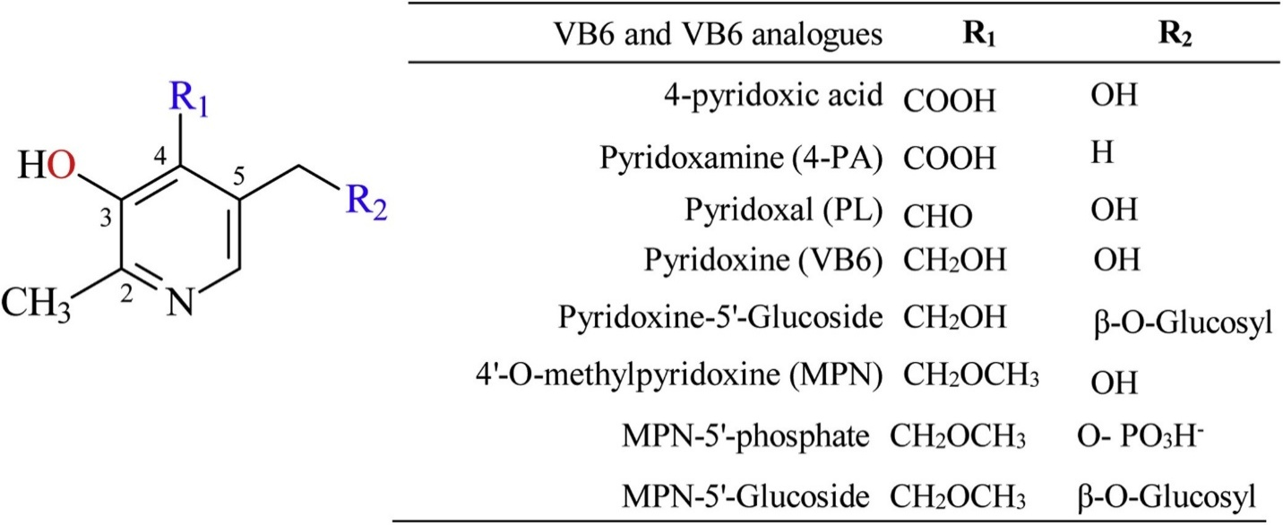
Fig. 1. Structural formula of pyridoxine (vitamin B6) and its analogues in G. biloba seeds (Hori et al., 2004; Wada et al., 1985).
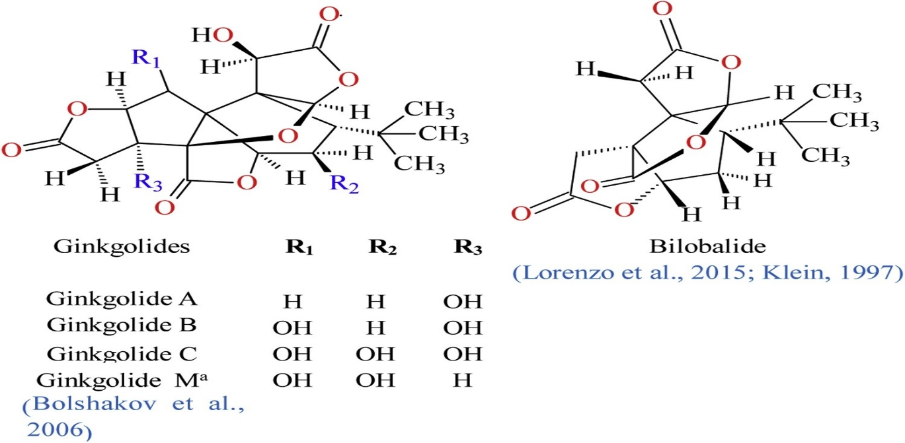
Fig. 2. Skeletal structural formula of terpenoids in G. biloba seeds. a: Ginkgolide M is present in the G. biloba root (Bolshakov et al., 2006; Lorenzo et al., 2015).
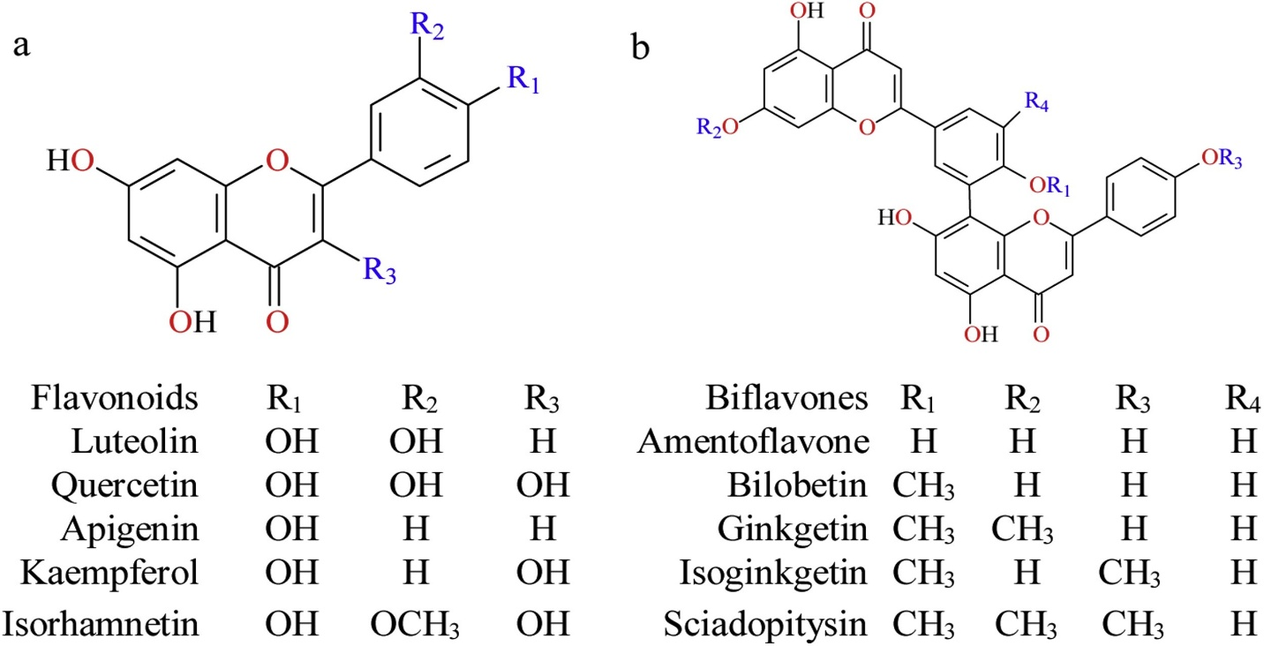
Fig. 3. Skeletal structural formula of flavonoids and bioflavonoids in G. biloba seeds (Liu et al., 2015; Zhou et al., 2014).
Biological Activity
Standardized Ginkgo biloba extract (EGb 761) has been the subject of numerous studies to evaluate its potential advantages, especially in relation to memory enhancement and neurodegeneration prevention. Winter (1997) examined the effects of EGb 761 extract on rats' memory. Following their initial acclimatization to a multi-armed labyrinth, the number of incorrect starts made by the rats was noted. The study discovered that rats given EGb 761 orally by the ingestion of sweetened condensed milk had better memory, as shown by fewer incorrect starts. Furthermore, EGb 761-consuming rats had a noticeably longer lifespan than non-consuming rats (Winter, 1997). Rats who had either drug-induced or stress-induced memory loss were shown to restore memory function when EGb 761 was added to their diet (Anna Walesiuk et al., 2005). Additionally, the extract showed efficacy against Parkinson's and Alzheimer's disease in studied animals (Yohitake, 2010).
It has also been demonstrated that extracts enhance short-term memory in mice and enhance memory function and spatial learning in both young and old rats (Perry, 2011). It was also demonstrated in otherin vivo investigations that EGb 761 improved memory acquisition and retention via influencing the hippocampus in animals, which is important in the formation of new memories (Smith and Luo, 2004). In rats, EGb 761 has been shown to have positive effects on the following processes: scavenging of free radicals, age-related brain loss, ischemic neuronal death, hippocampal function, uptake of high-affinity choline, regulation of hippocampal glucocorticoid receptors, neuronal plasticity, and cognitive deficits related to stress (Smith and Luo, 2004). The nematode Caenorhabditis elegans showed enhanced resilience to oxidative and thermal stress after being administered EGb 761, according to Smith and Luo (2004). Similar to this, animals given modest doses of ginkgo extract in their drinking water demonstrated less oxidative damage to their brain and liver’s mitochondrial DNA (Chan, 2007).
Ginkgo extract's stress-relieving properties may have an impact on dopaminergic system receptors (Yohitake, 2010). One study found that rats fed EGb 761 experienced significantly lower levels of stress, which the researchers ascribed to the ginkgolides' effects on the expression of the peripheral benzodiazepine receptor in the adrenal cortex (Smith, 2004; DeFeudis). Numerous positive effects, including less immunosuppression, neurotoxicity, and neuro endangerment, result from this drop in circulating glucocorticoid levels (Amri et al., 1996). Some flavonoids, such as kaempferol, have been tested for their ability to prevent cancer. Some studies have found that they have a positive effect on prostate and colon cancers. Additionally, mice given ginkgo extract showed reduced expression of peripheral benzodiazepine receptor (PBR), which in turn suppressed the proliferation of breast cancer cells (DeFeudis et al., 2003). Flavonoids in ginkgo extract were reported to have anticancer effects by Feng et al., (2009). After receiving the extract for a week and a half, numerous leukemia-stricken mice exhibited symptoms of tumor shrinkage and suppression (Feng, 2009).
Furthermore, research indicates that the vascular-protective properties of G. biloba extract make it a useful therapeutic agent for ischemic and cardiovascular disorders. By enhancing endothelial dysfunction, lowering inflammatory markers, and raising the generation of clopidogrel's active metabolite, the G. biloba extract, ginkgolide B, and ginkgo leaf tablets shown effectiveness against atherosclerosis (Deng et al., 2016; Feng et al, 2018). According to an in vivo investigation, ginkgo lactone nanosuspensions may reduce platelet aggregation (Rui et al., 2016). Additionally, G. biloba demonstrated advantages in acute myocardial infarction by boosting endogenous antioxidant enzymes, reducing inflammation, and apoptosis (Badore et al., 2017).
In Vitro The neuroprotective properties of EGb 761 stem from its synergistic and simultaneous interaction with numerous cellular pathways; in vitro, EGb 761 was found to have multiple mechanisms of action for its neuroprotective properties, including up-regulating specific proteins and preserving membrane potential in mitochondria (Smith and Luo, 2004). Similarly, it has been demonstrated that EGb 761 improves cardiac conditions by changing the concentrations of ions across membranes, which in turn changes action potentials that cause the smooth muscles of the aorta to relax and dilate (Satoh, 2004). Proanthocyanidins and flavonol glycosides both possess antioxidant qualities that might lessen oxidative stress, such as scavenging free radicals (Chan, 2007). This also contributes to part of the extract's effects of blood vessel relaxation and consequently, enhanced blood flow (Kleijnen and Knipschild, 2002). In an in vivo investigation, DeFeudis et al. supplied human breast cells with a modified form of EGb 761, known as IPS200 (2003). The modified version was found to have regulatory effects on several genes related to cell proliferation and apoptosis, indicating anti-cancer potential, according to the study.
Clinical Studies
Ginkgo biloba leaf extract, especially EGb 761, has been the subject of numerous clinical trials due to its ability to improve cognitive function in both mentally challenged and healthy individuals, treat different conditions involving cardiovascular deficiencies and neurodegenerative disorders, have anxiolytic and antioxidant effects, and effectively treat sexual dysfunction brought on by antidepressants. Many of these studies discovered that ginkgo extract had a positive overall impact. Numerous studies have shown the positive effects of EGb 761 on a variety of illnesses, but many more have shown little evidence to support the use of EGb 761 for the treatment of many of these conditions. This divide in the literature was brought to light by one study, which first suggested that although ginkgo extract treatment resulted in a slight improvement in cognitive function, the trials' remarkable success may have been caused by other factors. Later, the same study acknowledged that Ginkgo biloba is one of the plants that works best for dementia and other cognitive conditions like tinnitus and premenstrual tension (Perry, 2010).
In the deluge of research describing the benefits of ginkgo extract, the few studies that demonstrate no effect are obscured. The extract of G. biloba was found to be effective against a number of conditions, including "early-stage Alzheimer’s disease, vascular dementia, peripheral claudication, vertigo, heart disease, eye diseases, chronic cerebral insufficiency, accidents involving brain trauma, dementia, and tinnitus of vascular origin" (Cxavusxog lu, 2011; Napryeyenko, 2007). These findings were supported by a research team's clinical trials.
In two experiments examining the effects of ginkgo extract on healthy participants aged 18–40 and 22–59, the extract was administered at a dose of 120 mg/day for 30 and 14 days, respectively. The results showed that the volunteers' working memory was improved, but their long-term memory was unaffected (Hartley, 2003). Several other studies support these findings, showing that healthy volunteers who received a similar dosage of ginkgo extract had better working memory, especially in older subjects, without showing any changes in other memory functions such as word recall, attention, or reaction time (Hartley, 2003).
Based on this research, it may be concluded that G. biloba extract primarily affects specific age groups (mostly the elderly) and specific brain regions, most likely the frontal lobe (which is in charge of working memory) (Hartley, 2003). The majority of studies concur that Ginkgo biloba is useful in treating mental decline and Alzheimer's disease. Numerous properties of the compounds present in the leaves are responsible for this efficacy. An important stage in the pathophysiology of Alzheimer's disease is the extract's inhibition of the production of the protein Aβ from its precursor β-amyloid. The early start and autosomal dominant forms of Alzheimer's disease, which EGb 761 can inhibit, are made worse and encouraged by the aggregation of this proteolytic fragment.
Reduced neuronal apoptosis is another effect of Aβ reduction, which runs opposite to the root cause of many neurodegenerative illnesses (Mahadevan, 2008; Smith, 2004). Le Bars et al. (1997) also discovered that EGb 761 enhanced cognitive functioning in older people suffering from dementia or Alzheimer's disease in a double-blind, placebo-controlled study. When forty individuals with cerebral insufficiencies were administered ginkgo extract (120–160 mg daily for more than four weeks), Kleijnen and Knipschild (1992) discovered that the majority of them had positive results. Cerebral insufficiencies included symptoms ranging from fatigue to disorientation. In multiple tests, the extract's alkaloids were shown to be potent antagonists of platelet-activating factors (PAF). According to Braquet and Hosford (1991), ginkgolides are a useful natural defence against inflammatory ailments such as shock, ischemia, asthma, and CNS problems because PAFs are inflammatory autacoids and are crucial to the pathologies of these conditions (Table.1).
Similarly, following an ischemic event, ginkgolides can be utilized to improve blood flow to the brain by decreasing aggregation and increasing circulation (Smith and Luo, 2004). Trilactone bilobalide, a sesquiterpene, has demonstrated potential in lowering the extent of cortical infarct after cerebral ischemia or stroke by increasing the flow of oxygen and glucose to the brain (Smith and Luo, 2004). The use of EGb 761 to improve mental health and living standards by reducing depression, anger, and exhaustion has also been supported by statistically significant results in a number of studies (Cieza A et al.; Kennedy, 2007). Additionally, it was discovered that ginkgo extract lowers depression and has anxiolytic effects on people (Smith, 2004; DeFeudis, 2000; Evans, 2009). Additionally, it has been discovered that EGb 761's antioxidant qualities can help alleviate sexual dysfunction. Because the antioxidants prevent nitric oxide from degrading, the guanylate cyclase enzyme is activated. Similar to Viagra, this impact causes the penis's smooth muscles to relax, allowing blood to flow in (Chan, 2007). This explains the findings of a related study that showed ginkgo extract to be very efficient in boosting sexual potency and reducing the effects of sexual dysfunction brought on by antidepressants (Cohen, 1998).
Table 1: Therapeutic effects of Ginkgo biloba.
Field of study | Bioactive compounds | Mechanism of action | References
Treatment of  respiratory diseases | Ginkgetin, biflavones, | Ginkgetin significantly reduced irregular expression of the Akt and p38 pathway, whereas biflavones reduced MUC5AC mRNA expression | Tao et al., (2019)
Treatment of  respiratory diseases | Ginkgolide B (GB), Ginkgolides mixture (GM) | GB and GM were shown to be a key component in the treatment of lipopolysaccharide induced lung injury | Wu et al., (2016)
Treatment of  respiratory diseases | GBE | Treatment with Ginkgo biloba leaf extracts resulted in a substantial decrease in serum tumor markers and oncogene downregulation, as well as upregulation of a tumor suppressor gene in liver tissue | Ahamad et al., (2017)
Treatment of  respiratory diseases | GBEE | GBEE demonstrated the antitumor and antimetastatic actions due to the induction of the Wnt/β-catenin VEGF signaling pathway, which inhibited tumor angiogenesis | Han et al., (2016)
Anticancer effects | GBE | GBE inhibited the proliferation of gastric carcinoma SGC7901 cells.  Ginkgo biloba extract improved chemotherapy sensitivity and reversed chemoresistance in gastric cancer cells by suppressing the KSR1 mediated ERK1/2 pathway | Qian et al., (2016), Liu et al., (2015)
Anticancer effects | Ginkgolide B | Ginkgolide B reduced the progression of endothelial and vascular dysfunction in diabetic rats by increasing antioxidants and enhancing vascular control. | Wang et al., (2015)
Antidiabetic effect | Bilobalide | Bilobalide lowered the risk of developing type 2 diabetes by protecting against hypoxia-induced inflammation. | Priyanka et al., (2017)
Antidiabetic effect | GBE | GBE resulted in substantial visceral adiposity deficiency, improved insulin sensitivity, reduced dyslipidemia, and activated the insulin signaling cascade. | Hirata et al., (2025)
Antiobesity effects | Ginkgolide B, Ginkgolide C | Ginkgolide B therapy reduced body weight gain and increased hypertriglyceridemia. Ginkgolide C decreased oleic acid induced lipid aggregation | Luo et al., (2017)
Antiobesity effects | Isoginkgetin, bilobetin, ginkgetin, and sciadopitysin | isoginkgetin, bilobetin, ginkgetin, and sciadopitysin had high to moderate inhibitory effects on PL | Liu et al., (2020)
Antimicrobial effects | Ginkgolide B | Ginkgolide B restored the neuroprotective function of apurinic/ apyrimidinic endonuclease 1 and mitochondrial oxidative phosphorylation against A25-35 induced neurotoxicity | Kaur et al., (2015)
Antimicrobial effects | GBE | GBE or similar drugs may be used as a long-term therapeutic alternative in elderly patients with ischemic brain injuries | Zhou et al., (2017)
Antioxidant effects | GBE | GBE demonstrated antioxidative activities by affecting the modulation of GSK3 to suppress zinc induced tau phosphorylation at Ser262. GBE has strong antioxidant properties and is likely to be a valuable medication for gamma irradiation safety and/ or as an antioxidant against oxidative stress | Kwon et al., (2015); Belviranli and Okudan (2015)
Neuroprotective effects | GBE and donepezil | GBE and donepezil combination demonstrated neuroprotective properties by lowering choline levels | Christoph et al., (2015)

Contraindications
It has been demonstrated that Ginkgo biloba leaf extract possesses vasodilatory qualities, raising concerns regarding potential interactions with medications that have blood-thinning or anti-platelet-forming activities. Because of its effects on the platelet-activating factor, one study even revealed that using ginkgo extract in conjunction with stronger anticoagulants and blood thinners increased the risk of bleeding (Perry, 2010). However, there is contradictory research on the adverse side effects of ginkgo extract consumption, much like the controversy over its potential to enhance cognition. In particular, one study examined case studies that indicated adverse synergistic interactions between G. biloba extract and medications such as ibuprofen, aspirin, and warfarin (Izzo, 2009). Despite earlier reports that ginkgo extract-induced medication responses caused patients to experience spontaneous haemorrhages or intracerebral haemorrhages, this investigation showed no evidence linking ginkgo extract to alterations in blood coagulation markers (Izzo, 2009). On the other side, individuals who take high dosages of G. biloba extract or consume large volumes of the seeds have experienced a number of seizure: however, these have not been statistically significant (Spinella, 2001). In Germany, where a large portion of EGb 761's supply is produced, manufacturers are compelled to list symptoms of overdose, including "headaches, dizziness, palpitations, gastrointestinal disturbances, and allergic skin reactions" (Chan, 2007). Although these side effects need to be listed on the labels, Kleijnen and Knipschild's (1992) investigation found no adverse effects after three months of EGb 761 use (Chan, 2007). Because the seeds contain the poisonous 4-O-methylpyridoxine, eating them uncooked can result in gastrointestinal issues and food poisoning symptoms (van Beek, 2002).
Currently Used in CAM and Allopathic Treatments, In Europe and around the world, Ginkgo biloba extract is one of the most widely used medications and herbal supplements. It is a part of a billion-dollar industry, mainly because of its supposed ability to improve cognitive performance (van Dongen, 2000). Ginkgo biloba was the most popular herbal medicinal product in the United States in 2008, outselling popular herbal supplements like ginseng, garlic, and echinacea. It was also the most popular dietary supplement and prescription medication, with a retail value of over $150 million (Smith and Luo, 2004). There are numerous trade names for it in America, such as "Ginkgobene, Ginkgold, Ginkoba, Vasan," among others (Spinella 2001). In Germany and France, ginkgo-based medications such as "Tebonin, Kaveri, rokan, and Tanakan" are widely used both as prescription and over-the-counter medications (van Dongen, 2000). People who want to improve their mental alertness, memory, and concentration like to take ginkgo extract as a dietary supplement, which is why older people particularly like it. Ginkgo extract is also a potent antioxidant and is popular for its potential to prevent age-related mental illnesses and aging (Goh, 2002; Bilia, 2002).
Discussion
The unique qualities of Ginkgo biloba make it highly important in social, medicinal, historical, and economic contexts. Due to its distinct chemical composition, the tree has remained mostly unaltered over millions of years and is resistant to air pollution, insects, and infection. This tree can be found in cities and temples in China and Japan, as well as in almost every country in the world. For thousands of years, ginkgo seeds have been employed in traditional Chinese medicine and are a common ingredient in many dishes and treats.
In addition to helping prevent dementia and Alzheimer's disease, the standardized extract EGb 761 has been demonstrated to improve memory in rats. The antioxidants in the extract may also have anti-aging and anti-cancer effects. Additionally, it has demonstrated efficacy in improving cerebral enhancement in healthy volunteers, boosting brain function following ischemia episodes, and aiding in the treatment of cardiovascular diseases. Most research has proven ginkgo extract to be safe, and there have been no clear studies establishing any negative consequences of use. It is marketed as an herbal supplement in 120 mg pills for its ability to improve memory, including heightened energy and alertness. Although the FDA has not approved it in America, its popularity as an herbal supplement has soared, and it is currently a part of a billion-dollar industry. This noble and lovely tree will undoubtedly continue to grow in gardens and urban areas around the globe, offering numerous treatments for brain disorders and, ideally, various types of cancer.
Conclusion
Despite its immense therapeutic and decorative potential, it has not yet gotten much attention in terms of cultivation and conservation, especially in India. Due to inadequate regeneration, only a few numbers of individuals exist in nature in a variety of climatic circumstances across several locations (Purohit et al., 2007). The long-term existence of these uncommon species is at risk because they are considered living fossils, and only a few numbers of individuals have been reported to survive. Large-scale propagation techniques must be developed to supplement supplies and construct nurseries in order to meet planting material demand and preserve the species' posterity for future needs, taking into account the current status, importance, and conservation value of Ginkgo biloba.
Declaration of Interest Statement: No potential conflict of interest was reported by the authors.
Disclaimer (Artificial intelligence)
Author(s) hereby declares that NO generative AI technologies such as Large Language Models (ChatGPT, COPILOT, etc.) and text-to-image generators have been used during the writing or editing of this manuscript.
References
- Ahmed, H. H. W. G. Shousha, H. A. El-Mezayen, S. A. El Toumy, A. H. Sayed, and A. R. Ramadan (2017). Biochemical and molecular evidences for the antitumor potential of Ginkgo biloba leaves extract in rodents,” Acta Biochimica Polonica, vol. 64:25–33
- Al-Kuraishy, H. M., Al-Gareeb, A. I., Kaushik, A., Kujawska, M., & Batiha, G. E.-S. (2022). Ginkgo biloba in the management of the COVID-19 severity. Archives of Pharmacy (Weinheim), 355(10), e2200188. https://doi.org/10.1002/ardp.202200188
- Amri, H., Ogwuegbu, S. O., Boujrad, N., Drieu, K., & Papadopoulos, V. (1996). In vivo regulation of peripheral-type benzodiazepine receptor and glucocorticoid synthesis by Ginkgo biloba extract EGb 761 and isolated ginkgolides. Endocrinology, 137(12), 5707-5718. https://doi.org/10.1210/endo.137.12.8940403
- Badore, N. S., Das, P. K., Pillai, S., & Thakur, A. (2017). Role of Ginkgo biloba Extract, Against Isoproterenol Induced Cardiac Toxicity in Rats. Indian Journal of Pharmaceutical Education and Research, 51(4s), s691–s699. https://doi.org/10.5530/ijper.51.4s.100
- Barbalho, S. M., Direito, R., Laurindo, L. F., Marton, L. T., Guiguer, E. L., Goulart, R. A., Tofano, R. J., Carvalho, A. C. A., Flato, U. A. P., Capelluppi Tofano, V. A., Detregiachi, C. R. P., Bueno, P. C. S., Girio, R. S. J., & Araújo, A. C. (2022). Ginkgo biloba in the aging process: a narrative review. Antioxidants, 11(3), 525. https://doi.org/10.3390/antiox11030525
- Belviranli M. and N. Okudan, (2015) “effects of Ginkgo biloba extract on cognitive functions in aged female rats: the role of oxidative stress and brain-derived neurotrophic factor,” Behavioural Brain Research, vol. 278.
- Biernacka, P., Adamska, I., & Felisiak, K. (2023). The potential of Ginkgo biloba as a source of biologically active compounds—A review of the recent literature and patents. Molecules, 28(10), 3993. https://doi.org/10.3390/molecules28103993
- Bilia, A. R. (2002). Ginkgo biloba L. Fitoterapia, 73(3), 276-279. https://doi.org/10.1016/s0367-326x(02)00071-0
- Birks, J., & Grimley Evans, J. (2009). Ginkgo biloba for cognitive impairment and dementia. Cochrane Database of Systematic Reviews, (1), CD003120. https://doi.org/10.1002/14651858.CD003120.pub3
- Boateng, I. D. (2023). Polyprenols in Ginkgo biloba; a review of their chemistry (synthesis of polyprenols and their derivatives), extraction, purification, and bioactivities, Food Chem. 418: 136006.
- Bolshakov, S., S.V. Dzyuba, J. Decatur, K. Nakanishi (2006). A concise synthesis of ginkgolide M, a minor component of a terpene trilactone fraction from Ginkgo biloba roots. J. Nat. Prod., 69:429-431
- Braquet, P., & Hosford, D. (1991). Ethnopharmacology and the development of natural PAF antagonists as therapeutic agents. Journal of Ethnopharmacology, 32(1-3), 135-139. https://doi.org/10.1016/0378-8741(91)90111-p
- Briskin, D. P. (2000). Medicinal plants and phytomedicines. Linking plant biochemistry and physiology to human health. Plant Physiology, 124(2), 507-514. https://doi.org/10.1104/pp.124.2.507
- Cavuşoğlu, K., Yapar, K., Oruç, E., & Yalçın, E. (2011). Protective Effect of Ginkgo biloba L. Leaf Extract Against Glyphosate Toxicity in Swiss Albino Mice. Journal of Medicinal Food, 14(10), 1263-1272. https://doi.org/10.1089/jmf.2010.0202
- Chan, P. C., Xia, Q., & Fu, P. P. (2007). Ginkgo biloba leave extract: biological, medicinal, and toxicological effects. Journal of Environmental Science and Health, Part C, Environmental Carcinogenesis and Ecotoxicology Reviews, 25(3), 211-244. https://doi.org/10.1080/10590500701569414
- Christoph H. Julia, L. Helene, and K. Jochen (2015). Effects of ginkgo biloba extract EGb 761, donepezil and their combi nation on central cholinergic function in aged rats. Journal of Pharmacy and Pharmaceutical Sciences, vol. 18.
- Cohen, A. J., & Bartlik, B. (1998). Ginkgo biloba for antidepressant-induced sexual dysfunction. Journal of Sex & Marital Therapy, 24(2), 139-143. https://doi.org/10.1080/00926239808404927
- DeFeudis, F. V., & Drieu, K. (2000). Ginkgo biloba extract (EGb 761) and CNS functions: basic studies and clinical applications. Current Drug Targets, 1(1), 25-58. https://doi.org/10.2174/1389450003349380
- DeFeudis, F. V., Papadopoulos, V., & Drieu, K. (2003). Ginkgo biloba extracts and cancer: a research area in its infancy. Fundamental & clinical pharmacology, 17(4), 405-417. https://doi.org/10.1046/j.1472-8206.2003.00156.x
- Del Tredici, P. (1992). Natural regeneration of Ginkgo biloba from downward growing cotyledonary buds (basal chichi). American Journal of Botany, 79(5), 522-530. https://doi.org/10.1002/j.1537-2197.1992.tb14588.x
- Deng, Y., Mo, Y. F., Chen, X. M., Zhang, L. Z., Liao, C. F., Song, Y., & Xu, C. (2016). Effect of Ginkgo biloba Extract on the Pharmacokinetics and Metabolism of Clopidogrel in Rats. Phytotherapy Research, 30(11), 1886–1892. https://doi.org/10.1002/ptr.5691
- Feng, X., Zhang, L., & Zhu, H. (2009). Comparative anticancer and antioxidant activities of different ingredients of Ginkgo biloba extract (EGb 761). Planta medica, 75(8), 792-796. https://doi.org/10.1055/s-0029-1185451
- Feng, Z., Yang, X., Zhang, L., Ansari, I. A., Khan, M. S., Han, S., & Feng, Y. (2018). Ginkgolide B ameliorates oxidized low-density lipoprotein-induced endothelial dysfunction via modulating Lectin-like ox-LDL-receptor-1 and NADPH oxidase 4 expression and inflammatory cascades. Phytotherapy Research, 32(12), 2417–2427. https://doi.org/10.1002/ptr.6177
- Goh, L. M., & Barlow, P. J. (2002). Antioxidant capacity in Ginkgo biloba. Food Research International. https://doi.org/10.1016/S0963-9969(02)00084-4
- Han, D., C. Cao,Y. Suetal. (2016). β Ginkgo biloba exocarp extracts inhibits angiogenesis and its effects on Wnt/β-catenin-VEGF signaling pathway in Lewis lung cancer,” Journal of Eth nopharmacology, vol. 192:406–412.
- Hartley, D. E., Heinze, L., Elsabagh, S., & File, S. E. (2003). Effects on cognition and mood in postmenopausal women of 1-week treatment with Ginkgo biloba. Pharmacology, biochemistry, and behavior, 75(3), 711-720. https://doi.org/10.1016/s0091-3057(03)00123-0
- Hirata B.K., R. M.Banin, A.P. Dornellas (2015). Ginkgo biloba extract improves insulin signaling and attenuates inflamma tion in retroperitoneal adipose tissue depot of obese rats, Mediators of Inflammation. 2015: 419106.
- Hong, L., Guo, Z., Huang, K., Wei, S., Liu, B., Meng, S., & Long, C. (2015). Ethnobotanical study on medicinal plants used by Maonan people in China. Journal of Ethnobiology and Ethnomedicine, 11(32). https://doi.org/10.1186/s13002-015-0019-1
- Hort J., T. Duning, R. Hoerr, Ginkgo biloba extract EGb 761 in the treatment of patients with mild neurocognitive impairment: a systematic review, Neuropsychiatr. Dis. Treat. 19 (2023) 647–660.
- Izzo, A. A., & Ernst, E. (2009). Interactions between herbal medicines and prescribed drugs: an updated systematic review. Drugs. https://doi.org/10.2165/11317010-000000000-00000
- Kaur N., M. Dhiman, J. R. Perez-Polo, and A. K. Mantha, (2015). βGinkgolide B revamps neuroprotective role of apurinic/ apyrimidinic endonuclease 1 and mitochondrial oxidative phosphorylation against Aβ25-35-induced neurotoxicity in human neuroblastoma cells. Journal of Neuroscience Research. 93:938–47.
- Kennedy, D. O., Jackson, P. A., Haskell, C. F., & Scholey, A. B. (2007). Modulation of cognitive performance following single doses of 120 mg Ginkgo biloba extract administered to healthy young volunteers. Human Psychopharmacology-Clinical and Experimental. https://doi.org/10.1002/hup.885
- Kleijnen, J., & Knipschild, P. (1992). Ginkgo biloba for cerebral insufficiency. British Journal of Clinical Pharmacology, 34(4), 352-358. https://doi.org/10.1111/j.1365-2125.1992.tb05642.x
- Kleijnen, J., & Knipschild, P. (1992). Ginkgo biloba. Lancet, 340(8828), 1136-1139. https://doi.org/10.1016/0140-6736(92)93158-j
- Kwon K. J., E. J. Lee, K. S. Cho, D. H Cho, C. Y Shin, and S. H Han, (2015). βGinkgo biloba extract (Egb761) attenuates zinc induced tau phosphorylation at Ser262 by regulating GSK3β activity in rat primary cortical neurons,” Food & Function. 6:2058–2067.
- Le Bars, P. L., Katz, M. M., Berman, N., Itil, T. M., Freedman, A. M., & Schatzberg, A. F. (1997). A placebo-controlled, double-blind, randomized trial of an extract of Ginkgo biloba for dementia. JAMA, 278(16), 1327-1332. https://doi.org/10.1001/jama.278.16.1327
- Liu H., M. Ye, and H. Guo (2020). An updated review of randomized clinical trials testing the improvement of cognitive function of ginkgo biloba extract in healthy people and alzheimer’s pa tients. Frontiers in Pharmacology, vol. 10.
- Liu, L., Wang, Y., Zhang, J., & Wang, S. (2021). Advances in the chemical constituents and chemical analysis of Ginkgo biloba leaf, extract, and phytopharmaceuticals. Journal of Pharmaceutical and Biomedical Analysis, 193, 113704. https://doi.org/10.1016/j.jpba.2020.113704
- Liu, S. Q. C., Y. Xu, M. B. Qin, and L. Tan, (2015). Ginkgo biloba extract enhances chemotherapy sensitivity and reverses chemoresistance through suppression of the KSR1-mediated ERK1/2 pathway in gastric cancer cells,” Oncology Reports. 33:2871–82.
- Lorenzo C.D., A. Ceschi, F. Colombo, G. Frigerio, M.G. Bianchetti, S. Lüde, M.V. Dechend. (2015). Identification and quantification of biomarkers to confirm the poisoning by Ginkgo biloba seeds in a 2-year-old boy. Toxicol. Res., 4 :922-930
- Luo L., Y. Li, and D. Wang, (2015). Ginkgolide B lowers body weight and ameliorates hepatic steatosis in high-fat diet induced obese mice correlated with pregnane X receptor activation. RSC Advances, vol. 60, 2017.
- Mahadevan, S., & Park, Y. (2008). Multifaceted therapeutic benefits of Ginkgo biloba L.: chemistry, efficacy, safety, and uses. Journal of Food Science, 73(1), R14-19. https://doi.org/10.1111/j.1750-3841.2007.00597.x
- Mahmoudian-Sani, M. R., Hashemzadeh-Chaleshtori, M., Asadi-Samani, M., & Luther, T. (2017). A review of medicinal plants for the treatment of earache and tinnitus in Iran. International Tinnitus Journal, 21(1), 44–49. https://doi.org/10.5935/0946-5448.20170009
- Mehla, J., Gupta, P., Pahuja, M., Diwan, D., & Diksha, D. (2020). Indian medicinal herbs and formulations for Alzheimer's disease, from traditional knowledge to scientific assessment. Brain Sciences, 10(12), 964. https://doi.org/10.3390/brainsci10120964
- Monte, M., Davel, L. E., & de Lustig, E. S. (1994). Inhibition of lymphocyte-induced angiogenesis by free radical scavengers. Free radical biology & medicine, 17(3), 259-266. https://doi.org/10.1016/0891-5849(94)90081-7
- Napryeyenko, O., & Borzenko, I. (2007). Ginkgo biloba special extract in dementia with neuropsychiatric features - A randomised, placebo-controlled, double-blind clinical trial. Arzneimittel-Forschung-Drug Research, 57(1), 4-11. https://doi.org/10.1055/s-0031-1296579
- ori et al., 2004
- Perry, E., & Howes, M. J. (2011). Medicinal plants and dementia therapy: herbal hopes for brain aging? CNS neuroscience & therapeutics, 17(6), 683-698. https://doi.org/10.1111/j.1755-5949.2010.00202.x
- Perry, E., & Howes, M.-J. R. (2011). Medicinal Plants and Dementia Therapy: Herbal Hopes for Brain Aging? CNS Neuroscience & Therapeutics, 17(6), 683-698. https://doi.org/10.1111/j.1755-5949.2010.00202.x
- Priyanka, A., G. Sindhu, G. L. Shyni, M. R. Preetha Rani, V. M. Nisha, and K. G. Raghu (2017). Bilobalide abates inflam mation, insulin resistance and secretion of angiogenic factors induced by hypoxia in 3T3-L1 adipocytes by controlling NF κB and JNK activation. International Immunopharmacol ogy. 42:209–217.
- Purohit V.K., P.C. Phondani, D. Dhyani, L.S. Rawat and R.K Maikhuri (2007). Ginkgo biloba a living fossil: Need conservation initiatives. Nat Acad Sci Lett. 30 (1&2)31-33.
- Qian, Y., L. Xia, W. Shi, J. J. Sun, and Y. Q. Sun, (2016). effect of EGB on proliferation of gastric carcinoma SGC7901 cells,” Clinical and Translational Oncology, vol. 18.
- Rui. T.Q., L. Zhang, H.Z. Qiao, P. Huang, S. Qian, J.S. Li, Z.P. Chen, T.M. Fu, L. Q. Di, B. Cai, (2016). Preparation and physicochemical and pharmacokinetic characterization of ginkgo lactone nanosuspensions for antiplatelet aggregation, J. pharm. sci. 105 (1):242–249. https://doi.org/10.1016/j.xphs.2015.10.002
- Satoh, H., & Nishida, S. (2004). Electropharmacological actions of Ginkgo biloba extract on vascular smooth and heart muscles. Clinica chimica acta; international journal of clinical chemistry, 342(1-2), 13-22. https://doi.org/10.1016/j.cccn.2003.12.014
- Silva H., F.G. Martins, (2022). Cardiovascular activity of Ginkgo biloba-an insight from healthy subjects, Biology 12 (1) 15 (Basel). https://doi.org/10.3390/biology12010015
- Smith, J. V., & Luo, Y. (2004). Studies on molecular mechanisms of Ginkgo biloba extract. Applied Microbiology and Biotechnology, 64(4), 465-472. https://doi.org/10.1007/s00253-003-1527-9
- Solomon, P. R., Adams, F., Silver, A., Zimmer, J., & DeVeaux, R. (2002). Ginkgo for memory enhancement - A randomized controlled trial. Jama-Journal of the American Medical Association, 288(7), 835-840. https://doi.org/10.1001/jama.288.7.835
- Song, M. J., & Kim, H. (2011). Ethnomedicinal application of plants in the western plain region of North Jeolla Province in Korea. Journal of Ethnopharmacology, 137(1), 167–175. https://doi.org/10.1016/j.jep.2011.05.001
- Spinella, M. (2001). Herbal Medicines and Epilepsy: The Potential for Benefit and Adverse Efects. Epilepsy and Behavior, 2, 524-532. https://doi.org/10.1006/ebeh.2001.0281
- Spinella, M. (2001). The psychopharmacology of herbal medicine: plant drugs that alter mind, brain, and behavior: MIT Press. https://pubs.acs.org/doi/abs/10.1021/np020001j
- T. Belwal, L. Giri, A. Bahukhandi, M. Tariq, P. Kewlani, I.D. Bhatt, R.S. Rawal, Chapter 3.19 - Ginkgo biloba, in: S.M. Nabavi, A.S. Silva (Eds.), Nonvitamin and Nonmineral Nutritional Supplements, Academic Press, 2019, pp. 241–250. https://doi.org/10.1016/B978-0-12-812491-8.00001-1
- Tao, Z., W. Jin, M. Ao, S. Zhai, H. Xu, and L. Yu (2019). Evaluation of the anti-inflammatory properties of the active constituents in Ginkgo biloba for the treatment of pulmonary diseases, Food & Function, vol. 10:2209–2220.
- Taylor TN, Taylor EL (1993) The biology and evolution of fossil plants. Prentice-Hall, Englewood Cliffs.
- Van Beek, T. A. (2002). Chemical analysis of Ginkgo biloba leaves and extracts. Journal of Chromatography A, 967(1), 21-55. https://doi.org/10.1016/s0021-9673(02)00172-3
- Van Beek, T. A., & Montoro, P. (2009). Chemical analysis and quality control of Ginkgo biloba leaves, extracts, and phytopharmaceuticals. Journal of Chromatography. A, 1216(11), 2002-2032. https://doi.org/10.1016/j.chroma.2009.01.013
- Van Dongen, M. C. J. M., van Rossum, E., Kessels, A. G. H., Sielhorst, H. J. G., & Knipschild, P. G. (2000). The efficacy of ginkgo for elderly people with dementia and age-associated memory impairment: New results of a randomized clinical trial. Journal of the American Geriatrics Society, 48(10), 1183- 1194. https://doi.org/10.1111/j.1532-5415.2000.tb02589.x
- Porterfield, W. M., Jr. “The Principal Chinese Vegetable Foods and Food Plants of Chinatown Markets” Economic Botany, Vol. 5, No. 1 (Jan. - Mar., 1951), pp. 3-37. New York Botanical Garden Press https://doi.org/10.1007/BF02984779
- Wada, K., S. Ishigaki, K. Ueda, M. Sakata, M. Haga (1985). An antivitamin B6, 4′-methoxypyridoxine, from the seed of Ginkgo biloba L Chem. Pharm. Bull., 33: 3555-3557
- Walesiuk, A., Trofimiuk, E., & Braszko, J. J. (2005). Ginkgo biloba extract diminishes stress-induced memory deficits in rats. Pharmacological Reports, 57, 176-187. https://doi.org/10.1016/S1734-1148(05)70176-X
- Walesiuk, Anna, E. T., Jan J. Braszko (2005). "Ginkgo biloba extract diminishes stress-induced memory deficits in rats." Pharmacological Reports 57: 176-187.
- Wang L., D. Wang, M.M. Lin, Y. Lu, X.X. Jiang, B. Jin, (2011). An embryological study and systematic significance of the primitive gymnosperm Ginkgo biloba, J. Syst. Evol. 49 353–361. https://doi.org/10.1111/j.1759-6831.2011.00123.x
- Wang, Y., R. Wang, Y. Wang, R. Peng, Y. Wu, and Y. Yuan, (2015). αGinkgo biloba extract mitigates liver fibrosis and apoptosis by regulating p38 MAPK, NF-κB/IκBα, and Bcl-2/Bax sig naling,” Drug Design, Development and erapy. 9: 6303–6317.
- Winter, J. C. (1998). The effects of an extract of Ginkgo biloba, EGb 761, on cognitive behavior and longevity in the rat. Physiology & behavior, 63(3), 425-433. https://doi.org/10.1016/s0031-9384(97)00464-2
- Wu, F., W. Shi, G. Zhou (2016). Ginkgolide B functions as a determinant constituent of Ginkgolides in alleviating lipo polysaccharide-induced lung injury,” Biomedicine & phar macotherapy Biomedecine & pharmacotherapie, vol. 81:71–78.
- Y. Hori, M. Fujisawa, K. Shimada, A. Oda, S. Katsuyama, K. Wada (2004). Rapid analysis of 4-O- methylpyridoxine in the serum of patients with Ginkgo biloba seed poisoning by ion-pair high-performance liquid chromatography. Biol. Pharm. Bull., 27 :486-491
- Yoshitake, T., Yoshitake, S., & Kehr, J. (2010). The Ginkgo biloba extract EGb 761(R) and its main constituent flavonoids and ginkgolides increase extracellular dopamine levels in the rat prefrontal cortex. British journal of pharmacology, 159(3), 659-668. https://doi.org/10.1111/j.1476-5381.2009.00580.x
- Z. Pang, F. P., and S. He. (1996). Ginkgo biloba L.: History, Current Status, and Future Prospects. Journal of Alternative and Complementary Medicine, 2(3), 359 - 363. https://doi.org/10.1089/acm.1996.2.359
- Zhou Y. Qi, and T. Chen (2017). Long-term pre-treatment of antioxidant Ginkgo biloba extract EGb-761 attenuates ce rebral-ischemia-induced neuronal damage in aged mice. Biomedicine & pharmacotherapy Biomedicine & pharmacotherapie, vol. 85, pp. 256–263, 2017.
- Zhou Z., S. Zheng, (2003) The missing link in Ginkgo evolution, Nature 423 (6942) 821–822. https://doi.org/10.1038/423821a

