Synthesis, Characterization, and Biological Evaluation of Two Hydrazone Schiff Base Ligands and Their Transition Metal Complexes

Abstract
Schiff bases are widely employed as chelating ligands in coordination chemistry, and their metals complexes have been extensively studied because of their potential applications. N,N-donor Schiff bases ligands are know to form series of transition-metal complexes display interesting structures antioxidant and antibacterial propreties. In this work, two new ligands and their corresponding complexes are prepared. The two ligands are structurally characterized by elemental analysis, infrared, UV-Vis spectroscopy as well as molar conductance measurements. Ligand H₂LA is obtained from the condensation of 5-bromo-2-hydroxyacetophenone with nicotinohydrazide whereas ligand H₂LB is synthesized from 4-hydroxy-3-methoxybenzaldehyde and nicotinohydrazide. Two water molecules are associed with H₂LB. In this paper the antibacterial activities of the ligands are investigated. Ligand H₂LB crystallizes in the monoclinic system, space group P2₁/c with the unit cell parameters a = 7.9079(2) Å, b = 27.5162(6) Å, c = 6.9736(2) Å, α = 90°, β = 110.495(3)°, γ = 90°.

KEYWORDS : Metal Complexes, UV, Ligands, antioxidant

- Introduction
The foundations of coordination chemistry were laid by from Alfred Werner [1] about 1875 and 1915 under the constant criticism and suggestions of S. M. Jorgensen. A coordination compound, or coordination complex, is defined as a chemical entity consisting of one or more metal ions referred to as central elements surrounded by one or more molecules containing electron-donating atoms, known coordinates or ligands or coordinating species. The branches of chemistry that describe the formation, structure and reactivity of such complexes are organometallic chemistry when metal-carbon bonds are present and coordination chemistry in the other cases.
Coordination chemistry has expanded over the last two centuries through the development and use of new Schiff base ligands. Althouth discovered having been discovered long ago by Hugo Schiff, Schiff base ligands and their complexes with transition metals and lanthanides still possess many interesting yet unexplored aspects [2,3]. Their applications in biology, medicine, magnetism, catalysis, etc., particularly in bioinorganic chemistry, which is an increasingly attractive field, have motivated interest in complexes of the first-row transition metals and lanthanides.
- Chemical context
Transition metal complexes of Schiff bases are currently attracting investigated attention due to their promising physicochemical and biological propreties particulary their pharmacological potential such as activity against Gram positive bacteria in vitro [4].
Schiff bases are widely employed in coordination chemistry to design materials with specific functionalities properties and numerous compounds for catalysis, magnetism, luminescence and biological activity studies [5] have been synthesized and extensively examined over the past decade.
The development of new drug-like molecules devoid of serious side effects remains a major scientific challenge and hydrazone-containing compounds with the -C=N-NH-R unit are well known as key intermediates in the synthesis of therapeutic active substances [6-9]. Coordination compounds of transition metals with hydrazone ligands have been intensively studied because of their broad profile in the pharmacological profile, including antitumor [10], antimicrobial [11,12] and anti-tuberculosis potential [13] and it has been demonstrated that biologically active hydrazone ligands often exhibit enhanced activity upon complexation with metal ions. These ligands are therefore widely used to obtain complexes with valuable biochemical and physical properties [14-17].
Metal complexes derived from o-vanillin-type ligands display a wide range of biological activities [18] and a particulary attractive for application in magnetism, catalysis, in medicine [19], and luminescence.
The presence of phenolic moiety suggests that such complexes may act as antioxidants as reported in the literature [20] and they can also bahave as antibacterial agents since the physical and chemical properties of complexes depend both of their geometry and on the distribution of the electron density around the metal center. In this context, recent work has focused been focusing on the synthesis of ligands and their complexes for biological evaluations specially antioxidant, antibacterial and antimicrobial activities [21-23].
- Experimental Part

1°) Starting materials and instrumentation
Elemental analyses of C, H and N were peformed using a VxRio EL Instrument. Infrared spectra were recorded on a Perkin Elmer Spectrum Two FTIR spectrometer in the 4000-400 cm⁻¹ range. The molar conductance of 1×10⁻³ M in DMSO solution of the metal complexes was measured at 25 °C with a WTW LF-330 conductivity meter with a WTW conductivity cell. The ¹H and ¹³C NMR spectra were obtained in DMSO-d₆ at room temperature on a Bruker 500 MHz using TMS as the internal reference. Proton ¹H and carbon ¹³C Nuclear Magnetic Resonance analyzes were thus carried out in a DMSO-d₆ solution.

2°) Synthesis of ligand H₂LA
In a 250 mL flask, 6 mmol of 5-bromo-2-hydroxyacetophenone were dissolved in 20 mL of ethanol. Nicotinohydrazide, previously dissolved in methanol was then added to this solution. The reaction mixture was heated under reflux for 3 hours allowed to cool room temperature, and the resulting solid was collected, washed twice with 10 mL of ethanol and dried to constant mass.
Scheme 1 : Synthesis of ligand H₂LA
Yield : 85 %, Melting temperature : 260°
Anal. Calc. (%) for C₁₄H₁₂BrN₃O₂: C, 50.32, H, 3.62, N, 12.56, Br, 23.91.
Found: C, 50.55, H, 3.16, N, 12.12, Br, 23.85.
NMR ¹H : (δ, ppm) : 3.835 (s, 3H, CH₃) ; 5.752-7.63 (m, 7H, Ar-H et Py-H) ; 10.80 (s, 1H, Ar-OH) ; 11.867 (s, 1H, NH).
NMR ¹³C : (δ, ppm) : 14.806 (CH₃–) ; 110.097-157.568 (C_{Ar}, C_{Py}) ; 158.350 (C=N) ; 163.603 (C=O).
3°) Synthesis of complexes deriving from ligand H₂LA

Coordination complexes were synthesized using the previously ethanolic solution of the ligand. To this solution 10 mL of ethanol and 1 mmol of MX₂.nH₂O (where M = Co, Mn, Fe or Cu) were added. After filtration, the mixture was left to evaporate slowly. The resulting powder complexes MnH₂LA(NO₃)₂.6H₂O, CoH₂LA(NO₃)₂.6H₂O, FeH₂LA(ClO₄)₃.6H₂O and CuH₂LA(ClO₄)₃.6H₂O were washed with 10 mL portions of diethyl ether and subsequently dried in a desiccator over P₂O₅. The melting temperature, physical appearance, color and yield of each complex are summarized in Table 1.

Table 1: Melting temperature, physical appearance, color and yield of the complexes

Metal salts | Complexes | Rdt% | Pf(°C) | Appearance Color
Mn(NO₃)₂.6H₂O | MnH₂LA(NO₃)₂.6H₂O | 54 | > 260 | Yellow precipitate
Co(NO₃)₂.6H₂O | CoH₂LA(NO₃)₂.6H₂O | 64 | > 260 | Brown precipitate
Fe(ClO₄)₃.6H₂O | FeH₂LA(ClO₄)₃.6H₂O | 61 | > 260 | Black precipitate
Cu(ClO₄)₂.6H₂O | CuH₂LA(ClO₄)₃.6H₂O | 70 | > 260 | Green precipitate

4°) Synthesis of HL ligand H₂LB
A mass of 1.2 g (8 mmol) of 4-hydroxy-3-methoxybenzaldehyde were introduced into a flask containing 20 mL of ethanol. After total dissolution, 1g (7.3 mmol) of nicotinohydrazide previously dissolved in methanol is added and a few drops of glacial acetic acid were added. The mixture was then headed under reflux for 3 hours. The resulting clear reaction solution was filtered while hot. Upon cooling a yellow precipitate formed in the filtrate; this solid was collected by filtration and washed with methanol to remove excess nicotinohydrazide. After two weeks of slow evaporation, X-rays-diffractaion-quality yellow crystals were obtained. The final solid was dried in air.

Scheme 2 : Synthesis of ligand H₂LB

Yield : 70,42 %, Melting temperature : 170°
Anal. Calc. (%) for C₁₄H₁₃N₃O₃: C, 61.99, H, 4.83, N, 15.49.
Found: C, 61.46, H, 4.26, N, 14.39.
NMR ¹H : (δ, ppm) : 3.835 (s, 3H, CH₃) ; 6,86-8,251 (m, 7H, Ar-H et Py-H) ; 8.332 (s, 1H, HC=N) ; 9,55 (s, 1H, NH) ; 11.847 (s, 1H, Ar-OH).
NMR ¹³C : (δ, ppm) : 13.52 (CH₃–) ; 109.541-152.62 (C_{Ar}, C_{Py}) ; 135.859 (C=N) ; 161.913 (C=O).
5°) Synthesis of complexes deriving from ligand H₂LB
Coordination complexes were synthesized using the previously ethanolic solution of the ligand. To this solution 10 mL of ethanol and 1 mmol of MX₂.nH₂O (M = Co, Mn or Cu) were added. After filtration, the mixture was left to evaporate slowly. The resulting powder complexes MnH₂LB(NO₃)₂.6H₂O, CoH₂LB(NO₃)₂.6H₂O and CuH₂LB(NO₃)₂.6H₂O were washed with 10 mL portions of diethyl ether and subsequently dried in a desiccator over P₂O₅. The melting temperature, physical appearance, color and yield of each complex are summarized in Table 2.
Table 2 : Melting temperature, physical appearance, color and yield of the complexes
.
Metal salts | Complexes | Rdt% | Pf(°C) | Appearance Color
Mn(NO₃)₂.6H₂O | MnH₂LB(NO₃)₂.6H₂O | 54 | >260 | Yellow precipitate
Co(NO₃)₂.6H₂O | CoH₂LB(NO₃)₂.6H₂O | 64 | >260 | Brown precipitate
Cu(NO₃)₂.6H₂O | CuH₂LB(NO₃)₂.6H₂O | 70 | >260 | Green precipitate

- Infrared spectroscopy study of ligands
1°) Infrared spectroscopy study of ligand H₂LA
The infrared spectrum of ligand (H₂LA) displays an intense band at 1641cm⁻¹ assigned to the valence vibration of the carbonyl (C=O) group [24]. The stretching vibration of the imine (C=N) function appears at 1597 cm⁻¹ while a strong band at 1289 cm⁻¹ is attributed to the phenolic C-O streaching mode. Bands observed at 1371 and 1023 cm⁻¹ are ascribed to C-N and N-N streaching vibrating, respectively and the aromatic C=C stretching modes located between 1557 and 1417 cm⁻¹. In the high-frequency region, the N-H and OH streching bands are found at 3211 cm⁻¹ whereas in the low-frequency-region, the out-of-plane deformation vibrations of aromatic C-H bonds appears between 815 and 620 cm⁻¹.
2°) Infrared spectroscopy study of the ligand H₂LB
Analysis of the ligand’s infrared spectrum reveals, in the high-frequency region, vibration bands at 3200 and 3019 cm⁻¹ assigned respectively to the stretching vibrations of free OH and N-H groups. The stretching vibration of the carbonyl group (C=O) appears at 1646 cm⁻¹ while that of the imine function is observed at 1595 cm⁻¹. The vibrations of the C=N and C=C bonds from both pyridine and aromatic rings are located between 1557 and 1417 cm⁻¹ whereas those of the C-N and C-O bonds are detected at 1290 cm⁻¹ and at 1273 cm⁻¹, respectively. The bending vibrations of aromatic C-H bonds are positioned in the low-frequency region, between 755 and 709 cm⁻¹.
3°) Infrared spectroscopy study of complexes of ligand H₂LA
- Study of HLAMn(NO₃).6H₂O complex
The infrared spectrum of the H₂LA ligand displays characteristic bands at 1641, 1597, 1557 and 1289 cm⁻¹ corresponding respectively to the vibrations of the carbonyl group ν(C=O), the imine group ν(C=N), the pyridine nitrogen ν(C=N) and the phenolic group ν(C-O). In the infrared spectrum of the manganese complex, these bands appear at 1639, 1585, 1513 and 1287 cm⁻¹ respectively. The observed shifts towards lower wavenumbers clearly indicate coordination the ligand to the metal ion through the carbonyl oxygen, phenolate oxygen, imine nitrogen and pyridine nitrogen atoms. Moreover, in the high-frequency region of the complex spectrum, broad absorption bands are observed between 3197 and 3193 cm⁻¹ which are assigned to the ν(OH) stretching vibrations of the coordinated water molecules.
.
- Study of HLAFe(ClO₄)₃.6H₂O complex
The infrared spectrum of the H₂LA ligand exhibits characteristics bands at 1641, 1597, 1557 and 1289 cm⁻¹ which are assigned to the ν(C=O) carbonyl, ν(C=N) imine, ν(C=N) pyridine and ν(C-O) phenolic vibrations, respectively. In the spectrum of the iron complex, these bands appear at 1590, 1575, 1527 and 1296 cm⁻¹ for ν(C=O), ν(C=N) imine, ν(C=N) pyridine and ν(C-O) phenolic vibrations, respectively. The observed shifts towards lower frequencies indicate coordination to the metal center with the carbonyl and phenolic oxygen atoms, as well the iminic nitrogen and pyridine. nitrogen atoms. Additionally, a broad band centered at 3347 cm⁻¹ is observed in the high-frequency region, which can be attributed to a coordinated water molecules.
- Study of HLACo(NO₃)₃.6H₂O complex
The infrared spectrum of the ligand (H₂LA) exhibits characteristics bands at 1641, 1597, 1557 and 1289 cm⁻¹ which are assigned to the ν(C=O) carbonyl, ν(C=N) imine, ν(C=N) pyridine and ν(C-O) phenolic vibrations, respectively. In the spectrum of the cobalt complex, the ν(C=O) band disappears, which can be attributed to enolization of the ligand during complexation. The ν(C=N) imine, ν(C=N) pyridine and ν(C-O) phenolic vibration bands are observed at 1575, 1554 and 1296 cm⁻¹, respectively. They show a shift towards low-frequencies indicate coordination of the metal with the phenolic oxygen atoms, as well as the iminic and pyridine nitrogen atoms. Furthermore, a broad band centered at 3094 cm⁻¹ is observed in the high- frequency region, which is attributable to a coordinated water molecules.
Table 3: IR data of ligand H₂LA and its complexes

Complexes and ligand | ν(OH) H₂O | ν(C=O) | ν(C=N)_{imine} | ν(C=N)_{pyridine} | ν(C-O)_{phénol}
H₂LA | - | 1641 | 1597 | 1557 | 1289
HLACo(NO₃)₃.6H₂O | 3347 | 1590 | 1575 | 1527 | 1296
HLAFe(ClO₄)₃.6H₂O | 3094 | - | 1575 | 1554 | 1296
HLAMn(NO₃).6H₂O | 3197 | 1639 | 1585 | 1513 | 1287

4°) Infrared spectroscopy study of complexes of ligand H₂LB
The ν(C=N) stretching vibration of the azomethine group appears in all the IR spectra of the complexes within the range [1597-1589] cm⁻¹ whereas it is observed at 1596 cm⁻¹ in the spectrum of the free ligand. This shift frequency after complexation confirms the involvement of the imine nitrogen atom in coordination with the metal center.
Similarly, the phenolic ν(C-O) band, which is identified at 1273 cm⁻¹ in the free ligand spectrum, undergoes a displacement and appears within the interval [1271-1286] cm⁻¹in the spectra of the complexes This frequency shift indicates the participation of the phenolate oxygen atom in coordination with the metal ion.
The bands observed in the regions [3372-3220] cm⁻¹ and [1554-1575] cm⁻¹ are attributed to ν(OH) stretching and δ(OH) bending vibrations, respectively. Their presence may result either from a monodeprotonation of the ligand or from the existence of a free hydroxyl (OH) group. The ν(C=N)py and ν(C=C)py vibration bands appear in the range 1570-1426 cm⁻¹ in the spectrum of the free ligand, while they are located within [1516-1353] cm⁻¹ in the spectra of the complexes. This shift towards low frequencies on the spectra of the complexes confirms that the pyridine nitrogen atom participates in coordination with the metal ion.
The infrared spectrum of the ligand displays vibrational bands at 1646, 1596 and 1557 cm⁻¹ which are attributed to the vibrations of the ν(C=O) stretching vibration of the carbonyl group, the ν(C=N) stretching vibration of the imine group and the ν(C=N) stretching vibration of the pyridine group, respectively. In the spectrum of the complex, these bands are observed respectively at regions [1634-1596], [1525-1503] and [1463-1447] cm⁻¹ respectively. The shifts towards lower frequencies indicate coordination of the carbonyl oxygen atoms, the iminic nitrogen atom and the pyridine nitrogen atom to the metal center. In the high-frequency region [3600-3200] cm⁻¹, a broad band of low intensity is present on the complex spectrum characteristic of the stretching vibrations of water molecules. This band is accompanied by a characteristic deformation vibration band ẟ(H₂O) of free water molecules in the region [1634-1516] cm⁻¹.
Table 4 : Data from infrared spectra of complexes deriving from the H2LB ligand

Complexes | ν(H₂O) | ν(NH) | ν(C=N)_{imine} | ν(C=O) | ν(C-O)_{ph} | ν(C=N)_{py}+ν(C=C)_{py}
H₂LB | 3400 | 3203 | 1596 | 1646 | 1273 | 1426-1570
H₂LBMn(NO₃)₂.6H₂O | 3400 | 3218 | 1597 | 1655 | 1271 | 1422-1508
H₂LBCo(NO₃)₂.6H₂O | 3400 | 3094 | 1589 | 1668 | 1286 | 1353-1516
H₂LBCu(NO₃)₂.6H₂O | 3400 | 3094 | 1581 | - | 1284 | 1360-1511

- Study by UV-visible spectrophotometry complexes
1°) Study by UV-visible spectrophotometry of H₂LA complexes
- Study by UV-visible spectrophotometry of HLAMn(NO₃).6H₂O complex
The electronic spectrum of the complex displays absorption bands at 259 and 349 nm attributed to the π → π* and n → π* transitions within the ligand, respectively. Additionally, the spectrum exhibits an absorption band at 449 nm assigned to a ligand-to-metal charge (LMCT) transfer.

- Study by UV-visible spectrophotometry of HLAFe(ClO₄)₃.6H₂O complex
The electronic spectrum of the complex displays absorption bands at 256 and 354 nm attributed to the to the π → π* and n → π* transitions within the ligand, respectively. Additionally, the spectrum exhibits an absorption band at 440 nm assigned to ligand → metal charge (LMCT) transfer.

- Study by UV-visible spectrophotometry of HLACo(NO₃)₃.6H₂O complex
The electronic spectrum of the complex displays absorption bands at 269 and 361 nm attributed to the to the π → π* and n → π* transitions within the ligand, respectively. Additionally, the spectrum exhibits an absorption band at 424 nm assigned to ligand → metal charge (LMCT) transfer.
- Study by UV-visible spectrophotometry of HLAMn(NO₃).6H₂O complex
The electronic spectrum of the complex displays absorption bands at 259 and 349 nm. These bands are due to the π → π* and n → π* transitions within the ligand, respectively. Additionally, the spectrum exhibits an absorption band at 449 nm assigned to ligand → metal charge (LMCT) transfer.

Table 5: UV-visible data of the ligand H₂LA complexes

complexes | UV-visible
complexes | λ (nm) | Attribution
HLACo(NO₃)₃.6H₂O | 269, 361et 424 | π→ π*, n→ π*, TCLM
HLAFe(ClO₄)₃.6H₂O | 256, 364, et 440 | π→ π*, n→ π*, TCLM
HLAMn(NO₃).6H₂O | 259, 369 et 449 | π→ π*, n→ π*, TCLM

2°) Study by UV-visible spectrophotometry of H₂LB complexes
The electronic absorption spectra of the complexes were recorded in DMF over the [200 – 1000] nm range. The UV spectra of all complexes exhibit electronic absorption bands in the intervals [241-324] and [346-364] nm intervals, attributable to the organic ligand. These absorptions correspond to π→ π*, n→ π* transitions, respectively. The π→ π* transitions originate from the aromatic nuclei of the organic ligand, while the n→ π* transitions are associated with the imine function of the ligand.
The UV-visible spectrum of the manganese complex displays two bands at 324 and 346 nm, attributed to ligand-to-metal charge transfer. The magnetic moment value of 4.6 MB indicates the presence of a high-spin manganese (III) d⁴ species [25].
The spectrum of the copper complex exhibits a broad band centered at 525 nm characteristic of the d-d transition of Cu(II) in a pentacoordinated environment. The magnetic moment of this complex is approximately 1.85MB [26].
Regarding the cobalt complex, it displays an absorption band centered at 559 nm, attributed to the d-d transition of a cobalt (III) atom in an octahedral environment. The magnetic moment value of the complex) is 5.15 MB which falls within the theoretical range of [4.3-5.2] MB expected for a cobalt complex in an octahedral environment [27].

Table 6 : UV-visible and magnetic data of H₂LB ligand complexes

Complexes | λ(nm) | Attribution | μ_{eff}(MB)
MnH₂LB(NO₃)₂.6H₂O | 215,75 | π π* | 4,67
MnH₂LB(NO₃)₂.6H₂O | 285 | n π* | 4,67
MnH₂LB(NO₃)₂.6H₂O | 324,8 | L M | 4,67
MnH₂LB(NO₃)₂.6H₂O | 346,3 | L →M | 4,67
CoH₂LB(NO₃)₂.6H₂O | 241 | π π* | 5,15
CoH₂LB(NO₃)₂.6H₂O | 350 | n π* | 5,15
CoH₂LB(NO₃)₂.6H₂O | 559 | d d | 5,15
CoH₂LB(NO₃)₂.6H₂O | 423 | L →M | 5,15
CuH₂LB(NO₃)₂.6H₂O (B3) | π π* | 302 | 1,85
CuH₂LB(NO₃)₂.6H₂O (B3) | n π* | 364 | 1,85
CuH₂LB(NO₃)₂.6H₂O (B3) | d →d | 525 | 1,85

The electronic spectrum of the complex displays absorption bands at 216 and 346 nm. These bands are due to the π → π* and n → π* transitions within the ligand, respectively. Additionally, the spectrum exhibits an absorption band at 408 nm assigned to ligand → metal charge (LMCT) transfer.

- Study of the conductivity of the complexes
1°) Study of the conductivity of H₂LA complexes
- Study of the conductivity of HLACo(ClO₄)₃.6H₂O complex
Molar conductivity measurements of the complex were peformed using a millimolar DMF solution. The conductivity value obtained with the freshly prepared solution is observed at 20 Ω⁻¹cm².mol⁻¹ indicating a neutral electrolyte behavior. After one week of storage, the conductivity value increases to 25 Ω⁻¹cm².mol⁻¹ while maintaining neutral electrolyte characteristics. This result demonstrates the stability of the complex in solution [28].
- Study by the conductivity of HLAMn(NO₃).6H₂O complex
Molar conductivity measurements of the complex were peformed using a millimolar DMF solution. The conductivity value obtained with the freshly prepared solution is observed at 12 Ω⁻¹cm².mol⁻¹ indicating a neutral electrolyte behavior. After one week of storage, the conductivity value increases to 14 Ω⁻¹cm².mol⁻¹ while maintaining neutral electrolyte characteristics. This result demonstrates the stability of the complex in solution.
- Study of the conductivity of HLAFe(ClO₄)₃.6H₂O complex
Molar conductivity measurements of the complex were peformed using a millimolar DMF solution. The conductivity value obtained with the freshly prepared solution is observed at 22 Ω⁻¹cm².mol⁻¹, indicating a neutral electrolyte behavior. After one week of storage, the conductivity value increases to 26 Ω⁻¹cm².mol⁻¹ while maintaining neutral electrolyte characteristics. This result demonstrates the stability of the complex in solution.

Table 7: Conductimetric data of the ligand H₂LA complexes

Complexes | Fresh solutions (t = 25°) |  | 15 days after (t = 31°)
Complexes | Λ (Ohm⁻¹cm.mol⁻¹) | Electrolyte | Λ (Ohm⁻¹cm.mol⁻¹) | Electrolyte
HLACo(NO₃)₃.6H₂O | 20 | Neutral | 25 | Neutral
HLAFe(ClO₄)₃.6H₂O | 22 | Neutral | 26 | Neutral
HLAMn(NO₃).6H₂O | 12 | Neutral | 14 | Neutral

2°) Study of the conductivity of H₂LA complexes
Conductimetric measurements of millimolar solutions of all complexes were performed in dimethylformamide (DMF). Two measurements series, separated by an interval of fifteen (15) days were carried out in order to determine the electrolyte type and to monitor the stability of the complexes in solution. The molar conductivity values ​​of the freshly prepared solution of all complexes lie in the range [23-30 Ohm⁻¹.cm.mol⁻¹], which is consistent with the behavior of neutral electrolytes. Moreover, the molar conductivity values ​​of the fresh solutions practically no change after two weeks, confirming the stability of the complexes in solution.
Table 8 : Conductimetric data of the ligand H₂LB complexes
Complexes | Fresh solutions  Λ (Ohm⁻¹cm.mol⁻¹) | 15 days after  Λ (Ohm⁻¹cm.mol⁻¹) | Electrolytes
MnH₂LB(NO₃)₂.6H₂O | 25 | 26 | Neutral
CoH₂LB(NO₃)₂.6H₂O | 26.96 | 30.2 | Neutral
CuH₂LB(NO₃)₂.6H₂O | 23 | 23.7 | Neutral
Molar conductivity measurements of the complex were peformed using a millimolar DMF solution. The conductivity value obtained with the freshly prepared solution is observed at 52.72 Ω⁻¹cm².mol⁻¹. It has neutral electrolytes. After a week of storage, the conductivity value changes to 54.57 Ω⁻¹cm².mol⁻¹ while maintaining neutral electrolyte characteristics. This result demonstrates the stability of the complex in solution.
3°) X–ray crystallography study of ligand H₂LB
Crystals suitable for X-diffraction analysis were obtained through slow evaporation of the methanolic solution of the ligand. Details of the crystal structure determination and refinement are provided in Table 5. A suitable crystal was selected and mounted on Bruker APEX-II CCD diffractometer with graphite monochromatized MoKα radiation (λ = 0.71073 Å). All data were corrected for Lorentz and polarization effects while no absorption correction was applied. Hydrogen atoms of water molecules and NH groups were located from difference Fourier maps and refined accordingly. All others hydrgen atoms were positioned geometrically and refined using a riding model with AFIX instructions.

Table 9 : Crystal data and structures refinement for ligand

Formula | C₁₄H₁₃N₃O₃, 2H₂O
System | Monoclinic
Space Group | P2₁/c
Cell Lengths | a = 7.9079(2)  b = 27.5162(6)  c = 6.9736(2)
Cell Angles | α = 90  β = 110.495(3)  γ = 90
Cell Volume | 1421.37

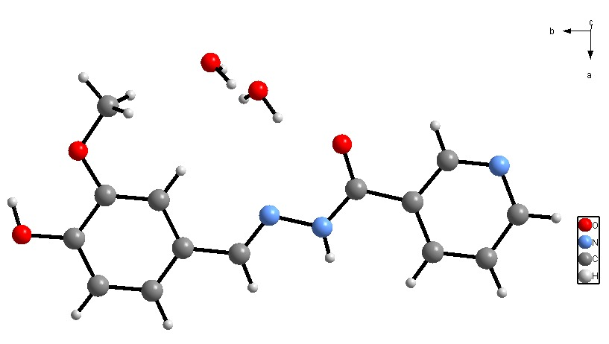
Figure 1 : Structure of H₂LB ligand
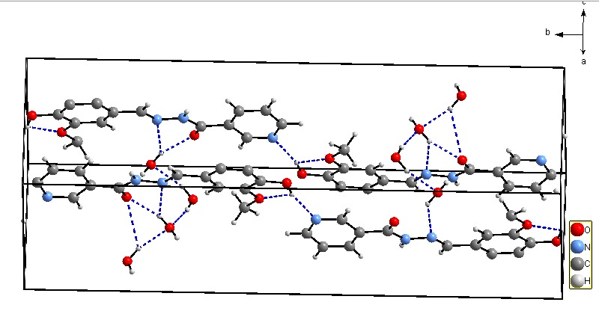
Figure 2 : The packing of the compound in the crystal structure

- Antibacterial activities study
Sensitivity testing protocol : The diffusion method represents one of the earliest technique for assessing bacteria susceptibility to antibiotics or natural or synthetic compounds and it continues to be among the most widely employed methods on routing practice. This approach is applicable to most pathogenic bacteria, including slow-growing species, offers flexibility in antibiotics selection, and requires no specialized equipment. Similar to other agar diffusion techniques, the EUCAST method follows standardized procedures. It is founded on the principles established in the International Collaborative Study of Antimicrobial Susceptibility Testing (1972) and incorporate expertise from specialist worldwide.
1°) Media preparation
- Preparation of MH medium
A masse of 19 g of Mueller-Hinton agar was weighed using a precision balance and suspended in 500 mL of distilled water, then homogenized a magnetic stir bar. The medium was sterilized in an autoclave at 121°C for 15 minutes and subsequently cooled in a water bath to 45°C. It was then poured into sterile square Petri dishes to a uniform thickness of approximately 4 mm, and the agar was allowed to solidify at room temperature before incubation at 37°C for 24 hours prior to use.
- Preparation of Colombia agar
This medium was used for microbial culture.
A mass of 20 g of Columbia agar powder was suspended in 500 mL of distilled water and homogenized using a magnetic stirrer. The mixture was then autoclaved at 121°C for 15 minutes and cooled in a water bath to 45°C. The medium was poured into round Petri dishes under a laminar flow hood and allowed to solidify at room temperature. The plate was incubated at 37°C for 24 hours to verify their sterility before use.
The plates must not be allowed to dry out : if they must are to be used more than 7 days after preparation, they should be stored at 4-8°C in a sealed plastic bag.
2°) Microbial culture and purification
The quadrant steak method was used to purify the strain.
A 20 µL aliquot of the microbial suspension was deposited on the surface of the Colombia agar medium, and the drop was gently spread toward the center of the plate with a sterile inoculating loop, taking care not to scratch the agar. Using the loop, tight streaks were first drawn in the first quadrant. The plate was then rotated to the second quadrant, which was streaked in the same way. After rotating the plate to third quadrant, looser widely spaced streaks were made, without overlapping the previous steaks. The plates were then incubated at 37°C in an atmosphere containing 5% CO₂ for 24 hours.
3°) Preparation of the inoculum
From a visible microbial grown on Colombian agar, a bacterial suspension was prepared in saline (PBS) to obtain a turbidity equivalent to the 0.5 McFarland standards. Several colonies with similar morphology were selected with a sterile inoculating loop, in order to avoid picking an atypical variant, and suspended in 10 mL of PBS.
The bacterial suspension was then standardized against the 0.5 McFarland control, as an excessively heavy inoculum leads to smaller inhibition diameters, and a light inoculum to larger ones. It is recommended to use a spectrophotometer to adjust the inoculum, after calibrating the device with a McFarland standard according to the manufacturer's instructions. Alternatively the turbidity of the bacterial suspension can also be compared visually with the 0.5 McFarland standards; in this case, the turbidity standard should be mixed thoroughly on a vortex mixer before use, unless the commercial standard is gel-based and specifically indicated not to be shaken; in which case the manufacturer's recommendations must be followed.
4°) Inoculation of the agar and Deposition of the unimpregnated discs
The bacterial inoculum should ideally be used within 15 minutes of its preparation. Ten milliliters of the inoculum were poured onto the surface of the poured and solidified Mueller-Hinton agar. The entire surface was covered, and the excess suspension was removed and discarded into the bleach. The plates were left to stand for 1 hour before the antibiotic discs of doripenem, erythromycin (10 µg/disc) and ceftriaxone (30 µg/disc), all 6 mm in diameter, were used as positive controls, while DMSO, used to prepare the dilutions of the different extracts served as a negative control.
The tests were performed using blank 6 mm disc, which were impregnated with 40 µl of the solution at the concentration of 10 mg/mL. The discs were carefully placed on the inoculated and dried agar, ensuring complete contact with the surface. Once deposited, the disc could not be moved because, as antibiotic diffusion occurs very rapidly. The number of discs placed per plate was limited to avoid overlapping inhibition zones and to minimize interference between compounds.
The plates were inverted and incubated for 24 hours at 37°C in an atmosphere containing 5% CO₂. Antibacterial activity was assessed by measuring the diameter of the inhibition zones.
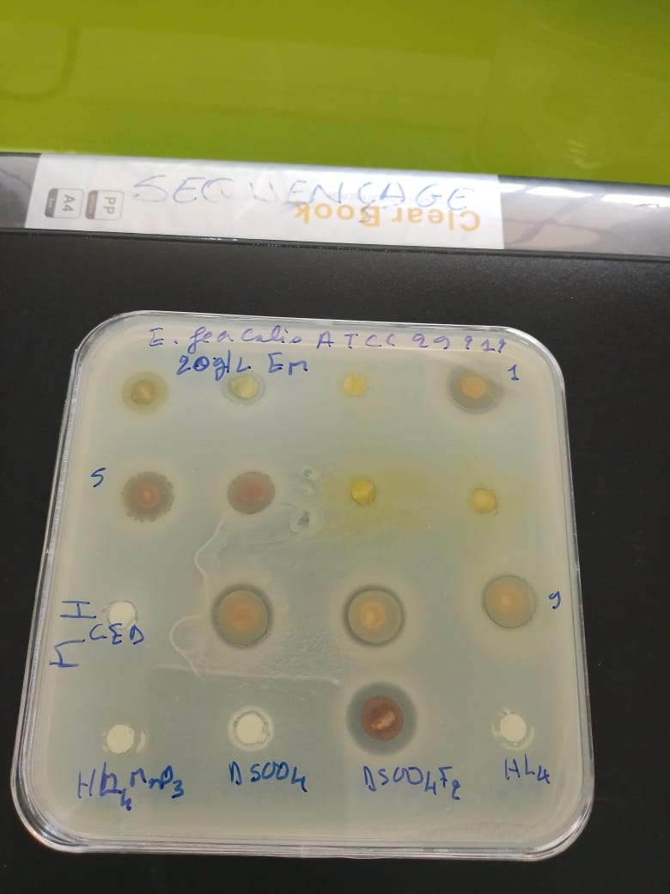
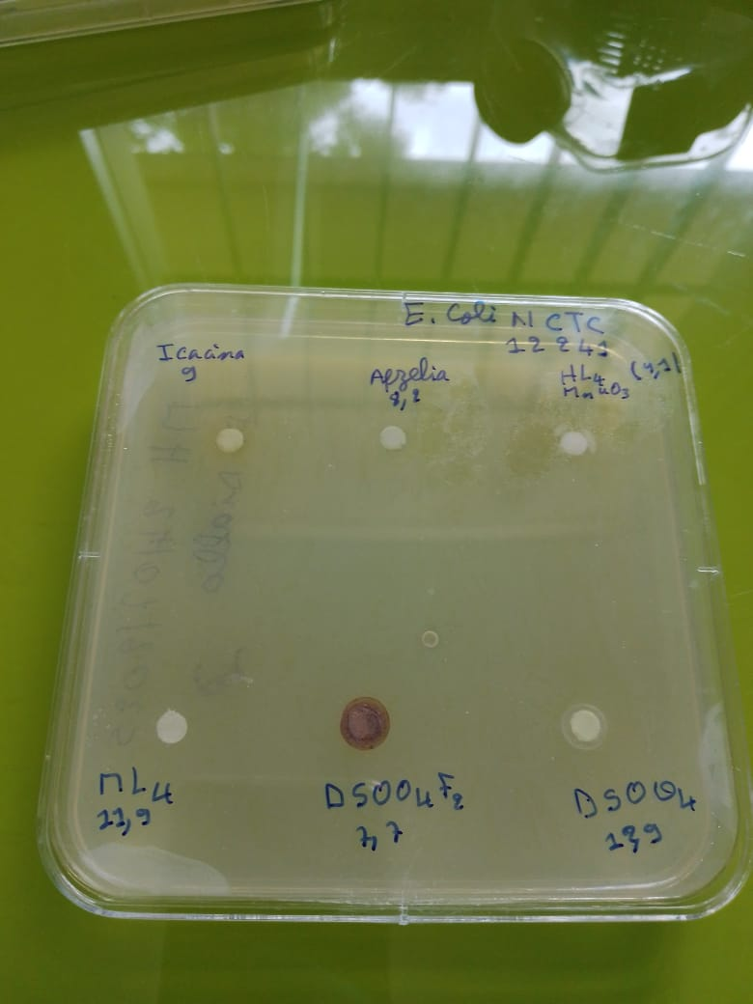
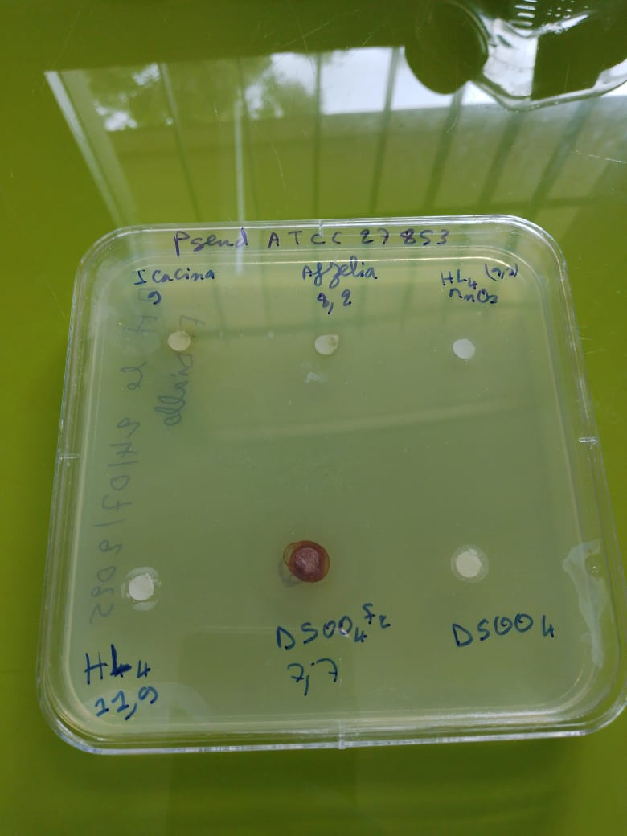
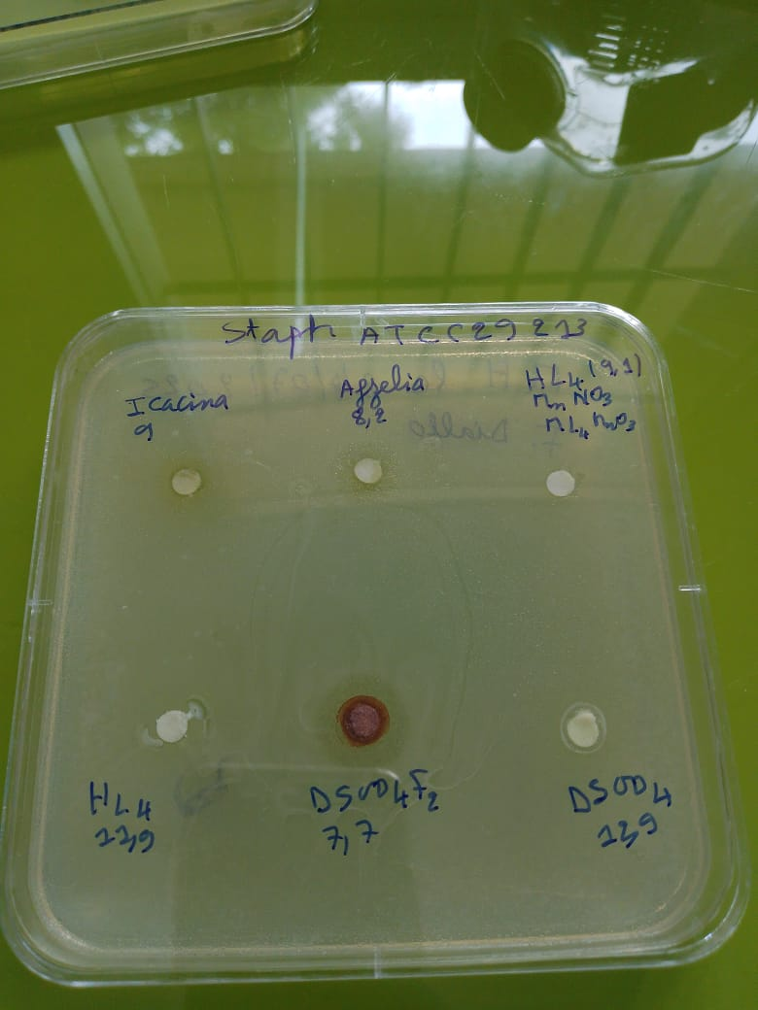

A b

Figure 3 : The antibacterial activity

Table 10 : Strains tested and Drugs tested

Strains tested | Drugs tested
Staphylococcus aureus ATCC 29213 (G+) (Staph aureus) | H₂LB
Escherichia Coli NCTC 12 241 (G-) (E. coli) | HLBMnO₃
Enterococcus faecalis ATCC 29212 (G+) (E. Faecalis) | HLA
Pseudomonas aeruginosa ATCC 27853 (G-) (P. aerus) | HLAFe

Table 11 : Inhibition diameters (mm)
Strains  Drugs (C : mg /mL) | Staph aureus  ATCC 29213 (G+) | E. coli  NCTC 12 241 (G-) | E. Faecalis  ATCC 29212 (G+) | P. aerus  ATCC 27853 (G-)
H₂LB 10 mg/mL | 7 | 6 | - | -
HLBMnO₃ 10 mg/mL | 8 | 10 | - | -
HLA 10 mg/mL | 10 | 10 | 7 | -
HLAFe 10 mg/mL | 15 | 10 | 16 | -
DMSO | - | - | - | -
Doripenem : 10 µg | 28 | 23 | 32 | 25
Ceftriaxone : 30 µg | - | 14 | 7 | -
(-) No activity

Table 12 : Minimum inhibitory concentration MIC
Strains  Drugs (C : mg /mL) | Staph aureus  ATCC 29213 (G+) | E. coli  NCTC 12 241 (G-) | E. Faecalis  ATCC 29212 (G+) | P. aerus  ATCC 27853 (G-)
H₂LB | ND | ND | ND | ND
HLBMnO₃ | 5 | 10 | ND | ND
HLA | 5 | 10 | ND | ND
HLAFe | ND | ND | ND | ND
DMSO | - | - | - | -
Doripenem : 10 µg | 28 | 23 | 32 | 25
Ceftriaxone : 30 µg | - | 14 | 7 | -

ND : Not Determined.
The strains used for susceptibility testing are as follows
- Staphylococcus aureus ATCC 29213 (Gram positive)
- Escherichia coli NCTC 12241 (Gram negative)
- Enterococcus faecalis ATCC 29212 (Gram positive)
- Pseudomonas aeruginosa ATCC 27853 (Gram negative)
5°) Bibliographic study of strains used in sensitivity tests
- Staphylococcus aureus ATCC 29213
Staphylococcus aureus is a Gram-positive coccus and an ubiquitous opportunistic pathogen.
- Clinical significance: This bacterium causes a range of infection including skin and soft tissue infections, pneumonia, osteo articular infection and septicemia.
- Microbiological applications: The ATCC 29213 strain serves as a reference standard commonly employed for antibiotic susceptibility testing through agar diffusion methods and minimum inhibitory concentration (MIC) determination. It is specifically utilized for quality control in the standardized CLSI and EUCAST protocols.
- Distinctive characteristics: This strain exhibits susceptibility to a broad spectrum of antibiotics, making it an ideal comparative model for evaluating noyel antimicrobial agents.
- Escherichia coli NCTC 12241
Escherichia coli is a Gram-negative bacillus belonging to the Entero bacteriaceae family, commonly found in the intestinal microbiota of humans and animals.
- Clinica significance: While certain commensal strains are non-pathogenic, harmless, virulent strains are responsible for urinary tract infections, gastrointestinal disorders septicemia, and meningitis.
- Microbiological applications: The NCTC 12241 strain functions as a reference standard for quality control in antimicrobial susceptibility testing, particularly for antibiotics targeting Gram-negative bacteria.
- Distinctive characteristics: This standardized strain enables comparative assessment of antimicrobial compound diffusion and efficacy international reproducibility.
- Enterococcus faecalis ATCC 29212
Enterococcus faecalis is a Gram-positive coccus commonly found in human intestinal flora.
- Clinica significance: This organism is implicated in urinary tract infections, endocarditis and healthcare-associated infections.
- Microbiological applications: the ATCC 29212 strain serves as a standard control for determining antibiotic minimum inhibitory concentrations (MICs). It is recommended by the CLSI for validation of diffusion and dilution assays.
- Distinctive characteristics: its relative tolerance to conventional antibiotics makes it a valuable strain for assessing novel compounds against resistant Gram-positive bacteria.
- Pseudomonas aeruginosa ATCC 27853
Pseudomonas aeruginosa is a non-fermentative Gram-negative bacillus that is ubiquitous in humid environments.
- Clinica significance: It is major opportunistic pathogen, particularly feared in nosocomial infections (burns, pneumonia, septicemia) and shows a high intrinsic resistance to many antibiotics.
- Microbiological applications: the ATCC 27853 strain is a reference strain used to evaluate the activity of antimicrobial agents against non-fermentative Gram-negative bacilli. It is also used a quality-control strain for disk diffusion tests (CLSI, EUCAST).
- Distinctive characteristics: it is a standardized sensitive strain, which allows the performance of antibiotics active against Pseudomonas to be compared.
This bibliography shows that the four selected strains represent a relevant panel:
- Gram négatif (Escherichia, Pseudomonas)
- Quality-control strains standardized by ATCC and NCTC, recognized internationally
6°) Results and discussions
- Staphylococcus aureus ATCC 29213
- Role: This Gram-positive strain is widely used as a reference organism and quality-control strain in antimicrobial susceptibility testing, notably for disk diffusion (Kirby-Bauer) and MIC determination according to CLSI and EUCAST guidelines.
- Quality: It is characterized as a low β-lactamase producer and remains susceptibility to standard antibiotics, making it suitable for monitoring test performance.
- Normative use: It is frequently cited in CLSI and EUCAST standards for the validation of Mueller-Hinton media and diffusion-based susceptibility tests
- Escherichia coli NCTC 12241
- Role: This Gram-negative strain is used as a wild-type control organism to validate antimicrobial susceptibility tests particularly disk diffusion assays.
- Quality: It is considered susceptibility to many commonly used antibiotics, including aminoglycosides (such as neomycin, kanamycin and gentamicin), polymysxins (such as colistin) chloramphenicol and several cephalosporins.
- Enterococcus faecalis ATCC 29212
- Role: This Gram-positive strain is commonly used as a control organism that is susceptible to vancomycin and is widely employed as a quality-control strain for antibiotic susceptibility testing, including both diffusion and dilution methods.
- Characterization: It has sequenced genome of approximatively 3 Mb a G+C content of about 37%, and it was originally isolated from a human urine sample.
- Quality-control (QC) value: Multicenter validation studies have confirmed its suitability for quality control in disk diffusion and microdilution assays, with established acceptable inhibition zone range such as 16–22 mm for gentamicin and 14–19 mm for streptomycin.
- Pseudomonas aeruginosa ATCC 27853
- Role: This non-fermentative Gram-negative strain is used as a reference organism to assess the activity of antibiotics against this genus, particularly in disk diffusion susceptibility tests. It serves a standard control to verify that diffusion assays correctly detect the expected susceptibility profile of non-fermentative Gram-negative bacilli.
- Normative reference:It is cited in major international guidelines (such as CLST documents) as a reference streain for antimicrobial susceptibility testing, including the verification of Mueller-Hinton media performance and diffusion test validity. Its use helps ensure the reliability and reproducibility of routine sensitivity testing across laboratories.
- Quote from a community testimony
As an illustration, the microbiology community provides the following guidance on the use of the ATCC 29213 strain:
“According to the M07, 37°C is acceptable but at the upper limit of the recommended range. The specified incubation range is 35° ± 2°C.”
This emphasizes the importance of strictly adhering to test conditions (temperature, inoculum size, number of subcultures) in order to ensure reliable and reproducible results.
7°) Interpretation of results
7.1. Analysis of Table 11 – Inhibition diameters (mm)
The diameter of the inhibition zone is an indicator of antibacterial activity
- A large inhibition zone diameter reflects high antibacterial activity indicating that the tested bacteria are susceptible to the antibiotic
- A small or absent inhibition indicates low or no antibacterial activity, suggesting that the bacteria are resistant to the antibiotic.
- Staphylococcus aureus (ATCC 29213, G⁺)
- H₂LB : low activity (7 mm)
- HLBMnO₃: modest activity (8 mm)
- HLA good activity (10 mm)
- HLAFe: highest activity (15 mm)
Conclusion : HLA derivatives, particularly HLAFe , exhibit the strongest antibacterial activity against Staphylococcus aureus.
- Escherichia coli (NCTC 12241, G⁻)
- H₂LB: very weak activity (6 mm)
- HLBMnO₃ and HLA moderate activity (10 mm)
- HLAFe : good activity (10 mm) similar in magnitude but more consistent.
Conclusion : E. coli shows lower overall sensitivity overall, HLA and particularly HLAFe maintain satisfactory antibacterial activity.
- Enterococcus faecalis (ATCC 29212, G⁺)
- HLAFe is the only compound displaying antibacterial activity (16 mm)
Conclusion: HLAFe is the only molecule exhibiting inhibition activity against Enterococcus faecalis.
- Pseudomonas aeruginosa (ATCC 27853, G⁻)
- None of the tested compounds exhibited antibacterial activity.
Conclusion : P. aeruginosa remains fully resistant, which is consistent with its well-known intrinsic multidrug-resistant nature.
- Comparison with controls (Doripenem & Ceftriaxone)
- Doripenem : shows large inhibition zones (23-32 mm), indicating very high antibacterial activity
- Ceftriaxone exhibits low activity against E. coli and E. faecalis (7-14 mm) and no detectable activity against S. aureus and P. aeruginosa under the tested conditions.
Conclusion: the new molecules tested display modest to moderate activity, clearly lower than of Doripenem, but in some situations they outperform Ceftriaxone particularly against E. faecalis when using the HLAFe compound.
7.2. Analysis of Table 8 – Minimum Inhibitory Concentrations (MIC, mg/mL)
The MIC is the lowest concentration preventing bacterial growth.
- Low MIC → powerful molecule
- High MIC or ND → ineffective molecule
- Staphylococcus aureus
- H₂LBMnO₃ CMI = 5 mg/mL equivalent
- HLAFe : ND → not tested or not active
Conclusion: H₂LBMnO₃ and HLA are effective on S. aureus at moderate concentrations.
- Escherichia coli
- H₂LBMnO₃: CMI = 10 mg/mL (low activity)
- HLA : CMI = 10 mg/mL (low activity)
Conclusion: limited effectiveness against E. coli, requiring higher doses.
- Enterococcus faecalis
- All ND except control → no inhibition detected.
Conclusion: despite the activity observed with HLAFe Table 12, the MIC was not determined (perhaps linked to an experimental limit).
- Pseudomonas aeruginosa
- All ND → confirmation of the absence of activity.
7.3. Overall interpretation
- Best candidates
- HLAFe active on S. aureus and especially E. faecalis (zone 16 mm).
- HLA: active on S. aureus and E. coli (MIC 5-10 mg/mL).
- Limited activity
- H₂LB and HLBMnO₃ → low effectiveness, especially on Gram negative.
- No effectiveness
- All molecules against P. aeruginosa.
Conclusion
The ligands H₂LA and H₂LB were synthesized as were their corresponding metal complexes.
The tested derivatives exhibit selective antibacterial activity, mainly against Gram-positive bacteria (S. aureus, E. faecalis), with only modest effectiveness against E. coli.
No activity was detected against P. aeruginosa, which is consistent with its well-known intrinsic resistance.
Among the compounds, the HLAFe derivative appears the most promising, particularly against Enterococcus faecalis, a species that is often difficult to treat in clinical pratice.
Overall, the study indicates that the synthesized hydrazones are effective ligands, easy to prepare and characterize, and that complexation with metal ions generally enhances their antimicrobial properties.
These new compounds therefore represent good candidates for potential biological applications, especially as antibacterial agents.
As a follow-up to this work, more in-depth studies will be undertaken to better characterize the synthesized complexes and to extend the approach to other transition metals, in order to further optimize their biological potential.

Disclaimer (Artificial intelligence)

Author(s) hereby declare that NO generative AI technologies such as Large Language Models (ChatGPT, COPILOT, etc.) and text-to-image generators have been used during the writing or editing of this manuscript.

REFERENCES
[1] Werner A., « Zur Kennis des asymetrichen kobaltation X.I », Chem. Ber 1911 ; 44 :.1887.
[2] Diallo, A. S., Sarr, M., Gueye, M. N., Kama, A. B., Tamboura, F. B., Thiam, I. E., Dieng, M., & Gaye, M. (2024). Synthesis and characterization of a novel metal complex Cobalt (III) with a tetradentate N,N,O,O-donor ligand and 2,2'-{propane-1,2-diyl-bis[nitrilo(E)methylidene]}bis(6-methoxyphenol). Earthline Journal of Chemical Sciences, 11(2), 297-322. https://doi.org/10.34198/ejcs.11224.297322
[3] Silva CMD, Silva DLD, Modolo LV, Alves RB, Resende MAD, Martins CV and Fatima ÂD, « a short review of their antimicrobial activitie », journal of advanced research, 2010 ; p.2,
[4] Ponka, P., Borova, J., Neuwirt, J., Fuchs, O., & Necas, E. (1979). Mobilization of iron from reticulocytes. Identification of pyridoxal isonicotinoyl hydrazone as a new iron chelating agent. FEBS Letters, 97(2), 317–321. https://doi.org/10.1016/0014-5793(79)80111-8
[5] Yang, X.-B., Huang, Y., Zhang, J.-S., Yuan, S.-K., & Zeng, R.-Q. (2010). Synthesis, characterization and DNA interaction of copper (II) complexes with Schiff base ligands derived from 2-pyridinecarboxaldehyde and polyamines. Inorganic Chemistry Communications, 13(12), 1421-1424. https://doi.org/10.1016/j.inoche.2010.08.006
[6]. Koivusalo, L., Karvinen, J., Sorsa, E., Jönkkäri, I., Väliaho, J., Kallio, P., Ilmarinen, T., Miettinen, S., Skottman, H., & Kellomäki, M. (2018). Hydrazone crosslinked hyaluronan-based hydrogels for therapeutic delivery of adipose stem cells to treat corneal defects. Materials Science and Engineering C: Materials for Biological Applications, 85, 68–78. https://doi.org/10.1016/j.msec.2017.12.013
[7]. Uppal, G., Bala, S., Kamboj, S., & Saini, M. (2011). Therapeutic review exploring antimicrobial potential of hydrazones as promising lead. Der Pharma Chemica, 3(1), 250–268. https://www.scholarsresearchlibrary.com/articles/therapeutic-review-exploring-antimicrobial-potential-of-hydrazones-as-promising-lead.pdf
[8]. Cukierman, D. S., Pinheiro, A. B., Castiñeiras-Filho, S. L. P., da Silva, A. S. P., Miotto, M. C., de Falco, A., de Ribeiro, P. T., Maisonette, S., da Cunha, A. L. M. C., Hauser-Davis, R. A., Landeira Fernandez, J., Aucélio, R. Q., Outeiro, T. F., Pereira, M. D., Fernández, C. O., & Rey, N. A. (2017). A moderate metal-binding hydrazone meets the criteria for a bioinorganic approach towards Parkinson's disease: therapeutic potential, blood-brain barrier crossing evaluation and preliminary toxicological studies. Journal of Inorganic Biochemistry, 170, 160–168. https://doi.org/10.1016/j.jinorgbio.2017.02.020
[9]. Sanford, A. G., Schulze, T. T., Potluri, L. P., Watson, G. F., Darner, E. B., Zach, S. J., Hemsley, R. M., Wallick, A. I., Warner, R. C., Charman, S. A., Wang, X., Vennerstrom, J. L., & Davis, P. H. (2018). Derivatives of a benzoquinone acyl hydrazone with activity against Toxoplasma gondii. International Journal for Parasitology: Drugs and Drug Resistance, 8(3), 488–492. https://doi.org/10.1016/j.ijpddr.2018.11.001
[10]. Alagesan, M., Bhuvanesh, N. S. P., & Dharmaraj, N. (2013). Potentially cytotoxic new copper(II) hydrazone complexes: Synthesis, crystal structure and biological properties. Dalton Transactions, 42(19), 7210–7223. https://doi.org/10.1039/c3dt50371b
[11]. Cao, W., Liu, Y., Zhang, T., & Jia, J. (2018). Synthesis, characterization, theoretical and antimicrobial studies of tridentate hydrazone metal complexes of Zn (II), Cd (II), Cu (II) and Co (III). Polyhedron, 147, 62–68. https://doi.org/10.1016/j.poly.2018.03.012
[12]. Bhaskar, R. S., Ladole, C. A., Salunkhe, N. G., Barabde, J. M., & Aswar, A. S. (2020). Synthesis, characterization and antimicrobial studies of novel ONO donor hydrazone Schiff base complexes with some divalent metal (II) ions. Arabian Journal of Chemistry, 13(8), 6559–6567. https://doi.org/10.1016/j.arabjc.2020.06.012
[13]. Joshi, N., Gore, V., Tekale, S., Rajani, D., Bembalkar, S., & Pawar, R. (2021). Synthesis, characterization and biological activity of transition metal complexes of [1-(2-bromo, 5-methoxy benzylidene) hydrazine] ligand. Letters in Applied NanoBioScience, 10(2), 2056–2062. https://doi.org/10.33263/LIANBS102.20562062
[14] Kahwa, I. A., Selbin, J., O'Connor, C. J., Foise, J. W., & McPherson, G. L. (1988). Magnetic and luminescence characteristics of dinuclear complexes of lanthanides and a phenolic schiff base macrocyclic ligand. Inorganica Chimica Acta, 148(2), 265-272. https://doi.org/10.1016/s0020-1693(00)87513-1
[15] Kaczmarek, M. T., Zabiszak, M., Nowak, M., & Jastrzab, R. (2018). Lanthanides: Schiff base complexes, applications in cancer diagnosis, therapy, and antibacterial activity. Coordination Chemistry Reviews, 370, 42-54. https://doi.org/10.1016/j.ccr.2018.05.012
[16] Jastrzab, R., Kaczmarek, M. T., Nowak, M., Trojanowska, A., & Zabiszak, M. (2017). Complexes of polyamines and their derivatives as living system active compounds. Coordination Chemistry Reviews, 351, 32-44. https://doi.org/10.1016/j.ccr.2017.05.001
[17] Wu, S.-G., Peng, Y.-Y., Chen, Y.-C., Liu, J.-L., & Tong, M.-L. (2020). Magnetic dynamics of an open-ring tridysprosium complex employing mixed ligands. Dalton Transactions, 49, 14140-14147. https://doi.org/10.1039/D0DT02698K
[18] Li Q, Zhu X, Zhao Y, & Xie Y. (2022) The antifungal activity of o-vanillin against Aspergillus flavus via disrupting ergosterol biosynthesis and promoting oxidative stress, and an RNA-seq analysis thereof. LWT; 164 : 113635.
https://doi.org/10.1016/j.lwt.2022.113635
[19] Londoño-Mosquera, J.-D., Aragón-Muriel, A., & Cerón, D. P. (2018). Synthesis, antibacterial activity and DNA interactions of lanthanide(III) complexes of N(4)-substituted thiosemicarbazones. Universitas Scientiarum, 23(2), 141-169. https://doi.org/10.11144/Javeriana.SC23-2.saaa
[20] Haba, P. M., Tamboura, F. B., Diouf, O., Gaye, M., Sall, A. S., Baldé, C. A., & Slebodnick, C. (2006). Preparation, spectroscopic studies, and x-ray structure of homobinuclear lanthanide(III) complexes derived from 2,6-diformyl-4-chlorophénol-bis- (2’-hydroxy-benzoylhydrazone). Bulletin of the Chemical Society of Ethiopia, 20(1), 45-54. https://doi.org/10.4314/bcse.v20i1.21142
[21] Singh, Y. P., Patel, R. N., Singh, Y., Butcher, R. J., Vishakarma, P. K., & Singh, R. K. B. (2017). Structure and antioxidant superoxide dismutase activity of copper(II) hydrazone complexes. Polyhedron, 122, 1-15. https://doi.org/10.1016/j.poly.2016.11.013
[22] Kamel, M. S., Belal, A., Aboelez, M. O., Shokr, E. Kh., Abdel-Ghany, H., Mansour, H. S., Shawky, A. M. and El-Remaily, M. A. E. A. A. A. (2022). Microwave-Assisted Synthesis, Biological Activity Evaluation, Molecular Docking, and ADMET Studies of Some Novel
Pyrrolo [2,3-b] Pyrrole Derivatives, 27, 2061. https://doi.org/10.3390/molecules27072061
[23] Egbujor, M. C. U., Okoro, C., D. Nwobodo, C., Ezeagu, C. U., Amadi, U. B., Okenwa-Ani, C. G., Ugwu, J. I., Okoye, I. G., Abu, I. P. and Egwuatu, P. I. (2020). Design, Synthesis, Antimicrobial and Antioxidant Activities of Novel Threonine-based Sulfonamide Derivatives. Journal of Pharmaceutical Research International. 51-61. DOI:10.9734/JPRI/2020/v32i830470
[24] | Thiam, E. I., Diop, M., Gaye, M., Sall, A. S. and Barry, A. H. (2008). Acta Cryst , vol. 64, p. 776.

[25] Syiemlieh, I., Kumar, A., Kurbah, S. D., De, A. K., and Lal, R. A. (2018). Low-spin manganese(II) and high-spin manganese(III) complexes derived from disalicylaldehyde oxaloyldihydrazone: Synthesis, spectral characterization and electrochemical studies. Journal of Molecular Structure, vol. 1151, p. 343‑352. doi: 10.1016/j.molstruc.2017.09.052
[26] Kébé, M. and al. (2021). Hexanuclear copper(II) complex of 2-hydroxy- N , N ′-bis[1-(2-hydroxyphenyl)ethylidene]propane-1,3-diamine incorporating an open-cubane core. Acta Crystallogr E Cryst Commun, vol. 77, nº 7, p. 708‑71. doi: 10.1107/S2056989021005570
[27] Ning, J. and al. (2025). Sulfur confinement via C–S bonding for stable sulfur conversion in aqueous Zn–S batteries. Chem. Commun., vol. 61, nº 60, p. 11203‑11206. doi: 10.1039/D5CC01471A.
[28] Geary, W. J. (1971). The use of conductivity measurements in organic solvents for the characterisation of coordination compounds. Coordination Chemistry Reviews, 7(1), 81–122. https://doi.org/10.1016/S0010-8545(00)80009-0

