Original Research Article
Thermal Analysis of Conversion Products Derived from Phosphogypsum and Natural Gypsum

ABSTRACT

This study investigates the scientific foundations for the environmentally and economically viable processing of phosphogypsum (PG), the primary waste from phosphoric acid manufacturing. Its main objective is a comparative analysis of converting natural gypsum (NG) and phosphogypsum using ammonium carbonate ((NH₄)₂CO₃) to produce valuable calcium carbonate (CaCO₃) and ammonium sulfate, alongside characterizing the thermal properties of the raw materials and products.
The conversion process was evaluated using thermal analysis, a critical method for assessing reaction efficiency, product stability, and material characteristics. This approach provides essential data on the thermal behavior and decomposition profiles of the substances involved.

Keywords: ammonium carbonate, calcium carbonate, conversion, decarbonation, differential thermal analysis (DTA), natural gypsum, phosphogypsum, simultaneous thermal analysis, thermogravimetry (TG).

- Intraduction

Phosphoric acid is a vital industrial product of strategic importance, widely used in various manufacturing sectors. Phosphogypsum (PG) is the main by-product generated during the wet-process production of phosphoric acid [1]. In this process, phosphate raw material reacts with sulfuric acid, resulting in an average of 4.0-5.0 tons of phosphogypsum produced per ton of manufactured phosphoric acid [2]. The comprehensive utilization of phosphogypsum (PG) as a secondary resource has become a central focus for the scientific community. This interest is directly linked to the overarching goals of environmental safety, resource efficiency, and sustainable development [3].
In terms of composition, phosphogypsum (PG) consists primarily of calcium sulfate dihydrate (CaSO₄·2H₂O) and contains certain amounts of phosphorus and fluorine compounds, organic residues, various oxides, heavy metal ions, and natural radioactive components [4]. The harmful impurities in phosphogypsum significantly restrict its direct use as a raw material, and advanced technologies aimed at its efficient long-term processing have not been sufficiently developed. Consequently, a large portion of phosphogypsum is stored in dumps or disposal sites or discharged into water basins [5], which intensifies environmental risks related to land occupation, pollution of the hydrosphere and soil environment, and the dispersion of harmful and radioactive elements into the atmosphere [6].
The adverse ecological and environmental impacts resulting from the long-term storage of phosphogypsum (PG) are increasingly drawing the attention of both society and government regulatory bodies. Simultaneously, the issue of developing and implementing rational and efficient processing technologies for phosphogypsum utilization is emerging as a priority scientific-practical direction on an international scale [7-8]. At the same time, the regulatory and legal measures being implemented within environmental policy are gaining crucial strategic importance globally in promoting the recycling of phosphogypsum as a secondary resource, as well as in addressing pressing ecological problems associated with the management of solid industrial waste [9-10].
Fundamental research and technological experiments on phosphogypsum (PG) processing and its multifunctional applications have been conducted over many years. However, despite the formation of very large quantities of this secondary industrial product in manufacturing processes, the indicators for its integration into real production cycles and its economically and ecologically efficient utilization remain limited.
The process of involving phosphogypsum as a secondary mineral resource in economic and technological circulation is a multifactorial and systemic in challenge, governed by a complex set of interrelated ecological and technological constraints. The issue of processing phosphogypsum (PG) as a secondary mineral resource and its comprehensive utilization has recently moved to the center of the scientific community's attention, directly linked to the concepts of environmental safety, resource efficiency, and sustainable development. However, a significant theoretical and practical discrepancy persists between the needs for large-scale, short-term utilization of phosphogypsum at an industrial level and the strategic goals aimed at long-term ecological stability and environmental protection. While existing research has addressed the chemical composition of phosphogypsum, processing technologies, and specific application directions, these developments are often of varied character, and their results have not been generalized within a unified, systematic framework.
One promising direction for phosphogypsum utilization is its use as a raw material in the production of construction materials, which includes the manufacture of wall panels, various dry construction mixtures, and cement compositions. However, the high acidity level of phosphogypsum and the presence of retained technogenic additives in its composition significantly limit the possibilities for its widespread industrial application. Technological processes aimed at purifying phosphogypsum from residual acids and foreign components are characterized by high energy consumption and low economic efficiency, and are therefore often deemed impractical [10-11]. In other studies, the compositional impurities in phosphogypsum and methods for their elimination have been systematically analyzed, providing a foundation for modern purification and high-value-added processing routes to enable its environmentally safe and comprehensive utilization. Research has scientifically highlighted the prospects of using phosphogypsum as a sustainable and economically efficient raw material, particularly in the construction materials and road construction sectors [1, 2, 12]. In this study [13], the main components (Si, P) and (F, Fe, Al, C) in phosphogypsum, their mineral-phase state, as well as their negative impact on the phosphogypsum processing process, have been systematically analyzed.
Scientific research indicates that phosphogypsum, after thorough purification from harmful impurities, can be technologically converted into construction materials, chemical products, nanomaterials, and eco-functional products in an economically efficient manner. In particular, flotation, acid washing, and combined purification methods are of decisive importance for the industrial-scale processing of phosphogypsum [13, 14].
Phosphogypsum (PG) can be effectively used as a secondary raw material in the synthesis of valuable inorganic compounds-ammonium sulfate, sodium sulfate, calcium carbonate, calcium sulfoaluminate, and lithium sulfate monohydrate. This direction not only allows for the rational use of raw material resources and reduction of production costs but also offers the opportunity to develop sustainable and environmentally harmless production by converting industrial waste into renewable resources [15-19].

- METHODS AND MATERIALS

In our scientific research on phosphogypsum processing, the possibilities for reprocessing the EFK waste product-phosphogypsum-generated during the phosphoric acid production process at "Ammofos-Maksam" JSC, as well as natural gypsum extracted from the "Sho‘rsuv" deposit in the Fergana region, were thoroughly studied based on liquid-phase carbonate conversion technology. The main objective of these studies was to determine the scientific and technological foundations of the process for converting phosphogypsum and natural gypsum into high-value products—ammonium sulfate ((NH₄)₂SO₄) and calcium carbonate (CaCO₃)-using ammonium carbonate.
The efficiency of this process directly depends on a number of technological factors. In the conducted experiments, the duration of conversion time, the concentration of the ammonium carbonate solution, the temperature regime of the medium, stirring intensity, the particle size composition of the gypsum, the stoichiometric ratios of the solution, and additional technological indicators affecting the reaction kinetics were thoroughly analyzed. The experimental results showed that the coordinated management of these parameters significantly influences the selectivity of the conversion process, product purity, the formation characteristics of the crystalline phase, and overall technological productivity [20-22].
In this article, the thermal analysis results (TG, DTA) of phosphogypsum and the conversion products obtained through its processing are analyzed.
To study the thermochemical properties of the materials, simultaneous thermal analysis (STA) was employed, combining thermogravimetry (TG) and differential thermal analysis (DTA) methods. All measurements were performed using a Shimadzu DTG-60 analyzer. Measurements were conducted in an inert atmosphere (Ar, 80 ml/min) using standard porcelain crucibles. A constant heating rate of 10 °C/min was applied, with the initial temperature set from room temperature up to 1200 °C.
Primary Materials:Natural gypsum and phosphogypsum were subjected directly to thermal analysis.
Conversion Product:The calcium carbonate (CaCO₃) precipitate obtained from the conversion of both types of gypsum with (NH₄)₂CO₃ was separated, dried, and then prepared for STA analysis.
TG curves were analyzed to identify mass loss stages, while DTA curves were examined to record endothermic/exothermic effects corresponding to dehydration, decomposition, and phase transitions, and to determine their temperature ranges. Based on the obtained results, the thermal stability and phase transformation pathways of the three materials were comparatively analyzed.

- RESULTS AND DISCUSSION

Thermoanalytical TG–DSC studies carried out by Chinese researchers have enabled an in-depth investigation of the thermal properties, stepwise phase transformations, and kinetic processes under thermal exposure of the two main products formed during the liquid-phase conversion of phosphogypsum with ammonium carbonate, namely ammonium sulfate and calcium carbonate. The obtained thermograms clearly demonstrate that ammonium sulfate ((NH₄)₂SO₄) undergoes thermal decomposition through three successive major endothermic stages. Specifically, in the temperature range of 235–280 °C, the dissociation and release of water bound to the crystal lattice are observed; in the interval of 280–330 °C, thermal decomposition reactions occur involving the transformation of ((NH₄)₂SO₄) into an intermediate (NH₄)HSO₄ phase accompanied by the release of NH₃; and in the temperature range of 330-450 °C, deeper disintegration of the sulfate anion leads to the release of SO₃ and the final thermal decomposition of the compound.
TG-DTG analysis of calcium carbonate (CaCO₃): The decomposition of CaCO₃ into CaO and CO₂ occurs at 600-750°C, with complete dissociation above 700 °C. The variant of CaCO₃ obtained from phosphogypsum was found to decompose faster and at a lower temperature compared to natural CaCO₃, which is attributed to its high dispersity and reactivity.
The impurities present in phosphogypsum (F⁻, P₂O₅, SiO₂) strongly influence its thermal behavior. The thermograms show additional endothermic peaks, secondary phase transitions, and the recrystallization of hemihydrate. This condition affects the quality of the CaCO₃ and ((NH₄)₂SO₄) products formed during the conversion process [23-24].
Literature analysis indicates that the thermal composition and dehydration stages of phosphogypsum are crucial for the correct selection of conversion technologies. The decomposition temperature of ammonium sulfate serves as a key control parameter in its recrystallization, granulation, and liquid fertilizer production processes. The thermal stability of CaCO₃ determines its potential applicability in developed fields such as fertilizers, plastics, and construction materials. Therefore, thermal analysis methods are regarded as essential and indispensable research tools for the scientific substantiation of phosphogypsum processing technologies, evaluation of the thermodynamic and kinetic characteristics of the processes, and determination of optimal technological parameters.
Synchronous thermal analysis (TG-DTA) of natural gypsum (NG) and phosphogypsum (PG) revealed that, despite sharing the same primary composition of CaSO₄·2H₂O, they exhibit significantly different thermochemical behavior due to the presence of impurities. The analyses were conducted under an inert atmosphere (Ar) at a standard heating rate of 10 °C/min (Figs. 1 and 2).

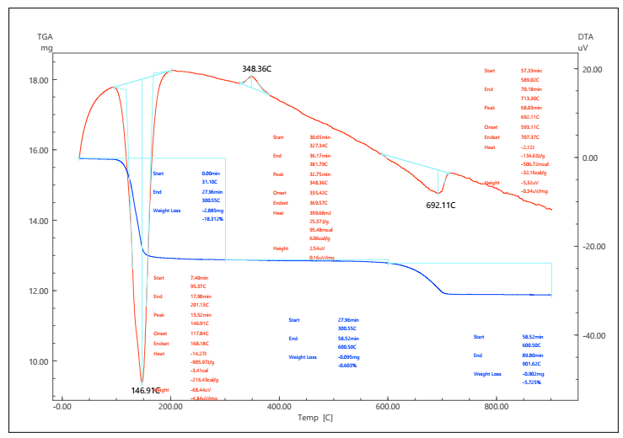
Fig. 1. Thermal analysis (TG–DTA) curves of natural gypsum.

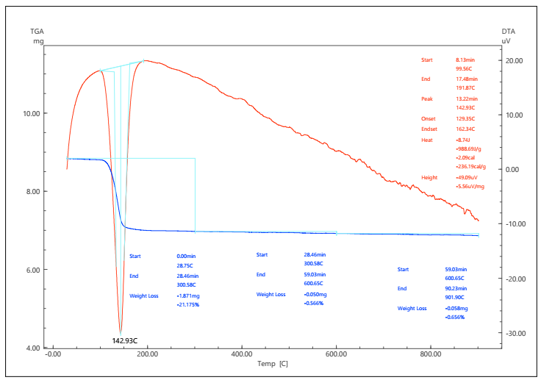
Fig. 2. Thermal analysis (TG–DTA) curves of phosphogypsum.
In the dehydration stage of natural gypsum, the first endothermic transition appears as a sharp and symmetric peak at 147 °C. This distinct onset temperature and acute peak indicate rapid kinetics associated with the material's high degree of crystallinity and chemical purity. In phosphogypsum, the same dehydration stage occurs at approximately 143 °C; however, the DTA peak is significantly broader and asymmetrical in shape. This decrease in temperature and broadening of the peak is explained by the weakening of the crystal lattice and alteration of the water release pathway due to impurities such as SiO₂, F⁻, phosphates, and organic residues present in PG. This process undergoes thermal spreading.
In the second stage, natural gypsum exhibits a distinct second endothermic transition observed as a well-defined peak at 348 °C, although broader than that of the first stage. This corresponds to the formation of γ-CaSO₄ and reflects its diffusion-limited nature. In phosphogypsum, no clear separate peak is observed at this stage. Instead, continuous mass loss is seen across a wide interval from 200 °C to 400 °C. This situation reflects not only the release of residual water but also the decomposition of various impurities (e.g., ammonium salts, organic substances). The non-conventional and defective structure of PG significantly slows down the process kinetics.
In both samples, high-temperature phase transitions are observed around ~700 °C, characterized by a low-intensity endothermic effect that occurs without a change in mass, attributed to the structural transition of β-CaSO₄ to α-CaSO₄ (anhydrite II → anhydrite I). However, in PG, this effect may often be obscured due to the decomposition of impurities or the formation of liquid phases.
Comparative analysis indicates that the key differences in the thermal properties of phosphogypsum are related to its lower degree of crystallinity, widespread impurities, and the resulting defective lattice. These factors lead to: a decrease in activation energy, the broadening of thermal stages, and a loss of their distinctness. The clear and reproducible "model" behavior of natural gypsum, characterized by well-defined endothermic peaks, confirms its advantage as a high-quality and predictable raw material. In contrast, the complex and diffuse thermogram of PG demonstrates that its processing (e.g., during calcination) requires a wider and more carefully controlled temperature range. This analysis provides important insight into the thermochemical properties of industrial waste materials compared to their pure mineral counterparts.
The simultaneous thermal analysis (TG-DTA) of calcium carbonate (CaCO₃) samples obtained from the conversion reaction of natural gypsum (NG) and phosphogypsum (PG) using (NH₄)₂CO₃ revealed significant structural differences depending on their origin, despite primarily consisting of the same carbonate phase. The analyses were conducted using a Shimadzu DTG-60 instrument under an Ar atmosphere (80 ml/min) and at a heating rate of 10 °C/min (Figures 3-4).
Both samples exhibited high thermal stability in the 25-600 °C range. The TG curves showed only a gradual mass loss of up to -1-2% within this interval, primarily associated with the removal of adsorbed moisture. The DTA curves recorded no significant endothermic or exothermic effects. This confirms the high degree of completion of the conversion process and the formation of predominantly stable calcium carbonate.
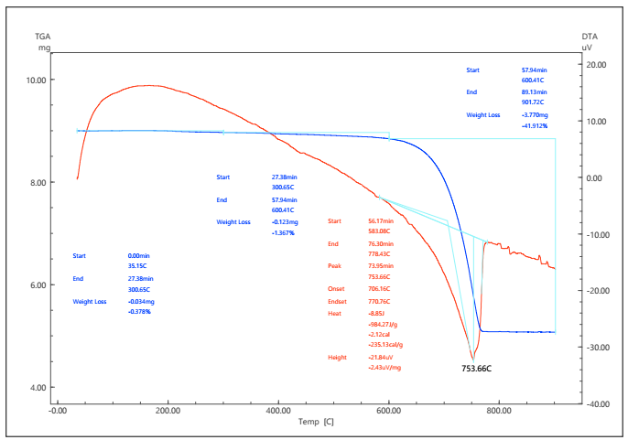
Fig. 3. TG-DTA curves of phosphomel based on natural gypsum.

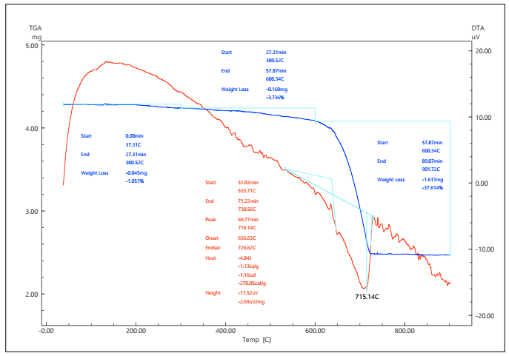
Figure 4. TG–DTA curves of phosphomel based on phosphogypsum.

The primary thermochemical event—the decomposition of calcium carbonate into calcium oxide (CaO) and carbon dioxide (CO₂) (CaCO₃ → CaO + CO₂↑)—occurred at high temperatures for both samples but differed sharply in terms of temperature and peak shape.
For the CaCO₃ derived from NG, the decarbonation process took place within an approximate range of 730–780 °C, characterized by a distinct and relatively narrow endothermic peak centered around ~750 °C. This higher temperature indicates a high degree of crystallinity, a well-developed crystal structure, and a low number of defects in the material, which requires additional energy to decompose the more stable carbonate lattice.
For CaCO₃ based on PG ("Phosphomel"): The main endothermic peak was observed at a significantly lower temperature—approximately 715 °C. Additionally, the peak shape may be relatively broader. This decrease is explained by the nanoscale size, high degree of dispersion, and large surface area of the carbonate derived from PG. Furthermore, residual ions in PG (phosphate, fluoride, sodium) create additional defects that weaken the crystal lattice or act as low-temperature fluxes, which accelerates decomposition and leads to its initiation at a lower temperature.
According to the TG data, the mass loss in the main stage is close to the theoretical value (~44%) in both cases, indicating the completeness of the conversion.
A comparative analysis shows that CaCO₃ obtained from pure NG is a high-quality, well-crystallized standard product with traditional high-temperature decomposition characteristics. In contrast, CaCO₃ derived from PG waste, although having structural shortcomings due to impurities, possesses excellent practical advantages due to its lower decomposition temperature. This characteristic makes it a promising raw material for calcination processes (e.g., CaO production or CO₂ capture cycles) that can significantly reduce energy consumption.
TG-DTA analyses clearly confirm the efficient implementation of the conversion process of natural gypsum and phosphogypsum with ammonium carbonate. The complete disappearance of the low- and medium-temperature dehydration stages characteristic of gypsum (dihydrate–hemihydrate–anhydrite) in the post-conversion products indicates the full or near-complete transformation of the calcium sulfate phase into calcium carbonate. This serves as a crucial thermal indicator of the reaction's completion.
Furthermore, the appearance in the conversion products of strong endothermic peaks specific only to the high-temperature decomposition of CaCO₃, accompanied by CO₂ release, confirms the formation of the carbonate phase as the primary component. The relatively lower decomposition temperature of the phosphomel derived from phosphogypsum indicates the formation of finely dispersed and highly reactive calcium carbonate during the conversion process.
Overall, the TG-DTA results scientifically substantiate that the conversion process carried out using ammonium carbonate not only proceeded correctly from a chemical standpoint but also yielded thermally stable calcium carbonate products that are promising for industrial application.
- CONCLUSION
The results of TG-DTA analyses demonstrate a significant difference in the thermal behavior of natural gypsum, phosphogypsum, and the calcium carbonate products obtained from their conversion with ammonium carbonate. The dehydration process in natural gypsum and phosphogypsum proceeds in two stages associated with dihydrate–hemihydrate–anhydrite phase transitions, with impurities specific to the industrial origin of phosphogypsum complicating the kinetics of this process. The conversion products exhibit high thermal stability at low and medium temperatures, confirming the effective formation of the carbonate phase.
At high temperatures, the decomposition of calcium carbonate manifests as an endothermic process accompanied by CO₂ release. CaCO₃ derived from natural gypsum is characterized by a relatively higher decomposition temperature, while phosphomel based on phosphogypsum is distinguished by a lower decomposition temperature and higher reactivity. Overall, it has been scientifically substantiated that processing phosphogypsum using ammonium carbonate is an effective technological solution for converting an environmentally hazardous industrial waste into high value-added, energetically favorable products—ammonium sulfate and calcium carbonate.
Disclaimer (Artificial intelligence)
Option 1:
Author(s) hereby declare that NO generative AI technologies such as Large Language Models (ChatGPT, COPILOT, etc.) and text-to-image generators have been used during the writing or editing of this manuscript.
Option 2:
Author(s) hereby declare that generative AI technologies such as Large Language Models, etc. have been used during the writing or editing of manuscripts. This explanation will include the name, version, model, and source of the generative AI technology and as well as all input prompts provided to the generative AI technology
Details of the AI usage are given below:
1. ChatGPT Plus for paraphrase and in order to be academic and clear.

REFERENCES
- Chuan, L. M., Zheng, H. G., Zhao, J. J., Wang, A. L., & Sun, S. F. (2018, July). Phosphogypsum production and utilization in China. In IOP Conference Series: Materials Science and Engineering (Vol. 382, No. 2, p. 022099). IOP Publishing. https://iopscience.iop.org/article/10.1088/1757-899X/382/2/022099
- Murali, G., & Azab, M. (2023). Recent research in utilization of phosphogypsum as building materials: Review. Journal of Materials Research and Technology. https://doi.org/10.1016/j.jmrt.2023.05.272
- Abushanab, A., & Alnahhal, W. (2023). Life cycle cost analysis of sustainable reinforced concrete buildings with treated wastewater, recycled concrete aggregates, and fly ash. Results in Engineering, 20, 101565. https://doi.org/10.1016/j.rineng.2023.101565
- Akfas, F., Elghali, A., Aboulaich, A., Munoz, M., Benzaazoua, M., & Bodinier, J. L. (2024). Exploring the potential reuse of phosphogypsum: A waste or a resource?. Science of the Total Environment, 908, 168196. https://doi.org/10.1016/j.scitotenv.2023.168196
- Chen, Q., Zhang, Q., Qi, C., Fourie, A., & Xiao, C. (2018). Recycling phosphogypsum and construction demolition waste for cemented paste backfill and its environmental impact. Journal of Cleaner Production, 186, 418-429. https://doi.org/10.1016/j.jclepro.2018.03.131
- Balaram, V. (2019). Rare earth elements: A review of applications, occurrence, exploration, analysis, recycling, and environmental impact. Geoscience Frontiers, 10(4), 1285-1303. https://doi.org/10.1016/j.gsf.2018.12.005
- Tayibi, H., Choura, M., López, F. A., Alguacil, F. J., & López-Delgado, A. (2009). Environmental impact and management of phosphogypsum. Journal of Environmental Management, 90(8), 2377–2386. https://doi.org/10.1016/j.jenvman.2009.03.007
- Silva, L. C. R., Wood, M. C., Johnson, B. R., Coughlan, M. R., Brinton, H., McGuire, K., & Bridgham, S. D. (2022). A generalizable framework for enhanced natural climate solutions. Plant and Soil, 479(1), 3-24. https://doi.org/10.1007/s11104-022-05472-8
- Macías, F., Pérez-López, R., Cánovas, C. R., Carrero, S., & Cruz-Hernandez, P. (2017). Environmental assessment and management of phosphogypsum according to European and United States of America regulations. Procedia Earth and Planetary Science, 17, 666-669. https://doi.org/10.1016/j.proeps.2016.12.178
- Millán-Becerro, R., Pérez-López, R., Cánovas, C. R., Macías, F., & León, R. (2022). Phosphogypsum weathering and implications for pollutant discharge into an estuary. Journal of Hydrology, 617, 128943. https://doi.org/10.1016/j.jhydrol.2022.128943
- Shabelskaya, N., Medvedev, R., Gaidukova, Y., & Astachova, M. (2019). Phosphogypsum recycling into inorganic dyes. E3S Web of Conferences, 140, 01002. https://doi.org/10.1051/e3sconf/201914001002
- Guan, Q., Wang, Z., Zhou, F., Yu, W., Yin, Z., Zhang, Z., Chi, R., & Zhou, J. (2024). Correction: Guan et al. The Impurity Removal and Comprehensive Utilization of Phosphogypsum: A Review. Materials 2024, 17, 2067. Materials, 17(22), 5574. https://doi.org/10.3390/ma17225574
- Li, X., Lv, X., & Xiang, L. (2023). Review of the state of impurity occurrences and impurity removal technology in phosphogypsum. Materials, 16(16), 5630. https://doi.org/10.3390/ma16165630
- Jia, W., Li, J., Shen, C., Li, G., Li, H., Fan, G., Zhou, G., & Cao, Y. (2025). Research advances in phosphogypsum flotation purification: Current status and prospects. Separation and Purification Technology. https://doi.org/10.1016/j.seppur.2024.129244
- Baojun, Y., Mengmeng, Y., Bainian, W., Xiaoyu, F., & Qiang, W. (2019). A new route to synthesize calcium carbonate microspheres from phosphogypsum. Materials research express, 6(4), 045042. https://iopscience.iop.org/article/10.1088/2053-1591/aafadf
- Ennaciri, Y., Mouahid, F. E., Bendriss, A., & Bettach, M. (2013). Conversion of phosphogypsum to potassium sulfate and calcium carbonate in aqueous solution. MATEC Web of Conferences, 5, 04006. https://doi.org/10.1051/matecconf/20130504006
- Wei, J., Gu, Y., Lv, H., & Wu, X. (2021). A zero-emission method for recycling phosphogypsum using Na2SO4 electrolysis: Preliminary study. Separation and Purification Technology, 259, 118168. https://doi.org/10.1016/j.seppur.2020.118168
- Idboufrade, A., Bouargane, B., Ennasraoui, B., Biyoune, M. G., Bachar, A., Bakiz, B., Atbir, A., & Mançour-Billah, S. (2022). Phosphogypsum two-step ammonia-carbonation resulting in ammonium sulfate and calcium carbonate synthesis: Effect of the molar ratio OH−/Ca2+ on the conversion process. Waste and Biomass Valorization, 13(3), 1795-1806. https://doi.org/10.1007/s12649-021-01600-0
- Abbas, K. K. (2011). Study on the production of ammonium sulfate fertilizer from phosphogypsum. Engineering and Technology Journal, 29(4), 814-821. https://www.uotechnology.edu.iq/dep-mat-eng/thesis/2011/Study%20on%20the%20production%20of%20ammonium%20sulfate%20fertlizer%20from%20phosphogypsum.pdf
- Kholmurodov, J. E., Numonov, B. O., Gʻaniyev, P. Kh., Abdurakhimov, B. B., & Kamalov, A. V. (2024). Development of an energy-efficient technology for gypsum processing. International Journal of Advanced Technology and Natural Sciences, 5(2), 26-30. https://doi.org/10.24412/2181-144X-2024-2-26-30
- Kholmurodov, J. E., Namazov, Sh. S., Radjabov, R., Seitnazarov, A. R., & Murodov, J. Z. U. (2022). Liquid-phase conversion of natural gypsum using an ammonium carbonate solution. Universum: Technical Sciences, (9-4 (102)), 44–47. https://7universum.com/ru/tech/archive/item/14244
- Kholmurodov, J., Temirov, U., Namazov, S., & Radjabov, R. (2024). Obtaining ammonium sulfate and calcium carbonate by processing natural gypsum and phosphogypsum. In E3S Web of Conferences (Vol. 563, p. 02038). https://doi.org/10.1051/e3sconf/202456302038
- López, F. A., Tayibi, H., García-Díaz, I., & Alguacil, F. J. (2015). Thermal dehydration kinetics of phosphogypsum. Materiales de Construcción, 65(319), e061 https://doi.org/10.3989/mc.2015.07214
- Yuan, P., Li, M., Chen, S., & Xiang, W. (2024). Advances in Phosphogypsum Calcination and Decomposition Processes in Circulating Fluidized Beds. ACS omega, 9(38), 39307-39325. https://doi.org/10.1021/acsomega.4c05475

