Original Research Article

Physicochemical quality of water resources in the Téguéré River watershed in the face of pressures from periurban market gardening in Korhogo (Northern Côte d'Ivoire)

.
ABSTRACT

In Korhogo, the Téguéré River watershed is home to intensive peri-urban market gardening. The widespread use of pesticides poses a significant risk to water resource quality.
This study aims to assess the impact of pesticides on the quality of water resources in the Téguéré watershed. To this end, ten water points were sampled, including four surface water sources (river) and six groundwater sources (wells). Physicochemical parameters and pesticide concentrations were measured. Pesticide contamination indices (PCI) and pesticide alteration indices (PAI) were calculated. Principal component analysis (PCA) identified measurement points groups.
The results reveal that the average temperatures of surface water (31.9°C) and groundwater (31.03°C) are higher than the WHO recommended standard (25°C). These waters are acidic, with an average pH of 4.264. Conductivity is higher in surface water (230 µS/cm) than in groundwater (75 µS/cm). Analysis of pesticide residues identified sixteen (16) active molecules belonging to six (6) chemical families: organophosphates, organochlorines, triazines and their metabolites, carbamates, substituted ureas, and pyrethroids. The majority of molecules detected in these waters have concentrations above the WHO guideline value (0.1 µg/L), with a maximum concentration of 3.45 µg/L for chlorpyrifos-ethyl recorded at sampling point No. 4. Triazines and their metabolites dominate surface waters, while organophosphates are most abundant in groundwater. Contamination index (PCI) results indicate that 20.1% of surface waters are of good quality, 47.9% are of poor quality, and 32% are of very poor quality. As for groundwater, 60.86% of samples are classified as good quality and 39.14% as poor quality. The PAI reveals an average value of 5.30 µg/L for surface water, indicating very poor quality, and 1.9445 µg/L for groundwater, indicating degraded quality. The discrimination of pesticide sources by PCA, reveals three distinct poles: intensive agriculture, hydrological interactions, and watersheds with their own characteristics.

Keywords: Peri-urban agriculture, Pesticide contamination, Surface and groundwater quality, Korhogo

1. INTRODUCTION

Rapid urbanization in sub-Saharan Africa is exerting increasing pressure on urban water systems through the combined effects of population growth, land-use change, and intensified resource demands (UN-Habitat 2016, McDonald et al. 2020). Urban surface waters, in particular, are highly vulnerable to multiple anthropogenic stressors, including domestic wastewater discharges, solid waste accumulation, and diffuse pollution from urban and peri -urban agriculture (Paul and Meyer 2001, Fletcher et al. 2013). In this context, understanding the interactions between land-use practices and urban water quality has become a central challenge for integrated urban water management.
Urban and peri -urban agriculture has emerged as a critical land-use system in many African cities, contributing significantly to food security, employment, and income generation (Obuobie et al. 2006). In Côte d'Ivoire, peri -urban market gardening plays a particularly important role in supplying fresh vegetables to urban markets, especially in secondary cities where food supply chains remain largely informal (Ducroquet et al. 2017, Coulibaly 2024). In the city of Korhogo , recent studies have emphasized the strategic importance of peri -urban vegetable production, while also highlighting increasing constraints related to land availability, water access, and the availability of agricultural inputs (Ballé 2024, Dosso et al. 2025).
To maintain high productivity under conditions of continuous cultivation and limited space, peri -urban market gardening systems rely heavily on mineral fertilizers and phytosanitary products. Numerous studies across West Africa have documented the widespread use of pesticides in urban and peri -urban agriculture, often characterized by inadequate training, non-compliance with recommended application rates, and limited awareness of environmental risks (Kpan et al. 2019, Mambe-Ani et al. 2019). Such practices increase the likelihood of agrochemical transfer to adjacent environmental compartments, particularly surface waters, through runoff, erosion, and leaching processes (Stehle and Schulz 2015, Carvalho 2017).
Urban rivers are especially sensitive to diffuse agricultural pollution, as they integrate upstream pressures within relatively small and highly modified catchments (Roy et al. 2008). Changes in physico -chemical water quality such as increased nutrient concentrations, altered ionic composition, or elevated conductivity can degrade aquatic ecosystems, reduce the suitability of water for irrigation and other urban uses, and exacerbate public health risks (Kaushal et al. 2018, WHO 2022). Despite these risks, water quality monitoring in rapidly expanding African cities remains limited, and empirical data linking peri -urban agricultural practices to urban river water quality are still scarce (Nyenje et al. 2010).
In Korhogo, the Téguéré River represents a key component of the urban hydrological network, flowing through areas intensively occupied by peri -urban market gardening. While socio-economic and value-chain analyzes have provided detailed insights into the organization, constraints, and performance of the local vegetable sector (Ballé 2024, Dosso et al. 2025), the environmental implications of these activities for urban surface water quality remain poorly documented. In particular, the physico -chemical status of the Téguéré River and its response to peri -urban agricultural pressures have not been systematically assessed, limiting the integration of agriculture-related pressures into urban water management strategies.
Assessing the physico -chemical quality of urban rivers under peri -urban agricultural influence is essential for improving the understanding of land–water interactions in rapidly urbanizing contexts and for supporting evidence-based decision-making in urban water governance (McGrane 2016). Such assessments contribute to the broader objectives of integrated urban water management by identifying degradation processes, informing risk mitigation strategies, and supporting the sustainable coexistence of food production and urban water systems.
The objective of this study is therefore to evaluate the physico -chemical quality of the Téguéré River under peri -urban market gardening pressures in the city of Korhogo, providing empirical evidence to support integrated management of urban surface waters in secondary cities of West Africa.

2. material and methods

The Téguéré River watershed is located in Korhogo , in the northern region of Côte d'Ivoire, in the Savanes district, approximately 568 km north of Abidjan and 331 km from Yamoussoukro, with coordinates of 9°03′N and 5°40′W and an average altitude of 380 m (Traoré 2025)(Figure 1). Part of the Bandama River system, it originates near Mount Korhogo , flows through agricultural areas, and joins other rivers (Dosso et al. 2025). The slightly rugged terrain and soils with low buffering capacity promote the transport of pollutants to surface waters ( Stehle & Schulz, 2015). The climate is characterized by a dry season (November–April) and a rainy season (May–October) with 1,200–1,400 mm of rainfall per year, leading to seasonal flooding between July and September and modulating the hydrological regime, which is also influenced by water withdrawals for irrigation (Goula et al. 2006). The basin includes surface and groundwater that feeds food crops (maize, cassava, rice), intensive market gardening (sweet potatoes, tomatoes, onions, okra), and livestock farming (Tano et al., 2011; Kpan et al., 2019). The ferruginous tropical and sandy-clay soils, which are poor in organic matter and cation retention capacity, are vulnerable to chemical pollutants (Carvalho , 2017). The fine texture, combined with limited vegetation cover, promotes runoff and erosion.
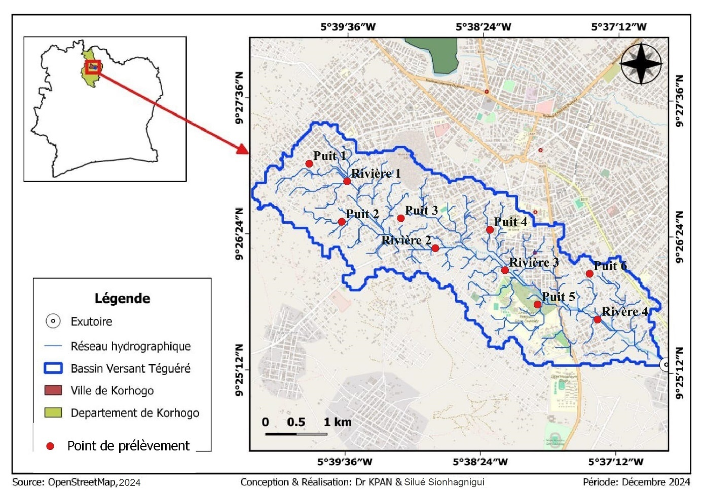
Figure 1: Map of sampling sites along the Téguéré River basin.

2.1 Study Design and Sampling Sites

Hydrochemical data were collected during a field campaign conducted on 11 March 2025 and supplemented by laboratory analyses. Both surface water (including a natural spring) and groundwater (from wells and boreholes) were sampled. In situ measurements included temperature, pH, and electrical conductivity.
Sampling sites were selected based on their proximity to peri -urban agricultural areas along the Téguéré River. A total of ten sites were included: six groundwater sites (wells and boreholes) and four surface water sites (Figure 1). Site selection aimed to capture potential gradients of agricultural influence on water quality. This sampling strategy aims to maximize the environmental and health relevance of the study by focusing on areas most likely to exhibit pesticide contamination (Konan et al. 2023). Furthermore, choosing sites near agricultural areas allows for a targeted assessment of the actual impact of local agricultural practices on surface and groundwater quality, while also facilitating the identification of spatial gradients of contamination (Chow et al. 2020). This approach is commonly recommended in environmental monitoring studies aimed at linking diffuse sources of pollution to concentrations observed in aquatic environments (Stehle and Schulz 2015, Chow et al. 2020).

2.2 Field Equipment and Procedures

Field measurements were performed using a Garmin ETrex 32X GPS to record UTM coordinates. The Garmin The eTrex 32x GPS offers a typical position accuracy of less than ±10 meters for geographic coordinates, with potential improvement to <5 meters when using WAAS/EGNOS (Differential Navigation System) corrections under optimal conditions. A multiparameter probe (HI9829-03042, Hanna Instruments) was used to measure temperature, pH, and electrical conductivity directly on site. The HI9829-03042 probe provides high accuracy (±0.02 pH, ±1% EC, ±0.15 °C) for field measurements, making it a reliable instrument for the physicochemical characterization of surface and groundwater. For sampling , 500 mL polyethylene bottles were used , carefully labeled with site- specific codes using adhesive tape and permanent markers (Shelton 1994). Surface water samples were collected by filling the bottles directly using a clean sampling cup. Groundwater from wells was collected using a stainless-steel ladle. After collection, all samples were stored in cooled containers and transported to the laboratory for chemical analysis (Koparan et al. 2019).

2.3 Laboratory Equipment and analytical Methods

Chemical analyses were conducted at the Central Hygiene Laboratory Food and Agro-industry (LCHAI). A Shimadzu HPLC system was used, including a TRAY reservoir with 10 mL methanol (mobile phase), a DGU-20A5 degasser, a SIL-20A autosampler , an LC-20AT pump, a CTO-20A column oven, and an SPD-20A UV/Vis detector. Data acquisition and preliminary processing were performed using LC Solution software (Lipps et al. 2023). Spatial analyzes were conducted using ArcGIS 10.2.2.
Pesticides were extracted from water samples using solid-phase extraction (SPE) with C18 cartridges. Columns were conditioned with 10 mL methanol and equilibrated with 10 mL deionized water. A 10 mL water sample was passed through the column to retain pesticides. After 30 minutes of drying, adsorbed pesticides were eluted with 5 mL methanol. The eluate was analyzed by HPLC-MS to identify and quantify multiple residues simultaneously (Nakhjavan et al. 2021, Von Ameln Lovison et al. 2021). Detection limits ranged from 0.002 µg/L to 0.0058 µg/L (Casado et al. 2018, Meng et al. 2024). Some parameters, including temperature, pH, and electrical conductivity, were measured directly on site to prevent alteration during transport (Ruiz-Gil et al. 2008). These measurements provide essential baseline data for interpreting laboratory analyses.
2.4 Data Analysis

Descriptive statistical analyzes were performed to determine the minimum and maximum values, means, and standard deviations of the measured parameters, in accordance with the methodological practices used in similar studies on the quality of water contaminated by pesticides (Kouamé et al. 2022, Konan et al. 2023).
Assessment of water quality with respect to pesticide contamination was further refined using two specific indices: the Pesticide Contamination Index (PCI) and the Pesticide Alteration Index (PAI) (Mark et al. 2006). These indices provide a comprehensive and quantitative evaluation of pollution levels based on the concentrations of detected active substances (Rocha et al. 2015). The assessment of water quality with respect to the presence of active substances was supplemented by the calculation of synthetic indices such as the Pesticide Contamination Index (PCI) and the Pesticide Alteration Index (PAI), recognized for their ability to quantitatively summarize the level of pesticide pollution in aquatic environments (Atto and Monde 2020, Kouamé et al. 2022). The concentration of each active substance was calculated using:
$$C_{P}=\frac{S_{c}×C_{e}×V_{2}×V_{f}×F}{S_{e}×M_{e}×V_{1}}$$
C_{P:} Concentration of active substance (mg/L); S_{C} : peak area of sample; S_{e} : peak area of standard; C _{e} : concentration of standard (mg/L); V₁ : volume to be purified (L); V ₂ : volume after purification (L); V_{f} : final volume (L); M_{e} : sample volume (L); F: dilution factor.

2.5 Principal Component Analysis (PCA)

To explore the relationships between sampling sites and pesticide contamination patterns, and to identify the main factors controlling the spatial distribution of contaminants within the Téguéré River watershed, a principal component analysis (PCA) was applied to the analytical dataset. PCA is a multivariate statistical technique widely used in environmental sciences to reduce data dimensionality, identify correlations among variables, and discriminate potential pollution sources in complex hydrochemical datasets (Helena et al. 2000, Jolliffe and Cadima 2016). The PCA was performed on a data matrix composed of pesticide concentrations measured in both surface water and groundwater samples. Prior to analysis, all variables were standardized using z-score normalization (mean = 0, standard deviation = 1) to minimize the influence of differences in units and magnitude among the analyzed compounds, ensuring that each pesticide contributed equally to the formation of the principal components (Reimann et al. 2011).
The analysis was based on the correlation matrix, and principal components with eigenvalues greater than 1 were retained according to the Kaiser criterion (Aydin Uncumusaoğlu and Akkan 2017). The cumulative variance explained by the retained components was used to assess the adequacy of the factorial solution (Aydin Uncumusaoğlu and Akkan 2017). Factor loadings were examined to identify the pesticides most strongly associated with each principal component, while factor scores were used to evaluate the similarities and contrasts among sampling sites (Shrestha and Kazama 2007). Graphical representations, including biplots of variables and sampling sites, were employed to facilitate the interpretation of PCA results. These diagrams allowed the identification of clusters of sites characterized by similar contamination profiles, as well as the discrimination of chemical signatures associated with distinct pesticide families and potential sources. Such an approach is particularly effective for distinguishing diffuse agricultural inputs from localized contamination and for highlighting the role of hydrological connectivity between surface water and groundwater systems (Hussain et al. 2025). The interpretation of PCA outputs was further supported by spatial analysis using a geographic information system (GIS), enabling the integration of multivariate statistical results with the spatial distribution of sampling points. This combined statistical and spatial approach enhances the environmental relevance of the analysis and provides a more comprehensive understanding of pesticide transport processes, accumulation patterns, and source apportionment within the watershed (Helena et al. 2000).

3. results and discussion

3.1 Results

3.1.1 Physical characteristics of surface water and groundwater

Table 1 provides an overview of the main physicochemical parameters, including temperature, pH, and electrical conductivity, measured in both surface water and groundwater at several sampling sites. These parameters provide essential information on water quality and the environmental factors that influence it.
Table 1: Physicochemical Characteristics of Surface Water and Groundwater
Water Type | Variable | Min | Max | Standard Deviation | Mean
Surface Water | Temperature (°C) | 29.9 | 33.1 | 1.395 | 31.90
Surface Water | pH | 3.83 | 4.76 | 0.421 | 4.335
Surface Water | Conductivity (µS/cm) | 40.00 | 370.00 | 139.28 | 230
Groundwater | Temperature (°C) | 27.90 | 35.40 | 3.20 | 31.03
Groundwater | pH | 3.45 | 5.06 | 0.58 | 4.22
Groundwater | Conductivity (µS/cm) | 20.00 | 180.00 | 60.25 | 75.00

Surface water temperatures ranged from 29.9 to 33.1°C, with an average of 31.90°C and a relatively low standard deviation of 1.395, indicating limited thermal variation between sites. This low range suggests that surface water temperature is mainly controlled by ambient temperature and solar radiation, with limited influence from site-specific factors. In contrast, groundwater temperatures showed greater variability, ranging from 27.9 to 35.4°C, with an average of 31.03°C and a higher standard deviation of 3.20. pH values indicate that both surface water and groundwater are acidic. The pH of surface water ranged from 3.83 to 4.76, with an average of 4.34 and a standard deviation of 0.421, while the pH of groundwater ranged from 3.45 to 5.06, with an average of 4.22 and a standard deviation of 0.58. The slightly higher variability of pH in groundwater suggests heterogeneity in the geochemical conditions of the subsoil. Electrical conductivity, which reflects the ion content and overall mineralization of water, shows notable differences between surface water and groundwater. Surface water has values ranging from 40 to 370 µS/cm, with an average of 230 µS/cm and a standard deviation of 139.28. Groundwater, on the other hand, has lower conductivity values, ranging from 20 to 180 µS/cm, with an average of 75 µS/cm and a standard deviation of 60.25, suggesting lower mineralization and reduced influence from surface contaminants.

3.1.2 Water contamination by active molecules
3.1.2.1 Water contamination by active molecules in surface water

Pesticide concentrations in surface water vary significantly depending on the family and molecules. Among insecticides, the maximum values recorded range from 0.01 µg/L for deltamethrin to 3.45 µg/L for chlorpyrifos –ethyl (Table 2). The averages indicate that the molecules most frequently detected at significant levels are chlorpyrifos -ethyl (1.17 µg/L) and dimethoate (0.83 µg/L), while deltamethrin and carbosulfan remain at very low levels (0.01 and 0.02 µg/L respectively). The relatively high standard deviations, particularly for chlorpyrifos -ethyl (1.59) and parathion-ethyl (0.47), indicate high spatial or temporal variability. Herbicides follow a similar trend, with maximum levels observed for terbutryn (2.23 µg/L), atrazine, and prometryn (1.03 µg/L each). The averages reveal that certain molecules, such as terbutryn (0.56 µg/L) and prometryn (0.51 µg/L), are present at relatively high levels, while metazachlor (0.07 µg/L) and diuron (0.20 µg/L) appear in low concentrations. The high standard deviations for terbutryn (1.12 µg/L) and prometryn (0.53 µg/L) indicate a heterogeneous distribution, probably linked to localized agricultural applications or hydrological variations. Finally, the fungicide vinclozolin is detected at very low concentrations (mean 0.01 µg/L, standard deviation 0.01 µg/L), highlighting.
Table 2: Summary Statistics of detected pesticides by family and compound in surface water
Pesticide Group | Active Compound | Min (µg/L) | Max (µg/L) | SD (µg/L) | Mean (µg/L)
Insecticides | Parathion-methyl | 0.00 | 0.07 | 0.03 | 0.02
Insecticides | Chlorfenvinphos | 0.01 | 0.83 | 0.37 | 0.28
Insecticides | Parathion-ethyl | 0.03 | 0.95 | 0.47 | 0.51
Insecticides | Profenofos | 0.15 | 0.91 | 0.37 | 0.36
Insecticides | Dimethoate | 0.37 | 1.03 | 0.31 | 0.83
Insecticides | Chlorpyrifos-ethyl | 0.02 | 3.45 | 1.59 | 1.17
Insecticides | Carbosulfan | 0.00 | 0.04 | 0.02 | 0.02
Insecticides | Lambda-cyhalothrin | 0.03 | 0.49 | 0.23 | 0.15
Insecticides | Deltamethrin | 0.00 | 0.01 | 0.01 | 0.01
Herbicides | Metolachlor | 0.02 | 0.71 | 0.30 | 0.29
Herbicides | Metazachlor | 0.01 | 0.13 | 0.05 | 0.07
Herbicides | Atrazine | 0.00 | 1.03 | 0.48 | 0.33
Herbicides | Prometryne | 0.04 | 1.03 | 0.53 | 0.51
Herbicides | Terbutryn | 0.00 | 2.23 | 1.12 | 0.56
Herbicides | Diuron | 0.09 | 0.42 | 0.15 | 0.20
Fungicide | Vinclozolin | 0.00 | 0.01 | 0.01 | 0.01

3.1.2.2 Concentration of active molecules in groundwater

Pesticide concentrations in groundwater are generally low, but vary considerably depending on the molecule. Among insecticides, the highest concentrations are observed for profenofos (1.04 µg/L) and dimethoate (1.022 µg/L), while molecules such as deltamethrin and lambda- cyhalothrin have very low values (0.02 and 0.021 µg/L, respectively) (Table 3). The averages confirm this disparity: dimethoate (0.685 µg/L) and profenofos (0.428 µg/L) appear to be the most significantly present insecticides, while deltamethrin and parathion-methyl remain virtually negligible (0.003 and 0.004 µg/L). The high standard deviations for certain molecules, particularly profenofos (0.468) and dimethoate (0.406), reflect a high variability in concentrations, probably linked to local differences in application or hydrological factors. Herbicides show more consistent concentrations and are generally lower than those of insecticides. The highest maximum levels are for diuron (0.192 µg/L) and metolachlor (0.202 µg/L), while terbutryn is detected at very low levels (0.012 µg/L). The averages indicate that metolachlor (0.078 µg/L), metazachlor (0.060 µg/L), and diuron (0.065 µg/L) are the most prevalent herbicides, with other molecules detected at low concentrations. The standard deviations are relatively close.

Table 3: Summary Statistics of detected pesticides by family and compound in groundwater
Pesticide Family | Active Compound | Min (µg/L) | Max (µg/L) | SD (µg/L) | Mean (µg/L)
Insecticides | Parathion-methyl | 0.000 | 0.023 | 0.009 | 0.004
Insecticides | Chlorfenvinphos | 0.000 | 0.850 | 0.330 | 0.202
Insecticides | Parathion-ethyl | 0.000 | 0.870 | 0.353 | 0.149
Insecticides | Profenofos | 0.000 | 1.040 | 0.468 | 0.428
Insecticides | Dimethoate | 0.010 | 1.022 | 0.406 | 0.685
Insecticides | Chlorpyrifos-ethyl | 0.012 | 0.420 | 0.156 | 0.152
Insecticides | Carbosulfan | 0.000 | 0.240 | 0.091 | 0.056
Insecticides | Lambda-cyhalothrin | 0.000 | 0.021 | 0.010 | 0.009
Insecticides | Deltamethrin | 0.000 | 0.020 | 0.008 | 0.003
Herbicides | Metolachlor | 0.020 | 0.202 | 0.072 | 0.078
Herbicides | Metazachlor | 0.013 | 0.154 | 0.053 | 0.060
Herbicides | Atrazine | 0.000 | 0.050 | 0.022 | 0.022
Herbicides | Prometryne | 0.010 | 0.042 | 0.013 | 0.022
Herbicides | Terbutryn | 0.000 | 0.012 | 0.005 | 0.002
Herbicides | Diuron | 0.000 | 0.192 | 0.078 | 0.065
Fungicide | Vinclozolin | 0.000 | 0.022 | 0.010 | 0.008

3.1.2.3 Concentration of different pesticide families in surface waters and groundwater

The table 4 presents descriptive statistics for the concentrations of pesticide families in groundwater, including minimum and maximum values, mean, and standard deviation. These data allow us to assess both the magnitude of the concentrations and their variability across chemical families. Organophosphates and triazines, as well as their metabolites, stand out with the highest mean concentrations, at 0.453 µg/L and 0.466 µg/L, respectively. These two families also exhibit high standard deviations, 0.713 µg/L for organophosphates and 0.700 µg/L for triazines, reflecting a marked dispersion of values depending on the sampling site and period. The maximum concentrations observed confirm this variability, reaching 3.450 µg/L for organophosphates and 2.230 µg/L for triazines and their metabolites. These results suggest that these pesticide families contribute most to the chemical load of the studied groundwater and that their presence is likely to be significant at specific points. Substituted ureas, pyrethroids, and carbamates have lower mean concentrations, ranging from 0.024 to 0.202 µg/L, and relatively modest standard deviations, ranging from 0.018 to 0.167 µg/L. This indicates that the distribution of these pesticides in groundwater is more homogeneous and that concentration peaks are less pronounced. However, the maximum values remain significant for substituted ureas and pyrethroids, at 0.490 µg/L each, which could reflect occasional or localized inputs. Analysis of the minimum values reveals that for four out of six families, concentrations can be zero, suggesting that these pesticides are sometimes undetectable in certain water sources. Organochlorines and substituted ureas are the only families to show minimum values above zero, respectively 0.013 µg/L and 0.087 µg/L, which reflects a near-permanent presence, probably linked to the chemical persistence of these substances in the environment.

Table 4 : Summary of Pesticide Concentrations in Surface Water and Groundwater
Water Type | Statistical variables | Organo-phosphates | Organo-phosphorines | Triazines and metabolites | Carbamates | Substituted ureas | Pyrethroids
Surface Water | Minimum | 0.00 | 0.013 | 0.00 | 0.00 | 0.087 | 0.00
Surface Water | Maximum | 3.45 | 0.71 | 2.23 | 0.24 | 0.49 | 0.49
Surface Water | Standard deviation | 0.713 | 0.234 | 0.7 | 0.018 | 0.149 | 0.167
Surface Water | Mean | 0.453 | 0.175 | 0.466 | 0.024 | 0.202 | 0.077
Ground-water | Minimum | 0.00 | 0.013 | 0.00 | 0.00 | 0.00 | 0.00
Ground-water | Maximum | 3.45 | 0.71 | 2.23 | 0.24 | 0.49 | 0.49
Ground-water | Standard deviation | 0537 | 0.159 | 0.486 | 0.071 | 0.126 | 0.108
Ground-water | Mean | 0.321 | 0.112 | 0.195 | 0.043 | 0.12 | 0.077

3.1.3 Water quality index

Surface waters exhibit varying levels of chemical and agricultural pollution. The Chemical Pollution Index (CPI) ranges from 1.31 at River 4 to 2.08 at River 3, with an average of 1.63, corresponding to 20.1% of samples being of good quality, 47.9% of poor quality, and 32% of very poor quality (figure 2). The Agricultural Pollution Index (API) varies from 2.65 µg/L at River 4 to 7.78 µg/L at River 3, with an average of 5.30 µg/L, indicating that 29.7% of samples are of poor quality and 70.3% are of very poor quality (Figure 3).

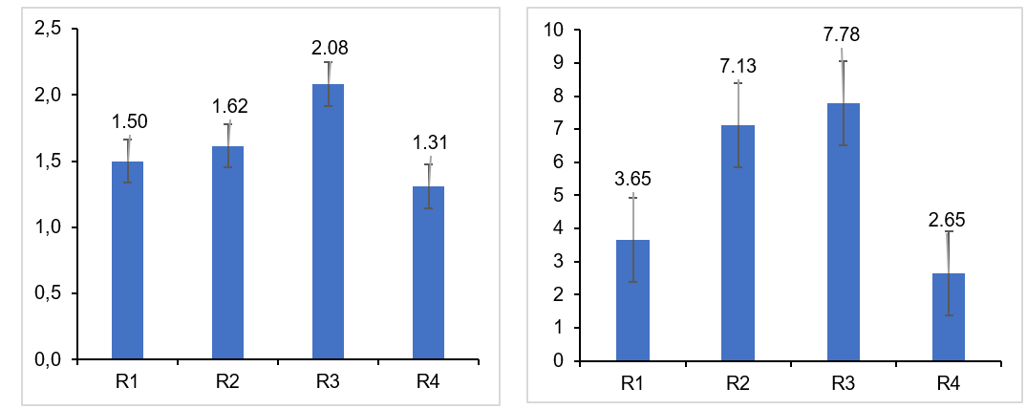
Figure 3 : Spatial distribution of Pesticide Alteration Indices (PAI) in surface waters.
Figure 2 : Spatial distribution of Pesticide contamination indices (PCIs) in surface waters.

In the groundwater, the Chemical Pollution Index (pCI) ranges from 1.00 at well 5 to 1.50 at well 3, with an average of 1.28, indicating that 60.86% of the samples are of good quality and 39.14% of poor quality (Figure 4). The Agricultural Pollution Index (API) ranges from 0.307 µg/L at well 5 to 3.085 µg/L at well 3, with an average of 1.945 µg/L, exceeding the limits established by the WHO and European Directive 98/83/EC (Figure 5). This situation reveals that 97.4% of the samples are of poor quality, compared to only 2.6% of good quality, highlighting significant agricultural pressure on groundwater resources.
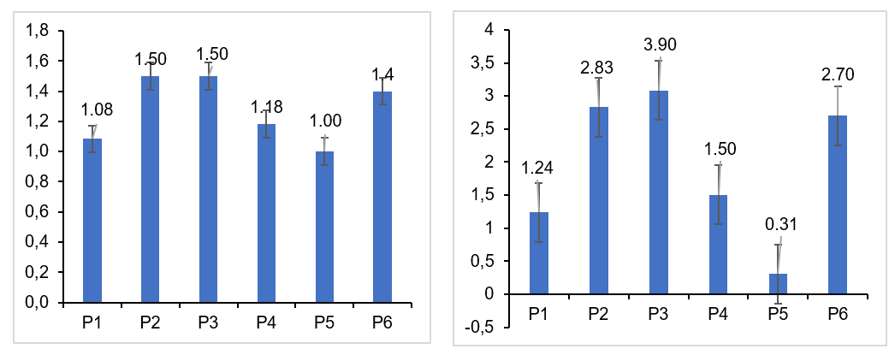
Figure 5 : Spatial distribution of Pesticide Alteration Indices (PAI) in groundwater.

Figure 4 : Spatial distribution of pesticide contamination indices (PCIs) in groundwater

3.1.4 Multivariate analysis of site-contaminant relationships

Principal component analysis (PCA) identified three main groups of measurement points based on their contamination profiles, revealing both spatial trends and specific chemical signatures (Figure 6).

Figure 6: Relationship between sampling sites and pesticide concentrations

Group 1 (Wells 1, 2, 4, 6, and River 4) has homogeneous profiles dominated by Dimethoate and Profenofos, two organophosphate insecticides widely used in intensive agriculture. This homogeneity suggests a point source or diffuse source linked to local agricultural practices, as well as hydrogeological conditions favorable to pesticide migration, such as shallow aquifers or highly permeable soils that facilitate infiltration and transport to wells and rivers.
Group 2 (Well 5 and River 2) stands out with a unique profile, marked by Chlorpyrifos-ethyl and Parathion-ethyl, indicating a localized source or specific hydrological connection. The strong contribution of these molecules to the second component (F2) suggests targeted or recent use, and their concomitant presence in the well and river could reflect rapid transfer from the surface to the hydrological network.
Group 3 (Rivers 1 and 3) shows intermediate profiles, dominated by Parathion-methyl and Vinclozolin, pesticides often associated with less intensive agricultural practices or specific crops. The variability observed probably reflects distinct watersheds, different hydrological regimes, and processes of dilution, adsorption, or biological degradation. Certain molecules, such as Terbutryn and Metolachlor, contribute to several axes, indicating multiple sources, complex transfers, or varied environmental behaviors, including persistence in soil and mobility in water.
The discrimination of pesticide sources by PCA, summarized in Figure 7, reveals three distinct poles: intensive agriculture, hydrological interactions, and watersheds with their own characteristics.
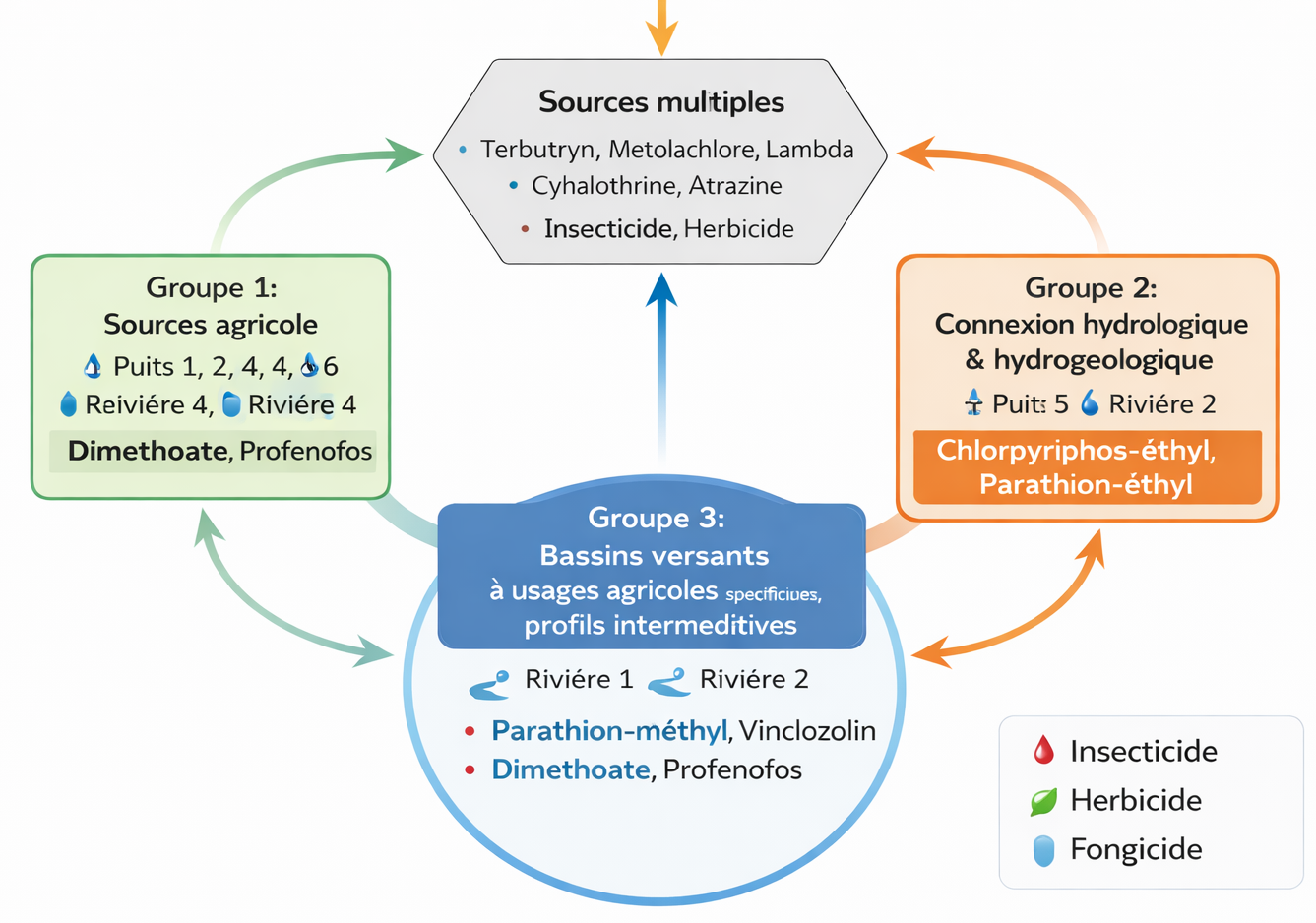
Figure 7: Mapping of sources by PCA

3.2 Discussion

Physico-chemical parameters of water
Analysis of the physicochemical parameters of the waters in the Teguéré River watershed reveals characteristics consistent with those observed in the humid tropical zones of West Africa. The average water temperature, estimated at 31.38 °C (31.9 °C for surface water and 31.03 °C for groundwater), is relatively high and comparable to values reported in the northern and forested regions of Côte d'Ivoire (Ebé et al. 2023, Yao et al. 2023). This temperature increase is explained by prolonged exposure to solar radiation, the absence of vegetation cover, and the shallow depth of the sampling points.
The average pH, 4.335 for surface water and 4.22 for groundwater, indicates marked acidity, linked to the structural acidity of the region's lateritic and granitic formations (Adjiri et al. 2019, Djahadi et al. 2021), exacerbated by the decomposition of organic matter, root respiration, and acid rain (Ossey et al. 2008, Yapo et al. 2016). Local agricultural practices, particularly the use of acidifying fertilizers and deforestation, also contribute to this acidity.
The average electrical conductivity is 230 µS/cm for surface water and 75 µS/cm for groundwater, reflecting higher mineralization at the surface, linked to agricultural runoff, domestic wastewater, and decomposing organic matter (Yapo et al. 2016, Yao and Ahoussi 2020). The low conductivity of groundwater reflects a reduced content of dissolved ions, typical of shallow aquifers on crystalline bedrock, but vulnerable to rapid infiltration of low-mineralized water (Ouattara et al. 2016). These values remain below the WHO limit of 500 µS/cm, but seasonal increases linked to agricultural spreading and rainfall are likely (Akognongbe et al. 2014, Lawani et al. 2017).

Contamination by active molecules
The results reveal widespread water contamination by agricultural active molecules, including organophosphates, organochlorines, triazines and metabolites, carbamates, substituted ureas and pyrethroids. These substances correspond to the most commonly used insecticides, herbicides and fungicides locally, often in an unregulated manner (Garud et al. 2024). Some molecules, such as parathion-methyl, parathion-ethyl, chlorfenvinphos, metazachlor and vinclozoline, are not registered for agricultural use in Côte d'Ivoire, suggesting illicit use (Dibi et al. 2012, Amadou et al. 2020).
In surface waters, several concentrations far exceed the WHO thresholds (0.1 µg/L per pesticide) and the European limits (0.5 µg/L for the total sum) (WHO 2024). Chlorpyrifos-ethyl (3.45 µg/L) and terbutryne (2.23 µg/L) illustrate local but intense inputs linked to local market gardening practices (Doumbia and Kwadjo 2009). Factors contributing to this contamination include the excessive and empirical use of pesticides, the absence of vegetated buffer zones, and intense runoff during the rainy season (Kouadio et al., 2021; Ahouangninou et al., 2011).
In groundwater, concentrations are generally lower, but some substances such as dimethoate (1.022 µg/L) and profenofos (1.04 µg/L) exceed the standards, indicating diffuse contamination through leaching and infiltration from agricultural areas (Kamenan et al. 2020). The total sum of residues in several wells also exceeds 0.5 µg/L, confirming high agricultural pressure on groundwater (Koné et al., 2018). Ecotoxicological effects include the loss of aquatic biodiversity and bioaccumulation in the food web, while health risks concern chronic exposure, which can lead to neurological, endocrine, and carcinogenic disorders ( Mostafalou & Abdollahi , 2017; Mamy & Barriuso , 2018).

Distribution of pesticide families
In surface waters, triazines and metabolites dominate (0.466 µg/L), followed by organophosphates (0.453 µg/L), substituted ureas (0.202 µg/L), organochlorines (0.175 µg/L), pyrethroids (0.077 µg/L) and carbamates (0.024 µg/L), reflecting the intensive use of triazine herbicides and their persistence in soils (Fingler et al. 2021, Gu et al. 2023). In groundwater, organophosphates predominate (0.232 µg/L), followed by organochlorines (0.069 µg/L), substituted ureas (0.065 µg/L), carbamates (0.056 µg/L), pyrethroids (0.035 µg/L), and triazines (0.015 µg/L), due to their solubility and frequent use, which promote leaching (Müller et al. 2002). The persistence of organochlorines, despite the ban, reflects their chemical stability and historical or illicit contamination (Troiano et al. 2001). Minor families, such as pyrethroids and carbamates, also present significant toxicological potential (Daam and Rico 2018). These observations are part of a global context of groundwater pollution by pesticides, exacerbated by intensive agricultural practices and limited regulatory oversight(Malla et al. 2021, Acharya et al. 2025).

Water resource quality indices
The contamination index (CI) and alteration index (AI) confirm a significant deterioration in water quality. For surface waters, the CI ranges from 1.31 to 2.08 (mean 1.63), indicating a significant impact of pesticides (Ariza Restrepo et al. 2023). According to the AI, 70.3% of the samples exhibit very poor quality, with concentrations exceeding WHO and European thresholds (0.1 µg/L per pesticide and 0.5 µg/L for the total). In groundwater, the ICP is between 1 and 1.5 (mean = 1.28), indicating lower but persistent pollution, with 39.14% of samples of poor quality. However, the IAP reveals that 97.4% of wells exceed the limit of 0.5 µg/L, highlighting diffuse and chronic contamination of groundwater, aggravated by unregulated agricultural practices and the absence of integrated management (Soro et al. 2022). These results confirm the urgency of monitoring measures and sustainable agricultural strategies to protect local water resources.

Multivariate analysis of site-contaminant relationships
The spatial structuring of pesticide contamination revealed by PCA in this study aligns well with recent research using similar multivariate techniques. For instance, a 2025 investigation of organophosphorus pesticides in groundwater from the Campania Plain (Southern Italy) identified Dimethoate, Chlorpyrifos, and Parathion as the most prevalent contaminants and demonstrated strong correlations between pesticide distribution, land use, and agricultural intensity using PCA, highlighting contamination hotspots in intensively farmed areas (De Rosa et al. 2025). Studies in other agricultural regions, such as the Júcar River Basin in Spain, also report marked spatial variability in pesticide contamination of groundwater, where concentrations reflect the intensity of agricultural land use (Pérez-Indoval and Romero-López 2024). These patterns support the interpretation that groups of sites with similar contamination profiles share common drivers related to agricultural practices and hydrological connectivity. In a broader context, global reviews of pesticide occurrence in rivers indicate that organophosphorus compounds such as Chlorpyrifos and Malathion remain widespread in aquatic systems worldwide, underscoring their frequent dominance in contamination profiles (López-Benítez et al. 2024). Furthermore, regional monitoring data show that pesticides continue to be detected above regulatory thresholds in both surface water and groundwater across Europe, providing additional evidence of pervasive agricultural contamination (Baran et al. 2022). Collectively, these findings confirm that pesticide distribution is influenced by land use, hydrology, and contaminant properties, and that multivariate statistical methods like PCA are effective tools for discriminating sources and interpreting complex contamination patterns.

4. Conclusion

This study highlights the growing vulnerability of urban and peri-urban water resources in Korhogo, northern Côte d’Ivoire, under the combined pressures of rapid urbanization and intensive peri-urban agriculture. The results demonstrate that both surface water and groundwater are affected by pesticide contamination, with several compounds exceeding World Health Organization guideline values, posing potential risks to human health and ecosystem integrity. The detection of multiple pesticide families across interconnected water compartments underscores the importance of considering surface–groundwater interactions in urban water assessments. Water quality indices and multivariate analysis reveal that agricultural practices represent a dominant pressure on water resources, while local hydrogeological conditions modulate contamination pathways. These findings emphasize the need to integrate peri-urban agriculture into urban water governance frameworks. Strengthening pesticide regulation, improving monitoring programs, and promoting safer agricultural practices are essential to support sustainable urban water management and protect drinking water supplies in rapidly growing secondary cities of sub-Saharan Africa.

References

Acharya, L.K., Paramaguru, P.K., Tripathi, K., Bhoi, T.K., Seth, P. & Birah, A., 2025. Pesticide contamination in groundwater: Processes, risks, and mitigation strategies. Discover Agriculture, 3 (1), 152 Available from: https://doi.org/10.1007/s44279-025-00337-x.
Adjiri, O.A., Kone, B., Aka, N., Djabakate, I. & Dibi, B., 2019. Physico-chemical characterization and source of mineralization of groundwater in the Daloa and Zoukougbeu departments, Côte d'Ivoire. International Journal of Biological Chemical Sciences, 13 (4), 2388-2401.
Akognongbe, A.J., Mama, D., Vissin, E.W. & Boko, M., 2014. Seasonal dynamics of the physico-chemical quality of surface waters in the Ouémé basin at the Beterou outlet. Rev. Ivoir. Sci. Technol, 24, 278-298.
Amadou, A., Gautier, K.O.J., Maxime, G.F., Solange, O.Y.M. & Jean, B., 2020. Impacts of agrochemicals on water quality parameters in Aboisso region (south-east of Côte d'Ivoire). Current Journal of Applied Science Technology, 39 (46), 1-19.
Ariza Restrepo, J.L., Rodriguez Diaz, Y.J. & Onate Barraza, H.C., 2023. Water quality indices (WQI) and contamination indices (WPI): a bibliographic review. Tecnura, 27 (77), 121-140. Atto, Y. & Monde, S.J., 2020. Assessment of the level of contamination of Lake Adaou (eastern Côte d'Ivoire) by phytosanitary products. Environmental Dynamics. International Journal of Geosciences and Environment, (45), 56-60.
Aydin Uncumusaoğlu, A. & Akkan, T., 2017. Assessment of water quality of Yağlıdere stream (Turkey) using multivariate statistical techniques. Polish Journal of Environmental Studies, 26 (4), 1715-1723.
Ballé, G.R.S., 2024. Urban and peri-urban market gardening in the face of the scarcity of production factors in the city of Korhogo (Côte d'Ivoire). African Journal of Environment and Agriculture, 7 (4), 56-66.
Baran, N., Rosenbom, A.E., Kozel, R. & Lapworth, D., 2022. Pesticides and their metabolites in European groundwater: Comparing regulations and approaches to monitoring in France, Denmark, England and Switzerland. Science of The Total Environment, 842, 156696 Available from: https://www.sciencedirect.com/science/article/pii/S0048969722037937.
Carvalho, F.P.J., 2017. Pesticides, environment, and food safety. Food Energy Security, 6 (2), 48-60.
Casado, J., Santillo, D. & Johnston, P., 2018. Multi-residue analysis of pesticides in surface water by liquid chromatography quadrupole-Orbitrap high resolution tandem mass spectrometry. Anal Chim Acta, 1024, 1-17. Chow, R., Scheidegger, R., Doppler, T., Dietzel, A., Fenicia, F. & Stamm, C.J.X., 2020.
A review of long-term pesticide monitoring studies to assess surface water quality trends. Water research x, 9, 100064.
Coulibaly, T.H., 2024. Urban agriculture and supply of markets in the city of Korhogo (northern Ivory Coast). International Journal of Researchers, 5 (1), 438-454.
Daam, M.A. & Rico, A., 2018. Freshwater shrimps as sensitive test species for the risk assessment of pesticides in the tropics. Environ Sci Pollut Res Int, 25 (14), 13235-13243.
De Rosa, E., Cerino, P., Triassi, M., Di Duca, F., Porreca, A., Russo, I., Scippa, S., Venuta, A., Coppola, A., Pizzolante, A., Nicodemo, F., Trama, U., Policino, F. & Montuori, P., 2025.
Contamination assessment and risk evaluation of organophosphorus pesticides in groundwater: A study on contamination patterns and implications. Journal of Hazardous Materials Advances, 18, 100701 Available from: https://www.sciencedirect.com/science/article/pii/S2772416625001135.
Dibi, B., Kouame, K.I., Konan-Waidhet, A.B., Savane, I., Biemi, J., Nedeff, V. & Lazar, G., 2012. Impact of agriculture on the quality of groundwater resources in peri-urban zone of Songon (Ivory Coast). Environmental Engineering Management Journal, 11 (12), 2173-2182.
Djahadi, S.D., Sandao, I., Ahmed, Y., Harouna, M. & Ousmane, B., 2021. Physico-chemical characteristics of groundwater in the bedrock of the Goroubi watershed in the commune of Torodi/Liptako, Niger. International Journal of Biological Chemical Sciences, 15 (6), 2715-2729.
Dosso, M., Martin, T., Ouedraogo, R., Bancal, V., Deletre, E., Angbo-Kouakou, E., Masse, D. & Avadi, A., 2025. Functional analysis of the peri-urban market gardening sector in Côte d'Ivoire (2021-2025).
Doumbia, M. & Kwadjo, K., 2009. Practices of pesticide use and management by market gardeners in Côte d'Ivoire: Case of the city of Abidjan and two of its suburbs (Dabou and Anyama). Journal of Applied Biosciences, 18, 992-1002.
Ducroquet, H., Tillie, P., Elouhichi, K. & Gomez, Y., 2017. Agriculture in Côte d'Ivoire under the microscope: State of play of plant and animal production sectors and review of agricultural policies, 9279731793.
Ebé, A.E.D., Yao, K.S.A. & Ahoussi, K.E., 2023. Determination of the physico-chemical quality of water resources in the Loka watershed in Bouaké, central Côte d'Ivoire. International Journal of Innovation Applied Studies, 41 (1), 105-114.
Fingler, S., Mendaš, G., Dvoršćak, M., Stipičević, S., Vasilić, Ž. & Drevenkar, V., 2021. Seasonal distribution of multiclass pesticide residues in the surface waters of northwest croatia. Arh Hig Rada Toksikol, 72 (4), 280-288.
Fletcher, T.D., Andrieu, H. & Hamel, P.J.a.I.W.R., 2013. Understanding, management and modeling of urban hydrology and its consequences for receiving waters: A state of the art. 51, 261-279.
Garud, A., Pawar, S., Patil, M.S., Kale, S.R. & Patil, S., 2024. A scientific review of pesticides: Classification, toxicity, health effects, sustainability, and environmental impact. Cureus, 16 (8), e67945.
Goula, B., Kouassi, V. & Savane, L., 2006. Impacts of climate change on water resources in humid tropical zones: Case of the Bandama watershed in Ivory Coast. African Agronomy, 18 (1), 1-11.
Gu, W., Xing, W., Liang, M., Wang, Z., Zhang, B., Sun, S., Fan, D. & Wang, L., 2023. Occurrence, distribution, and risk assessment of pesticides in surface water and sediment in jiangsu province, china. Environ Sci Pollut Res Int, 30 (56), 118418-118429.
Helena, B., Pardo, R., Vega, M., Barrado, E., Fernandez, J.M. & Fernandez, L., 2000. Temporal evolution of groundwater composition in an alluvial aquifer (Pisuerga river, Spain) by principal component analysis. Water Research, 34 (3), 807-816 Available from: https://www.sciencedirect.com/science/article/pii/S0043135499002250.
Hussain, F., Ahmed, S., Muhammad Zaigham Abbas Naqvi, S., Awais, M., Zhang, Y., Zhang, H., Raghavan, V., Zang, Y., Zhao, G. & Hu, J., 2025. Agricultural non-point source pollution: Comprehensive analysis of sources and assessment methods. Agriculture, 15 (5), 531.
Jolliffe, I.T. & Cadima, J., 2016. Principal component analysis: A review and recent developments. Philosophical Transactions of the Royal Society A: Mathematical, Physical and Engineering Sciences, 374 (2065), 20150202 Available from: https://doi.org/10.1098/rsta.2015.0202 [Accessed 12/21/2025].
Kamenan, Y.M., Mangoua, O.M.J., Dibi, B., Georges, S.E., Kouassi, K.L., Kouassi, K.A. & Protection, 2020. Assessment of vulnerability to groundwater pollution in the Lobo watershed at Nibéhibé (central-west, Côte d'Ivoire). Journal of Water Resource, 12 (8), 657-671.
Kaushal, S.S., Likens, G.E., Pace, M.L., Utz, R.M., Haq, S., Gorman, J. & Grese, M., 2018. Freshwater salinization syndrome on a continental scale. Proceedings of the National Academy of Sciences, 115 (4), E574-E583.
Konan, K.J.-P., Yao, K.T. & Adiaffi, B., 2023. Evaluation of water resource pollution by agricultural activities in the Loka watershed in the Sakassou department, Côte d'Ivoire. Afrique Science, 22 (3), 34-43. Koparan, C., Koc, A.B., Privette, C.V. & Sawyer, C.B., 2019.
Autonomous in situ measurements of noncontaminant water quality indicators and sample collection with a UAV. Water Research X, 11 (3), 604.
Kouamé, K.A., Éba, A.E.L., Serge Kouakou, D., Déabo, B.F. & Dongo, K., 2022. Induced effect of pesticide use in market gardening on the environment and human health in Daloa, Côte d'Ivoire. Rev. Ivoir. Sci. Technol., 88-105.
Kpan, K., Yao, B., Diemeleou, C., N’guettia, R., Traore, S. & Dembele, A., 2019. Phytosanitary practices in peri-urban agriculture and food contamination by pesticides: The case of market gardeners in Port-Bouët (Abidjan). Anim Plant Sci, 41, 6847-63.

Lawani, R., Kelome, N., Agassounon Djikpo Tchibozo, M., Hounkpe, J. & Adjagodo, A., 2017. Effects of agricultural practices on surface water pollution in the Republic of Benin. Larhyss Journal, 14 (2), 173-190.
Lipps, W.C., Braun-Howland, E.B. & Baxter, T.E., 2023. Standard methods for the examination of water and wastewater. 24th edition. American public health association, american water works association: washington dc.
López-Benítez, A., Guevara-Lara, A., Domínguez-Crespo, M.A., Andraca-Adame, J.A. & Torres-Huerta, A.M., 2024. Concentrations of organochlorine, organophosphorus, and pyrethroid pesticides in rivers worldwide (2014–2024): A review. 16 (18), 8066 Available from: https://www.mdpi.com/2071-1050/16/18/8066.
Malla, M.A., Gupta, S., Dubey, A., Kumar, A. & Yadav, S., 2021. Chapter 7 - contamination of groundwater resources by pesticides. In Ahamad, A., Siddiqui, S.I. & Singh, P. eds. Contamination of water. Academic Press, 99-107.
Mambe-Ani, P., Ouattara, K.N., Elleingand, F.E. & Kadjo, V., 2019. Assessment of the impact of pesticide use in urban and periurban agriculture in Abidjan, Ivory Coast. International Journal of Biological Chemical Sciences, 13 (6), 2824-2837.
Mark, D.M., Robert, J.G., Patrick, W.M. & Lisa, H.N., 2006. Pesticide toxicity index for freshwater aquatic organisms, 2nd edition. 87.
Mcdonald, R.I., Mansur, A.V., Ascensão, F., Colbert, M.L., Crossman, K., Elmqvist, T., Gonzalez, A., Güneralp, B., Haase, D. & Hamann, M., 2020. Research gaps in knowledge of the impact of urban growth on biodiversity. Nature Sustainability, 3 (1), 16-24.
Mcgrane, S.J., 2016. Impacts of urbanization on hydrological and water quality dynamics, and urban water management: A review. Hydrological Sciences Journal, 61 (13), 2295-2311.
Meng, L., Yao, W., Wen, L., Fu, X., Qi, Y. & Volmer, D.A., 2024. Optimized liquid chromatography-tandem mass spectrometry protocol for enhanced detection of 45 pesticides in water and soil samples. Rapid Commun Mass Spectrom, 38 (21), e9904.
Müller, K., Bach, M., Hartmann, H., Spiteller, M. & Frede, H.G., 2002. Point‐and nonpoint‐source pesticide contamination in the zwester ohm catchment, germany. Journal of environmental quality, 31 (1), 309-318.
Nakhjavan, B., Bland, J. & Khosravifard, M., 2021. Optimization of a multiresidue analysis of 65 pesticides in surface water using solid-phase extraction by lc-ms/ms. Molecules, 26 (21).
Nyenje, P., Foppen, J., Uhlenbrook, S., Kulabako, R. & Muwanga, A., 2010. Eutrophication and nutrient release in urban areas of sub-Saharan Africa—a review. Science of the total environment, 408 (3), 447-455.
Obuobie, E., Keraita, B., Danso, G., Amoah, P., Cofie, O.O., Raschid-Sally, L. & Drechsel, P., 2006. Irrigated urban vegetable production in Ghana: Characteristics, benefits and risks.
Ossey, B.Y., Mambo, V., Abiba, S.T. & Houenou, P.V., 2008. Analytical study of the chemical characteristics of a eutrophic lake in a tropical environment: Conductivity as an indicator of trophic status of Lake Buyo (Côte d'Ivoire). Journal of the West African Chemical Society, 25, 87-108.

Ouattara, I., Kamagaté, B., Dao, A., Noufé, D. & Savané, I., 2016. Groundwater mineralization process and flow transfer in a fissured basement environment: Case of the Comoé cross-border watershed (Ivory Coast, Burkina Faso, Ghana, Mali)[groundwaters mineralization process and transfer of flow within fissured aquifers: Case of transboundary basin of Comoé (Ivory Coast, Burkina Faso, Ghana, Mali)]. International Journal of Innovation Applied Studies, 17 (1), 57.
Paul, M.J. & Meyer, J.L., 2001. Streams in the urban landscape. Annual review of Ecology Systematics, 32 (1), 333-365.
Pérez-Indoval, R. & Romero-López, R., 2024. Assessment of pesticide contamination in groundwater bodies in the jucar river basin (spain) and its spatial distribution. Groundwater for Sustainable Development, 25, 101118 Available from: https://www.sciencedirect.com/science/article/pii/S2352801X24000419.
Reimann, C., Filzmoser, P., Garrett, R. & Dutter, R., 2011. Statistical data analysis explained: Applied environmental statistics with r: John Wiley & Sons.
Rocha, F.C., Andrade, E.M. & Lopes, F.B., 2015. Water quality index calculated from biological, physical and chemical attributes. Environ Monit Assess, 187 (1), 4163.
Roy, A.H., Wenger, S.J., Fletcher, T.D., Walsh, C.J., Ladson, A.R., Shuster, W.D., Thurston, H.W. & Brown, R.R., 2008. Impediments and solutions to sustainable, watershed-scale urban stormwater management: Lessons from Australia and the United States. Environmental management, 42 (2), 344-359.
Ruiz-Gil, L., Romero-González, R., Garrido Frenich, A. & Martínez Vidal, J.L., 2008. Determination of pesticides in water samples by solid phase extraction and gas chromatography tandem mass spectrometry. J Sep Sci, 31 (1), 151-61.
Shelton, L.R., 1994. Field guide for collecting and processing stream-water samples for the national water-quality assessment program: US Geological Survey.
Shrestha, S. & Kazama, F., 2007. Assessment of surface water quality using multivariate statistical techniques: A case study of the fuji river basin, japan. Environmental Modeling & Software, 22 (4), 464-475 Available from: https://www.sciencedirect.com/science/article/pii/S136481520600048X.
Soro, T.D., Fossou, N.M.R., Kone, G.Y.M., Oga, Y.M.-S. & Soro, N., 2022. Assessment of groundwater quality in the Grand-Lahou department (southwest of Ivory Coast) based on the wqi index. International Journal of Innovation Applied Studies, 38 (2), 417-427.
Stehle, S. & Schulz, R., 2015. Agricultural insecticides threaten surface waters at the global scale. Proceedings of the National Academy of Sciences, 112 (18), 5750-5755.
Traoré, M., 2025. Land artificialization and urban heat island development in Korhogo, northern Ivory Coast. Urban Art BioO, 4 (01), 1-16.
Troiano, J., Weaver, D., Marade, J., Spurlock, F., Pepple, M., Nordmark, C. & Bartkowiak, D., 2001. Summary of well water sampling in California to detect pesticide residues resulting from nonpoint-source applications. Journal of Environmental Quality, 30 (2), 448-459.
UN-Habitat, 2016. Urbanization and development: Emerging futures. 3 (4), 4-51.
Von Ameln Lovison, O., Jank, L., De Souza, W.M., Ramalho Guerra, R., Lamas, A.E., Da Costa Ballestrin, R.A., Da Silva Morais Hein, C., Da Silva, T.C.B., Corção, G. & Martins, A.F., 2021. Identification of pesticides in water samples by solid-phase extraction and liquid chromatography-electrospray ionization mass spectrometry. Water Environ Res, 93 (11), 2670-2680.
WHO, 2022. Guidelines for drinking-water quality: Incorporating the first and second addenda: World Health Organization.
WHO, 2024. Guidelines for drinking-water quality: Small water supplies: World Health Organization.
Yao, K.a.F., Ahoussi, K.E., Koffi, Y.B., Tivoli, L.M.S., Salze, D. & Lopez-Ferber, M.J.E.S.J., 2023. Hydrochemical characterization and evaluation of groundwater quality in the mining environment of the Afema canton (southeast Côte d'Ivoire). European Scientific Journal, 19 (6), 248002E
Yao, K.S.A. & Ahoussi, K., 2020. Physicochemical characterization of surface waters in a mining environment in central-western Côte d'Ivoire: Case of the Divo department. European Scientific Journal, 16, 12.
Yapo, R.I., Mambo, V., Alder, A.C., Ohou-Yao, M.J., Ligban, R., Dao, D., Stamm, C. & Bonfoh, B., 2016. Seasonal characterization of well water used for market gardening and domestic purposes in Korhogo (Côte d'Ivoire). International Journal of Biological and Chemical Sciences, 10 (3), 1433-1449.

