Climate projection in the Volta Basin by 2099: Precipitation and temperature

Abstract
Climate change is a global phenomenon caused by the emission of greenhouse gases into the atmosphere, resulting in an increase in global average temperatures. It occurs over long periods of time (typically decades). Given the high intrinsic variability of the climate in West Africa, which occurs over short time scales, it is difficult to clearly determine the impacts of general climate change from natural climate variability. The objective of this study is to assess climate change by 2099 in the Volta Basin region during the rainy season from June to September using the ICTP's RegCM4 regional model. This regional model is forced at its boundaries by two CMIP5-ESM global models, GFDL-ESM-2M and HadGEM2-ES, following the latest IPCC RCP4.5 and RCP8.5 scenarios. The results confirm that RegCM4 provides improvements over global models. The projection for 2099 shows that temperatures are higher in the north, with 3 to 4°C under RCP4.5 and 4 to 5°C under RCP8.5. This area also sees a significant decrease in precipitation. In contrast, south of the Volta Basin, there is a significant increase in precipitation. The Sahel remains less rainy and warmer than the Sudano-Sahelian and Guinean regions. In view of these results, environmental issues are very critical for the future. Consequently, there is a need to strengthen the adaptive capacities of farmers and local actors to avoid suffering from so-called natural disasters.
Keywords: Climate change, Climate modelling, Model GFDL-ESM-2M, Model HadGEM2-ES, Model RegCM4.5
1. Introduction
Climate change poses an increasingly noticeable threat to the sustainability of rural households in sub-Saharan Africa, where communities live mainly from the exploitation of natural resources [1]. This significant decline is reflected in variations in rainfall, rising temperatures and extreme weather events [2]. Changes in rainfall (spatio-temporal variations, intensity and frequency) and global warming have become urgent issues for climatologists and hydrologists ([3]; [4]). Indeed, the impact of climate change (CC) on quality of life, particularly in economic and social terms, makes reliable and accurate climate forecasts more necessary than ever [5].
Today, general circulation models coupled with the atmosphere and ocean (GCMO) are considered the most advanced numerical tools for better understanding the dynamics of the physical components of the climate system. To this end, projections based on assumptions about greenhouse gas (GHG) and aerosol emissions are the subject of several studies [6].
The Volta Basin region in West Africa is particularly vulnerable to the adverse effects of climate change [7]. This has prompted numerous recent studies aimed at analysing and characterising changes in several climate parameters using global climate models (GCMs) and regional climate models (RCMs) at different spatial scales ([8];[9]). Studies based on phase 3 of the Coupled Model Intercomparison Project [6] and phase 5 (CMIP5) [10], as well as the CORDEX (Coordinated Regional Climate Downscaling Experiment) ([11]; [12]) have identified variations in various climate parameters at the end of the 21st century ([13]; [14]; [15]). In order to take GHG emissions into account, these models are forced according to emission scenarios developed by the Intergovernmental Panel on Climate Change (IPCC).
The Volta Basin region in West Africa is particularly vulnerable to the adverse effects of climate change. The region's climate is controlled by two air masses: the north-easterly winds and the south-westerly monsoons. The north-easterly winds, known as the Harmattan, blow from the interior of the continent and are dry and dusty. In contrast, the south-westerly monsoons blow from the sea and are humid. The interface between these two air masses is called the Intertropical Convergence Zone (ITCZ). Several convective activities take place in the ITCZ, which is why the region experiences considerable rainfall. The ITCZ moves northward and then southward across the basin from around March to October during the region's rainy season [16]. Consequently, the development of climate modelling in this region is of crucial importance.
Recognising the region's vulnerability to climate change, several simulations have been jointly developed by researchers from the WASCAL, PANA, GLOWA, CPW, Volta-HYCOS and other projects. In addition, a new model domain needs to be identified to cover the above-mentioned issues and reduce the climate range of the basin region based on CMIP5 data. The parameters studied are temperature and precipitation.
In this study, we examine this question by analysing a set of high-resolution GCM and RCM experiments generated with the latest version of the International Centre for Theoretical Physics (ICTP) model, RegCM4 [11], trained at its boundaries by two CMIP5 models (ESM) models [10] and two IPCC Representative Concentration Pathways (RCP) scenarios (RCP4.5 and RCP8.5) [18]. The study is based on a novel set of projections for the 21st century with the RegCM4 MCR driven by five different general circulation models (GCMs), at a grid spacing of 25 km according to the representative concentration pathways RCP4.5 and RCP8.5.
2. Materials and methods
2.1. Description of the RegCM4 model
The model used in this study is a regional RegCM4 model (Giorgi et al., 2012), which is the latest version from the International Centre for Theoretical Physics (ICTP). RegCM4 is based on the fifth-generation hydrostatic dynamic core from the National Centre for Atmospheric Research (NCAR, USA) and Pennsylvania State University (PSU, USA), enhanced by Mesoscale Meteorological Model version 5 (MM5) [18]. Previous versions of this model have been described and documented by Giorgi et al. ([11], [19]), Giorgi and Mearns ([20], [21]). The RegCM4 model has undergone substantial changes in terms of software code and physical representations, leading to the development of a fourth version of the model, released by ICTP in June 2010 as a prototype version (RegCM4.0) and in May 2011 as the first full version (RegCM4.1).
Starting with version RegCM4.5, the model can also use a non-hydrostatic dynamic core and allows horizontal resolutions of a few kilometers. This is a primitive equation that uses hydrostatic sigma-P vertical coordinates on an Arakawa B-grid in which the wind and thermodynamic variables are shifted horizontally. It uses an explicit integration scheme in which the two fastest gravity modes are first separated from the model solution and then integrated at smaller time steps.
In the RegCM4 model, there are four convection schemes available. Convective precipitation is calculated using Emanuel's Massachusetts Institute of Technology (MIT) scheme [22], and resolved precipitation is handled using the subgrid explicit moisture (SUBEX) scheme [21].
The scheme developed by Zeng et al. [23] is used to represent ocean surface currents, while interactions between the land surface and the atmosphere are described by Community Land Model, version 3.5 (CLM3.5) [24]. It should be noted that RegCM4 can be used at higher resolutions. It was designed to be forced at the edges by global models and uses three global CMIP5 models: Max Planck Institute Earth System Model, Medium resolution (MPI-ESM-MR) [25]; Hadley Centre Global Environment Model version 2 – Earth System configuration (HADGEM2-ES) [26] and Geophysical Fluid Dynamics Laboratory Earth System Model version 2M (GFDL-ESM-2M) [27].
2.2. Data
The data used in this study are the outputs of the GFDL-ESM-2M (GFDL/GCM) and HadGEM2-ES (HadGEM/GCM) global models and the outputs of the latest RegCM4 regional climate model (RCM) forced at its boundaries by GFDL-ESM-2M and HadGEM2-ES for the future climate at the 2099 horizon for the June to September season.
• GFDL-ESM-2M outputs
The GFDL-ESM-2M global model (Geophysical Fluid Dynamics Laboratory Earth System Model version 2M; Dunne et al. 2013) is engaged in global research at the National Oceanic and Atmospheric Administration (NOAA) mission to advance our understanding of how the Earth's biogeochemical cycles, including human actions, interact with the climate system. GFDL scientists develop and use mathematical models and computer simulations to improve our understanding and prediction of the behaviour of the atmosphere, oceans, and climate. They focus on global and regional climate change modelling relevant to society, such as hurricane research and understanding, prediction, and seasonal forecasting.
The atmospheric component of GFDL-ESM-2M has a horizontal and vertical resolution (2.5° x 2.0°) and 24 vertical levels. In ESM-2M, atmospheric CO₂ is treated as a tracer variable that is exchanged between the land, ocean, and atmosphere.
• HadGEM2-ES outputs
The HadGEM2-ES global model (Hadley Centre Global Environment Model version 2 – Earth System configuration) [26] is a coupled Earth system model that was used by the Met Office Hadley Centre for the CMIP5 centennial simulations. HadGEM2 is a configuration of the Met Office Unified Model (UM) developed from UM version 6.6. The unified model is used by a number of institutions around the world for operational weather forecasting and climate research. HadGEM2-ES is a Global Atmosphere-Ocean Climate Model (GCAMO) coupled with horizontal and vertical atmospheric resolution (1.875° × 1.25°) with 38 vertical levels, and ocean resolution of 1° (increasing to 1/3° at the equator) and 40 vertical levels. HadGEM2-ES also represents the interactive cycles of the earth and ocean carbon and vegetation dynamics with the possibility of prescribing either atmospheric CO₂ concentrations or anthropogenic CO₂ emissions and simulating CO₂ concentrations.
• Observation data
To validate regional model simulations and seek added value in their representation of parameters such as average precipitation, average temperatures and relative humidity, we compare RCM and GCM output sets with three observation datasets ([28]; [29]; [30]: data from the Climatic Research Unit (CRU TS 3.2.0; 0.5° x 0.5° resolution [31]; data from the University of Delaware (UDEL 3.1.0.5° x 0.5° resolution [32]; for precipitation, data from the Tropical Rainfall Measuring Mission 3B43 (TRMM 3B43; 0.25° x 0.25° resolution [33] and ERA-Interim reanalyses (1.5° × 1.5° resolution [34] for temperatures and relative humidity.
For each global model forcing, two twenty-year downscaling experiments were carried out in the Volta Basin under the RCP4.5 and RCP8.5 scenarios. For the different experiments, the four-month average (June-September) of the time series for each parameter studied was calculated over the twenty simulated years. The ensemble averages for the four months, including the contribution of each experiment, were then constructed for the historical period and the two RCP scenarios in the case of climate change from 2080 to 2099. The output of the GFDL/GCM and HadGEM/GCM average is called the global climate ensemble (ENS/GCM) and that of the GFDL/RCM with HadGEM/RCM is called the regional climate model ensemble (ENS/RCM). The climate change difference is obtained by subtracting the historical data from the future data (RCP4.5 or RCP8.5 minus the historical data). These data are in NetCDF (Network Common Data Form) format.
These files are retrieved and processed using GrADS (Grid Analysis and Display System) software to generate maps. Operations and selections of parameters, months and years are performed using CDO (Climate Data Operators) software, which runs on Linux and is a collection of several operators for standard climate processing and model output forcing. Its operators include simple statistics, arithmetic functions, data selection, and spatial interpolation.
3. Results and discussion
3.1. Climate history in the Volta Basin
In order to establish the overall evolution of the two climate parameters (precipitation and temperature) using climate models (GFDL/GCM, GFDL/RCM, HadGEM/GCM, HadGEM/RCM) climate models, daily climate averages (June-September) were calculated for the present day (1985-2004) in order to determine the effectiveness of the RegCM4 model outputs seen above. Based on these results, the model can be validated for projections.
• Intercomparison of precipitation fields in JJAS from 1985-2004
Figure 1 shows the average seasonal field and annual cycle of precipitation (in mm/day) during the historical period 1985-2004 for global climate models (GCM) and regional climate models (RCM) and their ensemble averages (ENS/GCM and ENS/RCM), compared with CRU, TRMM and UDEL observational data.
During the same period (June-September), GFDL/GCM overestimates precipitation across the entire basin, while RCM simulations are closer to UDEL and TRMM observations. In addition, GFDL/GCM shows wet biases across all regions of the basin. HadGEM/GCM shows the same trend as CRU observational data, while RCM outputs and their ensemble mean are even closer. The HadGEM/GCM and HadGEM/RCM simulations are virtually the same below 10°N latitude with precipitation of 4 to 6 mm/day, but above 10°N, HadGEM/RCM shows a rate of 4-6 mm/day and HadGEM/GCM less than 4 mm/day. The ENS/GCM ensemble average shows a high precipitation rate across the entire basin compared to ENS/RCM, which is closer to the observations.
The regional models are closer to the CRU, UDEL and TRMM observations, thus improving the global models.

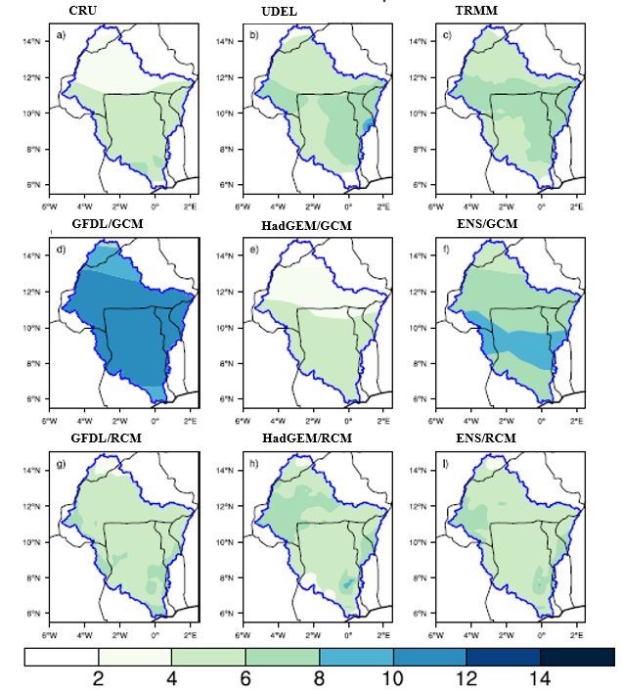
Figure 1: Average rainfall (in mm/day) for the months of June to September (JJAS) from 1985 to 2004 from the GFDL/GCM, GFDL/RCM, HadGEM/GCM, HadGEM/RCM models and their ensemble average ENS/GCM, ENS/GCM and CRU, UDEL and TRMM observation outputs.
• Intercomparison of temperature fields in JJAS from 1985 to 2004
Figure 2 shows the seasonal mean field and annual cycle of temperature (°C) during the historical period 1985-2004 for global climate models (GCM) and regional climate models (RCM) and their ensemble averages (ENS/GCM and ENS/RCM), compared with CRU observation data, UDEL, and ERA-INTERIM reanalyses.
The outputs of regional climate models (RCMs) and their ensemble average (ENS/RCM) show the same temperature variation across the basin regions. For the RCM model simulations and their ensemble average (ENS/RCM), from the south to the centre of the basin, the climate is cooler (23°C-27°C), whereas above 10°N up to Mali, the climate is hot, ranging from 27°C to 30°C. This is the temperature of the Sahel-Saharan regions. In general, the areas with high temperatures are in the north of the basin, in the Sahelian regions, and the temperatures there are like those observed for CRU, UDEL and ERA_INTERIM reanalyses. GFDL/GCM underestimates temperatures across the entire Volta basin. In addition, it shows cold biases across the entire basin, which can be explained by the fact that the model is completely humid (Figure 3.) across the entire basin. About HadGEM/GCM, there are warm biases in the north of the basin, while in the south the distribution is robust. Furthermore, RCM simulations show a similar distribution across the entire basin and are closer to observations. ENS/GCM improves on HadGEM/GCM. Overall, the results of the regional RCM models and the ENS/RCM ensemble mean are closer to observational data and therefore improve on global models.
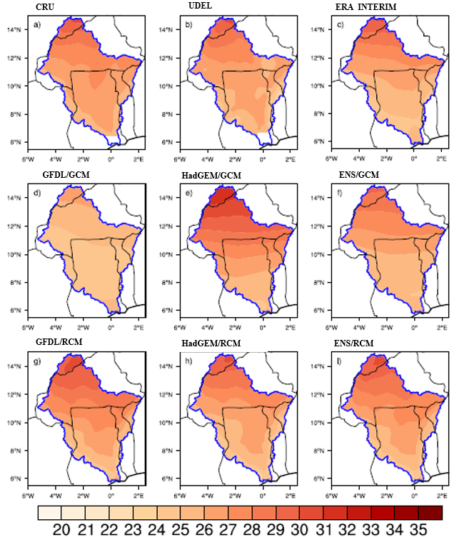
Figure 2: Average temperature (in °C) from June to September (JJAS) from 1985 to 2004 from the GFDL/GCM, GFDL/RCM, HadGEM/GCM, HadGEM/RCM and their ensemble mean ENS/GCM, ENS/GCM and CRU, UDEL, ERA_INTERI observation outputs
3.2. Climate change in the basin from June to September by 2099
• Precipitation projection: RCP4.5 scenario
In Figure 3, the spatial distribution of precipitation changes according to the RCP4.5 scenarios shows a zonal and meridional pattern, with the south of the basin being wet and the north being dry. GFDL/GCM projects an increase in rainfall in the regions of Côte d'Ivoire and western Ghana (with 1 mm/day) and 0.5 mm/day in central Ghana, south-western Burkina Faso and the waterfall regions. In addition, there is a decrease of 0.5 mm/day in western Burkina Faso and northern Ghana. In the Sahel, there is a decrease of 1 mm/day across central Burkina Faso, northern Togo and Benin. Similarly, it projects an amplified absence of rainfall (1.5 mm/day) in the regions located to the east of the basin.
However, HadGEM/GCM projects an increase in precipitation (0.5 mm/day) below 11°N and a decrease of 0.5 mm/day above 11°N latitude, which was predictable based on the current climate (Figure 4.). The ENS/GCM ensemble average simulates an increase of 0.5 mm/day in most of Ghana, Côte d'Ivoire, the waterfall regions and south-central Burkina Faso, and a decrease of 0.5 to 1 mm/day in Burkina Faso, Mali, northern Ghana, Togo and Benin. GCMs are similar for regions along the Gulf of Guinea but show a zonal decrease in precipitation in the north of the basin. GFDL/RCM projects an increase in precipitation across the basin of around 0.5 to 1.5 mm/day in the south-western region of Burkina Faso. Compared to the current climate, the spatial distribution can be said to be robust. HadGEM/RCM projects an increase in rainfall (0.5 mm/day) in Ghana, Côte d'Ivoire, south-western Burkina Faso and the Cascades region, and a decrease of 0.5 mm/day in Togo, Benin and southern Burkina Faso.
The decrease in rainfall is increasing (2 mm/day) above 11°N in Mali and Burkina Faso. The ENS/RCM ensemble average simulates an increase of 0.5 mm/day in southern Burkina Faso, Togo, Benin and central-eastern Ghana. ENS/RCM also projects an increase in rainfall (1 mm/day) in Côte d'Ivoire, south-western Burkina Faso and western Ghana, and a decrease of 0.5 to 1 mm/day. The GFDL/GCM, HadGEM/GCM, ENS/GCM and ENS/RCM models, in turn, project a slight increase in rainfall in coastal areas and waterfall regions and an absence of rainfall in the Sudano-Sahelian and Sahel regions. The RCM and GCM models are similar for the regions along the Gulf of Guinea, but show a zonal decrease in precipitation in the north of the basin.
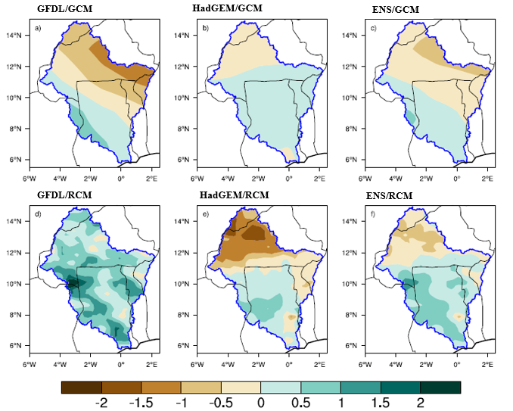
Figure 3: Precipitation differences (mm/day) from June to September in the Volta Basin relative to the 1985–2004 reference, according to the RCP4.5 scenario, by 2099 with GFDL/RCM, GFDL/GCM, HAdGEM/RCM, HAdGEM/GCM and their ensemble mean ENS/RCM and ENS/GCM.
• Precipitation projection: RCP8.5 scenario
In Figure 4, the models project a significant decrease in precipitation across the entire basin, except for HadGEM/RCM, which projects an increase in rainfall of between 0.5 and 1 mm/day in Ghana and Côte d'Ivoire. However, it projects an intense decrease (more than 2 mm/day) in other regions of the basin. Here again, there are disparities between the models. GFDL/GCM shows a zonal behaviour where rainfall gradually decreases in bands (0 to 0.5 mm/day) from west to east of the basin and amplifies south of Burkina Faso and north of Togo and Benin. HadGEM/GCM projects a decrease in rainfall of 1 mm/day above 10°N and 0.5 mm/day below.
As for GFDL/RCM, it projects a lack of rainfall across the entire basin, which is largely contrary to the current climate (Figure 1) and that of the RCP4.5 scenarios. The ENS/GCM ensemble average projects a decrease of 1 mm/day over the central part of the basin and 0.5 mm/day in Mali, Côte d'Ivoire and central Ghana, while 8ENS/RCM is completely dry in Burkina Faso and Mali (more than 1 mm/day). The ENS/RCM ensemble average shows a decrease in rainfall (0.5 mm/day) across the entire basin. Only rainfall becomes scarcer as one move northward in the basin. Precipitation in coastal areas, which was abundant with RCP4.5, gradually decreases as GHG forcing intensifies. Despite the uncertainty surrounding the magnitude and geographical distribution of precipitation change (compared to the current climate), the models seem to agree on a band (across the entire basin) of decreased precipitation near the regions at the end of the 21st century in the order of 0.5 to more than 2 mm/day. Overall, the models project a significant threat of climate change across the entire Volta basin if no action is taken.
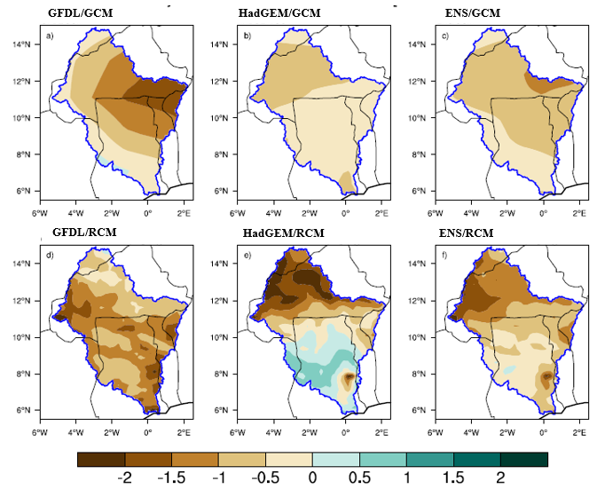
Figure 4: Precipitation differences (mm/day) from June to September in the Volta Basin relative to the 1985–2004 reference, according to the RCP8.5 scenario, by 2099 with GFDL/RCM, GFDL/GCM, HAdGEM/RCM, HAdGEM/GCM and their ensemble average ENS/RCM and ENS/GCM.
• Temperature projection: RCP4.5 scenario:
The results highlight an increase in the average temperature for the months of June-September over the 20-year period across the entire Volta Basin, with an increasing trend for the period 2080-2099. GFDL/GCM shows a similar distribution overall, except that the regions of Burkina Faso are warmer by 2.5 °C. The HadGEM/GCM simulation shows a sharp increase of up to 4.5 °C in northern Burkina Faso and Mali, 4 °C in central and western Burkina Faso (between 13 °N and 11 °N) and 4 °C below 11 °N latitude. As for the ENS/GCM ensemble average, it improves on HadGEM/GCM by projecting an increase of 3.5 °C over the regions of Burkina Faso and Mali (from 11°N) and 3 °C below 11 °N.
GFDL/RCM projects a slight increase across the entire basin (1.5 to 2 °C), but Mali remains the hottest. HadGEM/RCM projects a temperature increase of 3.5 °C above 11 °N and around 2.5 °C to 3 °C below 11 °N latitude. However, the ENS/RCM ensemble average improves on HadGEM/RCM by projecting a slight temperature increase (1°C to 2°C) over the same regions. The spatial distribution of temperature changes in the HadGEM/GCM and HadGEM/RCM models projects global warming as significant across the entire basin as the regional models. In fact, the lowest temperatures are projected for coastal areas and the highest for landlocked countries.
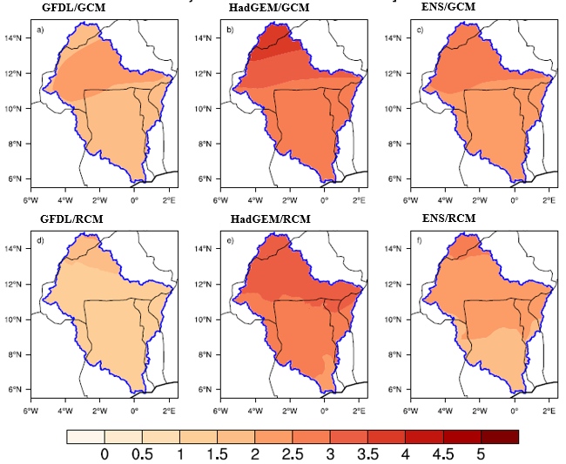
Figure 5: Temperature differences (°C/day) from June to September in the Volta Basin relative to the 1985–2004 reference, according to the RCP4.5 scenario, by 2099 with GFDL/RCM, GFDL/GCM, HadGEM/RCM, HadGEM/GCM and their ensemble average ENS/RCM and ENS/GCM.
• Temperature projection: RCP8.5 scenario:
The results of the RCP8.5 scenarios show higher warming in the basin for the horizon, for all our simulations. For the HAdGEM/RCM and HAdGEM/GCM models, the temperature increase is similar for the 2080-2099 period (more than 5 °C) across the entire basin, but for HAdGEM/RCM, the regions along the Gulf of Guinea are less warm. It should be noted that GFDL/GCM simulates a slight warming compared to all our simulations. It projects an increase of 3 °C below 8 °N in the southern basin in Ghana, 3 °C to 4 °C in Togo, Benin, northern Ghana, Côte d'Ivoire, western and southwestern Burkina Faso (8°N and 11°N), and 4°C to 4.5°C above 11°N latitude in Burkina Faso and Mali. GFDL/RCM shows a similar pattern but with amplified warming. All models agree on the increasing distribution of the temperature increase. ENS/GCM and ENS/RCM predict similar warming in Burkina Faso and Mali, with the only difference being that ENS/RCM extends its warming zone towards the south of the basin.
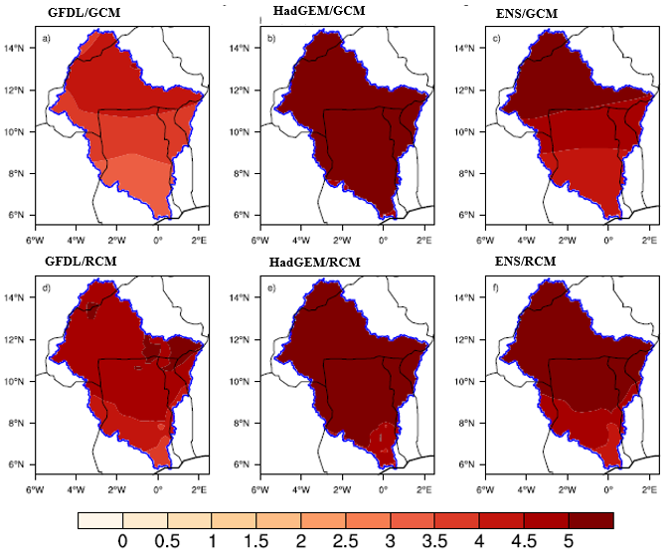
Figure 6: Temperature differences (°C/day) from June to September in the Volta Basin relative to the 1985–2004 reference, according to the RCP8.5 scenario, by 2099 with GFDL/RCM, GFDL/GCM, HAdGEM/RCM, HAdGEM/GCM and their ensemble average ENS/RCM and ENS/GCM.
4. Conclusion
The Volta Basin is one of the region’s most vulnerable to climate change in West Africa. For this reason, it needs reliable projections for a proper assessment of their impacts at regional and local levels. This is possible by making future projections using a regional climate model. The model used in this study is RegCM4, forced at its boundaries by the GFDL/GCM and HADGEM/GCM global models. To validate this model, RegCM4 simulations were compared with those of the same global models and CRU, UDEL and TRMM observations during the historical period 1985-2004. They show warm temperature biases in the Sahel and cold biases in regions along the Gulf of Guinea. However, the simulations also show negative precipitation biases in the north with weak ones.
The regional model RegCM4 represents more detail and simulates a more reasonable distribution compared to global models throughout the basin. Despite the uncertainties encountered, GFDL/GCM and HADGEM/GCM can provide projections to force RegCM4 to construct high-resolution climate change scenarios for the Volta Basin. Based on the RCP4.5 and RCP8.5 climate change scenarios, we developed a climatology focused on the end of the 21st century (the 2099 horizon). The assessment of climate change projected by the RCM and GCM models according to the different scenarios shows a decrease in precipitation in the north. This decrease is even more significant for the RCP8.5 scenario, with a marked amplitude depending on the model. However, the projections show that, regardless of the scenario or model considered, the decrease in precipitation is felt even more in the extreme north of the basin, with 1 to 2 mm/day less than the reference average. Projections indicate a general trend towards higher temperatures and drier conditions across the entire basin. The models are more consistent when it comes to temperatures. In both scenarios, the RCM models project a temperature increase of between 3-4 °C by 2099 compared to the historical twenty-year period from 1985 to 2004 if current policies remain unchanged.
The various parameters studied have enabled us to understand and predict, using regional models, the climate in the Volta basin by 2099. RegCM4 thus projects a real climate threat to the Volta basin. However, we found that RegCM4 simulates better than global models. This reinforces the need to use high-resolution regional climate models (up to 10 km) forced by different global models to provide regional and local information for better impact studies on the Volta Basin.

COMPETING INTERESTS DISCLAIMER:
Authors have declared that they have no known competing financial interests OR non-financial interests OR personal relationships that could have appeared to influence the work reported in this paper.

Disclaimer (Artificial intelligence)

Author(s) hereby declare that NO generative AI technologies such as Large Language Models (ChatGPT, COPILOT, etc.) and text-to-image generators have been used during the writing or editing of this manuscript.

Reference
[1] P. Kabore, B. Barbier, P. Ouoba, A. Kiema, L. Some, and A. Ouedraogo, “Perceptions of climate change, environmental impacts and endogenous adaptation strategies by producers in North-Central Burkina Faso,” VertigO Electronic Journal in Environmental Sciences, vol. 19, no. 1, 2019.
[2] B. Ibrahim, “Characterization of rainy seasons in Burkina Faso in a context of climate change and assessment of hydrological impacts on the Nakanbé basin,” Theses, Pierre and Marie Curie University - Paris VI, 2012.
[3] E. Guilyardi et al., “IPCC Special Report ‘Global Warming of 1.5°C’: Summary for Teachers,” 2019.
[4] F. Giorgi et al., “Higher hydroclimatic intensity with global warming,” J. Clim., vol. 24, no. 20, pp. 5309–5324, 2011.
[5] A. Belleudy, R. Marty, E. Le Pape, D. Narbais-Jaureguy, and F. Zuber, “Towards the generalization of probabilistic hydrological forecasting within the Vigicrues network: estimation, evaluation and communication,” LHB, vol. 110, no. 1, p. 2374079, Dec. 2024, doi: 10.1080/27678490.2024.2374079.
[6] G. A. Meehl et al., “The WCRP CMIP3 multimodel dataset: A new era in climate change research,” Bull. Am. Meteorol. Soc., vol. 88, no. 9, p. 1383-1394, 2007.
[7] J. Egah, E. Dimon, J. M. Odou, E. Houngue, and M. N. Baco, “Gendered analysis of vulnerability and the mechanism of adaptation to climate change in North Benin”, VertigO- Rev. Electronics In Sci. Approx., 2024,
[8] J. Sillmann, V. V. Kharin, F. W. Zwiers, X. Zhang, and D. Bronaugh, “Climate extremes indices in the CMIP5 multimodel ensemble: Part 2. Future climate projections,” J. Geophys. Res. Atmospheres, vol. 118, no. 6, p. 2473‑2493, 2013, doi: 10.1002/jgrd.50188.
[9] F. Giorgi et al., “RegCM4: model description and preliminary tests over multiple CORDEX domains”, Clim. Res., vol. 52, p. 7‑29, March 2012, doi: 10.3354/cr01018.
[10] K. E. Taylor, R. J. Stouffer, and G. A. Meehl, “An Overview of CMIP5 and the Experiment Design,” Apr. 2012, doi: 10.1175/BAMS-D-11-00094.1.
[11] F. Giorgi, C. Jones, and G. R. Asrar, “Addressing climate information needs at the regional level: the CORDEX framework,” World Meteorol. Organ. WMO Bull., vol. 58, no. 3, p. 175, 2009.
[12] C. Jones, F. Giorgi, and G. Asrar, “The coordinated regional downscaling experiment (CORDEX). An international downscaling link to CMIP5”, CLIVAR Exch., vol. 56, 2011, Accessed: December 15, 2025.
[13] B. R. Lintner, M. Biasutti, N. S. Diffenbaugh, J.-E. Lee, M. Niznik, and K. L. Findell, “Amplification of wet and dry monthly occurrence over tropical land regions in response to global warming,” J. Geophys. Res. Atmospheres, vol. 117, no D11, 2012, doi: 10.1029/2012JD017499.
[14] E. Scoccimarro, S. Gualdi, A. Bellucci, M. Zampieri, and A. Navarra, “Heavy precipitation events in a warmer climate: Results from CMIP5 models”, J. Clim., vol. 26, no. 20, p. 7902‑7911, 2013.
[15] F. Giorgi, C. Jones, and G. R. Asrar, “Addressing climate information needs at the regional level: the CORDEX framework,” World Meteorol. Organ. WMO Bull., vol. 58, no. 3, p. 175, 2009.
[16] B. Ampomah, W. Andah, and C. A. Biney, “Water governance in the Volta Basin,” in The Volta River Basin, Routledge, 2016, p. 128‑148.
[17] R. H. Moss et al., “The next generation of scenarios for climate change research and assessment”, Nature, vol. 463, no. 7282, p. 747-756, 2010.
[18] G. A. Grell, J. Dudhia, and D. R. Stauffer, “A description of the fifth-generation Penn State/NCAR Mesoscale Model (MM5)”, 1994,
[19] F. Giorgi, M. R. Marinucci, and G. T. Bates, “Development of a Second-Generation Regional Climate Model (RegCM2). Part I: Boundary-Layer and Radiative Transfer Processes”, Oct. 1993,
[20] L. O. Mearns, I. Bogardi, F. Giorgi, I. Matyasovszky, and M. Palecki, “Comparison of climate change scenarios generated from regional climate model experiments and statistical downscaling”, J. Geophys. Res. Atmospheres, vol. 104, no. D6, p. 6603‑6621, 1999, doi: 10.1029/1998JD200042.
[21] J. S. Pal, E. E. Small, and E. A. B. Eltahir, “Simulation of regional-scale water and energy budgets: Representation of subgrid cloud and precipitation processes within RegCM,” J. Geophys. Res. Atmospheres, vol. 105, no. D24, p. 29579‑29594, 2000, doi: 10.1029/2000JD900415.
[22] K. A. Emanuel and M. Živković-Rothman, “Development and Evaluation of a Convection Scheme for Use in Climate Models”, June 1999,
[23] X. Zeng, M. Zhao, and R. E. Dickinson, “Intercomparison of Bulk Aerodynamic Algorithms for the Computation of Sea Surface Fluxes Using TOGA COARE and TAO Data”, October 1998,
[24] K. W. Oleson et al., “Improvements to the Community Land Model and their impact on the hydrological cycle,” J. Geophys. Res. Biogeosciences, vol. 113, no G1, 2008, doi: 10.1029/2007JG000563.
[25] T. Mauritsen et al., “Tuning the climate of a global model”, J. Adv. Model. Earth Syst., vol. 4, no. 3, 2012, doi: 10.1029/2012MS000154.
[26] W. J. Collins et al., “Development and evaluation of an Earth-System model – HadGEM2”, Geosci. Model Dev., vol. 4, no. 4, p. 1051‑1075, Nov. 2011, doi: 10.5194/gmd-4-1051-2011.
[27] J. P. Dunne et al., “GFDL’s ESM2 Global Coupled Climate–Carbon Earth System Models.” Part II: Carbon System Formulation and Baseline Simulation Characteristics*,” Apr. 2013, doi: 10.1175/JCLI-D-12-00150.1.
[28] G. Nikulin et al., “Precipitation Climatology in an Ensemble of CORDEX-Africa Regional Climate Simulations,” Sept. 2012, doi: 10.1175/JCLI-D-11-00375.1.
[29] I. Diallo, M. B. Sylla, F. Giorgi, A. T. Gaye, and M. Camara, “Multimodel GCM-RCM Ensemble-Based Projections of Temperature and Precipitation over West Africa for the Early 21st Century,” Int. J. Geophys., vol. 2012, no. 1, p. 972896, 2012, doi: 10.1155/2012/972896.
[30] M. B. Sylla, F. Giorgi, E. Coppola, and L. Mariotti, “Uncertainties in daily rainfall over Africa: assessment of gridded observation products and evaluation of a regional climate model simulation. », Int. J. Climatol., vol. 33, no. 7, p. 1805, June 2013, doi: 10.1002/joc.3551.
[31] I. Harris, P.d. Jones, T.j. Osborn, and D. h. Lister, “Updated high-resolution grids of monthly climatic observations – the CRU TS3.10 Dataset”, Int. J. Climatol., vol. 34, no. 3, p. 623-642, 2014, doi: 10.1002/joc.3711.
[32] D. R. Legates and C. J. Willmott, “Mean seasonal and spatial variability in global surface air temperature,” Theor. Appl. Climatol., vol. 41, no. 1, p. 11-21, March 1990, doi: 10.1007/BF00866198.
[33] G. J. Huffman et al., “The TRMM Multisatellite Precipitation Analysis (TMPA): Quasi-Global, Multiyear, Combined-Sensor Precipitation Estimates at Fine Scales,” Feb. 2007, doi: 10.1175/JHM560.1.
[34] D. Dee and S. S. Uppala, “Variational Bias Correction in ERA-Interim,” Jan. 2008.

