Impact of Cladding Material and Air Cavity on Ventilated Facades in Warm Semi-Arid Climates

.
ABSTRACT

This study examines the high air conditioning demand characteristic of buildings located in warm semi-arid climates, where intense solar radiation and low humidity significantly increase thermal loads on the building envelope. In this context, ventilated facades have emerged as a promising passive strategy capable of reducing heat gain by combining external cladding with a ventilated air cavity. Despite the proven potential of these systems, the literature shows methodological fragmentation and limited evidence specifically focused on warm semi-arid regions.
The main objective of this research is to perform a comparative thermal assessment of six ventilated facade configurations generated from the combination of three cladding materials (Dekton, porcelain ceramic, and fiber-cement cladding) and two cavity depths (6 cm and 10 cm). The goal is to identify the relative influence of material properties and cavity geometry under extreme climatic conditions and to establish preliminary design criteria applicable to architectural practice.
The methodological approach integrates three components: (1) a selective review of the scientific literature to identify dominant parameters affecting ventilated facade performance; (2) the construction of an analytical matrix to systematize and prioritize these variables; and (3) a simplified thermal modeling procedure based on a one-dimensional series-resistance formulation applied to a southwest-oriented classroom of the Biotechnology Building at the Universidad Autónoma de Querétaro. Representative boundary conditions were adopted (Text = 40 °C, Tint = 26 °C) along with standard convection coefficients for external, internal, and cavity interfaces.
Results show that the steady-state heat flux transmitted to the interior remains within a narrow range (≈ 8.06–8.23 W/m²), indicating that cavity ventilation exerts a more dominant effect than cladding conductivity under the adopted assumptions. These findings provide a quantitative foundation for early-stage design decisions in warm semi-arid climates and underline the relevance of cavity depth and insulation in optimizing passive cooling performance.

Keywords: Thermal analysis, parametric design, passive strategies, energy efficiency

1. INTRODUCTION

The building sector is one of the largest energy consumers worldwide, accounting for nearly 40% of total global demand, primarily driven by cooling and air-conditioning requirements in warm regions (De Gracia et al., 2013).

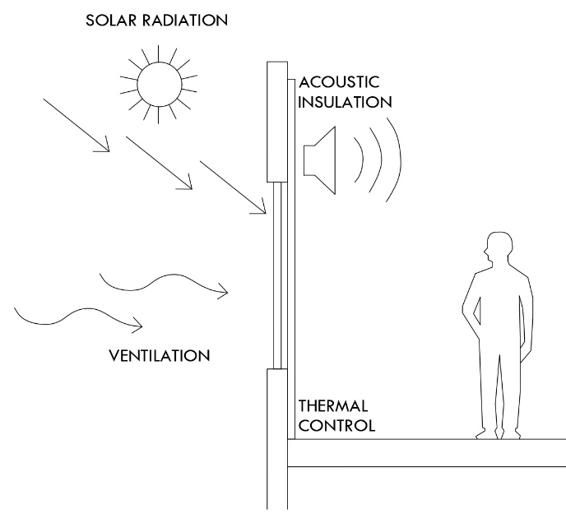
This issue intensifies in warm semi-arid climates, where the combination of high solar radiation and low humidity increases cooling loads. As illustrated in Fig. 1, these environmental conditions highlight the need for passive systems capable of mitigating external thermal stresses on conventional facade assemblies.
Fig. 1. Effect of external factors on a conventional facade
To address this situation, architecture and engineering have promoted the development of passive systems aimed at improving the thermal performance of building envelopes. Among these strategies, ventilated facades have demonstrated strong potential to reduce heat transfer toward the interior and to harness the stack effect within the air cavity (Schabowicz & Zawiślak, 2020).
This multilayer system incorporates an exterior cladding, a structural support, and an air cavity positioned in front of the traditional wall assembly, as shown in Fig. 2. This configuration facilitates the upward movement of heated air within the cavity, promoting its evacuation and allowing the entry of cooler air, which helps buffer solar loads and stabilize the interior surface temperature (Pizzatto et al., 2025).

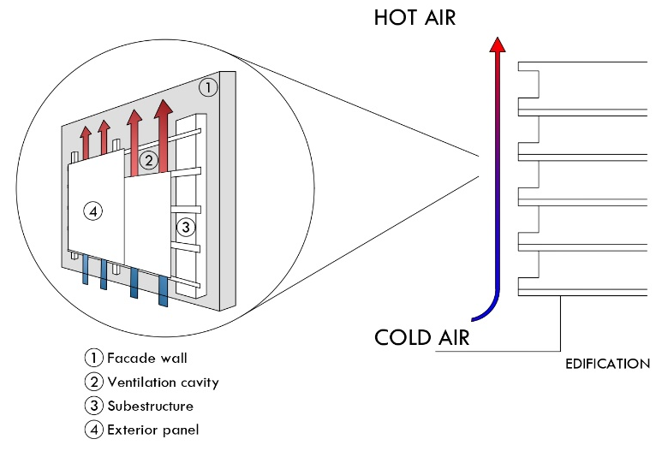
Fig. 2. Components and configuration of a ventilated facade system
Ventilated facades have proven to be a high-performance strategy for both new construction and retrofitting, increasing the thermal resistance of the envelope and reducing overheating risks (Colinart et al., 2019). Their effectiveness depends on the interaction of several factors, including the thermo-optical properties of the cladding, the geometry of the air cavity, the natural ventilation regime, and the prevailing climatic conditions (El Dallal et al., 2024).

Recent studies from diverse climatic regions confirm that a well-designed ventilated facade can reduce thermal loads by approximately 20% to 55%, depending on orientation, cavity depth, and the material used (Hosseini et al., 2025; Farzaneh et al., 2024).

Despite these advances, specialized literature reveals important gaps. First, most studies focus on temperate, Mediterranean, or humid climates, while evidence for warm semi-arid regions remains limited (Chatbi & Zouaoui, 2022). This gap hinders the development of reliable design guidelines for areas with high solar radiation.

Second, there is substantial methodological fragmentation: some works rely exclusively on three-dimensional Computational Fluid Dynamics (CFD) models, while others use dynamic simulations or experimental testing, making cross-comparison difficult. This methodological inconsistency underscores the lack of evidence-based guidelines that clearly identify which ventilated facade configurations are most effective under warm semi-arid conditions.

Additionally, there is a notable disconnect between academic findings and practical design criteria, generating uncertainty among architects, engineers, and builders. The sector requires simple, comparative, and evidence-based tools to support the selection of cladding materials, cavity depths, and facade configurations according to building type (residential, institutional, or industrial) and local climatic conditions. The absence of synthetic, decision-oriented methodologies limits the effective adoption of ventilated facade systems and often results in design choices driven more by intuition than by quantitative evidence.

Parallel to these gaps, recent research on multigeneration systems emphasizes thermal management as a key strategy for building energy efficiency. Eyvazi (2025) demonstrated that integrating heat-recovery mechanisms can achieve efficiencies above 21%, highlighting the value of residual heat utilization. Similarly, Eyvazi et al. (2025) presented a geothermal-based multigeneration system achieving 53% exergy efficiency with reduced energy costs.

Although these studies focus on energy conversion, they reinforce a principle applicable to ventilated facades: optimizing heat flow is essential for energy performance in warm semi-arid climates. Ventilated facades represent the passive counterpart of this thermal-management paradigm.

To address these limitations, this article proposes a conceptual framework that integrates modeling and synthesis tools. The current absence of decision-oriented methodologies limits ventilated facade adoption and leads to design choices based on intuition rather than evidence.

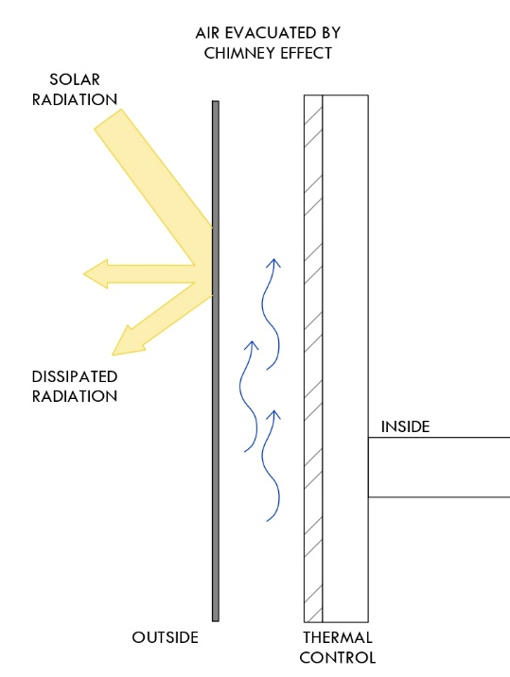
Figure 3 summarizes the physical principle: solar radiation heats the exterior cladding, warming the cavity air. The heated air becomes less dense and rises due to the stack effect, creating continuous upward flow that expels heat. This mechanism underscores the need for quantitative tools to translate principles into practical design criteria.

Fig. 3. Ventilation mechanism and heat transfer in a ventilated facade

This study addresses these gaps by evaluating six ventilated facade configurations combining three cladding materials and two cavity depths. The methodology integrates: (1) an analytical matrix based on recent findings; (2) a one-dimensional thermal model using series-resistance; and (3) representative warm semi-arid climate conditions.

This approach identifies each variable's relative influence on heat transfer and offers preliminary design criteria for early project stages, particularly for buildings exposed to intense solar radiation.
2. material and methods

2.1 General Approach and Methodological Strategy
The methodology was structured into three complementary stages. First, a review of specialized literature was conducted to identify the key thermal variables influencing ventilated facade performance. Second, based on this review, an analytical matrix was developed to organize and prioritize parameters—including thermal properties, geometric characteristics, and environmental conditions—reported in previous studies. This matrix allowed refinement of variables with the greatest impact on thermal behavior.

Third, a comparative mathematical model was developed to evaluate different ventilated facade configurations under representative warm semi-arid conditions. This model enabled analysis of both individual and combined variable effects, providing a robust foundation for assessing the system's thermal performance.

2.2 Selection Criteria and Matrix Development
A literature review (2015–2025) identified variables governing the thermal behavior of ventilated facades, focusing on studies with experimental validation or rigorous dynamic thermal modeling. This review extracted key parameters including air cavity depth, thermo-optical properties of exterior cladding, induced ventilation regime, and system response under high solar radiation.

Comparative analysis of these studies informed Table 1, which synthesizes dominant variables reported in the literature. The findings show consistent agreement that air cavities between 5 and 10 cm enhance natural ventilation potential in warm climates, while materials like ceramic and fiber cement offer favorable performance due to thermal stability and low emissivity.

The review also revealed that next-generation ultracompact materials—particularly Dekton—have been scarcely examined despite their potentially advantageous surface properties for ventilated facades, justifying their inclusion in this study.

Table 1. Justification of the Parameters Selected for the Simulation Stage

Variable | Selected Values | Justification Based on Literature Review | References
Air cavity depth | 6 cm and 10 cm | Most frequently reported and efficient range for natural ventilation in warm climates.  The selection of 6 to 10 cm allows the evaluation of the transition zone where convective benefits stabilize and marginal returns decrease. | Andreeva et al., 2022; Cuce & Cuce, 2025; Pizzatto et al., 2025; Schabowicz & Zawiślak, 2020
Exterior cladding material | Dekton | Very low emissivity (0.1–0.2), high thermal inertia, and minimal solar absorption. Represents next-generation materials, absent from existing ventilated facade literature. | Cuce & Cuce, 2025; Fathi & Fakhriaemmanesh, 2025; Gelesz & Reith, 2015
Exterior cladding material | Ceramic | Widely studied and with well-documented thermal behavior in warm and warm-humid climates. Excellent durability, low maintenance, and high reflectance. | Pizzatto et al., 2025; El Dallal et al., 2024; Luciani-Mejía et al., 2018; Ibañez-Puy et al., 2017
Exterior cladding material | Fiber cement | High reflectance, low cost, and reduced environmental impact. Commonly used in construction yet scarcely examined in combination with ventilated cavities in warm semi-arid climates. | Cuce & Cuce, 2025; Azkorra-Larrinaga et al., 2023; Piasecki et al., 2019

The matrix enabled the refinement of the broad set of parameters identified in the literature and allowed the selection of a reduced number of configurations suitable for analysis. As a result, three cladding materials—Dekton, ceramic porcelain, and fiber cement—and two cavity depths—6 cm and 10 cm—were selected, criteria supported both by their recurrent use in previous studies and by their relevance in hot and hot semi-arid climates.

Furthermore, the matrix facilitated the definition of the indicators guiding the mathematical analysis: the thermal conductivity of the exterior cladding, the transient response of the ventilated cavity, and the system’s capacity to reduce the inward thermal load. These parameters enable consistent comparison across configurations and provide an integrated evaluation of the thermal performance of each alternative.

2.3 Case Study
The case study was developed based on a real space located in the “Biotechnology Building” of the Facultad de Ingenieria at the Universidad Autónoma de Querétaro (UAQ). The southwest facade segment of the envelope was selected, as it represents the most critical orientation under hot semi-arid conditions: it receives direct solar radiation for most of the afternoon, concentrating the highest thermal loads and therefore maximizing the demand on the facade system.

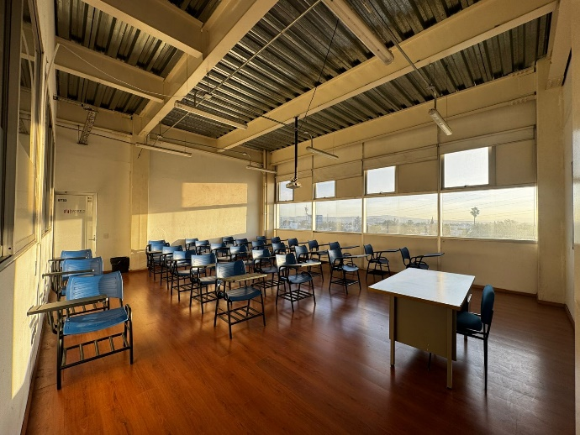
The analyzed classroom measures 8.00 m in length and 4.95 m in width, resulting in a floor area of approximately 39.6 m². With an interior height of 5.00 m, the total volume is 198.00 m³. This geometry, together with its orientation and local climatic conditions, makes it a representative case for evaluating the thermal behavior of different ventilated facade configurations in hot semi-arid regions (Fig. 4).

Fig. 4. Interior view of the reference classroom used as case study

The three-dimensional model was developed in Revit 2024.2, incorporating the exact location of the facade segment under study and accurately reproducing the physical composition of the wall. Each component—the exterior cladding, the air cavity, and the base wall—was defined using multilayer configurations to ensure proper geometric and material representation.

2.4 Ventilated Facade System Configuration
The geometric configuration of the ventilated facade included the explicit representation of the air cavity in two thicknesses—6 cm and 10 cm—as well as an interchangeable exterior cladding layer depending on the material analyzed: Dekton, porcelain ceramic, or fiber cement. These elements are described in table 2.

The objective of the modeling process was to enable a standardized comparison of the six resulting configurations (three materials × two cavity thicknesses). Fig. 5, 6, and 7 illustrate the generated variants, which allowed for a consistent evaluation of the relative differences associated with each cladding material and air cavity geometry.

Table 2. Configurations of the ventilated facade system evaluated

Case | Cladding Material | Air Cavity Thickness
Case 1 | Dekton | 6 cm
Case 1 | Dekton | 10 cm
Case 2 | Ceramic | 6 cm
Case 2 | Ceramic | 10 cm
Case 3 | Fiber-cement cladding | 6 cm
Case 3 | Fiber-cement cladding | 10 cm

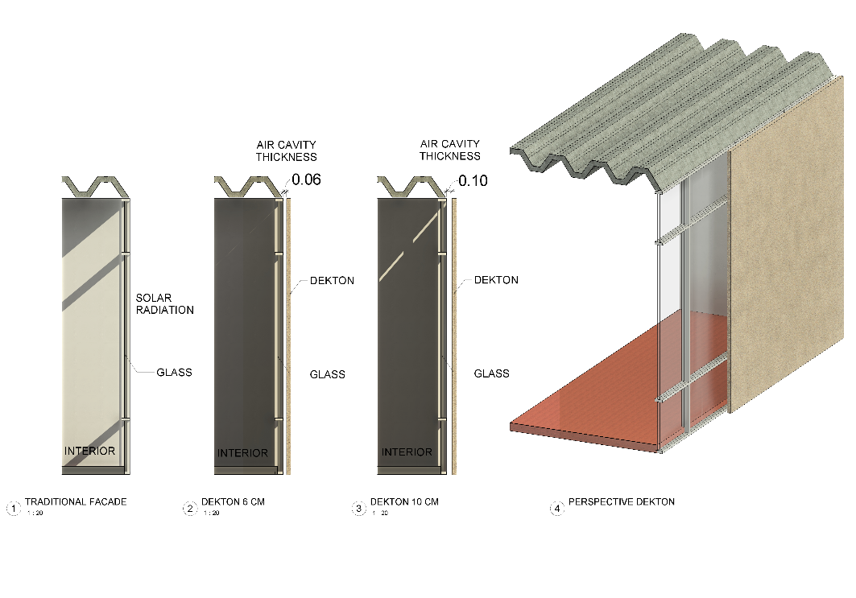
Each configuration was modeled as a multilayer system consisting of a tempered-glass base wall, a ventilated air cavity with variable thickness (6 cm or 10 cm), and an interchangeable exterior cladding layer depending on the material under analysis (Dekton, ceramic, or fiber-cement cladding). This structure enabled a consistent comparison of the expected thermal behavior among the different ventilated facade variants, while keeping the geometric and construction parameters of the model constant.
Fig. 5. Facade configurations analyzed:(1) existing single-glazed facade (reference case), (2) ventilated facade with 6 cm air cavity and Dekton outer layer,(3) ventilated facade with 10 cm air cavity and Dekton outer layer, and (4) perspective view of the proposed ventilated facade with Dekton cladding
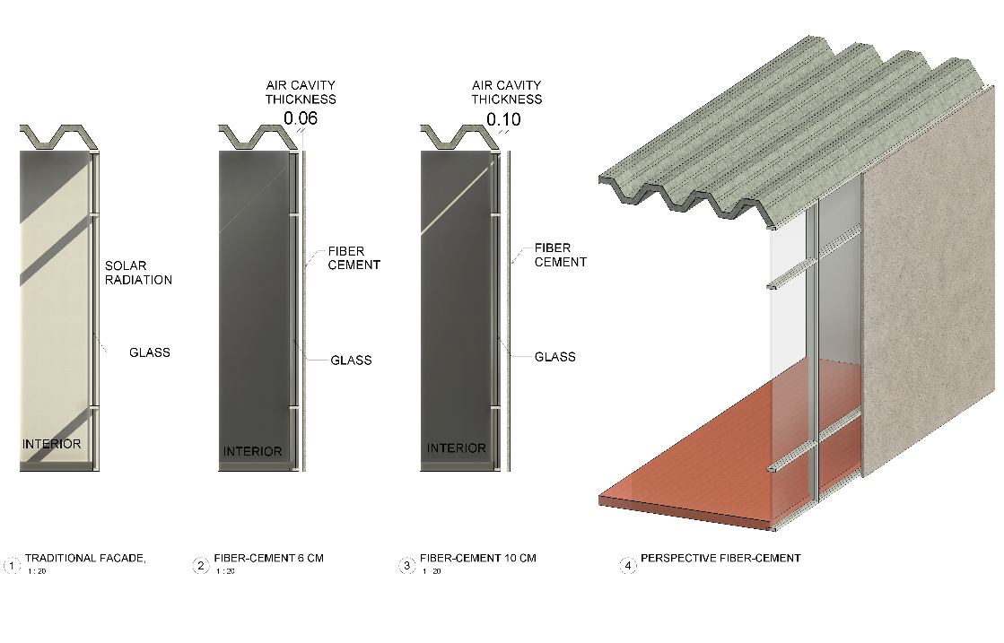
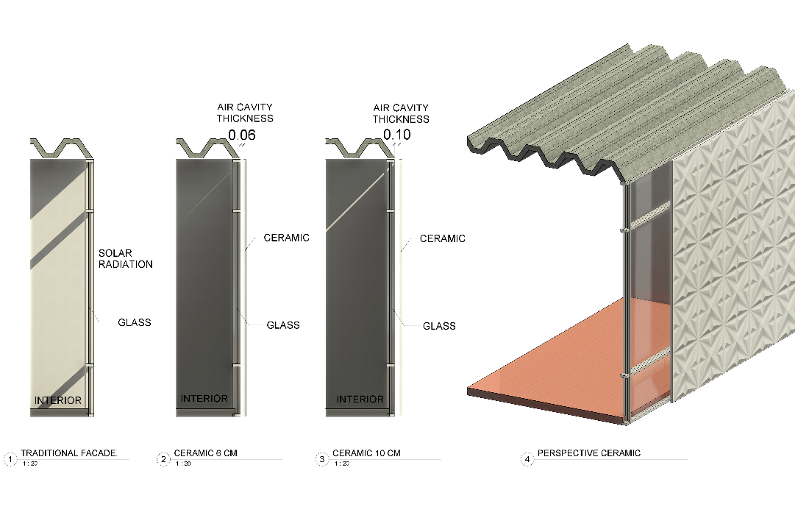
Fig. 6. Facade configurations analyzed:(1) existing single-glazed facade (reference case), (2) ventilated facade with 6 cm air cavity and Ceramic outer layer, (3) ventilated facade with 10 cm air cavity and ceramic outer layer, and (4) perspective view of the proposed ventilated facade with ceramic cladding.
Fig. 7. Facade configurations analyzed:(1) existing single-glazed facade (reference case), (2) ventilated facade with 6 cm air cavity and fiber-cement outer layer,(3) ventilated facade with 10 cm air cavity and fiber-cement outer layer, and (4) perspective view of the proposed ventilated facade with fiber-cement claddig.
2.5 Thermal Modeling and Calculation Procedure
A simplified thermal modeling approach was adopted based on a one-dimensional series-resistance scheme, with the purpose of estimating the heat flux through the evaluated ventilated facade configurations. Unlike more complex approaches this formulation allows the explicit decomposition of each layer’s contribution to heat transfer, ensuring methodological transparency and facilitating reproducibility across studies. The central objective was to quantify the effects of cladding material and cavity depth under extreme boundary conditions representative of a warm semi-arid climate.

To ensure the reproducibility of the procedure, the analysis was developed under a clearly defined set of assumptions: a unit area of 1.00 m², a temperature difference representative of a warm semi-arid climate ($T_{ext}=40°C$, $T_{int}=26°C$), typical convective coefficients for exterior $h_{ext}=15 W/m^{2}K$ and interior surfaces $h_{int}=8 W/m^{2}K$, a 6 mm tempered-glass base wall, a 50 mm mineral wool insulation layer (λ= 0.037 $W/mK$), and ventilated cavities of 6 cm and 10 cm, with assigned convective coefficients of $h_{cav}=5 W/m^{2}K$ and $h_{cav}=8 W/m^{2}K$, respectively. These assumptions represent consistent extreme heat-gain conditions for the southwest facade of the building under study.

Conduction through the exterior cladding: The thermal resistance due to conduction in the cladding layer was calculated using the classical fourier formulation
$R_{cond= }\frac{d}{k}$ (1)

Where 𝑑 is the material thickness and 𝑘 its thermal conductivity. This equation was applied separately to each cladding material, enabling comparison of their thermo-optical performance as the facade’s first barrier against heat gain.

Convection in the ventilated cavity and boundary surfaces: Convective resistance was modeled using the following formulation
$R_{conv= }\frac{1}{h}$ (2)

where ℎ is the convective heat-transfer coefficient associated with each boundary condition. This formulation is essential for isolating the influence of cavity depth, as the change from 6 cm to 10 cm alters natural ventilation and therefore the effective $h_{cav }$ value.
Total thermal resistance of the facade assembly: The entire multilayer facade was represented as a series of linear thermal resistances:
$R_{total=}\sum{R_{i}}$ (3)

This step makes it possible to identify which element dominates thermal behavior and how conduction and convection interact across layers.

Heat flux entering the interior: Finally, the total heat flux transmitted toward the interior was calculated through the one-dimensional expression:
$q=\frac{T_{ext}-T_{int}}{R_{total}}$ (4)
This value becomes the main comparative indicator in the study: configurations with lower heat flux are considered more thermally efficient.
3. results and discussion

Tables 3 and 4 summarize the thermal parameters for each configuration, including conductive and convective resistances, total heat flux, and intermediate temperatures. This organization allows clear evaluation of how cladding material and air-cavity depth influence thermal behavior, providing a consistent comparative basis for the six alternatives analyzed.

The results show that heat flux transmitted to the interior ranges between 8.067 and 8.231 W/m², confirming ventilated facades effectiveness for reducing heat transfer in warm semi-arid climates. The air cavity emerges as the dominant element in thermal moderation, contributing the largest share (approximately 70-80%) of the system's total thermal resistance, with $R_{tot}$ values ranging from 1.701 to 1.735 m²·K/W.

Increasing cavity depth from 6 cm to 10 cm consistently reduces heat flux by approximately 1.4% across all configurations. This moderate reduction suggests that, under steady-state conditions, the ventilated cavity's primary role is not large absolute heat transfer reduction but rather thermal response stabilization through air renewal and limited heat accumulation.

In the adopted model, increased cavity depth enhances the stack effect, promoting natural convection and air renewal. This enhancement is represented by a lower effective convective heat transfer coefficient, resulting in higher convective resistance ($R_{cav}$) and reduced overall heat transfer. This mechanism aligns with literature reports for ventilated facades in warm climates. Previous studies indicate diminishing marginal benefits beyond cavity depths of 10-12 cm (Andreeva et al., 2022), suggesting 10 cm as a technical-economic optimum for high solar radiation conditions with pronounced diurnal temperature variations.

Cladding material influence on thermal performance is limited, with heat flux variations below 2%. At 10 cm cavity depth, fiber-cement cladding shows the lowest heat flux (8.067 W/m²), followed by ceramic (8.113 W/m²) and Dekton (8.117 W/m²). This limited dispersion indicates that, within the steady-state framework, cladding thermal conductivity plays a secondary role relative to cavity geometry.

Therefore, while material selection may consider durability, cost, constructability, or environmental impact, air-cavity depth is the dominant design parameter for thermal performance in early-stage design.

Table 3. Thermal performance of the ventilated facade configurations evaluated

Case | Cladding Material | Air Cavity Thickness | $$R_{clad}$$  (m²·K/W) | $$R_{cav}$$  (m²·K/W) | $$R_{tot}$$  (m²·K/W) | $${ΔT}_{clad}$$  (K) | $${ΔT}_{cav}$$  (K) | $$T_{suf-Out}$$  (°C) | $$T_{aft-clad}$$  (°C) | $$T_{aft-cav}$$  (°C)
Case 1 | Dekton | 6 cm | 0.00909 | 0.1429 | 1.70101 | 0.0724 | 1.5926 | 39.469 | 39.397 | 37.804
Case 1 | Dekton | 10 cm | 0.00909 | 0.1667 | 1.72481 | 0.0756 | 1.0397 | 39.445 | 39.37 | 38.33
Case 2 | Ceramic | 6 cm | 0.01 | 0.1429 | 1.70192 | 0.0796 | 1.5918 | 39.469 | 39.39 | 37.798
Case 2 | Ceramic | 10 cm | 0.01 | 0.1667 | 1.72572 | 0.0831 | 1.0392 | 39.446 | 39.363 | 38.323
Case 3 | Fiber-Cement Cladding | 6 cm | 0.02 | 0.1429 | 1.71192 | 0.1583 | 1.5828 | 39.472 | 39.314 | 37.731
Case 3 | Fiber-Cement Cladding | 10 cm | 0.02 | 0.1667 | 1.73572 | 0.1653 | 1.033 | 39.449 | 39.284 | 38.251

Table 4. Heat flux through the facade for each ventilated facade configuration under design conditions.

Case | Cladding Material | Air Cavity Thickness | q ($W/m^{2}$) | Potencia  W
Case 1 | Dekton | 6 cm | 8.231 | 325.94
Case 1 | Dekton | 10 cm | 8.117 | 321.43
Case 2 | Ceramic | 6 cm | 8.226 | 325.75
Case 2 | Ceramic | 10 cm | 8.113 | 321.27
Case 3 | Fiber-Cement Cladding | 6 cm | 8.180 | 323.93
Case 3 | Fiber-Cement Cladding | 10 cm | 8.067 | 319.45

Where:
- $R_{clad}$ (K/W) : Thermal resistance by conduction through the exterior cladding, calculated using Fourier’s law
- $R_{cav}$ (K/W) : Thermal resistance associated with convection within the ventilated cavity.
- $R_{tot}$ (K/W) : Sum of all thermal resistances in the multilayer system.
- Potencia (W) : Total heat transfer through the entire facade panel under analysis.
- ${ΔT}_{clad}$ (K) : Temperature drop occurring exclusively across the exterior cladding.
- ${ΔT}_{cav}$ (K) : Temperature drop within the ventilated cavity.
- $T_{suf-Out}$ (°C) : Temperature of the exterior surface of the cladding after accounting for external convection.
- $T_{aft-Clad}$ (°C) : Temperature after passing through the exterior cladding, before entering the cavity.
- $T_{aft-Cav}$ (°C) : Temperature after the ventilated cavity (before reaching the insulation and interior wall).

4. Conclusion

The simplified thermal analysis based on the series-resistance model enabled a consistent comparison of six ventilated facade configurations, derived from the combination of three cladding materials (Dekton, ceramic, and fiber-cement cladding) and two air-cavity depths (6 and 10 cm), under representative warm semi-arid conditions (Text = 40 °C, Tint = 26 °C, peak solar radiation). The results show that the heat flux transmitted to the interior remains within a narrow range of 8.06 to 8.23 W/m², representing a reduction compared to a conventional single-glazed facade (> 25 W/m² under identical conditions). This significant decrease confirms the high effectiveness of the ventilated facade as a passive thermal strategy.
The air cavity consolidates itself as the dominant element in thermal moderation, contributing 70–80% of the total system resistance and generating the largest temperature drop (ΔT cav between 1.03 and 1.59 K). Increasing the cavity depth from 6 to 10 cm reduces the heat flux by an average of 1.4 %, approaching the transition point at which further convective benefits become marginal.
This study addresses a documented gap in the literature by providing a simple, reproducible, and decision-oriented methodology that translates academic findings into practical design recommendations for architects and engineers. Future research should complement this steady-state approach with dynamic modeling (CFD) and in-situ testing to quantify real performance impacts.

COMPETING INTERESTS DISCLAIMER:
Authors have declared that they have no known competing financial interests OR non-financial interests OR personal relationships that could have appeared to influence the work reported in this paper.

DISCLAIMER (ARTIFICIAL INTELLIGENCE)
Author(s) hereby declares that NO generative AI technologies such as Large Language Models (ChatGPT, COPILOT, etc.) and text-to-image generators have been used during the writing or editing of this manuscript.

References

- Andreeva, D., Nemova, D., & Kotov, E. (2022). Multi-skin adaptive ventilated facade: A review. Energies, 15(9), Article 3447. https://doi.org/10.3390/en15093447
- Aparicio-Fernández, C., Vivancos, J.-L., Ferrer-Gisbert, P., & Royo-Pastor, R. (2014). Energy performance of a ventilated façade by simulation with experimental validation. Applied Thermal Engineering, 66(1–2), 563–570. https://doi.org/10.1016/j.applthermaleng.2014.02.041
- Azkorra-Larrinaga, Z., Romero-Antón, N., Martín-Escudero, K., Lopez-Ruiz, G., & Giraldo-Soto, C. (2023). Evaluation of the thermal performance of two passive facade system solutions for sustainable development. Sustainability, 15(24), Article 16737. https://doi.org/10.3390/su152416737
- Chatbi, M., & Zouaoui, H. (2022). Thermal performance analysis of ventilated facades in hot climates: Case study in North Africa. Energy and Buildings, 256, Article 111728. https://doi.org/10.1016/j.enbuild.2021.111728
- Colinart, T., Bendouma, M., & Glouannec, P. (2019). Building renovation with prefabricated ventilated façade element: A case study. Energy and Buildings, 186, 221–235. https://doi.org/10.1016/j.enbuild.2019.01.033
- Cuce, P. M., & Cuce, E. (2025). Ventilated facades for low-carbon buildings: A review. Processes, 13(7), Article 2275. https://doi.org/10.3390/pr13072275
- De Gracia, A., Castell, A., Navarro, L., Oró, E., & Cabeza, L. F. (2013). Numerical modelling of ventilated facades: A review. Renewable and Sustainable Energy Reviews, 22, 539–549. https://doi.org/10.1016/j.rser.2013.02.029
- El Dallal, I. S., Abdel-Maksoud, R. A., & Faragallah, R. N. (2024). Guidelines for Façade Techniques to Optimize Energy Efficiency in Educational Buildings. Port-Said Engineering Research Journal. https://doi.org/10.21608/pserj.2024.282378.1333
- Eyvazi, A., Ameri, M., Shafiey Dehaj, M., & Ghaebi, H. (2025). Energy, exergy, and economic analysis and optimization of a novel geothermal energy-based multigeneration system for liquid hydrogen, hot water, cooling, and power production. Process Integration and Optimization for Sustainability. Advance online publication. https://doi.org/10.1007/s41660-025-00565-0
- Eyvazi, A. (2025). Energy, exergy, and economic analysis and optimization of novel multi-generation system with combination of heat recovery exchanger and absorption transformer. Renewable Energy and Renewable Agriculture, 6(2), 293–313. https://doi.org/10.22044/rera.2025.14929.1339
- Eyvazi, A., Ameri, M., Shafiey Dehaj, M., & Ghaebi, H. (2025). Thermodynamic and economic analysis of a novel geothermal energy-based multigeneration system for power, cooling, heating and liquid hydrogen production. Heat Transfer. Wiley Online Library. https://doi.org/10.1002/htj.70124
- Fathi, S., & Fakhraeimanesh, S. (2025). Smart materials in building façades: A systematic review of applications and impacts on energy efficiency. Energy Reports, 14, 2123–2140. https://doi.org/10.1016/j.egyr.2025.08.042
- Gelesz, A., & Reith, A. (2015). Climate-based performance evaluation of double skin facades by building energy modelling in Central Europe. Energy Procedia, 78, 555–560. https://doi.org/10.1016/j.egypro.2015.11.735
- Harrat, R., & Rabie, H. (2021). Numerical investigation of double-skin facades for energy efficiency in arid regions. Renewable Energy, 178, 45–56. https://doi.org/10.1016/j.renene.2021.06.012
- Ibañez-Puy, M., Vidaurre-Arbizu, M., Sacristán-Fernández, J. A., & Martín-Gómez, C. (2017). Opaque ventilated façades: Thermal and energy performance review. Renewable and Sustainable Energy Reviews, 79, 180–191. https://doi.org/10.1016/j.rser.2017.05.059
- Luciani-Mejía, S., Velasco-Gómez, R., & Hudson, R. (2018). Ecoenvolventes: análisis del uso de fachadas ventiladas en clima cálido-húmedo. Revista de Arquitectura (Bogotá), 20(2), 62–77. https://doi.org/10.14718/RevArq.2018.20.2.1726
- Piasecki, M., Fedorczak-Cisak, M., Furtak, M., & Biskupski, J. (2019). Experimental confirmation of the reliability of Fanger’s thermal comfort model—Case study of a near-zero energy building (NZEB) office building. Sustainability, 11(9), 2461. https://doi.org/10.3390/su11092461
- Pizzatto, S. M. d. S., Pizzatto, F., Raupp-Pereira, F., Arcaro, S., Angioletto, E., & Montedo, O. R. K. (2025). Ventilated facade system: A review. Boletín de la Sociedad Española de Cerámica y Vidrio, 64, Article 100443. https://doi.org/10.1016/j.bsecv.2025.100443
- Schabowicz, K., & Zawiślak, Ł. (2020). Numerical comparison of thermal behaviour between ventilated facades. Studia Geotechnica et Mechanica, 42(4), 297–305. https://doi.org/10.2478/sgem-2019-0044

