Original Research Article

Impact of Cladding Material and Air Cavity on Ventilated Facades in Warm Semi-Arid Climates

.
ABSTRACT

This study examines the high cooling-energy demand characteristic of buildings located in warm semi-arid climates, where intense solar radiation, low humidity, and pronounced diurnal temperature swings significantly increase thermal loads on the building envelope. In this context, ventilated facades have emerged as a promising passive strategy capable of reducing heat gain by combining external cladding with a ventilated air cavity. Despite the proven potential of these systems, the literature shows methodological fragmentation and limited evidence specifically focused on warm semi-arid regions, where thermal behavior is strongly driven by transient conditions.
The main objective of this research is to perform a comparative thermal assessment of six ventilated facade configurations generated from the combination of three cladding materials (Dekton, porcelain ceramic, and fiber-cement) and two cavity depths (6 cm and 10 cm). The goal is to identify the relative influence of material properties and cavity geometry under extreme climatic conditions and to establish preliminary design criteria applicable to architectural practice.
The methodological approach integrates three components: (1) a selective review of the scientific literature to identify dominant parameters affecting ventilated facade performance; (2) the construction of an analytical matrix to systematize and prioritize these variables; and (3) a simplified thermal modeling procedure based on a one-dimensional series-resistance formulation applied to a southwest-oriented classroom of the Biotechnology Building at the Universidad Autónoma de Querétaro. Representative boundary conditions were adopted (Text = 40 °C, Tint = 26 °C) along with standard convection coefficients for external, internal, and cavity interfaces.
Results show that the steady-state heat flux transmitted to the interior remains within a narrow range (≈ 7.9–8.3 W/m²), indicating that cavity ventilation exerts a more dominant effect than cladding conductivity under the adopted assumptions. These findings provide a quantitative foundation for early-stage design decisions in warm semi-arid climates and underline the relevance of cavity depth and insulation in optimizing passive cooling performance.

Keywords: Thermal analysis, parametric design, passive strategies, energy efficiency

Fig. 1. Effect of external factors on facade behavior

1. INTRODUCTION

The building sector is one of the largest energy consumers worldwide, accounting for nearly 40% of total global demand, primarily driven by cooling and air-conditioning requirements in warm regions (De Gracia et al., 2013).

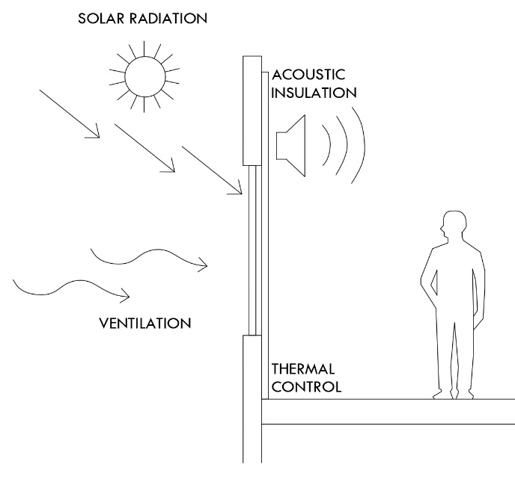
This challenge becomes more pronounced in warm semi-arid climates, where the combination of high solar radiation, low humidity, and significant diurnal temperature fluctuations substantially increases cooling loads. As illustrated in Fig. 1, these environmental conditions highlight the need for passive systems capable of mitigating external thermal stresses on conventional facade assemblies.
Fig. 1. Effect of external factors on facade behavior
In such contexts, the building envelope plays a decisive role in controlling heat gains, and the appropriate selection of materials and passive strategies can significantly reduce energy consumption. In response to these challenges, architecture and engineering have promoted the development of passive systems aimed at improving the thermal performance of building envelopes. Among these strategies, ventilated facades have demonstrated strong potential to reduce heat transfer toward the interior and to harness the stack effect within the air cavity (Schabowicz & Zawiślak, 2020).
This multilayer system incorporates an exterior cladding, a structural support, and an air cavity positioned in front of the traditional wall assembly, as shown in Fig. 2. This configuration facilitates the upward movement of heated air within the cavity, promoting its evacuation and allowing the entry of cooler air, which helps buffer solar loads and stabilize the interior surface temperature (Pizzatto et al., 2025).

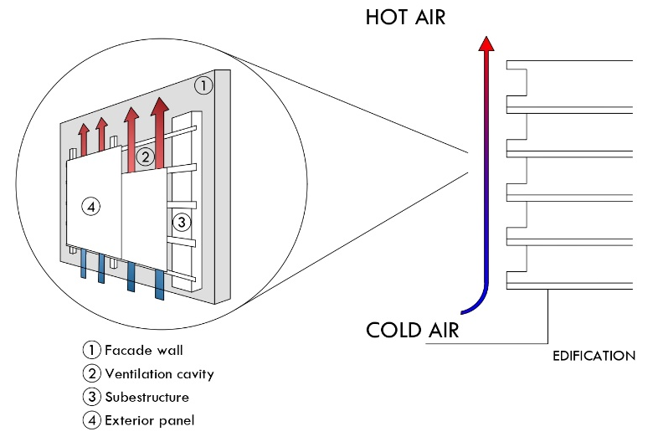
Fig. 2. Components and configuration of a ventilated facade system
Ventilated facades have proven to be a high-performance strategy for both new construction and retrofitting, increasing the thermal resistance of the envelope and reducing overheating risks (Colinart et al., 2019). Their effectiveness depends on the interaction of several factors, including the thermo-optical properties of the cladding, the geometry of the air cavity, the natural ventilation regime, and the prevailing climatic conditions (El Dallal et al., 2024).

Recent studies from diverse climatic regions confirm that a well-designed ventilated facade can reduce thermal loads by approximately 20% to 55%, depending on orientation, cavity depth, and the material used (Hosseini et al., 2025; Farzaneh et al., 2024).

Despite these advances, specialized literature reveals important gaps. First, most studies focus on temperate, Mediterranean, or humid climates, while evidence for warm semi-arid regions remain limited (Chatbi & Zouaoui, 2022), hindering the development of reliable design guidelines for areas with high solar radiation.

Second, there is substantial methodological fragmentation: some works rely exclusively on three-dimensional CFD models, while others use dynamic simulations or experimental testing, making cross-comparison difficult. This methodological inconsistency underscores the lack of evidence-based guidelines that clearly identify which ventilated facade configurations are most effective under warm semi-arid conditions.

Additionally, there is a notable disconnect between academic findings and practical design criteria, generating uncertainty among architects, engineers, and builders. The sector requires simple, comparative, and evidence-based tools to support the selection of cladding materials, cavity depths, and facade configurations according to building type (residential, institutional, or industrial) and local climatic conditions. The absence of synthetic, decision-oriented methodologies limits the effective adoption of ventilated facade systems and often results in design choices driven more by intuition than by quantitative evidence.

Parallel to these gaps, recent research on multigeneration systems has emphasized the importance of thermal management as a key strategy for improving overall energy efficiency in buildings. Eyvazi (2025) demonstrated that integrating heat-recovery mechanisms within multienergy systems can achieve efficiencies above 21%, highlighting the value of utilizing residual heat to reduce electrical cooling demand. Likewise, Eyvazi et al. (2025) presented a geothermal-based multigeneration system achieving exergy efficiencies of 53% and significantly reduced energy costs through advanced pre-cooling techniques.

Although these studies belong to the domain of energy conversion, their conclusions reinforce a principle directly applicable to ventilated facades: optimizing heat flow—whether through active recovery or passive strategies such as ventilated cavities—is essential to enhancing energy performance in warm semi-arid climates. In this sense, ventilated facades can be viewed as the passive counterpart of this broader thermal-management paradigm.

To address these limitations, this article proposes the development of a conceptual framework—namely, a methodology that integrates modeling and the creation of a synthesis tool. The sector requires simple, comparative, and evidence-based tools that support the selection of cladding materials, cavity depths, and facade configurations according to the building type (residential, institutional, or industrial) and the specific climatic context. The absence of synthetic, decision-oriented methodologies limits the effective adoption of ventilated facades and often results in design choices driven by intuition rather than quantitative evidence.

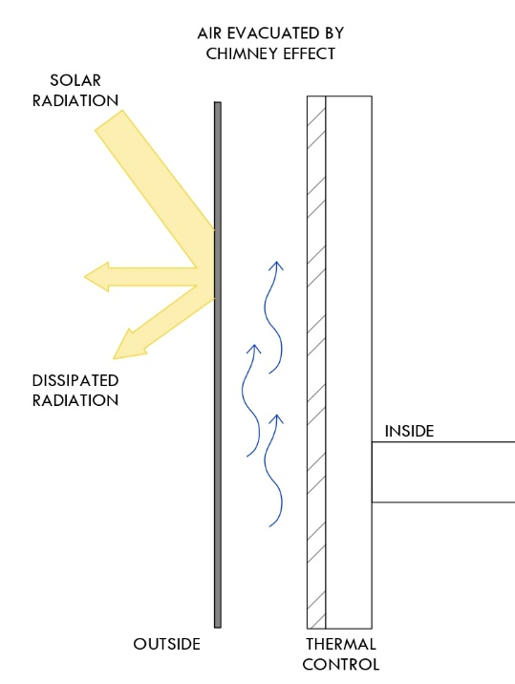
The physical principle underlying their effectiveness is summarized in Fig. 3: solar radiation strikes the exterior cladding, heating the air confined within the cavity; as its temperature rises, the air becomes less dense and ascends due to the stack effect, generating a continuous upward flow that expels heat outdoors. This representation highlights the need for quantitative tools—such as the modeling procedures adopted in this study—to translate these principles into practical and reproducible design criteria.

Fig. 3. Ventilation mechanism and heat transfer in a ventilated facade

In this context, the present study aims to contribute to existing literature through a comparative evaluation of six ventilated facade configurations, derived from the combination of three cladding materials and two cavity depths. The methodological framework integrates: (1) an analytical matrix grounded in recent findings; (2) a one-dimensional thermal model using a series-resistance formulation; and (3) representative boundary conditions for a warm semi-arid climate.

This integrated approach enables the identification of the relative influence of each variable on heat transfer toward the interior and offers preliminary design criteria applicable during early project stages—particularly for buildings exposed to intense solar radiation, such as classrooms, laboratories, offices, and industrial spaces.
2. material and methods

2.1 General Approach and Methodological Strategy
The methodology employed in this study was structured into three complementary stages. First, a review of specialized literature was conducted to identify the thermal variables that significantly influence the performance of ventilated facades. Based on this review, an analytical matrix was developed to organize the parameters reported in previous studies—thermal properties, geometric characteristics, and environmental conditions—thereby allowing the refinement and prioritization of the variables with the greatest impact on the system’s thermal behavior.

Finally, a comparative mathematical model was developed to evaluate the performance of different ventilated facade configurations under representative warm semi-arid conditions. This final stage enabled the analysis of both the individual and combined effects of the selected variables, providing a robust methodological foundation for assessing the thermal behavior of the system.

2.2 Selection Criteria and Matrix Development
The identification of the variables that govern the thermal behavior of ventilated facades was carried out through a literature review published between 2015 and 2025, with an emphasis on studies featuring experimental validation or highly rigorous dynamic thermal modeling.
This process enabled the systematic extraction of the most influential parameters, including air cavity depth, thermo-optical properties of the exterior cladding, the induced ventilation regime, and the system’s response under high solar radiation conditions.
A comparative analysis of these sources supported the development of table 1, which synthesizes the dominant variables reported across the literature. The findings reveal a consistent agreement that air cavities between 5 and 10 cm enhance natural ventilation potential in warm climates, while materials such as ceramic and fiber cement exhibit favorable performance due to their thermal stability and low emissivity.

Moreover, the review identified that next-generation ultracompact materials—such as Dekton—have been scarcely examined despite their potentially advantageous surface properties for ventilated facade applications, thus justifying their inclusion in the present study.

Table 1. Justification of the Parameters Selected for the Simulation Stage

Variable | Selected Values | Justification Based on Literature Review | References
Air cavity depth | 6 cm and 10 cm | Most frequently reported and efficient range for natural ventilation in warm climates (5–20 cm). The selection of 6 to 10 cm allows the evaluation of the transition zone where convective benefits stabilize and marginal returns decrease. | Andreeva et al., 2022; Cuce & Cuce, 2025; Pizzatto et al., 2025; Schabowicz & Zawiślak, 2020
Exterior cladding material | Dekton | Very low emissivity (0.1–0.2), high thermal inertia, and minimal solar absorption. Represents next-generation materials virtually absent from existing ventilated facade literature. | Cuce & Cuce, 2025; Fathi & Fakhriaemmanesh, 2025; Gelesz & Reith, 2015
Exterior cladding material | Ceramic | Widely studied and with well-documented thermal behavior in warm and warm-humid climates. Excellent durability, low maintenance, and high reflectance. | Pizzatto et al., 2025; El Dallal et al., 2024; Luciani-Mejía et al., 2018; Ibañez-Puy et al., 2017
Exterior cladding material | Fiber cement | High reflectance, low cost, and reduced environmental impact. Commonly used in construction yet scarcely examined in combination with ventilated cavities in warm semi-arid climates. | Cuce & Cuce, 2025; Azkorra-Larrinaga et al., 2023; Piasecki et al., 2019

The matrix enabled the refinement of the broad set of parameters identified in the literature and allowed the selection of a reduced number of configurations suitable for analysis. As a result, three cladding materials—Dekton, ceramic porcelain, and fiber cement—and two cavity depths—6 cm and 10 cm—were selected, criteria supported both by their recurrent use in previous studies and by their relevance in hot and hot–semiarid climates.

Furthermore, the matrix facilitated the definition of the indicators guiding the mathematical analysis: the thermal conductivity of the exterior cladding, the transient response of the ventilated cavity, and the system’s capacity to reduce the inward thermal load. These parameters enable consistent comparison across configurations and provide an integrated evaluation of the thermal performance of each alternative.

2.3 Case Study
The case study was developed based on a real space located in the “Biotechnology Building” of the Facultad de Ingenieria at the Universidad Autónoma de Querétaro (UAQ). The southwest facade segment of the envelope was selected, as it represents the most critical orientation under hot–semiarid conditions: it receives direct solar radiation for most of the afternoon, concentrating the highest thermal loads and therefore maximizing the demand on the facade system.

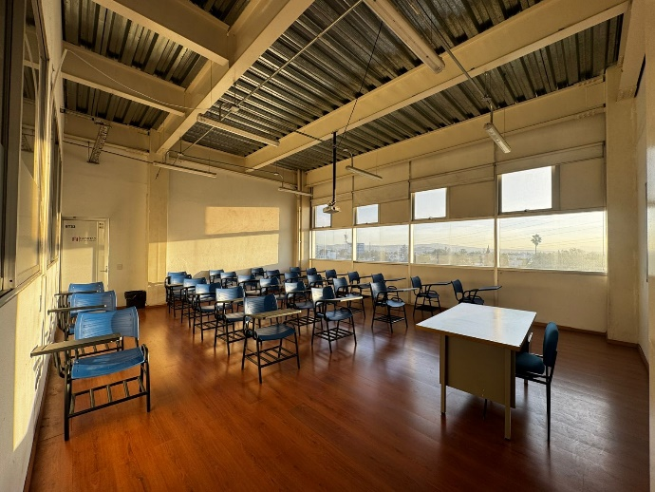
The analyzed classroom measures 8.00 m in length and 4.95 m in width, resulting in a floor area of approximately 39.6 m². With an interior height of 5.00 m, the total volume is 198.00 m³. This geometry, together with its orientation and local climatic conditions, makes it a representative case for evaluating the thermal behavior of different ventilated facade configurations in hot–semiarid regions (Fig. 4).

Fig. 4. Interior view of the reference classroom used as case study

The three-dimensional model was developed in Revit 2024.2, incorporating the exact location of the facade segment under study and accurately reproducing the physical composition of the wall. Each component—the exterior cladding, the air cavity, and the base wall—was defined using multilayer configurations to ensure proper geometric and material representation.

2.6 Ventilated Facade System Configuration
The geometric configuration of the ventilated facade included the explicit representation of the air cavity in two thicknesses—6 cm and 10 cm—as well as an interchangeable exterior cladding layer depending on the material analyzed: Dekton, porcelain ceramic, or fiber cement. These elements are described in table 2.

The objective of the modeling process was to enable a standardized comparison of the six resulting configurations (three materials × two cavity thicknesses). Figures 5, 6, and 7 illustrate the generated variants, which allowed for a consistent evaluation of the relative differences associated with each cladding material and air cavity geometry.

Table 2. Configurations of the ventilated facade system evaluated

Case | Cladding Material | Air Cavity Thickness
Case 1 | Dekton | 6 cm
Case 1 | Dekton | 10 cm
Case 2 | Ceramic | 6 cm
Case 2 | Ceramic | 10 cm
Case 3 | Fiber-cement | 6 cm
Case 3 | Fiber-cement | 10 cm

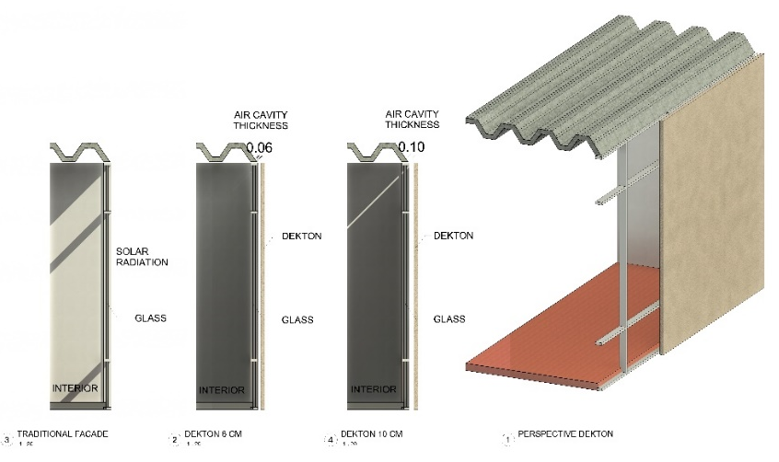
Each configuration was modeled as a multilayer system consisting of a tempered-glass base wall, a ventilated air cavity with variable thickness (6 cm or 10 cm), and an interchangeable exterior cladding layer depending on the material under analysis (Dekton, ceramic, or fiber-cement). This structure enabled a consistent comparison of the expected thermal behavior among the different ventilated facade variants, while keeping the geometric and construction parameters of the model constant.
Fig. 5. Facade configurations analyzed:(1) existing single-glazed facade (reference case), (2) ventilated facade with 6 cm air cavity and Dekton outer layer,(3) ventilated facade with 10 cm air cavity and Dekton outer layer, and (4) perspective view of the proposed ventilated facade with Dekton cladding
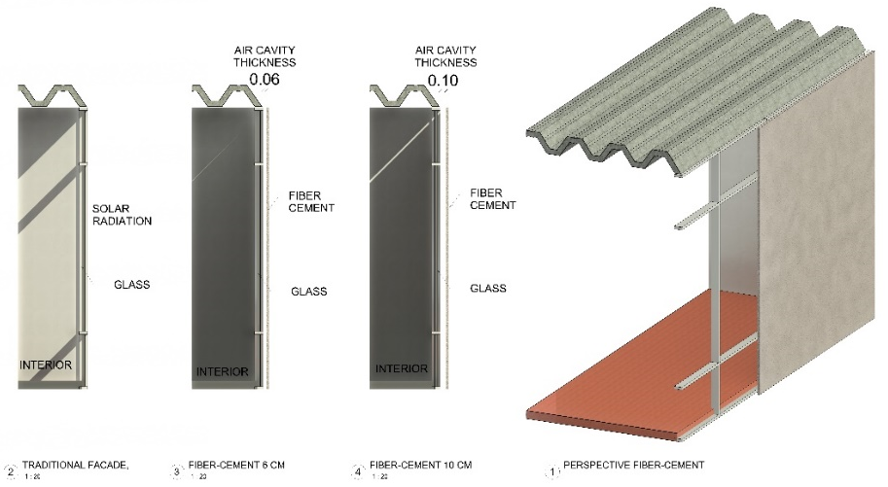
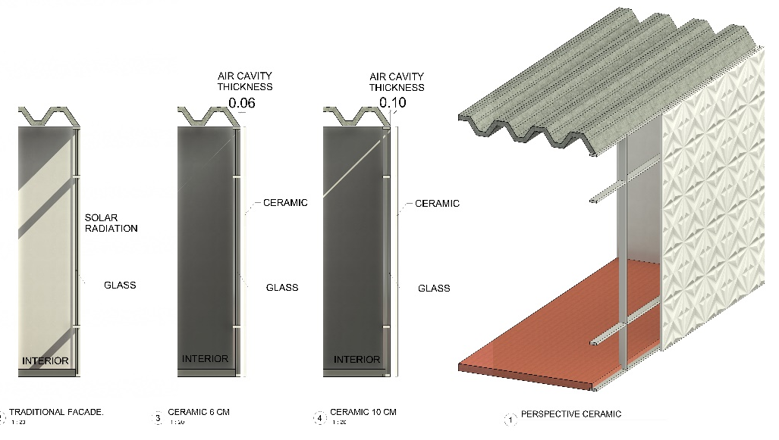
Fig. 6. Facade configurations analyzed:(1) existing single-glazed facade (reference case), (2) ventilated facade with 6 cm air cavity and Ceramic outer layer, (3) ventilated facade with 10 cm air cavity and ceramic outer layer, and (4) perspective view of the proposed ventilated facade with ceramic cladding.
Fig. 7. Facade configurations analyzed:(1) existing single-glazed facade (reference case), (2) ventilated facade with 6 cm air cavity and fiber-cement outer layer,(3) ventilated facade with 10 cm air cavity and fiber-cement outer layer, and (4) perspective view of the proposed ventilated facade with fiber-cement claddig.
2.7 Thermal calculation using a model
A simplified thermal modeling approach was adopted based on a one-dimensional series-resistance scheme, with the purpose of estimating the heat flux through the evaluated ventilated facade configurations. Unlike more complex approaches this formulation allows the explicit decomposition of each layer’s contribution to heat transfer, ensuring methodological transparency and facilitating reproducibility across studies. The central objective was to quantify the isolated effects of cladding material and cavity depth under extreme boundary conditions representative of a warm semi-arid climate.

To ensure the reproducibility of the procedure, the analysis was developed under a clearly defined set of assumptions: a unit area of 1.00 m², a temperature difference representative of a warm semi-arid climate ($T_{ext}:40°C$ , $T_{int}:26°C$), typical convective coefficients for exterior $h_{ext}:15 W/m^{2}K$ and interior surfaces $h_{int}:8 W/m^{2}K$, a 6-mm tempered-glass base wall, a 50-mm mineral wool insulation layer (λ: 0.037 $W/mK$), and ventilated cavities of 6 cm and 10 cm, with assigned convective coefficients of $h_{cav}:5 W/m^{2}K$ and $h_{cav}:8 W/m^{2}K$ , respectively. These assumptions represent consistent extreme heat-gain conditions for the southwest facade of the building under study.

Conduction through the exterior cladding: It´s the thermal resistance due to conduction in the cladding layer was calculated using the classical fourier formulation
$R_{cond: }\frac{d}{k}$ (1)

Where 𝑑 is the material thickness and 𝑘 its thermal conductivity. This equation was applied separately to each cladding material, enabling comparison of their thermo-optical performance as the facade’s first barrier against heat gain.

Convection in the ventilated cavity and boundary surfaces: Convective resistance was modeled using the following formulation
$R_{conv: }\frac{1}{h}$ (2)

where ℎ is the convective heat-transfer coefficient associated with each boundary condition. This formulation is essential for isolating the influence of cavity depth, as the change from 6 cm to 10 cm alters natural ventilation and therefore the effective hcav value.
Total thermal resistance of the facade assembly: The entire multilayer facade was represented as a series of linear thermal resistances:
$R_{total: }\sum{R_{i}}$ (3)

This step makes it possible to identify which element dominates thermal behavior and how conduction and convection interact across layers.

Heat flux entering the interior: Finally, the total heat flux transmitted toward the interior was calculated through the one-dimensional expression:
$q=\frac{T_{ext}-T_{int}}{R_{total}}$ (4)

This value becomes the main comparative indicator in the study: configurations with lower heat flux are considered more thermally efficient.

3. results and discussion

Based on the calculations performed, Tables 3 and 4 present a consolidated summary of the thermal parameters obtained for each configuration, including conductive and convective resistances, total heat flux, and intermediate temperatures. This organization enables a clear evaluation of the influence of cladding material and air-cavity depth on thermal behavior, providing a consistent comparative basis among the six analyzed alternatives.

The results show that the heat flux transmitted to the interior ranges between 7.91 and 8.313 W/m², values that are notably low and confirm the effectiveness of the ventilated facade as a passive strategy in warm semi-arid climates. The air cavity emerges as the dominant element in thermal moderation, contributing the largest portion of the system’s total resistance (Rtot between 1.758 and 1.694 m²·K/W).

Increasing the cavity depth from 6 to 10 cm reduces the heat flux, a trend consistent with findings reported in the literature: beyond approximately 10–12 cm, the marginal benefits associated with natural convection decline rapidly (Andreeva et al., 2022). This inflection point suggests that a 10-cm cavity represents a technical–economic optimum in climates characterized by high daytime solar radiation and pronounced nocturnal temperature swings, as it supports efficient evacuation of heated air without requiring additional structural loads or significant extra costs.

Regarding the cladding material, its influence is comparatively minor (< 3% variation in total heat flux). Among the evaluated options, Dekton exhibits the lowest heat-flux values (7.91 W/m² at 10 cm), followed by fiber-cement (7.91–8.26 W/m²) and ceramic (7.95–8.31 W/m²).

Table 3. Thermal performance of the ventilated facade configurations evaluated

Case | Cladding Material | Air Cavity Thickness | $$R_{clad}$$  (K/W) | $$R_{cav}$$  (K/W) | $$R_{tot}$$  (K/W) | $${ΔT}_{clad}$$  (K) | $${ΔT}_{cav}$$  (K) | $${ΔT}_{suf-Out}$$  (°C) | $${ΔT}_{aft-clad}$$  (°C) | $${ΔT}_{aft-cav}$$  (°C)
Case 1 | Dekton | 6 cm | 0.00909 | 0.200 | 1.75811 | 0.0724 | 1.5926 | 39.469 | 39.397 | 37.804
Case 1 | Dekton | 10 cm | 0.00909 | 0.125 | 1.68311 | 0.0756 | 1.0397 | 39.445 | 39.37 | 38.33
Case 2 | Ceramic | 6 cm | 0.01 | 0.200 | 1.75902 | 0.0796 | 1.5918 | 39.469 | 39.39 | 37.798
Case 2 | Ceramic | 10 cm | 0.01 | 0.125 | 1.68402 | 0.0831 | 1.0392 | 39.446 | 39.363 | 38.323
Case 3 | Fiber-Cement | 6 cm | 0.02 | 0.200 | 1.76902 | 0.1583 | 1.5828 | 39.472 | 39.314 | 37.731
Case 3 | Fiber-Cement | 10 cm | 0.02 | 0.125 | 1.69402 | 0.1653 | 1.033 | 39.449 | 39.284 | 38.251

Table 4. Heat flux through the facade for each ventilated facade configuration under design conditions.

Case | Cladding Material | Air Cavity Thickness | q ($W/m^{2}$) | Potencia  W
Case 1 | Dekton | 6 cm | 7.963 | 315.34
Case 1 | Dekton | 10 cm | 8.318 | 329.39
Case 2 | Ceramic | 6 cm | 7.959 | 315.18
Case 2 | Ceramic | 10 cm | 8.313 | 329.21
Case 3 | Fiber-Cement | 6 cm | 7.914 | 313.39
Case 3 | Fiber-Cement | 10 cm | 8.264 | 327.27

Where:
- $R_{clad}$ (K/W) : Thermal resistance by conduction through the exterior cladding, calculated using Fourier’s law
- $R_{cav}$ (K/W) : Thermal resistance associated with convection within the ventilated cavity.
- $R_{tot}$ (K/W) : Sum of all thermal resistances in the multilayer system.
- Potencia (W) : Total heat transfer through the entire facade panel under analysis.
- ${ΔT}_{clad}$ (K) : Temperature drop occurring exclusively across the exterior cladding.
- ${ΔT}_{cav}$ (K) : Temperature drop within the ventilated cavity.
- ${ΔT}_{suf-Out}$ (°C) : Temperature of the exterior surface of the cladding after accounting for external convection.
- ${ΔT}_{aft-Clad}$ (°C) : Temperature after passing through the exterior cladding, before entering the cavity.
- ${ΔT}_{aft-Cav}$ (°C) : Temperature after the ventilated cavity (before reaching the insulation and interior wall).

4. Conclusion

The simplified thermal analysis based on the series-resistance model enabled a consistent comparison of six ventilated facade configurations, derived from the combination of three cladding materials (Dekton, ceramic, and fiber-cement) and two air-cavity depths (6 and 10 cm), under representative warm semi-arid conditions (Text = 40 °C, Tint = 26 °C, peak solar radiation). The results show that the heat flux transmitted to the interior remains within a narrow range of 7.91 to 8.31 W/m², representing a 66–68% reduction compared to a conventional single-glazed facade (> 25 W/m² under identical conditions). This significant decrease confirms the high effectiveness of the ventilated facade as a passive thermal strategy.
The air cavity consolidates itself as the dominant element in thermal moderation, contributing 70–80% of the total system resistance and generating the largest temperature drop (ΔT cav between 1.03 and 1.59 °C). Increasing the cavity depth from 6 to 10 cm reduces the heat flux by an average of 3.9%, approaching the transition point at which further convective benefits become marginal.
This study addresses a documented gap in the literature by providing a simple, reproducible, and decision-oriented methodology that translates academic findings into practical design recommendations for architects and engineers. Future research should complement this steady-state approach with dynamic modeling (transient CFD) and in-situ testing to quantify real-world performance impacts.

COMPETING INTERESTS DISCLAIMER:
Authors have declared that they have no known competing financial interests OR non-financial interests OR personal relationships that could have appeared to influence the work reported in this paper.

DISCLAIMER (ARTIFICIAL INTELLIGENCE)
Author(s) hereby declare that NO generative AI technologies such as Large Language Models (ChatGPT, COPILOT, etc.) and text-to-image generators have been used during the writing or editing of this manuscript.

References

- Andreeva, D., Nemova, D., & Kotov, E. (2022). Multi-skin adaptive ventilated facade: A review. Energies, 15(9), Article 3447. https://doi.org/10.3390/en15093447
- Aparicio-Fernández, C., Vivancos, J.-L., Ferrer-Gisbert, P., & Royo-Pastor, R. (2014). Energy performance of a ventilated façade by simulation with experimental validation. Applied Thermal Engineering, 66(1–2), 563–570. https://doi.org/10.1016/j.applthermaleng.2014.02.041
- Azkorra-Larrinaga, Z., Romero-Antón, N., Martín-Escudero, K., Lopez-Ruiz, G., & Giraldo-Soto, C. (2023). Evaluation of the thermal performance of two passive facade system solutions for sustainable development. Sustainability, 15(24), Article 16737. https://doi.org/10.3390/su152416737
- Chatbi, M., & Zouaoui, H. (2022). Thermal performance analysis of ventilated facades in hot climates: Case study in North Africa. Energy and Buildings, 256, Article 111728. https://doi.org/10.1016/j.enbuild.2021.111728
- Colinart, T., Bendouma, M., & Glouannec, P. (2019). Building renovation with prefabricated ventilated façade element: A case study. Energy and Buildings, 186, 221–235. https://doi.org/10.1016/j.enbuild.2019.01.033
- Cuce, P. M., & Cuce, E. (2025). Ventilated facades for low-carbon buildings: A review. Processes, 13(7), Article 2275. https://doi.org/10.3390/pr13072275
- De Gracia, A., Castell, A., Navarro, L., Oró, E., & Cabeza, L. F. (2013). Numerical modelling of ventilated facades: A review. Renewable and Sustainable Energy Reviews, 22, 539–549. https://doi.org/10.1016/j.rser.2013.02.029
- El Dallal, I. S., Abdel-Maksoud, R. A., & Faragallah, R. N. (2024). Guidelines for Façade Techniques to Optimize Energy Efficiency in Educational Buildings. Port-Said Engineering Research Journal. https://doi.org/10.21608/pserj.2024.282378.1333
- Eyvazi, A., Ameri, M., Shafiey Dehaj, M., & Ghaebi, H. (2025). Energy, exergy, and economic analysis and optimization of a novel geothermal energy-based multigeneration system for liquid hydrogen, hot water, cooling, and power production. Process Integration and Optimization for Sustainability. Advance online publication. https://doi.org/10.1007/s41660-025-00565-0
- Eyvazi, A. (2025). Energy, exergy, and economic analysis and optimization of novel multi-generation system with combination of heat recovery exchanger and absorption transformer. Renewable Energy and Renewable Agriculture, 6(2), 293–313. https://doi.org/10.22044/rera.2025.14929.1339
- Eyvazi, A., Ameri, M., Shafiey Dehaj, M., & Ghaebi, H. (2025). Thermodynamic and economic analysis of a novel geothermal energy-based multigeneration system for power, cooling, heating and liquid hydrogen production. Heat Transfer. Wiley Online Library. https://doi.org/10.1002/htj.70124
- Fathi, S., & Fakhraeimanesh, S. (2025). Smart materials in building façades: A systematic review of applications and impacts on energy efficiency. Energy Reports, 14, 2123–2140. https://doi.org/10.1016/j.egyr.2025.08.042
- Gelesz, A., & Reith, A. (2015). Climate-based performance evaluation of double skin facades by building energy modelling in Central Europe. Energy Procedia, 78, 555–560. https://doi.org/10.1016/j.egypro.2015.11.735
- Harrat, R., & Rabie, H. (2021). Numerical investigation of double-skin facades for energy efficiency in arid regions. Renewable Energy, 178, 45–56. https://doi.org/10.1016/j.renene.2021.06.012
- Ibañez-Puy, M., Vidaurre-Arbizu, M., Sacristán-Fernández, J. A., & Martín-Gómez, C. (2017). Opaque ventilated façades: Thermal and energy performance review. Renewable and Sustainable Energy Reviews, 79, 180–191. https://doi.org/10.1016/j.rser.2017.05.059
- Luciani-Mejía, S., Velasco-Gómez, R., & Hudson, R. (2018). Ecoenvolventes: análisis del uso de fachadas ventiladas en clima cálido-húmedo. Revista de Arquitectura (Bogotá), 20(2), 62–77. https://doi.org/10.14718/RevArq.2018.20.2.1726
- Piasecki, M., Fedorczak-Cisak, M., Furtak, M., & Biskupski, J. (2019). Experimental confirmation of the reliability of Fanger’s thermal comfort model—Case study of a near-zero energy building (NZEB) office building. Sustainability, 11(9), 2461. https://doi.org/10.3390/su11092461
- Pizzatto, S. M. d. S., Pizzatto, F., Raupp-Pereira, F., Arcaro, S., Angioletto, E., & Montedo, O. R. K. (2025). Ventilated facade system: A review. Boletín de la Sociedad Española de Cerámica y Vidrio, 64, Article 100443. https://doi.org/10.1016/j.bsecv.2025.100443
- Schabowicz, K., & Zawiślak, Ł. (2020). Numerical comparison of thermal behaviour between ventilated facades. Studia Geotechnica et Mechanica, 42(4), 297–305. https://doi.org/10.2478/sgem-2019-0044

