Original Research Article
Molecular Characterization of blaCTX-M-G1 and blaOXA Genes in Enteropathogenic Escherichia coli Isolated from Children under Two Years in Ouagadougou, Burkina Faso
ABSTRACT
Extended Spectrum β-lactamases (ESBLs) are evolved forms of β-lactamases produced mainly by gram-negative bacilli that allow them to inactivate penicillins, cephalosporins and Aztreonam. They are encoded by various genes that are either chromosomal or plasmid and hosted by bacterial strains especially those of E. coli widely distributed in the world. The presence of antibiotic resistance genes increases the pathogenicity of bacterial strains already equipped with virulence factors. Objectives : The aim of this study was to characterize the CTX-M-G1 and OXA genes in enterophatogenic Escherichia coli Extended-Spectrum β-Lactamases-producing strains isolated from children under two years of age at Protestant Hospital Center Schiphra in Ouagadougou. Methods : A total of 53 strains of Escherichia coli responsible for human infections and isolated from stool were subjected to serotyping and susceptibility tests targeting antibiotics such as ceftriaxone, cefotaxime, ceftazidime, imipenem were performed according to discs diffusion method on Mueller-Hinton agar. The search for resistance genes was carried out by classical PCR. Results : Among 53 strains analyzed, 26.41% represented enteropathogenic Escherichia coli. The susceptibility test showed high proportions of resistance to third-generation cephalosporins, 27.27% (ceftriaxone), 75% (ceftazidime) and 100% (cefotaxime) . Imipenem was the most active of all the strains tested with a sensitivity ratio of 100%. Analysis of PCR products after agarose gel electrophoresis revealed 32 strains (60.37%) harboring at least one of the resistance genes sought. Of these strains, 28.30% harbored the bla_{OXA} gene, 32.07% the bla_{CTX-M-G1} gene. The co-existence of bla_{OXA} and bla_{CTX-M-G1} genes was found on 18.86%. Conclusion : This study calls attention to community and hospital hygiene measures and the need for monitoring to limit the spread of virulent, antibiotic-resistant strains.
Key words : Enteropathogenic Escherichia coli, bla_{CTX-M} , bla_{OXA}, infants, two years

INTRODUCTION
Escherichia coli is a commensal bacterium of the intestinal microbiota of warm-blooded organisms. It is involved in a wide variety of intestinal and extraintestinal infections as an opportunistic pathogen, including septicemia, urinary tract infections, and wound superinfection. This species has different pathovars including, enteropathogenic Escherichia coli (EPEC) which is responsible for epidemics of infantile gastroenteritis in developing countries (Clarke, 2001; Akinlabi et al., 2025). According to the World Health Organization (WHO), approximately five (05) million children die each year from acute diarrhea. One third of cases of infantile diarrhea in developing countries are caused by E. coli (Xu et al., 2015).This bacterial species is distinguished by his high ability to acquire antimicrobial resistance genes (Carvalho et al., 2021). Bacterial resistance is a reality all over the world and now constitutes a serious threat to public health and a major concern for the medical community (Rangama et al., 2021). Bacteria responsible for gastroenteritis, including Escherichia coli, are often multiresistant and produce β-lactamases, among which are Extended Spectrum β-lactamases (ESBLs) (Lavigne et al., 2002, Guindo et al., 2022). ESBLs are defined as enzymes belonging to class A or D of the Ambler classification, capable of hydrolyzing penicillins, first, second, third and fourth generation cephalosporins (C1G, C2G, C3G and C4G) and aztreonam (ATM) (Rodriguez-Villalobos and Struelens, 2006). CTX-M (Cefotaximase-Munich) type have been considered since the early 2000s as pandemic enzymes in hospitals, but also in the community (Mhaya, 2019). They were disseminated within community strains of E. coli mainly responsible for urinary tract infections. The genes encoding for these enzymes are carried by mobile genetic elements, explaining their significant dissemination. (Zongo et al., 2015). Several serotypes of Escherichia coli are responsible for hemolytic and uremic diarrhea in children under three years of age (Dupont, 2010). Equipment with virulence factors such as the production of enterotoxins, adherence to cells, and invasive potential and the acquisition of resistance genes probably aggravate the pathogenicity of E. coli. Our study aims to gather information on this type of specimens by searching for resistance genes of the CTX-M and OXA types in enteropathogenic Escherichia coli strains infecting infants.

Materials and methods
Clinical specimens and bacterial strains
Bacterial isolates consisting of Escherichia coli resistant to third generation cephalosporins (C3G), were collected between September and December 2022 during biological analysis at Protestant Hospital Center Schiphra in Ouagadougou, Burkina Faso. They were isolated from the stools of children under two years of age, whether hospitalized or not in various units of the hospital. Samples from patients on antibiotic therapy without an antibiotic-free window of at least 72 hours were not included in the study.The isolates were stored at -80 C in Luria-Bertani supplemented with glycerol.
Serotyping of bacterial strains
Serotyping of Escherichia coli strains was performed using, nonavalent, trivalent I, trivalent II, trivalent III and trivalent IV antisera (Guindo et al., 2022). Trivalent I is used for detection of antigens O111, O55, O26, trivalent II for antigens O86, O119, O127, trivalent III antigens O125, O126, O128 and trivalent IV for antigens O124, O114 and O142. It consisted of crushing a fraction of colony of each bacterial strain in a drop of antiserum deposited on sensitized latex paper. The device is placed under gentle agitation in search of agglutination. The reading and interpretation of agglutination reactions is done visually for the first five seconds. The appearance of fine granular agglutinates indicates a positive result. Negative results correspond to bacterial suspensions that remained homogeneous
Antibiotic sensitivity tests
Antibiotic susceptibility was tested by disk diffusion method, with antibiotic disks used to test Gram negative bacilli particularly monobactam: Aztreonam (30 µg), third generation cephalosporin like cefotaxim (30 µg), ceftriaxon (30 µg), ceftazidim(30 µg), fourth generation cephalosporins: cefepim (30 µg) and imipenem (30 µg ). Antibiotics were tested on Petri dish containing Muller Hinton agar. Measurements of inhibition area determine the clinical categories (CA-SFM, 2023). Isolates that were resistant to at least one of the antibiotics were collected, purified and conserved at -80°C for furthers analysis
Molecular characterization
DNA extraction
DNA extraction was performed according the boiling method (Maria-Eleni and al., 2020). For this, a colony from a young culture of the last 24 hours on TSA medium was suspended in 200 µL of distilled water in labeled Eppendorf tubes. Then, the tube was soaked in a water bath at 100 °C for 15 minutes to release the genetic material from the bacteria. After 10 min centrifugation at 12000 rpm, the supernatant containing the released DNA was transferred to a new Eppendorf tube. Quantification and purification of total DNA based on A260/A280 and A260/A230 absorbance ratios were determined for each sample using a Nanodrop spectrophotometer (Nanodrop Technologies, Wilmington, DE, USA).
Amplification of bla_{CTX-M-G1} and bla_{OXA}
PCR was performed using the GeneAmp PCR System 9700 thermal cycler (Applied Biosystems, California, USA) in a 20 μL reaction mixture. This reaction mixture was prepared using 4 μL of 5X Firepol® Master Mix, 0.5 μL of forward primer, 0.5 μL of reverse primer, 13 μL of PCR water, 2 μL of bacterial DNA from each strain. PCR conditions consisted of an initial denaturation of 94°C for 5 minutes, followed by 35 cycles each of a denaturation step at 94°C for 30 seconds, an annealing step at 63°C for 30 seconds and an elongation step at 72°C for 30 seconds. Finally, a final extension at 72°C for 7 minutes was performed. The primer sequences for the different genes are shown in the table below (Table I).
Table I : Primers and amplicon size
Genes | Primers | Amplicon size (bp) | Référence
CTX-M-G1 | F : 5’TCCAGAATAAGGAATCCCATGG3’  R : 5’ TGCTTTACCCAGCGTCAGAT3’ | 621 | (Kim et al., 2009)
OXA | F : 5’ ATTATCTACAGCAGCGCCAGTG3’  R : 5’ TGCATCCCGTCTTTGGTG3’ | 296 | (Kim et al., 2009)

Agarose gel electrophoresis
PCRproducts were separated by electrophoresis on agarose gel (1.5%) prepared in a 1X Tris-Acetate-EDTA (TAE) solution and containing 10 μL of SYBR Green. Migration was carried out for 35 minutes at a voltage of 100 Volts. The migration products obtained were visualized under ultraviolet light using GeneFlash (Syngene, Bio-Imaging, UK). A 100 bp molecular weight marker was used for amplicon size determination. A PCR mixture without DNA template was included as a negative control.
Results
Serotyping and antimicrobial susceptibility testing
Among Escherichia coli strains subjected to serotyping, a proportion of 26.41% of the strains represent enteropathogenic Escherichia coli aigainst 73.58% representing non-enteropathogenic Escherichia coli. The search for pathovars by agglutination allowed us to incriminate the groups of serotypes revealed by the antisera. So during this study, 35.71% of enteropathogenic Escherichia coli are revealed by Trivalent I, 21.43%, Trivalent II and 42.86% byTrivalent III.
For their susceptibility to targated antibiotics, the results revealed high proportions of strains resistant to cefotaxime (100%), ceftazidime (75%) and ceftraixone (27.27%).

**

¥

*

Figure 1 : Image showing the results of antibiotic sensitivity testing of a strain
of E. coli(Cop1195) on a Petri dish.
Legend : ** extended growth inhibition zone indicating the strain's sensitivity to the antibiotic, * no growth inhibition zone, resistant strain, ¥ Champagne cork image for a BLSE-producing strain (E. coli Cop1195)
Molecular characterization of bla_{CTX-M-1} and bla_{OXA} genes
Amplification and electrophoretic migration of PCR products allowed the isolation of bla_{OXA} and bla_{CTX-M-G1}The molecular weight marker used allowed the identification of amplicons around 300bp for bla_{OXA}(Figure 2) and 621 bp for bla_{CTX-M-G1}(figure 3).
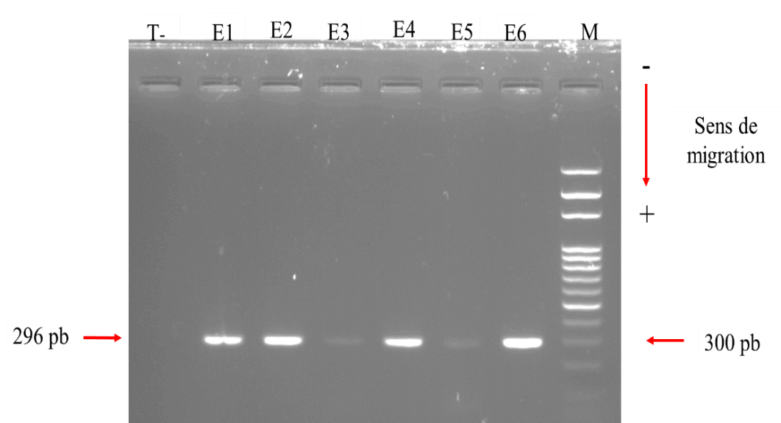
Direction of migration
300 bp
296 bp

Figure 2: Electrophoretic profile of bla_{OXA} gene amplicons (296bp)
Legend : M: Molecular weight marker (100 bp DNA Ladder). T (-): negative control, Numbers E1-E6 represent samples (E1 = Cop1298 ; E2 = Cop1300 ; E3 = Cop1310 ; E4 = Cop1392 ; E5 = Cop1398 ; E6 = Cop1617), cop = sample for coproculture, blaOXA (296 bp) appears around 300 bp.
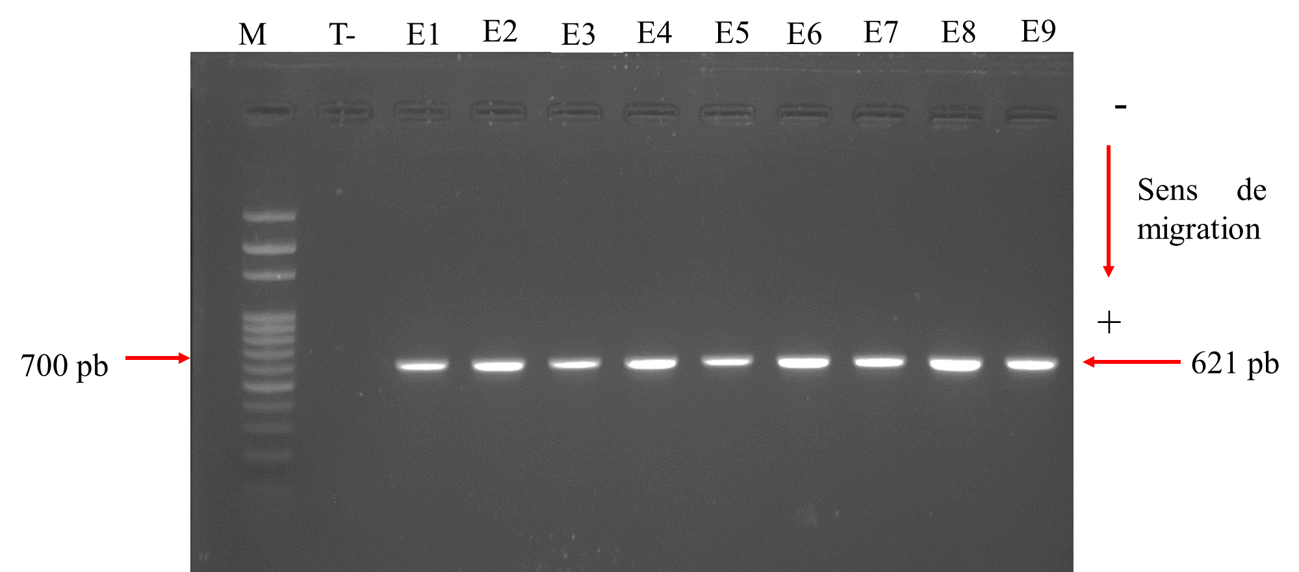
600 bp
621 bp
Direction of migration

Figure 3: Electrophoretic profile of bla_{CTX-M-G1} gene amplicons (621bp)
Legend : M: Molecular weight marker (100 bp DNA Ladder). T (-): negative control, Numbers E1-E7 represent samples (E1 = Cop1195 ; E2 = Cop1292 ; E3 = Cop1297 ; E4 = Cop1300 ; E5 = Cop1310 ; E6 = Cop1392 ; E7 = Cop1398). blaCTX-M-G1 (621 b) appears around 600 bp
Electrophoresis migration of PCR products revealed that 32.07% of bacterial strains harbor the bla_{CTX-M-G1} gene, while 28.30% harbor bla_{OXA}. Coexistence of bla_{OXA} and bla_{CTX-M-G1} genes was observed in 18.86% of strains.

Discussion
Frequency of Escherichia coli pathovars
The profile of bacterial, strains responsible of gastroenteritis in children is essential information for clinicians to guide curative antibiotic therapy, as well as for raising awareness among parents. They can be responsible for collective food poisoning and more seriously of Hemolytic Uremic Syndrome (HUS) when the bacteria incriminated according to their pathogenicity genes belong to Escherichia coli species
This study shown that 26.41% of Escherichia coli isolated on children under two years old, seen for consultation at the Protestant Shiphra are enteropathogenic Escherichia coli. Among these infected children, 22. 64% are between 0 and 6 months old. In developing countries, enteropathogenic Escherichia Coli infections are very common and are a major cause of diarrheal illness and death due to dehydration in children. Studies in Brazil, Mexico, and South Africa have shown that 30–40% of childhood diarrhea cases can be attributed to enteropathogenic Escherichia Coli (Stenutz et al., 2006).
Among enteropathogenic Escherichia coli identified, 35.71%, 21.43%and 42.86% are respectively distributed in trivalent I, trivalent II and trivalent III. Serogroups O111 and O26 are recognized by several authors as the main causes of childhood diarrhea epidemics in low-income countries (Clarke et al., 2003; Germani and Bouguénec, 2008). Infection by enteropathogenic E. coli strains occurs initially through the adhesion of the bacteria to epithelial cells, and subsequently through the ability of a membrane protein, intimin, to cause attachment and effacement lesions (Zhang et al., 2002, Lim et al., 2020).
Antibiotic susceptibility and bla genes harbored
In addition to virulence factors such as adhesion to enterocytes and effacement of intestinal villi, enteropathogenic Escherichia coli strains exhibit resistance to several classes of antibiotics belonging to β-lactam family. Our study revealed that 100%, 75% and 27.27% of strains are respectively resistant to cefotaxim, ceftazidim and ceftriaxon. A study conducted in Togo reported that 100% of Escherichia coli strains were resistant to cefotaxime.(Tabar et al., 2016; Toudji et al., 2017). In addition, authors from Senegal and Iran respectively reported that in their studies, 76% and 65.30% of E. coli strains were resistant to ceftazidime (Amirkamali et al., 2017; Diagne et al., 2019).
The resistance profile of the strains observed on Petri dishes was confirmed by molecular characterization. Indeed, PCR allowed to isolate resistance genes on our isolates. For all E. coli strains investigated, 32.07% harbor the CTX-M-G1 gene while 28.30% harbor the OXA gene. Several authors reported that CTX-M type enzymes constitute the majority of ESBLs regardless of the region of the world, to the point that their spread is described as pandemic(Ruppé, 2010). CTXM-G1 group gene isolation assumes that our strains harbor at least one of the CTX-M-1 type, CTX-M-3 type, or CTX-M-15 type ESBL genes. However, bacterial strains harboring the CTX-M-15 gene are incriminated as multidrug-resistant strains that can concurrently harbor the qnrA, qnrB and qnrS genes responsible for resistance to quinolones and fluoroquinolones (Strahilevitz et al., 2009). This study also revealed that 28.30% of the investigated Escherichia coli strains harbor the OXA gene. A study conducted in Thailand reported 8.1% of Escherichia coli harboring bla gene (Patarachai et al., 2008). OXA-type enzymes possess high hydrolytic activity against cloxacillin, oxacillin and methicillin(Evans et Amyes, 2014).
Conclusion
This study leaded at hospital center Shiphra, revealed that infections by Escherichia coli strains remain à public health concern particularly for children. Enteropathogenic strains are identified and among them some, in addition to being equipped with virulence factors, harbor genes that compromise antibiotic therapy in vulnerable individuals. Insteed, the study revealed that 32.07% of bacterial strains harbor the bla_{CTX-M-1} gene, while 28.30% harbor bla_{OXA}. Coexistence of bla_{OXA} and bla_{CTX-M-1} genes was observed in 18.86% of strains.
Serogrouping and antibiogram tests are needed to allow efficient survey and control of pathogenic Escherichia coli strains in diarrhea and other childhood illnesses. In addition, antibacterial prescription should ideally be carried out after antimicrobial susceptibility testing.

Disclaimer (Artificial intelligence)
Author(s) hereby declare that NO generative AI technologies such as Large Language Models (ChatGPT, COPILOT, etc.) and text-to-image generators have been used during the writing or editing of this manuscript.

References
- Akinlabi, OC., Dada, RA., Olayinka, AA., Oginni-Falajiki, IO., Bejide, OS., Adewole, PD., et al. (2025) Genomic epidemiology of enteropathogenic Escherichia coli in southwestern Nigeria. PLoS Negl Trop Dis 19(8): e0013442. https://doi.org/10.1371/journal.pntd.0013442
- Amirkamali, S., Naserpour-Farivar, T., Azarhoosh, K., & Peymani, A. (2017). Distribution of the blaOXA, blaVEB-1, and blaGES-1 genes and resistance patterns of ESBL-producing Pseudomonas aeruginosa isolated from hospitals in Tehran and Qazvin, Iran. Revista da Sociedade Brasileira de Medicina Tropical, 50, 315–320. https://doi.org/10.1590/0037-8682-0478-2016
- Evans, B. A., & Amyes, S. G. B. (2014). OXA β-Lactamases. Clinical Microbiology Reviews, 27(2), 241-263. https://doi.org/10.1128/CMR.00117-13
- Cavallo, J.-D., Fabre, R., Jehl, F., Rapp, C., & Garrabé, E. (2004). Bêtalactamines. EMC – Maladies Infectieuses, 1(3), 129–202. https://doi.org/10.1016/j.emcmi.2004.03.003
- Clarke, S. C. (2001). Diarrhoeagenic Escherichia coli—An emerging problem? Diagnostic Microbiology and Infectious Disease, 41(3), 93–98. https://doi.org/10.1016/s0732-8893(01)00303-0
- Dupont, C. (2010). Diarrhées aiguës de l’enfant. Journal de pédiatrie et de puériculture, 23(2), 84-95. https://doi.org/10.1016/j.jpp.2010.03.008
- Diagne, R., Diallo, A. A., Ka, R., Ngom, B., Lo, S., Dia, M. L., Diop, A., Niang, A. A., Baidy, D., Diallo, F., Sarr, H., & Sow, A. I. (2019). Antimicrobial Resistance and Characterization of Broad-Spectrum Batalactamases and Quinolone Resistance Genes of Urinary E. Coli Isolated in Senegal between 2009 and 2017. Journal of Bacteriology and Mycology. https://www.austinpublishinggroup.com/bacteriology-mycology/fulltext/jbcm-v6-id1106.php
- Guindo, I., Dicko, A.A., Konaté, I., Sacko, S., Abdou, M., Dao, S., & Bougoudogo, F. (2022). Facteurs de Pathogénicité et Résistance aux Antibiotiques des Souches d’Escherichia coli isolées chez les Enfants Diarrhéiques de 0 à 59 mois en Milieu Communautaire à Bamako. Health Sciences and Disease, 23, 49-56. https://doi.org/10.5281/hsd.v23i5.3615
- Lavigne, J.-P., Sotto, A., Merle, C., Jourdan, J., Soussy, C.-J., & Sirot, D. (2002). Résistance enzymatique d’Escherichia coli aux bêtalactamines et prévalence en clinique. Pathologie Biologie, 50(6), 388–393. https://doi.org/10.1016/S0369-8114(02)00325-5
- Lim, MA., Kim, JY., Acharya, D., Bajgain, BB., Park, JH., Yoo, SJ., et al. Lim M-A, Kim J-Y, Acharya D, Bajgain BB, Park J-H, Yoo S-J, et al.( 2020). A Diarrhoeagenic EnteropathogenicEscherichia coli (EPEC) Infection Outbreak That Occurred among Elementary School Children in Gyeongsangbuk-Do Province of South Korea Was Associated with Consumption of Water-Contaminated Food Items. Int J Environ Res Public Health.;17(9):3149. pmid:32366011
- Maria-Eleni, D., Venia, S., Chrysoula, K., Apostolos, V. (2020). Boiling extraction method VS commercial Kits for bacterial DNA isolation from food samples. Journal of Food Science and Nutrition Research 3311-319
- Mhaya, A. (2019). Analyse de la résistance aux antibiotiques chez les entérobactéries et étude d'une potentielle voie alternative aux traitements antibiotiques [Doctoral thesis, Université de Bordeaux]. Theses.fr. https://www.theses.fr/s199000
- Kiratisin, P., Apisarnthanarak, A., Laesripa, C., & Saifon, P. (2008). Molecular Characterization and Epidemiology of Extended-Spectrum-β-Lactamase-Producing Escherichia coli and Klebsiella pneumoniae Isolates Causing Health Care-Associated Infection in Thailand, Where the CTX-M Family Is Endemic. Antimicrobial Agents and Chemotherapy, 52(8), 2818–2824. https://doi.org/10.1128/AAC.00171-08
- Rangama, S., Lidbury, I. D. E. A., Holden, J. M., Borsetto, C., Murphy, A. R. J., Hawkey, P. M., & Wellington, E. M. H. (2021). Mechanisms involved in the active secretion of CTX-M-15 β-Lactamase by Pathogenic Escherichia coli ST131. Antimicrobial Agents and Chemotherapy, 65(10), e00663-21 https://doi.org/10.1128/AAC.00663-21
- Rodriguez-Villalobos, H., & Struelens, M.-J. (2006). Résistance bactérienne par β-lactamases à spectre étendu : Implications pour le réanimateur. Réanimation, 15(3), 205–213. https://doi.org/10.1016/j.reaurg.2006.03.006
- Ruppé, E. (2010). Épidémiologie des bêta-lactamases à spectre élargi : L’avènement des CTX-M. Antibiotiques, 12(1), 3–16. https://doi.org/10.1016/j.antib.2010.01.003
- Société Française de Microbiologie. (2023). Détermination de la sensibilité aux antibiotiques. In Société Française de Microbiologie (Ed.), *CA-SFM/EUCAST: Recommandations 2023* (pp. 12-20). Société Française de Microbiologie. https://www.sfm-microbiologie.org/wp-content/uploads/2023/06/CASFM2023_V1.0.pdf
- Stenutz, R., Weintraub, A., & Widmalm, G. (2006). The structures of Escherichia coli O-polysaccharide antigens. FEMS Microbiology Reviews, 30(3), 382-403. https://doi.org/10.1111/j.1574-6976.2006.00016.x
- Strahilevitz, J., Jacoby, G. A., Hooper, D. C., & Robicsek, A. (2009). Plasmid-Mediated Quinolone Resistance: A Multifaceted Threat. Clinical Microbiology Reviews, 22(4), 664-689. https://doi.org/10.1128/CMR.00016-09
- Toudji, A. G., Djeri, B., Karou, S. D., Tigossou, S., Ameyapoh, Y., & de Souza, C. (2017). Prévalence des souches d’entérobactéries productrices de bêta-lactamases à spectre élargi isolées au Togo et de leur sensibilité aux antibiotiques. International Journal of Biological and Chemical Sciences, 11(3), 1165-1177. https://doi.org/10.4314/ijbcs.v11i3.19
- Xu, Y., Liu, Y., Liu, Y., Pei, J., Yao, S., & Cheng, C. (2015). Bacteriophage therapy against Enterobacteriaceae. Virologica Sinica, 30(1), 11–18. https://doi.org/10.1007/s12250-014-3543-6
- Germani, Y., & Le Bouguénec, C. (2008). Diagnostic des Escherichia coli agents de diarrhée chez l'homme. Revue Francophone des Laboratoires, 2008(400), 67-76. https://doi.org/10.1016/S1773-035X(08)80102-5
- Zhang, W. L., Köhler, B., Oswald, E., Beutin, L., Karch, H., Morabito, S., Caprioli, A., Suerbaum, S., & Schmidt, H. (2002). Genetic diversity of intimin genes of attaching and effacing Escherichia coli strains. Journal of Clinical Microbiology, 40(12), 4486–4492. https://doi.org/10.1128/JCM.40.12.4486-4492.2002
- Zongo, K. J., Dabire, A. M., Compaore, L. G., Sanou, I., Sangare, L., Simpore, J., & Zeba, B. (2015). First detection of blaTEM, SHV and CTX-M among Gram negative bacilli exhibiting extended spectrum -lactamase phenotype isolated at University Hospital Center, Yalgado Ouedraogo, Ouagadougou, Burkina Faso. African Journal of Biotechnology, 14(14), 1174–1180. https://doi.org/10.5897/AJB2014.13908

