Evaluation of Some Biochemical Parameters of Taro Corms (Colocasia esculenta) of the "Fouê" and "Yatan" Cultivars and Organoleptic Characterization of Traditional Pastry Dishes Made with Composite Flour of Wheat (Triticum aestivum) Type 45 and Taro Corms

Types of articles: Original Research Article

ABSTRACT
Aims: This study explores the biochemical properties of taro corms and the sensory qualities of traditional pastries made with composite flours from wheat and taro of the Fouê and Yatan cultivars.
Methods: Biochemical and sensory data were analyzed with Tukey's test after ANOVA to compare sample means and identify significant differences at a 5% level (P < 0.05). This analysis assessed the impact of substituting wheat flour with taro powder on dish characteristics, identifying optimal substitution levels for acceptable sensory quality.
Results: Biochemical analysis showed significant differences (P < 0.05) between the two taro cultivars, with the Fouê cultivar having generally higher levels of dry matter (28,75 ± 3,93 %), protein (1,79 ± 0,04 g/100 g DM), fiber (5,53 ± 0,08 g/100 g DM), vitamin C (5,29 ± 0,08 mg/100 g DM), and minerals like calcium (48,75 ± 3,31 mg/100 g DM), magnesium (41,03 ± 2,16 mg/100 g DM), and iron (0,79 ± 0,02 mg/100 g DM). In preparing traditional pastries (Spring Rolls, snowball cakes, and savory croquettes) with composite flours, incorporating taro powder changed the appearance, texture, and sensory acceptability, especially above 6% substitution. Sensory analysis by a tasting panel assessed color, texture, aroma, and taro flavor. Low taro levels (1–3%) maintained acceptability similar to the 100% wheat control, while higher levels (9–12%) reduced it.
Conclusion: This work enhances understanding of the nutritional benefits of the Fouê and Yatan cultivars and their potential for producing traditional pastries with optimized sensory qualities.

Keywords: Biochemical Parameters, Composite Flour, Organoleptic Characteristics, Pastry, Taro Corms, Fouê, Yatan.

1. INTRODUCTION
In recent years, food security has become a global concern due to climate change, which is one of the main drivers of rising international food prices [1]. Today, about 1.02 billion people are considered undernourished [2]. It is therefore clear that food production must increase significantly to meet the future demand of a growing population, projected to reach around 9 billion by 2050 [3]. Africa’s rapid urbanization and the emergence of a middle class are changing dietary habits, boosting the consumption of bread and traditional dishes that need to be promoted [3]. Wheat flour is a staple ingredient in pastries, baked goods [4], and even certain traditional dishes. The costs of importing wheat and its derivatives heavily impact the trade balance of non-wheat-producing countries. In developing countries, especially in sub-Saharan Africa, research efforts are being made to partially substitute wheat flour with flours made from locally available crops [5]. This is aimed at reducing costly wheat imports and increasing the use of local products [6]. Studies on composite flours made with wheat and other products show that their use in baking, pastries, and traditional dishes is relatively recent worldwide. Three primary reasons for their development, varying by region, are economic, social, and health-related factors [5]. Research has thus focused on producing composite flour from local crops to replace wheat. Indeed, several authors have worked on developing composite flours where part of the wheat flour is replaced by other starchy sources [7]. Trials have shown successful substitution of wheat flour with flours or powders derived from carbohydrate-rich local products such as cereals (maize, rice, sorghum, millet), tubers (cassava, taro, sweet potato, yam), and protein-rich foods (cowpea, soybean) [8-10]. It can be inferred from these studies that product qualities depend on the proportional composition of the composites and their properties [11]. Many studies have led to an understanding of the physicochemical and nutritional properties of taro powder [12-16]. Initial studies on taro have shown that taro corms are relatively low in protein (1.5%) and fat (0.2%), as is the case with many other tuber crops. However, taro is a good source of starch (70–80 g/100 g of dry taro), fiber (0.8%), and ash (1.2%). It is also a good source of thiamine, riboflavin, iron, phosphorus, and zinc, as well as an excellent source of vitamin B6, vitamin C, niacin, potassium, copper, and manganese [17]. Taro can also be used to trap flavor compounds [18]. Other studies have shown that up to 10% substitution with raw taro powder has no significant effect on the dough’s rheological properties [14]. Certain physical characteristics of food products, such as appearance and surface color, are typically the first quality parameters evaluated by consumers and are essential to product acceptance [19]. Therefore, the objective of this work is to study the biochemical parameters of taro corms (Colocasia esculenta) of the 'Fouê' and 'Yatan' cultivars and to conduct an organoleptic characterization of several traditional pastry dishes (Spring Rolls, snowball cakes, and savory croquettes) made with composite flour from wheat (Triticum aestivum) type 45 and taro corms. Specifically, the aims are to:
-Determine some biochemical parameters of taro corms from the Fouê and Yatan cultivars,
-Formulate composite flours from wheat flour and powders from each taro cultivar, 'Fouê' and 'Yatan,' in suitable proportions,
-Prepare traditional pastry dishes such as Spring Rolls, snowballs cakes, and savory croquettes using these composite flours,
-Assess the organoleptic characteristics and acceptability of these dishes through sensory analysis.

2. MATERIALS AND METHODS

2.1 Raw Material Procurement
The biological material used in this study consisted of wheat flour type 45 and corm powder from two taro species (Colocasia esculenta) cultivars "Fouê" and "Yatan." The wheat flour T45 was purchased from a supermarket in Abidjan. As for the taro tubers, they were specifically from purple-fleshed (Fig. 1) and white-fleshed (Fig. 2) cultivars, respectively called "Fouê" and "Yatan" in "Akyé," a dialect of the lagoon people of the Akan group in Côte d'Ivoire. These tubers were harvested at physiological maturity (after the leaves and stems had dried) in plantations in Afféry, a commune in the Akoupé department (Côte d'Ivoire), located in the southeast of the country. One hundred (100) kilograms of "Fouê" corm and eighty (80) kilograms of "Yatan" corm were then transported the day after harvest to the Laboratory of Biocatalysis and Bioprocesses of the Faculty of Food Science and Technology at Nangui Abrogoua University (Abidjan, Côte d'Ivoire) for studies.
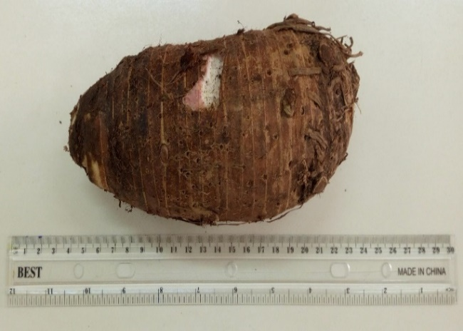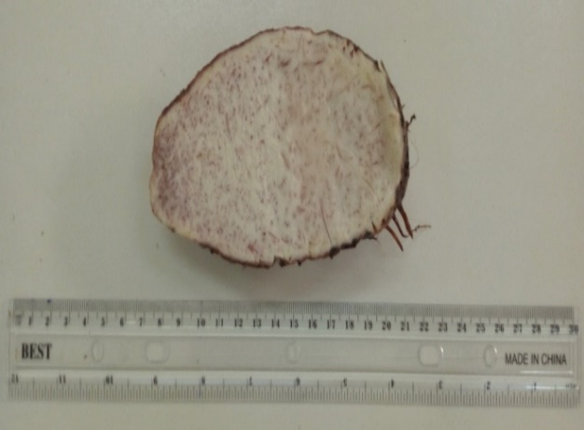
A
B

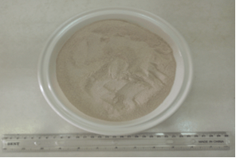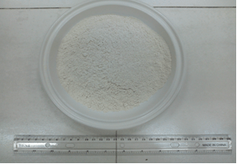
C
D
Fig. 1. Photography of the Corm and Powder of Taro Colocasia esculenta cv. "Fouê"
A: Whole corm; B: Longitudinal cut of the corm; C: Taro powder (cv. "Fouê"); D: Wheat flour T45
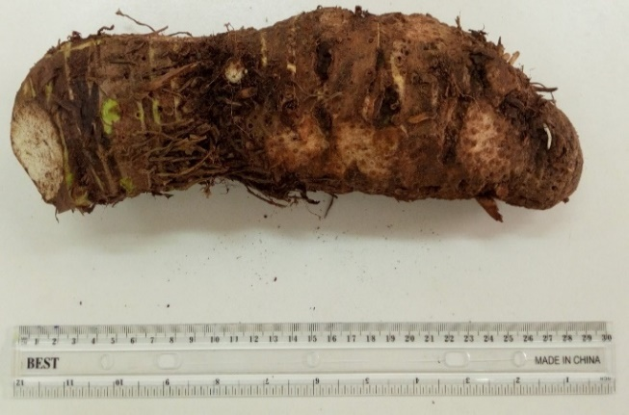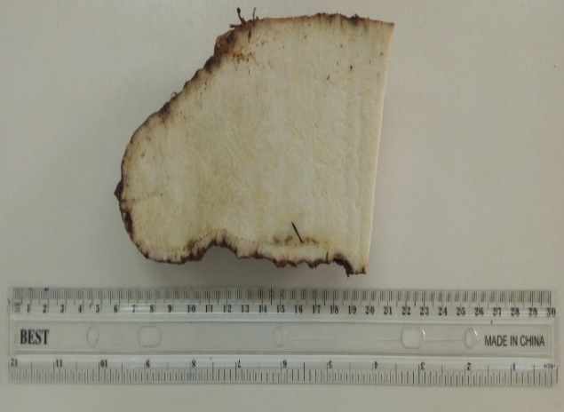
A
B
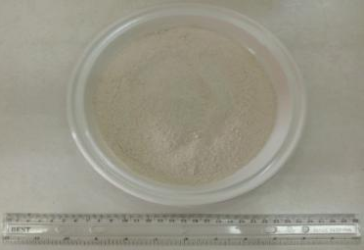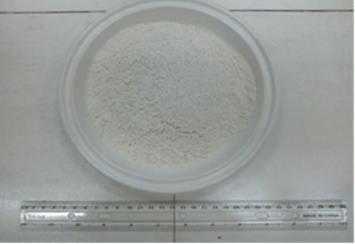
C
D
Fig. 2. Photography of the Corm and Powder of Taro Colocasia esculenta cv. "Yatan"
A: Whole corm; B: Longitudinal cut of the corm; C: Taro powder (cv. "Yatan"); D: Wheat flour T45

2.2 Technical Equipment
The technical equipment used for this work is the standard laboratory equipment for biochemical tasks. This includes, among others: a LE PROVENCAL AU SABOT 392355 stainless steel knife, a MOULINEX K1011014 grater, a MEMMERT 854 ventilated oven from Sewabach, Germany, a COOK WORKS SILVER GLASS BLENDER, a SMAUTOP B07TT5J3J2 electronic rotating porcelain mortar, a MATFER INOX 500 μm sieve, a MOULINEX ABM 11A30 electric whisk, an OXO 1126980 manual whisk, and a FAURE FCG510G1WA gas stove.

2.3 Other Food Ingredients
Salt (sodium chloride), yeast (Saccharomyces cerevisiae), sugar (sucrose), CALVE butter, PRINCESSE sweetened condensed milk, DINOR palm oil, fish, onions, garlic, and eggs were used as food ingredients in this work. They were purchased from a supermarket in Abidjan (Côte d'Ivoire).

2.4 Methods

2.4.1 Determination of Biochemical Parameters of Taro Corms

2.4.1.1 Determination of Dry Matter
The moisture content (MC) was determined according to the [20] method. A 5 g sample (PE) of fresh taro corm was weighed into pre-tared porcelain crucibles. The crucible and sample together (M1) were then placed in an oven at 105 °C until a constant weight was achieved (for 24 hours). After drying, the crucible was removed from the oven, placed in a desiccator to cool, and then reweighed (M2). The moisture content (MC) was calculated using the following equation:

$$MC \left(\%\right)=\frac{\left(M_{1} – M_{2}\right)}{PE}×100$$
(1)

The dry matter content (DMC) was calculated using the following equation:
$$DMC \left(\%\right)= 100-MC$$
(2)

2.4.1.2 Determination of Protein Content
The protein content was determined using the Kjeldahl method [20]. One (1) gram of taro corm was heated at 400 °C for 150 minutes in the presence of a pinch of catalyst mixture (Selenium + potassium sulfate (K2SO4)) and 20 mL of sulfuric acid (H2SO4), 95-97%. The resulting mineral extract was diluted to 60 mL with distilled water. To this volume, 50 mL of sodium hydroxide (40%, w/v) was added before being boiled in a LEGALLAIS type distiller. The released ammonia was trapped in a receiving flask containing 10 mL of boric acid mixture (4%, w/v) with a mixed indicator (methyl red + bromocresol green) at pH 4.4 - 5.8. The titration was performed using a decimolar solution of sulfuric acid. The percentage of nitrogen was determined using the following mathematical relationship:

$\%N=\frac{V_{(H2SO4)}x N_{(H2SO4)}x 14,007 x 100}{1000 × PE}$
(3)

Where:
V(H2SO4): volume (mL) of sulfuric acid solution added
N(H2SO4): normality of the sulfuric acid solution added (0.1 N)
me: mass (g) of the sample taken
PE: sample taken.
%N: nitrogen rate.
14.007: atomic mass of nitrogen.

The protein content, expressed as a percentage of dry matter, was obtained by multiplying the nitrogen content by the conversion factor of 6.25 [21].

2.4.1.3 Determination of Crude Fiber Content
The determination of crude fiber content was carried out according to the [20] method. Two grams (2 g) of taro corm were placed into a flask, and then 50 mL of 0.25 N sulfuric acid was added. The resulting mixture was homogenized and brought to a boil for 30 minutes under a reflux condenser. After 30 minutes, 50 mL of 0.31 N sodium hydroxide (NaOH) was added to the mixture and brought back to a boil under a reflux condenser for another 30 minutes. The obtained extract was filtered through Whatman No. 4 paper, and the residue was washed several times with hot water until all alkalis were completely removed. The resulting residue was dried in an oven at 105 °C for 8 hours. After cooling in a desiccator, it was weighed and then incinerated in a furnace at 550 °C for 3 hours. After cooling, the obtained ash was weighed. The crude fiber content was expressed as a percentage of mass using the following mathematical expression:

$$Crude fiber (\%) = \frac{{(m}_{1}-m_{2}) x 100}{m_{e}}$$
(4)

Where:
𝒎𝟏 : mass (g) of the dried residue
𝒎 : mass (g) of the obtained ash
me : mass (g) of the sample taken

2.4.1.4 Determination of Ash Content
The ash content was determined using the [20] method. Five grams (5 g) of taro corm were weighed in a porcelain crucible with a known mass (M1) and placed in a muffle furnace at 550 °C for 6 hours. After ashing, the crucible was cooled in a desiccator for 30 minutes and then weighed (M2). The ash content (Tc) was calculated using the following mathematical expression:
$T_{C}=\frac{M_{1}-M_{2}}{5} ×100$
(5)

2.4.1.5 Determination of Vitamin C Content
Vitamin C content was measured following the method described by [22]. The principle of this assay is based on the reduction of 2,6-dichlorophenol-indophenol (2,6-DCPIP). Ten grams (10 g) of taro corm were dissolved in 40 mL of a 2% (w/v) metaphosphoric acid-acetic acid solution. The mixture was centrifuged for 20 minutes at 3000 rpm, and the supernatant was collected. The supernatant volume was adjusted to 50 mL with distilled water. Ten milliliters of this adjusted solution were titrated with 2,6-DCPIP (0.5 g/L) until a pink endpoint was reached. The equivalence point volume (Veq)​, represents the volume in mL of 2,6-DCPIP (previously standardized with a 0.5 g/L vitamin C solution) used. Vitamin C content (mg/100 g of sample) was calculated using the following formula:
$Vitamin C (mg/100g)= \frac{C_{DCPIP}× V_{eq}×5 ×100}{m_{e}}$
(6)

Where:
$C_{DCPIP}$ : DCPIP concentration (g/L) = 0.5
$m_{e}$ : mass of the sample
$V_{eq}$ : volume (mL) of 2,6-DCPIP added at equivalence.

2.4.1.6 Mineral Content Analysis
The content of selected minerals was analyzed by atomic absorption spectrophotometry following the digestion method described by [20]. The minerals measured were iron (Fe), calcium (Ca), and magnesium (Mg). To perform this analysis, 1 g of taro corm was placed in a 125 mL Erlenmeyer flask, to which 20 mL of an acid mixture containing 325 mL of nitric acid (14.44 mol/L), 40 mL of perchloric acid (11.80 mol/L), and 10 mL of sulfuric acid (18.01 mol/L) was added. The mixture, thoroughly stirred under a fume hood, was heated on a hot plate (JP SELECTA, France) until thick white fumes appeared. After thermal treatment, the reaction mixture was cooled on the bench for 10 minutes, then diluted with 50 mL of distilled water. It was then reheated to boiling for 30 minutes on the same hot plate and cooled again under the same conditions. The mixture was filtered through Whatman filter paper (No. 42), and the filtrate was brought to the calibration mark with distilled water. The content of each mineral was determined using a flame atomic absorption spectrophotometer (VARIAN AA.20, Australia) at the specific wavelength for each mineral (Ca: 422.7 nm; Mg: 285.2 nm; Fe: 248.3 nm) by comparison with standard solutions. A blank sample was processed under the same conditions as the test sample. The concentration of each mineral was calculated using the following formula:

$C (mg/kg)= \frac{(a-b) x f_{d} x 25}{m_{e}}$
(7)

Where:
C: concentration of the mineral in the sample (mg/kg)
a: concentration of the mineral in the sample solution (mg/L)
b: concentration of the mineral in the blank (mg/L)
$f_{d}$: dilution factor
$m_{e}$: mass of the test sample (g)

2.4.2 Process for Obtaining Taro Flour
The cleaned taro corms were peeled and split in half. The pieces were then grated to obtain chips. These chips were placed in an oven at 50 °C for seventy-two hours (3 days). The dried chips were ground using a blender and then further ground with a rotary electric mortar. The resulting powders (Fig. 3) were sieved and stored in clean, airtight plastic jars. The taro powder is produced according to the following diagram.

Fresh taro corms
Washing with tap water
Fresh taro corms cleaned of impurities
Peel, cut and grate into small slices with a stainless-steel knife then rinse
Small slices of fresh corms
Dried taro corm chips
Grinding and sieving
Taro Powders
Open air display on plastic sheeting followed by drying for 72 hours at 45°C

Fig. 3. Process for obtaining powder from taro corms Colocasia esculenta

2.4.3 Wheat-Taro Composite Flours
The wheat-taro composite flours were formulated by partially substituting wheat flour with taro corm flour from Colocasia esculenta cv "Yatan" or "Fouê" in the following proportions: 1%, 3%, 6%, 9%, and 12%. In each case, 3 kg of composite flours were prepared, and the exact quantities of flour taken for each proportion are listed in Table 1. The flours were thoroughly mixed manually. They were stored in designated containers for analysis and the preparation of spring rolls, savory croquettes, and snowballs cakes. The composite flours made with partial substitution using taro powder from the "Yatan" cultivar were labeled as Yatan 1%, Yatan 3%, Yatan 6%, Yatan 9%, and Yatan 12%. The ones made with the "Fouê" cultivar were labeled as Fouê 1%, Fouê 3%, Fouê 6%, Fouê 9%, and Fouê 12%, while the control sample was designated as wheat flour T45 (100% wheat) (Table 2).

Table 1. Proportions of wheat flour substitution with taro corm powder from Colocasia esculenta cv "Yatan" or "Fouê"
Yatan ou Fouê | 1 % | 3 % | 6 % | 9 % | 12 % | Control
Taro powder (g) | 30 | 90 | 180 | 270 | 360 | 0
T45 wheat flour (g) | 2970 | 2910 | 2820 | 2730 | 2640 | 3000
Composite flour  Wheat-taro (g) | 3000 | 3000 | 3000 | 3000 | 3000 | 3000

Table 2. Identification of the different types of composite flours formed according to the proportions of added taro flours.
Type de farine | Identification
FBT 100% wheat control | Control wheat flour (100% wheat)
FCF1 Fouê 1 % | Composite flour of 99% wheat flour and 1% taro cultivar powder ‘fouê’
FCF3 Fouê 3 % | Composite flour of 97% wheat flour and 3% taro cultivar powder ‘fouê’
FCF6 Fouê 6 % | Composite flour of 94% wheat flour and 6% taro cultivar powder ‘fouê’
FCF9 Fouê 9 % | Composite flour of 91% wheat flour and 9% taro cultivar powder ‘fouê’
FCF12 Fouê 12 % | Composite flour of 88% wheat flour and 12% taro cultivar powder ‘fouê’
FCY1 Yatan 1 % | Composite flour of 99% wheat flour and 1% taro powder cultivar ‘’yatan’’
FCY3 Yatan 3 % | Composite flour of 97% wheat flour and 3% taro powder cultivar ‘’yatan’’
FCY6 Yatan 6 % | Composite flour of 94% wheat flour and 6% taro powder cultivar ‘’yatan’’
FCY9 Yatan 9 % | Composite flour of 91% wheat flour and 9% taro powder cultivar ‘’yatan’’
FCY12 Yatan 12 % | Composite flour of 88% wheat flour and 12% taro powder cultivar ‘’yatan’’
FCF Fouê | Composite flour with powder of taro cultivar ‘fouê’
FCY Yatan | Composite flour with taro powder cultivar ‘’yatan’’

2.4.4 Pastry Products Preparation

2.4.4.1 Preparation of Spring Rolls
First, the sauce is prepared. For this, the fish is deboned and crushed in a mortar along with onion, garlic, green onions, and cabbage. The mixture is blended to obtain the sauce. Next, the ingredients for the dough are added successively into an aluminum bowl and mixed by hand for 8 minutes. First, flour is added, followed by baker's yeast and water. The mixture is thoroughly combined manually for 3 minutes. Then, butter is added, and the dough is kneaded for 5 minutes to form a dough. Once the dough is formed, it is flattened on a board and cut into pieces with a knife. Each piece is filled with 0.5 g of sauce. The pieces are then rolled up and fried in oil for 7 minutes. The fried African spring rolls are placed in trays to cool to room temperature for 10 minutes before being labeled and packaged (Fig. 4). The same process was used for the formulations: 100% wheat T45, Yatan (1%, 3%, 6%, 9%, 12%), and Fouê (1%, 3%, 6%, 9%, 12%) (Table 3).

Flour
Add the baker's yeast and water
Knead manually for 3 minutes
Add the butter
Knead manually for 5 minutes
Obtaining the dough
Fry in oil for 7 minutes
Spring rolls
Flatten on a board then cut into pieces and add 0.5 g of sauce before rolling up
Fish
Remove the stops then crush with the onion, cabbage, green onion and garlic
Sauce
Fig. 4. Process of Making Spring Rolls

2.4.4.2 Preparation of Snowballs cakes
The ingredients for the dough are added successively into an aluminum bowl and mixed by hand for 8 minutes. First, composite flour is added, followed by baker's yeast, baking powder, nutmeg, milk, oil, and eggs. The mixture is manually combined for 8 minutes to form a dough. The dough is then shaped into balls by hand, which are then cooked in oil in an aluminum pan for 7 minutes. Finally, the cooked balls are cooled for 10 minutes at room temperature in trays before being labeled and packaged (Fig. 5). The same preparation method was applied for the formulations: 100% wheat T45, Yatan (1%, 3%, 6%, 9%, 12%), and Fouê (1%, 3%, 6%, 9%, 12%) (Table 3).

Flour
Add baker's yeast, baking powder, nutmeg, milk, oil and eggs
Knead manually for 8 minutes
Fry in oil for 7 minutes
Form balls manually with the dough
Obtaining the dough
Snowballs cakes
Fig. 5. Process of Making Snowballs cakes

2.4.4.3 Preparation of Savory Croquettes
Onion and garlic were crushed in a blender. Fifty (50) grams of the onion-garlic mixture were taken and added to each formulation. In a steel bowl, flour, water, oil, salt, and 50 g of the onion-garlic mixture were added. The mixture was kneaded by hand for 5 minutes to form a dough. The dough was then flattened and rolled out on a board, and cut into small dice with a knife. The dice were then cooked in oil for 5 minutes. The cooked savory croquettes were removed from the oil and placed in trays. The croquettes were allowed to cool to room temperature for 10 minutes before being labeled and packaged (Fig. 6). The same process was used for the formulations: 100% wheat T45, Yatan (1%, 3%, 6%, 9%, 12%), and Fouê (1%, 3%, 6%, 9%, 12%) (Table 3).

Flour
Add water, oil, salt and 50 g of sauce
Knead manually for 5 minutes
Obtaining the dough
Fry in oil for 5 minutes
Salty croquettes
Flatten and spread out on a board then cut into small pieces in the form of cubes
Onion and garlic
Crush in a blender
Sauce
Fig. 6. Process of Making Savory Croquettes

Table 3. Ingredients Used in the Production of Control and Test Samples of Spring Rolls, Snowballs cakes, and Savory Croquettes for the Cultivars "Fouê" and "Yatan"
 | Types of flour
Ingredients | Control | Fouê tests | Yatan tests
Spring Rolls
100% wheat flour T45 | 200 g | 0 | 0
Composite flours | 0 | 200 g | 200 g
Fish | 50 g | 50 g | 50 g
Water | 100 mL | 100 mL | 100 mL
Butter | 60 g | 60 g | 60 g
Baker's yeast | 5,5 g | 5,5 g | 5,5 g
Onions | 1 | 1 | 1
Garlic | 1 gousse | 1 gousse | 1 gousse
Green onions | 5 g | 5 g | 5 g
Cabbage | 1,5 g | 1,5 g | 1,5 g
Snowballs cakes
100% wheat flour T45 | 400 g | 0 | 0
Composite flours | 0 | 400 g | 400 g
Nutmeg | 0,56 g | 0,56 g | 0,56 g
Baking powder | 1 sachet | 1 sachet | 1 sachet
Baker's yeast | 1 sachet | 1 sachet | 1 sachet
Oil | 200 mL | 200 mL | 200 mL
Milk | 200 mL | 200 mL | 200 mL
Eggs | 03 | 03 | 03
Savory Croquettes
100% wheat flour T45 | 200 g | 0 | 0
Composite flours | 0 | 200 g | 200 g
Garlic | ½ gousse | ½ gousse | ½ gousse
Onion | 1 | 1 | 1
Oil | 1,5 l | 1,5 l | 1,5 l
Water | 50 mL | 50 mL | 50 mL
Salt | 1,5 g | 1,5 g | 1,5 g

2.4.5 Sensory Analysis of Traditional Pastry Dishes
The sensory analysis was conducted using the Quantitative Descriptive Analysis (QDA) method described by [23]. Each sample, labeled with a three-digit code, was randomly presented to the tasters (Table 4). The evaluation focused on general aspects such as texture and color of the crust (appearance, color, cell structure, and regularity) of the crumb, as well as taste, flavor, and overall acceptability. This method allowed the 15 trained panelists to assess the organoleptic parameters of the various dishes made from the test and control flours. During the session, a score sheet featuring a questionnaire with a rating scale was provided to each taster. This score sheet was tailored to capture the specific characteristics of Spring Rolls, snowballs cakes, and savory croquettes. A briefing was held to help participants understand the evaluation criteria and complete the pre-established questionnaire. The session was conducted in French. Each judge assigned a score based on a scale from 0 to 10. The scores collected were used to create sensory profiles for the different traditional pastry items. The evaluation tests were held in a well-ventilated classroom at Nangui Abrogoua University, free from odors and other distractions that might interfere with the panelists' perception. Samples of the dishes, including Spring Rolls, snowballs cakes, and savory croquettes, were presented anonymously in disposable plates and identified by a three-digit code. The test took place midday, between 12:00 PM and 1:30 PM, to ensure optimal sensitivity from the tasters. To maintain consistent sensitivity, panelists were advised to rinse their mouths or drink water provided between tastings, and they were prohibited from communicating with one another during the entire evaluation. Participants then recorded their enjoyment based on the selected organoleptic attributes for each sample on the provided scale.

Table 4: Codes for the Different Formulated Traditional Pastry Dishes
Cultivars | Samples | Products
 | 100 | Control Spring Rolls 100% Wheat
Blé | 200 | Control Snowball cake 100% Wheat
 | 300 | Control Savory Croquette 100% Wheat
 | 411 | Spring Rolls 1 % Fouê
 | 511 | Snowball cake 1 % Fouê
 | 611 | Savory Croquette 1 % Fouê
 | 413 | Spring Rolls 3 % Fouê
 | 513 | Snowball cake 3 % Fouê
 | 613 | Savory Croquette 3 % Fouê
Fouê | 416 | Spring Rolls 6 % Fouê
 | 516 | Snowball cake 6 % Fouê
 | 616 | Savory Croquette 6 % Fouê
 | 419 | Spring Rolls 9 % Fouê
 | 519 | Snowball cake 9 % Fouê
 | 619 | Savory Croquette 9 % Fouê
 | 412 | Spring Rolls 12 % Fouê
 | 512 | Snowball cake 12 % Fouê
 | 612 | Savory Croquette 12 % Fouê
 | 711 | Spring Rolls 1 % Yatan
 | 811 | Snowball cake 1 % Yatan
 | 911 | Savory Croquette 1 % Yatan
 | 713 | Spring Rolls 3 % Yatan
 | 813 | Snowball cake 3 % Yatan
 | 913 | Savory Croquette 3 % Yatan
Yatan | 716 | Spring Rolls 6 % Yatan
 | 816 | Snowball cake 6 % Yatan
 | 916 | Savory Croquette 6 % Yatan
 | 719 | Spring Rolls 9 % Yatan
 | 819 | Snowball cake 9 % Yatan
 | 919 | Savory Croquette 9 % Yatan
 | 712 | Spring Rolls 12 % Yatan
 | 812 | Snowball cake 12 % Yatan
 | 912 | Savory Croquette 12 % Yatan

2.5 Data Analysis
Analysis of variance (ANOVA) was performed on the results using IBM SPSS Statistics 26 software to compare the means. When a significant difference was found, the Tukey test was used to identify the means involved in the observed difference at the 5% significance level. The results of the biochemical parameters and the sensory analysis are presented as means ± standard deviation. Radar charts, created using Microsoft Excel 2021 software, were used to compare the sensory profiles of each traditional pastry product.

3. RESULTS

3.1 Biochemical Parameters of Taro Corms from the Fouê and Yatan Cultivars
The biochemical parameters of taro corms from the Fouê and Yatan cultivars reveal significant differences (P ˂ 0.05) in their nutritional composition, highlighting distinct characteristics for each cultivar (Table 5). The Fouê cultivar generally stands out with higher values in most of the measured parameters. First, in terms of dry matter, the Fouê cultivar shows a content of 28.75%, which is higher than that of Yatan, which is 23.62%. In terms of protein content, the Fouê corm also has a higher content (1.79 g/100 g DM) compared to Yatan (1.35 g/100 g DM). Regarding crude fiber content, it follows the same trend, with 5.53 g/100 g DM for Fouê and 4.66 g/100 g DM for Yatan. In terms of micronutrients, the Fouê cultivar also presents higher levels of vitamin C (5.29 mg/100 g DM) compared to Yatan (4.03 mg/100 g DM). For minerals, Fouê is again richer, with higher levels of calcium, magnesium, and iron compared to Yatan. For example, calcium is measured at 48.75 mg/100 g DM in Fouê, compared to 38.45 mg/100 g DM in Yatan, while magnesium is 41.03 mg/100 g DM for Fouê versus 28.18 mg/100 g DM for Yatan.

Table 5: Biochemical Parameters of Taro Corms from the Fouê and Yatan Cultivars
Paramètres  Biochimiques | Fouê | Yatan
Matière sèche % | 28,75 ± 3,93 (a) | 23,62 ± 3,08 (b)
Protéines g/100 g MS | 1,79 ± 0,04 (a) | 1,35 ± 0,07 (b)
Fibre brute g/100 g MS | 5,53 ± 0,08 (a) | 4,66 ± 0,08 (b)
Vitamine C mg/100 g MS | 5,29 ± 0,08 (a) | 4,03 ± 0,14 (b)
Cendre g/100 g MS | 1,47 ± 0,07 (a) | 1,19 ± 0,03 (b)
Calcium mg/100 g MS | 48,75 ± 3,31 (a) | 38,45 ± 4,27 (b)
Magnésium mg/100 g MS | 41,03 ± 2,16 (a) | 28,18 ± 2,33 (b)
Fer mg/100 g MS | 0,79 ± 0,02 (a) | 0,47 ± ,03 (b)
Mean ± standard deviation, n = 3. Values in the same row with different alphabetic letters are significantly different at the 5% level according to the Tukey test of analysis of variance.

3.2 Appearance and Characteristics of Different Taro-Wheat Composite Flours Obtained According to Taro Cultivars
100% wheat T45 flour is very white. When part of the wheat flour is substituted with taro powder from the "fouê" or "yatan" cultivars, the color of the mixture becomes brown. The composite flour made with the "fouê" cultivar has a darker red color compared to the composite flour made with the "yatan" cultivar. Additionally, as the percentage of substitution increases, the composite flour takes on a progressively darker shade (Fig. 7).

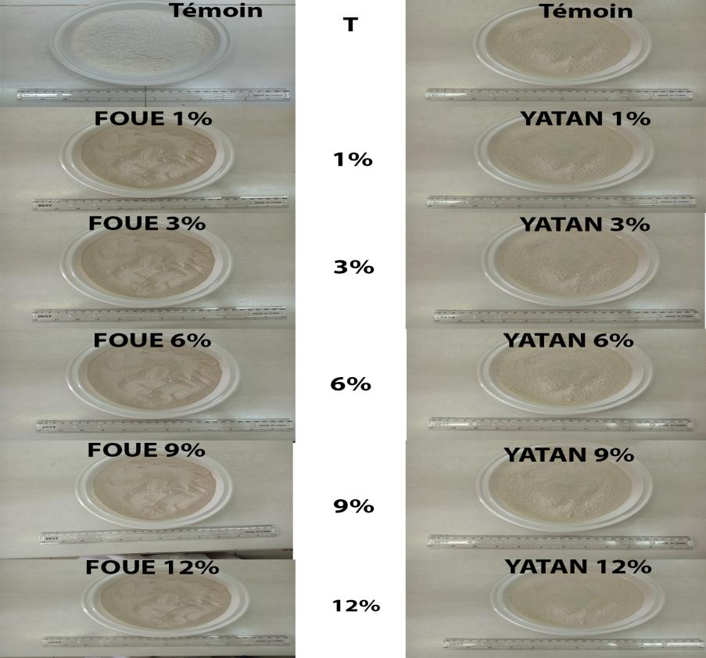
CONTROL

CONTROL
B
A
Fig. 7. Photos of Different Composite Flours (Taro-Wheat) Prepared
A) Wheat-Fouê; B) Wheat-Yatan; T: Incorporation Rate of Taro Flour or Control Flour

3.3 Production of Traditional Dishes

3.3.1 Spring Rolls
African spring rolls made with the control flour 100% wheat T45 have a light-yellow color and a very light appearance. When part of the wheat flour T45 is substituted with taro powder up to a substitution rate of 6%, the resulting spring rolls have a color and appearance similar to the control for both "fouê" and "yatan" cultivars. For substitution rates of 9% and 12%, the color becomes dark yellow and the appearance less light for both cultivars (Fig. 8).

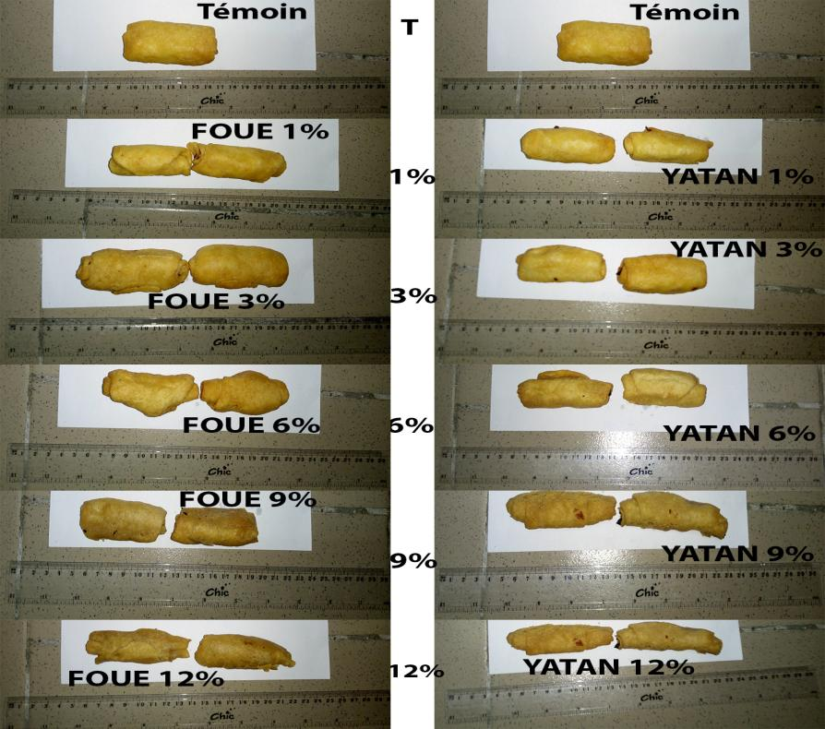
CONTROL
CONTROL
B
A
Fig. 8. Photos of Spring Rolls Made with Composite Flours Wheat-Fouê, Wheat-Yatan, and 100% Wheat T45 Flour
A) Wheat-Fouê; B) Wheat-Yatan; T: Incorporation Rate of Taro Flour or Control Flour

3.3.2 Snowballs cakes
Snowballs cakes made with the control flour 100% wheat T45 have a light-yellow color and a light appearance. When part of the wheat flour T45 is substituted with taro powder up to a substitution rate of 6%, the resulting snowballs cakes have a color and appearance similar to the control. For substitution rates of 9% and 12%, the color becomes dark yellow for the "yatan" cultivar. For the "fouê" cultivar, beyond a taro powder incorporation rate of 1%, the snowballs cakes take on a dark yellow color. This color darkens to red when the substitution reaches 12%. For both cultivars, as the incorporation rate increases, the appearance becomes less light (Fig. 9).
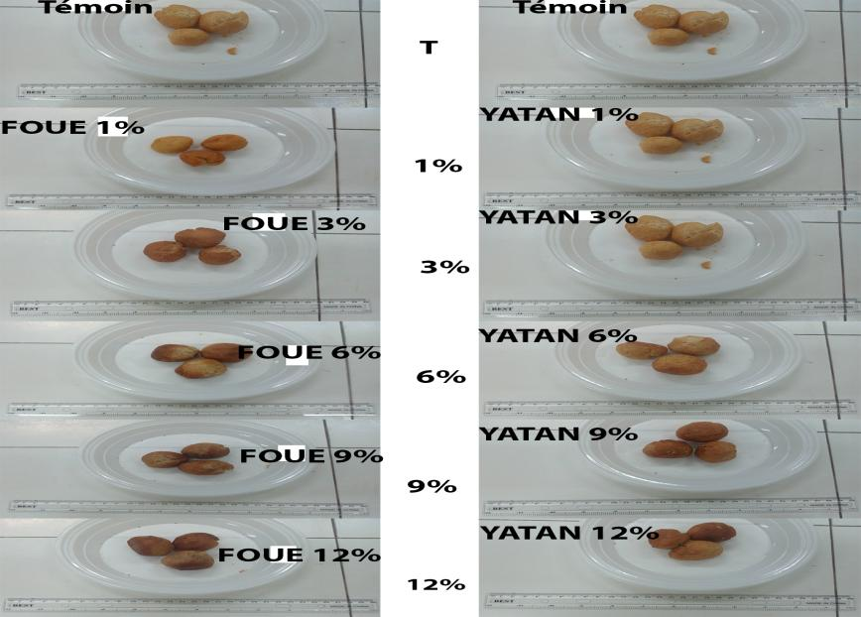
CONTROL
B
CONTROL
A
Fig. 9. Photos of Snowballs cakes Made with Composite Flours Wheat-Fouê, Wheat-Yatan, and 100% Wheat T45 Flour
A) Wheat-Fouê; B) Wheat-Yatan; T: Incorporation Rate of Taro Flour or Control Flour

3.3.3 Savory Croquettes
Savory croquettes made with the control flour 100% wheat T45 have a light-yellow color and a light appearance. When part of the wheat flour T45 is substituted with taro powder up to a substitution rate of 6%, the resulting savory croquettes have a color and appearance similar to the control. For substitution rates of 9% and 12%, the color becomes dark yellow for the "fouê" cultivar. For the "yatan" cultivar, the light-yellow color is similar to the control up to a substitution rate of 12%. For both cultivars, as the incorporation rate increases, the appearance becomes less light (Fig. 10).
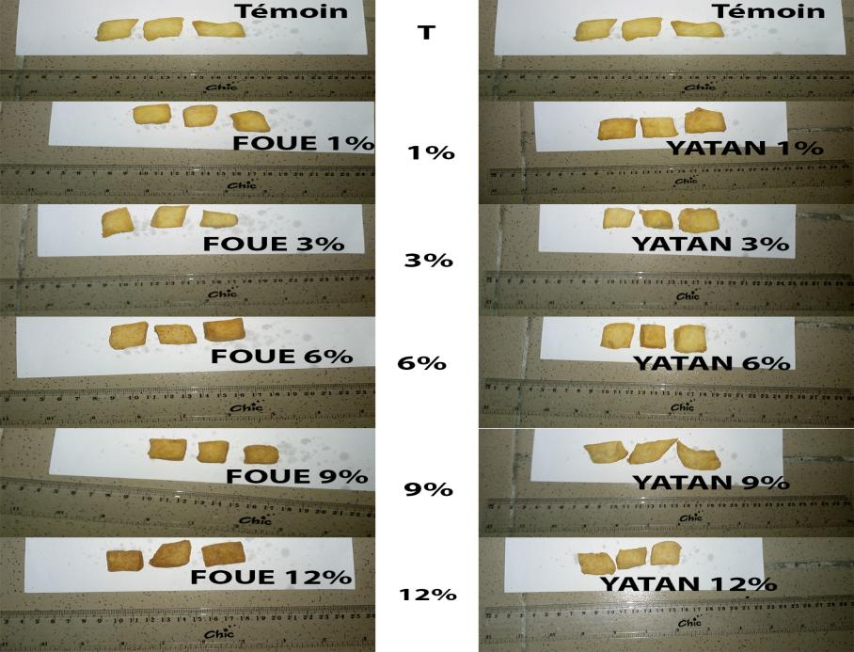
CONTROL
CONTROL
B
A
Fig. 10. Photos of Savory Croquettes Made with Composite Flours Wheat-Fouê, Wheat-Yatan, and 100% Wheat T45 Flour
A) Wheat-Fouê; B) Wheat-Yatan; T: Incorporation Rate of Taro Flour or Control Flour

3.4 Sensory Profiles of Traditional Pastry Dishes Made with Wheat Composite Flours Enriched with Taro Powder from the Fouê and Yatan Cultivars

3.4.1 Spring Rolls
The sensory analysis of Spring Rolls made from wheat-Fouê composite flour and wheat-Yatan composite flour reveals significant variations (P ˂ 0.05) in the perception of various parameters, depending on the proportion of taro powder incorporated (Table 6). A radar plot representing the sensory profiles of the different Spring Rolls samples was created based on the average scores (0 to 10) given to the descriptors by the panelists (Fig. 11). The results show that crust color, texture, crumb appearance, and its color tend to deteriorate as the amount of taro increases. The control sample (100% wheat flour) received the best scores for crust color and texture, while the samples containing 12% taro (412 and 712) were perceived as less visually appealing. These results suggest that the addition of taro powder causes a notable change in the visual appearance of the crust, which could influence the overall acceptability of the product. The internal structure of the products, particularly the alveolation and regularity of the crumb, is also affected by the proportion of taro powder. The control sample has a lighter and well-alveolated crumb, while the samples with 9% and 12% taro show a denser and irregular crumb. However, the samples with low proportions of taro powder (1-3%) maintain a relatively regular crumb, suggesting that moderate incorporation can maintain an acceptable crumb quality. The incorporation of taro powder also influences the aromas and flavors perceived in the products. The wheat aroma and flavor, highly appreciated in the control, decrease significantly as the proportion of taro increases. From 3% taro, the wheat aroma becomes less intense, while the characteristic taro aroma begins to take over. The samples with 12% taro are those that present the most marked taro aroma, while the control sample naturally lacks this aroma. The flavor of taro follows a similar trend: it is strongly present in the samples with the highest concentration of taro (412 and 712), showing that the characteristic taste of taro becomes predominant in the products with high levels of taro powder. Finally, the overall acceptability, represented by the sensory impression, reveals that products with low proportions of taro powder (1-3%) are well accepted, with a sensory quality similar to that of the control. However, as soon as the proportion of taro reaches 6%, a marked decrease in acceptability is observed. At 12%, the acceptability of the products is significantly lower, indicating that consumers perceive products with high taro powder content less favorably.

Table 6: Means and Standard Deviations of Scores (from 0 to 10) Given by the Tasting Panel for spring rolls Made from Wheat-Taro Composite Flours from the Fouê and Yatan Cultivars Compared to a Control 100% Wheat Flour Sample.
Descriptors | 100 | 411 | 413 | 416 | 419 | 412 | 711 | 713 | 716 | 719 | 712
Crust color | 10 ± 0 (f) | 9,13 ± 0,99 (ef) | 8,47 ± 0,83 (de) | 6,27 ± 0,96 (bc) | 5,87 ± 0,92 (b) | 4,33 ± 0,62 (a) | 9,53 ± 0,64 (f) | 8,13 ± 1,25 (d) | 6,93 ± 0,80 (c) | 5,93 ± 0,80 (b) | 4,20 ± 0,68 (a)
Crust texture | 10 ± 0 (f) | 8,53 ± 0,99 (e) | 7,87 ± 0,35 (e) | 7,00 ± 0,53 (cd) | 6,07 ± 0,80 (b) | 4,40 ± 0,51 (a) | 8,60 ± 0,83 (e) | 7,80 ± 0,77 (de) | 6,40 ± 1,06 (bc) | 5,67 ± 0,72 (b) | 3,93 ± 0,70 (a)
Crumb appearance | 10 ± 0 (h) | 9,13 ± 0,83 (gh) | 7,67 ± 0,72 (ef) | 6,80 ± 0,68 (de) | 5,93 ± 0,80 (cd) | 4,80 ± 0,68 (ab) | 9,13 ± 0,74 (gh) | 8,27 ± 0,80 (fg) | 6,33 ± 0,82 (cd) | 5,60 ± 0,74 (bc) | 4,33 ± 0,90 (a)
Crumb color | 10 ± 0 (i) | 8,47 ± 0,83 (gh) | 7,53 ± 0,52 (ef) | 6,73 ± 0,46 (de) | 6,00 ± 0,76 (cd) | 4,87 ± 0,52 (ab) | 9,27 ± 0,88 (hi) | 8,00 ± 0,93 (fg) | 6,20 ± 0,68 (cd) | 5,67 ± 0,90 (bc) | 4,53 ± 0,74 (a)
Crumb alveolization | 10 ± 0 (f) | 9,33 ± 0,72 (f) | 8,00 ± 0,65 (de) | 7,47 ± 0,64 (cd) | 6,53 ± 0,52 (b) | 5,40 ± 0,51 (a) | 9,33 ± 0,72 (f) | 8,33 ± 0,62 (e) | 6,93 ± 1,03 (bc) | 5,67 ± 0,90 (a) | 4,93 ± 0,96 (a)
Crumb regularity | 10 ± 0 (g) | 9,00 ± 0,65 (f) | 7,93 ± 0,46 (e) | 7,47 ± 0,64 (de) | 6,47 ± 0,64 (c) | 5,53 ± 0,64 (b) | 9,27 ± 0,80 (fg) | 7,80 ± 0,68 (e) | 7,00 ± 0,85 (cd) | 5,67 ± 0,72 (b) | 4,60 ± 0,83 (a)
Wheat aroma | 10 ± 0 (e) | 9,73 ± 0,46 (e) | 7,73 ± 0,59 (d) | 7,53 ± 0,52 (d) | 6,40 ± 0,51 (c) | 5,33 ± 0,72 (ab) | 9,60 ± 0,63 (e) | 7,47 ± 0,52 (d) | 7,20 ± 1,01 (d) | 5,87 ± 0,74 (bc) | 4,80 ± 0,86 (a)
Taro aroma | 10 ± 0 (f) | 1,60 ± 0,51 (a) | 3,33 ± 0,49 (b) | 4,47 ± 1,06 (c) | 5,67 ± 0,82 (d) | 7,47 ± 0,74 (e) | 1,60 ± 0,63 (a) | 2,67 ± 0,62 (b) | 4,40 ± 0,99 (c) | 6,07 ± 1,10 (d) | 7,73 ± 0,88 (e)
Wheat flavor | 10 ± 0 (g) | 9,47 ± 0,74 (g) | 7,87 ± 0,52 (f) | 6,73 ± 0,80 (de) | 6,27 ± 0,70 (cd) | 5,20 ± 0,68 (ab) | 9,20 ± 0,68 (g) | 7,47 ± 0,52 (ef) | 6,40 ± 0,91 (cd) | 5,73 ± 0,70 (bc) | 4,60 ± 0,91 (a)
Taro flavor | 10 ± 0 (g) | 1,60 ± 0,51 (a) | 3,53 ± 0,52 (b) | 4,53 ± 0,52 (c) | 5,60 ± 0,51 (e) | 7,53 ± 0,64 (f) | 1,60 ± 0,51 (a) | 3,33 ± 0,72 (b) | 4,53 ± 0,52 (c) | 6,07 ± 0,96 (e) | 8,00 ± 0,85 (f)
Acceptability | 10 ± 0 (f) | 9,53 ± 0,52 (f) | 7,87 ± 0,52 (e) | 7,53 ± 0,52 (de) | 6,60 ± 0,63 (bc) | 5,00 ± 0,65 (a) | 9,33 ± 0,72 (f) | 8,00 ± 0,53 (e) | 7,07 ± 0,70 (cd) | 6,00 ± 0,65 (b) | 4,33 ± 0,49 (a)
Mean ± standard deviation, n = 15. Values in the same row with different alphabetical letters are significantly different at the 5% level according to the Tukey test of analysis of variance.
100: Control Spring Rolls 100% Wheat; 411: Spring Rolls 1% Fouê; 413: Spring Rolls 3% Fouê; 416: Spring Rolls 6% Fouê; 419: Spring Rolls 9% Fouê; 412: Spring Rolls 12% Fouê; 711: Spring Rolls 1% Yatan; 713: Spring Rolls 3% Yatan; 716: Spring Rolls 6% Yatan; 719: Spring Rolls 9% Yatan; 712: Spring Rolls 12% Yatan.

Fig. 11. Sensory profile of the Spring Rolls made from "wheat-fouê" and "wheat-yatan" composite flour and the 100% wheat T45 control flour.
100: Control Spring Rolls 100% Wheat; 411: Spring Rolls 1% Fouê; 413: Spring Rolls 3% Fouê; 416: Spring Rolls 6% Fouê; 419: Spring Rolls 9% Fouê; 412: Spring Rolls 12% Fouê; 711: Spring Rolls 1% Yatan; 713: Spring Rolls 3% Yatan; 716: Spring Rolls 6% Yatan; 719: Spring Rolls 9% Yatan; 712: Spring Rolls 12% Yatan.

3.4.2 Snowballs cakes
The sensory analysis of the snowballs cakes made from wheat-fouê and wheat-yatan composite flour reveals significant variations (P˂0.05) in the perception of different parameters, depending on the proportion of taro powder incorporated (Table 7). A sensory profile of the snowballs cakes samples from different batches was also created using radar representation based on the average scores (0 to 10) given by the panelists for each descriptor (Fig. 12). The results for the crust color indicate that the 100% wheat control (200) received the highest score of 10, while the samples containing increasing percentages of taro received progressively lower scores. At 12% taro powder, the samples of both cultivars (512 and 812) received low scores (4.07 and 4.47), suggesting that high taro incorporation affects the visual appearance of the crust. The crust texture follows a similar trend, with the control scored at 10 and progressively lower scores as the taro proportion increases. The 512 and 812 samples recorded particularly low scores (3.73 and 4.33), which could indicate that the higher presence of taro alters the perceived consistency of the crust. Similarly, the appearance and color of the crumb showed significant variations, with the low-taro samples (1-3%) maintaining relatively high scores, while the 12% taro samples displayed reduced scores, indicating a visual and sensory impact on the crumb. Regarding the crumb's alveolation and regularity, the control maintained a perfect score of 10, while the samples with higher taro percentages (notably at 9% and 12%) had lower scores, indicating a decrease in crumb quality with increasing taro content. The wheat aroma and flavor were best rated in the control and the samples with low taro proportions. As the taro proportion increased, the ratings for wheat aroma and flavor decreased, while the ratings for taro aroma and flavor increased. The 12% taro samples showed more pronounced taro aromas and flavors (7.67 and 7.93 for 512 and 812), illustrating the increasing intensity of taro flavor with its incorporation. Finally, the overall acceptability, measured by the sensory impression, shows that the samples containing low proportions of taro (1-3%) were well accepted, with scores close to those of the control. However, samples with higher proportions of taro (notably 512 and 812) recorded lower scores, indicating a reduction in sensory acceptability as the amount of taro increased.

Table 7: Means and standard deviations of the scores (0 to 10) given by the tasting panel to snowballs cakes made from wheat-taro composite flour from two taro cultivars (Fouê and Yatan) compared to a 100% wheat control.
Descriptors | 200 | 511 | 513 | 516 | 519 | 512 | 811 | 813 | 816 | 819 | 812
Crust color | 10 ± 0 (e) | 9,47 ± 0,64 (de) | 8,13 ± 1,30 (c) | 6,13 ± 0,83 (b) | 5,73 ± 0,70 (b) | 4,07 ± 0,70 (a) | 8,93 ± 0,80 (cd) | 8,20 ± 0,56 (c) | 6,40 ± 0,63 (b) | 5,73 ± 0,70 (b) | 4,47 ± 0,52 (a)
Crust texture | 10 ± 0 (f) | 9,33 ± 0,72 (ef) | 7,67 ± 0,49 (d) | 6,60 ± 0,99 (c) | 5,67 ± 0,82 (b) | 3,73 ± 0,80 (a) | 8,67 ± 0,90 (e) | 7,87 ± 0,35 (d) | 6,87 ± 0,52 (c) | 5,60 ± 0,63 (b) | 4,33 ± 0,49 (a)
Crumb appearance | 10 ± 0 (h) | 9,00 ± 0,93 (g) | 8,13 ± 0,74 (ef) | 6,40 ± 0,83 (cd) | 5,47 ± 0,64 (b) | 4,13 ± 0,92 (a) | 8,93 ± 0,96 (fg) | 7,53 ± 0,52 (e) | 6,60 ± 0,51 (d) | 5,60 ± 0,63 (bc) | 4,47 ± 0,52 (a)
Crumb color | 10 ± 0 (g) | 9,00 ± 0,93 (f) | 8,00 ± 0,93 (e) | 6,13 ± 0,74 (bc) | 5,53 ± 0,92 (b) | 4,67 ± 0,62 (a) | 8,40 ± 0,63 (ef) | 7,67 ± 0,49 (de) | 6,87 ± 0,52 (cd) | 5,60 ± 0,63 (b) | 4,60 ± 0,51 (a)
Crumb alveolization | 10 ± 0 (g) | 9,20 ± 0,68 (f) | 8,40 ± 0,51 (de) | 7,00 ± 0,93 (c) | 5,93 ± 0,70 (b) | 4,80 ± 0,77 (a) | 8,93 ± 0,80 (ef) | 7,93 ± 0,59 (d) | 7,13 ± 0,64 (c) | 6,07 ± 0,59 (b) | 5,07 ± 0,46 (a)
Crumb regularity | 10 ± 0 (e) | 9,40 ± 0,74 (de) | 7,87 ± 0,64 (c) | 6,87 ± 0,92 (b) | 5,67 ± 0,72 (a) | 5,13 ± 0,64 (a) | 9,07 ± 0,59 (d) | 7,93 ± 0,46 (c) | 7,07 ± 0,70 (b) | 5,80 ± 0,68 (a) | 5,13 ± 0,35 (a)
Wheat aroma | 10 ± 0 (e) | 9,27 ± 0,96 (e) | 7,53 ± 0,52 (cd) | 7,20 ± 1,15 (c) | 6,13 ± 0,74 (b) | 5,07 ± 0,70 (a) | 9,40 ± 0,51 (e) | 8,00 ± 0,53 (d) | 7,27 ± 0,59 (cd) | 6,20 ± 0,41 (b) | 5,13 ± 0,52 (a)
Taro aroma | 10 ± 0 (f) | 1,73 ± 0,46 (a) | 2,73 ± 0,59 (b) | 4,33 ± 1,11 (c) | 6,13 ± 1,06 (d) | 7,67 ± 0,82 (e) | 1,67 ± 0,49 (a) | 3,33 ± 0,49 (b) | 4,53 ± 1,13 (c) | 5,73 ± 0,59 (d) | 7,73 ± 0,70 (e)
Wheat flavor | 10 ± 0 (f) | 9,13 ± 0,74 (e) | 7,67 ± 0,62 (d) | 6,40 ± 0,83 (bc) | 5,73 ± 0,59 (b) | 4,80 ± 0,68 (a) | 9,07 ± 0,70 (e) | 7,67 ± 0,49 (d) | 6,60 ± 0,51 (c) | 5,93 ± 0,59 (bc) | 4,93 ± 0,46 (a)
Taro flavor | 10 ± 0 (f) | 1,67 ± 0,62 (a) | 3,27 ± 0,59 (b) | 4,73 ± 0,96 (c) | 6,27 ± 1,10 (d) | 8,07 ± 0,80 (e) | 1,67 ± 0,49 (a) | 3,40 ± 0,51 (b) | 4,53 ± 0,52 (c) | 5,67 ± 0,49 (d) | 7,93 ± 0,70 (e)
Acceptability | 10 ± 0 (f) | 9,73 ± 0,46 (ef) | 7,93 ± 0,59 (d) | 7,07 ± 0,80 (c) | 6,33 ± 0,82 (b) | 4,33 ± 0,49 (a) | 9,13 ± 0,52 (e) | 7,80 ± 0,56 (d) | 7,33 ± 0,49 (cd) | 6,27 ± 0,46 (b) | 4,67 ± 0,49 (a)
Mean ± standard deviation, n = 15. Values within the same row marked with different alphabetic letters are significantly different at the 5% level according to Tukey’s test from the analysis of variance.
200: Control snowball cake 100% Wheat; 511: Snowball cake 1% Fouê; 513: Snowball cake 3% Fouê; 516: Snowball cake 6% Fouê; 519: Snowball cake 9% Fouê; 512: Snowball cake 12% Fouê; 811: Snowball cake 1% Yatan; 813: Snowball cake 3% Yatan; 816: Snowball cake 6% Yatan; 819: Snowball cake 9% Yatan; 812: Snowball cake 12% Yatan.

Fig. 12. Sensory profile of snowballs cakes made from wheat-fouê and wheat-yatan composite flour, and the 100% wheat control flour T45.
200: Control snowball cake 100% Wheat; 511: Snowball cake 1% Fouê; 513: Snowball cake 3% Fouê; 516: Snowball cake 6% Fouê; 519: Snowball cake 9% Fouê; 512: Snowball cake 12% Fouê; 811: Snowball cake 1% Yatan; 813: Snowball cake 3% Yatan; 816: Snowball cake 6% Yatan; 819: Snowball cake 9% Yatan; 812: Snowball cake 12% Yatan.

3.4.3 Savory Croquettes
The sensory analysis of savory croquettes made from composite flour of wheat-Fouê and wheat-Yatan reveals significant variations (P<0.05) in the perception of different parameters, depending on the proportion of taro powder incorporated (Table 8). Also, a sensory profile of the samples of different snowballs cakes dishes was created in radar representation, based on the average scores (0 to 10) given by the panelists for the descriptors (Fig. 13). The results highlight the sensory perception differences between savory croquettes made solely from wheat flour (300) and those incorporating varying proportions of taro powder (cultivars Fouê and Yatan). Overall, the control (300) received the highest scores for each parameter evaluated, suggesting that the absence of taro powder enhances the traditional sensory qualities expected for this type of product. However, samples with low taro incorporation, particularly at 1% and 3%, manage to maintain relatively high acceptability. The appearance of the crust and crumb is one of the most affected criteria by the addition of taro powder. The 300 sample, with no added taro, received perfect scores for both the color and texture of the crust, as well as the appearance, color, and alveolation of the crumb. These parameters show a gradual decline as the percentage of taro increases, with the 12% taro samples (612 and 912) displaying the lowest scores. This indicates that the integration of taro into the recipe alters the perception of color and texture, which are essential visual characteristics in the appreciation of croquettes. In contrast, the scores remain at acceptable levels for moderate proportions of taro (1% and 3%). Aroma and flavor are other critical elements of evaluation. Sample 300, representative of the wheat flavor and aroma, is preferred by the tasters, receiving perfect scores in these categories. However, the taro-enriched samples show a decrease in wheat aroma and flavor, while the presence of taro becomes more pronounced. The samples with higher taro proportions, such as samples 612 and 912, reveal stronger taro aromas and flavors, which may not align with the panel's expectations for this type of product. This suggests that while the incorporation of taro adds a distinct taste, it is perceived as deviating from the traditional flavor expected in wheat croquettes, which may affect their acceptability. Regarding the overall sensory impression, the control (300) remains the most appreciated with a perfect score, indicating excellent acceptability. The samples with low taro incorporation (1% and 3%) also maintain high acceptability, proving that small amounts of taro can enrich the product without compromising its popularity. However, as the taro percentage increases, particularly from 6% and beyond, overall acceptability gradually declines, with samples 612 and 912 showing the lowest scores in this category. This indicates that beyond a certain incorporation threshold, taro alters the organoleptic characteristics to the point of making the product less appealing to the tasting panel.

Table 8: Averages and standard deviations of the scores (0 to 10) given by the tasting panel for savory croquettes made from composite wheat-taro flour of two taro cultivars, Fouê and Yatan, compared to a 100% Wheat control.
Descriptors | 300 | 611 | 613 | 616 | 619 | 612 | 911 | 913 | 916 | 919 | 912
Crust color | 10 ± 0 (e) | 9,13 ± 0,92 (de) | 8,73 ± 0,88 (d) | 6,47 ± 0,99 (bc) | 6,07 ± 0,80 (bc) | 4,47 ± 0,74 (a) | 9,20 ± 0,77 (de) | 8,93 ± 1,03 (d) | 6,93 ± 0,96 (c) | 5,87 ± 0,92 (b) | 4,40 ± 0,74 (a)
Crust texture | 10 ± 0 (i) | 8,87 ± 1,06 (h) | 8,00 ± 0,53 (gh) | 7,07 ± 0,70 (ef) | 5,93 ± 0,80 (cd) | 4,47 ± 0,52 (ab) | 8,80 ± 0,94 (gh) | 7,93 ± 0,96 (fg) | 6,40 ± 0,83 (de) | 5,07 ± 0,70 (bc) | 4,00 ± 0,76 (a)
Crumb appearance | 10 ± 0 (h) | 9,07 ± 1,03 (gh) | 7,80 ± 0,68 (ef) | 6,87 ± 0,64 (de) | 5,87 ± 0,83 (cd) | 4,67 ± 0,90 (ab) | 9,07 ± 0,96 (gh) | 8,27 ± 1,10 (fg) | 6,33 ± 0,82 (cd) | 5,33 ± 0,90 (bc) | 4,27 ± 0,88 (a)
Crumb color | 10 ± 0 (g) | 8,60 ± 0,91 (f) | 7,53 ± 0,52 (e) | 6,60 ± 0,51 (d) | 5,93 ± 0,80 (cd) | 4,93 ± 0,59 (ab) | 8,87± 0,99 (f) | 7,67 ± 0,62 (e) | 6,13 ± 0,74 (cd) | 5,33 ± 0,98 (bc) | 4,27 ± 0,88 (a)
Crumb alveolization | 10 ± 0 (g) | 9,20 ± 0,94 (fg) | 8,27 ± 0,59 (ef) | 7,40 ± 0,83 (de) | 6,47 ± 0,64 (cd) | 5,33 ± 0,62 (ab) | 9,53 ± 0,64 (g) | 8,07 ± 0,80 (e) | 6,67 ± 1,18 (d) | 5,53 ± 0,92 (bc) | 4,53 ± 1,13 (a)
Crumb regularity | 10 ± 0 (h) | 9,07 ± 0,59 (g) | 8,13 ± 0,64 (ef) | 7,33 ± 0,72 (de) | 6,27 ± 0,80 (bc) | 5,53 ± 0,64 (b) | 8,73 ± 0,59 (fg) | 7,67 ± 0,72 (de) | 7,00 ± 0,76 (cd) | 5,67 ± 0,98 (b) | 4,40 ± 0,99 (a)
Wheat aroma | 10 ± 0 (e) | 9,87 ± 0,35 (e) | 7,73 ± 0,59 (d) | 7,73 ± 0,59 (d) | 6,67 ± 0,62 (c) | 5,47 ± 0,64 (ab) | 9,47 ± 0,74 (e) | 7,40 ± 0,51 (cd) | 6,87 ± 0,74 (c) | 5,73 ± 0,70 (b) | 4,73 ± 0,88 (a)
Taro aroma | 10 ± 0 (f) | 1,40 ± 0,51 (a) | 3,07 ± 0,46 (b) | 4,13 ± 0,83 (c) | 5,47 ± 0,74 (d) | 7,27 ± 0,70 (e) | 1,47 ± 0,74 (a) | 3,07 ± 0,88 (b) | 4,53 ± 0,92 (c) | 5,93 ± 0,80 (d) | 7,93 ± 0,96 (e)
Wheat flavor | 10 ± 0 (h) | 9,47 ± 0,64 (gh) | 7,93 ± 0,46 (f) | 6,80 ± 0,77 (de) | 6,33 ± 0,49 (cd) | 5,27 ± 0,70 (b) | 8,93 ± 0,70 (g) | 7,53 ± 0,52 (ef) | 6,27 ± 0,96 (cd) | 5,73 ± 0,70 (bc) | 4,33 ± 0,98 (a)
Taro flavor | 10 ± 0 (h) | 1,40 ± 0,51 (a) | 3,33 ± 0,49 (b) | 4,33 ± 0,49 (cd) | 5,40 ± 0,51 (ef) | 7,53 ± 0,74 (g) | 1,87 ± 0,64 (a) | 3,80 ± 0,86 (bc) | 4,73 ± 0,59 (de) | 6,00± 0,76 (f) | 8,07 ± 0,80 (g)
Acceptability | 10 ± 0 (g) | 9,47 ± 0,64 (fg) | 8,13 ± 0,52 (e) | 7,60 ± 0,51 (de) | 6,73 ± 0,59 (c) | 4,87 ± 0,74 (a) | 9,07 ± 0,88 (f) | 7,60 ± 0,51 (de) | 7,07 ± 0,70 (cd) | 5,93 ± 0,70 (b) | 4,13 ± 0,74 (a)
Mean ± standard deviation, n = 15. Values in the same row marked with different alphabetical letters are significantly different at the 5% level according to the Tukey test of variance analysis.
300: Control savory croquette 100% Wheat; 611: Savory croquette 1% Fouê; 613: Savory croquette 3% Fouê; 616: Savory croquette 6% Fouê; 619: Savory croquette 9% Fouê; 612: Savory croquette 12% Fouê; 911: Savory croquette 1% Yatan; 913: Savory croquette 3% Yatan; 916: Savory croquette 6% Yatan; 919: Savory croquette 9% Yatan; 912: Savory croquette 12% Yatan.

Fig. 13. Sensory profile of savory croquettes made with composite flour "wheat-fouê", "wheat-yatan", and the control 100% wheat T45 flour.
300: Control savory croquette 100% Wheat; 611: Savory croquette 1% Fouê; 613: Savory croquette 3% Fouê; 616: Savory croquette 6% Fouê; 619: Savory croquette 9% Fouê; 612: Savory croquette 12% Fouê; 911: Savory croquette 1% Yatan; 913: Savory croquette 3% Yatan; 916: Savory croquette 6% Yatan; 919: Savory croquette 9% Yatan; 912: Savory croquette 12% Yatan.

4. DISCUSSION
The results of the biochemical analyses showed that the Fouê cultivar has significantly (P < 0.05) higher levels of dry matter, protein, crude fiber, vitamin C, and minerals (calcium, magnesium, iron) compared to the Yatan cultivar. These differences could be attributed to genetic variations and agronomic conditions during plant development [24;25]. Furthermore, the difference in the color of the flesh and powder of the taro from the Fouê cultivar, compared to the Yatan cultivar, may result from its higher nutrient content. These variations could be attributed to genetic and environmental differences, daylight duration, and absorption maxima for carotenoid biosynthesis, extraction procedures, and quantification methods [26]. Several authors have obtained similar results, showing that the biochemical composition of two taro cultivars differed. For example, [27] observed that the dry matter content of the Hoaktoa and Puptung taro cultivars differed, with 36.91% for the first and 19.91% for the second. Regarding the sensory profiles of traditional pastry products, sensory quality is an important dimension of food product quality. Sensory results from this study show that the variety of taro does not significantly influence the organoleptic qualities of the products made. To give a sensory identity to the different product samples, their profiles were created with several descriptors considering color, aroma, taste, and texture. The ratings obtained for these products indicate that they were highly appreciated by the panelists. However, this appreciation decreased as the substitution level increased (9% and 12%). This finding is consistent with results obtained by [28] for cakes made with wheat-plantain flour composites. The clarity of the products deteriorated as more wheat flour was substituted with taro powder, resulting in darker colorations. This can be explained by the fact that incorporating taro corm powder (Colocasia esculenta cv "Yatan" and "Fouê") into wheat flour significantly reduced the clarity of the composite flour. This loss of clarity may be due to the storage time of the composite flours and the clarity of the gel from the taro corm powder. Concerning the crust, according to [29], the color of the crust of breadsticks made from wheat and taro corm flour composites could be explained by the reddish-brown color of the taro corm powders. This result agrees with [30], who also worked with wheat/taro composite flours. They stated that the darker color of the crust can be attributed to the reddish-brown color of taro powder. The taro color becomes darker as the substitution level reaches 9% and 12%. [30] suggested that the crust color results from the Maillard reaction between reducing sugars and amino acids from proteins. Additionally, [31] noted that bread crust color changes from creamy white to dull or dark brown. In this study, the color changed from light yellow to dark yellow or from white to dark white for the different products made. This could be explained by the amount of powder from the "Fouê" and "Yatan" cultivars incorporated into the wheat flour. Other factors, such as the chemical composition of taro and wheat, drying temperature and time, and cooking temperature and time, could also affect the crust color [32]. Regarding the crumb, products with 1%, 3%, and 6% incorporation levels received good ratings, except for the products with 9% and 12% levels. This observation may be due to the high amount of taro flour, according to [33]. Products made with composite flours with 9% and 12% substitutions have a hard crust and crumb structure. Their appearance becomes less acceptable as the wheat flour substitution with taro powder increases. Moreover, according to [34], the fiber content generally weakens the structure of bread by reducing the volume and elasticity of the crumb. This effect has been attributed to the interaction between fiber and gluten, which leads to a decrease in gas retention capacity [35;36]. Additionally, the crumb structure depends on the behavior of gas bubbles during the manufacturing process. Our results corroborate those of [33]. These authors observed a change in the color of the crumb from creamy white to dull brown and a progressive hardening of the crumb texture as the amount of soybean flour (rich in fat and defatted) and barley increased. As for the texture of the crust, almost all of the products made exhibited a good crisp texture. Regarding the appearance of the crumb, a similarity between the different products (except those made from composite flours with 9% and 12% proportions) was noted. Concerning the alveolization, products made from composite flours with 1%, 3%, and 6% proportions showed alveoles similar to those of the control products (100% wheat). Thus, the products made from composite flours with 1%, 3%, and 6% substitution proportions were the most appreciated by the panelists. These results are similar to those reported by [30;37], whose studies focused on wheat/plantain composite flours. [38] showed in their work on wheat/cassava composite flours that supplementation levels of 10% to 20% do not affect the taste of the bread. Products made from composite flours with 1%, 3%, and 6% substitutions had aroma and flavor similar to the control products. Based on the results of this study and compared to those of [30], the substitution level of wheat flour with taro powder up to 10% in traditional product preparation is acceptable. In general, the panelists accepted all products, except those with substitution levels of 9% and 12%. These studies clearly show that traditional products made with 9% and 12% proportions do not have sensory characteristics similar to the control products or those with substitutions of 1%, 3%, and 6%. Regarding the acceptability (sensory impression) of the traditional products made, sensory tests on products made from wheat-taro composite flour showed that these products received general acceptability scores corresponding to an acceptable level. The variety (Fouê or Yatan) did not impact the acceptability of the products. However, the snowballs cakes, spring rolls, and salted croquettes were accepted up to a 6% incorporation level with taro powder. Beyond that (>6%), the incorporation levels were not accepted by the panelists. General acceptability is significantly influenced by the substitution level of wheat flour with taro flour. It was also observed that general acceptability depends on odor, color, and texture, which is consistent with results obtained by [39], who studied the traditional "achu" dish. The scores of the different products obtained show the specificity of products made with 100% wheat or substitution levels lower than 9%, which were accepted by the panel, while other products were moderately accepted.

5. CONCLUSION
This study evaluated the biochemical characteristics and sensory properties of traditional pastries enriched with taro corm powder from the Fouê and Yatan cultivars. The results showed that the taro corms of these two cultivars have significant differences in nutritional composition, with the Fouê cultivar having higher levels of dry matter, protein, crude fiber, vitamin C, and minerals (calcium, magnesium, iron) compared to Yatan. This nutritional richness, especially for the Fouê cultivar, represents an interesting potential for incorporating taro into food preparations to enhance local products while meeting the nutritional needs of consumers. Sensory analysis revealed that the progressive incorporation of taro powder into composite flours influenced the visual characteristics, texture, and flavor of the traditional pastry products (spring rolls, snowballs cakes, and salted croquettes). Moderate substitution of wheat flour (up to 6%) preserved sensory qualities similar to those of the control products. However, higher proportions (9% to 12%) led to noticeable changes, including darker color, increased density, and a reduction in the intensity of the wheat aroma, favoring a stronger taro flavor, which limited sensory acceptability for some consumers. Therefore, adding taro corm powder, especially from the Fouê cultivar, can enrich products with nutrients, offering an opportunity for dietary diversification and the valorization of local resources. However, to ensure consumer acceptability, it is recommended to limit the taro proportion to a certain threshold. Further studies could explore transformation methods to optimize taro integration while maintaining attractive organoleptic properties, to promote the use of these varieties in innovative food product formulations.

Disclaimer (Artificial intelligence)
Option 1:
Author(s) hereby declare that NO generative AI technologies such as Large Language Models (ChatGPT, COPILOT, etc.) and text-to-image generators have been used during the writing or editing of this manuscript.

REFERENCES
1. Capone R, Bilali HE, Debs P, Bottalico F, Cardone G, Berjan S et al. Bread and bakery products waste in selected mediterranean arab countries. American Journal of Food and Nutrition. 2016;4(2):40-50. DOI:10.12691/ajfn-4-2-2
2. FAO. L’état de l’insécurité alimentaire dans le monde: Crises économiques - répercussions et enseignements. Organisation des Nations Unies pour l’Alimentation et l'Agriculture. 2009; 66 pp. French. Available : https://www.fao.org/4/i1683f/i1683f.pdf
3. Camel L. Status report and report. Definition of bakery and pastry products to be developed and choice of raw materials (speculations) to be used for the CIPE-Agroalimentaire. 2018;1-8 p. French.
4. Nejla L. Alveolar structure of cooking cereal products in relation to the rheological and thermal properties of the dough: Effect of composition. Sciences du Vivant [q-bio]. ENSIA (AgroParisTech). 2005. NNT : 2005EIAA0155. pastel-00003695. French.
5. Shittu, Raji AO, Sanni LO. Bread from composite cassava-wheat flour: Effect of baking time and temperature on some physical properties of bread loaf. Food Res. Inter. 2007;40:280-290. DOI:10.1016/j.foodres.2006.10.012
6. Ikpeme, Emmanuel CA, Osuchukwu NC, Oshiele L. Functional and sensory properties of wheat (Aestium triticium) and taro flour (Colocasia esculenta) composite bread. African Journal of Food Science. 2010;4(5):248-253. Available: https://academicjournals.org/journal/AJFS/article-full-text-pdf/4AAAB0C23570
7. Diallo S., Soro D., Kone KY., Assidjo NE., Yao KB, Gnakri D. Fortification and substitution of wheat flour with Voandzou flour (Vigna subterranea L. verdc) in the production of bakery products. International Journal of Innovation and Scientific Research. 2015;18(2): 434-443 French Available: http://www.ijisr.issr-journals.org/
8. Begum, Uddin MJ, Rahman MA, Islam MS. Comparative study on the development of maize flour based composite bread. J Bangladesh Agr Univ. 2013;11(1):133-139. DOI:10.3329/jbau.v11i1.18224
9. Bibiana, Grace N, Julius A. Quality evaluation of composite bread produced from wheat, maize and orange-fleshed sweet potato flours. American Journal of Food Science and Technology. 2014;2(4):109-115. DOI: 10.12691/ajfst-2-4-1
10. Trejo-González, Loyo-González AG, Munguía-Mazariegos MR. Evaluation of bread made from composite wheat-sweet potato flours, International Food Research Journal. 2014;21(4):1683-1688. Available: http://www.ifrj.upm.edu.my/21%20(04)%202014/58%20IFRJ%2021%20(04)%202014%20Marita%20735.pdf
11. Oladunmoye R, Akinoso AA, Olapade. Evaluation of some physical-chemical properties of wheat, cassava, maize and cowpea flours for bread making. Journal of Food Quality. 2010;33:693-708. Available: https://doi.org/10.1111/j.1745-4557.2010.00351.x
12. Njintang, YN, Parker ML, Moates GK, Mbofung CMF, Smith AC, Waldron KW. Rheology and microstructure of achu, food based on taro (Colocasia esculenta L. Schott) as affected by the method of preparation. Journal of Science Food Agriculture. 2006;86:902–907. Available: https://doi.org/10.1002/jsfa.2434
13. Njintang NY, Mbofung CM, Kesteloot R. Multivariate analysis of the effect of drying method and particle size of flour on the instrumental texture characteristics of paste made from two varieties of taro (Colocasia esculenta L. Schott) flour. Journal of Food Engineering. 2007;81(1):250–256. Available: https://d1wqtxts1xzle7.cloudfront.net/42115067/j.jfoodeng.2006.11.007-libre.pdf20160204-3411-1pp3osb?1454653663=&response-content-disposition=attachment%3B+filename%3DMultivariate_analysis_of_the_effect_of_d.pdf&Expires=1726696593&Signature=NgZzv2FQT8HS8-oFOb8BmhBxRUqn9~9UNh5EE4rxrU3KJzFilnNMgFIfmesDN1t4hTxmsFHpcQv-r810jdnKCkQEKdH2wQ4pl44krkaKuNCODA3EOKCmcquaVaRL~vqCg9PNWeP6UIApzt4e0B2LMlS6Ch30PK16yhA4WllPRV2NTFmUJel78EIh1iiSSkTY8je-1WoGjvweyghXQp~6C3uVQQm9x0Nkuydbv0dUARo7p4G~1VUZPi8T7XL2tgQUFd1RG8~238QdTNcJHZD7lk9-ikbMMQoLwSP3w-NBgUcbvG1vt5dUxVxt762GdI3kxjBSf~7iM6pLupjxjdE4Yw__&Key-Pair-Id=APKAJLOHF5GGSLRBV4ZA
14. Njintang YN, Mbofung CMF, Balaam F, Kitissou P, Scher J. Effect of taro (Colocasia esculenta) flour addition on the functional and alveographic properties of wheat flour and dough. Journal of science Food and Agriculture. 2008;88:273–279. Available: https://doi.org/10.1002/jsfa.3085
15. Aboubakar, Njintang NY, Scher J, Mbofung CMF. Texture, microstructure and physicochemical characteristics of taro (Colocasia esculenta L. Schott) as influenced by cooking conditions. Journel of food Engineering. 2009;91(3):373-379. DOI:10.1016/j.jfoodeng.2008.09.030
16. Aboubakar, Njintang NY, Nguimbou RM, Scher J, Mbofung CMF. Effect of storage on the physicochemical, functional and rheological properties of taro (Colocasia esculenta) flour and paste. Innovative Romanian Food Biotechnology. 2010;7:37-48. Available: https://www.gup.ugal.ro/ugaljournals/index.php/IFRB/article/view/3357/3028
17. Quach ML, Melton LD, Harris PJ, Burdon JN, Smith BG. Cell wall compositions of raw and cooked corms of taro (Colocasia esculenta). Journal of the Science of Food and Agriculture. 2003; 81:311-318. DOI: https://doi.org/10.1002/1097-0010(200102)81:3%3C311::AID-JSFA816%3E3.0.CO;2-B
18. Tari AT, Singhal RS. Starch based spherical aggregates: Stability of a model flavoring compound, vanillin entrapped therein. Carbohydrate Polymers. 2002; 50:417-421. DOI: https://doi.org/10.1016/S0144-8617(02)00055-3
19. Pedreschi F., León J., Mery D., Moyano P. Development of computer vision system to measure the color of potato chips. Food Research International. 2006;39(10):1092-1098. DOI:10.1016/j.foodres.2006.03.009
20. AOAC (Association of Official Analytical Chemists). Official Methods of Analysis Washington, DC: Association of Official Analytical Chemists. 1990; Vol. 2, 15th ed.
21. Glowa W. Zircomuim dioxide, a new catalyst in the Kjeldahl method for total N determination. Journal of the Association of Official Analytical Chemists. 1974; 57:1228-1230. DOI: https://doi.org/10.1093/jaoac/57.5.1228
22. Pongracz G. New potentiometric determination method for ascorbic acid and its compounds. Journal of Analytical Chemistry. 1971; 253:271-274. Available: https://link.springer.com/article/10.1007/BF00430085 German.
23. Watts BM, Ylimaki GL, Jeffery LE, Elias LG. Basic Methods for the Sensory Evaluation of Foods. 1991;30–34. Available: https://idl-bnc-idrc.dspacedirect.org/bitstream/handle/10625/3774/IDL-3774.pdf French
24. Tran TS., Tremblay G. “Recovery of 15N-labeled fertilizer by spring bread wheat at différent N rates and application times”. Canadian Journal of Soil Science. 2000;74: 279-285.
25. Manna MC., Swarup A., Wanjari RH., Mishra B., Shahi DK. “Long-term fertilization, manure and liming effects on soil organic matter and crop yields”. Soil Tillage Res. 2007;94(4), 397-409.
26. Anthony N., Ukom, Philippa C., Ojimelukwe, Chidi F., Ezeama et al. Proximate composition and carotenoid profile of yams (Dioscorea spp.) and cocoyam (Xanthosoma maffa (Scoth)) root tubers from Nigeria. American journal of food and nutrition. Am. J. Food. Nutr, 2014; 4(1):1-10. Print: ISSN 2157-0167, Online: ISSN 2157-1317, doi:10.5251/ajfn.2014.4.1.1.10, ScienceHuβ, http://www.scihub.org/AJFN
27. Buragohain J., Angami T., Choudhary BU., Singh P., Bhatt BP., Thirugnanavel A. et al. Quality Evaluation of Indigenous Taro (Colocasia esculenta L.) Cultivars of Nagaland. Indian Journal of Hill Farming. 2013; 26(2):16-20
28. Yao AK, Koffi DM, Irié ZB, Niamké SL. Effet de la substitution partielle de la farine de blé par la purée de banane plantain (Musa AAB) bien mûre sur la qualité des produits de pâtisserie Journal of Applied Biosciences. ISSN 1997–5902. 2014;82:7436-7448. DOI:10.4314/jab.v82i1.12
29. Bello-Perez LA, Romero-Manilla R, Paredes-Lopez O. Preparation and properties of physically modiﬁed banana starchprepared by alcoholic alkaline treatment. Starch. 2000;52:154-159. DOI:10.1002/1521-379X(200006)52:53.0.CO;2-#
30. Mongi RJ, Ndabikunze BK, Chove BE, Mamiro P, Ruhembe CC, Ntwenya JG. Proximate composition, bread characteristics and sensory evaluation of cocoyam-wheat composite breads. African Journal of Food, Agriculture, Nutrition and Development. 2011;11(7):5586-5599. DOI: 10.18697/ajfand.48.11315
31. Raidi MA, Klein BP. Effect of soy or field pea flour substitution on physical and sensory characteristics of chemically leavened quick breads. Journal of Cereal Chemistry. 1983;60:367-370. Available: https://www.cerealsgrains.org/publications/cc/backissues/1983/Documents/Chem60_367.pdf
32. Ikpeme-Emmanuel CA, Okoi J, Osuchukwu NC. Functional, anti-nutritional and sensory acceptability of taro and soybean based weaning food. African Journal of Food Science. 2009;3(11):372-377. Available: https://doi.org/10.5897/AJFS.9000148
33. Dhighra S, Jood S. Effect of flour blending on functional, baking and organoleptic characteristics of bread. International Journal of Food Science and Technology. 2004;39(2):213-222. Available: https://doi.org/10.1046/j.0950-5423.2003.00766.x
34. Salmenkallio-Marttila M, Katina K, Autio K. Effect of bran fermentation on quality and microstructure of high-fibre wheat bread. Cereal Chemistry. 2001;78(4):429-435. Available: https://doi.org/10.1094/CCHEM.2001.78.4.429
35. Gomez M, Ronda F, Blanco CA, Caballero PA, Apesteguia A. Effect of dietary fibre on dough rheology and bread quality. European Food Research and Technology. 2003;216:51-56. DOI:10.1007/s00217-002-0632-9
36. Ishida PMG, Steel CJ. Physicochemical and sensory characteristics of pan bread samples available in the Brazilian market. Food Science and Technology, Campinas. 2014;34(4):746-754. Available: https://doi.org/10.1590/1678-457X.6453
37. Adeniji TA. Plantain, banana and wheat flour composites in bread making: prospects for industrial application. African Journal of Food, Agiculture, Nutrition and Development. 2015;15(4):10182-10197. DOI: 10.18697/ajfand.71.13330
38. Eddy NO, Udofia PG, Eyo D. Sensory evaluation of wheat/cassava composite bread and effect of label information on acceptance and preference. African Journal of Biotechnology. 2007;6(20):2415-2418. DOI: 10.5897/AJB2007.000-2379
39.. Aboubakar. Optimisation des paramètres de production et de conservation de la farine de taro (Colocasia esculenta). Thèse ENSAI/ Université de Ngaoundéré. 2009;211 p. French. Available: https://www.doc-developpement-durable.org/file/Culture/Culture-plantes-alimentaires/FICHES_PLANTES/taro/Optimisation%20des%20param%C3%A8tres%20de%20production%20et%20de%20conservation%20de%20la%20farine%20de%20taro.pdf

DEFINITIONS, ACRONYMS, ABBREVIATIONS
cv: cultivar
mL: mililiter
g: gram
mg: milligram
%: percentage

APPENDIX

Appendix: Rating Sheet for the Sensory Profiles of "Savory Croquette, spring rolls, and Snowball cakes" (Pastry Products) Made from Taro-Wheat Composite Flour.

Session N° : Date …………………
Taster Name: ............................ First Name:.............................................................
Age group 12-17 years old 18-44 years old 45-64 years old > 65 years old
Scoring Instructions
Taste the different samples, mark the intensity of the indicated attribute on the scoring scale.

Sample code

1. Color of the crust

0
Dark
10
Clear
  - Brown

2. Texture of the crust
0
Faible
10
Strong
2.1. Crispy

3. The crumb
10
Strong
3.1. Appearance: light
0
Low

10
Strong
0
Low
3.2. Color: brown

0
Low
10
Strong
3.3. Alveolar: coarse

0
Low
10
Strong
3.4. Regularity

4. Taste
10
Strong
0
Low
4.1. Wheat aroma: perceptible

4.2. Taro aroma: noticeable
0
Low
10
Strong

5. Flavor
10
Strong
0
Low
5.1. Wheat characteristic: noticeable

10
Strong
0
Low
5.1. Taro characteristic: noticeable

6. Acceptability
0
Acceptable
0
Not acceptable
6. Acceptability: Sensory impression

