Review article
Unlocking the Power Beneath: The rhizosphere as a natural engine for soil health and sustainable agriculture

Abstract
The rhizosphere, the narrow soil zone influenced by plant roots, is a dynamic hotspot of biological, chemical, and physical interactions that regulate soil health and crop productivity. This interface hosts complex plant–microbe–soil interactions that drive nutrient cycling, enhance soil structure, suppress pathogens, and improve plant resilience to environmental stress. Root exudates act as biochemical signals, shaping microbial communities that facilitate nitrogen fixation, phosphorus and potassium solubilization, and organic matter decomposition. Beneficial rhizosphere organisms also contribute to disease suppression and systemic plant defense, reducing reliance on chemical inputs. The purpose of this review is to synthesize current knowledge on rhizosphere processes, microbial community functions, and management strategies that enhance soil health and promote sustainable agricultural productivity. Effective rhizosphere management through microbial inoculants, organic amendments, crop diversification, reduced tillage, and precision fertilization enhances soil fertility and ecosystem services, while mitigating environmental degradation. Emerging technologies such as metagenomics, metabolomics, and digital soil mapping provide new insights for harnessing rhizosphere processes in climate-smart agriculture. Unlocking the shift is essential for the rhizosphere as a natural engine for soil health offers a paradigm shift toward sustainable, resilient, and productive agricultural systems capable of meeting global food security challenges.
.

Keywords: climate-smart agriculture, nutrient cycling, plant–microbe interactions, Rhizosphere, soil health, sustainable agriculture.

- Introduction
The rhizosphere, the narrow zone of soil influenced by plant roots, represents one of the most dynamic interfaces in terrestrial ecosystems, bridging plant biology and soil ecology (Berendsen, Pieterse, & Bakker, 2012; Philippot et al., 2013). This zone is not merely an inert medium for root anchorage but a highly active biochemical environment, teeming with microbial life that interacts intimately with plant roots, soil minerals, and organic matter. Recent advances in molecular biology, metagenomics, and soil chemistry have revealed that the rhizosphere acts as a natural engine driving soil health and ecosystem functioning, thereby offering untapped potential for sustainable agricultural systems (Kuzyakov & Domanski, 2000). Understanding the rhizosphere’s complex dynamics is essential to meet the global challenges of food security, soil degradation, and climate change, which threaten agricultural productivity and environmental resilience.
The concept of the rhizosphere was first formally introduced by (Hiltner, 1904), who recognized that microbial populations around the root surface were distinct from those in bulk soil. Subsequent studies have shown that root exudates - a diverse mixture of sugars, amino acids, organic acids, phenolics, and secondary metabolites — play a critical role in shaping the rhizosphere microbial community (Berendsen, Pieterse, & Bakker, 2012). These exudates serve as chemical signals and nutrient sources, facilitating complex interactions among plants, microbes, and soil constituents. Such interactions influence nutrient availability, soil structure, organic matter turnover, and plant health, making the rhizosphere a central driver of soil fertility and productivity (Philippot et al., 2013).
Soil health, defined as the continued capacity of soil to function as a living ecosystem that sustains plants, animals, and humans, is fundamentally linked to rhizosphere processes (Kuzyakov & Domanski, 2000). The microbial diversity and activity within the rhizosphere regulate key soil functions such as nitrogen fixation, phosphorus solubilization, organic matter decomposition, and suppression of soilborne pathogens (Vessey, 2003). Healthy rhizospheres exhibit higher microbial biomass, enzyme activity, and functional redundancy, which collectively enhance soil resilience to environmental stressors. Conversely, disturbances in rhizosphere interactions, due to excessive chemical fertilization, monoculture cropping, or soil compaction, can lead to nutrient imbalances, reduced microbial diversity, and increased susceptibility to disease (Berendsen et al., 2012).
Agricultural systems worldwide are facing multiple pressures that compromise soil health. Conventional intensive farming practices, while enhancing short-term productivity, often degrade soil structure, reduce organic carbon content, and disrupt the microbial balance essential for nutrient cycling (Kuzyakov & Domanski, 2000). In this context, leveraging the rhizosphere as a natural bioengine represents a promising strategy to restore soil functions while improving crop productivity. Plants, through selective root exudation and symbiotic associations, recruit beneficial microorganisms that enhance nutrient uptake, suppress pathogens, and modulate stress responses (Vessey, 2003). Integrating such plant-microbe-soil interactions into agroecosystems could reduce dependency on synthetic fertilizers and pesticides, promoting environmentally sustainable agriculture (Berendsen et al., 2012).
Recent research emphasizes the rhizosphere’s role in mediating key biogeochemical cycles. Nitrogen, phosphorus, and potassium — essential macronutrients for plant growth — are often immobilized in forms unavailable to plants. Rhizosphere microorganisms, including rhizobia, mycorrhizal fungi, and phosphate-solubilizing bacteria, enhance nutrient bioavailability through mineralization, solubilization, and symbiotic nutrient transfer (Philippot et al., 2013; Vessey, 2003). For instance, mycorrhizal fungi extend the root’s effective surface area, increasing phosphorus acquisition from soil fractions otherwise inaccessible to plant roots. Similarly, rhizobacteria can fix atmospheric nitrogen or mobilize potassium from mineral sources, directly contributing to plant nutrition. These processes underscore the rhizosphere’s critical role in closing nutrient loops within agricultural soils.
Beyond nutrient cycling, the rhizosphere serves as a critical zone for plant defence and disease suppression. Beneficial microbes produce antimicrobial compounds, compete with pathogens for resources, and induce systemic resistance in plants (Berendsen et al., 2012). Such interactions reduce the incidence of soilborne diseases, highlighting the rhizosphere’s potential as a natural biocontrol reservoir. Moreover, rhizosphere-mediated mechanisms contribute to soil carbon sequestration by enhancing organic matter stabilization, promoting aggregate formation, and mitigating greenhouse gas emissions (Kuzyakov & Domanski, 2000). This dual function of promoting plant productivity while enhancing ecosystem services positions the rhizosphere as a keystone for climate-smart agriculture.
Emerging technologies are providing unprecedented insights into rhizosphere processes. High-throughput sequencing, metagenomics, metabolomics, and stable isotope probing have unraveled the immense microbial diversity, metabolic potential, and functional networks in rhizospheres across different crops and environments (Philippot et al., 2013). Such knowledge enables precision management of rhizosphere interactions through crop rotation, cover cropping, microbial inoculants, and organic amendments. The integration of rhizosphere science into agroecological frameworks represents a paradigm shift from conventional input-intensive farming toward holistic soil stewardship, enhancing sustainability, resilience, and productivity. Despite growing understanding, significant knowledge gaps remain in rhizosphere research. The spatial and temporal dynamics of microbial communities, their functional redundancy, and the context-specific nature of plant-microbe interactions require further investigation. Moreover, translating laboratory and greenhouse findings to field-scale applications presents technical and ecological challenges. Understanding the underlying principles of rhizosphere ecology and harnessing these processes effectively is crucial for the development of next-generation sustainable agriculture strategies (Berendsen, Pieterse, & Bakker, 2012; Vessey, 2003).
In conclusion, the rhizosphere is not merely a zone of nutrient exchange; it is a dynamic biological engine shaping soil health, plant productivity, and ecosystem resilience. Unlocking its potential requires an integrative approach that combines molecular insights, ecological principles, and practical management strategies. By leveraging the rhizosphere’s natural functions, we can reduce reliance on synthetic inputs, restore degraded soils, and promote sustainable, climate-resilient agriculture. This review aims to synthesize current knowledge on the rhizosphere’s role in soil health, explore its mechanisms in nutrient cycling and disease suppression, and discuss management practices that harness its potential to transform agricultural systems worldwide.

Materials and Methods
1.1 Literature Search Strategy
A comprehensive and structured literature search was conducted to synthesize current knowledge on rhizosphere processes and their implications for soil health and sustainable agriculture. Peer-reviewed articles were retrieved from major scientific databases, including Web of Science, Scopus, ScienceDirect, and Google Scholar. The search covered publications from 2000 to 2025 to capture both foundational studies and recent advances. The literature search and study selection process followed the PRISMA 2020 guidelines, and the flow of records through identification, screening, eligibility and inclusion is presented in Figure 1.

Search strings combined relevant keywords using Boolean operators, including:
“rhizosphere” AND “soil health”, “plant–microbe interactions”, “root exudates”, “nutrient cycling”, “nitrogen fixation”, “phosphorus solubilization”, “potassium availability”, “microbial inoculants”, “climate-smart agriculture”, and “soil management practices”. Reference lists of selected articles were also screened to identify additional relevant studies.

1.2 Inclusion and Exclusion Criteria
Studies were included if they:
(i) focused on rhizosphere biological, chemical, or physical processes.
(ii) examined plant–microbe–soil interactions influencing nutrient cycling, soil fertility, or crop productivity.
(iii) assessed rhizosphere management strategies (e.g., microbial inoculants, organic amendments, reduced tillage, crop diversification); or
(iv) applied emerging tools such as metagenomics, metabolomics, or digital soil mapping.
Exclusion criteria included non-peer-reviewed articles, conference abstracts without full texts, studies not related to soil–plant systems, and publications not available in English.

1.3 Data Extraction and Synthesis
From each selected study, key information was extracted, including soil type, crop system, experimental or observational approach, rhizosphere processes examined, and reported impacts on nutrient dynamics, soil structure, microbial diversity, and ecosystem services. Findings were synthesized thematically rather than quantitatively, given the diversity of experimental designs and methodologies across studies.

1.4 Thematic Analysis
The reviewed literature was organized into major thematic areas:
(i) rhizosphere-mediated nutrient cycling (N, P, and K).
(ii) root exudates and microbial community dynamics.
(iii) disease suppression and plant resilience.
(iv) management practices for enhancing rhizosphere function; and
(v) emerging technologies for rhizosphere assessment.

1.5 Conceptual Integration
A conceptual framework was developed to illustrate how rhizosphere processes function as a natural engine for soil health and climate-smart agriculture. This integrative approach highlights linkages between biological mechanisms, management interventions, and ecosystem services relevant to sustainable and resilient cropping systems.
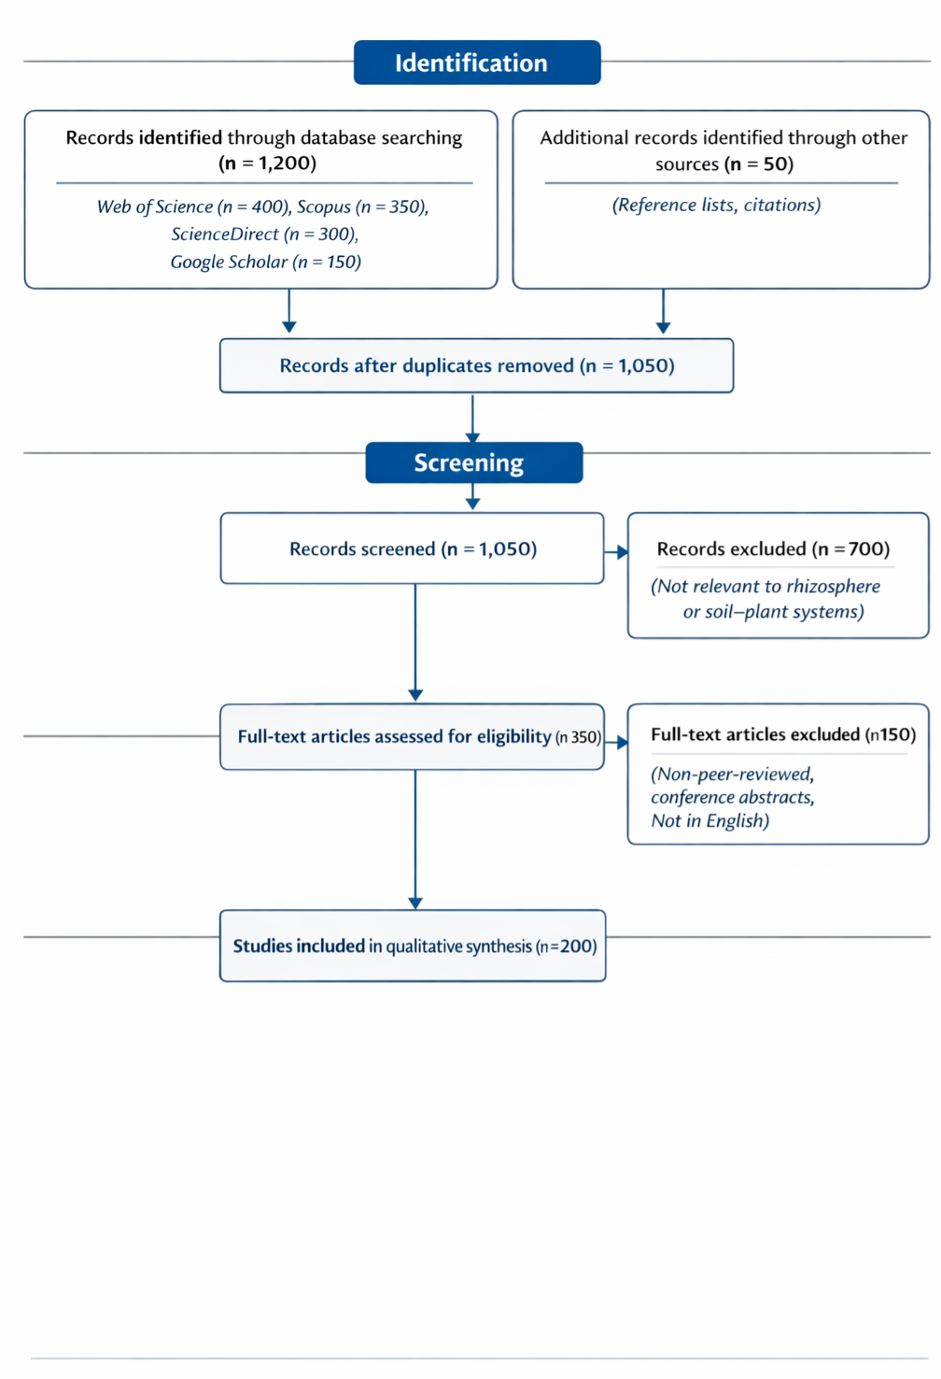
Figure 1: Prisma flow diagram illustrating the literature search, screening, eligibility assessment, and selection process for studies included in this review on rhizosphere processes and soil health.

Rhizosphere: Definition, Structure, and Function
2.1 Definition and Conceptual Framework
The rhizosphere is defined as the narrow region of soil that is directly influenced by root secretions and associated microbial activity (Hiltner, 1904; Philippot et al., 2013). Typically extending a few millimeters from the root surface, this zone is characterized by intense biochemical, physical, and biological interactions, which differentiate it from the surrounding bulk soil. Hiltner (1904) first recognized the rhizosphere as a hotspot of microbial activity, highlighting the unique microbial populations inhabiting this zone compared to bulk soil. Over the past century, advances in soil microbiology, molecular biology, and imaging technologies have refined this definition, emphasizing the rhizosphere as a dynamic interface where plants actively recruit, modulate, and interact with microbial communities to optimize nutrient acquisition, growth, and defence. From a conceptual perspective, the rhizosphere can be seen as a functional ecosystem within the soil, wherein root exudates act as chemical mediators shaping microbial populations and functions (Berendsen, Pieterse, & Bakker, 2012). This ecological framework recognizes three overlapping zones within the rhizosphere: the endorhizosphere (inside the root tissues), the rhizoplane (root surface), and the ectorhizosphere (soil immediately surrounding the root) (Raaijmakers et al., 2009). Each zone exhibits distinct microbial compositions and functional potentials, with microbes adapting to gradients of nutrients, oxygen, and pH created by root activities.

2.2 Rhizosphere Structure and Composition
The rhizosphere’s structure is shaped by the interplay between root architecture, soil texture, and microbial colonization. Root architecture, including primary, lateral, and fine roots, dictates the spatial distribution of exudates and microbial niches (Lugtenberg & Kamilova, 2009). Fine roots, with high surface area-to-volume ratios, often harbor dense microbial populations due to higher exudation rates, while thicker roots contribute to long-term structural changes in soil through mucilage deposition and aggregate formation (Zhang et al., 2023). Soil texture further modulates rhizosphere interactions; clay-rich soils provide more adsorption sites for root exudates, whereas sandy soils promote higher microbial mobility but lower nutrient retention.
Root exudates are central to rhizosphere structure, acting as carbon sources, signaling molecules, and modulators of microbial activity. These exudates include low molecular weight compounds such as sugars, amino acids, and organic acids, as well as high molecular weight compounds like mucilage and proteins (Bais et al., 2006). The composition and quantity of exudates vary with plant species, developmental stage, and environmental conditions, creating selective pressures that shape microbial communities (Badri & Vivanco, 2009). For instance, phenolic compounds exuded by roots can stimulate beneficial microbes while suppressing pathogens, demonstrating the chemical sophistication of rhizosphere-mediated interactions. Microbial composition in the rhizosphere is highly diverse and dynamic, comprising bacteria, fungi, archaea, protozoa, and nematodes (Philippot et al., 2013). Bacteria often dominate in numbers and functional diversity, performing key roles in nutrient cycling, phytohormone production, and disease suppression. Fungi, particularly mycorrhizal species, form symbiotic associations with roots, facilitating nutrient uptake and soil aggregation (Smith & Read, 2010). Archaea contribute to nitrogen and carbon transformations, while protozoa and nematodes regulate microbial populations through predation, indirectly influencing nutrient turnover (Bonkowski, 2004). The collective interactions among these organisms, mediated by root exudates and soil properties, define the structural and functional integrity of the rhizosphere ecosystem.

2.3 Functional Dynamics of the Rhizosphere
The rhizosphere serves as a biochemical engine driving multiple soil functions, including nutrient acquisition, organic matter decomposition, disease suppression, and soil structural stability. Root exudates act as carbon sources that stimulate microbial activity, enhancing decomposition rates and nutrient mineralization (Kuzyakov & Domanski, 2000). Nitrogen-fixing bacteria, phosphate-solubilizing microbes, and potassium-mobilizing bacteria are selectively recruited by roots to optimize nutrient availability (Vessey, 2003). Symbiotic associations with arbuscular mycorrhizal fungi further enhance the uptake of immobile nutrients such as phosphorus and micronutrients, highlighting the rhizosphere’s role in closing nutrient cycles.
Soil structure within the rhizosphere is also influenced by root activities. Mucilage and microbial extracellular polymeric substances promote soil aggregation, enhancing porosity, water retention, and aeration (KUMAR, 2017). These structural changes improve root penetration, microbial habitat diversity, and soil resilience against erosion. Moreover, rhizosphere microbial communities contribute to soil carbon sequestration by stabilizing organic matter in aggregates, thereby mitigating greenhouse gas emissions and enhancing ecosystem services (Kuzyakov, 2010). The rhizosphere is also critical for plant defence and disease suppression. Beneficial microbes can produce antibiotics, siderophores, and volatile organic compounds that inhibit pathogen growth (Compant, Clément, & Sessitsch, 2010). Some microbes induce systemic resistance in plants, priming defence mechanisms against a broad spectrum of pathogens (Pieterse et al., 2012). This ecological function reduces dependency on chemical pesticides, contributing to sustainable crop management.

2.4 Rhizosphere as a Hub of Biogeochemical Cycles
The rhizosphere is central to global biogeochemical cycles. Microbial transformations of nitrogen, phosphorus, potassium, and sulphur are accelerated in the rhizosphere due to higher substrate availability and microbial density (Philippot et al., 2013). For example, rhizobia convert atmospheric nitrogen into ammonium, while mycorrhizal fungi mobilize phosphorus from mineral and organic pools. Potassium-solubilizing bacteria release potassium from insoluble minerals, making it available for plant uptake (Mahmud et al., 2021). These processes collectively enhance nutrient efficiency, reduce fertilizer losses, and improve crop yields, highlighting the rhizosphere’s ecological and agronomic importance. Moreover, the rhizosphere contributes to carbon cycling through root exudation and microbial metabolism. Labile carbon compounds from roots fuel microbial growth, while microbial by-products, such as polysaccharides and humic substances, contribute to stable soil organic matter formation (Kuzyakov, 2010). This dual role in nutrient cycling and carbon sequestration underscores the rhizosphere’s multifunctionality, bridging productivity and environmental sustainability.

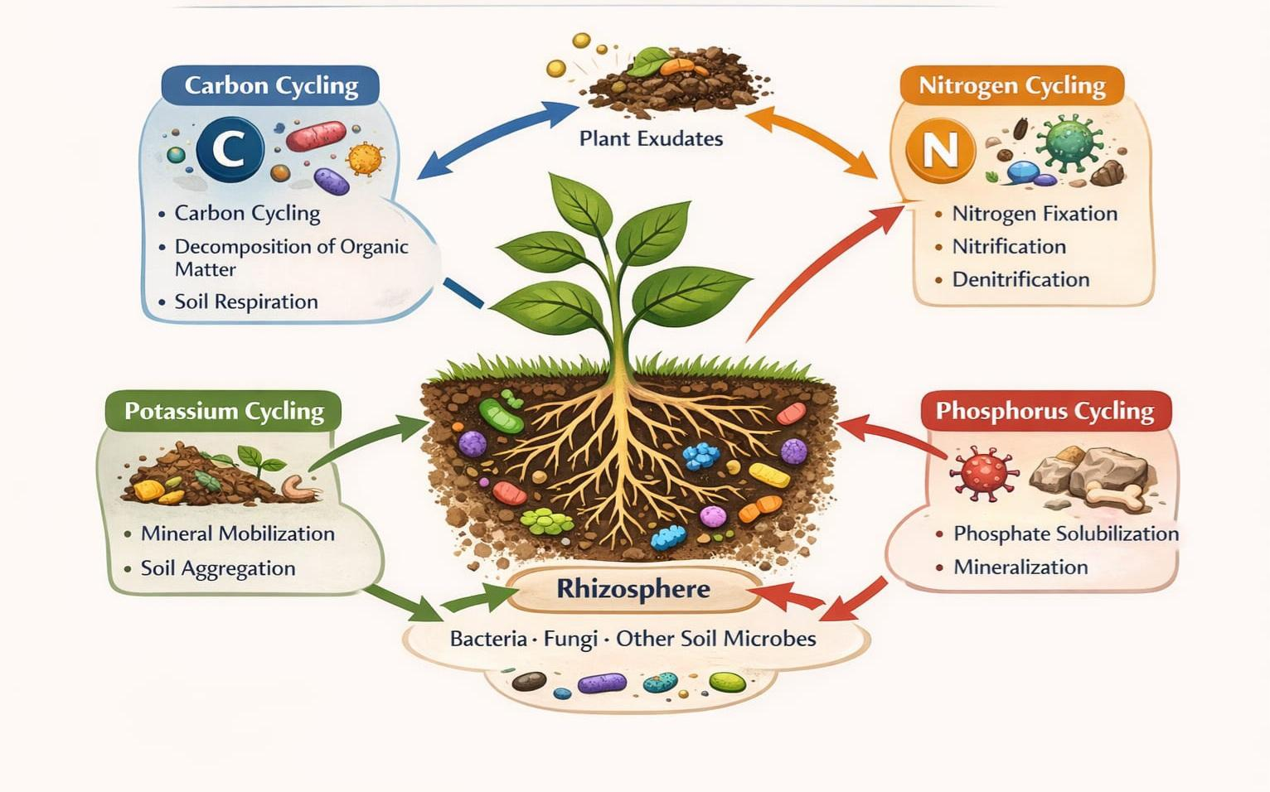
Figure 2: Rhizosphere as a hub of biochemical (C-N-P-K) cycles

2.5 Rhizosphere Interactions under Environmental Stress
Environmental stresses such as drought, salinity, and heavy metal contamination influence rhizosphere dynamics. Plants adapt by modifying root architecture and exudation patterns, recruiting stress-tolerant microbes that mitigate adverse effects (Vacheron et al., 2013). For instance, drought-stressed plants release osmolytes and organic acids that support beneficial microbial consortia capable of enhancing water and nutrient acquisition. Similarly, rhizosphere microbes can immobilize or detoxify heavy metals, reducing phytotoxicity and promoting plant survival in contaminated soils. These interactions highlight the resilience-building capacity of rhizosphere ecosystems.

3. Microbial Communities in the Rhizosphere and Their Roles in Soil Health
3.1 Introduction to Rhizosphere Microbial Communities
The rhizosphere is a hotspot of microbial diversity, hosting complex communities of bacteria, fungi, archaea, protozoa, and viruses that collectively influence soil health and plant productivity (Philippot et al., 2013). Microorganisms in the rhizosphere are more abundant and metabolically active than those in bulk soil due to the continuous supply of root exudates, which provide readily available carbon and energy sources (Bais et al., 2006). The composition and function of these communities are highly dynamic, shaped by plant species, genotype, developmental stage, soil type, and environmental factors (Berendsen, Pieterse, & Bakker, 2012). Understanding the structure and functional roles of rhizosphere microbial communities is critical for leveraging natural processes to improve soil fertility, nutrient cycling, disease suppression, and resilience to environmental stress.

3.2 Composition of Rhizosphere Microbial Communities
3.2.1 Bacteria
Bacteria dominate the rhizosphere in both abundance and functional diversity. Proteobacteria, Actinobacteria, Firmicutes, and Bacteroidetes are among the most frequently reported bacterial phyla in rhizospheres across different crops and soils (Philippot et al., 2013). These bacteria are involved in key soil functions including nitrogen fixation, phosphorus solubilization, organic matter decomposition, and production of plant growth-promoting substances (Vessey, 2003). For example, rhizobia, a group of symbiotic nitrogen-fixing bacteria, form nodules on legume roots and convert atmospheric nitrogen into bioavailable ammonium, supporting plant growth in nitrogen-limited soils (Sprent, 2009). Similarly, phosphate-solubilizing bacteria mobilize insoluble phosphorus, making it available to plants (Rodrı́guez & Fraga, 1999). Certain bacterial species also produce phytohormones, such as indole-3-acetic acid (IAA), that stimulate root growth and enhance nutrient uptake (Spaepen, Vanderleyden, & Remans, 2007).

3.2.2 Fungi
Fungi, particularly mycorrhizal species, play a pivotal role in nutrient acquisition and soil structure. Arbuscular mycorrhizal fungi (AMF) form symbiotic associations with most terrestrial plants, extending hyphal networks into the soil to access immobile nutrients such as phosphorus and micronutrients (Smith & Read, 2010). AMF also enhance water uptake, improve soil aggregation through glomalin production, and facilitate plant resilience to biotic and abiotic stresses (Rillig, 2004). Saprophytic fungi contribute to organic matter decomposition, converting complex polymers such as lignin and cellulose into forms accessible to other microorganisms and plants (Six et al., 2006). Pathogenic fungi, conversely, can suppress plant growth, but beneficial fungi often mitigate these effects through competition or induction of systemic resistance in the host plant (Compant, Clément, & Sessitsch, 2010).

3.2.3 Archaea and Other Microorganisms
Archaea, although less abundant than bacteria and fungi, contribute to critical soil processes such as nitrification and methane cycling (Leininger et al., 2006). They are often present in specialized niches within the rhizosphere and can influence nutrient transformations under extreme conditions. Protozoa and nematodes regulate microbial populations through predation, indirectly influencing nutrient mineralization and microbial community dynamics (Bonkowski, 2004). Viruses, including bacteriophages, shape microbial diversity and function by controlling bacterial population dynamics and facilitating horizontal gene transfer (Sime-Ngando, 2014). These multi-trophic interactions highlight the complexity of rhizosphere microbial networks and their collective role in soil health.

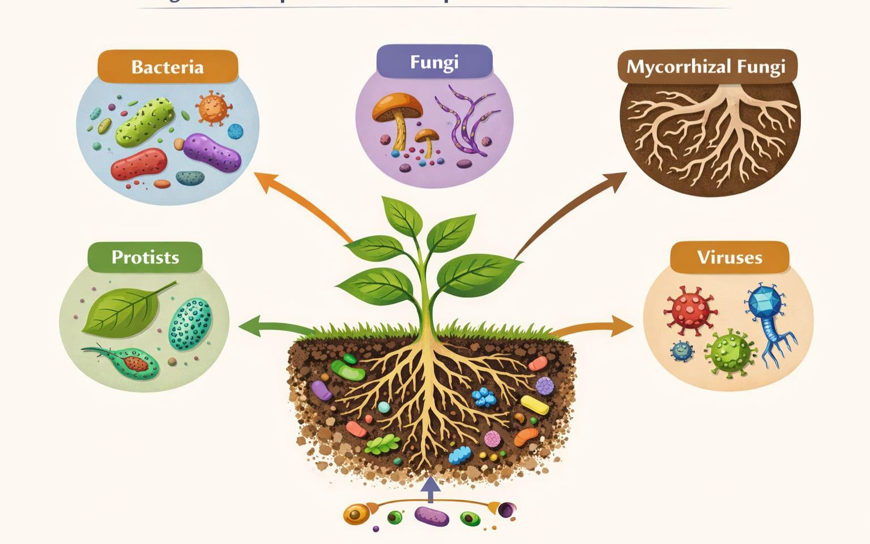
Figure 3: Composition of Rhizosphere Microbial Communities

3.3 Functional Roles of Rhizosphere Microbes in Soil Health
3.3.1 Nutrient Cycling
Rhizosphere microbes are central to nutrient cycling, enhancing the bioavailability of nitrogen (N), phosphorus (P), and potassium (K) — essential macronutrients for plant growth (Dotaniya & Meena, 2015). Nitrogen-fixing bacteria, including rhizobia and free-living diazotrophs, convert atmospheric N₂ into ammonium, reducing the need for synthetic fertilizers (Sprent, 2009). Phosphate-solubilizing microbes release phosphorus from mineral and organic compounds, while potassium-solubilizing bacteria mobilize potassium from insoluble silicate minerals (Shrivastava, Srivastava, & D’souza, 2018). Sulfur-oxidizing and decomposer microorganisms contribute to sulfur cycling and organic matter decomposition, respectively, enhancing nutrient availability and soil fertility (Philippot et al., 2013).

3.3.2 Soil Structure and Organic Matter Dynamics
Microbial activity in the rhizosphere contributes to soil aggregation, porosity, and water retention. Fungal hyphae and microbial extracellular polymeric substances (EPS) act as natural “glues” binding soil particles into stable aggregates (Rillig, 2004). Aggregated soils improve root penetration, aeration, and microbial habitat diversity, fostering a resilient soil ecosystem. Rhizosphere microbes also mediate carbon cycling by decomposing plant residues and stabilizing organic matter into soil humus, thereby enhancing soil organic carbon stocks and mitigating greenhouse gas emissions (Kuzyakov, 2010; Six et al., 2006).

3.3.3 Disease Suppression and Plant Protection
Beneficial rhizosphere microbes play a critical role in suppressing soilborne pathogens. They achieve this through multiple mechanisms: production of antibiotics and siderophores, competition for nutrients and space, and induction of systemic resistance in plants (Berendsen, Pieterse, & Bakker, 2012; Compant, Clément, & Sessitsch, 2010). For instance, Pseudomonas spp. and Bacillus spp. are well-documented biocontrol agents that inhibit pathogenic fungi and bacteria, reducing disease incidence and improving crop yield. Similarly, mycorrhizal fungi can protect plants against root pathogens by enhancing nutrient uptake and inducing defensive responses in host plants (Smith & Read, 2010). The interplay between beneficial microbes and pathogens in the rhizosphere underscores the importance of microbial management for soil health and sustainable agriculture.

3.3.4 Stress Mitigation
Environmental stresses, such as drought, salinity, and heavy metal contamination, disrupt rhizosphere functions. Microbial communities mediate plant resilience by producing osmoprotectants, phytohormones, and bioactive compounds that enhance stress tolerance (Vacheron et al., 2013). Halotolerant bacteria can alleviate salinity stress by producing exopolysaccharides that retain soil moisture, while heavy metal-tolerant microbes immobilize or detoxify metals, reducing phytotoxicity. Such stress-mitigating functions of rhizosphere microbes are critical for maintaining soil health under adverse environmental conditions and for ensuring sustainable crop production in marginal lands.

3.4 Factors Shaping Rhizosphere Microbial Communities
Several biotic and abiotic factors govern the structure and function of rhizosphere microbial communities. Plant genotype and species influence root exudate composition, selecting for specific microbial consortia (Badri & Vivanco, 2009). Soil properties such as pH, texture, organic matter content, and moisture regulate microbial survival and metabolic activity (Lugtenberg & Kamilova, 2009). Agricultural practices, including tillage, fertilization, crop rotation, and pesticide use, also impact microbial diversity and function (Hartmann et al., 2015). Understanding these factors is essential for managing rhizosphere communities to enhance soil health and sustainable productivity.

3.5 Harnessing Rhizosphere Microbes for Sustainable Agriculture
The functional diversity of rhizosphere microbial communities offers immense potential for sustainable agriculture. Microbial inoculants, biofertilizers, and biocontrol agents derived from rhizosphere microbes can enhance nutrient efficiency, reduce chemical inputs, and suppress soilborne diseases (Berendsen, Pieterse, & Bakker, 2012; Vessey, 2003). Integrating microbial management with agronomic practices such as crop rotation, intercropping, and organic amendments can further strengthen microbial resilience and ecosystem services (Philippot et al., 2013). Advances in metagenomics, metabolomics, and systems biology allow for the identification of key microbial taxa and functional traits that contribute to soil health, providing opportunities for precision microbiome engineering in agroecosystems (Trivedi et al., 2020).

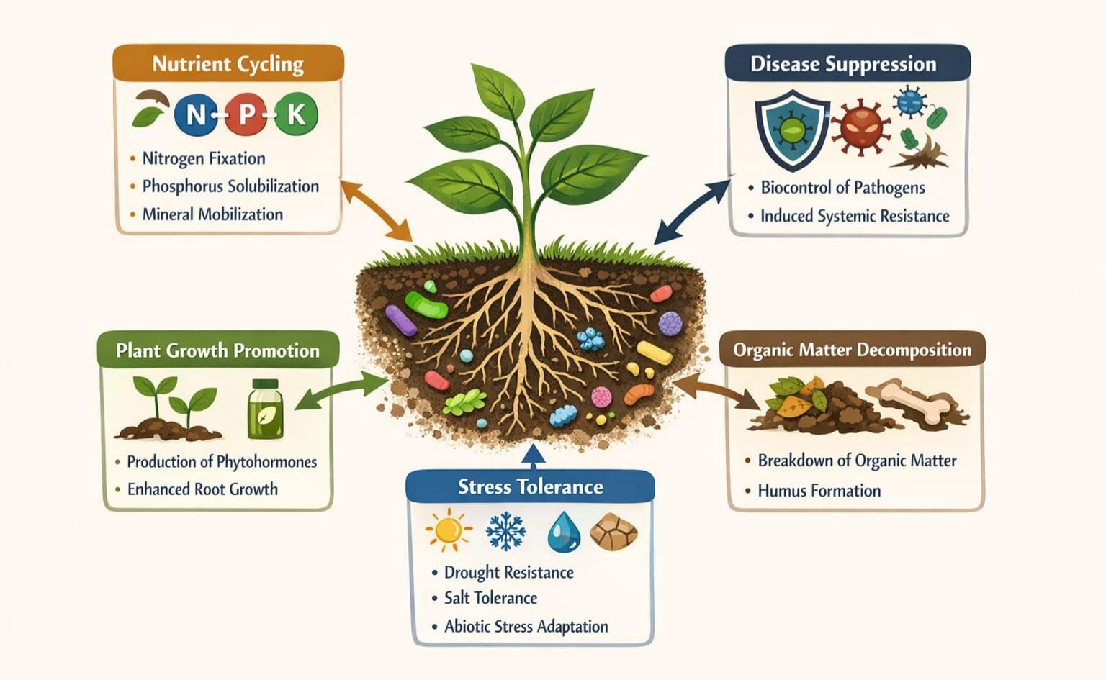
Figure 4: Functional Roles of Rhizosphere Microbes in Soil health

4. Nutrient Cycling and Plant Nutrition Mediated by the Rhizosphere
4.1 Introduction
Plant nutrition is intrinsically linked to the rhizosphere, where root-microbe-soil interactions drive the availability, uptake, and transformation of essential nutrients. Nitrogen (N), phosphorus (P), and potassium (K) are macronutrients critical for plant growth, metabolism, and productivity (Wang et al., 2024). However, a large proportion of these nutrients exists in forms that are unavailable to plants due to soil chemical fixation, mineralization dynamics, or leaching losses (Sinha & Tandon, 2020). The rhizosphere serves as a biogeochemical hotspot where microorganisms, root exudates, and soil processes synergistically mobilize these nutrients, enhancing plant nutrition and soil fertility (Kuzyakov & Domanski, 2000). Understanding these processes is essential for sustainable nutrient management in agriculture, reducing reliance on synthetic fertilizers and minimizing environmental impacts.

4.2 Nitrogen Cycling in the Rhizosphere
Nitrogen is often the most limiting macronutrient in cropping systems. Within the rhizosphere, microbial communities facilitate nitrogen transformations through biological nitrogen fixation (BNF), mineralization, nitrification, and denitrification (Philippot et al., 2013).

4.2.1 Biological Nitrogen Fixation
Symbiotic nitrogen-fixing bacteria, such as Rhizobium spp., Bradyrhizobium spp., and Sinorhizobium spp., form nodules on legume roots, converting atmospheric N₂ into ammonia (NH₃) that plants can assimilate (Sprent, 2009). Free-living diazotrophs, including Azotobacter and Clostridium, contribute to N inputs in non-legume systems. Root exudates, particularly flavonoids, act as chemical signals that initiate nodulation and attract symbionts (Dakora & Phillips, 2002). Enhanced N availability in the rhizosphere improves plant growth, grain protein content, and overall soil fertility.

4.2.2 N Mineralization and Nitrification
Soil organic nitrogen compounds, derived from plant residues and microbial biomass, undergo mineralization by rhizosphere microbes to produce ammonium (NH₄⁺), which can then be converted into nitrate (NO₃⁻) through nitrification (Kuzyakov & Domanski, 2000). Ammonia-oxidizing bacteria (AOB) and archaea (AOA) play crucial roles in nitrification, influencing N availability and leaching potential (Leininger et al., 2006). Root exudates stimulate microbial activity, accelerating N mineralization and improving nitrogen use efficiency.

4.2.3 Denitrification and Nitrogen Losses
Denitrifying bacteria in the rhizosphere convert nitrate to gaseous forms (N₂, N₂O) which can result in nitrogen losses from soil (Philippot et al., 2013). Although denitrification contributes to the N cycle, excessive activity can reduce soil fertility and contribute to greenhouse gas emissions. Rhizosphere management, such as optimizing microbial communities and maintaining soil aeration, is key to minimizing N losses while sustaining plant-available N.

4.3 Phosphorus Cycling in the Rhizosphere
Phosphorus is an essential nutrient for energy transfer, nucleic acid synthesis, and root development. However, P is highly immobile in soils, often forming insoluble complexes with calcium, iron, and aluminum (Marschner, 2011). The rhizosphere enhances P availability through chemical and biological mechanisms.

4.3.1 Phosphate Solubilization
Phosphate-solubilizing bacteria (PSB), including Pseudomonas, Bacillus, and Rhizobium spp., release organic acids (e.g., gluconic and citric acids) that solubilize inorganic phosphates, making them accessible to plants (Rodrı́guez & Fraga, 1999). These microorganisms are often selectively recruited by root exudates, which contain sugars and amino acids that stimulate their growth and activity (Bashan et al., 2014). Mycorrhizal fungi also enhance P uptake by extending hyphal networks into soil microsites inaccessible to roots (Smith & Read, 2010).

4.3.2 Organic Phosphorus Mineralization
Soil organic P, often in the form of phytate and phospholipids, requires enzymatic mineralization before plant uptake. Rhizosphere microbes, particularly bacteria and fungi, produce phosphatases and phytases that hydrolyze organic P compounds (Azeem et al., 2015). The synergistic interaction between root exudates and microbial activity creates a rhizosphere “P-mobilization zone,” increasing plant phosphorus acquisition.

4.3.3 Phosphorus Use Efficiency
Optimizing rhizosphere processes reduces dependency on chemical P fertilizers and enhances P-use efficiency. Management practices, such as inoculation with PSB, AMF, and crop rotation with legumes, can sustain P availability and improve crop yields while minimizing environmental losses (Shukla et al., 2018).

4.4 Potassium Cycling in the Rhizosphere
Potassium (K) is a macronutrient critical for enzyme activation, osmoregulation, and stress tolerance. Although K is abundant in soils, a large proportion is in insoluble mineral forms, unavailable to plants (Mahmud et al., 2021). The rhizosphere enhances K bioavailability through microbial and root-mediated processes.

4.4.1 Potassium-Solubilizing Microorganisms
Potassium-solubilizing bacteria (KSB) and fungi release organic acids and protonate mineral surfaces to mobilize K from feldspar, mica, and clay minerals (Mahmud et al., 2021). Root exudates stimulate KSB activity, creating localized zones of higher K availability around roots. These microbes enhance K uptake, supporting plant growth, stress tolerance, and crop yield, particularly in K-deficient soils.

4.4.2 Root-Mediated K Mobilization
Roots contribute to K availability through rhizosphere acidification and cation exchange. Exudation of protons (H⁺) and organic acids lowers local soil pH, dissolving K-bearing minerals and facilitating plant uptake (Marschner, 2011). Fine root proliferation and root hairs increase the surface area for K acquisition, complementing microbial solubilization mechanisms.

4.5 Interactions Between N, P, and K in the Rhizosphere
The availability and uptake of N, P, and K are interconnected in the rhizosphere. Nitrogen supply influences root growth and exudation patterns, affecting microbial recruitment and P and K solubilization (Marschner, 2011). Similarly, P availability modulates root morphology and mycorrhizal colonization, indirectly affecting N and K acquisition. Potassium influences osmotic balance and enzyme activity, affecting microbial metabolism and nutrient cycling. These interactions highlight the integrative role of the rhizosphere in coordinating nutrient dynamics for optimal plant growth.

4.6 Rhizosphere Management for Improved Nutrient Cycling
Rhizosphere management strategies can enhance nutrient cycling and plant nutrition sustainably:
1. Microbial Inoculants: Introduction of N-fixing bacteria, PSB, and KSB improves nutrient availability and reduces fertilizer dependency (Vessey, 2003).
2. Mycorrhizal Symbiosis: AMF inoculation enhances P and micronutrient uptake, improves soil aggregation, and supports stress resilience (Smith & Read, 2010).
3. Organic Amendments: Compost and biochar stimulate microbial activity and nutrient mineralization, enhancing N, P, and K cycling (Kuzyakov, 2010).
4. Crop Rotation and Intercropping: Inclusion of legumes and deep-rooted species enhances N input, P mobilization, and soil microbial diversity (Philippot et al., 2013).
5. Precision Fertilization: Targeted application of fertilizers in combination with rhizosphere-enhancing practices optimizes nutrient use efficiency and reduces losses (Han et al., 2025).

5. Rhizosphere-Mediated Disease Suppression and Plant Protection
5.1 Introduction
Plant health is intrinsically linked to the rhizosphere, where complex interactions between roots, soil microorganisms, and pathogens determine disease incidence and crop productivity (Mukherjee, 2019). The rhizosphere acts as a frontline defense zone, harboring beneficial microbes that suppress pathogens, stimulate plant immunity, and enhance resilience to biotic stress (Sharma et al., 2020). With increasing concerns about chemical pesticide overuse, harnessing rhizosphere-mediated disease suppression offers a sustainable and eco-friendly alternative for crop protection. Understanding the mechanisms, key microbial players, and environmental factors influencing disease suppression is essential for developing effective biocontrol strategies.

5.2 Mechanisms of Rhizosphere Disease Suppression
Rhizosphere microbes suppress plant pathogens through multiple mechanisms, which can be broadly categorized as direct antagonism, competition for resources, induced systemic resistance, and modulation of the rhizosphere environment.

5.2.1 Direct Antagonism
Beneficial microbes in the rhizosphere produce bioactive compounds that directly inhibit pathogens. These include antibiotics, lytic enzymes, volatile organic compounds (VOCs), and siderophores (Naz et al., 2022). For instance, Pseudomonas spp. and Bacillus spp. produce a wide array of antibiotics, such as phenazines, pyoluteorin, and iturins, that inhibit bacterial and fungal pathogens (Sharma et al., 2020). Fungal antagonists, such as Trichoderma spp., secrete chitinases, glucanases, and proteases that degrade fungal cell walls, suppressing pathogen colonization (Naz et al., 2022). These direct antagonistic mechanisms reduce pathogen load and contribute to healthier plant growth.

5.2.2 Competition for Nutrients and Space
Microbes compete with pathogens for essential nutrients, root exudates, and colonization sites. The high microbial density in the rhizosphere limits resources available to pathogens, suppressing their growth (Spooren et al., 2024). Siderophore-producing bacteria exemplify this mechanism by sequestering iron, a critical micronutrient, thereby depriving pathogens and limiting infection (Glick et al., 1999). Similarly, rapid colonization of the rhizoplane by beneficial bacteria and fungi prevents pathogen attachment and biofilm formation, providing a natural barrier to infection.

5.2.3 Induced Systemic Resistance (ISR)
Rhizosphere microbes can trigger plant defense mechanisms known as induced systemic resistance (ISR). ISR primes the plant immune system, enhancing the production of pathogenesis-related proteins, secondary metabolites, and defensive hormones such as jasmonic acid and ethylene (Pieterse, 2025). Unlike direct antagonism, ISR does not involve direct pathogen killing but prepares the plant to respond more rapidly and effectively to biotic stress. For example, Pseudomonas fluorescens and certain Bacillus strains can induce ISR against bacterial, fungal, and viral pathogens (Van Wees, Van der Ent, & Pieterse, 2008). Mycorrhizal fungi also contribute to ISR, improving plant resistance to root pathogens and foliar diseases (Pozo & Azcón-Aguilar, 2007).

5.2.4 Modulation of the Rhizosphere Environment
Microbial activity alters rhizosphere pH, redox potential, and organic matter composition, creating conditions unfavorable for pathogens. Organic acid exudation and microbial metabolism can acidify the rhizosphere, inhibiting pH-sensitive pathogens (Joshi et al., 2024). Similarly, microbial production of hydrogen cyanide (HCN), ammonia, and VOCs contributes to pathogen suppression. By modifying the chemical and physical environment, rhizosphere microbes indirectly protect plants while enhancing nutrient cycling and root growth.

5.3 Key Microbial Players in Disease Suppression
5.3.1 Bacteria
Bacteria are among the most studied rhizosphere microbes for biocontrol. Pseudomonas spp. produce antibiotics, siderophores, and VOCs, suppressing pathogens such as Fusarium, Rhizoctonia, and Pythium (Naz et al., 2022). Bacillus spp., including B. subtilis and B. amyloliquefaciens, form endospores that survive adverse conditions and produce lipopeptides with antifungal properties (Ongena & Jacques, 2008). Actinobacteria, particularly Streptomyces spp., produce a wide range of secondary metabolites that inhibit bacterial and fungal pathogens while promoting plant growth (Palaniyandi et al., 2013).
5.3.2 Fungi
Beneficial fungi, especially Trichoderma spp., are effective biocontrol agents. They parasitize pathogens through mycoparasitism, secrete lytic enzymes, and induce ISR in plants (Shoresh, Harman, & Mastouri, 2010). Arbuscular mycorrhizal fungi (AMF) indirectly suppress pathogens by enhancing nutrient uptake, improving plant vigor, and modulating root exudation patterns that favor beneficial microbes over (Pozo & Azcón-Aguilar, 2007). Saprophytic fungi contribute to soil health by decomposing organic matter and creating competitive niches that limit pathogen establishment.

5.3.3 Other Microorganisms
Protozoa and nematodes regulate microbial populations in the rhizosphere, indirectly influencing disease suppression by maintaining microbial balance (Bonkowski & Scheu, 2004). Viruses, particularly bacteriophages, control pathogenic bacterial populations, shaping microbial community composition and disease outcomes (Suttle, 2007). The combined activity of these multi-trophic players enhances ecosystem stability and resilience against soilborne diseases.

5.4 Factors Influencing Rhizosphere Disease Suppression
Several biotic and abiotic factors modulate disease suppression:
1. Plant Species and Genotype: Different plant species exude distinct chemical signals that recruit specific microbial consortia with biocontrol potential (Berendsen, Pieterse, & Bakker, 2012).
2. Soil Properties: pH, texture, moisture, and organic matter influence microbial diversity and activity, affecting disease suppression efficiency (Kariuki, Muriuki, & Kibiro, 2015)
3. Agricultural Practices: Tillage, crop rotation, fertilization, and pesticide use can enhance or disrupt beneficial microbial populations (Hartmann & Six, 2023).
4. Environmental Stress: Drought, salinity, and heavy metals alter microbial community composition, potentially reducing disease suppression capabilities (Vacheron et al., 2015).
Optimizing these factors through integrated soil and crop management enhances rhizosphere-mediated disease suppression.

5.5 Practical Applications in Sustainable Agriculture
Harnessing rhizosphere-mediated disease suppression offers practical solutions for sustainable crop production:
1. Biofertilizers and Biocontrol Agents: Inoculation with Pseudomonas, Bacillus, Trichoderma, and AMF enhances disease suppression while promoting nutrient acquisition (Pathak, Lone, & Koul, 2017).
2. Crop Rotation and Intercropping: Diversifying plant species enriches beneficial microbial communities and disrupts pathogen life cycles (Liang et al., 2025).
3. Organic Amendments: Compost, biochar, and green manures support microbial diversity, increase biocontrol potential, and improve soil health (Naghman et al., 2023).
4. Reduced Chemical Pesticide Use: Integrating rhizosphere-mediated biocontrol reduces dependency on synthetic chemicals, lowering environmental pollution and enhancing food safety (Shahrtash, 2022).

6. Rhizosphere Management for Sustainable Agriculture and Soil Health
The rhizosphere, as a dynamic interface between plant roots, soil, and microorganisms, is central to soil health, nutrient cycling, disease suppression, and crop resilience. Effective rhizosphere management involves practices that harness these natural processes to improve agricultural productivity while minimizing environmental impact (Pathak, Lone, & Koul, 2017). With global challenges such as soil degradation, nutrient depletion, climate change, and increasing demand for food, sustainable rhizosphere management has emerged as a critical component of climate-smart agriculture (Rai & Sarkar, 2025). Integrating microbial inoculants, organic amendments, crop rotations, precision fertilization, and soil conservation practices can optimize rhizosphere functions for long-term soil health and sustainable crop production.

6.2 Principles of Rhizosphere Management
Successful rhizosphere management is guided by several key principles:
1. Enhancing Beneficial Microbial Communities: Promoting populations of nitrogen-fixing bacteria, phosphate- and potassium-solubilizing microbes, mycorrhizal fungi, and biocontrol agents to improve nutrient availability and plant health (Yinan Zeng et al., 2025).
2. Improving Root Exudation and Activity: Selecting crop species and genotypes with favorable root traits and exudation profiles that recruit beneficial microbes and enhance nutrient cycling (Ahlawat et al., 2024).
3. Maintaining Soil Structure and Organic Matter: Practices that increase soil organic carbon and aggregation create favorable habitats for microbes and improve nutrient retention (Khan et al., 2025).
4. Reducing Chemical Dependence: Minimizing synthetic fertilizer and pesticide use encourages microbial diversity and resilience, reducing nutrient losses and environmental pollution (Odebode & David, 2025).
These principles provide the foundation for designing sustainable management strategies tailored to specific cropping systems and environmental conditions.

6.3 Strategies for Enhancing Rhizosphere Functions
6.3.1 Microbial Inoculants and Biofertilizers
Microbial inoculants—comprising rhizobia, phosphate-solubilizing bacteria (PSB), potassium-solubilizing bacteria (KSB), and arbuscular mycorrhizal fungi (AMF) can significantly enhance rhizosphere functions (Ahlawat et al., 2024). In legumes, rhizobial inoculation improves nitrogen fixation, reducing the need for synthetic N fertilizers (Raza et al., 2020). PSB and KSB inoculants mobilize soil-bound nutrients, enhancing phosphorus and potassium uptake ((Ahlawat et al., 2024; Morel, Braña, & Castro-Sowinski, 2012). AMF improve root nutrient acquisition, water uptake, and soil aggregation (Smith & Read, 2010). The effectiveness of inoculants depends on soil conditions, crop type, and compatibility with native microbial communities, highlighting the need for context-specific formulations and applications (Trivedi et al., 2020).

6.3.2 Organic Amendments
Incorporating organic matter through compost, manure, green manures, or biochar enhances microbial activity, nutrient availability, and soil structure (Kuzyakov, 2010). Organic amendments provide substrates for rhizosphere microbes, stimulate enzymatic activity, and increase soil cation exchange capacity, improving nutrient retention and availability. For instance, compost-amended soils show increased populations of beneficial bacteria and fungi, enhanced N mineralization, and reduced pathogen incidence (Hartmann et al., 2015). Biochar, due to its porous structure and high surface area, can improve microbial colonization, water retention, and nutrient cycling (Lehmann et al., 2015).

6.3.3 Crop Rotation and Intercropping
Diversified cropping systems influence rhizosphere microbial composition and function (Philippot et al., 2013). Rotating legumes with cereals enhances N input through biological nitrogen fixation, improves P availability, and suppresses soilborne pathogens. Intercropping promotes complementary root exudation patterns, increasing microbial diversity and nutrient acquisition efficiency (Maltais-Landry, 2015). These practices reduce pest and disease pressure while maintaining soil fertility, contributing to sustainable production systems.

6.3.4 Minimal Tillage and Soil Conservation
Reduced or no-tillage systems preserve soil structure, organic matter, and microbial habitats, supporting a diverse and active rhizosphere (Six et al., 2006). Tillage disrupts soil aggregates, reduces microbial biomass, and increases nutrient losses. Conservation practices, such as cover cropping and residue retention, protect soil from erosion, enhance organic matter inputs, and create favorable microenvironments for rhizosphere microbes (Lal, 2020).

6.3.5 Precision Fertilization
Applying fertilizers based on soil testing, crop demand, and rhizosphere conditions maximizes nutrient use efficiency while minimizing losses (Simpson et al., 2014). Fertilizer placement near the root zone, split applications, and integration with microbial inoculants promote nutrient uptake and stimulate beneficial microbial activity. For example, banding phosphorus fertilizers with PSB inoculants enhances P availability and reduces fixation in soils with high P-fixing capacity.

6.3.6 Biocontrol Integration
Incorporating biocontrol agents within rhizosphere management suppresses soilborne pathogens and enhances plant resilience (Berendsen et al., 2012). Using microbial consortia rather than single strains can provide complementary mechanisms, including direct antagonism, competition, and induction of systemic resistance (Compant et al., 2010). Combining biocontrol with organic amendments, crop rotation, and reduced pesticide use amplifies disease suppression while maintaining soil health.

6.4 Role of Rhizosphere Management in Nutrient Efficiency
Effective rhizosphere management improves nitrogen, phosphorus, and potassium use efficiency, reducing the need for chemical fertilizers. For nitrogen, promoting diazotroph activity and maintaining soil organic matter supports sustained N availability (Philippot et al., 2013). For phosphorus, PSB and AMF inoculation enhance P solubilization and uptake, reducing P fertilizer requirements (Smith & Read, 2010). Potassium availability is increased through KSB activity and root exudation, improving crop yield in K-deficient soils (Sardans & Peñuelas, 2021). Integrating these strategies supports nutrient cycling, minimizes environmental losses, and enhances productivity sustainably.

6.5 Enhancing Resilience and Soil Health
Rhizosphere management also contributes to soil resilience under environmental stress. Microbial communities improve soil structure, enhance water retention, and stabilize organic matter, buffering against drought, salinity, and erosion (Rillig, 2004). Disease suppression through microbial antagonism reduces crop losses, while ISR enhances plant tolerance to biotic and abiotic stressors (Berendsen et al., 2012; Vacheron et al., 2013). These benefits collectively maintain long-term soil health and productivity, supporting climate-smart agricultural practices.

6.6 Future Directions and Emerging Technologies
Emerging approaches in rhizosphere management leverage molecular biology, metagenomics, and precision agriculture:
1. Microbiome Engineering: Designing microbial consortia with specific nutrient-solubilizing, biocontrol, and stress-mitigating traits (Trivedi et al., 2020).
2. Metabolomics and Root Exudate Profiling: Understanding plant-microbe chemical communication to enhance recruitment of beneficial microbes (Badri & Vivanco, 2009).
3. Digital Soil and Rhizosphere Mapping: Using sensors, remote sensing, and machine learning to monitor soil microbial activity, nutrient dynamics, and root growth in real-time (Yijian Zeng et al., 2025).
4. Integration with Climate-Smart Practices: Combining rhizosphere management with water conservation, carbon sequestration, and agroforestry for sustainable landscapes (Loria & Lal, 2025).
These approaches hold promise for precision management of the rhizosphere to optimize productivity, reduce inputs, and enhance ecosystem sustainability.

Conclusion
The rhizosphere is a highly dynamic and intricate interface that functions as a natural engine for soil health and sustainable agriculture. Through complex interactions among plant roots, microorganisms, and soil physicochemical properties, the rhizosphere mediates critical ecosystem functions including nutrient cycling, plant nutrition, disease suppression, and stress resilience. Beneficial microbial communities such as nitrogen-fixing bacteria, phosphate- and potassium-solubilizing microorganisms, mycorrhizal fungi, and biocontrol agents work synergistically with root exudates to enhance nutrient availability, suppress pathogens, and stimulate plant growth. These processes reduce dependency on chemical fertilizers and pesticides, thereby promoting environmentally sustainable and economically viable agricultural systems (Berendsen et al., 2012; Philippot et al., 2013).
Effective rhizosphere management, which integrates microbial inoculants, organic amendments, crop rotation, minimal tillage, and precision fertilization, can enhance soil fertility, structure, and microbial diversity. These strategies optimize plant-microbe-soil interactions, increasing nutrient use efficiency, improving plant health, and mitigating biotic and abiotic stress. Additionally, practices that conserve soil organic matter, maintain soil aggregation, and promote diverse cropping systems contribute to long-term resilience of agroecosystems (Lal, 2020; Kuzyakov, 2010).
Importantly, the rhizosphere operates as a self-regulating ecosystem engine, capable of sustaining nutrient dynamics, suppressing diseases, and enhancing soil structure when properly managed. By leveraging its natural processes, farmers can achieve high crop productivity while reducing environmental pollution, conserving natural resources, and enhancing climate resilience.

Future Perspectives
Despite the immense potential of rhizosphere-based management, several research gaps and opportunities remain:
1. Microbiome Engineering: Advanced microbiome manipulation and synthetic consortia development could enhance nutrient solubilization, pathogen suppression, and stress tolerance in crops (Trivedi et al., 2020). Understanding microbe-microbe and plant-microbe interactions at a systems level is critical for designing robust microbial solutions.
2. Root Exudate Profiling and Signaling: Investigating the chemical ecology of root exudates and their role in microbial recruitment will enable targeted strategies to optimize nutrient uptake and disease resistance (Badri & Vivanco, 2009).
3. Digital Soil and Rhizosphere Monitoring: Integrating sensors, remote sensing, and artificial intelligence can provide real-time monitoring of rhizosphere processes, nutrient dynamics, and microbial activity, allowing precision management of soils and crops (Zhang et al., 2020).
4. Climate-Resilient Rhizosphere Management: Exploring rhizosphere processes under climate stressors (drought, salinity, temperature extremes) will help develop adaptive strategies that sustain productivity and soil health in changing environments (Vacheron et al., 2013; Lal, 2020).
5. Integration with Sustainable Agricultural Policies: Linking rhizosphere-based practices with agroecological policies, farmer training, and incentive systems will accelerate adoption of environmentally friendly and productive farming practices globally.
6. Interdisciplinary Research: Collaboration among soil scientists, plant physiologists, microbiologists, agronomists, and data scientists will be essential to translate fundamental rhizosphere knowledge into practical applications.

Disclaimer (Artificial intelligence)
Option 1:
Author(s) hereby declare that NO generative AI technologies such as Large Language Models (ChatGPT, COPILOT, etc.) and text-to-image generators have been used during the writing or editing of this manuscript.

References
- Ahlawat, O. P., Yadav, D., Walia, N., Kashyap, P. L., Sharma, P., & Tiwari, R. (2024). Root exudates and their significance in abiotic stress amelioration in plants: a review. Journal of Plant Growth Regulation, 43(6), 1736-1761.
- Azeem, M., Riaz, A., Chaudhary, A. N., Hayat, R., Hussain, Q., Tahir, M. I., & Imran, M. (2015). Microbial phytase activity and their role in organic P mineralization. Archives of Agronomy and Soil Science, 61(6), 751-766.
- Badri, D. V., & Vivanco, J. M. (2009). Regulation and function of root exudates. Plant, cell & environment, 32(6), 666-681.
- Bais, H. P., Weir, T. L., Perry, L. G., Gilroy, S., & Vivanco, J. M. (2006). The role of root exudates in rhizosphere interactions with plants and other organisms. Annu. Rev. Plant Biol., 57(1), 233-266.
- Bashan, Y., de-Bashan, L. E., Prabhu, S., & Hernandez, J.-P. (2014). Advances in plant growth-promoting bacterial inoculant technology: formulations and practical perspectives (1998–2013). Plant and soil, 378(1), 1-33.
- Berendsen, R. L., Pieterse, C. M., & Bakker, P. A. (2012). The rhizosphere microbiome and plant health. Trends in plant science, 17(8), 478-486.
- Bonkowski, M. (2004). Protozoa and plant growth: the microbial loop in soil revisited. New Phytologist, 162(3), 617-631.
- Bonkowski, M., & Scheu, S. (2004). Biotic interactions in the rhizosphere: effects on plant growth and herbivore development. In Insects and ecosystem function (pp. 71-91). Springer.
- Compant, S., Clément, C., & Sessitsch, A. (2010). Plant growth-promoting bacteria in the rhizo-and endosphere of plants: their role, colonization, mechanisms involved and prospects for utilization. Soil biology and biochemistry, 42(5), 669-678.
- Dakora, F. D., & Phillips, D. A. (2002). Root exudates as mediators of mineral acquisition in low-nutrient environments. Plant and soil, 245(1), 35-47.
- Dotaniya, M., & Meena, V. (2015). Rhizosphere effect on nutrient availability in soil and its uptake by plants: a review. Proceedings of the National Academy of Sciences, India Section B: Biological Sciences, 85(1), 1-12.
- Glick, B. R., Holguin, G., Patten, C., & Penrose, D. M. (1999). Biochemical and genetic mechanisms used by plant growth promoting bacteria. World Scientific.
- Han, Y., Lv, M., Liu, J., He, S., Shi, W., Li, M., & Gao, Z. (2025). Agronomic practices-driven response of nitrogen-related microorganisms. Plant and soil, 1-16.
- Hartmann, M., Frey, B., Mayer, J., Mäder, P., & Widmer, F. (2015). Distinct soil microbial diversity under long-term organic and conventional farming. The ISME journal, 9(5), 1177-1194.
- Hartmann, M., & Six, J. (2023). Soil structure and microbiome functions in agroecosystems. Nature Reviews Earth & Environment, 4(1), 4-18.
- Hiltner, L. (1904). Über neuere Erfahrungen und Probleme auf dem Gebiet der Bodenbakteriologie und unter besonderer Berücksichtigung der Gründüngung und Brache. Arbeiten der deutschen landwirtschaftlichen gesellschaft, 98, 59.
- Joshi, S. R., Tfaily, M. M., Young, R. P., & Mcnear Jr, D. H. (2024). Root exudates induced coupled carbon and phosphorus cycling in a soil with low phosphorus availability. Plant and soil, 498(1), 371-390.
- Kariuki, G. M., Muriuki, L. K., & Kibiro, E. M. (2015). The impact of suppressive soils on plant pathogens and agricultural productivity. In Organic amendments and soil suppressiveness in plant disease management (pp. 3-23). Springer.
- Khan, M. T., Supronienė, S., Žvirdauskienė, R., & Aleinikovienė, J. (2025). Climate, soil, and microbes: interactions shaping organic matter decomposition in croplands. Agronomy, 15(8), 1928.
- KUMAR, S. (2017). Study on Temperature Sensitivity of Soil Organic Matter Decomposition in Aggregate Size Classes Under Conservation Tillage in Vertisol Rajmata Vijayaraje Scindia Krishi Vishwa Vidyalaya].
- Kuzyakov, Y. (2010). Priming effects: interactions between living and dead organic matter. Soil biology and biochemistry, 42(9), 1363-1371.
- Kuzyakov, Y., & Domanski, G. (2000). Carbon input by plants into the soil. Review. Journal of Plant Nutrition and Soil Science, 163(4), 421-431.
- Lehmann, J., Abiven, S., Kleber, M., Pan, G., Singh, B. P., Sohi, S. P., & Zimmerman, A. R. (2015). Persistence of biochar in soil. In Biochar for environmental management (pp. 235-282). Routledge.
- Leininger, S., Urich, T., Schloter, M., Schwark, L., Qi, J., Nicol, G. W., Prosser, J. I., Schuster, S. C., & Schleper, C. (2006). Archaea predominate among ammonia-oxidizing prokaryotes in soils. Nature, 442(7104), 806-809.
- Liang, X., Yu, S., Ju, Y., Wang, Y., & Yin, D. (2025). Integrated management practices foster soil health, productivity, and agroecosystem resilience. Agronomy, 15(8), 1816.
- Loria, N., & Lal, R. (2025). Carbon Farming: Science and Practice. Springer Nature.
- Lugtenberg, B., & Kamilova, F. (2009). Plant-growth-promoting rhizobacteria. Annual review of microbiology, 63(1), 541-556.
- Mahmud, N. U., Surovy, M. Z., Gupta, D. R., & Islam, M. T. (2021). Advances in potassium nutrition in crop plants by potassium solubilizing bacteria. Agriculturally Important Microorganisms, 175-199.
- Maltais-Landry, G. (2015). Legumes have a greater effect on rhizosphere properties (pH, organic acids and enzyme activity) but a smaller impact on soil P compared to other cover crops. Plant and soil, 394(1), 139-154.
- Marschner, H. (2011). Marschner's mineral nutrition of higher plants. Academic press.
- Morel, M. A., Braña, V., & Castro-Sowinski, S. (2012). Legume crops, importance and use of bacterial inoculation to increase production. Crop plant, 12, 218-240.
- Mukherjee, D. (2019). Microbial interventions in soil and plant health for improving crop efficiency. In Microbial Interventions in Agriculture and Environment: Volume 3: Soil and Crop Health Management (pp. 17-47). Springer.
- Naghman, R., Bhatti, M. T., Najabat, Z., Hyder, S., Rizvi, Z. F., Gondal, A. S., Zafar, Z., Malik, S., Iqbal, R., & Hafeez, A. (2023). Organic amendments: a natural way to suppress phytopathogens: a sustainable approach to go green. Turkish Journal of Agriculture and Forestry, 47(5), 602-622.
- Naz, R., Khushhal, S., Asif, T., Mubeen, S., Saranraj, P., & Sayyed, R. (2022). Inhibition of bacterial and fungal phytopathogens through volatile organic compounds produced by Pseudomonas sp. In Secondary metabolites and volatiles of PGPR in plant-growth promotion (pp. 95-118). Springer.
- Odebode, A., & David, O. (2025). Microbial Diversity in Humid Tropical Agricultural Ecosystem: Impact on Food Security. In Ecofriendly Frontiers: Harnessing Microbial Applications for Food Security (pp. 61-88). Springer.
- Ongena, M., & Jacques, P. (2008). Bacillus lipopeptides: versatile weapons for plant disease biocontrol. Trends in microbiology, 16(3), 115-125.
- Palaniyandi, S. A., Yang, S. H., Zhang, L., & Suh, J.-W. (2013). Effects of actinobacteria on plant disease suppression and growth promotion. Applied microbiology and biotechnology, 97(22), 9621-9636.
- Pathak, D., Lone, R., & Koul, K. (2017). Arbuscular Mycorrhizal fungi (AMF) and plant growth-promoting Rhizobacteria (PGPR) Association in Potato (Solanum tuberosum L.): A brief Review. Probiotics and plant health, 401-420.
- Philippot, L., Raaijmakers, J. M., Lemanceau, P., & Van Der Putten, W. H. (2013). Going back to the roots: the microbial ecology of the rhizosphere. Nature reviews microbiology, 11(11), 789-799.
- Pieterse, C. M. (2025). The Extended Plant Immune System. Molecular Plant-Microbe Interactions(ja).
- Pieterse, C. M., Van der Does, D., Zamioudis, C., Leon-Reyes, A., & Van Wees, S. C. (2012). Hormonal modulation of plant immunity. Annual review of cell and developmental biology, 28(1), 489-521.
- Pozo, M. J., & Azcón-Aguilar, C. (2007). Unraveling mycorrhiza-induced resistance. Current opinion in plant biology, 10(4), 393-398.
- Raaijmakers, J. M., Paulitz, T. C., Steinberg, C., Alabouvette, C., & Moënne-Loccoz, Y. (2009). The rhizosphere: a playground and battlefield for soilborne pathogens and beneficial microorganisms. In: Springer.
- Rai, A., & Sarkar, S. (2025). Adapting Soil and Nutrient Management to a Changing Climate: Emerging Innovations and Policy Priorities. In Drought and Heat Stress in Agriculture: Implications, Mitigation and Policy Approaches (pp. 279-313). Springer.
- Raza, A., Zahra, N., Hafeez, M. B., Ahmad, M., Iqbal, S., Shaukat, K., & Ahmad, G. (2020). Nitrogen fixation of legumes: Biology and Physiology. In The plant family Fabaceae: biology and physiological responses to environmental stresses (pp. 43-74). Springer.
- Rillig, M. C. (2004). Arbuscular mycorrhizae and terrestrial ecosystem processes. Ecology letters, 7(8), 740-754.
- Rodrı́guez, H., & Fraga, R. (1999). Phosphate solubilizing bacteria and their role in plant growth promotion. Biotechnology advances, 17(4-5), 319-339.
- Sardans, J., & Peñuelas, J. (2021). Potassium control of plant functions: Ecological and agricultural implications. Plants, 10(2), 419.
- Shahrtash, M. (2022). Microbial ecology of the invasive plant kudzu (Pueraria montana var. lobata) in the southeast United States: Toward a framework of integrative weed management. The University of Memphis.
- Sharma, P., Sharma, M. M. M., Anamika, Kapoor, D., Rani, K., Singh, D., & Barkodia, M. (2020). Role of microbes for attaining enhanced food crop production. Microbial biotechnology: basic research and applications, 55-78.
- Shoresh, M., Harman, G. E., & Mastouri, F. (2010). Induced systemic resistance and plant responses to fungal biocontrol agents. Annual review of phytopathology, 48(1), 21-43.
- Shrivastava, M., Srivastava, P., & D’souza, S. (2018). Phosphate-solubilizing microbes: diversity and phosphates solubilization mechanism. In Role of Rhizospheric Microbes in Soil: Volume 2: Nutrient Management and Crop Improvement (pp. 137-165). Springer.
- Shukla, A., Kumar, A., Chaturvedi, O. P., Nagori, T., Kumar, N., & Gupta, A. (2018). Efficacy of rhizobial and phosphate-solubilizing bacteria and arbuscular mycorrhizal fungi to ameliorate shade response on six pulse crops. Agroforestry systems, 92(2), 499-509.
- Sime-Ngando, T. (2014). Environmental bacteriophages: viruses of microbes in aquatic ecosystems. Frontiers in microbiology, 5, 355.
- Simpson, R. J., Richardson, A. E., Nichols, S. N., & Crush, J. R. (2014). Pasture plants and soil fertility management to improve the efficiency of phosphorus fertiliser use in temperate grassland systems. Crop and Pasture Science, 65(6), 556-575.
- Sinha, D., & Tandon, P. K. (2020). An overview of nitrogen, phosphorus and potassium: Key players of nutrition process in plants. Sustainable solutions for elemental deficiency and excess in crop plants, 85-117.
- Six, J., Frey, S. D., Thiet, R. K., & Batten, K. (2006). Bacterial and fungal contributions to carbon sequestration in agroecosystems. Soil Science Society of America Journal, 70(2), 555-569.
- Smith, S. E., & Read, D. J. (2010). Mycorrhizal symbiosis. Academic press.
- Spaepen, S., Vanderleyden, J., & Remans, R. (2007). Indole-3-acetic acid in microbial and microorganism-plant signaling. FEMS microbiology reviews, 31(4), 425-448.
- Spooren, J., van Bentum, S., Thomashow, L. S., Pieterse, C. M., Weller, D. M., & Berendsen, R. L. (2024). Plant-driven assembly of disease-suppressive soil microbiomes. Annual review of phytopathology, 62.
- Sprent, J. I. (2009). Legume nodulation: a global perspective.
- Suttle, C. A. (2007). Marine viruses—major players in the global ecosystem. Nature reviews microbiology, 5(10), 801-812.
- Trivedi, P., Leach, J. E., Tringe, S. G., Sa, T., & Singh, B. K. (2020). Plant–microbiome interactions: from community assembly to plant health. Nature reviews microbiology, 18(11), 607-621.
- Vacheron, J., Desbrosses, G., Bouffaud, M.-L., Touraine, B., Moënne-Loccoz, Y., Muller, D., Legendre, L., Wisniewski-Dyé, F., & Prigent-Combaret, C. (2013). Plant growth-promoting rhizobacteria and root system functioning. Frontiers in plant science, 4, 356.
- Vacheron, J., Renoud, S., Muller, D., Babalola, O. O., & Prigent-Combaret, C. (2015). Alleviation of abiotic and biotic stresses in plants by Azospirillum. Handbook for Azospirillum: technical issues and protocols, 333-365.
- Van Wees, S. C., Van der Ent, S., & Pieterse, C. M. (2008). Plant immune responses triggered by beneficial microbes. Current opinion in plant biology, 11(4), 443-448.
- Vessey, J. K. (2003). Plant growth promoting rhizobacteria as biofertilizers. Plant and soil, 255(2), 571-586.
- Wang, H., Yang, Y., Yao, C., Feng, Y., Wang, H., Kong, Y., Riaz, U., Zaman, Q. u., Sultan, K., & Fahad, S. (2024). The correct combination and balance of macronutrients nitrogen, phosphorus and potassium promote plant yield and quality through enzymatic and antioxidant activities in potato. Journal of Plant Growth Regulation, 43(12), 4716-4734.
- Zeng, Y., Verhoef, A., Vereecken, H., Ben‐Dor, E., Veldkamp, T., Shaw, L., Van Der Ploeg, M., Wang, Y., & Su, Z. (2025). Monitoring and modeling the soil‐plant system toward understanding soil health. Reviews of Geophysics, 63(1), e2024RG000836.
- Zeng, Y., Wang, Y., Wang, X., Jing, X., Shu, X., Ren, P., Liu, W., Ye, Q., Fu, W., & Hao, Z. (2025). Arbuscular Mycorrhizal Fungi as Core Engineers in Synthetic Microbial Communities: Boosting Plant Growth and Soil Health for Sustainable Agriculture. Journal of Fungi, 11(11), 769.
- Zhang, Q., Ma, J., Gonzalez-Ollauri, A., Yang, Y., & Chen, F. (2023). Soil microbes-mediated enzymes promoted the secondary succession in post-mining plantations on the Loess Plateau, China. Soil Ecology Letters, 5(1), 79-93.

