Molecular Characterisation of Striga hermonthica Populations from Major Agricultural Regions of Niger

ABSTRACT
Striga hermonthica is one of the most destructive parasitic weeds affecting cereal production in sub-Saharan Africa, particularly in Sahelian agricultural systems. Despite its major impact, information on the genetic diversity of S. hermonthica in Niger remains limited. This study assessed the genetic diversity and population structure of 25 S. hermonthica ecotypes from five major agricultural regions of Niger using five microsatellite (SSR) markers. The results reveal substantial genetic diversity among the S. hermonthica characterised. All loci were polymorphic, with regional polymorphism rates ranging from 60% to 100%. The mean observed heterozygosity (Ho = 0.530) exceeded the expected heterozygosity (He = 0.344), resulting in a negative inbreeding coefficient (F = -0.442) and indicating an excess of heterozygotes and deviation from Hardy-Weinberg equilibrium. Moderate genetic differentiation among regions was detected (mean Fst = 0.167), suggesting structured populations influenced by geographic origin. Cluster analyses consistently separated genotypes from the Dosso region from those of the other regions, while closer genetic relationships were observed between Tahoua and Tillabéry, and between Maradi and Zinder. These findings provide a valuable genetic baseline for understanding the adaptive potential of the species and support the development of region-specific and sustainable management strategies against this parasitic weed.
Keywords: Genetic diversity, Striga hermonthica, SSR markers, Population structure, Niger.

INTRODUCTION
Striga, commonly known as witchweed, is a detrimental hemiparasitic plant that severely limits cereal production across Sub-Saharan Africa (SSA) (Runo et al., 2012). The genus Striga, which comprises approximately 30 to 35 species, is currently classified within the Orobanchaceae family, although earlier classifications placed it in the Scrophulariaceae family (Gethi et al., 2005). Striga species are widely distributed in tropical and semi-arid regions of Africa, the Middle East, Asia, and Australia (Cochrane and Press, 1997; Teka, 2014), and their presence has been reported in more than 40 countries worldwide. In Africa, Striga infestations occur in at least 25 countries, with the most severely affected areas located in SSA (Ejeta, 2007; De Groote et al., 2008; Parker, 2012). Though Striga is less problematic in developed countries, it is still a severe problem leading to food insecurity for resource poor smallholder farmers in the majority of African and Asian countries. More than 50 species of Striga have been reported across the globe with S. hermonthica, S. asiatica, S. gesneroides, S. aspera and S. forbesii as the most common and destructive in cultivated cereal and legume crops (Mitiku et al., 2022; Ahmed et al., 2025 ). Among the species, Striga hermonthica (Del.) Benth. and Striga asiatica (L.) Kuntze is the most economically significant parasitic weed in rainfed cereal-based farming systems of SSA. These species infect major staple crops such as pearl millet and sorghum (Haussmann et al., 2000; Parker, 2009, 2012; Rispail et al., 2007). It is estimated that over 50 million hectares of arable land in SSA are infested with Striga spp., resulting in significant yield losses ranging from 40% to complete crop failure (Ejeta, 2007; Gressel et al., 2004; Parker, 2012; Westwood et al., 2012). The severity of Striga damage is exacerbated by low soil fertility and drought, common conditions in Striga-prone regions (Oswald, 2005). Striga is regarded as one of the most serious biotic constraints to crop production in Africa, affecting the livelihoods of over 300 million people, particularly smallholder farmers, and worsening food insecurity and poverty (Pennisi, 2010).
In Niger, the impacts of Striga hermonthica are particularly alarming. With a rapidly growing population (3.9% per year) and a predominantly rural demographic (85%) reliant on agriculture and livestock (INS, 2018), the country faces substantial vulnerability to Striga infestations. Over five million hectares of farmland in Niger are infested by Striga (Gressel et al., 2004), posing major threats to national food security (Salamatou et al., 2025). Several control strategies have been developed, including manual weeding, herbicide application, crop rotation using trap crops, soil fertility enhancement, intercropping, biological control, deployment of resistant varieties, and integrated management approaches combining multiple methods (Haussmann et al., 2000; Badu-Apraku, 2010). While these approaches have helped mitigate the parasite’s impact, none have provided a sustainable or fully effective solution (Ransom, 2000). This underscores the need for a better understanding of Striga hermonthica’s biology and genetic diversity for developing long-term and ecologically sound management strategies.
To date, there are no available reports on the genetic diversity of Striga hermonthica in Niger using molecular markers. Characterising the genetic diversity of Striga hermonthica ecotypes using molecular markers will offer valuable insights into their genetic variability and phylogenetic relationships essential for understanding how different ecotypes adapt to diverse environmental conditions and for guiding breeding programs aimed at developing resistant crop varieties. Therefore, the main objective of this study was to assess the genetic diversity of 25 Striga hermonthica ecotypes collected from five regions of Niger using microsatellite (SSR) markers.
MATERIALS AND METHODS
Plant material
Striga hermonthica seeds were collected from five regions of Niger in 2021 (Figure 1). A total of 25 leaf samples were taken from 2-week-old leaves. The samples were placed in paper bags, then in sachets containing silica gel. After drying, the silica gel was removed from the sachets and the samples were sent to the Kappa Biotechnology laboratory (Nigeria) for analysis.
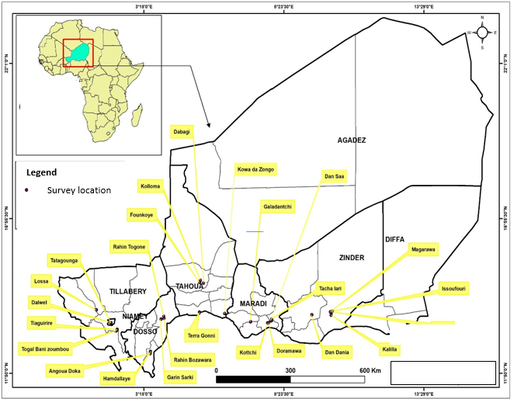
Figure 1: The 25 Striga hermonthica ecotypes collection sites

DNA extraction and quantification

DNA extraction
Genomic DNA was extracted from fresh leaves of 25 individual seedlings randomly selected from each of the Striga ecotypes. The extraction was performed using the protocol described by Dellaporta et al. (1983). Briefly, 75 mg of leaf tissue was frozen in liquid nitrogen, ground to a fine powder, and homogenised in 15 ml of extraction buffer containing 100 mM Tris-HCl (pH 8.0), 50 mM EDTA (pH 8.0), 500 mM NaCl, and 10 mM β-mercaptoethanol. Cell lysis was achieved by adding 10 ml of 20% SDS and incubating the mixture at 65 °C for 10 min. Proteins and polysaccharides were precipitated by adding 5 ml of 5 M potassium acetate, followed by incubation on ice for 20 min and centrifugation at 25,000 × g for 20 min. The supernatant was filtered, and DNA was precipitated with 10 ml of isopropanol at −20 °C for 20 min, then pelleted by centrifugation at 20,000 × g for 15 min. The DNA pellet was resuspended in 0.5 ml of TE buffer (50 mM Tris-HCl, 10 mM EDTA, pH 8.0), clarified by centrifugation, and reprecipitated using 75 µl of 3 M sodium acetate and 500 µl of isopropanol. The final DNA pellet was washed with 80% ethanol, air-dried, and dissolved in 100 µl of TE buffer (10 mM Tris-HCl, 1 mM EDTA, pH 8.0).

DNA quantification
The quality of the crude DNA extracts, in terms of molecular weight and purity, was assessed by electrophoresis on a 1% agarose gel run at 60 mA for 20 min in 1× Tris–borate–EDTA (TBE) buffer (pH 8.0). DNA integrity was evaluated by comparing the intensity of sample bands with those of a Smart Ladder DNA standard. DNA concentration was measured using a multi-sample NanoDrop spectrophotometer. For GBS library construction, 30 µL of high-quality DNA at a concentration of 30–100 ng µL⁻¹, as determined by fluorometric quantification, was used.

Microsatellite markers
Five (5) SSR markers were used in this study (Table 1). These SSR markers have been successfully used in previous studies, demonstrating their reliability and effectiveness (Yoshida et al., 2010; Joel et al., 2018). The primers designed for these markers ranged from 19 to 21 nucleotides in length.
Table 1: microsatellite (SSR ) markers and primers used
SSR ID | Primer name | Repeat unit | Primer Sequences (5'- 3')
ShSSR_ShContig6892_1 | SSR 26 | AG | Forward: CAACAAAACAATGCGTGGA
ShSSR_ShContig6892_1 | SSR 26 | AG | Reverse: GGGTTGATCACTCTGTGCAGT
ShSSR_ShContig9253_1 | SSR 43 | CCG | Forward: CCACTGAAATCACAGGACGA
ShSSR_ShContig9253_1 | SSR 43 | CCG | Reverse: GTGACCGCCGTTACCATTAG
ShSSR_ShContig5198_1 | SSR 53 | ACC | Forward: GCAACTGAATGGAAGGAAGC
ShSSR_ShContig5198_1 | SSR 53 | ACC | Reverse: CTCGGCTGATCCATCTGTTT
ShSSR_ShContig10128_1 | SSR 58 | AAAC | Forward: ACCGAGTGGTTCAAGATTGC
ShSSR_ShContig10128_1 | SSR 58 | AAAC | Reverse: TGCTTCCAATACCGATCACA
ShSSR_ShContig9110_1 | SSR 63 | AAAG | Forward: TTTTGTTGGGGTTTATGTGGA
ShSSR_ShContig9110_1 | SSR 63 | AAAG | Reverse: TGGGAGAAAAATGGAATTAA

PCR amplification
The polymerase chain reaction (PCR) technique was performed to specifically amplify the five microsatellite markers. The PCR reaction was performed following the International Institute of Tropical Agriculture (IITA) protocol, with a total reaction volume of 20 µL (Table 2). The thermocycler settings were as follows: an initial denaturation at 94° C for 3 minutes, followed by 40 cycles. Each cycle consisted of a first step denaturation at 94° C for 1 minute, annealing at 40° C for 1 minute, and extension at 72 °C for 1 minute. A final extension step of 10 minutes at 72 °C was included. The PCR product was stored at -20°C until further analysis.
Table 2 : PCR mixture
Composition | Initial concentration | 1 reaction (20 µl)
Stabilized dNTPs | 10 mM | 0.4 µL
Forward Primer | 10 µM | 0.8 µL
Reverse Primer | 10 µM | 0.8 µL
Reaction Buffer *with MgCl2 | 10X | 2 µL
Genomic DNA | 100 ng/µL | 2 µL
Taq DNA Polymerase | 5 units/µL | 0.2 µL
QSP: Ultrapure H₂O | - | 13.8 µL
Total volume |  | 20 µL
*The reaction buffer consists of: 100 mM Tris-HCl (pH 9.0 at 25°C), 500 mM KCl, 1% Triton X-10, 15 mM MgCl2 And stabilizers.

Gel electrophoresis
PCR products were analysed by electrophoresis on a 3% (w/v) agarose gel. Ten microliters of each PCR product were loaded into individual wells, and 4 µL of a 50-bp DNA size marker (Biomatik) was loaded into one well per gel to estimate the sizes of the amplified fragments. Electrophoresis was carried out at a constant voltage of 130 V for 2 h 40 min. Following electrophoresis, the gel was visualized and the DNA banding patterns were recorded and analysed.

Genetic diversity analysis
Genetic diversity parameters were estimated using several analytical approaches. A genetic distance matrix was computed following Nei (1972). Discriminant Factor Analysis (DFA) was then performed on the standardised genetic distance data using GenAlEx software to visualise genetic differentiation among populations. In addition, a dendrogram was generated using the Unweighted Pair Group Method with Arithmetic Mean (UPGMA), based on Nei’s genetic distance, to assess genetic relationships and similarity among populations. All analyses were conducted using GenAlEx version 6.51b2.xlam.
RESULTS

Genetic diversity per region
Allelic diversity and polymorphism rate
The number of different alleles (Na) showed marked variation among genotypes across regions, with an overall mean of 2.28 alleles per locus across the five regions. The average proportion of polymorphic loci (P) across all regions was 88%. Genotypes from the Dosso, Tahoua, and Zinder regions exhibited the highest level of polymorphism, with 100% polymorphic loci, whereas the lowest proportion of polymorphic loci (60%) was observed in genotypes from the Tillabéry region (Table 3).

Table 3: Allelic diversity and polymorphism rate per region
Regions | N | Na | P
Dosso | 5.000 | 2.600 | 100.00%
Maradi | 5.000 | 2.000 | 80.00%
Tahoua | 5.000 | 2.200 | 100.00%
Tillabéry | 5.000 | 1.800 | 60.00%
Zinder | 5.000 | 2.800 | 100.00%
Average | 5.000 | 2.280 | 88.00%
Number of samples (N), Number of different alleles (Na), Proportion of polymorphic loci (P)
Expected and observed heterozygosity
Observed heterozygosity (Ho) and expected heterozygosity (He) were estimated for genotypes from the five regions under the assumption of Hardy-Weinberg equilibrium. All genotypes from the five regions displayed significant heterozygosity excess (Ho > He). Expected heterozygosity ranged from 0.240 (Tillabéry) to 0.468 (Zinder), whereas observed heterozygosity ranged from 0.360 (Tillabéry) to 0.730 (Zinder). Across the five regions, the mean Ho and He were 0.530 and 0.344, respectively (Figure 2).
Figure 2: Expected (He) and observed heterozygosity (Ho) across regions

Inbreeding coefficients
The inbreeding coefficient (F) per population, averaged across loci, varied among the regions. The highest F value was observed in genotypes from the Tahoua region (-0.261), while the lowest was recorded in genotypes from the Maradi region (-0.604). The overall mean inbreeding coefficient was -0.442, indicating an overall excess of heterozygotes across the populations (Figure 3).
Figure 3: Inbreeding coefficients across genotypes from the five regions

Genetic diversity per locus
Total genetic diversity
The total number of alleles per locus (Na) ranged from 1.8 at locus SSR 53 to 2.8 at locus SSR 26, with an overall average of 2.28 alleles per locus across the population. The total polymorphism rate (P) for the population was 100%. Among the polymorphic loci, SSR 58 exhibited the highest expected heterozygosity (He = 0.524) and the highest observed heterozygosity (Ho = 0.920). Across all five loci, the mean expected heterozygosity was 0.344, while the mean observed heterozygosity was 0.530. The highest locus-specific inbreeding coefficient (F) was observed at SSR 53 (–0.143), and the lowest at SSR 63 (–0.757), resulting in an overall average F of –0.442 (Table 4).

Table 4: Variation of genetic parameters across loci
Locus | Na | NAL | P | Ho | He | F
SSR 26 | 2.600 | 5 | 100 | 0.360 | 0.292 | -0.178
SSR 43 | 2.200 | 4 | 100 | 0.320 | 0.256 | -0.208
SSR 53 | 1.800 | 4 | 100 | 0.170 | 0.148 | -0.143
SSR 58 | 2.400 | 3 | 100 | 0.920 | 0.524 | -0.756
SSR 63 | 2.400 | 4 | 100 | 0.880 | 0.500 | -0.757
Moyenne | 2.280 | 4 | 100 | 0.530 | 0.344 | -0.442
N: Number of individuals sampled per locus; Na: Number of different alleles; NAL: Total number of alleles per polymorphic locus; P: Polymorphism rate; He: Expected heterozygosity; Ho: Observed heterozygosity; F: Overall inbreeding coefficient
Allele frequencies
Allele frequencies for each SSR marker locus are presented in Table 6. The number of alleles per locus ranged from 3 (SSR 58) to 5 (SSR 26). Across loci and ecotypes, allele frequencies varied from 0.1 (for rare alleles) to 1.0 (for fixed alleles). The allele frequencies of the five SSR loci across the five regions show both shared and region-specific patterns. Two region-specific alleles were identified: allele 230 in genotypes from the Dosso region and allele 500 in genotypes from Tahoua (Table 5).
Table 5: Allele frequencies per locus and region
Locus | Allèle/N | Dosso | Maradi | Tahoua | Tillabéry | Zinder
SSR 26 | N | 5 | 5 | 5 | 5 | 5
 | 125 | 0,000 | 0,000 | 0,000 | 0,000 | 0,200
 | 230 | 0,100 | 0,000 | 0,000 | 0,000 | 0,000
 | 290 | 0,100 | 0,100 | 0,100 | 0,000 | 0,100
 | 300 | 0,800 | 0,900 | 0,900 | 0,900 | 0,600
 | 425 | 0,000 | 0,000 | 0,000 | 0,100 | 0,100
SSR 43 | N | 5 | 5 | 5 | 5 | 5
 | 125 | 0,000 | 0,100 | 0,000 | 0,000 | 0,000
 | 250 | 0,100 | 0,200 | 0,100 | 0,000 | 0,200
 | 290 | 0,000 | 0,000 | 0,000 | 0,000 | 0,100
 | 300 | 0,900 | 0,700 | 0,900 | 1,000 | 0,700
SSR 53 | N | 5 | 5 | 5 | 5 | 5
 | 190 | 0,000 | 0,000 | 0,000 | 0,000 | 0,125
 | 200 | 0,100 | 1,000 | 0,900 | 1,000 | 0,875
 | 290 | 0,100 | 0,000 | 0,000 | 0,000 | 0,000
 | 300 | 0,800 | 0,000 | 0,100 | 0,000 | 0,000
SSR 58 | N | 5 | 5 | 5 | 5 | 5
 | 110 | 0,500 | 0,500 | 0,400 | 0,400 | 0,500
 | 190 | 0,100 | 0,000 | 0,000 | 0,000 | 0,100
 | 300 | 0,400 | 0,500 | 0,600 | 0,600 | 0,400
SSR 63 | N | 5 | 5 | 5 | 5 | 5
 | 110 | 0,500 | 0,500 | 0,200 | 0,300 | 0,500
 | 250 | 0,000 | 0,000 | 0,000 | 0,100 | 0,000
 | 300 | 0,500 | 0,500 | 0,700 | 0,600 | 0,500
 | 500 | 0,000 | 0,000 | 0,100 | 0,000 | 0,000
N: Number of individuals sampled per locus
Wright’s fixation indices (F-statistics) per locus
The average values of Wright’s fixation indices, calculated across all loci for the different genotypes, were Fis = -0.430, Fit = -0.226, and Fst = 0.167 (Table 6). Locus-specific Fis values ranged from -0.760 at SSR 63 to -0.151 at SSR 53, while Fit values varied from -0.714 at SSR 58 to 0.535 at SSR 53. Genetic differentiation (Fst) was low for SSR 58 (0.024) and SSR 63 (0.049), moderate for SSR 26 (0.081) and SSR 43 (0.083), and markedly high at SSR 53 (0.596), indicating substantial locus-specific differentiation among the populations (Table 6).
Table 6: Wright's fixation indices for the 5 loci
Locus | Fis | Fit | Fst | Level of Differentiation
SSR 26 | -0.233 | -0.134 | 0.081 | 0.05 < Fst < 0.15: moderate differentiation
SSR 43 | -0.250 | -0.146 | 0.083 | (moderate differentiation implied, as per SSR 26 range)
SSR 53 | -0.151 | 0.535 | 0.596 | Fst > 0.25: very significant differentiation
SSR 58 | -0.756 | -0.714 | 0.024 | 0 < Fst < 0.05: low differentiation
SSR 63 | -0.760 | -0.674 | 0.049 | (low differentiation implied, as per SSR 58 range)
Mean | -0.430 | -0.226 | 0.167 | 0.15 < Fst < 0.25: significant differentiation
SE | 0.135 | 0.227 | 0.108
Genetic distances across populations
The genetic distance matrix (Table 7) based on the five SSR markers revealed variation in genetic differentiation among ecotypes from the five regions. Pairwise genetic distances ranged from 0.013 between Tahoua and Tillabéry, indicating very close genetic similarity, to 0.284 between Dosso and Zinder, reflecting the greatest genetic divergence among the populations.
Table 7: Genetic distances Matrix between Striga hermonthica populations
Dosso | Maradi | Tahoua | Tillabéry | Zinder
0.000 |  |  |  |  | Dosso
0.277 | 0.000 |  |  |  | Maradi
0.229 | 0.035 | 0.000 |  |  | Tahoua
0.267 | 0.032 | 0.013 | 0.000 |  | Tillabéry
0.284 | 0.029 | 0.062 | 0.053 | 0.000 | Zinder

Genetic Structure of the studied genotypes
Discriminant Factor Analysis (DFA)
The DFA scatterplot based on the first two axes reveals clear genetic structuring among the five regional populations. Axis 1 primarily separates the Dosso genotypes (ED01-ED05) from the other populations, with the exception of one Zinder genotype (EZ23) clustering near Dosso, indicating some genetic similarity. Axis 2 highlights within-population variation, particularly among Dosso genotypes, suggesting the presence of distinct sub-populations. Genotypes from Maradi and Zinder show moderate differentiation along both axes, while those from Tahoua and Tillabéry form tighter clusters, indicating lower intra-population variability (Figure 4).
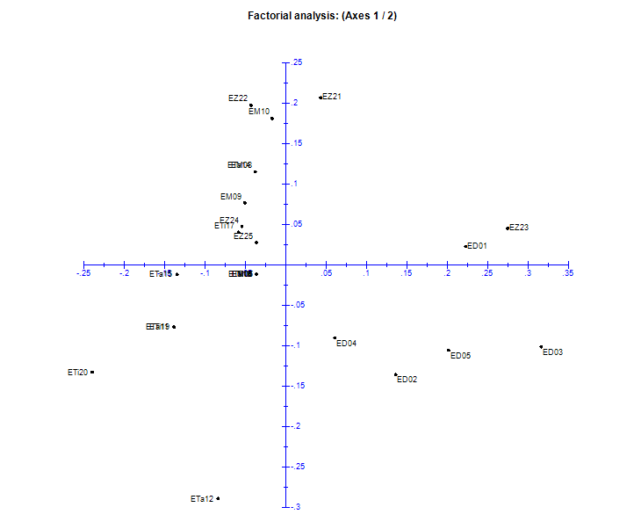
Figure 4: Projection of the 25 Striga genotypes in the 1-2 axes of the DFA
Phylogenetic relationships
To assess the phylogenetic relationships among the 25 Striga genotypes, an unweighted pair group method with arithmetic mean (UPGMA) hierarchical clustering was performed between the different pairs of genotypes, based on Nei's (1978) genetic distances. The dendrogram reveals distinct patterns of clustering among the 25 genotypes from the five regions (Figure 5). Overall, the genotypes were grouped into two major clusters, indicating substantial genetic diversity across regions. Genotypes from Dosso (ED) clustered closely together, reflecting high genetic similarity within this region. In contrast, genotypes from Maradi (EM) and Tahoua (ETa) were interspersed with those from Tillabery (ETi) and Zinder (EZ), suggesting shared alleles or gene flow among these regions. Some genotypes, such as EZ23 (Zinder), EM09 (Maradi), and ETa15 (Tahoua), were more genetically distant from all other genotypes, indicating the presence of unique alleles. Other clusters included genotypes from multiple regions, highlighting inter-regional genetic similarity, likely due to germplasm exchange or shared ancestry (ETi16; EMO7; EM06; EZ24; ETi17; and EZ25), (ETi18 and Eta13), (EZ22; EM10; EM08 and ETa11), and (ETi19 and Eta11).
The classification, based on the matrix of genetic distances computed between pairs of populations from each region, distinctly delineates three groups. Genotypes from the Tahoua and Tillabéry regions cluster into the first group, those from Maradi and Zinder form the second, and genotypes from Dosso constitute the third group (Figure 6).
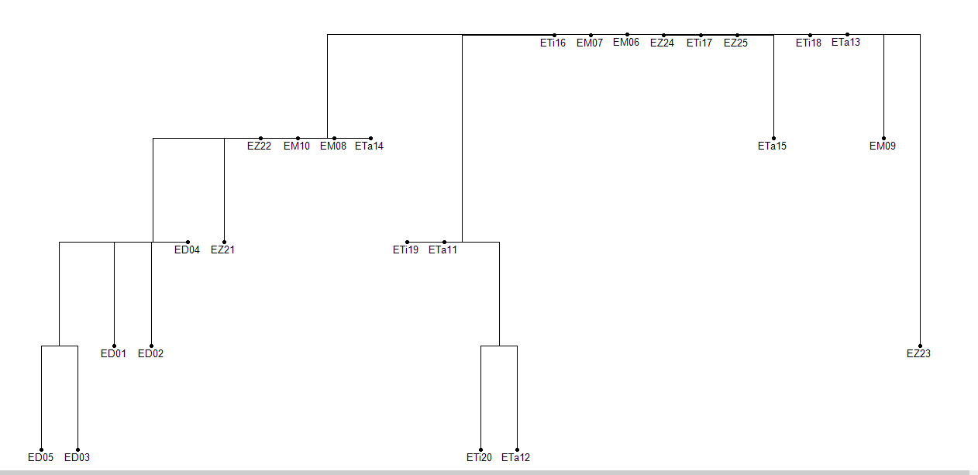
Figure 5: Dendrogram showing the phylogenetic relationships among the 25 Striga genotypes collected in the five regions of Niger
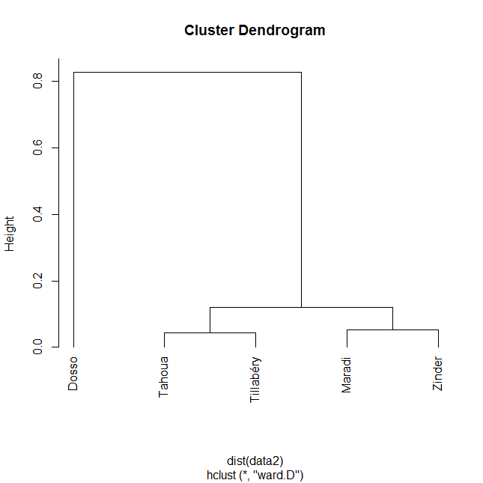
Figure 6: Dendrogram showing the phylogenetic relationships among Striga populations from the five regions of Niger

DISCUSSION
In this study, populations selected from five regions of Niger were characterised using microsatellite markers to describe the genetic diversity and structure of S.hermonthica. The results of this study reveal high polymorphism rates ranging from 60% to 100% for the different Striga hermonthica genotypes examined. This indicates substantial genetic diversity within the species, reflecting considerable variability among the genotypes analysed. These results exceed those reported by Welsd et al. (2011) for 12 Ethiopian populations of the same species (53.2% to 76.4%) using AFLP markers. The discrepancy may be attributed to the choice of molecular markers, as AFLP markers are generally less informative than SSR markers for detecting genetic diversity. The inbreeding coefficient (F) quantifies the deviation between observed and expected heterozygosity under the assumption of random mating. The F results in this study indicate an excess of heterozygosity within the populations. These findings are consistent with previous studies reporting deviations from the Hardy–Weinberg equilibrium and high genetic variability in Striga hermonthica populations. For instance, Estep et al. (2011) observed Hardy-Weinberg disequilibrium in 63% of the populations analysed in Mali, while Bozkurt et al. (2015) reported substantial genetic diversity among East and West African S. hermonthica populations using microsatellite markers, along with marked differences in virulence on contrasting sorghum cultivars. Similarly, Nnunnachukwu et al. (2017) revealed pronounced genetic diversity and clear population structuring in S. hermonthica populations from Kenya and Nigeria based on SNP markers. This excess of heterozygosity is likely due to negative assortative mating, which is expected in a strictly allogamous species like S. hermonthica (Safa et al., 1984). Allele frequency analysis revealed variable allelic diversity across SSR markers. Three region-specific alleles were detected in this study, which is considerably fewer than the 50 specific alleles reported by Estep et al. (2011). This difference likely reflects methodological factors, as Estep et al. analysed a larger sample (11 populations, approximately 250 individuals) using a greater number of microsatellite markers (12), thereby capturing more genetic diversity.
Region-specific alleles, such as allele 230 in Dosso and allele 500 in Tahoua, suggest a structured genetic population with differentiation among genotypes (Slatkin, 1987). Conversely, allele 300, found at high frequency across multiple loci, may represent an ancestral or neutral allele that has increased in frequency through genetic drift (Wright, 1965). These patterns may also be influenced by the limited sample size of this study.
The 100% polymorphism observed across all SSR loci further supports the presence of high genetic diversity. Such polymorphism is consistent with findings from natural populations, which often exhibit extensive genetic variation that allows adaptation to changing environments (Leffler et al., 2012). Notably, SSR locus 58 displayed particularly high observed (Ho = 0.920) and expected (He = 0.524) heterozygosity, suggesting high allelic diversity and possibly a recent demographic expansion. The overall observed heterozygosity (Ho = 0.530) among the five S. hermonthica genotypes from different regions of Niger aligns closely with values reported by Joel et al. (2018) for seven populations in Kenya and Uganda (Ho = 0.529). The preservation of high genetic diversity across a broad geographic area underscores the species’ adaptive potential to diverse environmental conditions. The lower expected heterozygosity in this study (He = 0.344) compared to Joel et al. (He = 0.585) likely reflects differences in allelic richness, as Joel et al. reported 3-14 alleles per locus, with an average of 7.8. For all loci analysed, observed heterozygosity exceeded expected heterozygosity, indicating Hardy-Weinberg disequilibrium. This pattern could result from non-random mating, population structure, or technical genotyping errors (Waples and Gaggiotti, 2006). In line with this, F values across loci suggest a complex population structure, with the strongest excess of heterozygotes observed at SSR 53 (F = -0.143).
Clustering analyses, including the dendrogram and discriminant factor analysis (DFA), revealed a clear genetic separation of genotypes from Dosso from those of other regions. This differentiation may be influenced by Dosso’s geographic position at the transition between Sahelian and Sudanian zones, combined with heterogeneous soil conditions and unique domestication histories that promote local adaptation. In contrast, genotypes from Tahoua and Tillabéry, as well as from Maradi and Zinder, showed closer genetic relationships, suggesting higher gene flow among these regions. This pattern may reflect similar agricultural practices, comparable climatic conditions, or historical population movements.
CONCLUSION
This study provides the first molecular assessment of the genetic diversity and population structure of Striga hermonthica in Niger using microsatellite markers. The results reveal a high level of genetic diversity across the 25 genotypes sampled from five major agricultural regions, as evidenced by high polymorphism rates, substantial allelic richness, and an overall excess of heterozygosity. Moderate but significant genetic differentiation among regions indicates that geographic origin plays an important role in structuring S. hermonthica populations in Niger. Clustering analyses consistently distinguished genotypes from the Dosso region from those of the other regions, while closer genetic relationships were observed between Tahoua and Tillabéry, and between Maradi and Zinder. These patterns likely reflect similarities in agro-ecological conditions, cropping systems, and seed or soil-mediated dispersal of the parasite, as well as historical connectivity among farming communities. These findings highlight the need for integrated and region-specific management strategies, including the deployment of locally adapted resistant crop varieties and the incorporation of genetic information into breeding and control programs. Future studies incorporating larger samples and molecular markers will further refine our understanding of Striga population dynamics and support the development of more sustainable and effective control approaches.
REFERENCES
Badu-Apraku, B. (2010). Effects of recurrent selection for grain yield and Striga resistance in an extra-early maize population. Crop Science, 50(5), 1735–1743. https://doi.org/10.2135/cropsci2009.09.0523
Bozkurt, M. L., Muth, P., Parzies, H. K., & Haussmann, B. I. G. (2015). Genetic diversity of East and West African Striga hermonthica populations and virulence effects on a contrasting set of sorghum cultivars. Weed Research, 55(1), 71–81. https://doi.org/10.1111/wre.12117.
Cochrane, V., & Press, M. C. (1997). Geographical distribution and aspects of the ecology of the hemiparasitic angiosperm Striga asiatica (L.) Kuntze: a herbarium study. Journal of Tropical Ecology, 13(3), 371–380. https://doi.org/10.1017/S0266467400010579
De Groote, H., Wangare, L., Kanampiu, F., Odendo, M., Diallo, A., Karaya, H., & Friesen, D. (2008). The potential of a herbicide resistant maize technology for Striga control in Africa. Agricultural Systems, 97(1-2), 83–94. https://doi.org/10.1016/j.agsy.2007.09.003
Dellaporta, S. L., Wood, J., & Hicks, J. B. (1983). A plant DNA minipreparation: Version II. Plant Molecular Biology Reporter, 1(4), 19–21. https://doi.org/10.1007/BF02712670
Ejeta, G. (2007). Breeding for Striga resistance in sorghum: Exploitation of an intricate host–parasite biology. Crop Science, 47(S3), S216–S227. https://doi.org/10.2135/cropsci2007.04.0011IPBS
Estep, M. C., Van Mourik, T. A., & Muth, P. (2011). Genetic diversity of a parasitic weed, Striga hermonthica, on sorghum and pearl millet in Mali. Tropical Plant Biology https://doi.org/10.1007/s12042-011-9073-6
Gethi, J. G., Smith, S. E., Mitchell, S. E., & Kresovich, S. (2005). Genetic diversity of Striga hermonthica and Striga asiatica populations in Kenya. Weed Research, 45(1), 64–73. https://doi.org/10.1111/j.1365-3180.2004.00432.x
Gressel, J., Hanafi, A., Head, G., Marasas, W., Obilana, A. B., Ochanda, J., Souissi, T., & Tzotzos, G. (2004). Major heretofore intractable biotic constraints to African food security that may be amenable to novel biotechnological solutions. Crop Protection, 23(7), 661–689. https://doi.org/10.1016/j.cropro.2003.11.014
Haussmann, B. I. G., Hess, D. E., Welz, H. G., & Geiger, H. H. (2000). Improved methodologies for breeding Striga-resistant sorghums. Field Crops Research, 66(3), 195–211. https://doi.org/10.1016/S0378-4290(00)00076-9
Institut National de la Statistique (INS). (2018). Niger. Retrieved November 17, 2018, from https://www.populationdata.net/pays/niger
Joel, K. A., Runo, S., & Muchugi, A. (2018). Genetic diversity and virulence of Striga hermonthica from Kenya and Uganda on selected sorghum varieties. NUS Bioscience, 10(2), 111–120. https://doi.org/10.13057/nusbiosci/n100208
Welsh, A. B., & Mohamed, K. I. (2011). Genetic diversity of Striga hermonthica populations in Ethiopia: Evaluating the role of geography and host specificity in shaping population structure. International Journal of Plant Sciences, 172(6), 773–782. https://doi.org/10.1086/660104
Leffler, E. M., Bullaughey, K., Matute, D. R., Meyer, W. K., Ségurel, L., Venkat, A., ... & others. (2012). Revisiting an old riddle: What determines genetic diversity levels within species? PLOS Biology, 10(9), e1001388. https://doi.org/10.1371/journal.pbio.1001388
Nei, M. (1973). Analysis of gene diversity in subdivided populations. Proceedings of the National Academy of Sciences, 70(12), 3321–3323. https://doi.org/10.1073/pnas.70.12.3321
Nei, M. (1978). Estimation of average heterozygosity and genetic distance from a small number of individuals. Genetics, 89(3), 583–590. https://doi.org/10.1093/genetics/89.3.583
Parker, C. (2012). Parasitic weeds: A world challenge. Weed Science, 60(2), 269–276. https://doi.org/10.1614/WS-D-11-00068.1
Pennisi, E. (2010). Armed and dangerous. Science, 327(5967), 804–805. https://doi.org/10.1126/science.327.5967.804
Ransom, J. K. (2000). Long‐term approaches for the control of Striga in cereals: Field management options. Crop Protection, 19(7), 759–763. https://doi.org/10.1016/S0261-2194(00)00101-0
Rispail, N., Dita, M. A., González‐Verdejo, C., Pérez‐De‐Luque, A., Castillejo, M. A., Prats, E., ... & Rubiales, D. (2007). Plant resistance to parasitic plants: Molecular approaches to an old foe: Research review. New Phytologist, 173(4), 703–712. https://doi.org/10.1111/j.1469-8137.2007.01980.x
Runo, S., Macharia, S., Alakonya, A., Machuka, S., Sinha, N., & Scholes, J. (2012). Striga parasitizes transgenic hairy roots of Zea mays and provides a tool for studying plant-plant interactions. Plant Methods, 8(1), 20. https://doi.org/10.1186/1746-4811-8-20
Safa, S. B., Jones, B. M. G., & Musselman, L. J. (1984). Mechanisms Favouring Out Breeding In Striga Hermonthica (Scrophulariaceae). New Phytologist, 96(2), 299–305. https://doi.org/10.1111/j.1469-8137.1984.tb03567.x
Slatkin, M. (1987). Gene flow and the geographic structure of natural populations. Science, 236(4803), 787–792. https://doi.org/10.1126/science.3576198
Teka, H. B. (2014). Advance research on Striga control: A review. African Journal of Plant Science, 8(11), 492–506. https://doi.org/10.5897/AJPS2014.1186
Unachukwu, N. N., Menkir, A., Rabbi, I. Y., Oluoch, M., Muranaka, S., Elzein, A., Odhiambo, G., Farombi, E. O., & Gedil, M. (2017). Genetic diversity and population structure of Striga hermonthica populations from Kenya and Nigeria. Weed Research, 55(1), 71–81. https://doi.org/10.1111/wre.12260
Waples, R. S., & Gaggiotti, O. (2006). What is a population? An empirical evaluation of some genetic methods for identifying the number of gene pools and their degree of connectivity. Molecular Ecology, 15(6), 1419–1439. https://doi.org/10.1111/j.1365-294X.2006.02890.x
Welsh, A. B., & Mohamed, K. I. (2011). Genetic diversity of Striga hermonthica populations in Ethiopia: Evaluating the role of geography and host specificity in shaping population structure. International Journal of Plant Sciences, 172(6), 773–782. https://doi.org/10.1086/660104
Westwood, J. H., dePamphilis, C. W., Das, M., Fernández‐Aparicio, M., Honaas, L. A., Timko, M. P., ... & Yoder, J. I. (2012). The parasitic plant genome project: New tools for understanding the biology of Orobanche and Striga. Weed Science, 60(2), 295–306. https://doi.org/10.1614/WS-D-11-00113.1
Wright, S. (1965). The interpretation of population structure by F-statistics with special regard to systems of mating. Evolution, 19(3), 395–420. https://doi.org/10.1111/j.1558-5646.1965.tb01731.x
Wright, S. (1978). Evolution and the genetics of populations, Volume 4: Variability within and among natural populations. University of Chicago Press. https://press.uchicago.edu/ucp/books/book/chicago/E/bo5950004.html
Yoshida, S., Ishida, J. K., Kamal, N. M., Ali, A. M., Namba, S., & Shirasu, K. (2010). A full-length enriched cDNA library and expressed sequence tag analysis of the parasitic weed, Striga hermonthica. BMC Plant Biology. https://doi.org/10.1186/1471-2229-10-55
Salamatou, S. S., Maina, F., Mohammed, R., Amadou, H. I., & Bakasso, Y. (2025). Morphological Diversity of 23 Ecotypes of Striga hermonthica Collected in the 5 Regions of Niger. Journal of Experimental Agriculture International, 47(9), 222–233. https://doi.org/10.9734/jeai/2025/v47i93743
Mitiku, G., Rybka, D., Klein‐Gunnewiek, P., Tessema, T., Raaijmakers, J. M., & Etalo, D. W. (2022). Molecular detection and quantification of the Striga seedbank in agricultural soils. Weed Research, 62(3), 181-191.
Ahmed, A., Elsafy, M., Zhourghane, A., Abdalla, A. A., Abreha, K. B., Geleta, M., ... & Abdelhalim, T. S. (2025). Exploring the genetic variability of sudanese wild sorghum (sorghum bicolor (L.) moench) germplasm for post-attachment striga hermonthica resistance mechanisms using single sequence repeat (SSR) primers. Genetic Resources and Crop Evolution, 72(4), 4583-4595.

