Profile of Temperature and Relative Humidity and Measure of Evapotranspiration in Summer Green Gram (Vigna radiata L. Wilczek.) Crop Under Semi-Arid Region of Haryana, India

ABSTRACT
A field experiment was conducted at Research Farm, Dept of Agril Meteorology, CCS HAU, Hisar Haryana, India during the summer season in the 2020 and 2021. Experimental designed laid out with factorial randomized design, as main plot treatment: date of sowing i.e. D₁-1st second fortnight of March with sub plot treatment viz., V₁: MH 421, V₂: MH 318, V₃; MH 1-25. Temperature and Humidity in the atmosphere is of great biological importance. Measurements relative humidity and temperature were made at 9:00, 12:0 & 16:00 hourly intervals throughout the observation day with the help of Psychrometric. The humidity profiles indicated that the relative humidity was higher inside the crop canopy than above the canopy in all the treatments i.e. the relative humidity profiles were lapse inside the crop canopy throughout the day while iso-humic at morning hours at different growth stage during crop season 2020 and 2021. Humidity profiles were observed lapse in NW-SE direction within crop canopy during the both crop season. The temperature profiles indicated that the temperature inside the canopy was lower than recorded at top of the canopy in all the treatments i.e. temperature profiles were inverse throughout the day within the canopy. Over the top of the crop canopy the temperature profile was lapse. Temperature profiles were observed inverse in NW-SE direction within crop canopyduring the both crop season. The evapotranspiration observed high in MH 318, East-West and the lowest was observed MH 421, NW-SE during both the crop seasons. As per study, it was observed that suitable sowing direction is NW-SE with MH 421 varieties.
Keywords: Green gram, profile, relative humidity and temperature, iso-humic and phenology, evapotranspiration

INTRODUCTION:
Mung bean (Vigna radiata L. Wilczek) is one of the important and extensively grown pulse crops. The importance of growing the crop is associated to its high protein content and other essential minerals, especially micronutrients. Furthermore, this crop has the ability to fix atmospheric nitrogen (Delfin et al., 2008) and short duration maturity period which made it preferable crop for resource poor farmers in dryland areas of the tropics and subtropics. Hayat et al., (2008) reported that N2-fixation under normal soil fertility condition by mung bean valued 47 kg ha-1 . Its seed contains 22.5% protein, 9.4% moisture, 2.05% fat, 6.95% fiber and 343.5 kcal/100g energy (Abas and Shah, 2007). Kabir and Sarkar (2008) reported that highest seed yield of mung bean was obtained maintaining 30 cm × 10 cm spacing between rows and plants, respectively.
It is grown throughout Southern Asia including India, Pakistan, Bangladesh, Srilanka, China etc. In India green gram is mostly grown in Andhra Pradesh, Maharashtra, Orissa, Rajasthan, Gujarat, Madhya Pradesh and Utter Pradesh etc. Pulses are grown in India on 29.03 million hectares of land with an annual production of 23.40 million tons in the year 2018-19 and the productivity of pulses 806 kg/ha (Anonymous, 2019). Green gram requires different amount of Growing Degree Days, Photothermal unit, Heliothermal unit and Heat use efficiency for growth and developmental stages. The GDD is used to quantify effect of temperature and described the timing of different biological process (McMaster and Wilhelm 1997, Qiao-yan et al. 2012). Yu li et al., (2013) revealed the effect of row spacing and row direction on microclimate of Maize grown under NS and EW directions. The maize plant row spacing increasing decreased the accumulated temperature and daily average relative humidity in EW was higher than NS planting pattern.
Microclimate is the climate which is usually within the reach of crop canopy. Microclimate of a crop field can be manipulated for the growth and yield of crops (Rosenberg et al., 1983).Light is an important factor which plays a great role in crop production (Saitheja et al, 2022). The arrangement, shape and number of leaves in plant canopy affect the penetration, interception distribution and reflection of light (Blad and Lemur, 1979). Singh et al., (2020) showed that all the growth parameter, yield attributes and yield was significantly higher in North South sowing direction as compared to East-West. PAR absorption by canopy results in increases plant biomass and grain weight (Kooman and Haverkort, 1995; Shaykewich et al., 1998). The main objective of finding was to profile of relative humidity and measure evapotranspiration in summer green gram (Vigna radiata L. wilczek.) crop under semi arid region.
MATERIALS AND METHODS:
Field experiment was conducted during the summer seasons of 2020 and 2021 in the experimental farm of Agromet farm, CCS HAU, Hisar (29⁰10 ‘N latitude, 75⁰46’ E longitude and 215 m above sea level). The treatment comprised main plot contain date of sowing second fortnight of March and subplot contained three varieties and three row direction under factorial randomized block design. Soil of experiment site (0-15 cm) was sandy loam in texture (56.7% sand, 25.8% silt, 17.8% clay). Micrometeorological observation was computed at different phenophases of crop using Psychrometric instrument.
Weather condition prevailed during crop growing season
Hisar station is situated in the tract of semi-arid climate with hot and dry summers and extremely cold winters. The mean monthly maximum temperature during summer months of May and June may go up to 46⁰C or beyond, while minimum temperature during the month of January and February sometimes falls as low as below 0 ⁰C. the average annual rainfall in the region is around 450 mm which is mainly received during southwest monsoon season with few light showers during winter and spring seasons due to westerly depressions. The mean weekly meteorological data of the crop season from the months of March to May for the years 2020 and 2021 were taken from Agrometeorological observatory situated at Research Area of Department of Agricultural Meteorology near the experimental field. (Fig. 1)
A perusal of meteorological data indicates that the mean weekly maximum and minimum temperature fluctuated from 24.9 ⁰C to 45.0 ⁰C and 11.0 to 25.7 ⁰C, respectively during the crop growing season of 2020. The corresponding values of maximum and minimum temperatures fluctuated from 25.8 to 42.6 ⁰C and 10.0 to 28.3 ⁰C, respectively during the crop season of 2021. The total rainfall was recorded to be 52.8 mm and 33.3 mm during the summer seasons of two consecutive years. The maximum temperature exceeded normal temperature in 4.1 and 1.4 ⁰C during 2020 and 2021 respectively.

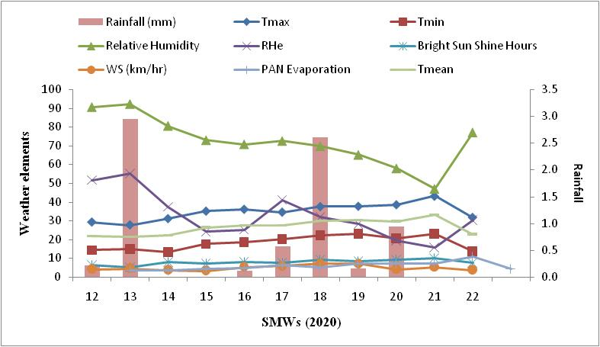
(a)
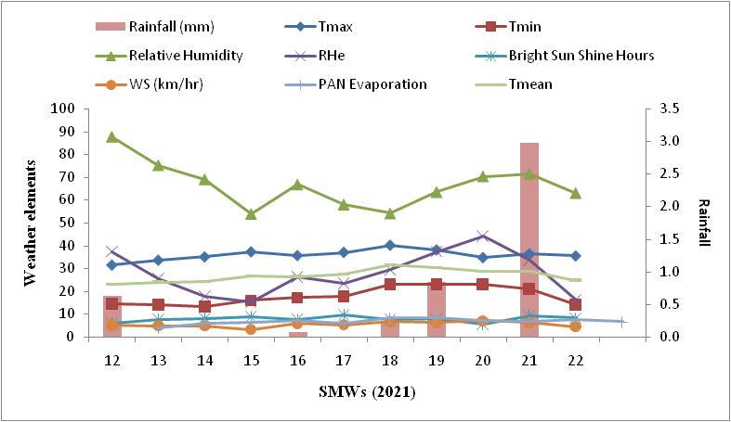
(b)
Fig.1 (a,b): Mean weekly meteorological data during crop season of 2020 and 2021.

Temperature and humidity profile studies
The dry and wet bulb temperatures were measured at bottom, middle and top of the canopy at flower initiation, pod initiation and physiological maturity at 09:00, 12:00 and 15:00 hours with the help of Assmann Psychrometer. Calculation was done with the help of Psychrometric tables. Temperature and relative humidity profiles were drawn at flower initiation, pod initiation and physiological maturity.

Evapotranspiration
It was computed using remote sensing method ofModifying the Monteith surface energy balance equation Bartholic et al., (1970) developed for ET estimation:
ETd = (Rn-G) / [1 +γ (Ta - Tc) / (ea (Ta)-es (Tc)}] .
Where,
ETd = Daily ET, mm
γ = Psychrometric constant, mm of Hg °C-1
Ta = Air temperature above the canopy, °C
Tc = Canopy temperature, °C
ea (Ta), es (Tc) = Saturation vapour pressure (mm of Hg) at Ta and Tc
respectively.

3. RESULTS AND DISCUSSION:
Temperature and humidity profile:
The temperature profiles indicated that the temperature inside the canopy was lower than that recorded at top of the canopy in all the treatments i.e. temperature profiles were inverse throughout the day within the canopy. Over the top of the crop canopy the temperature profile was lapse. The maximum temperature was observed at noon hours and the minimum was at morning which was mostly iso-humic with height al all growth stages during both crop seasons due to radiation penetration was deep inside the canopy. The present study was confirmation with those reported by Singh et al., (2005) in cotton crop and by Bose (2008) in Pearlmillet.
The maximum value of temperature profile was recorded at physiological maturity during both crop season because of less ground area covered by the crop whereas, the higher temperature was recorded during crop season 2021 as compared to 2020 at all phenophases.
The humidity profile was recorded higher inside the crop canopy than above the canopy in all the treatments i.e. the relative humidity profile were lapse inside the crop canopy throughout the day while profile were iso-humic at 9:00 hour at different growth stages during both crop seasons. The relative humidity was observed decrease with height under all treatments at all phenophases. The present study was confirmation with those reported by Singh et al., (2005) in cotton crop and by Bose (2008) in Pearlmillet.
The highest humidity was measured at pod to physiological growth interval during the both crop seasons among different varieties and row directions. The maximum relative humidity during the day was observed at 9:00 hr. due to higher in air temperature, the relative humidity was lowest at noon time due to more ET and turbulence occurred within the crop canopy during noon hour which result in more exchange of water vapour with upper air layers lying over the canopy.
The MH 421 variety and NW-SE direction showed better phenology, growth, development and yield and yield attributes as compared to other treatments during both the crop season. This might be due to prevalence of favorable effect of temperature and humidity within the canopy.

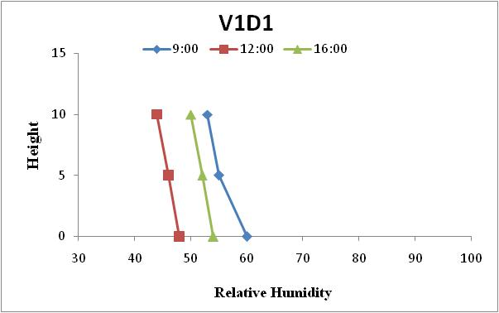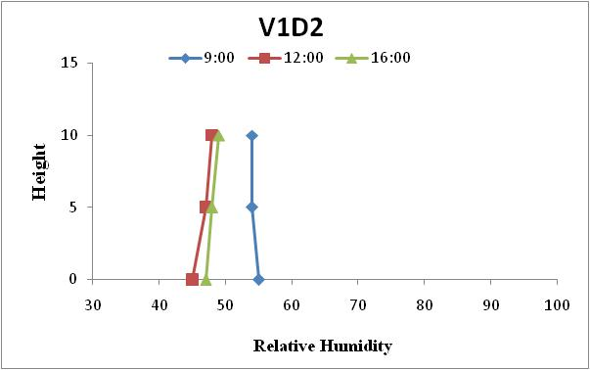
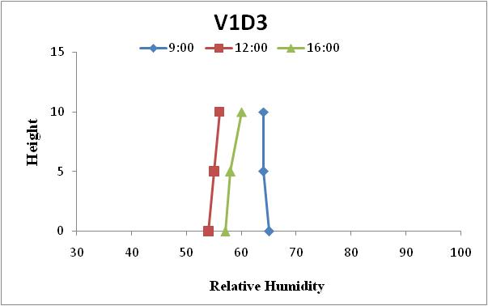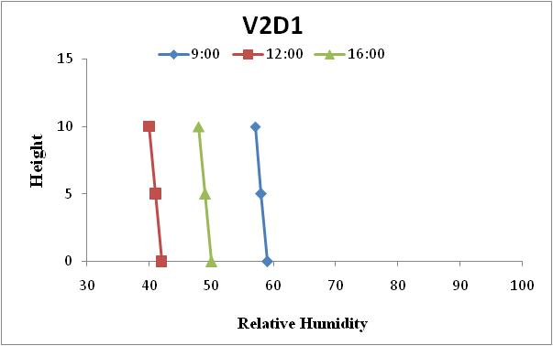
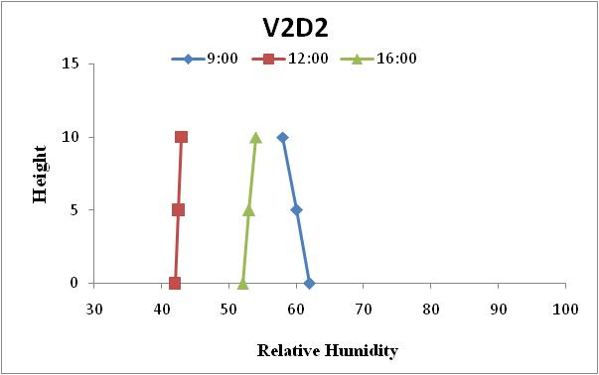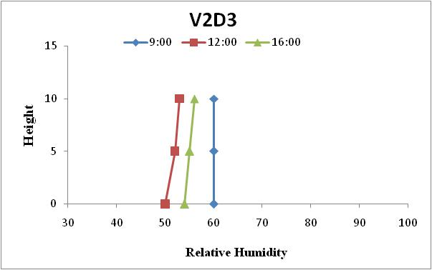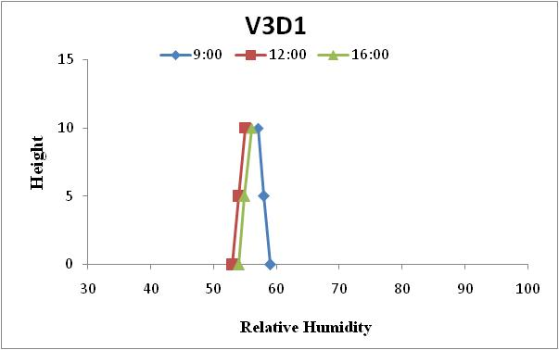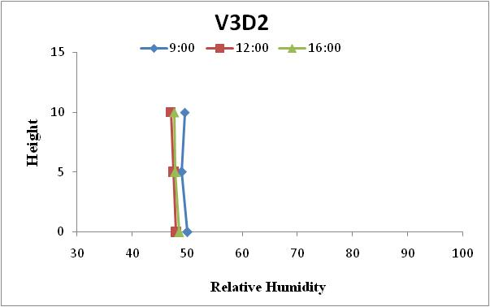
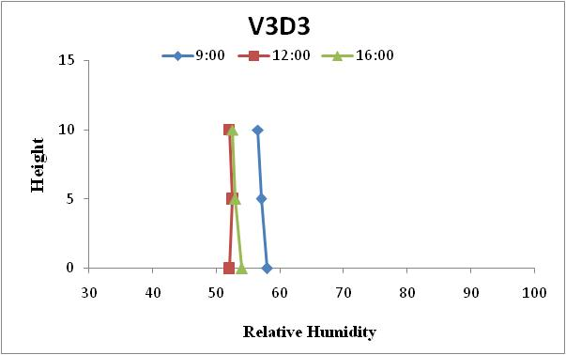
Fig: 2. Relative Humidity profile at flowering stage under different row directions and varieties of green gram during 2021.
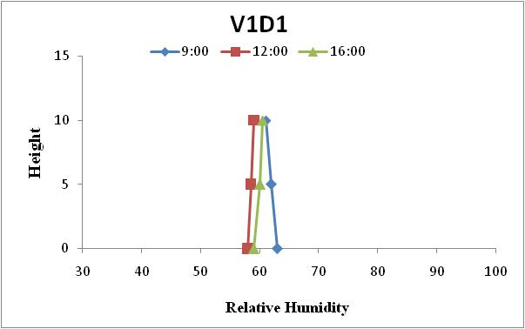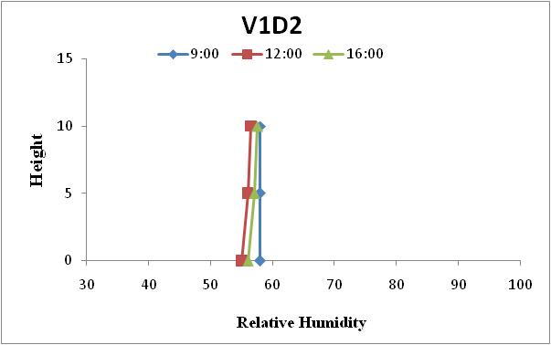
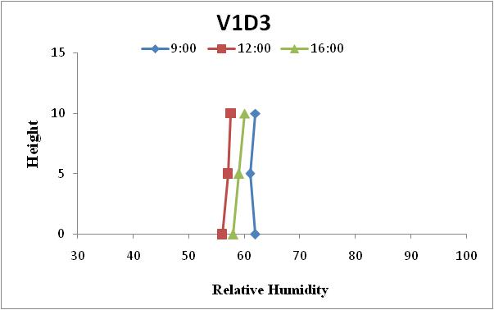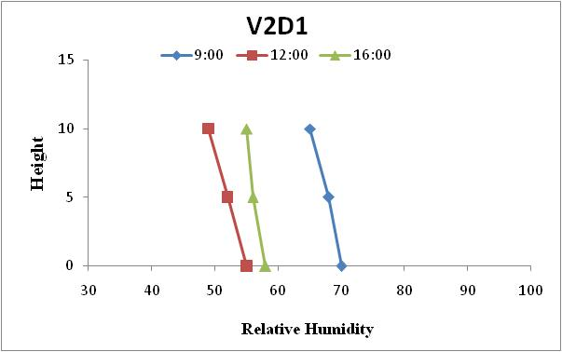
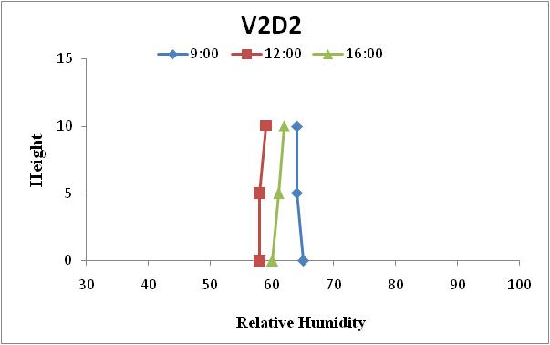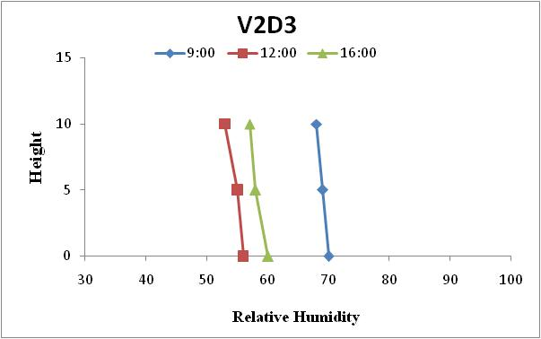
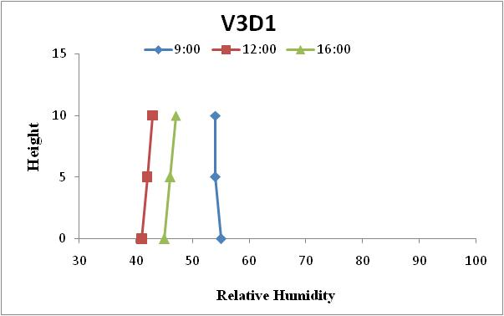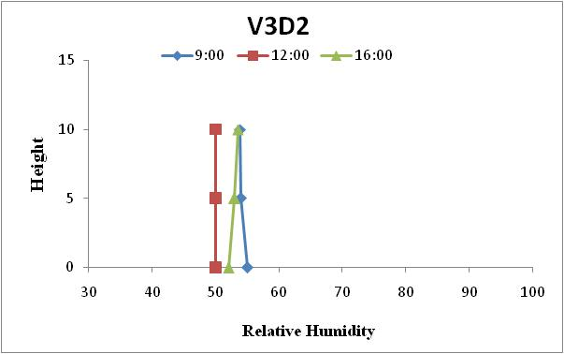
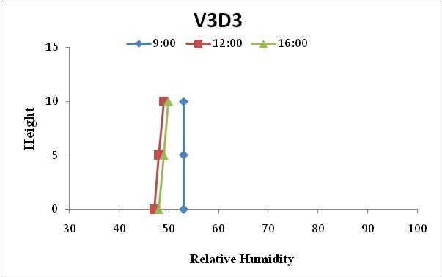
Fig: 3 Relative Humidity profile at flowering stage under different row directions and varieties of green gram during 2020.
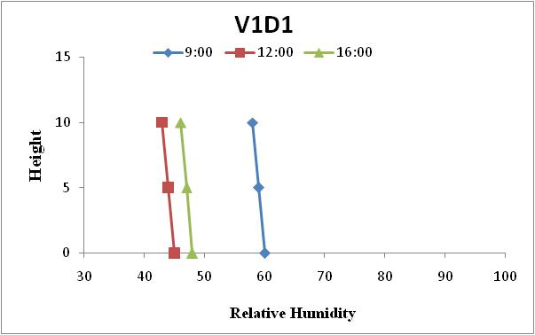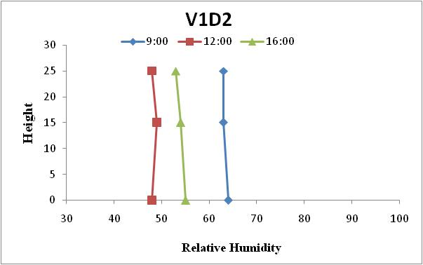
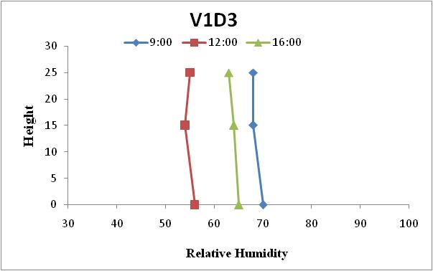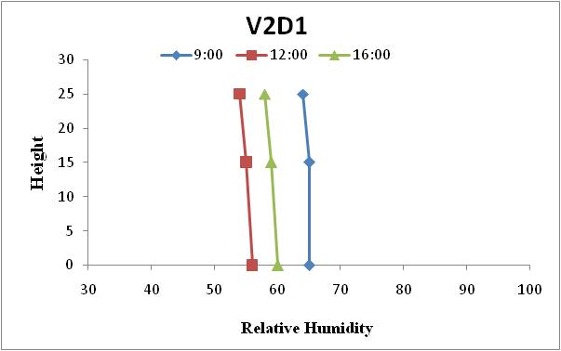
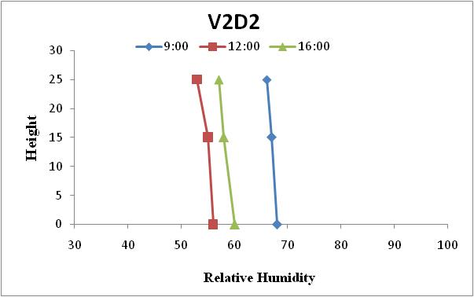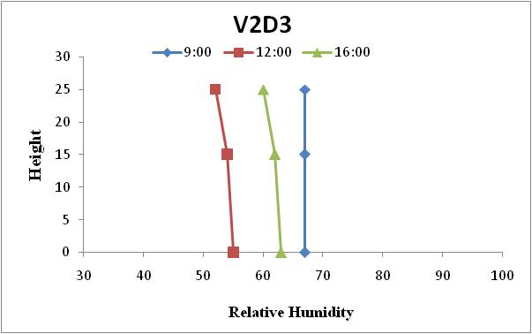
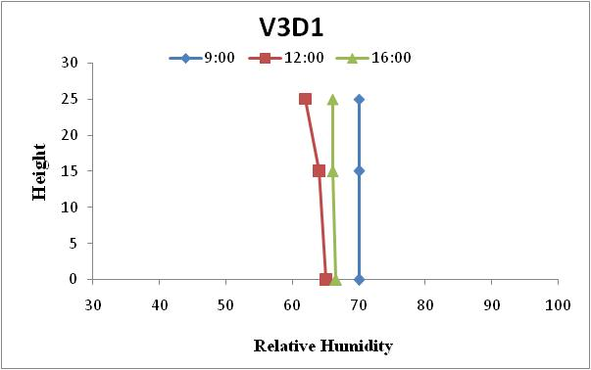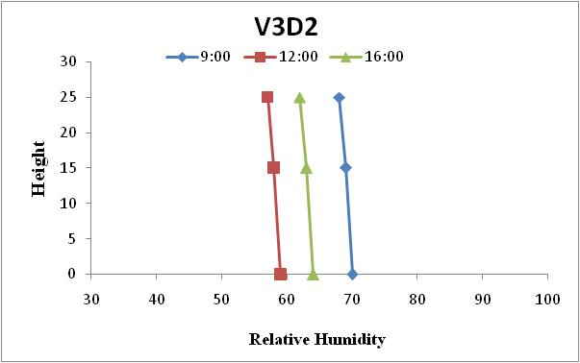

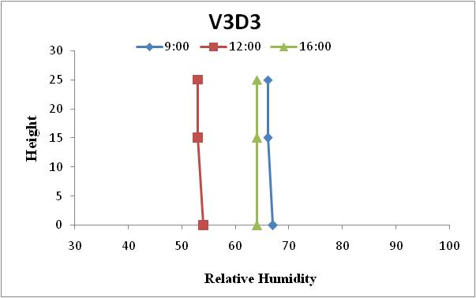
Fig: 4 Relative Humidity profile at pod initiation stage under different row directions and varieties of green gram during 2020.
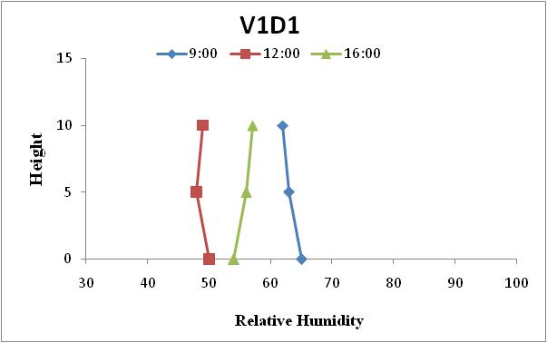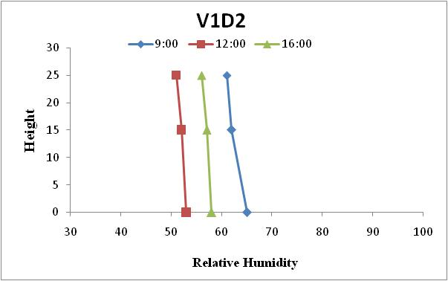
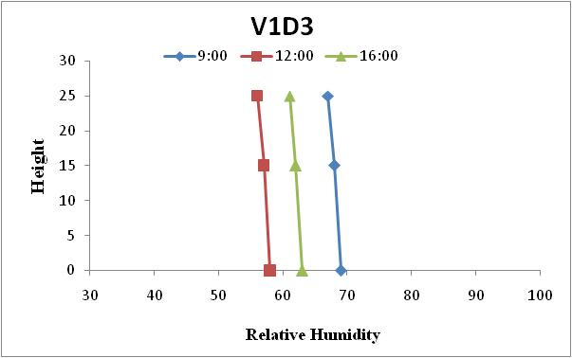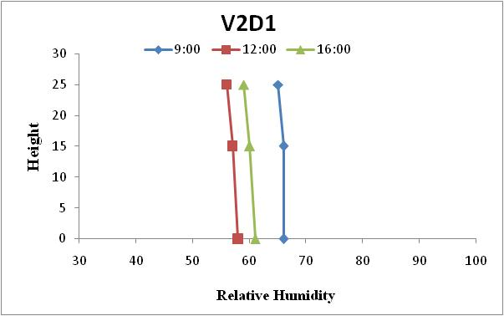
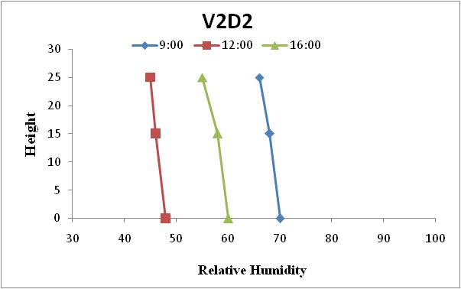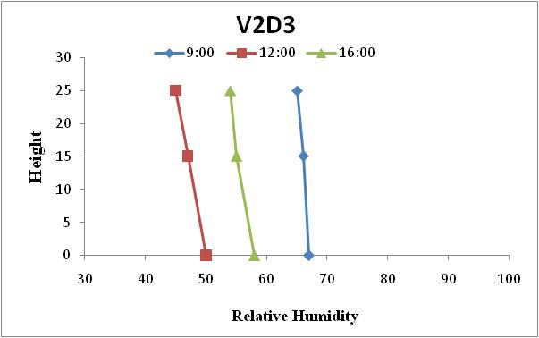
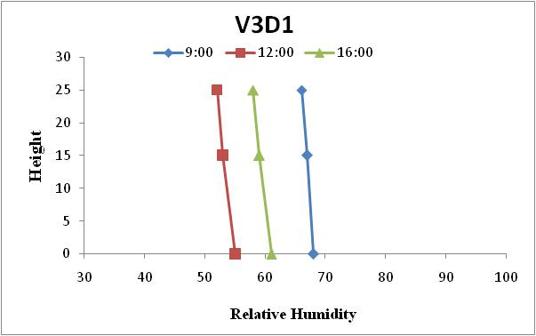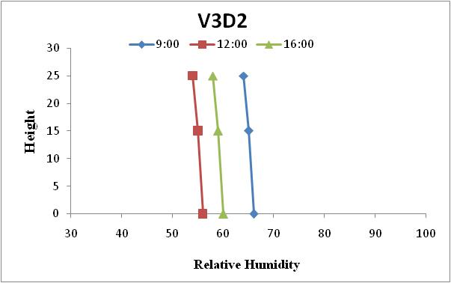

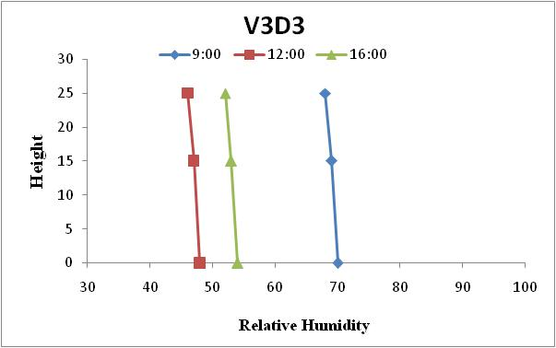
Fig: 5. Relative Humidity profile at pod initiation stage under different row directions and varieties of green gram during 2021.
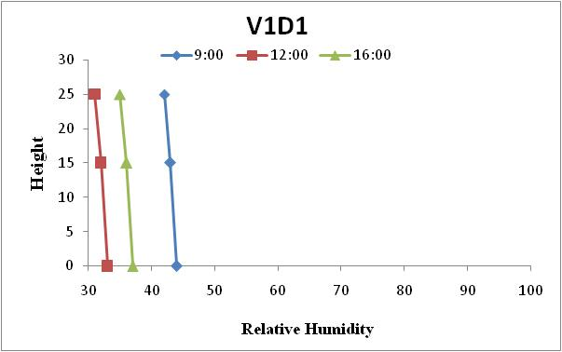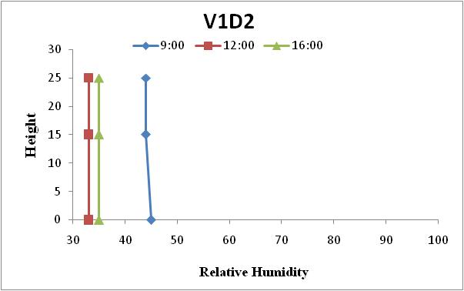
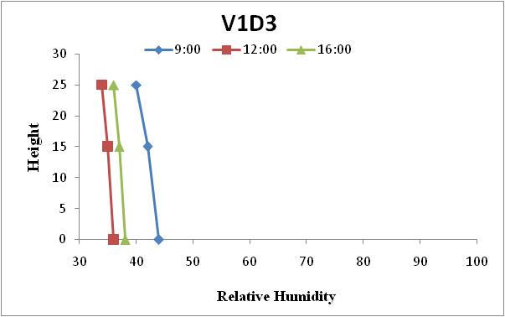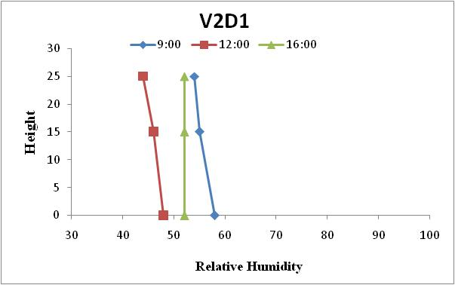
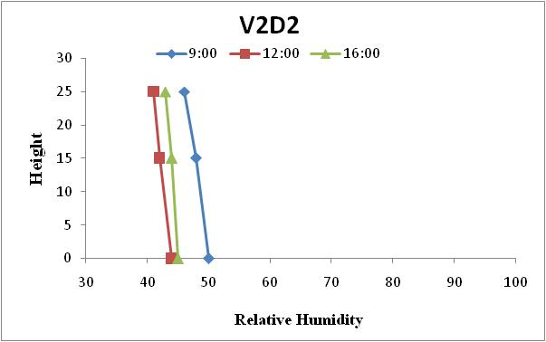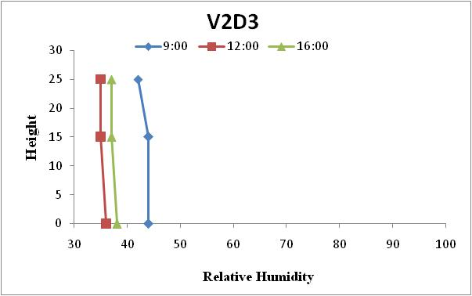
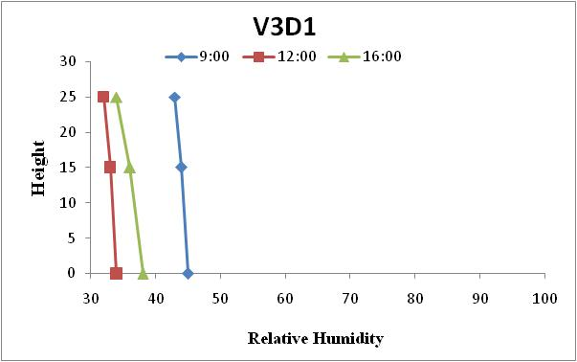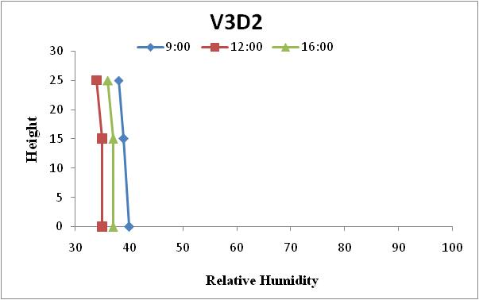
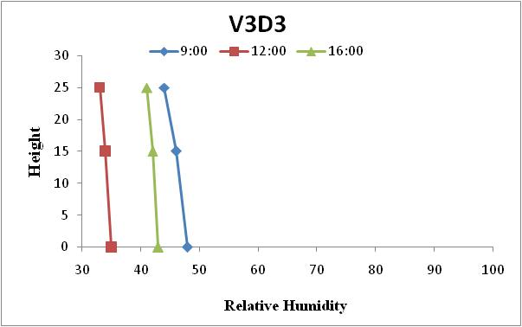
Fig: 6 Relative Humidity profile at physiological maturity stage under different row directions and varieties of green gram during 2020.
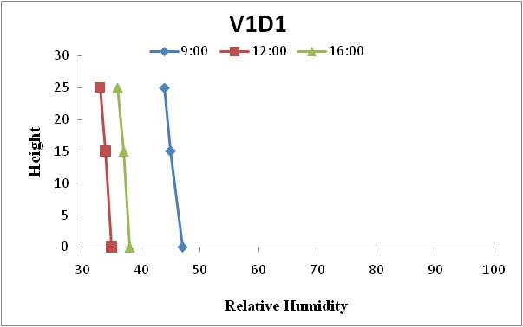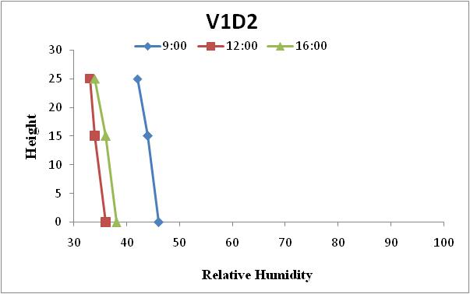
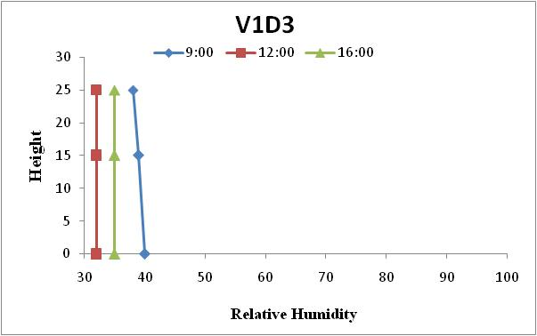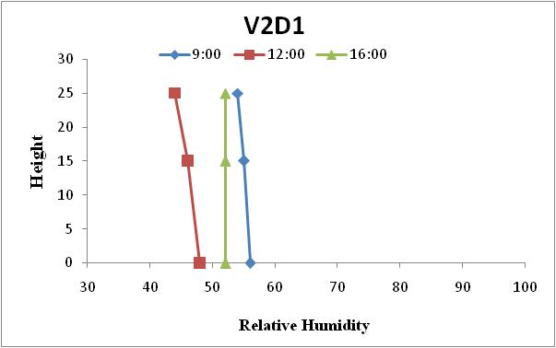
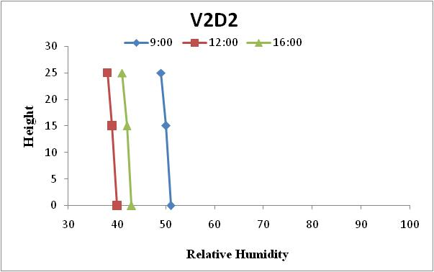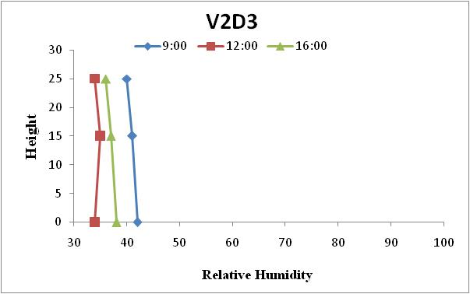
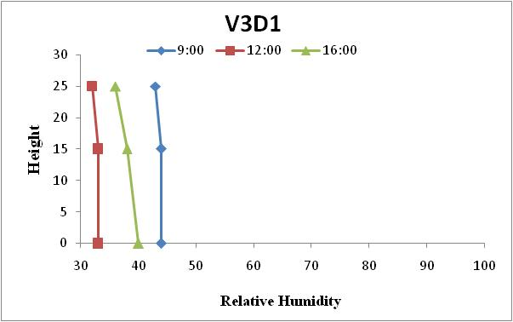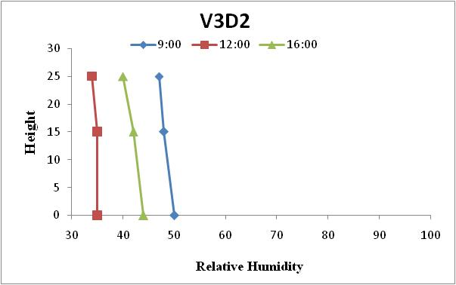
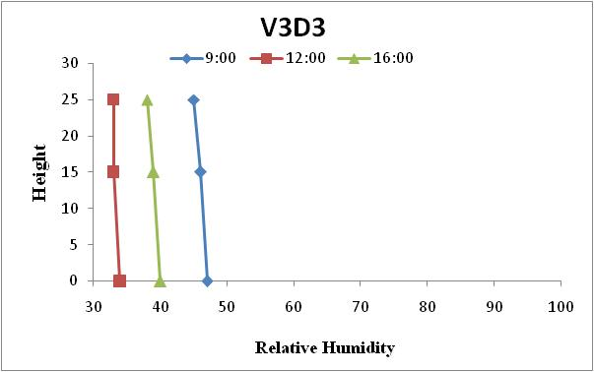
Fig: 7 Relative Humidity profile at physiological maturity stage under different row directions and varieties of green gram during 2021
The humidity profiles was higher inside the crop canopy than above the canopy in all the treatments i.e. the relative humidity profiles were lapse inside the crop canopy throughout the day while profiles were near iso-humic at 9:00 hours at different growth stages during both crop seasons. The relative humidity decreased with height under all treatments.
Temperature Profile:
The temperature profiles showed that the temperature inside the canopy was lower than that are recorded at top of the canopy in all the treatments i.e. temperature profiles were inverse throughout the day within the canopy. Over the top of the crop canopy the temperature profile was lapsing. The temperature varied from bottom to top of canopy among the treatments. The maximum temperature was observed at noon hours and the minimum was at morning which was mostly iso-thermic with height at all growth stages during both crop seasons. The maximum temperature was observed at physiological maturity during both crop seasons and higher temperature was observed during crop season 2020 as compared to crop season 2021 at all growth stages. During crop season maximum temperature was observed (33.5⁰C, 34 ⁰C); (35.3⁰C, 36.3 ⁰C) and (37.2 ⁰C, 38.2 ⁰C) during crop season 2020 and 2021 at flower initiation, pod initiation and physiological maturity respectively as shown in fig 8-13.

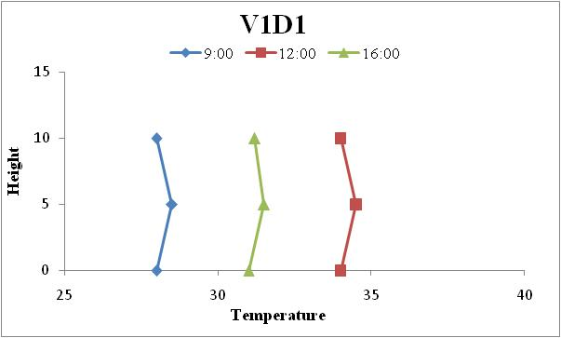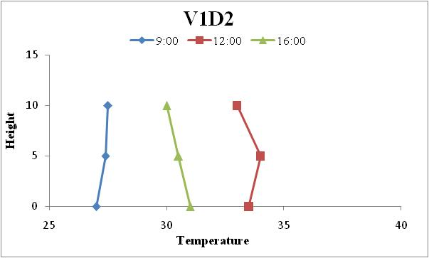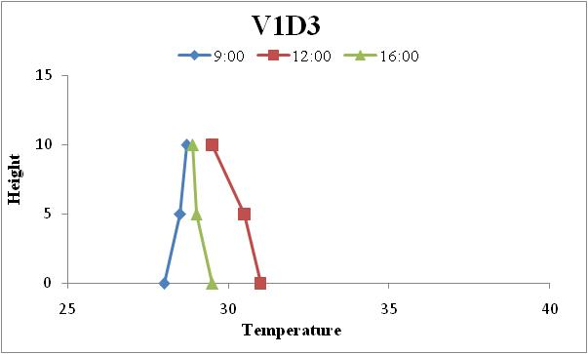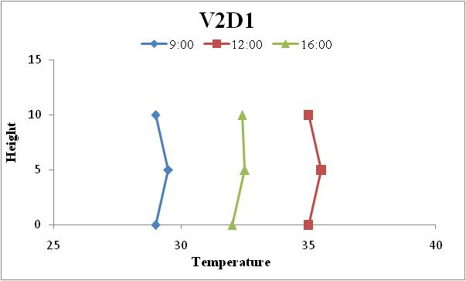
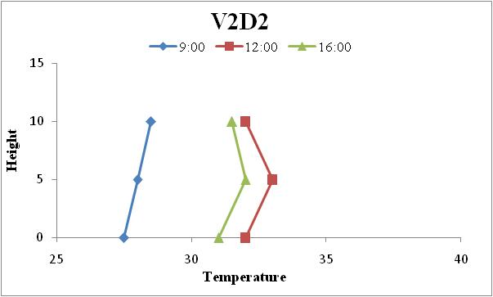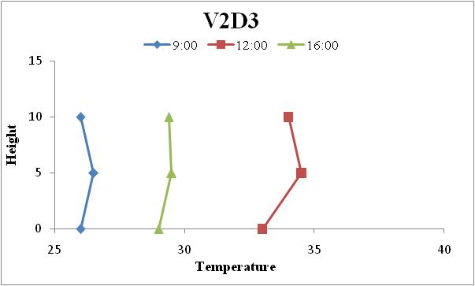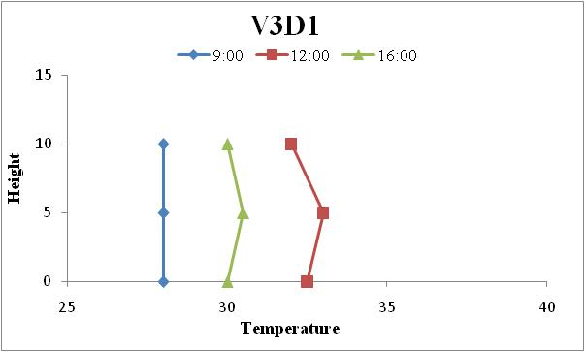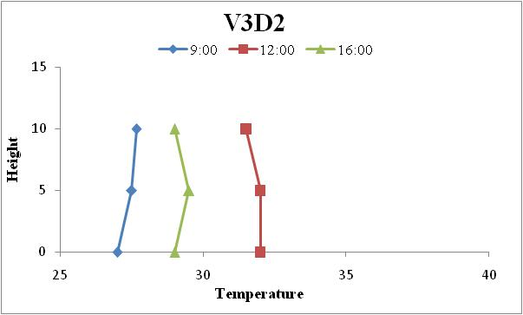
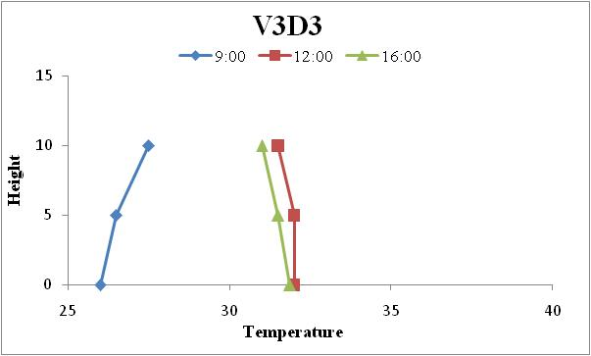
Fig. 8: Temperature profile at flowering stage under different row directions and varieties of greengram during 2020.
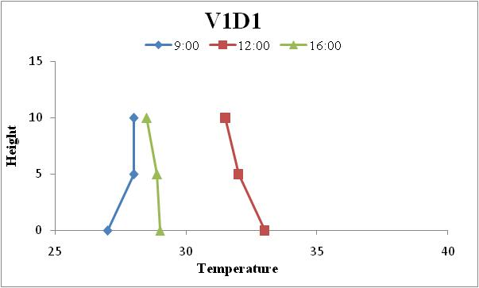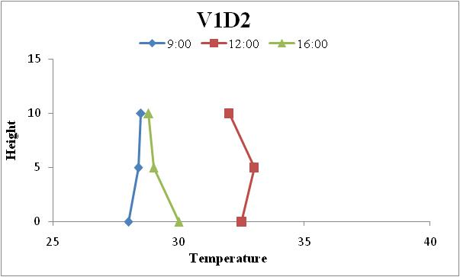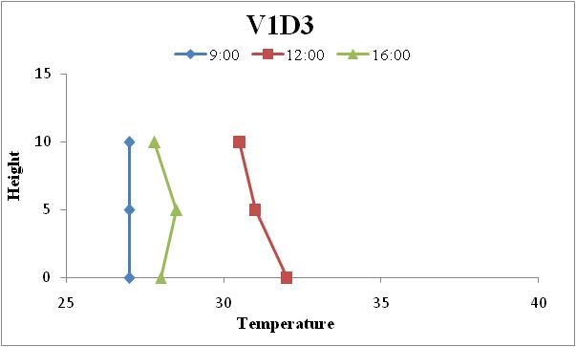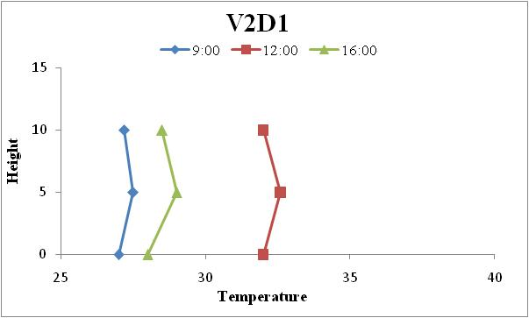
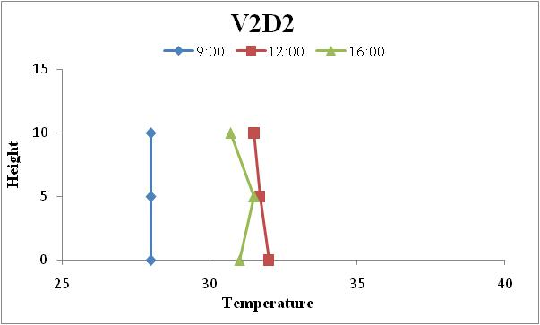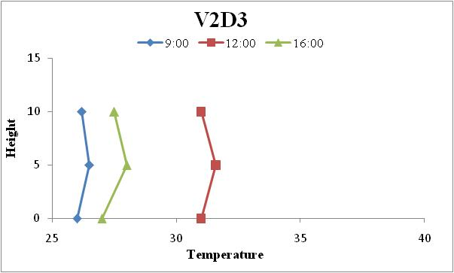
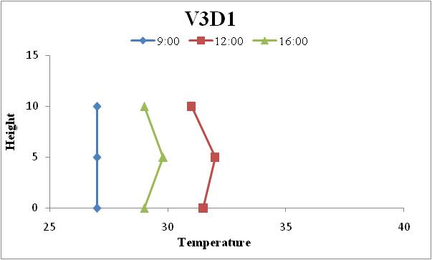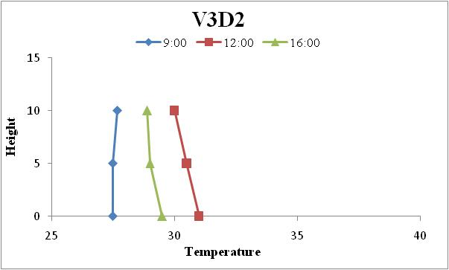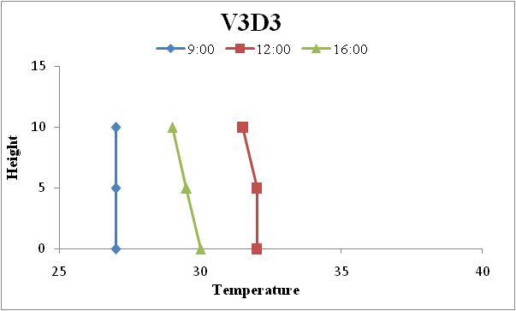
Fig. 9: Temperature profile at flowering stage under different row directions and varieties of greengram during 2021.
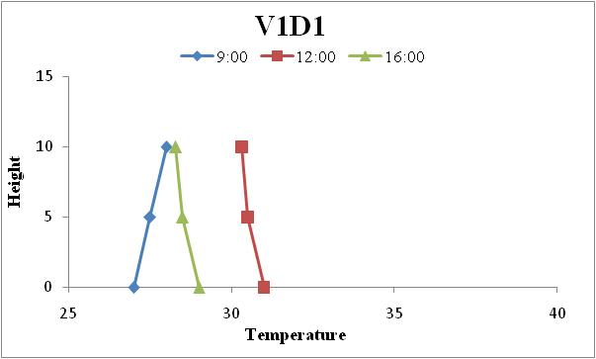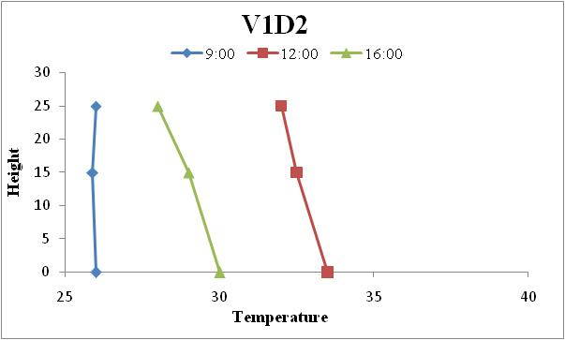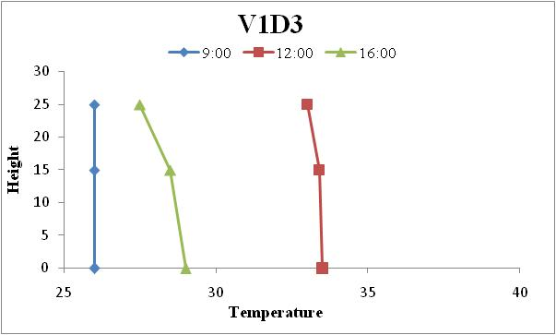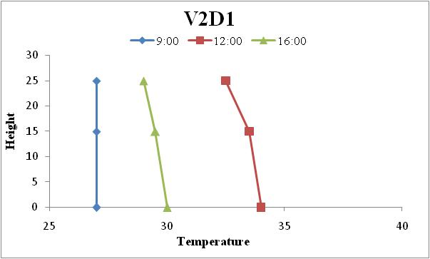
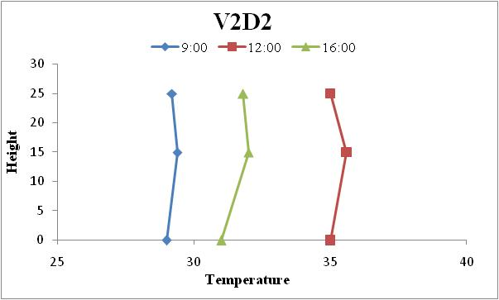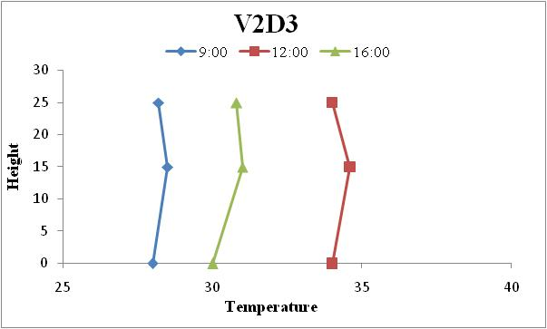
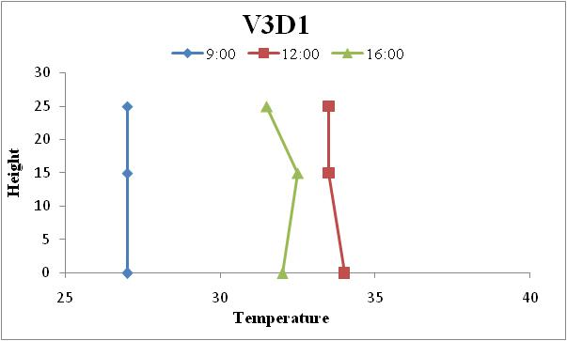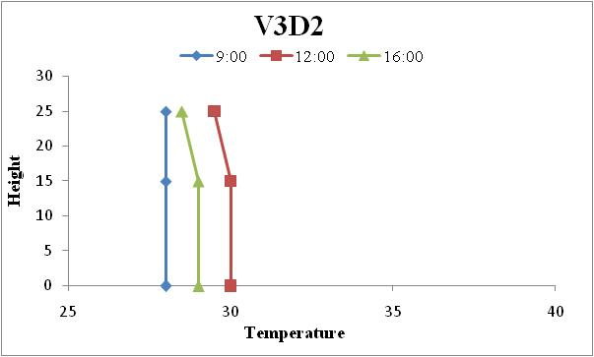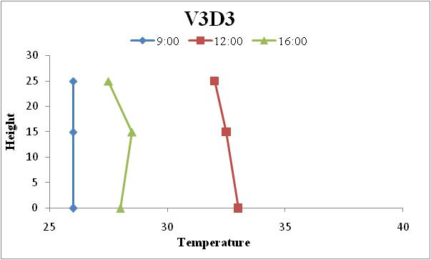
Fig. 10: Temperature profile at pod initiation stage under different row directions and varieties of greengram during 2020.
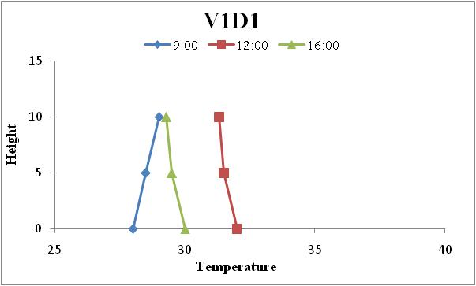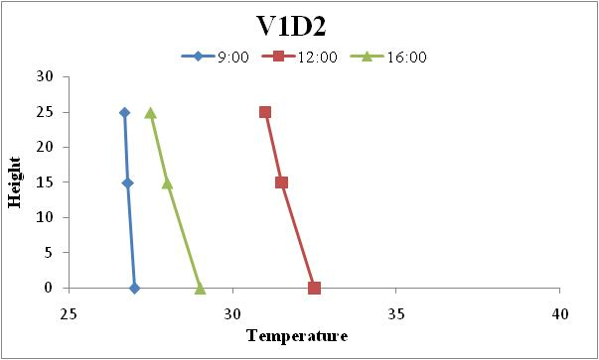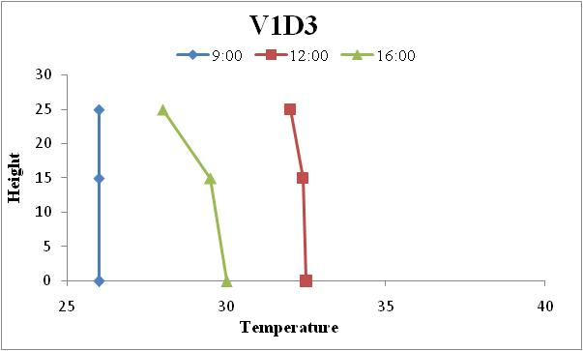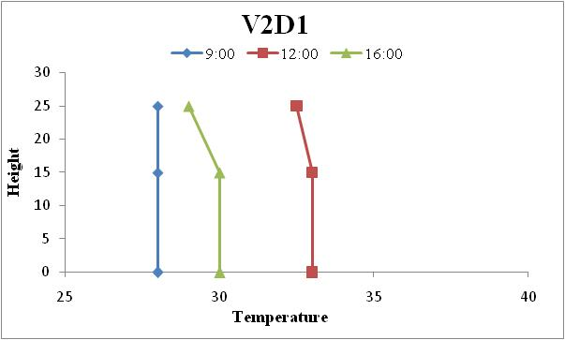
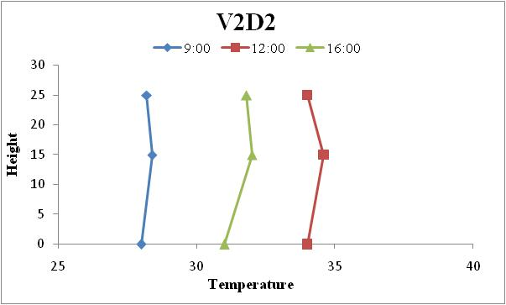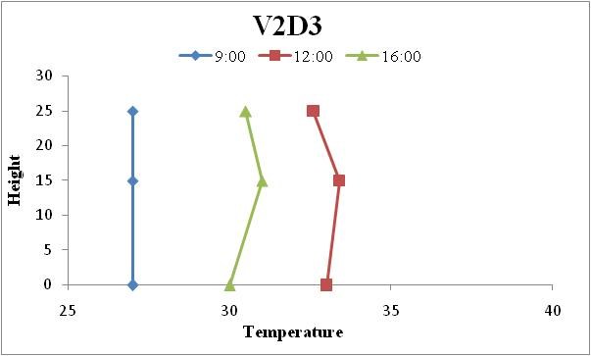
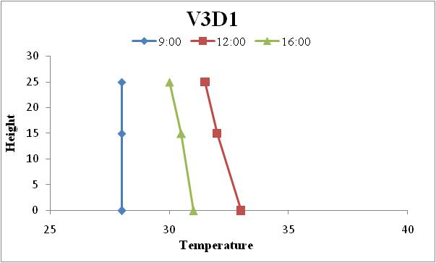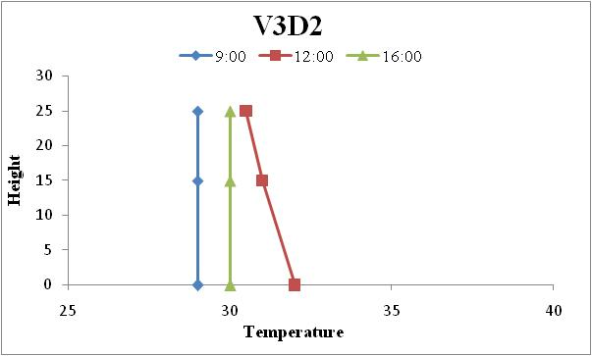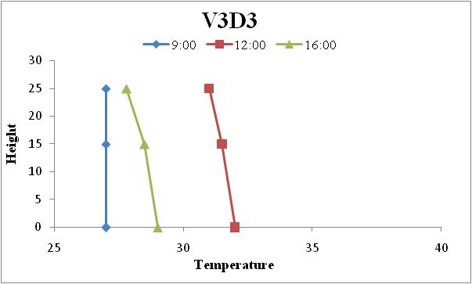
Fig. 11: Temperature profile at pod initiation stage under different row directions and varieties of greengram during 2021
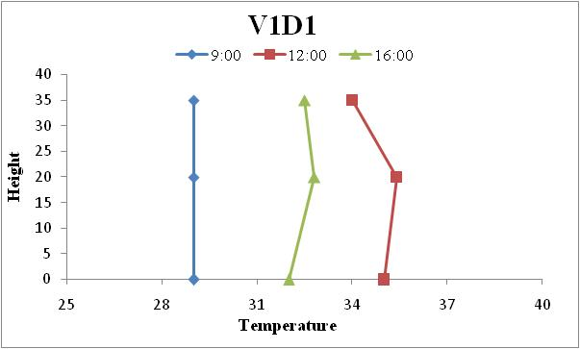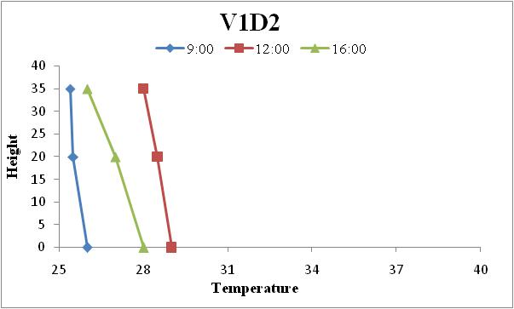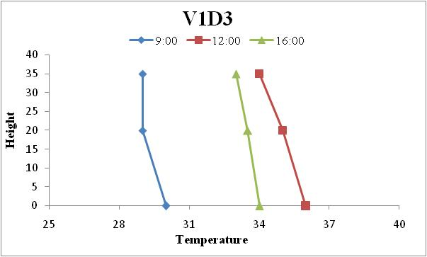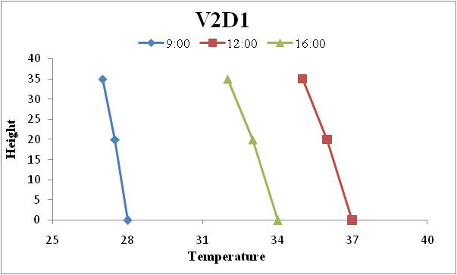
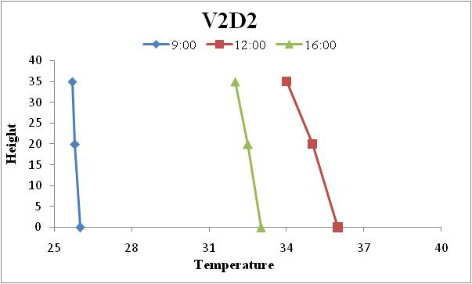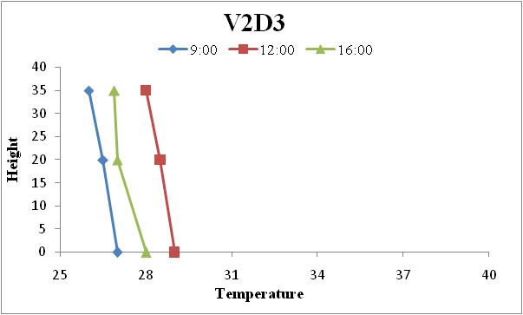
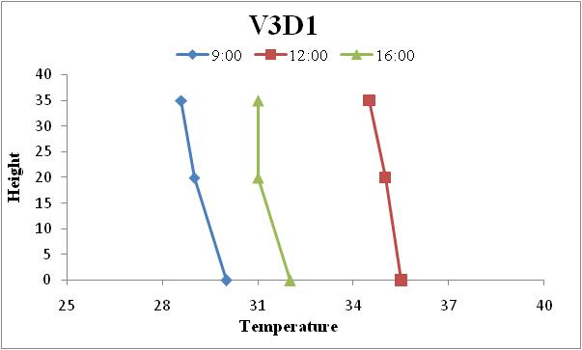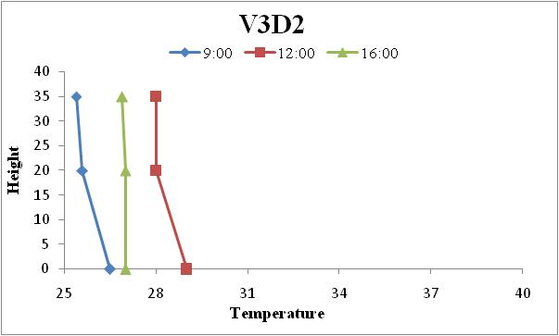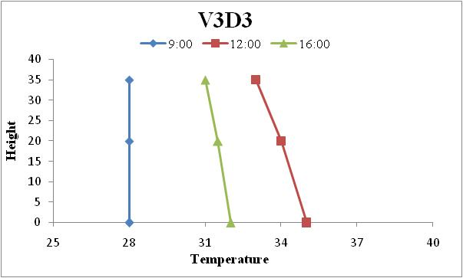
Fig. 12: Temperature profile at physiological maturity stage under different row directions and varieties of greengram during 2020
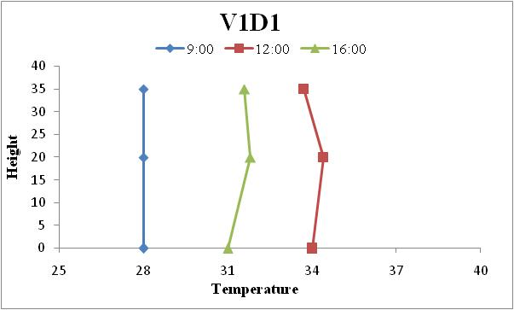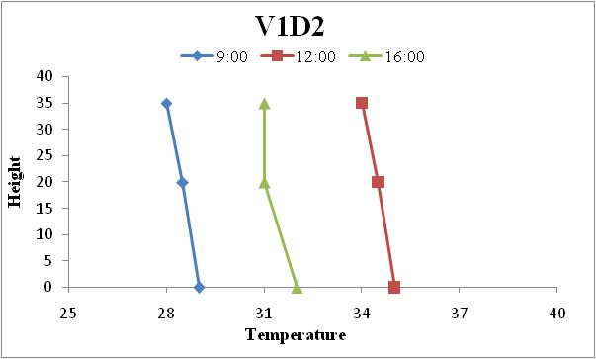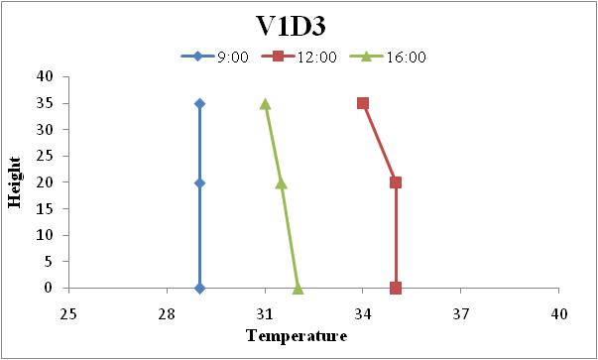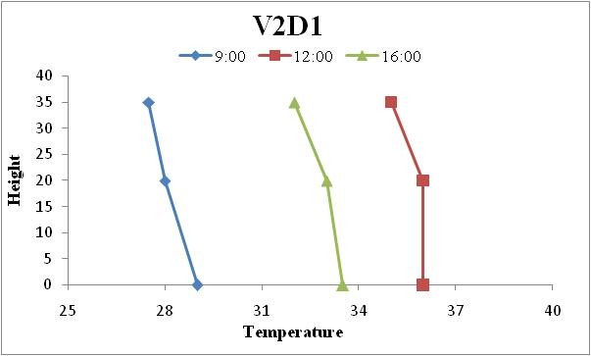
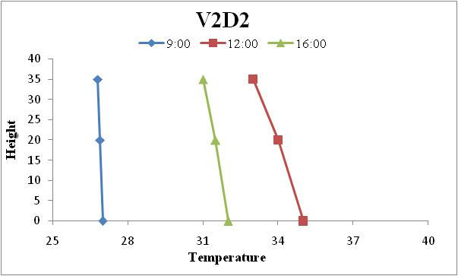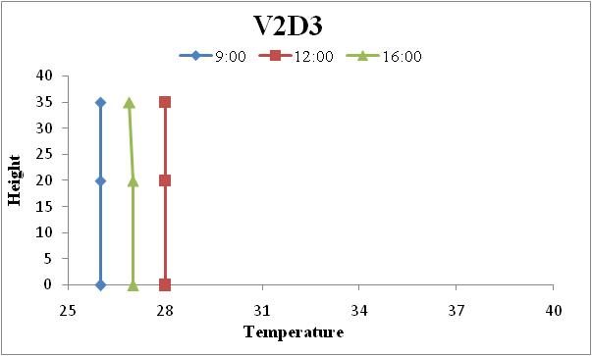
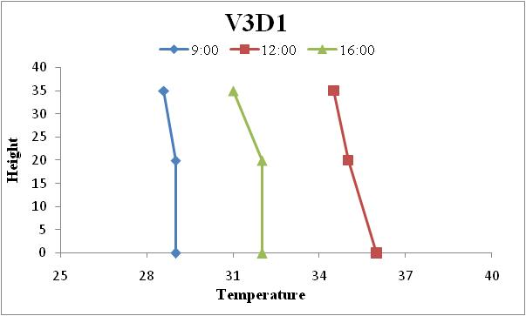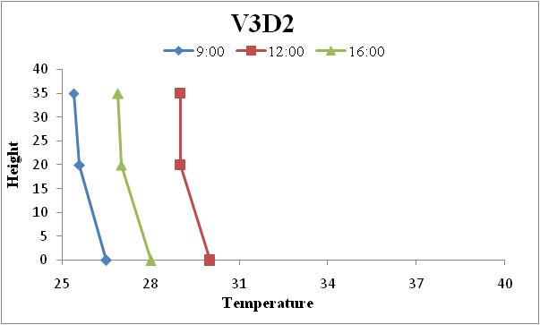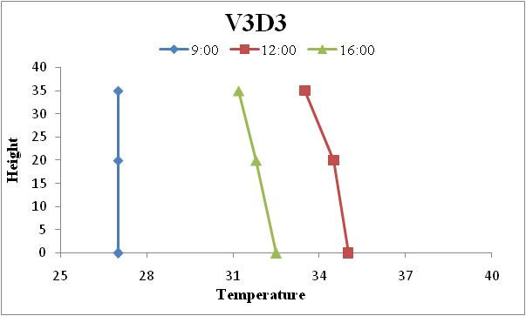
Fig. 13: Temperature profile at physiological maturity stage under different row directions and varieties of greengram during 2021

EVAPOTRANSPIRATION
The evapo-transpiration was recorded under three day interval after 20 DAS with the aid of canopy temperature and ambient air temperature of summer green gram during the crop season 2020 and 2021 as shown in Table 1 and graphical representation shown in Fig 14-16 . The computed evapo-transpiration showed a linear increasing trend till flowering stage and decline at pod stage and again increasing trend was observed till physiological maturity stage during both the crop seasons.
The evapotranspiration observed high in MH 318, East-West and the lowest was observed MH 421, NW-SE during both the crop seasons. There were observed lowest ET range of MH 421 (4.15 to 8.37 and 3.67 to 8.05 mm/day), NW-SE (3.98 to 7.66 and 3.43 to 7.35 mm/day) and the highest range of MH 318 (4.06 to 8.73 and 3.55 to 8.40 mm/day), East-West (4.44 to 9.73 and 3.96 to 9.36 mm/day) during the crop season 2020 and 2021. The evapotranspiration observed high in MH 318 variety, East-West direction and the lowest was observed MH 421, NW-SE during both the crop seasons. The highest ET was observed in treatment V1D2 at flower initiation, V2D2 at pod initiation, V3D2 at physiological maturity during both the year. Generally ET increase with the increase of irrigation, low humidity and high temperature during a day was found by Carcova et al., (2000).

Table 1: Computed ET (mm/day) of greengram crop during crop season 2020 and 2021
Treatment | 2020 |  |  | 2021
Treatment | Flower initiation | Pod initiation | Physiological maturity | Flower initiation | Pod initiation | Physiological maturity
Varieties
MH 421 | 4.149 | 4.316 | 8.372 | 3.666 | 3.081 | 8.053
MH 318 | 4.068 | 3.981 | 8.732 | 3.554 | 2.868 | 8.401
MH 1-25 | 4.414 | 4.157 | 8.710 | 3.894 | 3.021 | 8.350
SE (m) ± | 0.174 | 0.34 | 0.33 | 0.19 | 0.25 | 0.30
CD @ 5% | NS | NS | NS | NS | NS | NS
Row Orientation
North-South | 4.206 | 4.267 | 8.426 | 3.731 | 3.080 | 8.091
East-West | 4.441 | 4.732 | 9.729 | 3.958 | 3.388 | 9.360
NW-SE | 3.984 | 3.454 | 7.661 | 3.425 | 2.502 | 7.349
SE (m) ± | 0.174 | 0.35 | 0.33 | 0.19 | 0.25 | 0.30
CD @ 5% | NS | 0.72 | 0.71 | 0.41 | 0.52 | 0.64
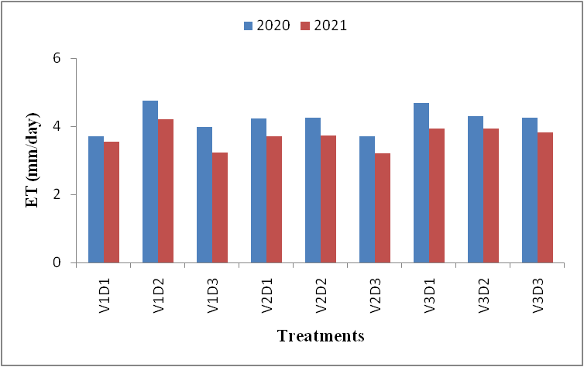
Fig. 14: Computed ET (mm/day) of green gram crop at flowering initiation during crop season 2020 and 2021
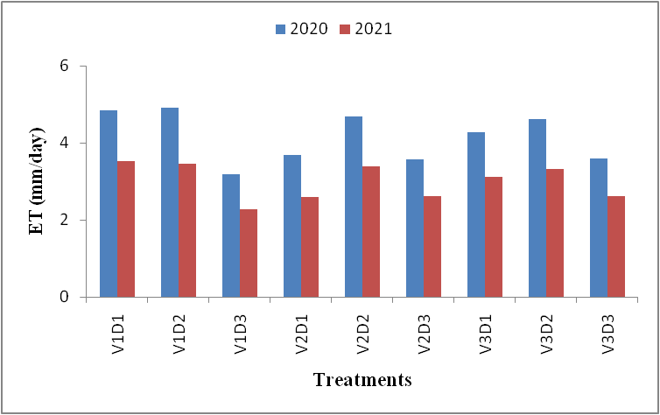
Fig. 15: Computed ET (mm/day) of green gram crop at pod initiation during crop season 2020 and 2021.
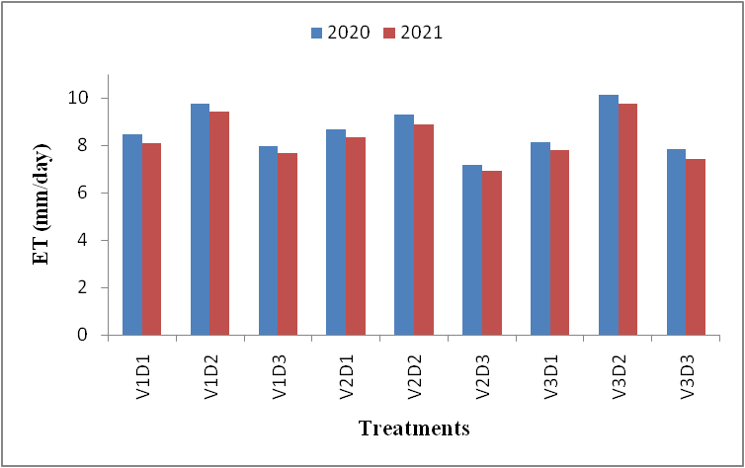
Fig. 16: Computed ET (mm/day) of green gram crop at physiological maturity during crop season 2020 and 2021.

CONCLUSION
When humidity is too high, it will promote the incidence of insect-pest and diseases that result plant to die and crop fail. The temperature profiles were inverses at morning, isothermal in noon hour and lapse in evening hour both the crop season. In orientations, NW-SE was showed inverse in crop canopy throughout the day. The relative humidity profiles were lapse at noon hour inside the crop canopy but profile were near iso-humic at morning and evening hours in all treatments during both the crop season. In orientations, NW-SE was showed lapse in crop canopy throughout the day.
The evapotranspiration observed high in MH 318, East-West and the lowest was observed MH 421, NW-SE during both the crop seasons. The highest ET was observed in treatment V1D2 at flower initiation, V2D2 at pod initiation, V3D2 at physiological maturity during both the year.

COMPETING INTERESTS DISCLAIMER:
Authors have declared that they have no known competing financial interests OR non-financial interests OR personal relationships that could have appeared to influence the work reported in this paper.

Disclaimer (Artificial intelligence)
Author(s) hereby declare that NO generative AI technologies such as Large Language Models (ChatGPT, COPILOT, etc.) and text-to-image generators have been used during the writing or editing of this manuscript.

REFERENCES
Abbas, M. and Shah, H.U., 2007. Proximate and mineral composition of mung bean. Sarhad Journal of Agriculture.23(2): 463-466.
Ministry of Agriculture and Farmers Welfare, Department of Agriculture, Cooperation and Farmers Welfare, Directorate of Economics and Statistics. (2019). *Agricultural Statistics and Data*. https://eands.dacnet.nic.in/
Bartholic, J.F., Namken, L.N. and Wiegand, C.L., (1970). Combination equations used to calculate evaporation and potential evaporation. ARS. USDA 41-170.
Blad, B.L. and Lemeur, R., 1979. Miscellaneous techniques for alleviating heat and moisture stress. Modification of Aerial Environment of Plants.American Society of Agricultural and Biological Engineers. 2-409.
Bose, S.K. (2008) Detection and forecasting of Downy mildew incidence in pearlmillet using Agromet- Remote sensing Approach. M.Sc. Thesis submitted to CCS HAU, Hisar
Cárcova, J., Maddonni, G.A., & Ghersa, C.M. (2000). Long-Term Cropping Effects on Maize: Crop Evapotranspiration and Grain Yield. Agronomy Journal, 92(6), 1256-1265. https://doi.org/10.2134/agronj2000.9261256x
Delfin, E.F., S.P. Erlinda, F.G. Torres, P.A. Santos (2008). Biomas, nitrogen uptake and fixd nitrogen partitioning in field grown mungbean (Vigna radiata L. Wilczek) inoculated with Bradyrehizobium sp. Philippines Journal of Crop Science. 33(3) 24-33.
Hayat, R., Ali, S., Ijaz, S. S., Chatha, T. H., & Siddique, M. T. (2008). Estimation of N2-Fixation of Mung Bean and Mash Bean through Xylem Ureide Technique under Rainfed Conditions. Pakistan Journal of Botany, 40(2), 723-734. https://www.pakbs.org/pjbot/detail.php?id=78
Kabir, M.H. and M.A.R. Sarkar (2008). Seed yield of mungbean as affected by variety and plant spacing in Kharif-I season. Journal of Bangladesh Agrilcultural University 6(2): 239–244.
Kooman, P. L., & Haverkort, A. J. (1995). Modelling development and growth of the potato crop influenced by temperature and daylength: LINTUL-POTATO. In A. J. Haverkort & D. K. L. MacKerron (Eds.), Potato ecology and modelling of crops under conditions limiting growth (pp. 41-59). Kluwer Academic Publishers. https://doi.org/10.1007/978-94-011-0051-9_3
McMaster, G. S., & Wilhelm, W. W. (1997). Growing degree-days: One equation, two interpretations. Agricultural and Forest Meteorology, 87, 291–300. https://doi.org/10.1016/S0168-1923(97)00027-0 .
Li, Q. Y., Yin, J., Liu, W. D., Zhou, M., Li, L., Niu, J. S., Niu, H. B., & Ma, Y. (2012). Determination of optimum growing degree days (GDD) range before winter for wheat cultivars with different growth characteristics in North China Plain. Journal of Integrative Agriculture, 11, 405–415. https://doi.org/10.1016/S2095-3119(12)60025-2
Rosenberg, N. J., Blad, B. L., & Verma, S. B. (1983). Microclimate: The biological environment. https://www.wiley.com/en-us/Microclimate%3A+The+Biological+Environment%2C+2nd+Edition-p-9780471060666
Shaykewich, C. F., Ash, G. H. B., Raddatz, R. L., & Tomasiewicz, D. J. (1998). Field evaluation of a water use model for potatoes. Canadian Journal of Soil Science, 78, 441–448. https://www.cdnsciencepub.com/doi/abs/10.1139/cjss.1998.78.441
Singh, P. K. (2005). Climatological study of severe cold waves and probabilities of minimum temperature over Sabour (Bihar). Journal of Agrometeorology, 7(2), 291-296. https://doi.org/10.54386/jam.v7i2.859
Singh, S. P., Sandhu, S. K., Dhaliwal, L. K., & Singh, I. (2012). Effect of planting geometry on microclimate, growth and yield of mungbean (Vigna radiata L.). Journal of Agricultural Physics, 12(1), 70-73. http://www.agrophysics.in
Yu, L., Liu, Z., Wang, B., Duan, H.M., Meng, F.J. andLi, Q.Y., (2013). Effects of different combinations of planting density, row spacing and row direction on field microclimatic conditions and grain yield of maize.Chinese Journal of Eco-Agricultural. 21: 938-942.
Vaddi Saitheja, M. Senthivelu, G. Prabukumar, and V. Babu Rajendra Prasad. 2022. “Maximizing the Productivity and Profitability of Summer Irrigated Greengram (Vigna Radiata L.) by Combining Basal Nitrogen Dose and Foliar Nutrition of Nano and Normal Urea”. International Journal of Plant & Soil Science 34 (22):109–116. https://doi.org/10.9734/ijpss/2022/v34i2231362.

