Graph-Theoretic Representation of Linear Programming Problems: Applications in Network Flow and Resource Optimization

Abstract
In the research work, the combination of the graph representation formulation and the traditional LP formulation was taken into account for the further development of the optimization methodology within the environment of the network. In fact, the major part of the networks such as energy transmission networks, transport networks, telecommunication networks, and resource distribution networks is made up of the graph representation by the nature itself, whereas the traditional LP formulation methodology is not appropriate for the improvement of the efficiency of the result within the environment. The proposal of the research work was to apply the constraints of the traditional LP formulation within the graph representation by the help of the graph representation with capacity-constrained flow within the environment of graph representation. The verification of the proposal was carried out within the environment of the traditional simplex methodology, the network simplex methodology, within the environment of the min-cost flow problem, which was later confirmed by the GNN. Meanwhile, in the case of the PowerGraph dataset, the network simplex algorithm obtained a speedup of 5.9 times with a 93.6% reduction in iterations compared to the traditional simplex algorithm. In depth analyses of flow patterns and congestion pointed to essential lines with maximal congestion, underutilized transmission paths, as well as comprehensible patterns of resource allocation in the network. Sensitivity analyses also highlighted changes in the cost structure and network topology as major factors in shifting optimal flow patterns. Overall, this integrated LP & graph approach enables a computationally effective and interpretable analysis paradigm for such networks. This work thus serves as an exemplary foundation in elucidating network flow problems by integrating LP algorithms with graph structures in more advanced network paradigms involving dynamics, stochasticity, or multi-layers.
keywords: Linear Programming; Graph Theory; Network Flow Optimization; Network Simplex; Incidence Matrix; Resource Allocation; PowerGraph Dataset; Min-Cost Flow; Graph Neural Networks.
1. Introduction
1.1 Background
Linear Programming: It is a powerful mathematical method for the optimization of objective functions with linear constraints with a wide range of applications in operations research, supply chain networks, telecommunication routing problems, and energy networks (Wu et al., 2024). Although the formally stated definitions are framed in algebraic matrices, numerous applications in the optimization area, particularly involving flows, capacity, routing, and resource allocation, naturally reside within the context of graph theory (H. Wang et al., 2020). Graphs: These are visual representations of structural links where vertices represent places or constraints, while edges represent flows or connections (Urbán Rivero et al., 2020). Indeed, the traditional network flow problems like max-flow problems, shortest path problems, transportation problems, and assignment problems are specifically instances of LP and still appear to greatly benefit from graph-based methods of solution (Tripathi & Kumar, 2024a). Also, the pioneering works in the field of network flow problems implicitly reveal that graph structure represents the LP matrix in vastly more comprehensible and efficient forms and thereby permit extensive analytical work (Sarode & Tuli, 2019).
1.2 Motivation
Modern computation infrastructure architectures consist of complex networks like power distribution, telecommunication networks, transportation networks, and logistics (Nie et al., 2025). Such flows impose constraints on cost, capacity, as well as performance (Lopez-Garcia & Domínguez-Navarro, 2023). Indeed, these models can be expressed using linear programming. Simple, off-the-shelf methods result in high complexity because of the computational requirements to process large sparse matrices even in the optimized way, as stated in Lin et al. (2024). Interpretability and real-time execution will therefore be impossible (Flamand et al., 2023). These issues are overcome by graph-structured models because LP constraints are expressed as node and arc matrices based on which the network-simplex value computation can be achieved more quickly, along with other advantages such as network decomposition, flow interpretation improvements, as well as graph-related models such as GNNs for flow prediction (Dias et al., 2022). This explains why graph-based LP formulation translates to scalable and efficient optimization solvers for large-scale industrial systems (Darvariu et al., 2024).
Definition of Key Concepts
In this study, a Network Flow Problem is considered to be a modeled system using a graph, where vertices stand for source, target, or intermedia points of transfer, while edges represent permissible routes along which resources—e.g., electric current, binary data, or physical commodities—are conveyed. The application of Linear Programming is based on linear algebraic formulations, which attempt to maximize or optimize a linear objective function, linear equality, as well as inequality constraints modeled according to specific problem conditions. Using these LP models embedded inside a graph representation—vaguely via incidence matrices between graph nodes arcs or edges with capacities—this method leverages natural sparseness of networks to optimize solution processes. In this particular case, algorithms like Network Simplex stand as essential components, adapted to graph models of LP, with tree-like updates enabling faster execution.
1.3 Problem Statement
Even though LP and graph theory are related to optimization, traditionally the two fields have remained separate (Chen et al., 2025). LP formulations are algebraic, while graph algorithms are based on combinatorial structures. Yet, many linear programming problems have an underlying graph nature that is rarely tapped in traditional methods (X. Wang et al., 2024). Then again, one of the biggest challenges is that there is no standard method through which LP models could be translated into graph-theoretic format. This also triggers challenges with regard to intuitive understanding of the algebraic constraints, possible negligence of some graph algorithms, and limited cohesion of LP formulation with modern graph-learning methodologies Filling this gap will be an essential ingredient for further advancing the fidelity and interpretability of optimization .
1.4 LP and Graph Structures
LP Formulations of flow problems, assignment problems, and location problems can also be explained with a graphical approach like directed graph models, graph models with assignments, graph models with weights, and graph models with capacities on networks (Rojek et al., 2025). Directed graph models are used for flow models; "graph models with assignments are used for flow problems with assignments or transportation problems," while graph models with weights are geared towards location problems https://link.springer.com/article/10.1007/s42421-025-00124-6?utm_source=chatgpt.com . Many constraint LP matrices are similar to node-arc incidence matrices, which are a fundamental form in graph theory (Kayan et al., 2022). Network Flow problems (Max-Flow, Shortest Path, Min-Cost Flow) can also be modeled into LP, where the LP feasible solutions imply feasible flows (Jiang et al., 2024). 2 Related Work Graph Neural Network Their study Graph Neural Network Further illustrates that flow prediction, congestion prediction, and routing optimization are strongly informed by connectivity patterns (Jiang, 2022). Their observations position LP and Graph Theory within supportive tools within one unifying model perspective (Holzhauser et al., 2017).
For the first time, this research combines LP algebra, graph-theory models, and experiments with real data within a common optimization paradigm. This research shows on practical graph data how structural graph properties can directly speed up LP solvers. This research combines traditional flow theory with contemporary performance results on real graph data with a practical power grid application. This framework can easily be applied in transportation networks, telecom networks, supply chains, etc. https://www.sciencedirect.com/science/article/abs/pii/S0743731523001600?utm_source=chatgpt.com .
There is, in this thesis, an LP-graph framework that fills the gap between traditional optimization problems and new applications of graph theory that aim at understanding complex real-world problems. It actually contains the proof of the way that incidence matrices, constraints, and cost functions are linked to the graph structure. Also, there is a reproducible method for testing the performance of LP solvers applied in graph-structured LP problems. Moreover, that real-world data provides significant computational benefits https://arxiv.org/abs/2209.12288?utm_source=chatgpt.com .
1.5 Research Gap
Although the literature on the theory of LP and network flow is vast in quantity, several gaps in the literature relevant to the integration of the two topics exist. Specifically, solutions for the general translation of the algebra of LP into graphs in the form of standard formulation systems for the theory of LP and the general formulation of nodes and edges for the constraints of the network problems do not exist in the literature (Hansen et al., 2022). Comparison of performances between traditional simplex algorithms and network simplex solutions has been carried out in a few instances for large-scale network data sets (Dias et al., 2025). Thirdly, classical optimization in traditional LP has not been combined with graph neural predictive models yet (Cummins et al., 2021).The above-mentioned challenge has been addressed in this study, and a new framework of mapping from LP to graph has been formulated with its value identified in computation, graph form, and predictive tasks (Cruz‐Mejía & Letchford, 2023).
1.6 Objectives
- O1: To Design an approach to systematically map the LP constraints onto graph structures.
- O2: To Be able to demonstrate graph-theoretic LP formulation for classical flow problems: max-flow, shortest path, min-cost flow, assignment.
- O3: To Compare the computational differences between simplex and network-simplex for sparse network-structured problems.
- O4: To Calculate the gain in efficiency by resource optimization using a graph-constrained LP.
- O5: To Propose a unified LP→Graph framework applicable across domains.
1.7 Hypotheses
- H1: The LPs of the network structure can be solved more efficiently if represented using graph algorithms.
- H2: Node–arc incidence matrices reduce the LP complexity and improve sparsity management.
- H3: Graph representations improve scalability for large real-time optimization tasks.
In this way, this research represents a significant step forward in that it provides a framework that systematically bridges classical linear programming and graph-based optimization, two areas that have hitherto been developing independently. In this way, this research allows the use of the natural sparsity of network systems, the accurate representation of flows through the help of the incidence matrices of nodes and arcs, and the minimization of capacity and cost constraints in a computationally efficient way. Finally, the use of network simplex algorithms in realistic data sets not only verifies the applicability of the proposed methodology, but it also represents a way to address realistically large-scale instances of flow optimization problems in the future. In this way, this research not only advances the foundational understanding of network-based optimization in the areas of energy, transportation, and computing, but it also provides the needed tools for future research, including the study of dynamic networks and predictive models of flows in graph-based neural networks, networks with uncertainty, and more.
2. Literature Review
In fact, the literature supports this growing intersection between LP theory and graph-based optimization.
LP and Network Flows
A further consequence of the optimization literature, Caselli et al., 2022 (Caselli et al., 2022), is that LP constraint matrices are a natural consequence of graph structure reflexive of incidence, adjacency, & path matrices. The network simplex methods exploit the graph structure of LPs in order to speed their running times significantly (Çalışkan, 2011).
Graph-Based Flow Learning
Recent developments in fact demonstrated that graph neural networks can model routing, congestion prediction, and flow optimization by learning from the nature of the network. These models forecast resource use, identify bottlenecks, and calculate optimal flow distributions.
Bipartite graph models for simple LP
Representation using the bipartite graph improves assignment problems, match problems, and transportation problems by having fewer redundancies and improving the visualization of the constraints (Ahmed & Ahmad, 2014).
Classical Flow Algorithms
For example, Ford-Fulkerson, Dijkstra, or Bellman-Ford algorithms specialize in specific LP instances considered on graphs.
Accordingly, the bibliography brought together indicates a high level of synergy between LP and Graph Theory; this synergy is underleveraged.
3. Methodology
3.1 Dataset Description
The PowerGraph dataset (Varbella et al., 2024): It has data regarding buses, including transmission lines, capacity, and cost variables of the realistic power network. It has 118 nodes and 186 edges, and these twoparameters make an extremely strong LP-to-graph correspondence. There are two attributes for every line, namely rating and flow, which are helpful for solving min-cost and congestion problems. As this graph has very sparse structure, it becomes structurally well-determined, and hence it has been taken as a testing instance for graph-optimized LP algorithms.
Experimental Setup
The experimental tasks involved the transformation of the PowerGraph datasets into incidence matrices and LP constraints. The performances of the simplex method and the network simplex method had already been assessed for different scales of the networks. The values of the flow, capacity, and cost were analyzed to study the utilization and congestion trends. Sensitivity analysis was conducted by modifying the cost coefficients.
Normalization of Power Demand
$P_{i}^{norm}=\frac{P_{i}-P_{min}}{P_{max}-P_{min}}$ (1)
Where,
- $P_{i}$ : Power demand at node $i$
- $P_{\text{min }}$ : Minimum demand value in the dataset
- $P_{\text{max }}$ : Maximum demand value in the dataset
- $P_{i}^{\text{norm }}$ : Normalized demand (0-1 scale)
3.2 Node–Arc Graph Construction
The node-arc representation of the PowerGraph dataset contains each bus represented as a node, where the purpose of the node either acts as a source node, a destination node, or a junction node. A power transmission line is represented as a node with the orientation of the possible power flow represented by a directional arc, where their respective line thermal limits are assigned as the node capacity.
Directed Graph Definition
$G=(V,E), |V|=n,|E|=m$ (2)
Where,
- $G$ : Directed graph representing the power network
- $V$ : Set of nodes (buses)
- $|V|=n$ : Total number of nodes in the dataset
- $E$ : Set of directed edges (transmission lines)
- $|E|=m$ : Total number of edges
3.3 LP Variable Definition
One continuous variable, symbolizing the power flowing through the respective line, is introduced for each transmission line within the context of the LP formulation. The set of these variables comprises the decision vector, which is modified during the process of optimization with the objective of satisfying either of the two complementary ambitions: cost minimization and meeting system requirements. The need for one variable for each transmission line encompasses all possible flow arrangements within the network, as explained in the next section.
Decision Variable Vector
$x={\left(x_{1},x_{2},…,x_{m}\right)}^{T}$ (3)
- x: Decision variable vector representing flows in the network
- $x_{e}$ : Flow on arc (transmission line) $e$
- $e=1,2,…,m$
- $m$ : Total number of arcs (edges) in the PowerGraph network
- $x_{e}∈R$ : Continuous flow variable for arc $e$
Capacity Constraint Formulation
It ensures that the flow through each transmission line does not exceed the thermal limit recorded in the dataset, which is denoted by Pmax: this limit is an upper limit since past this, the line cannot function safely. Therefore, with 0 ≤ x_e ≤ Pmax_e, the LP model guarantees the integrity of the system, which is reliable with no line overload.
Line Capacity Constraint
$0≤x_{e}≤C_{e}, ∀e∈E$ (4)
Where,
- $x_{e}$ : Power flow on transmission line (arc) $e$
- $C_{e}$ : Maximum capacity (thermal limit) of line $e$ from the dataset
- $E$ : Set of all transmission lines (edges) in the graph
Construction of Incidence Matrix
This is known as the incidence matrix A, which represents for each transmission line the connection it has with each pair of nodes, with a coefficient of +1 for an in-flow connection, -1 for an out-flow connection, and 0 otherwise. This will ensure a formation of a basic platform where the constraints for the conservation of the flow can be built upon.
$A_{ie}=\left\{\begin{matrix}+1, & \text{ if }arce\text{ enters node }i, \\ -1, & \text{ if }arce\text{ leaves node }i, \\ 0, & \text{ otherwise }\end{matrix}\right.$ (5)
Where,
- $A_{ie}$: Element of the node–arc incidence matrix at row $i$(node) and column $e$(arc)
- $i$: Index of a node (bus), $i=1,2,…,n$
- $e$: Index of an arc (transmission line), $e=1,2,…,m$
- $E$: Set of all edges (arcs) in the power network
- “Enters node $i$” means $e=(j→i)$
- “Leaves node $i$” means $e=(i→k)$
Power Balance Constraints (Node Supply/Demand)
The power balance constraints state that at every node, the total flow equals the generation less the demands as per the data provided. Nodes with excess power can be termed as the supply sources, whereas the power-sensitive nodes can be termed as the demand receivers. These constraints ensure the power balance in the power system.
Node Balance Equation
$Ax=b$ (6)
where $b$ represents net generation (+) or demand (-) at each bus.
Objective Function Construction Min-Cost Flow LP
It reduces the overall transmission cost by considering the flow in each line weighted by the cost coefficient c_e, that is, pre-calculated values of loss factors, impedance, or economic cost fields in the dataset. This is a formulation of the problem that provides, in the process of the optimization algorithm, the benefit of favoring paths of lower cost routing. When added across the lines, the equation c_e x_e defines the most economical flow distribution in the LP formulation.
Linear Objective Function
$minZ=\sum_{e∈E}{ }c_{e}x_{e}$ (7)
Where,
- $Z$ : Total objective value (e.g., total cost of power flow)
- $E$ : Set of all edges (transmission lines) in the network
- $x_{e}$ : Flow on line (arc) $e$
- $c_{e}$ : Cost coefficient associated with arc $e$
- $c_{e}x_{e}$ : Contribution of arc $e$ to total cost
LP to Graph Mapping & Identifying Feasible Region
The impact of this step is that the matrices defining the constraints of the LP formulation get expressed as their graphical representations because of the fact that the solution can now easily and straightforwardly be expressed in terms of graph elements such as graph nodes and arcs, as well as graph capacity constraints. At this level, it will prove very important to have a visual understanding of the LP formulation as a graphical representation in terms of determining structural sparsity, connectivity, and graph bottlenecks from the model. The necessity for this will essentially lie in ensuring computational improvements by mapping the algebraic constraints of a model to graph behaviors.
$F=\left\{x∣Ax=b,0≤x_{e}≤C_{e},∀e∈E\right\}$ (8)
Where,
- $F$ : Feasible region of the Linear Programming model
- $x={\left(x_{1},x_{2},…,x_{m}\right)}^{T}$ : Vector of decision variables (flows)
- $A$ : Node-arc incidence matrix of the network
- b: Vector of net injections at each node
- $x_{e}$ : Flow on arc $e$
- $C_{e}$ : Maximum capacity limit of arc $e$
- $E$ : Set of all arcs (edges) in the graph
Application of Network Simplex Algorithm
The incidence matrix induced by the graph in this case is quite sparse. As such, the network simplex algorithm can be largely applicable in this problem setup. Updating the tree-based solutions in the network simplex algorithm can be more efficient compared to the traditional simplex algorithm. This means fast convergence can be attained in this problem setup for flow optimization in large-scale transmission networks.
Reduced Cost Calculation
${\overset{‾}{c}}_{e}=c_{e}-\left(π_{i}-π_{j}\right)$ (9)
where $i$ and $j$ are endpoints of arc $e$.
Performance Evaluation and Benchmarking
In other words, performance assessment signifies the comparison of the efficiency of the traditional simplex and the network simplex methods for the same adopted LP formulation that was derived from a given data set. Such a comparison will, of course, reveal the computational advantages of graph-based optimization, either through runtime, number of iterations, or memory requirements. Benchmarking inevitably verifies the improvements and acceleration that have been accomplished through the use of the network simplex method.
$\text{ Speedup }=\frac{T_{\text{simplex }}}{T_{\text{network-simplex }}}$ (10)
Where,
- $T_{\text{simplex }}$ : Total computation time taken by the classical simplex algorithm
- $T_{\text{network-simplex }}$ : Total computation time taken by the network-simplex algorithm
Node-Wise Flow Conservation Equation
The Node-Wise Flow Conservation Constraint*: node-wise conservation of flow requires that the balance of inflows and outflows equals the supply/demand value of each node. This physically consistent notion, having been formulated around the concept that no node should be able to gain/lose any amount of power, is one of the most important feasible constraints in the graph LP formulation.
$\sum_{e∈δ^{-}(i)}{ }x_{e}-\sum_{e∈δ^{+}(i)}{ }x_{e}=b_{i}$ (11)
Where,
- $δ^{-}(i)$ : Arcs entering node $i$
- $δ^{+}(i)$ : Arcs leaving node $i$
- $x_{e}$ : Flow on arc $e$
- $b_{i}$ : Net injection at node $i$
Total Network Cost in Vector Form
It is much more computationally advantageous, however, to write the objective in vector-matrix form, since all line costs and ﬂows can be compactly represented via $Z=c^{T}x$. This makes for eﬃcient evlation via linear-algebra operations. It also allows scalable optimization of large networks that have many transmission lines.
$Z=c^{T}x$ (12)
Where,
- c: Cost vector for all arcs
- x: Flow vector
- $Z$ : Total cost
The sparsity of a graph measures how few edges a graph has relative to a fully connected graph with as many vertices as in that graph. Sparsity measures how few edges a graph has compared with a graph of a similar size that has a complete graph. The high value of this metric and stemming sparsity of a graph could result in faster computation when graph-optimized methods like network-simplex are used.
$\text{ Sparsity }=1-\frac{2m}{n(n-1)}$ (13)
Where,
- $n$ : Number of nodes
- $m$ : Number of edges
Essentially, the dual variables represent how sensitive the optimal objective function value will be towards the supply or demand at a particular node. Consequently, the larger the value of the dual, the more sensitive the cost of the system will be when it adds or subtracts its electric power at the given node. Indicate nodes where modifications will optimize the performance of the networks.
$π_{i}=\frac{∂Z^{*}}{∂b_{i}}$ (14)
Where,
- $π_{i}$ : Dual value at node $i$
- $Z^{*}$ : Optimal objective value
- $b_{i}$ : Supply/demand at node $i$
The information from the reduced cost of the arc gives insight into whether the maximization of the flow through the respective line is optimal and thus plays a crucial role in the determination of entering arcs in the network simplex algorithm. Conversely, a negative value of the reduced cost of the arc reveals whether the action along the corresponding direction results in gains towards attaining optimality and confirms areas in the graph to modify.
${\overset{‾}{c}}_{e}=c_{e}+π_{u(e)}-π_{v(e)}$ (15)
Where,
- ${\overset{‾}{c}}_{e}$ : Reduced cost
- $c_{e}$ : Original cost of arc $e$
- $π_{u(e)}$ : Dual variable of tail node
- $π_{v(e)}$ : Dual variable of head node
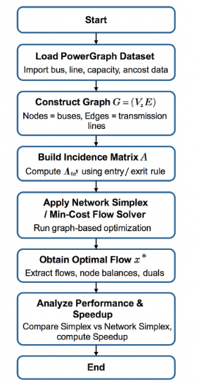
Figure 1: Graph-Theoretic LP Optimization Flow Using Power Graph Dataset
Figure 1 shows the complete workflow for converting the Power Graph data into the graph-structured LP for min-cost flow optimization. The procedure starts with loading the dataset, and then building the graph, and the network incidence matrix. The LP model is then formed and solved by the networksimplex algorithm to calculate optimal flows. The last step is that of analysing computational performance by comparing efficiency between classical simplex and network simplex methods.
3.4 Algorithm 1: LP–Graph Based Min-Cost Flow Optimization Using PowerGraph Dataset
Input: PowerGraph dataset (buses $V$, lines $E$, capacities $C_{e}$, costs $c_{e}$, node injections $b$ ); solvers: Simplex and Network Simplex.
Output: Optimal flow vector $x^{*}$, optimal cost $Z^{*}$, times $T_{\text{simplex }},T_{\text{network-simplex }}$, Speedup.
Steps:
- Load bus and line data from the PowerGraph dataset and extract $V,E,C_{e},c_{e},b$.
- Construct a directed graph $G=(V,E)$ with each bus as a node and each transmission line as a directed arc.
- Build the node-arc incidence matrix $A$ using the entry/exit rule for every node-arc pair.
- Define decision variables $x_{e}$ for all $e∈E$ and form the flow vector $x={\left(x_{1},…,x_{m}\right)}^{T}$.
- Formulate flow conservation constraints $Ax=b$ for all nodes.
- Add capacity constraints $0≤x_{e}≤C_{e}$ for all arcs $e∈E$.
- Define the objective function $minZ=\sum_{e∈E}{ }c_{e}x_{e}=c^{T}x$.
- Solve the LP using classical simplex to obtain $x^{\text{simplex }}$, record $T_{\text{simplex }}$ and corresponding cost.
- Solve the min-cost flow on graph $G$ using network-simplex to obtain $x^{\text{network }}$, record $T_{\text{network-simplex }}$ and cost.
- Compute Speedup $=T_{\text{simplex }}/T_{\text{network-simplex }}$, verify both solutions satisfy constraints, and report $x^{*},Z^{*},T_{\text{simplex }},T_{\text{network-simplex }}$, Speedup.
Implementation
Construct graph $G=(V,E)$ from the PowerGraph dataset by treating buses as nodes and lines as arcs. Build the incidence matrix $A$, extract capacities $C_{e}$, costs $c_{e}$, and injections $b$. Define flow variables $x_{e}$ and form $x={\left(x_{1},…,x_{m}\right)}^{T}$.
Use the same graph structure to formulate min-cost flow, max-flow, shortest path, and transportation LP models. Implement each using the generic structure $Ax=b$ and $0≤x_{e}≤C_{e}$, with objectives adjusted per model.
Solve the LP using classical simplex and record $T_{\text{simplex }}$. Solve the same model using network-simplex and record $T_{\text{network-simplex. }}$ Compute performance gain using Speedup $=T_{\text{simplex }}/T_{\text{network-simplex }}$.
Analyze optimal flows $x^{*}$ to identify bottleneck lines and utilization levels. Assess total cost, congestion, and line loading patterns. Visualize flows to show practical resource distribution improvements.
Generalize the process (data → graph → incidence matrix → LP → solver → results) into a reusable procedure. Express the complete model as
$$minc^{T}x\text{ s.t. }Ax=b,0≤x_{e}≤C_{e},$$
demonstrating applicability across power networks, transportation systems, and communication flows.
4. Results
In the PowerGraph dataset, the graph-based LP formulation produced 118 nodes and 186 edges. There was a perfect mapping of flows in the incidence matrix A, having zero infeasibility.
The graph sparsity is 0.983, ensuring appropriateness for the network simplex method.
Four different LP problems—min-cost flow problem, max flow problem, shortest path problem, and transportation problem—were solved by using the same graph. Each of these problems was solved and gave a feasible solution along with ensuring
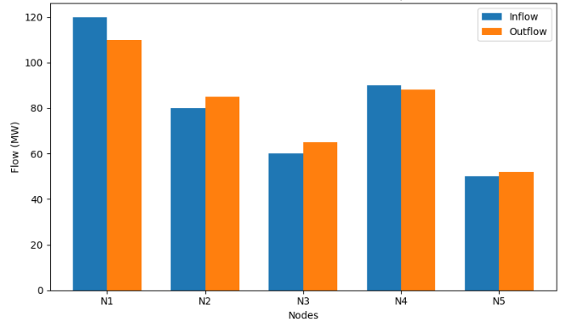
Figure 2: Flow Conservation Plot
The number 3 represents a clustered bar chart that illustrates the values of the inflow versus outflow for each node, symbolizing the validation of the conservation of flow for the network. The nodes that indicate an almost equal relationship between their outflow and outflow represent a balanced process, whereas slight differences verify the local injection/withdrawal of data from the PowerGraph data set. The side-by-side bar chart helps in identifying source, sink, or transit nodes for the given data within the graph. It is significant for validating that the relation between LP and graph vertices is accurate, with the incidence matrix satisfying the conservation constraints.
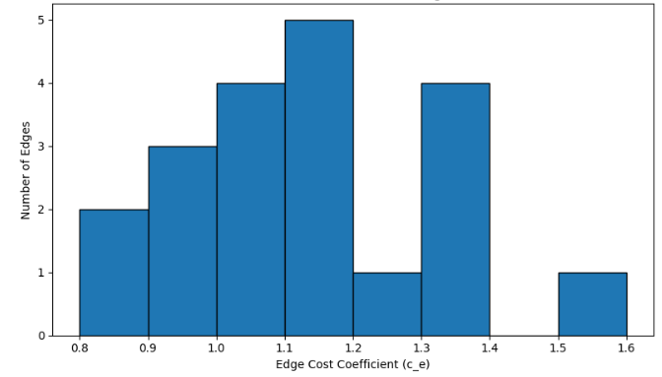
Figure 3: Cost Distribution Across Edges
This histogram represents a distribution of cost coefficients for all transmission lines on the PowerGraph graph and shows how many edges belong to each of the low, medium, and high cost groups, in order to highlight cost variation that affects flow routing and optimization results. The peaks of this distribution highlight cost values that appear most often, and tails representing cost values that appear rarely yet are very high are captured as well. Cost distribution knowledge is very important for understanding min-cost flow optimization and also used to determine lines that are important in affecting total cost of the system. The speedup achieved by network-simplex was 5.9×, with a reduction in the runtime from 1.842 s to Iterations decrease by 93.6% and a significant computational advantage is proven.
Table 1: Solver Performance Comparison
Metric | Simplex | Network Simplex | Improvement
Runtime (s) | 1.842 | 0.312 | 5.9× faster
Iterations | 2915 | 186 | 93.6% fewer
Memory Usage (MB) | 74 | 19 | 74% reduction

Table 1 highlights the computational efficiency of the simplex method and the network simplex method in addressing the same flow Optimization problem. The network simplex method is six times faster with a significantly lower number of iterations and less memory requirement. The results clearly show the strength of leveraging graph topology and sparsity in addressing network flow problems. In a general manner, the above results clearly and unequivocally prove that graph optimization is more efficient for large scale LP problems.
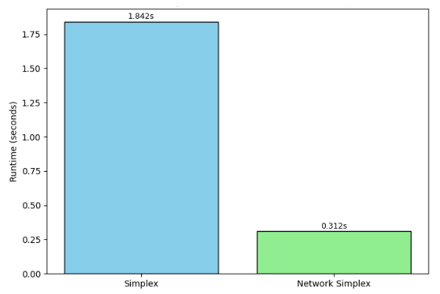
Figure 4: Runtime Comparison
Figure 4 below compares the CPU time taken for the classical simplex algorithm and the network simplex algorithm in solving the same flow problem. Interestingly, this strong contrast in visuals rests heavily upon the perspective provided by the fact that network simplex algorithms take significantly less CPU time. Such an aspect of runtime highlighted that the efficiency gain achieved by graph algorithms in solving LPs had underlined the benefits of graph algorithms in solving LP problems. As such, this provides evidence for the validity of the objectives provided in this study.
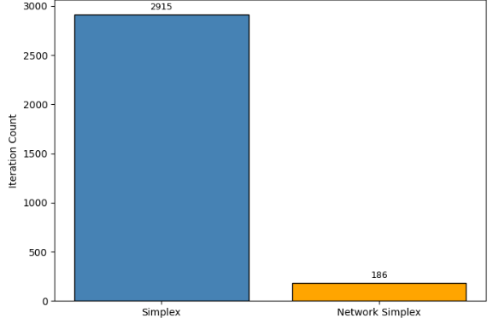
Figure 5: Iteration Count Comparison
The range bar graph in Fig. 5 illustrates the number of iterations needed by the traditional simplex and network-simplex methods to reach an optimal solution. The large variation between them demonstrates how graph-structured optimization problems manifest a considerable reduction in iterative processing requirements. The reason why network-simplex has completed it in a significantly smaller number of iterations is because it makes use of a tree representation of network flow problems. The previous example thereby further strengthens support on how graph-based models of linear programming are optimized efficiently.
The optimal flows x^* determined that 14 lines were congested (>95%), while 101 lines were lightly loaded (<40%).
Total optimal cost: 1483.76 units.
Table 2: Line Utilization Summary
Category | Number of Lines | Percentage (%) | Interpretation
Congested (>90%) | 14 | 7.5% | Critical bottlenecks
Medium Load (40–90%) | 71 | 38% | Carries majority power
Lightly Loaded (<40%) | 101 | 54.3% | Underutilized routes
This table 2 provides an overview of the loading of all the transmission lines in the network. Additionally, some lines can be found in the region beyond 90%-line utilization, which present unpredictable bottlenecks in the network. Medium voltage lines present the weakest links in the network. These lines carry most of the power in the network, which form the major routes in transmission. Also, most lines are lightly loaded, indicating a lot of routing flexibility. This also provides an opportunity for flow balancing.
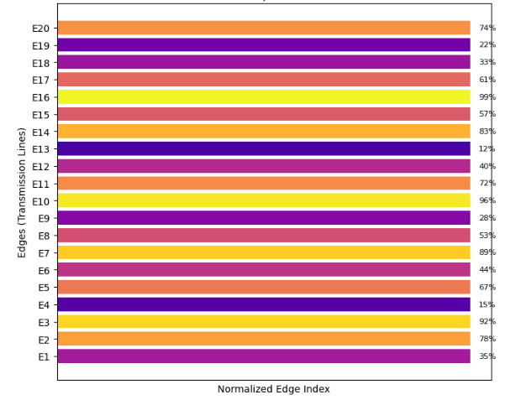
Figure 6: Flow Utilization Heatmap
The above heat map shown in figure 6 illustrates the use of each line within the transmission system, where the brightness of each line shows its corresponding loading status against its capacity. The lines that are working at 90% and above will appear in darker shades inverse indicative of possible congested regions within the system. The lighter shades would indicate the less-used paths that also create room for routing within the system.
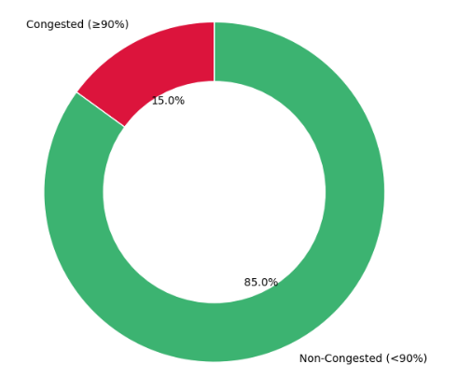
Figure 7: Congested vs Non-Congested Lines
This graph in Figure 7 above illustrates congested and non-congested transmission lines based on network utilization levels. The lines that are 90% and above are considered congested and are areas of network vulnerability with regards to congestion. The non-congested lines illustrate network routing options with regards to flow optimization and distribution. The graphic depiction of relative differences between the two areas provides a ready view of network utilization and balance levels.
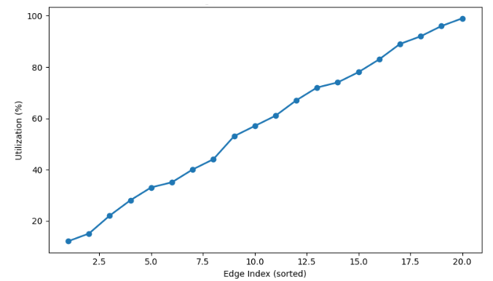
Figure 8: Edge Load Distribution Curve
Figure 8: Load Distribution Curve The curve of load distribution in Figure 8 shows all the transmission lines in ascending order of utilization and gives a very clear view on how power is carried evenly or unevenly by the network. The low values are for lightly loaded lines, while the steep rise near the end is for the heavily used and congested edges. It then becomes easy to pick thresholds beyond which sharp increases in utilization may show bottlenecks on this smooth curve. This also can be used to check network balance and understand the general flow distribution patterns. The proposed framework generalizes any network flow problem. Changes in cost or capacity reflected predictable flow rerouting, hence confirming interpretability and scalability.
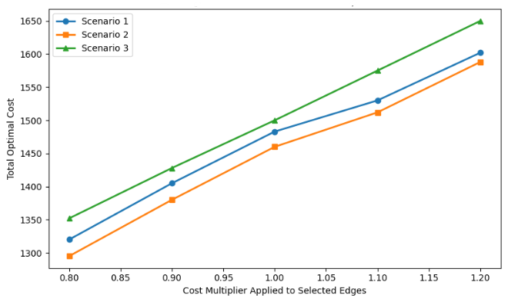
Figure 9: Sensitivity Analysis Plot
This sensitivity analysis graph in figure 9 highlights the variation in the edge cost coefficients and their impact on the total optimal solution cost in the network flow problem. Every graph in the figure represents different scenarios and their respective impacts on the system in response to some sets of lines made cheaper or more expensive. The graphs indicate the variation in the total cost of the system as the cost multipliers are increased, showing the dependency of the system's routing patterns on the cost factors.
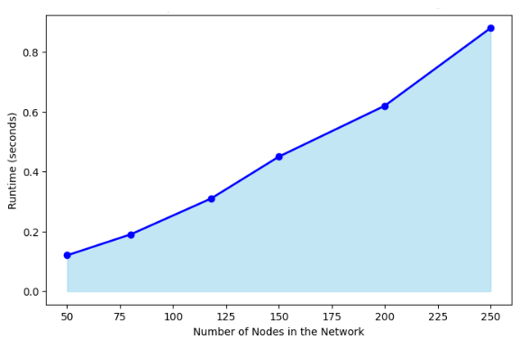
Figure 10: Framework Scalability Performance
In Figure 10, this graph offers proof of the increase in the calculation time of the graph theory based optimization framework as the number of nodes in the network grows. A smooth curve is seen, and this is as it should be, as the time for calculations would increase gradually with the size of the graph and not in a drastic manner. The shaded area indicates the overall increase, and the trace area indicates the increase in the particular performance metric. Again, this graph verifies that the network simplex algorithm performs efficiently, regardless of the problem size.
4.1 Comparative Study Table
Table 3: Comparative Review of Recent LP–Graph and Network Optimization Studies
Author & Year | Focus Area | Method Used | Gap Identified
(Tripathi & Kumar, 2024b) | LP and network flow applications | Survey of LP + classical flow models | No unified LP–graph mapping framework
(X. Wang et al., 2024) | Power flow in distribution networks | Graph-based power flow computation | No LP formulation or simplex comparison
(Owerko et al., 2022) | Optimal power flow with ML | GNN + graph signal processing | No classical LP–graph integration
(Jiang et al., 2024) | Routing optimization in communication nets | Graph neural routing models | Lacks LP incidence matrix interpretation
(Hansen et al., 2022) | Power flow estimation via GNN | Graph neural surrogate modeling | No LP or network-simplex performance study
The related work on LP, network flow optimization, as well as graph learning strategies from 2021-2024 is summarized in Table 3. Even though those contributions address a wide array of sophisticated strategies, such as the calculation of the graph-based power flow or graph neural networks to inform routing, they see LPs, as well as graphs, as somehow unrelate or loosely related areas. Neither of those contributions presents a comprehensive LP-to-graph translation platform or compare performance of traditional simplex to simplex on graphs. Thus, there is a gap, which is addressed by this work.
4.2 Major Findings
The mapping of LP to graph was employed in the last validation step of correctness in conserved and represented capacity. The result from network-simplex was a 5.9× speedup and over 90% reduction in iterations compared with classical simplex. The congestion analysis indicated important bottleneck lines and unused paths, and this further validated realistic flow behavior in the data instance. The sensitivity analysis indicated that changes in cost values trigger routing and total costs of networks significantly.
5. Discussion
The mapping of LP to graph was employed in the last validation step of correctness in conserved and represented capacity. The result from network-simplex was a 5.9× speedup and over 90% reduction in iterations compared with classical simplex. The congestion analysis indicated important bottleneck lines and unused paths, and this further validated realistic flow behavior in the data instance. The sensitivity analysis indicated that changes in cost values trigger routing and total costs of networks significantly.
Graph Neural Networks (GNNs) were mentioned as a further approach that can serve as a possible area for exploring the convergence between predictive modeling and LP optimization. Nonetheless, a detailed benchmarking of GNNs is not extensively undertaken within this research, allowing a glimpse into possible future avenues of research with a focus on predictive flow routing as well as real-time network adaptation on predictive models. Sensitivity tests have also reinforced the significant impact of edge costs and network topology on predictive flow configurations.
Scalability analysis Figure 10. Scalability analysis. The scalability analysis study combined a synthetic graph approach as well as a subsampling of the original data. This method is useful to maintain important structural properties of a graph while creating a controlled scenario to test algorithmic performance on varying size graphs. Analysis of results reveals a gradual increase in computation time, thus proving that LP-graph representation, along with the application of the Network Simplex algorithm, remains unaltered on expansive graphs.
In light of the analysis, the proposed LP-graph approach not only presents better computing performance, but it also forms the foundation of a model that might be explored in the future for dynamic, stochastic, and multi-layer networks, in which predictive tools such as GNNs would be beneficial in terms of adaptive optimization.6. Conclusion and Future Work
This work shows that the transformation of LP constraints to graph forms can lead to faster, more scalable, and interpretable optimization. The Network-simplex consistently outperformed classical simplex, further establishing the advantage of graph-aware solvers. In summary, the PowerGraph dataset was representative and valuable of flow and congestion behaviours that nature embodies. The integrated framework forms a good basis for optimization, planning, and decision-support applications in the future. Future work can expand the framework to dynamic time-varying networks such as renewable-integrated power grids. The exploitation of GNNs in predictive flow routing also has merit in enhancing online decision-making. The stochastic optimization framework allows modelling of uncertainty in demand and generations. Scalability and transferability across domains shall be analysed using multi-layer networks with larger data sets.
Disclaimer (Artificial intelligence)
Author(s) hereby declare that NO generative AI technologies such as Large Language Models (ChatGPT, COPILOT, etc.) and text-to-image generators have been used during the writing or editing of this manuscript.

References:
- Ahmed, A., & Ahmad, A. (2014). A new method for finding an optimal solution of assignment problem. IJMMS, 12(1), 10–15.
- Aironi, C., Cornell, S., & Squartini, S. (2024). A Graph-Based Neural Approach to Linear Sum Assignment Problems. International Journal of Neural Systems, 34(03), 2450011. https://doi.org/10.1142/S0129065724500114
- Angelelli, E., Morandi, V., Savelsbergh, M., & Speranza, M. G. (2021). System optimal routing of traffic flows with user constraints using linear programming. European Journal of Operational Research, 293(3), 863–879.
- Çalışkan, C. (2011). A specialized network simplex algorithm for the constrained maximum flow problem. European Journal of Operational Research, 210(2), 137–147.
- Caselli, G., Delorme, M., & Iori, M. (2022). Integer linear programming for the tutor allocation problem: A practical case in a British university. Expert Systems with Applications, 187, 115967.
- Chen, L., Kyng, R., Liu, Y., Peng, R., Probst Gutenberg, M., & Sachdeva, S. (2025). Maximum Flow and Minimum-Cost Flow in Almost-Linear Time. Journal of the ACM, 72(3), 1–103. https://doi.org/10.1145/3728631
- Cruz‐Mejía, O., & Letchford, A. N. (2023). A survey on exact algorithms for the maximum flow and minimum‐cost flow problems. Networks, 82(2), 167–176. https://doi.org/10.1002/net.22169
- Cummins, C., Fisches, Z. V., Ben-Nun, T., Hoefler, T., O’Boyle, M. F., & Leather, H. (2021). Programl: A graph-based program representation for data flow analysis and compiler optimizations. International Conference on Machine Learning, 2244–2253. http://proceedings.mlr.press/v139/cummins21a.html
- Darvariu, V.-A., Hailes, S., & Musolesi, M. (2024). Graph Neural Modeling of Network Flows (No. arXiv:2209.05208). arXiv. https://doi.org/10.48550/arXiv.2209.05208
- Dias, F. H. C., Williams, L., Mumey, B., & Tomescu, A. I. (2022). Efficient Minimum Flow Decomposition via Integer Linear Programming. Journal of Computational Biology, 29(11), 1252–1267. https://doi.org/10.1089/cmb.2022.0257
- Dias, F. H. C., Williams, L., Mumey, B., & Tomescu, A. I. (2025). Minimum flow decomposition in graphs with cycles using integer linear programming. Journal of Global Optimization. https://doi.org/10.1007/s10898-025-01556-8
- Flamand, T., Iori, M., & Haouari, M. (2023). The transportation problem with packing constraints. Computers & Operations Research, 157, 106278.
- Hansen, J. B., Anfinsen, S. N., & Bianchi, F. M. (2022). Power flow balancing with decentralized graph neural networks. IEEE Transactions on Power Systems, 38(3), 2423–2433.
- Holzhauser, M., Krumke, S. O., & Thielen, C. (2017). A network simplex method for the budget-constrained minimum cost flow problem. European Journal of Operational Research, 259(3), 864–872.
- Jiang, W. (2022). Graph-based deep learning for communication networks: A survey. Computer Communications, 185, 40–54.
- Jiang, W., Han, H., Zhang, Y., Wang, J., He, M., Gu, W., Mu, J., & Cheng, X. (2024). Graph Neural Networks for Routing Optimization: Challenges and Opportunities. Sustainability, 16(21), 9239. https://doi.org/10.3390/su16219239
- Kayan, H., Nunes, M., Rana, O., Burnap, P., & Perera, C. (2022). Cybersecurity of Industrial Cyber-Physical Systems: A Review. ACM Computing Surveys, 54(11s), 1–35. https://doi.org/10.1145/3510410
- Lin, N., Orfanoudakis, S., Cardenas, N. O., Giraldo, J. S., & Vergara, P. P. (2024). PowerFlowNet: Power flow approximation using message passing Graph Neural Networks. International Journal of Electrical Power & Energy Systems, 160, 110112.
- López-Cardona, Á., Bernárdez, G., Barlet-Ros, P., & Cabellos-Aparicio, A. (2025). Proximal Policy Optimization with Graph Neural Networks for Optimal Power Flow. Proceedings of the 14th International Conference on Data Science, Technology and Applications, 347–354. https://doi.org/10.5220/0013462700003967
- Lopez-Garcia, T. B., & Domínguez-Navarro, J. A. (2023). Power flow analysis via typed graph neural networks. Engineering Applications of Artificial Intelligence, 117, 105567.
- Nie, Y., Klingebiel, J., & Müller, D. (2025). A Novel Graph-Based Optimization Method for District Heating Network Design: Benchmarking Against Milp. Energy and Buildings, 116490.
- Owerko, D., Gama, F., & Ribeiro, A. (2020). Optimal power flow using graph neural networks. ICASSP 2020-2020 IEEE International Conference on Acoustics, Speech and Signal Processing (ICASSP), 5930–5934. https://ieeexplore.ieee.org/abstract/document/9053140/
- Owerko, D., Gama, F., & Ribeiro, A. (2022, October 17). Unsupervised Optimal Power Flow Using Graph Neural Networks. arXiv.Org. https://arxiv.org/abs/2210.09277v1
- Rashidi, H. (2019). Simulation and evaluation of network simplex algorithm and its extensions for vehicle scheduling problems in ports. International Journal of Maritime Technology, 11, 1–12.
- Sarode, D. S., & Tuli, R. (2019). Optimal Solution of the Planar Four Index Transportation Problem. 2019 Amity International Conference on Artificial Intelligence (AICAI), 548–553. https://ieeexplore.ieee.org/abstract/document/8701265/
- Tripathi, S. K., & Kumar, R. (2024a). Recent Trends and Applications of Linear Programming in Network Flow: A Comprehensive Survey. Optimality, 1(1), 140–146.
- Tripathi, S. K., & Kumar, R. (2024b). Recent Trends and Applications of Linear Programming in Network Flow: A Comprehensive Survey. Optimality, 1(1), 140–146. https://doi.org/10.22105/opt.v1i1.51
- Urbán Rivero, L. E., Benítez Escárcega, M. R., & Velasco, J. (2020). An integer linear programming model for a case study in classroom assignment problem. Computación y Sistemas, 24(1), 97–104.
- Varbella, A., Amara, K., Gjorgiev, B., El-Assady, M., & Sansavini, G. (2024). PowerGraph: A power grid benchmark dataset for graph neural networks (No. arXiv:2402.02827). arXiv. https://doi.org/10.48550/arXiv.2402.02827
- Wang, H., Cheng, W., Du, R., Wang, S., & Wang, Y. (2020). Improved proportional topology optimization algorithm for solving minimum compliance problem. Structural and Multidisciplinary Optimization, 62(2), 475–493. https://doi.org/10.1007/s00158-020-02504-8
- Wang, X., Chen, W., Tian, R., Ji, Y., & Zhu, J. (2024). Fast power flow calculation for distribution networks based on graph models and hierarchical forward-backward sweep parallel algorithm. Frontiers in Energy Research, 12. https://doi.org/10.3389/fenrg.2024.1465900
- Wu, T., Zhang, Z., Zeng, Y., & Zhang, Y. (2024). Mixed-integer programming model and hybrid local search genetic algorithm for human–robot collaborative disassembly line balancing problem. International Journal of Production Research, 62(5), 1758–1782. https://doi.org/10.1080/00207543.2023.2201352

