Effectiveness of Swiss Ball and Pilates Exercises on Weight Management in Young Women with Polycystic Ovarian Disease
ABSTRACT
Polycystic Ovary Disease is a hormonal disorder that develops due to abnormal secretion of androgens, resulting in functional ovarian hyperandrogenism. PCOD is one of the most frequently observed endocrine conditions affecting women in their reproductive years. Regular physical activity, particularly exercises such as Swiss ball and Pilates, can play a significant role in the management of PCOD. These exercises help regulate hormonal balance, improve insulin sensitivity, support weight control, and restore overall hormonal health. They also contribute to BMI reduction and improvement in waist–hip ratio, which is key of metabolic risk in PCOD. Along with this, they promote better strength, postural alignment, and muscle coordination, which enhances day-to-day activities. Consistent practice may further assist in achieving more regular menstrual cycles in women experiencing irregularities. The present research aims to investigate the effectiveness of Swiss ball and pilates exercises on weight management in young women with PCOD. The inclusion criteria cover students with diagnosed PCOD of age 18-24 years with BMI ranging from 25-30 kg/m.2 This Swiss ball and pilates exercise will include 15-20 repetitions, performed for 5 days a week for up to 8-12 weeks. The current study revealed that Swiss ball and Pilates exercises are effective in reducing BMI among young women with PCOD, though changes in waist-to-hip ratio were fluctuating. Individual differences in body composition may influence outcomes, but overall, these exercises can support lifestyle modification and improve both metabolic and reproductive health.
Keywords: BMI, PCOD, pilates, students, swiss ball, waist hip ratio, weight reduction management
INTRODUCTION
Polycystic Ovarian Disease (PCOD) is a common endocrine disorder affecting individuals with ovaries, primarily during their reproductive years. Polycystic Ovary Disorder (PCOD), also known as Stein-Leventhal Syndrome, characterized by the presence of multiple small, pearl-sized cysts in the ovaries. These cysts are fluid-filled and contain immature eggs, often leading to irregular menstrual cycles, ovulatory dysfunction, and hormonal imbalances. Both genetic and environmental factors contribute to its development. It is characterized by hormonal imbalances, irregular menstrual cycles, multiple small cysts in the ovaries, and metabolic disturbances¹´². The effective lifestyle management is a key component of PCOS care, evidence of higher longitudinal weight gain in community populations and high attrition rates in clinical weight management interventions. Women are particularly vulnerable to psychological factors that can reduce self-efficacy, such as poor self-esteem and self-doubt, which detrimentally affects their ability to implement lifestyle change. In order to avoid disease-related complications, regulate symptoms, and reduce the severity of disease, self-management strategies that counter negative thoughts and improve support from family/friends should be targeted in PCOS. However, previous research reported that only a limited number of PCOS websites provided advice on self-management strategies [14,15].
The prevalence of PCOD is steadily increasing worldwide, partly due to low awareness of its symptoms among young women. Undiagnosed PCOD can result in infertility. Globally, approximately 5–10% of women of reproductive age (15–44 years) are affected, with most cases identified in the second and third decades of life, often when difficulties in conception prompt medical consultation. The condition commonly presents with weight gain, acne, excessive hair growth (hirsutism), and metabolic disturbances, particularly insulin resistance and elevated androgen levels. Notably, women with PCOD often experience preferential fat accumulation in the abdominal region, which further exacerbates hormonal imbalances and metabolic complications³.Physical therapy, in particular, has been shown to play a significant role in the management of PCOD by reducing body mass index (BMI),and waist hio ratio , improving insulin sensitivity, regulating menstrual cycles, and alleviating associated symptoms. In addition to physical activity, physiological adaptations in body composition are conditioned by numerous endogenous and exogenous factors, such as genetic factors, lifestyle, gender, age, caloric intake, food quality, sleep quality, stress, and other factors determining body composition [16].
Generally, regular physical activity with proper nutrition is considered a dominant factor Among various forms of exercise, Swiss ball training has gained attention as it not only enhances core stability and postural control but also promotes muscular strength, balance, and fat loss. Research has shown that Swiss ball exercises are particularly effective in reducing abdominal fat and overall body weight, which is important for improving hormonal regulation, metabolic function, and reproductive health in women with PCOD. Women with PCOD often experience greater weight gain, especially in the abdominal region, compared to individuals with normal fat distribution. This central fat accumulation is more resistant to reduction, making weight management slower and more challenging in PCOD⁴´⁵. Similarly, Pilates, a form of controlled and low-impact exercise, has demonstrated considerable benefits in women with PCOD. Regular practice of Pilates improves body composition, flexibility, and endurance, while also reducing pain and improving menstrual regularity. Furthermore, Pilates contributes to better mental well-being, which is often compromised in women with PCOD due to stress, anxiety, and body image issues⁶.Both Swiss ball and Pilates exercises are effective non-pharmacological strategies for managing PCOD. Swiss ball training enhances core stability, balance, and muscular strength while promoting abdominal fat reduction and weight management through dynamic movements. Pilates improves flexibility, joint mobility, breathing, and mind-body awareness, supporting stress reduction and menstrual regularity. Together, these exercises improve insulin sensitivity, cardiovascular health, and mental well-being, offering a holistic approach to managing the physical, hormonal, and psychological aspects of PCOD. This present study is aimed to investigate the effectiveness of swiss ball and pilates exercises on weight management in young womens with PCOD.
METHODOLOGY:
The patients for study are scouted from the Dr. B.R Ambedkar Medical College and Hospital, Department of Physiotherapy, Bangalore.
STUDY DESIGN:
- STUDY TYPE: Experimental study
- SAMPLING TECHNIQUE: Purposing sampling technique
- SAMPLE SIZE: 18
- DURATION OF STUDY: The duration of the study is 8-12 weeks
INCLUSION CRITERIA:
- Diagnosed PCOD in young womens
- Age group: 18-24years.
- BMI range: 25-30 kg/m.²

EXCLUSION CRITERIA:
- History of recent abdominal or pelvic surgery.
- Hormonal therapy.
- BMI range: less than 25kg/m²

OUTCOME MEASURES: Waist hip ratio and Body Mass Index
STUDY PROCEDURE:
In this study, Young womens, aged 18–24 years, diagnosed with polycystic ovarian disease (PCOD), and having a BMI between 25–30 kg/m². Participants were recruited through purposive sampling, based on inclusion and exclusion criteria. After obtaining informed consent, a structured exercise program was implemented for 8 -12 weeks exercise programme was implemented, combining swiss ball and pilates exercise, both pre- and post-intervention assessments were conducted to measure changes in waist-Hip ratio (WHR), and Body Mass Index (BMI), allowing evaluation of the effectiveness of the exercise program. The intervention aimed to reduce abdominal fat, improve BMI, decrease WHR, and promote more regular menstrual cycles. Data collection was carried out systematically, ensuring confidentiality and voluntary participation

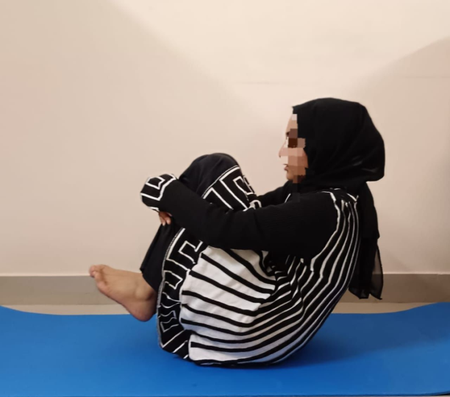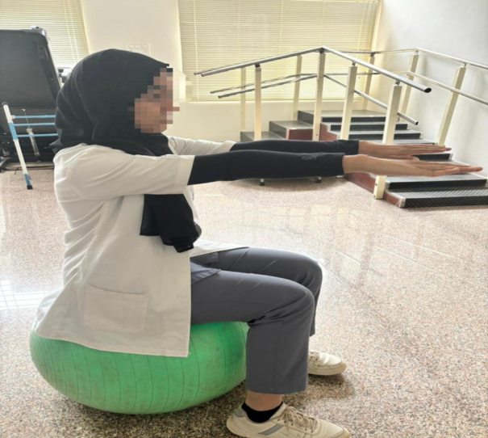
Fig. 1. Student perfoming exercise
DATA ANALYSIS
The statistical analysis was done using SPSS 23.0. The categorical variables were represented in frequency and percentage. Numerical variables were presented using mean and standard deviation. Pre post comparison was done using Paired sample t test. A p value <0.05 was considered statistically significant.

RESULTS and Discussion:
Table 1: Participants Distribution based on age in years
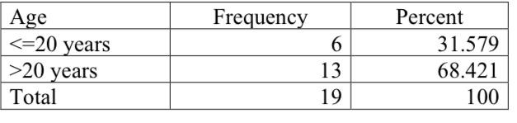
Among the participants, 31.58% were aged ≤20 years and 68.42% were aged >20 years. The overall age ranged from 18 to 24 years, with a mean of 21.11 ± 1.76 years.
Figure 2: Representation of age in years
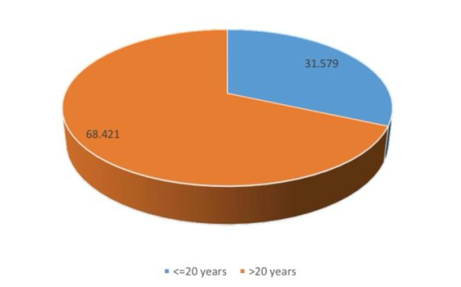
Table 2: Participants Distribution based on gender
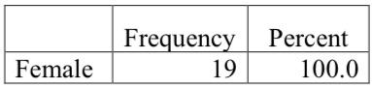
All participants in the study were female (100%).

Table 3: Pre post comparison in waist to hip ratio 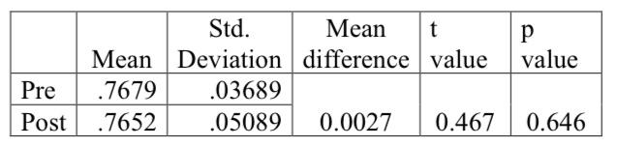
In the waist-to-hip ratio, the pre-intervention mean was 0.7679 ± 0.0369, while the post-intervention mean was 0.7652 ± 0.0369. The mean difference of 0.0027 was not statistically significant (t = 0.467, p = 0.646)

Figure 3: Representation of waist to hip ratio
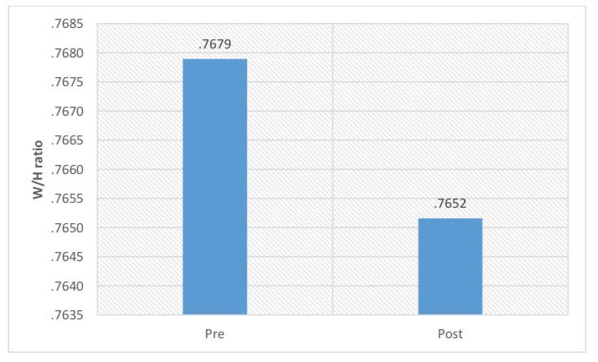

Table 4: Pre post comparison in BMI
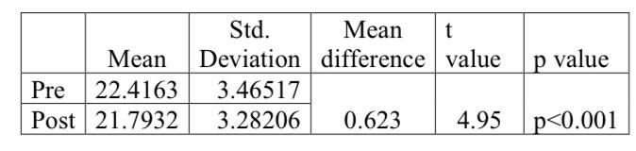
In BMI, the pre-intervention mean was 22.4163 ± 3.4652, while the post intervention mean was 21.7932 ± 3.2821. The mean difference of 0.623 was statistically significant (t = 4.95, p < 0.001).

Figure 4: Representation of BMI
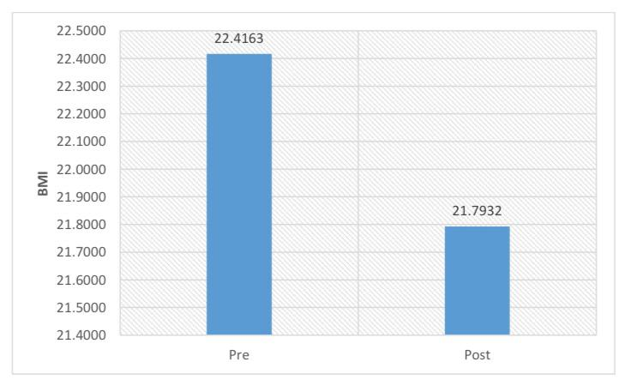
Polycystic Ovarian Disease (PCOD) is a common hormonal disorder in young womens, often associated with irregular menstruation, obesity, and metabolic complications, making lifestyle modification an essential part of management. The present study aimed to investigate the effectiveness of Swiss ball and Pilates exercises in weight reduction and BMI management among young female students with PCOD¹. This study was conducted at DR.B.R Ambedkar medical College with 19 young female students aged 18–24 years, out of total 6 were ≤20 years and 13 were >20 years. The intervention involved structured Swiss ball and Pilates exercises for 8-12 weeks, and outcomes such as BMI and waist-to-hip ratio were assessed pre- and post-intervention. The results showed a significant reduction in BMI after 8–12 weeks of intervention, indicating that these exercises are effective in supporting weight reduction. Swiss ball and Pilates exercises which focus on controlled movements, core strengthening, balance, and muscle activation, which may increase energy expenditure and improve overall physical fitness, leading to weight loss. However, individual variations were noted:changes in waist-to-hip ratio were not significant, suggesting that fat distribution, particularly around the abdomen, did not change equally in all participants. Individual differences in body composition, hormonal levels, and fat distribution patterns may explain this variation, as some participants showed weight loss without changes in waist hip ratio, while others showed improvement in waist hip ratio without major changes in body mass index. These findings highlight that body mass index alone may not fully represent changes in body fat distribution in women with polycystic ovarian disease. Compared to previous study, which reported high rates of obesity, dyslipidemia, and metabolic syndrome in adolescents with PCOS, our findings highlight the importance of exercise as an early non-pharmacological intervention to reduce such risks. Similarly, the study by Sumiya Nazir et al. (2024) found that Pilates improved menstrual cycle regularity and reduced pain, complementing our results that focused mainly on weight reduction. The results support previous studies showing that early exercise intervention can help reduce obesity-related risks in polycystic ovarian disease and may also contribute indirectly to improved metabolic and reproductive health. Overall, the study suggests that Swiss ball and Pilates exercises are safe, simple, and effective methods for weight management in young women with PCOD, although longer duration and combined lifestyle approaches may be required to achieve significant changes in central obesity¹¹.
CONCLUSION
This current study demonstrated that Swiss ball and Pilates exercises are effective in reducing BMI among young womens with PCOD, though changes in waist-to-hip ratio were less consistent. In a few cases, BMI was reduced without a significant improvement in waist-to-hip ratio, whereas in others, waist-to-hip ratio showed improvement despite minimal reduction in BMI. These individual variations suggest that body composition and fat distribution may influence exercise outcomes.. Overall, structured exercise programs such as Swiss ball and Pilates plays a valuable role in PCOD weight reduction management, complementing lifestyle modifications and potentially improving both metabolic and reproductive outcomes.

LIMITATIONS
- The study had a short follow up period for 8-12 weeks only, which is a short duration.
- Other parameters and scales were not assessed.

RECOMMENDATIONS
- The intervention period should be extended with larger sample, as longer durations may bring about more significant improvements in both BMI and waist-to-hip ratio.
- The study was conducted only among young female students within a narrow age range (18–24 years), limiting its applicability to broader populations.

Consent
As per international standards or university standards, Participants’ written consent has been collected and preserved by the author(s).

Disclaimer (Artificial intelligence)

- Author(s) hereby declare that NO generative AI technologies such as Large Language Models (ChatGPT, COPILOT, etc.) and text-to-image generators have been used during the writing or editing of this manuscript.

REFERENCES
- Joshi A. PCOD (Polycystic Ovarian Disease): A Review Article. ECS Transactions. 2022 Apr 24;107(1):15973.
- Anjali CS, George M, Das P, Soji S. PCOD in female reproductive age: A review. World J Pharm Res. 2019 Oct 27;9(1):677-84.
- Jayabalan Prakash TT, Sivakumar S, Dharini S. Effectiveness of Swiss ball exercises along with aerobic exercises among college girls with polycystic ovarian syndrome. IP Journal of Urology, Nephrology & Hepatology Science. 2021 Apr;4(2):34-7.
- Meenakshi M, Anitha A, Ramana K, Kamalakannan M. Efficacy of Swiss Ball Exercise and Resistance Training in Polycystic Ovarian Syndrome. Indian Journal of Physiotherapy & Occupational Therapy. 2024 Jan 2;18.
- OBG M. Effect of Swiss Ball Exercise and Progressive Resisted Exercise in Polycystic Ovarian Syndrome among Young Obese Women. Specialusis Ugdymas. 2022;1(43):43.
- Kumar MP, Angela SJ, Kavitha S. Benefit of Stability Exercise on Swiss Ball Exercise along with Treadmill Walking in Physiotherapy College Girl Students with PCOS Symptoms: Single Group Pre Post Design. Indian Journal of Physiotherapy & Occupational Therapy Print-(ISSN 0973-5666) and Electronic–(ISSN 0973-5674). 2022 Oct 19;16(4):117-21.
- Bonab SB. The effect of 12-week pilates training and ginger supplementation on polycystic ovary syndrome in women. Studies in Medical Sciences. 2020 May;31(2).
- Kite C. The effectiveness of exercise in the treatment of polycystic ovary syndrome (Doctoral dissertation, Aston University).
- Nazir S, Sadhu S. Effect of pilates on regulating menstrual cycle in females with polycystic ovarian syndrome. European journal of obstetrics & gynecology and reproductive biology: X. 2024 Mar 1;21:100271.
- Baidya S, Kumari V. Chapter-8 PCOD and Rehabilitation. Emerging Trends in Medical Sciences. 2023;113.
- Wardhan R. Polycystic ovarian cyst disorder (PCOD): causes and control. Best Pract Res Clin Obstet Gynaecol. 2016;18(5):685-706.
- Wang Y, Chen Z, Wu Z, Ye X, Xu X. Pilates for overweight or obesity: a meta-analysis. Frontiers in physiology. 2021 Mar 11;12:643455.
- Cao Y, Li G, Ren Y. Association between self-reported sedentary behavior and health-related quality of life among infertile women with polycystic ovary syndrome. BMC Womens Health. 2023 Feb 14;23
- Cowan S, Grassi A, Monahan Couch L, Jeanes Y, Lim S, Pirotta S, Harris J, McGirr C, Moran L. Evidence-based lifestyle guidelines and self-management strategies utilized by women with polycystic ovary syndrome. Nutrients. 2023 Jan 22;15(3):589.
- Abohllala AN, Branković N, Trajković N, Stojiljković N, Stamenković S, Marković S, Branković S, Nikolić U. Adaptive Changes in Body Composition under the Influence of the Core Body Ball Pilates Training. Facta Universitatis, Series: Physical Education and Sport. 2024 May 22:033-47.
- Sudhakar S, Ramachandran S, Deepthi RN, Senthil Selvam P, Ramachandran S, Senthil SP. Comparing Pilates and Gym Ball Exercises for Primary Dysmenorrhea Management: An Empirical Study. Cureus. 2024 Apr 28;16(4).

