The Geography of Hıgh-Value Agrıculture in Türkiye: Regıonal Clusterıng and Market Dynamıcs
ABSTRACT
This study analyzes the spatial distribution, regional clustering trends, and the underlying factors shaping these dynamics of high-value agricultural products (fruit, vegetables, ornamental plants) in Türkiye during the 2020-2024 period. Quantitative data analyses reveal that this production does not exhibit a random pattern but rather a distinct "geographical clustering". Fruit production has concentrated in the TR3 (Aegean), TRC (Southeastern Anatolia), and TR6 (Mediterranean) regions, driven by climatic advantages and irrigation investments. In vegetable production, the rise of traditional grain regions such as TR7 (Central Anatolia) is noteworthy, facilitated by market proximity and modern irrigation. The most extreme concentration is observed in the ornamental plants sector, which is entirely market- and logistics-oriented; 92.7% of production is clustered in the TR1 (Istanbul), TR3 (Aegean), and TR4 (Eastern Marmara) regions. The research emphasizes that while this clustering model provides productivity and competitive advantage, it simultaneously brings risks associated with climate change, water scarcity, and monoculture. For sustainable growth, product and regional diversification, water efficiency, strengthening of the value chain, and the dissemination of climate-resilient practices are recommended.
KEYWORDS: High-value agriculture, regional clustering, geographical clustering, fruit and vegetable geography, ornamental plants, Türkiye agriculture

- INTRODUCTION
In the global agri-food system, high-value (HV) products such as fresh fruit, vegetables, and ornamental plants hold critical importance both in terms of export revenues and gross income per unit area. Türkiye, with its climatic diversity, geographical location, young labor potential, and developing logistics infrastructure, holds a strategic position in this global market (Bashımov, 2017; Golowczyc & Gomez-Zavaglia, 2024).

This section analyzes the spatial distribution of high-value agricultural products in Türkiye and their changing dynamics over the last decade (Barrett et al., 2022; Benucci et al., 2022). Our core argument is that this production exhibits a "geographical clustering" in specific regions, rather than a random distribution. This clustering is based on economic and ecological dynamics such as comparative advantages, economies of scale, and market proximity, as emphasized in Paul Krugman's new trade and economic geography theories (Krugman, 1991a, 1991b; Cassani & Gomez-Zavaglia, 2022). "In the Türkiye context, these clusters are shaped by natural climatic advantages, state investments (especially irrigation projects), and access to major consumption/export centers. The climatic profiles of the studied regions are characterized by significant variations: the Mediterranean and Aegean regions benefit from mild winters and long growing seasons, whereas Central and Southeastern Anatolia rely heavily on irrigation due to semi-arid conditions” (Koubaa et al., 2024)). This study also considers the role of state-led irrigation investments, particularly the Southeastern Anatolia Project (GAP), as a transformative factor in regional agricultural specialization.
- MATERIALS AND METHODS
This research examines the geographical distribution of high-value agriculture in Türkiye using quantitative data and spatial analysis techniques.
Data Sources
The primary data source for the study is the annual "Crop Production Statistics" published by the Türkiye Statistical Institute (TurkStat). Specifically, datasets for the years 2020 and 2024 were used in the analyses. The data were compiled at the level of 12 NUTS-1 Regions for the fruit, vegetable, and ornamental plants groups as sown/planted areas (decare). State Hydraulic Works reports were utilized for supporting qualitative data on investment and transformation.
Analytical Methods and Calculations
- Regional Concentration Analysis: For each product group, the combined share of the total production area within the top three regions was calculated. This ratio was used as the primary indicator of the degree of geographical clustering.
- Temporal Change Analysis: Absolute and relative changes in the production areas of regions during the 2020-2024 period were calculated as percentages (%), and shifts among leading regions were identified.
- Comparative Regional Profile Analysis: By comparing the shares of HV products within the total agricultural area of each region, the degrees of regional clustering and agricultural identities were revealed.
Visualization and Software
All statistical calculations and tables were performed using Microsoft Excel. The Python programming language and pandas, matplotlib libraries were employed for processing datasets and creating thematic maps (choropleth maps) and bar charts. This software combination provided reproducible, verifiable, and effective visual analyses.

3. FINDINGS AND DISCUSSION
The Geography of Türkiye Fruit Production
Fruit production areas are among the most dynamic and value-adding components of Türkiye's agricultural sector. As of 2024, the total fruit area in Türkiye reached 37.99 million decares. However, an examination of the geographical distribution of this area reveals that production is concentrated in specific regions and this concentration is strengthening.
Table 1. Leading Regions in Fruit Area in 2024 and 2020-2024 Change Analysis
Rank | Region Code | Region Name | Fruit Area (da) | Share (%) | 2020-2024 Change (%)
1 | TR3 | Aegean | 8,652,765 | 22.8 | +2.1
2 | TRC | Southeastern Anatolia | 7,428,396 | 19.6 | +20.7
3 | TR6 | Mediterranean | 5,969,725 | 15.7 | +7.9
4 | TR9 | Eastern Black Sea | 5,052,886 | 13.3 | -0.0
5 | TR4 | Eastern Marmara | 2,977,887 | 7.8 | +6.1
- | Total | Türkiye Total | 37,992,021 | 100.0 | -
Source: TurkStat Crop Production Statistics (2020, 2024)
The data show that 58.1% of Türkiye’s fruit area is concentrated in just three regions (TR3 Aegean, TRC Southeastern Anatolia, TR6 Mediterranean) (Table 1). This indicates a distinct geographical clustering pattern. The most striking development in the table is the 20.7% growth experienced in the TRC (Southeastern Anatolia) region. The fruit area, which was 6.15 million decares in 2020, reached 7.43 million decares in 2024, surpassing the Mediterranean region and rising to second place. Behind this transformation lie the irrigation opportunities provided under the Southeastern Anatolia Project (GAP) and intensive investments in high-value products such as pistachio, olive, and apricot (Benek, 2009). This is a concrete example of how state investments can radically alter a region's comparative advantage.

Figure 1. Regional Distribution of Fruit Areas in Türkiye (2024)
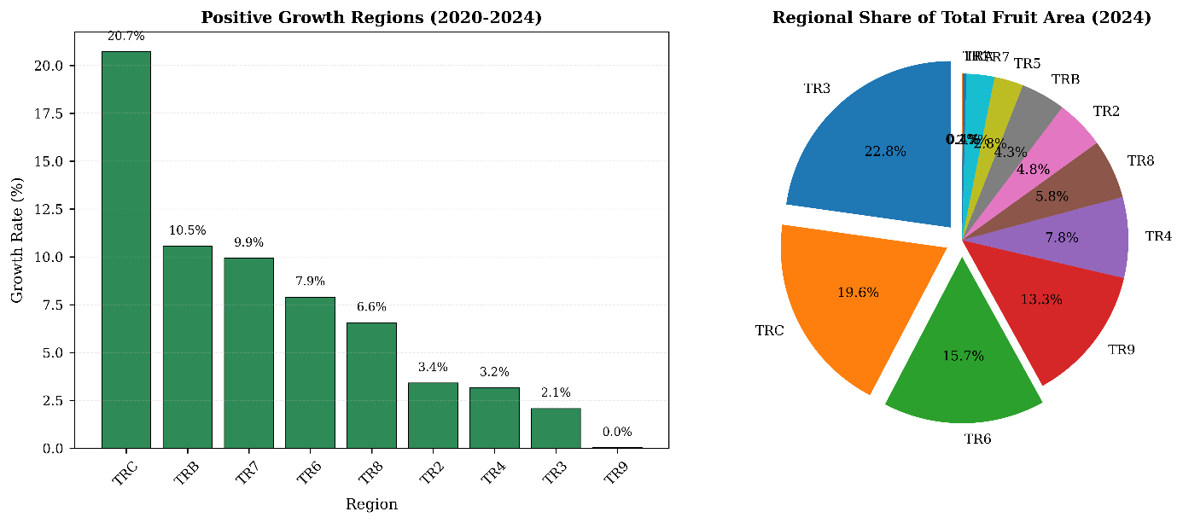
Figure 2. Regional Distribution of Growth Rate in Türkiye (2020-2024)
Figure 1 & 2 presents the geographical distribution of fruit production areas in Türkiye in 2024 alongside the regional growth rates for the 2020-2024 period. The data clearly demonstrate that specialization and growth in the sector are not geographically uniform. The TRC (Southeastern Anatolia) region stands out as the most dynamic expansion hub with an annual growth rate of 20.7%. This extraordinary growth is a direct result of irrigation investments under the Southeastern Anatolia Project (GAP) and investments in high-income products such as pistachio and olive. The traditional fruit production centers, TR3 (Aegean, 2.1%) and TR6 (Mediterranean, 7.9%), with relatively lower growth rates, can be interpreted as an indicator of already possessing an intensive production infrastructure. These findings reveal how state-supported infrastructure investments can rapidly transform regional comparative advantages in Türkiye's fruit-growing geography and highlight the strategic importance of sustainable water management for the sector's growth. The concentration of growth in a region with high water stress points to the critical role of efficient irrigation technologies and basin-based planning for the future sustainability of production.
Vegetable Production Corridors: The Balance of Domestic Market and Export
Vegetable production exhibits less geographical concentration compared to fruit; as many vegetable species have broader climate tolerance, and market proximity (logistics) plays a much more critical role in determining production location due to fresh consumption. Nevertheless, distinct clusters are observed, especially in regions with export-oriented activities and/or intensive greenhouse cultivation. The most noteworthy development here is the rise of TR7 (Central Anatolia), traditionally known as a grain and fallow region, to second place in vegetable area, overtaking the traditional vegetable base TR6 (Mediterranean) region (Table 2). A visual representation of the leading regions is provided in Figure 3.

Table 2. Prominent Regions in Vegetable Area in 2024
Rank | Region Code | Region Name | Vegetable Area (da) | Share (%)
1 | TR3 | Aegean | 1,175,632 | 15.9
2 | TR7 | Central Anatolia | 918,247 | 12.4
3 | TR6 | Mediterranean | 914,247 | 12.3
Source: TurkStat Crop Production Statistics (2024)

Figure 3. Leading Regions in Vegetable Area, 2024

Table 3. Vegetable Area (da) for Years 2020-2024
Region / Year | 2020 | 2021 | 2022 | 2023 | 2024
Mediterranean - TR6 | 1,634,888 | 1,541,056 | 1,435,388 | 1,393,400 | 1,425,836
Western Anatolia- TR5 | 865,690 | 885,827 | 882,758 | 864,388 | 897,372
Western Black Sea - TR8 | 771,009 | 762,723 | 689,532 | 656,248 | 664,579
Western Marmara - TR2 | 582,684 | 520,712 | 489,267 | 459,149 | 502,656
Eastern Black Sea - TR9 | 84,458 | 87,589 | 83,011 | 81,095 | 80,095
Eastern Marmara - TR4 | 691,770 | 666,752 | 610,411 | 621,269 | 700,375
Aegean - TR3 | 1,294,249 | 1,161,006 | 1,104,170 | 1,121,586 | 1,175,632
Southeastern Anatolia - TRC | 616,749 | 627,089 | 622,365 | 634,633 | 663,749
Northeastern Anatolia - TRA | 87,369 | 85,491 | 82,037 | 75,334 | 73,786
Central Anatolia - TR7 | 886,071 | 937,047 | 900,762 | 891,180 | 918,247
Eastern Anatolia - TRB | 248,828 | 249,705 | 249,096 | 298,107 | 278,695
Türkiye - TR | 7,792,463 | 7,553,346 | 7,176,802 | 7,122,641 | 7,406,857
Istanbul - TR1 | 28,698 | 28,349 | 28,005 | 26,252 | 25,835
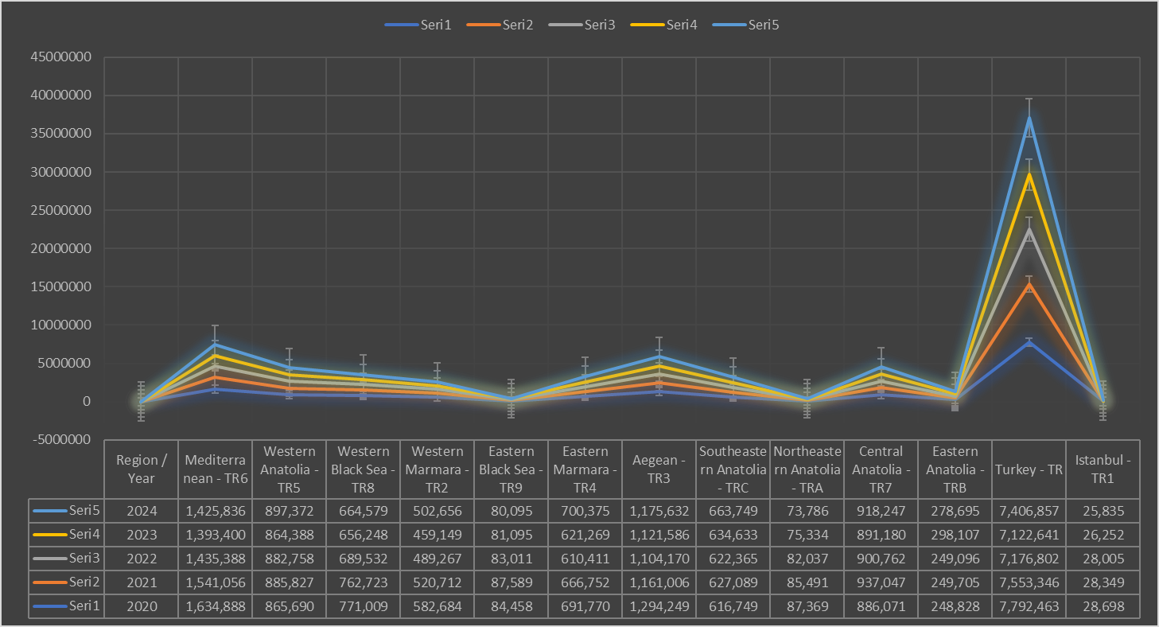
Figure 4. Annual Change in Total Vegetable Area in Türkiye's 12 Statistical Regions (2020-2024)
Figure 4 and Table 3 show the annual change in the total vegetable area across Türkiye's 12 statistical regions during the 2020-2024 period. The general trend is an approximately 5% decrease in Türkiye's total vegetable area, from 7.79 million decares in 2020 to 7.41 million decares in 2024. However, different regional dynamics underlie this decline. While areas in traditional vegetable production centers such as the Mediterranean (TR6), Aegean (TR3), and Eastern Marmara (TR4) have decreased significantly, the Western Anatolia (TR5), Central Anatolia (TR7), and Southeastern Anatolia (TRC) regions have recorded significant increases. Particularly in Central Anatolia (TR7), vegetable area increased by 3.6%, reaching 918 thousand decares with the spread of modern irrigation projects and greenhouse cultivation, making the region a rising center in Türkiye's vegetable production geography. In Southeastern Anatolia (TRC), a growth of 7.6% was observed, influenced by GAP irrigation investments. This distribution indicates a tendency for vegetable production to shift from traditional areas dependent on climatic advantages towards interior regions where factors such as irrigation infrastructure and market access are decisive.
Private Sector's Geographical Dominance: Extreme Concentration in Ornamental Plants
The ornamental plants (cut flowers, potted plants, seedlings) sector represents the peak of spatial concentration in Türkiye agriculture-a field entirely driven by market and logistics. Production is extremely densely locked into centers that are the heart of consumption and the main gates for exports. A striking 92.7% of Türkiye's ornamental plant area is clustered in just three regions (TR1 Istanbul, TR3 Aegean/Izmir, TR4 Eastern Marmara) (Table 4). The extreme concentration is visually summarized in Figure 5.
Table 4. Regional Distribution of Ornamental Plants Area in 2024
Region Code | Region Name | Area (da) | Share (%)
TR1 | Istanbul | 22,494.9 | 38.1
TR3 | Aegean (Izmir) | 18,951.4 | 32.1
TR4 | Eastern Marmara | 13,277.4 | 22.5
Other | Remaining 9 Regions | 5,267.6 | 7.3
Total | Türkiye Total | 59,991.3 | 100.0
Source: TurkStat Crop Production Statistics (2024)
A striking 92.7% of Türkiye's ornamental plant area is clustered in just three regions (TR1 Istanbul, TR3 Aegean/Izmir, TR4 Eastern Marmara) (Table 4). This situation proves the sector's absolute dependence on massive local consumption centers like Istanbul and export facilities such as the airport/port in Izmir (Taşçıoğlu & Sayın, 2005). TR4 (Sakarya, Kocaeli, Yalova, Bursa, Bilecik) has become a critical part of this cluster due to its proximity to the Istanbul market and suitable microclimate characteristics. This model is an example of the decisive role of "market potential" in determining production location, as described in Krugman's economic geography theory (Krugman, 1991b).

Figure 5. Regional Distribution of Ornamental Plants Area, 2024
Figure 5 clearly demonstrates the extreme geographical concentration of ornamental plant production in Türkiye in 2024. 92.7% (55,724 decares) of the total production area of 59,991 decares is clustered in only three regions (TR1 Istanbul, TR3 Aegean/Izmir, and TR4 Eastern Marmara). This distribution reflects the sector's absolute logistical dependence on consumption and export centers. The TR1 (Istanbul) region ranks first with a 38.1% share, showing the determining influence of the presence of a massive local market with a population exceeding 16 million and wholesale distribution centers on production location. The TR3 (Aegean) and TR4 (Eastern Marmara) regions, with shares of 32.1% and 22.5% respectively, form the other critical pillars of this intensive cluster, thanks to their proximity to the Istanbul market, suitable microclimate conditions, and access to air/sea export corridors in Izmir. The fact that the combined share of the remaining nine regions is only 7.3% proves that the geographical flexibility of ornamental plant production is extremely limited and that "market potential" has become a dominant factor in the spatial organization of production, as foreseen in Paul Krugman's economic geography theory (Krugman, 1991b).
Dynamics of Clustering, Gains, and Future Risks
The analyses clearly reveal three main driving forces shaping the geography of high-value agriculture in Türkiye:
- Absolute Climate and Natural Resource Advantage: The natural superiorities of the Mediterranean (TR6) and Aegean (TR3) regions, such as mild winters and long, hot summers, formed the basis of traditional fruit and vegetable strongholds.
- State Investments and Infrastructure Transformation: The massive transformation experienced in the TRC (Southeastern Anatolia) region thanks to GAP projects is evidence of how the state's irrigation and rural infrastructure investments can fundamentally change a region's comparative advantage.
- Market and Logistics-Oriented Clustering: As seen especially in the ornamental plants sector, proximity to major consumption centers and export points can become the strongest factor determining the geography of production.
This high degree of geographical clustering provides significant gains in terms of productivity, knowledge accumulation, branding, and market access. However, it also brings significant risks. Extreme heat, drought, and frost events caused by climate change directly threaten these regions where production is excessively concentrated (Göçmez & İşçioğlu, 2004). Additionally, disease risk, dependency on single-crop production, and excessive pressure on water resources are other important problem areas. In this context, the adoption of digital transformation strategies in agriculture-such as precision farming, IoT-based monitoring, and data-driven decision support systems-could enhance resilience and optimize resource use (Kumar, 2025).
For maintaining sustainability and competitiveness in the future, the following policies are of great importance:
- Product and Regional Diversification: Development of alternative products and production regions to reduce excessive dependency on a single region/product.
- Maximization of Water Use Efficiency: Widespread adoption of precision irrigation systems like drip irrigation in all regions where high-value agriculture is practiced.
- Strengthening the Value Chain: Enhancing product value through protection of geographical indications, branding, cold chain logistics, and processing facility investments. Furthermore, improving contractual arrangements and market coordination between agricultural producers and food industries can reduce transaction costs and enhance market efficiency, as highlighted in recent agri-food value chain studies (Sgroi & Sciancalepore, 2022).
- Climate-Resilient Agricultural Practices: Adaptation of drought- and heat-resistant varieties, investment in smart greenhouse technologies, and microclimate management.
In summary, Türkiye's high-value agricultural map is a dynamic and constantly evolving mosaic. The market brush and the colors of nature shaping this mosaic can carry the country's agriculture towards long-term prosperity and competitiveness only when used in harmony with rational policy interventions, sustainability-focused investments, the integration of digital transformation into farming practices (Kumar, 2025), and the improvement of contractual coordination between producers and the food industry (Sgroi & Sciancalepore, 2022).

- CONCLUSION
The analyses clearly reveal three main driving forces shaping the geography of high-value agriculture in Türkiye:
- Absolute Climate and Natural Resource Advantage: The natural superiorities of the Mediterranean (TR6) and Aegean (TR3) regions, such as mild winters and long, hot summers, formed the basis of traditional fruit and vegetable strongholds.
- State Investments and Infrastructure Transformation: The massive transformation experienced in the TRC (Southeastern Anatolia) region thanks to GAP projects is evidence of how the state's irrigation and rural infrastructure investments can fundamentally change a region's comparative advantage.
- Market and Logistics-Oriented Clustering: As seen especially in the ornamental plants sector, proximity to major consumption centers (Istanbul) and export points (Izmir) can become the strongest factor determining the geography of production.
This high degree of geographical clustering provides significant gains in terms of economies of scale, specialized labor and knowledge accumulation, increased productivity, and easy market access. However, it also brings significant risks. The extreme heat, drought, and frost events caused by climate change directly threaten these regions where production is excessively concentrated. Additionally, disease risk, dependency on single-crop production (monoculture), and excessive pressure on water resources are other important problem areas.
For maintaining sustainability and competitiveness in the future, the following policy recommendations are of great importance:
- Product and Regional Diversification: Development of alternative products and climate-resilient production regions (e.g., elevated Black Sea regions) to reduce excessive dependency on a single region/product.
- Maximization of Water Use Efficiency: Widespread adoption of precision irrigation systems like drip irrigation and water harvesting techniques in all regions where high-value agriculture is practiced.
- Strengthening the Value Chain: Enhancing product value and market power through protection of geographical indications, branding, cold chain logistics, and processing facility investments.
- Climate-Resilient Agricultural Practices and R&D: Adaptation of drought- and heat-resistant varieties, investment in smart greenhouse technologies, microclimate management, and climate risk early warning systems.
In conclusion, Türkiye's high-value agricultural map is a dynamic and constantly evolving mosaic. The market brush and the colors of nature shaping this mosaic can carry the country's agriculture towards long-term prosperity, resilience, and global competitiveness only when used in harmony with rational policy interventions, strategic infrastructure investments, and a sustainability-focused vision.

Disclaimer (Artificial intelligence)
Author(s) hereby declare that NO generative AI technologies such as Large Language Models (ChatGPT, COPILOT, etc.) and text-to-image generators have been used during the writing or editing of this manuscript.

REFERENCES

- Bashımov, G. (2017). Comparative advantage of Türkiye in agricultural and food products. Turkish Journal of Agriculture and Natural Sciences, 4(3), 319–330.
- Benek, S. (2009). The Southeastern Anatolia Project (GAP) in terms of its emergence, development trajectory and effects on the region. Ankara University Faculty of Political Sciences Journal, 64(3), 45–71.
- Göçmez, G., & İşçioğlu, A. (2004). Groundwater level changes in the Konya closed basin. National Symposium on Groundwater, 23–24.
- Krugman, P. (1991a). Geography and trade. MIT Press.
- Krugman, P. (1991b). Increasing returns and economic geography. Journal of Political Economy, 99(3), 483–499. https://doi.org/10.1086/261763
- Kumar, S. (2025). Unveiling digital transformation in agriculture: An analytical review of strategic shifts and market dynamics. Journal of Scientific Research and Reports, 31(7), 1227–1239. https://doi.org/10.9734/jsrr/2025/v31i73336
- Sgroi, F., & Sciancalepore, V. D. (2022). Dynamics of structural change in agriculture, transaction cost theory and market efficiency: The case of cultivation contracts between agricultural enterprises and the food industry. Journal of Agriculture and Food Research, 10, 100396. https://doi.org/10.1016/j.jafr.2022.100396
- Taşçıoğlu, Y., & Sayın, C. (2005). Cut flower production and export structure in Türkiye. Akdeniz University Journal of the Faculty of Agriculture, 18(3), 343–354.
- TURKSTAT. (2024). Crop production statistics methodology. Turkish Statistical Institute. https://data.tuik.gov.tr/Bulten/Index?p=Bitkisel-Uretim-Istatistikleri-2023-49393
- Barrett, C. B., Reardon, T., Swinnen, J., & Zilberman, D. (2022). Agri-food value chain revolutions in low-and middle-income countries. Journal of Economic Literature, 60(4), 1316-1377.
- Cassani, L., & Gomez-Zavaglia, A. (2022). Sustainable food systems in fruits and vegetables food supply chains. Frontiers in Nutrition, 9, 829061.
- Golowczyc, M., & Gomez-Zavaglia, A. (2024). Food Additives Derived from Fruits and Vegetables for Sustainable Animal Production and Their Impact in Latin America: An Alternative to the Use of Antibiotics. Foods, 13(18), 2921.
- Benucci, I., Lombardelli, C., Mazzocchi, C., & Esti, M. (2022). Natural colorants from vegetable food waste: Recovery, regulatory aspects, and stability—A review. Comprehensive Reviews in Food Science and Food Safety, 21(3), 2715-2737.
- Koubaa, M., Ammar, M. H., Dhouib, D., & Mnejja, S. (Eds.). (2024). Optimization in the Agri-Food Supply Chain: Recent Studies. John Wiley & Sons.

