Physiological regulation of crop growth rate in quality protein maize under crop establishment and weed management practices

Abstract
A two-year field experiment (2024–2025) was conducted under temperate conditions to investigate the physiological regulation of crop growth rate (CGR) in quality protein maize (QPM) as influenced by crop establishment methods and weed management practices. Pooled relationships among leaf area index (LAI), net assimilation rate (NAR), and CGR were examined during three growth intervals (30–60, 60–90, and 90–120 days after sowing, DAS). During early growth (30–60 DAS), CGR increased by 28.8–32.6% under effective weed management practices compared to the weedy check, primarily due to higher LAI, which explained 69–79% of CGR variability. In the mid-growth stage (60–90 DAS), CGR was jointly regulated by LAI and NAR, with the combined model explaining 88–92% of CGR variation across years. During late growth (90–120 DAS), CGR under weed-free and polyethylene mulch treatments was 28–34% higher than the weedy check, and NAR emerged as the dominant determinant, accounting for 89–93% of CGR variability, while LAI showed weak or non-significant effects. Crop establishment and weed management practices influenced CGR indirectly by modifying canopy development and assimilatory efficiency rather than through direct treatment effects. The consistency of physiological relationships across both seasons highlights the robustness of growth regulation mechanisms in QPM and provides a mechanistic basis for refining crop establishment and weed management strategies aimed at improving biomass production and yield stability.
Keywords: canopy physiology; crop establishment methods; crop growth rate; leaf area index; net assimilation rate; weed management practices

1. Introduction
Maize (Zea mays L.) is a globally important cereal crop valued for its high productivity, adaptability, and versatility across agro-ecological regions. Quality protein maize (QPM), enriched with higher lysine and tryptophan content, offers improved nutritional quality compared to normal maize and plays a crucial role in enhancing food and nutritional security, particularly in developing regions. Achieving high productivity in maize depends on efficient interception of solar radiation and effective conversion of assimilates into biomass, processes that are strongly influenced by crop establishment methods and weed management practices.
Recent studies have emphasized that maize productivity is strongly influenced by canopy structural dynamics and photosynthetic efficiency, which together determine radiation interception, biomass accumulation, and yield stability under varying agronomic practices (Wang et al., 2020; Zhang et al., 2025). Despite extensive research on agronomic management of maize, recent studies indicate that limited attention has been paid to disentangling the relative physiological contributions of canopy development and assimilatory efficiency across growth stages under contrasting establishment and weed management regimes (Xu et al., 2024; Tian et al., 2024). Crop growth rate (CGR) serves as an integrative physiological parameter describing biomass accumulation per unit land area per unit time. Physiologically, CGR is determined by the interaction between leaf area index (LAI), representing canopy size and light interception capacity, and net assimilation rate (NAR), reflecting photosynthetic efficiency per unit leaf area. Variations in LAI and NAR caused by crop establishment and weed management practices can lead to substantial differences in CGR, with effective weed control treatments increasing CGR by 25–35% over the weedy check across growth stages, as observed in the present study.
Most agronomic studies emphasize treatment-wise comparisons of growth and yield, which often mask the underlying physiological mechanisms governing crop performance. A pooled physiological approach allows identification of universal growth relationships that remain consistent across management practices and seasons. Therefore, the present study aimed to (i) quantify pooled relationships among leaf area index, net assimilation rate, and crop growth rate at different growth stages of quality protein maize, (ii) evaluate the stability of these relationships across two growing seasons, and (iii) interpret how crop establishment methods and weed management practices indirectly regulate crop growth through modifications in canopy structure and assimilatory efficiency. Recent advances in crop physiology and growth modelling further support the need for pooled, process-based analyses to identify universal growth mechanisms that remain consistent across years and management systems (Wang et al., 2020; Kumar et al., 2024).

2. Materials and Methods
2.1 Experimental Site and Design The experiment was conducted during the kharif seasons of 2024 and 2025 under temperate agro-climatic conditions. The soil of the experimental field was representative of the region, with adequate fertility status. The experiment was laid out in a split-plot design with crop establishment methods in main plots and weed management practices in sub-plots, replicated thrice.
2.2 Treatments and Crop Management Crop establishment methods included flat bed and furrow systems. Weed management treatments comprised organic mulches, chemical weed control options, and weedy check conditions. Quality Protein Maize variety LQMH-1 was sown following recommended agronomic practices. Fertilization, irrigation, and plant protection measures were uniformly applied across treatments.
2.3 Growth Analysis Plant samples were collected at 30, 60, 90, and 120 DAS to determine dry matter accumulation and leaf area. LAI was calculated as the ratio of leaf area to ground area. CGR was computed for three growth intervals (30–60, 60–90, and 90–120 DAS), and NAR was estimated following standard growth analysis procedures.
2.4 Statistical Analysis Instead of treatment-wise regressions, pooled linear regression analyses were performed to examine relationships between CGR and LAI, CGR and NAR, and combined LAI–NAR effects on CGR at each growth stage. Separate analyses were conducted for 2024 and 2025 to assess year-to-year consistency. Treatment effects were interpreted physiologically rather than statistically through regression stratification.

3. Results and Discussion
3.1 Regulation of CGR by Leaf Area Index (LAI)
3.1.1 Early Growth Stage (30–60 DAS) The pooled regression analysis between LAI and CGR during 30–60 DAS revealed a strong and highly significant positive relationship in both 2024 and 2025 (Figures 1a and 1b). The steep slope of the regression line indicates that CGR during early crop growth was predominantly governed by canopy expansion rather than assimilatory efficiency. At this stage, rapid leaf emergence and expansion enhance light interception, thereby increasing dry matter production per unit ground area. The consistency of this relationship across both years highlights the robustness of LAI as the principal driver of early biomass accumulation in Quality Protein Maize.
These findings suggest that agronomic interventions impact growth primarily through structural enhancements during this phase. Crop establishment methods such as furrow planting, which improve soil aeration and early root development, likely accelerated canopy expansion, resulting in higher LAI and consequently greater CGR. Similarly, weed management practices that minimized early-season competition ensured uninterrupted leaf area development, indirectly strengthening the LAI–CGR relationship. Similar dominance of LAI during early maize growth has been reported in recent studies, where rapid canopy expansion was identified as the primary determinant of early biomass accumulation irrespective of management treatments (Wang et al., 2020; Li et al., 2024).
3.1.2 Mid Growth Stage (60–90 DAS) During the 60–90 DAS period, LAI maintained a positive and significant association with CGR in both years, although the strength of the relationship was comparatively lower than that observed during early growth (Figures 2a and 2b). This suggests a gradual transition in physiological control from purely structural (leaf area) to combined structural and functional regulation. This transition phase has been widely documented as a critical period when both canopy size and photosynthetic efficiency jointly regulate crop growth, particularly under optimized nutrient and weed management conditions (Xu et al., 2024; Zhang et al., 2025). While LAI continued to contribute to biomass accumulation, the plateauing of canopy expansion reduced its exclusive dominance over CGR.
In this context, weed management practices providing sustained weed suppression likely helped preserve functional leaf area by reducing shading and nutrient competition. This preservation of green leaf area maintained the effectiveness of LAI in driving CGR under favourable crop establishment systems.
3.1.3 Late Growth Stage (90–120 DAS) In contrast to earlier stages, the pooled LAI–CGR relationship during 90–120 DAS was weak and non-significant in both seasons (Figures 3a and 3b). This indicates that additional leaf area no longer translated into proportional increases in crop growth rate. The decline in LAI effectiveness during this stage reflects leaf senescence, mutual shading, and the reduced photosynthetic contribution of older leaves. Consequently, differences in crop establishment or weed management practices exerted minimal influence on CGR through LAI during this stage. Instead, management strategies that delay senescence or reduce stress appear to act through physiological efficiency rather than canopy size. Recent physiological investigations confirm that during reproductive stages, further increases in leaf area offer limited benefits, and crop growth becomes increasingly dependent on sustained assimilatory efficiency and delayed leaf senescence (Tian et al., 2024; Meng et al., 2024).

Table 1. Comparative pooled regression analysis of leaf area index (LAI) and net assimilation rate (NAR) effects on crop growth rate (CGR) of Quality Protein Maize during different growth stages in 2024 and 2025
Growth stage (DAS) | Model | Predictor | Regression coefficient (β) | R² (2024) | R² (2025) | Significance
30–60 | CGR ~ LAI | LAI | +3.52 (2024) / +3.75 (2025) | 0.69 | 0.79 | ***
 | CGR ~ NAR | NAR | −0.14 / −0.21 | 0.21 | 0.24 | ** / ***
 | CGR ~ LAI + NAR | LAI | +4.57 / +5.28 | 0.75 | 0.88 | ***
 |  | NAR | +0.10 / +0.20 |  |  | ** / ***
60–90 | CGR ~ LAI | LAI | +3.78 / +4.61 | 0.30 | 0.43 | ***
 | CGR ~ NAR | NAR | +0.53 / +0.58 | 0.47 | 0.51 | ***
 | CGR ~ LAI + NAR | LAI | +4.43 / +4.46 | 0.88 | 0.92 | ***
 |  | NAR | +0.59 / +0.57 |  |  | ***
90–120 | CGR ~ LAI | LAI | −0.97 / −1.62 | 0.03 | 0.10 | NS / *
 | CGR ~ NAR | NAR | +0.30 / +0.33 | 0.89 | 0.93 | ***
 | CGR ~ LAI + NAR | LAI | +1.05 / +1.32 | 0.92 | 0.97 | ***
 |  | NAR | +0.32 / +0.38 |  |  | ***
Significance levels: NS = non-significant; * p ≤ 0.05; ** p ≤ 0.01; *** p ≤ 0.001

The pooled regression analysis revealed a consistent physiological regulation of crop growth rate across both years. During early growth (30–60 DAS), CGR was predominantly governed by leaf area development, as reflected by higher LAI coefficients and R² values compared to NAR. In the mid-growth stage (60–90 DAS), both LAI and NAR jointly contributed to CGR, indicating a transition from structural to functional control. During the late growth stage (90–120 DAS), NAR emerged as the dominant determinant of CGR, while LAI showed weak or non-significant effects. The close agreement between 2024 and 2025 further confirms the stability of these physiological relationships across seasons and management conditions.

3.2 Regulation of CGR by Net Assimilation Rate (NAR)
3.2.1 Early Growth Stage (30–60 DAS) The pooled regression between NAR and CGR during 30–60 DAS showed a weak to moderate relationship in both years (Figures 4a and 4b). This confirms that during early growth, photosynthetic efficiency per unit leaf area plays a secondary role compared to canopy expansion. Young maize plants prioritize leaf production, and assimilatory efficiency remains relatively uniform across treatments at this stage. Therefore, early weed competition or establishment differences are more likely to affect CGR indirectly by limiting leaf area development rather than by altering NAR itself. Comparable findings have been reported in recent maize studies, which show that assimilatory efficiency remains relatively stable during early growth and contributes less to CGR compared with structural canopy development (Wang et al., 2020).
3.2.2 Mid Growth Stage (60–90 DAS) A strong and significant positive relationship between NAR and CGR was observed during 60–90 DAS in both years (Figures 5a and 5b). This period represents the physiological peak of maize growth, where fully expanded leaves actively contribute to photosynthesis. The increasing importance of NAR suggests that assimilatory efficiency becomes a critical determinant of biomass accumulation once canopy development stabilizes. Effective weed management practices that reduce mid-season competition for nutrients, water, and light likely enhanced photosynthetic efficiency, thereby increasing NAR and CGR. Crop establishment methods facilitating better root proliferation and nutrient uptake further strengthened this relationship. Enhanced importance of NAR during mid growth has been attributed to improved nutrient uptake and reduced competitive stress, resulting in higher photosynthetic efficiency and dry matter accumulation (Kumar et al., 2024; Biswas et al., 2025).
3.2.3 Late Growth Stage (90–120 DAS) During the late growth stage, the NAR–CGR relationship was exceptionally strong in both years, explaining a very high proportion of CGR variability (Figures 6a and 6b). This clearly establishes NAR as the dominant physiological driver of CGR during grain filling and maturity. As leaf area expansion ceases, biomass accumulation depends almost entirely on the efficiency of existing photosynthetic tissues. Recent experimental and modelling studies consistently demonstrate that assimilatory efficiency during grain filling is the key determinant of biomass production and yield formation in maize (Meng et al., 2024; Zhang et al., 2025).
Mechanistically, weed management practices ensuring weed-free conditions during reproductive stages likely reduced stress-induced declines in photosynthesis, thereby sustaining higher NAR and CGR. Furthermore, establishment methods improving soil moisture retention may indirectly support assimilatory efficiency during this critical grain-filling period.
3.3 Integrated Physiological Interpretation Across Years, a clear physiological progression in CGR regulation was evident: CGR was governed by LAI during 30–60 DAS, jointly by LAI and NAR during 60–90 DAS, and predominantly by NAR during 90–120 DAS. The remarkable similarity in regression trends across years confirms that these physiological relationships are stable and largely independent of seasonal variability.
While pooled regression analysis elucidates the fundamental physiological regulation of CGR, treatment-wise analysis is essential to demonstrate how specific crop establishment and weed management practices modulate these physiological parameters under field conditions. Table 2 presents the treatment-wise effects of crop establishment methods and weed management practices on CGR, NAR, and LAI of Quality Protein Maize, along with the corresponding statistical significance based on split-plot analysis. Significant differences among crop establishment methods were observed for LAI and CGR across growth stages, indicating that land configuration influenced canopy development and biomass accumulation. Weed management practices also exerted a pronounced effect on all three physiological parameters, with effective weed control treatments recording significantly higher LAI, CGR, and NAR compared to the weedy check, as evidenced by the standard error of mean (SEm) and critical difference (CD) values. The treatment-wise differences observed in LAI, CGR, and NAR corroborate recent findings that agronomic practices primarily influence maize growth through indirect modulation of canopy structure and physiological efficiency rather than direct alteration of growth rates (Xu et al., 2024; Tian et al., 2024).

4. Implications for Crop Management
The stage-wise physiological regulation of CGR observed in this study has direct implications for designing efficient crop establishment and weed management strategies. Early-season management should prioritize rapid canopy establishment through appropriate land configuration and early weed suppression to maximize LAI-driven growth. During mid-season, maintaining both canopy size and physiological efficiency becomes critical, emphasizing timely weed control and resource management. In the later stages, sustaining photosynthetic efficiency through stress avoidance and reduced competition is more important than further leaf area expansion. These insights are particularly relevant under climate change scenarios, where fluctuating temperature and moisture regimes may differentially affect canopy development and assimilatory efficiency. These findings are consistent with recent climate-smart agronomic research emphasizing physiology-based management approaches to enhance maize productivity and yield resilience under variable environmental conditions (Biswas et al., 2025; Zhang et al., 2025).

5. Conclusions
The two-year pooled physiological analysis demonstrated that CGR in Quality Protein Maize is governed by distinct growth-stage-specific mechanisms: LAI dominance during early growth (30–60 DAS), combined LAI and NAR influence during mid growth (60–90 DAS), and NAR dominance during late growth (90–120 DAS). Crop establishment and weed management practices modulated these physiological processes indirectly by influencing canopy development and assimilatory efficiency. The consistency of results across years highlights the robustness of the LAI–NAR–CGR framework and underscores its utility for interpreting agronomic management effects. Future studies may integrate structural equation modeling to explicitly partition direct and indirect effects of management practices on growth and yield. The present results reinforce recent physiological evidence advocating canopy- and efficiency-oriented crop management strategies as a robust pathway for sustainable maize production (Tian et al., 2024; Wang et al., 2020).
Conflict of Interest
The authors declare that there is no conflict of interest regarding the publication of this manuscript. The authors have no financial, personal, or professional relationships with any individual or organization that could inappropriately influence or bias the work reported in this paper.
Competing interests disclaimer:
Authors have declared that they have no known competing financial interests OR non-financial interests OR personal relationships that could have appeared to influence the work reported in this paper.
Disclaimer (Artificial Intelligence)
Generative artificial intelligence (ChatGPT) was used to assist with language refinement and structural organization of the manuscript. No AI tool was used to generate original data, results, interpretations, or conclusions. All scientific content was critically reviewed and validated by the authors, who retain full responsibility for the manuscript.

References
Biswas, S., Das, R., & Dutta, D. (2025). Analysing the impacts of irrigation and primary nutrients on shoot and root characteristics, soil temperature and moisture extraction pattern of winter maize in Gangetic plains of India. Discover Plants, 2, 115–123. https://doi.org/10.1007/s44372-025-00189-1
Kumar, K., Parihar, C. M., Nayak, H. S., Sena, D. R., Godara, S., Dhakar, R., Patra, K., Sarkar, A., Bharadwaj, S., Ghasal, P. C., Meena, A. L., Reddy, K. S., Das, T. K., Jat, S. L., Sharma, D. K., Saharawat, Y. S., Singh, U., Jat, M. L., & Gathala, M. K. (2024). Modeling maize growth and nitrogen dynamics using CERES-Maize (DSSAT) under diverse nitrogen management options in a conservation agriculture-based maize-wheat system. Scientific Reports, 14(1), 11743. https://doi.org/10.1038/s41598-024-61976-6
Li, W., Pan, K., Liu, W., Xiao, W., Ni, S., Shi, P., Chen, X., & Li, T. (2024). Monitoring Maize Canopy Chlorophyll Content throughout the Growth Stages Based on UAV MS and RGB Feature Fusion. Agriculture, 14(8), 1265. https://doi.org/10.3390/agriculture14081265
Meng, X., Zhang, S., Wang, L., et al. (2024). Evaluating crop nitrogen status in maize leaves: A predictive modelling approach using chlorophyll fluorescence parameters. https://doi.org/10.1016/j.heliyon.2024.e39601
Tian, J., Wang, C., Chen, F., Qin, W., Yang, H., Zhao, S., Xia, J., Du, X., Zhu, Y., Wu, L., Cao, Y., Li, H., Zhuang, J., Chen, S., Zhang, H., Chen, Q., Zhang, M., Deng, X. W., Deng, D., ... Tian, F. (2024). Maize smart-canopy architecture enhances yield at high densities. Nature, 632, 576–584. https://doi.org/10.1038/s41586-024-07669-6
Wang, X., Ren, J. and Wu, P. 2020. Leaf area index dynamics determine maize productivity under contrasting management. European Journal of Agronomy, 119: 126116.
Xu, T., Wang, D., Si, Y., Kong, Y., Shao, X., Geng, Y., Lv, Y., & Wang, Y. (2024). Plant Growth Regulators Enhance Maize (Zea mays L.) Yield under High Density by Optimizing Canopy Structure and Delaying Leaf Senescence. Agronomy, 14(6), 1262. https://doi.org/10.3390/agronomy14061262
Cheng, M., Jin, X., Nie, C., Liu, K., Wu, T., Lv, Y., Liu, S., Yu, X., Bai, Y., Liu, Y., Meng, L., Jia, X., Liu, Y., Zhou, L., & Nan, F. (2025). Remote sensing-based maize growth process parameters revel the maize yield: a comparison of field- and regional-scale. BMC Plant Biology, 25(1), 154. https://doi.org/10.1186/s12870-025-06146-0

Table 2: Effect of crop establishment methods and weed management practices on CGR, NAR and LAI of QPM
 | CGR (g/m²/day) |  |  |  |  |  | NAR (g/m²/day) |  |  |  |  |  | LAI
Treatments | 30-60 DAS |  | 60-90 DAS |  | 90 DAS-Harvest |  | 30-60 DAS |  | 60-90 DAS |  | 90 DAS-Harvest |  | 30-60 DAS |  | 60-90 DAS |  | 90 DAS-Harvest |  | At harvest
 | 2024 | 2025 | 2024 | 2025 | 2024 | 2025 | 2024 | 2025 | 2024 | 2025 | 2024 | 2025 | 2024 | 2025 | 2024 | 2025 | 2024 | 2025 | 2024 | 2025
Crop Establishment Methods
Flat Bed (E₁) | 21.20 | 21.21 | 14.66 | 14.73 | 3.02 | 3.00 | 9.52 | 8.76 | 4.22 | 4.00 | 1.35 | 1.26 | 0.87 | 1.00 | 3.74 | 3.97 | 3.23 | 3.40 | 1.37 | 1.53
Furrow (E₂) | 23.00 | 23.00 | 16.29 | 16.39 | 3.64 | 3.70 | 8.35 | 7.82 | 4.02 | 3.85 | 1.30 | 1.29 | 1.25 | 1.38 | 4.31 | 4.54 | 3.80 | 3.96 | 1.79 | 1.95
SEm(±) | 0.08 | 0.07 | 0.04 | 0.22 | 0.28 | 0.20 | 0.03 | 0.02 | 0.03 | 0.06 | 0.11 | 0.08 | 0.01 | 0.02 | 0.04 | 0.05 | 0.04 | 0.04 | 0.02 | 0.03
CD (p≤0.05) | 0.52 | 0.41 | 0.26 | 1.36 | Ns | Ns | 0.20 | 0.12 | 0.15 | Ns | Ns | 0.47 | 0.08 | 0.10 | 0.26 | 0.30 | 0.22 | 0.26 | 0.10 | 0.18
Weed Management Practices
Mustard Mulch (W₁) | 23.82 | 23.82 | 17.17 | 17.27 | 3.53 | 3.52 | 8.35 | 7.85 | 4.20 | 4.02 | 1.27 | 1.20 | 1.25 | 1.38 | 4.47 | 4.71 | 3.74 | 3.90 | 1.76 | 1.93
Saw Dust (W₂) | 18.67 | 18.68 | 12.65 | 12.78 | 3.05 | 3.07 | 9.80 | 8.97 | 4.13 | 3.91 | 1.49 | 1.36 | 0.67 | 0.80 | 3.19 | 3.41 | 3.02 | 3.18 | 1.18 | 1.34
Weed Mulch (W₃) | 20.00 | 20.00 | 13.67 | 13.67 | 3.03 | 3.13 | 9.55 | 8.80 | 4.19 | 3.94 | 1.40 | 1.36 | 0.77 | 0.89 | 3.43 | 3.67 | 3.09 | 3.26 | 1.28 | 1.45
Black Polyethene (W₄) | 26.50 | 26.50 | 18.67 | 18.82 | 3.88 | 3.92 | 7.91 | 7.50 | 4.02 | 3.88 | 1.22 | 1.34 | 1.57 | 1.71 | 5.12 | 5.36 | 4.18 | 4.34 | 2.13 | 2.30
Atrazine (W₅) | 23.02 | 23.02 | 15.83 | 15.95 | 3.37 | 3.32 | 8.69 | 8.12 | 4.02 | 3.86 | 1.29 | 1.19 | 1.14 | 1.27 | 4.21 | 4.44 | 3.62 | 3.79 | 1.63 | 1.80
Halosulfuron-methyl (W₆) | 21.97 | 22.02 | 15.32 | 15.32 | 3.15 | 3.17 | 8.84 | 8.22 | 4.09 | 3.88 | 1.25 | 1.18 | 1.03 | 1.17 | 3.96 | 4.19 | 3.54 | 3.70 | 1.53 | 1.70
Weed Free (W₇) | 25.50 | 25.50 | 18.52 | 18.65 | 3.73 | 3.67 | 8.03 | 7.58 | 4.11 | 3.99 | 1.21 | 1.14 | 1.44 | 1.58 | 4.93 | 5.16 | 4.07 | 4.19 | 2.04 | 2.21
Weedy Check (W₈) | 17.35 | 17.33 | 12.00 | 12.03 | 2.90 | 2.98 | 10.31 | 9.30 | 4.20 | 3.92 | 1.49 | 1.42 | 0.59 | 0.71 | 2.87 | 3.10 | 2.89 | 3.06 | 1.06 | 1.22
SEm(±) | 0.27 | 0.31 | 0.44 | 0.60 | 0.48 | 0.72 | 0.10 | 0.12 | 0.12 | 0.15 | 0.19 | 0.26 | 0.02 | 0.04 | 0.08 | 0.12 | 0.07 | 0.08 | 0.03 | 0.06
CD (p≤0.05) | 0.78 | 0.90 | 1.27 | 1.75 | Ns | Ns | 0.29 | 0.35 | Ns | Ns | Ns | Ns | 0.06 | 0.12 | 0.24 | 0.35 | 0.21 | 0.24 | 0.10 | 0.18

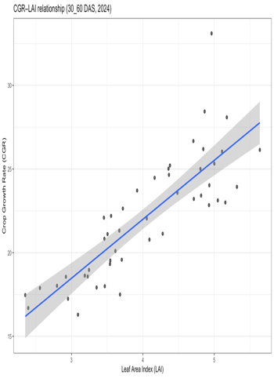  Figure 1(a) | 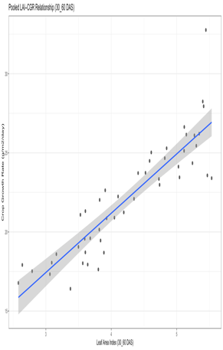  Figure 1(b) | 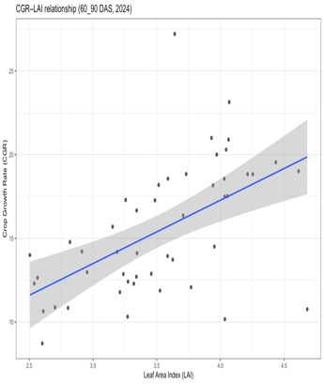  Figure 2(a) | 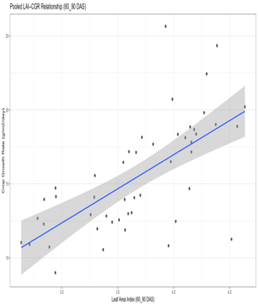  Figure 2(b)
Fig 1:Pooled relationship between leaf area index (LAI) and crop growth rate (CGR) of Quality Protein Maize during 30–60 DAS in 2024 (a) and 2025 (b).  Each point represents pooled observations across crop establishment methods and weed management practices. The fitted regression line indicates the contribution of canopy expansion to biomass accumulation during early crop growth. |  | Fig 2:Pooled relationship between leaf area index (LAI) and crop growth rate (CGR) during 60–90 DAS in 2024 (a) and 2025 (b).  The regression illustrates the continued but reduced influence of canopy size on CGR during mid-vegetative growth, reflecting the transition from structural to combined physiological control.
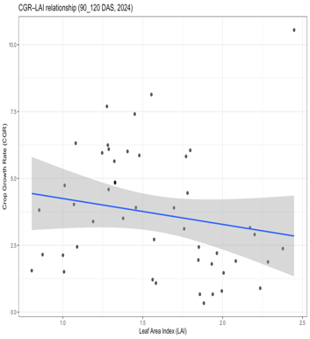  Figure 3(a) | 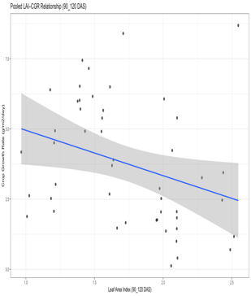  Figure 3(b) | 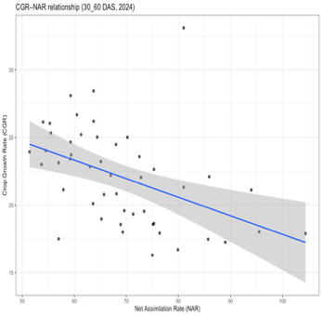  Figure 4(a) | 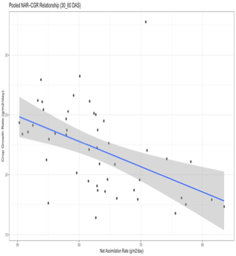  Figure 4(b)
Fig 3:Pooled relationship between leaf area index (LAI) and crop growth rate (CGR) during 90–120 DAS in 2024 (a) and 2025 (b).  The weak association indicates that further increases in leaf area contribute marginally to biomass accumulation during the late growth stage due to canopy saturation and onset of senescence. |  | Fig 4:Pooled relationship between net assimilation rate (NAR) and crop growth rate (CGR) during 30–60 DAS in 2024 (a) and 2025 (b).  The regression reflects the limited role of assimilatory efficiency in regulating CGR during early growth when leaf area development predominates.
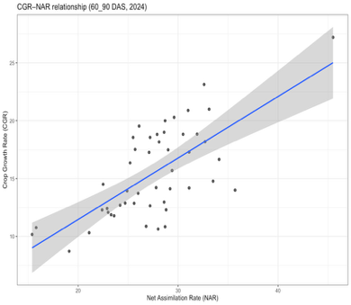  Figure 5(a) | 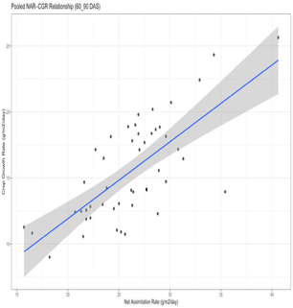  Figure 5 (b) | 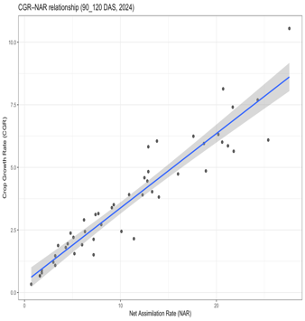  Figure 6 (a) | 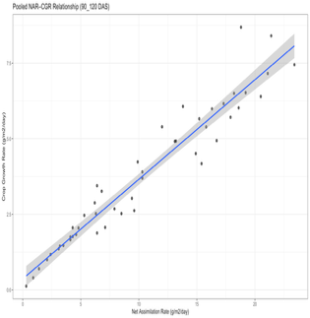  Figure 6 (b)
Fig 5:Pooled relationship between net assimilation rate (NAR) and crop growth rate (CGR) during 60–90 DAS in 2024 (a) and 2025 (b).  A strong positive association highlights the increasing importance of photosynthetic efficiency in determining biomass accumulation during peak vegetative growth. |  | Fig 6:Pooled relationship between net assimilation rate (NAR) and crop growth rate (CGR) during 90–120 DAS in 2024 (a) and 2025 (b).  The regression demonstrates the dominant role of assimilatory efficiency in sustaining CGR during reproductive development and grain filling.

*Each point represents pooled data across crop establishment methods and weed management practices; solid lines represent fitted linear regression model.

