A Review on Nutritional Significance of Sulfur in Pulse Crops

Abstract
Sulfur (S) is an important secondary plant nutrient required for plant growth and is particularly important in leguminous crops due to its role in amino acid synthesis, protein formation, enzyme activity and biological nitrogen fixation. A significant proportion of agricultural soils in Asia, including over 40% in India, are deficient in available sulfur. This widespread deficiency has adversely affected crop yield, nitrogen use efficiency and seed quality in pulse crops, especially under semi-arid tropical conditions. This study aims to evaluate the role and requirement of sulfur nutrition in pulse crops with specific emphasis on its influence on growth, nodulation, yield attributes and seed quality. The study focuses on sulfur availability in soils, sulfur uptake by pulse crops in the sulphate (SO₄²⁻) form through roots and its subsequent translocation to developing seeds. Comparative sulfur requirements of major pulse crops such as black gram, soybean and mung bean were analyzed under different agro-climatic conditions. Observations on physiological, biochemical and yield-related parameters were used to assess sulfur deficiency and sufficiency effects. Sulfur was found to be critical for the biosynthesis of sulfur-containing amino acids, proteins, vitamins and protective metabolites such as glutathione. Adequate sulfur supply significantly improved nodulation, nitrogen fixation, photosynthesis, protein content and overall productivity of pulse crops. Mung bean required higher sulfur (45 kg ha⁻¹) compared to black gram and soybean (40 kg ha⁻¹). Sulfur deficiency led to chlorosis, stunted growth, reduced flowering, poor pod and seed development, lower protein synthesis and increased susceptibility to biotic and abiotic stresses. Sulfur nutrition plays a vital role in sustaining growth, yield and quality of pulse crops, particularly in sulfur-deficient soils of semi-arid tropical regions. Regular sulfur replenishment through appropriate fertilizer and organic sources is essential for improving crop productivity, enhancing nitrogen use efficiency and ensuring sustainable pulse production.

Key word; Amino acid, Nodulation, Productivity, Sulfur, Sustainable

Introduction
Pulses play a essential position in selling environmental sustainability through fixing atmospheric nitrogen inside the soil and developing correctly as secondary plants on marginal lands with minimum inputs. further to enhancing soil fertility, pulses have enormous ability to make a contribution to food and nutritional safety. Their cultivation supports sustainable farming systems, reduces dependence on synthetic fertilizers, lowers environmental pollutants, and improves the productiveness of underutilized lands, thereby contributing to both ecological stability and human properly-being (Tiwari and Shivhare, 2016). It is considered one of the important protein sources for the vegetarian population in the country (Suresh and Reddy, 2016; Singh et al., 2022; Sah et al., 2021). India is the most important manufacturer, customer, and importer of pulses inside the world (Jadhav et al., 2018). for the duration of 2021–22, India produced 25. seventy-five million tonnes of pulses, accounting for approximately nine per cent of the entire food grain production within the united states (government of India, 2022–23). Chickpea (gram/chana), pigeon pea (tur/arhar), black gram (urd bean), mung bean (green gram), and lentil (masur) are the predominant pulse plants, together contributing 89.45 in line with cent of total pulse production throughout 2021–22. Madhya Pradesh, Rajasthan, Maharashtra, Uttar Pradesh, Karnataka, Gujarat, and Andhra Pradesh are the leading pulse-producing states, together accounting for nearly eighty four in keeping with cent of country wide pulse production. The average productiveness of pulses in India is 889 kg ha⁻¹, that's lower than the global average of 964 kg ha⁻¹. Pulses are predominantly cultivated beneath rainfed situations and therefore show off excessive yield instability (Kumar et al., 2023). As pulses are brief-period vegetation, the adoption of appropriate and balanced nutrient management practices is important to decorate productivity, enhance aid-use efficiency, and make sure sustainable pulse manufacturing.
Many of the crucial plant nutrients, sulfur is considered the fourth maximum crucial nutrient and is specifically required in larger quantities with the aid of leguminous plants. Sulfur is appeared as a obligatory nutrient because of its crucial position in plant boom, improvement, and metabolic techniques (Vidyalakshmi et al., 2009). It plays a key role inside the formation of sulfur-containing amino acids which include methionine, cystine, and cysteine, and is therefore essential for protein synthesis and effective root nodule improvement in legumes (Zenda et al., 2021). Sulfur is predominantly focused inside the surface layers of the soil, with its content normally lowering with increasing soil intensity. It has a vast have an effect on on vegetative growth, reproductive development, yield attributes, and ordinary productivity of leguminous plants. The distribution of overall sulfur in soils varies extensively because of variations in soil residences, discern fabric, and management practices. Sulfur deficiency has emerged as a main constraint to crop production in semi-arid tropical regions, especially in India, where about 73 million hectares of Vertisols and associated soils are affected (Rao and Ganeshamurthy, 1994). adequate sulfur software has the capacity to significantly enhance pulse productiveness. despite the fact that sulfur is not a constituent of chlorophyll, its deficiency outcomes in chlorosis due to its near affiliation with nitrogen metabolism. higher sulfur fertilizer requirements have been said throughout numerous areas of Asia. In soils, sulfur is specially derived from sulfur-bearing minerals in addition to from the decomposition of plant and animal residues.
Good enough availability of sulfur (S) inside the soil is crucial for plants to effectively whole their existence cycle and gain most appropriate yield, seed best, and protein content material. inside the absence of enough sulfur, vegetation are not able to efficaciously utilize provided nitrogen, that is critical for protein and enzyme synthesis (Zenda et al., 2021). Sulfur-containing compounds, in particular the tripeptide glutathione (GSH), play a imperative role in protective plant life in opposition to oxidative damage through detoxifying reactive oxygen species (ROS) generated underneath each abiotic and biotic stress conditions. in addition, sulfur serves as a precursor for the biosynthesis of phytochelatins and glucosinolates, which contribute to plant protection mechanisms towards herbivores and pathogenic organisms (Davidian et al., 2010).

Sulfur deficiency has been proven to markedly reduce sulfate ranges and sulfur-containing metabolites such as cysteine, methionine, and glutathione, resulting in suppressed protein synthesis (Honse et al., 2012). underneath sulfur-restricted situations, an accumulation of soluble nitrogen compounds, inclusive of nitrates and amides, has also been found, indicating an imbalance between nitrogen uptake and its assimilation into proteins. all through seed maturation, an growth within the GSH/GSSG ratio observed by using a decline in glutathione reductase interest has been stated. furthermore, glutathione degrees drop notably at some point of seed imbibition, a level often related to accelerated ROS production all through radicle emergence. The buildup of glutathione all through seed maturation highlights its protecting antioxidant position in keeping seed viability all through storage. on the identical time, sulfur reserves in the seed are remobilized, main to a discount in sulfur-rich seed storage proteins. To atone for the overall decline in general seed protein content, flowers growth the synthesis of sulfur-bad storage proteins (Nikiforova et al., 2004). those adaptive changes underscore the important significance of sulfur vitamins in regulating plant metabolism, strain tolerance, and seed satisfactory.
Crop yield and seed high-quality are carefully associated with sulfur content in plants (Fuentes Lara et al., 2019). Sulfur deficiency ends in a decline in the share of sulfur-containing amino acids in grains, whereas ok sulfur deliver complements their attention and improves normal grain nutritive value (Blake Kalff et al., 2000). In leguminous fodder plants, sulfur vitamins not handiest impacts seed yield but also improves seed satisfactory. application of sulfur at most useful ranges enhances those traits and improves the nutritional popularity of forage, which without delay blessings herbivorous farm animals. improved sulfur nutrients in fodder has been proven to boom wool yield and best, enhance milk manufacturing, and improve milk exceptional in dairy animals (Shi Ping et al., 2002). Proof from medical literature definitely shows that sulfur is a increase-restricting macronutrient essential for diverse physiological and developmental stages of vegetation. From an agronomic attitude, sulfur plays a key regulatory function in seed germination, vegetative boom, yield formation, and excellent across a huge range of crops, which include cereals, legumes, oilseeds, and different economically crucial plant species
Fate of Sulfur in Soil Ecosystem
Sulfur deficiency in soil is a widespread issue globally, including in India, significantly impacting crop yields and quality. In India, approximately 40% of agricultural land is sulfur deficient, with an additional 35% potentially deficient. This deficiency is prevalent in various regions and soil types, including alluvial and laterite soils. Numerous South Asian international locations are experiencing massive sulfur deficiency in agricultural soils. In India, more than 615 districts have been pronounced as sulphur poor, with almost 58.6% of the soils containing low levels of to be had sulfur (Shukla et al., 2021). In Pakistan, sulfur deficiency affects approximately 15% of cultivated soils (Imran et al., 2014). similarly, in Bangladesh, approximately 7 million hectares of agricultural land representing nearly 52% of the entire cultivated area are suggested to be deficient in sulfur (Ahmed and Khan, 2010). In Sri Lanka, around 30% of soils have been diagnosed as sulfur poor (Wickramasinghe, 1991). Although Nepal and Bhutan have comparatively smaller agricultural areas, sulfur deficiency has also been suggested as a issue in these nations. collectively, those findings highlight sulfur deficiency as a significant soil fertility constraint throughout South Asia, posing a large project to sustainable crop manufacturing and soil health.

TABLE 1. Requirement of Sulfur in Pulses under Different Agro-Climatic Conditions.
S. No | Crop | Sulfur  requirement | Agro-climatic conditions  and location | Soil | Reference
1 | Black gram | 40 kg ha⁻¹ | Humid subtropical | Sandy loam | Niraj and Ved Prakash, 2014
2 | Soybean | 40 kg ha⁻¹ | Humid subtropical | Sandy loam | Paliwal et al., 2009
3 | Mung bean | 45 kg ha⁻¹ | Humid subtropical | Sandy clay loam (Inceptisol) | Tripathi et al., 2012
4 | Pigeon pea | 20 kg ha⁻¹ | Subtropical | Dark clay | Deshbhratar et al., 2010
5 | Sun hemp | 40 kg ha⁻¹ | Subtropical | Sandy loam | Saha et al., 2013
6 | Soybean | 40 kg ha⁻¹ | Tropical wet and dry | Vertisol | Hosmath et al.,2014

Sulfur in soil
Soil sulfur exists as organic sulfur compounds, sulphide (S²⁻), elemental sulfur (S), and sulphate (SO₄²⁻) (Fuentes-Lara et al.,2019b). It is transformed between these forms via processes of mobilization, mineralization (microorganisms decompose organic matter in soil to release inorganic nutrients like nitrogen, sulfur, and phosphorus that plants can absorb), immobilization (The process where inorganic nutrients, like nitrogen, sulfur and heavy metals, are converted into an organic form that is unavailable to plants or other organisms), oxidation, and reduction. Up to 98% of the total soil sulfur occurs in form of organic sulfur compounds, and comprises a heterogeneous mixture of plant residues, animal manures, and soil microbes. It is not directly accessible to plants until it undergoes mineralisation by micro-organisms to release SO₄²⁻ for plant uptake (Scherer, H.W., 2001).
The strategies of sulfur mineralization and immobilization in soils are largely governed via factors that have an impact on microbial increase, which include soil moisture, temperature, pH, and the provision of different nutrients. therefore, the quantity of plant-to be had sulfur in soil fluctuates at some point of the yr. studies shows that sulfur contained inside the soil microbial biomass normally represents approximately 1.5–5 % of the entire soil natural sulfur pool, with proteins and amino acids being the dominant sulfur forms within microbial cells. Microbial biomass sulfur is exceptionally risky and is taken into consideration the maximum dynamic and biologically lively pool involved in sulfur cycling in soils. The incorporation of soil natural remember commonly enhances microbial activity, main to an increase in microbial biomass and related sulfur content. In assessment, underneath acid-sulfate soil situations, sulfide (S²⁻) may additionally come to be the dominant sulfur shape, whilst considerable tiers of sulfate (SO₄²⁻) are generally discovered in arid soils or in soils receiving great gypsum packages. Regardless of the presence of a couple of sulfur forms in soil, vegetation are not able to directly soak up natural sulfur or sulfide. Those bureaucracies must first go through biological or chemical ameliorations into sulfate (SO₄²⁻), that is the number one shape of sulfur taken up through plants (Zhao et al., 2008).
Sulfate (SO₄²⁻) is the most commonplace inorganic form of sulfur in soils and occurs as soluble sulfate in the soil solution, adsorbed sulfate on soil debris, and as mineral-certain sulfur. In maximum agricultural soils, inorganic sulfur constitutes a particularly small fraction typically 10% or less of the whole soil sulfur, with most people present in organically certain forms (Landers et al., 1983). In the soil answer, sulfate is noticeably mobile and weakly retained by means of soil colloids, making it susceptible to leaching from the crop rhizosphere. considerable sulfur losses through leaching had been stated, with values accomplishing as much as one hundred kg S ha⁻¹ according to 12 months in components of southern England. Sulfur may additionally precipitate as sulfate salts which include calcium sulfate (CaSO₄), magnesium sulfate (MgSO₄), or sodium sulfate (Na₂SO₄), depending on soil conditions and ionic composition. Under waterlogged or anaerobic situations, sulfur can acquire in reduced paperwork inclusive of sulfide (S²⁻). Whilst those soils are tired and become cardio, sulfide is oxidized to sulfate, the shape comfortably to be had for plant uptake. Wetland soils regularly accumulate huge quantities of steel sulfides, specially pyrite (FeS₂). Upon drainage, oxidation of those sulfide minerals results in the formation of sulfate and is commonly followed with the aid of a good sized decline in soil pH. If adsorbed sulfate isn't always effectively available to flora, control practices that reduce sulfate retention and boom its attention inside the soil solution can decorate sulfur availability. accelerated sulfate levels inside the surface soil are often associated with the application of sulfur-containing fertilizers and other outside sulfur inputs. It has additionally been recommended that subsoil plant residues might also adsorb more sulfate than surface residues, as adsorption websites in topsoil are regularly occupied or blocked by way of soil organic count and gathered phosphates (Eriksen, 2009a).
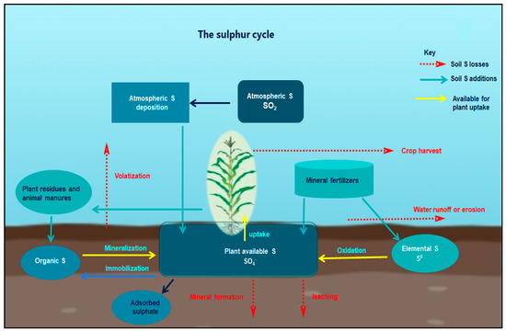
Fig 1. The sulfur cycle
The sulfur (S) cycle may be defined through a simplified and systematic framework related to atmospheric, soil, plant, and microbial strategies. Atmospheric sulfur, normally within the shape of sulfur dioxide (SO₂), originates from the combustion of sulfur-containing fossil fuels, volcanic hobby, and different herbal techniques. This sulfur is returned to the Earth’s surface specifically via moist deposition as sulfate (SO₄²⁻) and sulfuric acid in precipitation, in addition to through dry deposition inside the shape of dirt particles derived from mineral mining and rock weathering that determine plant and soil surfaces. In soils, organically certain sulfur becomes to be had to flora best after soil natural depend (SOM) undergoes microbial mineralization, releasing sulfate ions. The utility of mineral sulfur fertilizers inclusive of ammonium sulfate ((NH₄)₂SO₄), calcium sulfate (CaSO₄), potassium sulfate, zinc sulfate (ZnSO₄), magnesium sulfate (MgSO₄), elemental sulfur (S⁰), and single superphosphate (SSP) complements the readily available sulfur pool in soils for plant uptake.Unharvested crop biomass and recycled agricultural residues go back sulfur to the soil predominantly in natural paperwork. in addition, animal manures and different biosolids contribute natural sulfur, with the sulfur content relying on elements consisting of animal species, age, and diet. This organic sulfur should be mineralized through soil microorganisms to be transformed into sulfate before it will become to be had to flora. Sulfur derived from plant residues also turns into plant-available most effective after microbial decomposition. Elemental sulfur requires biological oxidation by using sulfur-oxidizing bacteria to convert into sulfate, the shape absorbed with the aid of plant roots. Sulfur losses from soil can occur through several pathways. Volatilization losses are normally minimum, accounting for less than 0.05% of total soil sulfur. Sulfate can be leached below the basis sector beneath situations of excessive rainfall or might also collect close to the soil surface in the course of extended dry periods. below particular soil conditions, sulfur may additionally shape noticeably insoluble mineral complexes such as calcium sulfate or iron sulfate, lowering its instantaneous availability. floor losses can occur thru runoff whilst sulfate accumulates close to the soil floor at some point of excessive-depth rainfall events, or thru erosion when sulfur-wealthy soil debris are eliminated. in the long run, sulfur absorbed through flora is assimilated into metabolic compounds and is eliminated from the field through harvested seeds and different plant products. designated descriptions of sulfur cycling strategies are furnished by means of until (2010) and Eriksen (2009).
Source - Sink Relationship
Sulfur is absorbed with the aid of plant roots from the rhizospheric area often inside the shape of sulfate (SO₄²⁻) and is in the end transported in the course of the plant largely in this inorganic form. Tabe and Droux (2001) stated that sulfate represents the dominant sulfur shape translocated thru the phloem and provided to growing pods during seed formation in lupin, in which it's far later reduced and assimilated inside the seed tissues. when sulfate is not straight away reduced and incorporated into organic compounds, excess sulfate is briefly stored in vacuoles inside plant cells, such as those of growing seeds (Martinoia et al., 2007). Transcriptomic studies conducted on growing seeds of Medicago truncatula have proven that sulfur assimilation within seed tissues follows two wonderful pathways (figure 2). in the major pathway, sulfate is transported into the embryo, wherein it's miles reduced and applied for the biosynthesis of cysteine, in the end turning into included into seed proteins. within the alternative pathway, sulfate is directed in the direction of the seed coat and endosperm, in which it preferentially contributes to the synthesis of sulfur-containing compounds related to defense mechanisms (Gallardo et al., 2007). This compartmentalization of sulfur inside distinctive seed tissues shows an active and tightly regulated alternate of sulfate among seed cubicles, making sure finest allocation for both garage protein formation and protective features.

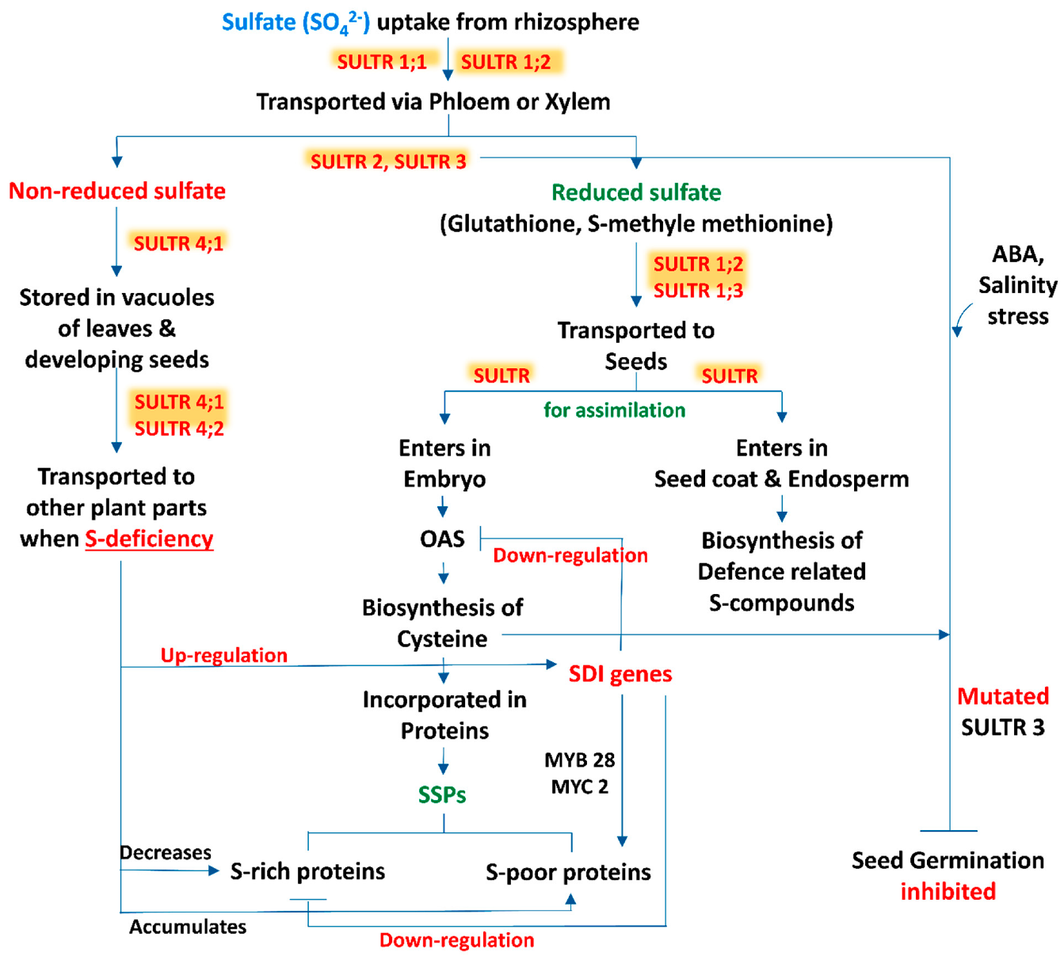
Fig 2. Pathways of sulfur assimilation
Fuigure 2. Schematic illustration of the supply–sink courting of sulfur (S) in flora, highlighting the uptake of sulfate (SO₄²⁻) from the rhizosphere and its delivery to specific plant organs via specific sulfate transporters (SULTRs). The diagram additionally depicts sulfur assimilation pathways, accumulation of sulfur-containing seed storage proteins (SSPs), and the regulatory role of sulfur in seed development and germination.
Role of Sulfur in Plants
Sulfur is universally present in living organisms and plays a fundamental role in protein formation and overall plant metabolism. In leguminous crops such as peas and beans, sulfur supports key biological processes that improve soil fertility. As nutrient availability increases in the soil, sulfur becomes increasingly important for improving nutrient use efficiency in plants, which ultimately contributes to higher growth and better yields in both field crops and grasses (Dawar et al.,2023).

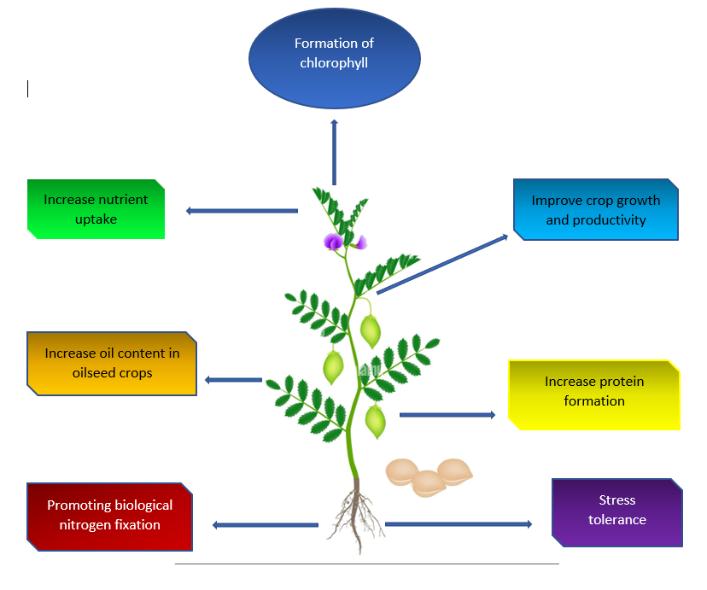

Fig 3. Sulfur Deficiency in Plants
Sulfur deficiency in flora takes place whilst the available deliver of sulfur is inadequate to fulfill the dietary requirements vital for ordinary boom and improvement. As sulfur is an important macronutrient worried in key metabolic and physiological techniques, its deficiency leads to the appearance of function signs and sensible problems that adversely affect plant health, growth, and productiveness.
Common signs and symptoms of sulfur deficiency in plants may include:
- Chlorosis: The maximum distinguished symptom of sulfur deficiency is leaf chlorosis, characterized via yellowing of the foliage. in contrast to nitrogen deficiency, sulfur deficiency normally seems first in more youthful leaves and may step by step make bigger to older leaves because the severity of the deficiency will increase (Hawkesford et al., 2016)
- Stunted Growth: Sulfur deficiency in vegetation regularly leads to stunted growth, manifested as a discount in usual plant size and energy, because of impaired metabolic and physiological techniques (Narayan et al., 2023).
- Delayed Maturity: Sulfur deficiency can delay flowering and fruit set in crop vegetation, thereby adversely affecting yield formation and in the long run main to decreased crop productiveness (Dobermann et al., 2000)
- Reduced Protein Synthesis: Sulfur is an essential constituent of sulfur-containing amino acids, which function the essential building blocks of proteins. insufficient sulfur supply limits amino acid and protein synthesis, resulting in impaired plant structure, metabolic feature, and average physiological overall performance (Yu et al., 2018).
- Impaired Photosynthesis: Sulfur performs an critical position in chlorophyll formation and in keeping the photosynthetic performance of plant life. although it is not a structural component of chlorophyll, sulfur deficiency disrupts chlorophyll synthesis and function, thereby impairing photosynthesis and lowering the plant’s capacity to supply energy and carbohydrates (Terry, 1976).
- Increased Susceptibility to Pests and Diseases: Sulfur deficiency can compromise a plant’s herbal protection mechanisms, growing its vulnerability to pest infestations and sickness incidence because of impaired synthesis of sulfur-containing shielding compounds (Criollo-Arteaga et al., 2021).
- Altered Nutrient Uptake: Sulfur deficiency can intervene with the uptake and usage of different vital vitamins, specifically nitrogen and phosphorus, thereby creating nutrient imbalances that similarly constrain plant increase and productiveness (Mehmood et al., 2021).
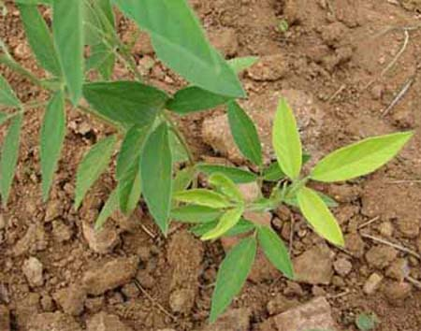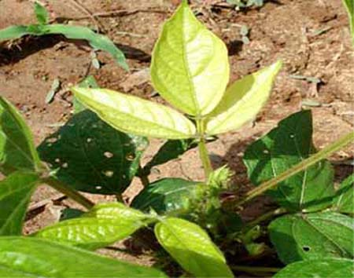
S Deficiency in Pigeon Pea S Deficiency in Moongbean
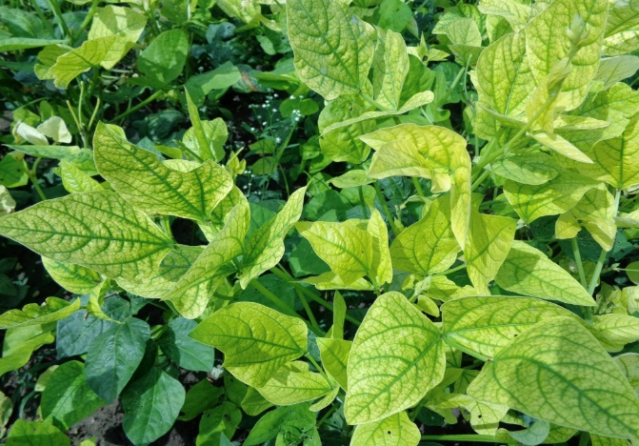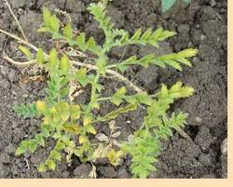
S Deficiency Cowpea S Deficiency Chickpea

Fig 4. Symptoms of sulfur deficiency in different plants

The severity of sulfur deficiency signs varies with crop species, soil houses, and triumphing environmental conditions. powerful prognosis and management of sulfur deficiency require normal soil testing to determine available sulfur levels, accompanied by means of suitable sulfur fertilization when wished. Adoption of balanced and location-specific nutrient control practices guarantees an good enough sulfur deliver, thereby helping most reliable plant growth, improvement, and productiveness. The characteristic sulfur deficiency signs observed in pulse and oilseed vegetation are summarized in Table 2

Table 2. Sulfur deficiency symptoms in pulse crops
Crops | Deficiency Symptoms
Chickpea | Plants appear erect, with premature drying and withering of young leaves.
Pea | Chlorosis in young leaves. Flowering and yield are reduced.
Green gram | Chlorosis in young leaves. Flowering and yield are reduced.
Soybean | Foliage becomes pale green to yellow with non-prominent veins, growth and maturity is delayed, and protein formation is reduced
Pigeon pea | Young and middle leaves turn yellow, branching; leaf size and flowering are suppressed. Flowers lack normal yellow colour and shed early. Pod formation and seed development is retarded.
French bean | Plants have short internodes, fewer and smaller leaves. The entire foliage appears pale green. Growth is poor and yield is low

Conclusion
Sulfur has a major influence on the yield, quality, and overall performance of pulse crops because it supports several essential plant functions its adequate supply is necessary for stable production and healthy crop growth. However, sulfur deficiency is now common in many Indian soils and has become a key factor limiting pulse productivity and nutritional value. Efficient sulfur management through balanced fertilizer use, the inclusion of organic inputs and location-specific nutrient strategies, can greatly improve pulse yields, strengthen nutrient use efficiency and help crops better with stand environmental and biological stresses. Therefore, a well-planned and region-based approach to sulfur nutrition is vital for promoting sustainable pulse farming and ensuring long-term food and nutritional security at both national and global scales.
Disclaimer (Artificial intelligence)
Option 1:
Author(s) hereby declare that NO generative AI technologies such as Large Language Models (ChatGPT, COPILOT, etc.) and text-to-image generators have been used during the writing or editing of this manuscript.
Option 2:
Author(s) hereby declare that generative AI technologies such as Large Language Models, etc. have been used during the writing or editing of manuscripts. This explanation will include the name, version, model, and source of the generative AI technology and as well as all input prompts provided to the generative AI technology
Details of the AI usage are given below:
1.
2.
3.

Reference
- Ahmed, F. and Khan, M.H.R., 2010. Residual Response of the Sulfidic Material on the Yield of Tomato and Onion Grown in Two Sulfur Deficient Soils in Bangladesh. New York Science Journal, 3(9).
- Blake-Kalff, M. M. A., Hawkesford, M. J., Zhao, F-J., & McGrath, S. P. (2000). Diagnosing sulfur deficiency in field-grown oilseed rape (Brassica napus L.) and wheat (Triticum aestivum L.). Plant and Soil, 225(1), 95-107. https://doi.org/10.1023/A:1026503812267
- Criollo-Arteaga, S., Moya-Jimenez, S., Jimenez-Meza, M., Gonzalez-Vera, V., Gordon-Nunez, J., Llerena-Llerena, S., Ramirez-Villacis, D.X., van 't Hof, P., & Leon-Reyes, A. (2021). Sulfur deprivation modulates salicylic acid responses via nonexpressor of pathogenesis-related gene 1 in Arabidopsis thaliana. Plants, 10(6), 1065. https://doi.org/10.3390/plants10061065
- Davidian, J. C., & Kopriva, S. (2010). Regulation of sulfate uptake and assimilation—the same or not the same. Molecular Plant, 3(2), 314-325. https://doi.org/10.1093/mp/ssq001
- Dawar, R., Karan, S., Bhardwaj, S., Meena, D. K., Padhan, S. R., Reddy, K. S., & Bana, R. S. (2023). Role of Sulfur Fertilization in Legume Crops: A Comprehensive Review. International Journal of Plant & Soil Science, 35, 718-727. https://doi.org/10.9734/IJPSS/2023/v35i214033
- Deshbhratar, P. B., Singh, P. K., Jambhulkar, A. P., & Ramteke, D. S. (2010). Effect of sulfur and phosphorus on yield, quality and nutrient status of pigeonpea (Cajanus cajan). *Journal of Environmental Biology*, *31*(6), 933–937. https://pubmed.ncbi.nlm.nih.gov/21506478/
- Dobermann, A., & Fairhurst, T. H. (2000). Rice: Nutrient disorders and nutrient management. Potash and Phosphate Institute; Potash and Phosphate Institute of Canada; International Rice Research Institute. https://www.nlb.gov.sg/biblio/11900007
- Eriksen, J. (2009). Soil sulfur cycling in temperate agricultural systems. Advances in Agronomy, 102, 55-89. https://doi.org/10.1016/S0065-2113(09)01002-5
- Fuentes-Lara, L. O., Medrano-Macías, J., Pérez-Labrada, F., Rivas-Martínez, E. N., García-Enciso, E. L., González-Morales, S., Juárez-Maldonado, A., Rincón-Sánchez, F., & Benavides-Mendoza, A. (2019). From elemental sulfur to hydrogen sulfide in agricultural soils and plants. Molecules, 24(12), 2282. https://doi.org/10.3390/molecules24122282
- Gallardo, K., Firnhaber, C., Zuber, H., Hericher, D., Belghazi, M., Henry, C., Kuester, H., & Thompson, R. (2007). A combined proteome and transcriptome analysis of developing Medicago truncatula seeds: evidence for metabolic specialization of maternal and filial tissues. Molecular & Cellular Proteomics, 6(12), 2165–2179. https://doi.org/10.1074/mcp.M700208-MCP200
- Government of India, Directorate of Pulses Development. (2022-23). *Annual Progress Report*. Ministry of Agriculture & Farmers Welfare, Department of Agriculture and Farmers Welfare, Directorate of Pulses Development. https://dpd.nic.in/images/Annual_Progress_Report_2022-23.pdf
- Hawkesford, M. J., Kopriva, S., & De Kok, L. J. (Eds.). (2014). Nutrient Use Efficiency in Plants: Concepts and Approaches. Springer. https://doi.org/10.1007/978-3-319-10635-9
- Hosmath, J.A., Babalad, H.B., Basavaraj, G.T., Jahagirdar, S., Patil, R.H., Athoni, B.K., & Agasimani, S.C. (2014). Sulfur nutrition in soybean [Glycine max (L.) Merril] in India. In International Conference on Biological, Civil and Environmental Engineering (BCEE-2014) (pp. 17-18). https://doi.org/10.15242/IICBE.C0314071
- Imran, M., Sajida, P., Amjad, A. and Fayaz, A., 2014. Influence of sulfur rates on phosphorus and sulfur content of miaze crop and its utilization in soil. Intl J. Farm Alli Sci, 3(11), pp.1194-1200.
- Jadhav, V., Swamy, N. M., & Gracy, C. P. (2018). Supply-demand gap analysis and projection for major pulses in India. Economic Affairs, 63(1), 277-285. https://doi.org/10.30954/0424-2513.2018.00150.34
- Kumar, S., Gopinath, K.A., Sheoran, S., Meena, R.S., Srinivasarao, C., Bedwal, S., Jangir, C.K., Mrunalini, K., Jat, R., & Praharaj, C.S. (2023). Pulse-based cropping systems for soil health restoration, resources conservation, and nutritional and environmental security in rainfed agroecosystems. Frontiers in Microbiology, 13, 1041124. https://doi.org/10.3389/fmicb.2022.1041124
- Landers, D. H., David, M. B., & Mitchell, M. J. (1983). Analysis of organic and inorganic sulfur constituents in sediments, soils and water. International Journal of Environmental Analytical Chemistry, 14(4), 245-256. https://doi.org/10.1080/03067318308071623
- Martinoia, E., Maeshima, M., & Neuhaus, H. E. (2007). Vacuolar transporters and their essential role in plant metabolism. Journal of Experimental Botany, 58(1), 83–102. https://doi.org/10.1093/jxb/erl183
- Mehmood, M. Z., Afzal, O., Ahmed, M., Qadir, G., Kheir, A. M. S., Aslam, M. A., Din, A. M. U., Khan, I., Hassan, M. J., Meraj, T. A., Raza, M. A., & Ahmad, S. (2021). Can sulfur improve the nutrient uptake, partitioning, and seed yield of sesame?. Arabian Journal of Geosciences, 14(10), 865. https://doi.org/10.1007/s12517-021-07229-6
- Narayan, O. P., Kumar, P., Yadav, B., Dua, M., & Johri, A. K. (2023). Sulfur nutrition and its role in plant growth and development. Plant Signaling & Behavior, 18(1), 2030082. https://doi.org/10.1080/15592324.2022.2030082
- Nikiforova, V. J., Gakière, B., Kempa, S., Adamik, M., Willmitzer, L., Hesse, H., & Hoefgen, R. (2004). Towards dissecting nutrient metabolism in plants: a systems biology case study on sulfur metabolism. Journal of Experimental Botany, 55(404), 1861–1870. https://doi.org/10.1093/jxb/erh177
- Niraj, V.P.S. and Ved Prakash, V.P., 2014. Effect of phosphorus and sulfur on growth, yield and quality of blackgram (Phaseolus mungo L.).
- Paliwal, A.K., VajpaI, S.K. and Kiran Vajpai, K.V., 2009. Interaction effect of sulfur and phosphorus application on yield and major nutrient composition of soybean (Glycine max L. Merrill) grown on alfisol.
- Rao, A.S. and Ganeshamurthy, A.N., 1994. Soybean responses to applied phosphorus and sulfur on Vertic Ustochrepts in relation to available phosphorus and sulfur. Journal of the Indian Society of Soil Science, 42(4), pp.606-610.
- Sah, U., Verma, P., Pal, J., Singh, V., Katiyar, M., Dubey, S.K., & Singh, N.P. (2024). Pulse Value Chains in India- Challenges and Prospects: A Review. Legume Research: An International Journal, 47(7), 1065-1072. https://doi.org/10.18805/LR-4632
- Saha, S., Saha, M., Saha, A.R., Mitra, S., Sarkar, S.K., Ghorai, A.K., & Tripathi, M.K. (2013). Interaction effect of potassium and sulfur fertilization on productivity and mineral nutrition of sunnhemp. Journal of Plant Nutrition, 36(8), 1191-1200. https://doi.org/10.1080/01904167.2013.779705
- Scherer, H. W. (2001). Sulfur in crop production. European Journal of Agronomy, 14(2), 81-111. https://doi.org/10.1016/s1161-0301(00)00082-4
- Shi-Ping, W.A.N.G., Yan-Fen, W.A.N.G., Xiao-Yong, C.U.I., Zuo-Zhong, C.H.E.N., Hong-Kang, C.H.I., Schnug, E., Haneklaus, S. and Fleckenstein, J., 2002. Influence of sulfur fertilizer on sulfur cycling and its implications on sulfur fertilizer requirement of grazed pasture in warm seasonal rangeland of Nei Monggol steppe of China. Journal of Integrative Plant Biology, 44(2), p.204.
- Singh, J. M., Kaur, A., Chopra, S., Kumar, R., Sidhu, M. S., & Kataria, P. (2022). Dynamics of Production Profile of Pulses in India. Legume Research - An International Journal, 45(5), 565-572. https://doi.org/10.18805/LR-4274
- Suresh, A., & Reddy, A.A. (2016). Total factor productivity of major pulse crops in India: implications for technology policy and nutritional security. Agricultural Economics Research Review, 29, 87-98. https://doi.org/10.5958/0974-0279.2016.00036.7
- Tabe, L. M., & Droux, M. (2001). Sulfur assimilation in developing lupin cotyledons could contribute significantly to the accumulation of organic sulfur reserves in the seed. Plant Physiology. https://doi.org/10.1104/pp.126.1.176
- Terry, N. (1976). Effects of sulfur on the photosynthesis of intact leaves and isolated chloroplasts of sugar beets. Plant Physiology, 57(4), 477-479. https://doi.org/10.1104/pp.57.4.477
- Till, A. R. (2010). Sulfur and sustainable agriculture. International Fertiliser Industry Association. https://www.fertilizer.org/resource/sulfur-and-sustainable-agriculture/
- Tiwari, A.K. and Shivhare, A.K., 2016. Pulses in India: retrospect and prospects. Published by Director, Govt. of India, Ministry of Agri. & Farmers Welfare (DAC&FW), Directorate of Pulses Development, VindhyachalBhavan, Bhopal, MP.
- Tripathi, P. K., Singh, M. K., Singh, J. P., & Singh, O. N. (2012). Effect of rhizobial strains and sulfur nutrition on mungbean (Vigna radiata (l.) wilczek) cultivars under dryland agro-ecosystem of Indo-Gangetic plain. African Journal of Agricultural Research, 7(1), 34-42. https://doi.org/10.5897/AJAR11.868
- Vidyalakshmi, R., Paranthaman, R. and Bhakyaraj, R., 2009. Sulfur Oxidizing Bacteria and Pulse Nutrition- A Review. World Journal of Agricultural Sciences, 5(3), pp.270-278.
- Wickramasinghe, L.A., 1991. Soil constraints on sustainable plant production in Sri Lanka. JIRCAS, 24, pp.12-29.
- Yu, Z., Juhasz, A., Islam, S., Diepeveen, D., Zhang, J., Wang, P., & Ma, W. (2018). Impact of mid-season sulfur deficiency on wheat nitrogen metabolism and biosynthesis of grain protein. Scientific Reports, 8(1), 2499. https://doi.org/10.1038/s41598-018-20935-8
- Zenda, T., Liu, S., Dong, A. and Duan, H., 2021. Revisiting sulphur—The once neglected nutrient: It’s roles in plant growth, metabolism, stress tolerance and crop production. Agriculture, 11(7), p.626.
- Zenda, T., Liu, S., Dong, A., & Duan, H. (2021). Revisiting sulfur—The once neglected nutrient: It’s roles in plant growth, metabolism, stress tolerance and crop production. Agriculture, 11(7), 626. https://doi.org/10.3390/agriculture11070626
- Zhao, F. J., Tausz, M., & De Kok, L. J. (2008). Role of sulfur for plant production in agricultural and natural ecosystems. In R. Hell, C. Dahl, D. B. Knaff, & T. Leustek (Eds.), Sulfur metabolism in phototrophic organisms (pp. 417-435). Springer. https://doi.org/10.1007/978-1-4020-6863-8_21

