Impact of urban sprawl on the socio-economic structure of the inhabitants in Imphal Urban Agglomeration, Manipur, India

Abstract:
Urbanization has brought about a monumental change in the structure of the existing urban landscape. Urban sprawling has often caused problems in the structural and spatial alignment that disrupts the planned and balanced growth of a city. The Imphal Urban Agglomeration (IUA), the primate city of Manipur, India has witnessed increasing urban sprawl since recent decades impacting the spatial structure, land-use alignment, and overall morphological organization of the city. The present study aims at an assessment of the impact of urban sprawling on the socio-economic structure of the original and the migrant inhabitants in the IUA. Both secondary data (Landsat 5 and Sentinel 2 satellite imageries) and primary data (household survey data) were used for the study. Urban sprawl in IUA was quantified using Shannon’s Entropy technique while primary data collected from original and migrant inhabitants were analyzed using descriptive statistics to assess the impact of urban sprawl on the socio-economic structure of the inhabitants. The findings reveal that increasing urban sprawl has led to uneven socio-economic development with different challenges for both original and migrant population. The study underscores the need for spatially balanced planning strategies to promote inclusive urban growth in the IUA.
Keywords: Urban sprawl, Shannon’s Entropy, IUA, Impacts.

1. Introduction
Urban sprawl has emerged as a dominant feature of contemporary urbanization process, particularly in rapidly growing cities of the developing world. It refers to the uncontrolled and low-density expansion of urban areas into surrounding rural and peri-urban landscapes, often driven by population growth, economic transformation, and inadequate urban planning (Brueckner, 2000; Samantha et al., 2022). All the major cities of the world have been experiencing the problems of urban sprawling. The pattern of urban sprawling in developed countries is different from those in the developing countries (Owusu, 2013; Adaku, 2014). The associated problems of urban sprawl are more prominent in the cities of developing countries like India (Sinha, 2018).Urban sprawl has emerged as a growing and problematic dimension of metropolitan and large-city growth and development in India in recent decades(Rahman et al., 2011). Urban sprawl is increasingly recognized as a significant threat to sustainable development, as it raises critical concerns regarding effective urban planning, efficient resource utilization, and equitable infrastructure allocation (Hasse & Lathrop, 2003;Sudhira et al., 2004). This unplanned and dispersed pattern of urban expansion has led to the conversion of productive agricultural land, the reduction of open and green spaces, the degradation of surface water bodies, increase carbon reduction, greater intensity of Urban Heat Island, and the depletion of groundwater resources (Tu et al., 2007; Dadi et al., 2016; Bhat et al., 2017; Wen et al., 2024; Tabassum et al., 2025).Urban sprawl may give rise to several significant socio-economic consequences, including economic disparities, administrative challenges for local governments, and financial imbalances among communities. It also exerts considerable influence on the quality of life of individuals(Karakayaci, 2016).
Urban sprawl has been widely viewed as a major driver of socio-economic transformation in cities in both developed and developing countries. It is generally associated with negative impact on the socio-economic life of the people. In developed countries, urban sprawl has impacted the socio-economic structures as a result of the automobile dependent suburban expansion, long commuting distances, infrastructure and service delivery cost, socio-spatial segregation by income (Ewing & Hamidi, 2015). This disperse urban growth is often associated with reduced economic efficiency, weakened social cohesion and lead to the gradual decline of inner city areas (Wei & Ewing, 2018). However, contrasting improvements were also observed regarding the impact of urban sprawl in China where it reduces household energy consumption by promoting increased public transport usage (Yang et al., 2024). In developing countries, urban sprawl is predominantly rapid and unplanned expansion, characterized by informality, the growth of slums, inadequate basic service, growing urban poverty and the encroachment on agricultural land (Sinha, 2018; Renu & Hussain, 2019). It is mainly influenced by multiple factors, including political fragmentation, economic competition, social preferences for suburban areas, rural–urban migration, growing housing demand, weak institutional regulations, inadequate transport facilities, and technological advancements (Soltani et al., 2025). In the context of India, a developing country, urban sprawl has resulted in the expansion of informal settlements, loss of productive agricultural land, unequal access to basic services, and widening socio-economic inequalities (Kundu, 2011; Ramachandra et al., 2012). It has specifically impacted the rural communities by widening income disparities, disruption of traditional livelihood, and straining infrastructure and services (Muzaffar & Ali, 2024).
The present study is an assessment of the impact of urban sprawling on the socio-economic structure of the inhabitants living in the Imphal Urban Agglomeration (IUA) of the north-east India. For the study, primary data were generated through extensive household survey. Both the migrants and the original settlers were taken into consideration. Objective variables and subjective variables which are mainly based on the perspectives of both the inhabitants were incorporated in the data collection process. The findings and outcomes of the study clearly depict the nature of urban sprawl and its impact on the socio-economic structure of the inhabitants. The impact study of urban sprawl is first of its kind in the study area and is expected to give new insights into the dynamics of urban sprawling and how it is impacting the socio-economic structure of the inhabitants.
2. Study Area
The area of study is the Imphal Urban Agglomeration in the state of Manipur, India. It is the biggest city in the state. The city is exceptionally big that it holds the important services and functions. The IUA extends between 24º 41′ N to 25º 06′ N latitude and 93º 42′ E to 94º 11′ E longitude. It has an area of approximately 11920.82 hectares with an elevation of 786m above sea level.The Imphal Urban Agglomeration (IUA) spans two administrative districts, namely Imphal East and Imphal West, and supported a population of 414,288 as per the 2011 Census. The IUA comprises of 27 constituent units and has been classified as a Class I city according to the Census of India (1971 Census). Location of the study area is shown in fig.1.
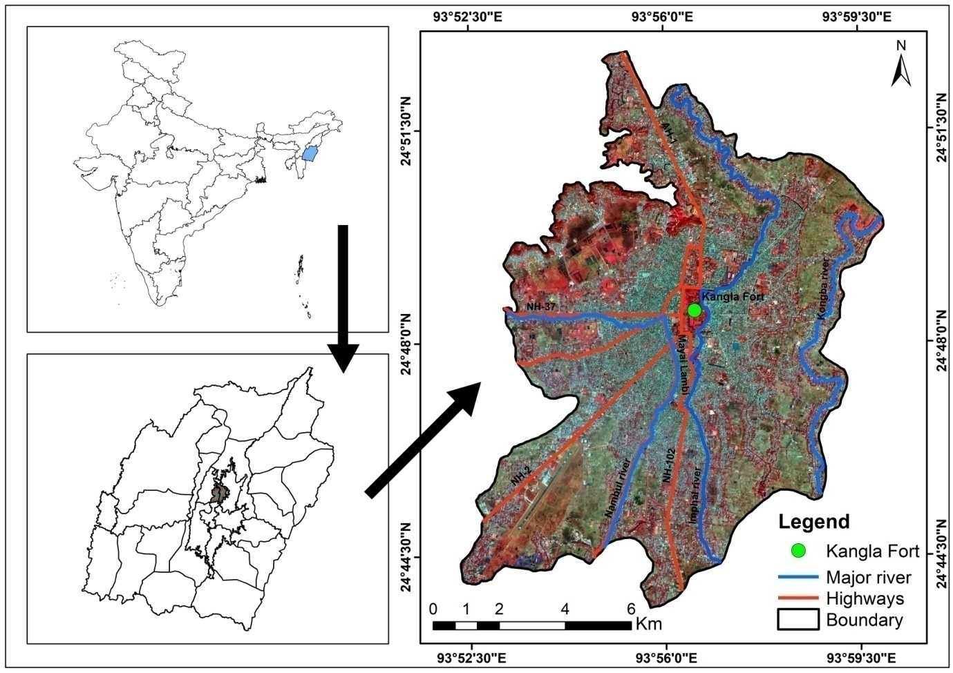
Fig. 1 Location of the study area
3. Methodology
Methodology is divided into two parts. The first part deals with the mapping of the urban sprawling in the IUA and the second part deals with an assessment of the impact of the urban sprawling on the socio-economic structures of the inhabitants. The whole methodological framework applied in the study is shown in fig.2.
3.1 Urban Sprawl mapping
3.1.1 Image processing
For the mapping process, image processing was first conducted. For this, satellite data for land use land cover (LULC) classification were obtained from open sources. Landsat 5 TM images for 1991, 2001, and 2011 were downloaded from the USGS EarthExplorer, while Sentinel-2 Level-2A image for 2021 was acquired from the Copernicus Open Access Hub. The Landsat datasets were subjected to radiometric and geometric corrections using ERDAS Imagine to improve data quality. Subsequently, layer stacking was carried out to generate false colour composite (FCC) images, and the study area was extracted by clipping the FCC images to the defined study area boundary.

3.1.2 Image classification
To obtain the LULC of the study area, the processed images were classified by Supervised Maximum Likelihood Classification Method in ArcGIS software. Maximum Likelihood Classification (MLC) is one of the most widely used supervised classification algorithms in remote sensing and has been applied in a broad range of LULC mapping applications for its statistical robustness (McGwire et al., 1996;Ahmad & Quegan, 2012;Sisodia et al., 2014) and hence this method has been adopted. The study area was divided into 5 LULC classes viz. agricultural land, built-up, vegetation, barren land and water body. The classified maps of the year 1991, 2001, 2011 and 2021 were validated by performing accuracy assessment where the Kappa Statistics were found to be 0.860, 0.865, 0.865 and 0.928 respectively.
3.1.3 Shannon’s Entropy
The Khwairamband Keithel which is the main centre for the business activities in the city is considered as the CBD. For the measurement of urban sprawling, the study area is divided into five concentric circles with an increment of 2km each from the CBD. For a systematic analysis and comparison of growth dynamics, the study area is again divided into four sectors i.e. NE, NW, SE and SW. From the prepared LULC maps, the built-up and non built-up area for each of the buffer zones in each direction was extracted for the Shannon’s Entropy calculation.
Shannon entropy has been widely adopted in urban and environmental studies as a robust quantitative tool to quantify spatial dispersion and heterogeneity associated with urban growth (Sudhira et al., 2004;Jat et al., 2008). The Shannon’s Entropy is calculated with the following equation-
$$Hn=-\sum_{i=1}^{n}{Pi*loge(Pi)}$$
Where Hn is the Shannon’s Entropy, Pi=($\frac{xi}{\sum_{i=1}^{n}{xi}} )$is the proportion of the variable (built-up item) in ith zone, xi is the observed value of the variable and n is the total number of zones in the study region. The entropy value ranges between 0 to log_{n}. A minimum value of 0 occurs when all built-up land is concentrated within a single zone (Pi=1 for one zone and 0 for the remaining zones) indicating a perfectly compact urban development. The maximum value i.e. log_{n} is obtained when built-up land is evenly distributed across all zones (Pi​=1/n for all zones) reflecting maximum spatial dispersion and urban sprawl. The midpoint of the entropy range is considered as the threshold value. Entropy values exceeding this threshold value denotes urban sprawling. Lower entropy values denote compact urban development, whereas higher values approaching log_{n} signify dispersed built-up growth i.e. urban sprawl.

3.2 Urban Sprawl Impact Assessment
To assess the impact of urban sprawling on the socio-economic structure of the inhabitants in the IUA, anextensive field survey was carried out using the stratified random sampling method. Two types of inhabitants targeted in the survey are the original inhabitants and the migrants. Since the period of study starts from the year 1991, inhabitants staying before the study period were counted as original settlers and those migrating between the study periods were counted as migrants. The survey ensures the representation of both the population and from all the sectors. The household survey was conducted to 392 settlers out of which 262 are original settlers and 130 are migrants. Descriptive statistical analysis has been conducted to determine the association between the variables.
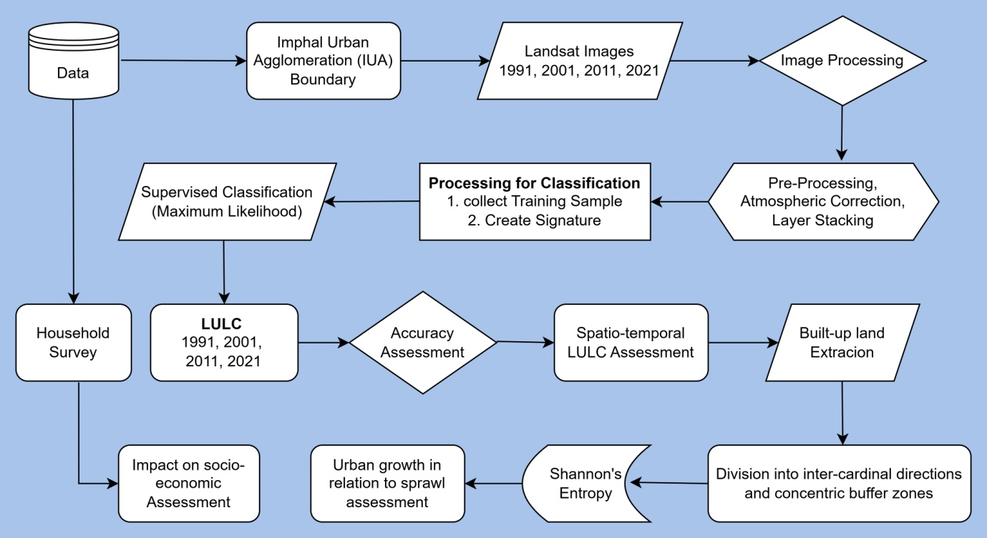
Fig. 2 Methodology Flowchart
4. Results and Discussions
4.1 Spatio-temporal LULC Change
LULC change for the IUA has been mapped for the four decades i.e. 1991, 2001, 2011 and 2021 as shown in fig. 3. Significant inter-class changes have been observed. In the year 1991, the agricultural land comprises 36.65% of the total area with an area of 4368.73 hectares (Table1). It reduces to 32.24% in the next decade with a reduction in the area to 3842.78 hectares. It further reduces to 30.37% in the decade 2011 with an area of 3620.01 hectares. Finally in the last decade of the study i.e. 2021 the agricultural land reduces to 26.13% with an area of 3115.41 hectares. Built-up constitutes 34.86% in 1991 with an area of 4155.03 hectare. It increases significantly to 41.98% in 2001 with an area of 5004.09 hectares. It continues to increase its extent in the 2001-2011 decade to 5629.97hectares occupying 47.23% of the total area. It further increases to 54.18% in the final decade covering an area of 6458.66 hectares. The vegetation class shows significant changes during the study period. In 1991, it constitutes 20.78% of the area with an area of 2477.56 hectares. In the next decade 1991-2001, it decreases to 17.25% covering an area of 2056.35 hectares. It decreases again in the next decade to 13.81% occupying an area of 1646.22 hectares. In the final decade 2011-2021, it further decreases to 12.02% with an area of 1434.51 hectares.
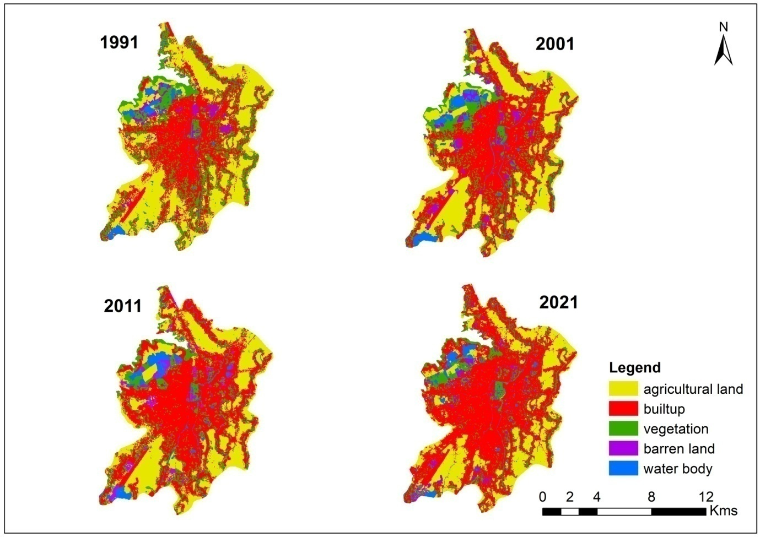
Fig. 3 LULC maps of the year 1991, 2001, 2011 and 2021
The share of barren land and water body keeps on fluctuating over the study period. Certain areas under these classes are easily alterable in nature depending on the season. During the rainy season some parts of the barren land, especially on the north-western sector, is converted into water body and during the dry season it either exists as barren land or are converted into agricultural land. The share of barren land constitutes 3.48% covering an area of 414.91 hectares in 1991. It slightly increases to 3.68% in the next decade covering an area of 439.11 hectares. In the next decade 2001-2011, it increases further to 3.87% constituting an area of 460.90 hectares. In the last decade 2011-2021, it again reduces to 3.24% covering an area of 385.76 hectares. The share of water body constitutes 4.23% in the year 1991 covering an area of 504.58 hectares. It increases in the decade 1991-2001 to 4.85% with an area of 578.50 hectares. It slightly decreases to 4.73% with an area of 563.73 hectares in the next decade 2001-2011 and further decreases in the last decade to 4.425% covering an area of 385.76 hectares.
Table 1 Area (in hectare) of the LULC classes in different years of the IUA
LULC CLASS | 1991 |  | 2001 |  | 2011 |  | 2021
LULC CLASS | Area(ha) | % | Area(ha) | % | Area(ha) | % | Area(ha) | %
Agricultural land | 4368.73 | 36.65 | 3842.78 | 32.24 | 3620.01 | 30.37 | 3115.41 | 26.13
Built-up | 4155.03 | 34.86 | 5004.09 | 41.98 | 5629.97 | 47.23 | 6458.66 | 54.18
Vegetation | 2477.56 | 20.78 | 2056.35 | 17.25 | 1646.22 | 13.81 | 1434.51 | 12.03
Barren land | 414.91 | 3.48 | 439.11 | 3.68 | 460.90 | 3.87 | 385.76 | 3.24
Water body | 504.58 | 4.23 | 578.50 | 4.85 | 563.73 | 4.73 | 526.48 | 4.42

4.2 Urban expansion mapping with Shannon’s Entropy
The urban expansion mapping in the IUA was conducted at the zone level across all the four sectors i.e. North-East, North-West, South-East and South-West (fig.4). The entropy values in the north-east sector for all the years crosses the threshold value signalling significant urban sprawling in the sector. The entropy values are found to be increasing over the years indicating the increasing sprawling in the IUA. The entropy values for the years 1991, 2001, 2011 and 2021 are 0.82, 0.94, 0.96 and 1.0 respectively as shown in table 2. The zone-wise entropy values were observed to follow a trend of increase from the core area towards the middle zones and then reduce towards the periphery. In all the four years, the entropy values increases from the core area i.e. zone I towards the middle zone i.e. II and III and then finally reduce towards the periphery. The decrease in the entropy value in zone I over the years signify the increase in built-up resulting in compacting the area. However the increase in the entropy values in the middle and the outer zones indicate the increasing sprawling in the area.
The north-west sector experiences significant urban sprawling as suggested by the entropy values. The entropy values in this sector increases over the years in the study period. The values for the year 1991, 2001, 2011 and 2021 are 0.76, 0.85, 1.00 and 1.12 respectively. This sector has five zones where a trend of increasing entropy values from the core towards the middle zones and then reduces towards the periphery is observed. In this sector, entropy values increases from zone I to zone II and then reduces from zone III till the periphery i.e. zone V. However the entropy values keep on increasing over the years in all the zones signalling the increase in built-up and sprawling (fig.5).
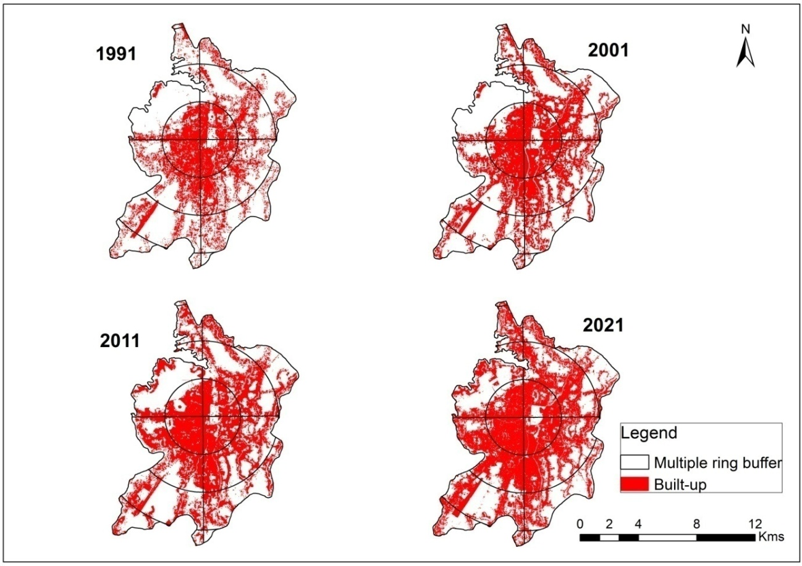
Fig. 4. Built-up expansion in the IUA in different zones and direction for different years
The south-east sector has four zones. The entropy values, here too, cross the threshold value indicating the occurrence of urban sprawl. The entropy values are 0.81, 0.89, 0.93 and 0.95 for the year 1991, 2001, 2011 and 2021 respectively. The trend of increasing entropy values from the core area towards the middle zone and then reduces towards the periphery is also observed in this sector. In all the years, the entropy values increase from zone I to zone II and then slightly reduce in the zone III and then sharply reduce in the outer zone. The increase of built-up in zone I, II and III as suggested by the entropy values suggest the increase of infillings and the sprawling process. Zone IV located in the peripheral areas become the new target for the built-up expansion.
The south-west sector has five zones. The entropy values have shown an increase in all the zones over the years in the study period. Similar trend of increasing entropy values from the core towards the middle zones and then reduces again towards the outer zones has been observed in this sector too. The entropy values increases from zone I to zone II. From zone II, it then reduces till the outer zone. Zone I and II have shown an increasing trend in the entropy values over the years signifying the increase of built-up resulting in compactness of the area. Zone III and IV have also shown an increasing trend of entropy values over the years indicating that these zones have been the continuously sprawling areas. The outer zone V has become the new targets for the built-ups as seen from the increasing entropy values over the years.
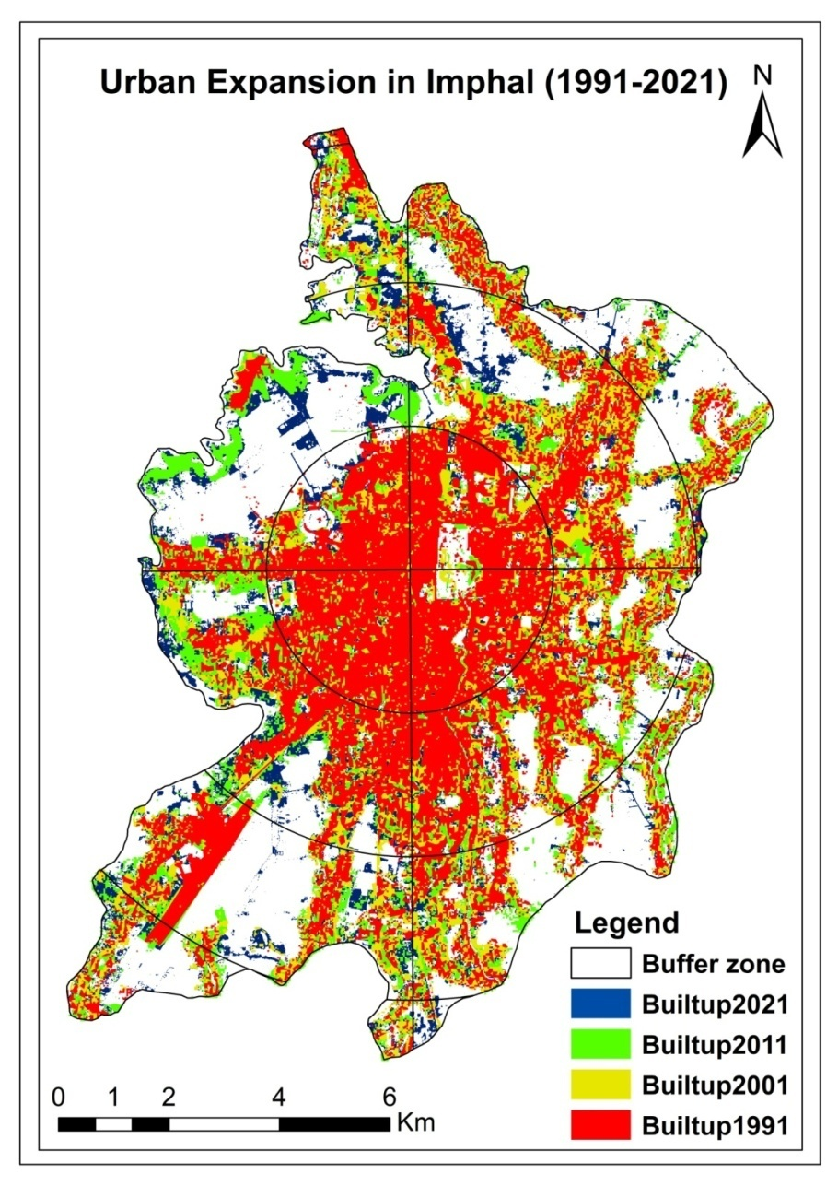
Fig. 5 Urban expansion of IUA at different sectors and distances from the city centre

Table 2 Shannon’s Entropy values zone-wise and direction-wise | 2021 | SW | 0.22 | 0.33 | 0.28 | 0.24 | 0.07
 | 2021 | SE | 0.24 | 0.34 | 0.28 | 0.10
 | 2021 | NW | 0.24 | 0.32 | 0.29 | 0.18 | 0.08
 | 2021 | NE | 0.16 | 0.32 | 0.32 | 0.20
 | 2011 | SW | 0.22 | 0.31 | 0.23 | 0.22 | 0.06
 | 2011 | SE | 0.23 | 0.33 | 0.29 | 0.09
 | 2011 | NW | 0.25 | 0.29 | 0.25 | 0.15 | 0.07
 | 2011 | NE | 0.17 | 0.31 | 0.29 | 0.19
 | 2001 | SW | 0.21 | 0.29 | 0.22 | 0.20 | 0.05
 | 2001 | SE | 0.22 | 0.32 | 0.25 | 0.09
 | 2001 | NW | 0.24 | 0.27 | 0.15 | 0.13 | 0.06
 | 2001 | NE | 0.17 | 0.31 | 0.29 | 0.17
 | 1991 | SW | 0.20 | 0.27 | 0.20 | 0.15 | 0.04
 | 1991 | SE | 0.22 | 0.30 | 0.22 | 0.07
 | 1991 | NW | 0.24 | 0.26 | 0.14 | 0.06 | 0.06
 | 1991 | NE | 0.17 | 0.28 | 0.23 | 0.14
 | Zones |  | I | II | III | IV | V

4.3 Assessment of urban sprawl impact
Urban sprawl is usually associated with various problems on economic, social, cultural and environmental aspects. An attempt was made to assess the impact of urban sprawling on the socio-economic structure of the people living in the IUA. The survey covers seven socio-economic determinants viz. income, family status, perspectives of both the inhabitants on increasing land price caused by the sprawling induced migration, social conflict, improvement on livelihood, transport network and frequency and ease of livelihood opportunity. A comparison between the migrants and the original settlers from the collected primary data were made for all the determinants.
The income variable was divided into six categories as seen in fig. 6(a). The low income group showed an almost equal percentage of migrants and original settlers. The middle income group were slightly dominated by the original settlers and the high income group were highly dominated by the migrants. Comparatively the migrants were found to have a better income structure. The income group was divided into two categories viz. above poverty line and below poverty line. 76.9% of the migrants fall under the above poverty line category while 65.6% of the original settlers fall under the same category. Whereas 23.1% of the migrants fall under below poverty line while 34.4% of the original settlers fall under the same category. It is clearly seen from this statistics that the migrants outperform the original settlers in terms of income generation (fig. 6(b)). Family status variable was categorized into two viz. joint family and nuclear family. The traditional system of joint family was more seen within the original settlers as 44.7% of them are still living in joint family whereas 71.5% the migrants were staying in nuclear family (fig. 6(c)). This structure of increasing nuclearization of family indicates the growing necessity and importance of migration in search of livelihood and better employment opportunities.
The survey is mainly based on the perceptions of both the settlers. When asked about the migration induced urban sprawling in the city and suburbs leading to the increased in land price, both the migrants and the original settlers were affirmative in their perspectives with 93.1% of the migrant and 95.8% of the original settler replying yes. The remaining 6.9% and the 4.2% respectively replied either a no or no change answer (fig. 6(d)). For the instances of social conflict 56.2% of the migrants and 40.1% of the original settler reported a yes indicating the increase in occurrence of social conflict among the settlers. Whereas 32.3% of the migrants and 49.6% of the original settler denied the increase in social conflict and the remaining 11.5% and 10.3% respectively replied a no change answer (fig. 6(e)).The perception of both the settlers was significantly positive with regard to the improvement in livelihood where 76.2% of the migrants and 48.9% of the original settlers replied a yes. 13.8% of the migrants and 32.4% of the original settlers were negative in their perception with regard to the improvement in livelihood induced by the urban sprawling. The remaining 10% and 18.7% respectively were neither positive nor negative in their perception as seen fig. 6(f).
Perceptions on the transport network and frequency associated with the urban expansion were also assessed. 79.2% of the migrants and 76.3% of the original settlers were affirmative of the improvement in transport network and frequency associated with the urban expansion. 10% of the migrants and 13% of the original settlers were negative in their perspective whereas the remaining 10.8% and 10.7% respectively were neither positive nor negative in their perspectives (fig. 6(g)). Finally, perspective on the ease of livelihood opportunity associated with the urban expansion in their settlement area was assessed from both the settlers. 4.6% of the migrants and 6.9% of the original settlers have responded that they find it very hard to find a livelihood occupation. 20% of the migrants and 23.7% of the original settlers find it hard to pick up a livelihood opportunity. However a significant portion of both the settlers i.e. 66.2% of the migrants and 57.6% of the original settlers find it moderate to search a livelihood opportunity in their area. The remaining 9.2% and 11.8% respectively find it easy to find a livelihood opportunity in their area (fig. 6(h)).
The type of migration which is inducing urban sprawling in the IUA is opportunity driven migration which is aspirational in nature. Major sections of the migrants were aspired to get better living conditions in the city and hence they migrate. As many as 76.9% of the migrants were in the above poverty line which means their migration were not primarily induced by searching for a livelihood. Hence in comparison with the original settlers, the migrants outperform the original settlers in income generation, high income group inclusion. Their perceptions on the improvement in livelihood, transport network and frequency and ease of finding a livelihood opportunity were all affirmative which means their economic conditions were improved after migrating to the city. However their perceptions reveal the occurrence of social conflict indicating that they experienced less social cohesion as they were new to the place they migrated. In overall perspectives their socio-economic conditions were improved after being migrated to the city.
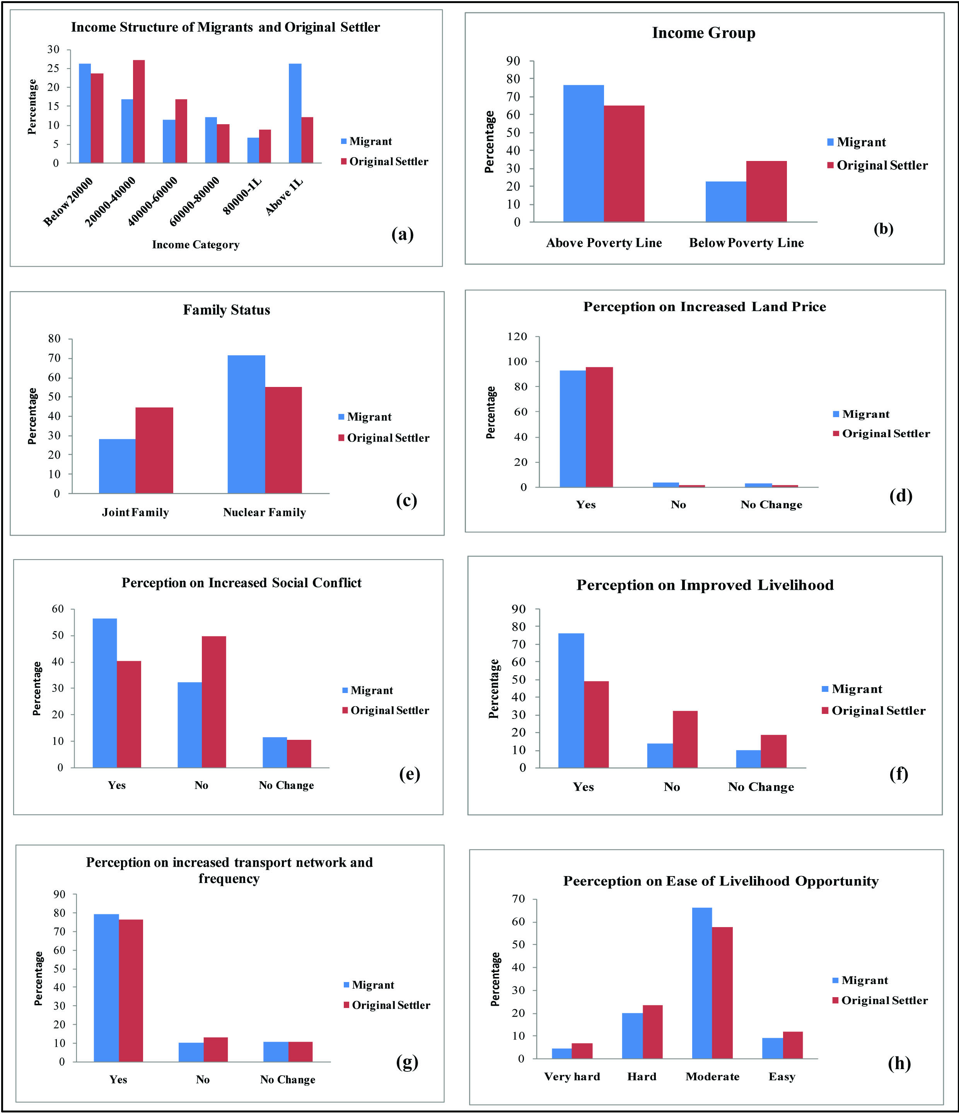
Fig. 6. Charts showing the comparison of the inhabitants at different variables a) income b) income group c) family status d) increased land price, e) increased social conflict, f) improved livelihood, g) transport network and frequency, h) ease of livelihood opportunity

4.4 Chi Square Test
Table 3 Chi Square test of income and inhabitant; inhabitant and improved livelihood
Variable | Chi Square Test | Value | df. | P Value
Income, Inhabitant | Pearson Chi Square | 16.829 | 5 | .005
Inhabitant, Improved Livelihood | Pearson Chi Square | 26.778 | 2 | .001

Chi Square test was performed to test the association between variables as shown in table 3. In the first instance, the test was performed between income and the inhabitant. Since the P value is less than .05, it indicates that there is significant association between the income and the type of inhabitant. As we have observed from the comparison between the migrants and the original settlers regarding the income generation as seen in fig. 6(a), the migrants were having better income structures. In the second case, the test was performed between the inhabitant and the perception on improved livelihood. Since the P value is .001, it indicates that there is highly significant association between the type of inhabitant and the perception on improved livelihood. As we have also observed from fig. 6(f) that the migrants were highly optimistic on their perception about the improvement in their livelihood after being migrated to the city. As much as 76.2% of the migrants have found improvement in their livelihood whereas only 48.9% of the original settlers find it positive on their perspectives about the improvement in their livelihood regarding the sprang up of huge migrants in their area leading to urban sprawl.
5. Conclusion
The IUA has experienced the adversaries of urban sprawling which the major cities of the world especially the cities of developing countries has been experiencing. The IUA is continuously sprawling with ever increasing intensity. The notion of sprawling in the IUA is random and haphazard in nature with no sign of systematic planning. Hence the random sprawling in the IUA is costing the precious agricultural land in and around the suburbs of the IUA which is located in a small and limited valley. The urban sprawling in the IUA has its impact on the inhabitants living in the city. The migration of people into the city is more of an aspirational type which means that people migrated into the city aiming to get better living condition rather than searching for an employment opportunity or to alleviate poverty. The socio-economic conditions of the inhabitants are aligned in such a way that the migrants are more favoured. Lastly the study highlights the nature of random and haphazard urban sprawling in the IUA and emphasized the need to orient the urban expansion process in the IUA to a more planned, systematic sustainable way.

Ethical Approval
The authors have taken all the ethical requirements in the study.

Disclaimer (Artificial intelligence)
Author(s) hereby declare that NO generative AI technologies such as Large Language Models (ChatGPT, COPILOT, etc.) and text-to-image generators have been used during the writing or editing of this manuscript.

Reference
- Adaku, E. (2014). Urban sprawl: A view from developing and developed countries. African Journal of Geography and Regional Planning, 1(6), 193-207. https://www.internationalscholarsjournals.com/articles/urban-sprawl-a-view-from-developing-and-developed-countries.pdf
- Ahmad, A., &Quegan, S. (2012). Analysis of maximum likelihood classification on multispectral data. Applied mathematical sciences, 6(129), 6425-6436. http://www.m-hikari.com/ams/ams2012/ams129-132-2012/ahmadAMS129-132-2012.html
- Bhat, P. A., ul Shafiq, M., Mir, A. A., & Ahmed, P. (2017). Urban sprawl and its impact on landuse/land cover dynamics of Dehradun City, India. International Journal of Sustainable Built Environment, 6(2), 513-521. https://doi.org/10.1016/j.ijsbe.2017.10.003
- Brueckner, J. K. (2000). Urban sprawl: Diagnosis and remedies. International Regional Science Review, 23(2), 160-171. https://doi.org/10.1177/016001700761012710
- Dadi, D., Azadi, H., Senbeta, F., Abebe, K., Taheri, F., &Stellmacher, T. (2016). Urban sprawl and its impacts on land use change in Central Ethiopia. Urban Forestry & Urban Greening, 16, 132-141. https://doi.org/10.1016/j.ufug.2016.02.005
- Ewing, R., & Hamidi, S. (2015). Compactness versus sprawl: A review of recent evidence from the United States. Journal of Planning Literature, 30(4), 413-432. https://doi.org/10.1177/0885412215595439
- Hasse, J. E., & Lathrop, R. G. (2003). Land resource impact indicators of urban sprawl. Applied geography, 23(2-3), 159-175. https://doi.org/10.1016/j.apgeog.2003.08.002
- Jat, M. K., Garg, P. K., &Khare, D. (2008). Monitoring and modelling of urban sprawl using remote sensing and GIS techniques. International Journal of Applied Earth Observation and Geoinformation, 10(1), 26-43. https://doi.org/10.1016/j.jag.2007.04.002
- Karakayaci, Z. (2016). The concept of urban sprawl and its causes. Journal of International Social Research, 9(45). https://doi.org/10.17719/jisr.20164520658
- Kundu, A. (2011). Trends and processes of urbanisation in India. Urbanisation and Emerging Population Issues 6. International Institute for Environment and Development (IIED) and United Nations Population Fund (UNFPA). https://www.iied.org/trends-and-processes-urbanisation-india
- McGwire, K. C., Estes, J. E., & Star, J. L. (1996). A comparison of maximum likelihood‐based supervised classification strategies. Geocarto International, 11(2), 3-13. https://doi.org/10.1080/10106049609354530
- Muzaffar, M., & Ali, M. (2024). Assessing the Socio-Economic Impacts of Urban Sprawl on Rural Communities. ASEAN Journal of Economic and Economic Education, 4(1), 1-8. Retrieved from https://www.ejournal.bumipublikasinusantara.id/index.php/ajeee/article/view/551
- Owusu, G. (2013). Coping with urban sprawl: A critical discussion of the urban containment strategy in a developing country city, Accra. Planum: The Journal of Urbanism, 26(1), 1-17. http://www.planum.net/planum-magazine/cities-to-be-tamed/section-1
- Rahman, A., Aggarwal, S. P., Netzband, M., & Fazal, S. (2010). Monitoring urban sprawl using remote sensing and GIS techniques of a fast growing urban centre, India. IEEE Journal of Selected Topics in Applied Earth Observations and Remote Sensing, 4(1), 56-64. https://doi.org/10.1109/JSTARS.2010.2084072
- Ramachandra, T. V., Aithal, B. H., & Sanna, D. D. (2012). Insights to urban dynamics through landscape spatial pattern analysis. International journal of applied earth observation and geoinformation, 18, 329-343. doi:10.1016/j.jag.2012.03.005
- Renu, S. K. T., & Hussain, T. P. R. S. (2019). A Literature Review on Urban Sprawl in Developed and Developing Countries. Journal of Advance Research in Social Science & Humanities, 5(7), 01-04. https://doi.org/10.53555/nnssh.v5i7.767
- Sinha, S. K. (2018). Causes of Urban Sprawl: A comparative study of Developed and Developing World Cities. RESEARCH REVIEW International Journal of Multidisciplinary, 3(9), 5-9. https://doi.org/10.5281/zenodo.1409035
- Sisodia, P. S., Tiwari, V., & Kumar, A. (2014). Analysis of supervised maximum likelihood classification for remote sensing image. In *International Conference on Recent Advances and Innovations in Engineering (ICRAIE-2014)* (pp. 1-4). IEEE. https://doi.org/10.1109/ICRAIE.2014.6909319
- Soltani, A., Azizi, P., Javadpoor, M., Allan, A., & Bagheri, B. (2025). Determining and Quantifying Urban Sprawl Drivers: A Delphi-DANP Approach. Land, 14(2), 311. https://doi.org/10.3390/land14020311
- Sudhira, H. S., Ramachandra, T. V., & Jagadish, K. S. (2004). Urban sprawl: metrics, dynamics and modelling using GIS. International Journal of Applied Earth Observation and Geoinformation, 5(1), 29-39. https://doi.org/10.1016/j.jag.2003.08.002
- Tabassum, A., Kamal, A. M., Rahman, M. Z., & Shahid, S. (2025). Impact of urban sprawl on urban heat island in Chittagong: a non-parametric analysis using satellite nighttime light and land surface temperature data for the period 2000–2021: Tabassum et al. Theoretical and Applied Climatology, 156(6), 341. https://doi.org/10.1007/s00704-025-05487-y
- Tu, J., Xia, Z. G., Clarke, K. C., & Frei, A. (2007). Impact of urban sprawl on water quality in eastern Massachusetts, USA. Environmental Management, 40(2), 183-200. https://doi.org/10.1007/s00267-006-0097-x
- Wei, Y. D., & Ewing, R. (2018). Urban expansion, sprawl and inequality. Landscape and Urban Planning, 177, 259-265. https://doi.org/10.1016/j.landurbplan.2018.05.021
- Wen, H., Yu, H., & Nghiem, X. H. (2024). Impact of urban sprawl on carbon emission efficiency: Evidence from China. Urban Climate, 55, 101986. https://doi.org/10.1016/j.uclim.2024.101986
- Yang, X., Liu, J., & Li, M. (2024). Transportation energy consumption decreases despite urban sprawl: Evidence from Chinese household survey. Cities, 146, 104738. https://doi.org/10.1016/j.cities.2023.104738
- Samantha Kahoya Nyongesa, Marianne Maghenda & Mika Siljander. (2022). Assessment of Urban Sprawl, Land Use and Land Cover Changes in Voi Town, Kenya Using Remote Sensing and Landscape Metrics. Journal of Geography, Environment and Earth Science International, 26(4), 50–61. https://doi.org/10.9734/jgeesi/2022/v26i430347

