Ethnobotanical Study of Medicinal Plants Used in the Treatment of Diseases in the Kangu Grouping
Aims: This study aimed to establish a systematic ethnobotanical inventory of medicinal plants used by vendors and traditional healers for the treatment of human diseases in the Kangu community, Democratic Republic of Congo. Specifically, it sought to identify the main afflictions treated, the most frequently used plant parts, and the predominant modes of preparation and administration.

Study Design: A descriptive ethnobotanical survey based on structured questionnaires and statistical analysis.

Place and Duration of Study: Conducted in the Kangu Grouping between January and June 2025.

Methodology: Data were collected from 30 respondents, including traditional healers and herbal vendors, through structured questionnaires and interviews. Plant species were identified and therapeutic indications categorized. Descriptive statistics were applied to analyze citation frequencies, plant parts used, and preparation modes. A total of 67 medicinal species were documented.

Results: The respondents reported 67 species used to treat 40 afflictions grouped into 10 categories. Malaria emerged as the most frequently cited condition, followed by gastrointestinal disorders and reproductive health issues. Leaves were the most commonly used plant part, while enemas and oral intake represented the predominant modes of administration.

Conclusion: This study provides a baseline ethnobotanical inventory of medicinal plants in the Kangu community, emphasizing their cultural and therapeutic relevance. The findings highlight species of potential pharmacological interest and underscore the importance of preserving traditional knowledge. They also open new avenues for validation and safe integration of local remedies into future clinical research, while promoting sustainable use of biodiversity.
Keywords: Traditional medicine, Medicinal plants, Kangu groupement, Diseases

INTRODUCTION

Medicinal plants constitute an indispensable resource for healthcare worldwide, particularly in developing regions where they often serve as alternatives to modern treatments (Srivastava et al., 2000; WHO, 2002; Heinrich et al., 2020). The growing population, combined with the limited accessibility of conventional pharmaceuticals in many low-income countries, has contributed to an increasing reliance on plant-based remedies (Mohammadi et al., 2022; Jamshidi-Kia et al., 2018). Recent ethnobotanical surveys confirm that traditional medicine remains a cornerstone of healthcare delivery in Africa, where biodiversity conservation and cultural practices intersect (Nargawe et al., 2023; De Meyer et al., 2024; Quave & Pieroni, 2020).In the Democratic Republic of the Congo, the Kangu groupement represents a distinct sociocultural and ecological context in which medicinal plants play a central role in primary healthcare. The community is characterized by its dependence on forest resources, the transmission of endogenous knowledge across generations, and the preservation of therapeutic practices deeply embedded in cultural identity. Sustainable management of these resources, actively involving local populations, is therefore essential (Mavinga, 2020; Vandebroek et al., 2020). Sustainable management of these resources, actively involving local populations, is therefore essential (Schippmann et al., 2002; Albuquerque et al., 2019).

Several studies indicate that local communities in the DRC have been insufficiently involved in forestry reforms, particularly during the drafting of the Forestry Code enacted in 2002. Although this legal framework constitutes a significant advancement, its implementation remains limited, and the operationalization of community forestry management provisions is still largely at the planning stage (Sakata, 2009; Ndambo, 2014; Nlandu, 2020).
The importance of traditional medicine in health systems and natural resource management is well established. Indeed, more than 40% of current medical prescriptions worldwide are of natural origin (Fabricant et al., 2001; Newman et al., 2003; Newman & Cragg, 2020)). Moreover, it is estimated that over 70% of African populations rely on traditional healers (Kayombo et al., 2012; Fakeye et al., 2009; WHO, 2019).). In these contexts, where access to Western medicine is often absent or prohibitively expensive, dependence on remedies derived from native plants is particularly pronounced (Abdullahi, 2011; Ekor, 2014; Mahomoodally, 2019).
Within the Kangu groupement, traditional medicine occupies a central position in healthcare practices. This reliance is largely attributable to the local abundance of medicinal plants, their recognized therapeutic properties, the financial accessibility of traditional treatments, and the comparatively low incidence of reported side effects relative to modern medicine (Vandebroek et al., 2020). Local ethnobotanical knowledge enables the treatment of a wide spectrum of ailments, including dermatological diseases, bacterial infections, and conditions requiring traditional physiotherapeutic practices (Paniagua-Zambrana et al., 2020). However, the prominence of these practices raises concerns regarding the pressure exerted on forest resources in the Mayombe, which are already experiencing a trend toward depletion. Similar threats linked to overharvesting of medicinal plants have been reported across tropical forests (Ticktin, 2015; Baldauf et al., 2020). In this context, it is essential to gain a deeper understanding of the population’s actual needs for medicinal plants in order to guide sustainable management strategies.

The central question of this study can therefore be formulated as follows: Which plant species are most frequently used in the treatment of diseases within the Kangu groupement, and what information should be disseminated to local communities to ensure a sustainable supply of medicinal plants?

This study pursues the overall objective of establishing a systematic inventory of the plants used by traditional healers and herbal vendors in the Kangu groupement. More specifically, it aims to identify, through ethnobotanical surveys, the most commonly used species, the plant parts most frequently harvested, and the preferred modes of administration. This work contributes not only to the valorization of local therapeutic knowledge but also to the conservation of the natural heritage of the Mayombe. The expected outcomes are intended to support ongoing efforts to promote sustainable management and encourage staggered harvesting practices, which are essential to preventing the gradual depletion of medicinal plant species.

2. Material and Methods
2.1 Study Area
The Territory of Lukula is subdivided into five sectors and comprises a total of 60 community groups. The Fubu Sector consists of 12 community groups (Figure 1), namely: Kangu, Khoze, Kiniati, Kuimba-Lukula, Mbamba, Mbavu, Mboma-Tsundi, Nkuangila-Lukula, Phelele, Tsese-Ntinu, Vonde, and Vungu. The sector also includes an urban settlement known as Nsioni.
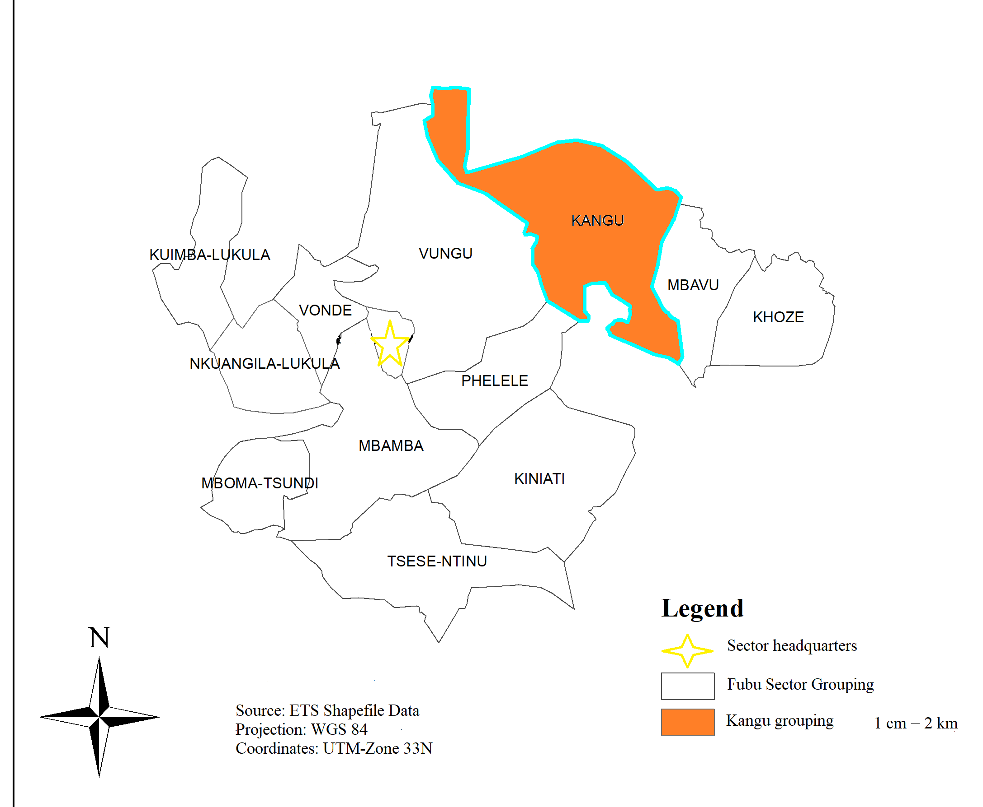
Figure.1. administrative subdivision of the Fubu Sector
Source : Khala Claude-Benoit, 2025

The Kangu community group consists of 36 villages (Table 1) and covers an area of 670 km², making it the largest community group within the Fubu Sector. However, some villages are gradually disappearing as a result of rural outmigration affecting the region. The local population increasingly prefers to migrate toward the town of Nsioni and other more developed urban centers, attracted by more favorable and modern living conditions.
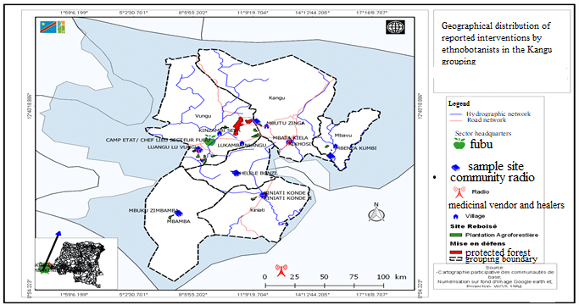
Figure.2. Ethnobotanical Sampling Site, PIF/PGAPF
Source: Reagan Mbumba, 2024

Table 1 Villages of the Kangu Community Group
Kangu Keba | Kayi Ki kangu | Kuimba Ntoto | Mbutu Thebukila
Kangu Luvu | Kayi Nzambi | Makangu Mombo | Mbutu Zinga
Kangu Mbunda | Kayi Nzambi Ma Kangu | Makayi Ku Kuimba | Singa Phanda
Kangu Mbenza | Kiobo Ki Kangu | Maniaka Mbumba | Tsundi Kupika
Kayi keba | Kiyenga Kangu | Mayenga Di Mbutu | Tsundi Loba
Kayi kumbi | Kiyombo Kangu | Mayenga Ma Kangu | Yema Di Kangu
Kayima Diambu | Konde Kaka | Mboma Bunzi | Zeba Kikangu
Kayi Kaka 1 | Kutilu Bela | Mbuku Buete | Yema Di Kangu
Kayi Kaka 2 | Kuimba Nsole | Mbuku Zikangu

2.1.1 Climate

The climate of Kangu corresponds to a tropical savanna climate (Aw) according to the Köppen classification. It is characterized by a five-month dry season and a seven-month rainy season, with intense seasonal rainfall and an average annual temperature of approximately 25°C.

2.1.2 Relief

The area shows diverse topography, ranging from alluvial plains to plateaus and ridges. This variation influences land use, agriculture, and infrastructure accessibility.

2.1.3 Pedology

Soils are generally rich and well-drained, supporting staple crops such as cassava, maize, groundnut, and oil palm. Some southeastern zones are less suitable for mango cultivation, highlighting the need for differentiated soil management.

2.1.4 Hydrography

The hydrographic system is structured around the Mungumungu River and its tributaries. It ensures surface water drainage, soil moisture recharge, and contributes to fertility and ecosystem stability.

2.1.5 Vegetation

Vegetation consists mainly of shrub savannas, acacia plantations, and gallery forests along rivers. This mosaic regulates water, protects soils, and sustains biodiversity.

2.1.6 Fauna
Wild fauna is limited due to anthropogenic pressure and forest fragmentation, while domestic animals (goats, poultry, cattle, dogs, cats) are abundant. Rivers and streams also provide fish species that contribute to local nutrition.
2.2 Methods
The ethnobotanical inventory of medicinal plants in the Kangu community was conducted between January and June 2025 in the main markets and selling points. In accordance with the Declaration of Helsinki, a stratified probabilistic sampling method was applied, with each stratum representing a market or selling point.
A total of 30 participants were selected, including 21 traditional healers and 9 herbal vendors. Data were collected through structured questionnaires and semi-structured interviews conducted in the Kiyombe language. Information gathered included cited species, therapeutic indications, plant parts used, and preparation methods.
Responses were codified and grouped into categories (indications, plant parts, administration modes). Descriptive statistical analyses were performed using Excel and RStudio, applying means for quantitative variables and percentages for qualitative variables.
Aims and Objectives
• To establish a systematic inventory of medicinal plants used by traditional healers and vendors in the Kangu community.
• To identify the most frequently treated afflictions.
• To determine the plant parts most commonly used.
• To describe the preferred modes of administration.
Observation and Results
The study population consisted of 30 informants, comprising traditional healers and medicinal plant vendors from the Kangu community group. The questionnaires were administered to individuals representing various sociocultural profiles within the community group.

1. Sociodemographic Characteristics of the Respondents
The sociocultural description of our respondents includes sex, age, marital status, level of education, and income derived from this activity.
Table 2 presents the sociocultural distribution of the study sample.
Table.2. Descriptive Statistics of Sociodemographic Characteristics
Variable | Categories | frequencies | Percentage | Min | max | Mean | Standard deviation | Range
Sex | Male | 21 | 70
Sex | Female | 9 | 30
Sex | Total | 30 | 100
Age | 30-39 years | 11 | 37 | 35.00 | 45.00 | 41.33 | 4.901325 | 10.00
Age | 40 years and more | 19 | 63 (rounded from)
Age | Total | 30 | 100
Marital status | Single | 0 | 0
Marital status | Married | 28 | 93,3
Marital status | Divorced | 1 | 3,33
Marital status | Widowed | 1 | 3,33
Marital status | Total | 30 | 100
Education level | No formal education | 20 | 67 (rounded from)
Education level | Primary education | 10 | 33 rounded from)
Education level | Secondary | 0 | 0
Education level | Higher/university | 0 | 0
Education level | Total | 30 | 100
Household Size | 1 to 5 persons | 28 | 93 (rounded from) | 4.00 | 7.00 | 4.20 | 0.7611244 | 3.00
Household Size | 6 to 10 persons | 2 | 7 (rounded from)
Household Size | Total | 30 | 100
Income | Less than 100 $ | 24 | 80 | 80.00 | 600.00 | 134.00 | 121.0472 | 520.00
Income | Between 100 and 500$ | 5 | 17(rounded from)
Income | 500$ and more | 1 | 3 (rounded from)
Income | Total | 30 | 100

As shown in the results, the distribution of respondents by sex indicates that 70% of the traditional healers were male, while 30% were female, demonstrating a clear predominance of men in the practice of traditional medicine within the study area.
With regard to marital status, the vast majority of respondents were married (93,3%), representing the dominant group within the sample. In contrast, single individuals were not represented (0%), while divorced and widowed respondents accounted for only 3,33% respectively. This finding suggests that traditional medical practice in the study area is largely carried out by individuals with established family responsibilities.
The age of the informants ranged from 35 to 45 years, with a mean age of 41,33 years. This age structure indicates that the study population is primarily composed of older adults, reflecting a high level of accumulated experience and extensive knowledge of traditional medical practices, which are typically acquired over long periods of practice and intergenerational transmission.
Regarding educational level and income, although these variables are not presented in detail in the dataset, the findings highlight the economic importance of traditional medical practice. Respondents expressed a strong preference for traditional medicine due to its associated economic benefits. Traditional healers reported earning an estimated USD 100 to 350 per semester, which constitutes a relatively substantial income for an informal economic activity in the local context.
3.1. Plant Species Used in Traditional Medicine

The survey focused on local and introduced plant species used in traditional medicine, regardless of their formally recognized medicinal status. A total of 67 specific taxa were recorded in the Kangu community group. These taxa include Angiosperms (both dicotyledons and monocotyledons) as well as Pteridophytes (spore-bearing plants), all of which possess medicinal properties and are utilized in the local traditional pharmacopoeia.
These species are distributed across 81 genera and 38 botanical families. The most represented families were Euphorbiaceae (11 species), followed by Fabaceae (7 species), Annonaceae (6 species), and Asteraceae (6 species).
The documented plant species are primarily used in the treatment of 40 different ailments, which were grouped into 10 major disease categories (Figure 3).

«Major Categories of Ailments and Their Relative Importance in Traditional Medicine in the Kangu Community Group.»
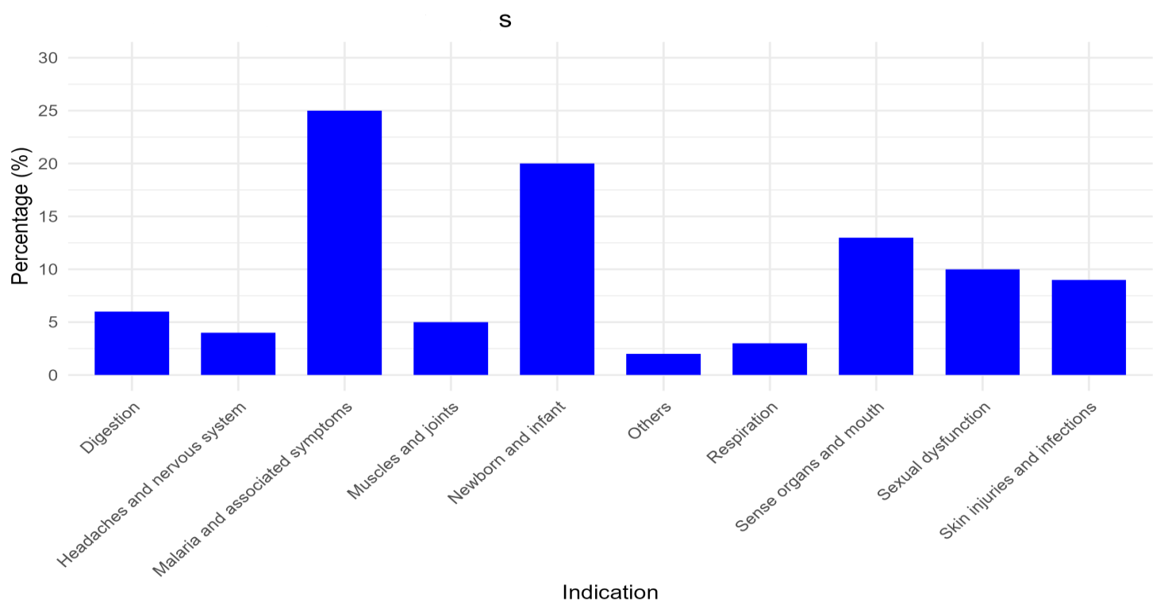

Figure.3. Categories of Ailments and Their Significance

3.2. Common Therapeutic Indications of Medicinal Plants
More specifically, the study demonstrates that, within the traditional medical practices of the Kangu community group, medicinal plants are used to treat a wide range of commonly encountered ailments. The most frequently cited therapeutic indications reported by traditional healers were malaria (26 citations); hemorrhoids and diarrhea (8 citations); dysmenorrhea and sexual asthenia (7 citations); pregnancy maintenance (6 citations); and hydrocephalus (5 citations).
Overall, a total of 119 use-reports (citations) were recorded for the various pathologies treated with medicinal plants in the study area.
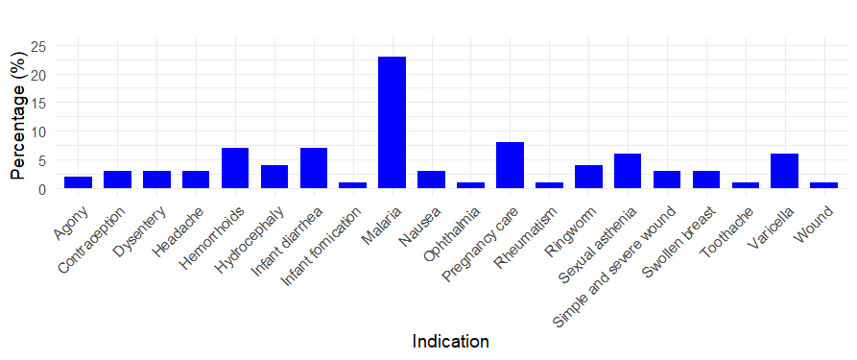
Figure.4. Most Frequent Mode of Indication

3.3. PARTS USED
Figure 5 below illustrates the plant parts most commonly used in traditional medicine in the Kangu groupement, according to the survey results. Regarding the most preferred parts of these plant species, the findings indicate the following patterns of use:
- Leaves (25%): Healers and vendors mainly favor the use of leaves due to their recognized therapeutic properties.
- Bark (20%): Bark ranks second, accounting for a substantial proportion of medicinal plant use in the treatment of various ailments.
- Roots (15%): Roots are also used, although less frequently than leaves and bark. This lower frequency of use is explained by the types of ailments for which this plant part is employed. Indeed, healers and vendors report that root-based treatments are mainly used for musculoskeletal and joint-related disorders, as well as for sexual dysfunctions—conditions that occur relatively infrequently over the course of the year.
- Other parts (40%): The remaining proportion corresponds to the use of other plant parts. However, these are generally of lesser significance in therapeutic applications.
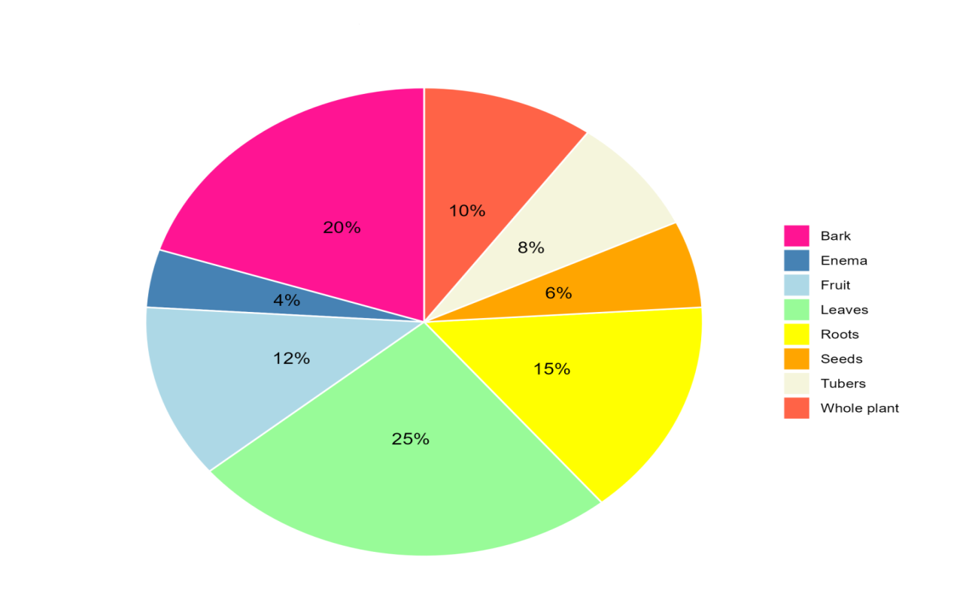
Figure.5. parts used

3.4. Modes of Administration

Figure 6 illustrates the modes of use of medicinal plants and shows that, among the various methods recorded, enemas (34%) were the most frequently reported mode of administration, followed by oral administration (19%), topical application by rubbing or smearing (15%), and intimate bathing (10%).

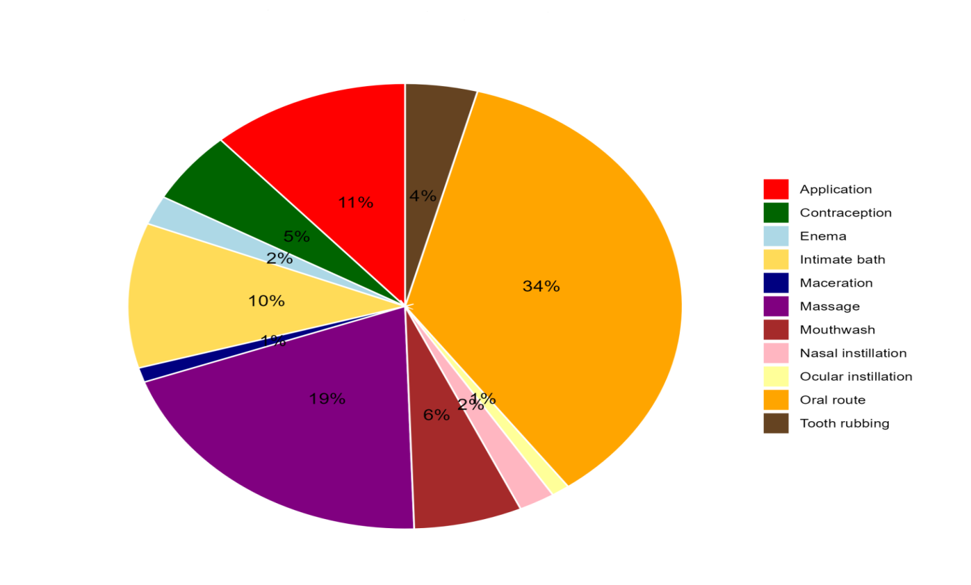
Figure.6. Mode of Use
3.5. ETHNOBOTANICAL INVENTORY

Table 3 presents the list of recorded plant species, their therapeutic indications, the parts used, and the modes of administration. It includes spontaneous species from the local flora as well as plants commonly sold and used by traditional healers.

Table.3. List of documented plant species.

Plante | Indication | Partie utilisée | Mode d’utilisation
Abrus precatorius | Intoxication ; palpitations | Leaf | oral route
Ageratum conyzoides | Headache (cephalgia) | Leaf | nasal instillations.
Alchornea cordifolia | vaginal discharge (Leucorrhea) | Leaf | Enema
Alstonia boonei | malaria | bark, Leave | Oral route, Enema,  Body painting
Alternanthera pungens | Convulsion ; Infant diarrhea | Leaf | Body painting, Enema
Anchomanes difformis | dysmenorrhea | Tuber | Enema
Anthocleista nobilis | Paludisme ; Rheumatism | bark, Root | Body painting
Azadirachta indica | Malaria | Leaf | Oral route, Enema, Body painting,
Bambusa vulgaris | malaria | Leaf | Oral route
Baphia nitida | Bad breath ; Bubo; Lower back pain | Root, Leaf | Tooth powder, Topical application
Bidens pilosa | Malaria, Hydrocephalus, Diarrhea | Leaf | Enema, Body painting
Bridelia micrantha | Malaria | Leaf | Bath, Enema
Caesalpinia bonduc | Malaria | Leaf | Enema
Cajanus cajan | Malaria | Leaf | Enema, Oral route, bain
Capsicum frutescens | Contraception, Agony | Fruit, Leaf | Contraception, Enema, Eye drops
Carica papaya | Malaria, Contraception | Leaf | Oral route, Enema
Carpolobia lutea | sexual asthenia | root | Oral route
Cassia alata | Malaria ; Eczema, Constipation | Leaf | Topical application, Body painting, Oral route
Cassia occidentalis | Constipation ; malaria ; headache (cephalgia) | Leaf | Oral route, Eye drops, nasal instillations.
Catharanthus roseus | Inguinal hernia | root | Enema
Cnestis ferruginea | Antenatal care ; Hydrocephalus | Leaf,root | Enema, Bath
Cocos nucifera | toothache | bark | Mouthwash
Cola lateritia var. maclaudi | Malaria | bark | Body painting
Cola nitida | Felon, Chickenpox | bark | Topical application
Digitaria horizontalis | Edema | whole plant | Body painting
Dioclea reflexa | infant fortification | seed | Bain
Eclipta prostrata | Malaria, Antenatal care Hydrocéphalus, Diarrhea, | Leaf | Enema, Bath,  Body painting
Erythrina senegalensis | Dysménorrhée, Rheumatism, Edema | bark | Enema, Topical application, Body painting
Eugenia whytei | Infant diarrhea, Bad breath Nausea | root, Leaf | Enema, Tooth powder, Oral route
Euphorbia hirta | Prenatal care, Measles, Diarrhea | whole plant | Enema
Ficus exasperata | Injury | root | Topical application
Flagellaria guineensis | Malaria, delayed motor functions, | Leaf | Bath
Garcinia kola | Bad breath , Sexual asthenia , Sexual weakness, Lung infection, Azoospermia, | root, fruit | Tooth powder, macération
Glyphaea brevis | prenatal care | Leaf | Enema
Gossypium spp | Dysménorrhea | Leaf | Enema
Harungana madagascariensis | Malaria | bark | Enema, bain, Oral route, Body painting
Heterotis rotundifolia | Diarrhea | Leaf | Enema
Hoslundia opposita | Convulsion (Seizure) | Leaf | Eye drops
Icacina mannii | Dysménorrhea, Sexual asthenia, Hemorrhoids | Tuber | Oral route
Jatropha curcas | abortion. | Leaf | Enema
Jatropha gossypiifolia | Dysménorrhea | Leaf | Enema
Khaya ivorensis | Sexual asthenia, Hemorrhoids | bark | Oral route, Enema
Kigelia africana | Swollen breasts, Sterility | Fruit, bark,  Leaf | Topical application , Enema, Oral route
Lophira alata | Bad breath | root | Tooth powder
Mangifera indica | Malaria , wound | bark | Oral route
Manihot esculenta | infant diarrhea | Fruit | Enema
Milicia excelsa | dysentery. | bark | Enema
Milicia regia | Hydrocephalea | bark | Bath, Body painting
Mitracarpus scaber | Eczema, Lower back pain | Leaf | Topical application, Enema
Momordica charantia | Malaria, Chickenpox. | Leaf | Bath, Oral route,  Body painting
Moringa oleifera | Malaria | Leaf | Oral route
Musa paradisiaca | Malaria, Ophtalmies | Leaf | Bath, Oral route, Enema
Ocimum gratissimum | prenatal care,  Infant diarrhea, ophthalmia, cephalea, Dysmenorrhea, Convulsion, malaria | Leaf | Enema, nasal instillations, Eye drops
Parinari excelsa | Hémorrhoids | bark | Enema
Paullinia pinnata | Malaria, gastritis, Hemorrhoids | Leaf | Bath, Body painting, Enema, Oral route
Pentaclethra macrophylla | Hydrocephalea | bark | Bath, Body painting
Phyllanthus amarus | Malaria, prenatal care ; Chickenpox | whole plant, Leaf | Oral route, Enema, Body painting
Psidium guajava | anal sores. | root | Enema
Pycnanthus angolensis | anemia, Hemorrhoids | bark | Oral route, Enema
Rauvolfia vomitoria | Malaria | root | Enema, Body painting
Ricinodendron heudelotii | sexual asthenia, Dysmenorrhea, Hémorrhoids | bark | Enema, Oral route
Ricinus communis | Lower back pain, Headache | Leaf | Massage, Topical application
Saccharum officinarum | Abortion | Leaf | Enema
Solanum lycopersicum | Contraception, Blessure grave, Agonie | Leaf | Enema, Topical application
Solanum nigrum | Malaria | Leaf | Bath, Enema, Body painting
Vernonia amygdalina | Malaria | Leaf | Bath, Body painting, Enema
Zanthoxylum gilletii | Malaria, sexual Asthénia, Hemorrhoids | bark | Oral route, Enema

DISCUSSION

The results of this study reveal a considerable richness of ethnobotanical knowledge within the Kangu community group, with 67 plant taxa traditionally used to treat a wide range of ailments. This diversity reflects a significant local pharmacopoeial heritage, consistent with recent observations indicating that African communities continue to rely heavily on a wide variety of plant species for healthcare purposes (Muanga et al., 2024).

Diversity of species and botanical families

The predominance of botanical families such as Euphorbiaceae, Fabaceae, Annonaceae, and Asteraceae is consistent with ethnobotanical inventories conducted in other Central African contexts, where these families are frequently cited in local pharmacopoeias for the treatment of infectious and systemic diseases (Numbi Wa Ilunga et al., 2025). The high number of taxa recorded in Kangu also aligns with the regional trend in which communities identify numerous plant species with diverse therapeutic uses, highlighting the complexity of traditional knowledge systems and the biological richness of the region.

Frequently cited therapeutic indications

Therapeutic indications such as malaria, gastrointestinal disorders, genitourinary conditions, and pregnancy maintenance reflect health priorities that are widely reported across Central Africa. In the Republic of Congo, for example, anti-infective plants—some of which are also locally used to treat malaria and other infections—dominate the practices of traditional healers, thus corroborating the findings of the present inventory (Muanga et al., 2024).

The diversity of pathologies treated underscores the importance of medicinal plants as a first-line therapeutic option in areas where healthcare infrastructure is limited and where populations continue to place strong trust in traditional medicine.

Plant parts used

The preference for leaves (25%) observed in this study is consistent with findings from other regional studies, which report that leaves are the most frequently harvested plant parts due to their availability, richness in active compounds, and harvesting methods that are less destructive than those involving roots or bark (Afiong et al., 2024).

The notable use of bark and roots further confirms that deeper plant parts are often sought for specific ailments despite their potential negative impact on plant survival, thereby highlighting the need for sustainable management and domestication strategies (Afiong et al., 2024).

Modes of administration

The study reveals that enemas and oral administration are the most frequently cited modes of use. This reflects the diversity of traditional preparations adapted to specific therapeutic indications and illustrates a cultural adaptation of usage modes according to disease type. Such patterns have already been reported in African ethnobotanical studies, where multiple administration routes (oral, rectal, topical) are strategically employed based on symptoms and associated beliefs (Muanga et al., 2024).

The prominence of these administration methods also highlights the need for more in-depth evaluation of pharmacodynamic effects and associated risks in order to safely integrate these practices into public health policies.

Comparison with other regional ethnobotanical studies

Studies conducted in other parts of the Democratic Republic of the Congo confirm the high prevalence of local medicinal knowledge and the diversity of plants used to treat similar categories of diseases (Ethnomedical Knowledge., 2024). For example, traditional medicine in Mampa documents the use of 38 plant species for a broad spectrum of ailments, with a dominance of root use in certain cases, thereby illustrating regional variations even within the same country (Ethnomedical Knowledge., 2024).

Implications for conservation and community health

The pressure exerted on forest resources due to the intensity of use—particularly of roots and bark—raises concerns about unsustainable exploitation, as highlighted in several studies focused on Central Africa (Afiong et al., 2024). In this context, it is essential to integrate participatory conservation measures, promote phytopharmacological research, and encourage medicinal agroforestry practices to reduce pressure on wild plant species.

Ethnobotanical inventory and interregional variability

This study on plant species used in the traditional pharmacopoeia of Kangu provides several key insights. In particular, it confirms that the therapeutic use of a given plant species is not universal, as the same species may be employed to treat different ailments depending on geographical and cultural contexts. A plant considered effective against malaria in the Democratic Republic of the Congo may be used elsewhere for entirely different indications or may exhibit a different perceived therapeutic efficacy. Recent comparative ethnobotanical studies have highlighted similar interregional variability in medicinal plant applications across sub-Saharan Africa (Ngbolua et al., 2023; De Meyer et al., 2024).

This variability is largely explained by endogenous knowledge systems specific to each community, transmitted from generation to generation. Knowledge inherited from early inhabitants of a given environment, cultural perceptions of the plant world, symbolic values attributed to certain species, and accumulated empirical experience in disease management collectively shape local therapeutic practices. These elements highlight the importance of documenting and understanding ethnobotanical practices to fully appreciate the diversity of traditional healthcare systems.

As indicated by the inventory of medicinal flora in Kangu, Vernonia amygdalina is primarily used locally for the treatment of malaria. However, findings reported by Zabo et al. (2019) indicate that the same species is used to treat Buruli ulcer and as an antidiabetic remedy among the Ntandu people in the Lukaya district, Kongo Central Province. Similarly, plant species such as Alchornea cordifolia, Mangifera indica, Vernonia amygdalina, Carica papaya, and Ocimum gratissimum, which are used in Kangu to manage conditions including malaria, wounds, contraception, pregnancy maintenance, infantile diarrhea, gastritis, headaches, dysmenorrhea, convulsions, and leucorrhea, were also reported by Adrien Tuswisana et al. (2019) to be used by traditional healers in Kwango and Kinshasa for the treatment of diabetes.

This interregional variability in plant use highlights the ethnopharmacological plasticity of medicinal species and underscores the need to document local knowledge systems in order to better understand the therapeutic rationales underlying these practices.

A similar pattern is observed for species such as Carica papaya (malaria, contraception), Pentaclethra macrophylla (hydrocephalus), and Harungana madagascariensis (malaria), which were recorded in the medicinal flora of Kangu for these indications. According to Engomba Mokekola et al. (2022), these same plant species are used by the Boginda and Bikoro communities in the Democratic Republic of the Congo for the treatment of snake envenomation, once again illustrating the diversity of therapeutic applications across regions.

In Kinshasa, Fundiko et al. (2015) and Mola et al. (2021) evaluated in vitro the efficacy of several traditional medicinal formulations against bacterial strains such as Escherichia coli, Staphylococcus aureus, and Salmonella typhi. Their studies demonstrated that species including Millettia laurentii, Morinda morindoides, and Ageratum conyzoides, among others, are components of preparations with antibacterial properties used to treat infectious diseases. This contrasts with practices observed in the Kangu community group, where these same species are primarily used to treat headaches, diarrhea, low back pain, and sexual asthenia.

As discussed above, these variations in use reflect the decisive role of endogenous knowledge shaped by cultural history, population adaptation to the environment, and local availability of plant resources. They also highlight the capacity of traditional medical systems to evolve through accumulated empirical knowledge while remaining closely linked to the ecological contexts in which they are embedded

LIMITATIONS OF THE STUDY
Several limitations of the present study should be acknowledged. First, although the ethnobotanical inventory is comprehensive, it does not systematically provide information on the relative abundance of each plant species or on their prevalence of use within the community, such as frequency of use or user preference.
Second, while modes of administration are described, dosage, duration of treatment, and potential contraindications are not consistently documented.
Third, for many of the species identified in this inventory, the transition from traditional use to scientific validation remains to be undertaken through phytochemical, pharmacological, and toxicological studies.
Finally, the sustainability dimension, including harvesting pressure and the regeneration capacity of plant resources, is not explicitly addressed in this study but represents an important complementary area for future research
CONCLUSION
This ethnobotanical survey in the Kangu groupement documented 67 medicinal plant species used to treat 40 ailments, underscoring the resilience of ancestral knowledge systems despite limited formal education. Leaves were the most frequently harvested plant part, with Euphorbiaceae, Fabaceae, Annonaceae, and Asteraceae families most cited. Malaria emerged as the most commonly treated disease, followed by hemorrhoids, sexual disorders, and infant diarrhea.
Beyond descriptive data, these findings highlight the therapeutic relevance of several species and provide a baseline for phytochemical and pharmacological validation. They emphasize the importance of sustainable harvesting and community-based conservation to mitigate pressure on Mayombe forest resources. By integrating local knowledge into scientific research and conservation policies, this study contributes to biodiversity preservation and strengthens traditional healthcare systems in the Democratic Republic of the Congo. Medicinal plants documented here stand out as promising candidates to address common health challenges, warranting further validation and responsible utilization.
.

PERSPECTIVES

- The issues addressed in this study are far from exhaustive and warrant further investigation. In the short term, the following research directions are proposed, in collaboration with other researchers:

- To investigate the ecology (distribution, availability, and conservation status) of the main medicinal plants used throughout the Fubu sector, with particular emphasis on species employed in gynecological, obstetric, pediatric, and cosmetic practices.

- To conduct an in-depth study, in collaboration with a sociologist, of the traditional religion of the Fubu sector and its conceptualization of floristic resource management.

- To assess the ethnobotanical potential of the Kangu community group in particular and the Fubu sector in general, with a view to developing ethnobotanical circuits. Such a study would also make it possible to identify and investigate selected species suitable for controlled harvesting, whose sustainable exploitation could provide tangible benefits to local communities.

CONﬂICTS OF INTEREST
The authors declare no conﬂict of interest.

Disclaimer (Artificial intelligence)
Option 1:
The author(s) hereby declare that no generative AI technologies, such as Large Language Models (ChatGPT, Copilot, etc.) or text-to-image generators, were used during the writing or editing of this manuscript.
RÉFÉRENCES
- Srivastava, J., Lambert, J., & Vietmeyer, N. (1996). Medicinal Plants: An Expanding Role in Development. The World Bank.
http://documents.worldbank.org/curated/en/293821468766828964
- World Health Organization. (2002). *WHO Traditional Medicine Strategy 2002–2005* (WHO/EDM/TRM/2002.1). World Health Organization.
http://whqlibdoc.who.int/hq/2002/WHO_EDM_TRM_2002.1.pdf
- Heinrich, M., et al. (2020). Ethnopharmacology and drug discovery. Nature Reviews Drug Discovery, 19(8), 575–576. https://doi.org/10.1038/d41573-020-00096-7
- Mohammadi, H., & Saghaian, S. H. (2022). Factors affecting consumption of different forms of medicinal plants: The case of licorice. Agriculture, 12(9). https://doi.org/10.3390/agriculture12091453
- Jamshidi-Kia, F., et al. (2018). Medicinal plants: Past history and future perspective. Journal of Herbmed Pharmacology, 7(1), 1–7. https://doi.org/10.15171/jhp.2018.01
- Nargawe, L., Malathi, G., Vidhya, C.S. & Upadhyay, L. (2023). Ethnobotanical Survey of Medicinal Plants Used in Traditional Medicine in Africa. Plant Science Archives, 8(4), 26–28. DOI: https://doi.org/10.51470/PSA.2023.8.4.26
- De Meyer, E., Ceuterick, M., Van Damme, P. & de la Peña, E. (2024). Medicinal Plant Use Among the Congolese (Democratic Republic of Congo) Community in Belgium. Human Ecology, 52, 607–616. DOI: https://doi.org/10.1007/s10745-024-00502-8
- Quave, C. L., & Pieroni, A. (2020). A return to traditional knowledge. Journal of Ethnopharmacology, 244, 112–137. https://doi.org/10.1016/j.jep.2019.112127.
- Adossides, A. (2003) : Plantes aromatiques & médicinales. Projet « Assistance au Recensement Agricole », p. 69.
- El Hilah, F., Ben Akka, F., Bengueddour, R., Rochdi, A., & Zidane, L. (2016). Étude ethnobotanique des plantes médicinales utilisées dans le traitement des affections dermatologiques dans le plateau central marocain. Journal of Applied Biosciences, 98, 9252–9260. https://doi.org/10.4314/jab.v98i1.2
- Mavinga, M. S. (2020). Note de cours d'écologie (inédit, 97 pages). Université Simon Kimbangu.
- Vandebroek, I., et al. (2020). The importance of ethnobotany in healthcare. Frontiers in Pharmacology, 11, 20. https://doi.org/10.3389/fphar.2020.00020
- Albuquerque, U. P., et al. (2019). Conservation of medicinal plants. Journal of Ethnopharmacology, 240, 111–115. https://doi.org/10.1016/j.jep.2019.111940
- Sakata, G. (2009). La réforme du secteur des ressources naturelles : historique, enjeux et bilans. L'Afrique des Grands Lacs d'Afrique, Annuaire 2008-2009, 269-288.
https://www.uantwerpen.be/en/research-groups/glac/publications/annuaire/
- Ndambo, M. N. (2014). Participation des communautés locales et gestion durable des forêts : cas de la Réserve de la biosphère de Luki en République Démocratique du Congo (Thèse de doctorat, Université Laval). http://hdl.handle.net/20.500.11794/25349
- Nlandu Mbele, W. (2020). Rapport de clôture du projet d'investissement pour la forêt (120 pages). [Manuscrit inédit].
- Maridass, M., & De Britto, A. J. (2008). Origins of plant derived medicines. Ethnobotanical Leaflets, 2008(1), 44.
- Fabricant, D. S., & Farnsworth, N. R. (2001). The value of plants used in traditional medicine for drug discovery. Environmental Health Perspectives, 109(Suppl 1), 69–75. https://doi.org/10.1289/ehp.01109s169
- Newman, D. J., Cragg, G. M., & Snader, K. M. (2003). Natural products as sources of new drugs over the period 1981–2002. Journal of Natural Products, 66(7), 1022–1037. https://doi.org/10.1021/np030096l
- Newman, D. J., & Cragg, G. M. (2020). Natural products as drug sources. Journal of Natural Products, 83(3), 770–803. https://doi.org/10.1021/acs.jnatprod.9b01285
- Kayombo, E. J., Uiso, F. C., & Mahunnah, R. L. A. (2012). Experience on healthcare utilization in seven administrative regions of Tanzania. Journal of Ethnobiology and Ethnomedicine, 8(5), 1–8. https://doi.org/10.1186/1746-4269-8-5
- Fakeye, T. O., Adisa, R., & Musa, I. E. (2009). Attitude and use of herbal medicines among pregnant women in Nigeria. *BMC Complementary and Alternative Medicine*, *9*(1), 53. https://doi.org/10.1186/1472-6882-9-53
- World Health Organization (2019). WHO global report on traditional medicine. https://doi.org/10.4060/CA3405EN
- Abdullahi, A. A. (2011). Trends and challenges of traditional medicine in Africa. African Journal of Traditional, Complementary and Alternative Medicines, 8(5 Suppl), 115–123.
https://doi.org/10.4314/ajtcam.v8i5S.5
- Ekor, M. (2014). The growing use of herbal medicines: issues relating to adverse reactions and challenges in monitoring safety. Frontiers in Pharmacology, 4, 177. https://doi.org/10.3389/fphar.2013.00177
- Mahomoodally, M. F. (2019). Traditional medicine and healthcare. Clinical Phytoscience, 5(1), 1–12. https://doi.org/10.1186/s40816-019-0136-2
- Paniagua-Zambrana, N. Y., et al. (2020). Medicinal plant use and conservation. Plants, 9(11), 156. https://doi.org/10.3390/plants9111560
- Ticktin, T. (2015). The ecological implications of harvesting non-timber forest products. Journal of Applied Ecology, 41(1), 11–21. https://doi.org/10.1111/j.1365-2664.2004.00859
- Baldauf, C., Korner, C., & Homeier, J. (2020). Forest ecosystem services and biodiversity conservation in tropical regions. Forest Ecology and Management, 462, 117–122. https://doi.org/10.1016/j.foreco.2020.11796
- Ngbolua, K.-T.-N., Inkoto, C.L., Mongo, N.L., Ashande, C.M., Masens, Y.D.-M., & Mpiana, P.T. (2019). Étude ethnobotanique et floristique de quelques plantes médicinales commercialisées à Kinshasa, République Démocratique du Congo. Revue Marocaine des Sciences Agronomiques et Vétérinaires, 7(1), 118-128. https://agrimaroc.org/index.php/Actes_IAVH2/article/view/705
- Masengo, C. A., Ngbolua, J.-P. K.-T.-N., Butoto, S. I. W. R., Gbolo, B. Z., Inkoto, C. L., & Mpiana, P. T. (2023). Ethno-botanical survey of medicinal plants species traditionally used for the treatment of diseases in Kasangulu Territory (Democratic Republic of Congo). Moroccan Journal of Agricultural Sciences, 4(2), 76–85. https://revues.imist.ma/index.php/MJAS/article/view/3090
- Martin, G.J. (1995). Ethnobotany: A Methods Manual. London & New York: Chapman & Hall. Disponible en ligne : SpringerLink https://archive.org/details/ethnobotanymetho0000mart_t8r1
- Cotton, C.M. (1996). Ethnobotany: Principles and Applications. Chichester & New York: John Wiley & Sons. Disponible en ligne :
Google Books https://books.google.com/books/about/Ethnobotany.html?id=MGXb4A04XicC
- Prance, G. T., Balée, W., Boom, B. M., & Carneiro, R. L. (1987). Quantitative ethnobotany and the case for conservation in Amazonia. Conservation Biology, 1(4), 296–310. https://doi.org/10.1111/j.1523-1739.1987.tb00050.x
- Ngbolua, K.N., Mpiana, P.T., Tshibangu, D.S. & al. (2023). Ethnopharmacological survey of medicinal plants in the Democratic Republic of Congo: diversity and therapeutic variability. Journal of Ethnopharmacology, 305, 116–124. DOI: https://doi.org/10.1016/j.jep.2023.116124
- Zabo, I. A., Tamasala, N., & Diakedika, L. (2019). Phytochemical study of medicinal plants used against Buruli ulcer by Ntandu people in Kongo Central, D.R. Congo. Tropical Plant Research, 6(1), 49–53. https://doi.org/10.22271/tpr.2019.v6.i1.009
- Tuwisana Masunda, A., Liyongo Inkoto, C., Ngiala Bongo, G., Oleko Wa Oloko, J. D., Ngbolua, K.-T.-N., Tshibangu, D. S. T., Tshilanda, D. D., & Mpiana, P. T. (2019). Ethnobotanical and ecological studies of plants used in the treatment of diabetes in Kwango, Kongo Central and Kinshasa in the Democratic Republic of the Congo. International Journal of Diabetes and Endocrinology, 4(1), 18-25. https://doi.org/10.11648/j.ijde.20190401.14
- Engomba Mokekola, B., Tamasala Ndombe, R., Mwange, R. K., Bulambo Mulonda, A., Biduaya, F., Kusamba Chifundera, Z., & Assumani Zabo, I. (2022). Ethnobotanical survey of medicinal plants against ophidian envenomations in the Bonginda/Bikoro group in D.R. Congo. World Journal of Advanced Pharmaceutical and Life Sciences, 2(2), 56–62. https://doi.org/10.53346/wjapls.2022.2.2.0024
- Fundiko, M. C. C., Mandango, M. A., Idrissa, A. Z., & Ludiongo, N. E. (2000). Activité antibactérienne de quelques recettes utilisées contre les maladies infectieuses à Kinshasa (R.D. Congo). Revue Pédagogique Appliquée (RPA), UPN, Kinshasa, XVI(2), 275–280.
- Mola, A. M., Idrissa, A. Z., Mwange, R. K., Mukeba, F. B., Cakupewa, M. F., Mangambu, J. D., & Balagizi, I. K. (2022). Ethnobotanical survey of plants used against erectile dysfunction in the commune of Ngaba in Kinshasa / DR Congo. World Journal of Advanced Research and Reviews, 13(03), 193–200. https://doi.org/10.30574/wjarr.2022.13.3.0193

